**HCM BARNCH**

**1. Router HCM-EDGE**

- Định tuyến giữa LAN <-> WAN

- Giao tiếp vs Core Switch qua G0/0/0

- Giao tiếp vs ISP qua G0/0/1

Command:

enable

configure terminal

hostname HCM-EDGE

! Cổng kết nối tới ISP

interface GigabitEthernet0/0/1

description Link_to_ISP

ip address 203.0.113.1 255.255.255.252

no shutdown

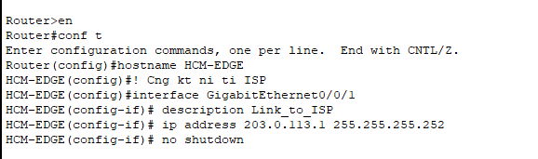

! Cổng kết nối tới LAN (Core Switch)

interface GigabitEthernet0/0/0

description Link_to_HCM_CORE

ip address 192.168.10.254 255.255.255.0

no shutdown

! Bật định tuyến

ip routing

exit

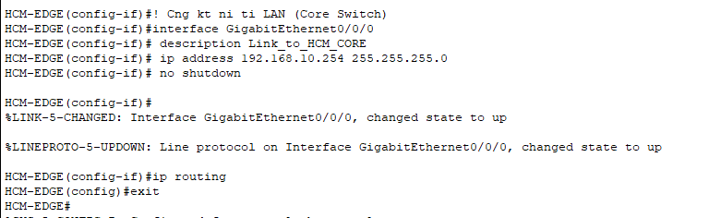

**2. HCM-CORE**

⦁ Định tuyến VLAN

⦁ Tạo SVI (Switch Virtual Interface) cho từng VLAN

⦁ Trunk

Command:

enable

configure terminal

hostname HCM-CORE

! Tạo VLAN cho các phòng ban

vlan 10

name NHANSU

vlan 20

name KETOAN

vlan 30

name IT

vlan 40

name GIAMDOC

vlan 99

name QUANLY

exit

! Cấu hình các SVI (gateway VLAN)

interface vlan 10

ip address 192.168.10.1 255.255.255.192

no shutdown

interface vlan 20

ip address 192.168.10.65 255.255.255.192

no shutdown

interface vlan 30

ip address 192.168.10.129 255.255.255.224

no shutdown

interface vlan 40

ip address 192.168.10.161 255.255.255.240

no shutdown

interface vlan 99

ip address 192.168.10.241 255.255.255.240

no shutdown

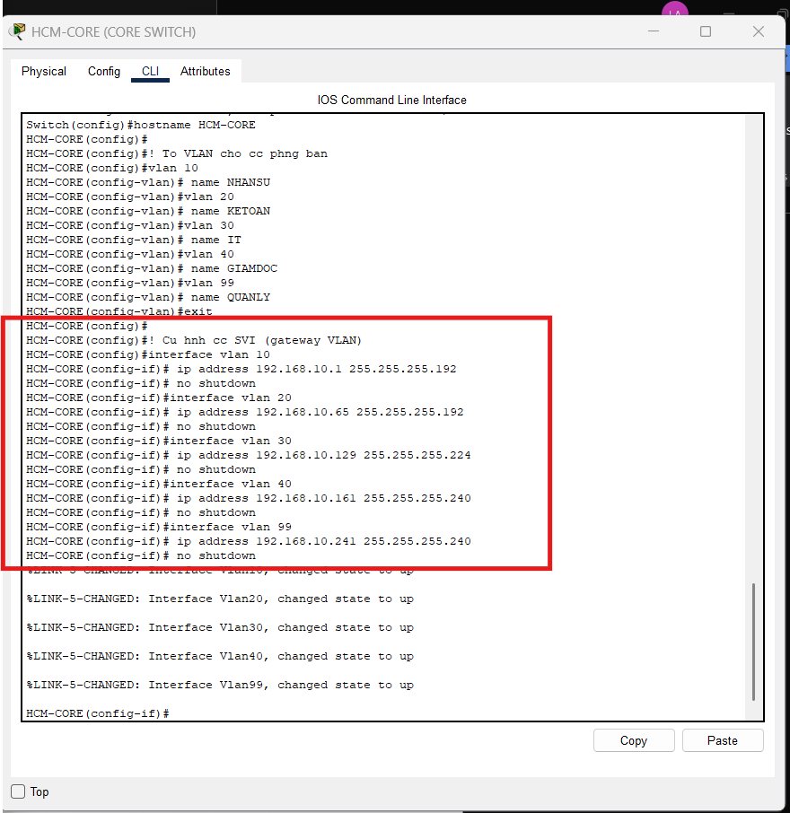

! Cổng uplink về router

interface GigabitEthernet0/1

description Uplink_to_HCM-EDGE

interface GigabitEthernet1/0/1

description *** Uplink to HCM-EDGE (Layer 3 Link) ***

no switchport

ip address 192.168.10.253 255.255.255.252

no shutdown

exit

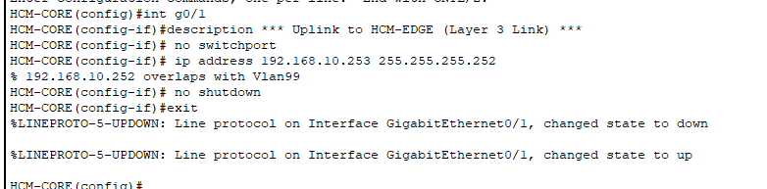

! === Cổng Trunk đến HCM-SW1 ===

interface F0/1

description *** Trunk to HCM-SW1 ***

switchport trunk encapsulation dot1q

switchport mode trunk

switchport trunk native vlan 99

switchport trunk allowed vlan 10,20,30,40,99

no shutdown

exit

! === Cổng Trunk đến HCM-SW2 ===

interface F0/2

description *** Trunk to HCM-SW2 ***

switchport mode trunk

switchport trunk native vlan 99

switchport trunk allowed vlan 10,20,30,40,99

no shutdown

exit

*Trên HCM-SW1, 2:*

*interface FastEthernet0/1*

*description *** Trunk to HCM-CORE \*\*\**

*switchport mode trunk*

*switchport trunk native vlan 99*

*switchport trunk allowed vlan 10,20,30,40,99*

*no shutdown*

! === Cổng Access cho Servers (VLAN 99) ===

interface FastEthernet0/3

description *** SRV-DHCP-HCM ***

switchport mode access

switchport access vlan 99

spanning-tree portfast

no shutdown

exit

interface FastEthernet0/4

description *** SRV-FILE-HCM ***

switchport mode access

switchport access vlan 99

spanning-tree portfast

no shutdown

exit

interface FastEthernet0/5

description *** SRV-RADIUS-HCM ***

switchport mode access

switchport access vlan 99

spanning-tree portfast

no shutdown

exit

! === Default Route đến HCM-EDGE ===

ip route 0.0.0.0 0.0.0.0 192.168.10.254

end

copy running-config startup-config

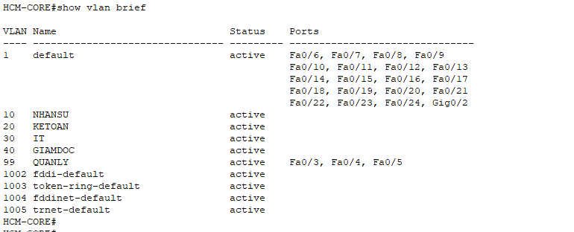

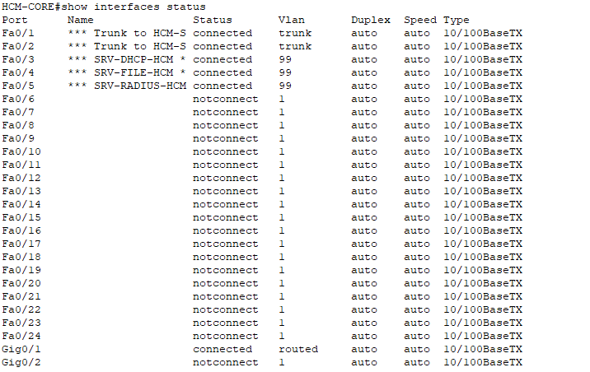

**3. HCM-SW1**

enable

configure terminal

hostname HCM-SW1

! === VLAN ===

vlan 10

name NHANSU

exit

vlan 20

name KETOAN

exit

vlan 99

name QUANLY

exit

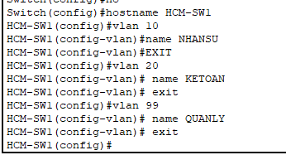

! === Trunk Uplink đến HCM-CORE ===

interface F0/1

description *** Uplink to HCM-CORE ***

switchport mode trunk

switchport trunk native vlan 99

switchport trunk allowed vlan 10,20,99

no shutdown

exit

! === Cổng Access cho PC Nhân Sự (VLAN 10) ===

interface range FastEthernet0/2 - 5

description *** PC Nhan Su ***

switchport mode access

switchport access vlan 10

spanning-tree portfast

no shutdown

exit

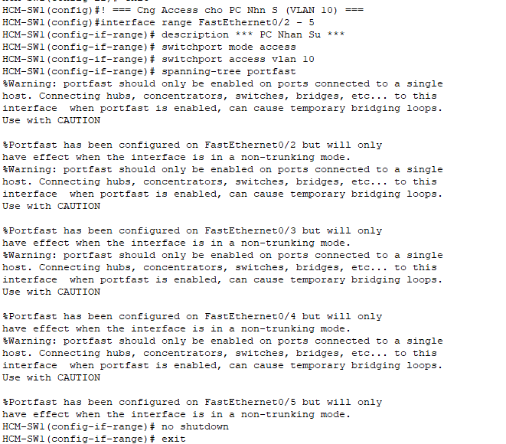

! === Cổng Access cho PC Kế Toán (VLAN 20) ===

interface range FastEthernet0/6 - 9

description *** PC Ke Toan ***

switchport mode access

switchport access vlan 20

spanning-tree portfast

no shutdown

exit

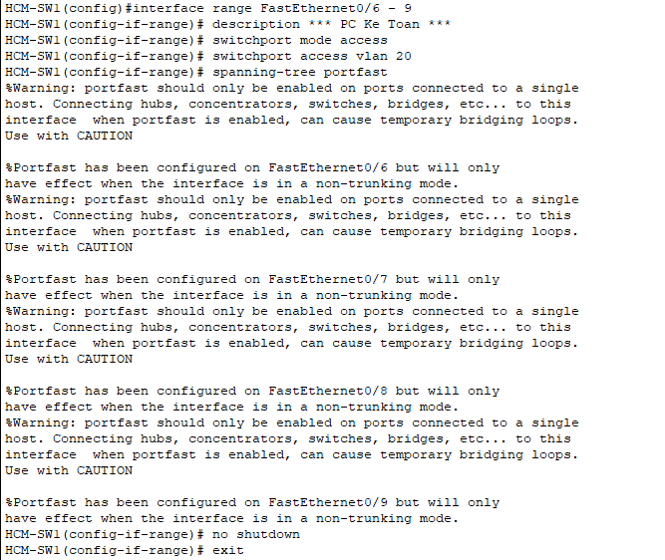

! === IP Quản Lý ===

interface Vlan99

ip address 192.168.10.244 255.255.255.240

no shutdown

exit

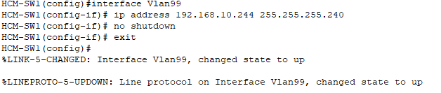

ip default-gateway 192.168.10.241

end

copy running-config startup-config

**4. HCM-SW2**

enable

configure terminal

hostname HCM-SW2

! === VLAN ===

vlan 30

name IT

exit

vlan 40

name GIAMDOC

exit

vlan 99

name QUANLY

exit

! === Trunk Uplink ===

interface F0/1

description *** Uplink to HCM-CORE ***

switchport mode trunk

switchport trunk native vlan 99

switchport trunk allowed vlan 30,40,99

no shutdown

exit

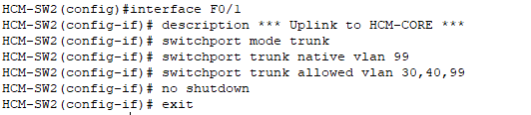

! === Cổng Access cho PC IT (VLAN 30) ===

interface range FastEthernet0/2

description *** PC IT ***

switchport mode access

switchport access vlan 30

spanning-tree portfast

no shutdown

exit

interface range FastEthernet0/4

description *** PC IT ***

switchport mode access

switchport access vlan 30

spanning-tree portfast

no shutdown

exit

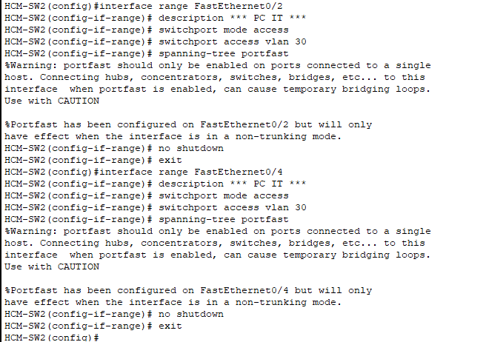

! === Cổng Access cho PC Giám Đốc (VLAN 40) ===

interface FastEthernet0/3

description *** PC Giam Doc ***

switchport mode access

switchport access vlan 40

spanning-tree portfast

no shutdown

exit

! === IP Quản Lý ===

interface Vlan99

ip address 192.168.10.245 255.255.255.240

no shutdown

exit

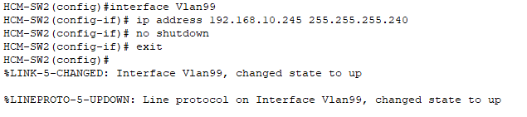

ip default-gateway 192.168.10.241

end

copy running-config startup-config

```

**5. DHCP Server (SRV-DHCP-HCM)**

*Cấu hình trên giao diện GUI:*

**a. Cấu hình IP tĩnh:**

- IP: `192.168.10.242`

- Subnet: `255.255.255.240`

- Gateway: `192.168.10.241` (SVI VLAN 99)

- DNS: `8.8.8.8`

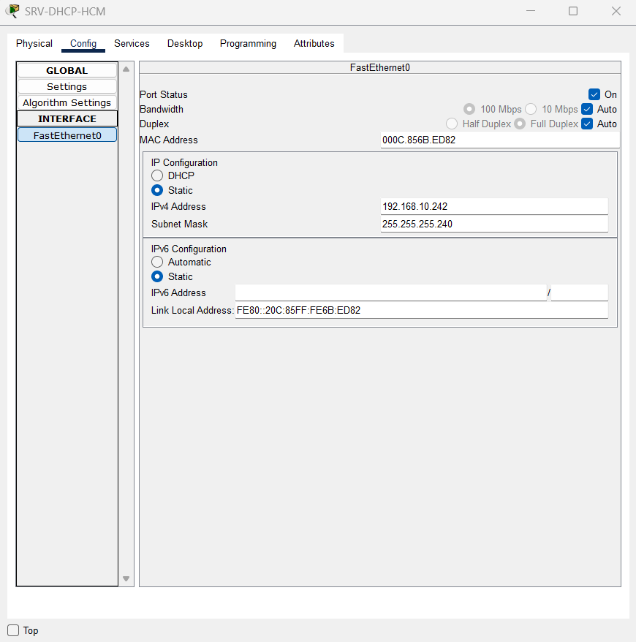 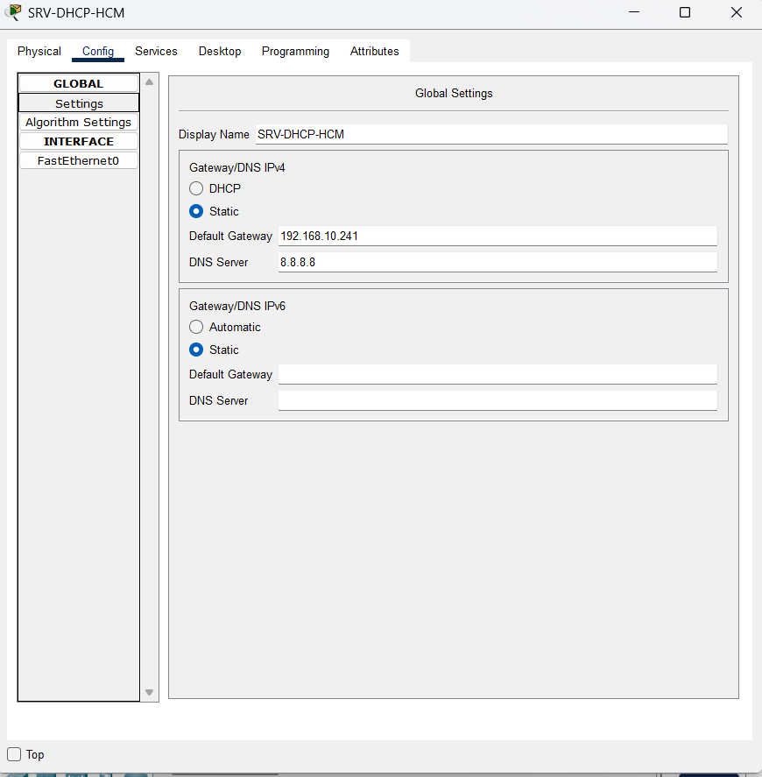

**b. Kích hoạt DHCP Service:**

DHCP Pool cho VLAN 10 (Nhân Sự):

```

Pool Name: VLAN10_POOL

Default Gateway: 192.168.10.1

DNS Server: 8.8.8.8

Start IP: 192.168.10.10

Subnet Mask: 255.255.255.192

Maximum Users: 50

```

DHCP Pool cho VLAN 20 (Kế Toán):

```

Pool Name: VLAN20_POOL

Default Gateway: 192.168.10.65

DNS Server: 8.8.8.8

Start IP: 192.168.10.70

Subnet Mask: 255.255.255.192

Maximum Users: 50

```

DHCP Pool cho VLAN 30 (IT):

```

Pool Name: VLAN30_POOL

Default Gateway: 192.168.10.129

DNS Server: 8.8.8.8

Start IP: 192.168.10.135

Subnet Mask: 255.255.255.224

Maximum Users: 25

```

DHCP Pool cho VLAN 40 (Giám Đốc):

```

Pool Name: VLAN40_POOL

Default Gateway: 192.168.10.161

DNS Server: 8.8.8.8

Start IP: 192.168.10.165

Subnet Mask: 255.255.255.240

Maximum Users: 10

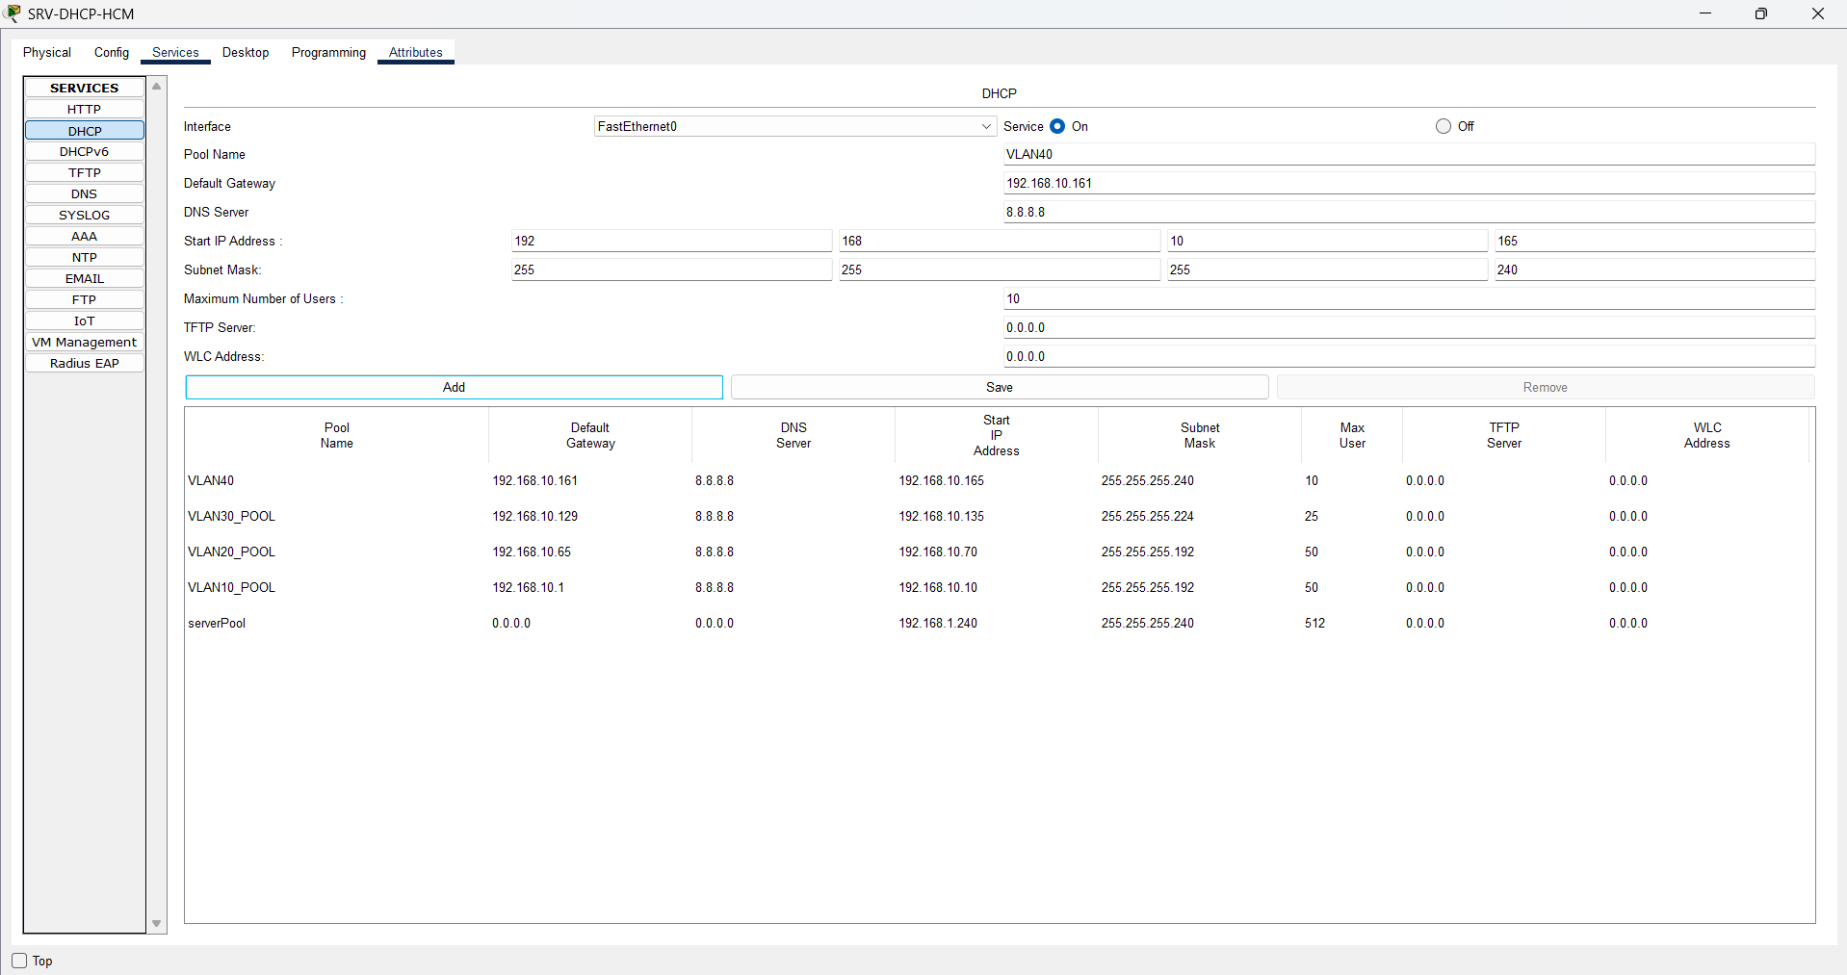

**6. Cấu hình IP Helper trên HCM-CORE**

enable

configure terminal

! === IP Helper cho từng VLAN SVI ===

conf t

interface vlan10

ip helper-address 192.168.10.242

interface vlan20

ip helper-address 192.168.10.242

interface vlan30

ip helper-address 192.168.10.242

interface vlan40

ip helper-address 192.168.10.242

exit

end

copy running-config startup-config

**HOÀN THÀNH QUÁ TRÌNH CẤU HÌNH ĐỊA CHỈ IP CỦA CÁC THIẾT BỊ Ở CHI NHÁNH HCM.** Giờ đây, có thể cấp phát địa chỉ ip động cho các thiết bị trong mạng

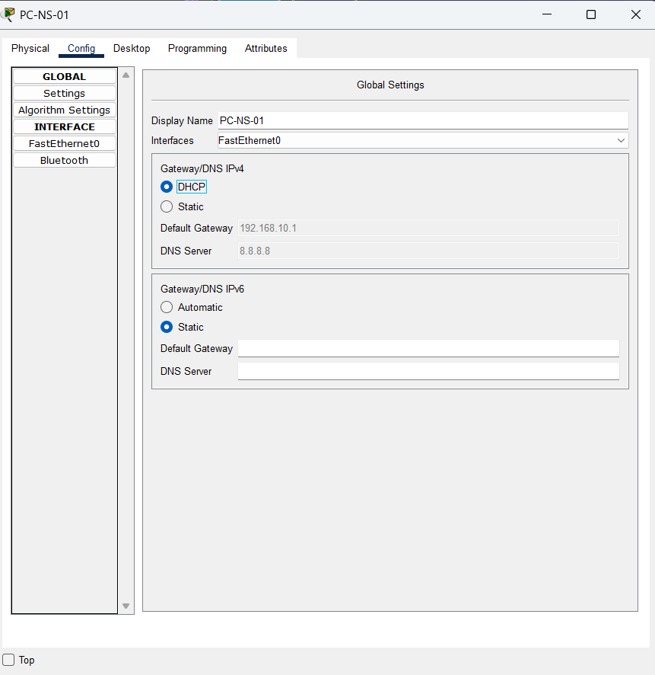 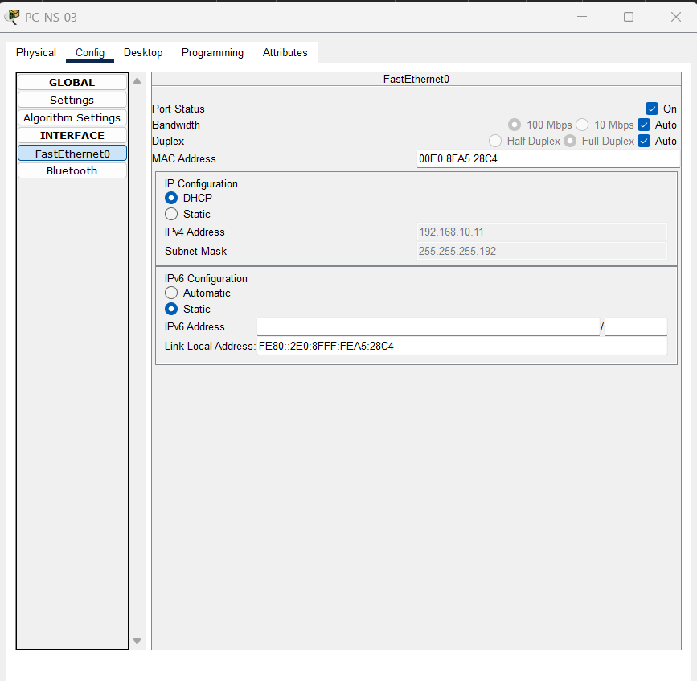

**NHA TRANG BRANCH**

**1. Router NT-EDGE**

- Định tuyến giữa LAN <-> WAN

- Giao tiếp vs Core Switch qua G0/0/0

- Giao tiếp vs ISP qua G0/0/1

Command:

enable

configure terminal

hostname NT-EDGE

! Cổng kết nối tới ISP

interface GigabitEthernet0/0/1

description Link_to_ISP

ip address 203.0.113.5 255.255.255.252

no shutdown

! Cổng kết nối tới LAN (Core Switch)

interface GigabitEthernet0/0/0

description Link_to_NT_CORE

ip address 172.16.20.254 255.255.255.0

no shutdown

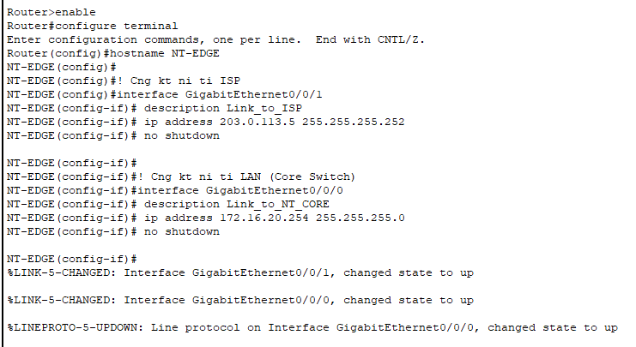

! Bật định tuyến

ip routing

exit

**2. NT-CORE**

Command:

enable

configure terminal

hostname NT-CORE

! Tạo VLAN cho các phòng ban

vlan 10

name NHANSU

vlan 20

name KETOAN

vlan 30

name IT

vlan 40

name GIAMDOC

vlan 99

name QUANLY

exit

! === Cấu hình các SVI (gateway VLAN) ===

interface vlan 10

ip address 172.16.20.1 255.255.255.192

no shutdown

exit

interface vlan 20

ip address 172.16.20.65 255.255.255.192

no shutdown

exit

interface vlan 30

ip address 172.16.20.129 255.255.255.224

no shutdown

exit

interface vlan 40

ip address 172.16.20.161 255.255.255.240

no shutdown

exit

interface vlan 99

ip address 172.16.20.241 255.255.255.240

no shutdown

exit

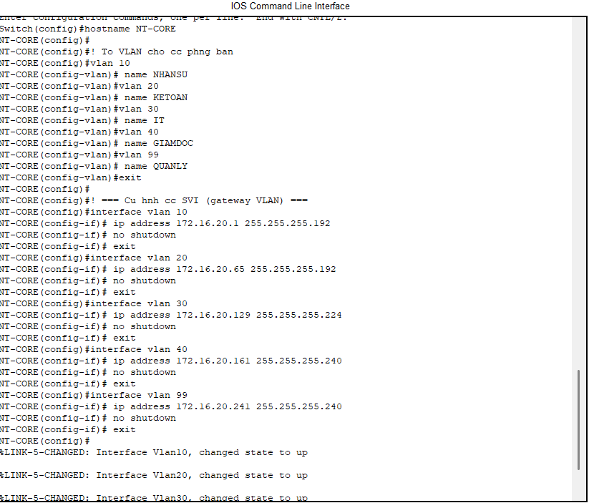

! === Cổng uplink về router (Layer 3) ===

interface F0/1

description *** Uplink to NT-EDGE (Layer 3 Link) ***

no switchport

ip address 172.16.20.253 255.255.255.252

no shutdown

exit

! === Cổng Trunk đến NT-SW1 ===

interface FastEthernet0/3

description *** Trunk to NT-SW1 ***

switchport trunk encapsulation dot1q

switchport mode trunk

switchport trunk native vlan 99

switchport trunk allowed vlan 10,20,30,40,99

no shutdown

exit

! === Cổng Trunk đến NT-SW2 ===

interface FastEthernet0/2

description *** Trunk to NT-SW2 ***

switchport mode trunk

switchport trunk native vlan 99

switchport trunk allowed vlan 10,20,30,40,99

no shutdown

exit

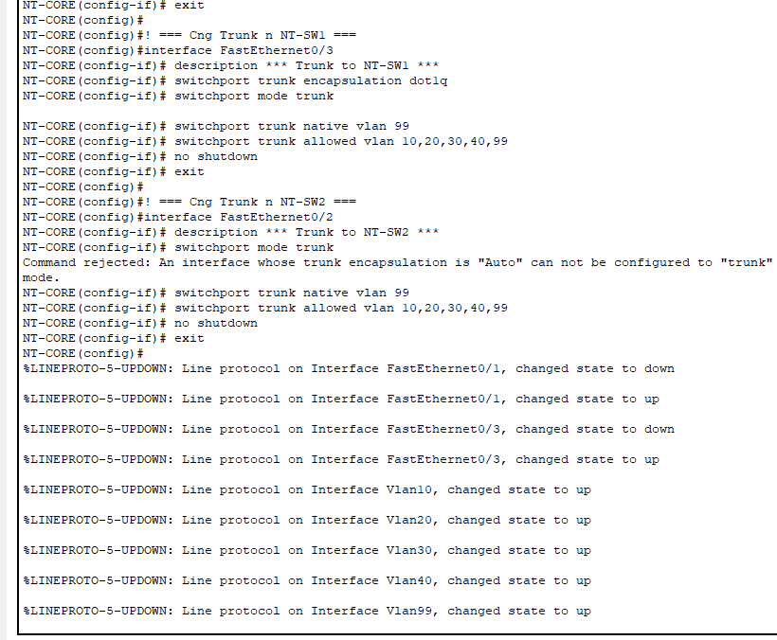

*Trên NT-SW1, 2:*

*interface FastEthernet0/1*

*description *** Trunk to NT-CORE \*\*\**

*switchport mode trunk*

*switchport trunk native vlan 99*

*switchport trunk allowed vlan 10,20,30,40,99*

*no shutdown*

! === Cổng Access cho Servers (VLAN 99) ===

interface FastEthernet0/4

description *** SRV-DHCP-HCM ***

switchport mode access

switchport access vlan 99

spanning-tree portfast

no shutdown

exit

interface FastEthernet0/5

description *** SRV-FILE-HCM ***

switchport mode access

switchport access vlan 99

spanning-tree portfast

no shutdown

exit

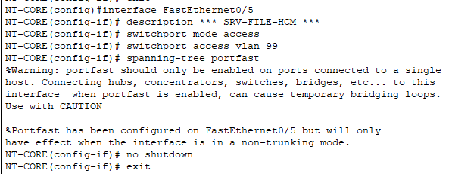

! === Default Route đến NT-EDGE ===

ip route 0.0.0.0 0.0.0.0 172.16.20.254

end

copy running-config startup-config

**3. NT-SW1**

enable

configure terminal

hostname NT-SW1

! === VLAN ===

vlan 10

name NHANSU

exit

vlan 20

name KETOAN

exit

vlan 99

name QUANLY

exit

! === Trunk Uplink đến NT-CORE ===

interface F0/1

description *** Uplink to NT-CORE ***

switchport mode trunk

switchport trunk native vlan 99

switchport trunk allowed vlan 10,20,99

no shutdown

exit

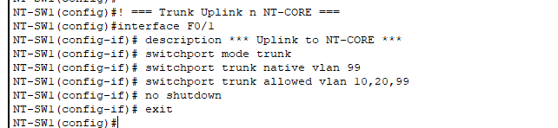

! === Cổng Access cho PC Nhân Sự (VLAN 10) ===

interface range FastEthernet0/2 - 5

description *** PC Nhan Su ***

switchport mode access

switchport access vlan 10

spanning-tree portfast

no shutdown

exit

! === Cổng Access cho PC Kế Toán (VLAN 20) ===

interface range FastEthernet0/6 - 9

description *** PC Ke Toan ***

switchport mode access

switchport access vlan 20

spanning-tree portfast

no shutdown

exit

! === IP Quản Lý ===

interface Vlan99

ip address 172.16.20.244 255.255.255.240 no shutdown

exit

ip default-gateway 172.16.20.241

end

copy running-config startup-config

**4. NT-SW2**

enable

configure terminal

hostname NT-SW2

! === VLAN ===

vlan 30

name IT

exit

vlan 40

name GIAMDOC

exit

vlan 99

name QUANLY

exit

! === Trunk Uplink ===

interface F0/1

description *** Uplink to NT-CORE ***

switchport mode trunk

switchport trunk native vlan 99

switchport trunk allowed vlan 30,40,99

no shutdown

exit

! === Cổng Access cho PC IT (VLAN 30) ===

interface range FastEthernet0/2 - 3

description *** PC IT ***

switchport mode access

switchport access vlan 30

spanning-tree portfast

no shutdown

exit

! === Cổng Access cho PC Giám Đốc (VLAN 40) ===

interface FastEthernet0/4

description *** PC Giam Doc ***

switchport mode access

switchport access vlan 40

spanning-tree portfast

no shutdown

exit

! === IP quản lý ===

interface vlan99

ip address 172.16.20.245 255.255.255.240

no shutdown

exit

ip default-gateway 172.16.20.241

end

copy running-config startup-config

**5. DHCP Server (SRV-DHCP-HCM)**

*Cấu hình trên giao diện GUI:*

**a. Cấu hình IP tĩnh:**

- IP: `172.16.20.242`

- Subnet: `255.255.255.240`

- Gateway: `172.16.20.241` (SVI VLAN 99)

- DNS: `8.8.8.8`

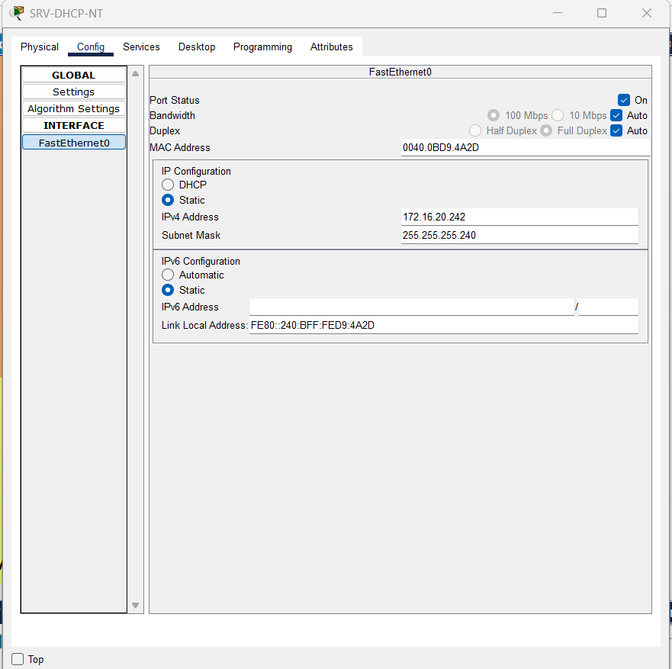 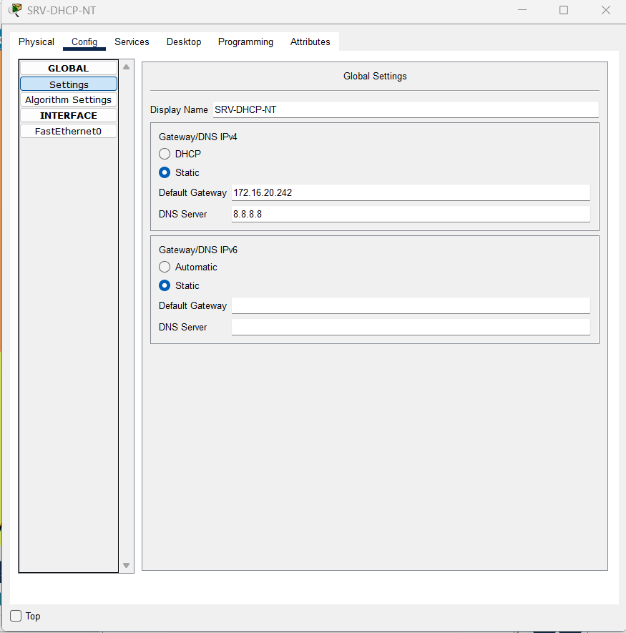

**b. Kích hoạt DHCP Service:**

DHCP Pool cho VLAN 10 (Nhân Sự):

```

Pool Name: VLAN10_POOL

Default Gateway: 172.16.20.1

DNS Server: 8.8.8.8

Start IP: 172.16.20.10

Subnet Mask: 255.255.255.192

Maximum Users: 50

```

DHCP Pool cho VLAN 20 (Kế Toán):

```

Pool Name: VLAN20_POOL

Default Gateway: 172.16.20.65

DNS Server: 8.8.8.8

Start IP: 172.16.20.70

Subnet Mask: 255.255.255.192

Maximum Users: 50

```

DHCP Pool cho VLAN 30 (IT):

```

Pool Name: VLAN30_POOL

Default Gateway: 172.16.20.129

DNS Server: 8.8.8.8

Start IP: 172.16.20.135

Subnet Mask: 255.255.255.224

Maximum Users: 25

```

DHCP Pool cho VLAN 40 (Giám Đốc):

```

Pool Name: VLAN40_POOL

Default Gateway: 172.16.20.161

DNS Server: 8.8.8.8

Start IP: 172.16.20.165

Subnet Mask: 255.255.255.240

Maximum Users: 10

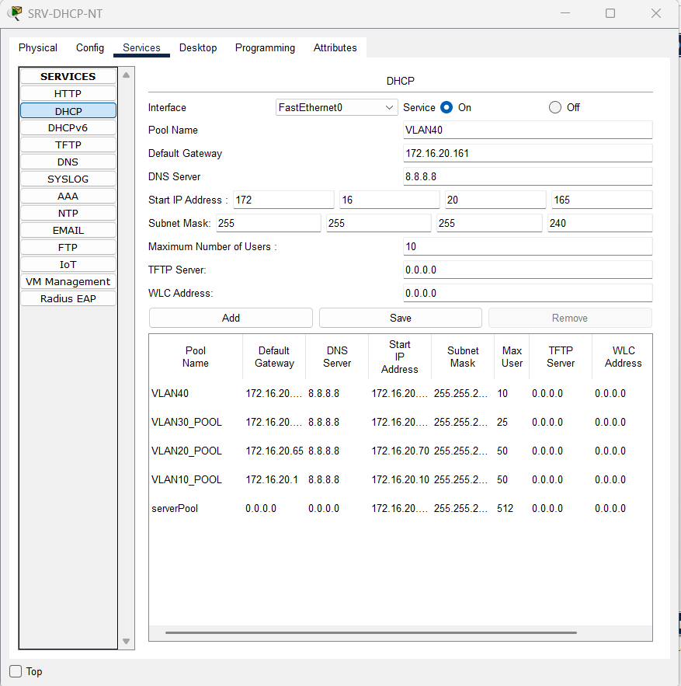

**6. Cấu hình IP Helper trên NT-CORE**

enable

configure terminal

interface vlan10

ip helper-address 172.16.20.242

exit

interface vlan20

ip helper-address 172.16.20.242

exit

interface vlan30

ip helper-address 172.16.20.242

exit

interface vlan40

ip helper-address 172.16.20.242

exit

end

copy running-config startup-config

**HOÀN THÀNH QUÁ TRÌNH CẤU HÌNH ĐỊA CHỈ IP CỦA CÁC THIẾT BỊ Ở CHI NHÁNH NHA TRANG.** Giờ đây, có thể cấp phát địa chỉ ip động cho các thiết bị trong mạng

