**1. Router HCM-EDGE**

- Định tuyến giữa LAN <-> WAN

- Giao tiếp vs Core Switch qua G0/0/0

- Giao tiếp vs ISP qua G0/0/1

Command:

enable

configure terminal

hostname HCM-EDGE

! Cổng kết nối tới ISP

interface GigabitEthernet0/0/1

description Link_to_ISP

ip address 203.0.113.1 255.255.255.252

no shutdown

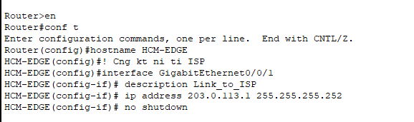

! Cổng kết nối tới LAN (Core Switch)

interface GigabitEthernet0/0/0

description Link_to_HCM_CORE

ip address 192.168.10.254 255.255.255.0

no shutdown

! Bật định tuyến

ip routing

exit

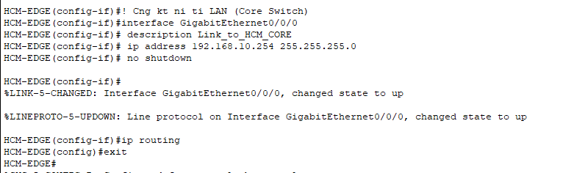

**2. HCM-CORE**

⦁ Định tuyến VLAN

⦁ Tạo SVI (Switch Virtual Interface) cho từng VLAN

⦁ Trunk

Command:

enable

configure terminal

hostname HCM-CORE

! Tạo VLAN cho các phòng ban

vlan 10

name NHANSU

vlan 20

name KETOAN

vlan 30

name IT

vlan 40

name GIAMDOC

vlan 99

name QUANLY

exit

! Cấu hình các SVI (gateway VLAN)

interface vlan 10

ip address 192.168.10.1 255.255.255.192

no shutdown

interface vlan 20

ip address 192.168.10.65 255.255.255.192

no shutdown

interface vlan 30

ip address 192.168.10.129 255.255.255.224

no shutdown

interface vlan 40

ip address 192.168.10.161 255.255.255.240

no shutdown

interface vlan 99

ip address 192.168.10.241 255.255.255.240

no shutdown

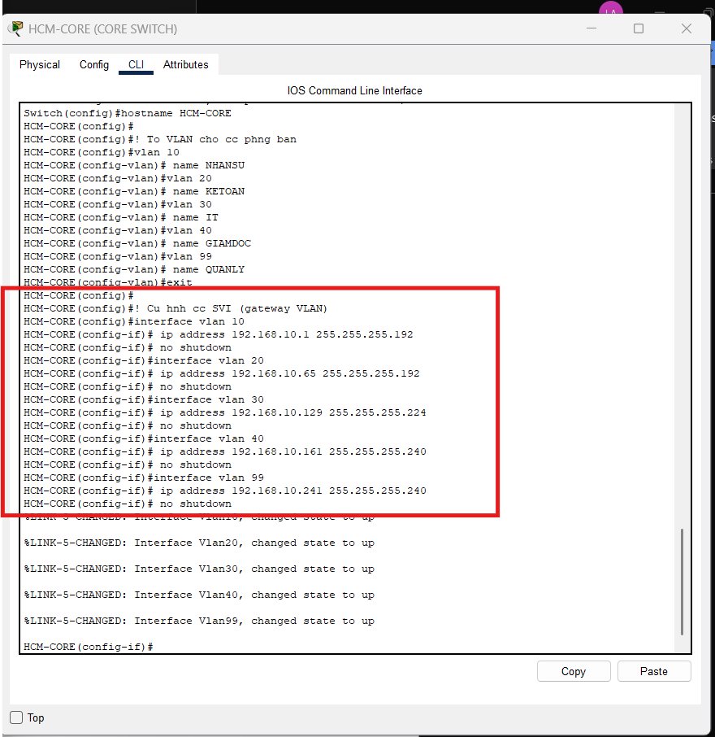

! Cổng uplink về router

interface GigabitEthernet0/1

description Uplink_to_HCM-EDGE

interface GigabitEthernet1/0/1

description *** Uplink to HCM-EDGE (Layer 3 Link) ***

no switchport

ip address 192.168.10.253 255.255.255.252

no shutdown

exit

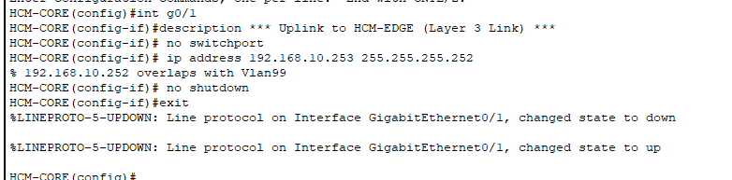

! === Cổng Trunk đến HCM-SW1 ===

interface F0/1

description *** Trunk to HCM-SW1 ***

switchport trunk encapsulation dot1q

switchport mode trunk

switchport trunk native vlan 99

switchport trunk allowed vlan 10,20,30,40,99

no shutdown

exit

! === Cổng Trunk đến HCM-SW2 ===

interface F0/2

description *** Trunk to HCM-SW2 ***

switchport mode trunk

switchport trunk native vlan 99

switchport trunk allowed vlan 10,20,30,40,99

no shutdown

exit

*Trên HCM-SW1, 2:*

*interface FastEthernet0/1*

*description *** Trunk to HCM-CORE \*\*\**

*switchport trunk encapsulation dot1q*

*switchport mode trunk*

*switchport trunk native vlan 99*

*switchport trunk allowed vlan 10,20,30,40,99*

*no shutdown*

! === Cổng Access cho Servers (VLAN 99) ===

interface FastEthernet0/3

description *** SRV-DHCP-HCM ***

switchport mode access

switchport access vlan 99

spanning-tree portfast

no shutdown

exit

interface FastEthernet0/4

description *** SRV-FILE-HCM ***

switchport mode access

switchport access vlan 99

spanning-tree portfast

no shutdown

exit

interface FastEthernet0/5

description *** SRV-RADIUS-HCM ***

switchport mode access

switchport access vlan 99

spanning-tree portfast

no shutdown

exit

! === Default Route đến HCM-EDGE ===

ip route 0.0.0.0 0.0.0.0 192.168.10.254

end

copy running-config startup-config

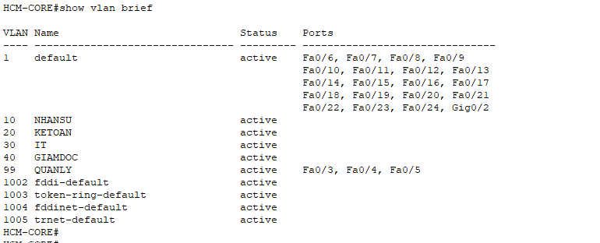

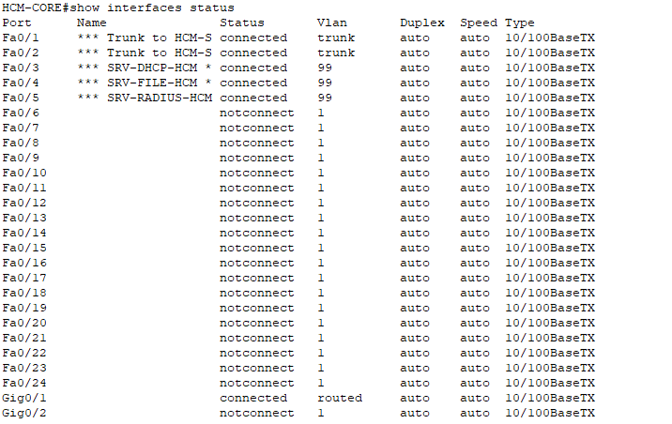

*Tiếp tục cấu hình trên HCM-SW1*