

**Employee Management System**



**USER INRTERFACE DESIGN DOCUMENT**

*Version 1.2*

*Date: April 20, 2020*

**TEAM 3: DHP**

**MENTOR(S): MSc, DAO, NGUYEN THI ANH**

**MEMBER: DAT, HOANG QUANG**

**PHUOC, HUYNH VAN**

**HIEU, NGUYEN HONG**

**HIEU, NGUYEN QUANG**

**DUAN, MAI LE**

**INTERNATIONAL SCHOOL**

|  |  |  |  |  |  |
| --- | --- | --- | --- | --- | --- |
| **PROJECT INFORMATION** | | | | | |
| **Project Acronym** | Employee Management System | | | | |
| **Project Title** | Employee Management System | | | | |
| **Start Date** | 13 – Apr – 2021 | **End Date** | | 20 – Apr– 2021 | |
| **Lead Institution** | International School, Duy Tan University | | | | |
| **Project Mentor** | Dao, Nguyen Thi Anh  Email: nguyenthianhdao@dtu.edu.vn  Phone: 0 | | | | |
| **Partner Organization** | Duy Tan University | | | | |
| **Leader T** | Dat, Hoang Quang | | uy.hoang.2000@gmail.com | | 0379782308 |
| **Team Members** | Hieu, Nguyen Hong | | nguyenhonghieuit@gmail.com | | 0777903474 |
| Hieu, Nguyen Quang | | hieunguyen.13092000@gmail.com | | 0707960071 |
| Phuoc, Huynh Van | | huynhphvan@gmail.com | | 0765386683 |
| Duan, Mai Le | | maileduan24899@gmail.com | | 0385338303 |

|  |  |  |  |
| --- | --- | --- | --- |
| **DOCUMENT NAME** | | | |
| **Document Title** | User Interface Document | | |
| **Author(s)** | DPH | | |
| **Class** | CMU-CS 445 BIS | | |
| **Date** | 20 – Apr – 2021 | **File name:** | [Employee Management System] UserInterface ver.1.2.docx |

|  |  |  |  |
| --- | --- | --- | --- |
| **REVISION HISTORY** | | | |
| **Version** | **Person** | **Date** | **Description** |
| 1.1 | Duan, Hong Hieu, Quang Hieu | 13-4-2021 | GUI version 1.1 basic |
| 1.1.1 | Duan, Hong Hieu, Quang Hieu | 15-4-2021 | GUI version 1.1.1 (add function) |
| 1.2 | Duan, Hong Hieu, Quang Hieu | 18-4-2021 | GUI version 1.2 |

|  |  |  |  |
| --- | --- | --- | --- |
| **DOCUMENT APPROVAL**  The following signatures are required for approval of this document | | | |
| **Mentor** | Dao, Nguyen Thi Anh | **Signature:** |  |
| **Date:** |  |
| **Team Leader** | Dat, Hoang Quang | **Signature:** | Dat |
| **Date:** | 20 – Apr – 2021 |
| **Team Member(s)** | Hieu, Nguyen Quang | **Signature:** | Hieu |
| **Date:** | 19 – Apr – 2021 |
| Hieu, Nguyen Hong | **Signature:** | Hieu |
| **Date:** | 19 – Apr – 2021 |
| Phuoc, Huynh Van | **Date** | Phuoc |
| **Signature** | 20 – Apr – 2021 |
| Duan, Mai Le | **Date** | Duan |
| **Signature** | 19 – Apr – 2021 |

**CONTENTS**

**1.** **OVERVIEW****.............................................................................................................................1**

1.1. Purpose 1

1.2. Related Documents 1

**2. INTERFACE 2**

2.1 Login 2

2.2 CEO Interface 4

2.2.1 Dashboard - Total Earnings 4

2.2.2 Dashboard - Total number vacation days 7

2.2.3 Dashboard - Average Benefits 9

2.3 Manager Interface (not Shareholder) 6

2.3.1 Dashboard - Total Earnings

2.3.2 Dashboard - Total number vacation days

2.3.3 Dashboard - Average Benefits

2.3.4 Set Alert

2.4 Manager Interface( Shareholder) 6

2.4.1 Dashboard - Total Earnings

2.4.2 Dashboard - Total number vacation days

2.4.3 Dashboard - Average Benefits

2.5 Shareholder Interface 6

2.4.1 Dashboard - Total Earnings

2.4.2 Dashboard - Total number vacation days

2.4.3 Dashboard - Average Benefits

**1.** **OVERVIEW**

* 1. **Purpose**

This document helps to better understand the interface of the Employee Management website, detailed specification components and function of the system.

With this document, the development team can understand detail the structure and composition to create a consistent and complete system.

* 1. **Related Documents**

|  |  |  |
| --- | --- | --- |
| No | References | Document Information |
| 1 | Product Backlog document | [Employee Management System] Product_Backlog_Ver1.2.docx |
| 2 | Architecture Design Document | [Employee Management System] ArchitectureDesign_Ver1.2.docx |
| 3 | Database Design Document | [Employee Management System] DatabaseDesign_Ver1.2.docx |

1. **INTERFACE**

**2.1 Login**

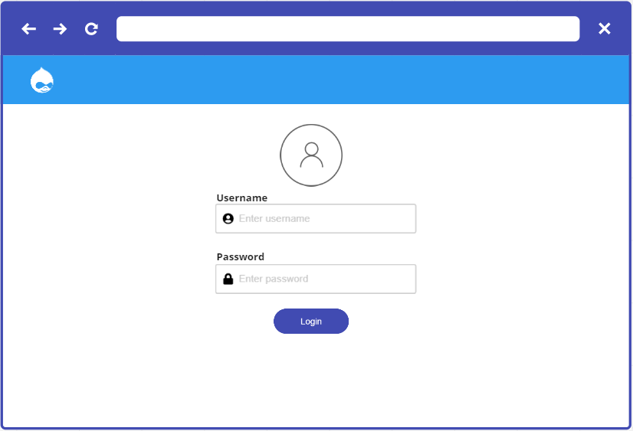

*Figure 1: Login*

Table 1: Table of screen interface specifications Login

|  |  |  |  |  |
| --- | --- | --- | --- | --- |
| **Show** | Login | | | |
| **Description** | The system will display a login box for users to access the system with an account to use the website's features | | | |
| **Show counter** | Click on the [Login] button on website. | | | |
| **Content displayed** | | | | |
| **Item** | **Type** | **Data** | **Description** | |
| Login logo | ImageButton |  | Shown logo of Login | |
| Login | Label |  | Shown tittle of Login | |
| Enter username | Textfield (30) |  | Enter the username | |
| Enter password | Textfield(30) |  | Enter the password | |
| Login | Button |  | Go to log in to the system as a user | |
| **Action** | | | | |
| **Action name** | **Description** | | **Success** | **No success** |
| Click on Login button | After 0.3 seconds, the system will navigate to the Home Page. | | Go to the Home Page. | Hang in the current screen interface |

**2.2 CEO Interface**

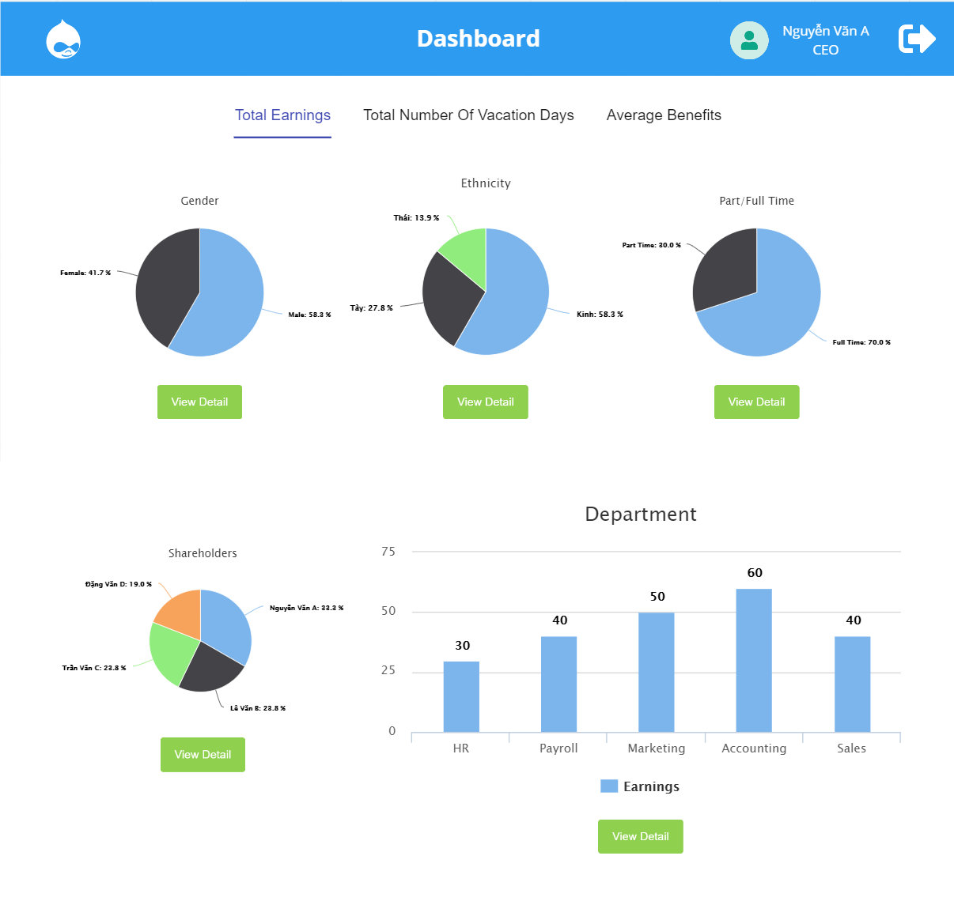2.2.1 Dashboard - Total Earnings(Home Page)

*Figure 2: Dashboard - Total Earnings(Home Page)*

Table 2: Table of screen interface specifications Total Earnings

|  |  |  |  |  |
| --- | --- | --- | --- | --- |
| **Show** | Dashboard - Total Earnings | | | |
| **Description** | After user login successful, the system will navigate to the Dashboard-Total Earning. It will allow user interact with it. | | | |
| **Show counter** | Click on the [Login] button on website and login successful | | | |
| **Content displayed** | | | | |
| **Item** | **Type** | **Data** | **Description** | |
|  | Button |  | Shown account | |
|  | Button |  | Click to sign out | |
|  | Image |  | Graphs display information in a general way | |
|  | Button |  | Click to view corresponding information for the chart in detail | |
| Tab “Total number vacation days” | TabButton |  | Click to view detail ” Total number vacation days” | |
| Tab “Average Benefits” | TabButton |  | Click to view detail ”Average Benefits”- | |
| **Action** | | | | |
| **Action name** | **Description** | | **Success** | **No success** |
| Click on: | The system will navigate to the account screen | | The account screen will be display | Hang in the current screen interface |
| Click on: | The system will sign out and navigate to the login screen | | The login screen will be display | Hang in the current screen interface |
| Click on tab “Total number vacation days” | The system will navigate to the “Total number vacation days” screen | | Go to the “Total number vacation days “screen | Hang in the current screen interface |
| Click on tab “Average Benefits” | The system will navigate to the “Average Benefits” screen | | Go to the “Average Benefits “screen | Hang in the current screen interface |
| Click on button “View details” | The system will navigate to the “Dashboard-Earning” screen as a summary table | | Go to the the “Dashboard-Earning” screen as a summary table | Hang in the current screen interface |

**\* Detail of Total Earnings**

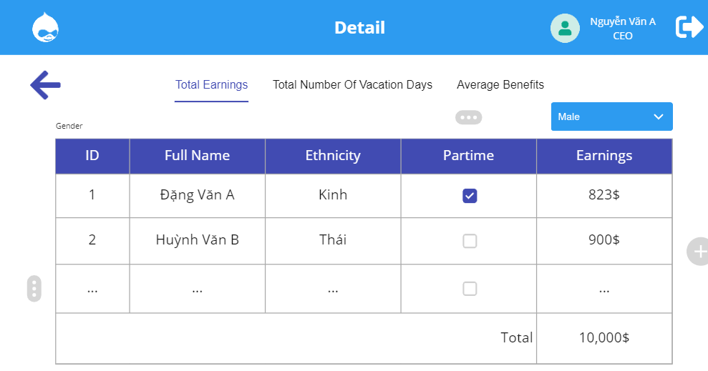

*Figure 3: Detail of Total Earnings*

**Table 3: Table of screen interface specifications Detail of Total Earnings**

|  |  |  |  |
| --- | --- | --- | --- |
| **Show** | **Total Earning** | | |
| **Description** | After user click to “ View detail”. It will display detailed summary information in the form of a table | | |
| **Content displayed** | | | |
| **Item** | **Type** | **Data** | **Description** |
|  | Button |  | Show account |
|  | Button |  | Click to sign out |
|  | Select box |  | Show and choose condition |
| **Action** | | | |
| **Action name** | **Description** | **Success** | **No success** |
| Click on: | The system will navigate to the account screen | The account screen will be display | Hang in the current screen interface |
| Click on: | The system will sign out and navigate to the login screen | The login screen will be display | Hang in the current screen interface |
| Click on: | The system will clarify data and display data follow condition which was chosen | The data follow condition will be display | Hang in the current screen interface |

2.2.2 Dashboard - Total number vacation days

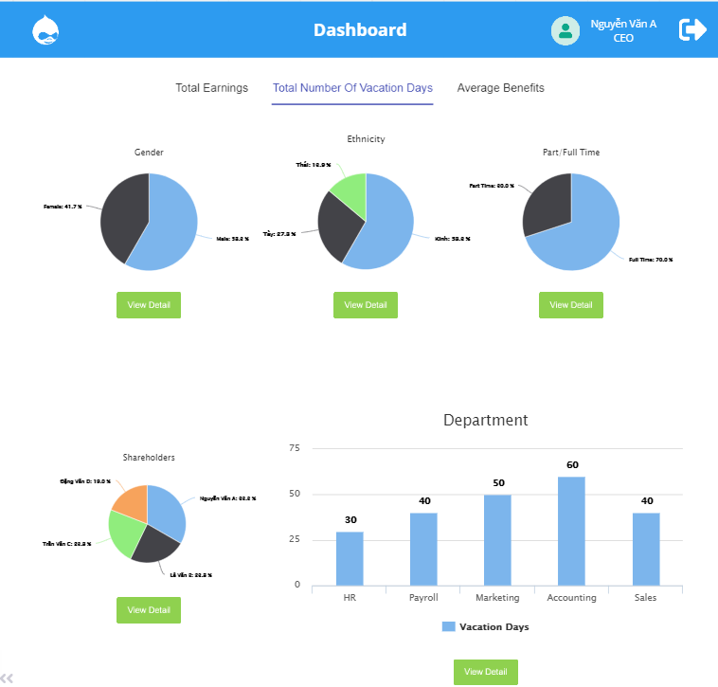

*Figure 4: Dashboard - Total number vacation days*

**Table 4: Table of screen interface specifications Total number vacation days**

|  |  |  |  |  |
| --- | --- | --- | --- | --- |
| **Show** | Total number vacation days | | | |
| **Description** | The user is on the main dashboard and click to “Total number vacation days”, the system will navigate to the “Total number vacation days”. It will allow user interact with it | | | |
| **Content displayed** | | | | |
| **Item** | **Type** | **Data** | **Description** | |
|  | Button |  | Show account | |
|  | Button |  | Click to sign out | |
|  | Image |  | Graphs display information in a general way | |
|  | Button |  | Show summary of information | |
| **Action** | | | | |
| **Action name** | **Description** | | **Success** | **No success** |
|  | Button | |  | Show account |
|  | Button | |  | Click to sign out |
| Click on tab “Total earning” | The system will navigate to the “Total earning” screen | | Go to the “Total earning “screen | Hang in the current screen interface |
| Click on tab “Average Benefits” | The system will navigate to the “Average Benefits” screen | | Go to the “Average Benefits “screen | Hang in the current screen interface |
| Click on button “View details” | The system will navigate to the “Total number vacation days” screen as a summary table | | Go to the the “Total number vacation days” screen as a summary table | Hang in the current screen interface |

**\* Detail of Total number vacation days** 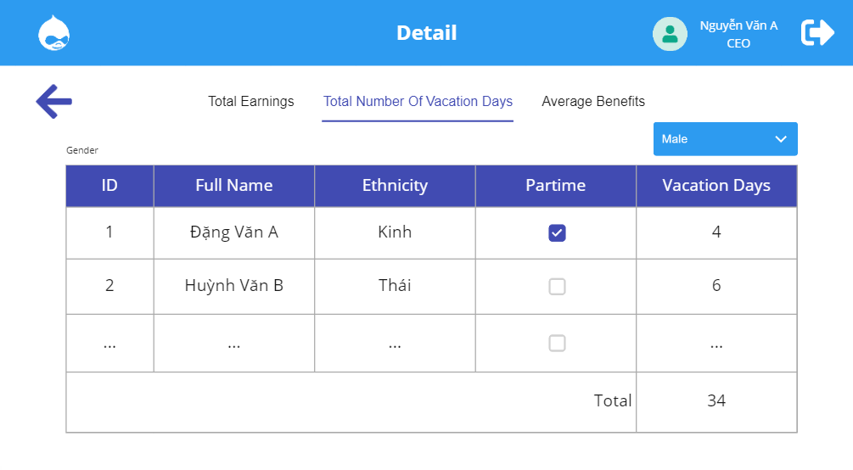

*Figure 5: Detail of Total number vacation days*

**Table 5: Table of screen interface specifications Total number vacation days**

|  |  |  |  |
| --- | --- | --- | --- |
| **Show** | **Total Earning** | | |
| **Description** | After user click to “ View detail”. It will display detailed summary information in the form of a table | | |
| **Content displayed** | | | |
| **Item** | **Type** | **Data** | **Description** |
|  | Image |  | Show account |
|  | Button |  | Click to sign out |
|  | Select box |  | Show and choose condition |
| **Action** | | | |
| **Action name** | **Description** | **Success** | **No success** |
| Click on: | Button |  | Show account |
| Click on: | Button |  | Click to sign out |
| Click on: | The system will clarify data and display data follow condition which was chosen | The data follow condition will be display | Hang in the current screen interface |

**2.2.3 Dashboard-Average Benefits**

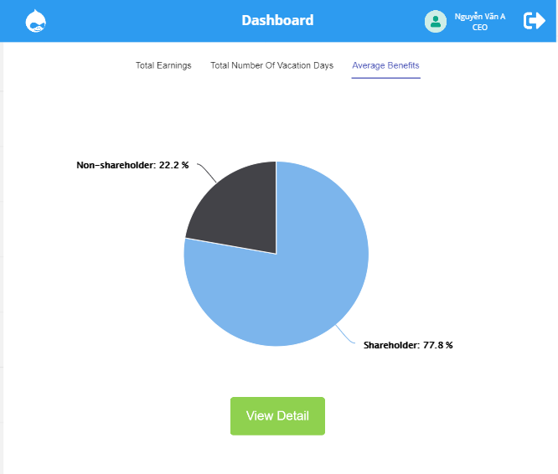

***Figure 6:dashboard- avarage benefits***

**Table 6: Table of screen interface specifications Avarage Benefits**

|  |  |  |  |  |
| --- | --- | --- | --- | --- |
| **Show** | **Average Benefits** | | | |
| **Description** | After user login successful and click to “Avarage benefits”, the system will navigate to the “Avarage benefits”. It will allow user interact with it | | | |
| **Content displayed** | | | | |
| **Item** | **Type** | **Data** | **Description** | |
|  | Image |  | Show account | |
|  | Button |  | Click to sign out | |
|  | Image |  | Graphs display information in a general way | |
|  | Button |  | Click to view corresponding information for the chart in detail | |
| **Action** | | | | |
| **Action name** | **Description** | | **Success** | **No success** |
|  | Button | |  | Show account |
|  | Button | |  | Click to sign out |
| Click on tab “Total earning” | The system will navigate to the “Total earning” screen | | Go to the “Total earning “screen | Hang in the current screen interface |
| Click on tab “Total number vacation days” | The system will navigate to the “Total number vacation days” screen | | Go to the “Total number vacation days “screen | Hang in the current screen interface |
| Click on button “View details” | The system will navigate to the “Avarage benefits” screen as a summary table | | Go to the the “Avarage benefits” screen as a summary table | Hang in the current screen interface |

**\* Detail of Average Benefits**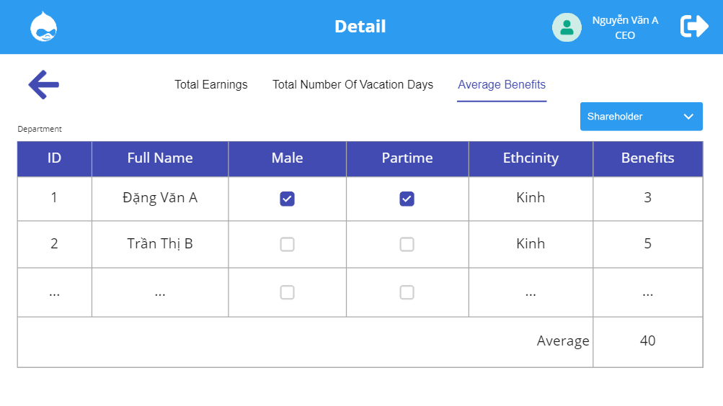

***Figure 7: Detail of Average Benefits***

**Table 7: Table of screen interface specifications Detail of Average Benefits**

|  |  |  |  |
| --- | --- | --- | --- |
| **Show** | **Total Earning** | | |
| **Description** | After user click to “ View detail”. It will display detailed summary information in the form of a table | | |
| **Content displayed** | | | |
| **Item** | **Type** | **Data** | **Description** |
|  | Image |  | Show account |
|  | Button |  | Click to sign out |
|  | Select box |  | Show and choose condition |
| **Action** | | | |
| **Action name** | **Description** | **Success** | **No success** |
| Click on: | Button |  | Show account |
| Click on: | Button |  | Click to sign out |
| Click on: | The system will clarify data and display data follow condition which was chosen | The data follow condition will be display | Hang in the current screen interface |

**2.3 Manager Interface (not Shareholder)**

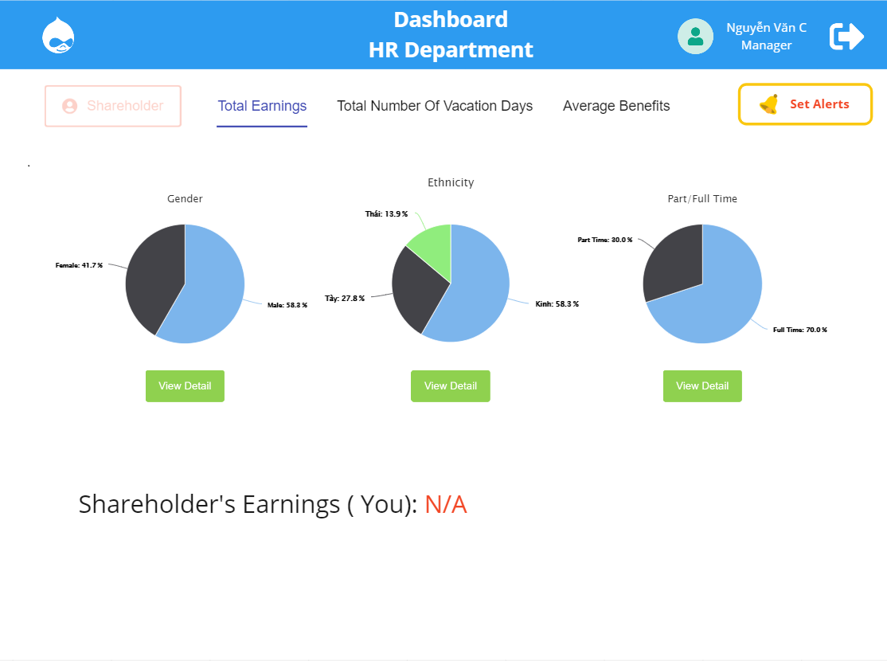2.3.1 Dashboard - Total Earnings(Home Page)

*Figure 2: Dashboard - Total Earnings(Home Page)*

Table 2: Table of screen interface specifications Total Earnings

|  |  |  |  |  |
| --- | --- | --- | --- | --- |
| **Show** | Dashboard - Total Earnings | | | |
| **Description** | After user login successful, the system will navigate to the Dashboard-Total Earning. It will allow user interact with it. | | | |
| **Show counter** | Click on the [Login] button on website and login successful | | | |
| **Content displayed** | | | | |
| **Item** | **Type** | **Data** | **Description** | |
|  | Button |  | Shown account | |
|  | Button |  | Click to sign out | |
|  | Button(not active) |  | It uses for Manager(Shareholder) | |
| Tab “Total Earning” | TabButton |  | Click to view detail “Total Earning” | |
| Tab “Total Number Of Vacation Days” | TabButton |  | Click to view detail “Total Number Of Vacation Days” | |
| Tab “Average Benefits” | TabButton |  | Click to view detail “Average Benefits” | |
|  | Button |  | Click to set alerts | |
|  | Image |  | Graphs display information in a general way | |
|  | Button |  | Click to view corresponding information for the chart in detail | |
|  | Text |  | It uses for Manager(Shareholder) | |
| **Action** | | | | |
| **Action name** | **Description** | | **Success** | **No success** |
| Click on: | The system will navigate to the account screen | | The account screen will be display | Hang in the current screen interface |
| Click on: | The system will sign out and navigate to the login screen | | The login screen will be display | Hang in the current screen interface |
| Click on tab “Total Number Of Vacation Days” | The system will navigate to the “Total Number Of Vacation Days” screen | | Go to the “Total Number Of Vacation Days” screen | Hang in the current screen interface |
| Click on tab “Average Benefits” | The system will navigate to the “Average Benefits” screen | | Go to the “Average Benefits” screen | Hang in the current screen interface |
| Click on: | The system will navigate to the “Set Alerts” screen | | The form for set alerts will be display | Hang in the current screen interface |
| Click on button “View details” | The system will navigate to the detail screen of tab respectively | | The detail screen of tab respectively will be display | Hang in the current screen interface |

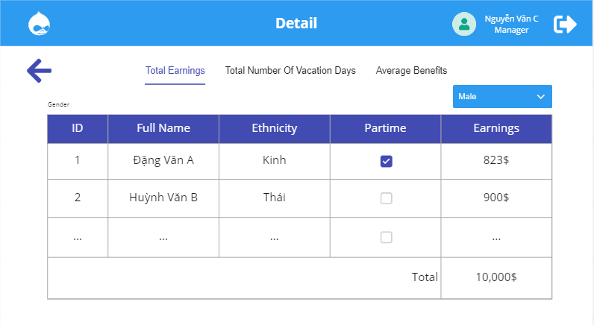**\* Detail of Total Earnings**

*Figure 3: Detail of Total Earnings*

**Table 3: Table of screen interface specifications Detail of Total Earnings**

|  |  |  |  |  |
| --- | --- | --- | --- | --- |
| **Show** | **Detail of Total Earning** | | | |
| **Description** | After user click to “ View detail”. It will display detailed summary information in the form of a table | | | |
| **Content displayed** | | | | |
| **Item** | **Type** | **Data** | **Description** | |
|  | Button |  | Show account | |
|  | Button |  | Click to sign out | |
|  | Select box |  | Show and choose condition | |
| **Action** | | | | |
| **Action name** | **Description** | | **Success** | **No success** |
| Click on: | The system will navigate to the account screen | | The account screen will be display | Hang in the current screen interface |
| Click on: | The system will sign out and navigate to the login screen | | The login screen will be display | Hang in the current screen interface |
| Click on: | The system will clarify data and display data follow condition which was chosen | | The data follow condition will be display | Hang in the current screen interface |

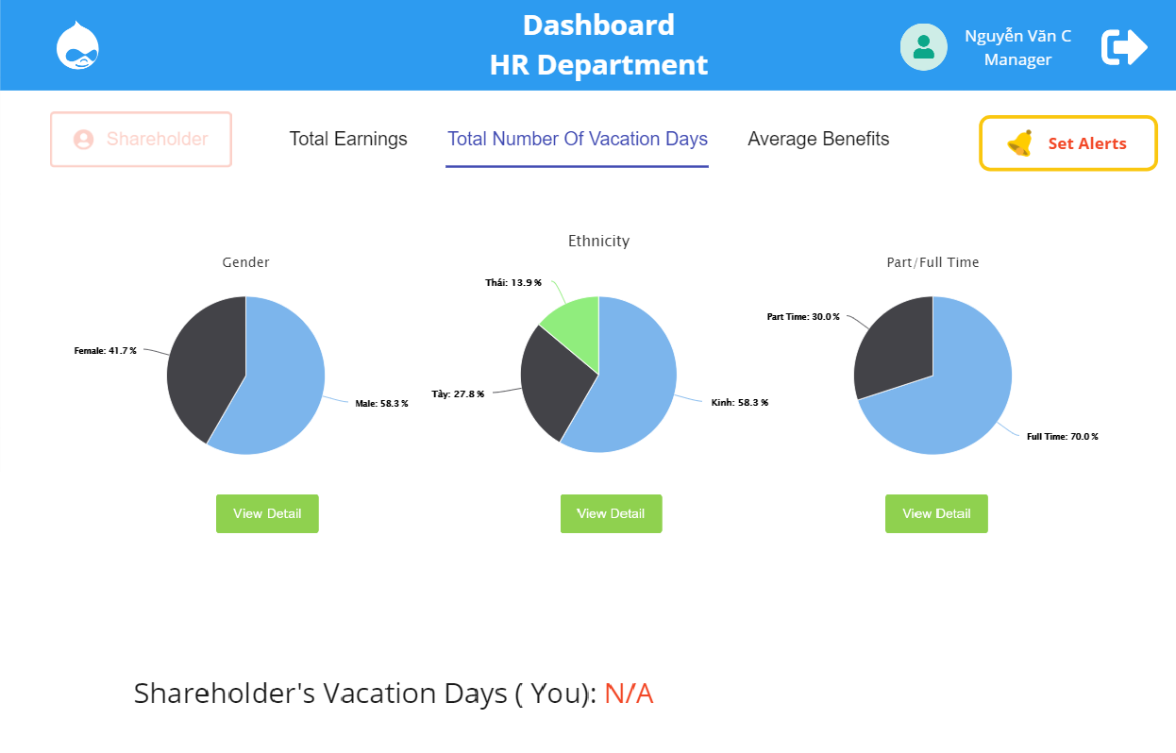2.3.2 Dashboard - Total number vacation days

*Figure 4: Dashboard - Total number vacation days*

**Table 4: Table of screen interface specifications Total number vacation days**

|  |  |  |  |  |
| --- | --- | --- | --- | --- |
| **Show** | Total number vacation days | | | |
| **Description** | The user is on the main dashboard and click to “Total number vacation days”, the system will navigate to the “Total number vacation days”. It will allow user interact with it | | | |
| **Content displayed** | | | | |
| **Item** | **Type** | **Data** | **Description** | |
|  | Button |  | Shown account | |
|  | Button |  | Click to sign out | |
|  | Button(not active) |  | It uses for Manager(Shareholder) | |
| Tab “Total Earning” | TabButton |  | Click to view detail “Total Earning” | |
| Tab “Total Number Of Vacation Days” | TabButton |  | Click to view detail “Total Number Of Vacation Days” | |
| Tab “Average Benefits” | TabButton |  | Click to view detail “Average Benefits” | |
|  | Button |  | Click to set alerts | |
|  | Image |  | Graphs display information in a general way | |
|  | Button |  | Click to view corresponding information for the chart in detail | |
|  | Text |  | It uses for Manager(Shareholder) | |
| **Action** | | | | |
| **Action name** | **Description** | | **Success** | **No success** |
| Click on: | The system will navigate to the account screen | | The account screen will be display | Hang in the current screen interface |
| Click on: | The system will sign out and navigate to the login screen | | The login screen will be display | Hang in the current screen interface |
| Click on tab “Total Number Of Vacation Days” | The system will navigate to the “Total Number Of Vacation Days” screen | | Go to the “Total Number Of Vacation Days” screen | Hang in the current screen interface |
| Click on tab “Average Benefits” | The system will navigate to the “Average Benefits” screen | | Go to the “Average Benefits” screen | Hang in the current screen interface |
| Click on: | The system will navigate to the “Set Alerts” screen | | The form for set alerts will be display | Hang in the current screen interface |
| Click on button “View details” | The system will navigate to the detail screen of tab respectively | | The detail screen of tab respectively will be display | Hang in the current screen interface |

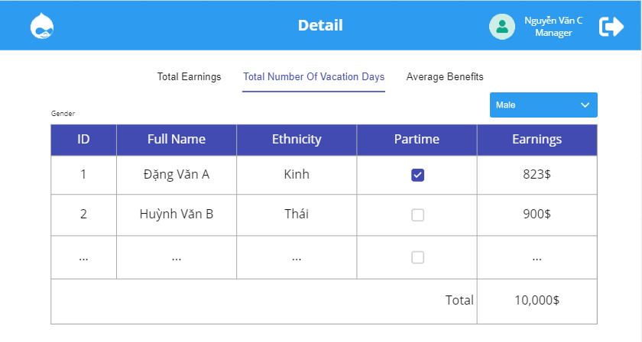**\* Detail of Total number vacation days**

*Figure 5: Detail of Total number vacation days*

**Table 5: Table of screen interface specifications Total number vacation days**

|  |  |
| --- | --- |
| **Show** | **Detail of Total number vacation days** |
| **Description** | After user click to “View detail”. It will display detailed summary information in the form of a table. Its has content displayed and action like **Detail of Total Earning** |

**2.3.3 Dashboard - Average Benefits**

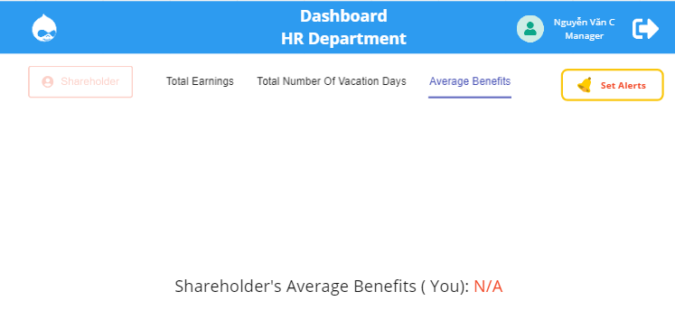

***Figure 6:dashboard - average benefits***

**Table 6: Table of screen interface specifications Avarage Benefits**

|  |  |  |  |
| --- | --- | --- | --- |
| **Show** | **Average Benefits** | | |
| **Description** | After user login successful and click to “Avarage benefits”, the system will navigate to the “Avarage benefits”. It will allow user interact with it. | | |
| **Content displayed** | | | |
| **Item** | **Type** | **Data** | **Description** |
|  | Button |  | Shown account |
|  | Button |  | Click to sign out |
|  | Button(not active) |  | It uses for Manager(Shareholder) |
| Tab “Total Earning” | TabButton |  | Click to view detail “Total Earning” |
| Tab “Total Number Of Vacation Days” | TabButton |  | Click to view detail “Total Number Of Vacation Days” |
| Tab “Average Benefits” | TabButton |  | Click to view detail “Average Benefits” |
|  | Button |  | Click to set alerts |
|  | Text |  | It uses for Manager(Shareholder) |
| **Action: Action in each button be like Dashboard - Total Earnings** | | | |

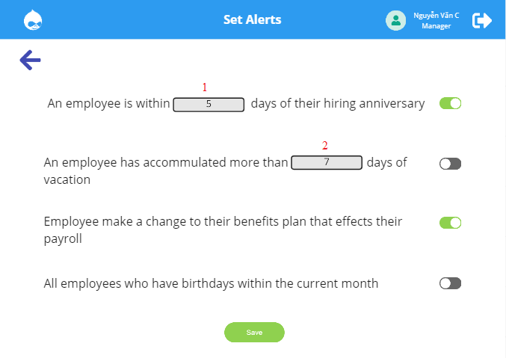**2.3.4 Set Alert**

***Figure 6: Interface of Set Alert***

**Table 6: Table of screen interface specifications Set Alert**

|  |  |  |  |  |
| --- | --- | --- | --- | --- |
| **Show** | **Set Alert** | | | |
| **Description** | After user login successful and click to “Set Alert”, the system will navigate to the “Set Alert” screen. It will allow user interact with it. | | | |
| **Content displayed** | | | | |
| **Item** | **Type** | **Data** | **Description** | |
|  | Button |  | Shown account | |
|  | Button |  | Click to sign out | |
|  | Button |  | Click to back to previous screen | |
|  | Textbox |  | Press and enter number days of their hiring anniversary | |
|  | Textbox |  | Press and enter number days of vacation | |
|  | Button |  | Click to enable or disable alert | |
|  | Button |  | Click to save alerts | |
| **Action** | | | | |
| **Action name** | **Description** | | **Success** | **No success** |
| Click on: | The system will navigate to the account screen | | The account screen will be display | Hang in the current screen interface |
| Click on: | The system will sign out and navigate to the login screen | | The login screen will be display | Hang in the current screen interface |
| Click on: | The system will navigate to the previous screen | | The previous screen will be display | Hang in the current screen interface |
| Click and enter number into | The system will update input from textbox | | The system will display a number which was entered | Hang in the current screen interface |
| Click and enter number into | The system will update input from textbox | | The system will display a number which was entered | Hang in the current screen interface |
| Click on: | The system will enable alert when node move to the right and disable when node move to the left | | The system enable/ disable alert | Hang in the current screen interface |
| Click on: | The system will save action for alert to user | | Alerts will be save and notify to user | Hang in the current screen interface |