IP: 192.168.11.0/24
1) Tạo 2 VLAN: PC và Laptop.
2) Server2 cấp DHCP cho PC3, PC2.
3) Cấu hình WEB_MAIL cho toàn mạng.
4) Service cung cấp dịch FTP, DNS, HTTP.
5) Cấu hình routing để các máy tính ping thấy nhau và sử dụng các dịch vụ mạng mail, web, http, FTP.

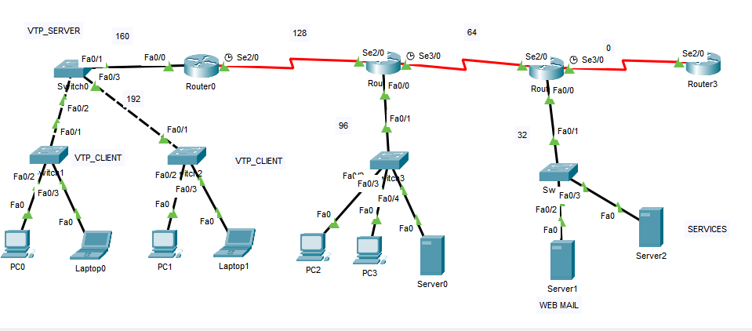

Switch 0:
en
conf t
vtp domain CNTT
vtp mode server

Switch 1,2:
en
conf t
vtp domain CNTT
vtp mode client

interface fa0/2
switchport mode access
switchport access vlan 10
Exit

interface fa0/3
switchport mode access
switchport access vlan 20
Exit

interface fa0/24
switchport mode trunk
end

Router 1:
interface fa0/0.10
encapsulation dot1Q 10
ip address 192.168.11.97 255.255.255.224
Exit

ip dhcp pool VLAN10
network 192.168.11.96 255.255.255.224
default-router 192.168.11.97
dns-server 8.8.8.8

Router 2:
ip dhcp pool VLAN10
network 192.168.11.32 255.255.255.224
default-router 192.168.11.33
dns-server 8.8.8.8

Router 0:
interface fa0/0.10
encapsulation dot1Q 10
ip address 192.168.11.161 255.255.255.224
Exit

interface fa0/0.20
encapsulation dot1Q 20
ip address 192.168.11.193 255.255.255.224
Exit

ip dhcp pool VLAN10
network 192.168.11.161 255.255.255.224
default-router 192.168.11.161
dns-server 8.8.8.8
Exit

ip dhcp pool VLAN20
network 192.168.11.193 255.255.255.224
default-router 192.168.11.193
dns-server 8.8.8.8
Exit

Switch 0:
interface fa0/24
switchport mode trunk
end
Exit

