BEGIN

INPUT C

F = ( C\*9)/5 + 32

DISPLAY F

END

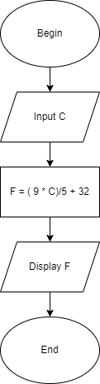

I