*Link github:* https://github.com/NguyenHuynhThaoNhu/MKTG5883.N22_19521970

I. Matplotlib

1. Importing



2. Basic example

3. Basic Matplotlib Commands

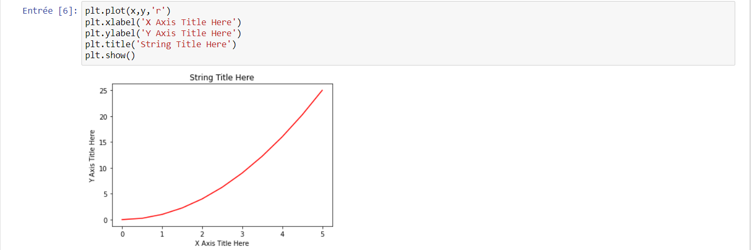

4. Creating Multiplots on Same Canvas

5. Object Oriented Method

6. Suplot()

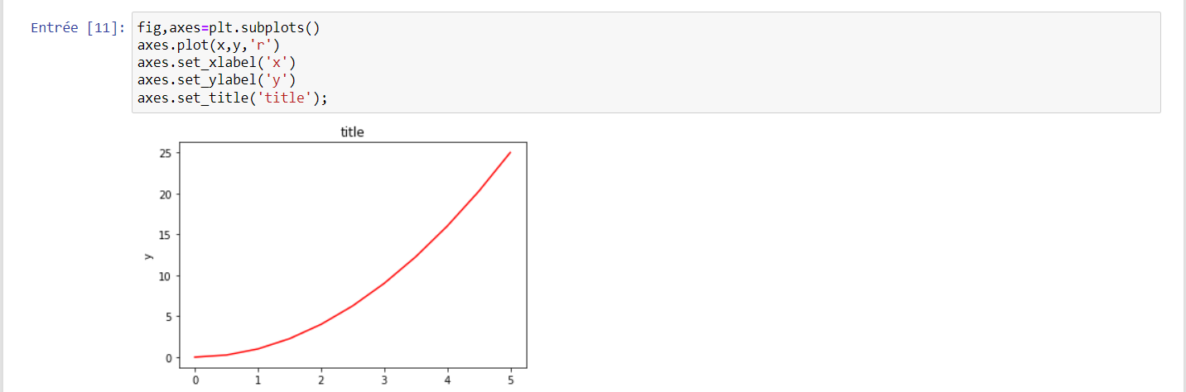

7. Figure size, aspect ratio and DPI

8. Saving figures



9. Figure titles



10. Axis labels



11. Legends

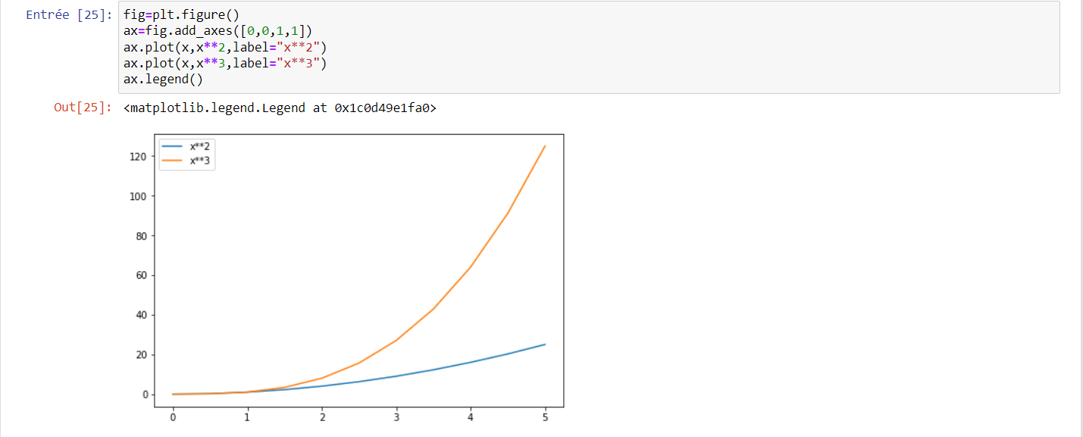

12. Plot range

II. Seaborn

1. Load testing dataset

2. Scatter plot

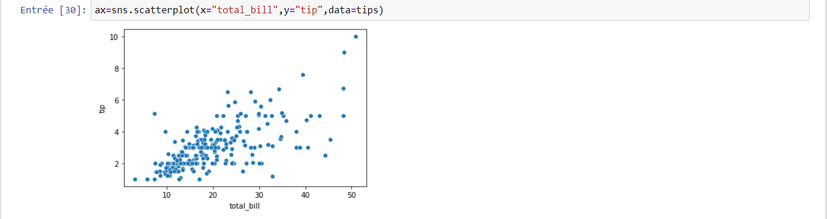

3. Categorical functions

