2.3 Theoretical Background of the AI Model
This section explains the image-classification model used in the project and the numerical representation required to prepare convolution test vectors. The implemented network is a two-convolution, LeNet-inspired classifier trained on MNIST. Its convolution layers also provide the activations, learned weights, and reference outputs needed for later accelerator verification. The theoretical discussion therefore covers both recognition accuracy and the exact data passed to an integer convolution engine.

2.3.1 Overview of Convolutional Neural Networks
A convolutional neural network (CNN) processes an image through local filters whose coefficients are learned from data. Each filter is applied across multiple spatial locations. Local connectivity and weight sharing allow convolutional layers to use fewer trainable parameters than an equivalent fully connected mapping while preserving the spatial structure of the input image. LeCun et al. demonstrated the effectiveness of convolution-based architectures for document and handwritten-character recognition.
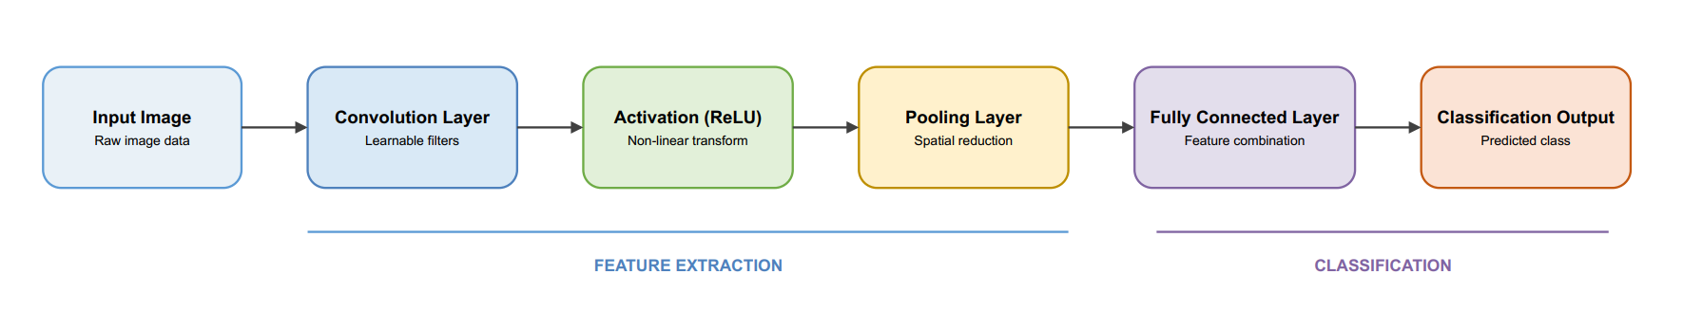
A CNN usually separates feature extraction from classification. Convolution and nonlinear activation produce feature maps; pooling reduces their spatial size; and a classifier converts the resulting representation into class scores.
Figure 2.1. General processing flow of a Convolutional Neural Network, based on the concepts described in LeCun et al.
In the present model, the early convolutional layers learn local features such as strokes, edges, and simple shapes, while the final fully connected layers combine these learned features to distinguish the ten MNIST digits. The model is also useful as a source of realistic convolution workloads, since the trained filters and intermediate tensors can later be exported as accelerator test data.

2.3.2 MNIST Dataset
MNIST is a standard handwritten-digit benchmark published by LeCun, Cortes, and Burges. It contains 60,000 training examples and 10,000 test examples. Each example is a centered, size-normalized grayscale image of 28 × 28 pixels with a label from 0 to 9. After conversion to a PyTorch tensor, each individual sample has shape C × H × W = 1 × 28 × 28, where C = 1 denotes the single grayscale channel. During training, a batch is represented as N × 1 × 28 × 28, where N is the batch size.
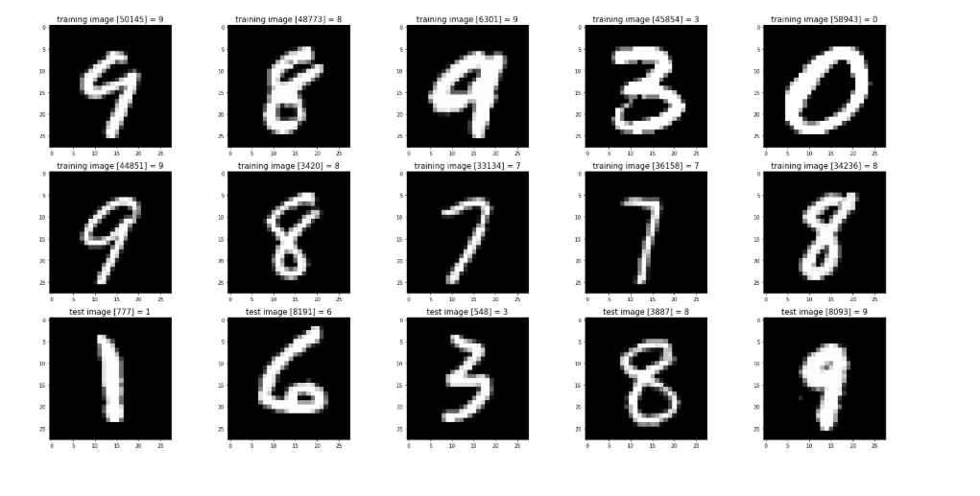
Figure 2.2. Representative handwritten digit samples from the MNIST dataset.
Before training, the MNIST images are converted to floating-point tensors and normalized. Data augmentation is also applied to the training set to introduce small geometric variations such as rotation, translation, and scaling. These transformations expose the model to modest variations in handwriting while preserving the digit label, which can improve robustness and generalization. The same normalization convention must be used when input activations are later exported as accelerator test data.

2.3.3 LeNet Architecture and the Implemented CNN
LeNet-5 is an early convolutional neural network architecture developed for handwritten character recognition. Its architecture progressively extracts spatial features through convolution and subsampling stages before performing classification with fully connected layers. The original architecture processes a 32 × 32 input through successive convolutional and subsampling stages and finally produces ten output classes. The CNN implemented in this project follows the general design principle of LeNet-5 but does not reproduce the original architecture. It accepts 28 × 28 grayscale images and uses two 3 × 3 convolutional layers with 16 and 32 output channels, respectively. Each convolution is followed by a ReLU activation and a 2 × 2 max-pooling operation. The extracted features are then flattened and processed by fully connected layers for classification into ten digit classes.
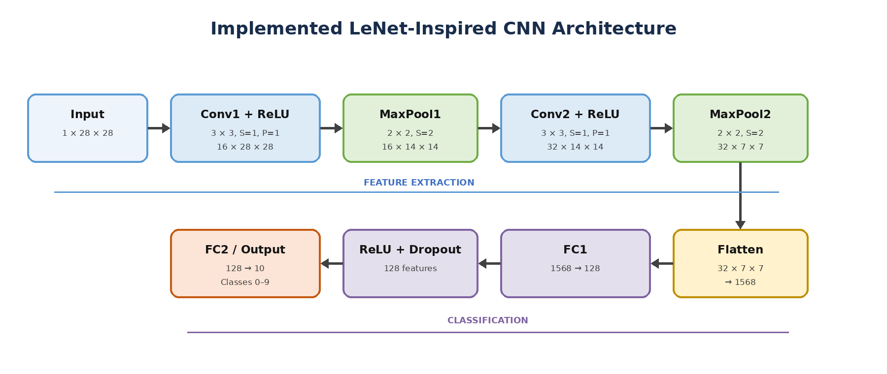
Figure 2.3. Architecture of the implemented LeNet-inspired CNN, based on the project configuration and inspired by LeCun et al.
Stage | Output shape | Trainable parameters
Input | 1 × 28 × 28 | 0
Conv1, 3 × 3, S = 1, P = 1 | 16 × 28 × 28 | 16 × 1 × 3 × 3 = 144
ReLU and 2 × 2 MaxPool | 16 × 14 × 14 | 0
Conv2, 3 × 3, S = 1, P = 1 | 32 × 14 × 14 | 32 × 16 × 3 × 3 = 4,608
ReLU and 2 × 2 MaxPool | 32 × 7 × 7 | 0
Flatten + FC1 | 1568 → 128 | 1568 × 128 + 128 = 200,832
ReLU + Dropout | 128 | 0
FC2 | 128 → 10 logits | 128 × 10 + 10 = 1,290
Total | — | 206,874
Table 2.1. Tensor dimensions and trainable parameters of the implemented model. The convolution layers use no bias.
The two convolutional layers contain 4,752 learned kernel coefficients, whereas the fully connected classifier contains most of the trainable parameters. Nevertheless, the convolutional layers define the arithmetic workload of interest for the planned accelerator. For one image, Conv1 requires 16 × 28 × 28 × 1 × 3 × 3 = 112,896 multiply-accumulate (MAC) operations, and Conv2 requires 32 × 14 × 14 × 16 × 3 × 3 = 903,168 MAC operations. The two convolutional layers therefore require 1,016,064 MAC operations per image, with Conv2 accounting for approximately 88.9% of the convolution workload. These values count every kernel position, including positions that overlap zero padding. They are derived from the layer dimensions and do not represent measured accelerator performance.

2.3.4 Two Dimensional Convolution
For each output channel, a two-dimensional convolution computes a weighted sum over a local region of the input feature map and across all input channels. In most deep-learning libraries, including PyTorch, this operation is implemented as cross-correlation, in which the kernel coefficients are not spatially reversed as in the strict mathematical definition of convolution.
For an input tensor $X$, weight tensor $W$, stride $S$, padding $P$, output channel $o$, and spatial output position $\left(u , v\right)$, the operation can be expressed as
$$Y\left[o , u , v\right]=\sum_{c=0}^{C_{in}-1}{\sum_{i=0}^{K-1}{\sum_{j=0}^{K-1}{W}}}\left[o , c , i , j\right] X\left[c , u , S+i-PvS+j-P\right]$$
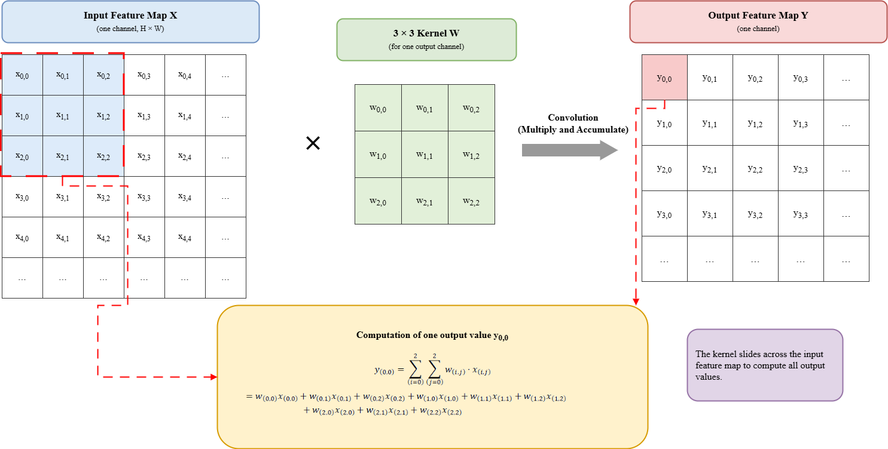
where $C_{in}$ is the number of input channels and $K$is the kernel size. Each output value is therefore obtained by multiplying the corresponding input activations and kernel weights and accumulating all products.
Figure 2.4. Illustration of the two-dimensional convolution operation using a 3 × 3 kernel.
A convolutional layer contains multiple filters. Each filter produces one output feature map, meaning that the number of filters is equal to the number of output channels $C_{out}$. For a layer with $C_{in}$input channels, $C_{out}$output channels, and a $K×K$kernel, the weight tensor has the shape
$$C_{out}×C_{in}×K×K$$
Thus, each output channel has a separate $K×K$kernel for every input channel. The partial convolution results from all input channels are accumulated to form the final output feature map.
The fundamental arithmetic operation in convolution is the multiply-accumulate (MAC) operation. For a single output element, the required number of multiplications is
$$C_{in}×K×K$$
In the implemented CNN, Conv1 has $C_{in}=1$and $K=3$, so each output element requires
$$1×3×3=9$$
products. Conv2 receives 16 input feature maps, so each output element requires
$$16×3×3=144$$
products. Therefore, Conv2 represents a considerably larger convolution workload and is particularly relevant to the computational requirements of the proposed accelerator.

2.3.5 Kernel Size, Stride, and Padding
Kernel size $K$determines the local receptive field of a convolution. Stride $S$specifies the displacement between adjacent kernel positions, while padding $P$adds additional values around the input boundary. For a square input and square kernel with dilation equal to one, the output height can be calculated as follows:
$$H_{out}=\left\lfloor \frac{H_{in}+2P-K}{S}\right\rfloor +1$$
The same expression applies to width. With $H_{in}$ = 28, K = 3, S = 1, and P = 1, Conv1 retains a $28×28$spatial map. The 2 × 2 max-pooling layer then selects the largest value in each non-overlapping window and reduces it to 14 × 14. Conv2 uses the same kernel, stride, and padding, so its convolution output remains 14 × 14 before the second pooling layer reduces it to 7 × 7. This sequence explains the 32 × 7 × 7 = 1,568 inputs to the first fully connected layer.

2.3.6 Processing Layers in the CNN Model
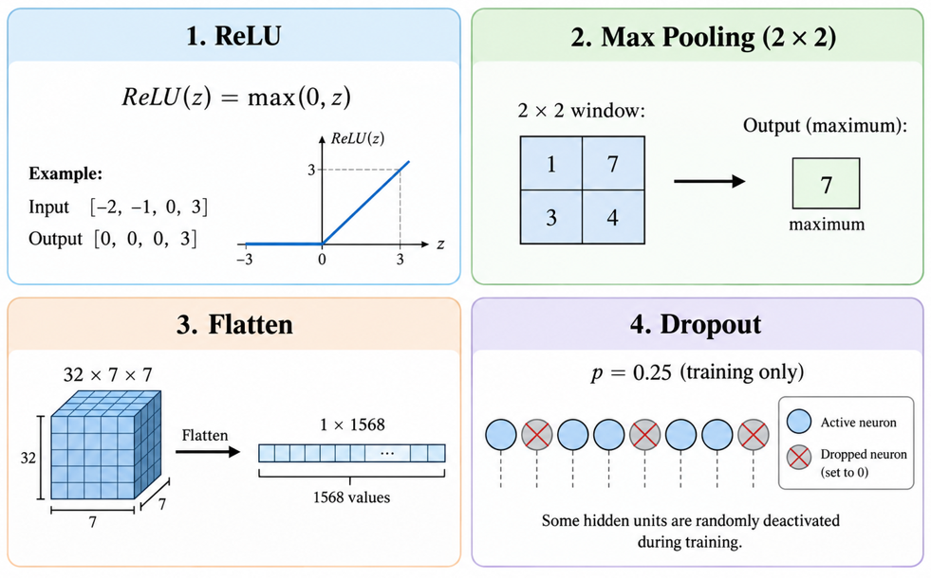
After each convolution, the model applies the Rectified Linear Unit (ReLU), defined as $ReLU\left(z\right)=max⁡\left(0 , z\right)$, which suppresses negative values while preserving positive responses. ReLU is a simple nonlinear activation function widely used in convolutional neural networks. A $2×2$ max-pooling operation is then applied to retain the strongest response within each local region while reducing the spatial dimensions of the feature maps. Across the two pooling stages, the spatial dimensions are reduced from $28×28$ to $14×14$ and finally to 7×7.
Figure 2.5. Illustration of the main processing operations used in the implemented CNN model.
The output of the second pooling layer has the shape $32×7×7$and is flattened into a vector of 1,568 values. A fully connected layer then maps this vector to 128 hidden features, followed by ReLU and dropout with a probability of 0.25 during training. Dropout randomly deactivates a subset of hidden units during training to reduce overfitting and is disabled during evaluation. The final fully connected layer maps the 128 hidden features to ten unnormalized class scores, referred to as logits. The predicted digit is obtained by selecting the class with the largest logit. A softmax layer is not required inside the model because the loss function directly accepts unnormalized logits.

2.3.7 CNN Training Process
Training adjusts the model parameters to minimize the classification error on labeled images. During the forward pass, the input images are propagated through the network to produce ten class logits. The predicted outputs are then compared with the corresponding ground-truth labels using a loss function. During backpropagation, gradients of the loss with respect to the trainable parameters are computed, and an optimization algorithm uses these gradients to update the model weights.
For a batch of $N$samples and $C$classes, the mean cross-entropy loss can be expressed as:
$$L=-\frac{1}{N}\sum_{n}{\log\left(\frac{\exp\left(z\left[n,y_{n}\right]\right)}{\sum_{c}{\exp\left(z\left[n,c\right]\right)}}\right)}$$
where $z_{n,c}$denotes the logit for class $c$of sample $n$, and $y_{n}$is the corresponding ground-truth class label. Cross-entropy loss directly operates on the unnormalized logits produced by the final fully connected layer.
After the gradients are obtained through backpropagation, an optimizer updates the model parameters in the direction that reduces the loss. In this project, AdamW is used as the optimization algorithm. AdamW separates weight decay from the adaptive gradient update, providing explicit regularization during training. The training procedure is repeated over multiple batches and epochs until the model converges.

2.3.8 Model Evaluation
Classification accuracy is commonly used to evaluate the performance of an image-classification model. It represents the percentage of input samples for which the predicted class matches the corresponding ground-truth label. For a dataset containing $N$samples, the accuracy can be expressed as:
$$Accuracy=\frac{N_{correct}}{N}×100\%$$
where $N_{correct}$denotes the number of correctly classified samples and $N$is the total number of evaluated samples.
In this project, model evaluation is performed for both the original Float32 model and the simulated INT8 quantized model. The Float32 model represents the reference classification performance before quantization, while the simulated INT8 model is used to estimate the effect of reduced numerical precision on the prediction results. Comparing the two accuracy values provides a direct indication of how quantization influences the classification behavior of the model
The difference between the Float32 and simulated INT8 accuracies can be used to quantify the change in classification performance introduced by quantization. A small difference indicates that the reduced-precision representation preserves most of the original model performance, which is desirable for later hardware implementation. In addition to overall accuracy, a confusion matrix can be used to examine classification performance for individual digit classes by comparing the ground-truth labels with the predicted classes. This allows frequently confused digit pairs to be identified and provides a more detailed view of model behavior than overall accuracy alone.

2.3.9 Quantization from Float32 to INT8
Float32 values are convenient for gradient-based training but expensive to store and move in a small integer datapath. Quantization represents an approximate real value with an integer q, a positive scale s, and a zero point z. The project uses signed, symmetric, per-tensor INT8 quantization for the exported convolution operands. Its zero point is zero, and the scale is based on the largest absolute value in each tensor:
$$s=\frac{\max\left(\left|X\right|\right)}{127}; q=clip\left(round\left(\frac{X}{s}\right),-127,127\right)$$
The approximation in real units is X̂ = s q. The scale formula assumes that the tensor contains at least one nonzero value; an all-zero tensor requires an explicitly defined positive fallback scale. The range −127 to 127 is intentional: it is symmetric around zero and leaves −128 unused. Conv1 and Conv2 each store separate scales for their activation and weight tensors. The weight scale is derived from learned convolution weights; the activation scale is derived from the selected test image activation. For a production inference pipeline, activation scales should instead be calibrated from a representative dataset and fixed before deployment, because determining a new scale from each unseen image requires additional work and changes the hardware interface.
Each product of operands in the stated −127 to 127 range fits in a signed 16-bit value. A Conv2 output sums 144 such products, so even its worst-case magnitude, 144 × 127² = 2,322,576, fits in signed INT32. The real-valued convolution can be approximated by multiplying the INT32 sum by sA × sW, where sA and sW are activation and weight scales. More general integer-only inference also requires a defined requantization rule, scale propagation between layers, and treatment of bias and pooling [6]. The project exports the convolution-level INT8 operands and INT32 reference sums; it does not yet define a complete bit-exact INT8 inference path for every network layer.

2.3.10 Python Golden Reference Model and Test Data
The Python golden model computes convolution directly from the exported INT8 activation and weight arrays. Every multiplication and accumulation is performed as an integer operation, and each output element is stored as signed INT32. For the current model the convolution layers have no bias, so the golden sum corresponds directly to the MAC datapath. ReLU is then applied as $max(0, G)$to create a second reference output. The separate pre-ReLU and post-ReLU arrays allow future hardware tests to isolate errors in convolution from errors in activation control.
$$G\left[o,u,v\right]=\sum_{c}{\sum_{i}{\sum_{j}{qW\left[o,c,i,j\right]}}}·qA\left[c,uS+i-P,vS+j-P\right]$$
For Conv1 the input activation has shape 1 × 28 × 28, the weight array has shape 16 × 1 × 3 × 3, and the golden convolution has shape 16 × 28 × 28. For Conv2 the input is the floating-point Conv1 activation after ReLU and pooling, quantized separately to INT8; the weight array has shape 32 × 16 × 3 × 3, and the golden output has shape 32 × 14 × 14. The Conv2 vector is therefore a layer-level test case, not a claim that the complete two-layer integer pipeline is already bit-exact.
Layer | INT8 input values | INT8 weights | INT32 output values
Conv1 | 1 × 28 × 28 = 784 | 16 × 1 × 3 × 3 = 144 | 16 × 28 × 28 = 12,544
Conv2 | 16 × 14 × 14 = 3,136 | 32 × 16 × 3 × 3 = 4,608 | 32 × 14 × 14 = 6,272
Table 2.2. Test-vector element counts derived from the implemented convolution shapes.
The artifact set for this stage contains a trained-model checkpoint, measured accuracy values, per-layer configuration files, quantization parameters, Float32 and INT8 activations and weights, INT32 convolution outputs, INT32 ReLU outputs, and compressed test-vector bundles. The golden result is checked against a separate PyTorch convolution on the quantized operands. An RTL testbench can later compare its output element-by-element against these arrays. Such a comparison is future work; the present AI-model stage prepares the expected data and does not demonstrate RTL correctness.

