HANOI UNIVERSITY OF SCIENCE AND TECHNOLOGY
School of Electrical and Electronic Engineering


Project report
Course: Electronics design
Topic: Rain detector circuit

Lecturer: Nguyễn Cảnh Quang
Group: 14
Group’s members:
- Nguyễn Khánh Duy 20222772
- Hoàng Đại Lộc 20222784
- Lê Quang Huy 20232411

December 2024

Table of Contents
Chapter 1: Overview of the topic 3
Chapter 2: Design Specifications And Block Diagram Of The Audio Amplifier 4
Chapter 3: Circuit Design 6
1. Power Supply Block. 6
2. Amplifier block. 6
How the Amplifier Block Works 6
Voltage Across C1 7
Current Through C1 8
Gain of the First Stage (Q1) 9
Gain of the Second Stage (Q2) 9
3. Comparator block. 11
Voltage Across C4 12
Current Through C4 12
Example Calculation 13
4. Output driver block. 14
Chapter 4: Simulation On Proteus Sortware And Real-Life Implementation 15
Chapter 5: Conclusion 18
APPENDIX 19

Chapter 1: Overview of the topic

A rain alarm circuit is an electronic system designed to detect the presence of rain and alert users with a sound or visual signal. It is useful for various applications such as in agricultural fields, to protect outdoor equipment, or in automatic systems where people want to know if it is raining. Below is an overview of how the rain alarm circuit works, its components, and basic functionality.
1.Objective of the topic:
- Detect rain through the light or sound signal.
- Master the knowledge learned in class.
2.Project Analysis:
2.1. System Requirements:
- The circuit should detect the water effectively.
- The design should meet specified requirements.
- Easy maintenance should be possible.
2.2. Non-functional Requirements:
- Applicable to various circuits.
- Simple, easy to build, and use.
- Ensure good quality and stability.

Chapter 2: Design Specifications And Block Diagram Of The Audio Amplifier

1.Component Specifications and Pre-calculation Requirements:
- Power supply: 12V DC

2. Block Diagram of the circuit.
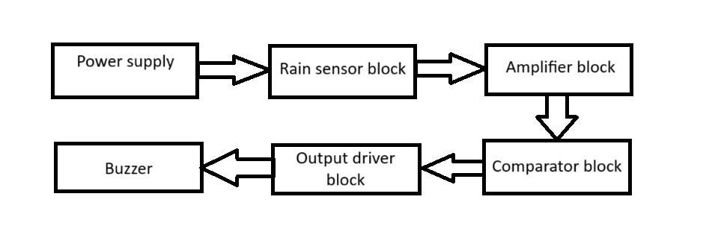
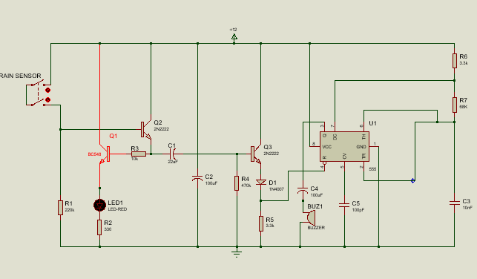

2.Component Selection after Calculation:
No. | Name | Quantity
1 | Rain sensor | 1
2 | 555 Timer IC | 1
3 | BC548 NPN Transistor | 1
4 | 1N4007 PN Junction Diode | 1
5 | 220kΩ Resistor | 1
6 | 330Ω Resistor | 1
7 | 10kΩ Resistor | 1
8 | 470 kΩ Resistor | 1
9 | 3.3kΩ Resistor | 2
10 | 2N2222 NPN Transistor | 2
11 | Bright Red LED | 1
12 | 68kΩ Resistor | 1
13 | 22μF Capacitor | 1
14 | 100μF Capacitor | 2
15 | 10nF Ceramic Capacitor | 1
16 | 100pF Ceramic Capacitor | 1
17 | Buzzer | 1
18 | Connection wires | n
19 | Breadboard | 1
20 | 12V Power Supply | 1

Chapter 3: Circuit Design

Power Supply Block.
• Provides voltage to the entire system.
• Uses 12Vdc through a voltage regulator from 220 VAC to 12Vdc.

Amplifier block.

How the Amplifier Block Works
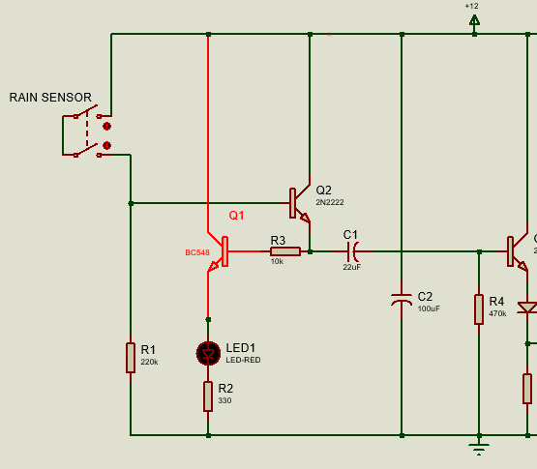
- Rain Detection:
  - When rain falls on the sensor, it closes the circuit between terminals A and B, allowing a small current to flow.
  - This current is very weak and cannot directly drive the subsequent circuit stages.

- First Stage Amplification (Q1):
  - The small current from the rain sensor biases Q1 (BC548), turning it on.
  - Q1 amplifies the signal and sends it to the base of Q2.

- Second Stage Amplification (Q2):
  - Q2 (2N2222) further amplifies the signal received from Q1.
  - This ensures that the signal is strong enough to trigger the comparator stage.
- Signal Coupling (C1):
  - The amplified signal from Q2 is sent to capacitor C1, which passes the AC signal to the comparator while blocking any DC component.

- Visual Indication (LED1):
  - If rain is detected and the circuit is active, LED1 lights up to indicate that the amplifier block is functioning.

Voltage Across C1
- The signal reaching C1 comes from the collector of Q2 (2N2222), which acts as the second-stage amplifier. The voltage across C1 will depend on the amplified output signal of Q2.
  - Assume the voltage swing at the collector of Q2 is approximately equal to the supply voltage (12V), minus the voltage drop across R4 and the saturation voltage of Q2 (approximately 0.2V).
$${VC}_{1max}≈VCC-\left(IC∙R4\right)-{VCE}_{sat}$$
Where:
- VCC​=12V
- IC​ is the collector current of Q2.
- R4 = 470kΩ.
The maximum voltage swing across C1 will typically range from 0V to near VCC​, depending on the circuit's operation.

Current Through C1
The current through the capacitor depends on the AC signal passing through it, as capacitors block DC currents. For AC signals, the current is calculated using the formula:
Ic​=C1⋅$\frac{dV}{dt}$

Where:
- C1=22 μF
- $\frac{dV}{dt}$​ is the rate of change of voltage across the capacitor.

Assumptions:
- If the AC signal has a frequency f (in Hz) and a peak-to-peak voltage Vpp:
  - Vpp ≈ VCC− (I_{C}⋅R4).
  - The maximum rate of voltage change dV/dt​ is proportional to the signal frequency and amplitude.

Example:
- Assume a square wave signal of f=1kHz and V_{pp}≈10V:
- The rate of change of voltage:
$\frac{dV}{dt}$≈ $\frac{Vpp }{T}$​​= $10∙1000$= 10,000V/s.
- The current through the capacitor:
I_{C}​=22$×$10⁻⁶ ⋅10,000=0.22A.

Gain of the First Stage (Q1)
The gain of a common-emitter amplifier is given by:
Av1= $- \frac{Rc}{Re}$
Where:
- R_{C} is the load resistor in the collector (here, R3 = 10kΩ).
- R_{E} is the effective resistance at the emitter.
In this circuit:
- RE​ is determined by R2 and the input resistance of Q2 (as Q2 loads Q1).
For simplicity, we approximate R_{E}​ ≈ R2 = 330Ω.
Av1$=\frac{​-R3}{R2}$​ = $\frac{​-10000}{330}$​≈ −30.3

Gain of the Second Stage (Q2)
The gain of the second stage is also a common-emitter amplifier:
Av2​ = $\frac{​-Rc}{Re}$
Where:
- R_{C} is the load resistor in the collector of Q2 (R4 = 470kΩ).
- R_{E}​ is the effective resistance at the emitter.
In this circuit:
- R_{E}​ is small due to the capacitor C2 bypassing it. This results in a very high gain for this stage.
We approximate the gain as:
Av2 $=\frac{​-R4}{Re}$
Where r_{e} is the intrinsic emitter resistance, given by:
r_{e}= ​$\frac{​26mV}{I_{E}}$
Assume I_{E} ​= 2mA (from typical transistor bias currents):
r_{e} = 13 Ω
Av2 ​≈ −36.2k
Overall Gain
The overall gain of the amplifier is the product of the gains of the two stages:
Av=Av1⋅Av2 ≈1096.9k

Comparator block.
Input to the Comparator Block
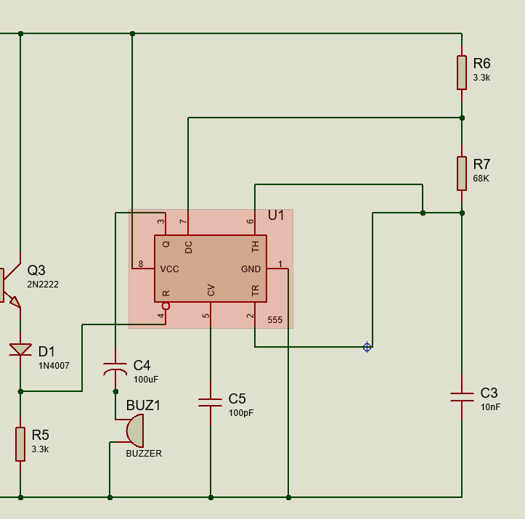
- The input to the comparator block is the voltage across the collector of Q3 (output of the amplifier block).
- When rainwater triggers the rain sensor, the amplifier block processes this signal and increases the voltage at Q3’s collector.

Internal Operation of the 555 Timer
The 555 timer has two internal comparators, which operate as follows:
- Threshold Comparator: Compares the voltage at the THRESHOLD (pin 6) to 2/3​VCC​.
- Trigger Comparator: Compares the voltage at the TRIGGER (pin 2) to 1/3​VCC.
When No Rain is Detected:
- The amplifier block output remains low.
- The voltage at pin 2 (TRIGGER) is higher than 1/3VCC, so the 555 timer output (pin 3) remains LOW.
When Rain is Detected:
- The rain sensor generates a signal that the amplifier boosts. The voltage at Q3’s collector increases.
- This signal drives pin 2 (TRIGGER) below 1/3VCC, triggering the 555 timer.
- The output at pin 3 goes HIGH for a duration determined by the RC timing network (R7 and C5).

Output of the Comparator Block
- The output of the 555 timer (pin 3) controls the buzzer.
- When rain is detected, the 555 timer output goes HIGH, activating the buzzer for the preset duration.

Key Functions of the Comparator Block
- Threshold and Trigger Detection: The 555 timer compares input signals with predefined thresholds 1/3VCC​ and 2/3VCC.
- Monostable Operation: Ensures the buzzer is activated for a specific duration, even if the rain sensor signal is transient.
- Signal Isolation: Ensures that the rain sensor and amplifier signals are processed without directly affecting the output buzzer.

Voltage Across C4
The voltage across C4​ is essentially the same as the supply voltage minus any voltage drop across the buzzer. Assuming minimal losses, the voltage across C4​ is approximately:
V_{C4}​​ ≈ VCC ​= 12V.

Current Through C4
The current through C4​ can be calculated using the capacitor current formula:
I_{C4}=C4​⋅$\frac{dV​}{dt}$.
where:
- C4​=100μF
- $\frac{dV​}{dt}$ is the rate of change of voltage across C4​.

Charging Current
When the 555 timer output goes HIGH,C4​ starts charging. The initial current through C4​ can be approximated using:
I_{C4} =$\frac{VCC​}{Req}$.​
where Req​ is the equivalent resistance of the buzzer and other circuit elements in series. If Req​ is not explicitly given, it must be estimated based on the buzzer impedance (Zb​) and any series resistances.

Example Calculation
Assume Req​ ≈ 100Ω:
I_{C4}​​= 12/100= 0.12A (=120mA).
The charging current will decay exponentially as C4​ charges, following the RC time constant:
I_{C4}​​(t)=I0​⋅e^{−t/τ},
Where τ=Req​⋅C4​ is the time constant.

Time Constant (τ):
Τ = Req​⋅C4 ​= 100Ω⋅100×10⁻⁶F = 0.01s.

- Output driver block.
How it works:
- The rain sensor detects water, triggering the amplifier and comparator blocks.
- The comparator outputs a HIGH signal to the base of Q3, turning it ON.
- When Q3 turns ON, current flows from the power supply through the buzzer to ground.
- The buzzer produces an audible alarm.
- If the rain sensor no longer detects water, the timer output goes LOW, turning Q3 OFF and deactivating the buzzer.

Component of the block:
- Q3 (2N2222): Acts as a current switch for the buzzer.
- D1 (1N4007): Prevents reverse voltage damage from the buzzer.
- C4 (100 µF): Stabilizes voltage across the buzzer to ensure proper operation.

Chapter 4: Simulation On Proteus Sortware And Real-Life Implementation

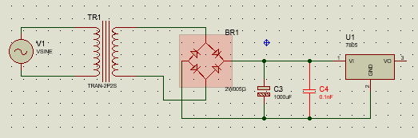

Run on simulation:
(Channel A is connected to the Buzzer and Channer B is connected to the Bright Red LED)
- When the sensor is not activate:
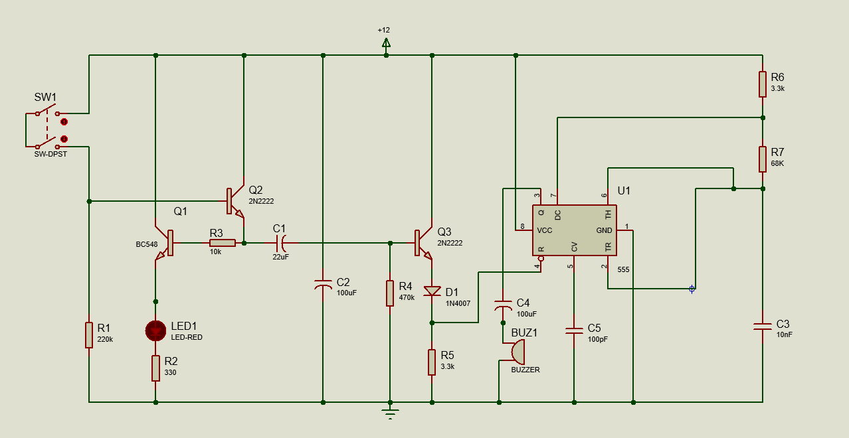

- When the sensor is activated:
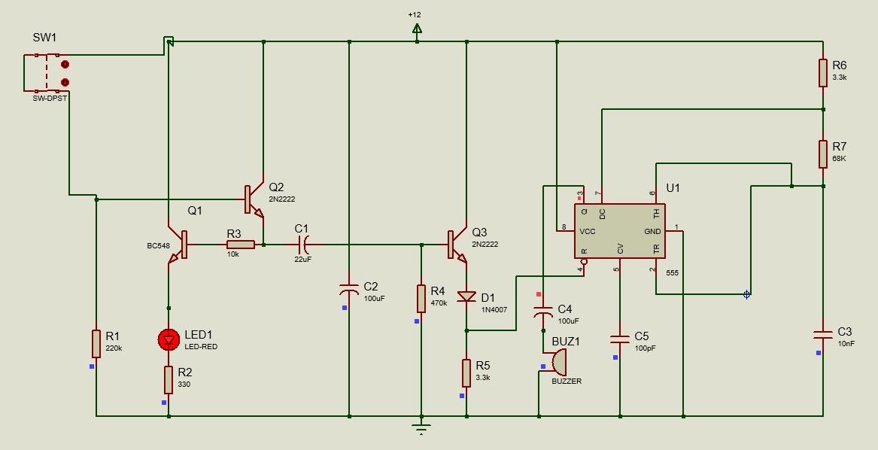
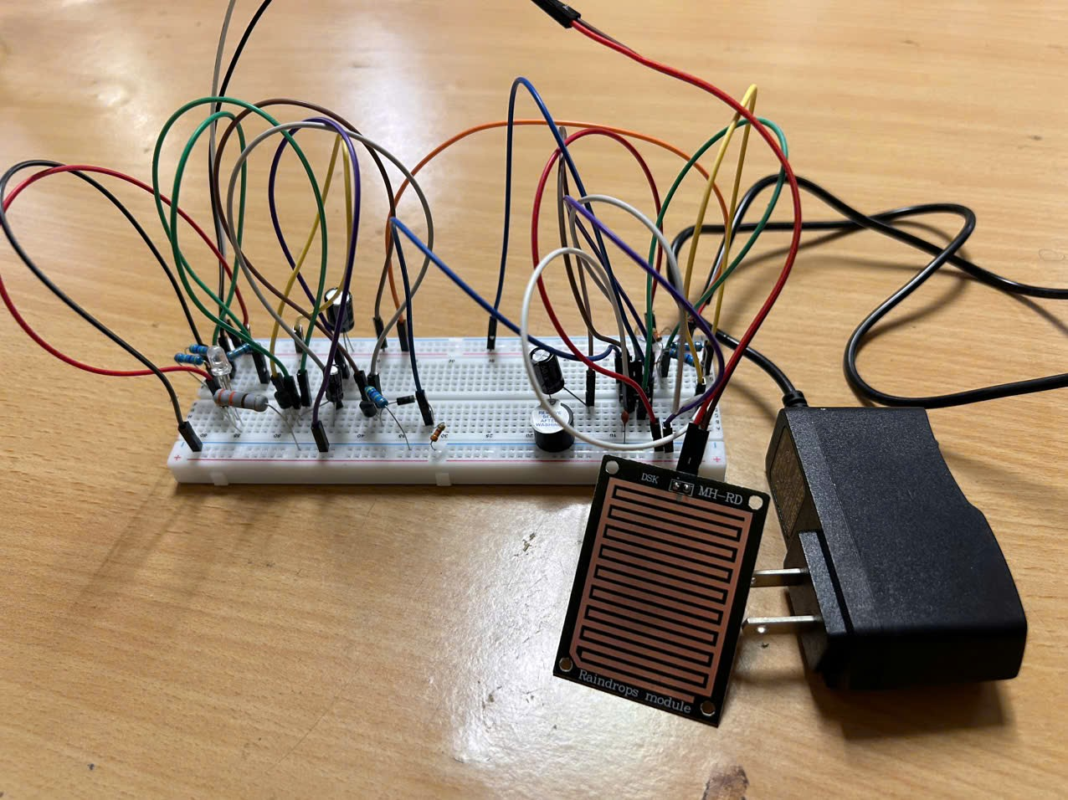
- Real-life circuit board:

Chapter 5: Conclusion
- Conclusion:
The rain alarm is such an effective circuit, it can be applied in many farms or gardens:
In the irrigation, it will detect the rain and immediately alert the farmer.
In automobiles, when the rain detector detects the rain, it will immediately active the wipers and inform the driver.
In communications, it will boost the power of the antenna and increase the signal strength to send or receive the signals.
In normal household, with the help of rainwater detector we can automatically save the rainwater. (This can be done only when home automation is done and there is proper equipment to save the rainwater. In this, rainwater detector will detect the rain and helps to switch ON the equipment which will automatically save rainwater for different purposes).
This can also be used if there is a chemical rain also. This is very common in industrial areas.

- Recommendation:
Rain senor should be kept in the open place at 30 to 40 degrees from the ground. As a result, rainwater will not be present on the sensor for long time.

APPENDIX

  - Rain Alarm Project – ElectronicsHub.
  - Electronics Design lecture notes – Lecturer Nguyen Canh Quang.
  - Foundations of Analog and Digital Electronic Circuits - Anant garwal & Morgan Kaufmann.
  - Proteus 8.17

