**VIETNAM GENERAL CONFEDERATION OF LABOUR**

**TON DUC THANG UNIVERSITY**

**INFORMATION TECHNOLOGY FALCULTY**



**FINAL REPORT**

**PROBABILITY AND STATISTIC**

**FINAL PROJECT REPORT**

**SOFTWARE ENGINEERING**

**CHECK THE GOOD**

*Instructor*: **Pham Thai Ky Trung**

*Author*: **Nguyen Dinh Minh Khoi – 519K0013**

Class**: 19K50201**

**HO CHI MINH CITY 2021**

APPRECIATION

To Mr. Trung with all gratefulness, thanks for the lessons, the instruction and everything about the Probability and Statistic. It is just like new knowledge about advanced math. Therefore, I was able to finish this final report. You not only inspired me to keep learning but you also taught me all of the most important and useful knowledge. I am really appreciating your effort, because of having you as a lecturer, I learned so many things which I don’t sure that I can learn from anywhere else.

THE REPORT WAS COMPLETED AT TON DUC THANG UNIVERSITY

We assure that this project was completed by ourselves with the instruction of Mr. Pham Thai Ky Trung. Research contents and results in this topic are honest and had not ever been published in any form.

In addition, the project also uses a number of comments, evaluations as well as data of other authors, other organizations and organizations with citations and origin notes.

If any fraud is detected, we will take full responsibility for the content of our project. Ton Duc Thang University is not related to any copyright or copyright infringement caused by us during the implementation process (if any).

Ho Chi Minh city, date…month…year…

Author

(sign with full name)

Nguyen Dinh Minh Khoi

LECTURER AND EXAMINER SCORING SECTION

**Comment and scoring for instructor**

_______________________________________________________________________________________________________________________________________________________________________________________________________________________________________________________________________________________________________________________________________________________________________________________________________________

Ho Chi Minh city, date…month…year

(sign with full name)

**Comment and scoring for examiner**

_______________________________________________________________________________________________________________________________________________________________________________________________________________________________________________________________________________________________________________________________________________________________________________________________________________

Ho Chi Minh city, date…month…year

(sign with full name)

**OVERVIEW**

Check the good is a small example of a software engineer project that we might see it in future in a company. This project will contain all you need in a project from planning to testing and demo.

1. INTRODUCTION 9

1.1 Purpose and Scope: 9

1.1.1 Purpose: 9

1.1.2 Scope: 9

1.2 Product overview: 10

1.3 Structure of Document: 10

2. PROJECT PLAN MANAGEMENT 11

2.1 Project Organization 11

2.2 Lifecycle Model Used 11

2.3 Risk analysis: 12

2.4 Hardware and Software resource requirement. 12

2.4.1 Hardware minimum requirement: 12

2.4.2 Software requirement: 13

2.5 Deliverables and schedule 13

2.6 Professional standards 13

3. Requirement Specification 14

3.1 Stakeholders for system 14

3.2 Use case diagram: 16

3.2.1 Graphic use case diagram: 16

3.2.2 Textual description for each use case 16

3.3 Functional and non functional requirements. 17

4. Architecture design 18

4.1 Architecture style: 18

4.2 Architecture model: 19

4.3 Technology, software, and hardware used 20

5. Design 20

5.1 Database design 20

5.2 Class diagram 21

5.3 Sequence diagram for usecase. 23

5.3.1 Login usecase 23

5.3.2 Manage Good usecase 24

5.3.3 Import Good 24

6 Git hub link: 25

# 1. INTRODUCTION

## 1.1 Purpose and Scope:

### 1.1.1 Purpose:

The goal of this project is to provide an application for accountant of company use it to manage the goods, and also an MVC web application for making payment. The application can show receipt when shop owner or accountant order (or import) goods from producers, also they can also update status of order as being transferred and update the payment of agents. We also aim to make an online payment method for agents by deploying a website. Project is planned to be done before December 26th 2021 with all basics and then keep continue developing through out the year.

### 1.1.2 Scope:

|  |  |
| --- | --- |
| Product scope Description | Check the good will develop and implement application with functionality to help the user can manage the goods better from importing to transferring (shipping) to online transaction for goods. Further, we also analyze and design goods for accountants by checking the review or the number of goods being import and sell in order to help accountants have a brief view of what should focus on. |
| Project Deliverables | * Create useful function like view receipt, create note, view stock and revenue for accountant that use check the good application * Make a website for online payment between accountants and agents. * Intake the data of users and then recommend goods for users base on their often order * Develop the review by gathering data of goods that being used most in each region and give it to accountants in order to push their sale. |
| Project Acceptance Criteria | * Successful implement all function in check the good app * Successful implement review table for accountant to see what most sale from * Successful deploy a website for agent to make online transaction to accountants. |
| Project Exclusion | Since check good app is a useful app for accountants to manage goods. And website for online payment reduce a lot of user’s effort spending. Some work will be occurring:   * 5% cost reduction for 1 month with user use app 5 years * Open community for all accountants and agents check information |
| Project Constraint | * Check good app should help accountants easier work their job without reduce labor. * Online payment need to be inside country and also globally * Check good app should be done by the end of December 2021 with review and necessary notification in 2021 * The budget must be done with no fee except huge amount of time * All resource must be done from scratch but the idea can be come up when using internet or friend and family daily work. * Personal limitations: time and knowledge is essential |

Table 1.1.2: project scope

## 1.2 Product overview:

Check the good is targeting to accountants most to help accountants able to manage their good easily, it also has a connection to the warehouse employees and create communication between accountants and warehouse employees without saying anything, all the data accountants do in the app is the thing they want to say to those employees.

Check the good is an application make as window form application, it first has login account for each accountants, function print receipt so that accountants can print receipt when they import goods, function update order for accountants to update order when they shipping good to agents. function view stock to see the stock and revenue report.

Every accountant should use the product as soon as possible because it reduces a lot of effort, and every accountant can use this app everywhere, they just need to download it and connect to internet.

This app has so many reward for long use accountants, if they use the app about years, they get many discounts.

## 1.3 Structure of Document:

Document is structured as first main part which is most important is written as big number bold letter and all is capitalized, then the is sub important which is the important part in the main part also big and bold letter but the size is smaller than the main part and is not in capitalized, then there will be sub part if the sub important content is a long topic, sub part will have number and letter same size with sub important but no bold. The last, there will be content with normal size, no bold and italic at all but some important information. The number is in the order and the sub important and sub part number will start again from 1, for example (1. Intro, 2. Plan , 2.1 model, 2.2 note,…).

The document is also have some table for easily read, and table of content at the beginning so that if a person just one to read a part only, they can skip to that part by looking at the part and the page number next to it.

# 2. PROJECT PLAN MANAGEMENT

## 2.1 Project Organization

This project team was done by 1 person company so every member is this person name. This picture below was made with help of tools in miro.com.

|  |  |
| --- | --- |
| Role | Employee Name |
| Project Manager | Nguyen Dinh Minh Khoi |
| Engineer Manager | Nguyen Dinh Minh Khoi |
| Project Document Writter | Nguyen Dinh Minh Khoi |
| Project Analysis & planning | Nguyen Dinh Minh Khoi |
| Design and implement | Nguyen Dinh Minh Khoi |
| Tester | Nguyen Dinh Minh Khoi |
| Demo & advertise | Nguyen Dinh Minh Khoi |

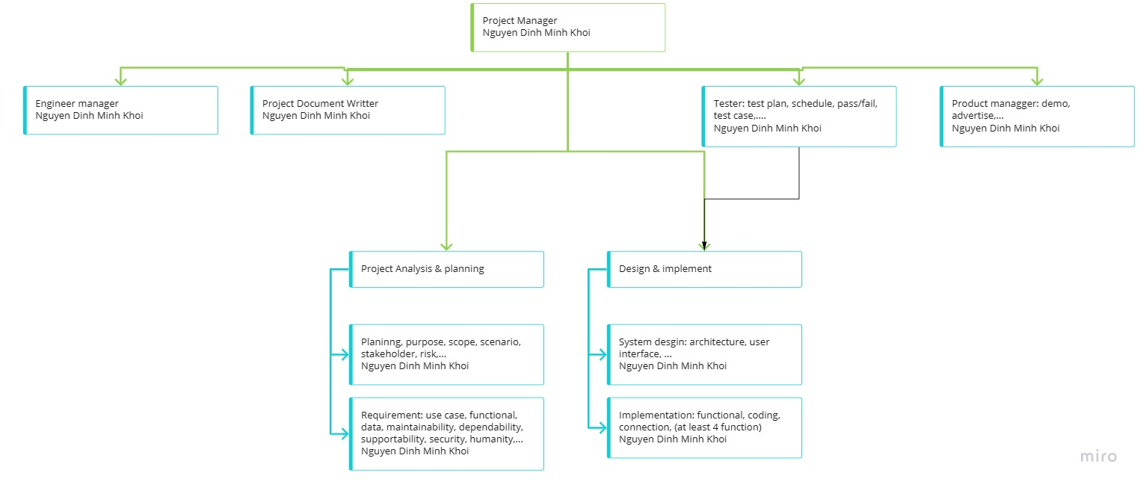

**Pic2.1: Project organization chart**

## 2.2 Lifecycle Model Used

The project follows to a specific software development lifecycle that is waterfall SDLC model. The project follows a sequential step-by-step process from planning -> analysis requirement ->…-> maintenance. Every section of the project is done carefully and also have well-defined for later step to use.

Using waterfall model for this project is to help team member easily understand and also can use effectively. Since this project was done by Nguyen Dinh Minh Khoi – university student so it is perfect because it suitable for inexperience member. Milestone can be easily understood and also the whole project is very easy to manage and control from planning to maintenance.

The reason why this project is using waterfall model but not other SLDC model:

- requirement are well known and will not change.

- product is stable and technology is understood.

- waterfall work best for small project like Check the good.

- I want to focus on quality rather than cost or schedule.  
Below is the picture of waterfall model that is being used in this project.

**Picture2.2: waterfall software development life cycle**

## 2.3 Risk analysis:

This project was done by only 1 person so there are many risks in this project.

|  |  |
| --- | --- |
| **Quantity risk** | **Quality risk** |
| Less function | Function is not effective (maybe require user action than automatic). |
| Less detailed document | Document is not effective for reader |
| More time needed to finish project | App design and Web design may have bad look |

Table2.3: risk analysis table

## 2.4 Hardware and Software resource requirement.

### 2.4.1 Hardware minimum requirement:

- Operation system:

+ computer: window 10/ MacOs

+ mobile: IOS/Android

- CPU: Pentium processor at 90 MHz or higher

- Memory: 2GB ram

- Free space: 100GB free space

- Graphic: 750GTX 2GB DirectX 11.0

### 2.4.2 Software requirement:

- Visual studio for working space

- Microsoft SQL and SQL server for database design

- Code editor (visual studio code…) for extra coding (optional).

- Browser (chrome, Microsoft Edge) for web review.

## 2.5 Deliverables and schedule

|  |  |  |  |
| --- | --- | --- | --- |
| **No** | **Deliverables** | **Date** | **Status** |
| **1** | **Project plan prepare** | **16/12/2021** | **Complete** |
| **2** | **Requirement definition (functional and non functional) v1.0** | **18/12/2021** | **Complete** |
| **3** | **Software model (use case) v1.0** | **19/12/2021** | **Complete** |
| **4** | **Architecture design document** | **19/12/2021** | **Complete** |
| **5** | **Design database and model** | **20/12/2021** | **Complete** |
| **6** | **Coding function** | **22/12/2021** | **Complete** |
| **7** | **Building web application** | **24/12/2021** | **Complete** |
| **8** | **Do unit test and system test for function and web application** | **26/12/2021** | **Complete** |
| **9** | **Link window form and web and API together and give final application** | **26/12/2021** | **Uncomplete** |
| **10** | **Make a video demo of app and save source code by pushing to github last time** | **27/12/2021** | **Complete** |
| **11** | **Complete report file** | **27/12/2021** | **Complete** |

## 2.6 Professional standards

|  |  |  |
| --- | --- | --- |
| 1 | Responsibility and standards. | - Accept full responsibility for this project.  - Moderate the interests of the software engineer, the employer, the client and the users with the public good. (what public want)  - Approve software only if they have a well-founded belief that it is safe, meets specifications, passes appropriate tests, and does not diminish quality of life, diminish privacy or harm the environment. The ultimate effect of the work should be to the public good.  Provide service in their areas of competence, being honest and forthright about any limitations of experience and education.  - Ensure that any document upon which they rely has been approved.  - Offer fair payment for the work like good score in final project. |
| 2 | Unaccepted behavior | - Not finish small target deadline on time and no announcement to others  - Cut off content so and turn in just to make it on time and then make the whole project less quality  - Not enough self-discipline to make the project as good as possible  - Reason that can be accepted like (Chirstmas off, New year off, illness, family urgency,..) |

# 3. Requirement Specification

3.1 Stakeholders for system:

The list of main stackholders included in the system:

|  |
| --- |
| - Analysist |
| - Client - Customer |
| - Developer |
| - Maintenance user and Technicians |
| - Trainer |
| - System admin |
| - The public |
| - The user participants |

More detailed stakeholders of the system:

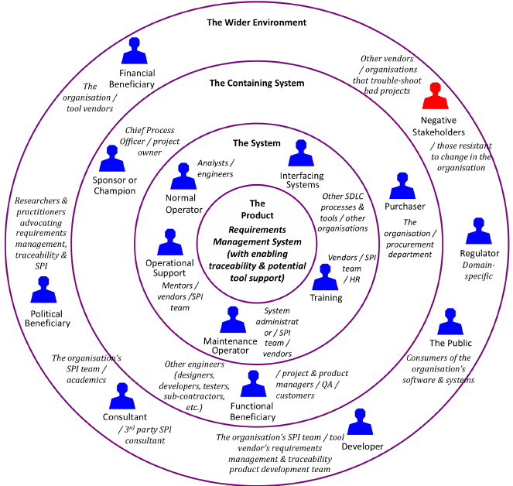

## 3.2 Use case diagram:

### 3.2.1 Graphic use case diagram:

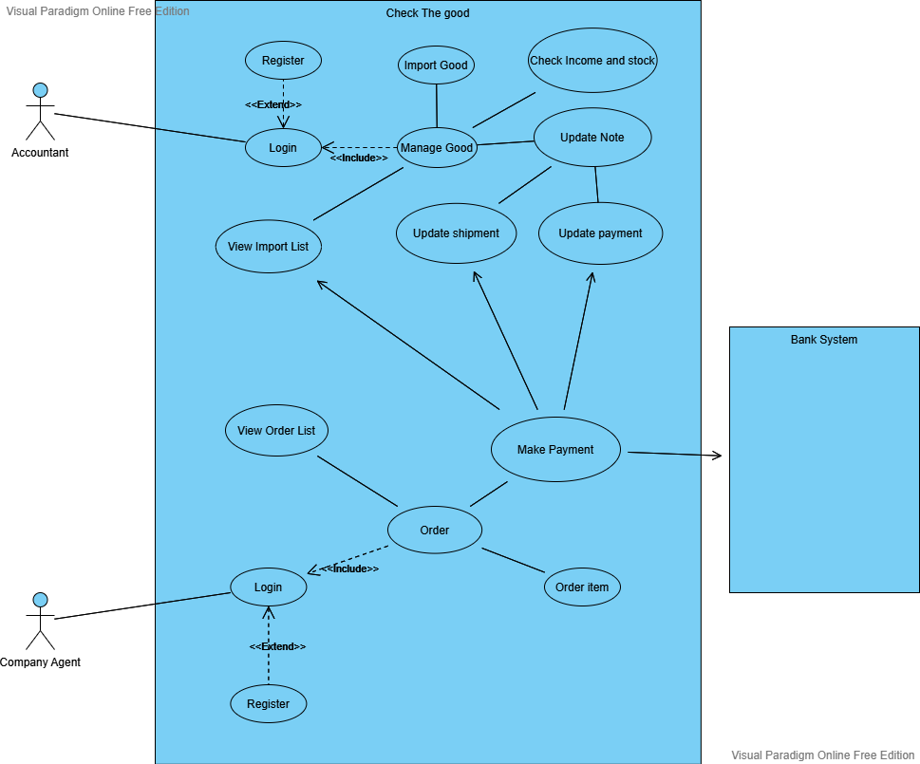

### 3.2.2 Textual description for each use case

|  |  |
| --- | --- |
| - Login | There are 2 login use case one for company agent actor and 1 for Accountant actor because each type of account will have different UI to use and different functionality features. When user login they will have a different function to use. This is to separate the actor. |
| - Register: | This is extend use case of Login. If the users don’t have account or want to create new account they can register if not then they can login using their account. |
| Manage good | This is home manager page for accountant actor only to choose other functionality use case. |
| View Agent import list | This use case will show every single import from every single agents, may be different agents want to import. For example 2 agents may import item so the list will show all 2 agents and all of their import list including the import that they haven’t made payment or already paid. |
| Update transaction status | This use case is when agent they make a payment success the status will automatically updated or the Accountant can update manually if the agent pay directly. It first initialize at N (no payment yet) when agent import. |
| Update shipment status | This use case is when accountant want to update the delivery process goods to agents. It first initialize at Undelivered (no payment yet) when agent import. |
| View Stock and revenue | This use case is for accountant to see all money income and all stock that being imported by agents. |
| Import goods | This use case is for Accountant to choose goods and import them. After import => import list will update. |
| View import list | This use case for agents to check all import they make (they cannot see other agent import like account has view all agent import). |
| Make payment | This is when agent make online payment then view import list and view all agent import list updated and also transaction status updated automatically. |

## 3.3 Functional and non functional requirements.

|  |  |
| --- | --- |
| **Funtional requirements** | **Non- functional requirements** |
| Authenticate of user when login | Show a username and password input place for user to type in |
| Create new user if they are new or demand for new account | Show a username and password and confirm user input place for user to type in. |
| The system allow the Accountant to manage the Note and Import list(upgrade, remove, edit). | The processing of each request should be done within 10 seconds |
| Agent can make online payment through a web with momo or zalo pay… | Show out a QR code for user to make payment and also make transaction in 10s |
| The system allow the administrator to back up and restore the information of customer in case of cyber attack or some physical damage to computer. | Friendly system, Image attractive and easy to use |

# 4. Architecture design

## 4.1 Architecture style:

- The main style of this project architecture is layered architectures, where many layers are used. The different layers are defined in the architecture. It consists of outer and inner layer. The components of outer layer manage the user interface operations. All the components then execute the operating system interfacing at the inner layer. The inner layers are application layer, utility layer and the core layer. In many cases, It is possible that more than one pattern is suitable and the alternate architectural style can be designed and evaluated.

- Because using layered architecture, the project is easily done base on the architecture where all the part is elaborated clearly. The good thing about check the good is that it is very simple to use, making all users navigate the application easily. Moreover, it has a considerable speed because it doesn’t use very complexity algorithm to run.

- The layered design also help the project improve the image of presentation layer where most users see it at first. How ever with limited time, the image does not have a lot color which also make the image look not very well. But the good thing is the application will be updated time to time. Therefore, everything will be improved soon in time.

## 4.2 Architecture model:

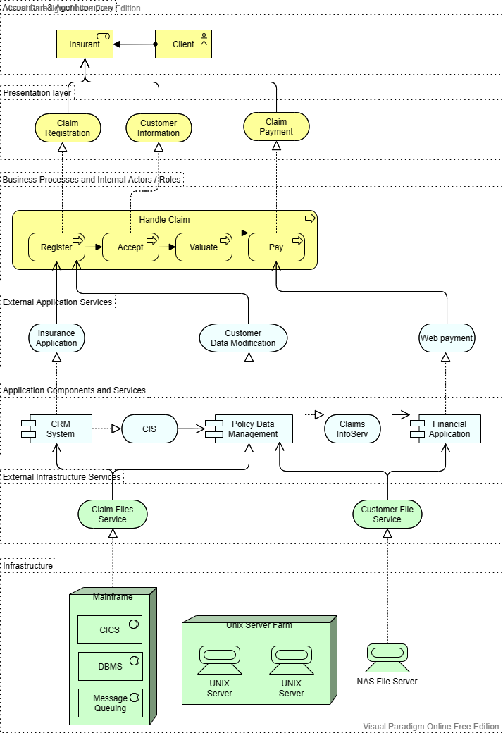

## 4.3 Technology, software, and hardware used

- To finish this project in the most efficient way these technology is used:

+ Diagram drawing online tools: to draw diagram for the project in order to make readers can understand more about project.

+ YouTube: where you get more idea and tutorial to work on the project more.

+ Social media: where you can contact your mate and team work for the project

- Software use:

+ Discord: to have a place for meeting with friends and talk about ideas and function of project

+ Visual studio: to make the application easily done and making the web MVC for payment made in application

+ SQL server management: where you store your database and also create new place to store new data.

- Hardware use:

+ Monitor with good resolution

+ Computer with standards requirement so that you can run the application and develop it

+ I/O hardware can help you more like microphone or headphone.

# 5. Design

## 5.1 Database design

- The database contain 6 main table to store all user data. This diagram below will illustrate clearly the relationship between table.

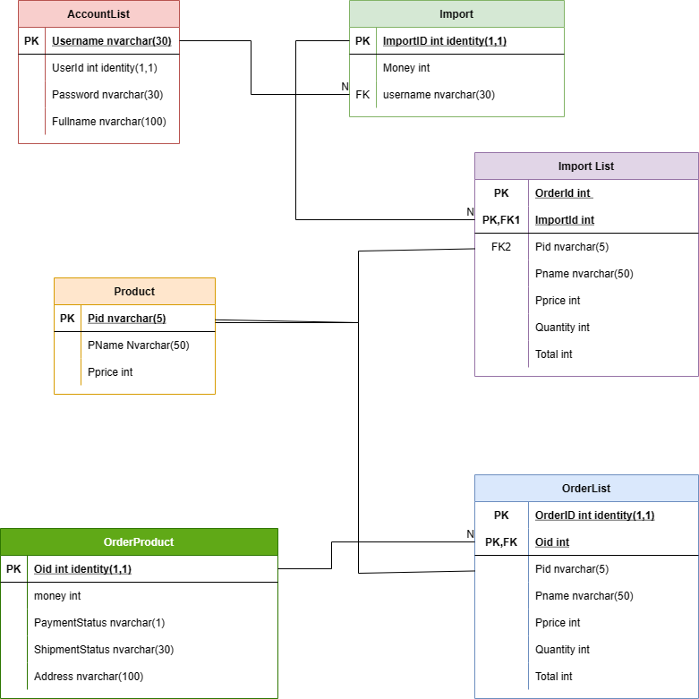

## 5.2 Class diagram

- Here is the whole application relationship between classes and database.

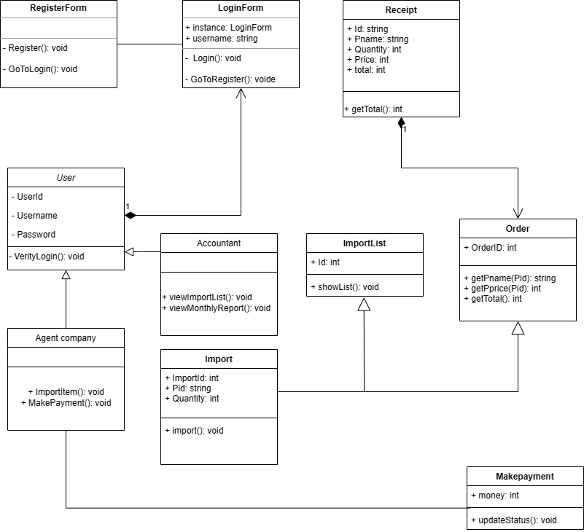

## 5.3 Sequence diagram for usecase.

## 5.3.1 Login usecase

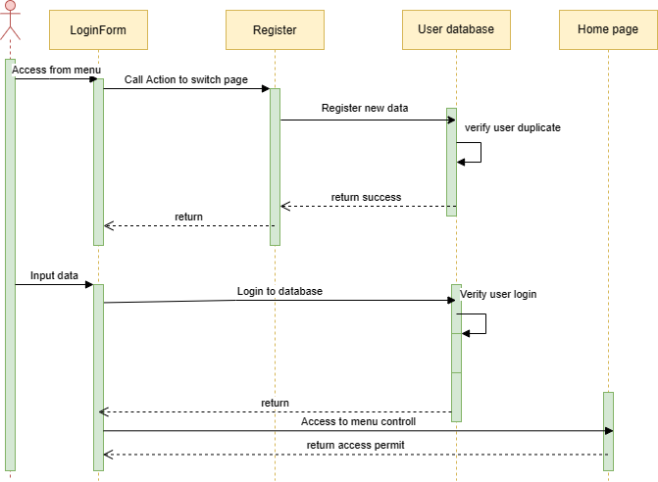

### 5.3.2 Manage Good usecase

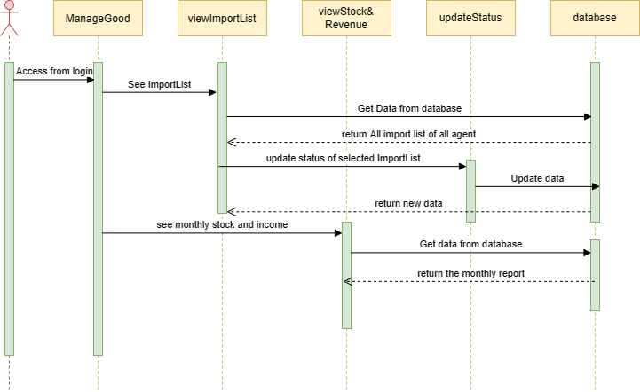

## 5.3.3 Import Good

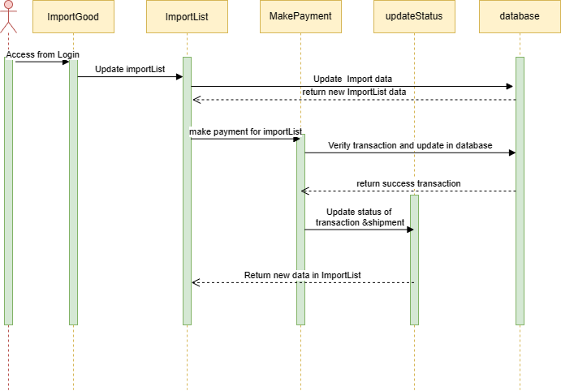

# 6 Git hub link:

<https://github.com/NguyenKhoi2001/SE2021Final>

