Caesar Cipher
using System;

class CaesarCipher
{
private int key;
public CaesarCipher(int k) { key = k % 26; }

public string Encrypt(string text)
{
text = text.ToUpper();
char[] result = new char[text.Length];
for (int i = 0; i < text.Length; i++)
result[i] = char.IsLetter(text[i])
? (char)((text[i] - 'A' + key) % 26 + 'A')
: text[i];
return new string(result);
}

public string Decrypt(string text)
{
text = text.ToUpper();
char[] result = new char[text.Length];
for (int i = 0; i < text.Length; i++)
result[i] = char.IsLetter(text[i])
? (char)((text[i] - 'A' - key + 26) % 26 + 'A')
: text[i];
return new string(result);
}
}

class Program
{
static void Main()
{
string text = "HELLO WORLD";
var caesar = new CaesarCipher(3);

string enc = caesar.Encrypt(text);
string dec = caesar.Decrypt(enc);

Console.WriteLine($"NguyenBan: {text}");
Console.WriteLine($"MaHoa: {enc}");
Console.WriteLine($"GiaiMa: {dec}");
}
}

Cấu trúc
Là phép dịch chuyển đơn giản trên bảng chữ cái.
Mỗi chữ cái được thay thế bằng chữ cái cách nó một số vị trí k (gọi là khóa).
Mã hóa:
Với ký tự P (Plaintext) → C = (P + k) mod 26.
Giải mã:
Với ký tự C (Ciphertext) → P = (C - k + 26) mod 26.
với HELLO và k=3 → KHOOR. Giải ngược lại sẽ ra HELLO.
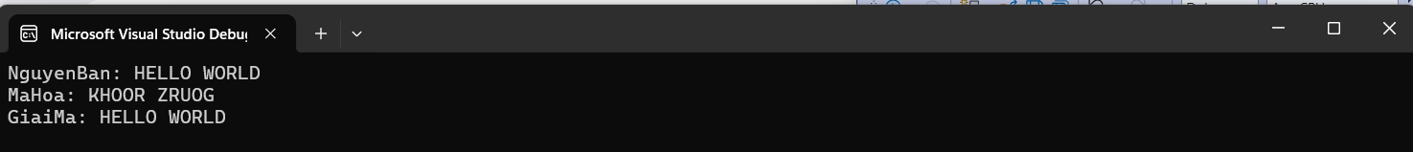

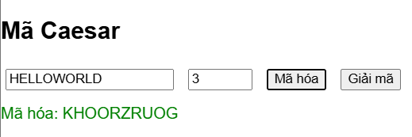
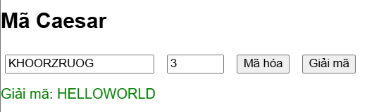

2. Affine Cipher
using System;

class AffineCipher
{
private int a, b, a_inv;
public AffineCipher(int a, int b)
{
if (GCD(a, 26) != 1) throw new Exception("a phải nguyên tố cùng nhau với 26!");
this.a = a; this.b = b;
this.a_inv = ModInverse(a, 26);
}

private int GCD(int x, int y) => y == 0 ? x : GCD(y, x % y);
private int ModInverse(int a, int m)
{
for (int x = 1; x < m; x++) if ((a * x) % m == 1) return x;
return 1;
}

public string Encrypt(string text)
{
text = text.ToUpper();
char[] result = new char[text.Length];
for (int i = 0; i < text.Length; i++)
result[i] = char.IsLetter(text[i])
? (char)(((a * (text[i] - 'A') + b) % 26) + 'A')
: text[i];
return new string(result);
}

public string Decrypt(string text)
{
text = text.ToUpper();
char[] result = new char[text.Length];
for (int i = 0; i < text.Length; i++)
result[i] = char.IsLetter(text[i])
? (char)((a_inv * ((text[i] - 'A' - b + 26)) % 26) + 'A')
: text[i];
return new string(result);
}
}

class Program
{
static void Main()
{
string text = "HELLO WORLD";
var affine = new AffineCipher(5, 8);

string enc = affine.Encrypt(text);
string dec = affine.Decrypt(enc);

Console.WriteLine($"Original: {text}");
Console.WriteLine($"Encrypted: {enc}");
Console.WriteLine($"Decrypted: {dec}");
}
}
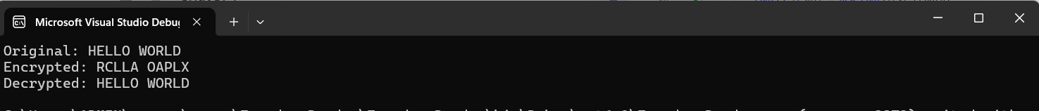
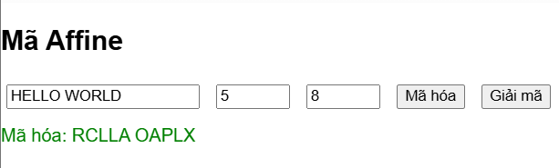
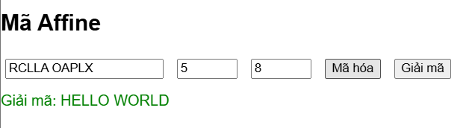

3. Permutation Cipher (Hoán vị khối)
using System;

class PermutationCipher
{
private int[] key;
public PermutationCipher(int[] key) { this.key = key; }

public string Encrypt(string text)
{
int n = key.Length;
text = text.PadRight(((text.Length + n - 1) / n) * n, 'X');
char[] result = new char[text.Length];
for (int block = 0; block < text.Length; block += n)
for (int i = 0; i < n; i++)
result[block + i] = text[block + key[i]];
return new string(result);
}

public string Decrypt(string text)
{
int n = key.Length;
char[] result = new char[text.Length];
for (int block = 0; block < text.Length; block += n)
for (int i = 0; i < n; i++)
result[block + key[i]] = text[block + i];
return new string(result);
}
}

class Program
{
static void Main()
{
string text = "HELLO WORLD";
var perm = new PermutationCipher(new int[] { 2, 0, 3, 1 });

string enc = perm.Encrypt(text);
string dec = perm.Decrypt(enc);

Console.WriteLine($"Original: {text}");
Console.WriteLine($"Encrypted: {enc}");
Console.WriteLine($"Decrypted: {dec}");
}
}

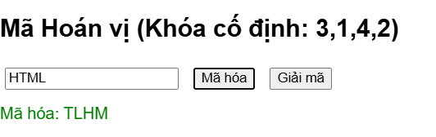
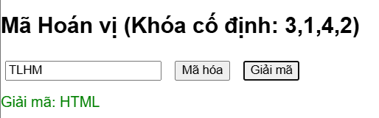

4.Vigenere Cipher
using System;

class VigenereCipher
{
private string key;
public VigenereCipher(string k) { key = k.ToUpper(); }
private int KeyAt(int i) => key[i % key.Length] - 'A';

public string Encrypt(string text)
{
text = text.ToUpper();
char[] result = new char[text.Length];
for (int i = 0; i < text.Length; i++)
result[i] = char.IsLetter(text[i])
? (char)(((text[i] - 'A' + KeyAt(i)) % 26) + 'A')
: text[i];
return new string(result);
}

public string Decrypt(string text)
{
text = text.ToUpper();
char[] result = new char[text.Length];
for (int i = 0; i < text.Length; i++)
result[i] = char.IsLetter(text[i])
? (char)(((text[i] - 'A' - KeyAt(i) + 26) % 26) + 'A')
: text[i];
return new string(result);
}
}

class Program
{
static void Main()
{
string text = "HELLO WORLD";
var vig = new VigenereCipher("KEY");

string enc = vig.Encrypt(text);
string dec = vig.Decrypt(enc);

Console.WriteLine($"Original: {text}");
Console.WriteLine($"Encrypted: {enc}");
Console.WriteLine($"Decrypted: {dec}");
}
}

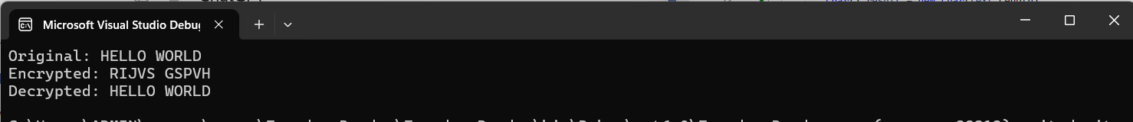

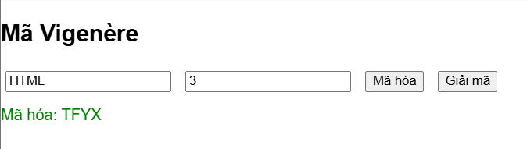
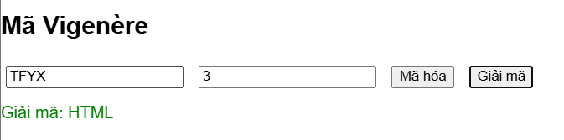

5. Playfair Cipher
using System;
using System.Collections.Generic;

class PlayfairCipher
{
private char[,] table = new char[5, 5];

public PlayfairCipher(string key) { BuildTable(key); }

private void BuildTable(string key)
{
string alphabet = "ABCDEFGHIKLMNOPQRSTUVWXYZ";
string k = "";
HashSet<char> used = new HashSet<char>();
foreach (char c in key.ToUpper())
{
char ch = (c == 'J') ? 'I' : c;
if (char.IsLetter(ch) && !used.Contains(ch))
{
used.Add(ch);
k += ch;
}
}
foreach (char c in alphabet)
if (!used.Contains(c)) k += c;
for (int i = 0; i < 25; i++)
table[i / 5, i % 5] = k[i];
}

private (int, int) Find(char c)
{
if (c == 'J') c = 'I';
for (int i = 0; i < 5; i++)
for (int j = 0; j < 5; j++)
if (table[i, j] == c) return (i, j);
return (-1, -1);
}

private string Process(string text, bool encrypt)
{
text = text.ToUpper().Replace("J", "I");
List<char> chars = new List<char>();
for (int i = 0; i < text.Length; i++)
if (char.IsLetter(text[i])) chars.Add(text[i]);

for (int i = 0; i < chars.Count - 1; i += 2)
if (chars[i] == chars[i + 1]) chars.Insert(i + 1, 'X');
if (chars.Count % 2 == 1) chars.Add('X');

string result = "";
for (int i = 0; i < chars.Count; i += 2)
{
var (r1, c1) = Find(chars[i]);
var (r2, c2) = Find(chars[i + 1]);
if (r1 == r2)
{
result += table[r1, (c1 + (encrypt ? 1 : 4)) % 5];
result += table[r2, (c2 + (encrypt ? 1 : 4)) % 5];
}
else if (c1 == c2)
{
result += table[(r1 + (encrypt ? 1 : 4)) % 5, c1];
result += table[(r2 + (encrypt ? 1 : 4)) % 5, c2];
}
else
{
result += table[r1, c2];
result += table[r2, c1];
}
}
return result;
}

public string Encrypt(string text) => Process(text, true);
public string Decrypt(string text) => Process(text, false);
}

class Program
{
static void Main()
{
string text = "HELLO WORLD";
var playfair = new PlayfairCipher("MONARCHY");

string enc = playfair.Encrypt(text);
string dec = playfair.Decrypt(enc);

Console.WriteLine($"Original: {text}");
Console.WriteLine($"Encrypted: {enc}");
Console.WriteLine($"Decrypted: {dec}");
}
}
