Bid Evaluation

Customer name : ${customerName}

Customer contact : ${customerEmail}

Case Handler : ${contactPersonEmail}

Date : ${currentDateTime}

**Scoping the opportunity:**

|  |  |
| --- | --- |
| Current Cost Structure | ${currency_code} |
| Total indirect cost | ${total_indirect_cost} |
| Total storage cost | ${total_storage_cost} |
| Total compute cost | ${total_compute_cost} |
| Total OS/Hypervisor lisence cost | ${total_os_lisence_cost} |
| Total monthly current infra-cost | **${total_month_infra_cost}** |

**Discounts and Margins**

|  |  |  |
| --- | --- | --- |
| Pricing Variables | Input | Adjusted |
| CSP or EA Discount | ${CSP_discount_in} | ${CSP_discount_ad} |
| CSP or EA Rebate | ${CSP_rebate_in} | ${CSP_rebate_ad} |
| Reserved Instance Discount | ${RI_discount_in} | ${RI_discount_in} |
| Percentage of Azure variable costs | | ${Az_discount_in} |
| Percentage of current infrastructure with multi-tenancy | | ${cur_inf_in} |

|  |  |
| --- | --- |
| End-Customer Pricing Variables | |
| Managed Service Margin | ${az_margin_in} |
| CSP discount to share with customer | ${CSP_discount_ad} |
| CSP rebate to share with customer | ${CSP_rebate_ad} |

|  |  |
| --- | --- |
| Partner Margins for End-Customer | |
| Absolute margin per month | ${end_ab_margin} |
| Relative margin | ${end_margin} |

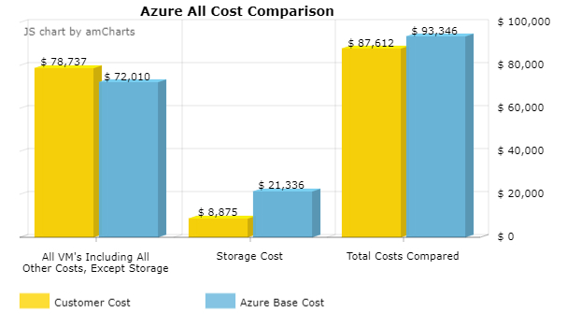

**Margin after the Azure benefits on/off and optimizations:**

|  |  |
| --- | --- |
| Partner Margin after applying Switching on/off and Optimization |  |
| Absolute margin per month (with Switching on/off and Optimization) | ${sw_ab_margin} |
| Relative margin (with Switching on/off and Optimization) | ${sw_re_margin} |

**If you sell Reserved instances:**

|  |  |
| --- | --- |
| Partner Margin after applying Reserved Instances benefits |  |
| Absolute margin per month (with Reserved Instances only) | ${ri_ab_margin} |
| Relative margin (with Reserved Instances only) | ${ri_re_margin} |

|  |  |
| --- | --- |
| Partner Margin after applying all Azure benefits |  |
| Absolute margin per month (with all Azure benefits) | ${be_ab_margin} |
| Relative margin (with all Azure benefits) | ${be_re_margin} |
| Upfront absolute margin for Reserved Instances | ${be_upfont} |

**Monthly revenue opportunity after all Azure benefits and including your margin**

