

Datacenter to Azure Migration

Proposal for ${customerName}, ${country}

Contact person: ${customerEmail}

Prepared by:

December 6, 2018

Table of Contents

1 Introduction 3

2 The current cost structure of ${customerName} 4

2.1 Your inputs evaluated 4

2.2 Your current infrastructure in more detail 6

3 Understanding Azure Virtual Machines 9

3.1 16 different Azure VM’s 9

3.2 The pricing of an Azure VM 10

3.3 Selecting the right Azure platform 11

3.4 Price development of Azure VM’s over years 11

4 Selecting the right set of Azure VM’s 13

5 The costs for running your business on Azure 14

5.1 The overall cost comparison 14

5.2 The storage cost details 15

5.3 The VM cost details 16

6 Azure Benefits 18

6.1 The benefit of switching actively on-/off VM’s 18

6.2 The benefit of optimizing the sizing of VM’s 19

6.3 The benefits of Reserved VM Instances and Hybrid Benefits 21

7 Quality of Services aspects 25

8 Three different migration scenarios 27

9 Our managed service approach 30

10 Next Step 32

Appendix 1: Azure Virtual Machines and Storage details 34

Azure Virtual Machines types 34

Introducing the Azure Storage services 38

11 Disclaimer 42

1. Introduction

In the last weeks we discussed the scenario of migrating your current data-center footprint to Microsoft Azure. In this proposal we will evaluate the financial consequences and the quality of service aspects of the transformation of your business-critical business applications to the intelligent cloud.

For this viability study we have received detailed information of your current operation after you submitted the questionnaire. We have signed an NDA to ensure you that all shared information will be handled with the greatest care.

This proposal is structured the following way:

* In the second chapter we will summarise the received information; compare this with various benchmarks that were set after more than 100 of similar studies and then we introduce the method used to compare your current compute infrastructure with a comparable environment of the same size on Microsoft’s Azure.
* In the third chapter we give background on different series of persistent virtual machines available on Azure and why there are 16 different series.
* In chapter four we motivate the selection of the VM series to run your workloads and on which is the basis of this proposal.
* In the fifth chapter a cost comparison is made between your current costs and the Azure costs if the same sized environment would run on Azure today.
* Running an infrastructure on the intelligent cloud is different than most application infrastructures today. In chapter six will be explained the three steps to / of these Azure benefits and the impact on the Azure cost levels presented in chapter 2.
* Chapter seven is focused on the quality of services aspects and the comparison of your current service levels with the ones Azure is offering today.
* In chapter eight we present three scenario’s,evaluate cost levels and cash-flow impacts where migration lead-time, book values andiabilities will be varied to give direction in a viable migration scenario.
* In chapter 9 we give a brief introduction of the Azure Managed Services portfolio we offer to make the most out of Azure.
* In chapter 10 we suggest the Next Step if you are interested to pursue in the journey to the Microsoft Azure cloud.
* In the appendices useful information is shared regarding Microsoft’s intelligent cloud.

1. The current cost structure of ${customerName}
   1. Your inputs evaluated

With answering the questions of the questionnaire, you have shared with us the following details about your current cost structure.

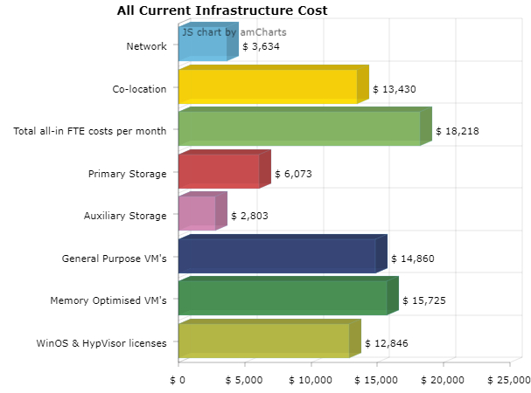

The cost totals are summarized in the following table as well as the most important parameters defining the size of your infrastructure:

|  |  |
| --- | --- |
| Current Cost Structure | ${currency_code} |
| Total indirect cost | ${total_indirect_cost} |
| Total storage cost | ${total_storage_cost} |
| Total compute cost | ${total_compute_cost} |
| Total OS/Hypervisor lisence cost | ${total_os_lisence_cost} |
| Total monthly current infra-cost | **${total_month_infra_cost}** |

To compare your cost data set with the benchmark we have break down your cost structure as followed:

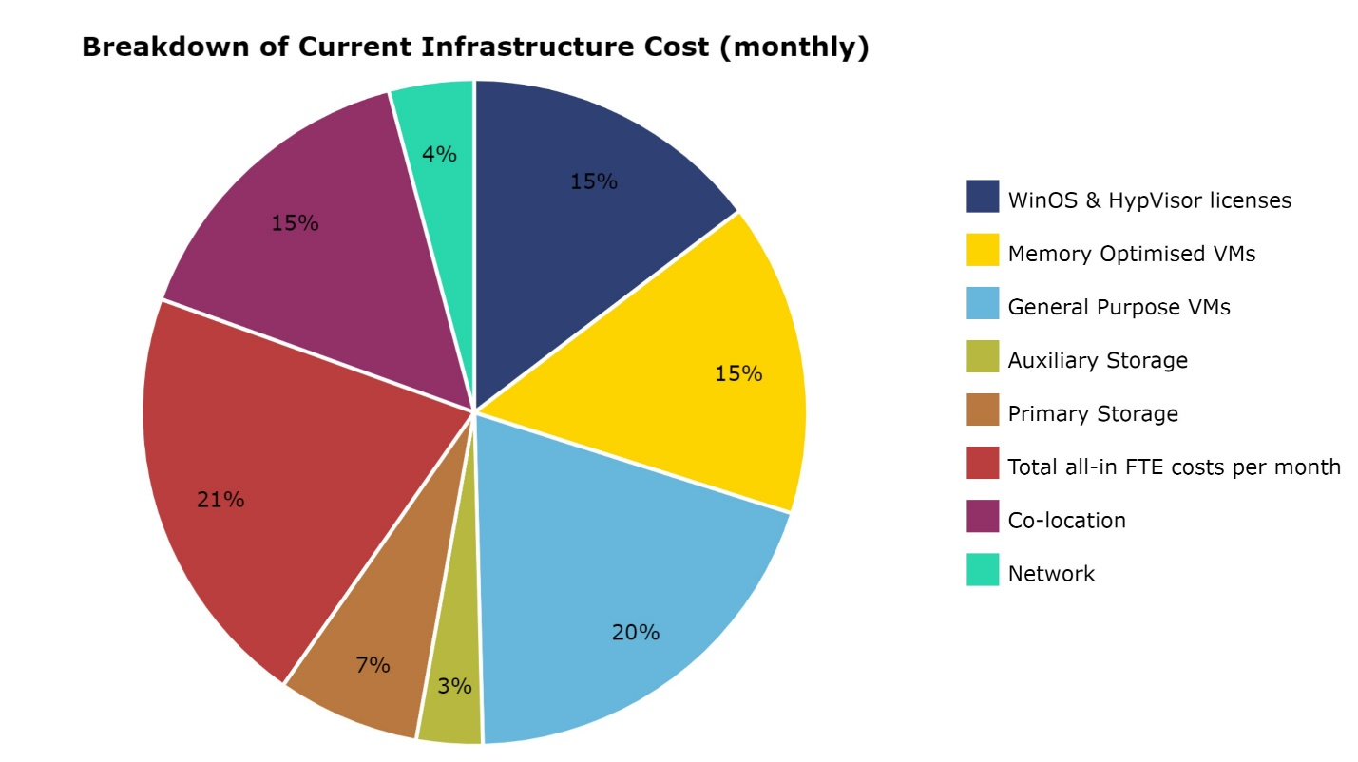

The total indirect costs are ${total_indirect_cost_percent} of today’s overall monthly infrastructure costs. The benchmark learns that in general indirect costs are around half of the total infrastructure costs. The other half is divided equally between storage, compute and licenses.

In this graph we compare your cost breakdown with the benchmark, based on data-sets of more than 100 comparable cases.

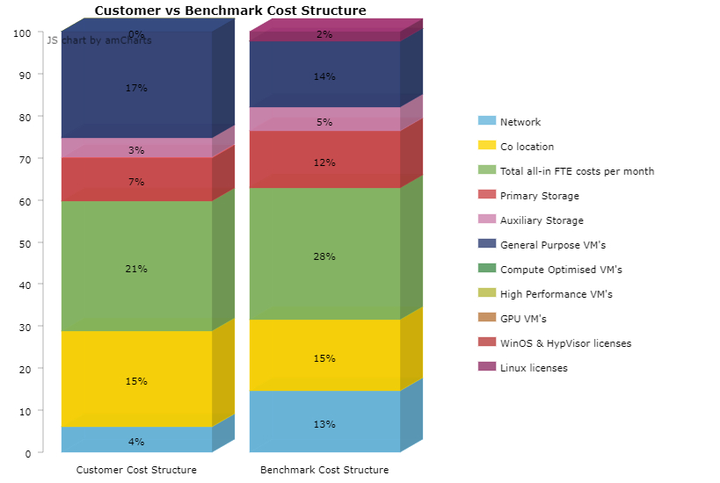

*[Make (a) comment(s) about the comparison between the benchmark and the customers cost structure.]*

* 1. Your current infrastructure in more detail

The scope of this proposal is defined in terms of number of VM’s (=Virtual Machine’s) - or in case there are only physical machines, this numer refers to that - , the number of CPU’s in use and the volume of Internal memory in ‘use’ and is as follows:

|  |  |
| --- | --- |
| Sizing Parameter of the current infrastructure | |
| Number of reported VMs | ${num_of_reported_vms} |
| Number of CPU's in use | ${num_of_cpus_in_use} |
| Volume of GB RAM in use | ${total_of_gb_in_use} |

The VM’s are using the following mix of Operating Systems.

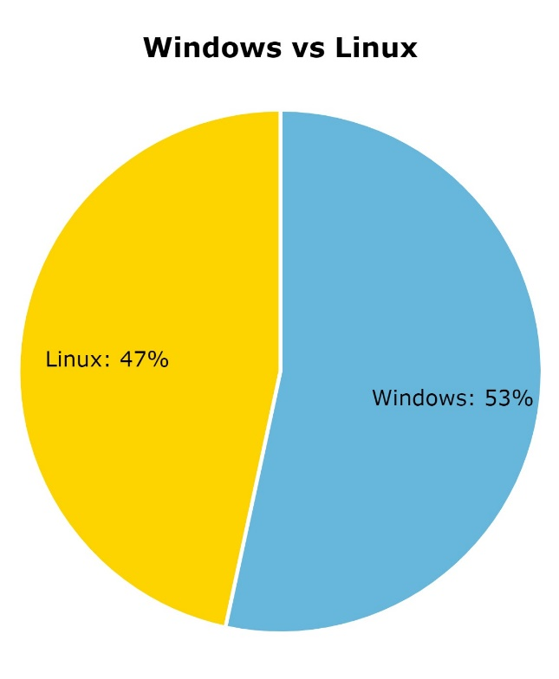

${customerName}’s hosting infrastructure is based on the following compute based components specified in terms of processors units:

|  |  |
| --- | --- |
| Processor type | Release date |
| ${infra_cpu_1_spec} | ${infra_cpu_1_spec_date} |
| ${infra_cpu_2_spec} | ${infra_cpu_2_spec_date} |
| ${infra_cpu_3_spec} | ${infra_cpu_3_spec_date} |

Your policy in depreciating hardware in-use is ${depreciation_period} months and at this moment ${percentage_of_fully_depreciated_cost} of the hardware has a zero-book value.

Currently ${customerName}’s configured VM’s can be characterized as follows:

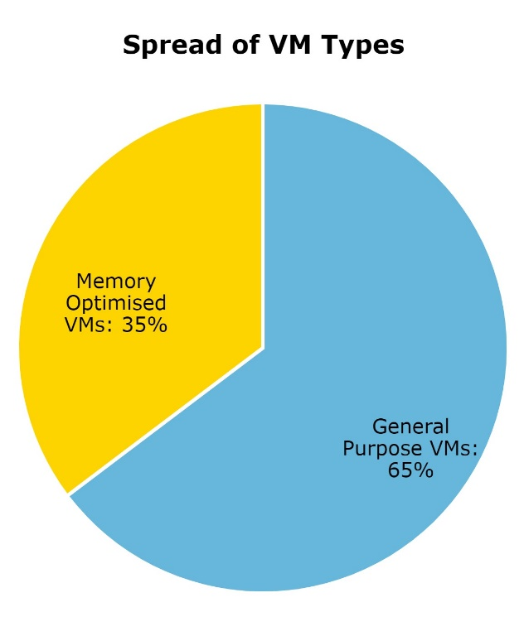

|  |  |
| --- | --- |
| Spread of VM Types | |
| General Purpose VMs | ${percent_calculate_gen_purVM} |
| Memory Optimised VMs | ${percent_calculate_mem_optVM} |

1. Understanding Azure Virtual Machines

Purpose of this proposal is to make an offering for an Azure infrastructure suitable for running your current workloads better, with a higher quality of service and at a lower cost. Before we present the cost levels of the framed Azure infrastructure it is necessary to explain the essentials of the pricing of an Azure VM in a few paragraphs.

* 1. 16 different Azure VM’s

Today Azure has 16 different VM series to choose from. Every VM series has multiple VM types. To compare your current infrastructure and costs with an Azure framed infrastructure, you must understand why the VM’s you choose to build an Azure infrastructure are suitable to run your workloads. In this paragraph we explain the differences between the Azure VM-series and motivate our choice of VM’s to build this proposal.

First step is to understand the differences between the VM series. The series are categorized by the ratio between CPU and GBRAM and for specialized VM’s in combination with a specific processor, like the Graphical Processor Unit.

The table is an overview of the 16 different VM series and their specific ratio of CPU and GBRAM.

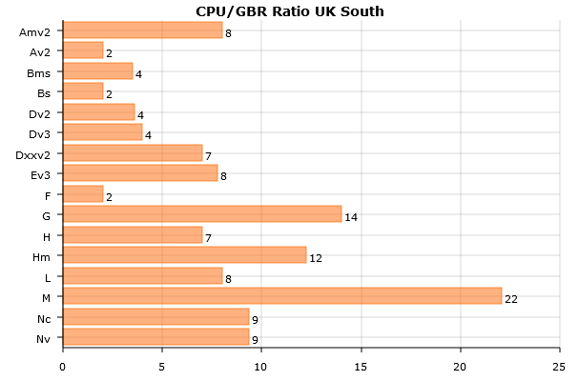

Within a VM serie the ratio between CPU and GBRAM stays constant over all VM types.

The most common used VM’s are the General Compute and Memory Optimized VM’s. Currently there are 5 different General Purpose VM’s available and 6 different Memory Optimized VM’s. For workloads asking very specific compute characteristics Azure offers already 5 specialized VM series.

By selecting a VM serie the ratio between CPU and Internal memory is fixed. Because an Azure CPU is never overcommitted, itmeans that choosing a VM series brings the sizing of the right VM back to the size of the internal memory in terms of GBRAM.

* 1. The pricing of an Azure VM

A second step in understanding Azure VM’s is to realise that the price of a GBRAM stays ‘more-or-less’ constant within a serie. For example a serie Dv3 VM with a Windows OS detailed in terms of CPU/GBRAM ratio (of factor 4) and the price per GBRAM.

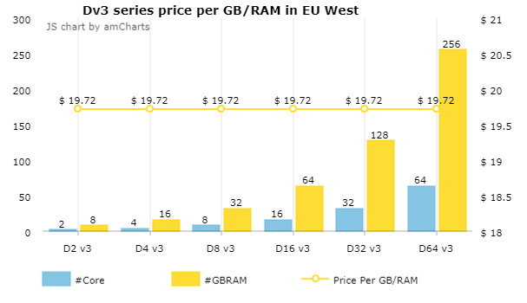

An important third step in understanding the selection of Azure VM’s, is to realize that the costs per GBRAM differs per VM series. That price difference comes from the CPU/GBRAM ratio and the release data of the VM series. In the following graph you see the different VM series and per VM series the price per GBRAM for a VM with a Windows OS and the VM with a Linux OS. The here listed Linux OS VM’s are priced with a free Linux OS (CentOS or Ubuntu). The mentioned prices are based on the list prices of the Azure platform of your choice, in this case ${region}.

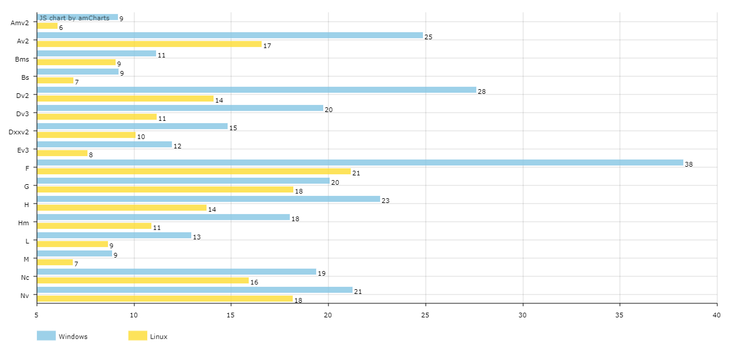

The big price differences of the GBRAM makes it extra important to make the right choices of the VM series you are selecting to build your Azure infrastructure.

For more information about the specifics of the different VM series, see chapter 4.

* 1. Selecting the right Azure platform

The prices mentioned in the graph above are depending on the selected Azure Platform, your choice was ${region}. We want to emphasize that the prices between the different Azure platform can differ up to 20%. Being selective in the used Azure platform can save money.

There are already 41 different Azure platforms around the world to choose from with 10 more to come soon. If you serve end-users around the world you should consider spreading your workloads over multiple Azure platforms, because latency is a significant performance influencer.

* 1. Price development of Azure VM’s over years

In 1975 Gordon Moore predicted that the number of [transistors](https://en.wikipedia.org/wiki/Transistor) in a dense [integrated circuit](https://en.wikipedia.org/wiki/Integrated_circuit) doubles about every two years. Now 43 years later that has slowed down to 2,5 years according to Intel. This means that compute power is still increasing at a fast pace without raising the price. With other words the price of compute has fall significantly over the last 40 years and will continue to fall in the future.

We see the same with the Azure compute price. New VM’s are introduced every year, based on new released processors, driving down the price of an Azure VM.

In the following graphs we show the results of an analysis of the price development of General Purpose and Memory Optimized VM’s on Azure over the past four years.

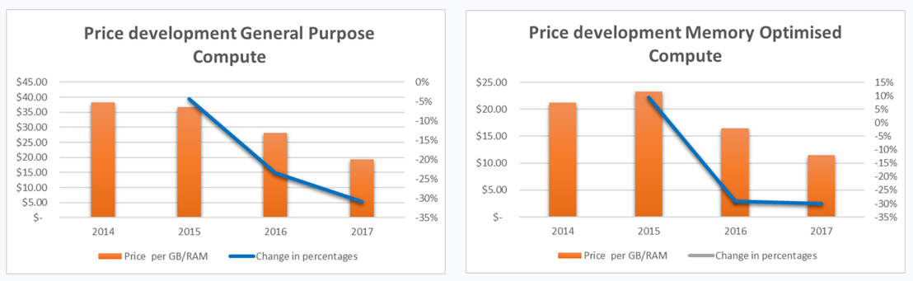

The price of a General Purpose VM dropped 47% and the Memory Optimized VM dropped 50% over the past three years. There is no guarantee that these prices will continue to drop in the same pace, but speed of innovation and market conditions will force Microsoft to continue to introduce new VM’s and stay price competitive in the years to come. This means that the price levels introduced later in this proposal are a snapshot of today’s price levels which will continue to fall in the years to come.

Moving to Azure means you will benefit directly from these innovations and cost savings.

1. Selecting the right set of Azure VM’s

The previous chapter explained the differences of Azure VM series and their pricing. In this chapter we will motivate what set of VM series we selected to build your Azure infrastructure to run your workloads.

This selection is based on the CPU/GBRAM ratio of your current infrastructure, ratios between CPU’s and GBRAM’s in ‘use’ and,if specified, specialized VM’s.

Based on these criteria we came to the following mix of VM-series to compare your current infrastructure costs with the costs of an Azure infrastructure running your workloads:

|  |  |
| --- | --- |
| Spread of GP MO Compute | |
| ${spreadRowTitle} | ${spreadRowValue} |

Based on the mix of the above specified VM’s we build the comparison between your current infrastructure costs and an comparably sized Azure framed infrastructure with your current infrastructure capacity.

1. The costs for running your business on Azure
   1. The overall cost comparison

Based on the same sizing parameters of today’s hosting infrastructure and in the mix of the Azure VM series as defined in the previous chapter the costs for running your workloads on Azure today is presented in the following graph.

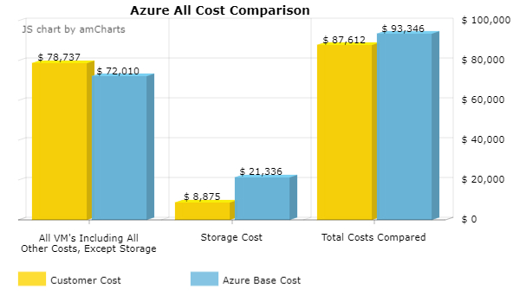

Running on Azure will ${status_all_total_cost_compared} ${customerName}’s cost structure with ${currency_code} ${diff_all_total_cost_compared} per month, which is a ${diff_all_total_cost_compared_percent} ${status_all_total_cost_compared} of today’s running monthly infrastructure costs.

The presented AZURE cost level is NOT optimized or influenced by potential extra specific Azure benefits which we will be described in the following paragraphs as well as the impact these will have on the Azure cost levels.

The two major cost factors compared in more detail:

* 1. The storage cost details

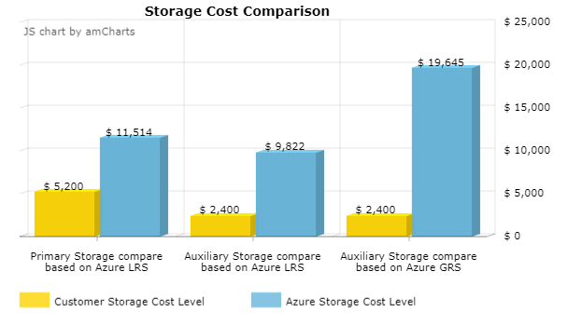

In the comparison between your current Primary storage costs and Azure we used the same mixture of SAS/SATA and SSD as being used. Specified was a ratio of ${sas_sata_percent} SAS/SATA storage and ${ssd_percent} SSD storage.

For this comparison the Azure SAS/SATA storage configuration is Standard Managed Disk in an LRS setting (LRS stands for Local Redundant Storage). The Azure SSD storage is based on parallel mounted high-performance disks andgoes up to 80.000 IOPS. Standard three data sets of the Primary file storage are held at the same Azure location.

For the back-up on Azure a combination of storage options is available. In the cost comparison we used the following mix:

|  |  |
| --- | --- |
| Primary Storage Mix | |
| SaS/SATA | ${sas_sata_percent} |
| SSD | ${ssd_percent} |
| Weighted Backup Storage | |
| Block Blob LRS HOT | ${Block_Blob_LRS_HOT} |
| Block Blob LRS COOL | ${Block_Blob_LRS_COOL} |
| Block Blob LRS Archive | ${Block_Blob_LRS_Archive} |

The Azure LRS Block Blob storage will give three identical data sets copies of the back-up on the same Azure location.

Optional ${customerName} can choose for the Block Blob GRS HOT. GRS stands for Geo Redundant Storage which means that six copies of the back-up are being hold, of which three copies are held at the mirror Azure site. The price consequences for that option are shown in the graph.

Here are the cost price comparisons per GB for Primary Storage and the weighted Azure Auxiliary Storage (as per ratio specified in the above table):

|  |  |  |
| --- | --- | --- |
| Storage cost factor comparison | perGB | |
| **CusCos**  **${currency_code}** | **WeAz**  **${currency_code}** |
| Price per GBRAM for Primary Storage | ${pri_customer_cost} | ${pri_azure_cost} |
| Price per GBRAM for Auxiliary Storage | ${aux_customer_cost} | ${aux_azure_cost} |

* 1. The VM cost details

Here the details of the server ‘only’ price comparison, where the Azure infrastructure is sized the same as ${customerName}’s current infrastructure. Price differences between the two can be influenced in general by indirect costs, underutilization of the current infrastructure, full depreciated hardware costs etc.

In the graph, the price difference on server level is illustrated. If you would run your current workloads on Azure today, that would ${status_server_total_cost_compared} your running infrastructure costs with ${currency_code} ${diff_server_total_cost_compared} per month which is an ${status_server_total_cost_compared} of ${diff_server_total_cost_compared_percent} compared to the current cost levels.

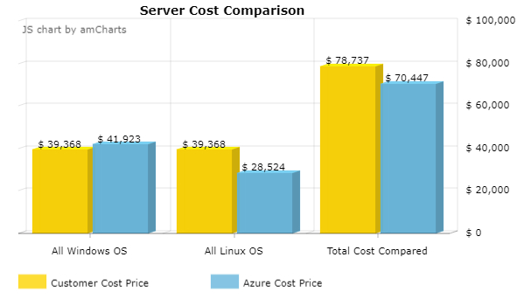

In the table you find a cost price comparison based on the price of internal memory in terms of GBRAM. Since the ratio between CPU and GBRAM is fixed within a selected VM series, the cost price of the CPU has become part of that GBRAM costprice representing the price of a VM.

|  |  |  |
| --- | --- | --- |
| Internal Memory cost factor comparison | perGB | |
| **CusCos**  **${currency_code}** | **WeAz**  **${currency_code}** |
| Price per GBRAM in use for GP Win | ${gpw_customer_cost} | ${gpw_azure_cost} |
| Price per GBRAM in use for GP Linux | ${gpl_customer_cost} | ${gpl_azure_cost} |
| Price per GBRAM in use for MO Win | ${mow_customer_cost} | ${mow_azure_cost} |
| Price per GBRAM in use for MO Linux | ${mol_customer_cost} | ${mol_azure_cost} |
| Price per GBRAM in use for CO Win | ${cow_customer_cost} | ${cow_azure_cost} |
| Price per GBRAM in use for CO Linux | ${col_customer_cost} | ${col_azure_cost} |
| Price per GBRAM in use for HP Win | ${hpw_customer_cost} | ${hpw_azure_cost} |
| Price per GBRAM in use for HP Linux | ${hpl_customer_cost} | ${hpl_azure_cost} |
| Price per GBRAM in use for GPU Win | ${gpuw_customer_cost} | ${gpuw_azure_cost} |
| Price per GBRAM in use for GPU Linux | ${gpul_customer_cost} | ${gpul_azure_cost} |

1. Azure Benefits

Running workloads on an Azure infrastructure is way more dynamic then on existing legacy hosting environments. These Azure dynamics are offering many opportunities to lower operational costs. In this chapter we will explain these benefits and what impact this could have on your monthly infrastructure cost levels if you actively manage your Azure environment.

In chapter 3 and 4 we explained the importance of picking the right VM series out of the available family of VM series on Azure today. The mixute of VM’s today will change over time while Microsoft keeps adding new VM series which could bring cost and performance benefits when moving workloads to new released VM series.

This is one example of what it means working in a true consumption priced model. According to the definition *a* ***consumption****-based pricing* ***model*** *is a service provision and payment scheme in which the customer pays according to the resources used*. In the coming paragraphs we introduce the benefits of the Azure consumption-based model.

* 1. The benefit of switching actively on-/off VM’s

It is as simple as teaching young kids to switch off the lights when leaving a room: if you switch off the light you don’t have to pay for electricity or in case of Azure for the VM ‘usage’. That can save you a lot of money. For example, if you switch off a VM for about three hours every night, you already save more than 10% of your VM costs. Another example. A lot of companies work roughly 12 hours per working day, 5 days a week. If you would switch off a server environment per default after hours, this would save up to 65% of the VM costs.

Typical workloads qualifying for switching on/off are load-balanced applications, like terminal server farms, or develop, test, train or acceptance environments which are not used after hours. Also, complete smaller production environments which are only used during office hours, qualify for switching on/off because SMB’s tend to be sensitive for these easy ways of significant cost savings.

Based on the analysis on specific data points you shared via the questionnaire we estimated that a saving of at least ${calculated_potential_of_switching_on_off} of the projected Azure VM costs is possible in your case by actively switching on/off VM’s. However we calculated with a potential reduction of ${adjusted_reduction_advantage_of_switching_on_off_VMs}. The impact of the running Azure costs per month is made visible in the following graph.

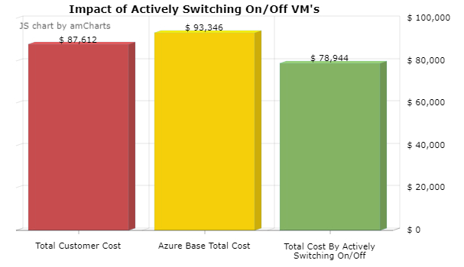

* 1. The benefit of optimizing the sizing of VM’s

Business software vendors are selling well performing applications, to achieve that they ‘oversize’ the necessary underlaying hardware infrastructure in their documentation. On top of that engineers implement these hardware requirements with an extra ‘safety zone’ with the consequence that servers are underutilized. Therefore 90% of all servers are running below 15% CPU load and hardly come above. This CPU underutilization is a waste of money and an unnecessary environmental pressure.

Because Azure VM’s don’t have overcommitted CPU’s and the upscaling of a VM instantly is always possible. The sizing recommendation of an Azure VM is an 80% CPU load.

The upscaling of a VM is easy on Azure and can be managed with a simple script which can be scheduled automatically, temporarily upscale the VM’s during peak times and downscale them the compute when demand is low, for example after month closure. Playing actively with the sizing of your VM’s is another Significant cost saving factor.

Another parameter impacting the optimization potential is the performance of the used processors. Migrating to Azure means always using the best performing processors in the industry. This also offers optimization potential and with that cost savings. To size this the questionnaire asked you what the three most used processors in your data center(s) are:

|  |  |
| --- | --- |
| Three most used processors in your data center | Comparable Azure processors |
| ${infra_cpu_1_spec} | 2.3 GHz Intel XEON® E5-2673 v4 (Broadwell) processor and can achieve 3.5 GHz with Intel Turbo Boost Technology |
| ${infra_cpu_2_spec} | 2.3 GHz Intel XEON® E5-2673 v4 (Broadwell) processor and can achieve 3.5 GHz with Intel Turbo Boost Technology |
| ${infra_cpu_3_spec} | 2.3 GHz Intel XEON® E5-2673 v4 (Broadwell) processor and can achieve 3.5 GHz with Intel Turbo Boost Technology |

To give an idea how Moore’s law could work in your advantage, here the comparison of the performance of the processors currently in use with those on Azure. To illustrate the potential gain, we use the Pass Mark Software CPU benchmark (is independent of Microsoft). For more information about this benchmark refer to chapter 4.2.

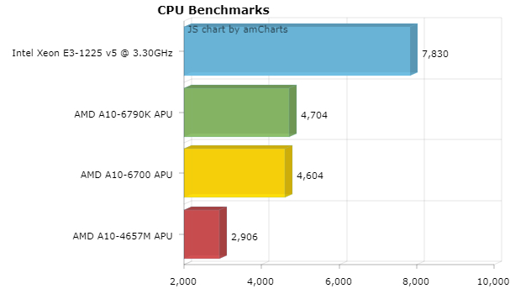

This benchmark tells us the comparison on average between the processors currently in use and the comparable ones used on Azure. The potential processor performance gain is roughly ${optimization_benefit_based_on_difference_processor_types}. The effect of better performing processors can be used to optimize further and tune the capacity of the VM’s.

The combination of all optimization effects will lower the total used footprint on CPUs and GB/RAM and with that the running monthly costs. We estimate conservatively, with a ${optimization_effect_primary_storage} optimization effect and suggest to start monitoring the current processor load as soon as possible, so in the complete migration planning the optimized environment can be designed.

In this graph, the monthly cost levels are compared including the effect of switching on-/off and optimizing the VM size as described before.Managing the Azure infrastructure dynamically, will positivelyeffect the monthly running costs, potentially significantly. In the case based on the mentioned assumptions the benefit is ${currency_code} ${total_cost_azure_benefit} which is a ${total_cost_azure_benefit_percent} reduction compared to the current customer cost price for the infrastructure.

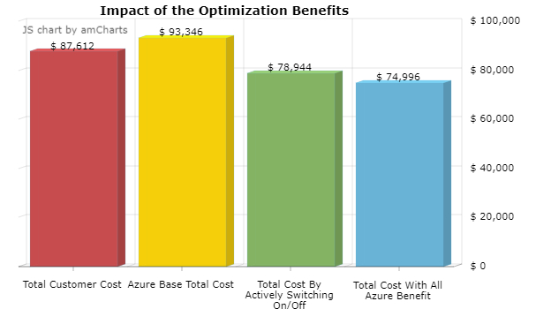

* 1. The benefits of Reserved VM Instances and Hybrid Benefits

[Azure Reserved VM Instances](https://azure.microsoft.com/pricing/reserved-vm-instances) helps you save money by pre-paying for one-year or three-years of compute capacity allowing you to get a discount on the VM’s you use. When you combine the cost savings gained from Azure RIs with the added value of the [Azure Hybrid Benefit](https://azure.microsoft.com/en-us/pricing/hybrid-benefit/), meaning re-use already acquired and maintained Windows OS licenses, you can save even more.

If you have virtual machines that run for long periods of time, purchasing a reserved instance gives you the most cost-effective option. For example, if you continuously run four instances of a Standard D2 VM, without a reserved instance you are charged at pay-as-you-go rates. If you purchase a reserved instance for say two VMs, the VMs immediately get the billing benefit. They are no longer charged at the pay-as-you-go rates.

The Azure Reserved Instance discount is applied to running VM instances on an hourly basis. The reserved instances that you have purchased are matched to the usage emitted by the running VMs to apply the Reserved Instance discount. For VMs that may not run the full hour, the reserved instance will be filled from other VMs not using a reserved instance, including concurrently running VMs.

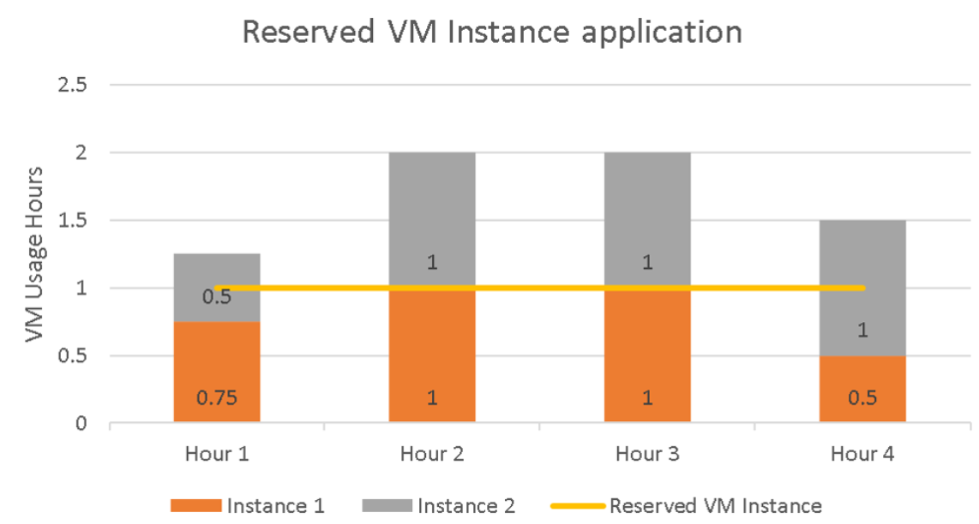

1. Any usage that’s above the reserved instance line gets charged at the regular pay-as-you-go rates. You're not charged for any usage below the reserved instances line, since it has been already paid as part of reserved instance purchase.
2. In hour 1, instance 1 runs for 0.75 hours and instance 2 runs for 0.5 hours. Total usage for hour 1 is 1.25 hours. You are charged the pay-as-you-go rates for the remaining 0.25 hours.
3. For hour 2 and hour 3, both instances ran for 1 hour each. One instance is covered by the reserved instance and the other is charged at pay-as-you-go rates.
4. For hour 4, instance 1 runs for 0.5 hours and instance 2 runs for 1 hour. Instance 1 is fully covered by the reserved instance and 0.5 hours of instance 2 is covered. You’re charged the pay-as-you-go rate for the remaining 0.5 hours.

For the selected VM-series we assumed the following potential for Reserved VM instances.

|  |  |  |  |  |
| --- | --- | --- | --- | --- |
| ALLOCATION OF RESERVED INSTANCE | | | | |
| Vm-series | **Weighted** | **RI 1Y** | **RI 3Y** | **RI 3Y Hyb** |
| ${allRowTitle} | ${allRowWeighted} | ${allRowRI1Y} | ${allRowRI3Y} | ${allRowHyb} |
| Pre-payment per category | | ${total_RI1Y} | ${total_RI3Y} | ${total_Hyb} |
| Total pre-payment for all RI | | | **${currency_code}** | **${total_RI}** |

For the mixture of Reserved VM Instances the pre-payment is mentioned at the bottom of the table.

The impact of buying reserved instance on the running cost of an Azure infrastructure is illustrated by the following graph.

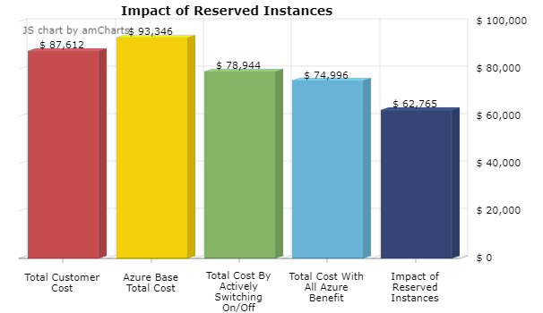

The gain of ${currency_code} ${diff_impact_of_RI} per month is caused by the extra discount you receive when you buy the Reserved Instances. Interest rates on the capital needed to buy upfront the Reserved Instances is not taken into account.

1. Quality of Services aspects

In the previous chapters we gave you insights in how we can lower the cost levels significantly with smart Azure management. But low costs is useless if the quality of service is poor and unpredictable.

In the table we compare your key current quality of service levels with the ones offered by Azure today.

|  |  |  |
| --- | --- | --- |
| Quality of Services Aspects | ${customerName} | AZURE |
| Service Level Agreement | | |
| Uptime guarantees on the infrastructure | ${cus_uptime} | ${azu_uptime} |
| Max. service credits pay out | ${cus_maxService} | ${azu_maxService} |
| Back-up | | |
| Back-up frequency to recovery vault per 24 hours | ${cus_backup24} | ${azu_backup24} |
| Back-up frequency to disk per 14 hours | ${cus_backup14} | ${azu_backup14} |
| Retention options | ${cus_rentention} | ${azu_rentention} |
| Guaranteed maximum retention period | ${cus_max_rentention} | ${azu_max_rentention} |
| Back-up data encrypted | ${cus_encrypted} | ${azu_encrypted} |
| Disaster Recovery | | |
| Pricing policy for DR | ${currency_code} ${cus_dr} | ${azu_dr} |
| RPO and RTO guaranteed | ${cus_rpo_rto} | ${azu_rpo_rto} |
| Compliancy | | |
| Current compliancy certifications | ${cus_complicancy} | ${azu_complicancy} |

Quality of service can be viewed from many angles. For Microsoft the quality of service is a key component of their success with Azure. For example, the compliancy. Here is an overview of all compliance standards Microsoft has achieved for Azure.

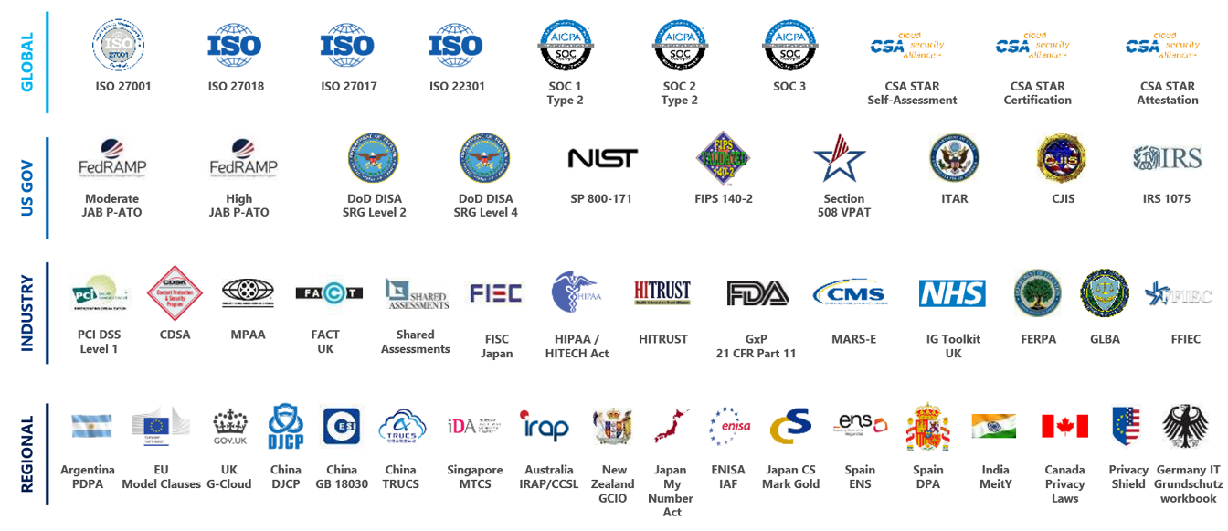

Every standard requires its own technical measures and operational processes to be compliant with the requirements of the standard. Then the time spent on audits is immense. To give an idea; the annual costs to exam for SOC 2 for a mid-sized company is already more than USD 100k per year. Anothergood example of the quality of service of Azure is the offered protection identity fraud. Most of security breaches take place when attackers gain access to an environment by stealing a user’s identity. Over the years, attackers have become increasingly effective in leveraging third-party breaches and using sophisticated phishing attacks. As soon as an attacker gains access to even low privileged user accounts, it is relatively easy for them to gain access to important company resources through lateral movement.

Azure Active Directory uses adaptive machine learning algorithms and heuristics to detect anomalies and suspicious incidents that indicate potentially compromised identities. Using this data, Identity Protection generates reports and alerts that enable you to evaluate the detected issues and take appropriate mitigation or remediation actions.

The above examples illustrate that Microsoft is lifting the concept of Quality of Service to another dimension.

1. Three different migration scenarios

To give a better understanding of the impact in terms of costs and cost savings a migration to Azure will bring, we worked out three different scenarios where we simulate with different variables to give direction to which scenario will bring you most benefit.

The details of these three scenarios are summarized in the table. In Scenario 1 we took the values you left behind in the questionnaire, the other two scenarios are configured by us.

|  |  |  |  |
| --- | --- | --- | --- |
| Business case in a 12 - 48 month perspective | Scenario 1 | Scenario 2 | Scenario 3 |
| Duration of the project in months | ${sce1_duration} | ${sce2_duration} | ${sce3_duration} |
| Start date of the migration project | ${sce1_startdate} | ${sce2_startdate} | ${sce3_startdate} |
| Estimated end-date of the migration project | ${sce1_enddate_es} | ${sce2_enddate_es} | ${sce3_enddate_es} |
| End-date of the DC contract obligation | ${sce1_enddate} | ${sce2_enddate} | ${sce3_enddate} |
| Duration of the migration project in months | ${sce1_mig_duration} | ${sce2_mig_duration} | ${sce3_mig_duration} |
| Number of VM's to be migrated per month | ${sce1_vmnumber_m} | ${sce2_vmnumber_m} | ${sce3_vmnumber_m} |
| Number of VM's to be migrated | ${sce1_vmmigrated} | ${sce2_vmmigrated} | ${sce3_vmmigrated} |
| Remaining bookvalues at the end of the DC contract | | | | |
| Remaining network cost | ${sce1_network_cost} | ${sce2_network_cost} | ${sce3_network_cost} |
| Remaining DC/Co-location cost | ${sce1_dc_cost} | ${sce2_dc_cost} | ${sce3_dc_cost} |
| Remaining staff costs after migration | ${sce1_staff_cost} | ${sce2_staff_cost} | ${sce3_staff_cost} |
| Remaining storage cost | ${sce1_storage_cost} | ${sce2_storage_cost} | ${sce3_storage_cost} |
| Remaining VM Server cost | ${sce1_vm_cost} | ${sce2_vm_cost} | ${sce3_vm_cost} |
| Remaining contracted position after contract obligation | ${sce1_position_cost} | ${sce2_position_cost} | ${sce3_position_cost} |
| Migration Cost Variables | | | | |
| Estimated training, transition cost by external partner (per month) | USD ${sce1_es_train} | USD ${sce2_es_train} | USD ${sce3_es_train} |
| Estimated External migration support cost (per month) | USD ${sce1_es_external} | USD ${sce2_es_external} | USD ${sce3_es_external} |
| Estimated migration cost per VM (per month) | USD ${sce1_es_migration} | USD ${sce2_es_migration} | USD ${sce3_es_migration} |
| Microsoft migration support program | | | | |
| Azure Consumption Commitment | USD ${sce1_commit} | USD ${sce2_commit} | USD ${sce3_commit} |
| ECIF % of commitment | ${sce1_ecif_percent} | ${sce2_ecif_percent} | ${sce3_ecif_percent} |
| ECIF in USD based on Azure commitment | USD ${sce1_ecif_cash} | USD ${sce2_ecif_cash} | USD ${sce3_ecif_cash} |
| Percentage cash incentive if reaching 100% of the committed Azure amount | ${sce1_reach_per} | ${sce2_reach_per} | ${sce3_reach_per} |
| Cash incentive in USD if reaching 100% of the committed amount | USD ${sce1_reach_cash} | USD ${sce2_reach_cash} | USD ${sce3_reach_cash} |
| Total Microsoft contribution based on the Azure commitment | **USD ${sce1_total}** | **USD ${sce2_total}** | **USD ${sce3_total}** |

The effect of the three scenarios are presented in a set of graphs detailing the impact for your situation per scenario in terms of costs and cost savings over time.

All above leads to the following financial summary of the three-different scenario’s.

|  |  |  |
| --- | --- | --- |
| Scenario 1 | Scenario 2 | Scenario 3 |

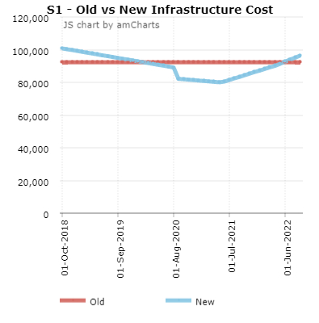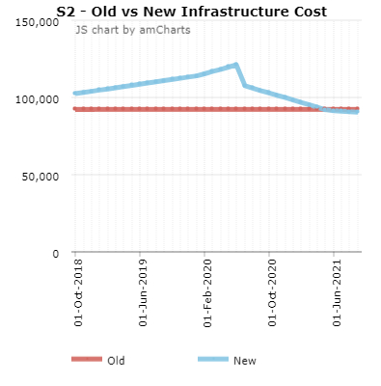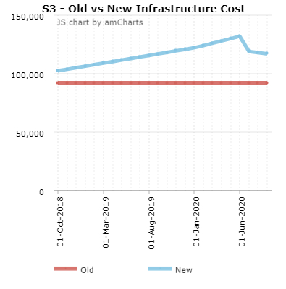

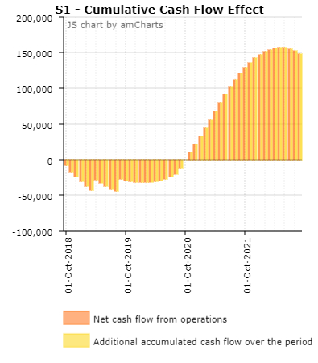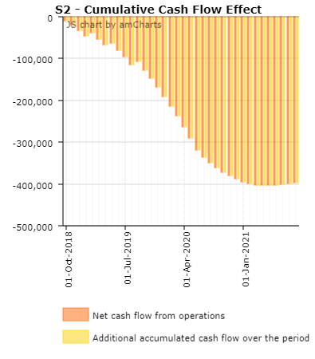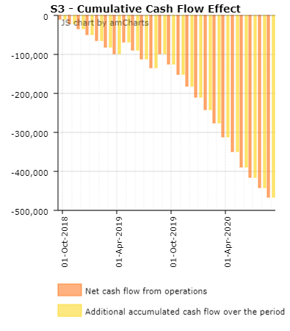

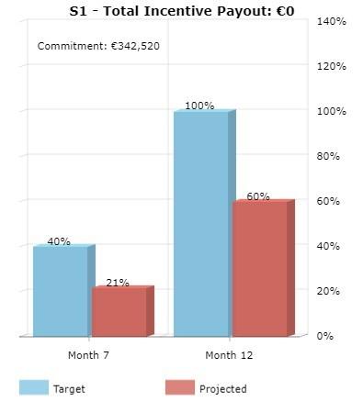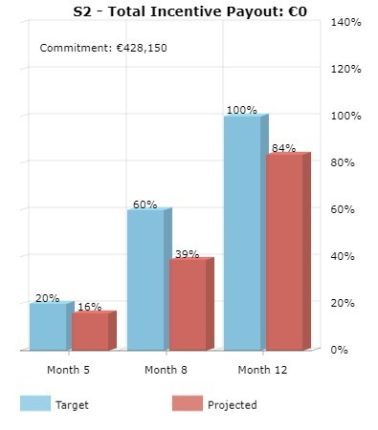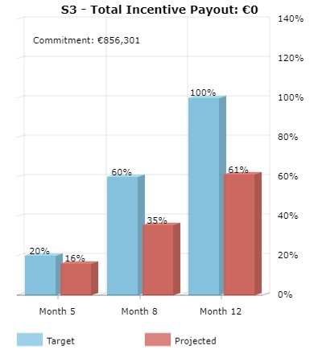

This all leads to a summary of major costs and benefits.

|  |  |  |  |  |
| --- | --- | --- | --- | --- |
| Projection over 48 months |  | Scenario 1 | Scenario 2 | Scenario 3 |
| Migration costs | ${currency_code} | ${sce1_migra} | ${sce2_migra} | ${sce3_migra} |
| Total savings as result of the migration | ${currency_code} | ${sce1_save} | ${sce2_save} | ${sce3_save} |
| Microsoft's Contribution | ${currency_code} | ${sce1_total1} | ${sce2_total1} | ${sce3_total1} |
| Based on a Azure commitment of | ${currency_code} | ${sce1_commit1} | ${sce2_commit1} | ${sce3_commit1} |
| Remaining DC contractual liability after migration | ${currency_code} | ${sce1_remain} | ${sce2_remain} | ${sce3_remain} |

1. Our managed service approach

In the previous chapters we have given you insights of what it means to migrate your current workloads to Microsoft Azure. We have given you insights to what the cost levels are for running your current workloads on Azure and how with ‘smart Azure management’ we can reduce the costs of your Azure consumption significantly and increase the quality of services.

In this chapter we give you a brief overview of our added value Azure managed service portfolio that we provide on top of the Microsoft Azure offering, to guarantee you get the best out of the Azure intelligent cloud against the lowest possible costs.

The Green marked managed services are already included in the price offering made in this proposal. The other services we would like to discuss with you after the next phase.

|  |  |  |
| --- | --- | --- |
|  | Added Value Services | Brief Description of the service |
| 1. | Azure migration TCO analysis | The proposal is your Azure TCO analysis and gives an indication of the migration costs to Azure in three different scenarios. |
| 2. | Migration planning | Described in chapter 10 of this proposal. |
| 3. | Deployment management | This service is to define your deployment standards and policies for servers, networks, storage use etc. and built automation scripts to consistently deploy new servers and networks. |
| 4. | Building the authorization matrix | To manage and control costs and security it is important to build and implement the authorization matrix by clearly define roles and responsibilities. |
| 5. | User management and access rights | Setting up policies for user management and RBAC, subscription management, user tagging and change management and the implementation of single- and or multi-factor authentication. |
| 6. | Infrastructure Monitoring | Monitoring and managing OS, compute, storage, network, firewall/DNS, load balancers etc. to ensure the guaranteed uptimes of your infrastructure running on Azure. |
| 7. | Application Performance Monitoring | Monitoring and managing your application(s) to assure your application(s) are running stable and are performing well. |
| 8. | SLA Reporting | Monthly reporting of the state of your infrastructure, incidents, changes, including recommendations to improve your infrastructure running on Azure. |
| 9. | Database management | Monitoring and maintaining your database(s). |
| 10. | IT Service and incident management | 24/7 second-line support to help you keep your business up and running. |
| 11. | Security Monitoring | Monitoring all critical elements from a security point of view of the infrastructure, including intrusion detection and remediation, including on a regular basis security and risk assessments. |
| 12. | Anti-virus, anti-malware | Keeping all your environments protected and up to date with respect to virus and malware attacks. |
| 13. | Storage management | Set-up storage policies with respect to snapshotting, back-up scheme’s, long term data retention, compression, encryption and selecting the right Azure storage options. |
| 14. | Usage and spend management | Based on our advanced monitoring capabilities we monitor your infrastructure based on utilization and usage and optimize actively the sizing of your infrastructure and switching of off resources which are not used to save significant costs. |
| 15. | Application Site Recovery | Planning the scope of the site recovery, designing the fail-over and restore and building the scripts for the automated recovery, including the annual test. |

1. Next Step

In this proposal we have given you an impression and a cost estimate of what it would mean to run your workloads on Microsoft Azure.

First of all it could bring you a significant cost benefit if all the optimization benefits Azure is offering are maximized. Second of all and maybe more important, the migration of your current workloads to Azure is a major step in facilitating your digital transformation. It is unlocking the enormous potential of what the intelligent cloud is already offering to enhance your business, now and in the nearby future.

In this chapter we describe what the next step will be if you decide to start this exciting journey with us.

Main goal of the next step is to make a detailed migration plan and price the migration effort.

The next step is a multiple day boot camp/workshop where the number of days is depending on the sizing and complexity of your environment.

During the boot camp/workshop we build a detailed migration plan together and explain how Azure works and how to benefit most from it.

The agenda of this boot camp/workshop

**Day 1 -  Azure Bootcamp**

* Platform
* Storage
* Networking
* Virtual Machines
* Resource Manager
* Business Continuity, DR & Hybrid Storage
* Azure Active Directory
* SQL Server
* Introduction Azure Migrate

**Day 2, 3 and 4 Workshop - Target Architecture**

* Describes as-is situation
  + Network infrastructure
  + Hypervisors
  + Identity / Customer segmentation
* Design to-be architecture
  + Cloud model
  + Services
  + Connectivity
  + Security
  + Identity
  + Business Continuity / Disaster Recovery
  + Deployment
  + Automation
* Design path to to-be architecture
  + Steps to goal architecture
  + Migration/Transition
    - Rehost
    - Refactor
    - Rearchitect
    - Rebuild
    - Replace
  + Manage

**Day 5, 6 and 7 – Analysis & Pre-POC**

* Deploy Azure Migrate
* Perform Analysis on existing resources
* Pre-migrate test workloads as-is to Azure
* Analyse migration results
* Build TCO & Financial model
* Prioritize workloads and customers

After the workshop:

* The design is ready
* A migration planning is ready
* A POC has been executed
* A migration team of your and our people has been formed and is ready to go
* Migration costs are known
* Estimated running costs are confirmed

The costs of the workshop is Euro 2,400 per day. Giving the size and complexity of your environment we plan a 7 days workshop, within a period of three weeks. The total costs for this crucial next step is thereforeEUR 16,800

# Appendix 1: Azure Virtual Machines and Storage details

## Azure Virtual Machines types

Azure Virtual Machines give the flexibility of virtualization for a wide range of computing solutions with support for Linux, Windows Server, SQL Server, Oracle, IBM, SAP, and more. Virtual machines are billed for the whole minute, so you don’t pay for the extra seconds. Most instances include load-balancing and auto-scaling free of charge.

In an Azure location the following types of VM’s are available to choose from:

**A Series**

Entry-level economical VMs for dev/test

A-series VMs have CPU performance and memory configurations best suited for entry-level workloads like development and test. They are economical and provide a low-cost option to get started with Azure.

Example of use cases includes development and test servers, low traffic web servers, small to medium databases, servers for proof-of-concepts, and code repositories.

A0-4 Basic

A Basic is an economical option for development workloads, test servers, build servers, code repositories, low-traffic websites and web applications, micro-services, early product experiments, and small databases.

Av2 Standard

Av2 Standard is the latest generation of A-series virtual machines with similar CPU performance and a faster disk. These virtual machines are suitable for development workloads, build servers, code repositories, low-traffic websites and web applications, micro-services, early product experiments, and small databases. Like the prior A Standard generation, Av2 virtual machines will include load balancing and auto-scaling at no additional charge.

**B-series** (in preview)

B-series are economical virtual machines that provide a low-cost option for workloads which typically run at a low to moderate baseline CPU performance, but sometimes need to burst to significantly higher CPU performance when the demand rises. These workloads don’t require the use of the full CPU all the time but occasionally will need to burst to finish some tasks more quickly. Many applications such as development and test servers, low traffic web servers, small databases, micro-services, servers for proof-of-concepts, build servers, and code repositories fit into this model. The prices are for the preview and may change when the service is available.

**D Series**

General purpose computer

D-series VMs feature solid state drives (SSDs), fast CPUs, and optimal CPU-to-memory configuration making them suitable for most general-purpose applications. A subset of the D-series VMs also supports higher memory per CPU making them suitable for applications that require higher amounts of memory.

Example use cases include most applications, relational databases, in-memory caching, and analytics.

D11-15 v2 instances are based on the 2.4 GHz Intel Xeon® E5-2673 v3 (Haswell) processor and can achieve 3.1 GHz with Intel Turbo Boost Technology 2.0. D11-15 v2 is ideal for memory-intensive enterprise applications. The d15 v2 instance is isolated to hardware dedicated to a single customer.

For persistent storage, use the variant Dsv2 virtual machines and purchase Premium Storage separately. The pricing and billing meters for Dsv2 sizes are the same as Dv2-series.

D2-64 instances are the latest generation of general purpose instances. D2-64 v3 cases are based on the 2.3 GHz Intel Xeon ® E5-2673 v4 (Broadwell) processor and can achieve 3.5 GHz with Intel Turbo Boost Technology 2.0. D2-64 v3 instances offer the combination of CPU, memory, and local disk for most production workloads.

Persistent storage disks are billed separately from virtual machines. To use premium storage disks, use the variant Dsv3 virtual machines. The pricing and billing meters for Dsv3 sizes are the same as Dv3-series. See pricing for disks.

**E Series**

E2-64 v3 instances are the latest generation of memory optimized instances. E2-64 v3 instances are based on the 2.3 GHz Intel XEON® E5-2673 v4 (Broadwell) processor and can achieve 3.5 GHz with Intel Turbo Boost Technology 2.0. E2-64 v3 instances are ideal for memory-intensive enterprise applications.

Persistent storage disks are billed separately from virtual machines. To use premium storage disks, use the variant Esv3 virtual machines. The pricing and billing meters for Esv3 sizes are the same as Ev3-series. See pricing for disks.

**F Series**

Compute-optimized virtual machines

F-series VM sizes sport a higher CPU-to-memory ratio. They feature 2 GB RAM and 16 GB of local solid-state drive (SSD) per CPU core and are optimized for compute-intensive workloads. The F-series is based on the 2.4 GHz Intel Xeon® E5-2673 v3 (Haswell) processor, which can achieve clock speeds as high as 3.1 GHz with the Intel Turbo Boost Technology 2.0.

Example use cases include scenarios like batch processing, web servers, analytics, and gaming.

**G Series**

Memory and storage optimized virtual machines

G-series VMs feature the latest Intel® Xeon® processor E5 v3 family, two times more memory, and four times more Solid-State Drive storage (SSDs) than the General-Purpose D-series. G-series sports RAM of up to ½ TB and 32 CPU cores, and provide unparalleled computational performance, memory, and local SSD storage for your most demanding applications.

Example-of-use cases include large SQL and NoSQL databases, ERP, SAP, and data warehousing solutions.

**H Series**

High performance virtual machines

The H series family are next-generation high-performance computing VMs. These are ideal for high-end computational needs like molecular modeling, computational fluid dynamics, and similar. These VMs are built on Intel Haswell processor technology, specifically E5-2667 V3 processors with 8 and 16 core VM sizes, both featuring DDR4 memory and local SSD based storage. The H-series line up offers, besides substantial CPU power, diverse options for RDMA and low latency capable networking using InfiniBand, along with several memory configurations to support memory-intensive computational requirements.

Example-of-use cases include high-performance computing, batch processing, analytics, molecular modeling, and fluid dynamics.

**L Series**

Storage optimized virtual machines

The L-series family of Azure virtual machines are storage optimized VMs. These are ideal for applications requiring low latency, high throughput, and large local disk storage. These VMs are built on Intel Haswell processor technology, specifically E5 Xeon v3 processors with 4, 8, 16, and 32 core VM sizes. L-series supports up to 6 TB of local SSD and offers unmatched storage I/O performance.

Example-of-use cases include NoSQL databases such as Cassandra, MongoDB, Cloudera, and Redis. Data warehousing applications and large transactional databases are great to use cases as well.

**N Series**

GPU enabled virtual machines

The N-series is a family of Azure Virtual Machines with GPU capabilities. GPUs are ideal for computer and graphics-intensive workloads, helping customers to fuel innovation through scenarios like high-end remote visualization, deep learning, and predictive analytics. Available in preview today, the N-series will feature the NVIDIA Tesla accelerated platform as well as NVIDIA GRID 2.0 technology, providing the highest-end graphics support available in the cloud today. One of the N-series VMs has a second low latency, a high-throughput network interface (RDMA) tuned for tightly coupled, parallel computing workloads.

Example use cases include graphics rendering, video editing, remote visualization, high-performance computing, and analytics.

## Introducing the Azure Storage services

#### Blob storage

Blobs are files that you store on your computer (or tablet, mobile device, and so on). They can be pictures, Microsoft Excel files, HTML files, virtual hard disks (VHDs), big data such as logs, database backups - pretty much anything. Blobs are stored in containers, which are like folders.

#### Azure Files

[Azure Files](https://docs.microsoft.com/en-us/azure/storage/files/storage-files-introduction) enables you to set up highly available network file shares that can be accessed by using the standard Server Message Block (SMB) protocol. This means that multiple VMs can share the same files with both read and write access. You can also read the files using the REST interface or the storage client libraries. One thing that distinguishes Azure Files from files on a corporate file share is that you can access the files from anywhere in the world using a URL that points to the file and includes a shared access signature (SAS) token. You can generate SAS tokens; they allow specific access to a private asset for a specific amount of time.

#### Queue storage

The Azure Queue service is used to store and retrieve messages. Queue messages can be up to 64 KB in size, and a queue can contain millions of messages. Queues are generally used to store lists of messages to be processed asynchronously. For example, say you want your customers to be able to upload pictures, and you want to create thumbnails for each picture. You could have your customer wait for you to create the thumbnails while uploading the pictures. An alternative would be to use a queue. When the customer finishes his upload, write a message to the queue. Then have an Azure Function retrieve the message from the queue and create the thumbnails. Each of the parts of this processing can be scaled separately, giving you more control when tuning it for your usage.

#### Table storage

Standard Azure Table Storage is now part of Cosmos DB. To see that documentation, see the [Azure Table Storage Overview](https://docs.microsoft.com/en-us/azure/cosmos-db/table-storage-overview). Also available is Premium Tables for Azure Table storage, offering throughput-optimized tables, global distribution, and automatic secondary indexes. To learn more and try out the new premium experience, please check out [Azure Cosmos DB: Table API](https://aka.ms/premiumtables).

#### Disk storage

Azure Storage also includes managed and unmanaged disk capabilities used by virtual machines. For more information about these features, please see the [Compute Service documentation](https://docs.microsoft.com/azure/#pivot=services&panel=Compute).

#### Standard storage

The most widely used storage accounts are standard storage accounts, which can be used for all types of data. Standard storage accounts use magnetic media to store data.

#### Premium storage

Premium storage provides high-performance storage for page blobs, which are primarily used for VHD files. Premium storage accounts use SSD to store data. Microsoft recommends using Premium Storage for all your VMs.

#### Encryption

There are a couple of basic kinds of encryption available for the Storage services.

#### Encryption at rest

You can enable Storage Service Encryption (SSE) on either the Files service (preview) or the Blob service for an Azure storage account. If enabled, all data written to the specific service is encrypted before it is written. When you read the data, it is decrypted before it is returned.

#### Client-side encryption

The storage client libraries have methods you can call to programmatically encrypt data before sending it across the wire from the client to Azure. It is stored encrypted, which means it also is encrypted at rest. When reading the data back, you decrypt the information after receiving it.

#### Encryption in transit with Azure File shares

See [Using Shared Access Signatures (SAS)](https://docs.microsoft.com/en-us/azure/storage/storage-dotnet-shared-access-signature-part-1) for more information on shared access signatures. See [Manage anonymous read access to containers and blobs](https://docs.microsoft.com/en-us/azure/storage/blobs/storage-manage-access-to-resources) and [Authentication for the Azure Storage Services](https://msdn.microsoft.com/library/azure/dd179428.aspx) for more information on secure access to your storage account.

For more information about securing your storage account and encryption, see the [Azure Storage security guide](https://docs.microsoft.com/en-us/azure/storage/common/storage-security-guide).

#### Replication

To ensure that your data is durable, Azure Storage can keep (and manage) multiple copies of your data. This is called replication, or sometimes redundancy. When you set up your storage account, you select a replication type. In most cases, this setting can be modified after the storage account is set up.

All storage accounts have **locally redundant storage (LRS)**. This means three copies of your data are managed by Azure Storage in the data center specified when the storage account was set up. When changes are committed to one copy, the other two copies are updated before returning success. This means the three replicas are always in sync. Also, the three copies reside in separate fault domains and upgrade domains, which means your data is available even if a storage node holding your data fails or is taken offline to be updated.

#### Locally redundant storage (LRS)

As explained above, with LRS you have three copies of your data in a single datacenter. This handles the problem of data becoming unavailable if a storage node fails or is taken offline to be updated, but not the case of an entire data center becoming unavailable.

#### Zone redundant storage (ZRS)

Zone-redundant storage (ZRS) maintains the three local copies of your data as well as another set of three copies of your data. The second set of three copies is replicated asynchronously across data centers within one or two regions. Note that ZRS is only available for block blobs in general-purpose storage accounts. Also, once you have created your storage account and selected ZRS, you cannot convert it to use to any other type of replication or vice versa.

ZRS accounts provide higher durability than LRS, but ZRS accounts do not have metrics or logging capability.

#### Geo-redundant storage (GRS)

Geo-redundant storage (GRS) maintains the three local copies of your data in a primary region plus another set of three copies of your data in secondary region hundreds of miles away from the primary region. In the event of a failure at the primary region, Azure Storage will fail over to the secondary region.

#### Read-access geo-redundant storage (RA-GRS)

Read-access geo-redundant storage is exactly like GRS except that you get read access to the data in the secondary location. If the primary data center becomes temporarily unavailable, you can continue to read the data from the secondary location. This can be very helpful. For example, you could have a web application that changes into read-only mode and points to the secondary copy, allowing some access even though updates are not available.

1. Disclaimer

The CloudLab is the developer of the CloudLab App used to produce this document.

The CloudLab assumes no responsibility for errors or omissions in the contents of this Business Plan especially if the data is coming from an external source.

In no event shall The CloudLab be liable for any special, direct, indirect, consequential, or incidental damages or any damages whatsoever, whether in an action of contract, negligence or another tort, arising out of or in connection with the use of the Service or the contents of the Service. The CloudLab reserves the right to make additions, deletions, or modification to the contents of the Service at any time without prior notice.

The CloudLab does not warrant that the Service is free of viruses or other harmful components.