



GPT Driver AUTOSAR

Order: Mr…

Provide: FPT Software

Aug 2019

|  |  |  |  |
| --- | --- | --- | --- |
| **Date** | **Release** | **Editor** | **Description** |
| 31 July | … | KhanhNLD  *Developer* | Draft  Initialization Proposal base on Customer requirements |
| 01 Aug | 1.0.0 | KhanhNLD  *Developer* | Submit to Project Manager |
| 01 Aug | 1.0.0 | Khanh NLD  Developer | Submission to Customers/Product Owner |

1. **Document History**
2. **Table of Contents**

**1.** **Document History** 1

**2.** **Table of Contents** 2

**3.** **Summary** 3

**4.** **Necessary part** 5

**5.** **Features and Deliverables** 6

**6.** **Implementation** 7

**7.** **Scope and Limitations** 8

**8.** **Budget** 9

**9.** **Benefits** 10

**10.** **Project Members** 11

**11.** **Approvals** 12

1. **Summary**

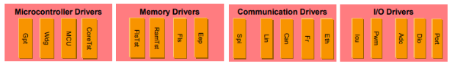**Based on previous exchanges, we will provide Microcontroller driver GPT module of MCAL layer model of autosar architecture follows AUTOSAR Classic standard (version 4.4.0) that can implement on Sam V71, ARM Cortex M7 Architechture.**

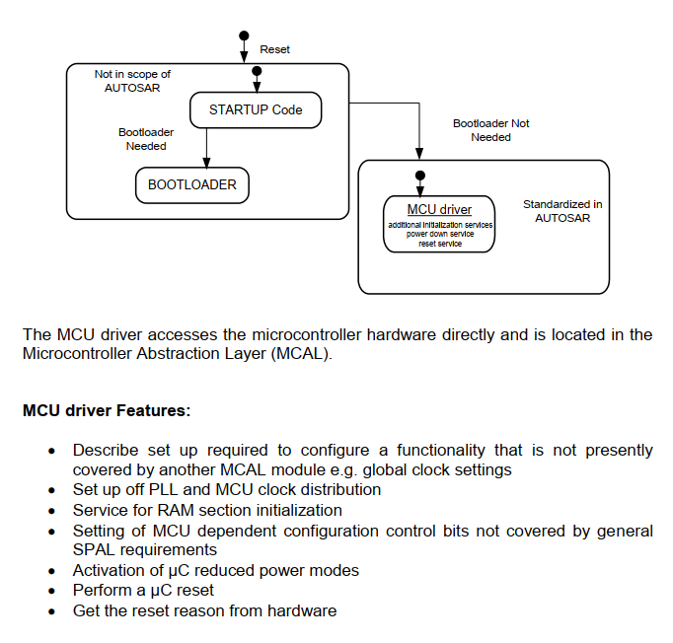**The main feature is follow Requirements on MCU Driver AUTOSAR CP Release 4.4.0**

**The API we make is follow section 8 of** Specification of GPT Driver  
AUTOSAR CP Release 4.4.0

**[Func1] Gpt_GetVersionInfo**

**[Func2] Gpt_Init**

**[Func3] Gpt_DeInit**

**[Func4] Gpt_GetTimeElapsed**

**[Func5] Gpt_GetTimeRemaining**

**[Func6]** **Gpt_StartTimer**

**[Func7] Gpt_StopTimer**

**[Func8] Gpt_EnableNotification**

**[Func9] Gpt_DisableNotification**

**[Func10] Gpt_SetMode**

**[Func11] Gpt_DisableWakeup**

**[Func12] Gpt_EnableWakeup**

**[Func13] Gpt_CheckWakeup**

**[Func14] Gpt_GetPredefTimerValue**

**About the functions prototype and how it work, please refer the *AUTOSAR_SWS_GPTDriver* AutoSar.**

1. **Necessary part**

**The table below shows the hardware / device requirements, documentation / software required or not, the specialized equipment that may be needed during the project, the authority to query the necessary resources. (server, network port, ...), etc.**

**There will be requests for FPT software to be self-sufficient or require the ordering party to provide.**

|  |  |  |  |
| --- | --- | --- | --- |
| **No.** | **Requirements** | **Descriptions** | **Require provide** |
| **1** | **SAM V71 Xplained Ultra Evaluation Kit** | **Using to testing and debuging.** | **x** |
| **2** | **Atmel Studio license** |  | **x** |
| **3** | **Sam V71 Datasheet** |  |  |
| **4** | Specification of GPT Driver AUTOSAR |  |  |
| **5** | Network Access authority to customer resource | **If needed** | **x** |

1. **Features and Deliverables**

**The end product is include the following part, and release at after 1 week since the contract signed:**

* **The API can porting on SAM V71 board with the function is follow the 3 section of this document.**
* **Things handed over that list in the 4 section of this document.**
* **Maintenance support for 1 week after handover**

1. **Implementation**

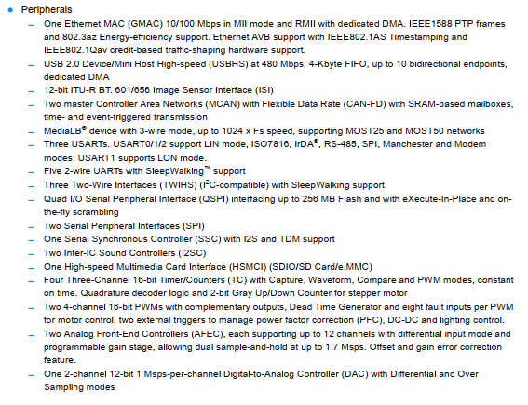**With SAM V71, we have these feature (focus on Timer/Counter module):**

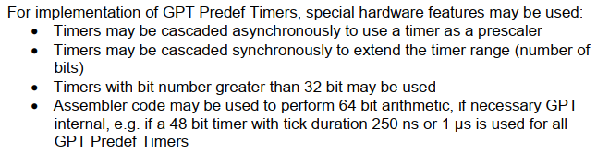**These fit with GPT module needed:**

1. **Scope and Limitations**

**Except for the items listed in section 5, the project does not include the following:**

* **The provider does not support deployment on the automotive system.**
* **The supplier does not support maintenance after more than 1 week from the time of handover.**
* **The supplier is not responsible for damages caused by improper implementation or damage from unchecked errors (listed in the accompanying test documentation when releasing the api).**
* **The supplier provides all the project source code to the customer without the copyright request, the customer is obliged to pay the project value.**

**However, it is still possible to negotiate the above provisions into a formal contract**

1. **Budget**

**Time is calculated based on the day an engineer needs to complete the task. Because the ability to work is based on the power of the team, so the experience of each engineer does not affect this estimate, so it is estimated based on the power of the group.**

**Proposing a budget based on an engineer's payday and a guarantee of profit for the business, paying engineer benefits.**

|  |  |  |  |
| --- | --- | --- | --- |
| **No.** | **Part** | **Time Consuming** | **Budget** |
| **1** | **Set up environment dev** | **4** | **…** |
| **2** | **Technology transfer**  **To learn about the SIM V71 board** | **4** | **…** |
| **3** | **Develope** | **8** | **…** |
| **4** | **Test and review source code** | **8** | **…** |
| **5** | **Pack and demo** | **4** | **…** |
| **6** | **Deploy and maintainent support** | **8** | **…** |

1. **Benefits**

**Customers will be supported by a professional team from FPT software, we have many years of experience in the field of automotive technology and are members of AutoSar.**

**Complete products, complying with AutoSar standards, delivered on time, which is our commitment.**

**Get support in the process of maintaining and consulting long-term system development.**

1. **Project Members**

**Product Owner**

**Mr/Ms. ABC – CEO of xxx Company**

**Headquarters 9 xyz street, xxx Dictrict**

**Contact: …**

**Project Manager**

**Mr/Ms. XYZ – Senior Engineer FGA LAB - FPT Software**

**Department …**

**Contact: …**

**Development Team**

|  |  |  |
| --- | --- | --- |
| **Name** | **Experience** | **Contact** |
| **Khánh Nguyễn** | **Team Leader - Intern**   * **Experienced working on embedded 32 bit systems.** * **Have skills in C programming language and computer hardware** | [KhanhNLD@fsoft.com.vn](mailto:KhanhNLD@fsoft.com.vn) |
| **ABC** | **Team Member – Intern**   * **Experienced working on Automobile Technology.** * **Have skills in C programming language and computer hardware** | [ABC@fsoft.com.vn](mailto:ABC@fsoft.com.vn) |
| **XYZ** | **Team Member – Intern**   * **Experienced working on ARM computer architechture.** * **Have skills in electronic circuit design.** | [XYZ@fsoft.com.vn](mailto:XYZ@fsoft.com.vn) |
| **MNP** | **Team Member – Intern**   * **Have good background an experienced working on semiconductor technology.** | [MNP@fsoft.com.vn](mailto:MNP@fsoft.com.vn) |

1. **Approvals**

**The terms of this document are the basis for the solution provider to discuss with the customer and may change after discussion.**

**By signing the space below, we (Product Owner and solution provider) both agree with the terms written in this document.**

**After being signed, all changes arising during project implementation that are not included in this document are not valid and require both parties to discuss.**

**This document is intended to address the specific requirements of the customer and the ability of the solution provider to meet, not the project contract and cannot replace the project contract.**

|  |  |
| --- | --- |
| **Product Owner** | **Project Manager** |
| **Mr/Ms. ABC** | **Mr/Ms. XYZ** |