**_________________________**

**Classes Design**

**for**

**The Automatic**

**Attendance Checking System**

**Version 1.0**

**Prepared by Huynh Vinh Nam**

**Le Huy Duc**

**Cao Phuong Linh**

**OOAD Group 2**

**21-Dec-2018**

**Table of Contents**

**Revision History**

|  |  |  |  |
| --- | --- | --- | --- |
| **Name** | **Date** | **Reason for Changes** | **Version** |
| Huynh Vinh Nam | 21-Dec-2018 | Create document template | 1.0 |
|  |  |  |  |
|  |  |  |  |
|  |  |  |  |
|  |  |  |  |
|  |  |  |  |
|  |  |  |  |

**1. Introduction**

**1.1. Purpose**

This is a report on the subject Object-oriented Analysis and Design of group two, class ICT-BI7 about Run-time Architecture Solution.

The report is written based on the reporting format “IEEE Std 830-1998 IEEE Recommended Practice for Software Requirements Specifications”. Content-based report is accepted and be satisfied with group meeting minute on 24-Dec-2018 at room 318, building 2A of VAST, Hanoi.

**1.2. Intended Audience and Reading Suggestions**

*The different types of reader that the document is intended for are:*

**● Project managers:** who manage and take respond for the quality of the system. Project

managers should read the whole document for planning and assigning work.

**● Developers:** Dev is the person who implement the system from the design and documents into a runnable version. Dev have to read the whole document to implement the right system.

**● Documentation writers:** who will write the future document (report, minutes).

Documentation writers should read to understand the Use Case Main Diagram part.

This section describes the Class Design Solution. Design Classes are used to define operations, states, attributes, dependencies and associations, generalizations.

**1.3. Product Scope**

The software’s main users are students and lecturers. Software will create an environment where user (student) can check for the attendance and user (lecturer) can view and/or manage the attendance list in the course(s).

**1.4. References**

[1] Form of presentation IEEE. IEEE Std 830-1998 IEEE Recommended Practice for Software Requirements Specifications. IEEE Computer Society, 1998.

**2. Classes Design**

**2.1. Define Operations**

**2.1.1. Use Case Realization - Lecturer Use Case**

**Sign In - VOPC**

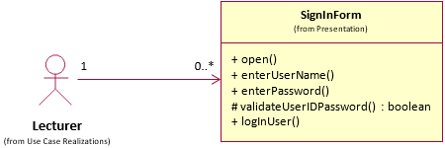

*Figure 1: Use Case Realization - Lecturer Use Case - Sign In VOPC*

**2.1.2. Use Case Realization - Student Use Case**

**Checking Attendance - VOPC**

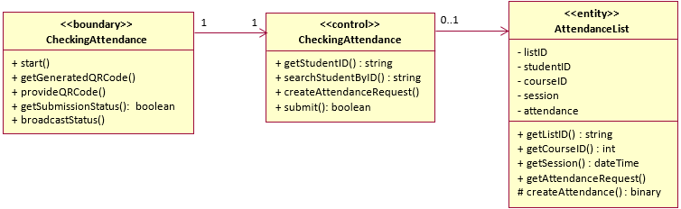

*Figure 2: Use Case Realization - Student Use Case - Checking Attendance VOPC*

**2.2. Define States**

**2.2.1. Lecturer**

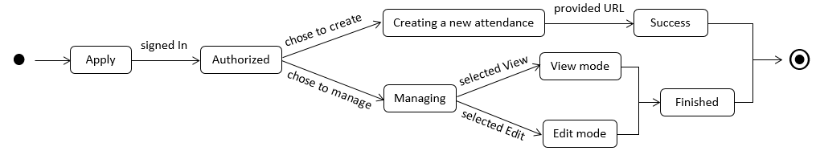

*Figure 3: Lecturer states diagram*

**2.2.2. Student**



*Figure 4: Student states diagram*