**_________________________**

**Database Design**

**for**

**The Automatic**

**Attendance Checking System**

**Version 1.2**

**Prepared by Huynh Vinh Nam**

**Le Huy Duc**

**Cao Phuong Linh**

**OOAD Group 2**

**22-Dec-2018**

**Table of Contents**

**Revision History**

|  |  |  |  |
| --- | --- | --- | --- |
| **Name** | **Date** | **Reason for Changes** | **Version** |
| Huynh Vinh Nam | 22-Dec-2018 | Create document template | 1.0 |
| Huynh Vinh Nam | 22-Dec-2018 | Add Picture from model file | 1.1 |
| Huynh Vinh Nam | 23-Dec-2018 | Database Finalize | 1.2 |
|  |  |  |  |
|  |  |  |  |
|  |  |  |  |
|  |  |  |  |

**1. Introduction**

**1.1. Purpose**

This is a report on the subject Object-oriented Analysis and Design of group two, class ICT-BI7 about Run-time Architecture Solution.

The report is written based on the reporting format “IEEE Std 830-1998 IEEE Recommended Practice for Software Requirements Specifications”. Content-based report is accepted and be satisfied with group meeting minute on 24-Dec-2018 (Facebook messenger).

**1.2. Intended Audience and Reading Suggestions**

*The different types of reader that the document is intended for are:*

**● Project managers:** who manage and take respond for the quality of the system. Project

managers should read the whole document for planning and assigning work.

**● Developers:** Dev is the person who implement the system from the design and documents into a runnable version. Dev have to read the whole document to implement the right system.

**● Database Designer:** is the person determines what data must be stored and how the data elements interrelate.

**● Documentation writers:** who will write the future document (report, minutes).

Documentation writers should read to understand the Use Case Main Diagram part.

This section describes the Database Design Solution. Designed Database is the organisation of data according to the database model in the AACS. The database will persist important data from our domain model, also configurations of the software and so on.

**1.3. Product Scope**

The software’s main users are students and lecturers. Software will create an environment where user (student) can check for the attendance and user (lecturer) can view and/or manage the attendance list in the course(s).

**1.4. References**

[1] Form of presentation IEEE. IEEE Std 830-1998 IEEE Recommended Practice for Software Requirements Specifications. IEEE Computer Society, 1998.

**2. Database Design**

**2.1. Table Design**

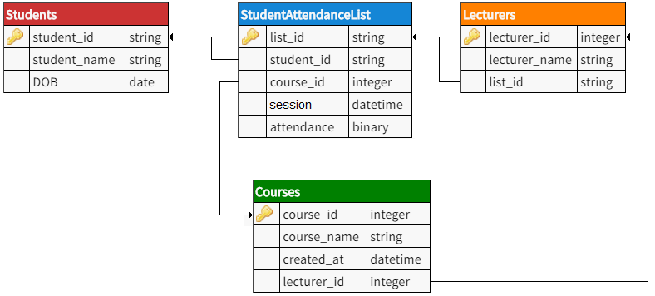

*Figure 1: Database Table Design*

**2.2. Table Descriptions**

* **Students table:** This table contains all informations belong to a student class, such as Student’s ID, Name and Date of Birth (DOB). The Student Profile data will be implemented in University package (from Domain).
* **StudentAttendanceList table:** This table contains information of attendance for each session/lecture. Each list also has an unique List ID so the Lecturer can easily manage his/her own attendance list(s).
* **Lecturers table:** This table contains Lecturer’s profile information. The Lecturer Profile data will be implemented in Lecture package (from Domain).
* **Courses table:** This table contains all informations about the existing courses. The Course catalogue data will be implemented in Lecture package (from Domain).