**_________________________**

**Use Case Design**

**for**

**The Automatic**

**Attendance Checking System**

**Version 1.2**

**Prepared by Huynh Vinh Nam**

**Le Huy Duc**

**Cao Phuong Linh**

**OOAD Group 2**

**21-Dec-2018**

**Table of Contents**

**Revision History**

|  |  |  |  |
| --- | --- | --- | --- |
| **Name** | **Date** | **Reason for Changes** | **Version** |
| Huynh Vinh Nam | 21-Dec-2018 | Create document template | 1.0 |
| Huynh Vinh Nam | 22-Dec-2018 | Add Picture from model file | 1.1 |
| Huynh Vinh Nam | 24-Dec-2018 | Add Manage Attendance | 1.2 |
|  |  |  |  |
|  |  |  |  |
|  |  |  |  |
|  |  |  |  |

**1. Introduction**

**1.1. Purpose**

This is a report on the subject Object-oriented Analysis and Design of group two, class ICT-BI7 about Use Case Analysis Solution.

The report is written based on the reporting format “IEEE Std 830-1998 IEEE Recommended Practice for Software Requirements Specifications”. Content-based report is accepted and be satisfied with group meeting minute on 19-Dec-2018 at room 602, building A21 of VAST, Hanoi.

**1.2. Intended Audience and Reading Suggestions**

*The different types of reader that the document is intended for are:*

**● Project managers:** who manage and take respond for the quality of the system. Project

managers should read the whole document for planning and assigning work.

**● Developers:** Dev is the person who implement the system from the design and documents into a runnable version. Dev have to read the whole document to implement the right system.

**● Documentation writers:** who will write the future document (report, minutes).

Documentation writers should read to understand the Use Case Main Diagram part.

*The content of report includes two main parts:*

**● Part 1 Use Case Design:** is when the Use Case implementations are verified for consistency. This means that for all the use-case realizations for each use case, the following items are verified: all the necessary behavior to support a use-case implementation has been distributed among the appropriate participating classes, the use case flows naturally over the participating design elements, all associations between design elements (classes or subsystems) needed for the use-case realizations have been defined and all of the attributes needed for the use-cases have been defined.

**1.3. Product Scope**

The software’s main users are students and lecturers. Software will create an environment where user (student) can check for the attendance and user (lecturer) can view and/or manage the attendance list in the course(s).

**1.4. References**

[1] Form of presentation IEEE. IEEE Std 830-1998 IEEE Recommended Practice for Software Requirements Specifications. IEEE Computer Society, 1998.

[2] Use Case Design Solution for CariGO, OOAD group 1, version 2.4 approved

[3] Glossary for AACS, OOAD group 2, Huynh Vinh Nam

[4] Use Case Model for AACS, OOAD group 2

**2. Use Case Design Diagrams**

**2.1. Sign In**

**2.1.1 Sign In - Basic Flow - Security**

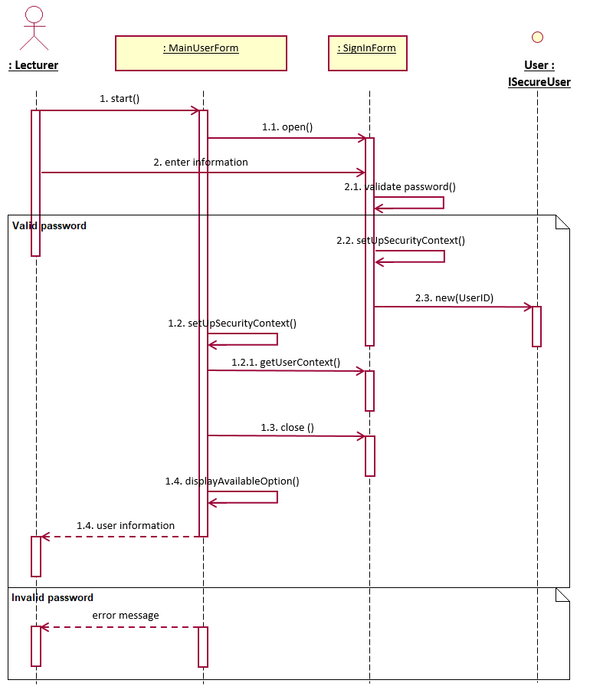

*Figure 1: Sign In (with Security) Sequence diagram*

**2.1.2 Sign In - Basic Flow - Security - VOPC**

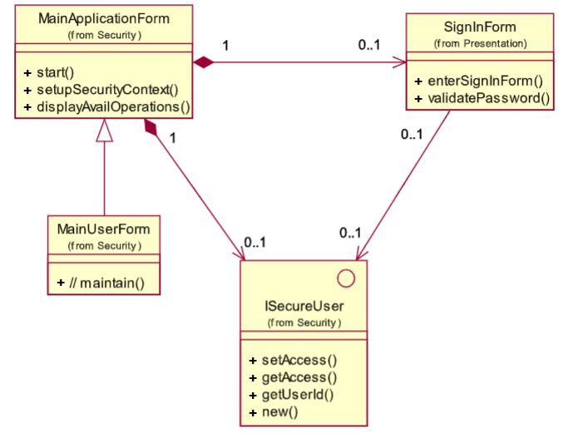

*Figure 2: Sign In (with Security) VOPC diagram*

**2.2. Generate QR Code**

**2.2.1 Generate QR Code - Basic Flow**

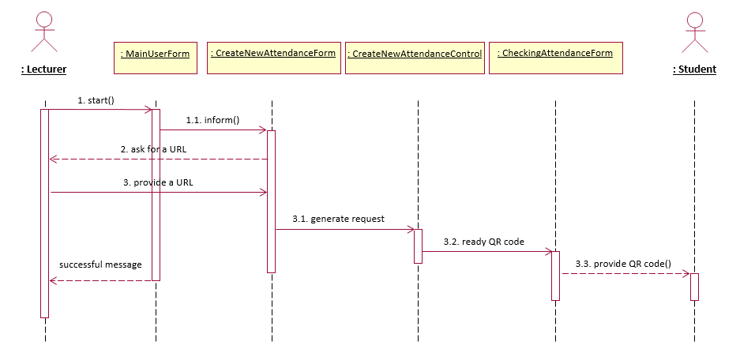

*Figure 3: Generate QR Code Sequence diagram*

**2.2.2 Generate QR Code - Basic Flow - VOPC**

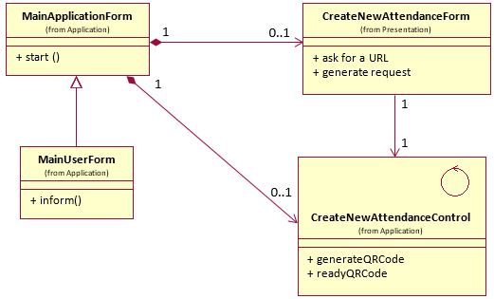

*Figure 4: Generate QR Code VOPC Sequence diagram*

**2.3. Checking Attendance**

**2.3.1 Checking Attendance - Basic Flow**

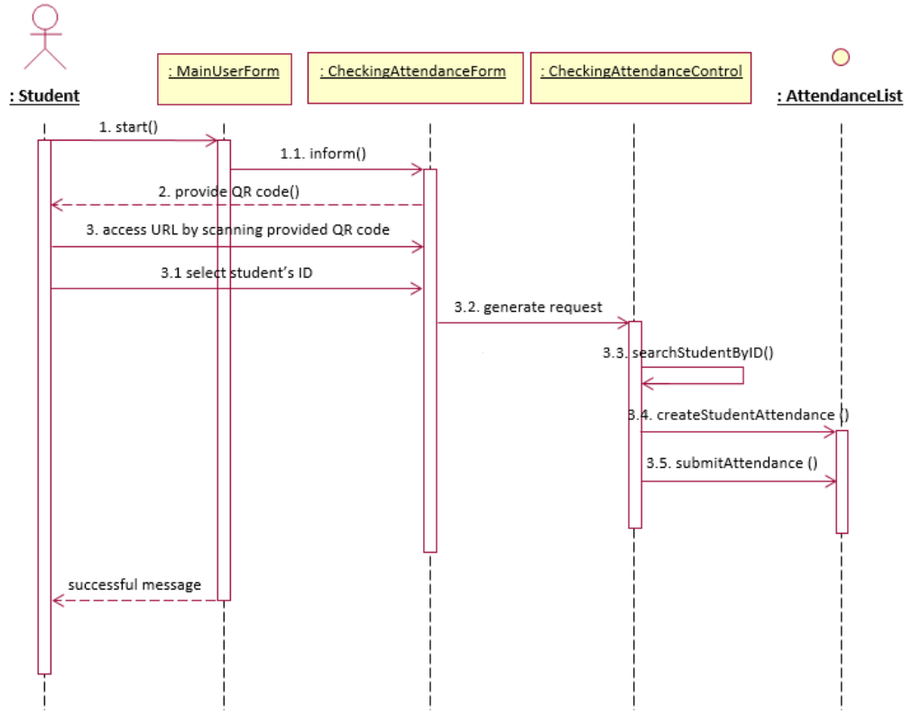

*Figure 5: Checking Attendance Sequence diagram*

**2.3.2 Checking Attendance - Basic Flow - VOPC**

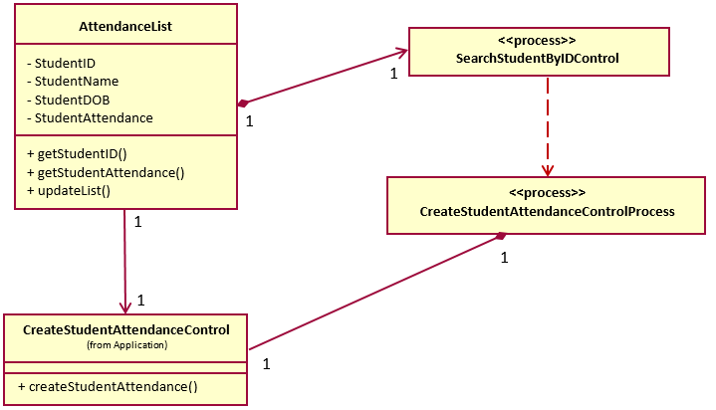

*Figure 6: Checking Attendance VOPC diagram*

**2.4. Manage Attendance**

**2.4.1 Manage Attendance - Basic Flow**

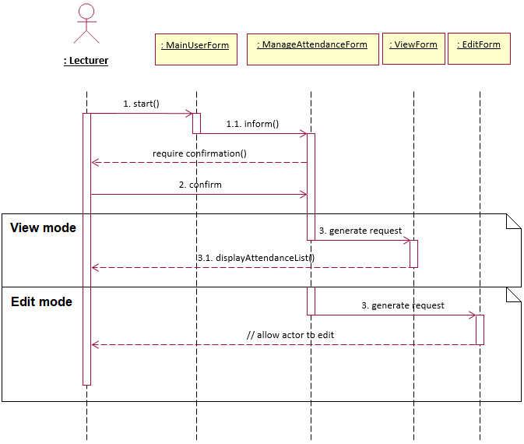

*Figure 7: Manage Attendance Sequence diagram*

**2.4.2 Manage Attendance - Basic Flow - VOPC**

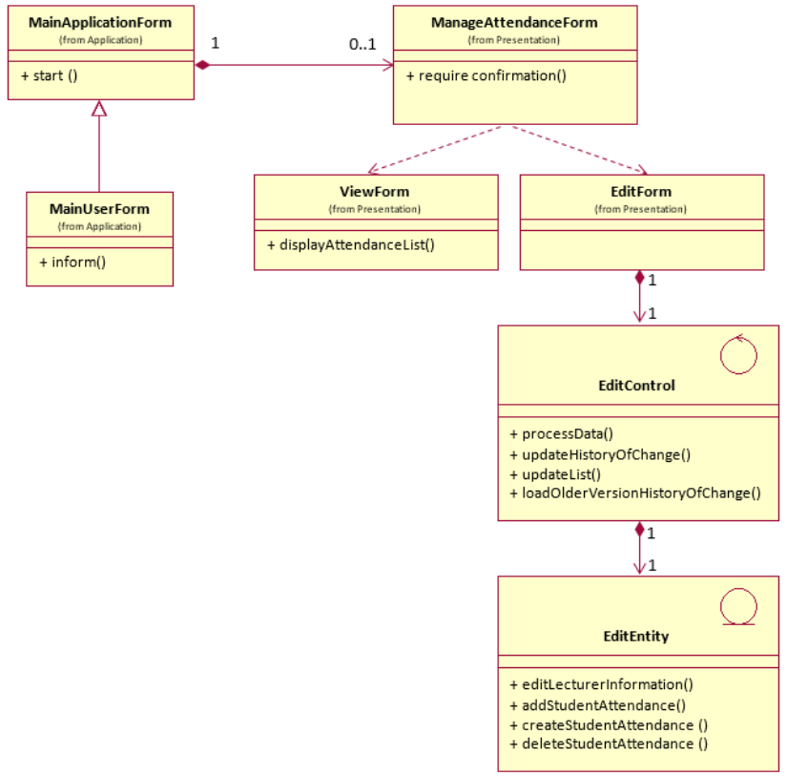

*Figure 8: Manage Attendance VOPC diagram*