**_________________________**

**Use Case Analysis**

**for**

**The Automatic**

**Attendance Checking System**

**Version 1.0**

**Prepared by Huynh Vinh Nam**

**Le Huy Duc**

**Cao Phuong Linh**

**OOAD Group 2**

**15-Dec-2018**

**Table of Contents**

**Revision History**

**1. Introduction**

**1.1. Purpose**

This is a report on the subject Object-oriented Analysis and Design of group two, class ICT-BI7 about Use Case Analysis of the project AACS.

**1.2. Intended Audience and Reading Suggestions**

**Role Designer:** The designer role defines the responsibilities, operations, attributes, and relationships of one or several classes, and determines how they will be adjusted to the implementation environment. In addition, the designer role may have responsibility for one or more design packages, or design subsystems, including any classes owned by the packages or subsystems.

*The different types of reader that the document is intended for are:*

**● Project managers:** who manage and take respond for the quality of the system. Project

managers should read the whole document for planning and assigning work.

**● Developers:** Dev is the person who implement the system from the design and documents

into a runnable version. Dev have to read the whole document to implement the right system.

**● Tester:** Tester should read the detail to write unit test particularly.

**● Documentation writers:** who will write the future document (report, minutes).

Documentation writers should read to understand the Use Case Main Diagram part.

**2. Use Case Realization Interaction Diagrams**

**2.1. Sign In**

**2.1.1. Sign In - Basic Flow**

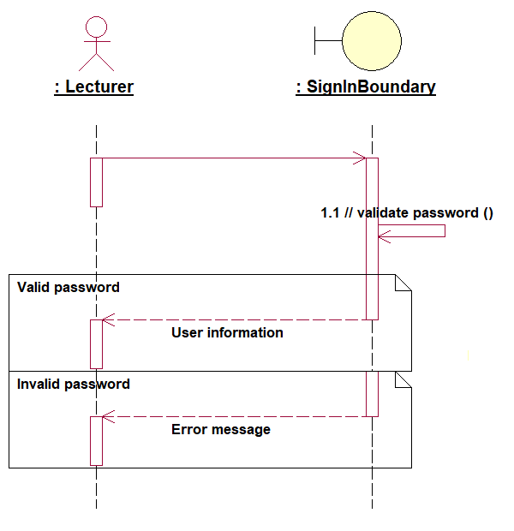

*Figure 1: Sign In Sequence diagram*

**2.1.2. Forgot Password - Sub Flow**

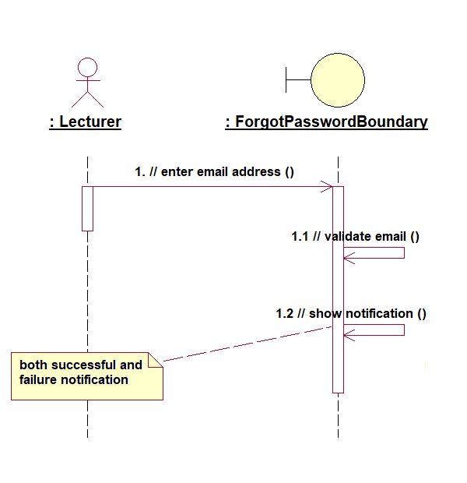

*Figure 2: Forgot Password Sequence diagram*

**2.2. Generate QR Code**

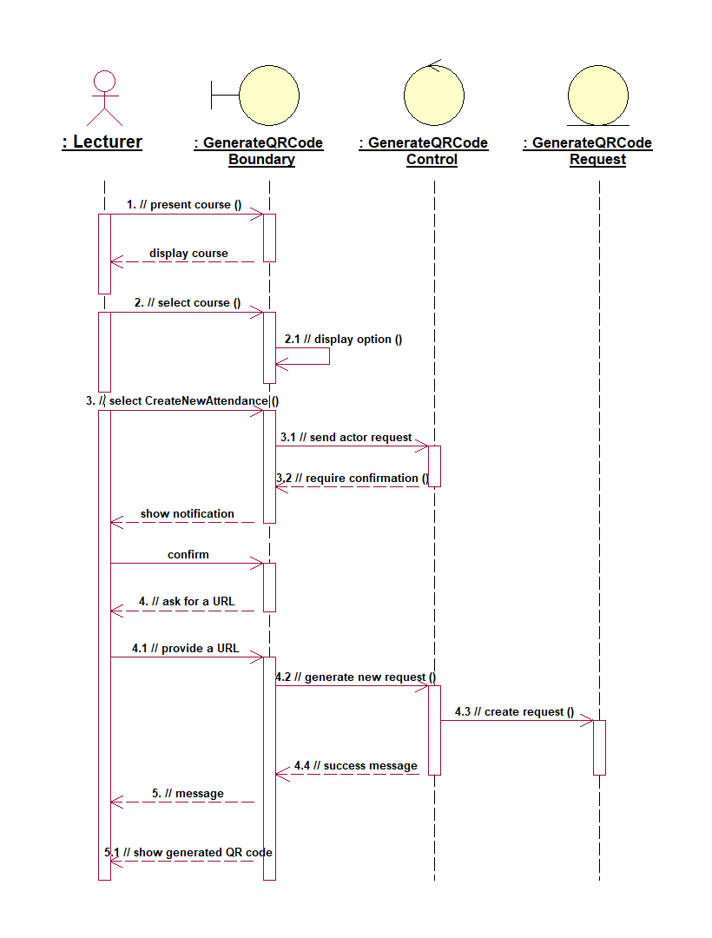

*Figure 3: Generate QR Code Sequence diagram*

**2.3. Checking Attendance**

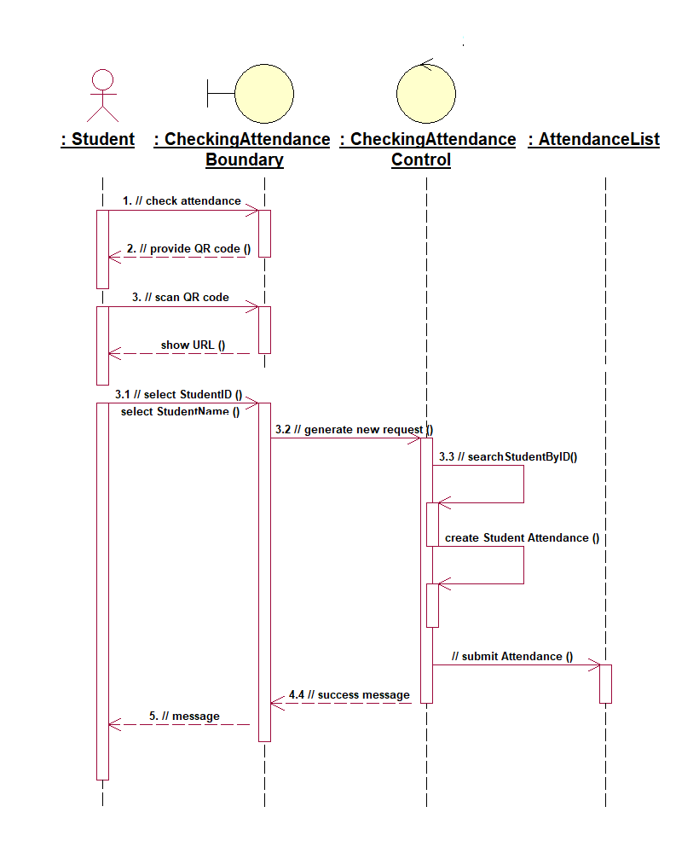

*Figure 4: Checking Attendance Sequence diagram*

**2.4. View the checklist**

**2.4.1. View - Basic Flow**

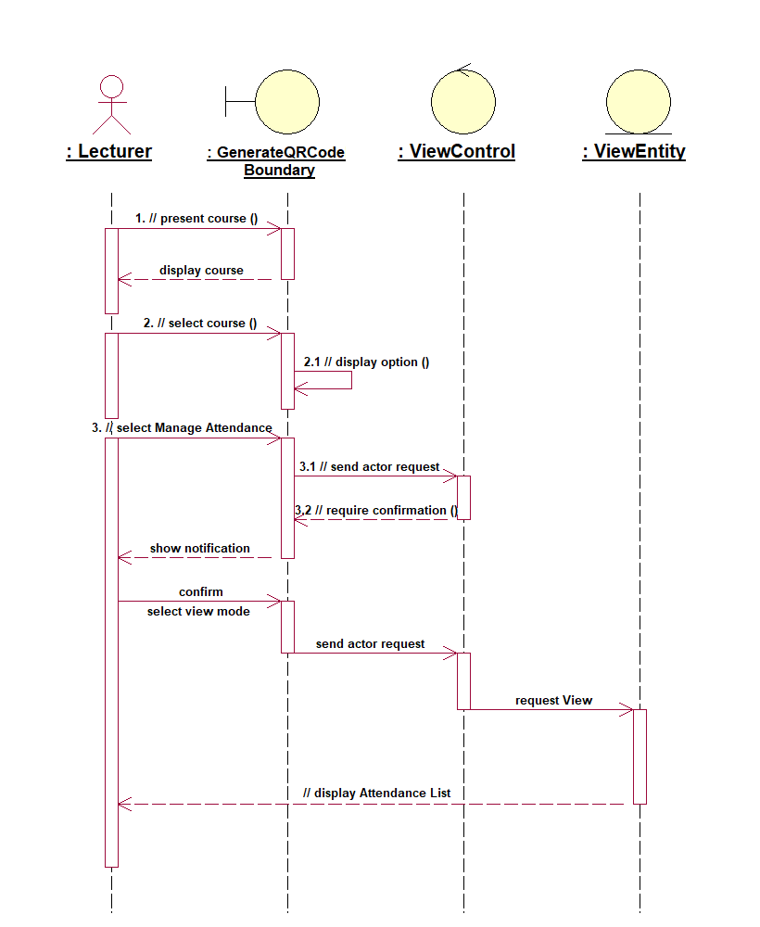

*Figure 5: View Sequence diagram*

**2.4.2. Edit - Sub Flow**

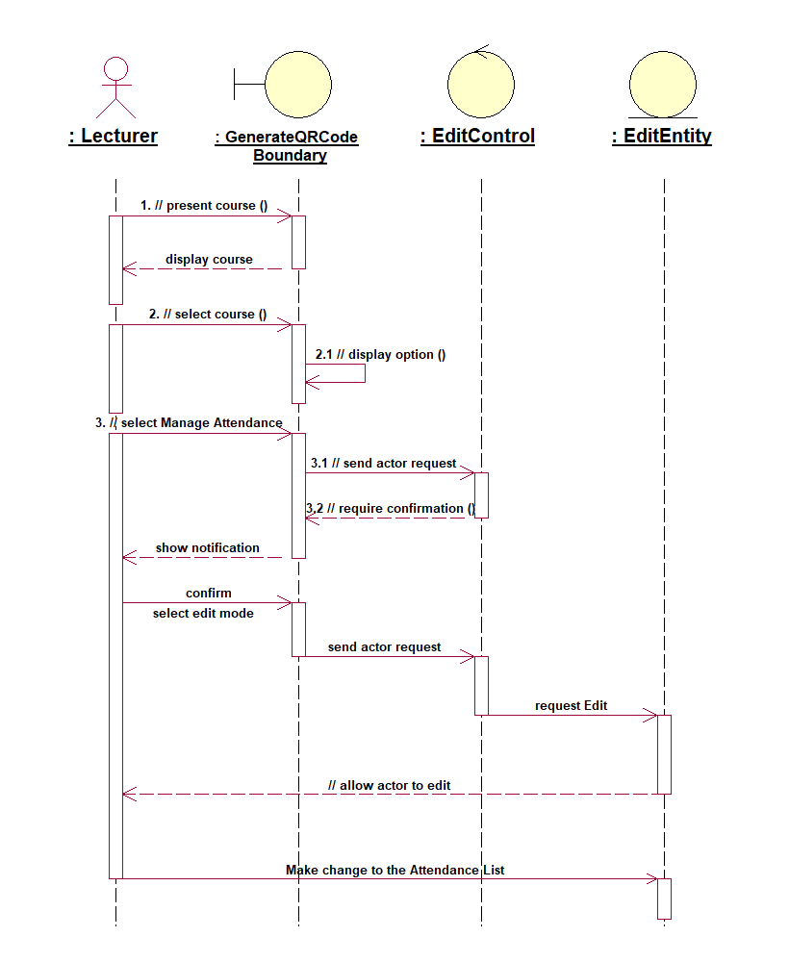

*Figure 6: Edit Sequence diagram*

**3. Use Case Realization View of Participating Classes (VOPCs)**

**3.1. Sign In**

**3.1.1. Sign In - VOPC**

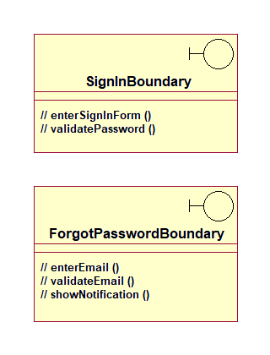

*Figure 7: Sign In - VOPC*

**3.2. Generate QR Code**

**3.2.1. Generate QR Code - VOPC**

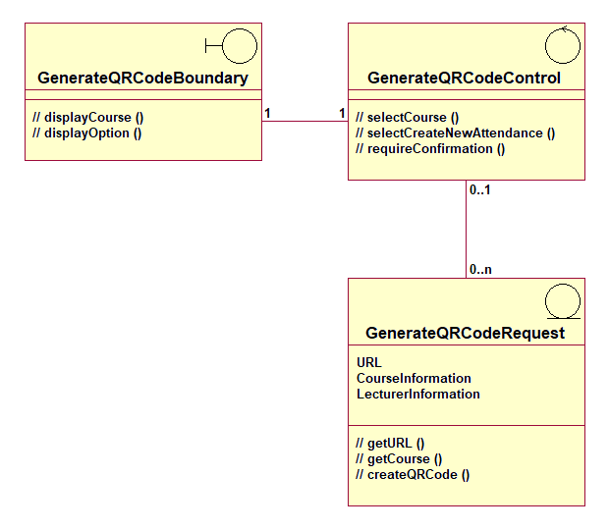

*Figure 8: Generate QR Code - VOPC*

**3.3. Checking Attendance**

**3.3.1. Checking Attendance - VOPC**

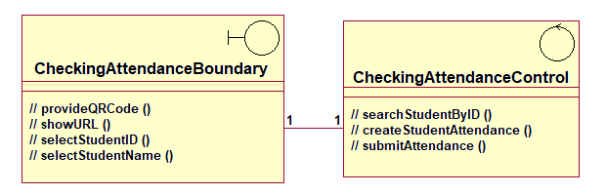

*Figure 9: Checking Attendance - VOPC*

**3.4. View the checklist**

**3.4.1. View - VOPC**

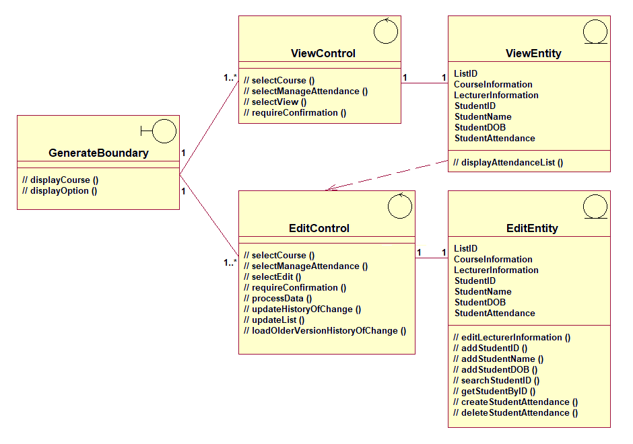

*Figure 10: View - VOPC*

**4. Analysis Class to Analysis Mechanism Map**