Dashboard User Guide

Dashboard project is an internal project of SMSVN. This project will build a system which help SMSVN to:
- Replace Daily report system
- Replace Human Resource Control system
- Summarize project cost realtime.

Here is the user guide:

- Login:

Please goto this URL to login Dashboard:
http://dashboard.bm-sms.com.vn

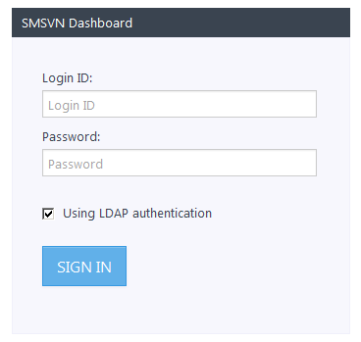
On, login form, please input your SMSVN LDAP account (which you use to login SMSVN Server)

- Missing Reports:

After login, Dashboard system will show your missing reports.
There are 2 types of missing reports:
+ Time missing: you forgot to input a period in your daily report -> The daily time is not 8 hour. So you have to add the missing time.
+ Day missing: when you forget to input daily report in a day, or you have a day-off -> Dashboard system will show a "day missing", so you have to input the missing time by
- clicking on "Chi Tiết" and choose category is "Time-off"
- then, choose process is "Time-off"
- finally, please add a simple text on note and click Save.

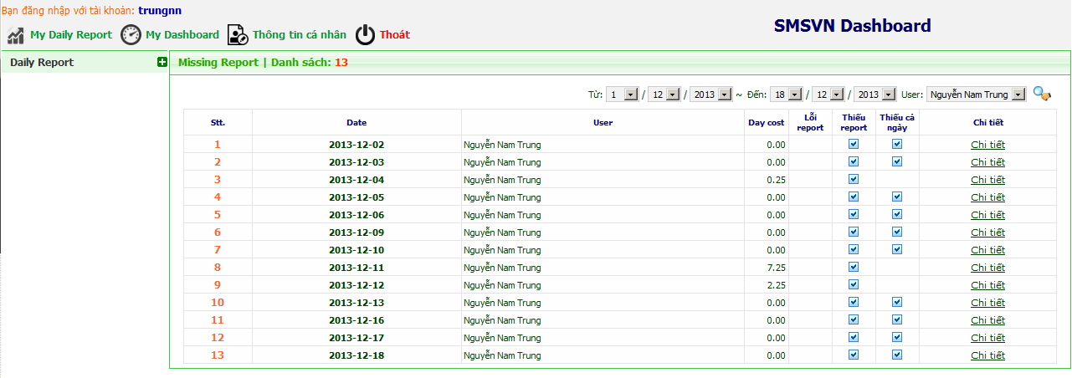

- Daily Report:

In order to update your "Daily Report", please click on "My Daily Report"

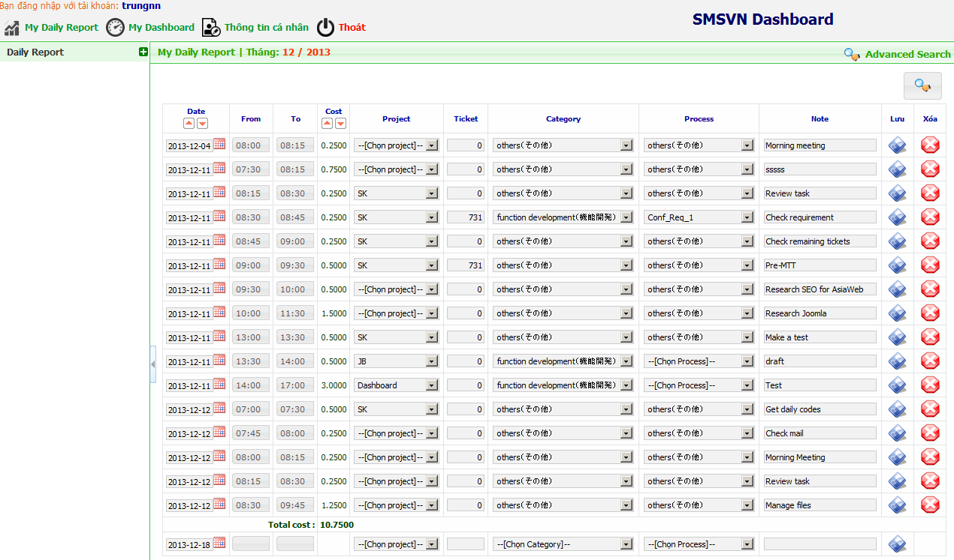

In "Daily Report", Dashboard system lists your current month records and input form where you can add record:

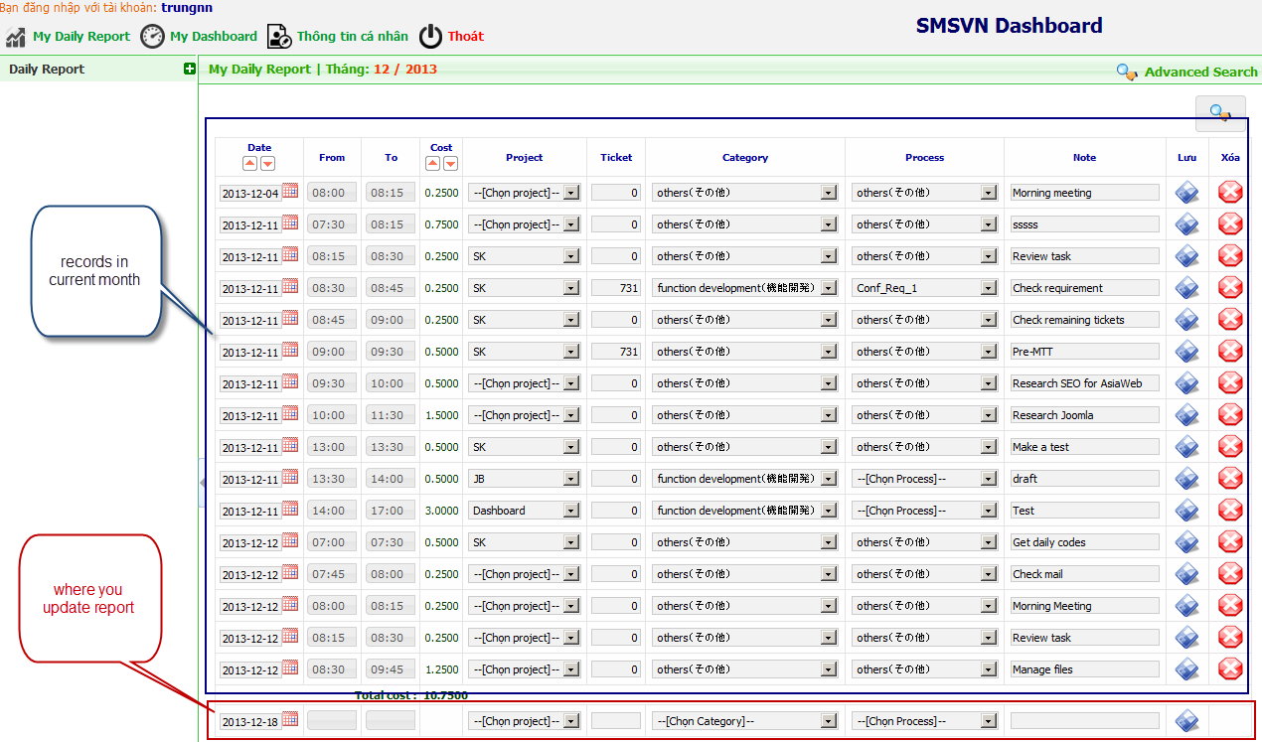

Steps to update records:
- From - To: please input the time with format HH:MM (Example: 08:15). Note: the minutes are multipled by 15.
- Project: please choose the project in drop-down list.
- Ticket: please input ticket number. Note: please input one ticket only in each row.
- Category - Process: please choose the suitable category or process in drop-down list
- Note: please input the note of your work.
- Click Save.

- My Dashboard:

My dashboard will show your work quotation and real workload in each projects you're taking parts in.

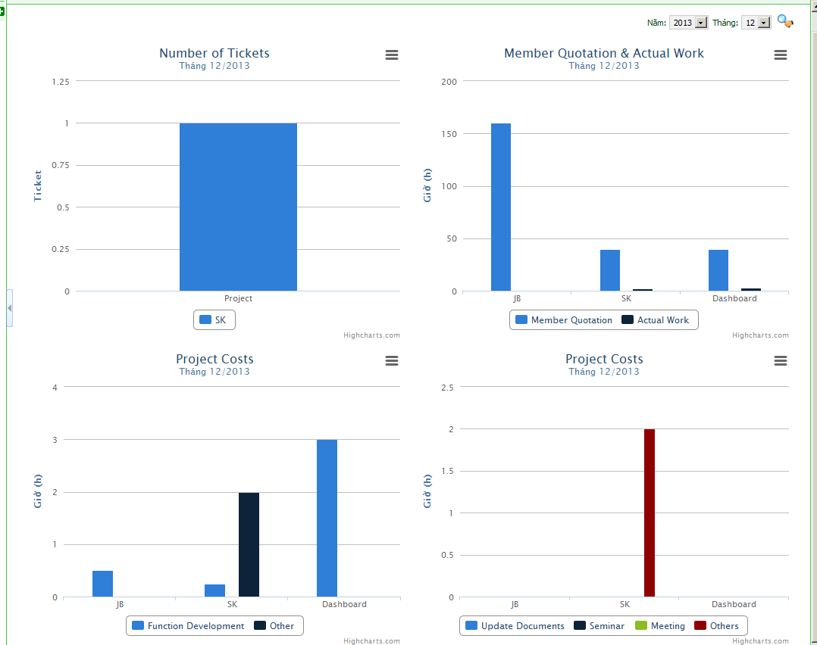

- Personal Information:

If you want to change the password, you can change it in "Personal Information" part.

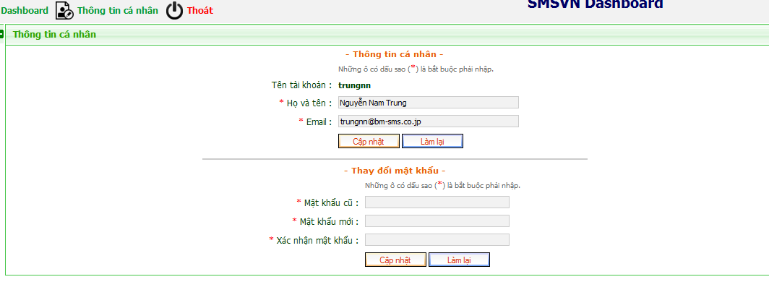

-----------------------------END OF DOCUMENT-----------------------------

