
CAPSTONE PROJECT REPORT
Report 2 – Project Management Plan

– Hanoi, September 2026 –
Table of Contents
I. Record of Changes 3
II. Project Management Plan 4
1. Overview 4
1.1 Scope & Estimation 4
1.2 Project Objectives 7
1.3 Project Risks 7
2. Management Approach 10
2.1 Project Process 10
2.2 Quality Management 11
2.2.1 Defect Prevention 11
2.2.2 Reviewing 12
2.2.3 Unit Testing 12
2.2.4 Integration Testing 12
2.2.5 System Testing 12
2.2.6 Acceptance Testing 12
2.3 Training Plan 12
2.4 Scope & SRS Change Control (optional) 13
3. Project Deliverables 15
4. Responsibility Assignments 16
4.1 Team Structures 16
4.2 Responsibility Assignments 17
5. Project Communications 18
6. Configuration Management 18
6.1 Document Management 18
6.2 Source Code Management 19
6.3 Tools & Infrastructures 19
6.4 Environments & Deployment 20

I. Record of Changes

Date | A* M, D | In charge | Change Description
08/10/2026 | A | All team members | Create initial draft of Project Management Plan: Scope & Estimation, Objectives, Risks, Management Approach, Deliverables, Responsibility Assignments, Communications, and Configuration Management.
08/10/2026 | M | All team members | Update technology stack (ASP.NET Core Web API, React, Microsoft SQL Server), deployment approach and environments, test approach, project risks, training plan, add the optional Docker task, and align the scope with the revised SRS (single Teacher role).
08/10/2026 | M | All team members | Update the plan for a five-member team (team structure, responsibility assignments, training), switch to a backlog-driven Iterative & Incremental model and add the optional controlled change process for minor scope/SRS changes (Section 2.4).
08/10/2026 | M | All team members | Align all dates, deliverables and iteration scope with the SEP490_G45 Incremental Project Tasklist (Fall 2026): re-balance the WBS effort to the working days of each iteration, add the capacity check, the schedule risk and the new training dates.
*A - Added M - Modified D - Deleted

II. Project Management Plan

1. Overview

1.1 Scope & Estimation
SAWP is estimated at 284 man-days across six WBS groups, delivered in three increments over the Fall 2026 term, from 07/09/2026 to 23/12/2026 (78 working days). The scope follows Report 3 (SRS): 9 feature groups, 66 use cases and 71 screens for seven user roles (Guest, Parent, Teacher, Office Staff, Lunch Service Staff, School Board, System Administrator) and the external Email Service. Homeroom and subject teaching are assignments of the single Teacher role, not separate roles. The effort is about 57 man-days for each of the five team members.
The schedule follows the SEP490_G45 Incremental Project Tasklist (Fall 2026): the SRS is finished on 08/10/2026, Iteration 1 runs 09/10–29/10 (15 working days), Iteration 2 runs 30/10–12/11 (10 days) and Iteration 3 runs 13/11–10/12 (20 days). The effort of each iteration is sized to these working days (see the capacity check below), so Iteration 2 only holds the attendance and leave features.
The SRS is the baseline backlog; details are refined during the iterations. Because the team learns the school domain while building the system, minor scope or SRS adjustments may optionally be made through the change control in Section 2.4 (WBS 6.1); such changes are capped and are not part of the total below.
# | WBS Item | Complexity | Est. Effort (man-days)
1 | Project Initiation & Documents |  | 54
1.1 | Project Idea (07/09–15/09) | Simple | 4
1.2 | Report 1 – Project Introduction (16/09–24/09) | Simple | 6
1.3 | Report 2 – Project Management Plan (25/09–08/10) | Medium | 8
1.4 | Report 3 – SRS (66 use cases, 71 screens, ERD) (25/09–08/10) | Complex | 20
1.5 | Report 4 – Software Design (09/10–03/11) | Complex | 16
2 | Code & Implement Iteration 1 – Foundation & Core Records (09/10–29/10) |  | 54
2.1 | Configuration, setup environment, create base projects (ASP.NET Core Web API, React app) | Simple | 6
2.2 | Authentication, session, profile, account activation and password recovery by e-mailed code | Medium | 8
2.3 | User accounts, roles & permissions, staff records and staff import, account–profile linking | Complex | 12
2.4 | Student & guardian records, student import, administrative history | Medium | 10
2.5 | School years, classes, school calendar, class schedule and teaching assignments | Complex | 12
2.6 | Unit test, integration test and bug fixing Iteration 1 | Medium | 6
3 | Code & Implement Iteration 2 – Attendance & Leave (30/10–12/11) |  | 32
3.1 | Daily attendance recording (by the teacher of the first session of the day or the Homeroom Teacher), attendance window and corrections | Complex | 12
3.2 | Leave requests, Teacher review and School Board escalation | Complex | 12
3.3 | Unit test, integration test and bug fixing Iteration 2 | Medium | 8
4 | Code & Implement Iteration 3 – Lunch, Requests, Communication & Reporting (13/11–10/12) |  | 68
4.1 | School lunch: service months/days, registration, per-day cancellation, meal counts, staff adjustments | Complex | 16
4.2 | Class transfer and school document requests, request tracking, additional information and cancellation | Complex | 14
4.3 | Notifications, announcements and public landing page | Medium | 8
4.4 | Role dashboards and operational reports (student/class, attendance, lunch, requests) | Complex | 14
4.5 | Audit logs, reference data, notification templates, system settings | Medium | 8
4.6 | Unit test, integration test and bug fixing Iteration 3 | Medium | 8
5 | Testing, Hardening, Guides & Closure |  | 60
5.1 | Report 5 – Test Document: test plan, test cases, test reports (04/11–10/12) | Medium | 16
5.2 | System test (create test cases 04/11–12/11, execute 13/11–03/12) and acceptance test (04/12–10/12) | Medium | 12
5.3 | Security and performance hardening; production deployment on a hosted environment (ready by 03/12, before acceptance testing), staging and fallback via tunnel and Cloudflare (26/11–23/12) | Medium | 8
5.4 | Fix defects from the system and acceptance tests; final regression (11/12–23/12) | Medium | 8
5.5 | Report 6 – Software Guides: installation guide, user manual (11/12–17/12) | Simple | 6
5.6 | Final code, final report and defense slides (11/12–23/12) | Medium | 10
5.7 | Optional: Docker packaging and Docker Compose deployment (recommended to ease the move to production; not counted in the total) | Simple | (3)
6 | Project Management (planning, tracking, weekly meetings, reviews) | Medium | 16
6.1 | Optional: controlled minor scope/SRS changes found while learning the school domain (Section 2.4; capped, not counted in the total) | Medium | (10)
 | Total Estimated Effort (man-days) |  | 284
Optional items (WBS 5.7 and 6.1) are shown in parentheses and are not included in the total. Dates in brackets are start–finish dates of 2026 from the Incremental Project Tasklist.
Capacity check. With five members the team has 5 person-days per working day. Effort is placed in the phase where the tasklist runs it; Report 4 (16) and Report 5 (28) are split across the phases they overlap, and Project Management (16) is spread over all phases. Training is part-time, runs in the first phase and is not counted in the WBS.
Phase (tasklist) | Dates (2026) | Working days | Capacity (person-days) | Planned effort | Load
Project Idea, Reports 1–3 | 07/09–08/10 | 24 | 120 | 38 | 32%
Iteration 1 + 13 of Report 4 | 09/10–29/10 | 15 | 75 | 67 | 89%
Iteration 2 + rest of Report 4, system test cases | 30/10–12/11 | 10 | 50 | 45 | 90%
Iteration 3 + system test execution, acceptance test | 13/11–10/12 | 20 | 100 | 86 | 86%
Hardening, defect fixes, Report 6, final code and report | 11/12–23/12 | 9 | 45 | 32 | 71%
Total (without Project Management) | 07/09–23/12 | 78 | 390 | 268 | 69%
Table 1.1.1. Effort versus capacity per phase

1.2 Project Objectives
The team commits to the six FPT capstone quality metrics below; Actual is filled in at project closure.
# | Metric | Unit | Committed | Actual | Notes / Refs
1 | Effort Usage | Person-day | <= 284 |  | Based on total estimated effort
2 | Defect Rate | No. Def/MM | <= 9.0 |  | Dev: 4.2/9.0/13.4; Maintain: 0/5.5/8.1
3 | Review Efficiency | % | >= 45% |  | Dev: 40/45/50; Maintain: 45/50/55
4 | Leakage Rate | No. Def/MM | <= 0.13 |  | Dev: 0/0.13/0.53; Maintain: 0/0.07/0.38
5 | Timeliness | % | >= 95% |  | 90/95/100
6 | Requirement Completeness | % | >= 95% |  | 90/95/100 (failed if <= 75%); measured against the SRS baseline plus approved change requests

1.3 Project Risks
# | Risk Description | Impact | Possibility | Response Plans
1 | Requirement changes: school policies still open in the SRS (leave-escalation threshold, document types needing School Board approval, administrator account recovery) change business logic during implementation. | Medium | High | Close each open decision with the supervisor before the iteration that implements it. Keep the rule configurable where the SRS allows it. Route every change through the change control in Section 2.4 and manage scope through the product backlog.
2 | Authorization errors: role and data-scope rules (linked child, assigned class, teaching assignment) leak student data to the wrong user. | High | Medium | Enforce access in one back-end authorization layer, never only in the UI. Write test cases per role for every protected endpoint.
3 | Domain knowledge gap: no member has worked in a primary school and there is no real school stakeholder, so workflows and rules in the SRS may be incomplete or differ from how a school actually works. Gaps are likely to surface during development. | High | High | Hold the school-domain walkthrough at the start and review workflows with the supervisor each iteration. Interview at least one teacher or school office staff member before Iteration 2. Fix minor gaps through the optional change control in Section 2.4 instead of ad-hoc coding.
4 | E-mail delivery: activation and password-recovery codes are delayed or marked as spam by the SMTP service. | Medium | Medium | Test with a sandbox SMTP inbox early. Keep the administrator password reset as a fallback.
5 | Import data quality: CSV/XLSX files for students and staff contain malformed or duplicate rows. | Medium | Medium | Provide a fixed import template, preview row-level errors, and commit only confirmed valid rows.
6 | Technical skill gaps: members lack experience with ASP.NET Core authorization policies, RBAC design or application deployment. | High | Medium | Run the training plan before Iteration 1. Pair a stronger member with a weaker one on each module.
7 | Personal data of minors: test data or screenshots expose real student information. | High | Low | Use synthetic data only in development, testing, demos and reports. Keep SQL Server listening on localhost only, and restrict the public demo to the supervisor and team with Cloudflare Access if needed.
8 | Resource unavailability: illness, exams or other courses reduce a member's time near a deadline. | High | Low | Commit code daily to GitHub. Cross-train members on modules so tasks can be redistributed.
9 | Deployment availability: the production host or, in the fallback case, the team PC goes offline during a supervisor review, acceptance testing or the defense. | High | Medium | Run acceptance testing and the defense on the hosted production environment, with the team PC staging environment kept ready as fallback. Back up the database daily to a second location. Test the public URL before every demo. Keep a local copy on the defense laptop and a recorded demo video.
10 | Hosting constraints: the available VPS (512 MB – 1 GB RAM) cannot run SQL Server, which needs at least 2 GB; a suitable host may not be approved or paid for in time, and the defense council may expect a cloud-hosted deployment. | Medium | Medium | Use the small VPS only as the tunnel server for staging. Choose the production host (a VPS with at least 2–4 GB RAM, or a cloud app service with a managed SQL database, e.g. using student credits or a free offer) with the supervisor before Iteration 3. Keep the installation guide portable; if no host is available by 26/11/2026, the team PC behind the tunnel stays as production (fallback).
11 | Scope growth: accepting many small SRS changes delays an iteration or breaks the deliverable dates. | Medium | Medium | Accept only changes that meet the minor-change criteria, cap the total at 10 man-days, and decide each change at the weekly meeting. Defer anything larger to the backlog or to the supervisor. No new change request is accepted after 12/11/2026.
12 | Schedule pressure: the tasklist finishes the SRS only on 08/10/2026 and gives Iteration 1, 2 and 3 just 15, 10 and 20 working days, so a delay in one iteration moves everything after it. | High | Medium | Size each iteration at about 90% of capacity or less (Table 1.1.1). Finish training, environment setup and the database skeleton before 09/10/2026. Track progress weekly in the shared Google Sheet. If an iteration slips, drop the optional items (WBS 5.7, 6.1) first and then move the lowest-priority feature to the backlog after supervisor agreement.

2. Management Approach

2.1 Project Process
SAWP follows an Iterative & Incremental Model driven by a product backlog. The SRS (Report 3) is the baseline backlog: its use cases are grouped into three increments with set dates and themes, and each increment is built through several short plan–design–code–test iterations. The supervisor reviews every increment and confirms the requirements before the next one starts. As the team learns the school domain, the backlog is refined: details are settled inside the iterations, and minor changes to the SRS go through the optional change control in Section 2.4.
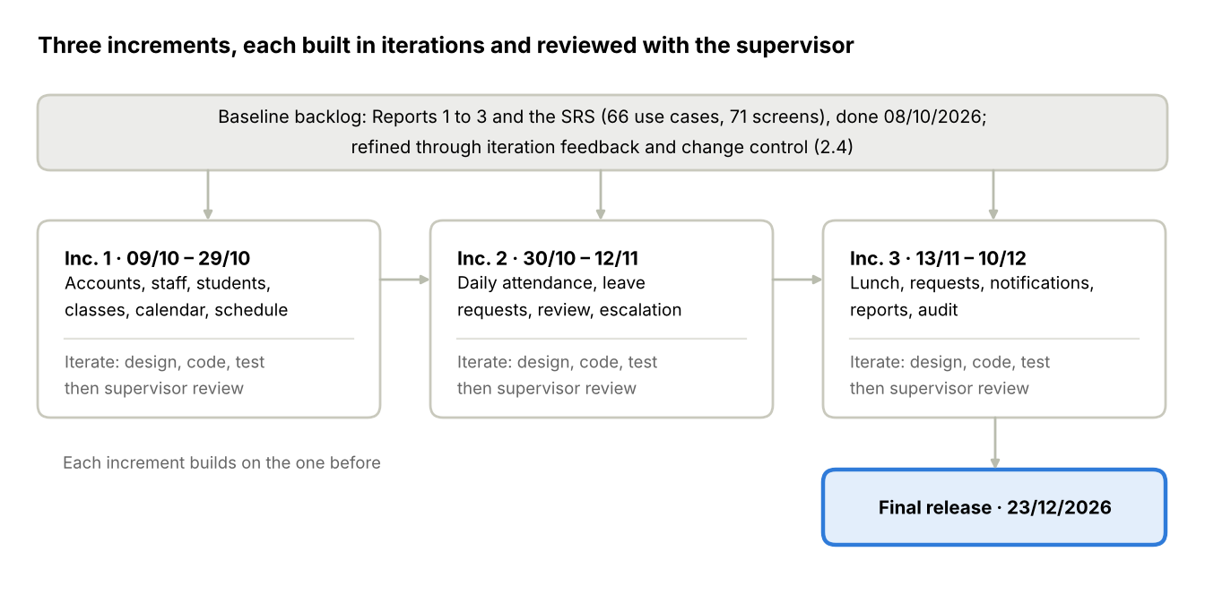
Figure 2.1.1. The backlog-driven Iterative & Incremental Model applied to SAWP
The Iterative & Incremental model combines an iterative development process with an incremental build model.
Iterative Development
Iterative development evolves the system through repeated cycles. Each iteration includes planning, design, implementation and testing, and is revisited as improvements or new requirements are identified.
Pros:
- The system evolves over time, so the team can respond to changes or new requirements.
- High-risk features are tackled early, which reduces the overall project risk.
- Testing and feedback occur every cycle, so issues are found earlier.
Cons:
- Without planning and control, iterations can drift into scope creep or unplanned features.
- It needs constant stakeholder involvement, which is hard when the supervisor has limited time.
- Reworking the design in later iterations can add complexity and delay.
Incremental Development
Incremental development breaks the project into smaller components. Each increment adds a part of the complete system, so some functionality is delivered early while other parts are still being built.
Pros:
- Parts of the system can be demonstrated early while other features are still being developed.
- Issues found in early increments inform and improve later ones.
- The project is easier to manage in smaller, focused segments.
Cons:
- Integration between increments can become complex if it is not planned from the beginning.
- It needs strong communication so that every increment stays compatible with the overall system.
- Early increments are incomplete, which can disappoint reviewers.
The Iterative & Incremental Model (backlog-driven)
The project is broken into increments, and each increment is developed through several iterations taken from a prioritised backlog. Each iteration refines the previous work, while new increments complete the overall system. Feedback from each review updates the backlog, so requirements can be corrected as understanding grows.
Pros:
- It has the structure of incremental delivery and the ongoing refinement of iterations.
- Requirements that turn out to be incomplete or wrong are handled in the next iteration instead of at the end.
- Working parts are demonstrated early, and supervisor feedback after each increment improves the next one.
Cons:
- It needs careful backlog control and a clear definition of each increment to avoid scope creep and delay.
- Dependencies between increments and between members working on different modules are hard to coordinate.
- Changes made in one iteration can affect other increments, and each review shows only part of the system.
Why this model fits SAWP. The modules depend on each other in a fixed order. Accounts, staff, students, classes and the school calendar must exist first, so those form Increment 1 (09/10–29/10/2026); attendance and leave requests build on them in Increment 2 (30/10–12/11/2026); school lunch, class transfer and document requests, notifications and reports follow in Increment 3 (13/11–10/12/2026). The team has no school-domain experience, and several school policies are still open in the SRS. A backlog-driven model lets each open point be settled just before the increment that needs it, and lets minor SRS adjustments be made through the optional change control in Section 2.4 without restarting the plan. The increment dates and the deliverables stay fixed, so the supervisor can still track progress.
Iterations, tasks and progress are tracked in GitHub Projects and a shared Google Sheet, at both the iteration and the increment level. This gives visibility of short-term progress and long-term project goals.

2.2 Quality Management

2.2.1 Defect Prevention
- Every defect found is reported to the responsible member immediately and logged in GitHub Issues with severity and priority.
- Each defect is assessed for impact (can it damage data or expose personal information?) and for the time needed to fix it.
- Every defect has a clear fix deadline, set at the next daily meeting.
- Requirements are traced to SRS use case and business-rule IDs, and to approved change requests, so code and test cases reference the rule they implement.

2.2.2 Reviewing
- Every document section and every pull request is reviewed by at least one other member before merging. Front-end reviews also check the clean UI code rules: small reusable components, styling only through Bootstrap and Tailwind CSS, and no new front-end dependency without team agreement.
- Reviewers are objective and report every issue found to the author, whoever the author is.
- Review defects are logged in GitHub Issues with priority; the author proposes and applies the fix promptly.

2.2.3 Unit Testing
- Each developer writes unit tests for the service layer of their own module, covering normal, alternative and exception flows of the use case. Unit tests may use an in-memory SQLite database for speed.
- Business rules with cutoffs, windows and uniqueness (attendance window, lunch cutoffs, one current class per student) have dedicated test cases.
- Failed tests are logged in GitHub Issues with priority and fixed before the pull request is merged.

2.2.4 Integration Testing
- Test cases cover the hand-offs between modules: leave approval to attendance indicator, class transfer to class assignment, lunch changes to meal counts. They run against Microsoft SQL Server, never an in-memory database, so constraints, unique indexes and transactions behave as in the deployed system.
- Every protected API is tested once per role to confirm data-scope authorization.
- Defects are logged in GitHub Issues with priority and fixed by the responsible member.

2.2.5 System Testing
- System test cases cover all 66 use cases and the main workflows end to end, including e-mail delivery of activation and recovery codes. Test cases are created from 04/11/2026 to 12/11/2026 and executed from 13/11/2026 to 03/12/2026.
- Test cases are derived from the SRS and the Software Design, and every defect is logged with priority.

2.2.6 Acceptance Testing
- Acceptance tests follow the five main workflows in SRS section 1.2 and are run with the supervisor through the public HTTPS address of the deployed system. They run from 04/12/2026 to 10/12/2026 and are repeated on the defense network before the defense.
- Tests also cover non-functional requirements: page response within 2 seconds, report response within 5 seconds, and 100 concurrent users.
- Defects are logged with priority and fixed before the final release.

2.3 Training Plan
Training runs part-time in parallel with Reports 1–3, which leave spare capacity before coding starts on 09/10/2026 (see Table 1.1.1). The deployment training is held during Iteration 1–2 so the deployment path is tried before Iteration 3.
Training Area | Participants | When | Duration | Waiver Criteria
Coding convention and GitHub workflow | All team members | 08/09/2026 | 1 day | Mandatory
School domain walkthrough (roles, attendance, leave, lunch, requests) with the supervisor or a school contact; then Q&A in each supervisor meeting | All team members | 16/09/2026 – 24/09/2026 | 1 week | Mandatory
C# and ASP.NET Core Web API, Entity Framework Core | All team members | 16/09/2026 – 29/09/2026 | 2 weeks | Mandatory
React with Bootstrap and Tailwind CSS, clean UI component design | All team members | 25/09/2026 – 08/10/2026 | 2 weeks | Mandatory
Microsoft SQL Server schema design and EF Core migrations | All team members | 28/09/2026 – 01/10/2026 | 4 days | Mandatory
ASP.NET Core authentication, JWT and role/data-scope authorization policies | All team members | 02/10/2026 – 08/10/2026 | 1 week | Mandatory
SMTP e-mail sending and CSV/XLSX import in .NET (e.g. MailKit, ClosedXML) | Members assigned to auth and import | 28/09/2026 – 02/10/2026 | 5 days | Optional if already used in a prior project
Deployment: tunneling software (e.g. frp), tunnel server on the VPS, Cloudflare DNS and HTTPS | Members assigned to deployment | 26/10/2026 – 30/10/2026 | 5 days | Mandatory
Docker and Docker Compose (optional, for WBS 5.7) | Members assigned to deployment | Only if time permits, before WBS 5.7 | 2 days | Optional

2.4 Scope & SRS Change Control (optional)
The SRS (Report 3) is the baseline backlog; details that the SRS leaves open are settled inside each iteration without a change request. Because the team lacks school-domain experience, some rules or workflows may prove incomplete or wrong once development starts. The team may therefore, but is not required to, make minor scope or SRS adjustments through the process below. It is optional: if no change is needed, WBS 6.1 is not used, and the 10 man-days are not part of the 284 man-day total.
A change is minor only when all of these hold:
- It does not add or remove a user role or a feature group, and does not change the project vision or the deliverable list.
- It affects at most two use cases or screens, and any database change is limited to adding or renaming an attribute or a lookup value.
- Its total effort (SRS update, design, code, tests) is at most 2 man-days, and it does not move any deliverable date.
- The accumulated effort of all accepted minor changes stays within 10 man-days (WBS 6.1).
Anything larger is a major change. It is not made on the team's own decision; it needs the supervisor's approval, or goes to the product backlog as future work.
# | Step | In charge | Description
1 | Raise | Any member | Open a GitHub Issue with the label change-request: what was learned about the school domain, the SRS items affected (use case, screen, business rule IDs) and why the SRS is wrong or incomplete.
2 | Assess | Team Leader / PM, Technical Leader | Within two working days, estimate the effort and the impact on the schedule, database, authorization rules and test cases, and classify the request as minor or major.
3 | Decide | Team Leader / PM, team | Minor requests are decided at the team weekly meeting and the supervisor is informed; major requests are sent to the supervisor. The decision (accept, defer or reject) is recorded in the issue.
4 | Update | Requester, Technical Leader | Update the SRS (new version and Record of Changes entry), then the affected design and test cases. Code the change on a branch that references the issue, and merge it through a reviewed pull request.
5 | Close | Team Leader / PM | Announce the change in the chat group, add it to the change log in the shared Google Sheet with its actual effort, and update the remaining change budget.
No new change request is accepted after 12/11/2026, the end of Iteration 2, so that Iteration 3 and the system test run on a stable SRS; later findings are listed as future work in the final report.

3. Project Deliverables
Eleven deliverables run from the project idea, started on 07/09/2026, to the final code and report, due on 23/12/2026. Start and due dates follow the SEP490_G45 Incremental Project Tasklist (Fall 2026).
# | Deliverable | Start | Due Date | Deliverable Scope
1 | Project Idea | 07/09/2026 | 15/09/2026 | Problem statement, target users, initial scope
2 | Report 1 – Project Introduction | 16/09/2026 | 24/09/2026 | Product background, existing systems, business opportunity, product vision, project scope & limitations
3 | Report 2 – Project Management Plan | 25/09/2026 | 08/10/2026 | WBS & estimation, objectives, risks, project process, quality and training plan, deliverables, team organization, communication and configuration management
4 | Report 3 – SRS | 25/09/2026 | 08/10/2026 | Context diagram, workflows, use cases, screen flow and authorization, ERD, functional and non-functional requirements, business rules. The approved version is the baseline backlog; approved change requests produce new versions (Section 2.4)
5 | Report 4 – Software Design | 09/10/2026 | 03/11/2026 | System architecture, back-end and front-end architecture, database design, detailed design of main functions
6 | Code & Implement Iteration 1 | 09/10/2026 | 29/10/2026 | Foundation & core records: authentication, accounts and roles, staff, students and guardians, school years, classes, calendar and schedule. Detailed design, code, unit and integration tests
7 | Code & Implement Iteration 2 | 30/10/2026 | 12/11/2026 | Daily attendance and leave requests with Teacher review and School Board escalation. Detailed design, code, unit and integration tests
8 | Report 5 – Test Document | 04/11/2026 | 10/12/2026 | Test model, test plan, test cases and test reports. System test: create test cases 04/11–12/11, execute 13/11–03/12; acceptance test 04/12–10/12
9 | Code & Implement Iteration 3 | 13/11/2026 | 10/12/2026 | School lunch, class transfer and school document requests, notifications and announcements, dashboards and reports, audit and system settings. Detailed design, code, unit and integration tests
10 | Report 6 – Software Guides | 11/12/2026 | 17/12/2026 | Deliverable package, installation guide (development setup and deployed setup), user manual per role
11 | Final Code and Report | 11/12/2026 | 23/12/2026 | Hardening and deployment, defect fixes, final source code and documents, user manual, defense slides

4. Responsibility Assignments

4.1 Team Structures
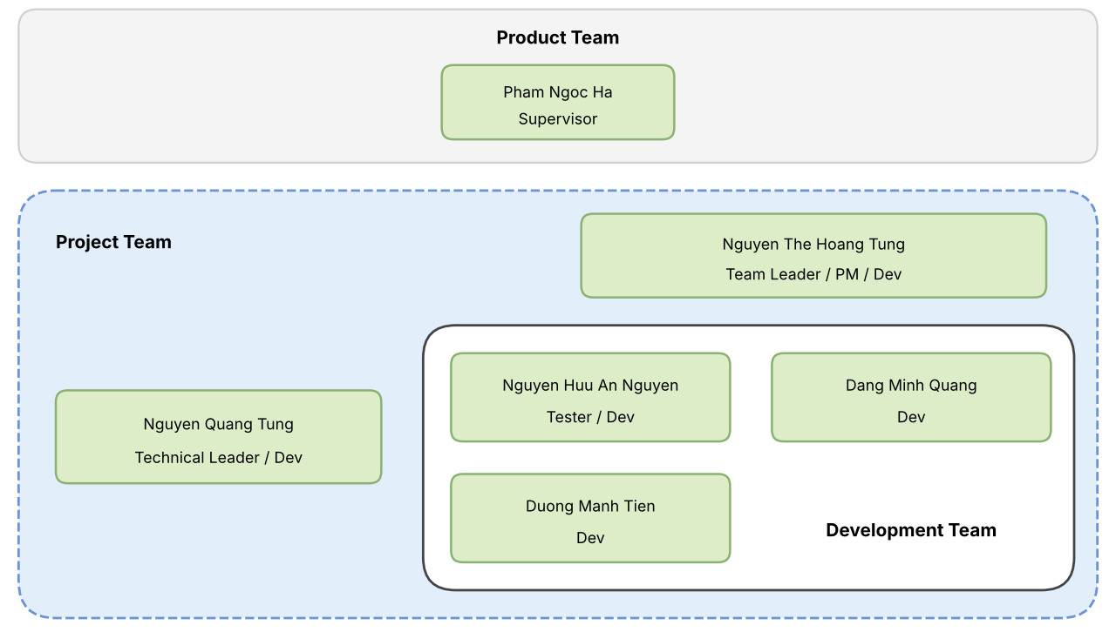
Figure 4.1.1. Team structures
Role description:
# | Role | Description
1 | Supervisor | Internal stakeholder. Guides the team, reviews deliverables at each iteration, and acts as the school-side reviewer for workflows and open policy decisions.
2 | Team Leader / Product Manager | Internal stakeholder. Plans and tracks the project, maintains the product backlog and the SRS scope, and decides the features of each increment so the product matches how a primary school operates. Owns the change control in Section 2.4: classifies change requests and decides minor ones.
3 | Technical Leader | Internal stakeholder. Owns the system architecture, the authorization layer and the database design, reviews pull requests, assesses the technical impact of change requests, and keeps each increment technically sound and maintainable.
4 | Development team | Internal stakeholders. The development team is responsible for design, code, test and deploy features in each increment. Developers implement their modules and fix defects; testers write and run test cases after each iteration and report defects back to the developers.

4.2 Responsibility Assignments
D – Do; R – Review; S – Support; I – Informed
Responsibility | TungNTH | NguyenNHA | TungNQ | QuangDM | TienDM
Project Planning & Tracking | D | R, S | R, S | R, S | R, S
Prepare Project Introduction Document | D | R, S | R, S | R, S | R, S
Prepare SRS Document (Overview Part) | D, R | D, R | D, R | D, R | D, R
Prepare SRS Document (Functional Specifications) | D, R, S | D, R, S | D, R, S | D, R, S | D, R, S
Scope & SRS change control (optional, Section 2.4) | D, R | S | D, R, S | S | S
Prepare Software Design Document | R, S | D, R | D | D, R | D, R
Code Back-End | D | D, R, S | I | D | D
Code Front-End | D | I | D, R, S | D | I
Test Document and Report | D, S | D, R | D, S | D, S | D, S
User Guides | D, R, S | D, R, S | D, R, S | D, R, S | D, R, S
Final Report (all documents and presentation slides) | D, R, S | D, R, S | D, R, S | D, R, S | D, R, S
Table 4.2.1. Responsibility Assignments

5. Project Communications

Communication Item | Who / Target | Purpose | When, Frequency | Type, Tool, Method(s)
Supervisor meeting | All team members | Review deliverables and iteration results, settle open requirements and policy decisions | Weekly, per the supervisor's slot; iteration reviews on 29/10, 12/11 and 10/12/2026 | Offline at FPT University or online through Google Meet
Team weekly meeting | All team members | Review plan and schedule, members' work for the week, project progress and status | 9:00 pm every Friday | Online through Google Meet; minutes in Google Drive
Daily meeting | All team members | Report what each member did, plans next, and any blocker | Daily | Chat group, Google Meet
Change request review | Team Leader / PM, Technical Leader, requester | Assess and decide pending change requests for minor scope/SRS changes (Section 2.4) | Weekly, inside the team weekly meeting; urgent ones in an unscheduled meeting | GitHub Issues (label change-request), Google Meet
Unscheduled meeting | All team members | Resolve a critical problem that needs an immediate decision | When a member raises a blocking issue | Online through Google Meet
Pre-demo deployment check | Members assigned to deployment | Confirm the public HTTPS address, the host PC and the five main workflows work, and that the fallback copy is ready | The day before each supervisor review, acceptance test and the defense | Checklist in Google Sheets, result posted in the chat group

6. Configuration Management

6.1 Document Management
System: Google Drive (project plans, requirement documents, design files, progress reports).
Management Process:
- Documents are organised into folders: Reports, Diagrams (draw.io sources and exported images), Management (templates, meeting minutes, surveys, topic).
- Each document is versioned (v1, v2, v3…) and every change is recorded in its Record of Changes table. The approved SRS is the scope baseline; each approved change request creates a new SRS version.
- Document changes are announced to all team members in the chat group.
- Edit access is limited to team members; the supervisor has comment access.

6.2 Source Code Management
System: GitHub manages the project source code.
Management Process:
- Branching: main holds released code, develop integrates work, and each feature or bug fix has its own branch (feature/<module>-<name>, fix/<issue-id>).
- Commits: each change is a commit with a clear message that references its GitHub Issue; scope changes reference their change-request issue.
- Merge PR: code is merged into develop and then main only through a pull request reviewed and approved by at least one other member, with tests passing.
- Tagging: each iteration release is tagged (v1.0, v2.0, v3.0) for easy rollback.

6.3 Tools & Infrastructures
Category | Tools / Infrastructure
Technology | Single web application: React front end with Bootstrap and Tailwind CSS (minimal front-end dependencies, clean UI component design), C# ASP.NET Core Web API back end
Database | Microsoft SQL Server (Developer or Express edition; SQL Server Express or LocalDB for development on Windows)
Database tools | SQL Server Management Studio, Azure Data Studio, Entity Framework Core migrations
IDEs/Editors | Visual Studio, Visual Studio Code
Diagramming | draw.io
Documentation | MS Office, Google Docs/Sheets/Slides
Version Control | GitHub (source code)
Containerization | Docker and Docker Compose (optional, recommended for the production host; staging runs directly on the team PC, and no member's laptop needs Docker)
Deployment server | Production: a hosted environment (VPS with at least 2–4 GB RAM, or a cloud app service with a managed SQL database), chosen before Iteration 3. Staging and fallback: team PC running the application and SQL Server locally, exposed through tunneling software (e.g. frp) to a tunnel server on a small VPS
HTTPS & DNS | Cloudflare DNS with proxy enabled (HTTPS for visitors), tunnel server on the VPS, tunnel client on the team PC for staging (frp or an equivalent tool); the production host is reached through Cloudflare directly
E-mail Service | SMTP service for account activation and password-recovery codes
File Storage | Server-side storage with permission-checked access for request attachments and issued documents
Project management | GitHub Projects, GitHub Issues (bug tracking), Google Sheets, Google Drive

6.4 Environments & Deployment
SAWP uses three deployed environments with a clear role each: a staging environment on a team PC for day-to-day reviews, a hosted production environment for acceptance testing and the defense, and the staging setup kept as a fallback if production is unavailable. The available VPS (512 MB – 1 GB RAM) cannot run SQL Server, which needs at least 2 GB, so it is used only as the tunnel server for staging.
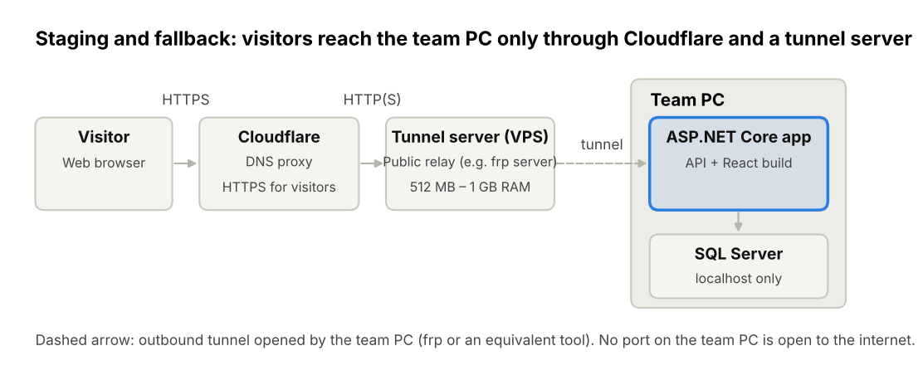
Figure 6.4.1. Staging and fallback deployment architecture
Environment | Where it runs | Database | Purpose
Development | Each member's laptop: ASP.NET Core API and React dev server run natively, without Docker | SQL Server Express or LocalDB on Windows; native SQL Server on Linux; a shared development database for macOS | Daily coding and unit tests
Testing | Development machines and the staging PC | Microsoft SQL Server (never in-memory) | Integration and system tests
Staging (Iterations 1–3) | Team PC: one ASP.NET Core application that also serves the React build, reached through a tunnel server on the small VPS and Cloudflare | Microsoft SQL Server on the team PC, listening on localhost only | Internal and supervisor reviews at the end of each iteration
Production (from 03/12/2026) | Hosted environment: a VPS with at least 2–4 GB RAM, or a cloud app service with a managed SQL database, behind Cloudflare | SQL Server on the host, or a managed SQL database; not reachable from the internet | Acceptance testing (04/12–10/12), hardening and the defense
Fallback | The staging setup, promoted to production | As staging | Used only if the production host is not approved or not available

Deployment rules:
- The production host is chosen with the supervisor before Iteration 3 (by 12/11/2026) and set up between 26/11 and 03/12/2026, so acceptance testing runs on it. If no host is available by 26/11/2026, the team PC behind the tunnel stays as production (fallback).
- In staging and fallback, visitors reach the system only through Cloudflare over HTTPS. The tunnel server on the VPS forwards requests to the team PC through a tunnel that the team PC opens outbound (frp or an equivalent tool), so no port on the team PC is open to the internet. Any tool that provides an authenticated, outbound-initiated tunnel is acceptable.
- The same build and the same configuration keys are used in every environment; only environment-specific settings change. Connection strings, SMTP credentials, tunnel tokens and other secrets are kept outside the repository.
- The database is backed up daily to a second location, and only synthetic data is used in every environment.
- During demo periods any team PC in use has sleep and automatic updates disabled; a local copy on the defense laptop and a recorded demo video are kept as a last resort.
- Docker packaging (WBS 5.7) is optional but recommended, because it makes the move from staging to the production host a configuration change.

