

CAPSTONE PROJECT REPORT
Report 3 – Software Requirement Specification

– Hanoi, September 2026 –
Table of Contents
I. Record of Changes 6
II. Software Requirement Specification 7
1. Overall Requirements 7
1.1 Context Diagram 7
1.2 Main Workflow 8
1.3 User Requirements 11
1.4 System Functionalities 24
2. Functional Specifications 34
2.1 Authentication & Profile Management 34
2.2 Student & Guardian Record Management 40
2.3 School Year, Class & Schedule Management 49
2.4 Attendance & Leave Management 57
2.5 School Lunch Service Management 65
2.6 Administrative Requests & School Documents 73
2.7 Notifications & Announcements 83
2.8 Operational Dashboards & Reports 86
2.9 System Administration & Audit 91
3. Non-Functional Requirements 100
3.1 External Interfaces 100
3.2 Quality Attributes 100
4. Requirement Appendix 102
4.1 Business Rules 102
4.2 Application Messages 105
4.3 Scope Assumptions and Open Decisions 108
4.4 Terminology and Vietnamese Equivalents 109

I. Record of Changes
Date | A*  M, D | In charge | Change Description
15/09/26 | A | NguyenNHA | Add 5 UC Diagram
18/09/26 | A | QuangMD | Add context diagram
22/09/26 | A | TungNTH | Add Detailed Screen Description and Authorization Matrix
24/09/26 | M | QuangMD | Fix context diagram
25/09/26 | A | QuangMD | Add screenflow
*A - Added M - Modified D - Deleted

II. Software Requirement Specification

1. Overall Requirements

1.1 Context Diagram
The School Administration and Workflow Platform for Primary Schools (SAWP) is a web-based system for routine primary-school administration. It connects Parent, Teacher, Subject Teacher, Office Staff, Lunch Service Staff, School Board and System Administrator through one role-based platform, publishes school notices to a Guest on the public landing page, and uses an external email service to deliver password-recovery and account-activation codes. SAWP begins after a student is already enrolled in the school and supports centralized student and staff records, class placement, weekly timetables with their teaching assignments, daily attendance, monthly school-lunch registration with per-day cancellation, administrative requests, notifications, auditability and operational reporting.
Scope boundary: Admissions/enrollment, school transportation, grading/academic assessment, homework/online learning, payroll, full accounting, library management, and inventory management are outside the baseline SAWP scope. School lunch means monthly meal registration with cancellation of single service days, and the operational meal counting that follows from it; supervision of meal or rest periods, nutrition planning, and fee collection are not included. Role and domain terms used in this document are listed with their Vietnamese equivalents in Section 4.4.
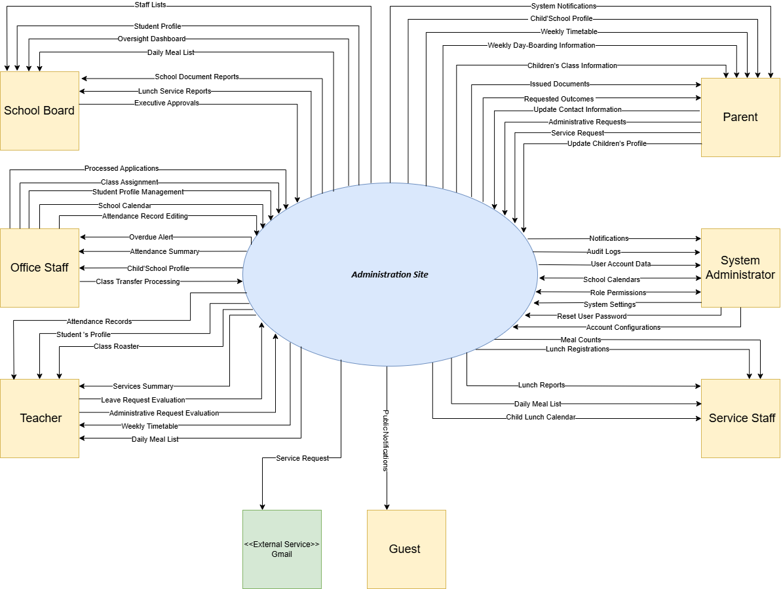
Figure 1.1.1 Context diagram for SAWP system

1.2 Main Workflow

1.2.1 Student Profile & Class Management workflow

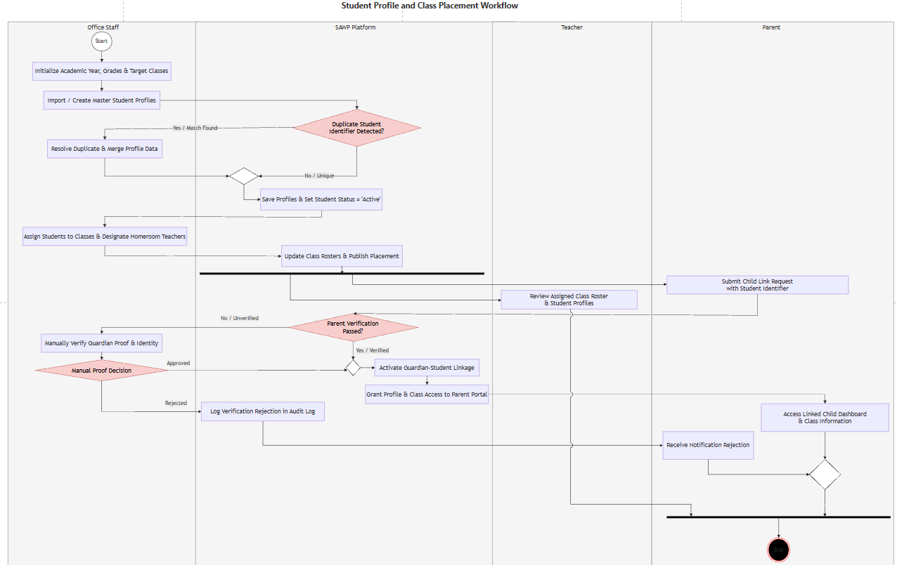
Figure 1.2.1.1 Student profile & Class Management workflow

1.2.2 Daily Attendance Tracking workflow
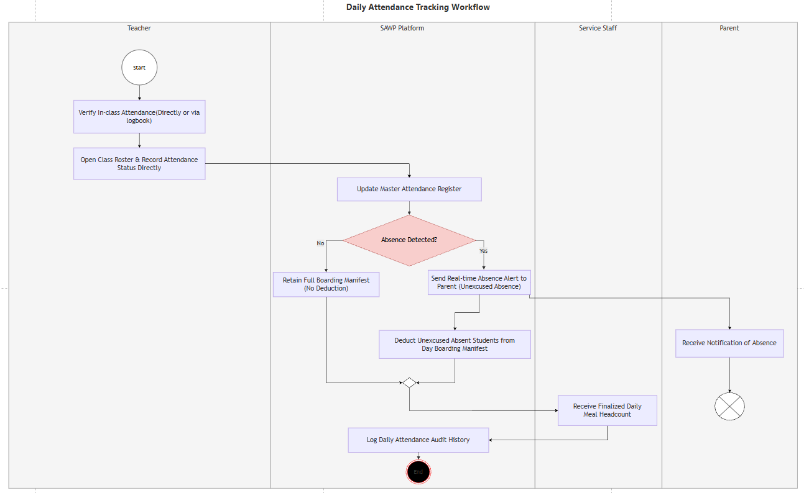
Figure 1.2.2.1 Daily Attendance Tracking workflow

1.2.3 Student Leave Request and Attendance Sync Workflow (code)
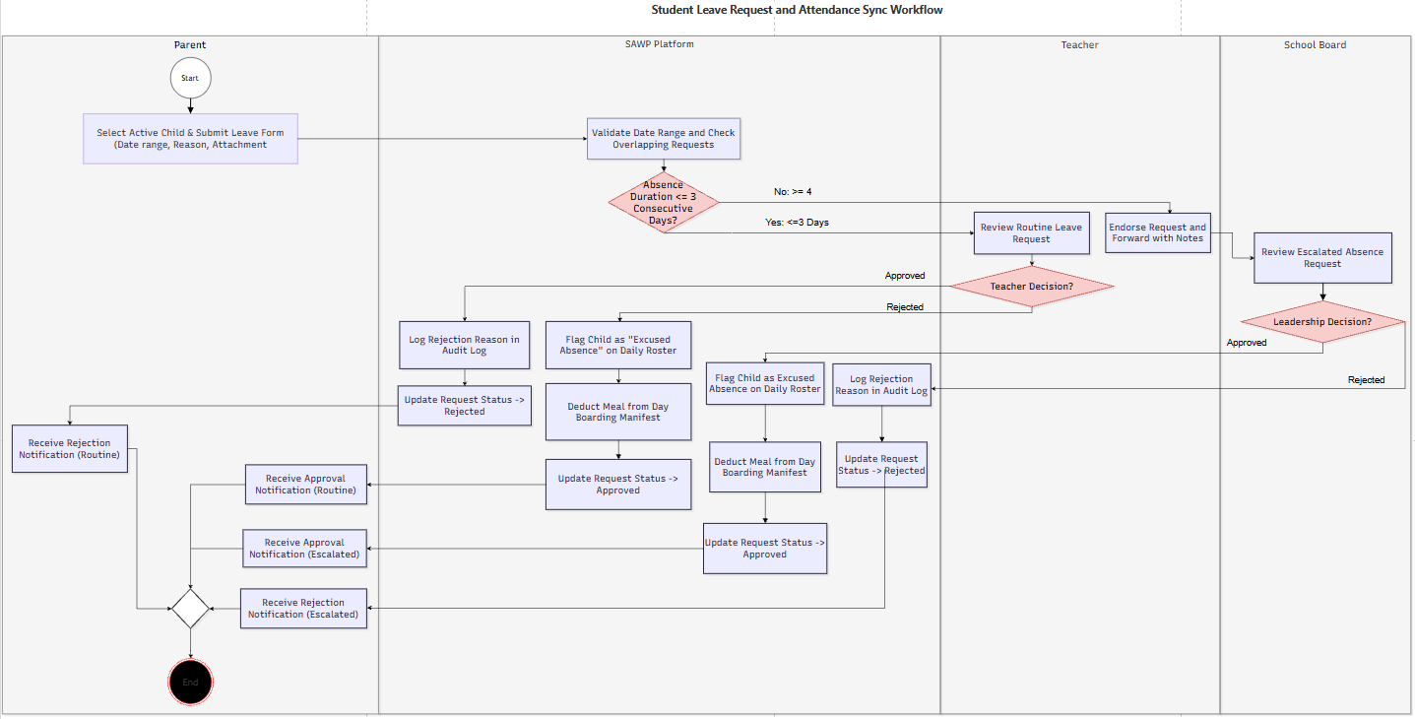
Figure 1.2.3.1 Student Leave Request and Attendance Sync Workflow1.2.4 Administrative Requests: Class Transfer & Document Issuance Workflow
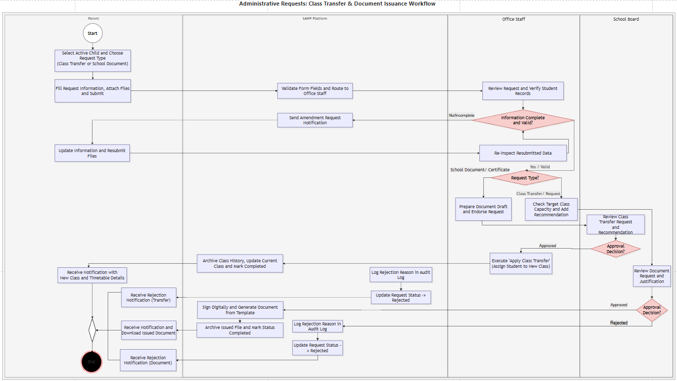
Figure 1.2.4.1 Administrative Requests: Class Transfer & Document Issuance Workflow

1.2.5 Day Boarding Service Management Workflow
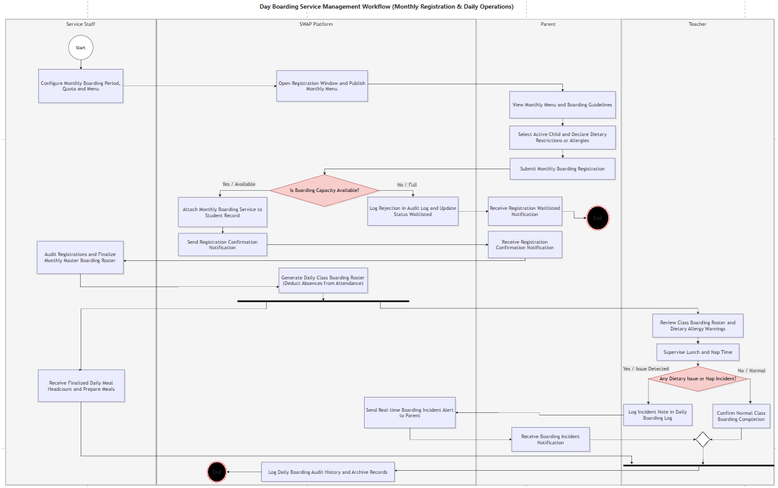
Figure 1.2.5.1 Day Boarding Service Management Workflow

1.3 User Requirements

1.3.1 Actors
# | Actor | Description
1 | Guest | Users who access the system without logging in.
2 | Parent | Views information about verified linked children, registers school lunch, submits supported requests, and tracks their statuses.
3 | Teacher | Manages attendance, reviews assigned leave requests, and accesses student and class information within assigned classes.
4 | Office Staff | Manages records of enrolled students, guardian links, class assignments, timetables, and assigned administrative requests.
5 | Services Staff | Staff responsible for managing school lunch services, including configuring service dates, monitoring student meal registrations, handling authorized registration corrections, and reviewing daily meal counts and related reports.
6 | School Board | Reviews operational reports and makes designated administrative decisions according to assigned authority.
7 | System Administrator | Manages user accounts, role permissions, system settings, and audit records without automatically receiving business approval authority.
8 | Email Service | External service used to deliver system-generated emails when email delivery is enabled.

1.3.2 Use Cases

1.3.2.1 UCs for Guest
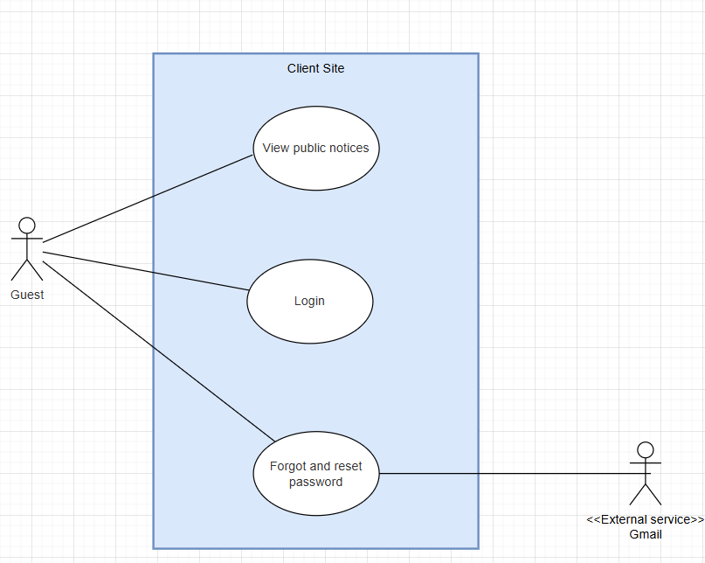
Figure 1.3.2.1 Use case Diagram for Guest

1.3.2.2 UCs for Parent/Guardian- administration site
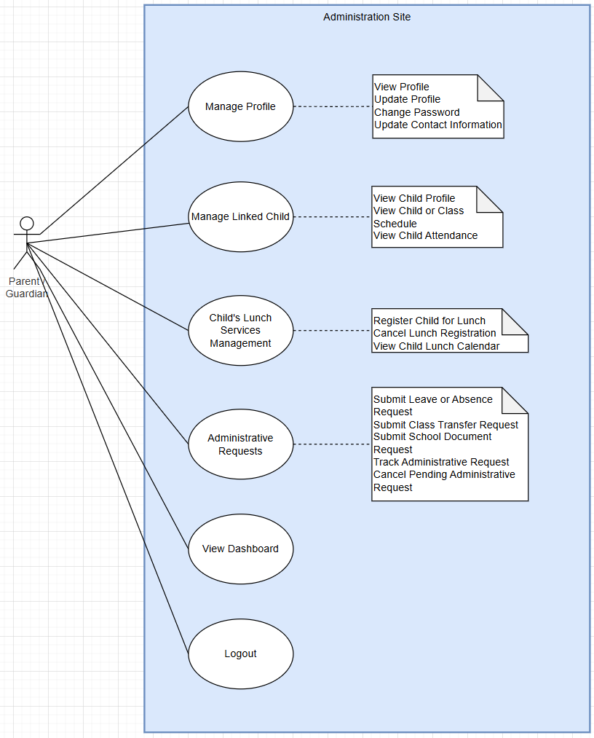
Figure 1.3.2.2 Use case Diagram for Parent/Guardian

1.3.2.3 UCs for Teacher

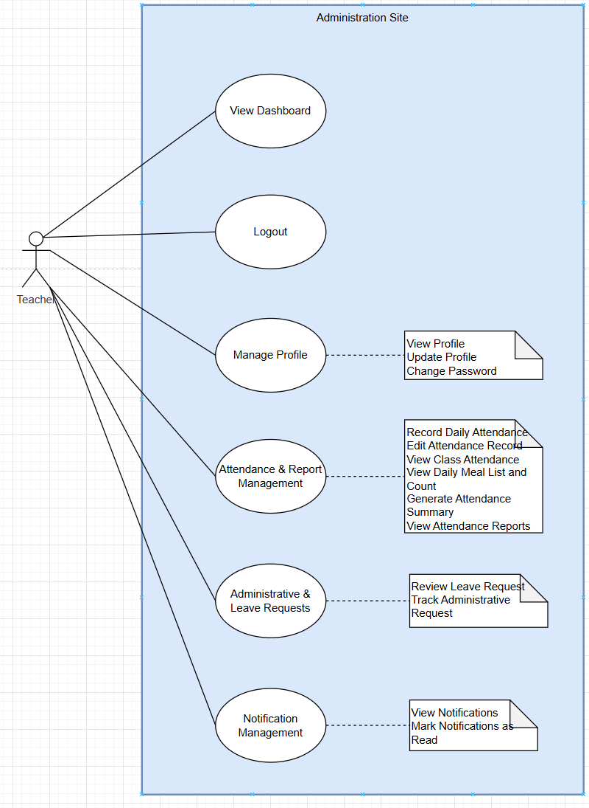
Figure 1.3.2.3 Use case Diagram for Teacher

1.3.2.4 UCs for Office Staff

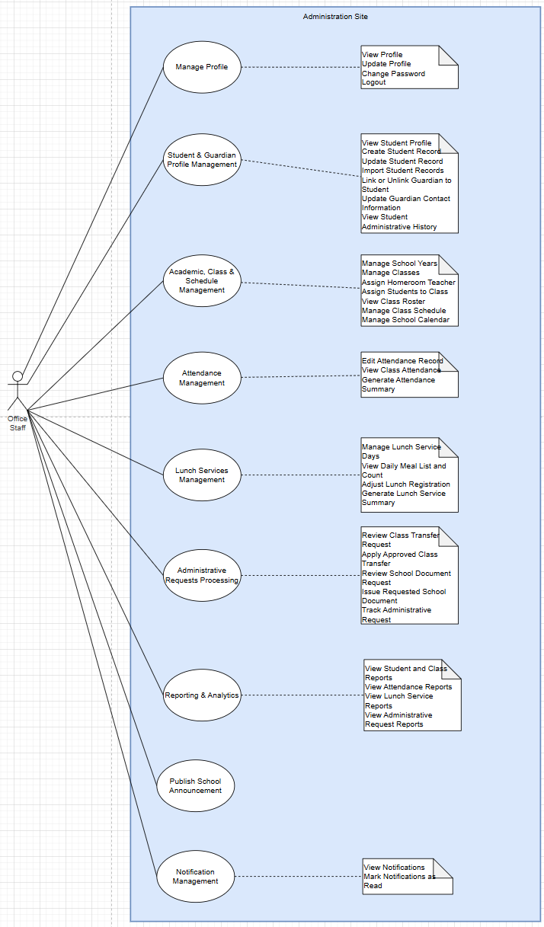
Figure 1.3.2.3 Use case Diagram for Office Staff

1.3.2.5 UCs for Service Staff
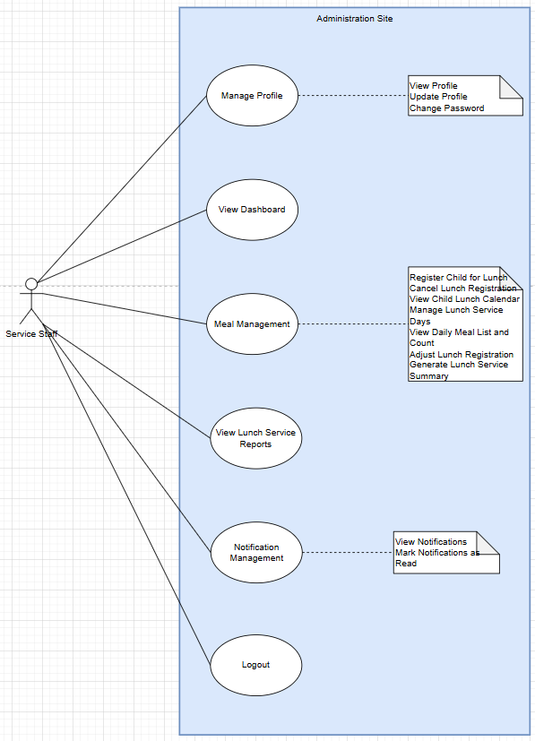

Figure 1.3.2.5 Use case Diagram for Service Staff

1.3.2.6 UCs for School Board

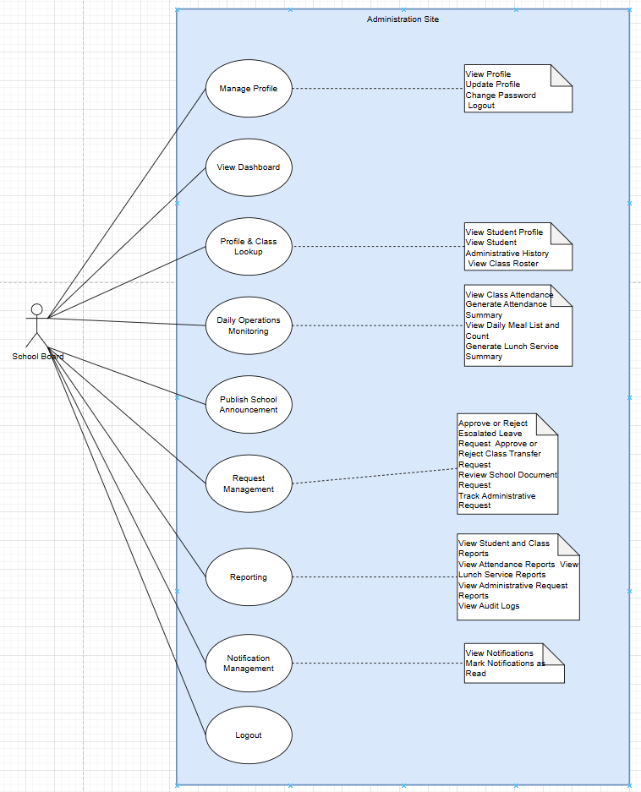

Figure 1.3.2.6 Use case Diagram for School Board

1.3.2.7 UCs for System Admin
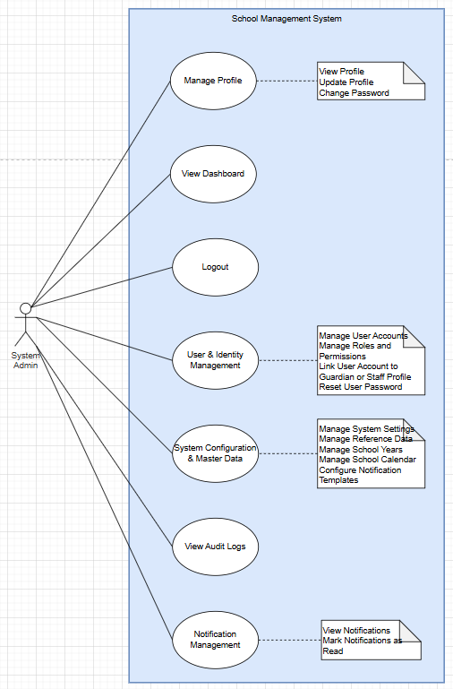
Figure 1.3.2.7 Use case Diagram for System Admin

1.3.2.4 UC Descriptions
F-ID | Feature | UC-ID | Use Case | Use Case Description
1 | Authentication & Profile Management | 1 | Login | Authenticates an active user and directs the user to the workspace permitted by their role.
1 | Authentication & Profile Management | 2 | View Profile | Displays the signed-in user profile and account information relevant to the user role.
1 | Authentication & Profile Management | 3 | Update Profile | Allows a user to update permitted personal profile fields and preferences.
1 | Authentication & Profile Management | 4 | Change Password | Allows an authenticated user to change their own account password.
1 | Authentication & Profile Management | 5 | Logout | Ends the current authenticated session.
2 | Student & Guardian Record Management | 6 | View Student Profile | Displays student information within the viewer’s authorized data scope.
2 | Student & Guardian Record Management | 7 | Create Student Record | Creates a SAWP record for a student who is already enrolled in the school.
2 | Student & Guardian Record Management | 8 | Update Student Record | Updates permitted administrative information for an existing student.
2 | Student & Guardian Record Management | 9 | Import Student Records | Bulk imports records for students who are already enrolled, using a school-provided import file.
2 | Student & Guardian Record Management | 10 | Link or Unlink Guardian to Student | Maintains the relationship between a student and Parent / Guardian records.
2 | Student & Guardian Record Management | 11 | Update Contact Information | Updates guardian contact details used for school communication.
2 | Student & Guardian Record Management | 12 | View Student Administrative History | Shows a chronological administrative history for a student.
3 | School Year, Class & Schedule Management | 13 | Manage School Years | Creates, activates, updates, and archives school-year records.
3 | School Year, Class & Schedule Management | 14 | Manage Classes | Creates and maintains classes for a school year.
3 | School Year, Class & Schedule Management | 15 | Assign Teacher | Assigns a Teacher to a class for the active period.
3 | School Year, Class & Schedule Management | 16 | Assign Students to Class | Assigns one or more active students to a class in the selected school year.
3 | School Year, Class & Schedule Management | 17 | View Class Roster | Displays the current student roster for an authorized class.
3 | School Year, Class & Schedule Management | 18 | Manage Class Schedule | Creates and updates the weekly schedule for a class.
3 | School Year, Class & Schedule Management | 19 | View Child or Class Schedule | Displays the current class schedule to Parent / Guardian and school staff.
3 | School Year, Class & Schedule Management | 20 | Manage School Calendar | Maintains school days, holidays, and exceptional non-school days used by attendance and lunch functions.
4 | Attendance & Leave Management | 21 | Record Daily Attendance | Records daily attendance for students in the Teacher’s assigned class.
4 | Attendance & Leave Management | 22 | Edit Attendance Record | Corrects an existing attendance record within the permitted edit window.
4 | Attendance & Leave Management | 23 | View Class Attendance | Displays attendance details and summaries for an authorized class.
4 | Attendance & Leave Management | 24 | View Child Attendance | Allows a Parent / Guardian to review attendance for a linked child.
4 | Attendance & Leave Management | 25 | Submit Leave or Absence Request | Allows a Parent / Guardian to request an excused absence for a linked child.
4 | Attendance & Leave Management | 26 | Review Routine Leave Request | Allows the Teacher to review routine absence requests for their class.
4 | Attendance & Leave Management | 27 | Approve or Reject Escalated Leave Request | Handles leave requests requiring higher-level authorization.
4 | Attendance & Leave Management | 28 | Generate Attendance Summary | Produces operational attendance summaries by date, class, grade, or period.
5 | School Lunch Service Management | 29 | Register Child for Lunch | Registers a linked child for school lunch on one or more available dates before the cutoff.
5 | School Lunch Service Management | 30 | Cancel Lunch Registration | Cancels a child’s active daily lunch registration before the configured cutoff.
5 | School Lunch Service Management | 31 | View Child Lunch Calendar | Displays a linked child’s daily lunch-service status.
5 | School Lunch Service Management | 32 | Manage Lunch Service Days | Configures the dates on which school lunch registration is available.
5 | School Lunch Service Management | 33 | View Daily Meal List and Count | Provides Lunch Service Staff with the daily list and meal totals needed for operations.
5 | School Lunch Service Management | 34 | Adjust Lunch Registration | Allows authorized staff to correct a lunch registration after the normal parent cutoff.
5 | School Lunch Service Management | 35 | Generate Lunch Service Summary | Produces lunch-registration and meal-count summaries for operations and oversight.
6 | Administrative Requests & School Documents | 36 | Submit Class Transfer Request | Allows a Parent / Guardian to request that a linked child be moved to another class.
6 | Administrative Requests & School Documents | 37 | Review Class Transfer Request | Allows Giáo vụ to verify a class-transfer request before higher-level decision.
6 | Administrative Requests & School Documents | 38 | Approve or Reject Class Transfer Request | Allows Ban Giám hiệu to decide a reviewed class-transfer request.
6 | Administrative Requests & School Documents | 39 | Apply Approved Class Transfer | Executes an approved class transfer and preserves class-assignment history.
6 | Administrative Requests & School Documents | 40 | Submit School Document Request | Allows a Parent / Guardian to request a supported school document or certificate for a linked child.
6 | Administrative Requests & School Documents | 41 | Review School Document Request | Allows Giáo vụ to verify and process a submitted school-document request.
6 | Administrative Requests & School Documents | 42 | Issue Requested School Document | Records issuance/completion of an approved school-document request.
6 | Administrative Requests & School Documents | 43 | Track Administrative Request | Displays the current status and history of a submitted administrative request.
6 | Administrative Requests & School Documents | 44 | Cancel Pending Administrative Request | Allows a Parent / Guardian to cancel their own request before it reaches a non-cancellable processing state.
7 | Notifications & Announcements | 45 | View Notifications | Displays in-system notifications relevant to the signed-in user.
7 | Notifications & Announcements | 46 | Mark Notifications as Read | Updates read status for one or more notifications.
7 | Notifications & Announcements | 47 | Publish School Announcement | Publishes an announcement to selected school audiences.
8 | Operational Dashboards & Reports | 48 | View Role Dashboard | Displays role-specific operational summaries and shortcuts.
8 | Operational Dashboards & Reports | 49 | View Student and Class Reports | Provides operational reports on student distribution and class assignments.
8 | Operational Dashboards & Reports | 50 | View Attendance Reports | Provides school-level attendance reporting and trends.
8 | Operational Dashboards & Reports | 51 | View Lunch Service Reports | Provides operational and historical lunch-service utilization reports.
8 | Operational Dashboards & Reports | 52 | View Administrative Request Reports | Reports request volume, status, overdue work, and processing time.
9 | System Administration & Audit | 53 | Manage User Accounts | Creates, updates, activates, and deactivates user accounts.
9 | System Administration & Audit | 54 | Manage Roles and Permissions | Maintains role-permission assignments used by role-based access control.
9 | System Administration & Audit | 55 | Link User Account to Guardian or Staff Profile | Links a login account to the corresponding operational guardian/staff identity.
9 | System Administration & Audit | 56 | Manage Reference Data | Maintains configurable lists used across administrative forms.
9 | System Administration & Audit | 57 | Configure Notification Templates | Maintains reusable in-system notification text for workflow events.
9 | System Administration & Audit | 58 | View Audit Logs | Allows authorized technical administrators to inspect recorded security and administrative change events.
9 | System Administration & Audit | 59 | Manage System Settings | Maintains technical and school-wide settings that do not belong to ordinary operational records.
9 | System Administration & Audit | 60 | Reset User Password | Allows System Administrator to reset a user password when self-service recovery is not part of the baseline scope.

1.4 System Functionalities

1.4.1 Screens Flow

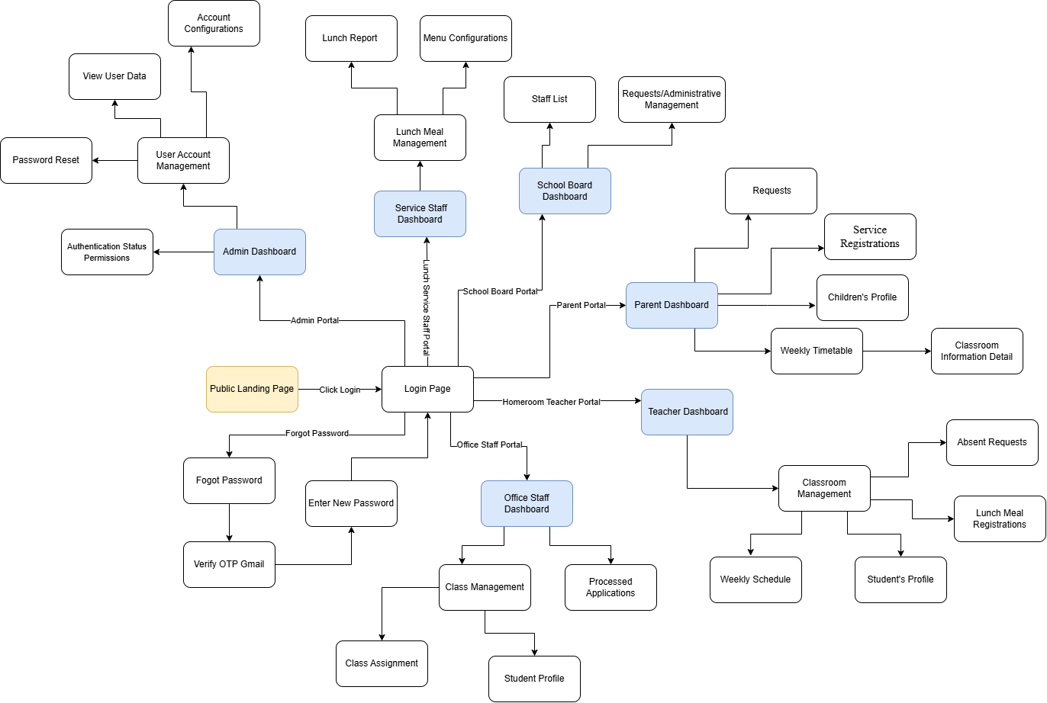

Figure 1.4.1 Screen Flow

1.4.2 Screen Descriptions

# | Feature | Screen | Description
1 | Authentication | Public Landing Page | Public Landing Page
2 | Authentication | Login Page | The authentication page that navigates users to their respective portals based on their roles.
3 | Authentication | Password Recovery | Password recovery through email OTP is not included in the baseline SAWP scope. Users who cannot access their accounts must contact an authorized System Administrator. The administrator may reset the password and require the user to change it at the next successful login. All password-reset actions must be recorded in the audit log.
4 | Admin Portal | Admin Dashboard | The main overview dashboard for Administrators.
5 | Admin Portal | Authentication Status Permissions | The screen for managing user permissions and authentication statuses within the system.
 | Admin Portal | Account Configurations | The screen to set up account parameters, customize settings, and manage access permissions (roles and authorizations) for individual users).
 | Admin Portal | View User Data | An interface displaying the system's user directory and detailed information, including user profiles and activity records.
 | Admin Portal | Password Reset | An administrative tool enabling the Admin to manually override and issue new passwords for users unable to recover their credentials.
 | Lunch Service Portal | Lunch Service Staff Dashboard | The dedicated overview dashboard for lunch service staff.
 | Lunch Service Portal | Menu Configurations | The screen for kitchen staff to plan, update, and configure the list of dishes for daily or weekly menus.
 | Lunch Service Portal | Lunch Report | An interface to view and generate summary reports regarding the number of registered meals, actual meals served, and other dining service statistics.
 | School Board Portal | School Board Dashboard | The main overview dashboard for the School Board members.
 | School Board Portal | Staff List | A directory screen displaying information about school staff and teachers. (Read only)
 | School Board Portal | Requests/Administrative Management | The interface for receiving and managing internal administrative requests.
 | Parent Portal | Parent Dashboard | The dedicated overview dashboard for Parents.
 | Parent Portal | Children's Profile | The interface allows parents to view their children's detailed profiles.
 | Parent Portal | Weekly Timetable | The screen displays the weekly schedule and detailed classroom information.
 | Parent Portal | Requests & Service Registrations | The screens where parents can submit requests and register for student services.
 | Teacher | Teacher Dashboard | The main overview dashboard for Teachers.
 | Teacher | Weekly Schedule | A screen displaying the class timetable, allowing teachers to track weekly academic and extracurricular activities.
 | Teacher | Student's Profile | The interface where Teachers can access detailed personal information, academic performance, and conduct records of individual students within their class.
 | Teacher | Lunch Meal Registrations | A screen providing a consolidated list of students in the homeroom class who have registered for school lunches, aiding in meal tracking for the kitchen.
 | Office Staff Portal | Class Assignment | A functional screen used by office staff to assign students to specific classes and allocate Teachers to their respective classrooms.
 | Office Staff Portal | Student Profile | The interface allows office staff to look up, view, and update the administrative and academic records of any student across the entire school.
 | Office Staff Portal | Processed Applications | The screen for tracking and reviewing applications and requests that have been processed by the office.

1.4.3 Screen Authorization
Screen | Public | Parent / Guardian | Teacher | Office Staff | Service Staff | School Board | System Administrator
Homepage / Public Landing Page | X | X | X | X | X | X | X
Login | X | X | X | X | X | X | X
Forgot Password | X | X | X | X | X | X | X
Verify OTP Gmail | X | X | X | X | X | X | X
Enter New Password | X | X | X | X | X | X | X
Admin Dashboard |  |  |  |  |  |  | X
User Account Management |  |  |  |  |  |  | X
Authentication Status Permissions |  |  |  |  |  |  | X
Account Configurations |  |  |  |  |  |  | X
View User Data |  |  |  |  |  |  | X
Password Reset |  |  |  |  |  |  | X
Parent Dashboard |  | X
Children's Profile |  | X
Requests |  | X
Service Registrations |  | X
Weekly Timetable |  | X | X
Classroom Information Detail |  | X |  | X
Teacher Dashboard |  |  | X
Classroom Management |  |  | X
Weekly Schedule |  |  | X
Student Profile |  |  | X | X
Lunch Meal Registrations |  |  | X
Absent Requests |  |  | X
Office Staff Dashboard |  |  |  | X
Class Management |  |  |  | X
Class Assignment |  |  |  | X
Processed Applications |  |  |  | X

1.4.4 Non-UI Functions
# | Feature | System Function | Description
1 | Authentication & Session Security | Session Validation and Expiration | Validates each protected request, enforces inactivity expiration, and invalidates sessions after logout, account deactivation, password change, or administrator-assisted reset.
2 | Authorization | Role and Data-Scope Authorization Filter | Applies role, linked-child, assigned-class, and feature permissions before reading or mutating protected data.
3 | Auditability | Audit Event Recorder | Creates append-only audit events for security-sensitive and material administrative changes, including actor, timestamp, entity/action, and relevant before/after references.
4 | Workflow | Administrative Request Routing Engine | Routes leave, class-transfer, and school-document requests to the correct role according to request type/status and records every transition.
5 | Notifications | In-System Notification Dispatcher | Creates recipient-specific notifications from workflow events, announcements, and important operational changes and maintains per-recipient read state.
6 | Attendance | Attendance Lock and Consistency Validator | Prevents duplicate student/day records, enforces Teacher class scope, and applies the teacher edit window and Giáo vụ correction rules.
7 | Lunch Service | Lunch Cutoff and Meal Count Service | Validates daily registration/cancellation cutoff and service-day availability, then recalculates meal counts after each valid change.
8 | School Calendar | School-Day Validation Service | Provides school-day/holiday information to attendance, leave, schedule, and lunch modules using the active school year and school timezone.
9 | Data Import | Student Import Validator | Parses supported import files, validates required fields and uniqueness, previews row-level errors, and commits only confirmed valid rows.
10 | Reporting | Operational Report Aggregator | Aggregates role-authorized student/class, attendance, lunch, and administrative-request metrics without exposing out-of-scope data.
11 | History | Historical Record Preservation | Keeps class assignment, request status, lunch, attendance, and audit history accessible after current records change or a school year is archived.
12 | File Handling | Attachment Validation and Storage | Validates allowed file type/size, stores approved attachments, and enforces access permission when files are retrieved.

1.4.5 Entity Relationship Diagram

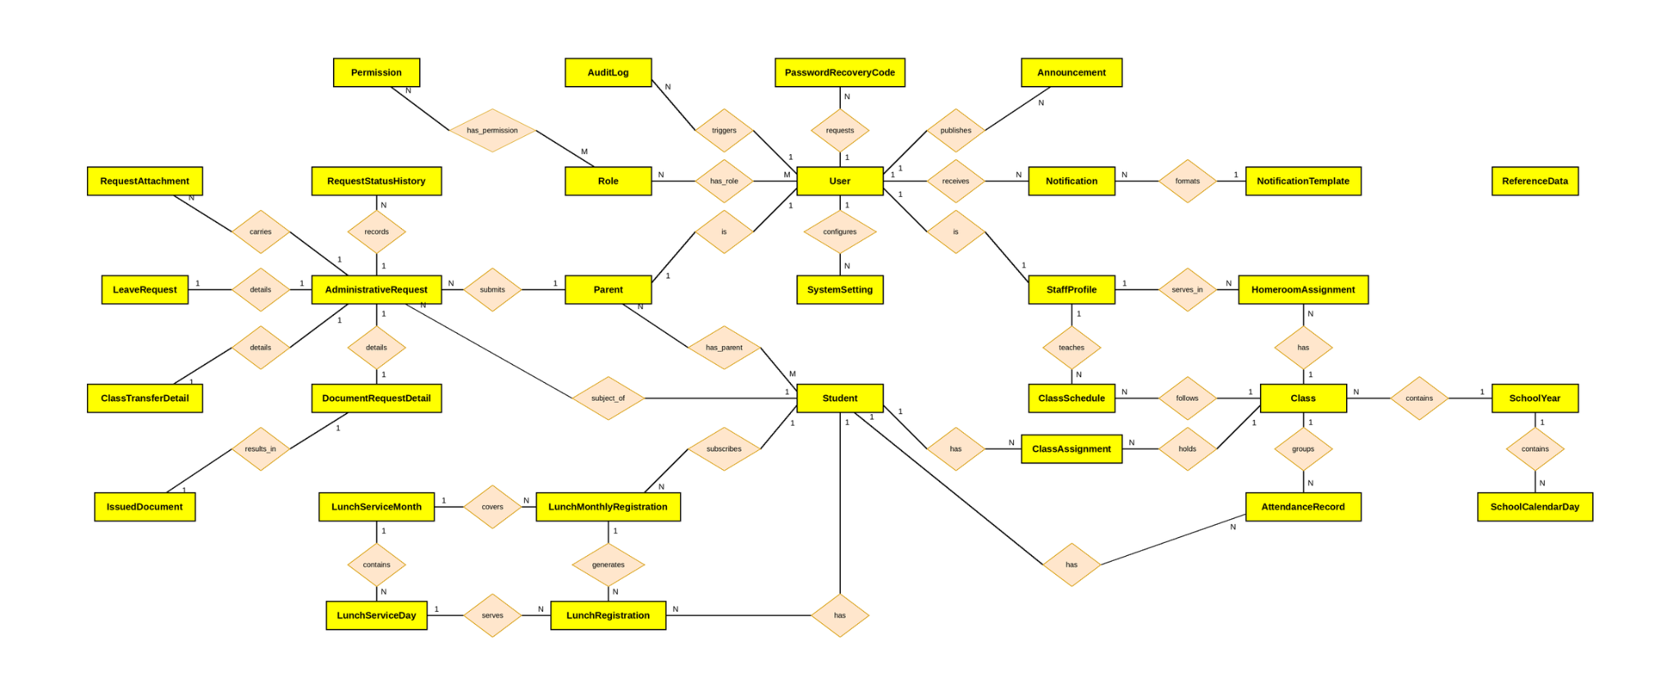

1.4.6 Logical ERD Diagram

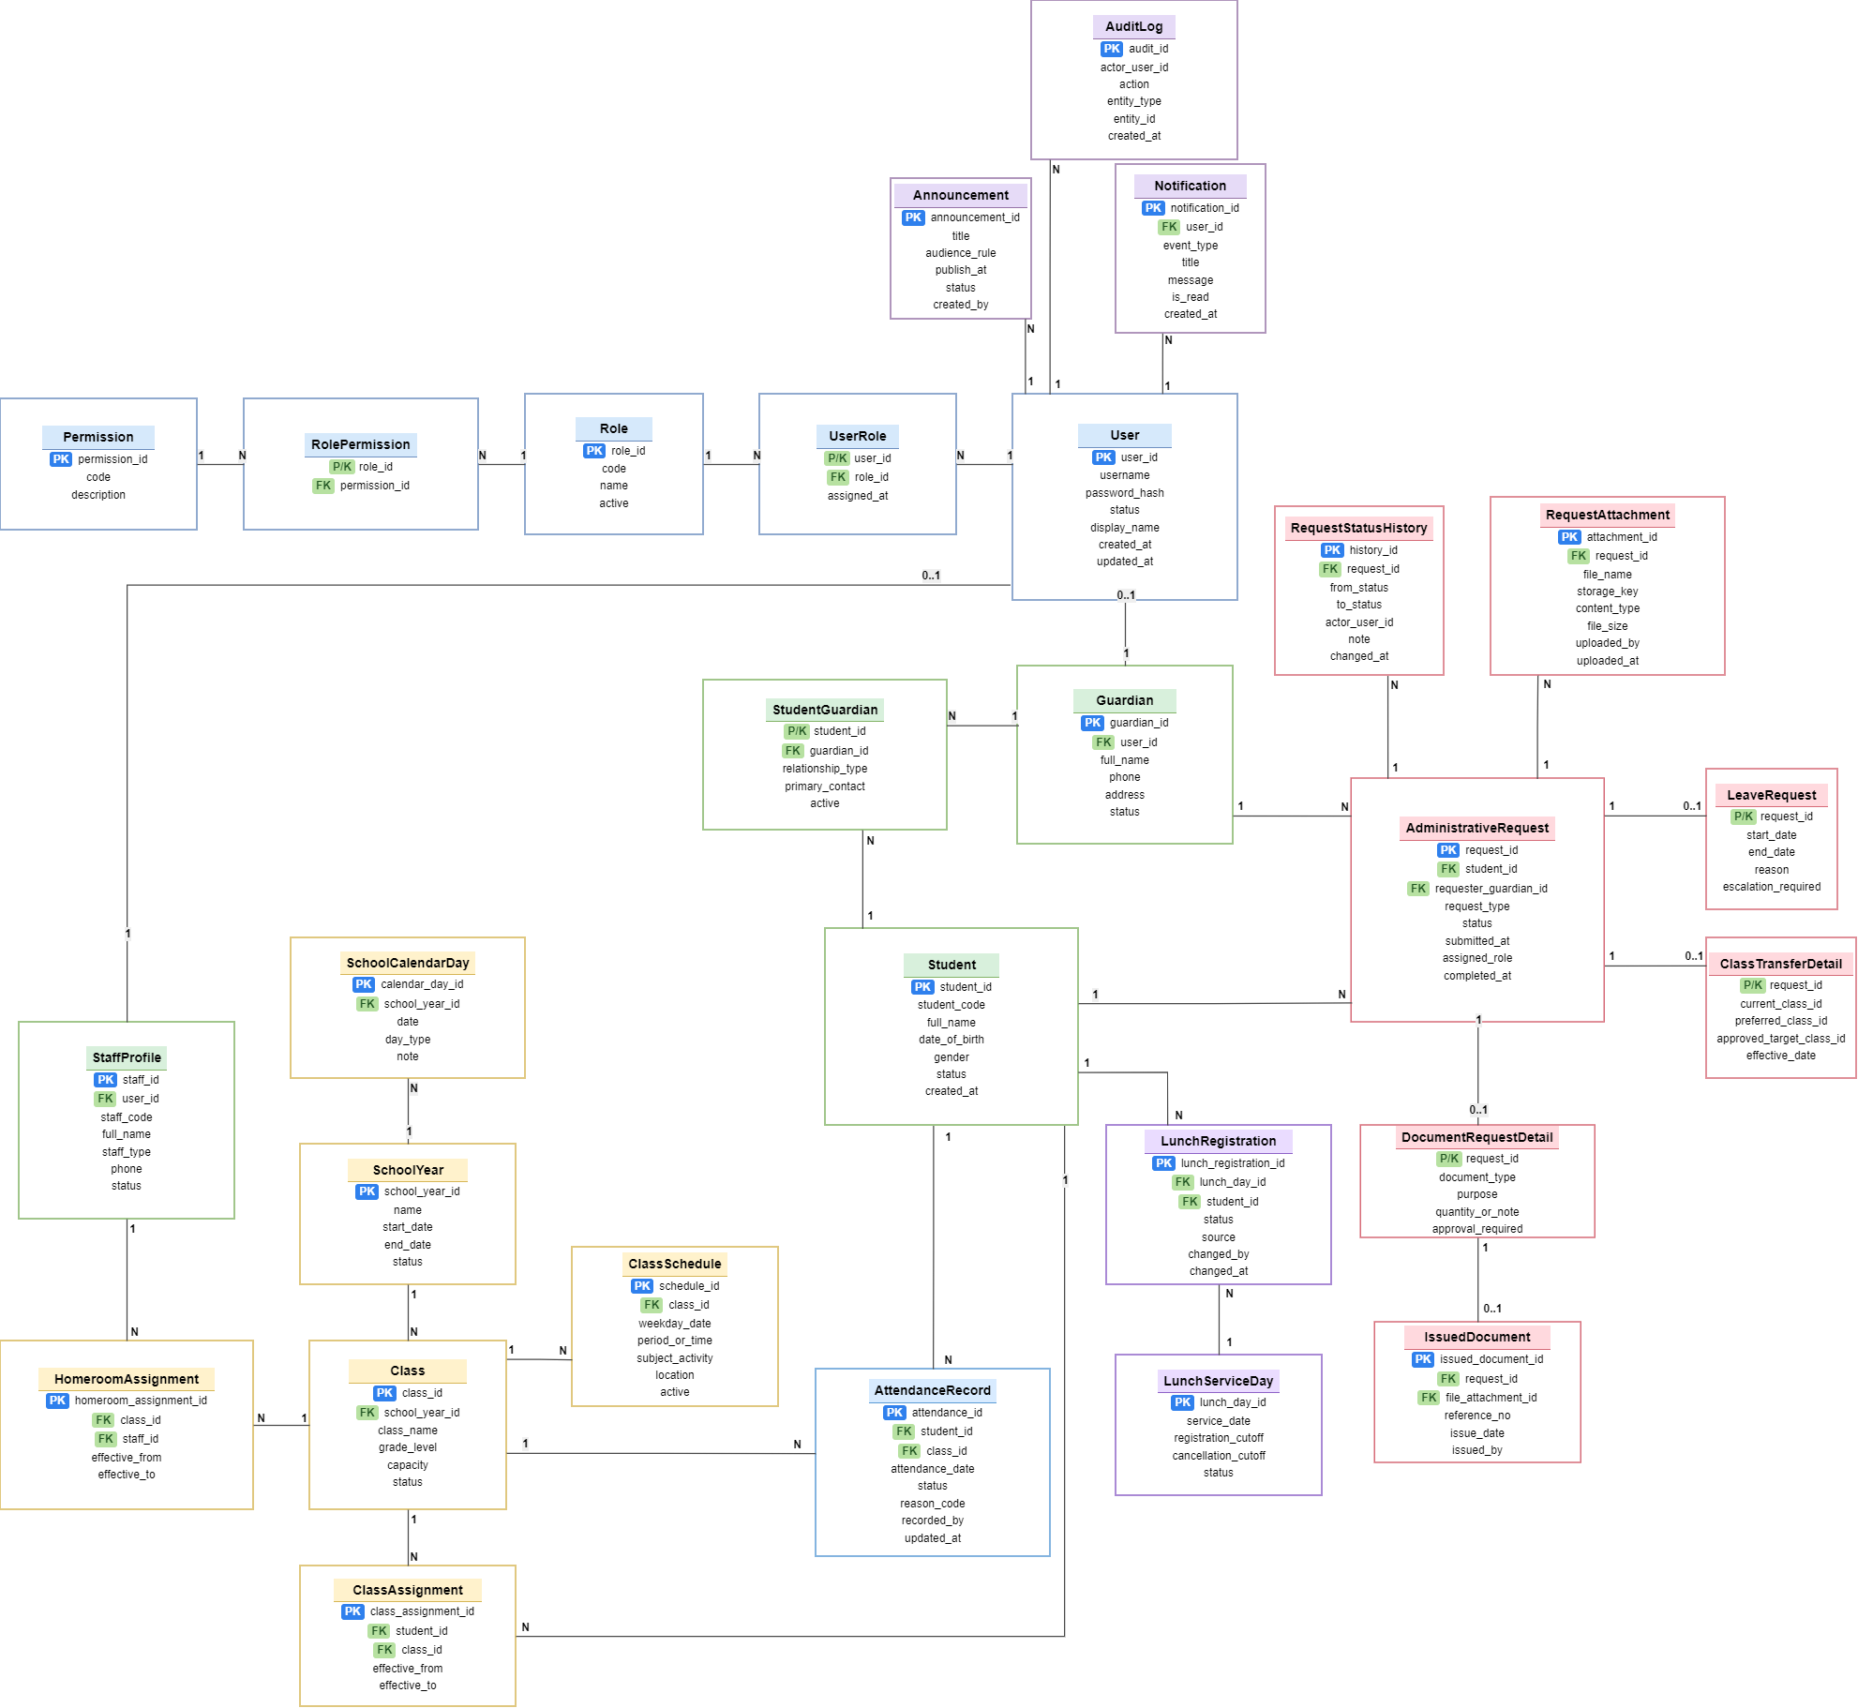
Entities Description

# | Entity | Description
1 | User | User login account, status, credential/security metadata, and linkage to operational profile.
2 | Role | Defined SAWP roles such as Parent / Guardian, Teacher, Giáo vụ, Lunch Service Staff, Ban Giám hiệu, and System Administrator.
3 | Permission | Granular authorization capability assigned to roles.
4 | UserRole | Associative entity linking users to roles when more than one role is supported.
5 | StaffProfile | School staff identity used for teacher/administrative role linkage.
6 | Guardian | Parent/guardian identity and contact information.
7 | Student | Central record for a student already enrolled in the school.
8 | StudentGuardian | Relationship between Student and Guardian, including relationship type and primary-contact flag.
9 | SchoolYear | School-year name, start/end dates, and active/archive state.
10 | SchoolCalendarDay | A date within a school year marked as school day, holiday, or exceptional closure.
11 | Class | Class name, grade, school year, capacity, and status.
12 | HomeroomAssignment | Effective-dated assignment of a Teacher to a Class.
13 | ClassAssignment | Effective-dated assignment of a Student to a Class, preserving history.
14 | ClassSchedule | Weekly/dated schedule entries for a Class.
15 | AttendanceRecord | Daily attendance status for one Student on one school day.
16 | LeaveRequest | Leave/absence request details associated with an AdministrativeRequest.
17 | LunchServiceDay | Daily lunch availability and registration/cancellation cutoff.
18 | LunchRegistration | Student lunch registration for one service date and its active/cancelled/corrected state.
19 | AdministrativeRequest | Common request header: requester, student, type, status, timestamps, and assignee/processing data.
20 | RequestStatusHistory | Chronological status transitions and processing notes for an AdministrativeRequest.
21 | RequestAttachment | File metadata linked to an AdministrativeRequest.
22 | ClassTransferDetail | Class-transfer-specific information linked one-to-one to an AdministrativeRequest.
23 | DocumentRequestDetail | School-document-request-specific information linked one-to-one to an AdministrativeRequest.
24 | IssuedDocument | Metadata about a school document issued in response to an approved request.
25 | Notification | Recipient-specific in-system notification and read state.
26 | Announcement | School announcement content, target audience, and publish schedule/status.
27 | AuditLog | Append-only security/administrative action record.

2. Functional Specifications

2.1 Authentication & Profile Management

2.1.1 UC-01 Login System

a. Screen Layouts
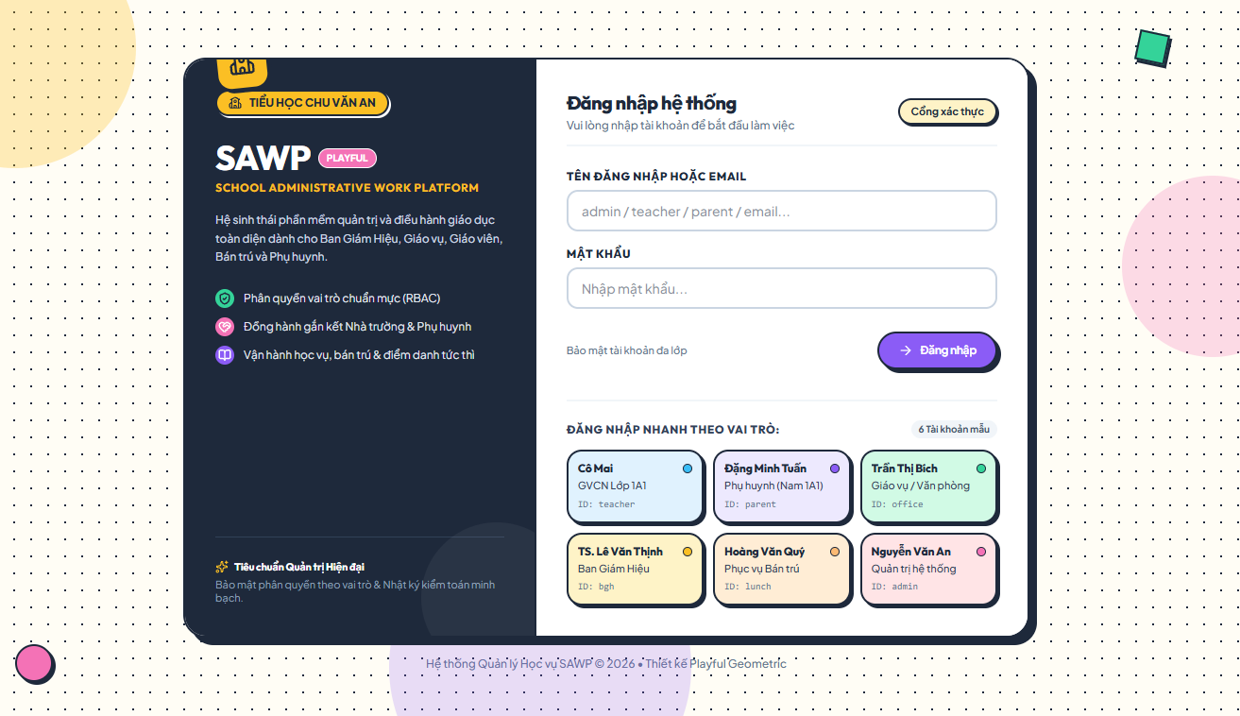

b. Specification
Use Case Name: | UC-01 Login
Primary Actor: | Guest | Secondary Actors: | None
Description: | Authenticates an active user and directs the user to the workspace permitted by their role.
Normal Flow | N1. Login System  1. User opens the Login page.  2. User enters their username/email and password, then submits the request.  3. System validates the submitted credentials. (E1)  4. System verifies the account status. (E2)  5. System identifies the user's role, creates an authenticated session, and redirects the user to the corresponding role dashboard.
Alternative Flows: | A1. Authenticated User Access: If a currently authenticated user accesses the Login page, the system immediately redirects the user to their current role dashboard.
Exceptions: | E1. Invalid Credentials: If the username/email and password combination is incorrect, the system displays MSG02 and remains on the Login page.  E2. Inactive Account: If the account is inactive, disabled, or locked, the system displays MSG03 and denies access.
Business Rules: | BR-01, BR-03, BR-05, BR-48

2.1.2 UC-02 View Profile
UC-02 screen layout
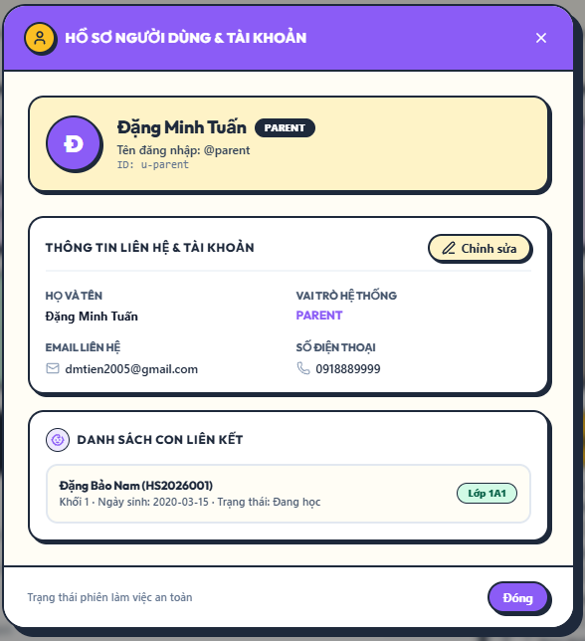

b. Specification
Use Case Name: | UC-02 View Profile
Primary Actor: | All authenticated user roles | Secondary Actors: | None
Description: | Displays the signed-in user profile and account information relevant to the user role.
Normal Flow | N1. View Profile  1. User opens Profile.  2. System identifies the signed-in account.  3. System displays profile details, role, account status, and linked guardian/staff record where applicable.
Alternative Flows: | A1. Parent / Guardian profile also shows the linked children summary without exposing unrelated students.
Exceptions: | E1. Session expired -> return to Login page and require re-authentication.
Business Rules: | BR-03, BR-05, BR-06, BR-47

2.1.3 UC-03 Update Profile

a. Screen Layouts
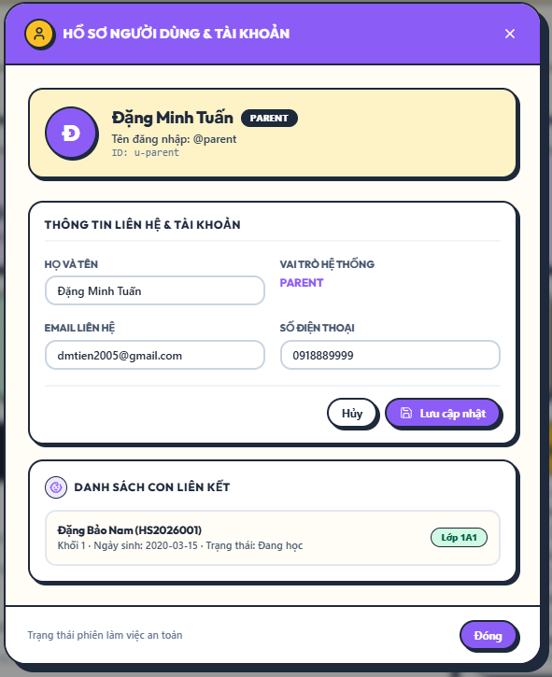

b. Specification
Use Case Name: | UC-03 Update Profile
Primary Actor: | All authenticated user roles | Secondary Actors: | None
Description: | Allows a user to update permitted personal profile fields and preferences.
Normal Flow | N1. Update Profile  1. User opens Profile and selects Edit.  2. System displays only fields that the role may change.  3. User updates permitted fields.  4. System validates the input. (E1)  5. System saves the changes and records an audit entry when required.  6. System displays MSG47.
Alternative Flows: | A1. Parent / Guardian contact data that belongs to the guardian record is synchronized with the linked guardian profile.
Exceptions: | E1. Invalid or incomplete input -> display MSG01 and keep the entered values.
Business Rules: | BR-05, BR-11, BR-51

2.1.4 UC-04 Change Password

a. Screen Layouts
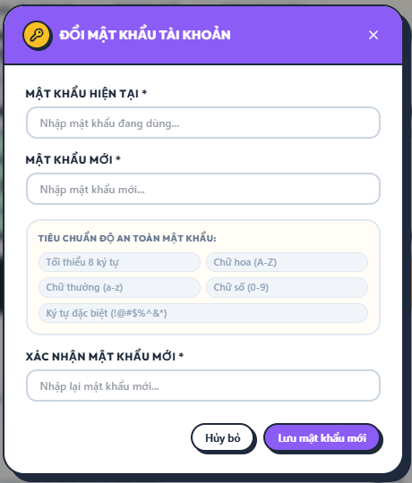

b. Specification
Use Case Name: | UC-04 Change Password
Primary Actor: | All authenticated user roles | Secondary Actors: | None
Description: | Allows an authenticated user to change their own account password.
Normal Flow | N1. Change Password  1. User opens Change Password.  2. User enters current password, new password, and confirmation.  3. System verifies the current password. (E1)  4. System validates the new password policy and confirmation. (E2)  5. System updates the password, invalidates other active sessions, and records the security event.  6. System displays MSG46 and requires re-login when configured.
Alternative Flows: | A1. User cancels before saving -> no password change is made.
Exceptions: | E1. Current password is incorrect -> display MSG02.  E2. New password fails policy or confirmation mismatch -> display MSG04.
Business Rules: | BR-02, BR-03, BR-45

2.1.5 UC-05 Logout

a. Screen Layouts


b. Specification
Use Case Name: | UC-05 Logout
Primary Actor: | All authenticated user roles | Secondary Actors: | None
Description: | Ends the current authenticated session.
Normal Flow | N1. Logout  1. User selects Logout.  2. System invalidates the current session.  3. System clears role/session context.  4. System returns the user to the Login page.
Alternative Flows: | A1. Session is already expired -> system still returns to Login page.
Exceptions: | None.
Business Rules: | BR-03

2.2 Student & Guardian Record Management

2.2.1 UC-06 View Student Profile

a. Screen Layouts
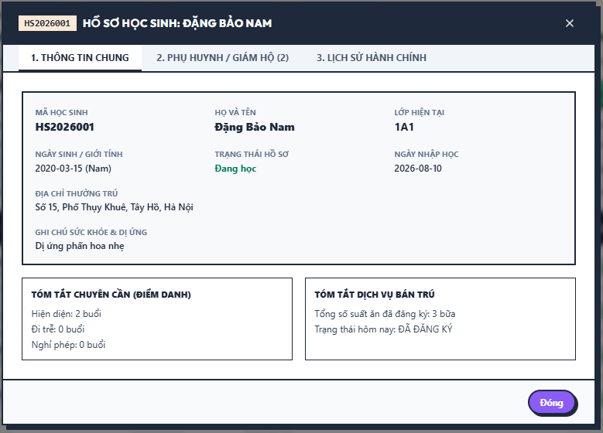

b. Specification
Use Case Name: | UC-06 View Student Profile
Primary Actor: | Parent / Guardian, Teacher, Office Staff, School Board | Secondary Actors: | None
Description: | Displays student information within the viewer’s authorized data scope.
Normal Flow | N1. View Student Profile  1. User selects a student from an authorized list or linked child list.  2. System verifies the relationship and data-access scope. (E1)  3. System displays permitted student information and current class assignment.  4. System displays role-appropriate summaries of attendance, lunch registration, and requests.
Alternative Flows: | A1. Parent / Guardian sees only linked children.  A2. Teacher sees only students in assigned class(es).
Exceptions: | E1. User is not authorized for the student -> display MSG10.  E2. Student cannot be found -> display MSG11.
Business Rules: | BR-05, BR-06, BR-07, BR-51

2.2.2 UC-07 Create Student Record

a. Screen Layouts
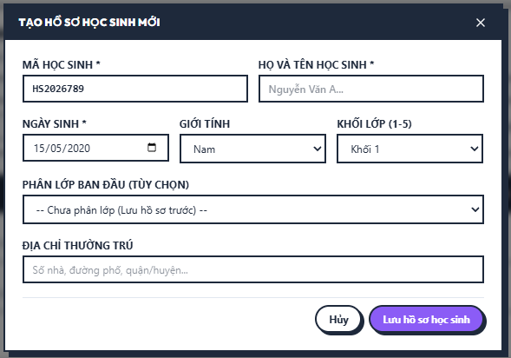

b. Specification
Use Case Name: | UC-07 Create Student Record
Primary Actor: | Office Staff | Secondary Actors: | None
Description: | Creates a SAWP record for a student who is already enrolled in the school.
Normal Flow | N1. Create Student Record  1. Office Staff opens Create Student.  2. System displays required student fields.  3. Office Staff enters student code, name, date of birth, grade-related information, and status.  4. System validates required data and student-code uniqueness. (E1/E2)  5. System creates the student record as an already-enrolled student and records the creation in the audit log.  6. System displays MSG08.
Alternative Flows: | A1. Office Staff saves the student first and links guardians/class later.
Exceptions: | E1. Required data missing/invalid -> display MSG01.  E2. Student code already exists -> display MSG12.
Business Rules: | BR-09, BR-10, BR-11, BR-52

2.2.3 UC-08 Update Student Record

a. Screen Layouts 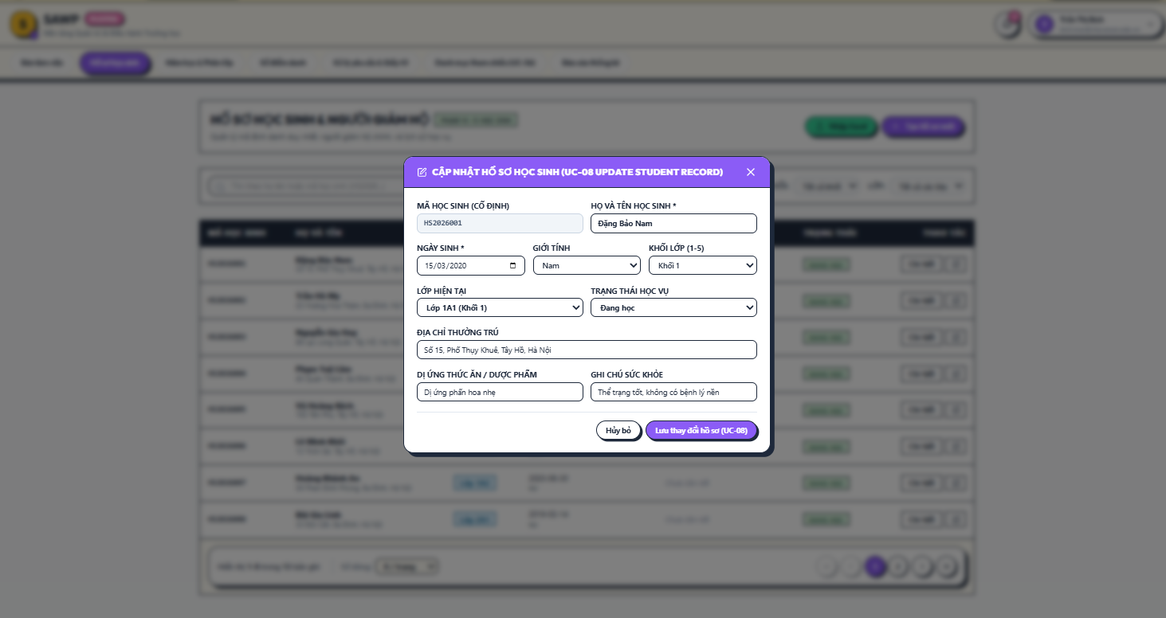

b. Specification
Use Case Name: | UC-08 Update Student Record
Primary Actor: | Office Staff | Secondary Actors: | School Board (view/audit as authorized)
Description: | Updates permitted administrative information for an existing student.
Normal Flow | N1. Update Student Record  1. Office Staff opens an existing student record.  2. System displays current data and editable fields.  3. Office Staff updates permitted information.  4. System validates the changes. (E1)  5. System saves the new values without deleting history that must be preserved.  6. System writes an audit entry and displays MSG08.
Alternative Flows: | A1. If the student becomes inactive, Office Staff changes status instead of deleting the record.
Exceptions: | E1. Invalid data or duplicate student code -> display MSG01 or MSG12.
Business Rules: | BR-09, BR-11, BR-52

2.2.4 UC-09 Import Student Records

a. Screen Layouts
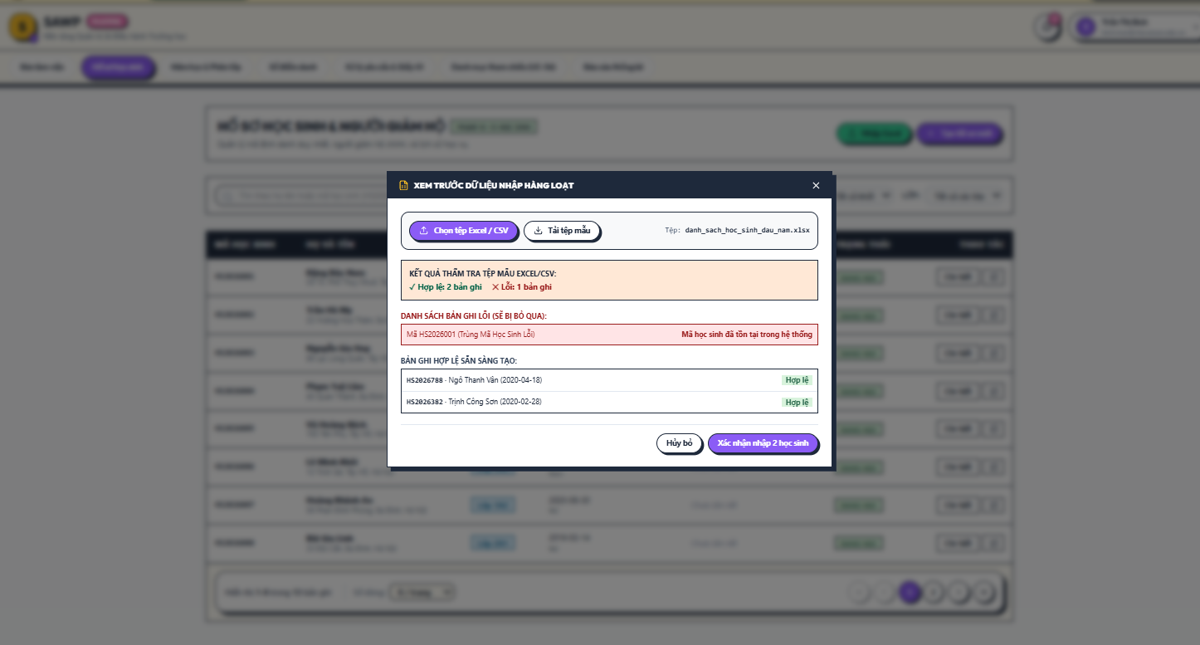

b. Specification
Use Case Name: | UC-09 Import Student Records
Primary Actor: | Office Staff | Secondary Actors: | None
Description: | Bulk imports records for students who are already enrolled, using a school-provided import file.
Normal Flow | N1. Import Student Records  1. Office Staff opens Import Students and selects a CSV/XLSX file matching the provided template.  2. System parses the file and validates required fields, formats, and duplicate student codes.  3. System displays a preview with valid and invalid rows.  4. Office Staff confirms import of valid rows.  5. System creates valid student records and skips invalid rows.  6. System displays import totals and an error list using MSG48/MSG49.
Alternative Flows: | A1. Office Staff cancels after validation -> no records are imported.  A2. Existing matching records can be skipped rather than overwritten.
Exceptions: | E1. Unsupported/corrupted file -> display MSG41.  E2. No valid rows -> display MSG49 and do not import.
Business Rules: | BR-09, BR-10, BR-11, BR-50, BR-52

2.2.5 UC-10 Link or Unlink Guardian to Student

a. Screen Layouts
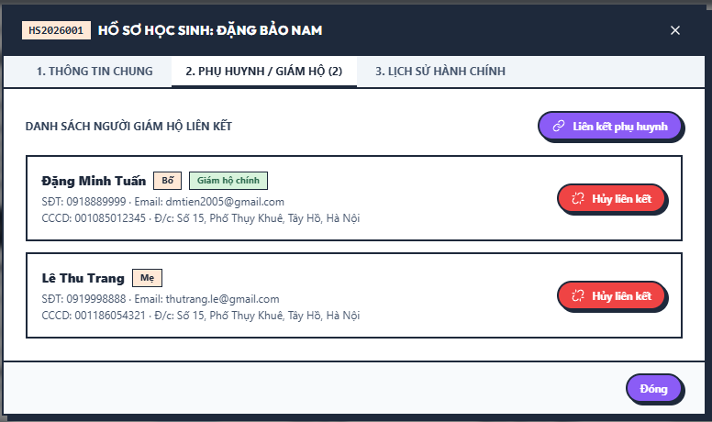

b. Specification
Use Case Name: | UC-10 Link or Unlink Guardian to Student
Primary Actor: | Office Staff | Secondary Actors: | Parent / Guardian
Description: | Maintains the relationship between a student and Parent / Guardian records.
Normal Flow | N1. Link or Unlink Guardian to Student  1. Office Staff opens the student Guardians section.  2. Office Staff selects an existing guardian or creates a guardian record as permitted.  3. Office Staff selects relationship type and whether the guardian is the primary contact.  4. System checks for duplicate relationships and required primary contact. (E1)  5. System saves the relationship and records the change.
Alternative Flows: | A1. Unlink Guardian: Office Staff selects an existing link, confirms removal, and system preserves relationship history if required.
Exceptions: | E1. Unlinking would leave an active student without a required primary guardian -> reject with MSG01.
Business Rules: | BR-12, BR-13, BR-11, BR-51

2.2.6 UC-11 Update Guardian Contact Information

a. Screen Layouts 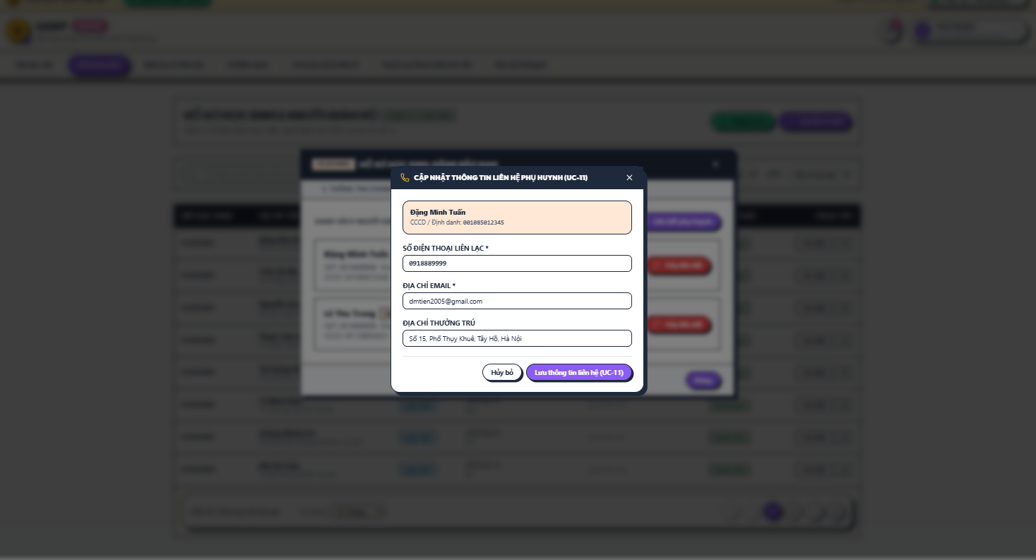

b. Specification
Use Case Name: | UC-11 Update Contact Information
Primary Actor: | Parent / Guardian, Office Staff | Secondary Actors: | None
Description: | Updates guardian contact details used for school communication.
Normal Flow | N1. Update Guardian Contact Information  1. Actor opens the guardian contact information.  2. System verifies that Parent / Guardian is editing their own record or that Office Staff is authorized. (E1)  3. Actor updates phone, address, or other permitted contact fields.  4. System validates the input and saves the changes.  5. System records the update and displays MSG47.
Alternative Flows: | A1. Office Staff may update contact details on behalf of the guardian based on school records.
Exceptions: | E1. Parent attempts to edit another guardian record -> display MSG10.
Business Rules: | BR-06, BR-11, BR-51

2.2.7 UC-12 View Student Administrative History

a. Screen Layouts
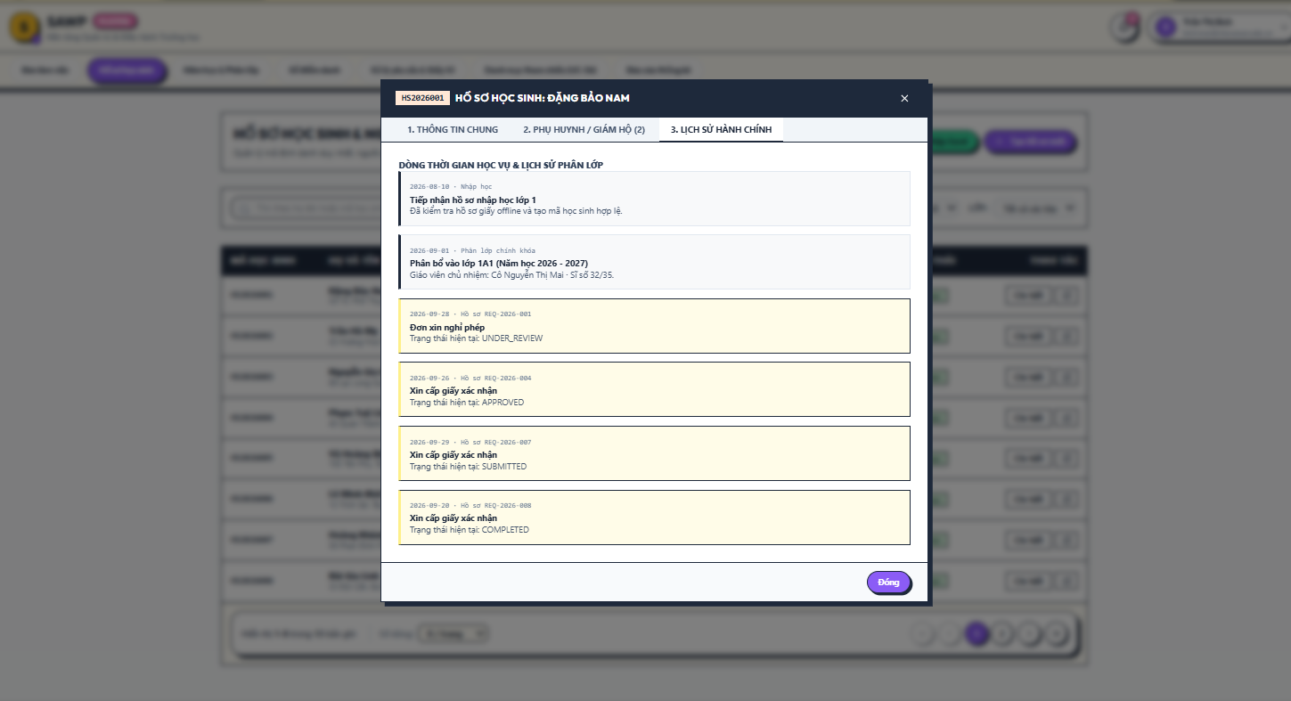

b. Specification
Use Case Name: | UC-12 View Student Administrative History
Primary Actor: | Office Staff, School Board | Secondary Actors: | Parent / Guardian (limited view)
Description: | Shows a chronological administrative history for a student.
Normal Flow | N1. View Student Administrative History  1. Actor opens Student History.  2. System verifies data scope.  3. System loads class-assignment history, request history, attendance summaries, and lunch-service history.  4. System displays entries in chronological order with filters.
Alternative Flows: | A1. Parent / Guardian may view only history that is exposed to families for their linked child.
Exceptions: | E1. No historical records -> display MSG43.
Business Rules: | BR-05, BR-06, BR-44, BR-55

2.3 School Year, Class & Schedule Management

2.3.1 UC-13 Manage School Years

a. Screen Layouts
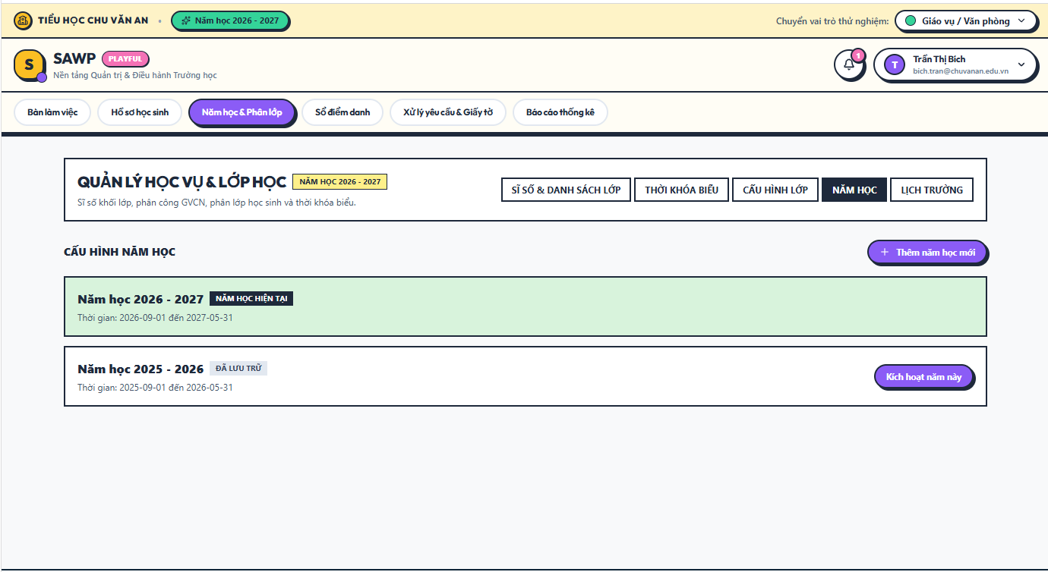

b. Specification
Use Case Name: | UC-13 Manage School Years
Primary Actor: | Office Staff | Secondary Actors: | System Administrator
Description: | Creates, activates, updates, and archives school-year records.
Normal Flow | N1. Manage School Years  1. Office Staff opens School Years.  2. Office Staff creates or edits a school year with name, start date, and end date.  3. System validates dates and existing active year. (E1)  4. Office Staff activates the intended current school year.  5. System saves changes and records an audit entry.
Alternative Flows: | A1. Archive a completed school year -> historical records remain accessible in read-only/reporting mode.
Exceptions: | E1. Date range is invalid or conflicts with active year rules -> display MSG01.
Business Rules: | BR-14, BR-53, BR-55

2.3.2 UC-14 Manage Classes

a. Screen Layouts
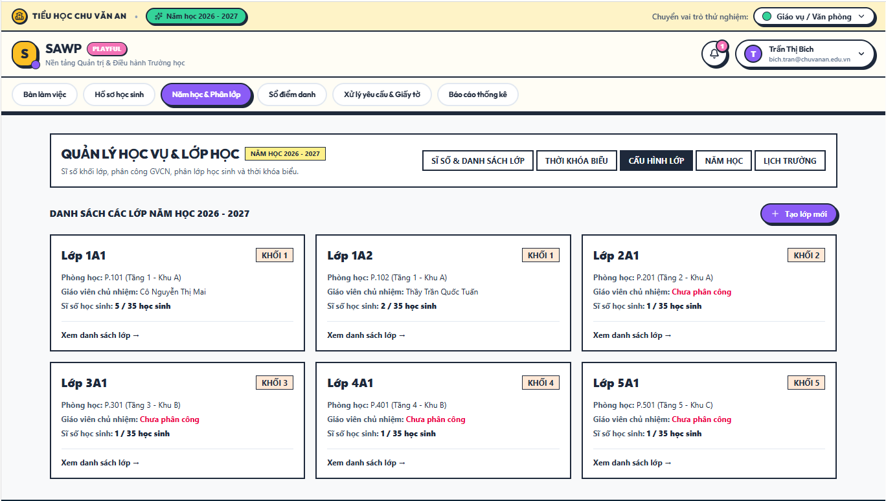

b. Specification
Use Case Name: | UC-14 Manage Classes
Primary Actor: | Office Staff | Secondary Actors: | None
Description: | Creates and maintains classes for a school year.
Normal Flow | N1. Manage Classes  1. Office Staff opens Class Management for a selected school year.  2. Office Staff creates or edits class name, grade, capacity, and status.  3. System validates grade and school-year association. (E1)  4. System saves the class and records the change.
Alternative Flows: | A1. Archive Class: class is marked inactive only when no current operational process requires it.
Exceptions: | E1. Invalid grade/year/capacity -> display MSG01.
Business Rules: | BR-15, BR-52, BR-53

2.3.3 UC-15 Assign Teacher

a. Screen Layouts
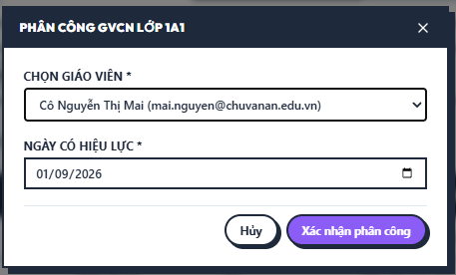

b. Specification
Use Case Name: | UC-15 Assign Teacher
Primary Actor: | Office Staff | Secondary Actors: | Teacher
Description: | Assigns a Teacher to a class for the active period.
Normal Flow | N1. Assign Teacher  1. Office Staff opens the class and selects Assign Teacher.  2. System lists eligible teacher accounts/staff profiles.  3. Office Staff selects a teacher and effective date.  4. System validates that the class does not have a conflicting active primary assignment. (E1)  5. System creates the assignment and notifies the teacher.
Alternative Flows: | A1. Reassign Teacher: system closes the prior assignment on the effective date and creates the new assignment.
Exceptions: | E1. Conflicting active assignment -> display MSG01.
Business Rules: | BR-16, BR-11, BR-42

2.3.4 UC-16 Assign Students to Class

a. Screen Layouts
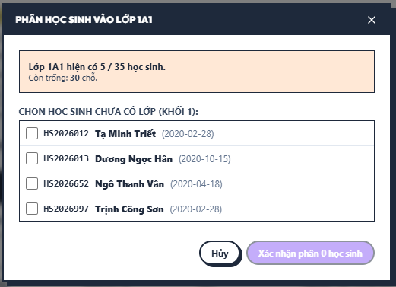

b. Specification
Use Case Name: | UC-16 Assign Students to Class
Primary Actor: | Office Staff | Secondary Actors: | None
Description: | Assigns one or more active students to a class in the selected school year.
Normal Flow | N1. Assign Students to Class  1. Office Staff opens Student Assignment for a class.  2. System lists eligible students not already assigned to another current class for that school year.  3. Office Staff selects one or more students.  4. System checks class capacity and current assignments. (E1)  5. System creates class-assignment records and updates each student’s current class.  6. System displays MSG16.
Alternative Flows: | A1. Bulk assignment may be performed for multiple students in one confirmation.
Exceptions: | E1. Class is full or a student already has a current class -> display MSG15.
Business Rules: | BR-15, BR-17, BR-18

2.3.5 UC-17 View Class Roster

a. Screen Layouts
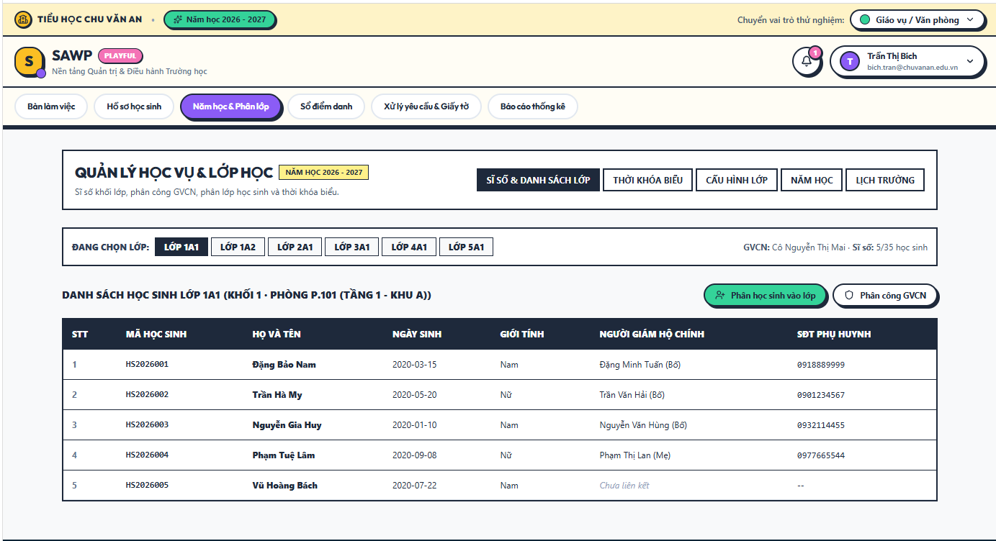

b. Specification
Use Case Name: | UC-17 View Class Roster
Primary Actor: | Teacher, Office Staff, School Board | Secondary Actors: | None
Description: | Displays the current student roster for an authorized class.
Normal Flow | N1. View Class Roster  1. Actor selects a class.  2. System verifies class access. (E1)  3. System displays active students assigned to the class with essential identifiers and guardian contact shortcut according to role.
Alternative Flows: | A1. Office Staff/School Board can filter by school year and class status.
Exceptions: | E1. Teacher opens an unassigned class -> display MSG10.
Business Rules: | BR-07, BR-17, BR-51

2.3.6 UC-18 Manage Class Schedule

a. Screen Layouts
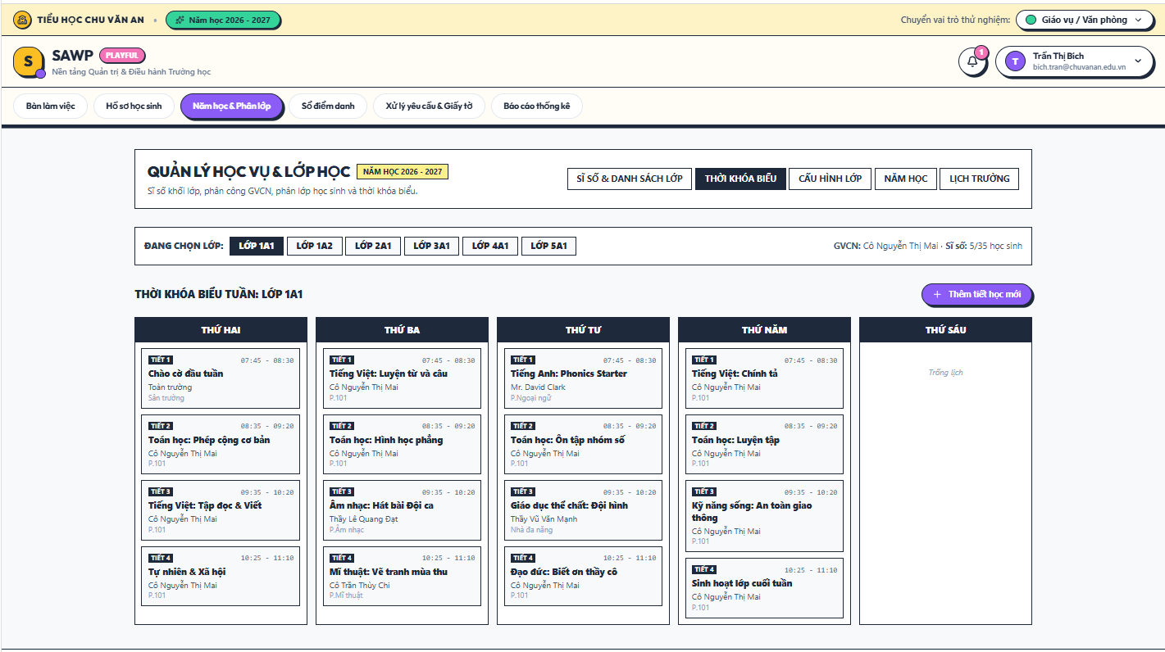

b. Specification
Use Case Name: | UC-18 Manage Class Schedule
Primary Actor: | Office Staff | Secondary Actors: | Teacher
Description: | Creates and updates the weekly schedule for a class.
Normal Flow | N1. Manage Class Schedule  1. Office Staff selects a class and opens Schedule.  2. Office Staff adds or edits weekday, period/time, subject/activity, and optional location/note.  3. System checks for duplicate/conflicting class time slots. (E1)  4. System saves the schedule and publishes the updated version to authorized viewers.
Alternative Flows: | A1. Copy Schedule: Office Staff may copy a prior class/week schedule and edit it before saving.
Exceptions: | E1. Time-slot conflict -> display MSG17.
Business Rules: | BR-19, BR-53

2.3.7 UC-19 View Child or Class Schedule

a. Screen Layouts 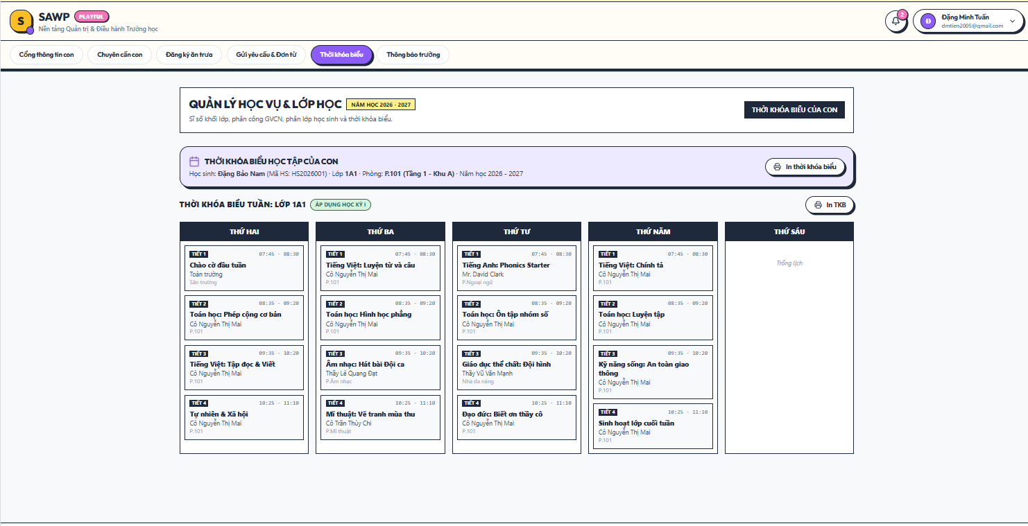

b. Specification
Use Case Name: | UC-19 View Child or Class Schedule
Primary Actor: | Parent / Guardian, Teacher | Secondary Actors: | Office Staff
Description: | Displays the current class schedule to Parent / Guardian and school staff.
Normal Flow | N1. View Child or Class Schedule  1. Actor opens Schedule.  2. System determines the linked child or assigned class.  3. System loads the published schedule for the active school year/week.  4. System displays schedule entries in chronological order.
Alternative Flows: | A1. Parent with multiple children selects a child before viewing schedule.
Exceptions: | E1. No schedule exists -> display MSG43.
Business Rules: | BR-06, BR-07, BR-19, BR-53

2.3.8 UC-20 Manage School Calendar

a. Screen Layouts
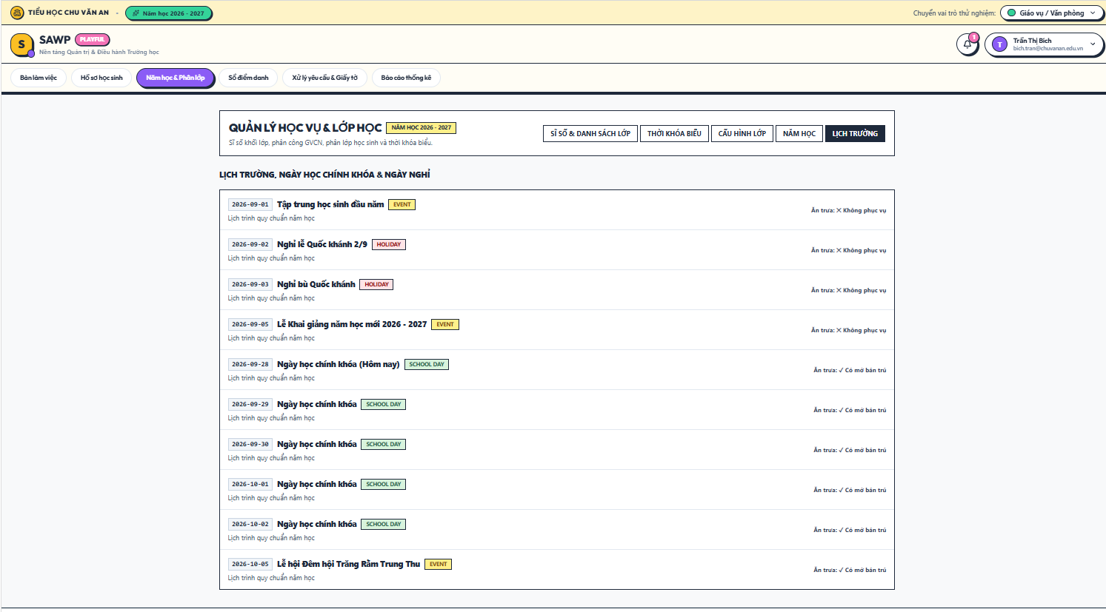

b. Specification
Use Case Name: | UC-20 Manage School Calendar
Primary Actor: | Office Staff | Secondary Actors: | System Administrator
Description: | Maintains school days, holidays, and exceptional non-school days used by attendance and lunch functions.
Normal Flow | N1. Manage School Calendar  1. Office Staff opens the calendar for the active school year.  2. Office Staff marks school days, holidays, or exceptional closure days and adds optional notes.  3. System validates that dates fall inside the school year. (E1)  4. System saves the calendar and makes it available to attendance/lunch validation.
Alternative Flows: | A1. Bulk-create standard weekdays as school days, then override holidays manually.
Exceptions: | E1. Date outside the selected school year -> display MSG01.
Business Rules: | BR-14, BR-27, BR-30, BR-53

2.4 Attendance & Leave Management

2.4.1 UC-21 Record Daily Attendance

a. Screen Layouts
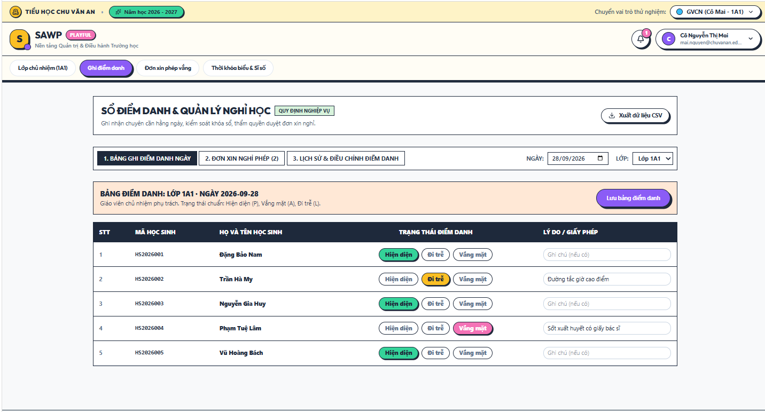

b. Specification
Use Case Name: | UC-21 Record Daily Attendance
Primary Actor: | Teacher | Secondary Actors: | None
Description: | Records daily attendance for students in the Teacher’s assigned class.
Normal Flow | N1. Record Daily Attendance  1. Teacher opens Attendance for the assigned class and school day.  2. System loads the class roster and any approved/pending leave indicators.  3. Teacher records a status for each student.  4. System validates one attendance record per student/date. (E1)  5. Teacher submits the attendance sheet.  6. System saves the records, timestamps the submission, and displays MSG18.
Alternative Flows: | A1. Teacher saves a draft before final submission if the school enables drafts.
Exceptions: | E1. Duplicate or non-school-day attendance entry -> display MSG01.  E2. Teacher is not assigned to the class -> display MSG20.
Business Rules: | BR-20, BR-21, BR-23, BR-26, BR-53

2.4.2 UC-22 Edit Attendance Record

a. Screen Layouts
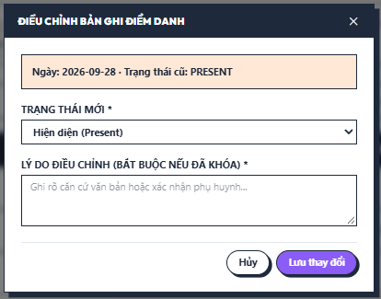

b. Specification
Use Case Name: | UC-22 Edit Attendance Record
Primary Actor: | Teacher, Office Staff | Secondary Actors: | None
Description: | Corrects an existing attendance record within the permitted edit window.
Normal Flow | N1. Edit Attendance Record  1. Actor opens an attendance record.  2. System checks role and whether the record is still editable. (E1)  3. Actor changes status/reason as permitted.  4. If correction occurs after the normal teacher window, Office Staff enters a correction reason.  5. System saves the change and records old/new values in the audit log.  6. System displays MSG18.
Alternative Flows: | A1. Before lock, Teacher edits records for their assigned class.  A2. After lock, Office Staff may correct records with a mandatory reason.
Exceptions: | E1. Record is locked for this actor -> display MSG19.
Business Rules: | BR-21, BR-22, BR-45

2.4.3 UC-23 View Class Attendance

a. Screen Layouts
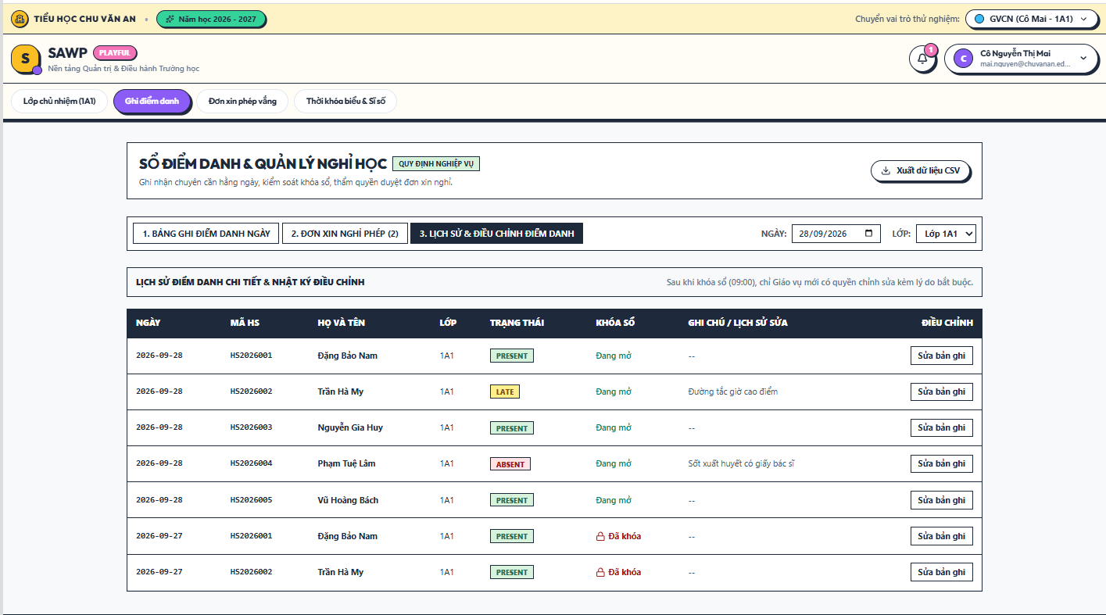

b. Specification
Use Case Name: | UC-23 View Class Attendance
Primary Actor: | Teacher, Office Staff, School Board | Secondary Actors: | None
Description: | Displays attendance details and summaries for an authorized class.
Normal Flow | N1. View Class Attendance  1. Actor selects a class and date/range.  2. System verifies access.  3. System loads attendance records and summary counts.  4. System displays present/absent/late counts and student-level details permitted by role.
Alternative Flows: | A1. Office Staff/School Board may compare multiple classes using report view.
Exceptions: | E1. No attendance data -> display MSG43.
Business Rules: | BR-07, BR-44, BR-51

2.4.4 UC-24 View Child Attendance

a. Screen Layouts 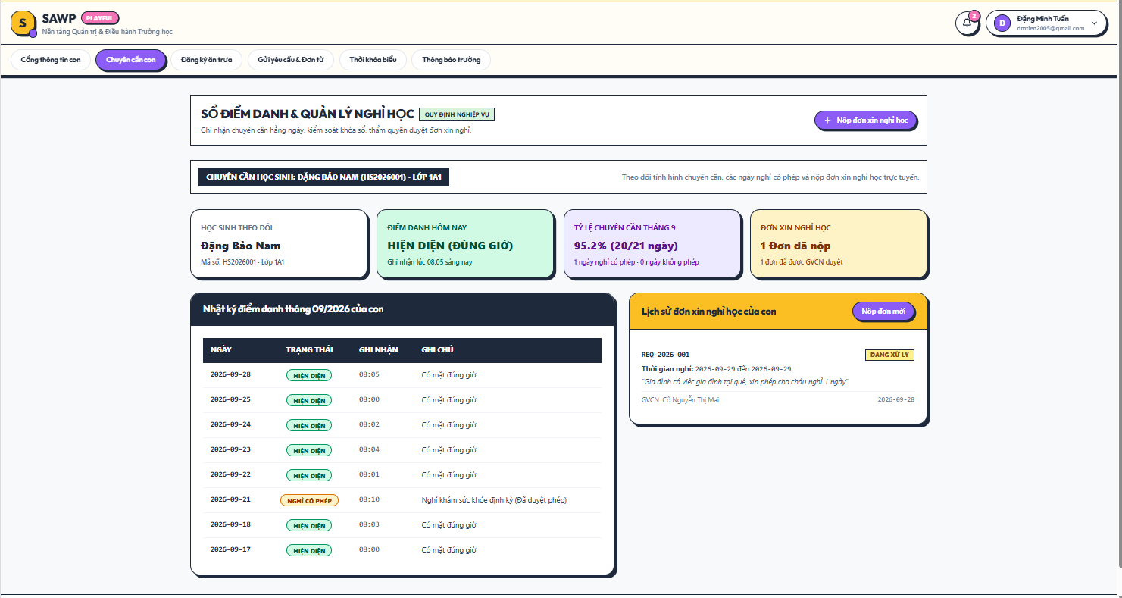

b. Specification
Use Case Name: | UC-24 View Child Attendance
Primary Actor: | Parent / Guardian | Secondary Actors: | None
Description: | Allows a Parent / Guardian to review attendance for a linked child.
Normal Flow | N1. View Child Attendance  1. Parent selects a linked child.  2. System verifies the parent-child link. (E1)  3. System displays attendance history, status, and school-visible reason/leave information.
Alternative Flows: | A1. Parent filters by month or date range.
Exceptions: | E1. Child is not linked to the account -> display MSG10.
Business Rules: | BR-06, BR-51

2.4.5 UC-25 Submit Leave or Absence Request

a. Screen Layouts
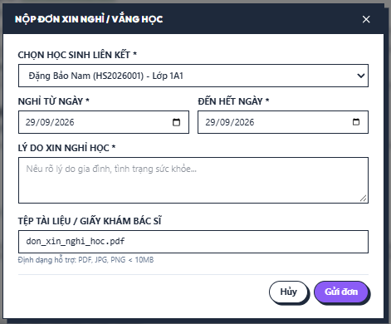

b. Specification
Use Case Name: | UC-25 Submit Leave or Absence Request
Primary Actor: | Parent / Guardian | Secondary Actors: | Teacher, Office Staff, School Board
Description: | Allows a Parent / Guardian to request an excused absence for a linked child.
Normal Flow | N1. Submit Leave or Absence Request  1. Parent selects a linked child and opens New Leave Request.  2. Parent enters start/end date, reason, and optional supporting attachment.  3. System validates the date range, file, and overlapping active requests. (E1)  4. System classifies routing according to configured school approval rules.  5. Parent submits the request.  6. System creates the request, notifies the responsible reviewer, and displays MSG21.
Alternative Flows: | A1. Routine request routes to Teacher.  A2. Request meeting escalation criteria routes onward to Office Staff/School Board after initial review.
Exceptions: | E1. Invalid dates, overlap, or invalid attachment -> display MSG24 or MSG41.
Business Rules: | BR-24, BR-25, BR-34, BR-50, BR-53

2.4.6 UC-26 Review Routine Leave Request

a. Screen Layouts
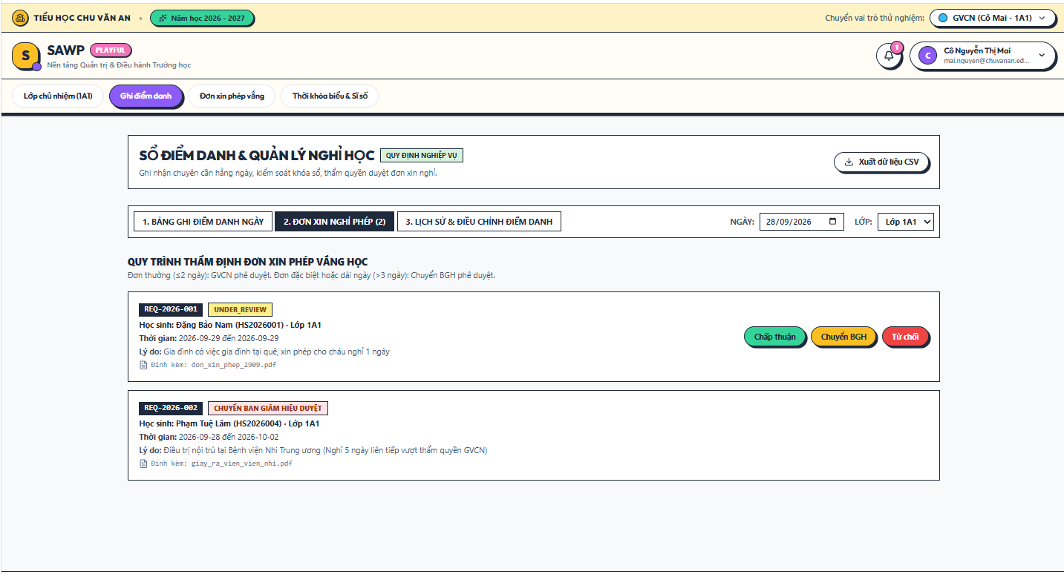

b. Specification
Use Case Name: | UC-26 Review Routine Leave Request
Primary Actor: | Teacher | Secondary Actors: | Office Staff, School Board
Description: | Allows the Teacher to review routine absence requests for their class.
Normal Flow | N1. Review Routine Leave Request  1. Teacher opens a pending leave request for a student in the assigned class.  2. System displays request dates, reason, attachment, and relevant class information.  3. Teacher reviews the request.  4. Teacher approves, rejects, or escalates according to school rules.  5. System updates status/history and notifies the parent.
Alternative Flows: | A1. Escalate: system routes the request to the designated higher-authority reviewer.  A2. Request information: status remains pending and parent is notified to provide clarification.
Exceptions: | E1. Teacher is not authorized for the student -> display MSG10.
Business Rules: | BR-21, BR-25, BR-35, BR-42

2.4.7 UC-27 Approve or Reject Escalated Leave Request

a. Screen Layouts
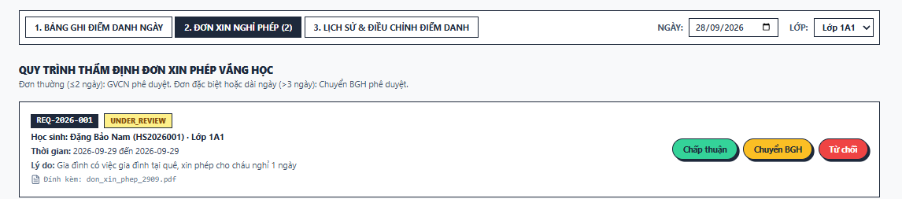

b. Specification
Use Case Name: | UC-27 Approve or Reject Escalated Leave Request
Primary Actor: | School Board | Secondary Actors: | Office Staff, Teacher
Description: | Handles leave requests requiring higher-level authorization.
Normal Flow | N1. Approve or Reject Escalated Leave Request  1. School Board opens an escalated leave request.  2. System displays the request, prior review notes, and student/class information.  3. School Board records an approval or rejection decision and optional note.  4. System updates request status/history.  5. System notifies Parent / Guardian and relevant school staff using MSG22 or MSG23.
Alternative Flows: | A1. School Board returns the request to Office Staff/Teacher for clarification before deciding.
Exceptions: | E1. Request is no longer pending approval -> display MSG09.
Business Rules: | BR-25, BR-35, BR-41, BR-42

2.4.8 UC-28 Generate Attendance Summary

a. Screen Layouts 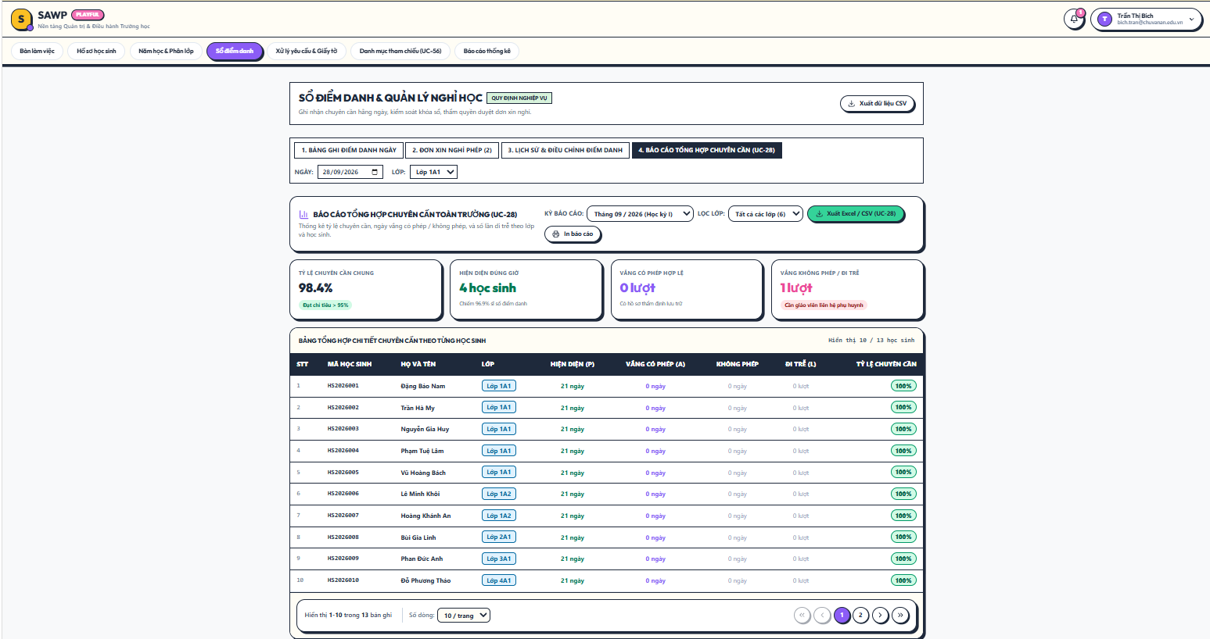

b. Specification
Use Case Name: | UC-28 Generate Attendance Summary
Primary Actor: | Office Staff, School Board | Secondary Actors: | Teacher (own class)
Description: | Produces operational attendance summaries by date, class, grade, or period.
Normal Flow | N1. Generate Attendance Summary  1. Actor opens Attendance Report.  2. Actor selects school year, date range, and class/grade filters within authorized scope.  3. System aggregates attendance records.  4. System displays counts and rates for present/absent/late statuses.  5. Actor may export the displayed report if permitted.
Alternative Flows: | A1. Teacher generates a summary limited to assigned class.
Exceptions: | E1. No matching data -> display MSG43.
Business Rules: | BR-44, BR-54, BR-55

2.5 School Lunch Service Management

2.5.1 UC-29 Register Child for Lunch
UC-29 screen layout
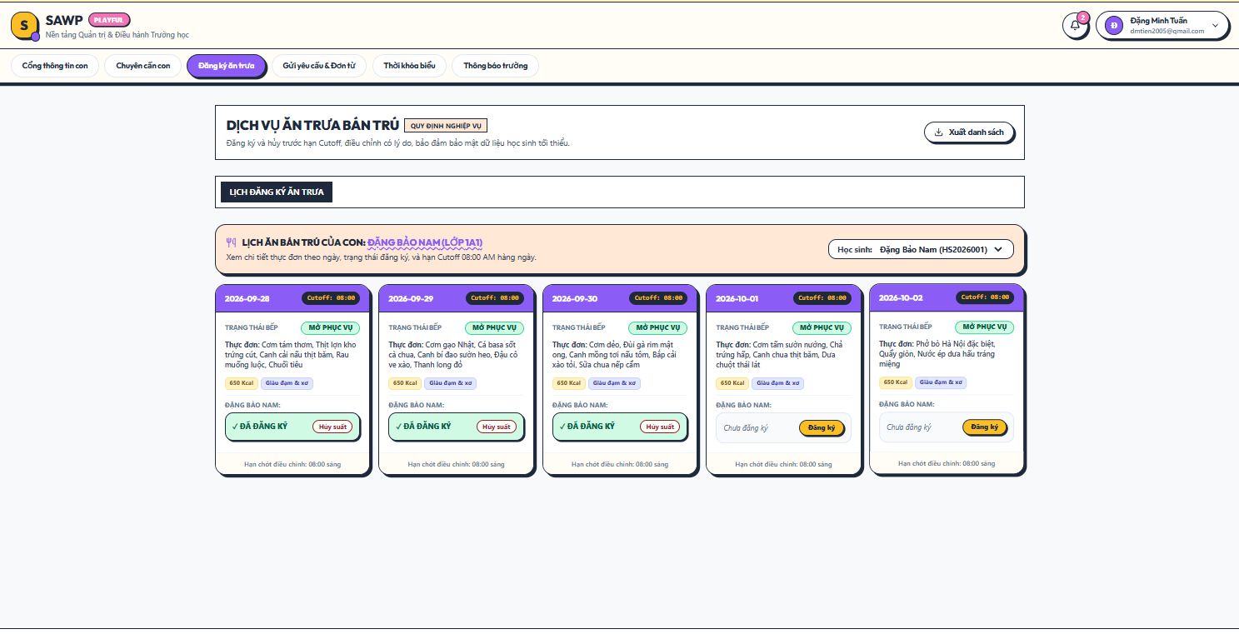

b. Specification
Use Case Name: | UC-29 Register Child for Lunch
Primary Actor: | Parent / Guardian | Secondary Actors: | Lunch Service Staff
Description: | Registers a linked child for school lunch on one or more available dates before the cutoff.
Normal Flow | N1. Register Child for Lunch  1. Parent selects a linked child and opens Lunch Calendar.  2. System displays available lunch service days and registration cutoff status.  3. Parent selects one or more open dates.  4. System validates service availability, cutoff, and duplicate registration. (E1/E2)  5. Parent confirms registration.  6. System creates one registration per selected date and displays MSG25.
Alternative Flows: | A1. Multi-date selection creates independent daily registrations so each date can later be cancelled separately.
Exceptions: | E1. Cutoff has passed -> display MSG27.  E2. Service unavailable or duplicate active registration -> display MSG28 or MSG29.
Business Rules: | BR-27, BR-28, BR-29, BR-30, BR-34

2.5.2 UC-30 Cancel Lunch Registration
UC-30 screen layout
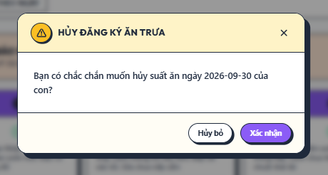

b. Specification
Use Case Name: | UC-30 Cancel Lunch Registration
Primary Actor: | Parent / Guardian | Secondary Actors: | Lunch Service Staff
Description: | Cancels a child’s active daily lunch registration before the configured cutoff.
Normal Flow | N1. Cancel Lunch Registration  1. Parent opens the child Lunch Calendar.  2. Parent selects an active lunch registration.  3. System checks cancellation cutoff. (E1)  4. Parent confirms cancellation.  5. System marks the registration cancelled and updates meal counts.  6. System displays MSG26.
Alternative Flows: | A1. Parent closes the confirmation dialog -> registration remains active.
Exceptions: | E1. Cancellation cutoff passed -> display MSG27 and direct the parent to contact school if correction is needed.
Business Rules: | BR-28, BR-29, BR-32, BR-34

2.5.3 UC-31 View Child Lunch Calendar

a. Screen Layouts
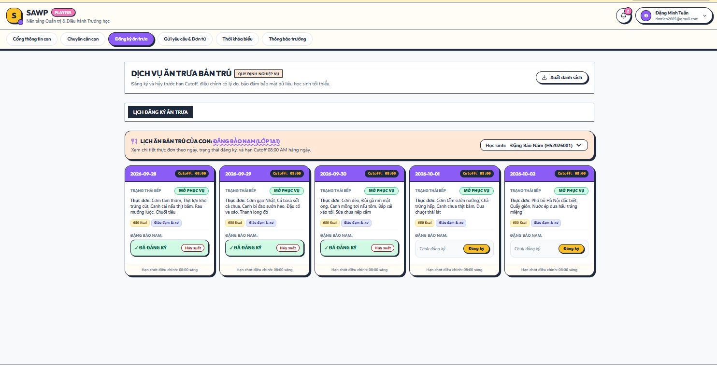

b. Specification
Use Case Name: | UC-31 View Child Lunch Calendar
Primary Actor: | Parent / Guardian | Secondary Actors: | None
Description: | Displays a linked child’s daily lunch-service status.
Normal Flow | N1. View Child Lunch Calendar  1. Parent selects a linked child.  2. System verifies the relationship.  3. System loads lunch-service days and the child’s registration status.  4. System displays a calendar with registration and cutoff indicators.
Alternative Flows: | A1. Parent changes month/date range.
Exceptions: | E1. No lunch service configured for the period -> display MSG43.
Business Rules: | BR-06, BR-27, BR-29

2.5.4 UC-32 Manage Lunch Service Days

a. Screen Layouts
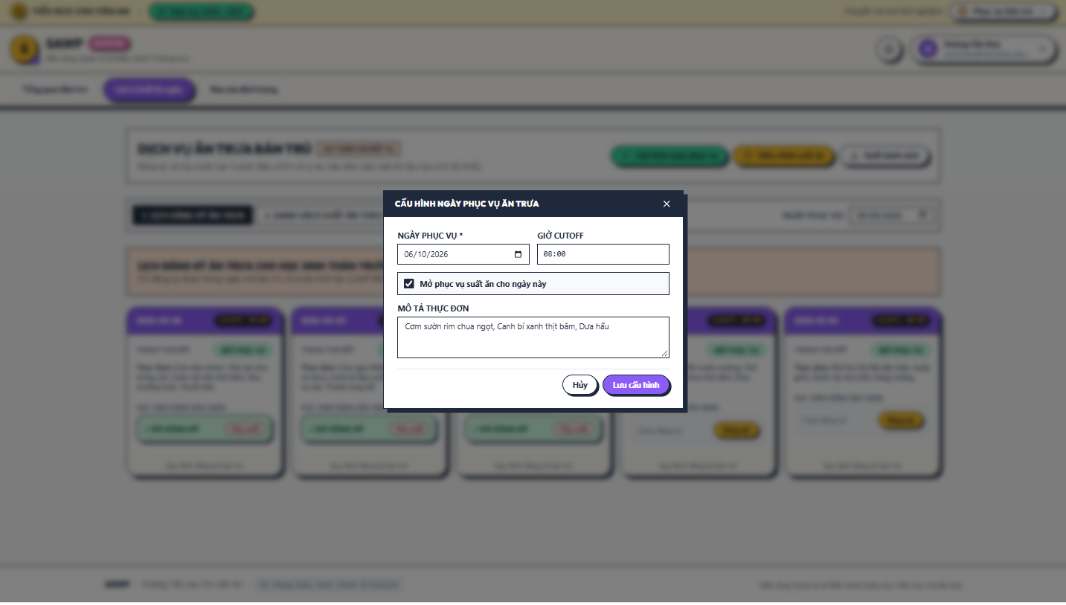

b. Specification
Use Case Name: | UC-32 Manage Lunch Service Days
Primary Actor: | Lunch Service Staff | Secondary Actors: | Office Staff
Description: | Configures the dates on which school lunch registration is available.
Normal Flow | N1. Manage Lunch Service Days  1. Lunch Service Staff opens Service Calendar.  2. Staff selects a valid school day.  3. Staff sets service availability, registration/cancellation cutoff, and optional note/menu text.  4. System validates the school calendar and cutoff. (E1)  5. System saves the service-day configuration and updates parent availability.
Alternative Flows: | A1. Bulk-open multiple future school days with the same default cutoff.
Exceptions: | E1. Date is not a valid school day or cutoff is invalid -> display MSG01.
Business Rules: | BR-27, BR-28, BR-30, BR-53

2.5.5 UC-33 View Daily Meal List and Count

a. Screen Layouts
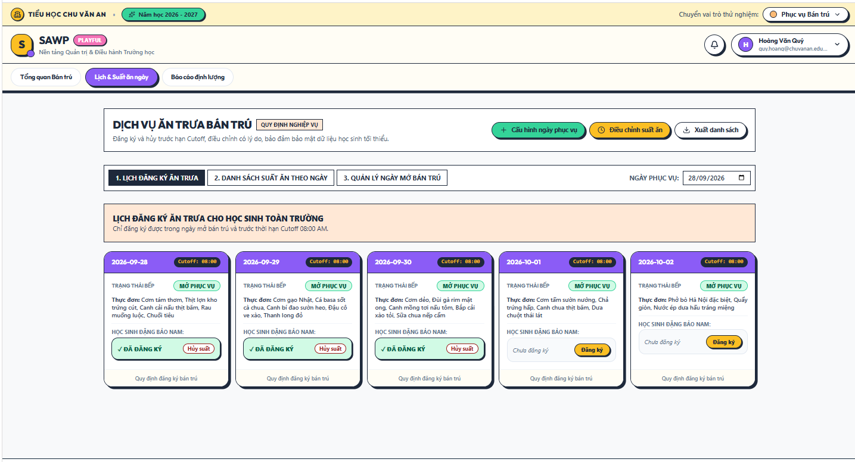

b. Specification
Use Case Name: | UC-33 View Daily Meal List and Count
Primary Actor: | Service Staff | Secondary Actors: | Office Staff, School Board, Teacher
Description: | Provides Lunch Service Staff with the daily list and meal totals needed for operations.
Normal Flow | N1. View Daily Meal List and Count  1. Staff selects a service date.  2. System loads active lunch registrations for that date.  3. System groups counts by class and calculates the total meal count.  4. System displays a minimal student list required for lunch operations.
Alternative Flows: | A1. Staff filters by grade/class or prints/exports the operational list if permitted.
Exceptions: | E1. No active registrations -> display MSG43 with total 0.
Business Rules: | BR-32, BR-44, BR-51

2.5.6 UC-34 Adjust Lunch Registration

a. Screen Layouts 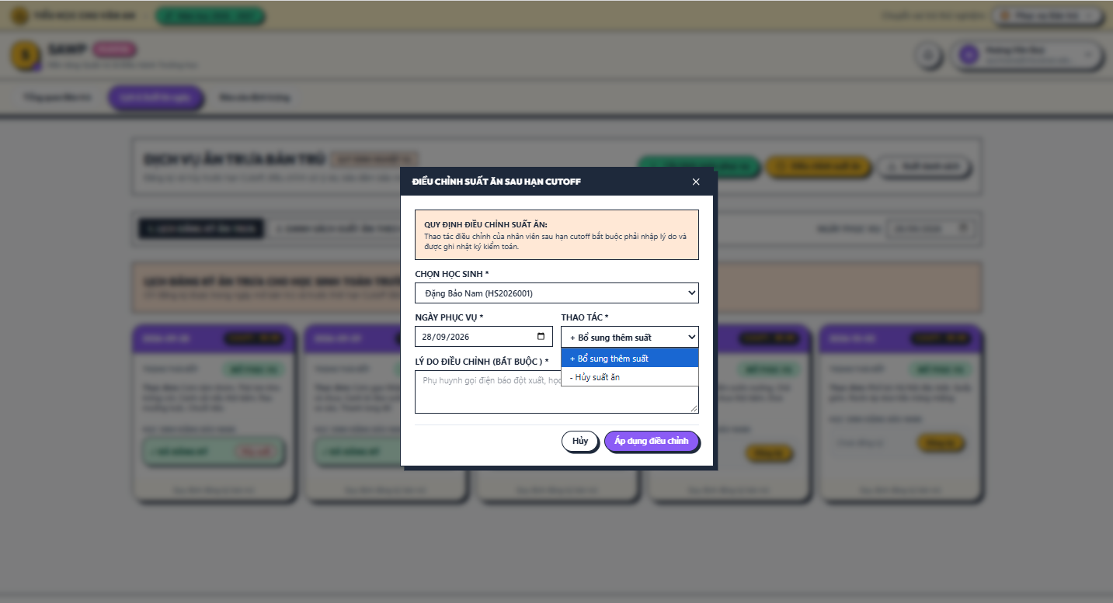

b. Specification
Use Case Name: | UC-34 Adjust Lunch Registration
Primary Actor: | Lunch Service Staff | Secondary Actors: | Office Staff
Description: | Allows authorized staff to correct a lunch registration after the normal parent cutoff.
Normal Flow | N1. Adjust Lunch Registration  1. Staff selects a student/date requiring correction.  2. System shows the current lunch-registration state.  3. Staff chooses add or cancel correction and enters a mandatory reason.  4. System validates the date and prevents duplicate active registrations. (E1)  5. System applies the correction, recalculates meal counts, and writes an audit entry.  6. System notifies the parent when appropriate.
Alternative Flows: | A1. Correction before cutoff may be processed using the same function but still records the staff actor.
Exceptions: | E1. Invalid date or conflicting registration state -> display MSG09.
Business Rules: | BR-29, BR-31, BR-32, BR-42, BR-45

2.5.7 UC-35 Generate Lunch Service Summary

a. Screen Layouts 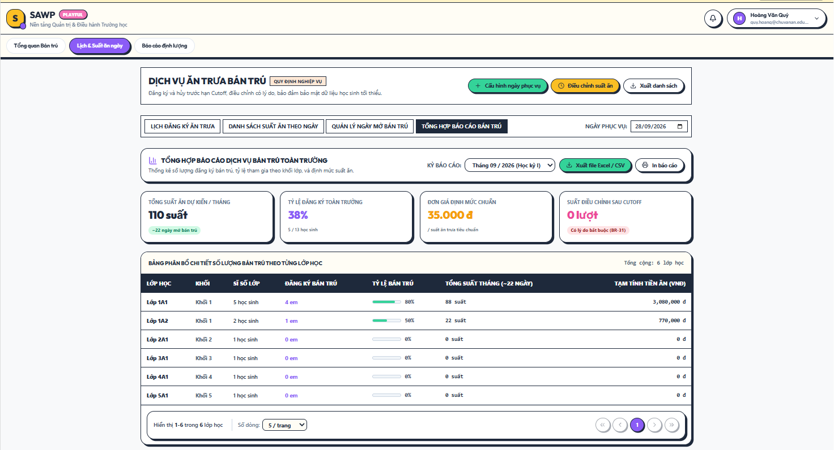

b. Specification
Use Case Name: | UC-35 Generate Lunch Service Summary
Primary Actor: | Lunch Service Staff, Office Staff, School Board | Secondary Actors: | None
Description: | Produces lunch-registration and meal-count summaries for operations and oversight.
Normal Flow | N1. Generate Lunch Service Summary  1. Actor opens Lunch Service Report.  2. Actor selects date range and optional class/grade filters.  3. System aggregates active, cancelled, and staff-adjusted registrations.  4. System displays meal counts by date/class and totals.  5. Actor may export the result if permitted.
Alternative Flows: | A1. Lunch Service Staff defaults to upcoming/current operational dates; School Board may select wider historical periods.
Exceptions: | E1. No data -> display MSG43.
Business Rules: | BR-32, BR-44, BR-54, BR-55

2.6 Administrative Requests & School Documents

2.6.1 UC-36 Submit Class Transfer Request

a. Screen Layouts
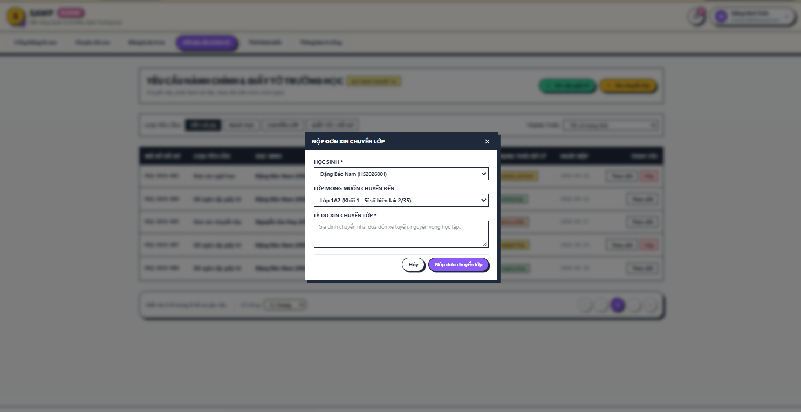

b. Specification
Use Case Name: | UC-36 Submit Class Transfer Request
Primary Actor: | Parent / Guardian | Secondary Actors: | Office Staff, School Board
Description: | Allows a Parent / Guardian to request that a linked child be moved to another class.
Normal Flow | N1. Submit Class Transfer Request  1. Parent selects a linked child and opens Class Transfer Request.  2. Parent enters reason and optional preferred target class/supporting attachment.  3. System validates required information and active duplicate requests. (E1)  4. Parent submits the request.  5. System creates the request in Submitted status and notifies Office Staff.  6. System displays MSG30.
Alternative Flows: | A1. Parent submits without a preferred class; Office Staff may propose an available class during review.
Exceptions: | E1. Another active transfer request exists or attachment is invalid -> display MSG09/MSG41.
Business Rules: | BR-34, BR-35, BR-37, BR-50

2.6.2 UC-37 Review Class Transfer Request

a. Screen Layouts
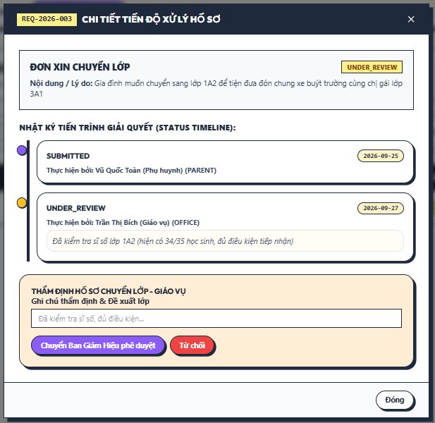

b. Specification
Use Case Name: | UC-37 Review Class Transfer Request
Primary Actor: | Office Staff | Secondary Actors: | School Board
Description: | Allows Office Staff to verify a class-transfer request before higher-level decision.
Normal Flow | N1. Review Class Transfer Request  1. Office Staff opens a submitted transfer request.  2. System displays student, current class, reason, class capacities, and attachments.  3. Office Staff checks completeness and feasible target classes.  4. Office Staff records review notes and a recommended target class if applicable.  5. Office Staff forwards the request to School Board for decision or rejects it when administratively invalid according to policy.  6. System updates status/history and notifies relevant users.
Alternative Flows: | A1. Request more information from parent -> status remains open and parent is notified.
Exceptions: | E1. No eligible target class is available -> display MSG15 and keep request under review.
Business Rules: | BR-35, BR-37, BR-41, BR-42

2.6.3 UC-38 Approve or Reject Class Transfer Request

a. Screen Layouts
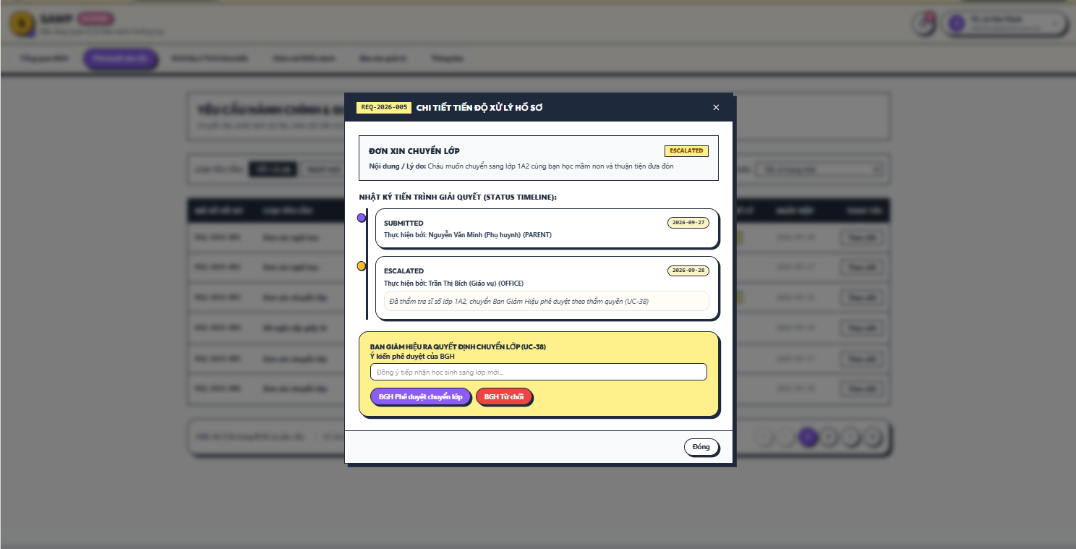

b. Specification
Use Case Name: | UC-38 Approve or Reject Class Transfer Request
Primary Actor: | School Board | Secondary Actors: | Office Staff
Description: | Allows School Board to decide a reviewed class-transfer request.
Normal Flow | N1. Approve or Reject Class Transfer Request  1. School Board opens a reviewed transfer request.  2. System displays the parent request and Office Staff review/recommendation.  3. School Board approves or rejects and enters an optional decision note.  4. System records the decision and status history.  5. System notifies Parent / Guardian and Office Staff using MSG31 or MSG32.
Alternative Flows: | A1. Return for re-review -> request returns to Office Staff with a note.
Exceptions: | E1. Request status changed before decision -> display MSG09.
Business Rules: | BR-35, BR-37, BR-41, BR-42

2.6.4 UC-39 Apply Approved Class Transfer

a. Screen Layouts
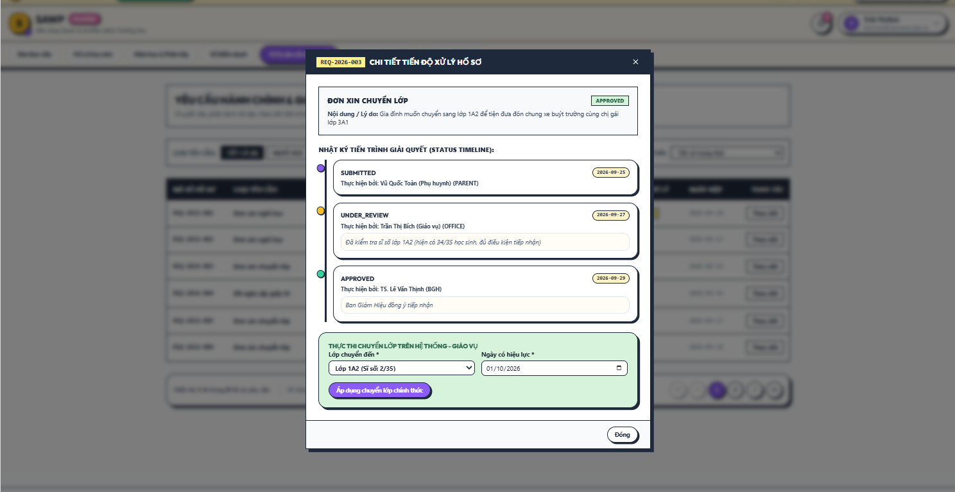

b. Specification
Use Case Name: | UC-39 Apply Approved Class Transfer
Primary Actor: | Office Staff | Secondary Actors: | Parent / Guardian, Teacher
Description: | Executes an approved class transfer and preserves class-assignment history.
Normal Flow | N1. Apply Approved Class Transfer  1. Office Staff opens an approved class-transfer request.  2. System displays approved target class/review details.  3. Office Staff confirms target class and effective date.  4. System rechecks class capacity and current assignment. (E1)  5. System closes the old class assignment and creates the new assignment with effective date.  6. System marks the request Completed and notifies affected users with MSG35.
Alternative Flows: | A1. If the approved target is no longer available, Office Staff returns the request for re-review rather than applying a different class without approval.
Exceptions: | E1. Class capacity/assignment conflict -> display MSG15 and do not modify class history.
Business Rules: | BR-17, BR-18, BR-37, BR-38, BR-42

2.6.5 UC-40 Submit School Document Request

a. Screen Layouts
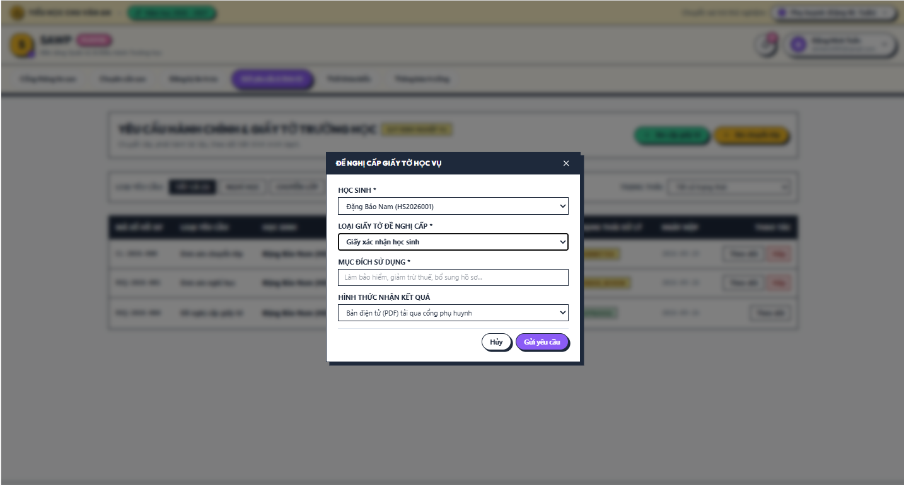

b. Specification
Use Case Name: | UC-40 Submit School Document Request
Primary Actor: | Parent / Guardian | Secondary Actors: | Office Staff, School Board
Description: | Allows a Parent / Guardian to request a supported school document or certificate for a linked child.
Normal Flow | N1. Submit School Document Request  1. Parent selects a linked child and document type.  2. System displays required information for that document type.  3. Parent enters purpose/details and attaches supporting files if required.  4. System validates required fields and attachments. (E1)  5. Parent submits the request.  6. System creates the request and notifies Office Staff with MSG30.
Alternative Flows: | A1. Document type requiring School Board approval is automatically flagged for approval after Office Staff review.
Exceptions: | E1. Missing required information or invalid file -> display MSG01/MSG41.
Business Rules: | BR-34, BR-39, BR-41, BR-50

2.6.6 UC-41 Review School Document Request

a. Screen Layouts
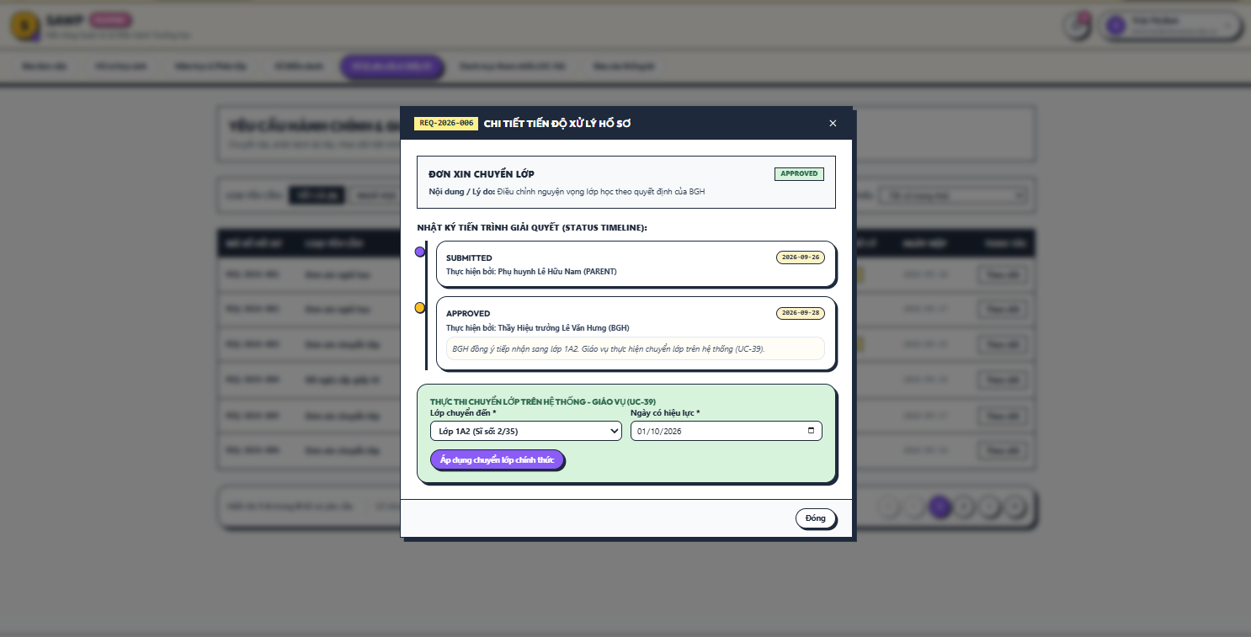

b. Specification
Use Case Name: | UC-41 Review School Document Request
Primary Actor: | Office Staff | Secondary Actors: | School Board
Description: | Allows Office Staff to verify and process a submitted school-document request.
Normal Flow | N1. Review School Document Request  1. Office Staff opens a document request.  2. System displays student data, requested document type, purpose, and attachments.  3. Office Staff verifies required information and school records.  4. Office Staff approves for preparation, rejects with reason, requests information, or forwards for School Board approval if required.  5. System records status/history and notifies the parent.
Alternative Flows: | A1. For request types not requiring higher approval, Office Staff proceeds directly to document preparation.
Exceptions: | E1. Required school data is missing -> keep request Under Review and display MSG09.
Business Rules: | BR-35, BR-39, BR-41, BR-42

2.6.7 UC-42 Issue Requested School Document

a. Screen Layouts
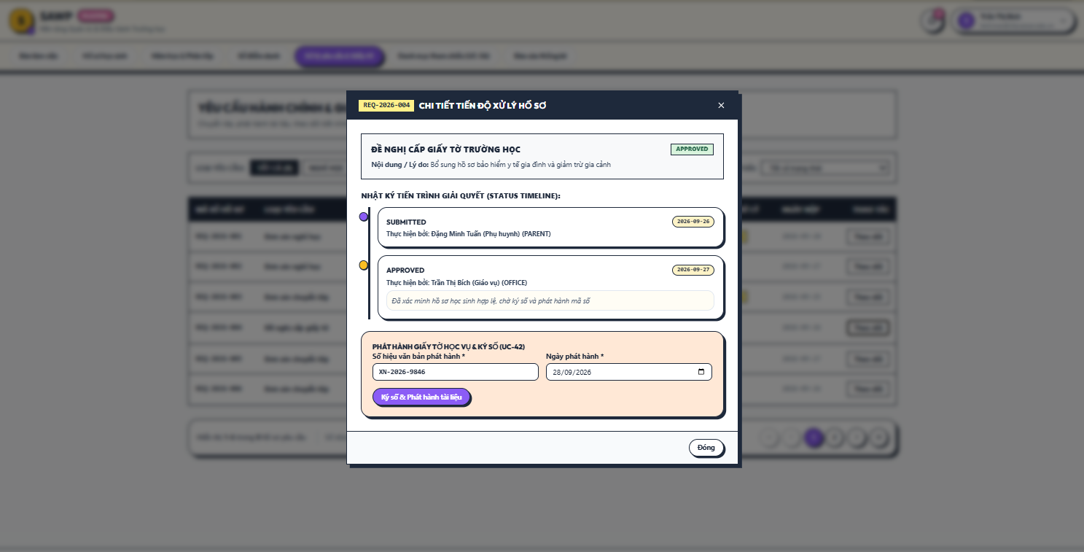

b. Specification
Use Case Name: | UC-42 Issue Requested School Document
Primary Actor: | Office Staff | Secondary Actors: | School Board
Description: | Records issuance/completion of an approved school-document request.
Normal Flow | N1. Issue Requested School Document  1. Office Staff opens an approved document request.  2. Office Staff enters issue date, document reference/number where applicable, and attaches the issued digital copy if used.  3. System validates issue information.  4. System records the issued-document metadata and issuer.  5. System marks the request Completed and notifies the parent using MSG36.
Alternative Flows: | A1. If the document is collected physically, the system may record collection status/note without requiring a digital copy.
Exceptions: | E1. Required issue metadata is missing -> display MSG01.
Business Rules: | BR-39, BR-40, BR-42, BR-50

2.6.8 UC-43 Track Administrative Request

a. Screen Layouts
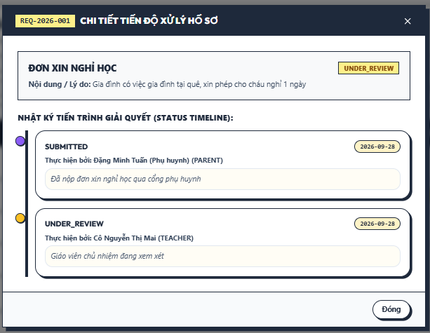

b. Specification
Use Case Name: | UC-43 Track Administrative Request
Primary Actor: | Parent / Guardian, Teacher, Office Staff, School Board | Secondary Actors: | None
Description: | Displays the current status and history of a submitted administrative request.
Normal Flow | N1. Track Administrative Request  1. Actor opens an authorized request.  2. System verifies request ownership or staff permission. (E1)  3. System displays request type, current status, submission date, latest update, decision/result, and status-history timeline.
Alternative Flows: | A1. Staff view additionally shows current responsible role and internal processing notes according to permission.
Exceptions: | E1. Request is outside the actor’s scope -> display MSG10.
Business Rules: | BR-05, BR-34, BR-35, BR-51

2.6.9 UC-44 Cancel Pending Administrative Request

a. Screen Layouts
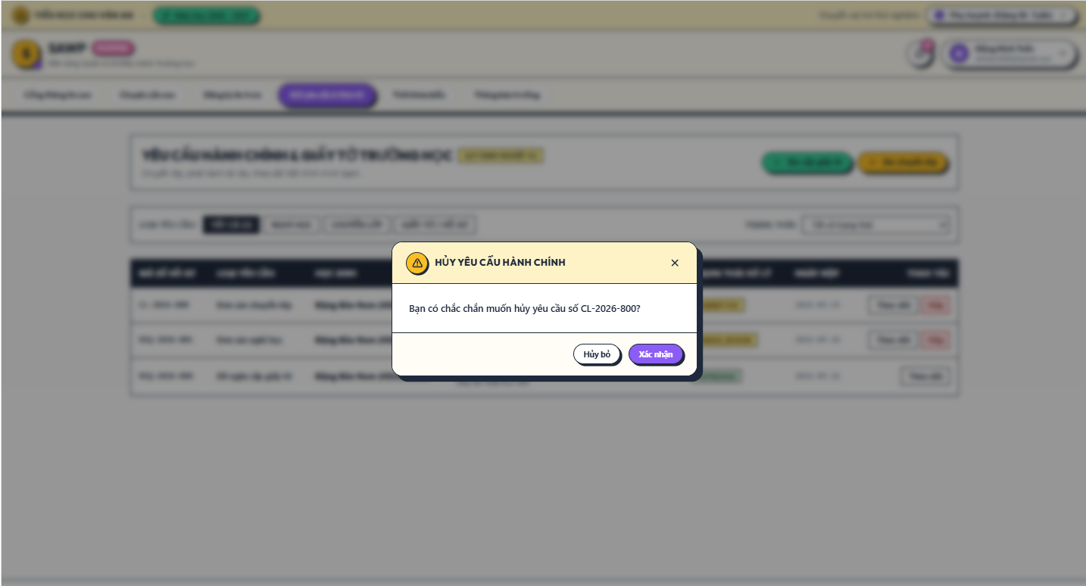

b. Specification
Use Case Name: | UC-44 Cancel Pending Administrative Request
Primary Actor: | Parent / Guardian | Secondary Actors: | None
Description: | Allows a Parent / Guardian to cancel their own request before it reaches a non-cancellable processing state.
Normal Flow | N1. Cancel Pending Administrative Request  1. Parent opens a request for a linked child.  2. System verifies ownership and current status.  3. Parent selects Cancel.  4. System checks that cancellation is allowed. (E1)  5. Parent confirms cancellation.  6. System marks the request Cancelled, records history, and notifies any assigned reviewer.
Alternative Flows: | A1. Parent closes confirmation -> request remains unchanged.
Exceptions: | E1. Request is already approved/in progress/completed -> display MSG34.
Business Rules: | BR-34, BR-35, BR-36, BR-42

2.7 Notifications & Announcements

2.7.1 UC-45 View Notifications

a. Screen Layouts
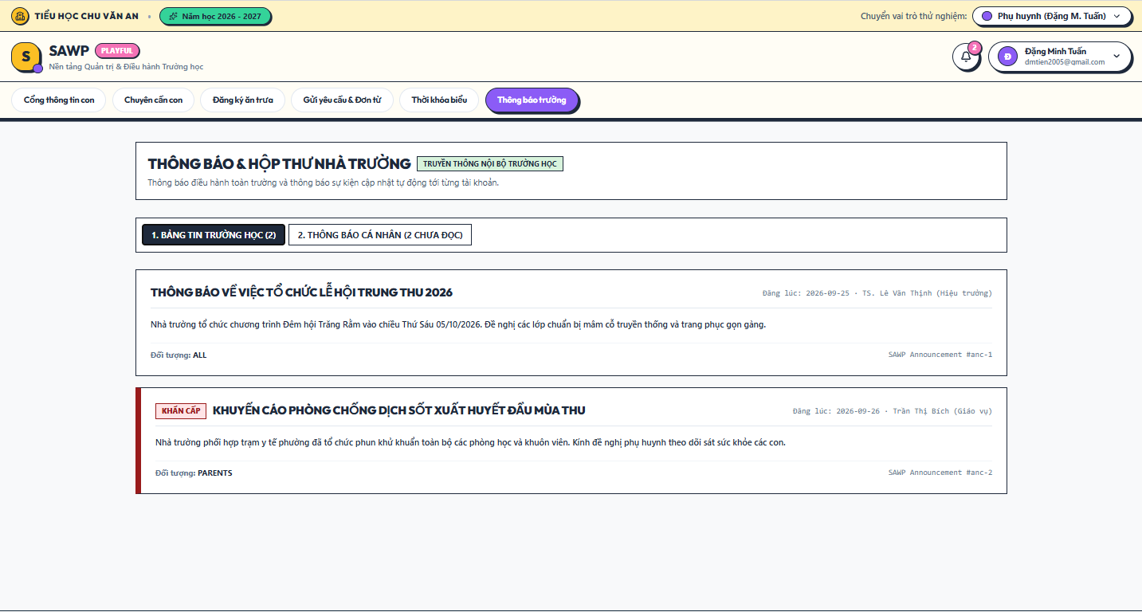

b. Specification
Use Case Name: | UC-45 View Notifications
Primary Actor: | All authenticated user roles | Secondary Actors: | None
Description: | Displays in-system notifications relevant to the signed-in user.
Normal Flow | N1. View Notifications  1. User opens Notification Center.  2. System loads notifications addressed to the user/role.  3. System displays newest notifications first with read/unread status and links to related records when permitted.
Alternative Flows: | A1. User filters to unread notifications.
Exceptions: | E1. No notifications -> display MSG43.
Business Rules: | BR-42, BR-43, BR-51

2.7.2 UC-46 Mark Notifications as Read

a. Screen Layouts
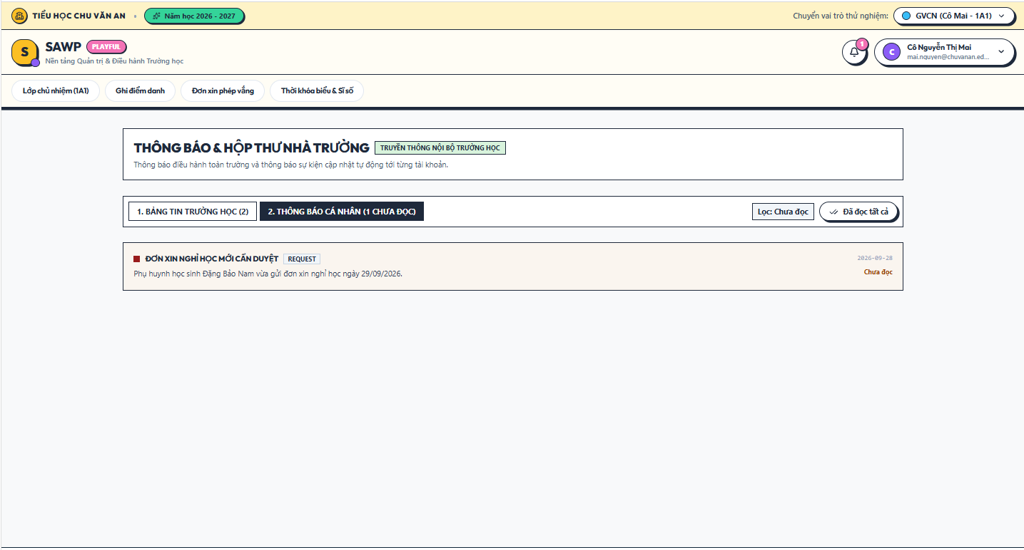

b. Specification
Use Case Name: | UC-46 Mark Notifications as Read
Primary Actor: | All authenticated user roles | Secondary Actors: | None
Description: | Updates read status for one or more notifications.
Normal Flow | N1. Mark Notifications as Read  1. User selects a notification or Mark All Read.  2. System verifies notification ownership.  3. System updates read status and unread count.  4. System displays MSG37 when explicit confirmation is used.
Alternative Flows: | A1. Opening a notification may automatically mark it read.
Exceptions: | E1. Notification no longer exists -> refresh list without failing the session.
Business Rules: | BR-43

2.7.3 UC-47 Publish School Announcement

a. Screen Layouts
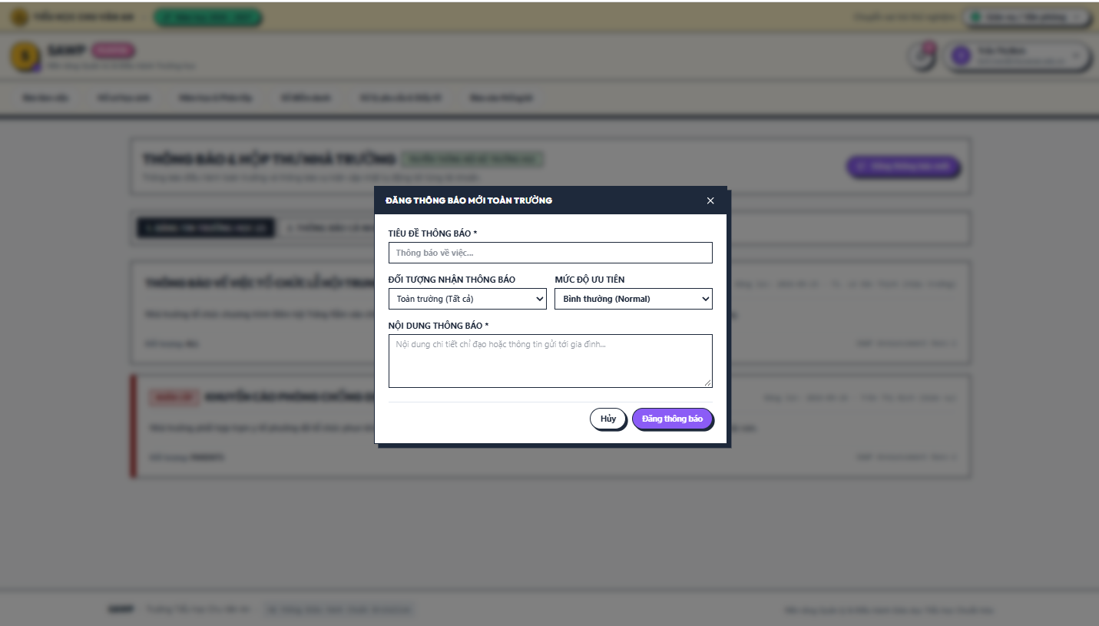

b. Specification
Use Case Name: | UC-47 Publish School Announcement
Primary Actor: | Office Staff, School Board | Secondary Actors: | None
Description: | Publishes an announcement to selected school audiences.
Normal Flow | N1. Publish School Announcement  1. Actor opens Create Announcement.  2. Actor enters title, content, target audience (e.g.,Guest, all parents, selected classes, staff roles), and optional publish time.  3. System validates required fields and actor authority. (E1)  4. Actor confirms publication.  5. System stores the announcement and creates notifications for the intended audience.
Alternative Flows: | A1. Schedule publication for a future time.  A2. Save as draft if draft announcements are enabled.
Exceptions: | E1. Actor selects an audience outside permitted scope -> display MSG10.
Business Rules: | BR-05, BR-42, BR-51, BR-53

2.8 Operational Dashboards & Reports

2.8.1 UC-48 View Role Dashboard

a. Screen Layouts
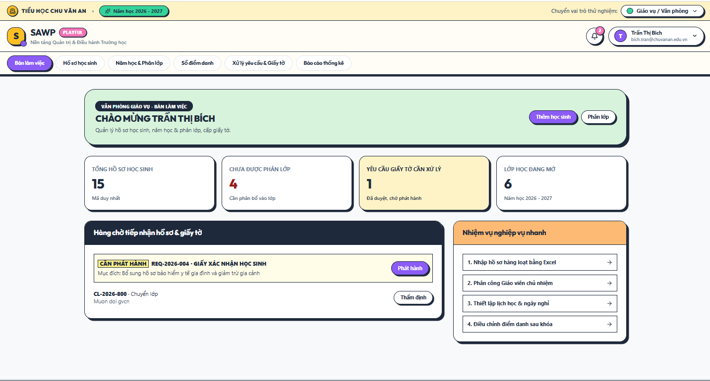

b. Specification
Use Case Name: | UC-48 View Role Dashboard
Primary Actor: | All authenticated user roles | Secondary Actors: | None
Description: | Displays role-specific operational summaries and shortcuts.
Normal Flow | N1. View Role Dashboard  1. User logs in or opens Dashboard.  2. System identifies role and authorized data scope.  3. System loads role-specific summary metrics and pending work.  4. System displays shortcuts to commonly used functions.
Alternative Flows: | A1. Parent dashboard uses linked-child context; staff dashboards use assigned work/class scope.
Exceptions: | E1. Dashboard data source temporarily unavailable -> show partial dashboard and MSG50 for affected widget.
Business Rules: | BR-05, BR-44, BR-54

2.8.2 UC-49 View Student and Class Reports

a. Screen Layouts
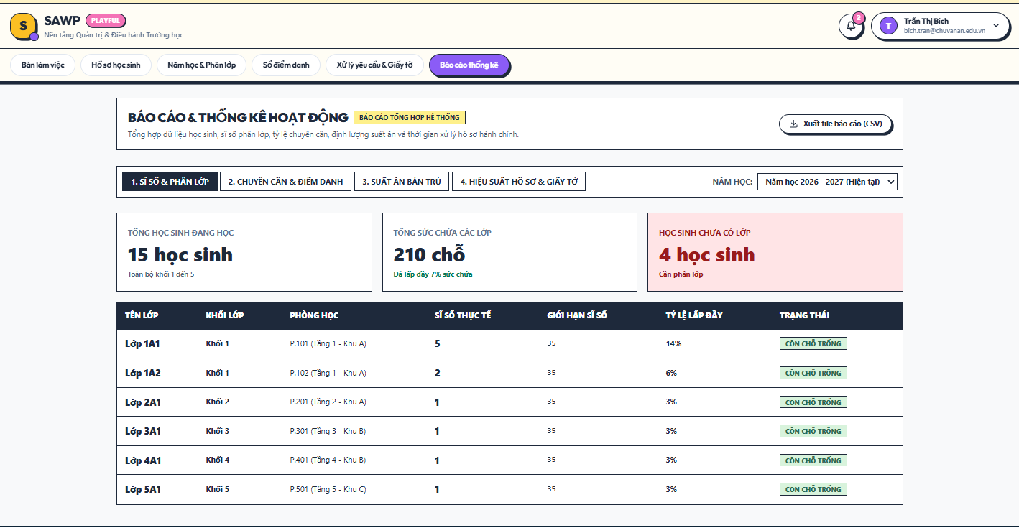

b. Specification
Use Case Name: | UC-49 View Student and Class Reports
Primary Actor: | Office Staff, School Board | Secondary Actors: | None
Description: | Provides operational reports on student distribution and class assignments.
Normal Flow | N1. View Student and Class Reports  1. Actor opens Student/Class Reports.  2. Actor selects filters.  3. System aggregates active students, class assignments, class capacity, and unassigned-record counts.  4. System displays report tables and summary totals.  5. Actor may export results if permitted.
Alternative Flows: | A1. School Board views school-wide scope; Office Staff can use the same operational scope.
Exceptions: | E1. No matching data -> display MSG43.
Business Rules: | BR-44, BR-54, BR-55

2.8.3 UC-50 View Attendance Reports

a. Screen Layouts
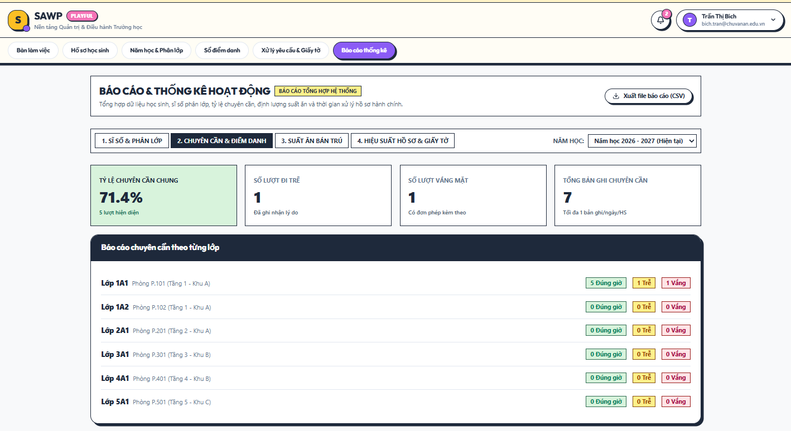

b. Specification
Use Case Name: | UC-50 View Attendance Reports
Primary Actor: | Office Staff, School Board | Secondary Actors: | Teacher (own class)
Description: | Provides school-level attendance reporting and trends.
Normal Flow | N1. View Attendance Reports  1. Actor selects date range and authorized class/grade scope.  2. System aggregates attendance data.  3. System displays daily/monthly attendance totals and absence/late counts.  4. Actor may drill down to class-level detail and export results.
Alternative Flows: | A1. Teacher accesses the same report limited to assigned class.
Exceptions: | E1. No matching records -> display MSG43.
Business Rules: | BR-44, BR-54, BR-55

2.8.4 UC-51 View Lunch Service Reports

a. Screen Layouts
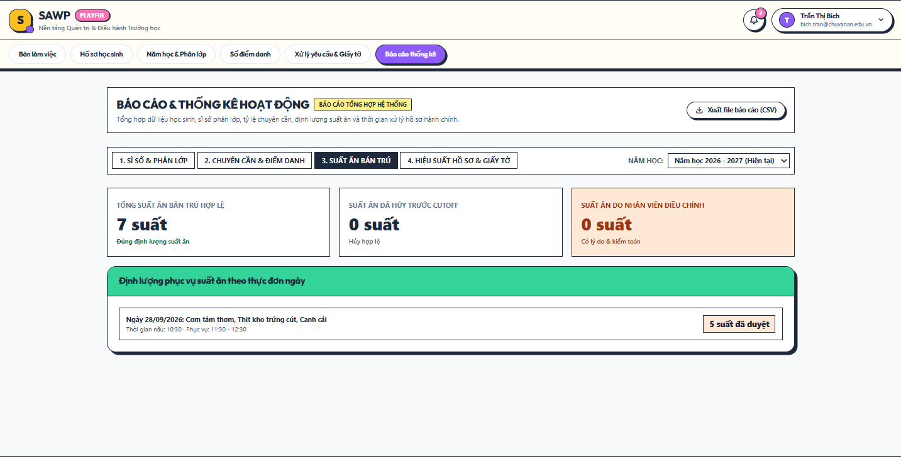

b. Specification
Use Case Name: | UC-51 View Lunch Service Reports
Primary Actor: | Lunch Service Staff, Office Staff, School Board | Secondary Actors: | None
Description: | Provides operational and historical lunch-service utilization reports.
Normal Flow | N1. View Lunch Service Reports  1. Actor selects a date range and optional class/grade filters.  2. System aggregates active/cancelled registrations and staff adjustments.  3. System displays daily meal totals, class totals, and utilization summaries.  4. Actor may export the displayed report.
Alternative Flows: | A1. Lunch Service Staff view emphasizes upcoming meal counts; School Board can view historical trends.
Exceptions: | E1. No data -> display MSG43.
Business Rules: | BR-32, BR-44, BR-54, BR-55

2.8.5 UC-52 View Administrative Request Reports

a. Screen Layouts
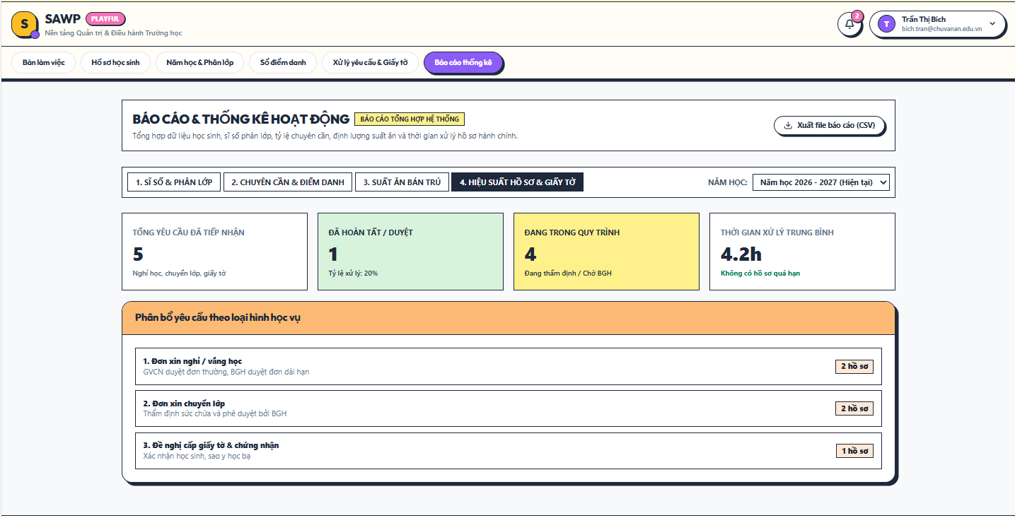

b. Specification
Use Case Name: | UC-52 View Administrative Request Reports
Primary Actor: | Office Staff, School Board | Secondary Actors: | None
Description: | Reports request volume, status, overdue work, and processing time.
Normal Flow | N1. View Administrative Request Reports  1. Actor opens Request Reports.  2. Actor selects request type/status/date filters.  3. System aggregates submitted, pending, approved, rejected, cancelled, and completed requests.  4. System calculates processing-time and overdue-work metrics from status history.  5. System displays summary and detail lists.
Alternative Flows: | A1. Actor drills down from a metric to the underlying authorized request list.
Exceptions: | E1. No matching data -> display MSG43.
Business Rules: | BR-35, BR-44, BR-54, BR-55

2.9 System Administration & Audit

2.9.1 UC-53 Manage User Accounts

a. Screen Layouts
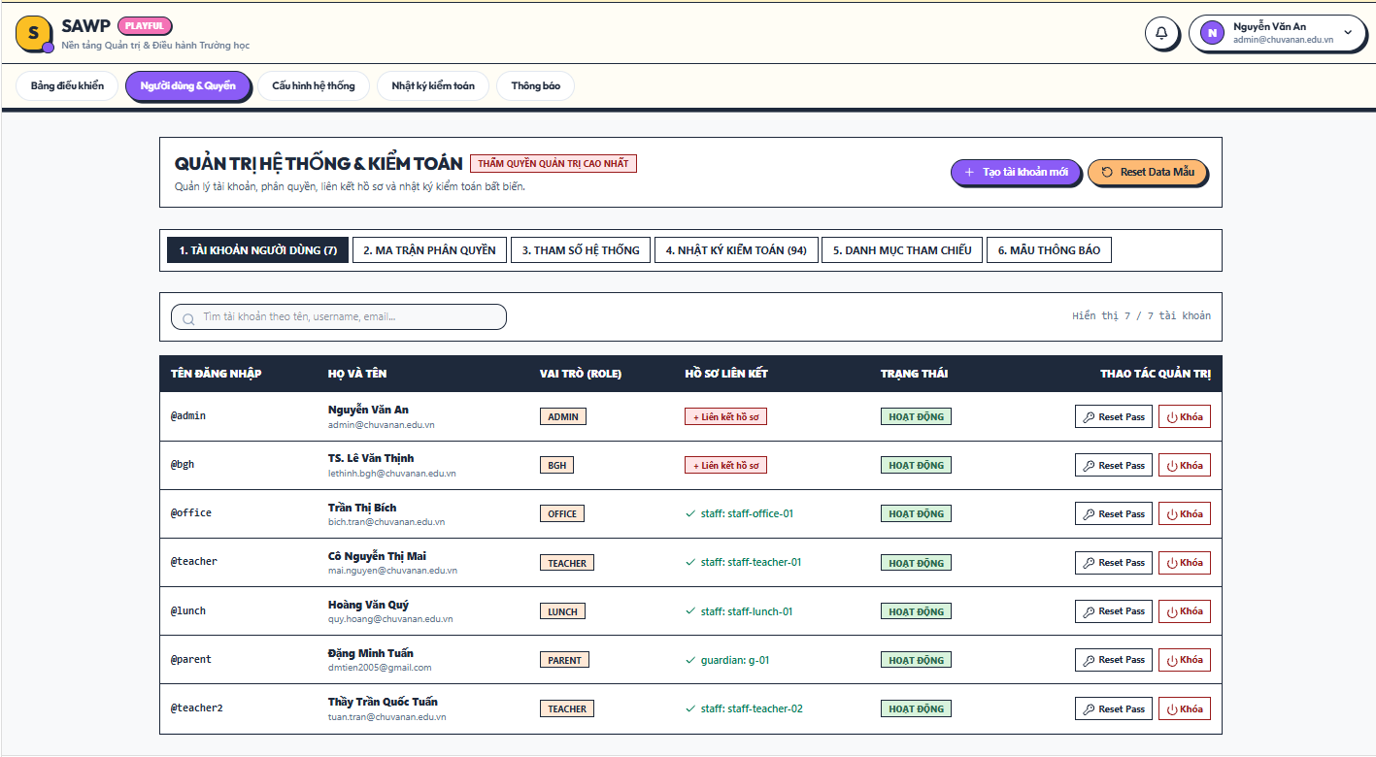

b. Specification
Use Case Name: | UC-53 Manage User Accounts
Primary Actor: | System Administrator | Secondary Actors: | None
Description: | Creates, updates, activates, and deactivates user accounts.
Normal Flow | N1. Manage User Accounts  1. System Administrator opens User Accounts.  2. Administrator searches or creates an account.  3. For creation, Administrator enters required identity/login information and selects an initial role.  4. System validates uniqueness and required fields. (E1)  5. System saves the account and records an audit event.  6. System displays MSG38 for creation or MSG39 for deactivation.
Alternative Flows: | A1. Reactivate a previously deactivated account.  A2. Edit account display/contact fields that belong to account identity, not student records.
Exceptions: | E1. Duplicate login identifier or invalid data -> display MSG01.
Business Rules: | BR-46, BR-48, BR-49, BR-51

2.9.2 UC-54 Manage Roles and Permissions

a. Screen Layouts
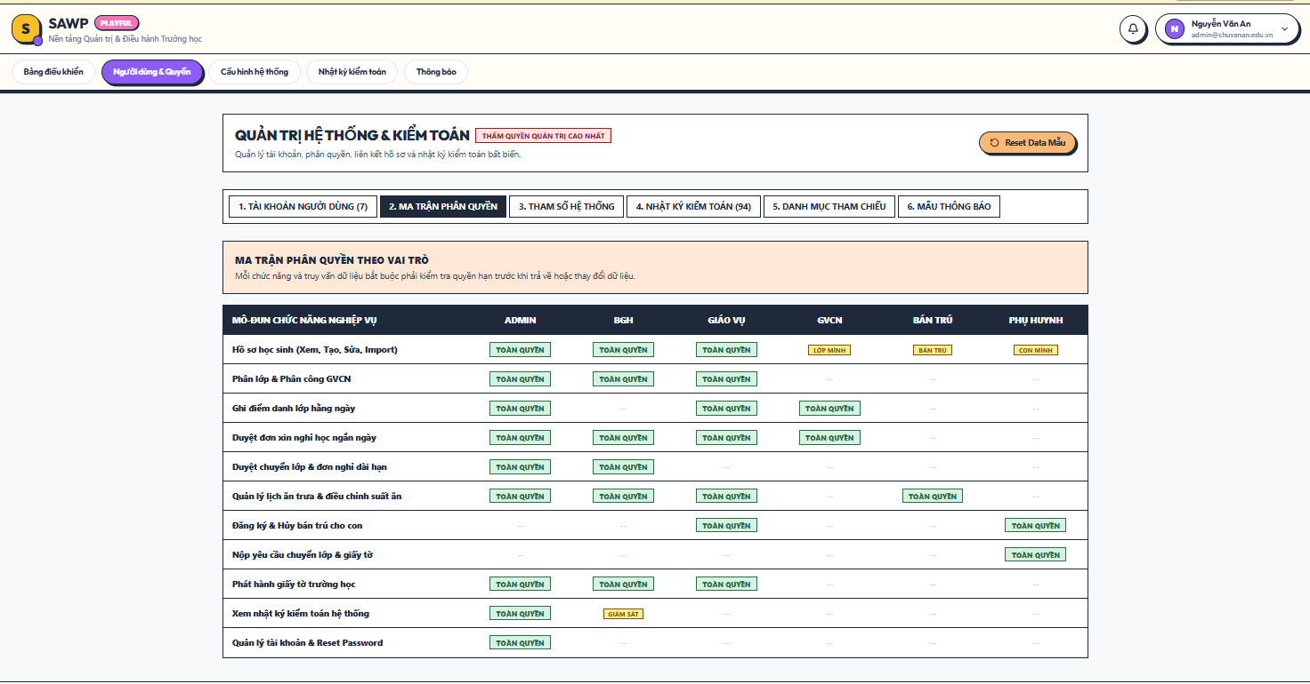

b. Specification
Use Case Name: | UC-54 Manage Roles and Permissions
Primary Actor: | System Administrator | Secondary Actors: | School Board (policy owner/view)
Description: | Maintains role-permission assignments used by role-based access control.
Normal Flow | N1. Manage Roles and Permissions  1. Administrator opens Roles & Permissions.  2. System displays defined roles and permission matrix.  3. Administrator selects permitted changes for a role.  4. System validates that protected core permissions are not removed in a way that locks administration. (E1)  5. Administrator saves changes.  6. System records the change and displays MSG40.
Alternative Flows: | A1. View-only inspection of current role permissions without changes.
Exceptions: | E1. Unauthorized/protected permission change -> display MSG10.
Business Rules: | BR-05, BR-46, BR-49, BR-51

2.9.3 UC-55 Link User Account to Guardian or Staff Profile

a. Screen Layouts
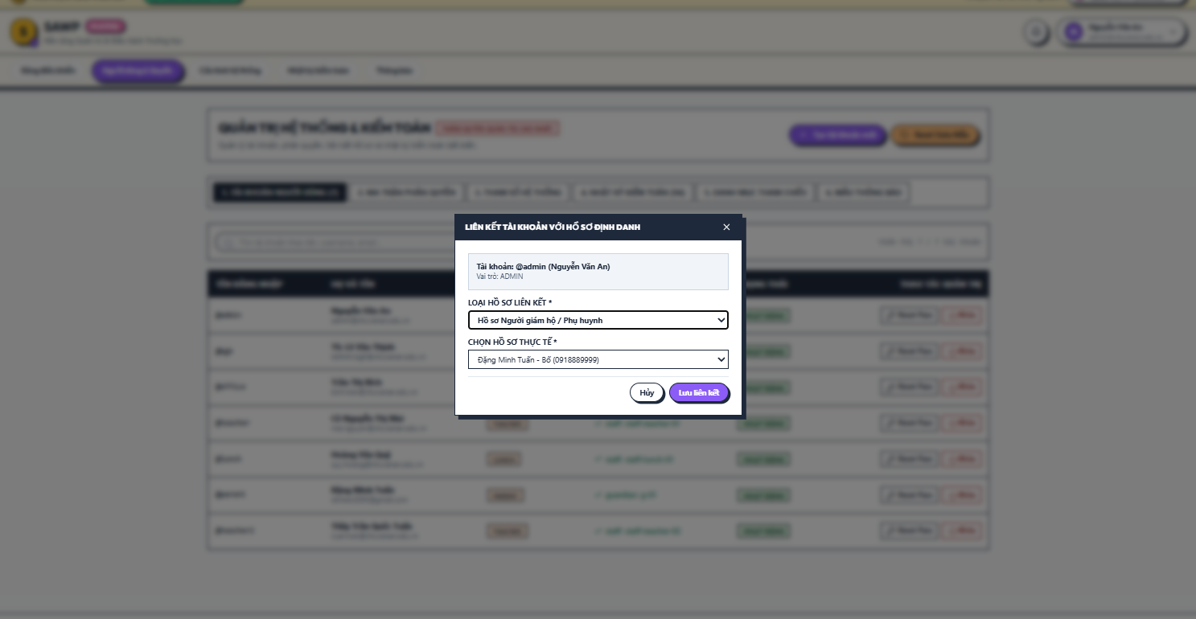

b. Specification
Use Case Name: | UC-55 Link User Account to Guardian or Staff Profile
Primary Actor: | System Administrator | Secondary Actors: | Office Staff
Description: | Links a login account to the corresponding operational guardian/staff identity.
Normal Flow | N1. Link User Account to Guardian or Staff Profile  1. Administrator opens an account with no linked profile.  2. Administrator selects profile type and searches for the corresponding guardian/staff record.  3. System checks that the target profile is not already linked to an incompatible account. (E1)  4. Administrator confirms the link.  5. System saves the association and enables role-scoped operational access.
Alternative Flows: | A1. Replace incorrect link only after explicit confirmation and audit logging.
Exceptions: | E1. Profile already linked incompatibly -> display MSG09.
Business Rules: | BR-47, BR-49, BR-51

2.9.4 UC-56 Manage Reference Data

a. Screen Layouts
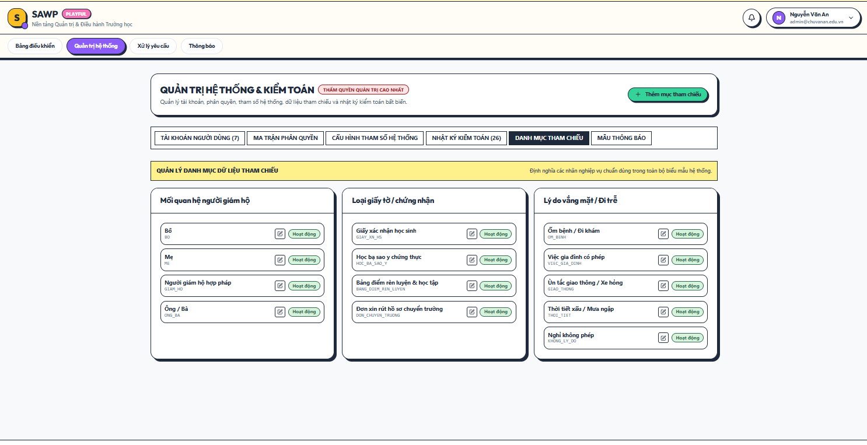

b. Specification
Use Case Name: | UC-56 Manage Reference Data
Primary Actor: | System Administrator | Secondary Actors: | Office Staff
Description: | Maintains configurable lists used across administrative forms.
Normal Flow | N1. Manage Reference Data  1. Administrator opens Reference Data.  2. Administrator selects a supported category such as relationship types, request document types, attendance reasons, or other configured labels.  3. Administrator adds, edits, or deactivates a value.  4. System validates duplicate/required values. (E1)  5. System saves the change and records an audit entry.
Alternative Flows: | A1. Deactivate a value already used historically; existing historical records keep the prior label/reference.
Exceptions: | E1. Duplicate active value -> display MSG09.
Business Rules: | BR-49, BR-52, BR-55

2.9.5 UC-57 Configure Notification Templates

a. Screen Layouts
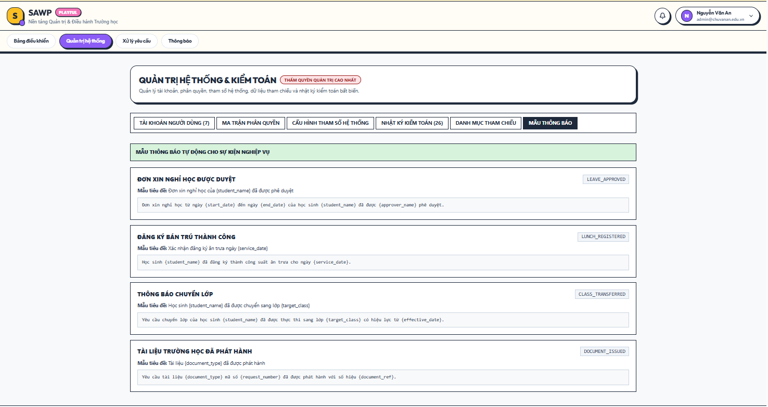

b. Specification
Use Case Name: | UC-57 Configure Notification Templates
Primary Actor: | System Administrator | Secondary Actors: | Office Staff
Description: | Maintains reusable in-system notification text for workflow events.
Normal Flow | N1. Configure Notification Templates  1. Administrator opens Notification Templates.  2. System lists supported workflow events.  3. Administrator edits subject/title and message body placeholders.  4. System validates required placeholders. (E1)  5. Administrator previews and saves the template.  6. System records the configuration change and displays MSG44.
Alternative Flows: | A1. Restore a default template if the configured template becomes invalid.
Exceptions: | E1. Required placeholder missing -> display MSG01.
Business Rules: | BR-42, BR-49

2.9.6 UC-58 View Audit Logs

a. Screen Layouts
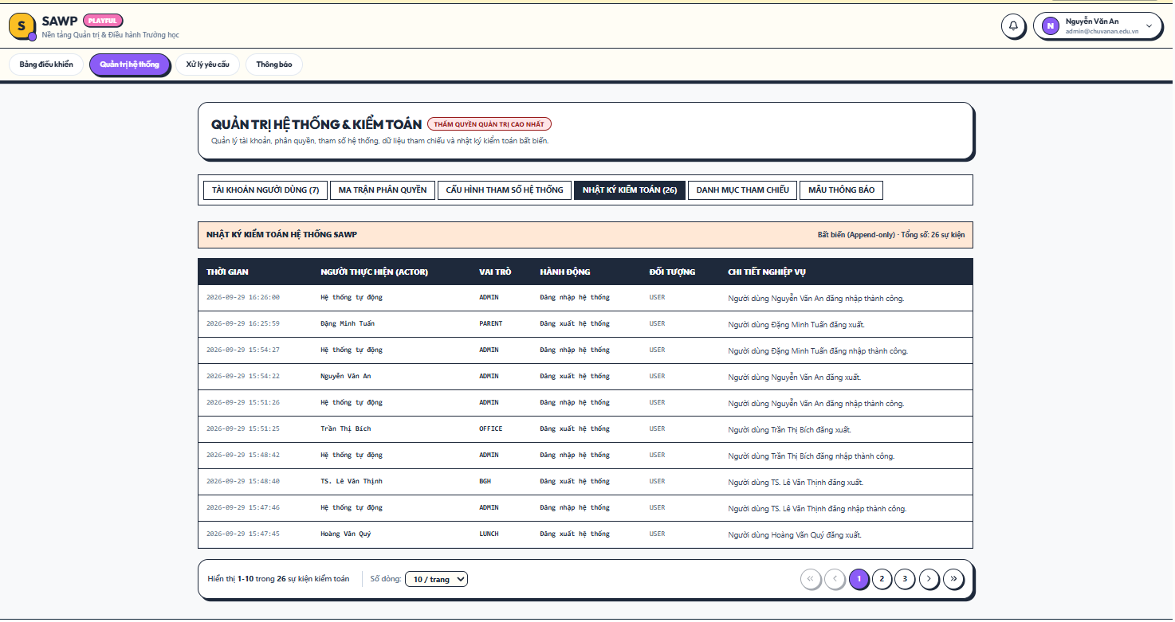

b. Specification
Use Case Name: | UC-58 View Audit Logs
Primary Actor: | System Administrator | Secondary Actors: | School Board (authorized oversight view)
Description: | Allows authorized technical administrators to inspect recorded security and administrative change events.
Normal Flow | N1. View Audit Logs  1. Actor opens Audit Logs.  2. System verifies audit-log permission. (E1)  3. Actor selects filters such as date, user, entity, or action.  4. System displays immutable log entries and before/after references where recorded.
Alternative Flows: | A1. School Board may receive a read-only oversight view limited to school-operational audit events.
Exceptions: | E1. User lacks audit permission -> display MSG42.
Business Rules: | BR-45, BR-49, BR-51, BR-55

2.9.7 UC-59 Manage System Settings

a. Screen Layouts
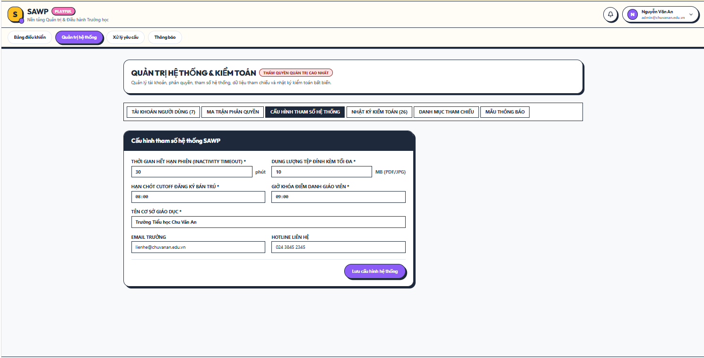

b. Specification
Use Case Name: | UC-59 Manage System Settings
Primary Actor: | System Administrator | Secondary Actors: | Office Staff, School Board (configuration input/view)
Description: | Maintains technical and school-wide settings that do not belong to ordinary operational records.
Normal Flow | N1. Manage System Settings  1. Administrator opens System Settings.  2. System displays configurable settings and current values.  3. Administrator changes permitted settings.  4. System validates ranges and dependencies. (E1)  5. Administrator saves changes.  6. System records the change and displays MSG44.
Alternative Flows: | A1. Reset a setting to the documented default value.
Exceptions: | E1. Invalid setting value -> display MSG01 and do not apply.
Business Rules: | BR-03, BR-28, BR-49, BR-50, BR-53

2.9.8 UC-60 Reset User Password

a. Screen Layouts
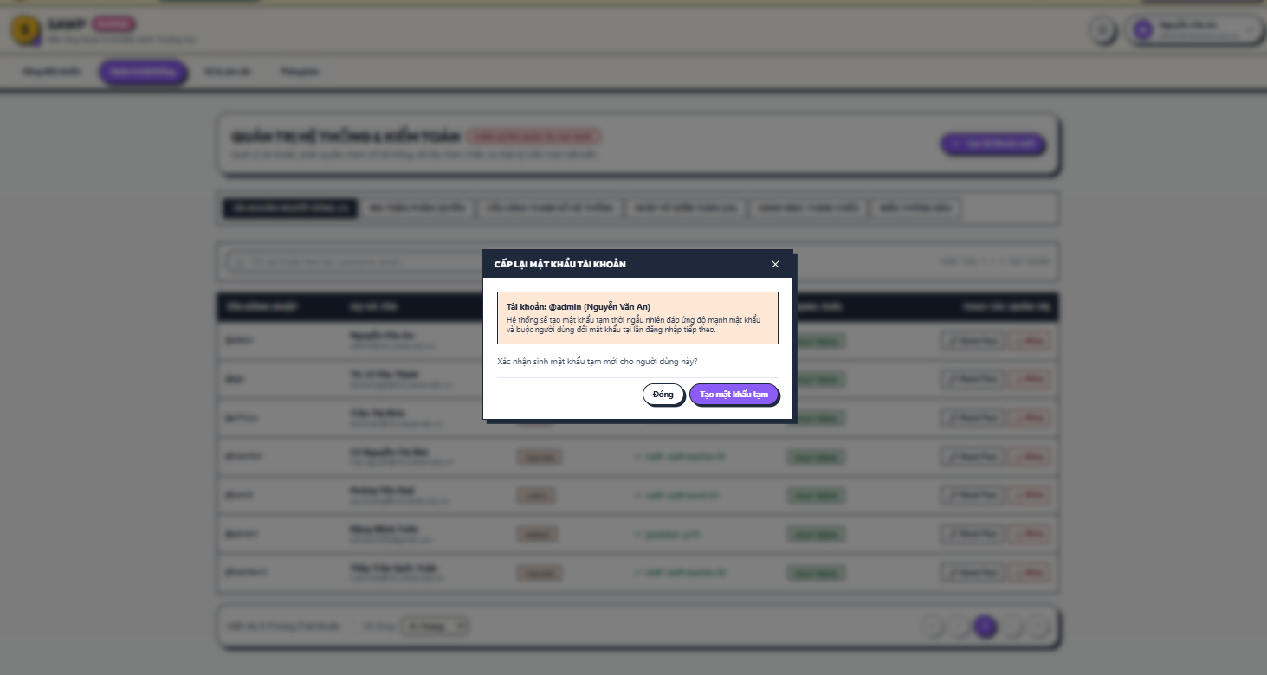

b. Specification
Use Case Name: | UC-60 Reset User Password
Primary Actor: | System Administrator | Secondary Actors: | Affected user
Description: | Allows System Administrator to reset a user password when self-service recovery is not part of the baseline scope.
Normal Flow | N1. Reset User Password  1. Administrator opens the target user account.  2. Administrator selects Reset Password.  3. System asks for confirmation.  4. System generates/accepts a temporary password according to policy or marks the account for forced password change.  5. System invalidates active sessions and records the security event.  6. Administrator communicates the temporary credential through the school’s approved channel.
Alternative Flows: | A1. Force Change at Next Login can be enabled so the temporary password cannot remain permanent.
Exceptions: | E1. Account is inactive or operation is not permitted -> display MSG10.
Business Rules: | BR-02, BR-03, BR-46, BR-48

3. Non-Functional Requirements

3.1 External Interfaces
• User Interfaces: SAWP shall provide a responsive web interface suitable for desktop and common tablet/mobile browsers. Role-specific dashboards and navigation must expose only functions authorized for the signed-in role. Forms must provide clear validation, confirmation, status indicators, and readable Vietnamese text for end-user messages.
• Hardware Interfaces: No dedicated school hardware is required for the baseline scope. Users access SAWP through standard computers, tablets, or smartphones with a modern web browser. Printing of school documents/reports may use the operating system/browser print function and ordinary school printers.
• Software Interfaces: The baseline system requires a web application server, relational database, and file-storage mechanism for approved attachments/documents. No admissions/enrollment portal, school-transport provider, grading system, or payment gateway integration is required. If the implementation later adds external email/SMS delivery, that integration is an extension and must not be required for core in-system notifications.

3.2 Quality Attributes
The system must provide a usable, responsive, reliable, secure, and maintainable environment for routine school administration and parent-school workflows.

3.2.1 Usability
• Learnability: A new Parent / Guardian or Teacher should be able to complete common tasks (view child/class information, record attendance, submit a request, register lunch) after no more than 15 minutes of basic orientation.
• Consistency: Similar actions such as Submit, Approve, Reject, Cancel, Save, and Back must use consistent labels and placement across modules.
• Error Prevention: Required fields, cutoff times, request status, and destructive/irreversible actions must be clearly indicated before confirmation.
• Accessibility: The interface should target WCAG 2.1 Level AA for contrast, keyboard navigation, focus indication, text scaling, and form labeling.

3.2.2 Performance
• Normal Page Response: For typical school operations under expected load, 95% of non-report page requests should complete within 2 seconds excluding client network latency.
• Transaction Response: Attendance save, lunch register/cancel, and request-status updates should normally confirm within 3 seconds under expected load.
• Report Response: Standard school-year reports over the project’s expected dataset should normally render within 5 seconds; larger exports may be generated asynchronously if needed.
• Concurrency: The baseline deployment should support at least 100 concurrently authenticated users without functional degradation, with capacity adjustable by deployment resources.

3.2.3 Reliability
• Availability: The deployed system should target at least 99.5% monthly availability excluding announced maintenance.
• Data Integrity: Student class assignment, attendance, lunch registration, and request-status transitions must be transactionally consistent and must not create duplicate active records prohibited by business rules.
• Recovery: Application/database data must be backed up at least daily, and restoration procedures must be documented and tested during the project.
• Failure Handling: If a save operation fails, the user must receive a clear error and the system must not display the transaction as completed unless the database commit succeeds.

3.2.4 Security & Privacy
• Access Control: Every protected endpoint and screen must enforce role and record-level scope; hiding a UI control alone is not sufficient authorization.
• Credential Protection: Passwords must be stored using a modern salted adaptive password-hashing algorithm; plaintext passwords must never be stored.
• Transport Security: Production web traffic must use HTTPS/TLS.
• Personal Data Minimization: Lunch Service Staff and other roles must receive only the student/guardian fields required for their assigned tasks.
• Auditability: Security-sensitive changes and material administrative actions must generate immutable audit events accessible only to authorized roles.
• File Access: Attachments/documents must not be publicly accessible by predictable URLs; access must be permission checked.

3.2.5 Maintainability & Compatibility
• Modularity: Authentication, student/class records, attendance, lunch service, administrative requests, notifications, reporting, and system administration should be separated into maintainable modules/services.
• Configuration: School year, school calendar, lunch cutoff, reference values, and notification text should be configurable without source-code changes where practical.
• Browser Compatibility: The web interface should support current stable versions of Chrome, Edge, Firefox, and mobile Chromium/WebKit browsers used by the target school community.
• Logging and Diagnostics: Server-side errors must be logged with sufficient technical context for troubleshooting while avoiding unnecessary exposure of student personal data.

4. Requirement Appendix

4.1 Business Rules
ID | Rule Definition
BR-01 | Only active user accounts may authenticate to SAWP, and each login identifier must uniquely identify one account.
BR-02 | Passwords must contain at least 8 characters and include uppercase, lowercase, numeric, and special characters. Temporary passwords must be changed at next login when that option is enabled.
BR-03 | Authenticated sessions must expire after a configurable inactivity period. Logout, password changes, password reset, and account deactivation invalidate applicable active sessions.
BR-04 | Reserved for future self-service password recovery. The baseline SAWP scope uses administrator-assisted password reset and does not require external email recovery.
BR-05 | Every protected function and data query must enforce role-based access control before returning or changing data.
BR-06 | A Parent / Guardian account may access only students explicitly linked to that guardian record.
BR-07 | A Teacher may access class-operational student data only for classes assigned to that teacher, unless an additional explicit permission is granted.
BR-08 | Lunch Service Staff may access only the student information necessary for lunch operations and must not receive unrestricted student administrative records.
BR-09 | Student code is required and unique within the school’s SAWP dataset.
BR-10 | SAWP does not perform admissions or enrollment. A student record may be created/imported only for a student who is already enrolled in the school through an external/offline process.
BR-11 | Creation and material changes to student and guardian administrative records must be audit logged with actor and timestamp.
BR-12 | A student may be linked to multiple guardians, and each guardian relationship must include a relationship type.
BR-13 | Each active student must have at least one designated primary guardian/contact unless the school explicitly records an approved exception.
BR-14 | Only one school year may be designated as the current active school year at a time. Its start date must precede its end date.
BR-15 | Each class belongs to one school year and one primary grade level from Grade 1 through Grade 5, with a configured capacity greater than zero.
BR-16 | A class may have at most one active primary Teacher assignment for the same effective period.
BR-17 | An active student may have only one current class assignment for a given school year.
BR-18 | Class reassignment/transfer must preserve prior class-assignment history and record an effective date.
BR-19 | A class schedule may not contain two active entries that occupy the same class time slot. Schedule changes must be reflected to authorized viewers.
BR-20 | There may be at most one attendance record per student per school day.
BR-21 | A Teacher may record or edit attendance only for an assigned class and only within the permitted attendance window.
BR-22 | After the normal teacher attendance edit window is locked, only authorized Giáo vụ users may correct attendance and a correction reason is mandatory.
BR-23 | Baseline attendance statuses are Present, Absent, and Late. Additional reason/excuse labels may be configured as reference data without changing the core status.
BR-24 | A leave/absence request must identify one linked student, a valid date or date range, and a reason. Overlapping active requests for the same student/date range are not permitted.
BR-25 | Leave approval routing is determined by school-configured policy. Routine requests may be handled by the Teacher; cases requiring higher authority may be escalated to Giáo vụ and/or Ban Giám hiệu.
BR-26 | Approval of a leave request provides an attendance indicator but does not replace the Teacher’s responsibility to record the actual daily attendance status.
BR-27 | Lunch registration is available only on school days explicitly opened as lunch-service days.
BR-28 | Parent lunch registration and cancellation are allowed only before the configured cutoff for the service date.
BR-29 | A student may have at most one active lunch registration for a given service date.
BR-30 | A lunch registration cannot be created for a non-school day, closed service day, or inactive student.
BR-31 | Lunch corrections performed by staff after the parent cutoff require a reason and must be audit logged.
BR-32 | Daily meal counts include only active lunch registrations after applying valid cancellations and staff corrections.
BR-33 | Baseline parent administrative request types are Leave/Absence, Class Transfer, and School Document Request. Additional labels may be added only if the project scope is formally expanded.
BR-34 | A Parent / Guardian may submit, view, or cancel an administrative request only for a linked child.
BR-35 | Administrative request status changes must follow the configured workflow and be recorded in status history with actor and timestamp.
BR-36 | A Parent / Guardian may cancel a request only while it is in a status designated as cancellable; approved, in-progress, rejected, completed, and already-cancelled requests are not parent-cancellable.
BR-37 | Class transfer approval requires a valid target class or an approved instruction for target-class selection, and the target class must satisfy capacity/eligibility checks when the transfer is applied.
BR-38 | An approved class transfer is not effective until Giáo vụ applies it and the new class assignment is recorded with an effective date.
BR-39 | Each supported school-document request type defines its required fields, supporting documents, and whether higher-level approval is required.
BR-40 | When a requested school document is issued, SAWP must store at least the request, issue date, issuer, and issue/reference identifier when one exists.
BR-41 | Ban Giám hiệu approval is required only for request types/cases designated by school policy; routine operational actions should not be routed to Ban Giám hiệu unnecessarily.
BR-42 | Workflow submissions and material status changes generate in-system notifications for the affected users/roles according to notification rules.
BR-43 | Notification read/unread state is maintained separately for each recipient account.
BR-44 | Reports and dashboards must apply the same role/data-scope restrictions as transactional screens.
BR-45 | Audit-log entries are append-only for ordinary application users and must not be editable through standard SAWP functions.
BR-46 | Only System Administrator may create/deactivate user accounts, assign administrative login roles, or perform administrator-assisted password reset.
BR-47 | A Parent / Guardian or staff login account must be linked to the corresponding guardian/staff profile before role-specific operational data is accessible.
BR-48 | A deactivated account cannot log in or continue using an existing session.
BR-49 | Changes to roles, permissions, user-profile links, reference data, notification templates, and system settings must be audit logged.
BR-50 | Uploaded attachments must use an allowed file type (PDF, JPG/JPEG, PNG by default) and must not exceed the configurable per-file size limit.
BR-51 | Student and guardian personal information must be displayed only to users whose role and relationship require that information for the current operation.
BR-52 | Operational student/class/reference records that are already referenced by history should be deactivated/archived rather than physically deleted through normal user functions.
BR-53 | All school dates and times are interpreted using the school’s configured local timezone and active school calendar.
BR-54 | Role dashboards and reports default to the active school year unless the user explicitly selects a historical year within authorized scope.
BR-55 | Historical administrative records must remain queryable for authorized users across school-year changes according to the school’s retention policy.

4.2 Application Messages
# | Message code | Message Type | Context | Content
1 | MSG01 | Inline / Toast (Error) | Required or invalid input | Vui lòng kiểm tra và nhập đầy đủ thông tin hợp lệ.
2 | MSG02 | Toast (Error) | Invalid login/current password | Tên đăng nhập hoặc mật khẩu không chính xác.
3 | MSG03 | Toast (Error) | Inactive/deactivated account | Tài khoản hiện không hoạt động. Vui lòng liên hệ quản trị viên.
4 | MSG04 | Inline (Error) | New password policy or confirmation fails | Mật khẩu mới chưa đáp ứng yêu cầu hoặc xác nhận mật khẩu không khớp.
5 | MSG05 | Toast (Success) | Login successful | Đăng nhập thành công.
6 | MSG06 | Toast (Success) | Logout successful | Đã đăng xuất khỏi hệ thống.
7 | MSG07 | Toast (Error) | Session expired | Phiên đăng nhập đã hết hạn. Vui lòng đăng nhập lại.
8 | MSG08 | Toast (Success) | Record saved | Lưu thông tin thành công.
9 | MSG09 | Toast (Error) | Operation cannot be completed in current state | Không thể thực hiện thao tác với trạng thái hiện tại.
10 | MSG10 | Toast (Error) | Permission/data-scope denied | Bạn không có quyền truy cập hoặc thực hiện thao tác này.
11 | MSG11 | Toast (Error) | Student not found | Không tìm thấy hồ sơ học sinh.
12 | MSG12 | Inline / Toast (Error) | Duplicate student code | Mã học sinh đã tồn tại trong hệ thống.
13 | MSG13 | Toast (Success) | Guardian link updated | Đã cập nhật liên kết phụ huynh/người giám hộ.
14 | MSG14 | Toast (Error) | No active school year | Chưa có năm học đang hoạt động.
15 | MSG15 | Toast (Error) | Class unavailable/capacity conflict | Lớp được chọn không còn phù hợp hoặc đã đạt giới hạn sĩ số.
16 | MSG16 | Toast (Success) | Class assignment saved | Đã cập nhật phân lớp cho học sinh.
17 | MSG17 | Inline / Toast (Error) | Schedule conflict | Thời khóa biểu bị trùng khung giờ. Vui lòng kiểm tra lại.
18 | MSG18 | Toast (Success) | Attendance saved | Đã lưu điểm danh.
19 | MSG19 | Toast (Error) | Attendance record locked | Bản ghi điểm danh đã bị khóa. Vui lòng liên hệ Giáo vụ nếu cần điều chỉnh.
20 | MSG20 | Toast (Error) | Teacher not authorized for class | Bạn không được phân công phụ trách lớp này.
21 | MSG21 | Toast (Success) | Leave request submitted | Đã gửi đơn xin nghỉ/vắng học.
22 | MSG22 | Notification / Toast (Success) | Leave approved | Đơn xin nghỉ/vắng học đã được chấp thuận.
23 | MSG23 | Notification / Toast (Info) | Leave rejected | Đơn xin nghỉ/vắng học không được chấp thuận.
24 | MSG24 | Inline / Toast (Error) | Invalid/overlapping leave dates | Khoảng thời gian xin nghỉ không hợp lệ hoặc đang trùng với yêu cầu khác.
25 | MSG25 | Toast (Success) | Lunch registration successful | Đăng ký ăn trưa thành công.
26 | MSG26 | Toast (Success) | Lunch cancellation successful | Đã hủy đăng ký ăn trưa.
27 | MSG27 | Toast (Error) | Lunch cutoff passed | Đã quá thời hạn đăng ký hoặc hủy ăn trưa cho ngày này.
28 | MSG28 | Toast (Error) | Lunch service unavailable | Dịch vụ ăn trưa không khả dụng cho ngày đã chọn.
29 | MSG29 | Toast (Info) | Duplicate lunch registration | Học sinh đã có đăng ký ăn trưa cho ngày này.
30 | MSG30 | Toast (Success) | Administrative request submitted | Đã gửi yêu cầu hành chính.
31 | MSG31 | Notification / Toast (Success) | Request approved | Yêu cầu đã được phê duyệt.
32 | MSG32 | Notification / Toast (Info) | Request rejected | Yêu cầu không được phê duyệt.
33 | MSG33 | Notification / Toast (Success) | Request completed | Yêu cầu đã được xử lý hoàn tất.
34 | MSG34 | Toast (Error) | Request cannot be cancelled | Yêu cầu không thể hủy ở trạng thái hiện tại.
35 | MSG35 | Notification / Toast (Success) | Class transfer applied | Đã cập nhật chuyển lớp cho học sinh.
36 | MSG36 | Notification / Toast (Success) | School document issued | Tài liệu/giấy xác nhận đã được xử lý và phát hành.
37 | MSG37 | Toast (Success) | Notifications marked read | Đã đánh dấu thông báo là đã đọc.
38 | MSG38 | Toast (Success) | User account created | Tạo tài khoản người dùng thành công.
39 | MSG39 | Toast (Success) | User account deactivated | Đã vô hiệu hóa tài khoản người dùng.
40 | MSG40 | Toast (Success) | Role/permission updated | Đã cập nhật vai trò và quyền truy cập.
41 | MSG41 | Inline / Toast (Error) | Invalid attachment/import file | Tệp không hợp lệ, không đúng định dạng hoặc vượt quá dung lượng cho phép.
42 | MSG42 | Toast (Error) | Audit-log access denied | Bạn không có quyền xem nhật ký hệ thống.
43 | MSG43 | Empty-state message | No matching data | Không có dữ liệu phù hợp để hiển thị.
44 | MSG44 | Toast (Success) | Configuration saved | Đã lưu cấu hình hệ thống.
45 | MSG45 | Confirmation Dialog | Confirm sensitive action | Bạn có chắc chắn muốn thực hiện thao tác này?
46 | MSG46 | Toast (Success) | Password changed | Đổi mật khẩu thành công.
47 | MSG47 | Toast (Success) | Profile/contact updated | Cập nhật thông tin thành công.
48 | MSG48 | Toast / Summary | Import completed | Nhập dữ liệu hoàn tất. Vui lòng kiểm tra kết quả các bản ghi thành công và lỗi.
49 | MSG49 | Toast / Summary (Error) | Import has no/partial valid rows | Một số dữ liệu không thể nhập. Vui lòng kiểm tra danh sách lỗi.
50 | MSG50 | Toast (Error) | Unexpected system error | Đã xảy ra lỗi hệ thống. Vui lòng thử lại sau.

4.3 Scope Assumptions and Open Decisions
• The target school already has enrolled students before SAWP records are created/imported; SAWP does not determine admission eligibility or enrollment acceptance.
• School transportation/private bus management is not part of SAWP.
•Lunch service supports monthly planning through date-specific meal registrations. Parents/Guardians may select multiple available lunch-service dates within a month, while each registration is managed by individual service date. The system supports registration, cancellation, authorized corrections, and daily meal counting. Nutrition planning, food procurement, payment/fee collection, and full boarding supervision are excluded from the baseline scope.
• Exact school-document/certificate types and which types require Ban Giám hiệu approval remain configurable project decisions; the SRS models a generic supported-document workflow.
• The exact leave-request escalation criteria are school policy. SAWP supports routing rules but this SRS does not impose a specific number of absence days.
• Self-service password recovery through email OTP or SMS is excluded from the baseline scope. Password resets are performed by an authorized System Administrator through UC-60. Self-service password recovery may be considered in a future release.
• No grading, learning-content management, homework, examination, payroll, accounting, library, inventory, or automatic timetable generation functions are included in the baseline scope. Class timetables are created and maintained manually by authorized Office Staff.

4.4 Terminology and Vietnamese Equivalents
This SRS uses the English terms below. Vietnamese equivalents are listed to prevent mistranslation. The Vietnamese user-facing messages in Section 4.2 intentionally keep the Vietnamese terms (for example, Giáo vụ).
# | Term (used in this SRS) | Type | Vietnamese equivalent | Description
1 | Office Staff | Role | Giáo vụ | School administrative staff who manage student records, class placement, schedules, attendance corrections, administrative requests, and school documents.
2 | School Board | Role | Ban Giám hiệu | School leadership (principal and vice-principals) responsible for escalated and designated approvals.
3 | Teacher | Role | Giáo viên chủ nhiệm | Teacher assigned to a class for a school year; records attendance and reviews leave requests for that class.
4 | Subject Teacher | Role | Giáo viên bộ môn | Teacher of a session of a class; records the daily attendance when scheduled for the first session of the day.
5 | Lunch Service Staff | Role | Nhân viên phụ trách bữa ăn trưa | Staff who manage lunch service days, registrations, and daily meal counts.
6 | Parent | Role | Phụ huynh | Parent or legal parent linked to one or more students.
7 | System Administrator | Role | Quản trị viên hệ thống | Technical administrator of accounts, roles, templates, and system settings.
8 | Guest | Role | Khách (chưa đăng nhập) | A user who has not logged in.
9 | Student | Entity | Học sinh | A student enrolled at the school.
10 | Class | Entity | Lớp | A group of students in a school year, with one Teacher at a time.
11 | Grade | Entity | Khối | The grade level of a class.
12 | School Year | Entity | Năm học | An academic year, the period that scopes classes, assignments, and calendars.
13 | Class Schedule | Entity | Thời khóa biểu | The weekly timetable of a class.
14 | School Calendar | Entity | Lịch năm học | Calendar of school days, holidays, and events.
15 | Announcement | Entity | Thông báo của nhà trường | A school-wide or audience-targeted notice published by the school.
16 | Notification | Entity | Thông báo trong hệ thống | An in-system message sent to a user about an event.
17 | Audit Log | Entity | Nhật ký hoạt động | Record of security-relevant and administrative actions.
18 | Attendance | Process | Điểm danh | The daily record of student presence or absence.
19 | Leave Request | Process | Đơn xin nghỉ học | A request by a Parent for an excused absence of a child.
20 | Class Transfer Request | Process | Đơn xin chuyển lớp | A request by a Parent to move a child to another class.
21 | School Document Request | Process | Yêu cầu cấp giấy tờ của nhà trường | A request for a school-issued document or certificate.
22 | School Lunch | Process | Bữa ăn trưa tại trường | Monthly lunch registration with per-day cancellation, and the operational meal counting that follows from it.
23 | Meal Count | Process | Số suất ăn | The number of registered lunches for a service day.
24 | Monthly Registration Cutoff | Rule | Hạn đăng ký ăn trưa theo tháng | The time before which a Parent must register a child for the lunch service of a month.
25 | Cancellation Cutoff | Rule | Hạn hủy suất ăn trong ngày | The time on a service day before which a Parent may cancel the lunch of that single day.
26 | Escalation Threshold | Rule | Ngưỡng chuyển cấp phê duyệt | The number of consecutive leave days above which a request needs School Board decision.
27 | Recovery Code (OTP) | Process | Mã xác nhận (OTP) | One-time code emailed to a user to recover a forgotten password.
28 | Staff Record | Entity | Hồ sơ nhân sự | The record identifying a teacher or other school staff member, maintained by the System Administrator and read by Office Staff for assignments.
29 | Teaching Assignment | Entity | Phân công giảng dạy | The teacher named on one session of the weekly timetable of a class.
30 | First Session of the Day | Rule | Tiết đầu tiên trong ngày | The session with the earliest period of a class on a school day; its teacher records the daily attendance of that class.
31 | Pending Activation | Rule | Chờ kích hoạt | State of a newly created account that has no usable password and cannot sign in until the user sets a password with the activation code.
32 | Lunch Service Month | Entity | Tháng phục vụ ăn trưa | A calendar month opened for lunch service, carrying the single monthly registration cutoff of that month.

