WDP301 - Aura Café | SDS | Revised 11 November 2026

III. Software Design Specification

1. High Level Design

1. Software Architecture
Aura Cafe uses React/Vite TypeScript, Node.js/Express and MongoDB/Mongoose. The following design fixes module responsibilities and business contracts across all 15 flows. Logical diagram methods are not literal private function signatures; acceptance evidence is maintained separately from this stable design.
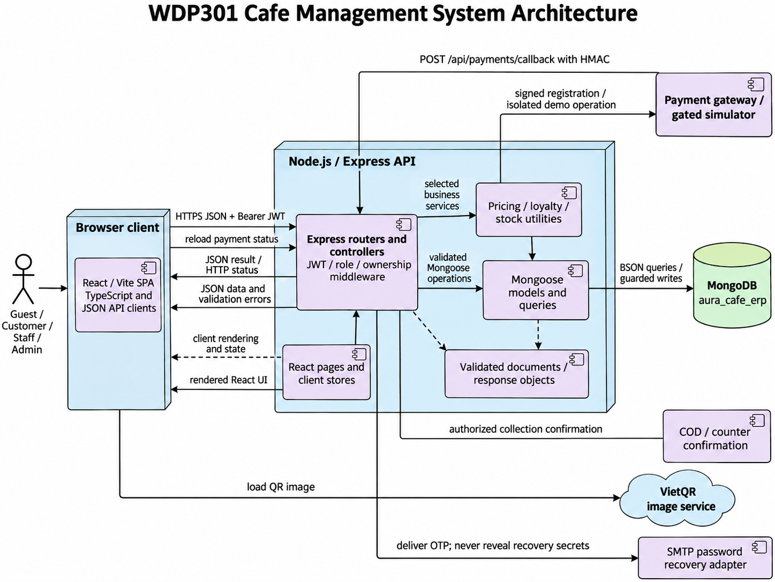

Component | Implementation | Responsibility
React client pages | frontend/src | React components, TypeScript, routing, browser cart state, API requests and payment-state display.
Express routing and controllers | backend/routes; backend/controllers; backend/middlewares | HTTP routing, JWT authentication, role/position/ownership checks, input validation and JSON responses.
Business utilities | cartItems; orderLoyalty; orderInventory; weeklyShifts | Server pricing, phone-based point changes, FIFO stock consumption, idempotency and weekly shift validation.
Data access | backend/models; Mongoose queries | BSON documents, ObjectId references and guarded writes inside required transaction boundaries. Unique indexes and state predicates support retries/concurrency; compensation is not a substitute for crash-safe atomicity.
Database | MongoDB aura_cafe_erp | Collections and embedded subdocuments model the business entities. Relational foreign keys and SQL CHECK constraints are replaced by Mongoose and application validation.
Payment integration | backend/routes/paymentRoutes.js; backend/utils/paymentGateway.js; backend/utils/paymentMode.js | Signed provider registration/callback and owner-authorized gated demo are separate. COD is confirmed on selection but collected only at successful delivery; the exact collected amount controls Payment SUCCESS.
Payment display and recovery boundary | PaymentPage; authController; EmailUtil; RedirectUtil | QR display is not proof of payment. EmailUtil normalizes login identities; RedirectUtil validates local paths; passwordRecoveryRoutes and recoveryEmail deliver server-validated, expiring OTP recovery.

2. Package Diagram
Backend modules use CommonJS routers, controllers, middleware, Mongoose models and shared utilities. The React/Vite client uses components, hooks, stores and TypeScript helpers. The browser accesses persistence only through the JSON API; there is no direct client-to-database exception.
PlantUML source - Package dependencies
@startuml CMS_Packages
title WDP301 Cafe Management System Package Diagram
skinparam packageStyle rectangle
package "routes / controllers" as controller
package "business utilities" as service
package "Mongoose persistence" as dao
package "schemas / documents" as model
package "MongoDB configuration" as context
package utils
package "React pages / hooks / stores" as webapp
controller ..> service
controller ..> dao
controller ..> model
controller ..> utils
service ..> dao
service ..> model
dao ..> model
dao ..> context
webapp ..> controller : JSON requests with Bearer JWT
controller ..> webapp : JSON response contracts
webapp ..> utils : formatting / safe redirects
note bottom of context
MongoDB is configured with MONGO_URI.
Mongoose models define validation and indexes.
end note
@enduml

Package | Examples | Purpose
routes / controllers | authController; orderRoutes; productIngredientRoutes | Express HTTP handlers, authentication and input/ownership validation.
utils | cartItems; orderLoyalty; orderInventory | Shared server pricing, point accounting and inventory operations.
models / queries | Order; ProductIngredient; Ingredient; LoyaltyTransaction | Mongoose queries, aggregation, guarded state changes and persistence.
models | User; Order; ProductIngredient; ShopSetting | Document schemas, ObjectId references, snapshots and validators.
config | Mongoose connection | MONGO_URI and protected environment settings configure the MongoDB connection.
utils | EmailUtil; RedirectUtil | Email normalization, login identifier matching and safe local redirects.
frontend | React pages, hooks, stores, assets and Vite configuration | Client presentation, navigation, local state and REST API integration.

3. Database Design

Cart → carts
Indexes: [[{"customer":1},{"unique":true}]]
Field | BSON / Mongoose type | Constraints / reference
customer | ObjectId | required; ref=User
items | Array | embedded=True
_id | ObjectId | optional / schema default
createdAt | Date | optional / schema default
updatedAt | Date | optional / schema default

Category → categories
Indexes: [[{"name":1},{"unique":true}]]
Field | BSON / Mongoose type | Constraints / reference
name | String | required
icon | String | optional / schema default
description | String | optional / schema default
imageUrl | String | optional / schema default
image_url | String | optional / schema default
status | String | enum=['ACTIVE', 'INACTIVE']
_id | ObjectId | optional / schema default
createdAt | Date | optional / schema default
updatedAt | Date | optional / schema default

CustomerReview → customerreviews
Indexes: [[{"submissionKey":1},{"unique":true,"partialFilterExpression":{"submissionKey":{"$type":"string"}}}]]
Field | BSON / Mongoose type | Constraints / reference
customer | ObjectId | required; ref=User
order | ObjectId | ref=Order
issueType | String | required; enum=['RATING', 'COMPLAINT']
rating | Number | min=1; max=5
topic | String | optional / schema default
content | String | required
attachments | Array | optional / schema default
status | String | enum=['PENDING', 'IN_PROGRESS', 'RESOLVED', 'REJECTED']
adminResponse | String | optional / schema default
respondedAt | Date | optional / schema default
respondedBy | ObjectId | ref=User
submissionKey | String | optional / schema default
_id | ObjectId | optional / schema default
createdAt | Date | optional / schema default
updatedAt | Date | optional / schema default

DeliveryArea → deliveryareas
Indexes: [[{"district":1},{"unique":true}],[{"isActive":1},{}]]
Field | BSON / Mongoose type | Constraints / reference
district | String | required
deliveryFee | Number | required; max=1000000
isActive | Boolean | optional / schema default
_id | ObjectId | optional / schema default
createdAt | Date | optional / schema default
updatedAt | Date | optional / schema default

DeliveryIssue → deliveryissues
Indexes: [[{"order":1},{}],[{"reporter":1},{}]]
Field | BSON / Mongoose type | Constraints / reference
order | ObjectId | required; ref=Order
reporter | ObjectId | required; ref=User
issueType | String | required; enum=['UNREACHABLE', 'BAD_ADDRESS', 'REFUSED', 'DAMAGED', 'DELAY', 'OTHER']
description | String | required
outcome | String | required; enum=['REPORT', 'RETURN', 'CANCEL']
_id | ObjectId | optional / schema default
createdAt | Date | optional / schema default
updatedAt | Date | optional / schema default

Ingredient → ingredients
Indexes: []
Field | BSON / Mongoose type | Constraints / reference
supplier | ObjectId | ref=Supplier
name | String | required
isActive | Boolean | optional / schema default
unit | String | required
currentStock | Number | optional / schema default
minStockLevel | Number | optional / schema default
stockLots | Array | embedded=True
lotsVersion | Number | optional / schema default
stockValuation.quantity | Number | optional / schema default
stockValuation.totalCost | Number | optional / schema default
stockValuation.updatedAt | Date | optional / schema default
stockValuation.updatedBy | ObjectId | ref=User
_id | ObjectId | optional / schema default

InventoryTransaction → inventorytransactions
Indexes: []
Field | BSON / Mongoose type | Constraints / reference
ingredient | ObjectId | required; ref=Ingredient
transactionType | String | required; enum=['IN_PURCHASE', 'OUT_ORDER', 'ADJUSTMENT', 'SPOILAGE']
quantity | Number | required
stockBefore | Number | optional / schema default
stockAfter | Number | optional / schema default
unitBefore | String | optional / schema default
unitAfter | String | optional / schema default
valueBefore | Number | optional / schema default
valueAfter | Number | optional / schema default
stockDelta | Number | required
referenceType | String | enum=['ORDER', 'PURCHASE_ORDER', 'ADJUSTMENT']
referenceId | Mixed | optional / schema default
note | String | optional / schema default
createdBy | ObjectId | ref=User
costTotal | Number | optional / schema default
lotAllocations | Array | embedded=True
_id | ObjectId | optional / schema default
createdAt | Date | optional / schema default
updatedAt | Date | optional / schema default

LoyaltyTransaction → loyaltytransactions
Indexes: [[{"order":1},{"unique":true,"partialFilterExpression":{"automatic":true}}],[{"order":1},{"name":"order_redemption_refund","unique":true,"partialFilterExpression":{"redemptionRefund":true}}],[{"order":1},{"name":"order_earning_reversal","unique":true,"partialFilterExpression":{"earningReversal":true}}]]
Field | BSON / Mongoose type | Constraints / reference
customer | ObjectId | required; ref=User
order | ObjectId | ref=Order
pointsChange | Number | required
balanceAfter | Number | optional / schema default
automatic | Boolean | optional / schema default
redemptionRefund | Boolean | optional / schema default
earningReversal | Boolean | optional / schema default
transactionType | String | required; enum=['EARN', 'REDEEM', 'REFUND', 'ADJUST']
reason | String | optional / schema default
performedBy | ObjectId | ref=User
_id | ObjectId | optional / schema default
createdAt | Date | optional / schema default
updatedAt | Date | optional / schema default

Order → orders
Indexes: [[{"orderCode":1},{"unique":true}],[{"customer":1,"idempotencyKey":1},{"unique":true,"partialFilterExpression":{"idempotencyKey":{"$type":"string"}}}]]
Field | BSON / Mongoose type | Constraints / reference
mutationLock | String | optional / schema default
orderCode | String | required
checkoutFlow | Boolean | optional / schema default
checkoutSessionId | String | optional / schema default
idempotencyKey | String | optional / schema default
requestHash | String | optional / schema default
cartClearedAt | Date | optional / schema default
customer | ObjectId | ref=User
cashier | ObjectId | ref=User
voucher | ObjectId | ref=Voucher
reward | ObjectId | ref=RewardItem
pointsRedeemed | Number | optional / schema default
orderType | String | required; enum=['DINE_IN', 'TAKEAWAY', 'ONLINE']
status | String | enum=['PENDING', 'CONFIRMED', 'PREPARING', 'READY', 'DELIVERING', 'COMPLETED', 'CANCELLED']
items | Array | embedded=True
totalAmount | Number | required
discountAmount | Number | optional / schema default
deliveryFee | Number | optional / schema default
finalAmount | Number | required
paymentMethod | String | enum=['COD', 'PAY_AT_COUNTER', 'CASH', 'VNPAY', 'MOMO', 'BANK_TRANSFER', 'DEMO_ONLINE']
demoProvider | String | enum=['MOMO', 'VNPAY', 'BANK_TRANSFER']
recipientName | String | optional / schema default
recipientPhone | String | optional / schema default
deliveryAddress | String | optional / schema default
district | String | optional / schema default
ward | String | optional / schema default
addressDetail | String | optional / schema default
shipper | ObjectId | ref=User
delivery.status | String | enum=['ASSIGNED', 'ACCEPTED', 'DELIVERING', 'DELIVERED', 'RETURNED', 'CANCELLED']
delivery.assignedAt | Date | optional / schema default
delivery.acceptedAt | Date | optional / schema default
delivery.pickedUpAt | Date | optional / schema default
delivery.deliveredAt | Date | optional / schema default
delivery.history | Array | embedded=True
tableNumber | String | optional / schema default
orderNote | String | optional / schema default
cancelReason | String | optional / schema default
inventoryDeductedAt | Date | optional / schema default
inventoryProcessing | Boolean | optional / schema default
costTotal | Number | optional / schema default
costCapturedAt | Date | optional / schema default
costStatus | String | enum=['PENDING', 'COMPLETE', 'MISSING_PRICE', 'LEGACY']
_id | ObjectId | optional / schema default
createdAt | Date | optional / schema default
updatedAt | Date | optional / schema default

OrderItem → orderitems
Indexes: []
Field | BSON / Mongoose type | Constraints / reference
order | ObjectId | ref=Order
product | ObjectId | required; ref=Product
productNameAtTime | String | required
unitPrice | Number | required
customization | Mixed | optional / schema default
quantity | Number | required; min=1
subtotal | Number | required
isPrepared | Boolean | optional / schema default
_id | ObjectId | optional / schema default
createdAt | Date | optional / schema default
updatedAt | Date | optional / schema default

PasswordRecovery → passwordrecoveries
Indexes: [[{"email":1},{"unique":true}],[{"expiresAt":1},{"expireAfterSeconds":0}]]
Field | BSON / Mongoose type | Constraints / reference
email | String | required
user | ObjectId | required; ref=User
challenge | String | required
otpHash | String | required
resetTokenHash | String | optional / schema default
attempts | Number | optional / schema default
sentAt | Date | required
expiresAt | Date | required
_id | ObjectId | optional / schema default

Payment → payments
Indexes: [[{"status":1,"paymentMethod":1,"paidAt":1},{}]]
Field | BSON / Mongoose type | Constraints / reference
order | ObjectId | required; ref=Order
paymentMethod | String | required; enum=['CASH', 'VNPAY', 'MOMO', 'BANK_TRANSFER', 'DEMO_ONLINE']
demoProvider | String | enum=['MOMO', 'VNPAY', 'BANK_TRANSFER']
transactionCode | String | optional / schema default
amount | Number | required
status | String | enum=['PENDING', 'SUCCESS', 'FAILED', 'REFUNDED']
paidAt | Date | optional / schema default
receivedAmount | Number | optional / schema default
changeAmount | Number | optional / schema default
refundedAt | Date | optional / schema default
refundAmount | Number | optional / schema default
refundMethod | String | enum=['CASH', 'BANK_TRANSFER', 'MOMO', 'VNPAY', 'DEMO_ONLINE']
refundReference | String | optional / schema default
refundNote | String | optional / schema default
refundedBy | ObjectId | ref=User
refundSchedule | ObjectId | ref=WorkSchedule
receivedBy | ObjectId | ref=User
remittanceId | String | optional / schema default
remittanceSchedule | ObjectId | ref=WorkSchedule
remittedAt | Date | optional / schema default
paymentNote | String | optional / schema default
_id | ObjectId | optional / schema default
createdAt | Date | optional / schema default
updatedAt | Date | optional / schema default

Product → products
Indexes: []
Field | BSON / Mongoose type | Constraints / reference
category | ObjectId | required; ref=Category
name | String | required
basePrice | Number | required
badge | String | optional / schema default
subtitle | String | optional / schema default
variantsConfig | Mixed | optional / schema default
description | String | optional / schema default
imageUrl | String | optional / schema default
isAvailable | Boolean | optional / schema default
recipe | Array | embedded=True
_id | ObjectId | optional / schema default
createdAt | Date | optional / schema default
updatedAt | Date | optional / schema default

ProductIngredient → productingredients
Indexes: [[{"product":1,"ingredient":1},{"unique":true}]]
Field | BSON / Mongoose type | Constraints / reference
product | ObjectId | required; ref=Product
ingredient | ObjectId | required; ref=Ingredient
quantityRequired | Number | required; min=0.001
_id | ObjectId | optional / schema default
createdAt | Date | optional / schema default
updatedAt | Date | optional / schema default

PurchaseOrder → purchaseorders
Indexes: []
Field | BSON / Mongoose type | Constraints / reference
supplier | ObjectId | required; ref=Supplier
creator | ObjectId | required; ref=User
totalCost | Number | optional / schema default
status | String | enum=['DRAFT', 'ORDERED', 'RECEIVED', 'CANCELLED']
note | String | optional / schema default
items | Array | embedded=True
_id | ObjectId | optional / schema default
createdAt | Date | optional / schema default
updatedAt | Date | optional / schema default

PurchaseOrderItem → purchaseorderitems
Indexes: []
Field | BSON / Mongoose type | Constraints / reference
purchaseOrder | ObjectId | ref=PurchaseOrder
ingredient | ObjectId | required; ref=Ingredient
quantity | Number | required; min=0.001
unitPrice | Number | required
totalCost | Number | optional / schema default
_id | ObjectId | optional / schema default
createdAt | Date | optional / schema default
updatedAt | Date | optional / schema default

RestockRequest → restockrequests
Indexes: []
Field | BSON / Mongoose type | Constraints / reference
requester | ObjectId | required; ref=User
reviewer | ObjectId | ref=User
status | String | required; enum=['DRAFT', 'PENDING_APPROVAL', 'APPROVED', 'REJECTED', 'CANCELLED']
reason | String | optional / schema default
note | String | optional / schema default
reviewNote | String | optional / schema default
reviewedAt | Date | optional / schema default
history | Array | embedded=True
items | Array | embedded=True
_id | ObjectId | optional / schema default
createdAt | Date | optional / schema default
updatedAt | Date | optional / schema default

RewardItem → rewarditems
Indexes: []
Field | BSON / Mongoose type | Constraints / reference
name | String | required
description | String | optional / schema default
pointsCost | Number | required
discountValue | Number | optional / schema default
minOrderValue | Number | optional / schema default
validDays | Number | optional / schema default
category | String | optional / schema default
imageIcon | String | optional / schema default
stock | Number | optional / schema default
status | String | enum=['ACTIVE', 'INACTIVE']
_id | ObjectId | optional / schema default

ShiftHandover → shifthandovers
Indexes: [[{"schedule":1},{"unique":true}],[{"cashier":1,"workDate":1},{}],[{"status":1},{}]]
Field | BSON / Mongoose type | Constraints / reference
schedule | ObjectId | required; ref=WorkSchedule
cashier | ObjectId | required; ref=User
workDate | Date | required
shiftName | String | required
checkInTime | Date | optional / schema default
checkOutTime | Date | optional / schema default
openingCash | Number | required
cashSales | Number | required
codReceipts | Number | optional / schema default
cashRefunds | Number | optional / schema default
expectedCash | Number | required
actualCash | Number | required
difference | Number | required
note | String | optional / schema default
status | String | required; enum=['SUBMITTED', 'CONFIRMED', 'REJECTED']
reviewedBy | ObjectId | ref=User
reviewedAt | Date | optional / schema default
reviewerNote | String | optional / schema default
resubmittedAt | Date | optional / schema default
revision | Number | optional / schema default
history | Array | embedded=True
_id | ObjectId | optional / schema default
createdAt | Date | optional / schema default
updatedAt | Date | optional / schema default

ShopSetting → shopsettings
Indexes: [[{"settingKey":1},{"unique":true}]]
Field | BSON / Mongoose type | Constraints / reference
settingKey | String | required
settingValue | String | required
_id | ObjectId | optional / schema default
createdAt | Date | optional / schema default
updatedAt | Date | optional / schema default

Supplier → suppliers
Indexes: []
Field | BSON / Mongoose type | Constraints / reference
name | String | required
phone | String | optional / schema default
address | String | optional / schema default
status | String | enum=['ACTIVE', 'INACTIVE']
_id | ObjectId | optional / schema default
createdAt | Date | optional / schema default
updatedAt | Date | optional / schema default

User → users
Indexes: [[{"phone":1},{"unique":true}],[{"emailKey":1},{"unique":true,"partialFilterExpression":{"emailKey":{"$type":"string"}}}]]
Field | BSON / Mongoose type | Constraints / reference
fullName | String | required
phone | String | required
email | String | optional / schema default
emailKey | String | optional / schema default
passwordHash | String | required
passwordChangedAt | Date | optional / schema default
checkoutRevision | Number | optional / schema default
birthday | Date | optional / schema default
address | String | optional / schema default
role | String | enum=['ADMIN', 'STAFF', 'CUSTOMER']
status | String | enum=['ACTIVE', 'INACTIVE', 'LOCKED']
position | String | enum=['MANAGER', 'BARISTA', 'CASHIER', 'SHIPPER']
baseSalary | Number | optional / schema default
hireDate | Date | optional / schema default
totalPoints | Number | optional / schema default
_id | ObjectId | optional / schema default
createdAt | Date | optional / schema default
updatedAt | Date | optional / schema default

UserReward → userrewards
Indexes: []
Field | BSON / Mongoose type | Constraints / reference
customer | ObjectId | required; ref=User
reward | ObjectId | required; ref=RewardItem
voucher | ObjectId | ref=Voucher
_id | ObjectId | optional / schema default
createdAt | Date | optional / schema default
updatedAt | Date | optional / schema default

Voucher → vouchers
Indexes: [[{"code":1},{"unique":true}]]
Field | BSON / Mongoose type | Constraints / reference
code | String | required
customer | ObjectId | ref=User
discountType | String | required; enum=['PERCENT', 'FIXED_AMOUNT']
discountValue | Number | required
minOrderValue | Number | optional / schema default
maxDiscount | Number | optional / schema default
startDate | Date | optional / schema default
validUntil | Date | optional / schema default
usageLimit | Number | optional / schema default
usedCount | Number | optional / schema default
status | String | enum=['ACTIVE', 'INACTIVE']
_id | ObjectId | optional / schema default
createdAt | Date | optional / schema default
updatedAt | Date | optional / schema default

WorkSchedule → workschedules
Indexes: [[{"user":1,"workDate":1,"shiftName":1},{"unique":true}]]
Field | BSON / Mongoose type | Constraints / reference
user | ObjectId | required; ref=User
workDate | Date | required
shiftName | String | required
shift | ObjectId | ref=WorkShift
checkInTime | Date | optional / schema default
checkOutTime | Date | optional / schema default
startingCash | Number | optional / schema default
endingCashSystem | Number | optional / schema default
endingCashActual | Number | optional / schema default
handoverCashSales | Number | optional / schema default
handoverPaymentCount | Number | optional / schema default
handoverUnattributedCash | Number | optional / schema default
handoverUnattributedCount | Number | optional / schema default
handoverAt | Date | optional / schema default
remittanceId | String | optional / schema default
codPaymentIds | Array | optional / schema default
codReceivedBy | ObjectId | ref=User
codReceivedAt | Date | optional / schema default
codReceivedAmount | Number | optional / schema default
codReceivedNote | String | optional / schema default
codReceivingSchedule | ObjectId | ref=WorkSchedule
codLedgerVersion | Number | optional / schema default
handoverCodReceipts | Number | optional / schema default
handoverCashRefunds | Number | optional / schema default
handoverNote | String | optional / schema default
status | String | enum=['SCHEDULED', 'PRESENT', 'ABSENT', 'COMPLETED']
note | String | optional / schema default
_id | ObjectId | optional / schema default
createdAt | Date | optional / schema default
updatedAt | Date | optional / schema default

WorkShift → workshifts
Indexes: [[{"weekStart":1,"shiftName":1},{"unique":true}]]
Field | BSON / Mongoose type | Constraints / reference
weekStart | Date | required
shiftName | String | required
startTime | String | required
endTime | String | required
_id | ObjectId | optional / schema default
createdAt | Date | optional / schema default
updatedAt | Date | optional / schema default

2. Detailed Code Design

Workflow Responsibility and Traceability
Ten design modules cover 15 flows and the existing screen allocations. Screen ownership is unchanged. Each module owns its UI/API/persistence/permission/acceptance responsibilities. Source paths define main entry points; private helper refactors do not change the business or public API contract.
SDS design module | SRS flows and use cases | Responsibility and SRS location
1 Online Order Placement and Payment | BF-01, BF-02; UC07-UC17, UC25, UC62, UC64 | Lead: Ngọc; screen owners: Ngọc, Nguyên; SRS I.2.1-I.2.2; II.2.1-II.2.2; II.2.3.1
2 Ingredient Restock and Purchasing | BF-08; UC44-UC53 | Lead: Duy; screen owners: Duy; SRS I.2.8; II.7
3 Customer Feedback and Complaint Handling | BF-09; UC65, UC70 | Lead: Sơn; screen owners: Sơn; SRS I.2.9; II.2.3.3; II.9.2.3
4 Delivery Management | BF-04; UC26-UC30, UC71-UC72 | Lead: Mạnh; screen owners: Mạnh; SRS I.2.4; II.5; II.9.1.1; II.10.1.2
5 Barista Order Preparation | BF-03; UC23-UC24 | Lead: Mạnh; screen owners: Mạnh; SRS I.2.3; II.4.1.1
6 Account Menu Recipe and Loyalty Design | BF-10, BF-11, BF-12; UC01-UC06, UC31-UC43, UC62-UC64 | Lead: Nguyên; screen owners: Nguyên, Duy, Ngọc; SRS I.2.10-I.2.12; II.1; II.2.1.1; II.2.3.2; II.6.2-II.6.3; II.9.2.2
7 Scheduling Attendance and Handover Design | BF-06, BF-07; UC55-UC60, UC69, UC73 | Lead: Sơn; screen owners: Sơn; SRS I.2.6-I.2.7; II.3.2.1; II.8.2
8 Order Oversight Reports and Settings Design | BF-13, BF-14; UC14, UC61, UC66-UC68 | Lead: Mạnh; screen owners: Mạnh, Ngọc, Duy; SRS I.2.13-I.2.14; II.9.1-II.9.3; II.10.1.1
9 Counter Ordering and Payment | BF-05; UC14, UC18-UC22, UC62, UC64 | Lead: Mạnh; screen owners: Mạnh, Ngọc; SRS I.2.5; II.3.1
10 Employee and Weekly Shift Setup | BF-15; UC54-UC55 | Lead: Sơn; screen owners: Sơn; SRS I.2.15; II.8.1

1. Online Order Placement and Payment (Ngọc)
SRS trace: BF-01, BF-02; UC07-UC17, UC25, UC62, UC64. Requirement sections: I.2.1-I.2.2; II.2.1-II.2.2; II.2.3.1.
The Customer ordering, payment, tracking, cancellation and reorder responsibilities follow BF-01/BF-02 and their source use cases. React pages communicate with orderRoutes, cartRoutes and paymentRoutes using JSON and Bearer JWT. Order item snapshots retain server-validated prices, options and quantities.
PaymentRoutes separates provider callback, DEMO_ONLINE simulation, counter confirmation and COD. Registration uses paymentGateway; callback verifies HMAC, transaction, amount and state. Provider integration requires environment credentials and independent acceptance evidence.

1.1 Class Diagrams
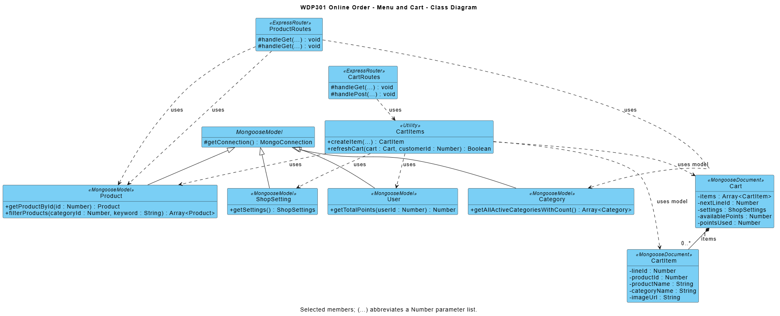
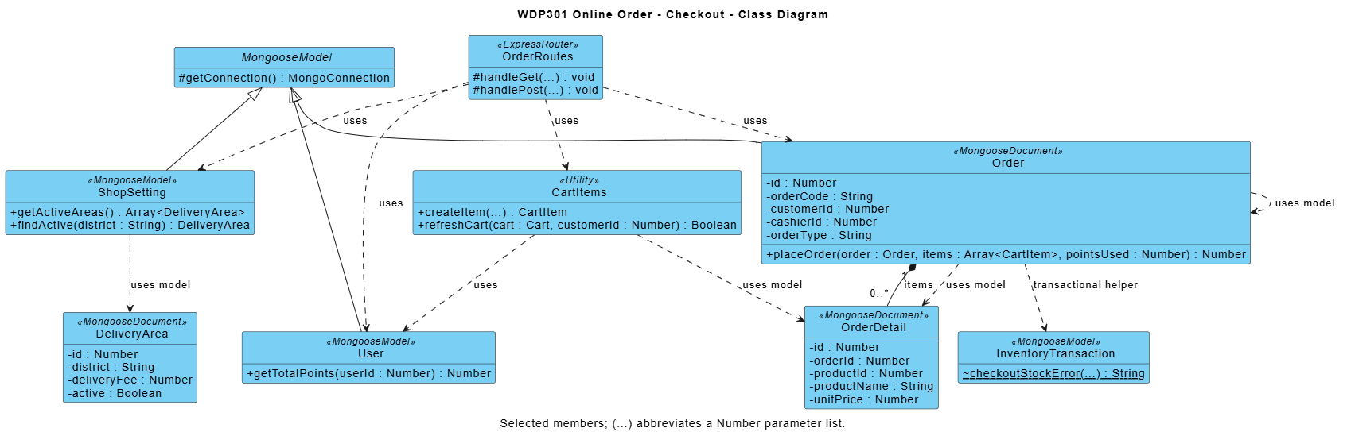

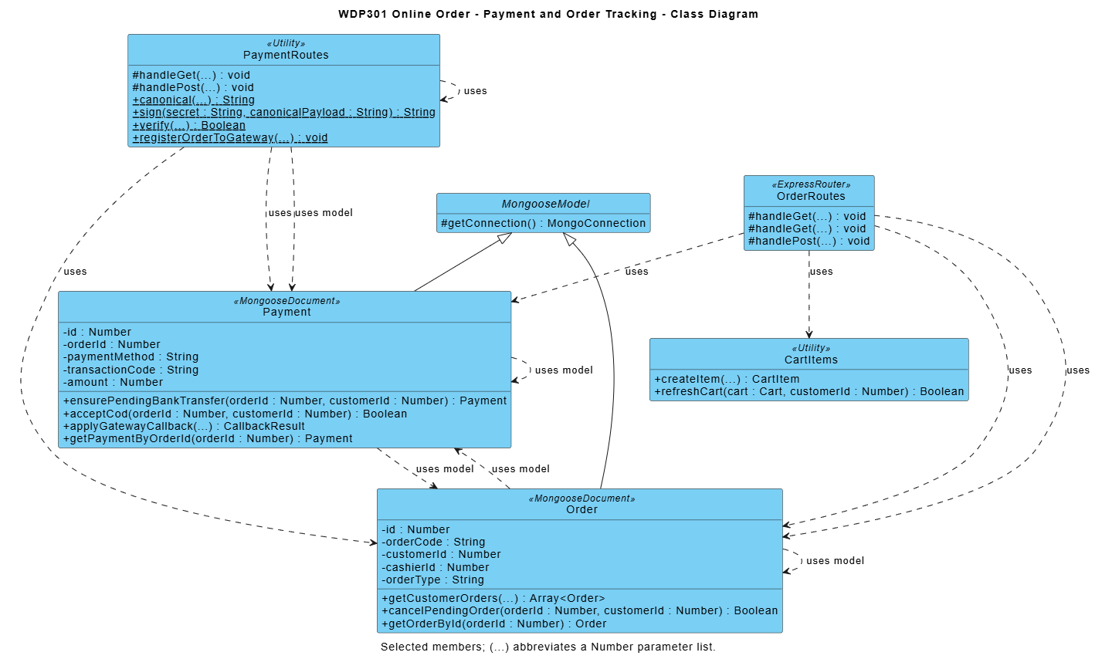

Module contract: React pages call Express JSON APIs; routers enforce access/validation and use shared business utilities and Mongoose models. Diagram methods are logical responsibilities, not private function names. Listed source paths identify primary modules; internal refactoring preserves public behavior and acceptance criteria.

1.2 Place Online Order
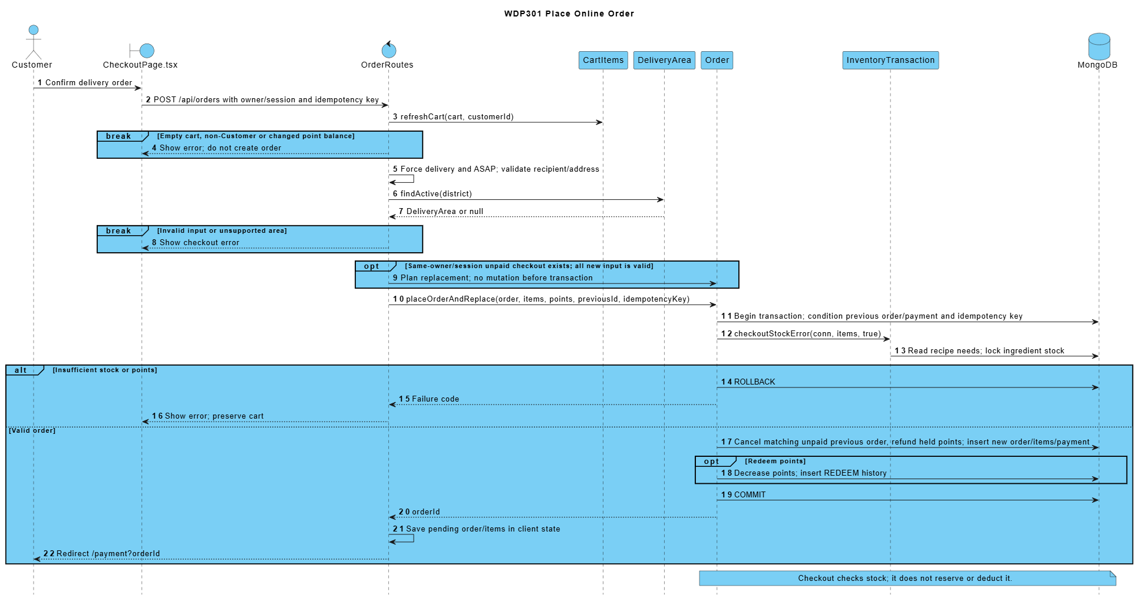

1.3 Confirm Online Bank Transfer
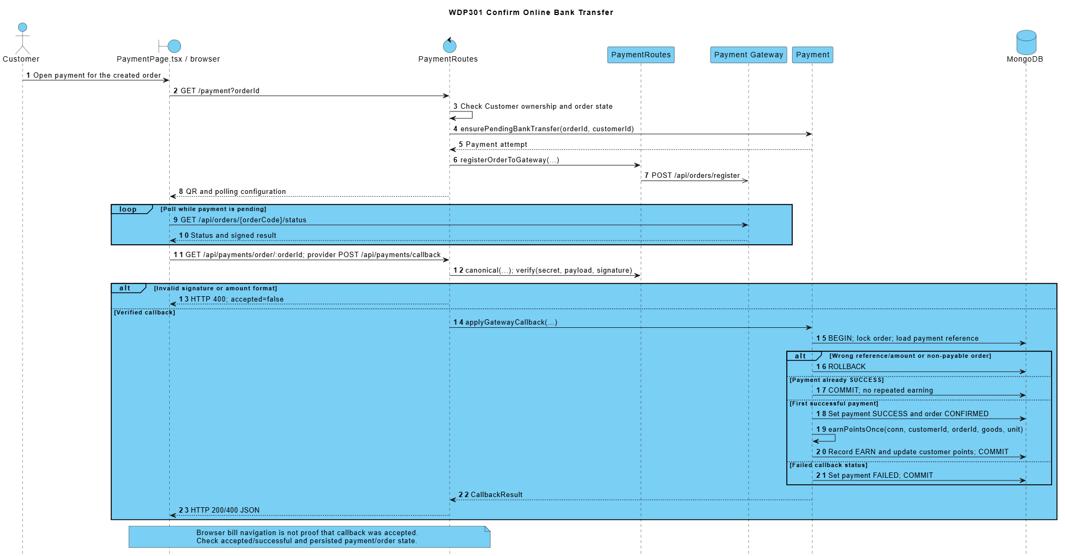

1.4 Choose COD and Track an Own Order
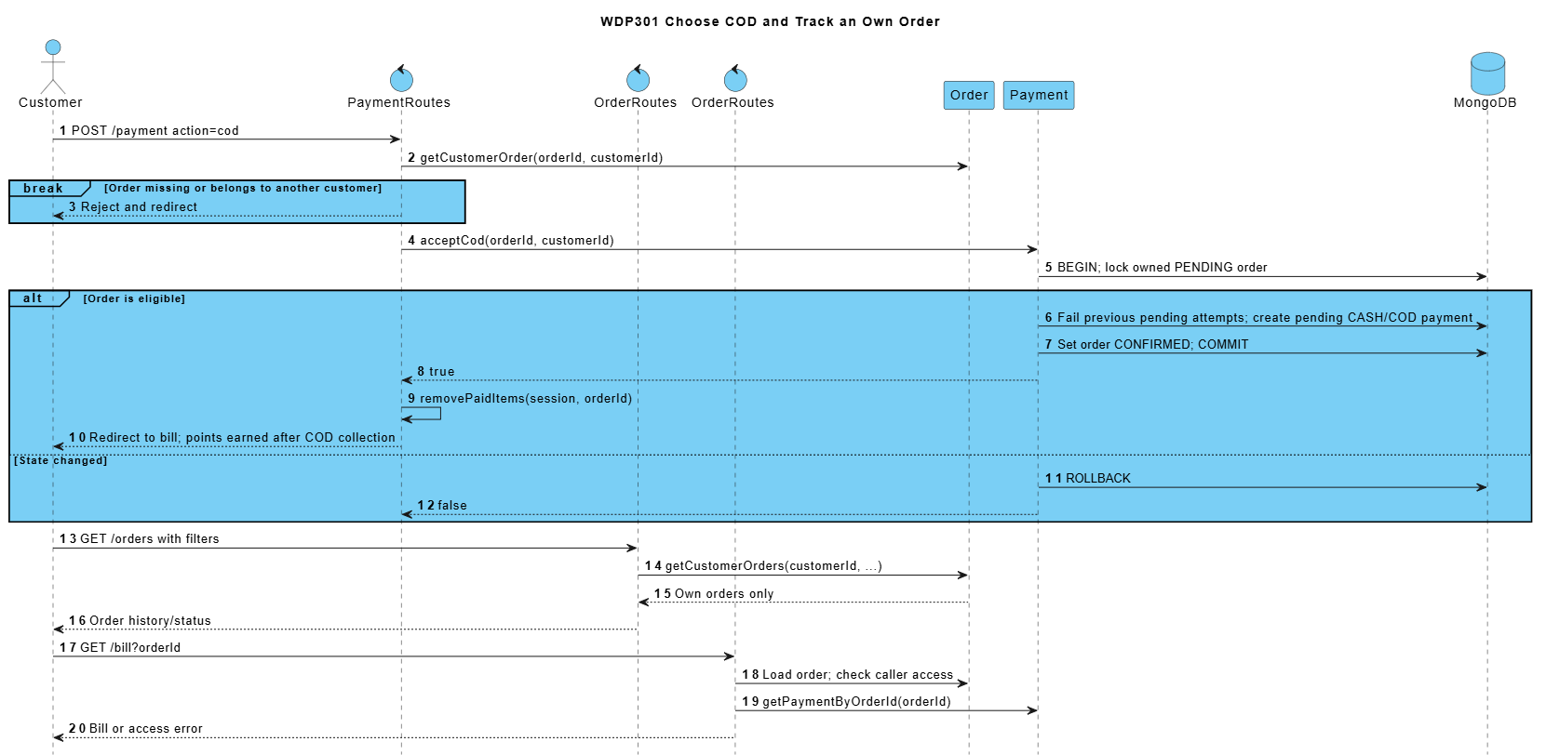

1.5 Cancel an Unpaid Order or Reorder
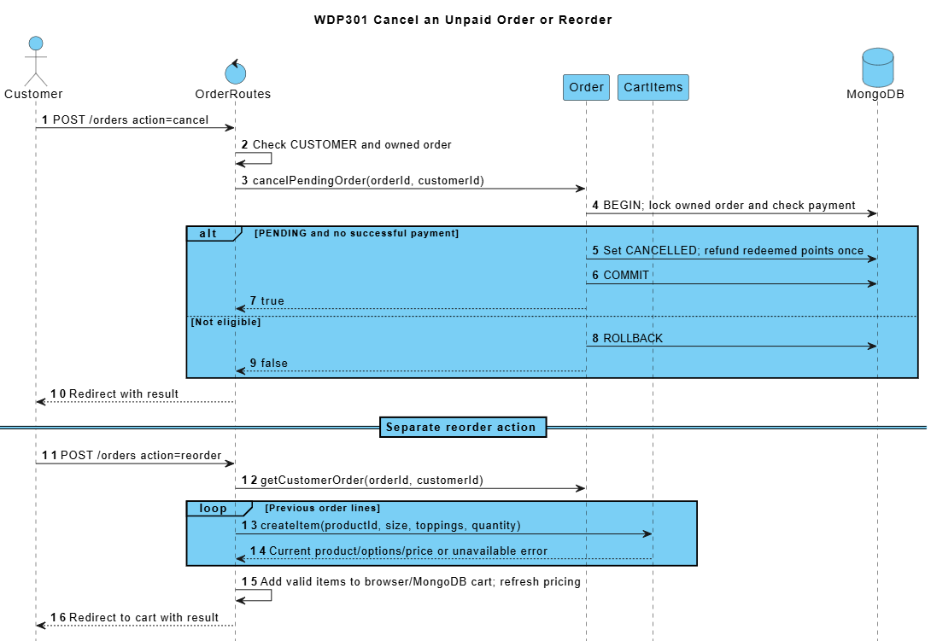

2. Ingredient Restock and Purchasing (Duy)
SRS trace: BF-08; UC44-UC53. Requirement sections: I.2.8; II.7.
Admin maintains suppliers and ingredients, checks stock and movement history, records adjustments or spoilage, reviews restock requests and receives purchase orders. The principal path converts an approved restock request into a purchase order; direct purchase-order creation is also supported.
RestockRequest follows DRAFT/PENDING_APPROVAL/APPROVED/REJECTED/CANCELLED with reviewer history. A linked purchase requires approval. DRAFT/ORDERED purchases do not change stock; atomic receipt records stock/lots and IN_PURCHASE exactly once.

2.1 Class Diagrams
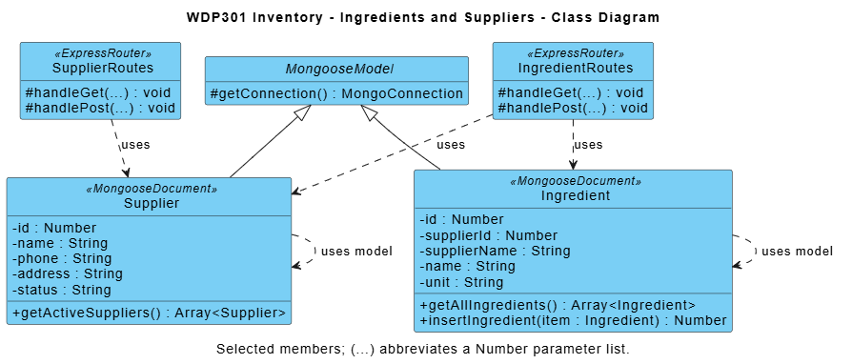

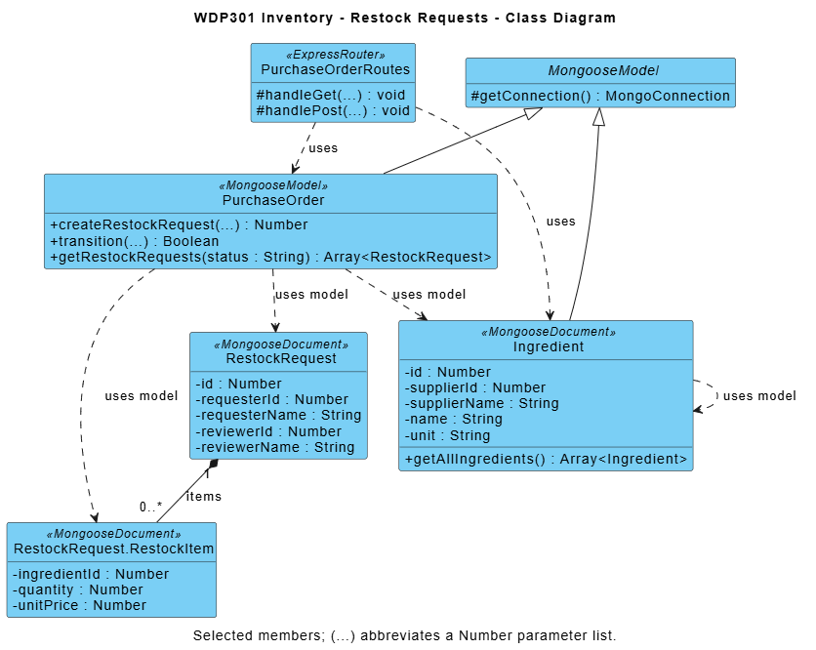

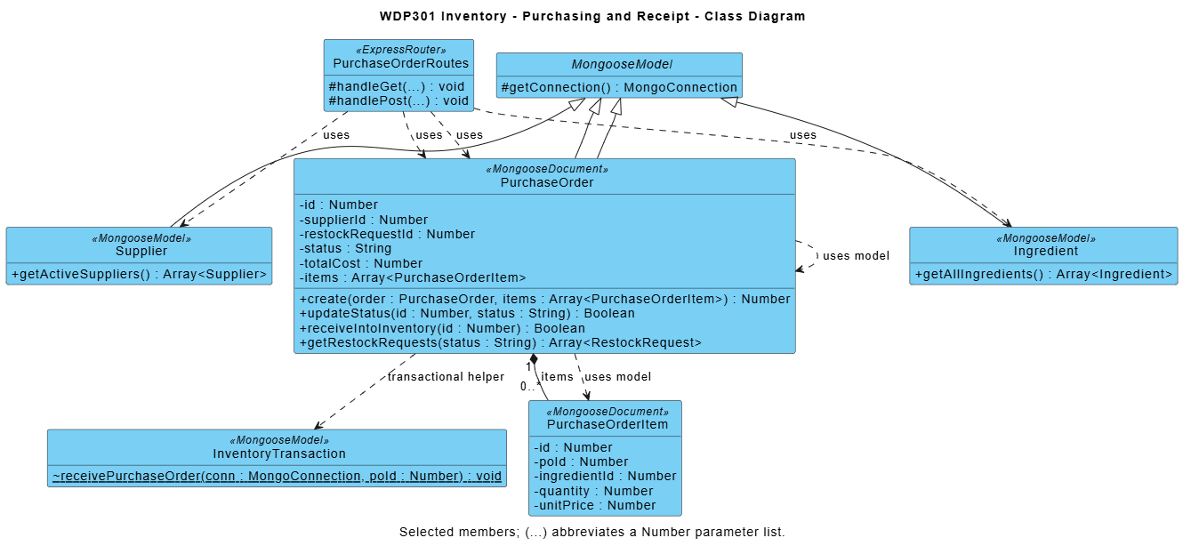
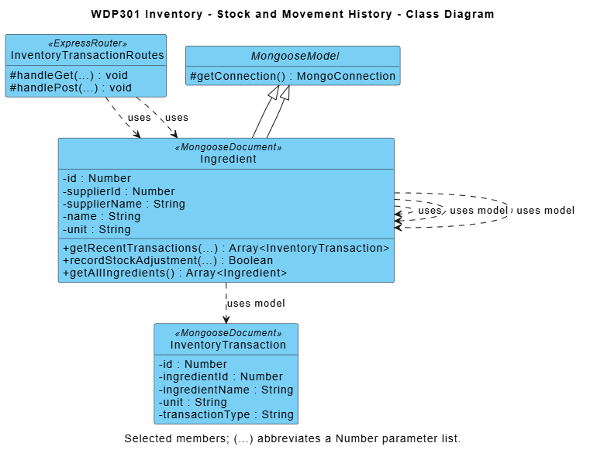

Module contract: React pages call Express JSON APIs; routers enforce access/validation and use shared business utilities and Mongoose models. Diagram methods are logical responsibilities, not private function names. Listed source paths identify primary modules; internal refactoring preserves public behavior and acceptance criteria.

2.2 Create Restock Request and Receive a Purchase Order
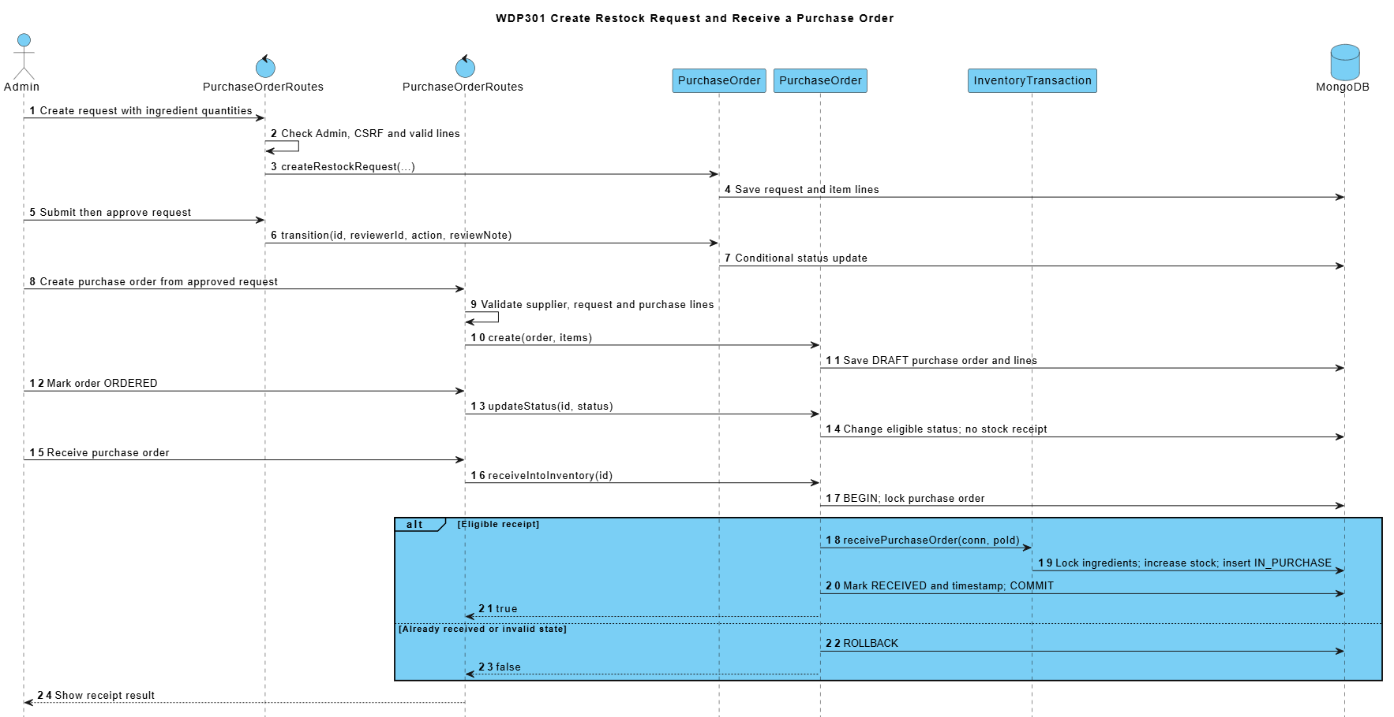

2.3 Adjust Stock or Record Spoilage
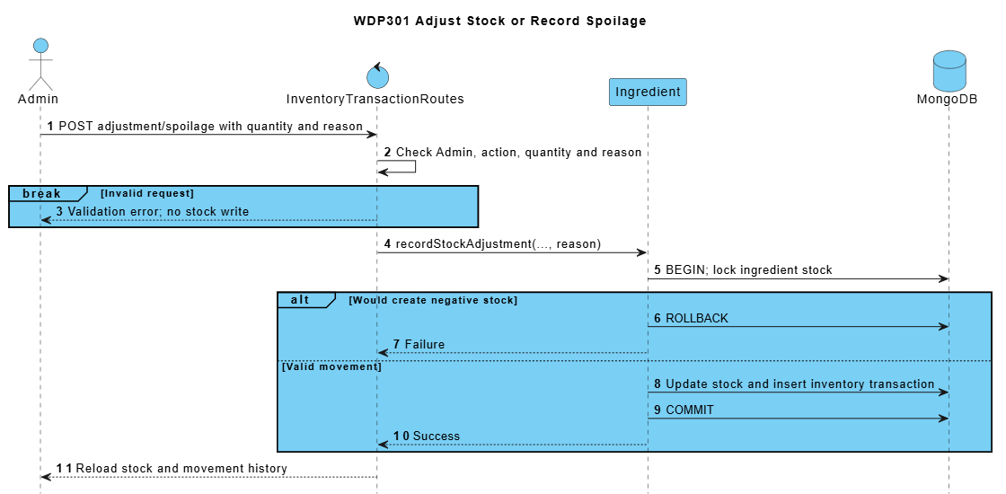

3. Customer Feedback and Complaint Handling (Sơn)
SRS trace: BF-09; UC65, UC70. Requirement sections: I.2.9; II.2.3.3; II.9.2.3.
A signed-in customer submits a rating or complaint linked to an own order, then reads its response. Admin filters tickets and moves an eligible ticket through Processing to Resolved or Rejected.
ReviewRoutes requires an active CUSTOMER and owned eligible order for submission. Customers read only their own tickets; guests/staff receive no unrestricted list. Enforce one submission per order and terminal ticket immutability on every request.

3.1 Class Diagram
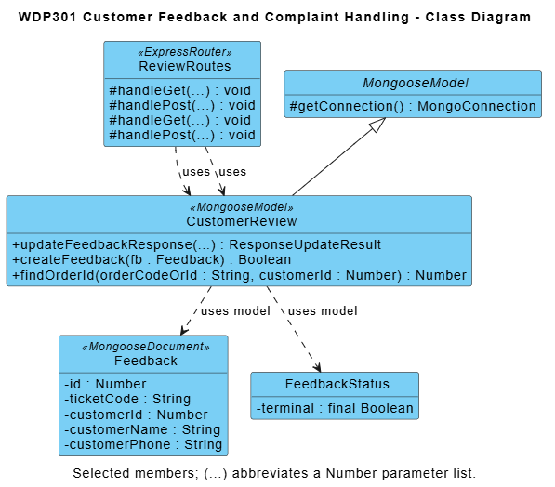

Module contract: React pages call Express JSON APIs; routers enforce access/validation and use shared business utilities and Mongoose models. Diagram methods are logical responsibilities, not private function names. Listed source paths identify primary modules; internal refactoring preserves public behavior and acceptance criteria.

3.2 Submit and Resolve Feedback
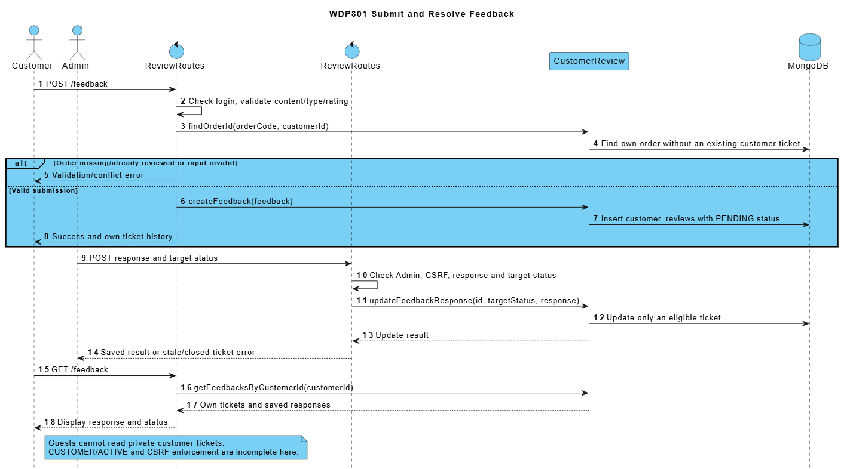

4. Delivery Management (Mạnh)
SRS trace: BF-04; UC26-UC30, UC71-UC72. Requirement sections: I.2.4; II.5; II.9.1.1; II.10.1.2.
Admin maintains delivery areas and assigns an active shipper to an eligible ONLINE delivery order. The assigned shipper accepts, picks up a READY order, completes delivery, reports issues and hands held COD cash to an active Cashier.
Delivery responsibilities include READY assignment/pickup, assigned-shipper transitions, issue history, exact COD collection and remittance to an active receiving cashier. Delivery state and history may be represented on Order and WorkSchedule without duplicate authoritative records.

4.1 Class Diagrams
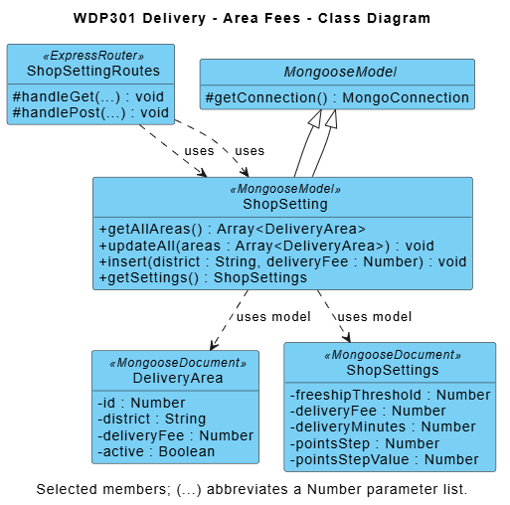

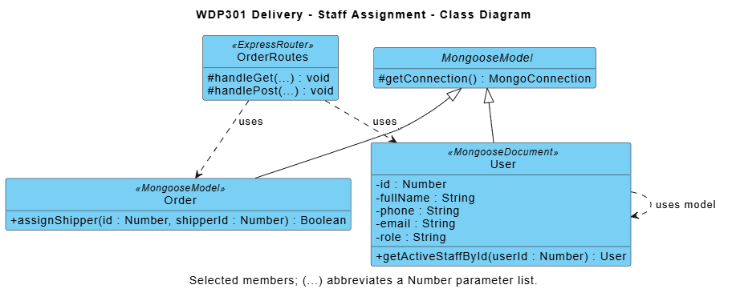

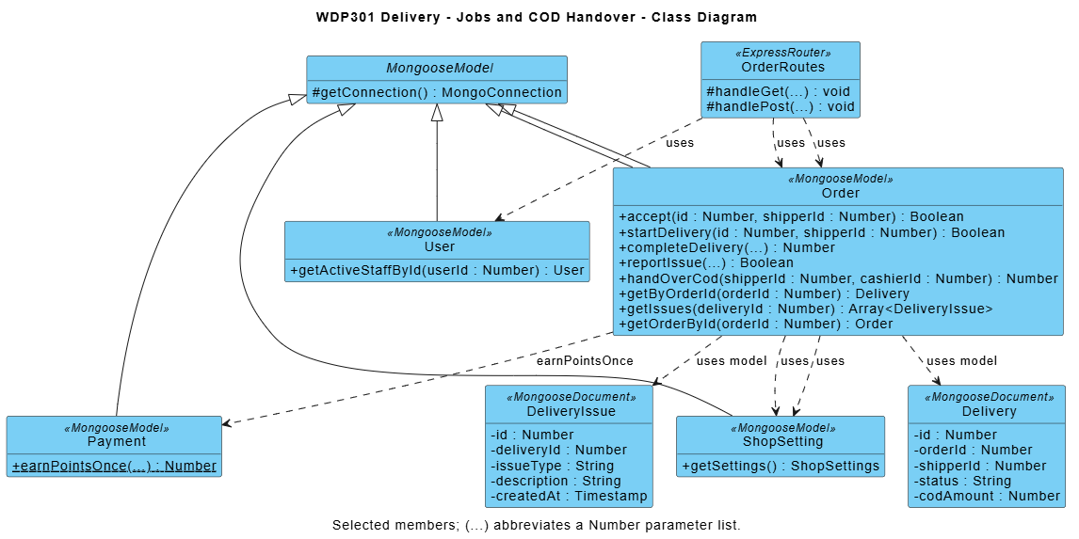

Module contract: React pages call Express JSON APIs; routers enforce access/validation and use shared business utilities and Mongoose models. Diagram methods are logical responsibilities, not private function names. Listed source paths identify primary modules; internal refactoring preserves public behavior and acceptance criteria.

4.2 Assign Delivery Staff
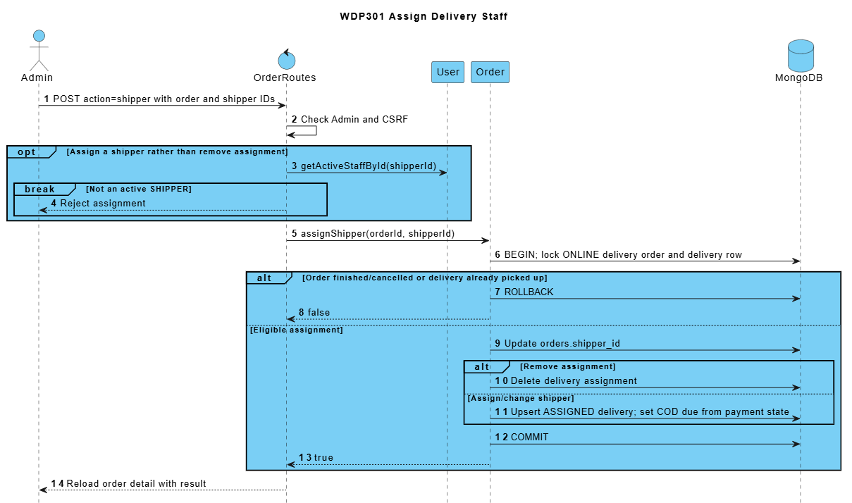

4.3 Accept Pick Up and Complete Delivery
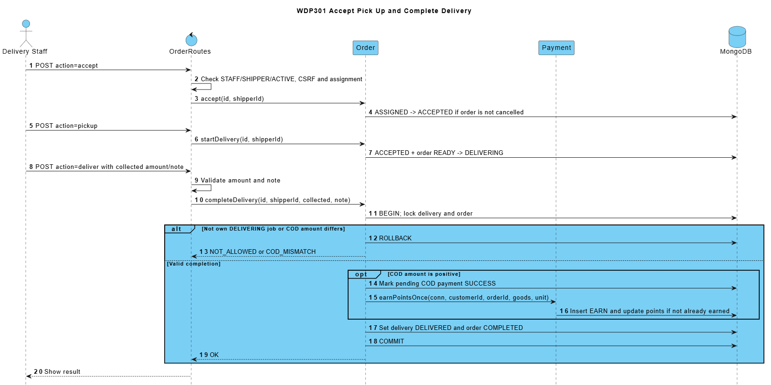

4.4 Report a Delivery Issue and Hand Over COD
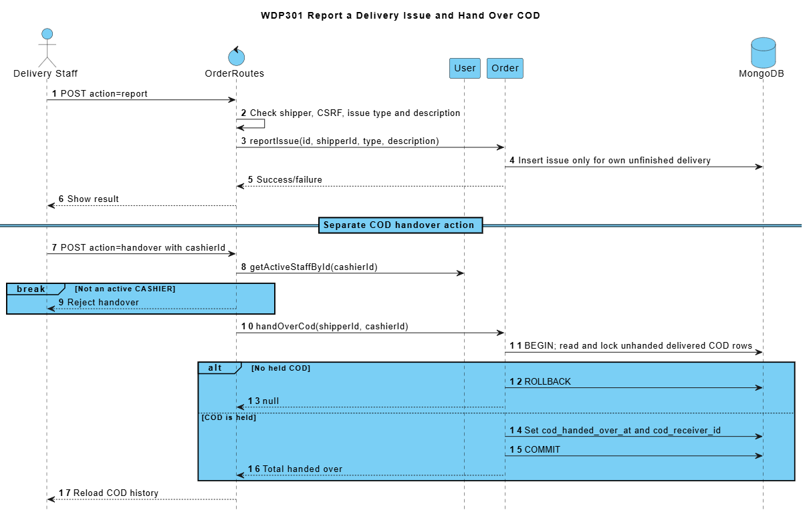

5. Barista Order Preparation (Mạnh)
SRS trace: BF-03; UC23-UC24. Requirement sections: I.2.3; II.4.1.1.
The Barista sees eligible paid orders and ONLINE COD orders. Entering PREPARING consumes recipe stock once; item-prepared flags are stored per item. Explicit completion persists READY only after preparation is complete, for cashier or shipper handover.
Persist preparation flags, status and timestamps in MongoDB so refresh/restart preserves progress. Order state guards, transaction sessions and OUT_ORDER idempotency protect stock across processes. Failed stock deduction leaves preparation unstarted; READY never deducts stock a second time.

5.1 Class Diagram
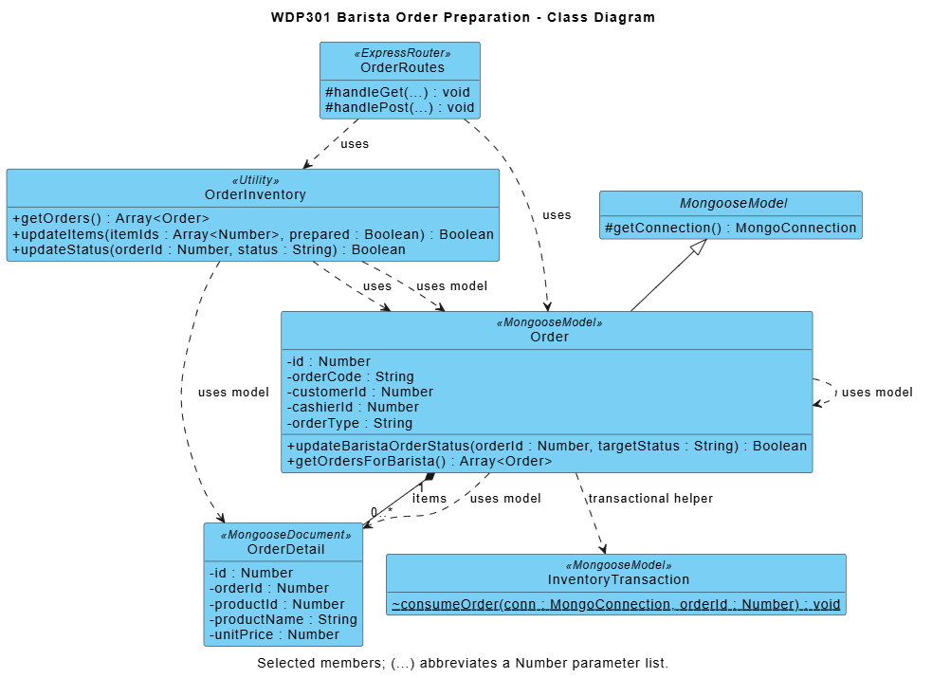

Module contract: React pages call Express JSON APIs; routers enforce access/validation and use shared business utilities and Mongoose models. Diagram methods are logical responsibilities, not private function names. Listed source paths identify primary modules; internal refactoring preserves public behavior and acceptance criteria.

5.2 Load Queue Update Items and Mark READY
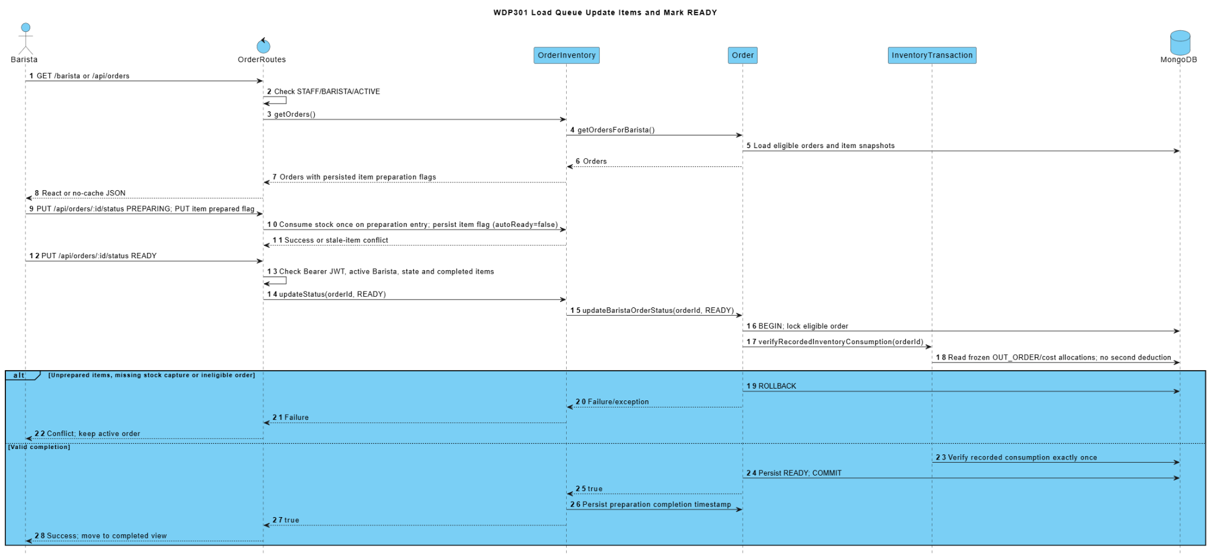

6. Account Menu Recipe and Loyalty Design (Nguyên)
SRS trace: BF-10, BF-11, BF-12; UC01-UC06, UC31-UC43, UC62-UC64. Requirement sections: I.2.10-I.2.12; II.1; II.2.1.1; II.2.3.2; II.6.2-II.6.3; II.9.2.2.
Homepage hosts the authentication dialog. Users register, recover access with an email OTP, sign in, log out and maintain their profile. Admin publishes category/product data and a BOM, calculates recipe cost from received purchase prices, and manages phone-based loyalty rules and adjustments. Role routing is handled by AuthController; endpoint authorization remains in the individual controllers.
AuthController, protect and User handle bcrypt/JWT identity, profile and phone points. PasswordRecoveryRoutes, PasswordRecovery and recoveryEmail own expiring OTP/reset. Product/category/recipe APIs own catalog data; React never queries MongoDB directly.

6.1 Class Diagrams
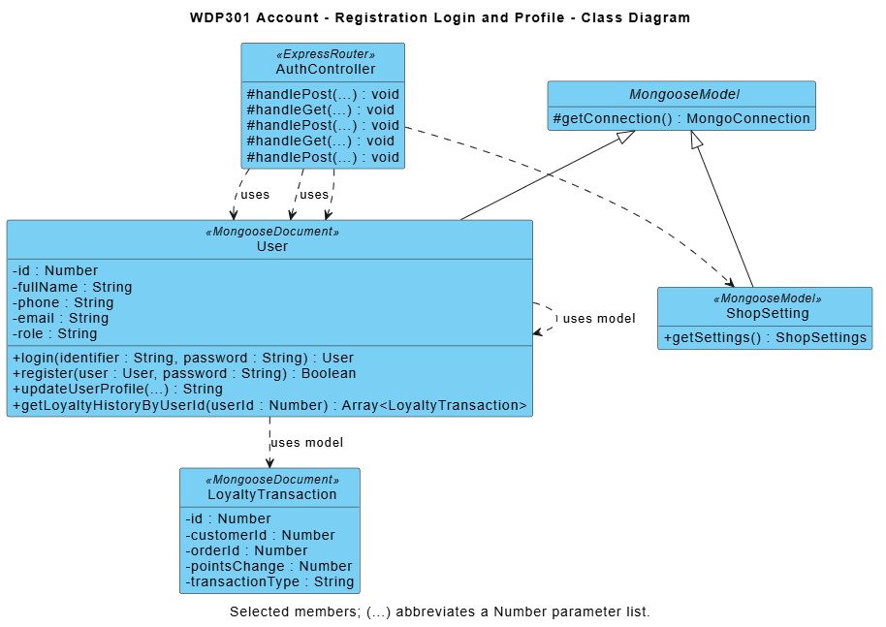

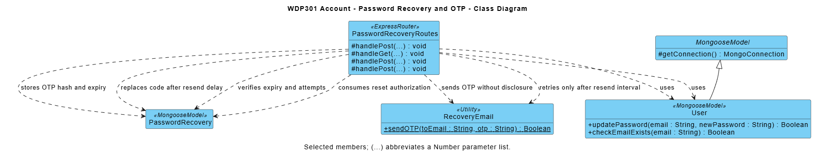

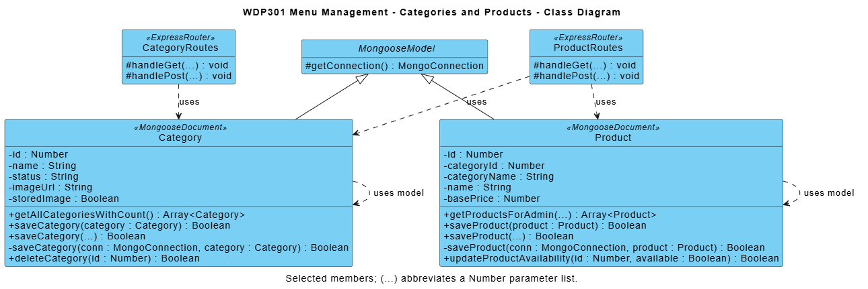

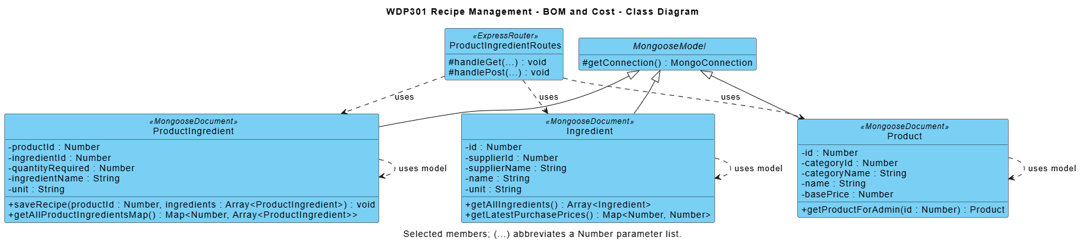

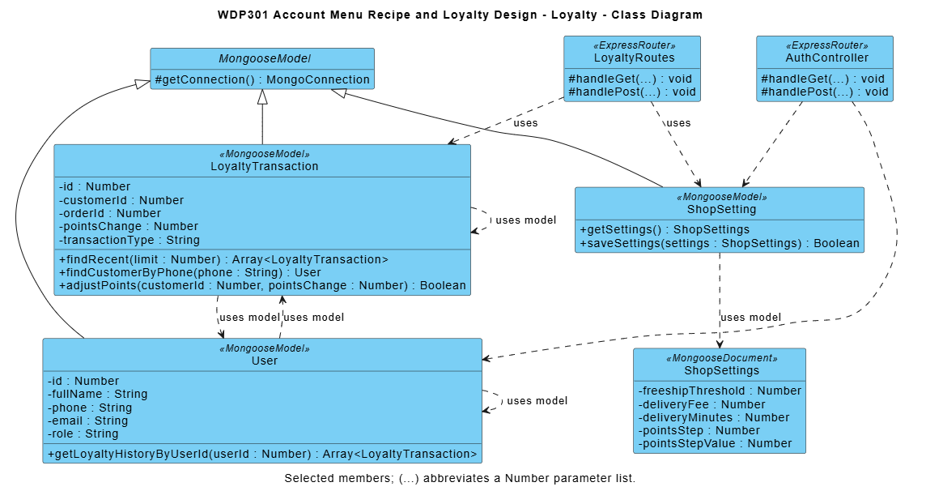

Module contract: React pages call Express JSON APIs; routers enforce access/validation and use shared business utilities and Mongoose models. Diagram methods are logical responsibilities, not private function names. Listed source paths identify primary modules; internal refactoring preserves public behavior and acceptance criteria.

6.2 Register Log In and Maintain Profile
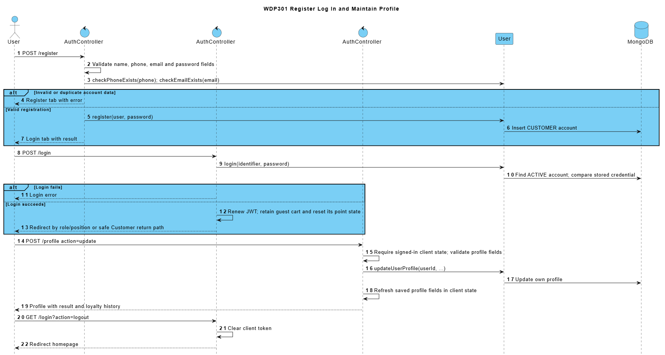

6.3 Recover Password with Email OTP
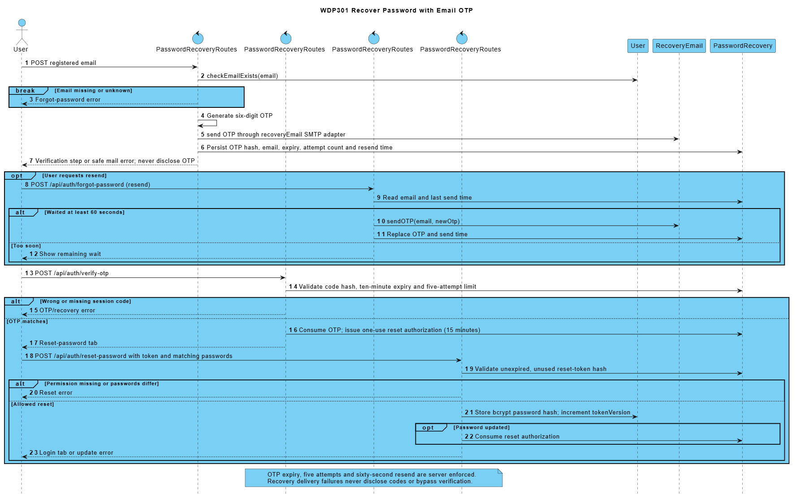

6.4 Publish Menu Data and Save a Recipe
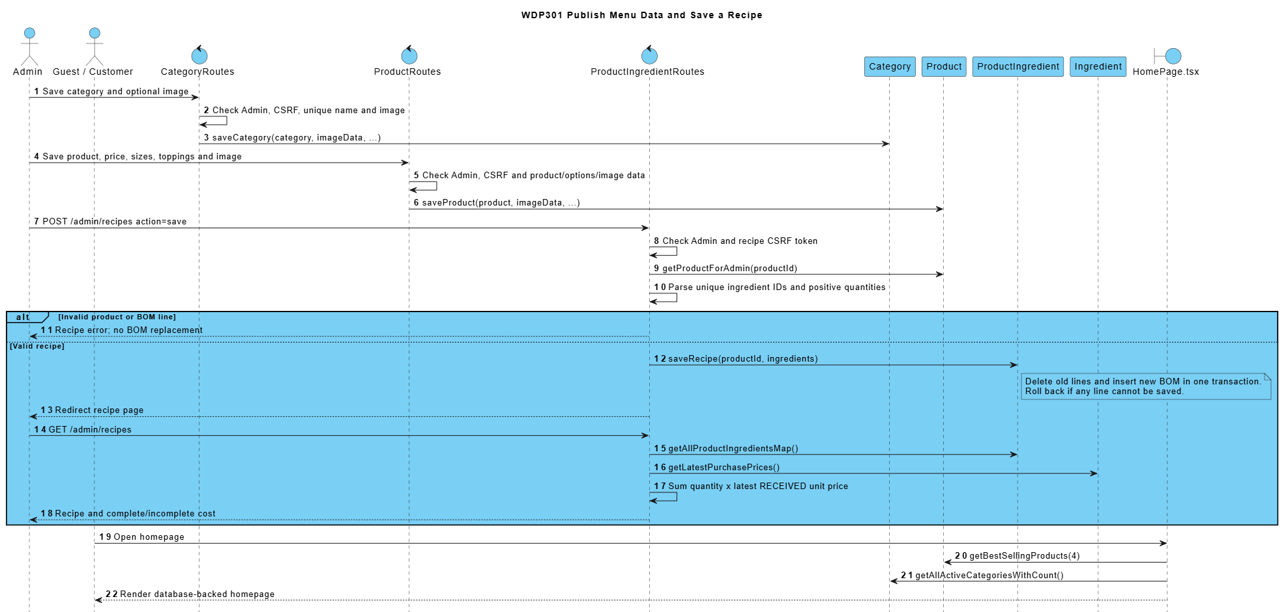

6.5 Look Up Customer Update Rules and Adjust Points
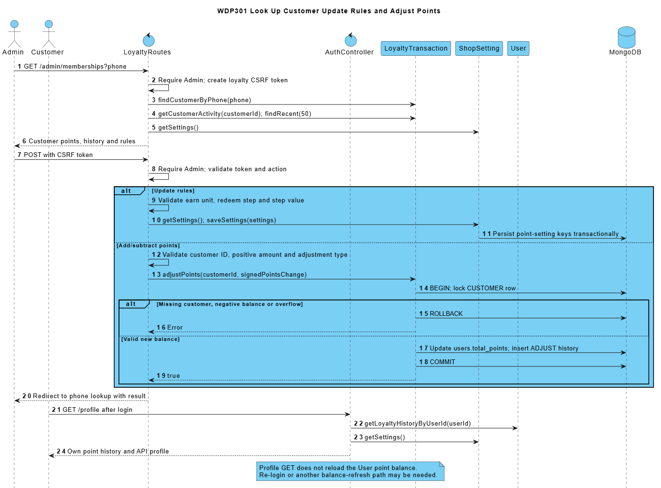

7. Scheduling Attendance and Handover Design (Sơn)
SRS trace: BF-06, BF-07; UC55-UC60, UC69, UC73. Requirement sections: I.2.6-I.2.7; II.3.2.1; II.8.2.
Admin assigns active employees to shifts of the matching week, records attendance and check-in cash, and reviews the Cashier shift report. Cashier submits counted cash, sees the result and may resubmit an own rejected report.
WorkShift/WorkSchedule define weekly frames and own attendance. ShiftHandover closes an owned PRESENT shift and stores SUBMITTED cash reconciliation atomically. Admin review and cashier resubmission are state-conditional and preserve every explanation/review in history.

7.1 Class Diagrams
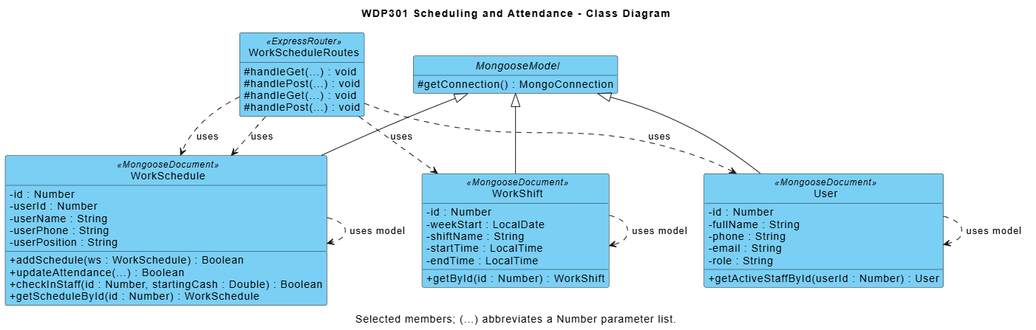

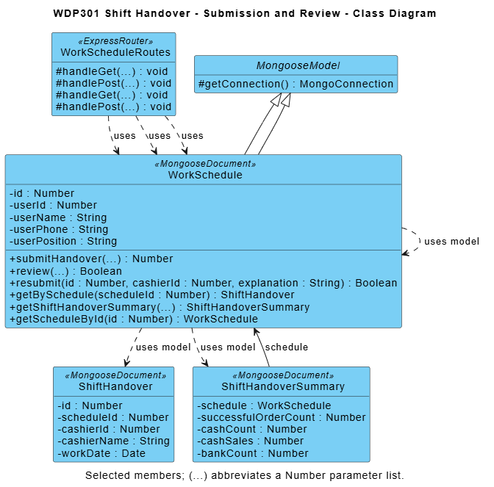

Module contract: React pages call Express JSON APIs; routers enforce access/validation and use shared business utilities and Mongoose models. Diagram methods are logical responsibilities, not private function names. Listed source paths identify primary modules; internal refactoring preserves public behavior and acceptance criteria.

7.2 Assign Work Schedule and Record Attendance
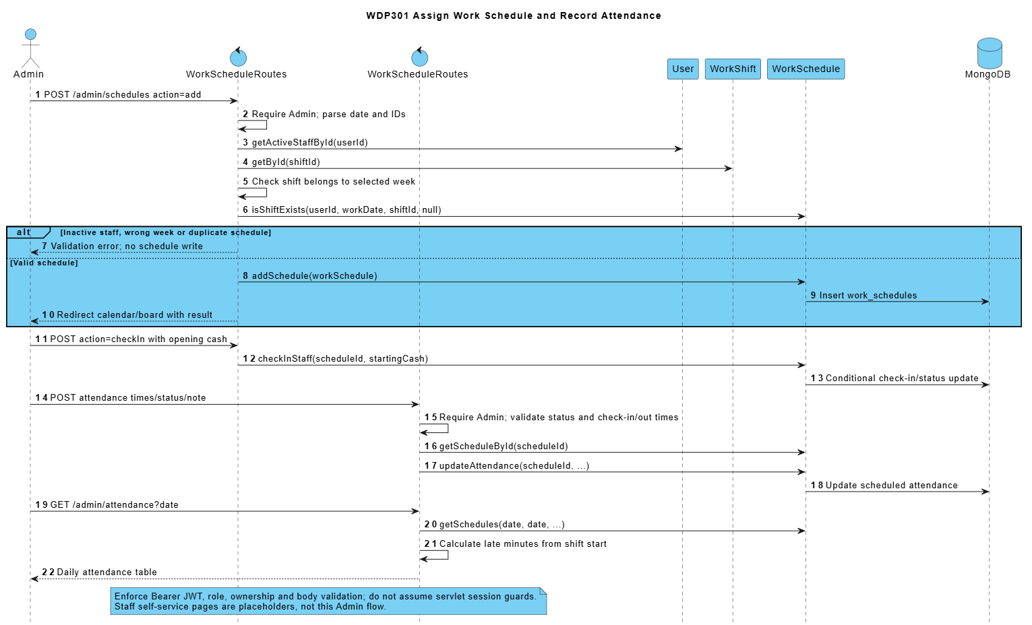

7.3 Close Review and Resubmit Shift Handover
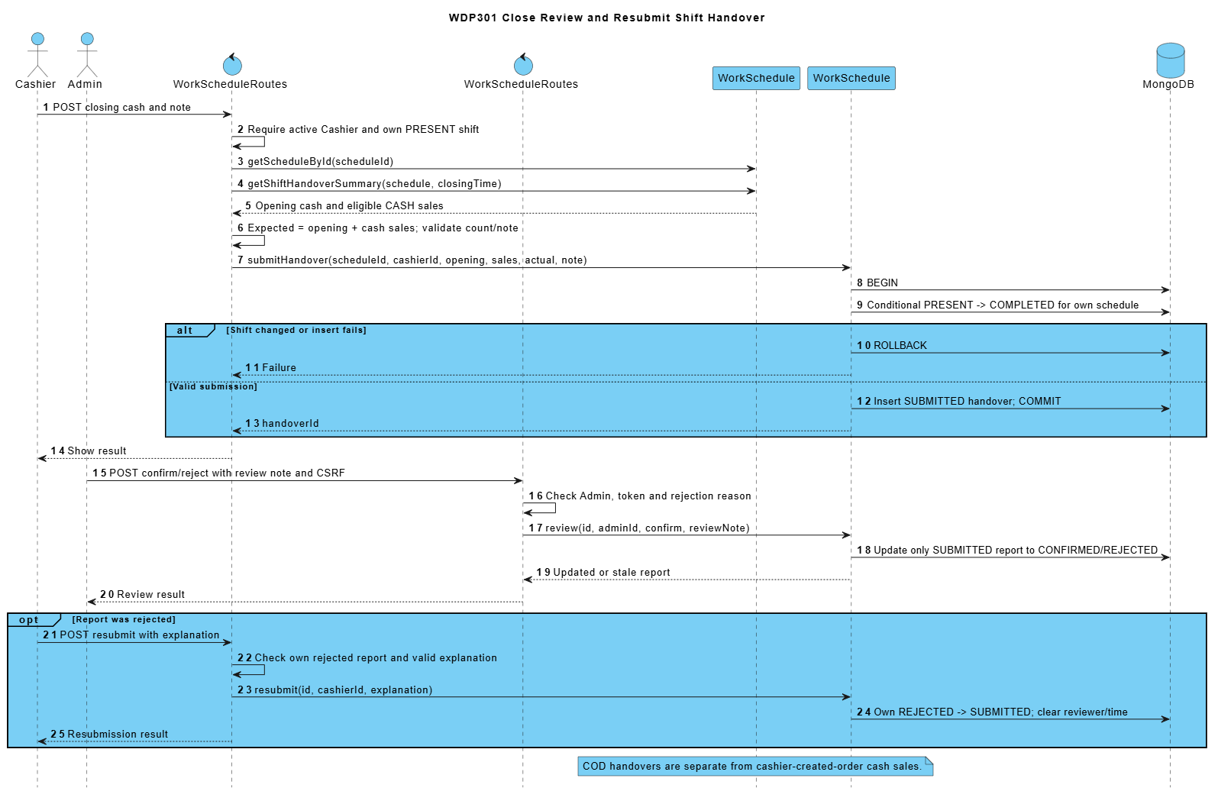

8. Order Oversight Reports and Settings Design (Mạnh)
SRS trace: BF-13, BF-14; UC14, UC61, UC66-UC68. Requirement sections: I.2.13-I.2.14; II.9.1-II.9.3; II.10.1.1.
Admin reviews orders with items, payments and delivery information, manages customers, loads period reports and persists shop settings. Report periods are validated before querying the report DAO.
Revenue, type sales and top products use matched SUCCESS payments by paidAt, excluding cancelled orders. Order counts use Order.createdAt; actual ingredient usage uses OUT_ORDER.createdAt. Vietnam calendar boundaries apply. Product totals are not net profit.

8.1 Class Diagrams
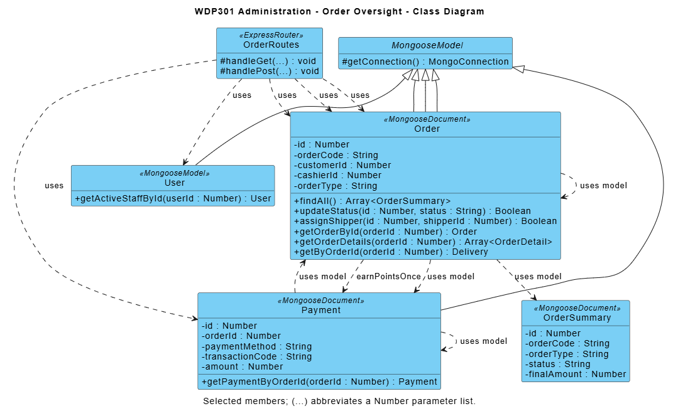

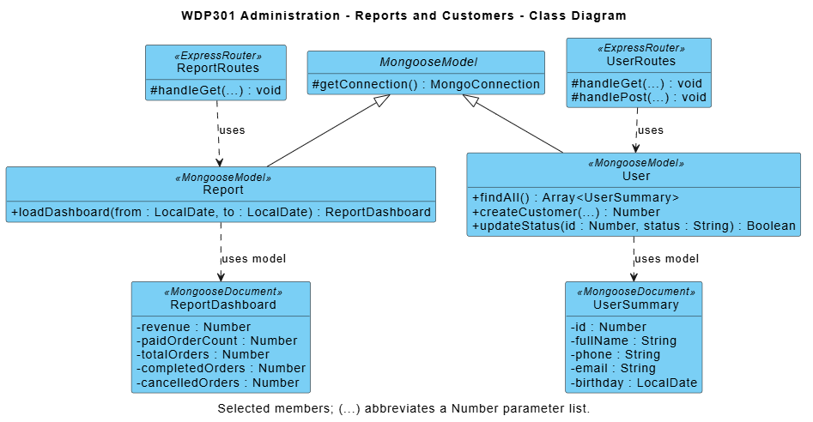

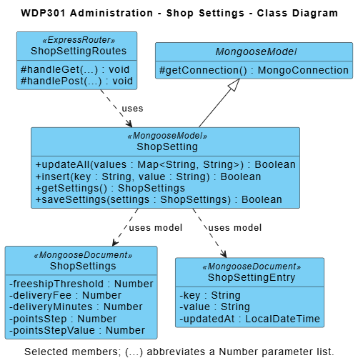

Module contract: React pages call Express JSON APIs; routers enforce access/validation and use shared business utilities and Mongoose models. Diagram methods are logical responsibilities, not private function names. Listed source paths identify primary modules; internal refactoring preserves public behavior and acceptance criteria.

8.2 Review Reports and Follow Up Orders or Customers
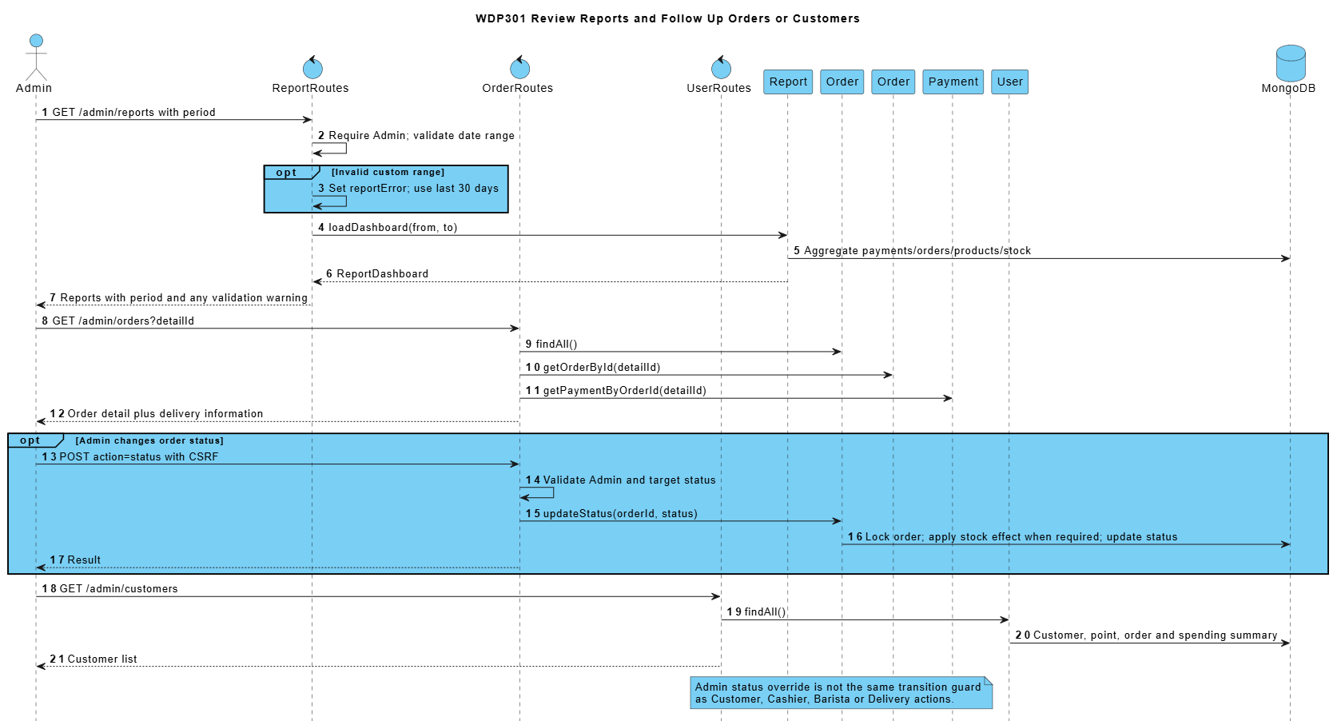

8.3 Load and Persist Shop Settings
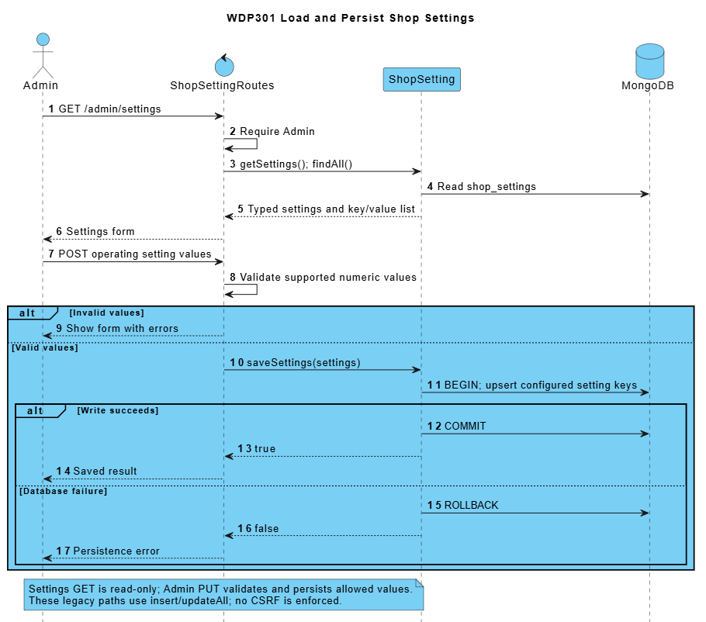

9. Counter Ordering and Payment (Mạnh)
SRS trace: BF-05; UC14, UC18-UC22, UC62, UC64. Requirement sections: I.2.5; II.3.1.
Cashier builds a DINE_IN or TAKEAWAY order, identifies an optional member, applies valid points and accepts cash or creates a bank-transfer payment. Counter list and Bill display the saved order. After Barista preparation, Cashier hands over a READY order.
Prices and totals are recalculated on the server rather than trusted from JSON. CASH confirmation and earning occur in createCounterOrder. BANK_TRANSFER remains pending outside test mode. The POS controller contains a local signed test callback but does not register the order with the external gateway; production POS bank integration is not demonstrated by that simulation.

9.1 Class Diagrams
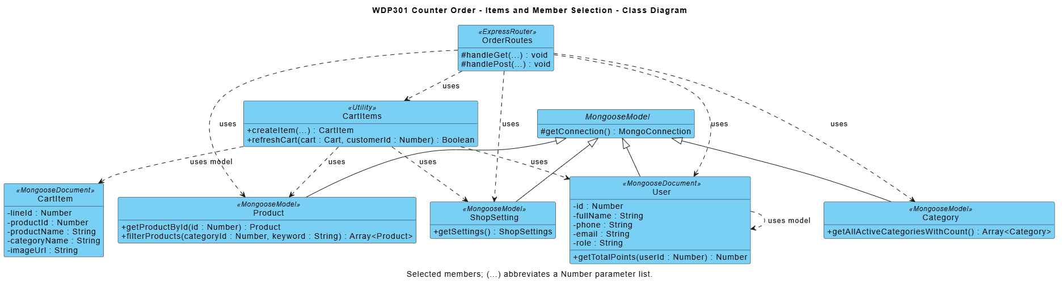

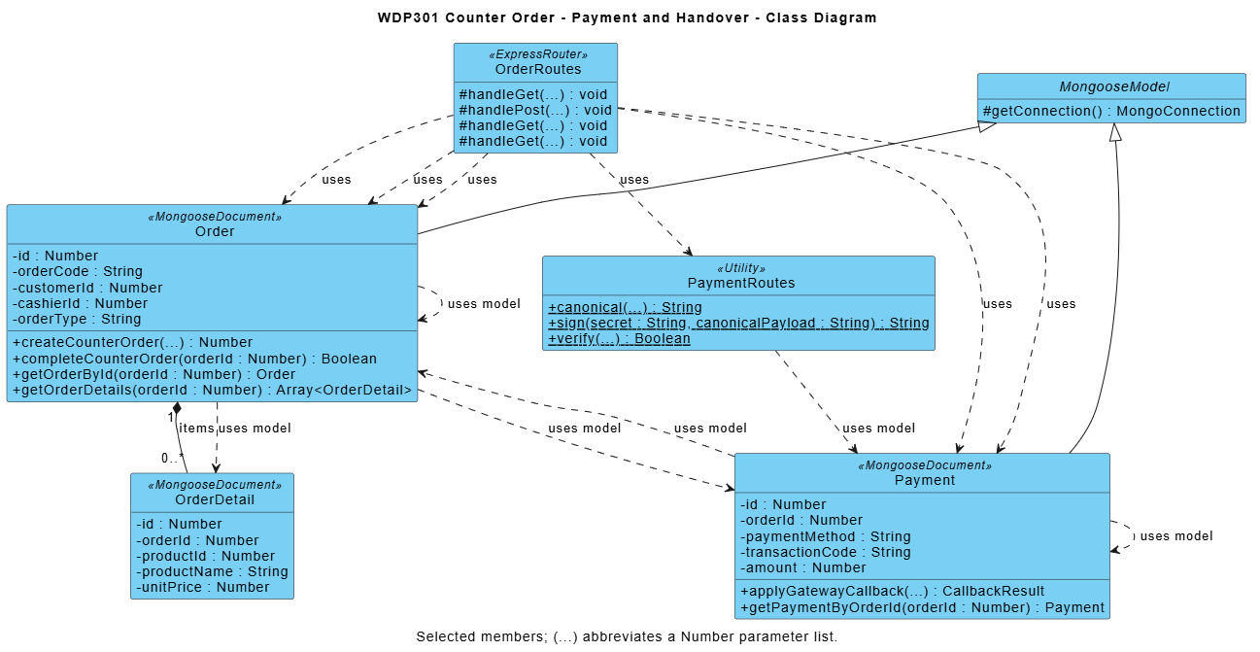

Module contract: React pages call Express JSON APIs; routers enforce access/validation and use shared business utilities and Mongoose models. Diagram methods are logical responsibilities, not private function names. Listed source paths identify primary modules; internal refactoring preserves public behavior and acceptance criteria.

9.2 Create Pay Prepare and Hand Over a Counter Order
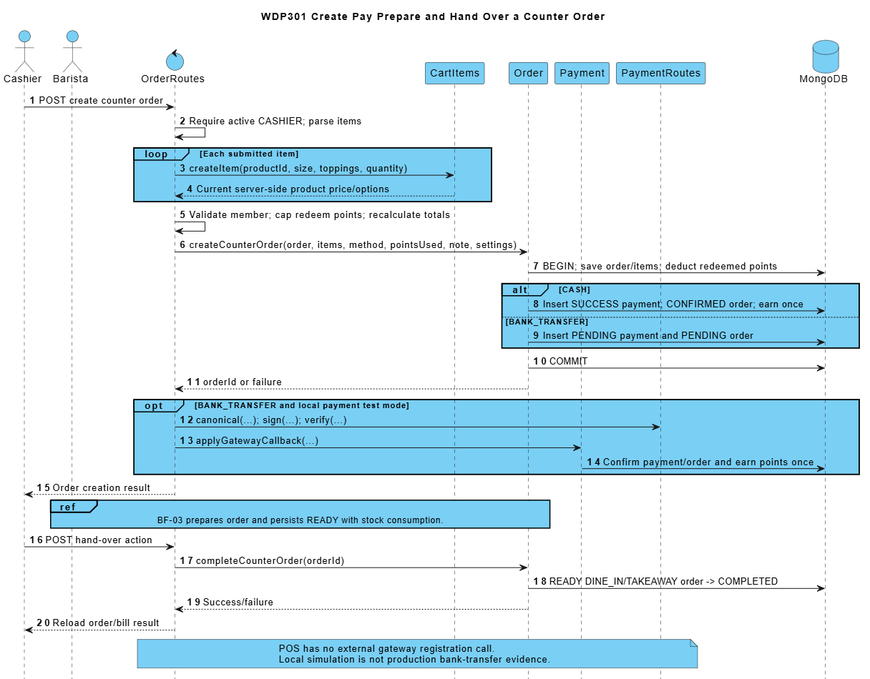

10. Employee and Weekly Shift Setup (Sơn)
SRS trace: BF-15; UC54-UC55. Requirement sections: I.2.15; II.8.1.
Admin creates and updates employees, locks or unlocks eligible accounts, and defines the shifts of a selected week. An empty week may copy the latest earlier week. These saved records are inputs to scheduling and attendance.
Employee forms validate phone/email uniqueness, role/position and password conditions. The current Admin cannot downgrade or lock their own account. Weekly shifts reject invalid hours, duplicate names and overlap; past weeks are not editable, and a shift referenced by a schedule cannot be deleted.

10.1 Class Diagram
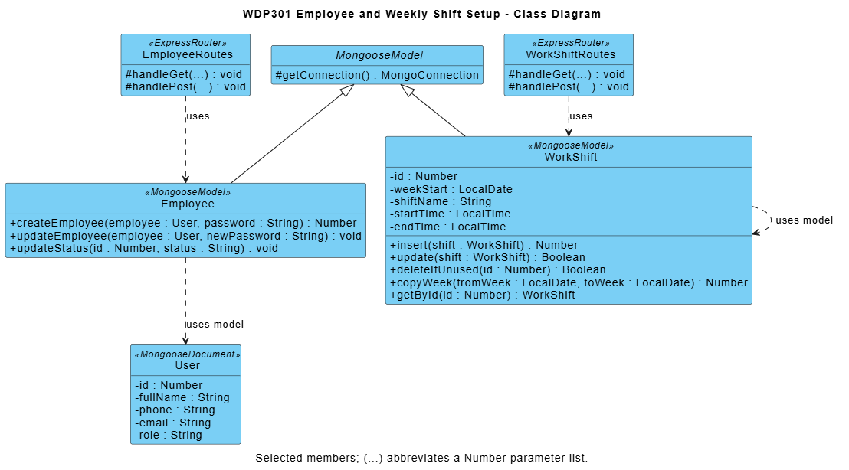

Module contract: React pages call Express JSON APIs; routers enforce access/validation and use shared business utilities and Mongoose models. Diagram methods are logical responsibilities, not private function names. Listed source paths identify primary modules; internal refactoring preserves public behavior and acceptance criteria.

10.2 Prepare Employee Accounts and Weekly Shifts
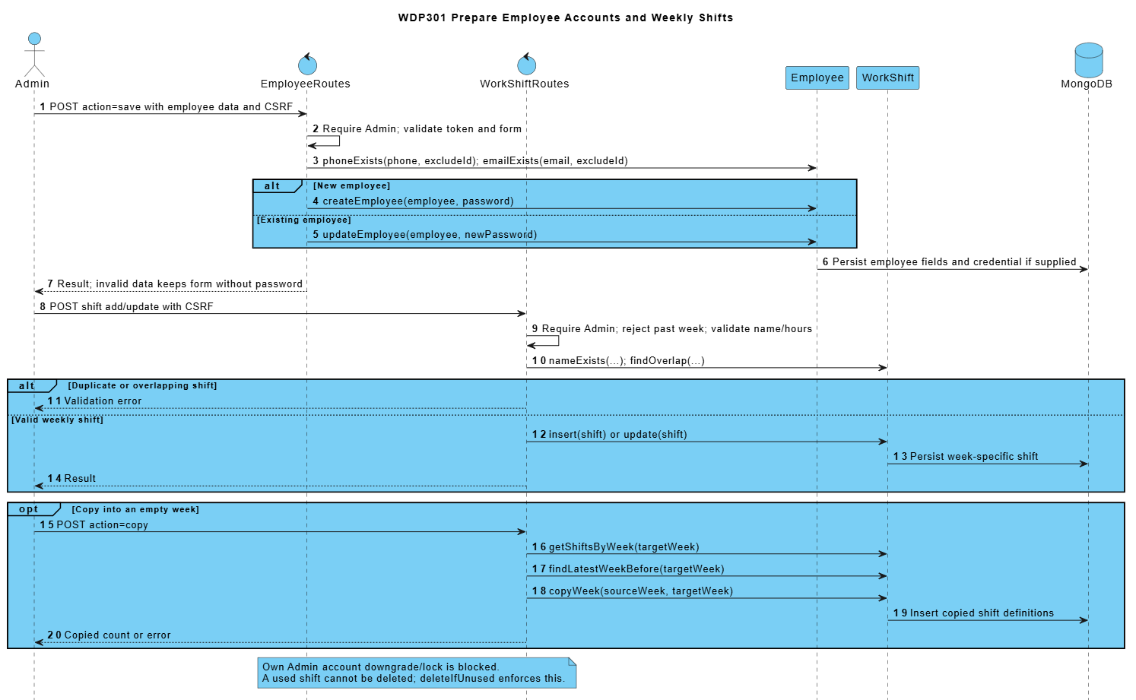

3. Other Design Specifications

1. State and Business Rules
Entity | Main transition path | Guard and implementation qualification
Online order | PENDING -> CONFIRMED -> READY -> DELIVERING -> COMPLETED | CONFIRMED follows verified bank payment or COD selection. PREPARING and item flags are persisted; entering preparation consumes stock once. Only an owned unpaid PENDING order may be cancelled by its customer; authorized overrides still enforce state/accounting guards.
Counter order | PENDING/CONFIRMED -> READY -> COMPLETED | Counter lifecycle: create, authorized payment confirmation, preparation, READY and customer handover. Successful payment is required before preparation/final handover; counter CASH/BANK_TRANSFER confirmation is not an online provider callback.
Payment | PENDING -> SUCCESS or FAILED | Signed callback checks payment reference and amount; repeat SUCCESS returns an idempotent result. COD earns only after successful collection.
Delivery | ASSIGNED -> ACCEPTED -> DELIVERING -> DELIVERED | Own assigned active shipper; READY order required for pickup; exact COD required for delivery completion. Reassignment is blocked after pickup.
Work schedule | SCHEDULED -> PRESENT -> COMPLETED, or ABSENT | WorkShift fixes weekly frames and WorkSchedule fixes assignments/check-in/check-out. Preserve historical shift definitions and own attendance permissions; close a PRESENT cashier shift together with its submitted reconciliation.
Shift handover | SUBMITTED -> CONFIRMED or REJECTED; REJECTED -> SUBMITTED | ShiftHandover: SUBMITTED -> CONFIRMED or REJECTED; only its cashier can explain and resubmit REJECTED -> SUBMITTED. One report per schedule; preserve review/resubmission history and state-guard concurrent requests.
Restock request | DRAFT -> PENDING_APPROVAL -> APPROVED/REJECTED | RestockRequest: DRAFT -> PENDING_APPROVAL -> APPROVED or REJECTED; permitted draft/pending cancellation follows SRS. Approval is required before a linked purchase; request transitions never directly increase stock.
Purchase order | DRAFT -> ORDERED -> RECEIVED | DRAFT/ORDERED may be cancelled. Only ORDERED can be received; receiving commits stock and movement records atomically.
Feedback | PENDING -> IN_PROGRESS -> RESOLVED/REJECTED | One review per owned eligible order; statuses PENDING/IN_PROGRESS/RESOLVED/REJECTED. Terminal tickets cannot be reopened, edited or deleted through the standard API.

2. Algorithms and Calculations
Calculation | Rule | Important boundary
Product line price | Base price + selected size surcharge + selected topping prices; multiply by quantity. | Prices/options are rebuilt from current product data before order persistence. Order lines store a historical snapshot.
Redeem discount | floor(pointsUsed / pointsStep) x pointsStepValue. | Redeem is capped by the customer balance and goods subtotal; guests/non-members cannot spend another customer balance.
Earn points | floor((goods total - discount) / pointsEarnUnit). | Shipping is excluded. Bank/CASH success earns once; COD earns on successful delivery collection.
Delivery fee | Delivery fee equals the selected active district fee when goods subtotal is below freeship_threshold, otherwise zero. Reject unknown/inactive areas and store the final address, district and fee snapshot on the order. | DeliveryAreaRoutes/AdminDeliveryAreasPage manage districts and rates. Public GET is read-only; explicit authorized setup is separate. Configuration changes do not reprice accepted orders.
Recipe cost | Recipe cost is the sum of consumed ingredient quantities multiplied by FIFO lot costs. Freeze per-order allocations at consumption; later purchases or recipe edits do not reprice historical orders. | Later receipts or recipe edits do not reprice consumed order snapshots. Missing costs remain unknown, not zero. The source latest-price estimate is distinguishable from this actual FIFO valuation.
Ingredient consumption | Aggregate BOM quantity x ordered quantity by ingredient. | Size/topping-specific BOM scaling is not implemented by this formula. No stock reservation occurs at checkout.
Shift expected cash | Expected cash = opening cash + attributed counter CASH receipts + COD physically confirmed by the cashier - CASH refunds issued from this shift. Preserve the original receipt even if later refunded through BANK_TRANSFER. Save the reconciliation snapshot atomically; require a reason for a difference. | BANK_TRANSFER is excluded from drawer receipts. Add COD only after the receiving cashier confirms physical receipt, once, through codReceivingSchedule; subtract CASH refunds attributed by refundSchedule. Difference = actual cash - expected cash.
Reports | Revenue, type sales and top products use matched SUCCESS payments by paidAt, excluding cancelled orders. Order counts use Order.createdAt; actual ingredient usage uses OUT_ORDER.createdAt. Vietnam calendar boundaries apply. Product totals are not net profit. | Range is [from 00:00, day after to 00:00). Low stock is current, not historical. Product totals use snapshots and are not net revenue/profit.

3. Transactions and Concurrency
Use transaction sessions for critical multi-document writes, with unique indexes, conditional states and idempotency keys. Every nested query/save participates in the same session. Unsupported transaction infrastructure fails before mutation; in-process locks and compensation alone do not satisfy atomicity. Keep network calls outside retryable database transactions.
Operation | Atomic writes and guards | Source
Online placement | Validate first; transactionally replace only same-owner/session unpaid checkout, refund held points and create Order/items/Payment/REDEEM. Bind an idempotency key; errors leave the previous checkout unchanged. | Order.placeOrder
Payment callback | Verify signature/reference/amount, condition Payment/order state, apply SUCCESS and EARN/cart effects once in the transaction. Coordinate with cancellation through shared order state guards across processes. | Payment.applyGatewayCallback/earnPointsOnce
Preparation entry | Guard eligible order; consume FIFO ingredient lots and record OUT_ORDER movements once, then update the order preparation state. | Order.updateBaristaOrderStatus; InventoryTransaction.consumeOrder
Purchase receipt | Within one session, require ORDERED, increase stock/lots, record IN_PURCHASE and set RECEIVED exactly once; any failure aborts all writes. | PurchaseOrder.receiveIntoInventory
Manual adjustment | Locked ingredient + non-negative stock result + movement record/reason. | Ingredient.recordStockAdjustment
Loyalty adjustment | Within one transaction, condition the phone-identified CUSTOMER balance to remain non-negative and append the matching ADJUST ledger entry; no balance-only partial result is allowed. | LoyaltyTransaction.adjustPoints
Recipe replacement | Validate the full replacement first; transactionally replace BOM links and embedded recipe so neither representation becomes partial or inconsistent. | ProductIngredient.saveRecipe
Shift submission | The owning active cashier closes PRESENT -> COMPLETED, stores checkOutTime and the cash snapshot, and creates SUBMITTED ShiftHandover in one transaction. Preserve compatible historical completed schedules without inventing Admin approval. | WorkSchedule.submitHandover
Admin review/resubmit | Admin review requires SUBMITTED; cashier resubmission requires ownership and REJECTED. Conditional writes and append-only history prevent concurrent decisions or lost explanations; related schedule/report writes share a transaction. | WorkSchedule.review/resubmit
Delivery completion | Require the assigned active shipper and DELIVERING state; transactionally record exact COD SUCCESS, EARN once and COMPLETED. A retry does not collect, credit or complete twice. | Order.completeDelivery
Category/product images | Persist imageUrl metadata on the Category/Product document; source relational image tables are not separate MERN collections. | Category.saveCategory; Product.saveProduct

4. Security and Requirement Alignment
Protected WDP301 JSON endpoints use JWT middleware and current account checks. The following controls define the MERN security boundary and replace observations about the SWP servlet implementation.
Area | Required control | Documentation boundary
Authentication and password storage | authController stores bcrypt password hashes, normalizes login identifiers and returns a JWT after credential and active-account checks. | Never include password hashes, database secrets or real credentials in API responses or design examples.
OTP recovery | RecoveryRoutes validate email/OTP/reset authorization and enforce expiry, attempts and resend interval; successful reset consumes authorization and revokes earlier login tokens. | Never disclose OTP/reset tokens in API errors or logs. Missing SMTP is an explicit delivery/configuration failure, never a verification bypass.
Endpoint authorization | protect middleware checks the current account; route guards check role, position and ownership for the requested operation. | Check authorization on the server for every protected request; hiding a React button is insufficient.
CSRF coverage | Client requests authenticate with an explicit Bearer JWT; the API does not use an ambient login-session cookie for protected writes. | Validate request bodies, origin/CORS configuration and safe redirects; do not describe a servlet CSRF filter.
Settings writes | GET reads settings; authenticated Admin PUT validates and persists configuration. | State changes must not be implemented as GET navigation or client-only updates.
Feedback privacy | Customers read their own reviews and submit once per owned order; Admin responds and views reports. Staff/guests do not receive unrestricted ticket access. | Closed tickets are immutable under the standard response/delete routes; record respondent and response time.
Online callback UI | PaymentPage registers through the backend and reads stored payment/order status. Only the signed provider callback confirms BANK_TRANSFER; owner-authorized demo applies only to DEMO_ONLINE when enabled. | Test the HTTP callback result plus stored order/payment state, not only the displayed screen.
Counter payment confirmation | An on-shift cashier/manager explicitly confirms CASH receipt. BANK_TRANSFER is confirmed only by a valid signed provider callback with matching amount and transaction. Manual references and QR display cannot settle a bank payment. | Local simulation and manual transaction references do not demonstrate a live bank webhook integration.
Category publication | Category ACTIVE tabs and product availability are read by separate public queries. | Every public catalog view must exclude unavailable products and products belonging to inactive categories; validate eligibility again on add/checkout.
Profile point refresh | Profile and loyalty views reload current User/ledger data from the API; balance changes are stored on the User identified by unique phone. | Points are linked to the unique Customer phone number. WDP301 has no card levels, automatic promotions, level multipliers or level discounts.
Cash reconciliation | BANK_TRANSFER is excluded from drawer receipts. Add COD only after the receiving cashier confirms physical receipt, once, through codReceivingSchedule; subtract CASH refunds attributed by refundSchedule. Difference = actual cash - expected cash. | BANK_TRANSFER is excluded from drawer receipts. Add COD only after the receiving cashier confirms physical receipt, once, through codReceivingSchedule; subtract CASH refunds attributed by refundSchedule. Difference = actual cash - expected cash.
Admin order override | Order routes apply explicit role, position, ownership and state validation, including stock and payment eligibility. | Admin permissions do not bypass invalid amounts, missing references or the terminal order state guards.
Unused and placeholder code | Staff schedule/attendance are served by workScheduleRoutes. React provides the active KdsTerminal and DeliveryScreen components. | Retained source sections describe business capabilities; they do not imply that servlet placeholder files are part of the MERN project.
Data/transport configuration | MONGO_URI and JWT_SECRET are environment settings. Configure HTTPS, CORS and protected secret storage for deployment. | Never copy production credentials into documents, client bundles or test fixtures.

5. Deployment and Integrations
Install backend/frontend dependencies from their manifests. Configure MONGO_URI and JWT_SECRET for the Express server; configure VITE_API_URL for the React client. Build the client with Vite and run the API on Node.js. Initialize sample data only in an explicitly selected development database.
Build the React/Vite client and run the Node.js/Express API with deployment-specific environment settings. React Router owns client navigation; protected JSON calls use JWT middleware.
PAYMENT_DEMO_ENABLED gates isolated DEMO_ONLINE. Configure PAYMENT_GATEWAY_URL, PAYMENT_CALLBACK_SECRET and bank/account variables for provider registration and HMAC callback. SMTP_* configures recovery delivery. Acceptance must test each configured provider without exposing secrets.
Business updates are request-driven. Preparation, payment and order states are persisted in MongoDB; no in-memory-only preparation state is described as durable. The release does not require a scheduled background job.

6. Route and Source Traceability
Controller | URL mappings | Module responsibility / acceptance boundary
WorkScheduleRoutes | /admin/attendance | Required contract; verify access, state and stored effects.
CategoryRoutes | /admin/categories | Required contract; verify access, state and stored effects.
ReportRoutes | /admin | frontend/src/pages/admin/AdminDashboardPage.tsx; authenticated Admin navigation and summaries; reports use the separately defined reporting contract.
UserRoutes | /admin/customers | Required contract; verify access, state and stored effects.
DeliveryAreaRoutes | /admin/delivery-areas | backend/routes/deliveryAreaRoutes.js; models/DeliveryArea.js; frontend/src/pages/admin/AdminDeliveryAreasPage.tsx; district/fee eligibility contract.
EmployeeRoutes | /admin/employees | Required contract; verify access, state and stored effects.
ReviewRoutes | /admin/complaints | Required contract; verify access, state and stored effects.
ShiftHandoverRoutes | /cashier/handover | backend/routes/shiftHandoverRoutes.js; models/ShiftHandover.js; close/review/resubmit contract with state/ownership/atomicity checks.
IngredientRoutes | /admin/inventory | Required contract; verify access, state and stored effects.
InventoryTransactionRoutes | /admin/inventory | Required contract; verify access, state and stored effects.
LoyaltyRoutes | /admin/memberships | Required contract; verify access, state and stored effects.
OrderRoutes | /admin/orders | Required contract; verify access, state and stored effects.
ProductRoutes | /admin/products | Required contract; verify access, state and stored effects.
PurchaseOrderRoutes | /admin/purchases | Required contract; verify access, state and stored effects.
ProductIngredientRoutes | /admin/recipes; /api/product-ingredients/product/:id | Required contract; verify access, state and stored effects.
ReportRoutes | /admin/reports | Required contract; verify access, state and stored effects.
PurchaseOrderRoutes | /admin/restock | Required contract; verify access, state and stored effects.
WorkScheduleRoutes | /admin/schedules | Required contract; verify access, state and stored effects.
ShopSettingRoutes | /admin/settings | Required contract; verify access, state and stored effects.
WorkShiftRoutes | /admin/shifts | Required contract; verify access, state and stored effects.
SupplierRoutes | /admin/suppliers | Required contract; verify access, state and stored effects.
AuthController | /login; /register; /api/auth/login; /api/auth/register | backend/controllers/authController.js; role/identity validation and safe post-login navigation.
OrderRoutes | /barista; /api/orders | Required contract; verify access, state and stored effects.
OrderRoutes | /bill | Required contract; verify access, state and stored effects.
CartRoutes | /cart; /api/cart | Required contract; verify access, state and stored effects.
ShiftHandoverRoutes | /cashier/handover | frontend/src/pages/pos/PosHandoverPage.tsx; frontend/src/pages/admin/AdminHandoversPage.tsx; submitted/reviewed report lifecycle.
CategoryRoutes | Category.imageUrl via /api/categories | Category image metadata/data URL; no separate legacy /category-image endpoint is required.
OrderRoutes | /checkout | Required contract; verify access, state and stored effects.
OrderRoutes | /cashier; /api/orders | Required contract; verify access, state and stored effects.
OrderRoutes | /cashier/orders | Required contract; verify access, state and stored effects.
UserRoutes | /profile; /api/users/customers | Own profile and Admin customer management remain separate permissions; no legacy /customer screen is required.
OrderRoutes | /delivery | Required contract; verify access, state and stored effects.
ReviewRoutes | /feedback | Required contract; verify access, state and stored effects.
PasswordRecoveryRoutes | /forgot-password; /api/auth/forgot-password | backend/routes/passwordRecoveryRoutes.js; frontend/src/components/PasswordRecoveryForm.tsx; OTP request and rate-limited resend.
AuthController | /login | Required contract; verify access, state and stored effects.
ProductRoutes | /menu | Required contract; verify access, state and stored effects.
OrderRoutes | /orders | Required contract; verify access, state and stored effects.
PaymentRoutes | /payment; /api/payments/callback; /api/payments/order/:orderId; /api/payments/:id/demo-confirm | backend/routes/paymentRoutes.js; utils/paymentGateway.js; frontend/src/pages/PaymentPage.tsx; signed provider callback separated from demo/COD.
ProductRoutes | /products/:id | Required contract; verify access, state and stored effects.
ProductRoutes | Product.imageUrl via /api/products | Product image metadata/data URL; no separate legacy /product-image endpoint is required.
AuthController | /profile | Required contract; verify access, state and stored effects.
AuthController | /register | Required contract; verify access, state and stored effects.
PasswordRecoveryRoutes | /api/auth/forgot-password (resend) | Same recovery request endpoint; minimum sixty-second resend interval and invalidation of the old code.
PasswordRecoveryRoutes | /api/auth/reset-password | One-use reset token, matching passwords, bcrypt storage and tokenVersion revocation.
WorkScheduleRoutes | /my-schedule; /api/work-schedules | Own-schedule reads; Admin weekly assignment writes; enforce ownership and historical frame rules.
WorkScheduleRoutes | /my-attendance; /api/work-schedules | Own check-in/check-out with schedule/time constraints; cashier close follows ShiftHandover transaction boundary.
WorkScheduleRoutes | /my-schedule; /my-attendance | frontend/src/pages employee schedule/attendance screens; WorkScheduleRoutes owns persisted assignments and attendance.
PasswordRecoveryRoutes | /api/auth/verify-otp | Verify hashed OTP, expiry and attempts; issue a one-use expiring reset token without exposing stored secrets.

Implementation revision - 11 November 2026
Baseline: develop f560f68; branch fix/manh-report-workflow-audit. This revision describes the working-tree implementation and automated verification. Earlier dated release test records remain historical. The 30 formal acceptance cases and group approval remain separate.

MongoDB persistence
MongoDB with Mongoose is the only application database. A replica set or Atlas is required for multi-document transactions. Database.docx replaces the unrelated MySQL salon document and lists all 26 actual collections, ObjectId references and schema constraints. Earlier entity tables and diagrams are conceptual views, not literal SQL DDL. Delivery is embedded as Order.delivery; DeliveryIssue, DeliveryArea, RestockRequest and ShiftHandover are implemented models. RestockRequestItem is embedded in request.items.

Mạnh - seven assigned screens
Counter POS (/cashier); counter orders (/cashier/orders); barista (/barista); delivery (/delivery, /delivery/problems, /delivery/cod); reports (/admin/reports); admin orders (/admin/orders); delivery fees (/admin/delivery-areas). The Excel tracking sheet records implementation Done with evidence, without implying group acceptance.

Counter and delivery corrections
POS preserves the chosen CASH or BANK_TRANSFER method, member/points and item customizations. Server prices are authoritative. CASH requires explicit receipt; BANK_TRANSFER requires a verified signed callback. A QR or browser return does not settle a payment.
Order.delivery persists ASSIGNED, ACCEPTED, DELIVERING, DELIVERED, RETURNED and CANCELLED, actor/shipper history and stage timestamps. Accept: POST /api/orders/:id/delivery/accept. Issues: POST /api/orders/:id/delivery/issues; list: GET /api/delivery-issues. Admin/manager see all; shipper sees their reported issues. Terminal retries are idempotent and cannot rewrite cancellation evidence.
Issue types: UNREACHABLE, BAD_ADDRESS, REFUSED, DAMAGED, DELAY, OTHER. REPORT records only; RETURN is allowed for READY/DELIVERING and unassigns; CANCEL rejects already-paid orders requiring the manager refund flow. Unfinished assigned deliveries block shipper checkout/remittance. COD completion validates both the actual amount and pending payment amount; admin confirmation attributes receipt to the shipper.

Cash reconciliation and reports
An open shipper remittance includes all unremitted COD held by that shipper, including amounts collected before the current check-in. Closed-shift views use remittanceSchedule to prevent duplicate inclusion.
Expected drawer cash = opening cash + actual attributed counter CASH receipts + confirmed incoming COD - CASH refunds issued by this cashier shift. CASH refund requires an active issuing cashier/manager and stores refundSchedule; a later bank refund does not erase the original cash receipt. Persist cashRefunds in the handover snapshot. Legacy refunds lacking an issuing shift require manual reconciliation; no historical data is invented.
Revenue, order-type sales and top products use paidAt on matching successful payments; order counts use createdAt. Ingredient usage comes from actual OUT_ORDER movements, not current recipes or estimated sales. Vietnam calendar boundaries and a maximum inclusive range of 366 days apply. Attention counts include pending restock requests and in-progress feedback. The dashboard is not a net-profit statement.

Verification and remaining acceptance
Full backend: 102/102 tests passed on isolated MongoDB replica-set databases. Frontend: 103/103 direct test cases passed across six files; production build passed. Browser smoke opened all seven assigned screens (nine URLs) using isolated fixtures without JavaScript page errors. Regression tests cover ownership, accept-before-pickup, immutable terminal orders, issue persistence/rollback, exact COD, cash refunds and Vietnam-day usage.
SMTP delivery and real bank settlement require deployment credentials and provider acceptance tests. Automated provider fixtures do not prove a real email delivery or money transfer. See ../WORKFLOW_AUDIT_2026-11-11.md for workflow coverage, commands and limitations. Keep the original source report folder unchanged.

