WDP301 - Aura Café | SRS | Revised 11 November 2026

II. Software Requirements Specification

1. Definition and Acronyms
Acronym / Term | Definition
CMS | Café Management System - the Aura Café web application described in this document
SRS | Software Requirement Specification
UC / BF | Use Case / Business Flow
ERD | Entity Relationship Diagram (Crow's Foot notation)
BOM | Bill of Materials - the recipe of a product: ingredient quantities for one portion
POS | Point of Sale - the Cashier counter-ordering screen
COD | Cash on Delivery - the customer pays cash to the delivery staff
OTP | One-Time Password - 6-digit code sent by e-mail to reset a password
CSRF | Cross-Site Request Forgery - mitigated by validated tokens in protected handlers; coverage is endpoint-specific
Payment authorization | Payment result validation - authenticate the requester, verify order ownership, compare the server-calculated amount and guard the current payment state.
VietQR | Vietnamese bank-transfer QR code standard (Napas 247)
VND / đ | Vietnamese đồng, the currency of all prices
DINE_IN / TAKEAWAY / ONLINE | Order types: eat at the café, take away from the counter, online delivery order
Aura point | Loyalty point of a Customer, identified by the customer's phone number
points_earn_unit / points_step / points_step_value | Loyalty settings: money spent for 1 point / points per redemption step / discount per step
Freeship threshold | Goods subtotal from which the delivery fee is 0 đ (setting freeship_threshold)
RR / PO | Restock Request / Purchase Order (displayed as RR-0001 / PO-0001)
Shipper | Database position code of the Delivery Staff actor
Admin | Administrator account (role ADMIN, position MANAGER, labelled "Quản trị")
Payment test mode | PAYMENT_DEMO_ENABLED enables the local payment simulation; COD remains pending until successful delivery collection.

2. Overall Requirements

1. Context Diagram
Aura Café Management System is a WDP301 web application using React with Vite, Node.js with Express and MongoDB through Mongoose. It supports online ordering, counter POS, preparation, delivery and administration of menu, recipes, inventory, purchasing, employees, weekly shifts, attendance, phone-based loyalty points, feedback and reports.
The context diagram below retains the system boundary and the information exchanges with Guest, Customer, Cashier, Barista, Delivery Staff, Admin and Payment Gateway. In the WDP301 release the payment-provider boundary is represented by local payment simulation and COD; a real provider integration is a separate deployment concern.
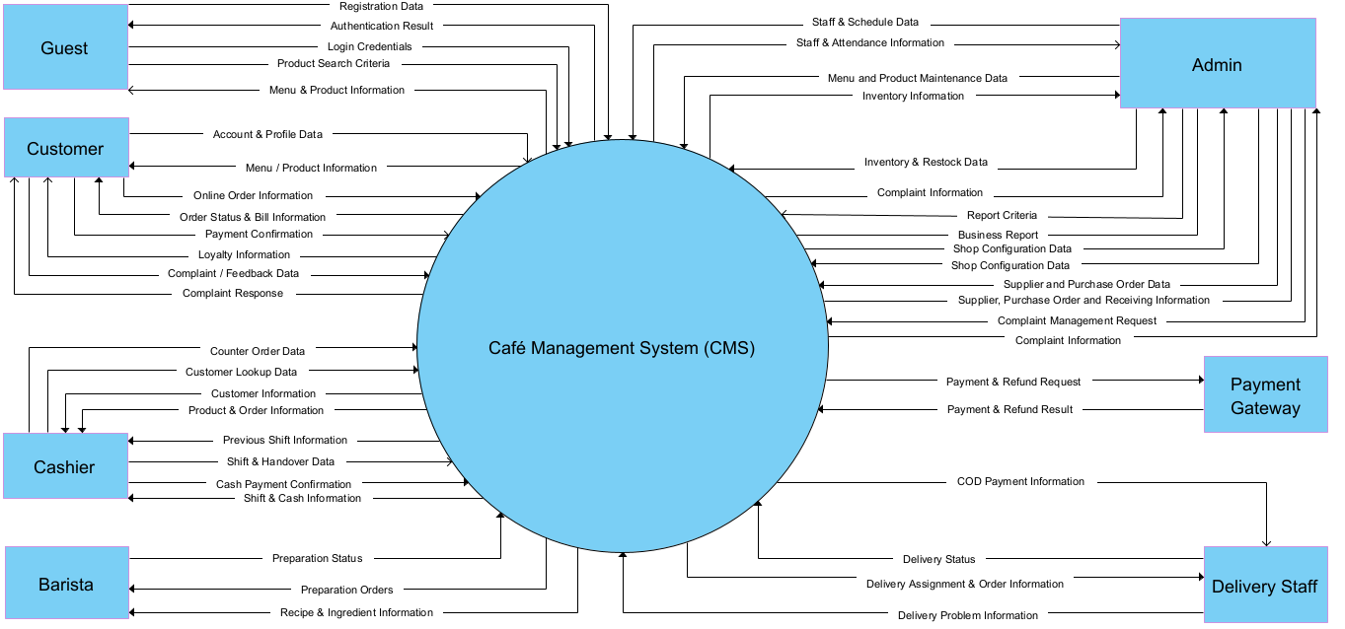
Figure 1 - Context diagram of the Café Management System

2. Main Business Flow
The baseline contains 15 business flows on React/Vite, Express and MongoDB. Screen ownership and workflow leadership remain separate. Requirements define required outcomes, not implementation completion. Internal code changes preserve these contracts; approved business/API changes require a versioned baseline update and linked acceptance evidence.

2.1 Online Ordering and Tracking (BF-01)
Workflow lead: Ngọc. Use cases: UC07-UC11, UC15-UC17, UC25, UC64. Screens: Menu; Product Detail; Shopping Cart; Checkout; My Orders.
Implementation references: Menu and Product Detail - Nguyên; Shopping Cart and Checkout - Ngọc; My Orders - Ngọc. Payment and Bill are covered by BF-02.
Trigger: Customer chooses products on the Menu or Product Details page.
End condition: The customer creates an ONLINE order and can track it, cancel it when eligible, or prepare a reorder. Payment is handled in BF-02.
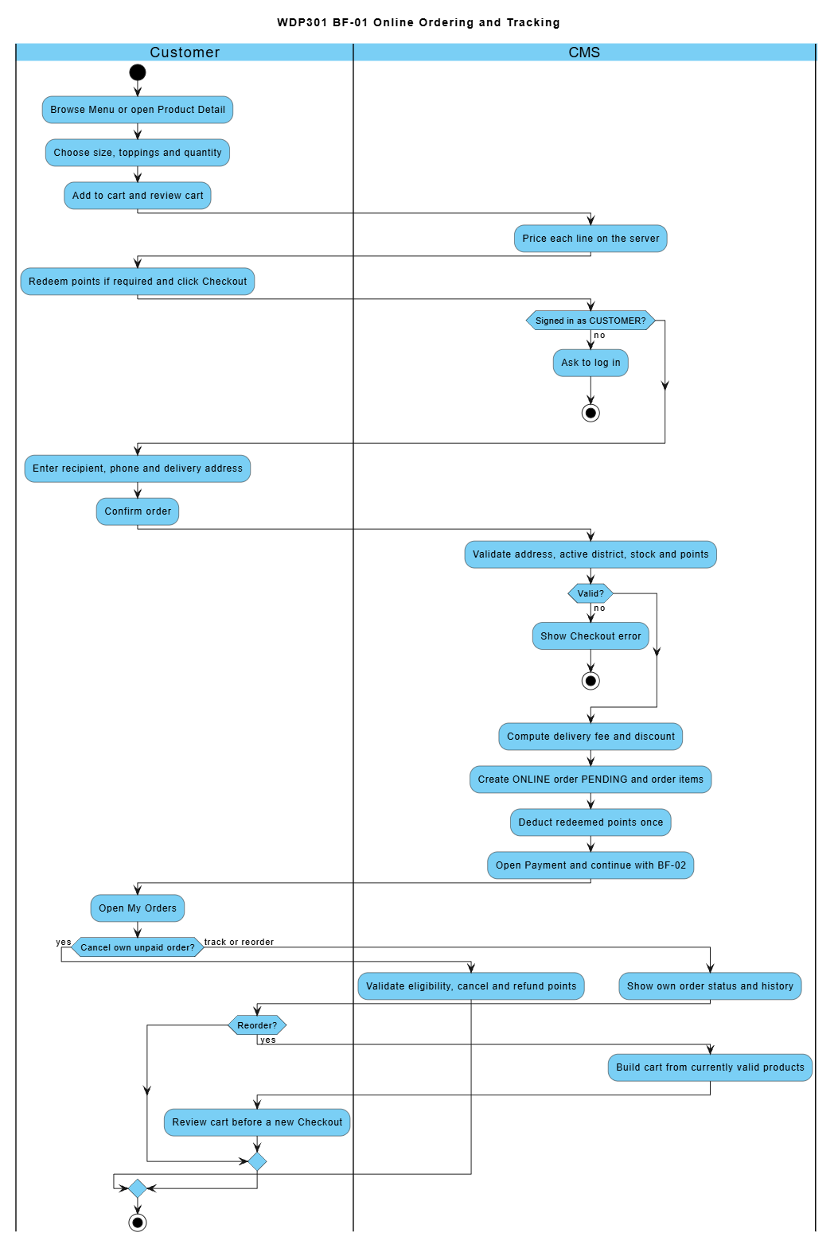

2.2 Online Payment (BF-02)
Workflow lead: Ngọc. Use cases: UC12-UC14, UC62, UC64. Screens: Payment; Bill.
Screen implementation: Payment and Bill - Ngọc. Workflow lead for online ordering and payment: Ngọc. The gateway is an external service, not an additional screen.
Trigger: Customer opens the Payment page of a PENDING order.
End condition: Order CONFIRMED (bank transfer verified or COD chosen), payment FAILED, or order CANCELLED with points refunded.
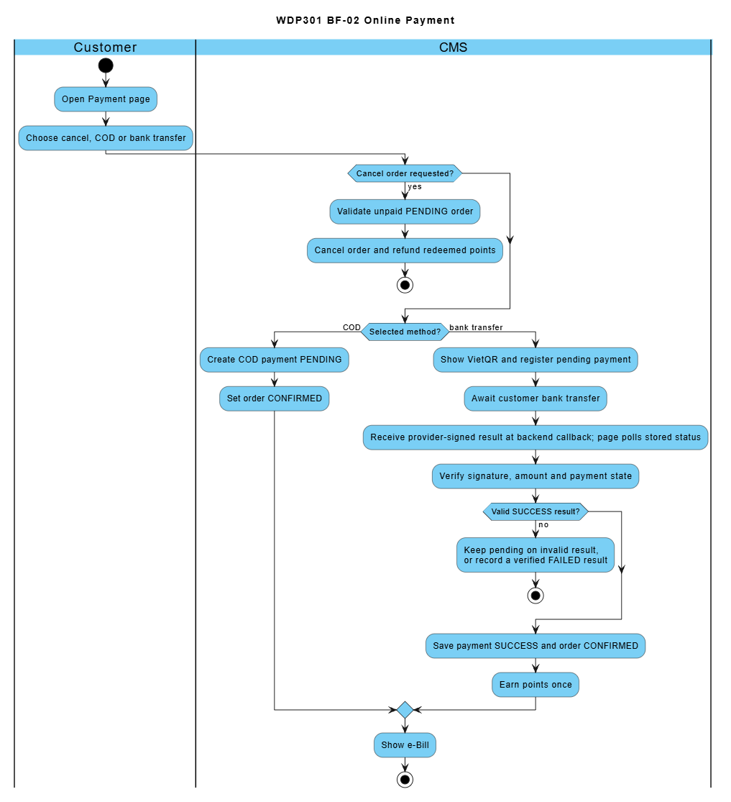

2.3 Order Preparation (BF-03)
Workflow lead: Mạnh. Use cases: UC23-UC24. Screens: Drink Preparation.
Trigger: Barista opens the Barista Dashboard.
End condition: The order is READY and its ingredients are deducted from stock.
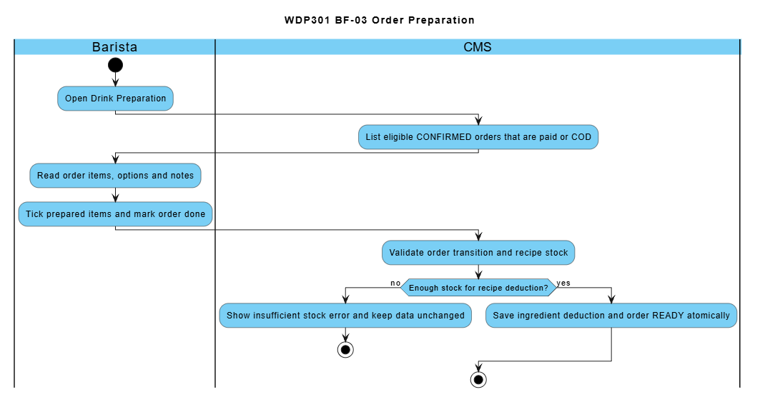

2.4 Order Delivery (BF-04)
Workflow lead: Mạnh. Use cases: UC26-UC30, UC71-UC72. Screens: Admin Orders; Delivery Management; Delivery Area Fees.
Screen implementation: Delivery Management, Delivery Area Fees, delivery assignment (UC72), and Admin Orders - Mạnh.
Trigger: Admin assigns a delivery staff to an ONLINE order.
End condition: The order is COMPLETED and the collected COD cash is handed over to a Cashier.
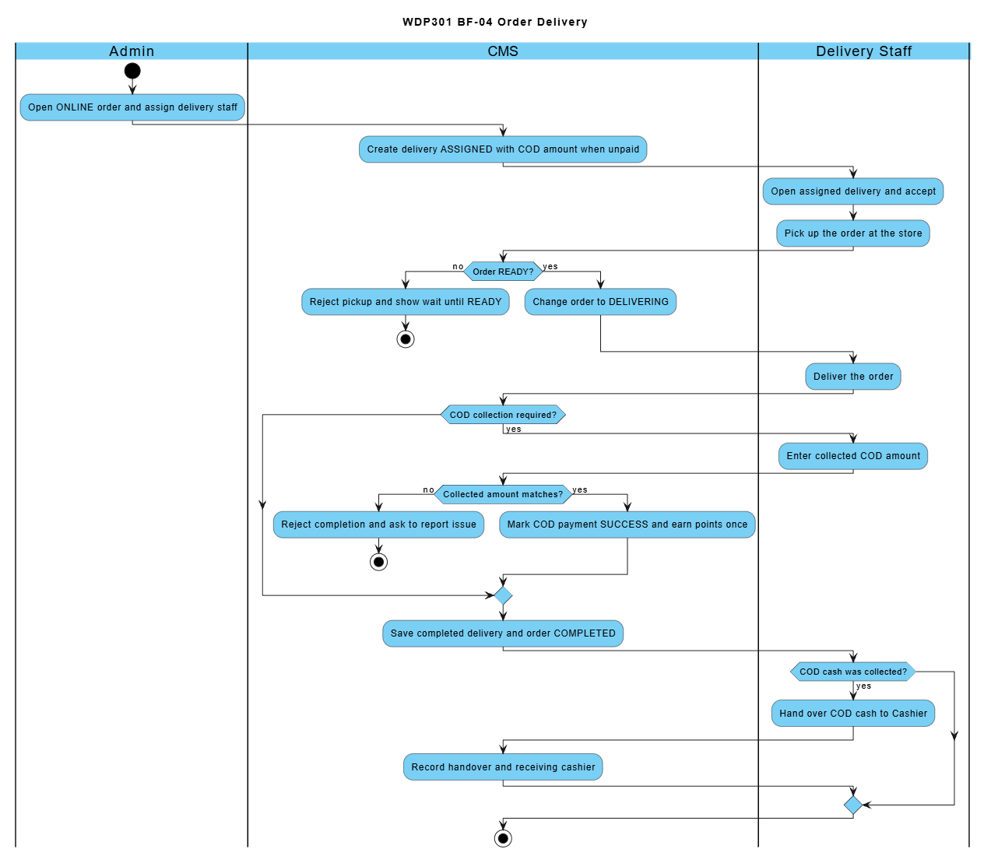

2.5 Counter Ordering (BF-05)
Workflow lead: Mạnh. Use cases: UC14, UC18-UC22, UC62, UC64. Screens: Menu; Counter Ordering; Counter Order List; Payment; Bill.
Trigger: Cashier enters the products ordered by a walk-in customer.
End condition: The order is COMPLETED when handed to the customer, or CANCELLED with points refunded / reversed.
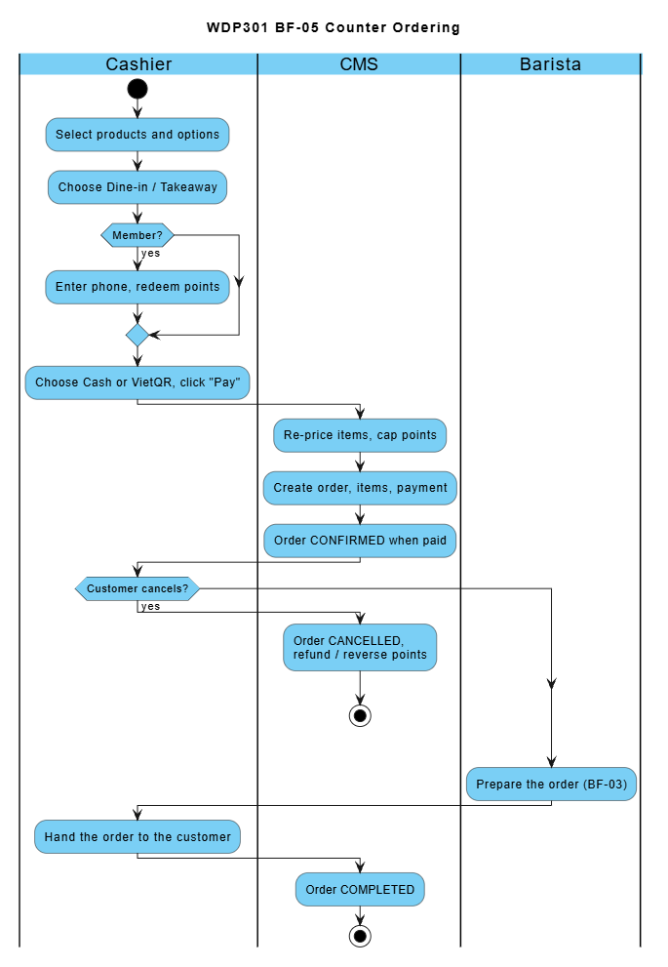

2.6 Work Shift Scheduling and Attendance (BF-06)
Workflow lead: Sơn. Use cases: UC55-UC59. Screens: Work Shift Management; Employee Schedule; Attendance.
Screen implementation: Employee Schedule, Attendance, Cashier Handover, Employee Management, Weekly Work Shifts and Admin Handover Review - Sơn. BF-15 supplies the employee and shift definitions.
Trigger: Admin schedules employees using weekly shift definitions prepared in BF-15.
End condition: Employees are scheduled and their attendance is recorded (COMPLETED or ABSENT).
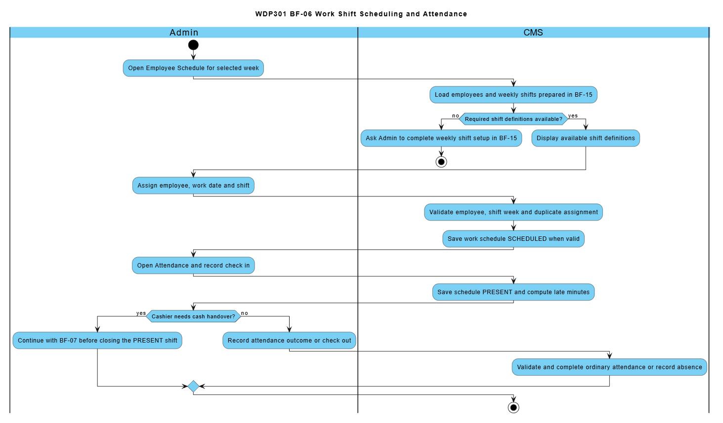

2.7 Shift Closing and Cash Handover (BF-07)
Workflow lead: Sơn. Use cases: UC60, UC69, UC73. Screens: Employee Schedule; Attendance; Shift Handover; Handover Review.
Screen implementation: Employee Schedule, Attendance, Cashier Handover, Employee Management, Weekly Work Shifts and Admin Handover Review - Sơn. BF-15 supplies the employee and shift definitions.
Trigger: Cashier closes a PRESENT shift.
End condition: The shift handover report is CONFIRMED by Admin.
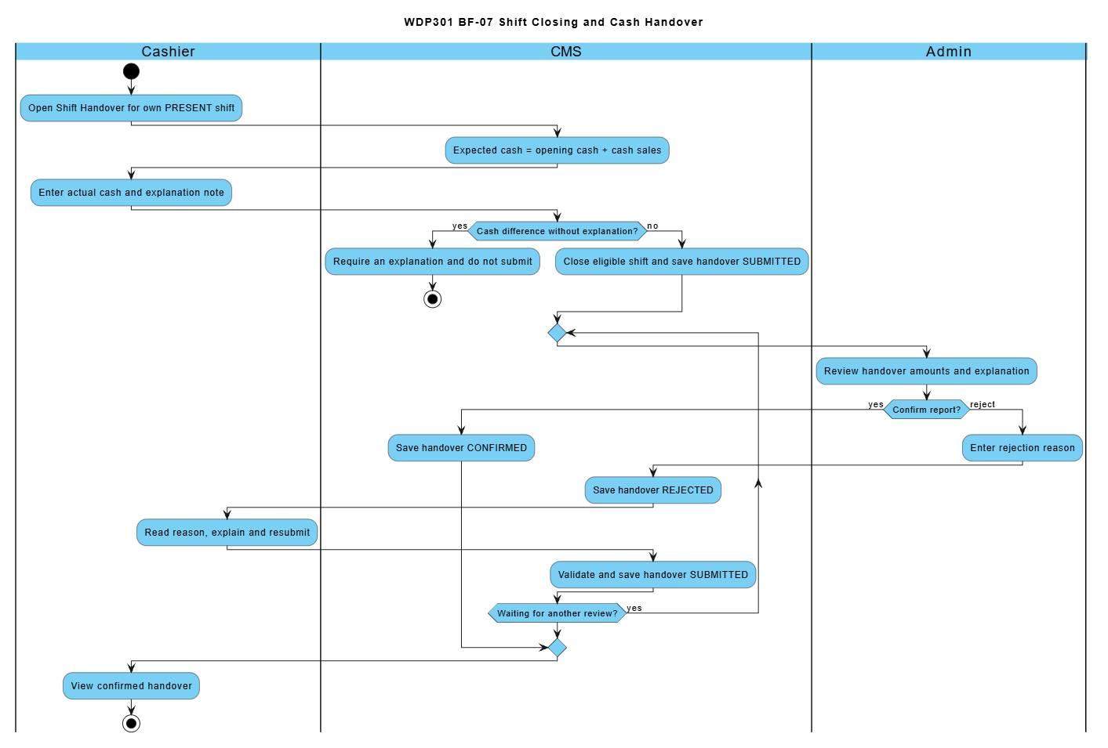

2.8 Ingredient Restock and Purchasing (BF-08)
Workflow lead: Duy. Use cases: UC44-UC53. Screens: Ingredient; Inventory; Restock Request; Supplier; Purchase Order.
The main path uses an approved restock request. A direct Purchase Order is also available when no request is linked. Supplier and Ingredient setup is needed only when the required master data does not exist.
Trigger: Admin checks the low-stock ingredients and creates a restock request.
End condition: The purchase order is RECEIVED and stock is increased, or the request is REJECTED.
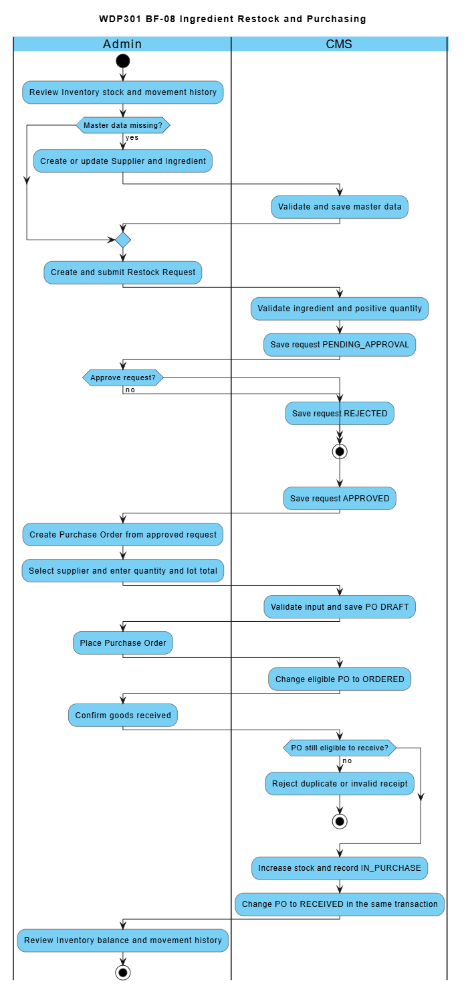

2.9 Feedback and Complaint Handling (BF-09)
Workflow lead: Sơn. Use cases: UC65, UC70. Screens: Customer Feedback and Complaints; Admin Feedback.
Trigger: Customer writes a rating or complaint about an own order.
End condition: The ticket is RESOLVED or REJECTED and the Customer can read the response.
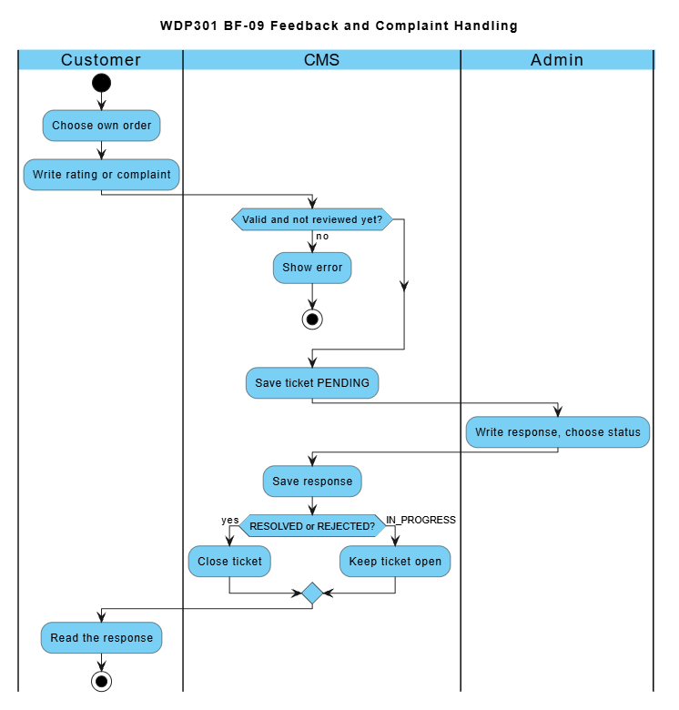

2.10 Account Access and Personal Profile (BF-10)
Workflow lead: Nguyên. Use cases: UC01-UC06. Screens: Homepage; Authentication Dialog; Customer Profile.
Trigger: A user opens the Authentication dialog from Homepage.
End condition: The permitted workspace or personal profile is available; logout invalidates the session.
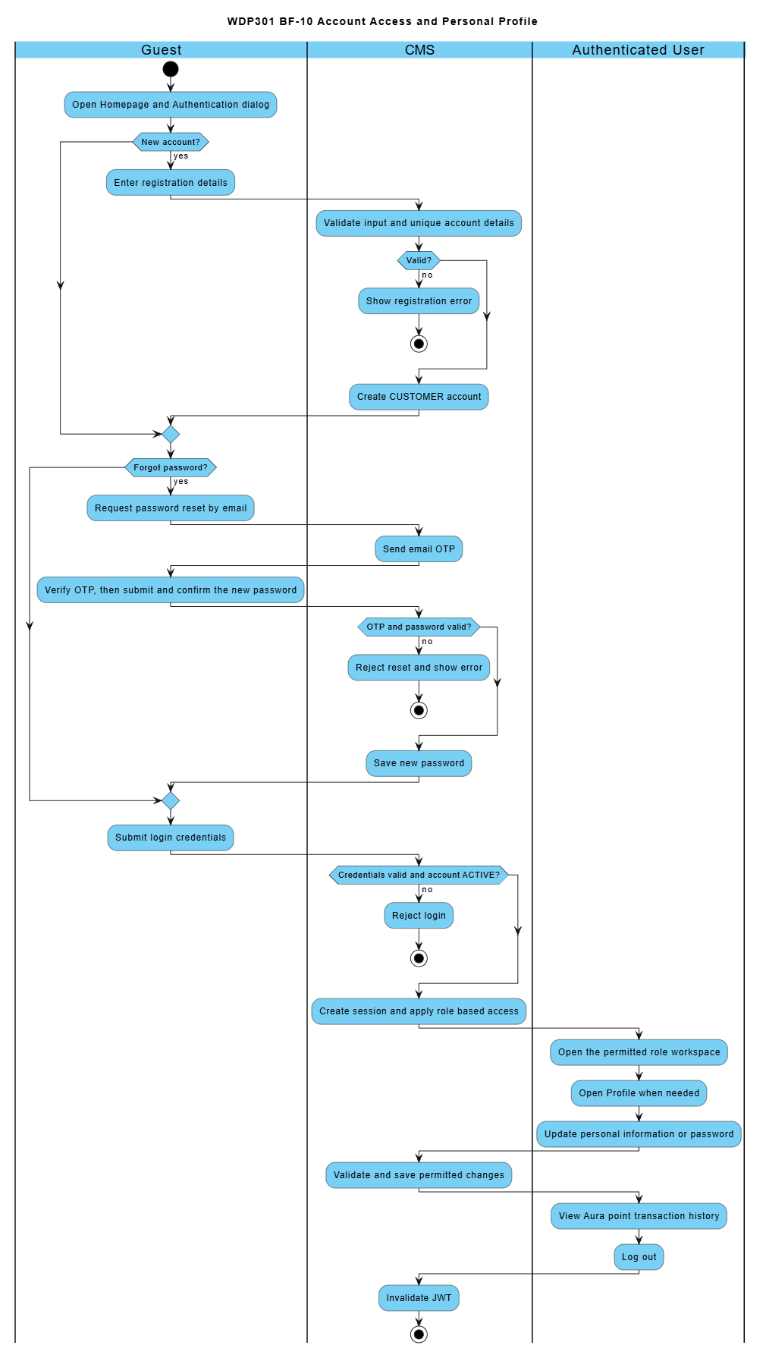

2.11 Menu and Recipe Publication (BF-11)
Workflow lead: Nguyên. Use cases: UC06, UC31-UC43. Screens: Category; Product; Recipe; Homepage.
Trigger: Admin prepares or updates a menu product and its recipe.
End condition: Product and BOM data are saved, cost completeness is visible and the public Homepage can be checked.
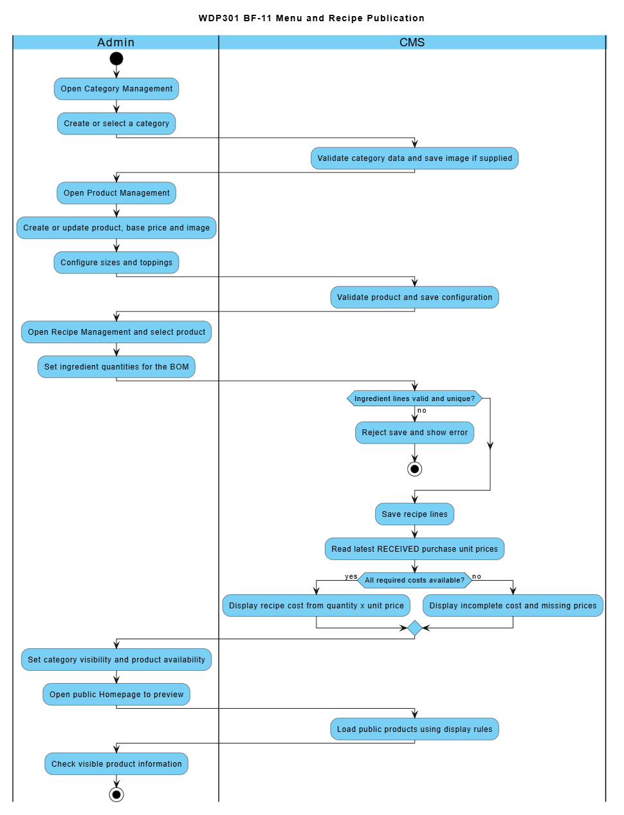

2.12 Phone Loyalty Administration (BF-12)
Workflow lead: Nguyên. Use cases: UC05, UC62-UC64. Screens: Phone Loyalty Management; Customer Profile.
Trigger: Admin opens Phone Loyalty Management to review rules or customer points.
End condition: Valid rules or point adjustments are saved and point history is available.
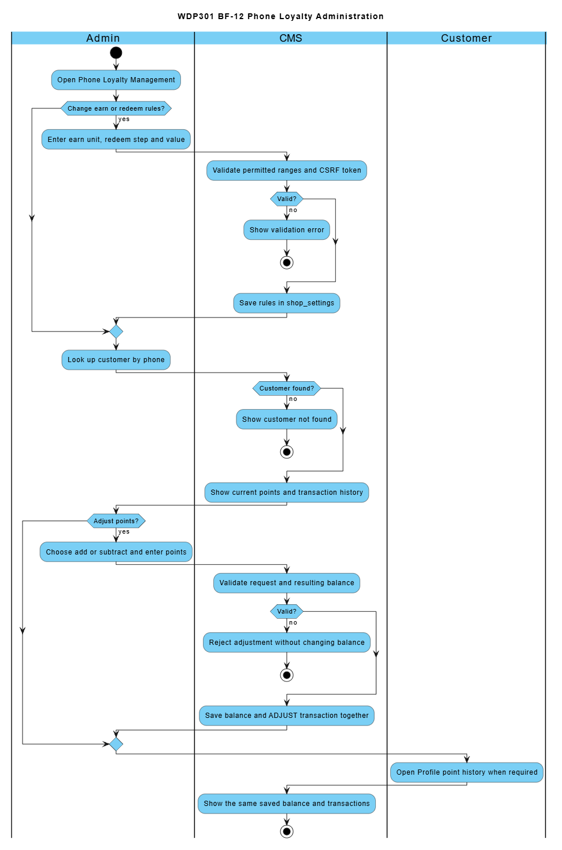

2.13 Sales Review and Order Follow Up (BF-13)
Workflow lead: Mạnh. Use cases: UC14, UC61, UC66-UC67. Screens: Reports; Admin Orders; Customer Management.
Trigger: Admin reviews business results and follows up an order or customer.
End condition: Reports and relevant order or customer details are reviewed; permitted updates are saved.
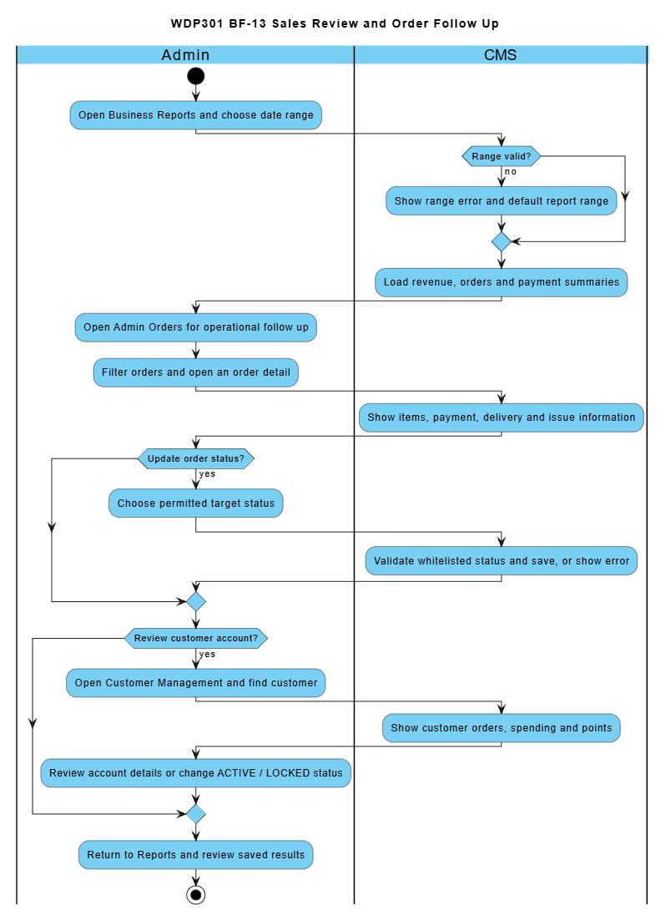

2.14 Shop Configuration (BF-14)
Workflow lead: Duy. Use cases: UC68. Screens: Shop Settings.
Trigger: Admin changes shop operating settings.
End condition: Valid settings persist after reloading the page.
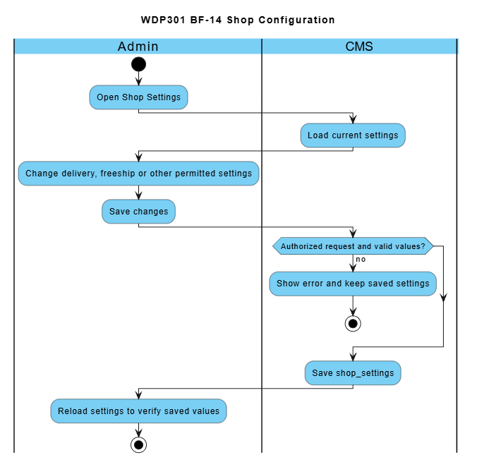

2.15 Employee and Weekly Shift Setup (BF-15)
Workflow lead: Sơn. Use cases: UC54-UC55. Screens: Employee Management; Work Shift Management.
Trigger: Admin prepares employee accounts and weekly shift definitions.
End condition: Employee and weekly shift data are available for scheduling in BF-06.
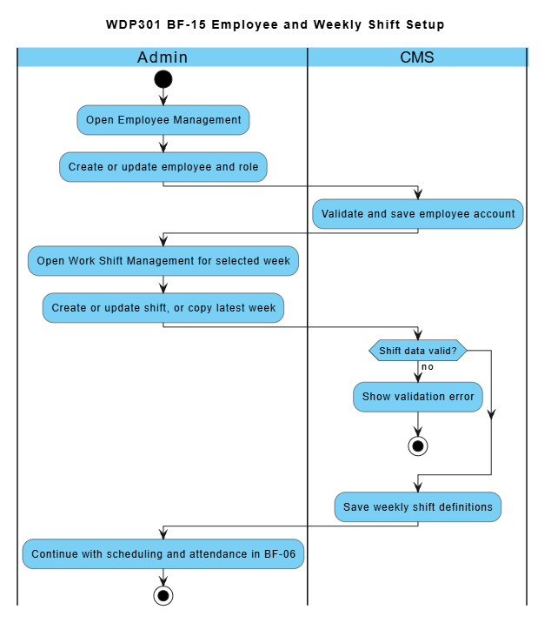

3. Conceptual Data Model

3.1 Entity Relationship Diagram
The conceptual model retains the source business entities and relationships. MongoDB implements them using ObjectId references and embedded snapshots rather than relational foreign keys. User phone is unique. Orders retain item price and customization snapshots; WorkShift belongs to a specific week. The detailed storage mapping is specified in the SDS.
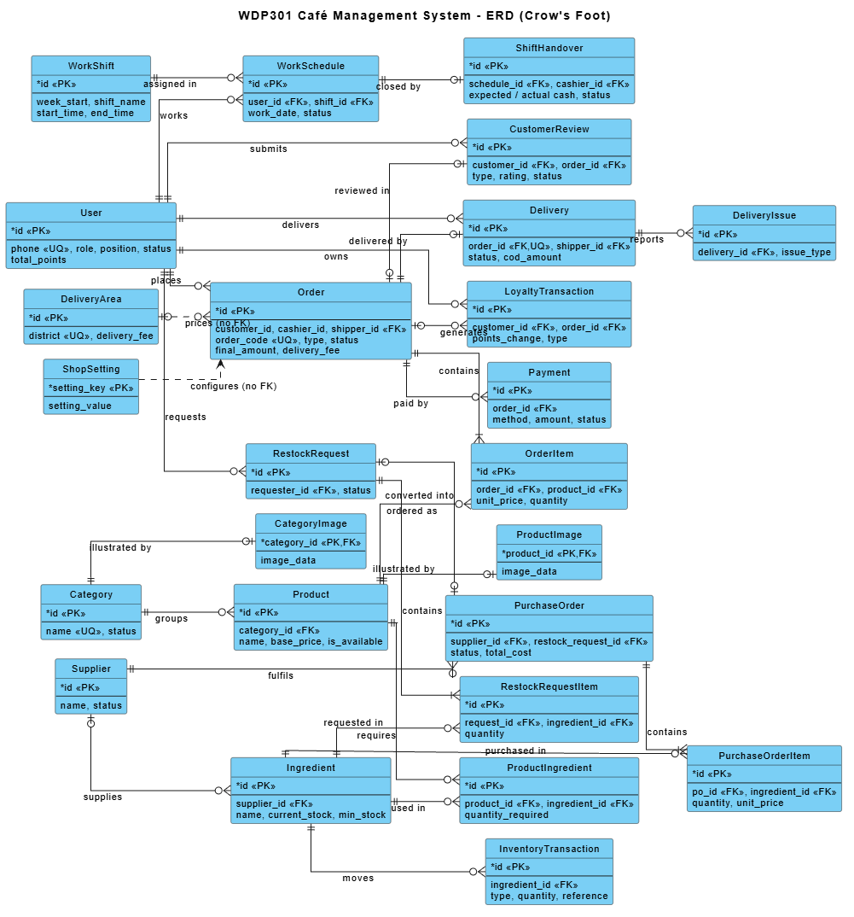

3.2 Entity Descriptions
Entity: User
Field | Value
Purpose | Every person with an account: customers, staff (cashier, barista, delivery staff) and administrators.
Key business attributes | Full name, phone number, e-mail, password, birthday, default address, role (ADMIN / STAFF / CUSTOMER), position (MANAGER / BARISTA / CASHIER / SHIPPER), hire date, base salary, Aura point balance, created date.
Business identity | Phone number is unique across the whole system and is the loyalty identity of a Customer. E-mail, when entered, is checked for uniqueness on registration and employee/profile update.
Status / lifecycle | ACTIVE (can sign in) · INACTIVE (deactivated employee) · LOCKED (locked by Admin). Accounts are locked or deactivated, never deleted from the UI.

Entity: WorkShift
Field | Value
Purpose | A named time frame of one specific week (e.g. "Ca sáng 07:00-12:00") used to schedule staff.
Key business attributes | Week start (Monday), shift name, start time, end time.
Business identity | Shift name is unique within a week (week_start + shift_name).
Status / lifecycle | Created for a week → edited → deleted (only when no employee is scheduled). Shifts of past weeks are read-only.

Entity: WorkSchedule
Field | Value
Purpose | Assignment of one employee to one shift on one work date, also holding attendance and cashier cash data.
Key business attributes | Employee, work date, shift, check-in time, check-out time, opening cash, system/actual closing cash, note.
Business identity | One employee can be scheduled to the same shift on the same date only once (user + work date + shift).
Status / lifecycle | SCHEDULED → PRESENT (checked in) → COMPLETED; or SCHEDULED → ABSENT.

Entity: ShiftHandover
Field | Value
Purpose | Cash handover report created when a Cashier closes a shift; reviewed by Admin.
Key business attributes | Schedule, cashier, opening cash, cash sales, expected cash, actual cash, difference, note / explanation, reviewer, review note, created and reviewed time.
Business identity | At most one handover per work schedule.
Status / lifecycle | SUBMITTED → CONFIRMED (final) or SUBMITTED → REJECTED → (Cashier explains) SUBMITTED.

Entity: Category
Field | Value
Purpose | Groups products on the menu and the POS.
Key business attributes | Category name, image (stored in database), number of products.
Business identity | Category name is unique.
Status / lifecycle | ACTIVE (shown) ↔ INACTIVE (hidden). Can be deleted only when it has no product.

Entities: CategoryImage / ProductImage
Field | Value
Purpose | Binary image of a category or product, stored in the database instead of a local file path.
Key business attributes | Image data, content type (JPG, PNG, GIF, WebP), file name, updated time.
Business identity | One image per category / product (the owner id is the key).
Status / lifecycle | Uploaded images are validated by MIME type and file signature; the maximum is 2 MiB per image. Replacement preserves references required by stored historical records.

Entity: Product
Field | Value
Purpose | A drink or food item sold on the menu, online and at the counter.
Key business attributes | Name, category, base price, description, image, size surcharges and topping prices. Legacy preparation instructions may remain in variant JSON, but the active recipe screen does not edit them.
Business identity | No natural key; identified by product id. Must belong to an existing category.
Status / lifecycle | Available (is_available = true) ↔ Paused (not sold online or at the counter).

Entity: ProductIngredient (Recipe line)
Field | Value
Purpose | Bill of materials: quantity of one ingredient needed to make one portion of a product.
Key business attributes | Product, ingredient, quantity required (up to 3 decimals).
Business identity | An ingredient appears at most once in a product recipe (product + ingredient).
Status / lifecycle | Defined → updated (the whole recipe is replaced on save) → removed with the product.

Entity: Ingredient
Field | Value
Purpose | Raw material kept in stock and consumed by recipes.
Key business attributes | Name, unit, default supplier, current stock, minimum stock level, latest purchase price.
Business identity | Identified by ingredient id.
Status / lifecycle | In stock → Low stock (current ≤ minimum) → Out of stock (0). Deletable only when not used in any recipe.

Entity: Supplier
Field | Value
Purpose | Company that supplies ingredients.
Key business attributes | Name, phone, address, number of supplied ingredients.
Business identity | Identified by supplier id.
Status / lifecycle | ACTIVE ↔ INACTIVE. Only ACTIVE suppliers can be chosen on a purchase order.

Entity: InventoryTransaction
Field | Value
Purpose | Every stock movement of an ingredient (audit trail of the inventory).
Key business attributes | Ingredient, type (IN_PURCHASE, OUT_ORDER, ADJUSTMENT, SPOILAGE), positive quantity, reference (order / purchase order / adjustment), reason, time.
Business identity | Identified by id. One OUT_ORDER movement per (order, ingredient).
Status / lifecycle | Recorded once, never edited.

Entities: RestockRequest / RestockRequestItem
Field | Value
Purpose | Internal request to buy more of an ingredient, approved before purchasing.
Key business attributes | Requester, reviewer, reason, note, review note; items: ingredient, quantity, item note.
Business identity | Identified by request id (shown as RR-0001). An ingredient appears once per request.
Status / lifecycle | DRAFT → PENDING_APPROVAL → APPROVED | REJECTED; DRAFT / PENDING_APPROVAL → CANCELLED.

Entities: PurchaseOrder / PurchaseOrderItem
Field | Value
Purpose | Official order sent to a supplier; receiving it increases the stock.
Key business attributes | Supplier, creator, linked restock request (optional), total cost, note; items: ingredient, quantity, unit price.
Business identity | Identified by id (shown as PO-0001). An approved restock request can be converted into at most one purchase order.
Status / lifecycle | DRAFT → ORDERED → RECEIVED; DRAFT / ORDERED → CANCELLED.

Entity: Order
Field | Value
Purpose | A sale: online delivery order of a Customer or a dine-in / takeaway order created by a Cashier.
Key business attributes | Order code, type (ONLINE / DINE_IN / TAKEAWAY), customer, cashier, delivery staff, goods amount, points discount, delivery fee, final amount, recipient name and phone, delivery address, table number, note, created time.
Business identity | Order code is unique (online: AURAyyMMddHHmmssSSS, counter: ORD-yyMMdd-nnnn).
Status / lifecycle | PENDING → CONFIRMED → PREPARING → READY → DELIVERING → COMPLETED (ONLINE); READY → COMPLETED (DINE_IN / TAKEAWAY); CANCELLED from PENDING (customer) or PENDING / CONFIRMED (cashier).

Entity: OrderItem
Field | Value
Purpose | One line of an order with a snapshot of the product at ordering time.
Key business attributes | Product, product name at time, unit price, customization (size, toppings, sugar / ice options), quantity, subtotal.
Business identity | Identified by id; belongs to exactly one order.
Status / lifecycle | Created with the order; prepared flag is tracked on the Barista screen.

Entity: Payment
Field | Value
Purpose | One payment attempt for an order.
Key business attributes | Order, method (CASH, BANK_TRANSFER; VNPAY and MOMO reserved), transaction code, amount, paid time, note, gateway reference, callback payload and time.
Business identity | Transaction code is unique (e.g. QR-<order code>, COD-<order code>).
Status / lifecycle | PENDING → SUCCESS | FAILED.

Entity: Delivery
Field | Value
Purpose | Delivery job of an ONLINE order assigned to a delivery staff member.
Key business attributes | Order, delivery staff, COD amount, COD collected, COD handed over time and receiving cashier, assigned / accepted / picked-up / delivered time, delivery note.
Business identity | At most one delivery per order.
Status / lifecycle | ASSIGNED → ACCEPTED → DELIVERING → DELIVERED. Re-assigning before pick-up resets it to ASSIGNED.

Entity: DeliveryIssue
Field | Value
Purpose | Problem reported by delivery staff during a delivery; one delivery may have many issues.
Key business attributes | Delivery, issue type (customer unreachable, wrong address, customer refused, damaged, traffic, other), description, time.
Business identity | Identified by id.
Status / lifecycle | Recorded (visible to Admin on the order detail).

Entity: DeliveryArea
Field | Value
Purpose | District of Hanoi the shop delivers to, with its fixed delivery fee.
Key business attributes | District name, delivery fee.
Business identity | District name is unique.
Status / lifecycle | Active (accepts delivery) ↔ Inactive.

Entity: LoyaltyTransaction
Field | Value
Purpose | History of Aura point changes of a Customer.
Key business attributes | Customer, order (optional), points change, type (EARN, REDEEM, REFUND, ADJUST), time.
Business identity | Identified by id. EARN is recorded at most once per order.
Status / lifecycle | Recorded once, never edited; the balance is stored in User.total_points.

Entity: CustomerReview (Feedback ticket)
Field | Value
Purpose | A rating (1-5 stars) or a complaint of a Customer about one of his/her orders.
Key business attributes | Ticket code, customer, order, type (RATING / COMPLAINT), rating, content, admin response, created / updated time.
Business identity | One ticket per (customer, order).
Status / lifecycle | PENDING → IN_PROGRESS → RESOLVED | REJECTED (RESOLVED and REJECTED are final).

Entity: ShopSetting
Field | Value
Purpose | Key-value configuration of the shop.
Key business attributes | Shop settings: freeship_threshold, delivery_fee, delivery_minutes, points_step, points_step_value and points_earn_unit. Provider credentials belong to protected environment variables SMTP_* and PAYMENT_*; PAYMENT_DEMO_ENABLED gates simulation and secrets are not exposed as public shop settings.
Business identity | Setting key is unique.
Status / lifecycle | Created → updated by Admin (applied on the next page load).

3.3 Data Business Rules
Rule | Description | Enforced On
DR-01 Unique phone | No two users may share the same phone number, regardless of role. | Registration, employee and customer creation, profile update
DR-02 Unique e-mail | An e-mail already used by another account is rejected. | Registration, employee save
DR-03 Unique category name | Category names are unique. | Category create / update
DR-04 Product needs category | A product must belong to an existing category; base price ≥ 0 with at most 2 decimals. | Product create / update
DR-05 Default size | Every product has at least one size and exactly the cheapest size has surcharge 0 đ so the default price equals the base price. | Product create / update
DR-06 Recipe line | Quantity required > 0 (max 3 decimals); an ingredient cannot appear twice in one recipe. | Recipe save
DR-07 Non-negative stock | Ingredient current stock and minimum level are never negative; a movement that would make stock negative is rejected. | Stock adjustment, order preparation
DR-08 Order lines | An order has at least one item; quantity > 0; subtotal = unit price × quantity, computed by the server. | Checkout, counter order
DR-09 Order amounts | final amount = goods amount − points discount + delivery fee; all amounts ≥ 0. | Checkout, counter order
DR-10 One delivery per order | An order has at most one delivery; only ONLINE orders with an address can be assigned. | Assign delivery staff
DR-11 Unique transaction code | A payment transaction code is unique so the same gateway callback is applied only once. | Payment callback
DR-12 Points never negative | User.total_points ≥ 0; EARN/REFUND > 0, REDEEM < 0, ADJUST ≠ 0. | All loyalty operations
DR-13 One feedback per order | A customer can send only one rating or complaint per own order; RATING requires 1-5 stars. | Feedback submission
DR-14 Unique shift name per week | Shift names are unique within a week; end time > start time; shifts of a week must not overlap. | Work shift create / update
DR-15 No duplicate schedule | An employee cannot be scheduled twice in the same shift on the same date; the shift must belong to the week of the work date. | Schedule assignment
DR-16 One handover per schedule | A work schedule has at most one shift handover report. | Close shift
DR-17 Restock item | Restock quantity > 0; an ingredient appears once per request. | Restock request create
DR-18 Purchase item | Purchase quantity > 0, unit price ≥ 0; an approved request converts into at most one purchase order. | Purchase order create
DR-19 Unique delivery district | District names in delivery areas are unique; delivery fee 0 - 1,000,000 đ. | Delivery area save
DR-20 Images in database | Category and product images are represented by imageUrl values. The application validates supported image input and does not describe relational BLOB tables as the MERN image store. | Image upload

4. User Requirements

4.1 Actors
# | Actor | Description
1 | Guest | A Guest may browse menu/details, maintain a browser cart, register, log in and request email password recovery. Checkout requires an active CUSTOMER. Recovery is implemented through server-validated OTP and one-use reset authorization, not administrator disclosure of passwords.
2 | Customer | A registered user with role CUSTOMER. Manages the personal profile and password, manages the cart, places online delivery orders, pays by bank transfer (VietQR) or cash on delivery, views e-bills, tracks, cancels (while unpaid) and re-orders orders, earns and redeems Aura loyalty points (identified by phone number) and submits ratings or complaints.
3 | Cashier | A staff member (role STAFF, position CASHIER, status ACTIVE). Creates DINE_IN and TAKEAWAY orders on the POS, looks up members by phone number, applies loyalty points, takes cash or VietQR payments, cancels counter orders, hands READY orders to customers, receives COD cash from delivery staff and closes the shift with a cash handover report.
4 | Barista | A staff member (role STAFF, position BARISTA, status ACTIVE). Sees the queue of paid orders from all channels, ticks prepared items, marks orders READY (ingredients are deducted by recipe when an order is finished) and reviews completed orders.
5 | Delivery Staff | A staff member (role STAFF, position SHIPPER, status ACTIVE). Sees deliveries assigned by Admin, accepts them, picks up READY orders, confirms successful delivery (entering the collected COD amount when required), reports delivery issues and hands collected COD cash over to a Cashier.
6 | Admin | An administrator (role ADMIN, position MANAGER - shown as "Quản trị"). Manages categories, products, recipes, ingredients, inventory, restock requests, suppliers, purchase orders, employees, weekly work shifts, schedules, attendance, shift handover review, customers, loyalty rules, orders and delivery assignment, feedback, reports, shop settings and delivery area fees.
7 | Payment Gateway | The gateway supplies HMAC-signed results to POST /api/payments/callback. Payment registers the order through the backend and polls the stored result. Local DEMO_ONLINE confirmation is a separate owner-authorized endpoint enabled only by PAYMENT_DEMO_ENABLED.

4.2 Use Cases (UC)
Use case IDs follow the numbering used in the source code and the implementation matrix of the team.
ID | Use Case | Feature | Use Case Description
UC01 | Register Account | Authentication | Guest creates a Customer account with full name, phone, e-mail and password (≥ 6 characters).
UC02 | Log In | Authentication | Any user signs in with phone, e-mail or e-mail name and password; the system redirects by role/position.
UC03 | Log Out | Authentication | A signed-in user logs out by clearing the client JWT and account state.
UC04 | Reset Forgotten Password | Authentication | The user requests a six-digit email OTP, verifies it within ten minutes and resets the password using a one-use authorization valid for fifteen minutes. Enforce five verification attempts, a sixty-second resend interval and revocation of earlier login tokens after reset.
UC05 | Manage Personal Profile | Customer Profile | The signed-in user views and updates name, phone, email, birthday and default address, changes password and views the Aura point history.
UC06 | View Homepage | Homepage | Guest/Customer views the banner and favourite products.
UC07 | Browse Menu by Category | Menu | Guest/Customer lists available products filtered by an active category.
UC08 | Search Products | Menu | Guest/Customer searches products by keyword.
UC09 | View Product Details | Product Detail | Guest/Customer views price, description, sizes, toppings and related products.
UC10 | Manage Shopping Cart | Shopping Cart | Guest/Customer adds items, changes quantity, selects/removes lines and clears the cart.
UC11 | Place Online Order | Online Ordering | Customer enters recipient and Hanoi delivery address and confirms the order (status PENDING).
UC12 | Pay by Bank Transfer (VietQR) | Payment | Customer transfers via VietQR; the Payment Gateway callback confirms the payment and the order.
UC13 | Choose Cash on Delivery | Payment | Customer chooses COD; the order is confirmed and cash is collected by delivery staff.
UC14 | View e-Bill | Bill | Customer (own orders), Cashier or Admin views and prints the electronic bill of an order.
UC15 | Track Order Status | Customer Order Management | Customer follows in-progress orders and their current status.
UC16 | View Order History | Customer Order Management | Customer lists orders by status tab, order code and date.
UC17 | Cancel Unpaid Order | Customer Order Management | Customer cancels an own PENDING order without successful payment; redeemed points are refunded.
UC18 | Create Counter Order | Counter Ordering | Cashier builds a DINE_IN/TAKEAWAY order with options, table number and note.
UC19 | Take Counter Payment | Counter Ordering | Cashier takes cash (with change) or VietQR payment for the counter order.
UC20 | View Counter Order List | Counter Order List | Cashier/Barista views counter orders of a date filtered by status and type.
UC21 | Cancel Counter Order | Counter Ordering | Cashier cancels a PENDING/CONFIRMED counter order; points are refunded/reversed.
UC22 | Hand Over Counter Order | Counter Ordering | Cashier marks a READY dine-in/takeaway order as COMPLETED.
UC23 | View Preparation Queue | Drink Preparation | Barista sees CONFIRMED/PREPARING/READY paid orders with items and notes.
UC24 | Update Preparation Progress | Drink Preparation | Barista ticks prepared items and marks the order READY; ingredients are deducted by recipe.
UC25 | Reorder Previous Order | Customer Order Management | Customer adds the items of a previous order back to the cart at current prices.
UC26 | View Assigned Deliveries | Delivery Management | Delivery staff lists deliveries assigned to him/her with items and counters.
UC27 | Accept, Pick Up and Complete Delivery | Delivery Management | Delivery staff accepts, picks up a READY order and confirms successful delivery.
UC28 | View Delivery Details and History | Delivery Management | Delivery staff views one delivery with items and issues, and deliveries of a date.
UC29 | Report Delivery Issue | Delivery Management | Delivery staff reports an issue type and description for an unfinished delivery.
UC30 | Collect and Hand Over COD Cash | Delivery Management | Delivery staff collects the exact COD amount and hands all held COD cash to a Cashier.
UC31 | View Category List | Category Management | Admin lists categories with image, product count and status.
UC32 | Create / Update Category | Category Management | Admin saves name, status and image of a category.
UC33 | Show / Hide Category | Category Management | Admin switches a category between ACTIVE and INACTIVE.
UC34 | Delete Category | Category Management | Admin deletes a category that has no product.
UC35 | View and Search Products | Product Management | Admin lists products filtered by category and keyword with counters.
UC36 | Create Product | Product Management | Admin creates a product with name, category, base price, description and image.
UC37 | Update Product | Product Management | Admin edits product information and image.
UC38 | Configure Sizes and Toppings | Product Management | Admin defines sizes with surcharges and toppings with prices of a product.
UC39 | Change Product Availability | Product Management | Admin pauses or resumes selling a product.
UC40 | View Recipe List | Recipe Management | Admin sees which products have or lack a recipe.
UC41 | View Recipe Details | Recipe Management | Admin views the ingredient lines of one product.
UC42 | Set Up Recipe (BOM) | Recipe Management | Admin adds, edits or removes ingredient lines and quantities of a product. The active recipe form saves the BOM only.
UC43 | Calculate Recipe Cost | Recipe Management | System calculates the cost of one portion from the latest received purchase prices.
UC44 | View and Search Ingredients | Ingredient Management | Admin lists ingredients by keyword and supplier with stock and latest price.
UC45 | Create Ingredient | Ingredient Management | Admin creates an ingredient with unit, supplier, opening stock and minimum level.
UC46 | Update Ingredient | Ingredient Management | Admin updates name, unit, supplier and minimum level.
UC47 | Delete Ingredient | Ingredient Management | Admin deletes an ingredient that is not used in any recipe.
UC48 | View Stock and Movement History | Inventory Management | Admin views current stock, stock status and the movement history.
UC49 | Adjust Stock | Inventory Management | Admin records a stock-count adjustment (+/−) or spoilage with a reason.
UC50 | Create Restock Request | Restock Request | Admin creates a restock request as draft or sends it for approval.
UC51 | Review Restock Request | Restock Request | Admin submits, approves, rejects or cancels a restock request.
UC52 | Manage Suppliers | Supplier Management | Admin creates, updates and activates/deactivates suppliers.
UC53 | Manage Purchase Orders | Purchase Order | Admin creates draft purchase orders, places, receives (stock in) or cancels them.
UC54 | Manage Employees | Employee Management | Admin creates and edits staff accounts, filters by role and locks/unlocks accounts.
UC55 | Manage Weekly Work Shifts | Work Shift Management | Admin adds, edits, deletes or copies the shifts of a selected week.
UC56 | Assign Work Schedule | Employee Schedule | Admin assigns an employee to a date and shift (opening cash for cashiers), updates or deletes it.
UC57 | View Work Schedules | Employee Schedule | Admin views schedules by week (calendar / table) or by day (board).
UC58 | Record Attendance | Attendance | Admin records check-in/check-out time, status and note of a scheduled shift.
UC59 | View Daily Attendance | Attendance | Admin views attendance of a date with late minutes.
UC60 | Close Shift and Submit Handover | Shift Handover | Cashier enters actual closing cash and note; the system completes the shift and submits a handover.
UC61 | Manage Customers | Customer Management | Admin lists customers with points, orders and spending, adds a customer and locks/unlocks.
UC62 | Earn Loyalty Points | Phone Loyalty | System adds floor(goods amount after discount / points_earn_unit) points when payment succeeds.
UC63 | Manage Loyalty Rules and Points | Phone Loyalty | Admin sets earn/redeem rules, looks up a customer by phone and adds/subtracts points.
UC64 | Redeem Loyalty Points | Phone Loyalty | Customer (cart) or Cashier (POS) uses points in multiples of points_step for a discount.
UC65 | Submit Feedback or Complaint | Feedback & Complaints | Customer sends a rating or complaint about an own order and follows the response.
UC66 | View Business Reports | Reports Dashboard | Admin views revenue, orders, payments, top products, ingredient usage and low stock for a period.
UC67 | Manage Orders | Admin Order Management | Admin lists all orders, views details, payments and delivery, and updates order status.
UC68 | Configure Shop Settings | Shop Settings | Admin configures freeship threshold, delivery fee/time, point rules and other setting keys.
UC69 | Review Shift Handover | Shift Handover | Admin confirms or rejects (with reason) a submitted cash handover report.
UC70 | Handle Feedback and Complaints | Feedback & Complaints | Admin answers a ticket and sets it IN_PROGRESS, RESOLVED or REJECTED.
UC71 | Configure Delivery Area Fees | Delivery Management | Admin adds districts and edits delivery fee and active flag per district.
UC72 | Assign Delivery Staff | Admin Order Management | Admin assigns, changes or removes the delivery staff of an ONLINE order before pick-up.
UC73 | Resubmit Rejected Handover | Shift Handover | Cashier writes an explanation for a rejected handover and sends it again.

4.3 Use Case Diagrams

4.3.1 UCs for Guest

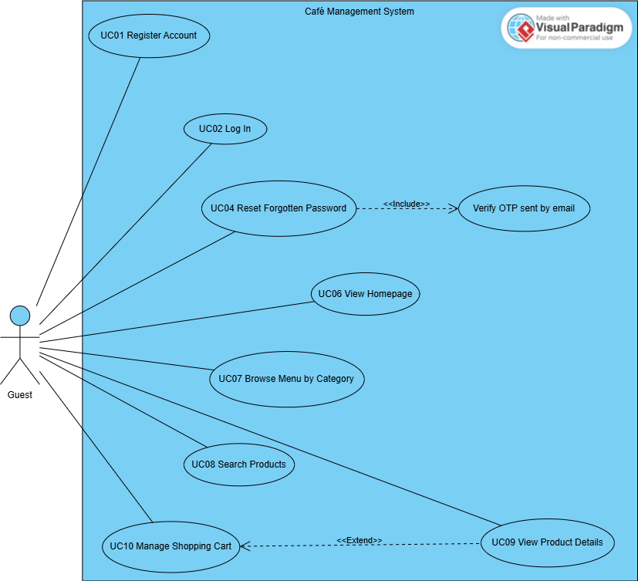

4.3.2 UCs for Customer

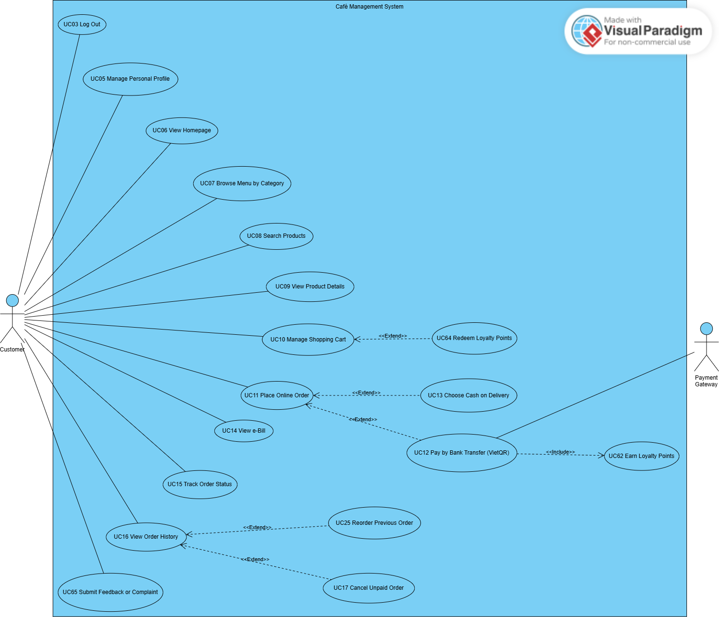

4.3.3 UCs for Cashier

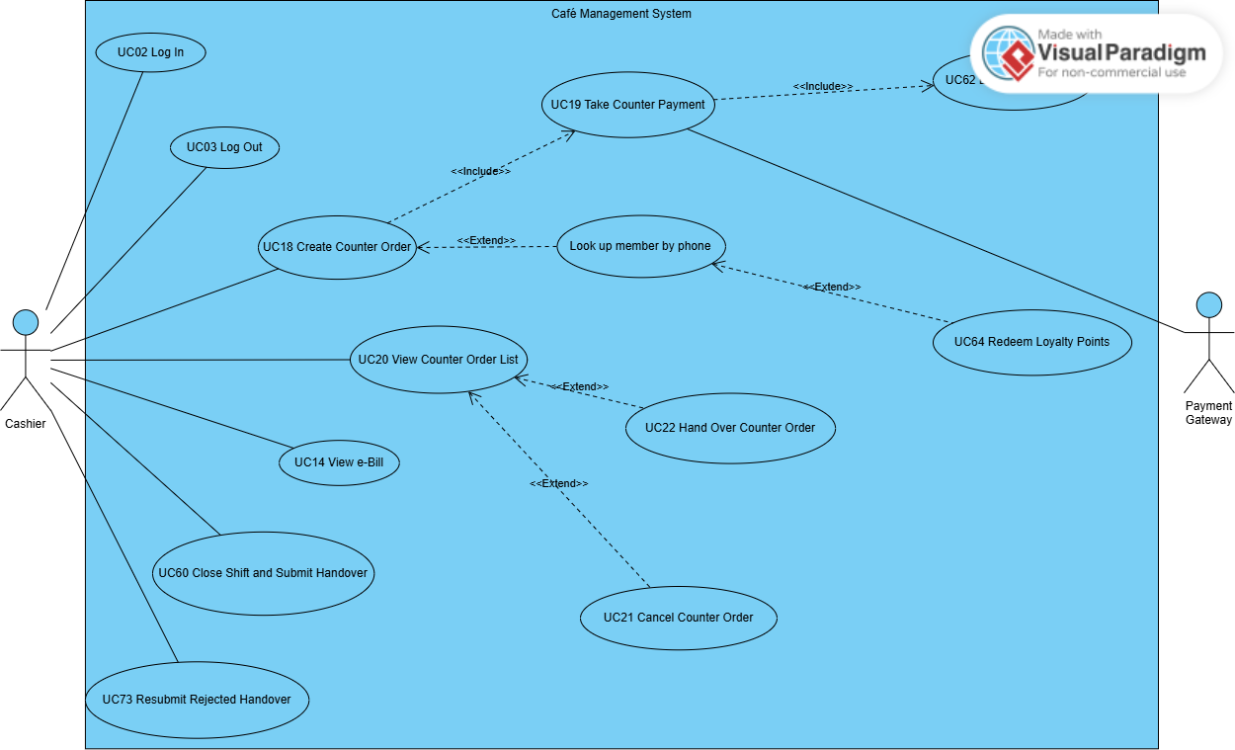

4.3.4 UCs for Barista

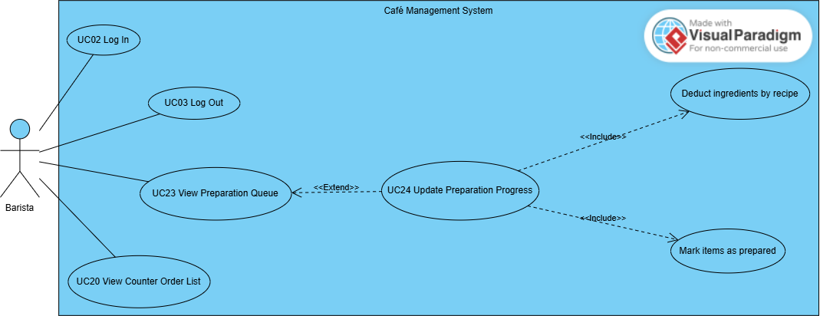

4.3.5 UCs for Delivery Staff

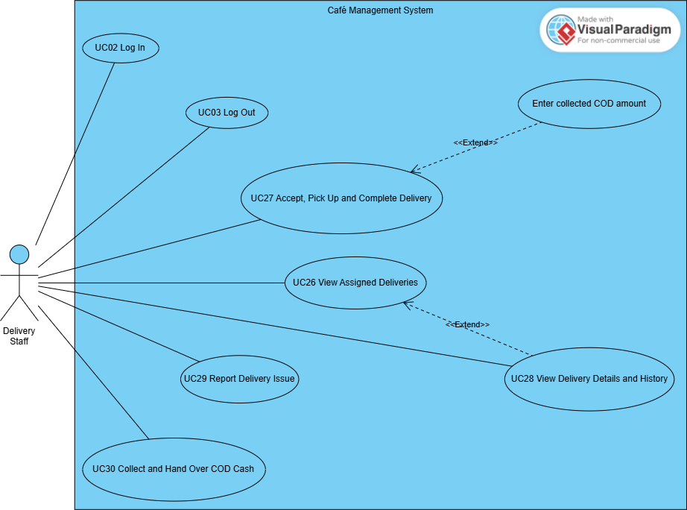

4.3.6 UCs for Admin – Menu, Recipe and Inventory
Responsible members: Nguyên (UC31–UC39); Duy (UC40–UC53).
This group covers category and product management, recipe configuration and costing, ingredient management, stock control, restock requests, suppliers and purchase orders.
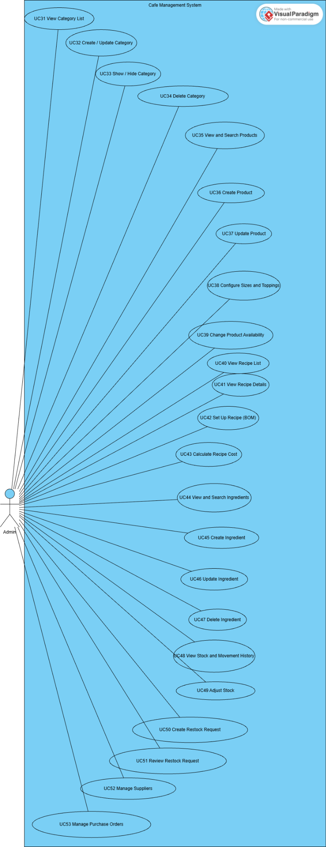
4.3.7 UCs for Admin – Employees, Shifts and Handover
Responsible member: Sơn (UC54–UC59, UC69).
This group covers employee management, weekly shift setup, work scheduling, attendance management and shift handover review.
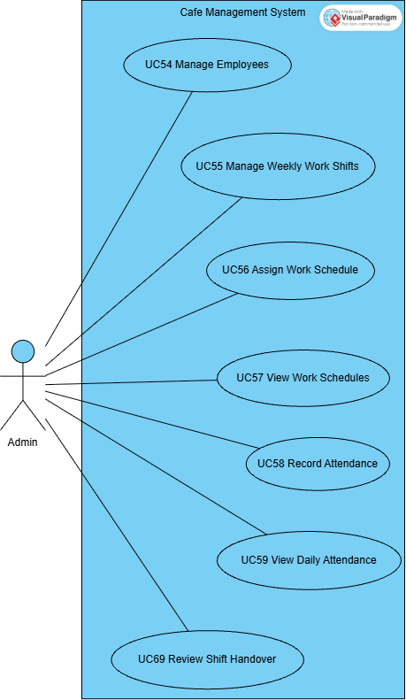

4.3.8 UCs for Admin – Orders, Customers and System
Responsible members: Mạnh (UC14, UC66, UC67, UC71, UC72); Ngọc (UC61, UC63); Sơn (UC70); Duy (UC68).
This group covers order management, electronic bills, business reports, customers, loyalty rules and points, feedback handling, shop settings and delivery configuration.
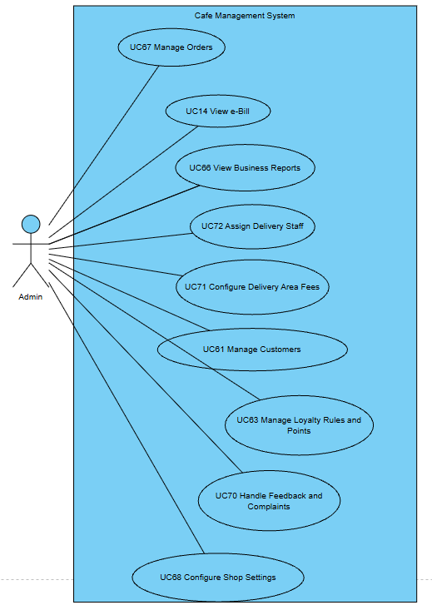

4.4 Permission Matrix
Full = unrestricted · Restricted = conditions apply (see footnotes) · No = denied
Entity | Action | Guest | Customer | Cashier | Barista | Delivery Staff | Admin
Account | Register (Customer) | Full | No | No | No | No | No
Account | Log in / reset password | Full | Full | Full | Full | Full | Full
Account | View / update own profile | No | Full | Restricted ¹ | Restricted ¹ | Restricted ¹ | Restricted ¹
Employee account | Create / edit / lock | No | No | No | No | No | Restricted ²
Customer account | View list / create / lock | No | No | No | No | No | Full
Category / Product | View (active / available) | Full | Full | Full | No | No | Full
Category / Product | Create / edit / hide / delete | No | No | No | No | No | Full
Recipe | View / set up / cost | No | No | No | No | No | Full
Cart | Manage browser/MongoDB cart | Full | Full | No | No | No | No
Online order | Place / pay / cancel (unpaid) | No | Restricted ³ | No | No | No | No
Online order | View own orders / reorder | No | Restricted ³ | No | No | No | No
Counter order | Create / take payment / cancel / hand over | No | No | Full | No | No | No
Counter order | View counter order list | No | No | Full | Full | No | No
Bill | View / print | No | Restricted ³ | Full | No | No | Full
Order | Prepare (PREPARING / READY) | No | No | No | Full | No | No
Order | View all / update status | No | No | No | No | No | Full
Delivery | Assign delivery staff | No | No | No | No | No | Full
Delivery | Accept / pick up / complete / report issue | No | No | No | No | Restricted ⁴ | View
COD cash | Hand over to Cashier | No | No | Receive | No | Restricted ⁴ | No
Ingredient / Inventory | View / create / edit / adjust | No | No | No | No | No | Full
Restock / Purchase order / Supplier | Create / review / receive | No | No | No | No | No | Full
Work shift / Schedule / Attendance | Create / edit / record | No | No | No | No | No | Full
Shift handover | Close shift / resubmit | No | No | Restricted ⁵ | No | No | No
Shift handover | Confirm / reject | No | No | No | No | No | Full
Loyalty points | Redeem | No | Restricted ³ | Restricted ⁶ | No | No | No
Loyalty points | Configure rules / adjust | No | No | No | No | No | Full
Feedback ticket | Submit / view own | No | Restricted ³ | No | No | No | No
Feedback ticket | Respond / close | No | No | No | No | No | Full
Reports / Settings / Delivery areas | View / configure | No | No | No | No | No | Full

¹ Staff and Admin can open the profile page of their own account; the page is designed for Customers (points history).
² Admin cannot downgrade, deactivate or lock the account he/she is currently signed in with.
³ Only for the Customer's own orders, points and tickets (ownership is checked on every request).
⁴ Only for deliveries assigned to the signed-in delivery staff member.
⁵ Only for the Cashier's own PRESENT shift (close) or own REJECTED handover (resubmit).
⁶ Only for an ACTIVE customer found by phone number, capped by balance and order subtotal.

5. System Functionalities
The system is organised in five portals that share one login: the public/Customer website, the Cashier POS, the Barista dashboard, the Delivery Staff dashboard and the Admin back-office. After login the user is redirected by role and position: ADMIN → Admin Dashboard, CASHIER → Cashier POS, BARISTA → Barista Dashboard, SHIPPER → Delivery Management, CUSTOMER → Homepage.

5.1 Screen Inventory

a. Screen Flow
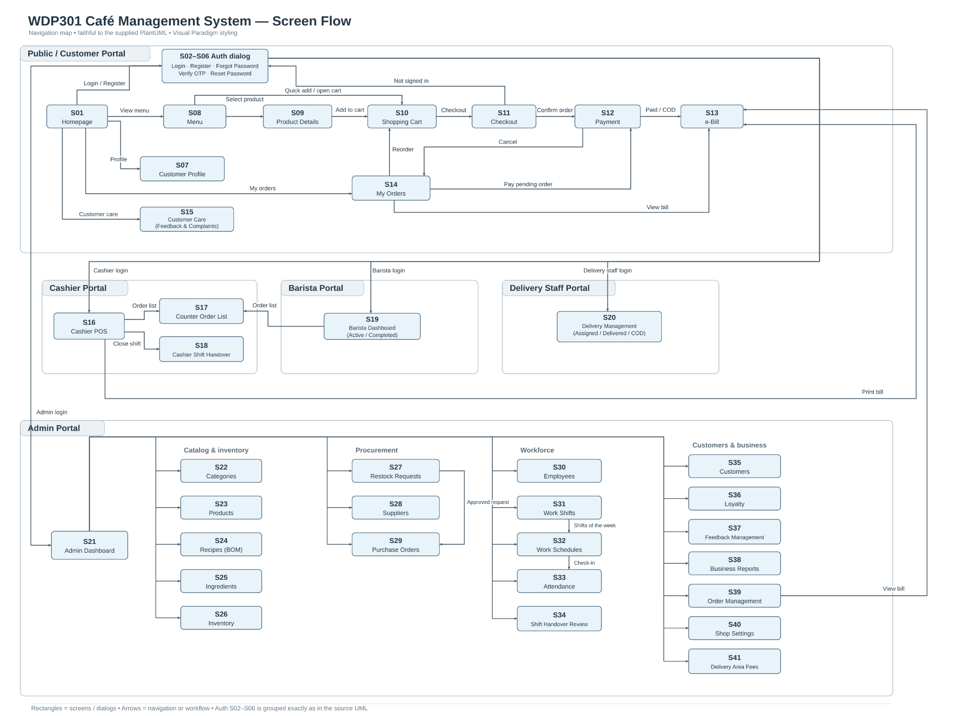

b. Screen List
# | Screen Name | Feature | Description
S01 | Homepage | Homepage | Landing page with banner product, favourite products and links to Menu, Cart, Orders and Profile. Hosts the authentication dialog.
S02 | Login (dialog) | Authentication | Sign in with phone / e-mail and password; redirects Admin, Cashier, Barista, Delivery Staff to their portal.
S03 | Register (dialog) | Authentication | Create a new Customer account.
S04 | Forgot Password (dialog) | Authentication | Request an OTP sent to the registered e-mail.
S05 | Verify OTP (dialog) | Authentication | Enter the 6-digit OTP; resend after 60 seconds.
S06 | Reset Password (dialog) | Authentication | Set a new password after OTP verification.
S07 | Customer Profile | Customer Profile | View/update personal information, change password and view phone-linked point balance and history. All Customers use the same earning and redemption rules.
S08 | Menu | Menu | Product list filtered by category and keyword with quick "add to cart".
S09 | Product Details | Product Detail | Product information, size and topping selection, quantity, add to cart, related products.
S10 | Shopping Cart | Shopping Cart | Cart lines with options, quantity, selection, point redemption and order summary.
S11 | Checkout | Online Ordering | Recipient and Hanoi delivery address, delivery fee by district, note, order confirmation.
S12 | Payment | Payment | VietQR information, backend-stored payment status polling, separate gated DEMO_ONLINE confirmation, COD selection and unpaid cancellation.
S13 | e-Bill | Bill | Electronic bill of an order with items, amounts, payment method and transaction code; printable.
S14 | My Orders | Customer Order Management | In-progress and past orders by status tab, code and date; pay, cancel, reorder, view bill.
S15 | Customer Care | Feedback & Complaints | Submit a rating/complaint about an own order and follow ticket status and responses.
S16 | Cashier POS | Counter Ordering | Product grid, order panel, member lookup, points, payment (cash / VietQR) and today's orders.
S17 | Counter Order List | Counter Order List | Counter orders of a date with status and type filters (Cashier, Barista).
S18 | Cashier Shift Handover | Shift Handover | Close the current shift (cash count) and view / resubmit the handover report.
S19 | Barista Dashboard | Drink Preparation | Active preparation queue (per item / per cup) and completed orders.
S20 | Delivery Management | Delivery Management | Assigned deliveries, delivery detail and issues, delivered list by date, COD holding and hand-over.
S21 | Admin Dashboard | Administration | Greeting and tiles linking to every admin function.
S22 | Category Management | Category Management | Category list and create/edit form with image upload.
S23 | Product Management | Product Management | Product list, filters and create/edit form with sizes, toppings and image.
S24 | Recipe Management | Recipe Management | Products with/without recipe, ingredient quantities, BOM saving and recipe cost; no instruction editor.
S25 | Ingredient Management | Ingredient Management | Ingredient list with stock, latest price and usage; create/edit/delete.
S26 | Inventory Management | Inventory Management | Current stock with status filter, movement history and stock adjustment.
S27 | Restock Requests | Restock Request | Low-stock list, create request (draft / send), request list with review actions.
S28 | Supplier Management | Supplier Management | Supplier list and create/edit form with status.
S29 | Purchase Orders | Purchase Order | Create draft purchase order, list with order / receive / cancel actions.
S30 | Employee Management | Employee Management | Employee list filtered by role; create/edit form; lock/unlock.
S31 | Work Shift Management | Work Shift Management | Week selector with the shifts of that week; add/edit/delete/copy shifts.
S32 | Work Schedules | Employee Schedule | Weekly calendar / table and daily board of schedules; assign, update, delete.
S33 | Attendance | Attendance | Attendance list of a date with late minutes; update check-in/out, status and note.
S34 | Shift Handover Review | Shift Handover | Handover reports by status; confirm or reject with reason.
S35 | Customer Management | Customer Management | Customer list with points, orders and spending; add customer; lock/unlock.
S36 | Loyalty Management | Phone Loyalty | Point rules, lookup by phone, add/subtract points, transaction log.
S37 | Feedback Management | Feedback & Complaints | Tickets filtered by type and status; respond and close.
S38 | Business Reports | Reports Dashboard | KPIs and charts for today / 7 days / 30 days / this month / custom range.
S39 | Order Management | Admin Order Management | All orders with filters; order detail with items, payment, delivery and issues; status and delivery staff update.
S40 | Shop Settings | Shop Settings | Online sales settings and the list of all setting keys; add a key.
S41 | Delivery Area Fees | Delivery Management | Districts with delivery fee and active flag; add a district.

5.2 External API Inventory
# | API Name | Calling Path | Description
1 | Payment callback (API-01) | Payment Gateway → CMS | POST /api/payments/callback receives provider-signed results and verifies HMAC-SHA256, transaction code, amount and order state. POST /api/payments/:id/demo-confirm is separate: owner JWT plus enabled demo mode, and DEMO_ONLINE only.
2 | VietQR image (API-02) | Browser → vietqr.app (URL generated by CMS) | Builds the VietQR "quick link" image URL (bank id, account number, amount, order code as transfer content, account name) shown on the Payment screen and the POS.
3 | E-mail OTP (API-03) | Email OTP: POST /api/auth/forgot-password, /api/auth/verify-otp and /api/auth/reset-password; protected SMTP configuration delivers recovery mail. | OTP codes expire, are rate/attempt limited and become unusable after verification or resend. Hash recovery secrets at rest and never disclose them through errors; failure to deliver mail does not authorize reset.

5.3 Background Job Inventory
# | Job Name | Group | Description
- | No scheduled background job | - | The current release has no timer-based job. All automatic processing (points, stock deduction, payment confirmation) is event-driven and runs inside the user request - see II.11.

3. Functional Requirements
This part describes the screens of the system grouped by feature. For each screen: the URL, actors and related use cases, a short description, the actions available and the description of its fields. Labels in Vietnamese are the texts shown on the user interface; message codes (MSGxx) refer to III.2 System Messages.

1. User Authentication

1.1 Account Authentication

1.1.1 Login
Screen / URL: / (dialog tab "login") → POST /login
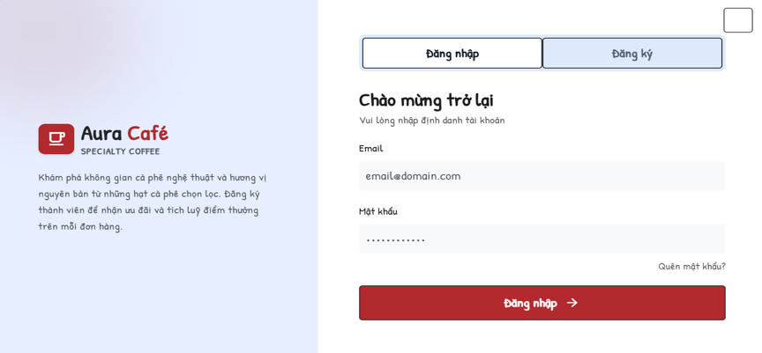
Actors: Guest, Customer, Cashier, Barista, Delivery Staff, Admin · Use cases: UC02, UC03
The React login form submits credentials to POST /api/auth/login. A successful response provides a JWT and the account role/position. The client preserves the guest cart and redirects only to a safe local route; protected API requests carry Authorization: Bearer <token>.
This screen allows the user to:
- Sign in with phone number, e-mail or the part of the e-mail before "@", and password.
- Log out from any portal by clearing the client token and account state; POST /api/auth/logout acknowledges the stateless logout request.
- Open the Register or Forgot password tabs.
Field Description
Field Name | Description
Email (identifier) | Textbox, required. Phone number, e-mail or e-mail name. Trimmed before checking.
Mật khẩu (Password) | Password box, required.
Đăng nhập (Sign in) | Button. Only ACTIVE accounts can sign in; on failure MSG10 is shown without telling which value was wrong.
Redirect after login | ADMIN → Admin Dashboard; STAFF + CASHIER → /cashier; STAFF + BARISTA → /barista; STAFF + SHIPPER → /delivery; CUSTOMER → previous page or Homepage.

1.1.2 Register
Screen / URL: / (dialog tab "register") → POST /register
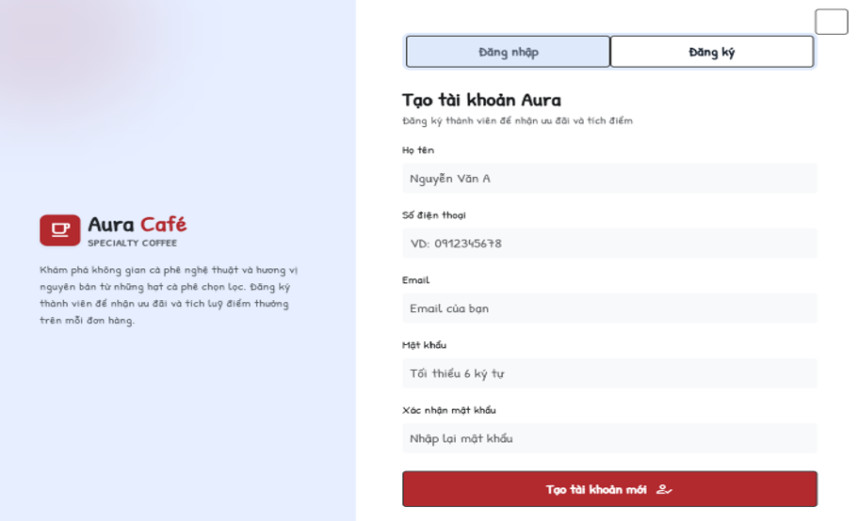
Actors: Guest · Use cases: UC01
Creates a new account with role CUSTOMER and status ACTIVE.
This screen allows the user to:
- Enter personal information and password, then create the account.
- Go to the Login tab after success.
Field Description
Field Name | Description
Họ tên (Full name) | Textbox, required.
Email | Textbox, required, e-mail format, must not exist (MSG13).
Số điện thoại (Phone) | Textbox, required; spaces and dots are removed; Vietnamese mobile format (84|0)[3|5|7|8|9]xxxxxxxx or 9-11 digits; must be unique (MSG12).
Mật khẩu (Password) | Password box, required, at least 6 characters.
Xác nhận mật khẩu (Confirm password) | Must equal Password.
Tạo tài khoản mới (Create account) | Button. On success shows MSG14 and opens the Login tab.

1.1.3 Forgot Password and Verify OTP
Screen / URL: /forgot-password; POST /api/auth/forgot-password and POST /api/auth/verify-otp.
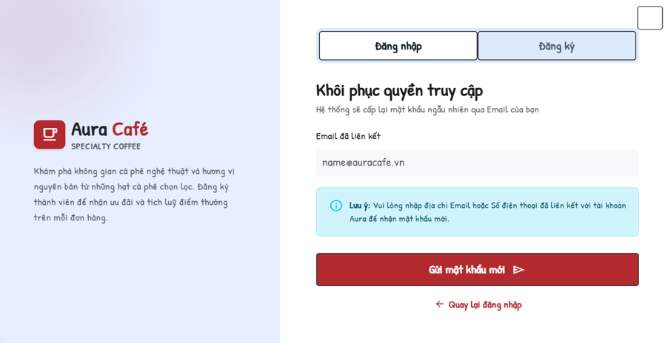
Actors: Guest · Use cases: UC04
Password recovery verifies control of the registered email using a short-lived OTP and then grants one-use password-reset authorization.
This screen allows the user to:
- Request an OTP using the registered email address.
- Verify a six-digit code within ten minutes; reject expired, reused or superseded codes and stop after five failed attempts.
- Resend after at least sixty seconds; invalidate the previous code and enforce the interval on the server.
Field Description
Field Name | Description
Email đã liên kết (Registered e-mail) | Textbox, required; must exist in the system (MSG15).
Gửi (Send) | Send mail through configured SMTP. Return a safe unavailable/delivery error without revealing the code; never bypass verification when mail fails.
Mã xác thực (OTP) | Six-digit input; the server rejects wrong, expired, reused or superseded codes and enforces the attempt limit.
Gửi lại (Resend) | Server-enforced minimum sixty-second resend interval; show remaining wait without exposing the code.

1.1.4 Reset Password
Screen / URL: reset step in /forgot-password; POST /api/auth/reset-password.
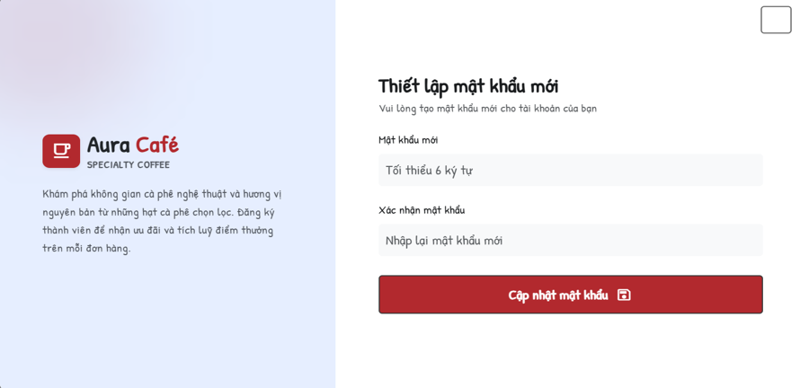
Actors: Guest · Use cases: UC04
Reset requires a valid one-use recovery token, matching new passwords and server validation. Store a bcrypt hash, consume the token and revoke earlier login tokens. Authenticated password change separately verifies the old password.
This screen allows the user to:
- Enter and confirm the new password.
Field Description
Field Name | Description
Mật khẩu mới (New password) | Password box, required.
Xác nhận mật khẩu mới (Confirm) | Must equal the new password (MSG19).
Cập nhật mật khẩu (Update) | Authenticated change uses PUT /api/auth/change-password, validates the current password and the new password confirmation, then stores a bcrypt hash.

2. Customer Portal

2.1 Homepage, Menu and Product

2.1.1 Homepage
Screen / URL: /
Actors: Guest, Customer · Use cases: UC06
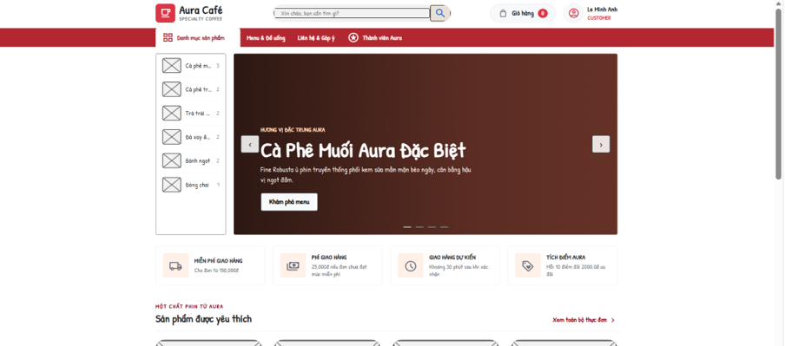
Landing page of the café website. Data (banner product, favourite products, categories, settings) is read from the database.
This screen allows the user to:
- View the banner product carousel and "Sản phẩm được yêu thích" (favourite products).
- Open a product, the Menu, Cart, My Orders, Profile or the login dialog from the header.
Field Description
Field Name | Description
Header | Logo, search box ("Xin chào, bạn cần tìm gì?"), Menu, Cart badge (item count), account menu.
Banner | Product name, image and "Xem món" button (carousel ‹ ›).
Favourite products | Product cards: image, name, price, "Xem món" / quick add.
Footer | Delivery policy, categories, account & support, Aura loyalty information.

2.1.2 Menu
Screen / URL: /menu?category={id}&keyword={text}
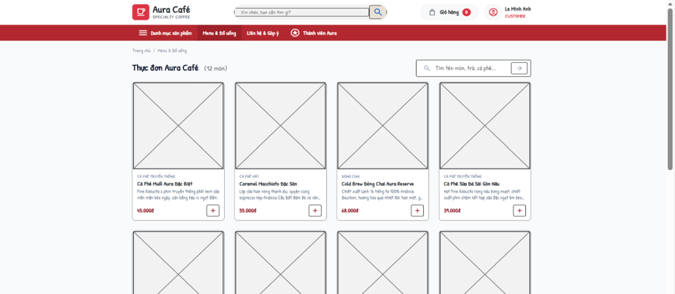
Actors: Guest, Customer · Use cases: UC07, UC08, UC10
Lists available products (is_available = true) of active categories.
This screen allows the user to:
- Filter by category (with product count per category).
- Search by keyword.
- Open a product detail dialog or page and add it to the cart.
Field Description
Field Name | Description
Category tabs | All + each ACTIVE category with its number of products.
Search box | Textbox "Tìm tên món, trà, cà phê..."; empty result shows "Không tìm thấy món phù hợp" (MSG01).
Product card | Image (from database), name, category, price (VND), "Xem món" and add button.

2.1.3 Product Details
Screen / URL: /products/:id?id={id} (also dialog via /menu?action=detail&id={id})
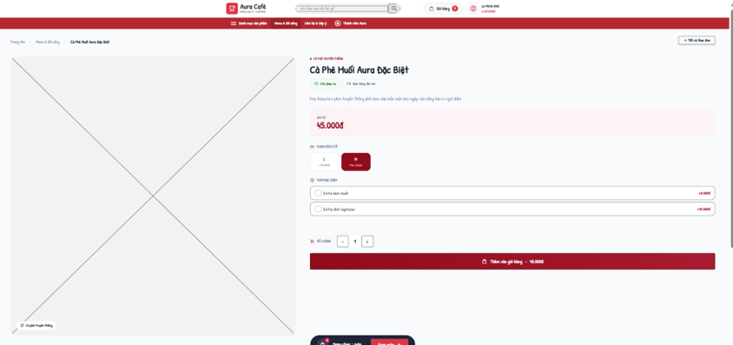
Actors: Guest, Customer · Use cases: UC09, UC10
Shows one product and lets the user choose options before adding it to the cart. The price shown is recalculated by the server when the item is added.
This screen allows the user to:
- Choose a size and toppings, set the quantity and add to cart.
- View related products of the same category.
Field Description
Field Name | Description
Product information | Image, name, category, description, base price.
Chọn size (Size) | Radio list from the product configuration; default = the size with 0 đ surcharge.
Topping thêm (Toppings) | Checkbox list with price per topping (default 8,000 đ when no price is configured).
Quantity | Stepper − / + (min 1).
Add to cart | Button. Unavailable product → MSG21 "Món này hiện đã ngừng phục vụ."
Có thể bạn cũng thích | Up to 4 related products.

2.2 Shopping and Ordering

2.2.1 Shopping Cart
Screen / URL: /cart (JSON: /api/cart, add: POST /api/cart)
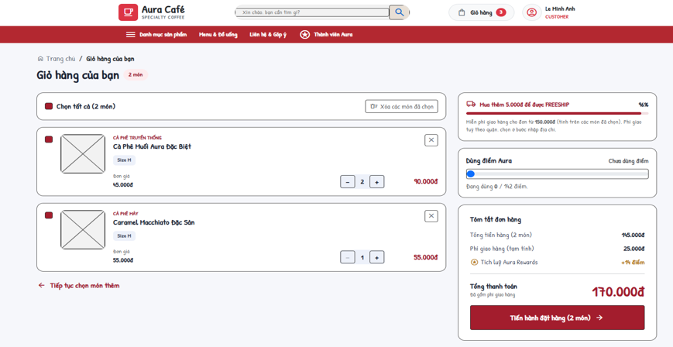
Actors: Guest, Customer · Use cases: UC10, UC64
The guest cart is kept in browser state. After Customer login it synchronizes through GET/PUT /api/cart. Order creation revalidates product availability, sizes, toppings, prices, points and totals using server data.
This screen allows the user to:
- Increase/decrease quantity, remove a line, clear the cart.
- Select lines to order (select all / remove selected).
- Redeem Aura points (Customer only).
- Go to Checkout.
Field Description
Field Name | Description
Cart lines
Chọn tất cả (Select all) | Checkbox; only selected lines are ordered.
Line | Image, name, size, toppings, unit price, quantity (1-99), subtotal; unavailable lines are flagged.
Remove / Clear | Remove one line, remove selected lines or clear the cart.
Tóm tắt đơn hàng (Order summary)
Tổng tiền hàng | Subtotal of selected lines.
Dùng điểm Aura (Points) | Number input. Capped by balance and subtotal and rounded down to a multiple of points_step; discount = (points / points_step) × points_step_value. Guest → MSG22; adjusted value → MSG23.
Phí giao hàng (tạm tính) | Estimated fee = delivery_fee setting, 0 when subtotal ≥ freeship_threshold.
Checkout button | Requires at least one selected line (MSG24).

2.2.2 Checkout
Screen / URL: /checkout
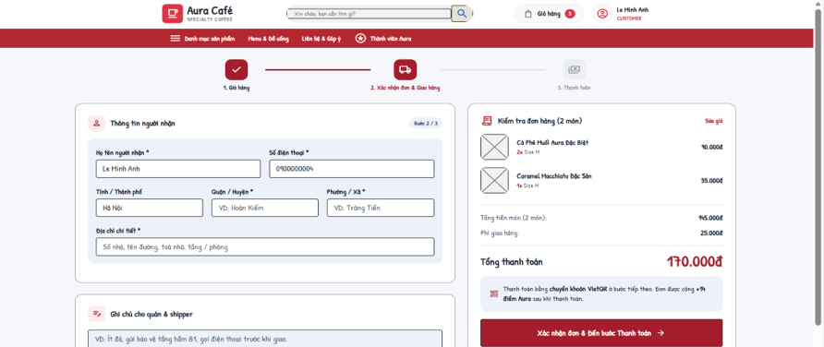
Actors: Customer · Use cases: UC11
Step 2 of 3 ("Xác nhận đơn & Giao hàng"). Online orders are delivered to an address in Hà Nội. Only a CUSTOMER account can place an order (Guest → MSG25, staff/admin → MSG26). Stock of all ingredients needed is checked before the form can be submitted.
This screen allows the user to:
- Enter recipient and delivery address.
- See the delivery fee of the chosen district and the total.
- Confirm the order and go to Payment.
Field Description
Field Name | Description
Thông tin người nhận (Recipient)
Họ tên người nhận * | Textbox, required, max 100 characters; default = Customer full name.
Số điện thoại * | Textbox, required, 10-11 digits starting with 0 (pattern 0\d{9,10}).
Địa chỉ giao hàng (Delivery address)
Tỉnh / Thành phố | Read-only: Hà Nội.
Quận / Huyện * | Dropdown of ACTIVE delivery areas with their fee; inactive/unknown district → MSG27.
Phường / Xã * | Textbox, 2-100 characters.
Địa chỉ chi tiết * | Textbox, 5-150 characters (house number, street, building, floor).
Ghi chú (Note) | Textarea, max 500 characters (for barista and delivery staff).
Order summary
Tổng tiền món | Subtotal of selected lines.
Điểm Aura | Discount from redeemed points.
Phí giao hàng | Fee of the selected district; 0 when subtotal ≥ freeship_threshold.
Xác nhận đơn & Đến bước Thanh toán | Confirm validates items, stock, address, points and expectedTotal before any old-order mutation. Atomically replace only an unpaid checkout of the same owner/session, refund held points and create the new order/payment/ledger. A failed request leaves the old order unchanged; an idempotent retry creates no duplicate.

2.2.3 Payment
Screen / URL: /payment?orderId={id}
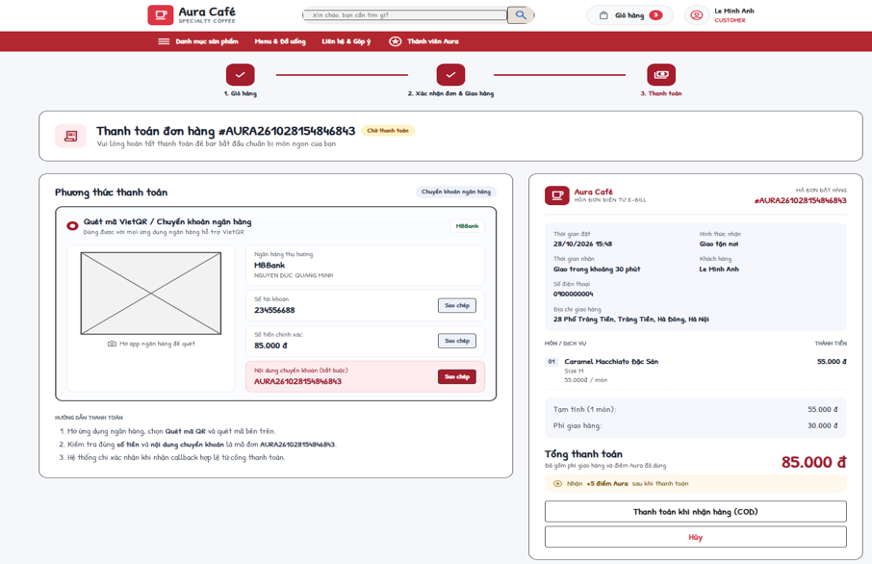
Actors: Customer, Payment Gateway · Use cases: UC12, UC13, UC17
Step 3 of 3. Only the owner of a PENDING order can open it; other statuses are redirected to the e-Bill. A PENDING BANK_TRANSFER payment is created or refreshed.
This screen allows the user to:
- Pay by bank transfer using the VietQR code and copied account/content.
- When demo mode is enabled, confirm a separate DEMO_ONLINE payment. BANK_TRANSFER always requires a provider-signed callback.
- Choose cash on delivery (COD).
- Cancel the order.
Field Description
Field Name | Description
Mã đơn (Order code) | Label, e.g. AURA261026103015123.
VietQR code | Image from vietqr.app with bank, account number, amount and order code as transfer content.
Ngân hàng / Số tài khoản / Chủ tài khoản | Read safe bank/account display data from the payment API. PAYMENT_* credentials stay server-side; Copy copies only the displayed public payment details.
Nội dung chuyển khoản | Order code (copy button).
Order summary | Items, subtotal, points discount, delivery fee, total, expected reward points.
Mô phỏng callback thanh toán thành công | DEMO_ONLINE only, gated by PAYMENT_DEMO_ENABLED and owner JWT: call /api/payments/:id/demo-confirm. Never sign or self-confirm a real BANK_TRANSFER in the browser.
Thanh toán khi nhận hàng (COD) | Button. Creates a CASH payment COD-<code> (PENDING) and confirms the order (MSG32).
Hủy | Cancels the unpaid order (see My Orders).

2.2.4 e-Bill
Screen / URL: /bill?orderId={id}
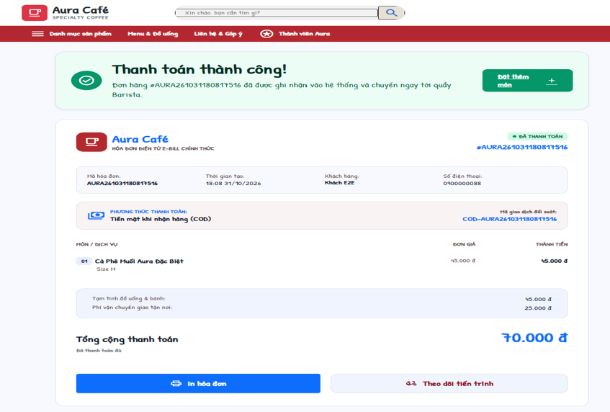
Actors: Customer, Cashier, Admin · Use cases: UC14
Electronic bill of an order. A Customer can only open bills of own orders (MSG33).
This screen allows the user to:
- View and print the bill.
Field Description
Field Name | Description
Header | Payment result, order code, time, order type, recipient / table.
Items | Quantity, product name, options, line amount.
Amounts | Subtotal, points discount, delivery fee, total.
Payment | Payment method, transaction code ("Mã giao dịch đối soát"), status.
Print | Button - browser print.

2.3 Orders, Profile and Customer Care

2.3.1 My Orders
Screen / URL: /orders?tab={all|pending|processing|delivering|completed|cancelled}&q={code}&date={yyyy-MM-dd}
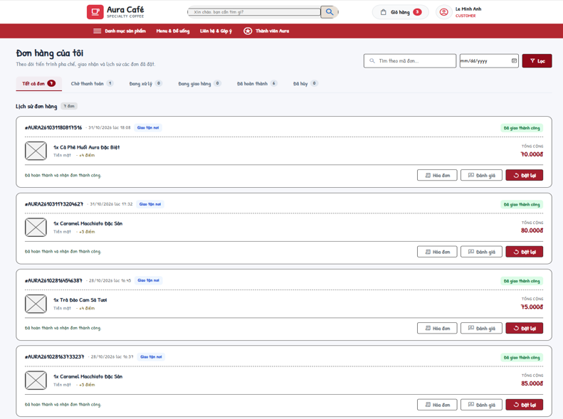
Actors: Customer · Use cases: UC15, UC16, UC17, UC25
Shows the Customer's orders, 10 per page ("load more" up to 100).
This screen allows the user to:
- Follow in-progress orders.
- Filter history by status tab, order code and date.
- Pay a pending order, view the bill, cancel an unpaid order or reorder.
Field Description
Field Name | Description
Status tabs | Tất cả, Chờ thanh toán (PENDING), Đang xử lý (CONFIRMED/PREPARING/READY), Đang giao (DELIVERING), Hoàn thành (COMPLETED), Đã hủy (CANCELLED) with counts.
Tìm theo mã đơn | Textbox, max 30 characters (upper-cased).
Ngày (Date) | Date picker (yyyy-MM-dd) for filtering orders.
Order card | Code, time, type, status, items, total, payment method.
Hủy đơn (Cancel) | Only PENDING orders without successful payment (MSG35); points refunded (MSG34).
Đặt lại (Reorder) | Adds still-available items to the cart at current prices (MSG36 / MSG37).

2.3.2 Customer Profile
Screen / URL: /profile
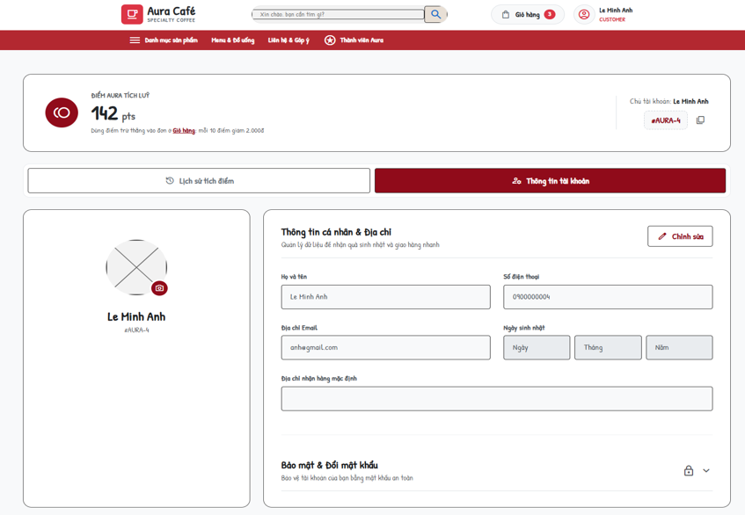
Actors: Customer · Use cases: UC05
Personal page of the signed-in user.
This screen allows the user to:
- Update personal information.
- Change password.
- View the point balance and transaction history for the Customer identified by the unique phone number.
Field Description
Field Name | Description
Thông tin cá nhân & Địa chỉ
Họ và tên | Textbox, required (MSG38).
Số điện thoại / Địa chỉ Email | Editable after clicking Edit. Phone: 9-15 digits when provided; email: format checked. Values are kept when omitted; duplicate phone/email errors are returned by User.
Ngày sinh nhật | Birthday day, month and year selectors populate the hidden birthday field.
Địa chỉ nhận hàng mặc định | Textbox.
Bảo mật & Đổi mật khẩu
Mật khẩu hiện tại | Required; must be correct (MSG39).
Mật khẩu mới / Xác nhận | At least 6 characters; must match.
Lịch sử biến động điểm thưởng
Point history | Phone-based point history: date, type, points change, resulting balance and linked order. Common earn/redeem rules apply to every Customer.

2.3.3 Customer Care (Feedback & Complaints)
Screen / URL: /feedback
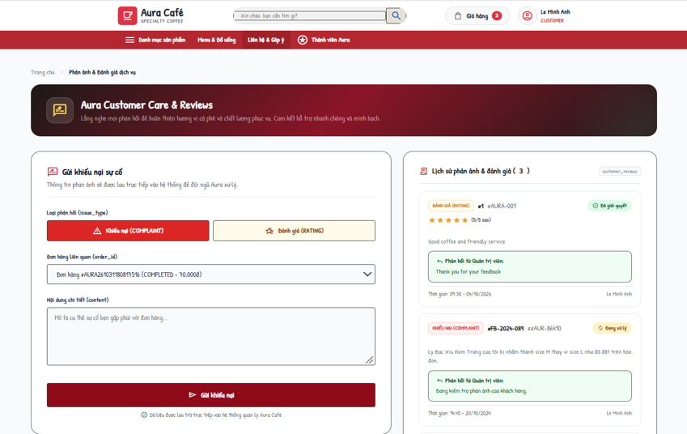
Actors: Customer · Use cases: UC65
The Customer sends a rating or a complaint about one of his/her orders and follows the tickets.
This screen allows the user to:
- Submit a rating (1-5 stars) or a complaint.
- View own tickets with status and admin response.
Field Description
Field Name | Description
Loại phản hồi (issue_type) | RATING (Đánh giá) or COMPLAINT (Khiếu nại).
Đơn hàng liên quan (order_id) | Dropdown of own orders that have no feedback yet ("Không còn đơn hàng chưa phản hồi" when empty). Invalid/already reviewed → MSG41.
Số sao đánh giá (rating) | 1-5, only for RATING (default 5).
Nội dung chi tiết (content) | Textarea, required (MSG40).
Gửi (Send) | Saves the ticket with status PENDING. Not signed in → MSG42.
My tickets | Code, order, type, rating, content, status, progress, admin response.

3. Counter Ordering (Cashier)

3.1 Point of Sale

3.1.1 Cashier POS
Screen / URL: /cashier (AJAX actions on /api/orders)
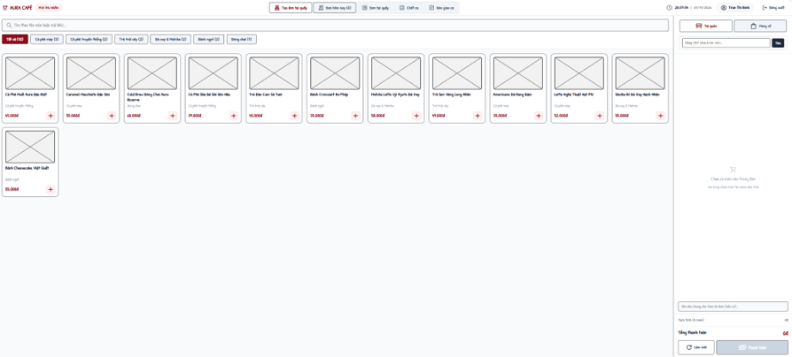
Actors: Cashier, Payment Gateway · Use cases: UC18, UC19, UC21, UC22, UC64, UC62
Point-of-sale screen. Access requires STAFF + CASHIER + ACTIVE (MSG43). Prices, points and totals sent by the browser are recalculated on the server.
This screen allows the user to:
- Pick products by category or search, choose options and add them to the order.
- Look up a member by phone and redeem points.
- Choose dine-in/takeaway, table and note; take cash or VietQR payment.
- See today's counter orders; cancel or hand over an order; print the bill.
Field Description
Field Name | Description
Product selection
Category filter / search | "Tất cả" + categories with counts; search "Tìm theo tên món hoặc mã SKU...".
Options dialog | Size, toppings, sugar (100% / 70% / 50% / 30% / Không đường), ice (100% / 70% / 50% / Ít đá / Không đá / Uống nóng), item note, quantity.
Order panel
Loại đơn | Tại quán (DINE_IN) with table number, or Mang đi (TAKEAWAY).
Nhập SĐT khách hội viên | Member lookup (GET action=search-customer). Not found → MSG44.
Dùng điểm | Points to redeem; capped to balance and subtotal; multiple of points_step.
Ghi chú chung | Order note.
Payment
Tiền mặt (Cash) | "Khách đưa (VNĐ)" with quick amounts (Đúng số tiền, 50k ... 1,000k) and "Tiền thừa trả khách". Order CONFIRMED, payment SUCCESS, points REDEEM/EARN.
VietQR | Shows bank, account number and holder for scanning. Payment PENDING until confirmed (auto-confirmed in test mode).
Create order | POST action=create-order. No item → MSG45; invalid member → MSG46; success → MSG47.
Đơn hôm nay (Today's orders)
Columns | Mã đơn, Thời gian, Loại đơn, Khách hàng, Món đã gọi, Tổng tiền, Hình thức, Trạng thái, Thao tác.
Hủy (Cancel) | action=cancel-order; only PENDING / CONFIRMED (MSG48).
Hoàn tất (Hand over) | action=complete-order; only READY dine-in / takeaway orders (MSG49).

3.1.2 Counter Order List
Screen / URL: /cashier/orders?date=&status=&type=
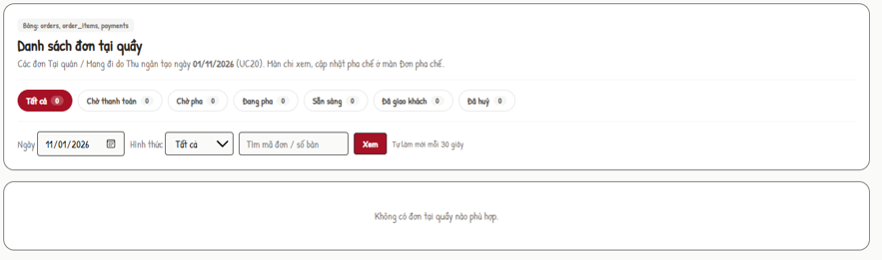
Actors: Cashier, Barista · Use cases: UC20
Read-only list of counter orders (DINE_IN / TAKEAWAY) of a day for Cashier and Barista (other roles → 403).
This screen allows the user to:
- Choose a date, filter by status and type, search by order code / table.
Field Description
Field Name | Description
Ngày (Date) | Date picker, default today.
Hình thức | Tất cả / Tại quán / Mang đi.
Status counters | ALL, PENDING, CONFIRMED, PREPARING, READY, COMPLETED, CANCELLED.
Order rows | Code, time, type, table / customer, items, amount, status.

3.2 Shift Handover

3.2.1 Cashier Shift Handover
Screen / URL: /cashier/handover?mode={close|handover}&scheduleId=

Actors: Cashier · Use cases: UC60, UC73
Closes the Cashier's current PRESENT shift and shows the resulting handover report. Only STAFF + CASHIER + ACTIVE (MSG50).
This screen allows the user to:
- Review the cash summary of the open shift and enter the counted cash.
- Submit the handover report.
- Read the review result; explain and resubmit a rejected report.
Field Description
Field Name | Description
Chốt két (Close mode)
Shift summary | Expected cash = opening cash + attributed counter CASH receipts + COD physically confirmed by the cashier - CASH refunds issued from this shift. Preserve the original receipt even if later refunded through BANK_TRANSFER. Save the reconciliation snapshot atomically; require a reason for a difference.
Tiền mặt thực tế cuối ca (actual_cash) | Number, 0 - 9,999,999,999, multiple of 1,000 đ (MSG51).
Ghi chú bàn giao (note) | Textarea, max 500 characters; required when actual ≠ expected (MSG52).
Chốt ca | Button. In one transaction: schedule → COMPLETED and handover → SUBMITTED (MSG53). Shift already closed → MSG54.
Biên bản bàn giao (Handover mode)
Report | Shift, opening cash, cash sales, expected, actual, difference (Khớp / Thừa / Thiếu), note, status, reviewer note.
Giải trình và gửi lại | Only for REJECTED reports; explanation required (MSG55); report → SUBMITTED (MSG56).
Recent shifts | Last 15 schedules of the Cashier.

4. Drink Preparation (Barista)

4.1 Order Preparation

4.1.1 Barista Dashboard
Screen / URL: /barista (JSON: /api/orders), completed view: /barista?action=completed
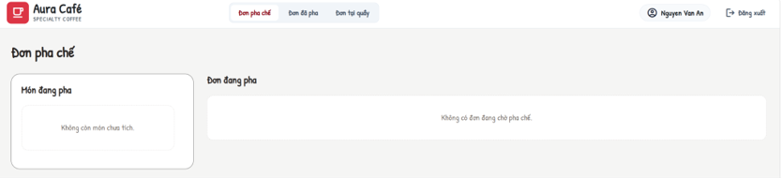
Actors: Barista · Use cases: UC23, UC24
Preparation queue shared by all channels (DINE_IN, TAKEAWAY, ONLINE). An order is shown when it is paid (payment SUCCESS) or is an ONLINE COD order. The page refreshes data from /api/orders. All POST actions require the Bearer JWT.
This screen allows the user to:
- See active orders (CONFIRMED / PREPARING) with items, customizations, table and note.
- Tick / untick prepared items (per cup); an order with ticked items is shown as "Đang pha".
- Finish an order (READY).
- See completed (READY) orders with completion time.
Field Description
Field Name | Description
Order card | Order code, type, created time, table / recipient, note, item count, status.
Item checkbox | action=update-items (itemIds, isPrepared). Prepared flags are kept by the server while the order is active; ticking an item shows the order as preparing.
Hoàn tất (Done) | action=update-order-status, status=READY; allowed from CONFIRMED / PREPARING. Deducts ingredients by recipe (OUT_ORDER) in the same transaction; not enough stock → MSG57; order changed meanwhile → MSG58. (status=PREPARING is also accepted by the API.)
Đơn đã pha (Completed) | READY orders, newest first.

5. Delivery Management (Delivery Staff)

5.1 Delivery Dashboard

5.1.1 Delivery Management
Screen / URL: /delivery?tab={active|done|cod}&id=&date=
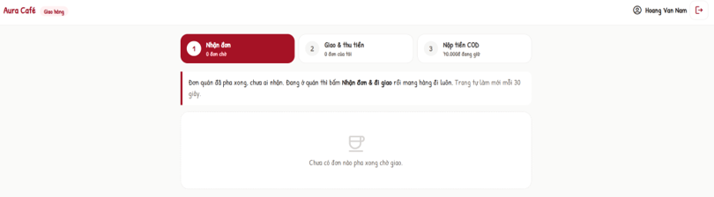
Actors: Delivery Staff · Use cases: UC26, UC27, UC28, UC29, UC30
Work screen of the delivery staff (STAFF + SHIPPER + ACTIVE; others → 403). Only deliveries assigned to the signed-in user are visible. All POST actions require the Bearer JWT.
This screen allows the user to:
- See assigned deliveries with counters (waiting, in progress, delivered today).
- Accept, pick up and confirm delivery; enter collected COD.
- Report a delivery issue.
- View delivered orders of a date.
- Hand over held COD cash to a Cashier and view the COD history.
Field Description
Field Name | Description
Đơn được phân công (Active tab)
Delivery card | Order code, recipient, phone, address, note, items, COD amount, status.
Nhận đơn (accept) | ASSIGNED → ACCEPTED (MSG59 when not waiting).
Lấy hàng (pickup) | ACCEPTED + order READY → delivery and order DELIVERING (MSG60).
Giao thành công (deliver) | "Tiền đã thu" (required for COD, must equal COD amount - MSG61) and delivery note (≤ 500). Payment SUCCESS + EARN points, delivery DELIVERED, order COMPLETED.
Báo sự cố (report) | Loại sự cố: Không liên lạc được khách, Sai / không tìm thấy địa chỉ, Khách từ chối nhận hàng, Hàng bị đổ vỡ / hư hỏng, Kẹt xe / thời tiết, giao trễ, Khác; Mô tả required ≤ 500 (MSG62). Allowed while the delivery is not DELIVERED.
Đơn đã giao (Done tab)
Date + table | Mã đơn, Người nhận, Địa chỉ, Giao lúc, COD đã thu.
Tiền COD (COD tab)
Tiền COD đang giữ | Delivered COD orders not yet handed over and their total.
Thu ngân nhận tiền | Dropdown of ACTIVE cashiers (MSG63). "Nộp tiền" records hand-over time and receiver for all held orders (MSG64).
Lịch sử nộp tiền COD | Mã đơn, Đã thu, Nộp lúc, Thu ngân nhận.

6. Administration - Menu and Recipe

6.1 Admin Home

6.1.1 Admin Dashboard
Screen / URL: /admin/reports, rendered by the React Admin workspace.
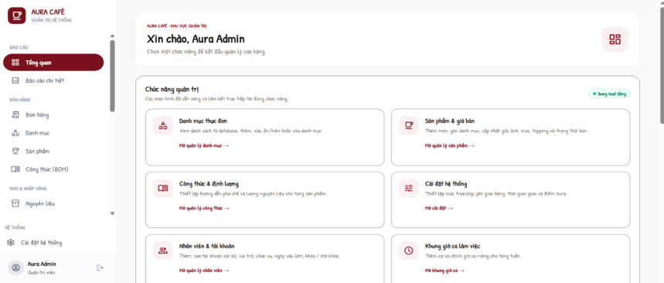
Actors: Admin
Home page of the back-office with a greeting and tiles for every admin function; the left sidebar is shared by all admin screens.
This screen allows the user to:
- Open any admin function.
Field Description
Field Name | Description
Tiles | Danh mục thực đơn, Sản phẩm & giá bán, Công thức & định lượng, Cài đặt bán hàng online, Nhân viên & tài khoản, Khung giờ ca làm việc, Lịch phân ca nhân viên, Chấm công nhân viên, Bàn giao ca, Nguyên vật liệu, Tồn kho & Xuất nhập, Đề xuất nhập hàng, Phiếu nhập hàng, Nhà cung cấp, Quản lý đơn hàng, Khách hàng, Tích điểm thành viên, Đánh giá & Khiếu nại, Báo cáo kinh doanh.

6.2 Category and Product

6.2.1 Category Management
Screen / URL: /admin/categories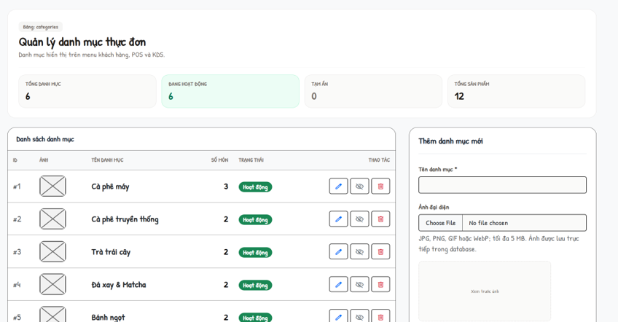

Actors: Admin · Use cases: UC31, UC32, UC33, UC34
Manages menu categories. All POST actions require the Bearer JWT (MSG65).
This screen allows the user to:
- List categories.
- Create or edit a category with image.
- Hide / show a category.
- Delete a category without products.
Field Description
Field Name | Description
List | ID, Ảnh, Tên danh mục, Số món, Trạng thái, Thao tác (edit, hide/show, delete).
Tên danh mục * | Required, max 100 characters, unique (MSG66).
Trạng thái | ACTIVE / INACTIVE.
Ảnh đại diện | Optional file: JPG, PNG, GIF, WebP, ≤ 2 MB, content must match the type (MSG67). "Xóa ảnh hiện tại" removes it.
Delete | Rejected when the category has products (MSG68).

6.2.2 Product Management
Screen / URL: /admin/products?categoryId=&q=
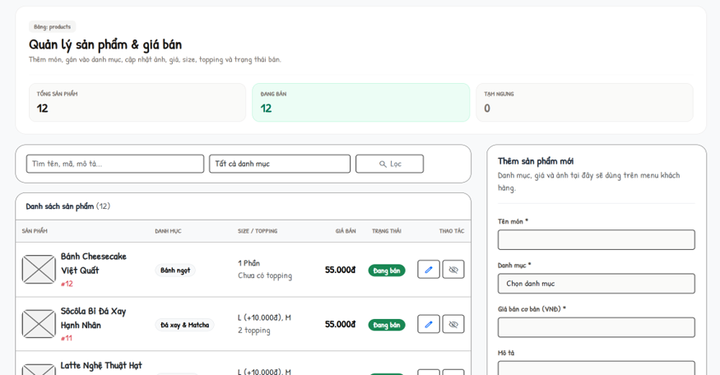
Actors: Admin · Use cases: UC35, UC36, UC37, UC38, UC39
Manages products, prices, options and images.
This screen allows the user to:
- Filter by category and keyword; see available / paused counters.
- Create or edit a product with sizes, toppings and image.
- Pause or resume selling.
Field Description
Field Name | Description
List | Sản phẩm, Danh mục, Size / Topping, Giá bán, Trạng thái, Thao tác.
Tên món * | Required, max 150 characters.
Danh mục * | Existing category.
Giá bán cơ bản (VNĐ) * | Number ≥ 0, max 2 decimals.
Mô tả | Textarea.
Sizes | Rows of name (≤ 30) + surcharge ≥ 0; at least one size and one size with 0 đ.
Toppings | Rows of name (≤ 50) + price ≥ 0.
Ảnh sản phẩm | Same rules as category image.
Bán / Tạm ngừng | Toggles is_available (MSG69).

6.3 Recipe

6.3.1 Recipe Management
Screen / URL: /admin/recipes?productId=
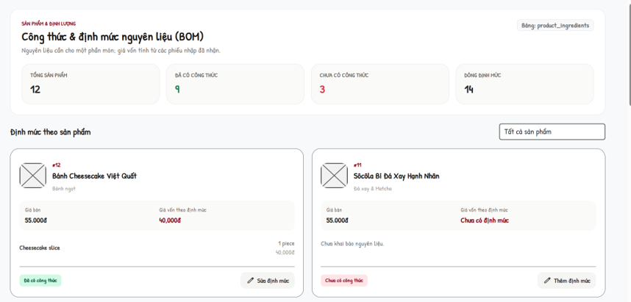
Actors: Admin · Use cases: UC40, UC41, UC42, UC43
Bill of materials per product. Cost of a portion = Σ(quantity required × latest unit price of a RECEIVED purchase order). Ingredients without a received price are listed as missing cost.
This screen allows the user to:
- See products with / without recipe and the number of recipe lines.
- Open a product recipe and its cost.
- Add, edit or remove ingredient lines and quantities; save the product BOM. There is no recipe deactivation or instruction editor in the active screen.
Field Description
Field Name | Description
Filter | Tất cả sản phẩm / Đã có công thức / Chưa có công thức.
Product summary | Product, ingredient lines for one portion, cost (complete or missing prices).
Legacy preparation instructions | Not editable or saved by the active Recipe Management form. Legacy instruction data may remain in products.variants_config.
Nguyên liệu + Định lượng | Rows: ingredient (dropdown with unit) and quantity > 0 with max 3 decimals; no duplicate ingredient (MSG70). "+ Thêm nguyên liệu" / "Xóa".
Lưu công thức | Replaces all lines of the product (MSG71).

7. Administration - Inventory and Purchasing

7.1 Ingredient and Inventory

7.1.1 Ingredient Management
Screen / URL: /admin/inventory?q=&supplierId=
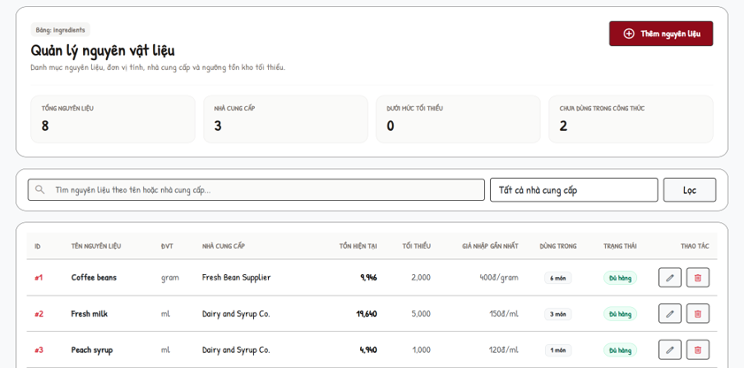
Actors: Admin · Use cases: UC44, UC45, UC46, UC47
Master data of ingredients with stock indicators.
This screen allows the user to:
- Search by name / supplier.
- Create, edit or delete an ingredient.
Field Description
Field Name | Description
List | ID, Tên nguyên liệu, ĐVT, Nhà cung cấp, Tồn hiện tại, Tối thiểu, Giá nhập gần nhất, Dùng trong (recipes), Trạng thái, Thao tác.
Tên nguyên liệu * | Required.
Đơn vị tính (ĐVT) * | Required (gram, ml, piece...).
Nhà cung cấp | Optional supplier.
Tồn kho ban đầu | Only on create, ≥ 0.
Ngưỡng tối thiểu | Minimum stock level ≥ 0.
Delete | Rejected when used in a recipe (MSG72).

7.1.2 Inventory Management
Screen / URL: /admin/inventory
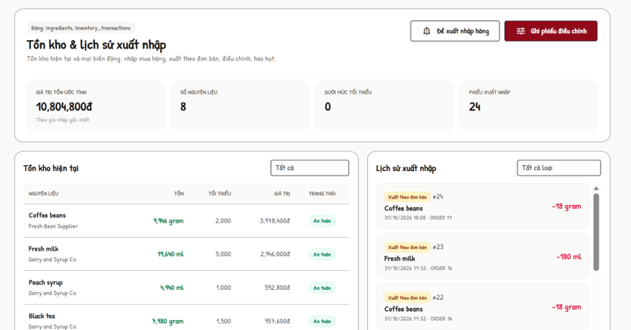
Actors: Admin · Use cases: UC48, UC49
Current stock and the movement history; manual adjustments are recorded as inventory transactions.
This screen allows the user to:
- Filter stock by status.
- Filter the movement history by type.
- Record a stock adjustment.
Field Description
Field Name | Description
Tồn kho hiện tại | Filter Tất cả / Sắp hết / An toàn / Hết hàng; columns Nguyên liệu, Tồn, Tối thiểu, Giá trị, Trạng thái.
Lịch sử xuất nhập | Filter Nhập mua hàng (IN_PURCHASE), Xuất đơn bán (OUT_ORDER), Điều chỉnh kho (ADJUSTMENT), Hao hụt / Hủy (SPOILAGE).
Nguyên liệu cần chỉnh * | Dropdown with current stock.
Loại điều chỉnh * | ADJUSTMENT (stock count) or SPOILAGE (always decreases).
Hướng điều chỉnh | Cộng thêm (+) / Trừ bớt (−).
Số lượng thay đổi * | Number > 0 (MSG73).
Lý do / Ghi chú | 3-500 characters (MSG74). Success → MSG75.

7.2 Purchasing

7.2.1 Restock Requests
Screen / URL: /admin/restock
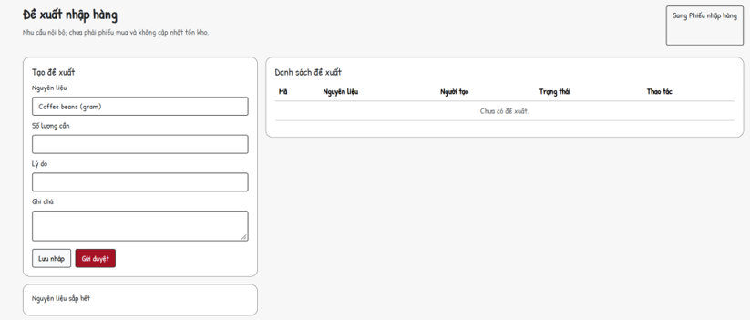
Actors: Admin · Use cases: UC50, UC51
Internal requests to buy ingredients, approved before a purchase order is made.
This screen allows the user to:
- See low-stock ingredients and counters (low stock, pending, approved, draft).
- Create a request as draft or send it for approval.
- Submit, approve, reject or cancel requests.
Field Description
Field Name | Description
Nguyên liệu | Dropdown (with unit).
Số lượng cần | Number > 0.
Lý do / Ghi chú | Text, max 500.
Lưu nháp / Gửi duyệt | Creates DRAFT or PENDING_APPROVAL.
List | Mã (RR-0001), Người tạo, items, Trạng thái, Thao tác (Gửi, Duyệt, Từ chối, Hủy with review note). Status changed meanwhile → MSG76.

7.2.2 Supplier Management
Screen / URL: /admin/suppliers
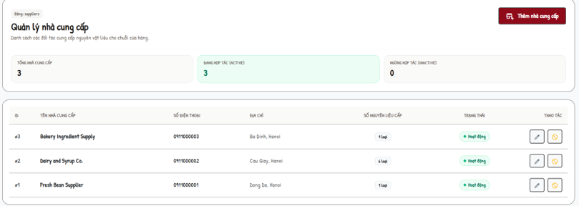
Actors: Admin · Use cases: UC52
Suppliers of ingredients.
This screen allows the user to:
- Create, edit and activate / deactivate suppliers.
Field Description
Field Name | Description
List | ID, Tên nhà cung cấp, Số điện thoại, Địa chỉ, Số nguyên liệu cấp, Trạng thái, Thao tác.
Tên nhà cung cấp * | Required (MSG77).
Số điện thoại / Địa chỉ | Optional.
Trạng thái | Hoạt động (ACTIVE) / Tạm ngừng (INACTIVE).

7.2.3 Purchase Orders
Screen / URL: /admin/purchases
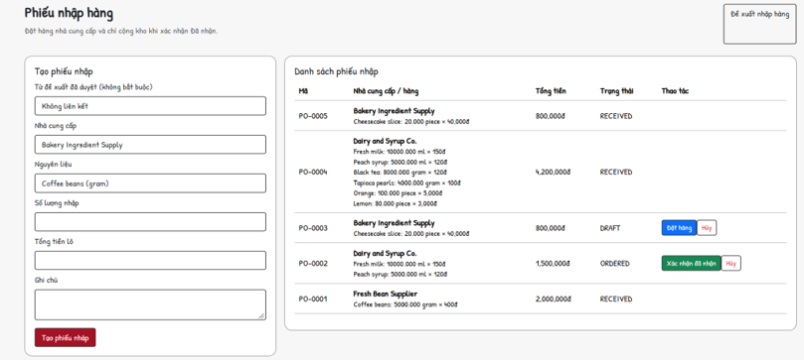
Actors: Admin · Use cases: UC53
Purchase orders to suppliers; stock is increased only when the order is confirmed as received.
This screen allows the user to:
- Create a draft purchase order (optionally from an approved restock request).
- Place, receive or cancel purchase orders.
Field Description
Field Name | Description
Từ đề xuất đã duyệt | Optional APPROVED request (each request used once; otherwise MSG78).
Nhà cung cấp | ACTIVE supplier, required.
Nguyên liệu | Required.
Số lượng nhập | Number > 0 (3 decimals).
Tổng tiền lô | Number ≥ 0; unit price = total / quantity (MSG79 when invalid).
Ghi chú | Max 500.
List | Mã (PO-0001), Nhà cung cấp / hàng, Tổng tiền, Trạng thái; Đặt hàng (DRAFT → ORDERED), Xác nhận đã nhận (ORDERED → RECEIVED, stock + IN_PURCHASE), Hủy (DRAFT / ORDERED).

8. Administration - Human Resources

8.1 Employees and Shifts

8.1.1 Employee Management
Screen / URL: /admin/employees?position=
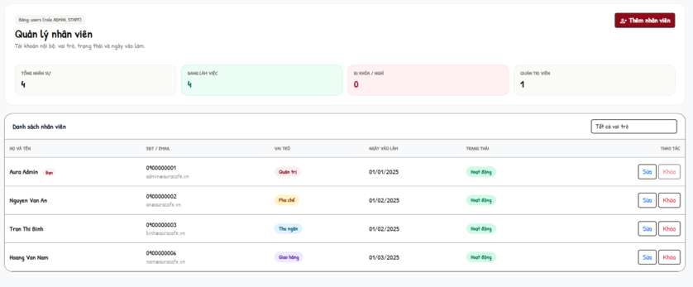
Actors: Admin · Use cases: UC54
Staff and administrator accounts. Only ADMIN can open it (MSG80).
This screen allows the user to:
- Filter employees by role.
- Add or edit an employee.
- Lock / unlock an account.
Field Description
Field Name | Description
Lọc theo vai trò | Tất cả vai trò, Quản trị, Pha chế, Thu ngân, Giao hàng.
List | Họ và tên, SĐT / Email, Vai trò, Ngày vào làm, Trạng thái, Thao tác (Sửa, Khóa / Mở khóa).
Họ và tên * | Required, max 120.
Số điện thoại (đăng nhập) * | 9-11 digits, unique.
Email | Optional, valid format, max 150, unique.
Mật khẩu * | Required on create, 6-255 characters; empty on edit keeps the old password.
Vai trò | Quản trị (ADMIN + MANAGER) / Thu ngân / Pha chế / Giao hàng (STAFF + position).
Trạng thái | Hoạt động / Ngừng hoạt động / Đã khóa. Admin cannot downgrade or lock himself (MSG81).
Ngày vào làm / Ngày sinh / Địa chỉ | Optional; birthday not in the future; address ≤ 500.

8.1.2 Work Shift Management
Screen / URL: /admin/shifts?week={yyyy-MM-dd}
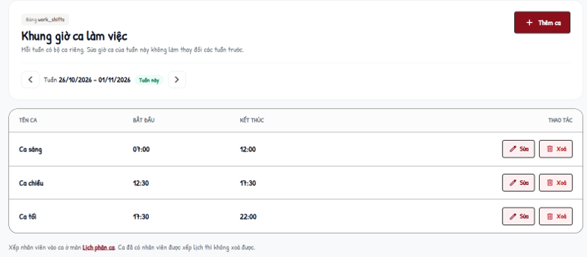
Actors: Admin · Use cases: UC55
Shift frames are stored per week so changing this week does not affect previous weeks. Past weeks are view-only.
This screen allows the user to:
- Move between weeks.
- Add, edit or delete a shift of the selected week.
- Copy the shifts of the latest earlier week into an empty week.
Field Description
Field Name | Description
Tuần (Week) | Week from Monday to Sunday.
Table | Tên ca, Bắt đầu, Kết thúc, Thao tác.
Tên ca * | Required, max 50, unique in the week (MSG82).
Bắt đầu / Kết thúc | HH:mm; end after start; must not overlap another shift of the week (MSG83).
Delete | Rejected when employees are scheduled in the shift (MSG84).
Sao chép ca | Only into an empty week; source = latest earlier week with shifts (MSG85).

8.2 Schedule and Attendance

8.2.1 Work Schedules
Screen / URL: /admin/schedules?view={calendar|table|board}&date=
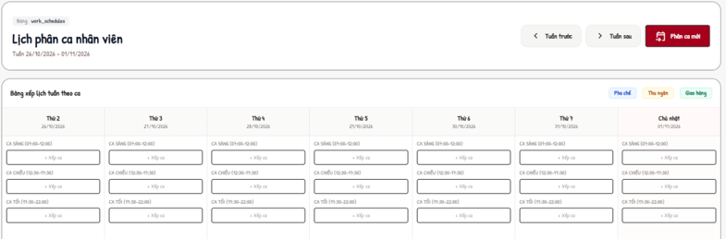
Actors: Admin · Use cases: UC56, UC57
Assigns employees to the shifts of the week that contains the work date.
This screen allows the user to:
- View the week as a calendar or table, or one day as a board.
- Assign, update or delete a schedule.
Field Description
Field Name | Description
Nhân viên * | ACTIVE employee with a position.
Ngày làm việc * | Date (yyyy-MM-dd).
Ca làm việc * | Shift of the week of the work date (MSG86 if the week has no shift / wrong week).
Tiền két đầu ca (VNĐ) | Cashier only; 0 - 9,999,999,999, multiple of 1,000 (MSG87).
Ghi chú | Max 500.
Trạng thái (update) | Đã xếp lịch, Có mặt, Vắng mặt, Hoàn thành; closing cash fields for cashier.
Duplicate | Same employee, date and shift → MSG88.

8.2.2 Attendance
Screen / URL: /admin/attendance?date=
Actors: Admin · Use cases: UC58, UC59
Daily attendance based on the schedules; late minutes are calculated from the start time of the shift of that week.
This screen allows the user to:
- Choose a date.
- Update check-in, check-out, status and note.
Field Description
Field Name | Description
List | Nhân viên, Ca làm việc, Giờ vào (late minutes), Giờ ra, Trạng thái, Ghi chú, Thao tác.
Trạng thái * | Đã xếp lịch / Có mặt / Hoàn thành / Vắng mặt.
Giờ vào / Giờ ra | HH:mm. PRESENT needs check-in; COMPLETED needs check-out after check-in (MSG89).
Ghi chú | Max 500.

8.2.3 Shift Handover Review
Screen / URL: /cashier/handover?status={SUBMITTED|CONFIRMED|REJECTED|ALL}
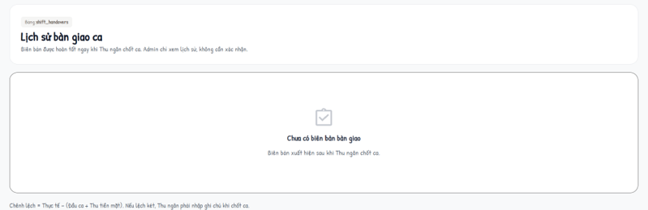
Actors: Admin · Use cases: UC69
Admin reviews the cash handover reports submitted by cashiers.
This screen allows the user to:
- Filter reports by status.
- Confirm or reject a SUBMITTED report.
Field Description
Field Name | Description
Table | Ca làm, Thu ngân, Đầu ca, Thu tiền mặt, Hệ thống, Thực tế, Chênh lệch (Khớp / Thừa / Thiếu), Ghi chú, Trạng thái, Thao tác.
Xác nhận | Optional opinion (≤ 500) → CONFIRMED.
Từ chối | Reason required (MSG90) → REJECTED; the cashier can resubmit.
Concurrency | Only SUBMITTED reports can be reviewed (MSG91).

9. Administration - Sales and Customers

9.1 Orders

9.1.1 Order Management
Screen / URL: /admin/orders?detailId=
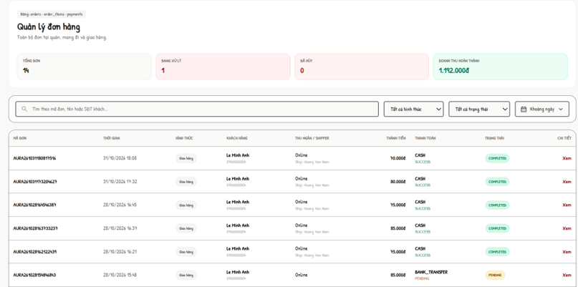
Actors: Admin · Use cases: UC67, UC72, UC14
All orders of all channels with KPIs (total, in progress, cancelled, completed revenue).
This screen allows the user to:
- Search and filter orders by type and status.
- Open the order detail (items, prepared flags, payment, delivery and issues).
- Update the order status.
- Assign, change or remove the delivery staff of an ONLINE order.
Field Description
Field Name | Description
Filters | Search (code, name, phone); Tại quán / Mang đi / Giao hàng; status list.
List | Mã đơn, Thời gian, Hình thức, Khách hàng, Thu ngân / Shipper, Thành tiền, Thanh toán, Trạng thái, Chi tiết.
Trạng thái đơn (status) | Any of PENDING, CONFIRMED, PREPARING, READY, DELIVERING, COMPLETED, CANCELLED (MSG92).
Shipper (shipper_id) | Select an active on-shift shipper for an unfinished ONLINE order before pickup. Persist ASSIGNED in Order.delivery and history. The assigned shipper explicitly accepts before pickup; reassignment after pickup requires a typed RETURN issue. Delivery is embedded in Order, not a separate authoritative collection.

9.2 Customers and Loyalty

9.2.1 Customer Management
Screen / URL: /admin/customers
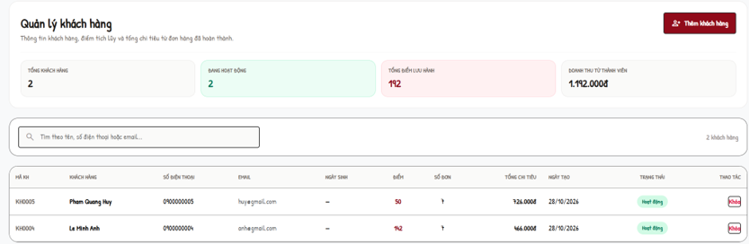
Actors: Admin · Use cases: UC61
Customers with loyalty and spending summary.
This screen allows the user to:
- Search customers.
- Add a customer.
- Lock / unlock a customer.
Field Description
Field Name | Description
List | Mã KH, Khách hàng, Số điện thoại, Email, Ngày sinh, Điểm, Số đơn, Tổng chi tiêu, Ngày tạo, Trạng thái, Thao tác.
Họ và tên / Số điện thoại | Required; phone format, unique (MSG94).
Email / Địa chỉ / Ngày sinh | Optional.
Điểm tặng khởi tạo | Initial points ≥ 0.
Khóa / Mở khóa | ACTIVE ↔ LOCKED.

9.2.2 Loyalty Management
Screen / URL: /admin/memberships?phone=
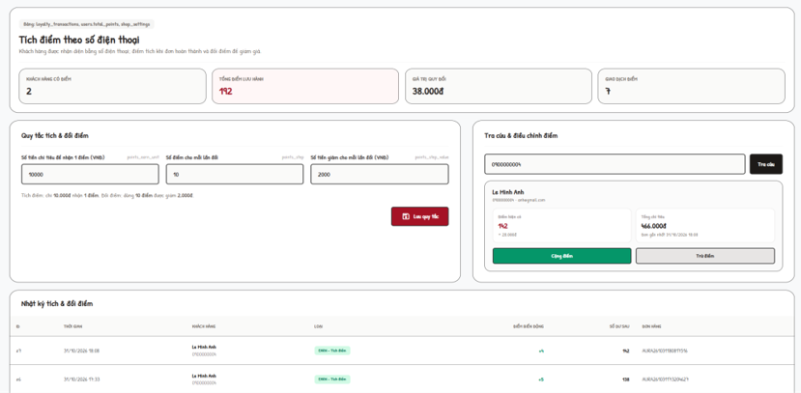
Actors: Admin · Use cases: UC63, UC62, UC64
Phone-number based loyalty: rules, lookup and manual adjustment.
This screen allows the user to:
- Edit earn and redeem rules.
- Look up a customer by phone.
- Add or subtract points (recorded as ADJUST).
- View the transaction log.
Field Description
Field Name | Description
points_earn_unit | Money spent for 1 point, 1 - 100,000,000 đ.
points_step | Points per redemption step, 1 - 1,000,000.
points_step_value | Discount per step, 0 - 100,000,000 đ.
Tra cứu | Phone lookup; not found → MSG95.
Cộng / Trừ điểm | 1 - 1,000,000 points.
Nhật ký | ID, Thời gian, Khách hàng, Loại, Điểm biến động, Số dư sau, Đơn hàng.

9.2.3 Feedback Management
Screen / URL: /admin/complaints?type=&status=
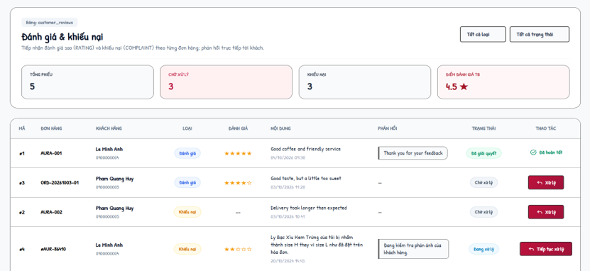
Actors: Admin · Use cases: UC70
Handles ratings and complaints. KPIs: total, complaints, average rating.
This screen allows the user to:
- Filter by type and status.
- Respond to a ticket and set its status.
Field Description
Field Name | Description
Filters | Tất cả loại / Đánh giá / Khiếu nại; Tất cả trạng thái / Chờ xử lý / Đang xử lý / Đã giải quyết / Từ chối.
List | Mã, Đơn hàng, Khách hàng, Loại, Nội dung, Phản hồi, Trạng thái, Thao tác.
Trạng thái xử lý | IN_PROGRESS (stays open), RESOLVED or REJECTED (closed, final).
Nội dung phản hồi * | Required, max 2,000 characters (MSG96). Closed tickets cannot be edited.

9.3 Reports

9.3.1 Business Reports
Screen / URL: /admin/reports?range={today|7d|30d|month|custom}&from=&to=
Actors: Admin · Use cases: UC66
Aggregated from orders, order items, payments, ingredients and inventory transactions; no report data is stored.
This screen allows the user to:
- Choose a period (default last 30 days; custom range ≤ 366 days).
- Read KPIs, charts and lists.
Field Description
Field Name | Description
Range | Hôm nay / 7 ngày / 30 ngày / Tháng này / Tùy chọn (from ≤ to, MSG97).
KPIs | Revenue (successful payments), paid orders, total / completed / cancelled / in-progress orders.
Charts and lists | Revenue by date, revenue by order type, successful payments by method, orders by status, top products, top ingredients used for orders.
Cần xử lý | Ingredients below minimum (current), pending restock requests, pending feedback.

10. Administration - System Configuration

10.1 Settings

10.1.1 Shop Settings
Screen / URL: /admin/settings
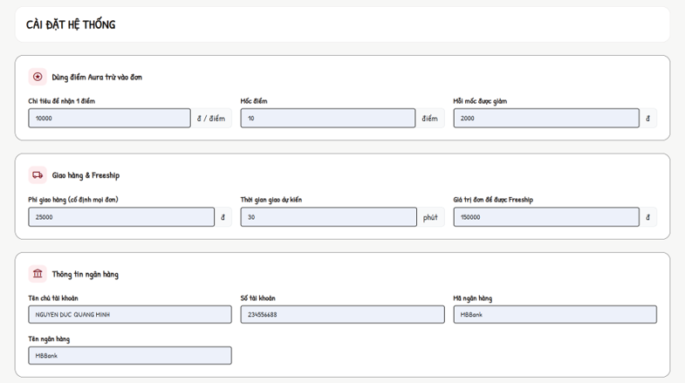
Actors: Admin · Use cases: UC68
Online-sales configuration plus a generic list of setting keys; changes apply on the next page load of the cart.
This screen allows the user to:
- Save online-sales settings.
- Edit all setting keys.
- Add a new setting key.
Field Description
Field Name | Description
Mua từ bao nhiêu thì được Freeship | freeship_threshold, 0 - 100,000,000 đ (0 = always free).
Phí giao tạm tính | delivery_fee, 0 - 1,000,000 đ (used before a district is chosen).
Thời gian giao dự kiến | delivery_minutes, 5 - 300.
Mốc điểm / Mỗi mốc được giảm / Chi tiêu để nhận 1 điểm | points_step 1 - 100,000; points_step_value 1,000 - 10,000,000 đ; points_earn_unit 1,000 - 100,000,000 đ.
Tất cả khóa cài đặt | Grouped: Giao hàng, Tích điểm, Ca làm việc, Khác; value required.
Thêm khóa cài đặt | Key: lowercase letters, digits, underscore, ≤ 50, unique; value ≤ 255 (MSG98).

10.1.2 Delivery Area Fees
Screen / URL: /admin/delivery-areas
Actors: Admin · Use cases: UC71
Fixed delivery fee per Hanoi district used at checkout.
This screen allows the user to:
- Edit fee and "Nhận giao" flag of each district.
- Add a district.
Field Description
Field Name | Description
Quận / Huyện | Name, required, max 50, unique.
Phí giao (đ) | 0 - 1,000,000 (MSG99).
Nhận giao | Active flag; inactive districts are not offered at checkout.

11. Background Job Inventory
The current release has no scheduled (timer-based) background job. The automatic processes below are event-driven: they run inside the request that triggers them and always in a single database transaction, so a failure leaves no partial data.
ID | Process | Trigger | Processing
EV-01 | Confirm payment from gateway callback | POST /api/payments/callback from the provider; authenticated DEMO_ONLINE uses its separate test-only confirmation. | Verify HMAC-SHA256 signature and amount; set payment SUCCESS/FAILED; order PENDING → CONFIRMED; EARN points once.
EV-02 | Earn loyalty points | Payment becomes SUCCESS (online, counter, COD on delivery) | points = floor((total − discount) / points_earn_unit); insert EARN; update user balance in the same transaction.
EV-03 | Deduct ingredients | An order moves from CONFIRMED to PREPARING or READY (Barista "Done") | For each recipe line: stock −= quantity × order quantity; insert OUT_ORDER once per ingredient; reject if stock is insufficient.
EV-04 | Receive purchase order | Admin confirms a purchase order as received | Increase stock, insert IN_PURCHASE movements, set RECEIVED in one transaction.
EV-05 | Refund / reverse points on cancellation | Customer or Cashier cancels an order | Insert REFUND for redeemed points and ADJUST for earned points; pending payment → FAILED.

12. External API Inventory

12.1 POST: /api/payments/callback (API-01)
Field | Value
URL | POST /api/payments/callback
Purpose | Verifies a provider-signed bank-transfer result and atomically updates payment/order and one-time point/cart effects. Demo confirmation uses its separate authenticated endpoint.
Caller | Payment provider server. The browser registers through the authenticated backend and reads stored status; it does not manufacture bank confirmation.
Auth | HMAC-SHA256 over orderCode|transactionCode|amount|STATUS using protected PAYMENT_CALLBACK_SECRET; constant-time comparison. This provider authentication is independent of a browser JWT.
Parameters | orderCode, transactionCode, amount, status (SUCCESS / FAILED), gatewayReference, signature.
Response | JSON accepted/successful result. HTTP 200 for accepted/repeated matching success; 401 for invalid signature; 400 for malformed data; 409 for mismatched amount/reference/state; 404 for unknown transaction. Do not apply payment effects on rejection.

12.2 GET VietQR image (API-02)
Field | Value
URL | GET https://vietqr.app/img?bank={bankId}&acc={accountNo}&template=compact&amount={amount}&des={orderCode}&showinfo=true&fullacc=true&holder={accountName}&store=AURA%20Cafe
Purpose | Renders the VietQR image that the customer scans to transfer the exact amount with the order code as content.
Caller | CMS pages (Payment screen, Cashier POS) - called by the browser.
Auth | No.

12.3 Password recovery API-03
Field | Value
URL | POST /api/auth/forgot-password; POST /api/auth/verify-otp; POST /api/auth/reset-password.
Purpose | Deliver an expiring email OTP, verify it and grant one-use reset authorization; no response or log may disclose recovery secrets.
Caller | Authentication recovery UI; backend/routes/passwordRecoveryRoutes.js calls backend/utils/recoveryEmail.js and persists PasswordRecovery documents.
Auth | No login JWT is required for recovery. Enforce email/code/token validation, TTL, attempt limits and resend limits; SMTP credentials remain server-only.

12.4 Internal JSON endpoints
Internal JSON APIs use Bearer JWT where protected. Public catalog reads do not require login; every write enforces its documented role, ownership and input contract.
Endpoint | Purpose
GET /api/cart; PUT /api/cart | Load/save the authenticated Customer cart; browser-only guest cart merges after login. Server recalculates supported options/prices.
GET /api/products; GET /api/products/:id | Public catalog/detail data for menu and product dialogs; the client applies category/keyword filters to available published products.
GET/POST /api/orders; PUT /api/orders/:id/status | Role-scoped order reads, counter creation and authorized status changes; separate payment endpoints confirm collection.
GET /api/orders; PUT /api/orders/:id/items/:itemIndex/prepared; PUT /api/orders/:id/status | Barista queue and preparation updates with Bearer JWT, position/eligibility/state checks and one-time stock effects.
GET /api/categories; GET /api/products | Read imageUrl/data URL metadata; image validation/upload belongs to authorized category/product mutations, not legacy image servlets.

4. Requirement Appendix

1. Business Rules
GBR-ID | Rule Statement | Applies To | Rationale | Enforced By
GB-01 | Prices, surcharges, points discount, delivery fee and totals are always recalculated on the server from the database; values sent by the browser are ignored. | Cart, Checkout, Cashier POS | Prevents price tampering and stale prices. | The system on every add-to-cart, cart view, checkout and counter order
GB-02 | Only a signed-in CUSTOMER account can place an online order; Admin and staff accounts cannot. | Checkout, Payment | Online orders and loyalty points belong to customers. | The system on every checkout / payment request
GB-03 | Online orders are delivery orders inside Hà Nội. The district must be an active delivery area; the fee is that district's fee, or 0 when the goods subtotal ≥ freeship_threshold. | Checkout | Fixed, explainable delivery cost per district. | The system at checkout
GB-04 | An order enters the preparation queue only when a payment is SUCCESS, or when it is an ONLINE order paid by COD. | Barista Dashboard | Avoids preparing unpaid orders. | The system when loading and updating the queue
GB-05 | Order status follows PENDING → CONFIRMED → PREPARING → READY → DELIVERING → COMPLETED (ONLINE) or READY → COMPLETED (DINE_IN / TAKEAWAY). A Customer can cancel only PENDING unpaid orders; a Cashier only PENDING / CONFIRMED counter orders. | Orders | Keeps the kitchen, delivery and payment consistent. | Role/position/ownership and current-state guards in the Express order, payment and work-schedule handlers.
GB-06 | Ingredients are deducted by recipe exactly once per order when it goes to PREPARING / READY; the change is rejected if any ingredient stock is insufficient. | Barista Dashboard, Inventory | Accurate stock without Number deduction. | The system in the same transaction as the status change
GB-07 | Points earned = floor((goods amount − points discount) / points_earn_unit); delivery fee is excluded; earned once per order when payment becomes SUCCESS (COD: on successful delivery). | Loyalty | Rewards actual spending only. | The system on payment success
GB-08 | Redeemed points must be a multiple of points_step, not exceed the balance, and the discount ((points / points_step) × points_step_value) must not exceed the goods amount. Redeemed points are refunded when the order is cancelled. | Cart, Cashier POS, Cancellation | Fair and reversible point usage. | The system at cart refresh, order creation and cancellation
GB-09 | Payment confirmation requires authenticated ownership/role, a matching server-calculated amount and the correct current payment state. A payment is confirmed and credited at most once. | Payment callback | Prevents forged or duplicated confirmations. | The system on every callback
GB-10 | A COD delivery can be completed only when the collected amount equals the COD amount; otherwise the delivery staff must report an issue. | Delivery Management | Cash accountability. | The system on "Giao thành công"
GB-11 | Delivery staff can see and act only on deliveries assigned to them; pick-up is allowed only when the order is READY; re-assignment is not allowed after pick-up. | Delivery Management, Order Management | Clear responsibility per order. | The system on every delivery request
GB-12 | A deactivated (INACTIVE) or LOCKED account cannot sign in; the login error does not reveal whether the identifier or the password is wrong. | Login | Security of accounts. | The system on every sign-in
GB-13 | Protected portals check current role, position and ACTIVE status through API middleware. Every request validates resource ownership; permissions do not rely on a stale browser session. | All staff and admin screens | Least privilege. | The system on every request
GB-14 | Protected JSON mutations use an explicit Bearer JWT rather than an ambient login-session cookie. Validate request bodies and configure deployment CORS and HTTPS. | Admin, Barista, Delivery screens | Prevents cross-site request forgery. | The relevant token-protected POST handlers
GB-15 | Work shifts are stored per week; editing a week never changes other weeks; past weeks are read-only; a shift with scheduled employees cannot be deleted. | Work Shift Management | Historical schedules and attendance stay correct. | The system on shift add / update / delete
GB-16 | Expected cash = opening cash + attributed counter CASH receipts + COD physically confirmed by the cashier - CASH refunds issued from this shift. Preserve the original receipt even if later refunded through BANK_TRANSFER. Save the reconciliation snapshot atomically; require a reason for a difference. | Cashier Shift Handover | Cash control between shifts. | The system on "Chốt ca"
GB-17 | A handover can be reviewed only while SUBMITTED; rejection requires a reason; a rejected handover can be resubmitted only by its cashier with an explanation. | Shift Handover Review | Auditable review cycle. | The system on confirm / reject / resubmit
GB-18 | Stock is increased only when a purchase order is confirmed as RECEIVED; recipe cost uses the latest received unit price of each ingredient. | Purchase Orders, Recipes | Inventory and cost reflect goods actually received. | The system on receive and on recipe view
GB-19 | Feedback tickets in RESOLVED or REJECTED status are final and cannot be edited or reopened. | Feedback Management | Stable history of customer care. | The system on every response
GB-20 | Admin cannot downgrade, deactivate or lock the account currently signed in. | Employee Management | Prevents locking out the last administrator. | The system on employee save and lock
GB-21 | Multi-table operations (place order, counter order, payment callback, COD completion, stock movements, shift close, purchase receive) run in one database transaction with conditional updates. | Whole system | No partial data after a failure. | The system (DAO layer)

2. System Messages
# | Message code | Message Type | Context | Content
1 | MSG01 | In line | Search / filter returns no data | Không tìm thấy món phù hợp / Không tìm thấy đơn hàng phù hợp
2 | MSG02 | Error page 403 | User opens a screen of another role | Chỉ tài khoản Admin được ... / Chỉ nhân viên ... được truy cập màn hình này.
3 | MSG03 | Alert (red) | Bearer JWT missing / expired on a staff or admin form | Phiên làm việc đã được làm mới. Vui lòng thao tác lại.
4 | MSG04 | Alert (red) | Database error while saving | Không thể lưu thay đổi vào database. Vui lòng thử lại.
5 | MSG05 | Alert (red) | Unknown action sent to a screen | Thao tác không hợp lệ.
6 | MSG06 | Error page | HTTP 404 / 500 | React error state with an actionable message and retry/navigation controls.
7 | MSG10 | Alert in login dialog | Wrong identifier / password or account not ACTIVE | Tên đăng nhập hoặc mật khẩu không chính xác, hoặc tài khoản đã bị khóa!
8 | MSG11 | Alert in register dialog | Invalid registration data | Họ và tên không được để trống. / Số điện thoại không hợp lệ (VD: 0912345678). / Địa chỉ email không hợp lệ. / Mật khẩu phải từ 6 ký tự trở lên. / Mật khẩu xác nhận không khớp.
9 | MSG12 | Alert in register dialog | Phone already used | Số điện thoại đã tồn tại trong hệ thống.
10 | MSG13 | Alert in register dialog | E-mail already used | Email đã tồn tại trong hệ thống.
11 | MSG14 | Alert (green) | Registration succeeded | Đăng ký thành công! Vui lòng đăng nhập.
12 | MSG15 | Alert (red) | Forgot password with unknown e-mail | Email không tồn tại trong hệ thống.
13 | MSG16 | Alert (red) | Wrong OTP | Mã OTP không chính xác. Vui lòng kiểm tra lại.
14 | MSG17 | Alert (red) | OTP session expired | Phiên xác thực đã hết hạn. Vui lòng yêu cầu lại.
15 | MSG18 | Alert (red) | Resend OTP within 60 seconds | Vui lòng đợi {n} giây trước khi gửi yêu cầu mới.
16 | MSG19 | Alert (red) | New password confirmation differs | Mật khẩu xác nhận không khớp.
17 | MSG20 | Alert (green) | Password reset succeeded | Đổi mật khẩu thành công! Vui lòng đăng nhập lại.
18 | MSG21 | Toast | Add an unavailable product to cart | Món này hiện đã ngừng phục vụ.
19 | MSG22 | Alert in cart | Guest tries to redeem points | Vui lòng đăng nhập bằng tài khoản khách hàng để dùng điểm Aura.
20 | MSG23 | Alert in cart | Redeemed points adjusted by the server | Số điểm Aura dùng cho đơn đã được điều chỉnh còn {n} điểm do tiền hàng, số điểm của bạn hoặc mốc điểm vừa thay đổi.
21 | MSG24 | Alert in cart | Checkout with no selected line | Vui lòng chọn ít nhất một món để đặt hàng.
22 | MSG25 | Alert in checkout | Guest submits checkout | Vui lòng đăng nhập bằng tài khoản khách hàng để tiếp tục đặt hàng.
23 | MSG26 | Alert in checkout | Staff / Admin submits checkout | Tài khoản quản trị/nhân viên không thể đặt hàng online. Vui lòng đăng nhập bằng tài khoản khách hàng.
24 | MSG27 | Alert in checkout | District not delivered | Quán chưa giao tới {district}. Vui lòng chọn quận khác hoặc Tự đến lấy.
25 | MSG28 | Alert in checkout | Not enough ingredient stock | Có món đã hết hoặc không đủ số lượng. Vui lòng sửa giỏ hàng.
26 | MSG29 | Alert in checkout | Point balance changed before placing | Số điểm Aura của bạn vừa thay đổi nên chưa thể trừ {n} điểm. Tổng tiền đã được cập nhật lại, vui lòng kiểm tra trước khi xác nhận.
27 | MSG30 | Alert in payment | Manual confirm when test mode is off | Giao dịch đang chờ cổng thanh toán xác nhận tự động.
28 | MSG31 | Alert (green) | Bank transfer confirmed | Thanh toán thành công đơn #{code}. Bạn được cộng {n} điểm Aura.
29 | MSG32 | Alert (green) | COD chosen | Đã xác nhận thanh toán COD cho đơn #{code}. Điểm sẽ được cộng sau khi giao hàng và thu tiền.
30 | MSG33 | Alert (red) | Customer opens another customer's bill | Bạn không có quyền truy cập hóa đơn của đơn hàng này!
31 | MSG34 | Alert (green) | Customer cancels an order | Đã hủy đơn #{code} và hoàn lại {n} điểm Aura.
32 | MSG35 | Alert (red) | Cancel a paid / processed order | Chỉ hủy được đơn chưa thanh toán.
33 | MSG36 | Alert (green) | Reorder succeeded | Đã thêm {n} món của đơn #{code} vào giỏ hàng (giá theo thực đơn hiện tại).
34 | MSG37 | Alert (red) | Reorder with no available item | Các món trong đơn #{code} hiện đã ngừng phục vụ.
35 | MSG38 | Alert (red) | Profile saved with empty name | Họ và tên không được để trống!
36 | MSG39 | Alert (red) | Wrong current password | Mật khẩu hiện tại không đúng!
37 | MSG40 | Alert (red) | Feedback without content | Vui lòng nhập nội dung góp ý hoặc phản ánh của bạn!
38 | MSG41 | Alert (red) | Feedback for invalid / already reviewed order | Đơn hàng không hợp lệ hoặc đã được bạn phản hồi trước đó.
39 | MSG42 | Alert (red) | Feedback when not signed in | Vui lòng đăng nhập trước khi gửi phản hồi!
40 | MSG43 | JSON error 403 | Non-cashier calls the POS | Chỉ nhân viên hoặc quản trị viên được phép truy cập POS.
41 | MSG44 | Toast (POS) | Member phone not found | Không tìm thấy thông tin hội viên.
42 | MSG45 | Toast (POS) | Create order without items | Vui lòng chọn ít nhất 1 món ăn/thức uống.
43 | MSG46 | Toast (POS) | Member id does not match phone / locked | Khách hàng không hợp lệ hoặc đã bị khóa.
44 | MSG47 | Toast (POS) | Counter order created | Tạo đơn tại quầy thành công!
45 | MSG48 | Toast (POS) | Cancel counter order | Đã hủy đơn hàng thành công. / Đơn hàng đang được Barista pha chế hoặc đang giao, không thể hủy. / Đơn hàng đã hoàn thành, không thể hủy.
46 | MSG49 | Toast (POS) | Hand over counter order | Đã đánh dấu hoàn tất đơn hàng và giao khách thành công. / Không thể hoàn tất đơn hàng này (đơn phải được Barista pha chế xong hoặc đang giao).
47 | MSG50 | Error page 403 | Non-cashier opens Shift Handover | Chỉ nhân viên Thu ngân được phép truy cập màn hình bàn giao ca.
48 | MSG51 | Alert (red) | Invalid actual cash | Tiền két thực tế phải từ 0 đến 9.999.999.999đ và là bội số của 1.000đ.
49 | MSG52 | Alert (red) | Cash difference without note | Tiền két thực tế lệch so với hệ thống, vui lòng nhập ghi chú giải trình.
50 | MSG53 | Alert (green) | Shift closed | Đã chốt két và gửi biên bản bàn giao ca. Biên bản đang chờ Admin xác nhận.
51 | MSG54 | Alert (red) | Shift already closed / changed | Ca đã được chốt hoặc trạng thái ca vừa thay đổi. Vui lòng tải lại trang.
52 | MSG55 | Alert (red) | Resubmit without explanation | Vui lòng nhập nội dung giải trình trước khi gửi lại.
53 | MSG56 | Alert (green) | Handover resubmitted | Đã gửi lại biên bản bàn giao, đang chờ Admin xác nhận.
54 | MSG57 | Toast (Barista) | Insufficient ingredient stock when finishing | Không đủ tồn kho {ingredient}: còn {stock}, can {required}
55 | MSG58 | Toast (Barista) | Order changed meanwhile | Đơn đã thay đổi hoặc không còn được pha chế. Vui lòng kiểm tra lại.
56 | MSG59 | Alert (red) | Accept a delivery not waiting | Đơn #{code} không còn ở trạng thái chờ nhận.
57 | MSG60 | Alert (red) | Pick up before READY | Chỉ lấy hàng khi đã nhận đơn và quán đã pha chế xong (Sẵn sàng).
58 | MSG61 | Alert (red) | Collected COD differs | Số tiền thu hộ phải đúng {amount}. Nếu khách không trả đủ, hãy báo sự cố thay vì xác nhận giao thành công.
59 | MSG62 | Alert (red) | Issue report incomplete | Vui lòng chọn loại sự cố. / Vui lòng nhập mô tả sự cố.
60 | MSG63 | Alert (red) | COD hand-over without cashier | Vui lòng chọn Thu ngân nhận tiền.
61 | MSG64 | Alert (green) | COD handed over | Đã ghi nhận nộp {amount} tiền COD cho Thu ngân {name}.
62 | MSG65 | Error 403 | Category / product form with expired token | Phiên làm việc đã hết hạn. Tải lại trang rồi thử lại.
63 | MSG66 | Alert (red) | Duplicate category name | Tên danh mục đã tồn tại.
64 | MSG67 | Alert (red) | Invalid image upload | Ảnh danh mục/sản phẩm không được lớn hơn 2 MB. / Chỉ chấp nhận ảnh JPG, PNG, GIF hoặc WebP. / Nội dung tệp không đúng định dạng ảnh đã chọn.
65 | MSG68 | Alert (red) | Delete category with products | Không thể xóa danh mục đang có sản phẩm. Hãy chuyển sang Tạm ẩn.
66 | MSG69 | Alert (green) | Product availability changed | Đã cập nhật trạng thái bán sản phẩm.
67 | MSG70 | Alert (red) | Invalid recipe line | Không chọn trùng một nguyên liệu trong cùng công thức. / Định lượng phải lớn hơn 0 và có tối đa 3 chữ số thập phân.
68 | MSG71 | Alert (green) | Recipe saved | Đã lưu công thức cho món “{product}”.
69 | MSG72 | Alert (red) | Delete ingredient used in a recipe | Nguyên liệu đang được sử dụng trong công thức món, không thể xóa!
70 | MSG73 | Alert (red) | Adjustment quantity ≤ 0 | Số lượng phải lớn hơn 0.
71 | MSG74 | Alert (red) | Adjustment reason length | Vui lòng nhập lý do điều chỉnh từ 3 đến 500 ký tự.
72 | MSG75 | Alert (green) | Stock adjusted | Ghi nhận phiếu điều chỉnh tồn kho thành công!
73 | MSG76 | Alert (red) | Restock request status changed meanwhile | Không thể cập nhật vì trạng thái đề xuất đã thay đổi.
74 | MSG77 | Alert (red) | Supplier without name | Tên nhà cung cấp không được để trống.
75 | MSG78 | Alert (red) | Purchase order from a non-approved request | Chỉ đề xuất đã duyệt mới được chuyển thành phiếu nhập.
76 | MSG79 | Alert (red) | Invalid quantity / lot total | Số lượng và tổng tiền không hợp lệ.
77 | MSG80 | Error page 403 | Non-admin opens Employee Management | Chỉ tài khoản Admin được quản lý nhân viên.
78 | MSG81 | Alert (red) | Admin edits own role / status | Bạn không thể tự hạ quyền tài khoản đang đăng nhập. / Bạn không thể tự khóa hoặc ngừng hoạt động tài khoản đang đăng nhập.
79 | MSG82 | Alert (red) | Duplicate shift name in week | Tuần này đã có ca tên "{name}".
80 | MSG83 | Alert (red) | Invalid shift time | Giờ kết thúc phải sau giờ bắt đầu. / Bị chồng giờ với {shift}.
81 | MSG84 | Alert (red) | Delete a shift in use | {shift} đã có nhân viên được xếp lịch. Hãy gỡ lịch ở màn Lịch phân ca trước khi xoá ca.
82 | MSG85 | Alert (red) | Copy shifts not allowed | Tuần này đã có khung ca, chỉ sao chép được vào tuần đang trống. / Chưa có tuần nào trước đó để sao chép.
83 | MSG86 | Alert (red) | Shift not in the week of the work date | Ca làm việc không thuộc tuần của ngày đã chọn. Hãy tạo khung ca cho tuần {week} ở màn Khung giờ ca.
84 | MSG87 | Alert (red) | Invalid opening / closing cash | {field} phải là bội số của 1.000đ. / {field} không được là số âm.
85 | MSG88 | Alert (red) | Duplicate schedule | Nhân viên đã được xếp vào ca này trong ngày đã chọn.
86 | MSG89 | Alert (red) | Invalid attendance time | Vui lòng nhập giờ vào. / Vui lòng nhập giờ ra khi ca đã hoàn thành. / Giờ ra phải sau giờ vào.
87 | MSG90 | Alert (red) | Reject handover without reason | Vui lòng nhập lý do từ chối để Thu ngân giải trình.
88 | MSG91 | Alert (red) | Handover already reviewed | Biên bản đã được xử lý trước đó, vui lòng tải lại trang.
89 | MSG92 | Alert (green) | Order status updated by Admin | Đã cập nhật trạng thái đơn hàng.
90 | MSG93 | Alert (red) | Assign delivery staff not allowed | Chỉ gán shipper cho đơn giao tận nơi chưa hoàn thành / huỷ và shipper chưa lấy hàng.
91 | MSG94 | Alert (red) | Add customer with existing phone | Số điện thoại đã tồn tại.
92 | MSG95 | In line | Loyalty lookup not found | Không tìm thấy khách hàng có số điện thoại {phone}.
93 | MSG96 | Alert (red) | Feedback response invalid | Nội dung phản hồi không được để trống. / Nội dung phản hồi không được vượt quá 2.000 ký tự.
94 | MSG97 | Alert (red) | Invalid report range | Ngày bắt đầu phải trước hoặc bằng ngày kết thúc. / Chỉ xem tối đa 366 ngày mỗi lần.
95 | MSG98 | Alert (red) | Invalid new setting key | Khóa chỉ gồm chữ thường, số, gạch dưới và tối đa 50 ký tự. / Khóa cài đặt đã tồn tại.
96 | MSG99 | Alert (red) | Invalid district fee | Phí giao của {district} phải từ 0 đến 1.000.000đ.

3. Other Requirements

3.1 Technology and Environment
- Server: Node.js 22.12 or later, Express REST API, Mongoose ODM, jsonwebtoken and bcryptjs. Dependency versions are managed by the project package manifests.
- Database: MongoDB, database aura_cafe_erp. Mongoose schemas define field validation, ObjectId references and indexes; no MySQL schema or JDBC driver is required.
- Recovery uses the configured SMTP adapter and PasswordRecovery storage; missing provider settings return an explicit unavailable error without disclosing OTP or granting reset.
- Client: React, Vite, TypeScript, React Router, Zustand and Tailwind CSS in modern Chrome, Edge, Firefox and Safari browsers.
- Automated checks use the Node.js test runner for backend integration and frontend regression/render tests, plus TypeScript and Vite build checks. Execute database tests only against isolated test databases.

3.2 Security
- JWT-based authentication. Passwords are stored as bcrypt hashes. Logout clears client authentication state. Protect middleware reloads the current account and rejects inactive or locked accounts.
- Protected Express routes use JWT middleware and current account checks. Each operation additionally enforces role, staff position and resource ownership as appropriate. React navigation and hidden controls are not authorization.
- Mongoose queries validate identifiers, enums, numeric bounds and request shapes. RedirectUtil restricts post-login redirects to safe local paths.
- Payment confirmation validates authenticated permissions, order ownership, expected amount and current payment status. Local simulation is explicitly separate from real bank confirmation.
- Uploaded images are limited to 2 MiB and validated by allowed MIME type and file signature; reject invalid content before persistence.

3.3 Data Integrity and Reliability
- Critical multi-document writes require replica-set transactions, conditional state changes, unique indexes and idempotency keys. In-process locks or compensating writes are not crash-safe atomicity. If transactions are required but unavailable, reject before writing and report configuration failure.
- Mongoose validation and indexes enforce unique identity and business keys. Application logic validates references, enum transitions, non-negative amounts, stock and points. MongoDB does not provide relational foreign-key enforcement.
- Product name and unit price are stored on each order item so past orders and bills never change when the menu changes.
- Category and product image locations are stored as imageUrl strings. Order items retain the product name, unit price, customization and subtotal at ordering time.

3.4 Usability and Localisation
- User interface language: Vietnamese; currency: VND (thousands separated by "."); time zone: Asia/Ho_Chi_Minh.
- Lists display explicit empty, loading and error states. API errors remain visible to the user; an empty fallback is not proof of success.

3.5 Current implementation and target scope
- Bank registration, signed callback, COD and gated simulation are separate contracts. Provider credentials and a verified test environment are deployment prerequisites; successful mock tests do not establish live-bank acceptance.
- Customer checkout is ONLINE delivery to an active served Hanoi district. DINE_IN and TAKEAWAY are counter workflows. The server owns price, points, fee and eligibility calculations.
- Staff read their own schedules and record attendance through protected work-schedule endpoints. Admin manages weekly shift definitions and assignments; historical shift definitions are read-only.
- There is no scheduled background job (see I.5.3).
- Recovery uses /api/auth/forgot-password, /verify-otp and /reset-password with expiry, resend/attempt limits and one-use authorization. Authenticated change-password requires the old password; both store bcrypt hashes and revoke obsolete tokens as specified.
- Password storage uses bcrypt hashes in User.passwordHash. Authentication accepts a unique phone, full email or unambiguous email local part and rejects inactive/locked accounts.
- Protected API requests pass protect middleware, which reloads the account and checks ACTIVE status. Route guards enforce role/position/ownership. Mutations use authenticated POST/PUT/PATCH/DELETE requests; GET settings is read-only.
- Recipe data uses ProductIngredient links and the Product recipe snapshot. Ingredient consumption and FIFO cost allocations are guarded and recorded once for each order. Do not infer support for a separate instruction/deactivation workflow from obsolete SWP fields.
- ONLINE delivery fees come from the active DeliveryArea district and the configured freeship_threshold. Reject unknown/inactive districts, snapshot the accepted fee/address, and use zero fee at the threshold. Public reads must never seed or change area records.
- Order administration uses orderRoutes with allowed transition checks, role restrictions and payment/stock eligibility. Terminal states and accounting safeguards remain enforced.
- Online simulation and counter confirmation use paymentRoutes. Clients reload the stored Payment and Order result. QR display and navigation to a bill do not prove a real bank payment.
- Customer feedback requires an active Customer and an owned eligible order, with one submission per order. Guests cannot read customer tickets; closed RESOLVED/REJECTED tickets cannot be reopened or removed through the normal API.
- This baseline specifies required behavior, not release acceptance. Code that differs is an implementation gap. Record tests, screenshots, defects and release results separately. Bug fixes/internal refactoring preserve this document; changed business rules, API contracts or module boundaries require approved revision.

Implementation revision - 11 November 2026
Baseline: develop f560f68; branch fix/manh-report-workflow-audit. This revision describes the working-tree implementation and automated verification. Earlier dated release test records remain historical. The 30 formal acceptance cases and group approval remain separate.

MongoDB persistence
MongoDB with Mongoose is the only application database. A replica set or Atlas is required for multi-document transactions. Database.docx replaces the unrelated MySQL salon document and lists all 26 actual collections, ObjectId references and schema constraints. Earlier entity tables and diagrams are conceptual views, not literal SQL DDL. Delivery is embedded as Order.delivery; DeliveryIssue, DeliveryArea, RestockRequest and ShiftHandover are implemented models. RestockRequestItem is embedded in request.items.

Mạnh - seven assigned screens
Counter POS (/cashier); counter orders (/cashier/orders); barista (/barista); delivery (/delivery, /delivery/problems, /delivery/cod); reports (/admin/reports); admin orders (/admin/orders); delivery fees (/admin/delivery-areas). The Excel tracking sheet records implementation Done with evidence, without implying group acceptance.

Counter and delivery corrections
POS preserves the chosen CASH or BANK_TRANSFER method, member/points and item customizations. Server prices are authoritative. CASH requires explicit receipt; BANK_TRANSFER requires a verified signed callback. A QR or browser return does not settle a payment.
Order.delivery persists ASSIGNED, ACCEPTED, DELIVERING, DELIVERED, RETURNED and CANCELLED, actor/shipper history and stage timestamps. Accept: POST /api/orders/:id/delivery/accept. Issues: POST /api/orders/:id/delivery/issues; list: GET /api/delivery-issues. Admin/manager see all; shipper sees their reported issues. Terminal retries are idempotent and cannot rewrite cancellation evidence.
Issue types: UNREACHABLE, BAD_ADDRESS, REFUSED, DAMAGED, DELAY, OTHER. REPORT records only; RETURN is allowed for READY/DELIVERING and unassigns; CANCEL rejects already-paid orders requiring the manager refund flow. Unfinished assigned deliveries block shipper checkout/remittance. COD completion validates both the actual amount and pending payment amount; admin confirmation attributes receipt to the shipper.

Cash reconciliation and reports
An open shipper remittance includes all unremitted COD held by that shipper, including amounts collected before the current check-in. Closed-shift views use remittanceSchedule to prevent duplicate inclusion.
Expected drawer cash = opening cash + actual attributed counter CASH receipts + confirmed incoming COD - CASH refunds issued by this cashier shift. CASH refund requires an active issuing cashier/manager and stores refundSchedule; a later bank refund does not erase the original cash receipt. Persist cashRefunds in the handover snapshot. Legacy refunds lacking an issuing shift require manual reconciliation; no historical data is invented.
Revenue, order-type sales and top products use paidAt on matching successful payments; order counts use createdAt. Ingredient usage comes from actual OUT_ORDER movements, not current recipes or estimated sales. Vietnam calendar boundaries and a maximum inclusive range of 366 days apply. Attention counts include pending restock requests and in-progress feedback. The dashboard is not a net-profit statement.

Verification and remaining acceptance
Full backend: 102/102 tests passed on isolated MongoDB replica-set databases. Frontend: 103/103 direct test cases passed across six files; production build passed. Browser smoke opened all seven assigned screens (nine URLs) using isolated fixtures without JavaScript page errors. Regression tests cover ownership, accept-before-pickup, immutable terminal orders, issue persistence/rollback, exact COD, cash refunds and Vietnam-day usage.
SMTP delivery and real bank settlement require deployment credentials and provider acceptance tests. Automated provider fixtures do not prove a real email delivery or money transfer. See ../WORKFLOW_AUDIT_2026-11-11.md for workflow coverage, commands and limitations. Keep the original source report folder unchanged.

