

Café Management System (Aura Café)
Final Release Document

WDP301 - Web Development Project
Class: SE2064 - Group 1

– Hanoi, Nov 2026 –
Table of Contents
Change Log | I. Project Overview and Planning | II. Software Requirements Specification | III. Software Design Specification | IV. Testing and Quality Assurance | V. Release Package and User Guides | Implementation revision - 11 November 2026

Change Log
Date | Version | In Charge | Change Description
05/10/2026 | v0.1.0 | SE2064 Group 1 | Initial baseline: Counter ordering (POS), cash/online payment, e-bill and Barista drink preparation queue.
12/10/2026 | v0.2.0 | SE2064 Group 1 | Customer portal specifications: authentication, registration, customer profile, shopping cart, checkout and payment.
18/10/2026 | v0.3.0 | SE2064 Group 1 | Administration specifications: category, product, recipe, ingredient, inventory, restock, supplier, customer & order management.
24/10/2026 | v0.4.0 | SE2064 Group 1 | HR & Shifts: Weekly work shifts, attendance, cashier shift handover with Admin review (UC60, UC69, UC73), checkout redesign.
26/10/2026 | v0.5.0 | SE2064 Group 1 | Delivery management, phone loyalty, customer feedback/complaints, business reports dashboard, PlantUML sequence diagrams.
31/10/2026 | v0.9.0 | SE2064 Group 1 | Design review scope: business entities, 15 SRS flows, MERN architecture, API contracts and transaction requirements. Acceptance evidence is recorded separately after testing.
03/11/2026 | v1.0.0 | SE2064 Group 1 | Final Release Consolidation: Merged SRS and SDS into Template5 Final Release Document with full installation guides, user manuals, and deliverable package.

I. Project Overview and Planning

1. Project Overview
Aura Cafe is a web-based cafe management system using React with Vite, Node.js and Express, and MongoDB. It supports customer ordering, counter sales, drink preparation, delivery and store administration.
This report covers the project team and estimated effort, software requirements, system design, testing, and installation and usage instructions. The detailed requirements remain the business baseline for implementation.

2. Project Team
The development of the Aura Café Management System is carried out by SE2064 Group 1 for course WDP301. All core functional modules, architectural components, and delivery artifacts are allocated across the project members as follows:
No. | Student ID | Full Name | Role | Main responsibility
1 | HA180033 | Nguyễn Quốc Nguyên | Leader | Access and menu management
2 | HA180034 | Lê Hữu Đức Duy | Member | Inventory and purchasing
3 | HA180035 | Ngọc | Member | Customer ordering and loyalty
4 | HA180036 | Mạnh | Member | POS, preparation and delivery
5 | HA180037 | Sơn | Member | Staff, shifts and customer care

3. Work Allocation and Man-day Estimation
Each of the five members owns seven business screens. The table below summarizes effort and main responsibilities; the following screen matrix gives the detailed allocation.

3.1 Man-day Estimation
Proposed total: 60 MD = 480 hours. One MD equals 8 effort-hours. These estimates cover development, integration, testing and documentation; they are not actual recorded effort.
Member | Effort (MD / hours) | Main responsibilities
Nguyên | 8 MD / 64 h | Authentication and profile; homepage, menu and product details; category and product management.
Duy | 7 MD / 56 h | Ingredients, stock and recipes; restock, suppliers and purchases; store settings.
Ngọc | 14 MD / 112 h | Cart, checkout and payment; bills and order tracking; customer management and phone loyalty.
Mạnh | 17 MD / 136 h | Counter POS and orders; drink preparation and delivery; delivery fees and business reports.
Sơn | 14 MD / 112 h | Employees, shifts, schedules and attendance; handover and Admin review; customer complaints.

3.2 Screen Allocation
Each owner delivers code, documentation and tests. Dates, actual effort and peer-review results are maintained in ProjectTracking.
No. | Screen or dialog | UCs | Implemented by | Flow
1 | Authentication | UC01, UC02, UC03, UC04 | Nguyên | BF-10
2 | Customer Profile | UC05 | Nguyên | BF-10
3 | Home Page | UC06 | Nguyên | BF-11
4 | Product Menu | UC07, UC08 | Nguyên | BF-01
5 | Product Details | UC09 | Nguyên | BF-01
6 | Shopping Cart | UC10, UC64 | Ngọc | BF-01
7 | Online Checkout | UC11 | Ngọc | BF-01
8 | Counter POS | UC18, UC19, UC21, UC22 | Mạnh | BF-05
9 | Payment Processing | UC12, UC13 | Ngọc | BF-02
10 | Order Bill | UC14 | Ngọc | BF-02
11 | Customer Order History and Tracking | UC15, UC16, UC17, UC25 | Ngọc | BF-01
12 | Counter Order Management | UC20 | Mạnh | BF-05
13 | Barista Preparation Dashboard | UC23, UC24 | Mạnh | BF-03
14 | Delivery Dashboard | UC26, UC27, UC28, UC29, UC30 | Mạnh | BF-04
15 | Category Management | UC31, UC32, UC33, UC34 | Nguyên | BF-11
16 | Product Management | UC35, UC36, UC37, UC38, UC39 | Nguyên | BF-11
17 | Recipe Management | UC40, UC41, UC42, UC43 | Duy | BF-11
18 | Ingredient Management | UC44, UC45, UC46, UC47 | Duy | BF-08
19 | Inventory Management | UC48, UC49 | Duy | BF-08
20 | Restock Request Management | UC50, UC51 | Duy | BF-08
21 | Supplier Management | UC52 | Duy | BF-08
22 | Purchase Order Management | UC53 | Duy | BF-08
23 | Employee Management | UC54 | Sơn | BF-15
24 | Work Shift Management | UC55 | Sơn | BF-15
25 | Weekly Staff Scheduling | UC56, UC57 | Sơn | BF-06
26 | Staff Attendance | UC58, UC59 | Sơn | BF-06
27 | Cashier Shift Handover | UC60, UC73 | Sơn | BF-07
28 | Customer Management | UC61 | Ngọc | BF-13
29 | Phone-Based Loyalty Management | UC62, UC63, UC64 | Ngọc | BF-12
30 | Customer Feedback and Complaint Management | UC65, UC70 | Sơn | BF-09
31 | Business Reports Dashboard | UC66 | Mạnh | BF-13
32 | Admin Order Management | UC67, UC72, UC14 | Mạnh | BF-13
33 | Store Settings | UC68 | Duy | BF-14
34 | Admin Shift Handover Review | UC69 | Sơn | BF-07
35 | Delivery Area Fee Management | UC71 | Mạnh | BF-04
Shared use cases keep their original identifiers: UC14 appears in online, counter and Admin order views; UC62 and UC64 are invoked by payment and ordering flows as well as loyalty functions. Role-based access applies to all protected screens; the Authentication and access scope is assigned to Nguyên. Each member owns seven of the 35 tracked business screens and at least one complete business flow, including React/Vite UI, Express API, MongoDB persistence, permission checks and tests. Shared Admin Dashboard navigation and the external Payment Gateway service are excluded from the screen count.

II. Software Requirements Specification

1. Definition and Acronyms
Acronym / Term | Definition
CMS | Café Management System - the Aura Café web application described in this document
SRS | Software Requirement Specification
UC / BF | Use Case / Business Flow
ERD | Entity Relationship Diagram (Crow's Foot notation)
BOM | Bill of Materials - the recipe of a product: ingredient quantities for one portion
POS | Point of Sale - the Cashier counter-ordering screen
COD | Cash on Delivery - the customer pays cash to the delivery staff
OTP | One-Time Password - 6-digit code sent by e-mail to reset a password
CSRF | Cross-Site Request Forgery - mitigated by validated tokens in protected handlers; coverage is endpoint-specific
Payment authorization | Payment result validation - authenticate the requester, verify order ownership, compare the server-calculated amount and guard the current payment state.
VietQR | Vietnamese bank-transfer QR code standard (Napas 247)
VND / đ | Vietnamese đồng, the currency of all prices
DINE_IN / TAKEAWAY / ONLINE | Order types: eat at the café, take away from the counter, online delivery order
Aura point | Loyalty point of a Customer, identified by the customer's phone number
points_earn_unit / points_step / points_step_value | Loyalty settings: money spent for 1 point / points per redemption step / discount per step
Freeship threshold | Goods subtotal from which the delivery fee is 0 đ (setting freeship_threshold)
RR / PO | Restock Request / Purchase Order (displayed as RR-0001 / PO-0001)
Shipper | Database position code of the Delivery Staff actor
Admin | Administrator account (role ADMIN, position MANAGER, labelled "Quản trị")
Payment test mode | PAYMENT_DEMO_ENABLED enables the local payment simulation; COD remains pending until successful delivery collection.

2. Overall Requirements

1. Context Diagram
Aura Café Management System is a WDP301 web application using React with Vite, Node.js with Express and MongoDB through Mongoose. It supports online ordering, counter POS, preparation, delivery and administration of menu, recipes, inventory, purchasing, employees, weekly shifts, attendance, phone-based loyalty points, feedback and reports.
The context diagram below retains the system boundary and the information exchanges with Guest, Customer, Cashier, Barista, Delivery Staff, Admin and Payment Gateway. In the WDP301 release the payment-provider boundary is represented by local payment simulation and COD; a real provider integration is a separate deployment concern.
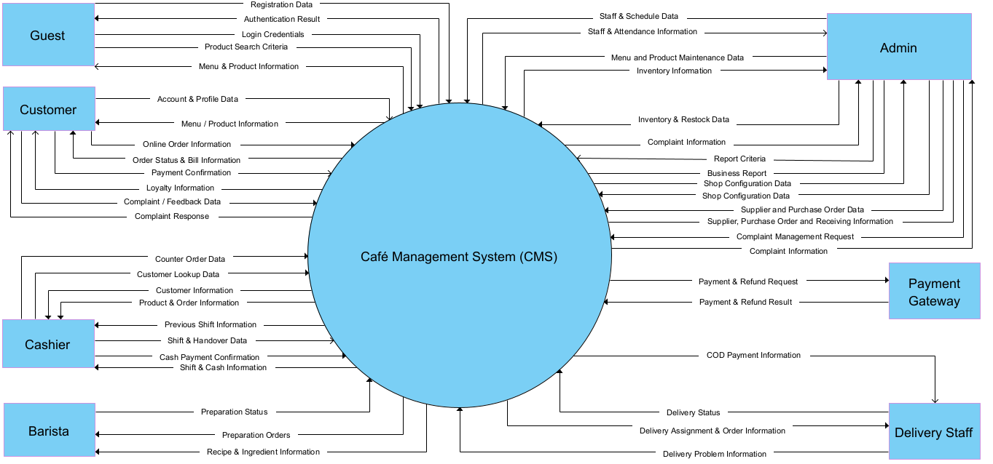
Figure 1 - Context diagram of the Café Management System

2. Main Business Flow
The baseline contains 15 business flows on React/Vite, Express and MongoDB. Screen ownership and workflow leadership remain separate. Requirements define required outcomes, not implementation completion. Internal code changes preserve these contracts; approved business/API changes require a versioned baseline update and linked acceptance evidence.

2.1 Online Ordering and Tracking (BF-01)
Workflow lead: Ngọc. Use cases: UC07-UC11, UC15-UC17, UC25, UC64. Screens: Menu; Product Detail; Shopping Cart; Checkout; My Orders.
Implementation references: Menu and Product Detail - Nguyên; Shopping Cart and Checkout - Ngọc; My Orders - Ngọc. Payment and Bill are covered by BF-02.
Trigger: Customer chooses products on the Menu or Product Details page.
End condition: The customer creates an ONLINE order and can track it, cancel it when eligible, or prepare a reorder. Payment is handled in BF-02.
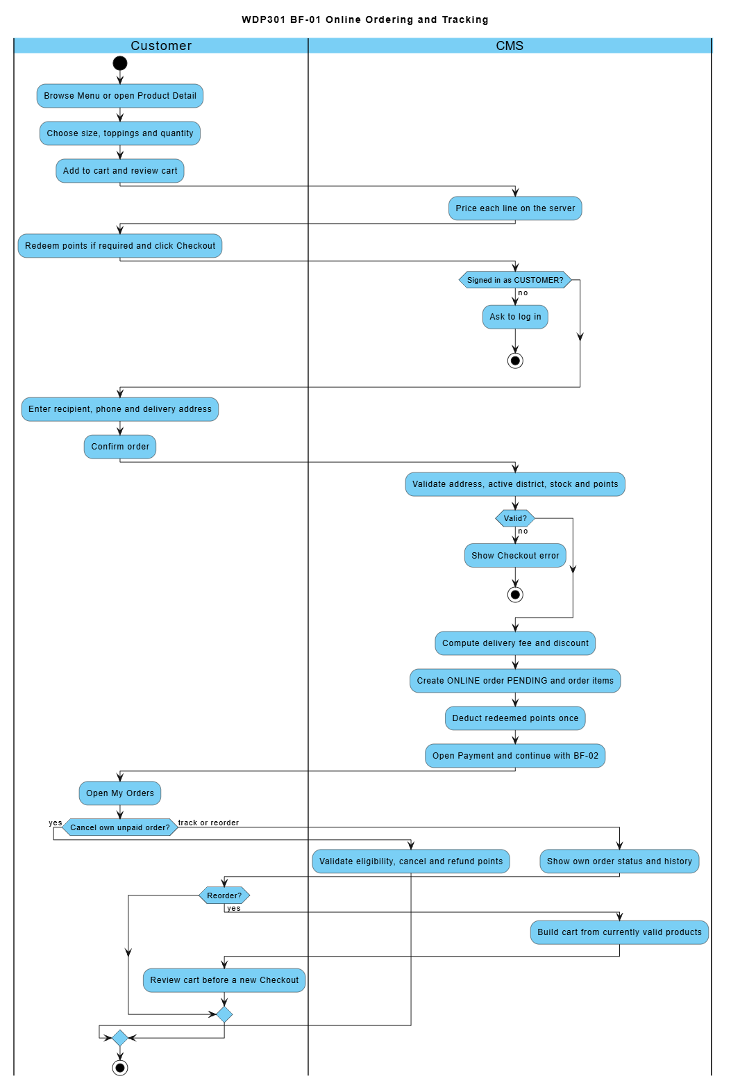

2.2 Online Payment (BF-02)
Workflow lead: Ngọc. Use cases: UC12-UC14, UC62, UC64. Screens: Payment; Bill.
Screen implementation: Payment and Bill - Ngọc. Workflow lead for online ordering and payment: Ngọc. The gateway is an external service, not an additional screen.
Trigger: Customer opens the Payment page of a PENDING order.
End condition: Order CONFIRMED (bank transfer verified or COD chosen), payment FAILED, or order CANCELLED with points refunded.
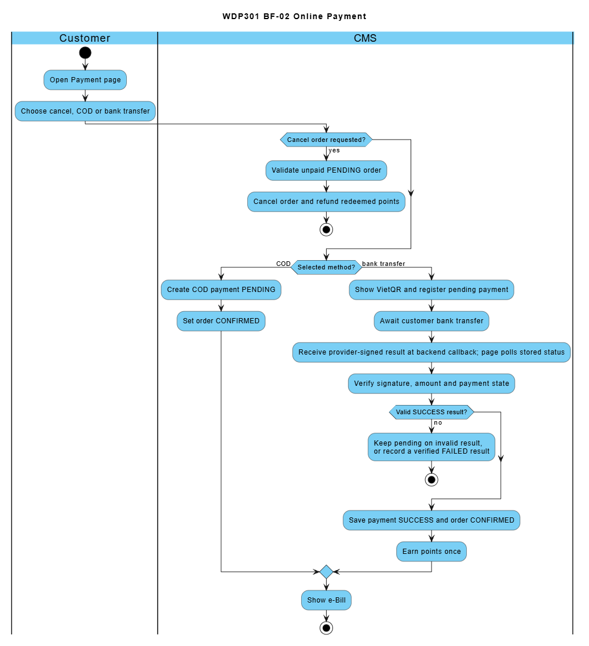

2.3 Order Preparation (BF-03)
Workflow lead: Mạnh. Use cases: UC23-UC24. Screens: Drink Preparation.
Trigger: Barista opens the Barista Dashboard.
End condition: The order is READY and its ingredients are deducted from stock.
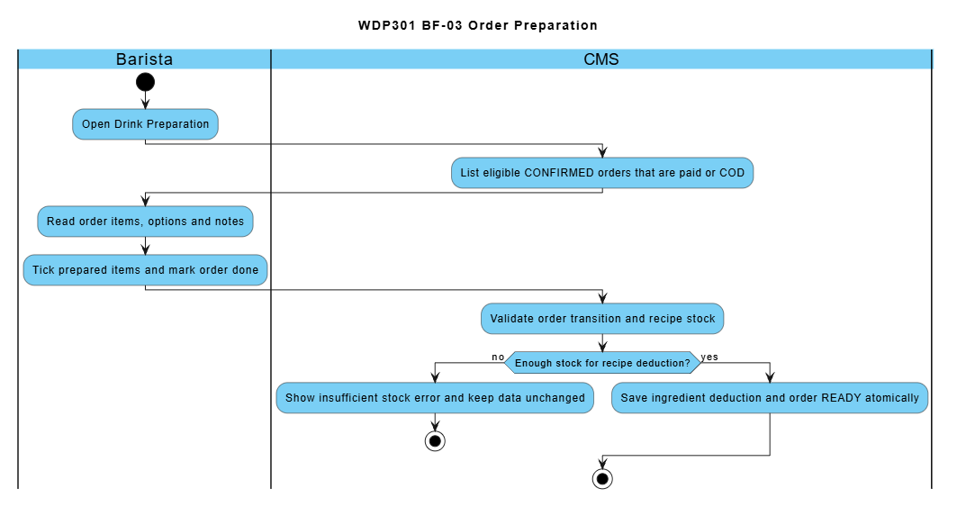

2.4 Order Delivery (BF-04)
Workflow lead: Mạnh. Use cases: UC26-UC30, UC71-UC72. Screens: Admin Orders; Delivery Management; Delivery Area Fees.
Screen implementation: Delivery Management, Delivery Area Fees, delivery assignment (UC72), and Admin Orders - Mạnh.
Trigger: Admin assigns a delivery staff to an ONLINE order.
End condition: The order is COMPLETED and the collected COD cash is handed over to a Cashier.
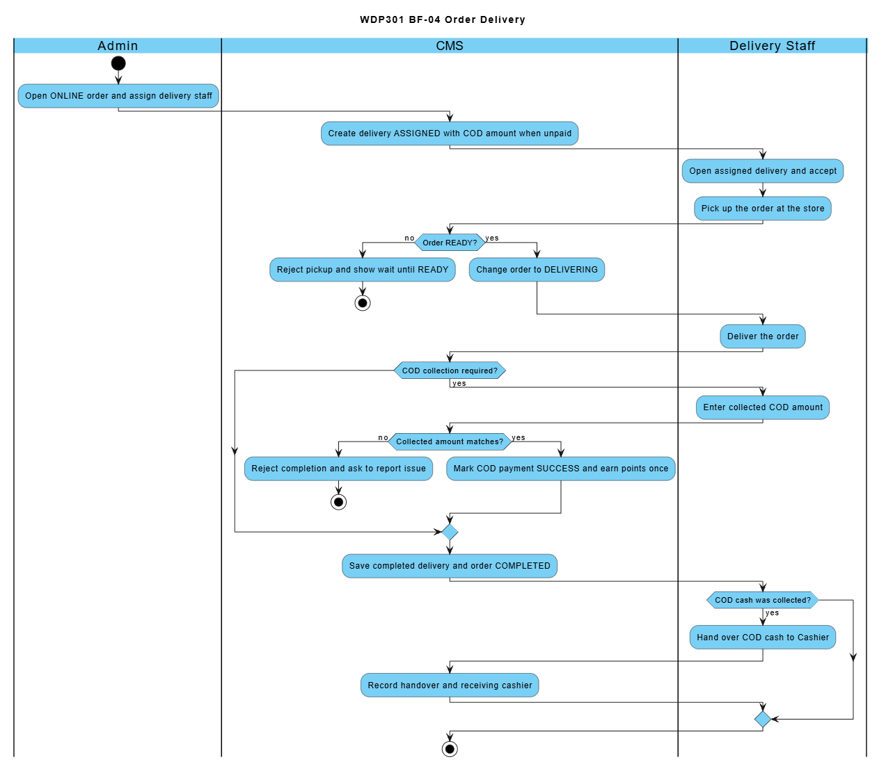

2.5 Counter Ordering (BF-05)
Workflow lead: Mạnh. Use cases: UC14, UC18-UC22, UC62, UC64. Screens: Menu; Counter Ordering; Counter Order List; Payment; Bill.
Trigger: Cashier enters the products ordered by a walk-in customer.
End condition: The order is COMPLETED when handed to the customer, or CANCELLED with points refunded / reversed.
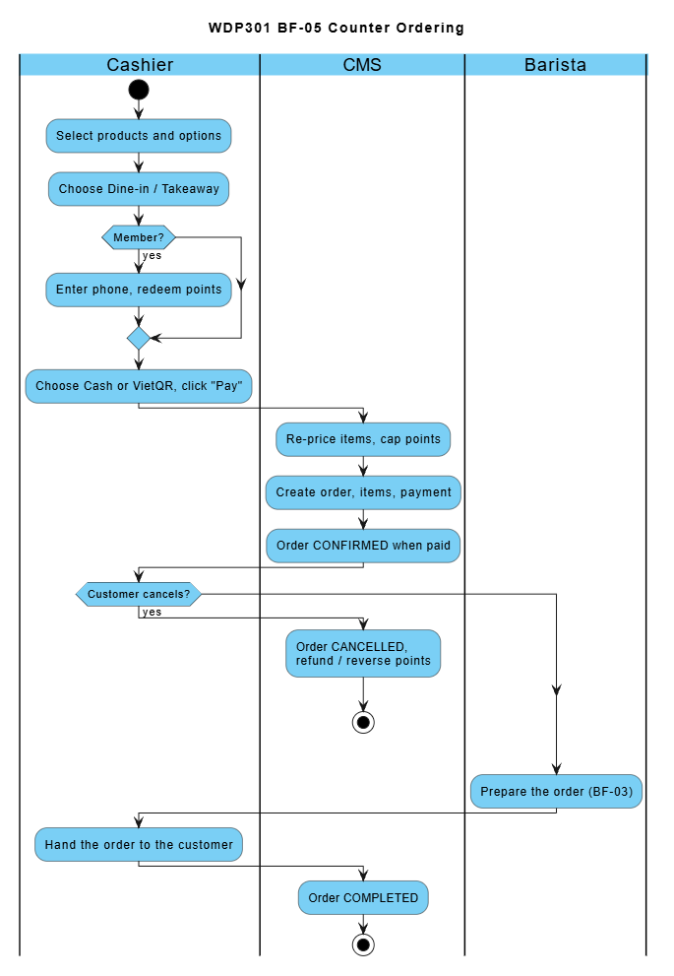

2.6 Work Shift Scheduling and Attendance (BF-06)
Workflow lead: Sơn. Use cases: UC55-UC59. Screens: Work Shift Management; Employee Schedule; Attendance.
Screen implementation: Employee Schedule, Attendance, Cashier Handover, Employee Management, Weekly Work Shifts and Admin Handover Review - Sơn. BF-15 supplies the employee and shift definitions.
Trigger: Admin schedules employees using weekly shift definitions prepared in BF-15.
End condition: Employees are scheduled and their attendance is recorded (COMPLETED or ABSENT).
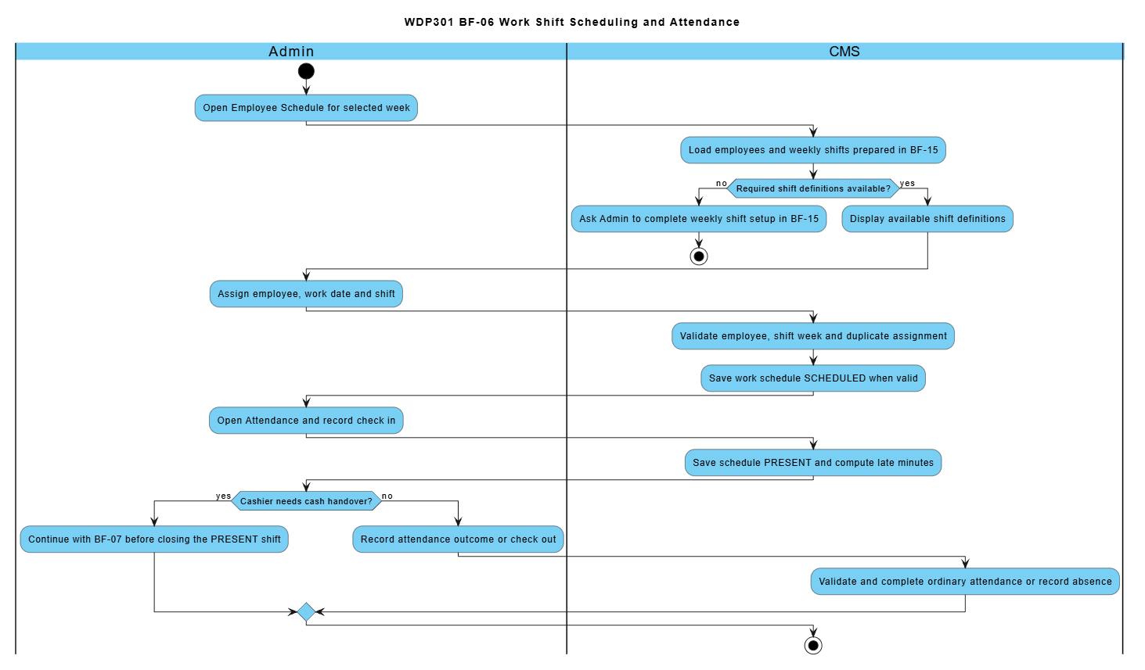

2.7 Shift Closing and Cash Handover (BF-07)
Workflow lead: Sơn. Use cases: UC60, UC69, UC73. Screens: Employee Schedule; Attendance; Shift Handover; Handover Review.
Screen implementation: Employee Schedule, Attendance, Cashier Handover, Employee Management, Weekly Work Shifts and Admin Handover Review - Sơn. BF-15 supplies the employee and shift definitions.
Trigger: Cashier closes a PRESENT shift.
End condition: The shift handover report is CONFIRMED by Admin.
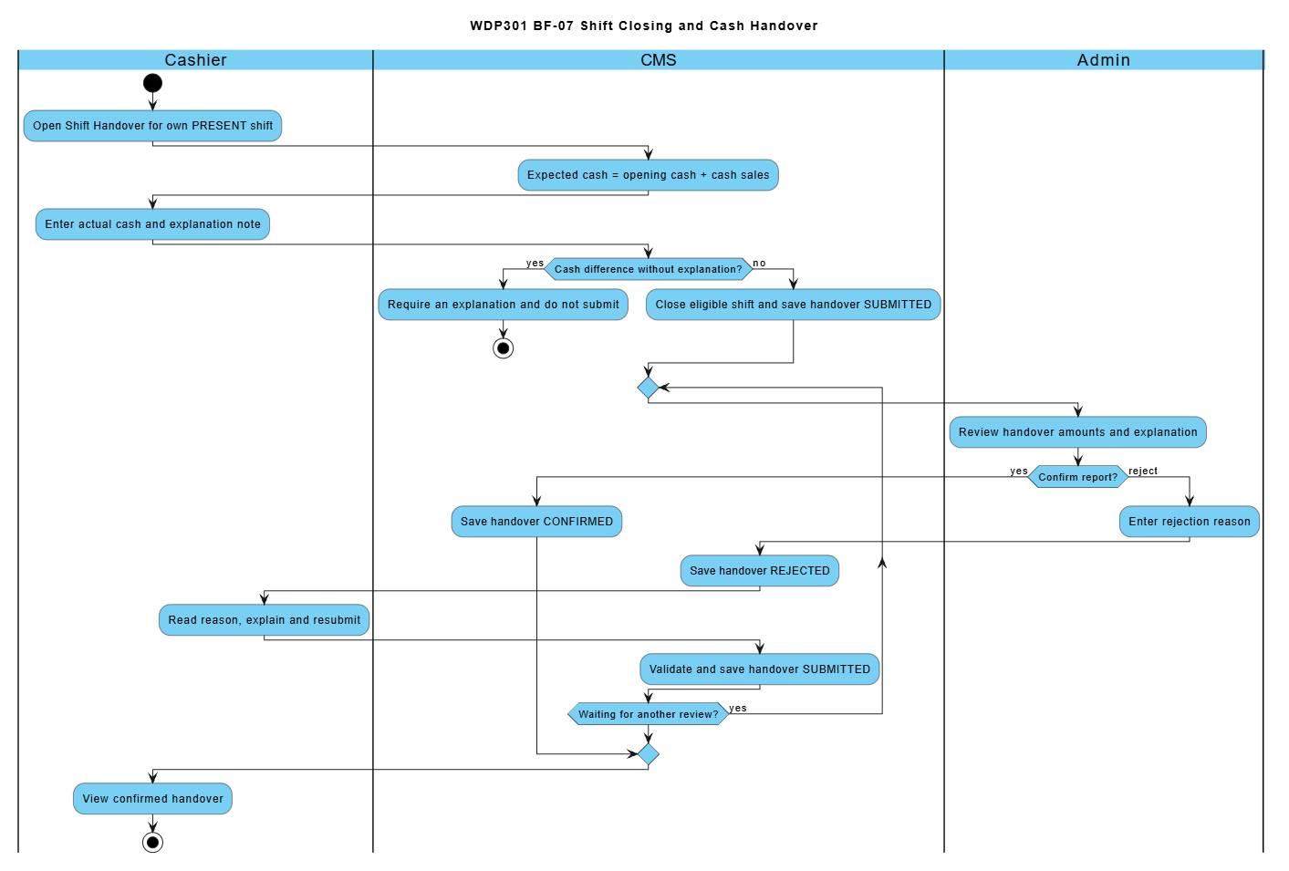

2.8 Ingredient Restock and Purchasing (BF-08)
Workflow lead: Duy. Use cases: UC44-UC53. Screens: Ingredient; Inventory; Restock Request; Supplier; Purchase Order.
The main path uses an approved restock request. A direct Purchase Order is also available when no request is linked. Supplier and Ingredient setup is needed only when the required master data does not exist.
Trigger: Admin checks the low-stock ingredients and creates a restock request.
End condition: The purchase order is RECEIVED and stock is increased, or the request is REJECTED.
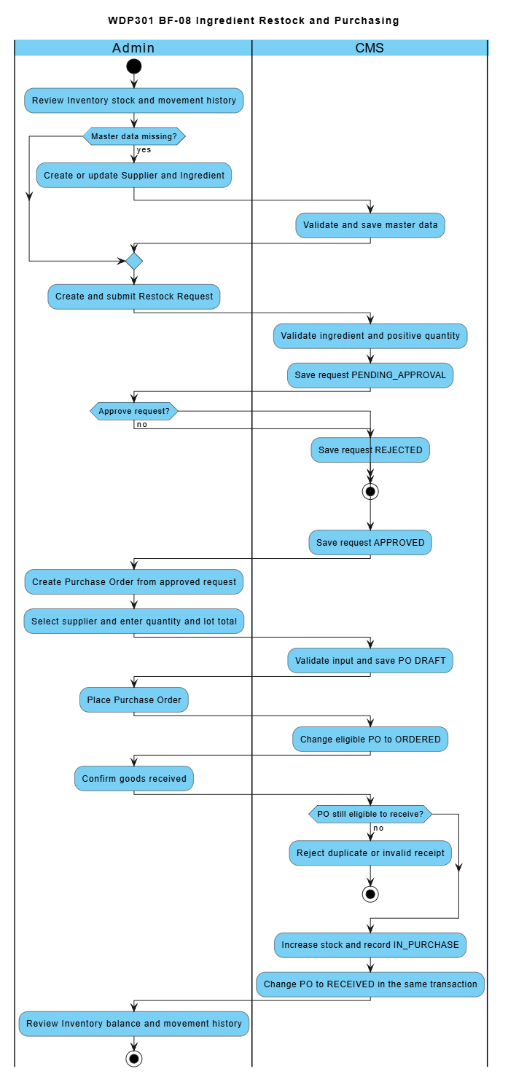

2.9 Feedback and Complaint Handling (BF-09)
Workflow lead: Sơn. Use cases: UC65, UC70. Screens: Customer Feedback and Complaints; Admin Feedback.
Trigger: Customer writes a rating or complaint about an own order.
End condition: The ticket is RESOLVED or REJECTED and the Customer can read the response.
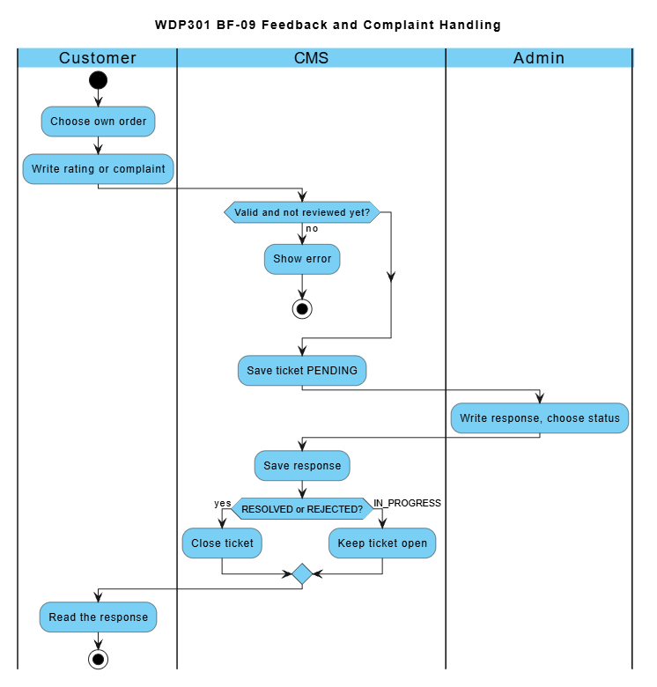

2.10 Account Access and Personal Profile (BF-10)
Workflow lead: Nguyên. Use cases: UC01-UC06. Screens: Homepage; Authentication Dialog; Customer Profile.
Trigger: A user opens the Authentication dialog from Homepage.
End condition: The permitted workspace or personal profile is available; logout invalidates the session.
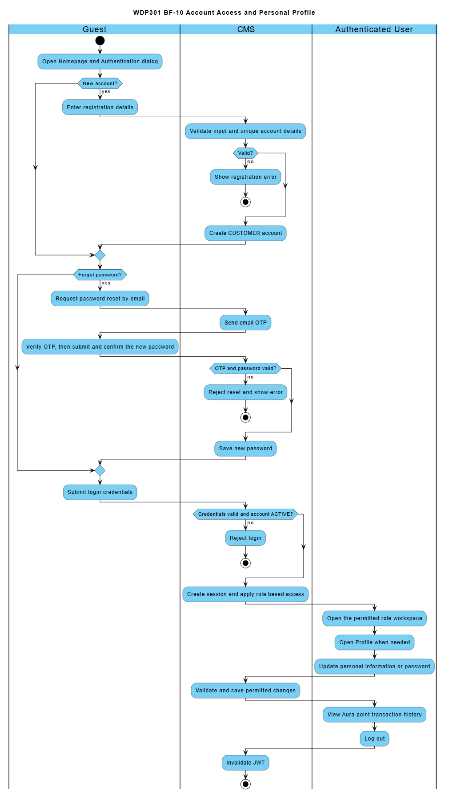

2.11 Menu and Recipe Publication (BF-11)
Workflow lead: Nguyên. Use cases: UC06, UC31-UC43. Screens: Category; Product; Recipe; Homepage.
Trigger: Admin prepares or updates a menu product and its recipe.
End condition: Product and BOM data are saved, cost completeness is visible and the public Homepage can be checked.
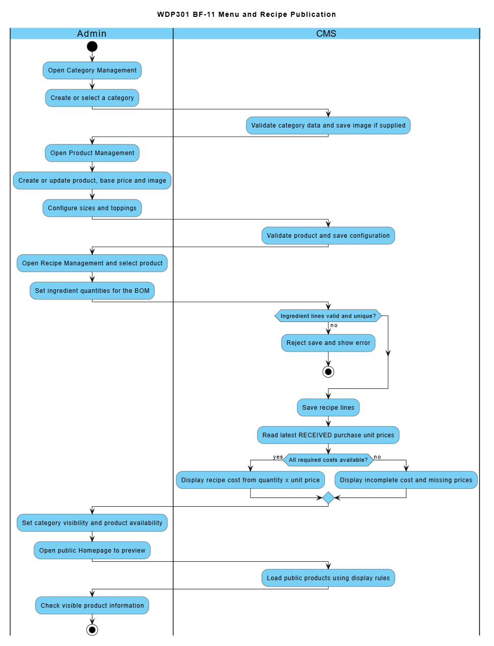

2.12 Phone Loyalty Administration (BF-12)
Workflow lead: Nguyên. Use cases: UC05, UC62-UC64. Screens: Phone Loyalty Management; Customer Profile.
Trigger: Admin opens Phone Loyalty Management to review rules or customer points.
End condition: Valid rules or point adjustments are saved and point history is available.
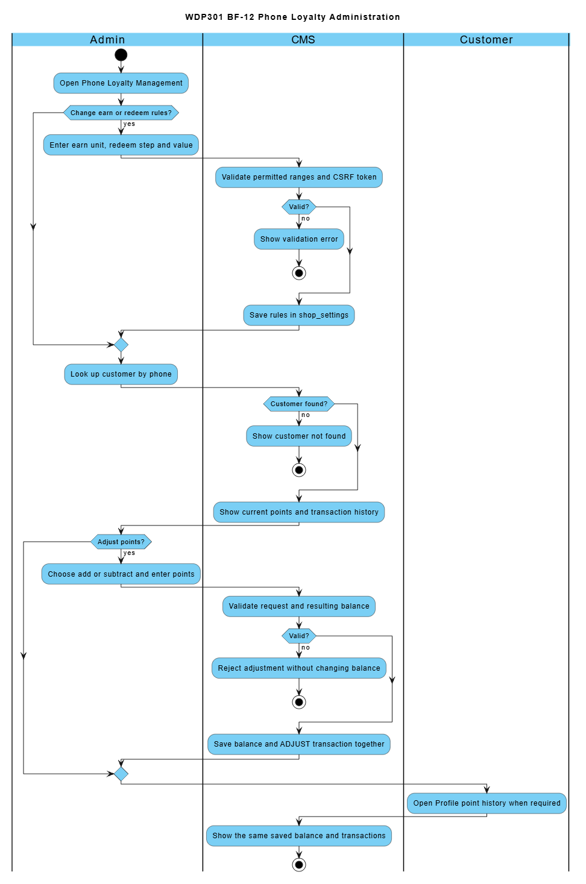

2.13 Sales Review and Order Follow Up (BF-13)
Workflow lead: Mạnh. Use cases: UC14, UC61, UC66-UC67. Screens: Reports; Admin Orders; Customer Management.
Trigger: Admin reviews business results and follows up an order or customer.
End condition: Reports and relevant order or customer details are reviewed; permitted updates are saved.
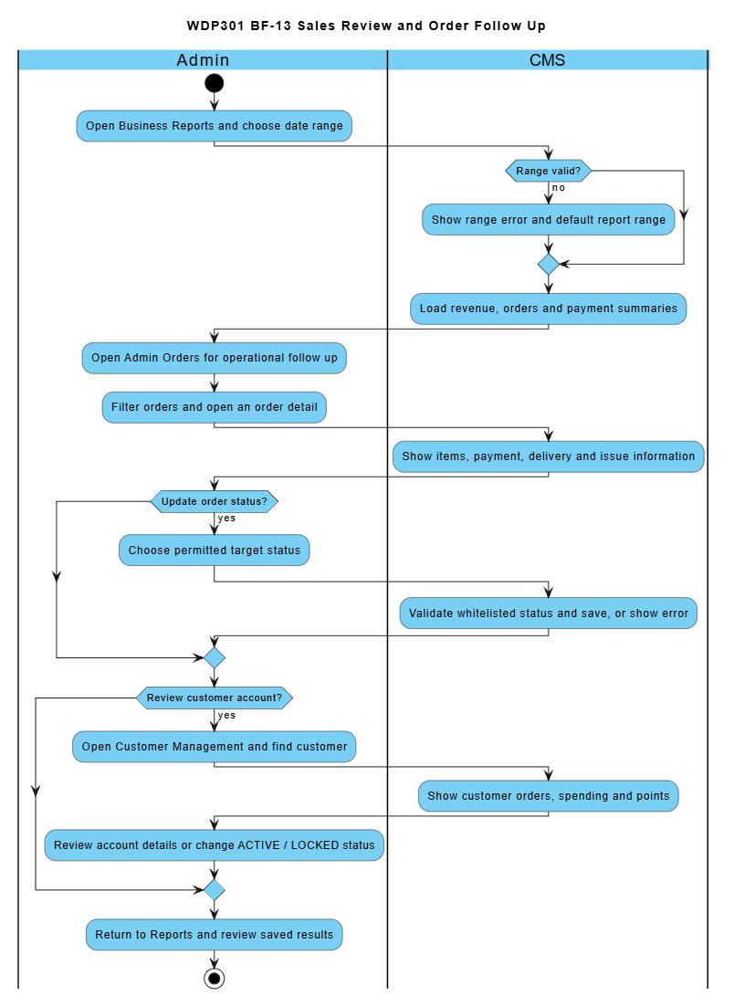

2.14 Shop Configuration (BF-14)
Workflow lead: Duy. Use cases: UC68. Screens: Shop Settings.
Trigger: Admin changes shop operating settings.
End condition: Valid settings persist after reloading the page.
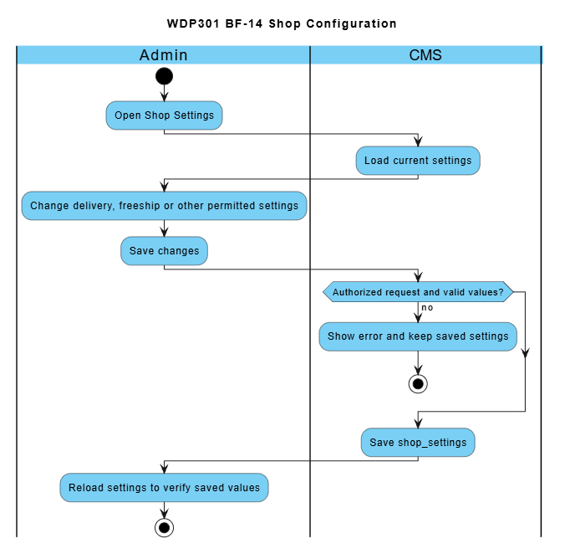

2.15 Employee and Weekly Shift Setup (BF-15)
Workflow lead: Sơn. Use cases: UC54-UC55. Screens: Employee Management; Work Shift Management.
Trigger: Admin prepares employee accounts and weekly shift definitions.
End condition: Employee and weekly shift data are available for scheduling in BF-06.
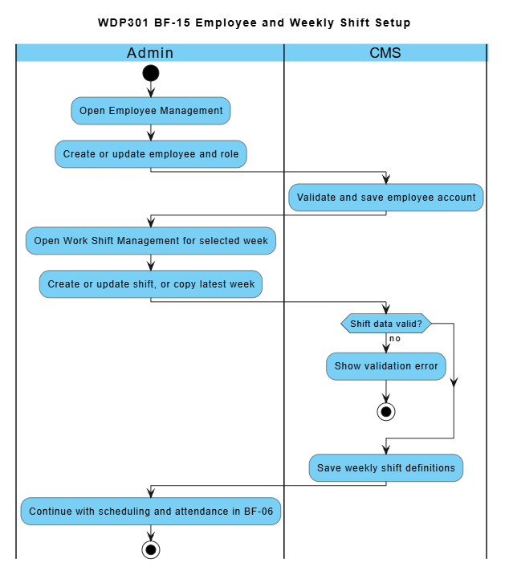

3. Conceptual Data Model

3.1 Entity Relationship Diagram
The conceptual model retains the source business entities and relationships. MongoDB implements them using ObjectId references and embedded snapshots rather than relational foreign keys. User phone is unique. Orders retain item price and customization snapshots; WorkShift belongs to a specific week. The detailed storage mapping is specified in the SDS.
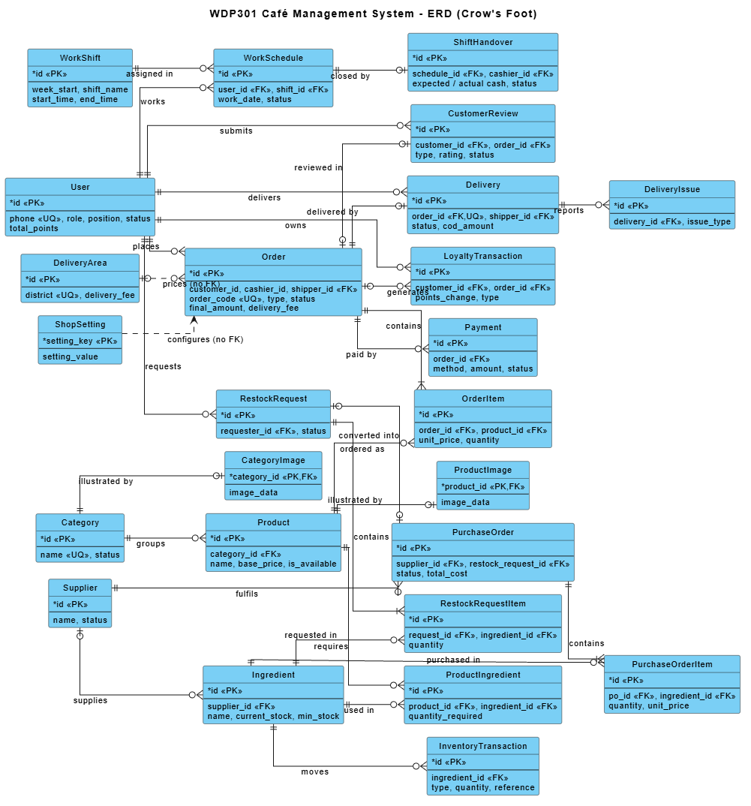

3.2 Entity Descriptions
Entity: User
Field | Value
Purpose | Every person with an account: customers, staff (cashier, barista, delivery staff) and administrators.
Key business attributes | Full name, phone number, e-mail, password, birthday, default address, role (ADMIN / STAFF / CUSTOMER), position (MANAGER / BARISTA / CASHIER / SHIPPER), hire date, base salary, Aura point balance, created date.
Business identity | Phone number is unique across the whole system and is the loyalty identity of a Customer. E-mail, when entered, is checked for uniqueness on registration and employee/profile update.
Status / lifecycle | ACTIVE (can sign in) · INACTIVE (deactivated employee) · LOCKED (locked by Admin). Accounts are locked or deactivated, never deleted from the UI.

Entity: WorkShift
Field | Value
Purpose | A named time frame of one specific week (e.g. "Ca sáng 07:00-12:00") used to schedule staff.
Key business attributes | Week start (Monday), shift name, start time, end time.
Business identity | Shift name is unique within a week (week_start + shift_name).
Status / lifecycle | Created for a week → edited → deleted (only when no employee is scheduled). Shifts of past weeks are read-only.

Entity: WorkSchedule
Field | Value
Purpose | Assignment of one employee to one shift on one work date, also holding attendance and cashier cash data.
Key business attributes | Employee, work date, shift, check-in time, check-out time, opening cash, system/actual closing cash, note.
Business identity | One employee can be scheduled to the same shift on the same date only once (user + work date + shift).
Status / lifecycle | SCHEDULED → PRESENT (checked in) → COMPLETED; or SCHEDULED → ABSENT.

Entity: ShiftHandover
Field | Value
Purpose | Cash handover report created when a Cashier closes a shift; reviewed by Admin.
Key business attributes | Schedule, cashier, opening cash, cash sales, expected cash, actual cash, difference, note / explanation, reviewer, review note, created and reviewed time.
Business identity | At most one handover per work schedule.
Status / lifecycle | SUBMITTED → CONFIRMED (final) or SUBMITTED → REJECTED → (Cashier explains) SUBMITTED.

Entity: Category
Field | Value
Purpose | Groups products on the menu and the POS.
Key business attributes | Category name, image (stored in database), number of products.
Business identity | Category name is unique.
Status / lifecycle | ACTIVE (shown) ↔ INACTIVE (hidden). Can be deleted only when it has no product.

Entities: CategoryImage / ProductImage
Field | Value
Purpose | Binary image of a category or product, stored in the database instead of a local file path.
Key business attributes | Image data, content type (JPG, PNG, GIF, WebP), file name, updated time.
Business identity | One image per category / product (the owner id is the key).
Status / lifecycle | Uploaded images are validated by MIME type and file signature; the maximum is 2 MiB per image. Replacement preserves references required by stored historical records.

Entity: Product
Field | Value
Purpose | A drink or food item sold on the menu, online and at the counter.
Key business attributes | Name, category, base price, description, image, size surcharges and topping prices. Legacy preparation instructions may remain in variant JSON, but the active recipe screen does not edit them.
Business identity | No natural key; identified by product id. Must belong to an existing category.
Status / lifecycle | Available (is_available = true) ↔ Paused (not sold online or at the counter).

Entity: ProductIngredient (Recipe line)
Field | Value
Purpose | Bill of materials: quantity of one ingredient needed to make one portion of a product.
Key business attributes | Product, ingredient, quantity required (up to 3 decimals).
Business identity | An ingredient appears at most once in a product recipe (product + ingredient).
Status / lifecycle | Defined → updated (the whole recipe is replaced on save) → removed with the product.

Entity: Ingredient
Field | Value
Purpose | Raw material kept in stock and consumed by recipes.
Key business attributes | Name, unit, default supplier, current stock, minimum stock level, latest purchase price.
Business identity | Identified by ingredient id.
Status / lifecycle | In stock → Low stock (current ≤ minimum) → Out of stock (0). Deletable only when not used in any recipe.

Entity: Supplier
Field | Value
Purpose | Company that supplies ingredients.
Key business attributes | Name, phone, address, number of supplied ingredients.
Business identity | Identified by supplier id.
Status / lifecycle | ACTIVE ↔ INACTIVE. Only ACTIVE suppliers can be chosen on a purchase order.

Entity: InventoryTransaction
Field | Value
Purpose | Every stock movement of an ingredient (audit trail of the inventory).
Key business attributes | Ingredient, type (IN_PURCHASE, OUT_ORDER, ADJUSTMENT, SPOILAGE), positive quantity, reference (order / purchase order / adjustment), reason, time.
Business identity | Identified by id. One OUT_ORDER movement per (order, ingredient).
Status / lifecycle | Recorded once, never edited.

Entities: RestockRequest / RestockRequestItem
Field | Value
Purpose | Internal request to buy more of an ingredient, approved before purchasing.
Key business attributes | Requester, reviewer, reason, note, review note; items: ingredient, quantity, item note.
Business identity | Identified by request id (shown as RR-0001). An ingredient appears once per request.
Status / lifecycle | DRAFT → PENDING_APPROVAL → APPROVED | REJECTED; DRAFT / PENDING_APPROVAL → CANCELLED.

Entities: PurchaseOrder / PurchaseOrderItem
Field | Value
Purpose | Official order sent to a supplier; receiving it increases the stock.
Key business attributes | Supplier, creator, linked restock request (optional), total cost, note; items: ingredient, quantity, unit price.
Business identity | Identified by id (shown as PO-0001). An approved restock request can be converted into at most one purchase order.
Status / lifecycle | DRAFT → ORDERED → RECEIVED; DRAFT / ORDERED → CANCELLED.

Entity: Order
Field | Value
Purpose | A sale: online delivery order of a Customer or a dine-in / takeaway order created by a Cashier.
Key business attributes | Order code, type (ONLINE / DINE_IN / TAKEAWAY), customer, cashier, delivery staff, goods amount, points discount, delivery fee, final amount, recipient name and phone, delivery address, table number, note, created time.
Business identity | Order code is unique (online: AURAyyMMddHHmmssSSS, counter: ORD-yyMMdd-nnnn).
Status / lifecycle | PENDING → CONFIRMED → PREPARING → READY → DELIVERING → COMPLETED (ONLINE); READY → COMPLETED (DINE_IN / TAKEAWAY); CANCELLED from PENDING (customer) or PENDING / CONFIRMED (cashier).

Entity: OrderItem
Field | Value
Purpose | One line of an order with a snapshot of the product at ordering time.
Key business attributes | Product, product name at time, unit price, customization (size, toppings, sugar / ice options), quantity, subtotal.
Business identity | Identified by id; belongs to exactly one order.
Status / lifecycle | Created with the order; prepared flag is tracked on the Barista screen.

Entity: Payment
Field | Value
Purpose | One payment attempt for an order.
Key business attributes | Order, method (CASH, BANK_TRANSFER; VNPAY and MOMO reserved), transaction code, amount, paid time, note, gateway reference, callback payload and time.
Business identity | Transaction code is unique (e.g. QR-<order code>, COD-<order code>).
Status / lifecycle | PENDING → SUCCESS | FAILED.

Entity: Delivery
Field | Value
Purpose | Delivery job of an ONLINE order assigned to a delivery staff member.
Key business attributes | Order, delivery staff, COD amount, COD collected, COD handed over time and receiving cashier, assigned / accepted / picked-up / delivered time, delivery note.
Business identity | At most one delivery per order.
Status / lifecycle | ASSIGNED → ACCEPTED → DELIVERING → DELIVERED. Re-assigning before pick-up resets it to ASSIGNED.

Entity: DeliveryIssue
Field | Value
Purpose | Problem reported by delivery staff during a delivery; one delivery may have many issues.
Key business attributes | Delivery, issue type (customer unreachable, wrong address, customer refused, damaged, traffic, other), description, time.
Business identity | Identified by id.
Status / lifecycle | Recorded (visible to Admin on the order detail).

Entity: DeliveryArea
Field | Value
Purpose | District of Hanoi the shop delivers to, with its fixed delivery fee.
Key business attributes | District name, delivery fee.
Business identity | District name is unique.
Status / lifecycle | Active (accepts delivery) ↔ Inactive.

Entity: LoyaltyTransaction
Field | Value
Purpose | History of Aura point changes of a Customer.
Key business attributes | Customer, order (optional), points change, type (EARN, REDEEM, REFUND, ADJUST), time.
Business identity | Identified by id. EARN is recorded at most once per order.
Status / lifecycle | Recorded once, never edited; the balance is stored in User.total_points.

Entity: CustomerReview (Feedback ticket)
Field | Value
Purpose | A rating (1-5 stars) or a complaint of a Customer about one of his/her orders.
Key business attributes | Ticket code, customer, order, type (RATING / COMPLAINT), rating, content, admin response, created / updated time.
Business identity | One ticket per (customer, order).
Status / lifecycle | PENDING → IN_PROGRESS → RESOLVED | REJECTED (RESOLVED and REJECTED are final).

Entity: ShopSetting
Field | Value
Purpose | Key-value configuration of the shop.
Key business attributes | Shop settings: freeship_threshold, delivery_fee, delivery_minutes, points_step, points_step_value and points_earn_unit. Provider credentials belong to protected environment variables SMTP_* and PAYMENT_*; PAYMENT_DEMO_ENABLED gates simulation and secrets are not exposed as public shop settings.
Business identity | Setting key is unique.
Status / lifecycle | Created → updated by Admin (applied on the next page load).

3.3 Data Business Rules
Rule | Description | Enforced On
DR-01 Unique phone | No two users may share the same phone number, regardless of role. | Registration, employee and customer creation, profile update
DR-02 Unique e-mail | An e-mail already used by another account is rejected. | Registration, employee save
DR-03 Unique category name | Category names are unique. | Category create / update
DR-04 Product needs category | A product must belong to an existing category; base price ≥ 0 with at most 2 decimals. | Product create / update
DR-05 Default size | Every product has at least one size and exactly the cheapest size has surcharge 0 đ so the default price equals the base price. | Product create / update
DR-06 Recipe line | Quantity required > 0 (max 3 decimals); an ingredient cannot appear twice in one recipe. | Recipe save
DR-07 Non-negative stock | Ingredient current stock and minimum level are never negative; a movement that would make stock negative is rejected. | Stock adjustment, order preparation
DR-08 Order lines | An order has at least one item; quantity > 0; subtotal = unit price × quantity, computed by the server. | Checkout, counter order
DR-09 Order amounts | final amount = goods amount − points discount + delivery fee; all amounts ≥ 0. | Checkout, counter order
DR-10 One delivery per order | An order has at most one delivery; only ONLINE orders with an address can be assigned. | Assign delivery staff
DR-11 Unique transaction code | A payment transaction code is unique so the same gateway callback is applied only once. | Payment callback
DR-12 Points never negative | User.total_points ≥ 0; EARN/REFUND > 0, REDEEM < 0, ADJUST ≠ 0. | All loyalty operations
DR-13 One feedback per order | A customer can send only one rating or complaint per own order; RATING requires 1-5 stars. | Feedback submission
DR-14 Unique shift name per week | Shift names are unique within a week; end time > start time; shifts of a week must not overlap. | Work shift create / update
DR-15 No duplicate schedule | An employee cannot be scheduled twice in the same shift on the same date; the shift must belong to the week of the work date. | Schedule assignment
DR-16 One handover per schedule | A work schedule has at most one shift handover report. | Close shift
DR-17 Restock item | Restock quantity > 0; an ingredient appears once per request. | Restock request create
DR-18 Purchase item | Purchase quantity > 0, unit price ≥ 0; an approved request converts into at most one purchase order. | Purchase order create
DR-19 Unique delivery district | District names in delivery areas are unique; delivery fee 0 - 1,000,000 đ. | Delivery area save
DR-20 Images in database | Category and product images are represented by imageUrl values. The application validates supported image input and does not describe relational BLOB tables as the MERN image store. | Image upload

4. User Requirements

4.1 Actors
# | Actor | Description
1 | Guest | A Guest may browse menu/details, maintain a browser cart, register, log in and request email password recovery. Checkout requires an active CUSTOMER. Recovery is implemented through server-validated OTP and one-use reset authorization, not administrator disclosure of passwords.
2 | Customer | A registered user with role CUSTOMER. Manages the personal profile and password, manages the cart, places online delivery orders, pays by bank transfer (VietQR) or cash on delivery, views e-bills, tracks, cancels (while unpaid) and re-orders orders, earns and redeems Aura loyalty points (identified by phone number) and submits ratings or complaints.
3 | Cashier | A staff member (role STAFF, position CASHIER, status ACTIVE). Creates DINE_IN and TAKEAWAY orders on the POS, looks up members by phone number, applies loyalty points, takes cash or VietQR payments, cancels counter orders, hands READY orders to customers, receives COD cash from delivery staff and closes the shift with a cash handover report.
4 | Barista | A staff member (role STAFF, position BARISTA, status ACTIVE). Sees the queue of paid orders from all channels, ticks prepared items, marks orders READY (ingredients are deducted by recipe when an order is finished) and reviews completed orders.
5 | Delivery Staff | A staff member (role STAFF, position SHIPPER, status ACTIVE). Sees deliveries assigned by Admin, accepts them, picks up READY orders, confirms successful delivery (entering the collected COD amount when required), reports delivery issues and hands collected COD cash over to a Cashier.
6 | Admin | An administrator (role ADMIN, position MANAGER - shown as "Quản trị"). Manages categories, products, recipes, ingredients, inventory, restock requests, suppliers, purchase orders, employees, weekly work shifts, schedules, attendance, shift handover review, customers, loyalty rules, orders and delivery assignment, feedback, reports, shop settings and delivery area fees.
7 | Payment Gateway | The gateway supplies HMAC-signed results to POST /api/payments/callback. Payment registers the order through the backend and polls the stored result. Local DEMO_ONLINE confirmation is a separate owner-authorized endpoint enabled only by PAYMENT_DEMO_ENABLED.

4.2 Use Cases (UC)
Use case IDs follow the numbering used in the source code and the implementation matrix of the team.
ID | Use Case | Feature | Use Case Description
UC01 | Register Account | Authentication | Guest creates a Customer account with full name, phone, e-mail and password (≥ 6 characters).
UC02 | Log In | Authentication | Any user signs in with phone, e-mail or e-mail name and password; the system redirects by role/position.
UC03 | Log Out | Authentication | A signed-in user logs out by clearing the client JWT and account state.
UC04 | Reset Forgotten Password | Authentication | The user requests a six-digit email OTP, verifies it within ten minutes and resets the password using a one-use authorization valid for fifteen minutes. Enforce five verification attempts, a sixty-second resend interval and revocation of earlier login tokens after reset.
UC05 | Manage Personal Profile | Customer Profile | The signed-in user views and updates name, phone, email, birthday and default address, changes password and views the Aura point history.
UC06 | View Homepage | Homepage | Guest/Customer views the banner and favourite products.
UC07 | Browse Menu by Category | Menu | Guest/Customer lists available products filtered by an active category.
UC08 | Search Products | Menu | Guest/Customer searches products by keyword.
UC09 | View Product Details | Product Detail | Guest/Customer views price, description, sizes, toppings and related products.
UC10 | Manage Shopping Cart | Shopping Cart | Guest/Customer adds items, changes quantity, selects/removes lines and clears the cart.
UC11 | Place Online Order | Online Ordering | Customer enters recipient and Hanoi delivery address and confirms the order (status PENDING).
UC12 | Pay by Bank Transfer (VietQR) | Payment | Customer transfers via VietQR; the Payment Gateway callback confirms the payment and the order.
UC13 | Choose Cash on Delivery | Payment | Customer chooses COD; the order is confirmed and cash is collected by delivery staff.
UC14 | View e-Bill | Bill | Customer (own orders), Cashier or Admin views and prints the electronic bill of an order.
UC15 | Track Order Status | Customer Order Management | Customer follows in-progress orders and their current status.
UC16 | View Order History | Customer Order Management | Customer lists orders by status tab, order code and date.
UC17 | Cancel Unpaid Order | Customer Order Management | Customer cancels an own PENDING order without successful payment; redeemed points are refunded.
UC18 | Create Counter Order | Counter Ordering | Cashier builds a DINE_IN/TAKEAWAY order with options, table number and note.
UC19 | Take Counter Payment | Counter Ordering | Cashier takes cash (with change) or VietQR payment for the counter order.
UC20 | View Counter Order List | Counter Order List | Cashier/Barista views counter orders of a date filtered by status and type.
UC21 | Cancel Counter Order | Counter Ordering | Cashier cancels a PENDING/CONFIRMED counter order; points are refunded/reversed.
UC22 | Hand Over Counter Order | Counter Ordering | Cashier marks a READY dine-in/takeaway order as COMPLETED.
UC23 | View Preparation Queue | Drink Preparation | Barista sees CONFIRMED/PREPARING/READY paid orders with items and notes.
UC24 | Update Preparation Progress | Drink Preparation | Barista ticks prepared items and marks the order READY; ingredients are deducted by recipe.
UC25 | Reorder Previous Order | Customer Order Management | Customer adds the items of a previous order back to the cart at current prices.
UC26 | View Assigned Deliveries | Delivery Management | Delivery staff lists deliveries assigned to him/her with items and counters.
UC27 | Accept, Pick Up and Complete Delivery | Delivery Management | Delivery staff accepts, picks up a READY order and confirms successful delivery.
UC28 | View Delivery Details and History | Delivery Management | Delivery staff views one delivery with items and issues, and deliveries of a date.
UC29 | Report Delivery Issue | Delivery Management | Delivery staff reports an issue type and description for an unfinished delivery.
UC30 | Collect and Hand Over COD Cash | Delivery Management | Delivery staff collects the exact COD amount and hands all held COD cash to a Cashier.
UC31 | View Category List | Category Management | Admin lists categories with image, product count and status.
UC32 | Create / Update Category | Category Management | Admin saves name, status and image of a category.
UC33 | Show / Hide Category | Category Management | Admin switches a category between ACTIVE and INACTIVE.
UC34 | Delete Category | Category Management | Admin deletes a category that has no product.
UC35 | View and Search Products | Product Management | Admin lists products filtered by category and keyword with counters.
UC36 | Create Product | Product Management | Admin creates a product with name, category, base price, description and image.
UC37 | Update Product | Product Management | Admin edits product information and image.
UC38 | Configure Sizes and Toppings | Product Management | Admin defines sizes with surcharges and toppings with prices of a product.
UC39 | Change Product Availability | Product Management | Admin pauses or resumes selling a product.
UC40 | View Recipe List | Recipe Management | Admin sees which products have or lack a recipe.
UC41 | View Recipe Details | Recipe Management | Admin views the ingredient lines of one product.
UC42 | Set Up Recipe (BOM) | Recipe Management | Admin adds, edits or removes ingredient lines and quantities of a product. The active recipe form saves the BOM only.
UC43 | Calculate Recipe Cost | Recipe Management | System calculates the cost of one portion from the latest received purchase prices.
UC44 | View and Search Ingredients | Ingredient Management | Admin lists ingredients by keyword and supplier with stock and latest price.
UC45 | Create Ingredient | Ingredient Management | Admin creates an ingredient with unit, supplier, opening stock and minimum level.
UC46 | Update Ingredient | Ingredient Management | Admin updates name, unit, supplier and minimum level.
UC47 | Delete Ingredient | Ingredient Management | Admin deletes an ingredient that is not used in any recipe.
UC48 | View Stock and Movement History | Inventory Management | Admin views current stock, stock status and the movement history.
UC49 | Adjust Stock | Inventory Management | Admin records a stock-count adjustment (+/−) or spoilage with a reason.
UC50 | Create Restock Request | Restock Request | Admin creates a restock request as draft or sends it for approval.
UC51 | Review Restock Request | Restock Request | Admin submits, approves, rejects or cancels a restock request.
UC52 | Manage Suppliers | Supplier Management | Admin creates, updates and activates/deactivates suppliers.
UC53 | Manage Purchase Orders | Purchase Order | Admin creates draft purchase orders, places, receives (stock in) or cancels them.
UC54 | Manage Employees | Employee Management | Admin creates and edits staff accounts, filters by role and locks/unlocks accounts.
UC55 | Manage Weekly Work Shifts | Work Shift Management | Admin adds, edits, deletes or copies the shifts of a selected week.
UC56 | Assign Work Schedule | Employee Schedule | Admin assigns an employee to a date and shift (opening cash for cashiers), updates or deletes it.
UC57 | View Work Schedules | Employee Schedule | Admin views schedules by week (calendar / table) or by day (board).
UC58 | Record Attendance | Attendance | Admin records check-in/check-out time, status and note of a scheduled shift.
UC59 | View Daily Attendance | Attendance | Admin views attendance of a date with late minutes.
UC60 | Close Shift and Submit Handover | Shift Handover | Cashier enters actual closing cash and note; the system completes the shift and submits a handover.
UC61 | Manage Customers | Customer Management | Admin lists customers with points, orders and spending, adds a customer and locks/unlocks.
UC62 | Earn Loyalty Points | Phone Loyalty | System adds floor(goods amount after discount / points_earn_unit) points when payment succeeds.
UC63 | Manage Loyalty Rules and Points | Phone Loyalty | Admin sets earn/redeem rules, looks up a customer by phone and adds/subtracts points.
UC64 | Redeem Loyalty Points | Phone Loyalty | Customer (cart) or Cashier (POS) uses points in multiples of points_step for a discount.
UC65 | Submit Feedback or Complaint | Feedback & Complaints | Customer sends a rating or complaint about an own order and follows the response.
UC66 | View Business Reports | Reports Dashboard | Admin views revenue, orders, payments, top products, ingredient usage and low stock for a period.
UC67 | Manage Orders | Admin Order Management | Admin lists all orders, views details, payments and delivery, and updates order status.
UC68 | Configure Shop Settings | Shop Settings | Admin configures freeship threshold, delivery fee/time, point rules and other setting keys.
UC69 | Review Shift Handover | Shift Handover | Admin confirms or rejects (with reason) a submitted cash handover report.
UC70 | Handle Feedback and Complaints | Feedback & Complaints | Admin answers a ticket and sets it IN_PROGRESS, RESOLVED or REJECTED.
UC71 | Configure Delivery Area Fees | Delivery Management | Admin adds districts and edits delivery fee and active flag per district.
UC72 | Assign Delivery Staff | Admin Order Management | Admin assigns, changes or removes the delivery staff of an ONLINE order before pick-up.
UC73 | Resubmit Rejected Handover | Shift Handover | Cashier writes an explanation for a rejected handover and sends it again.

4.3 Use Case Diagrams

4.3.1 UCs for Guest

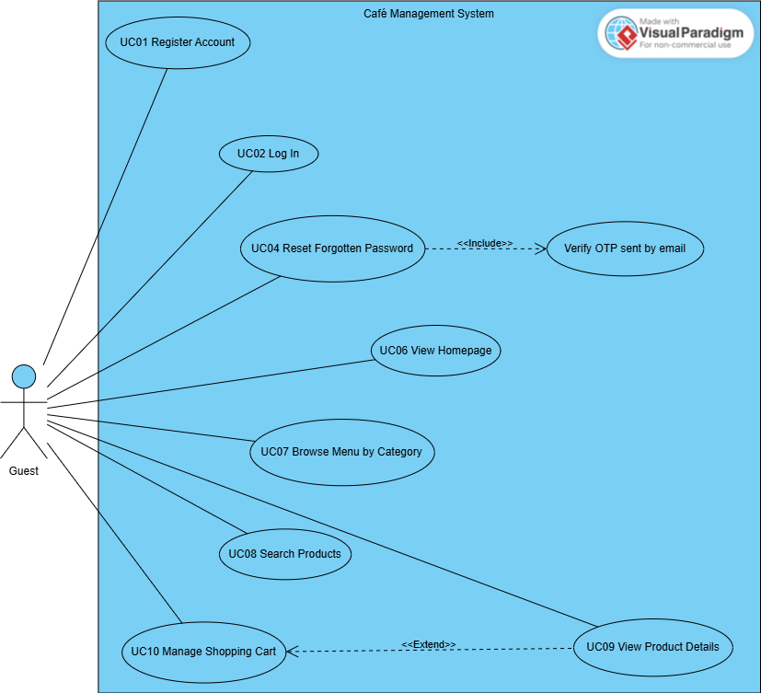

4.3.2 UCs for Customer

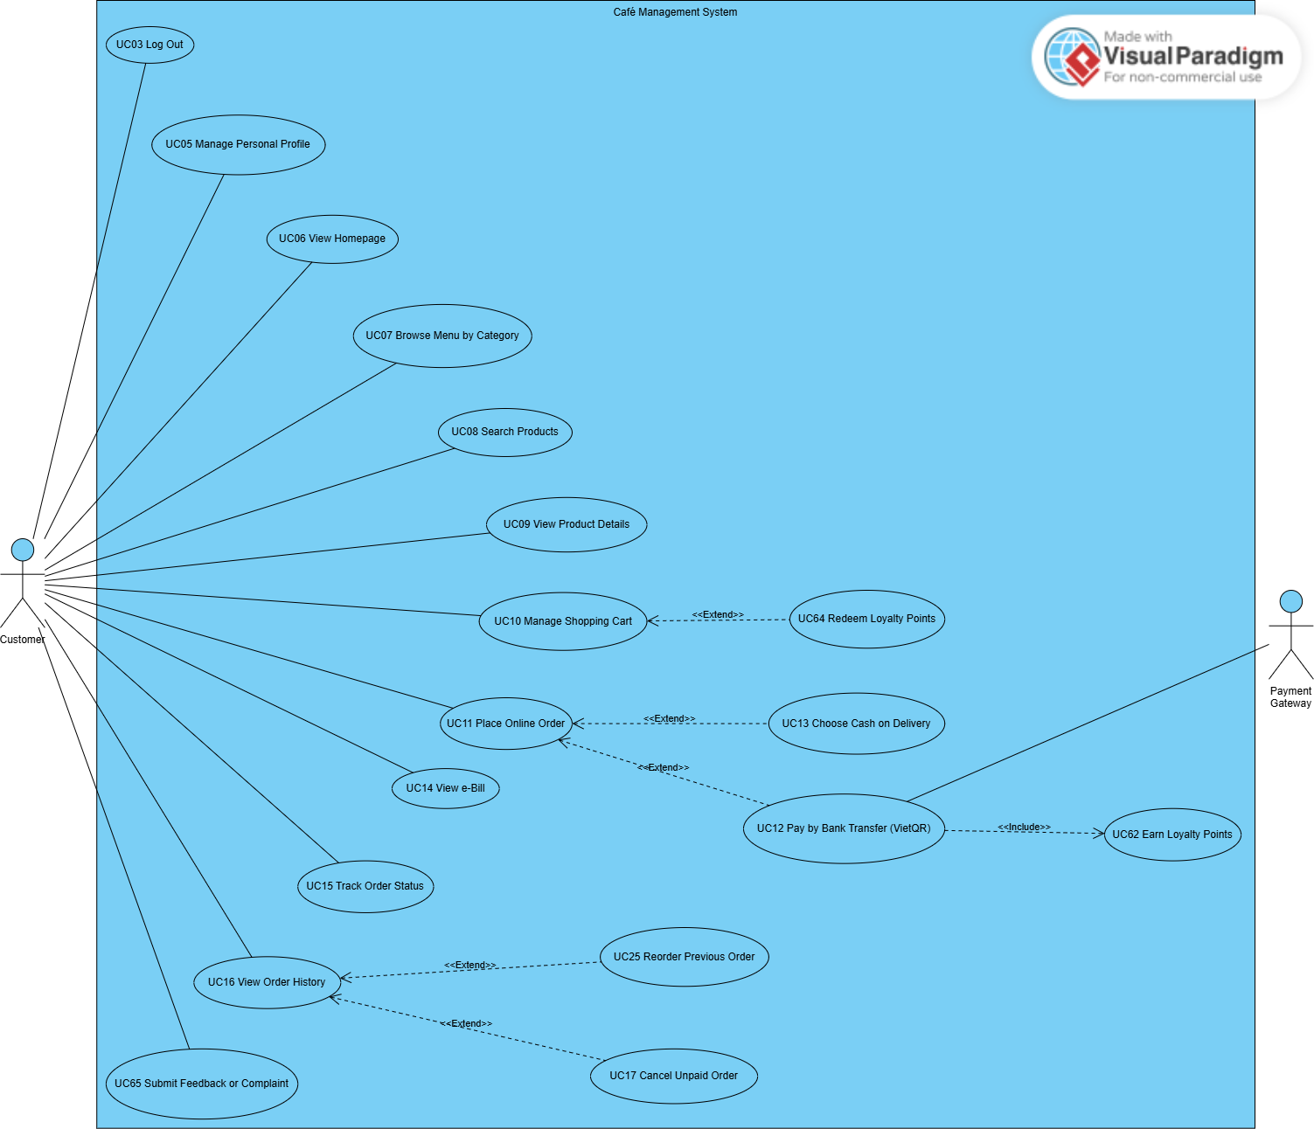

4.3.3 UCs for Cashier

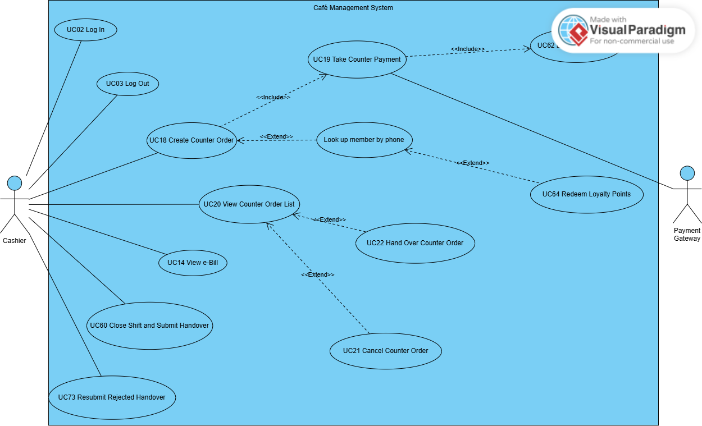

4.3.4 UCs for Barista

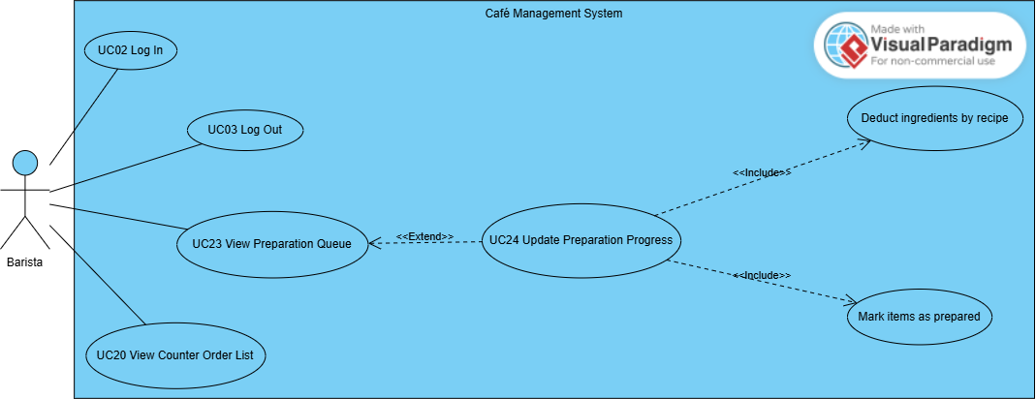

4.3.5 UCs for Delivery Staff

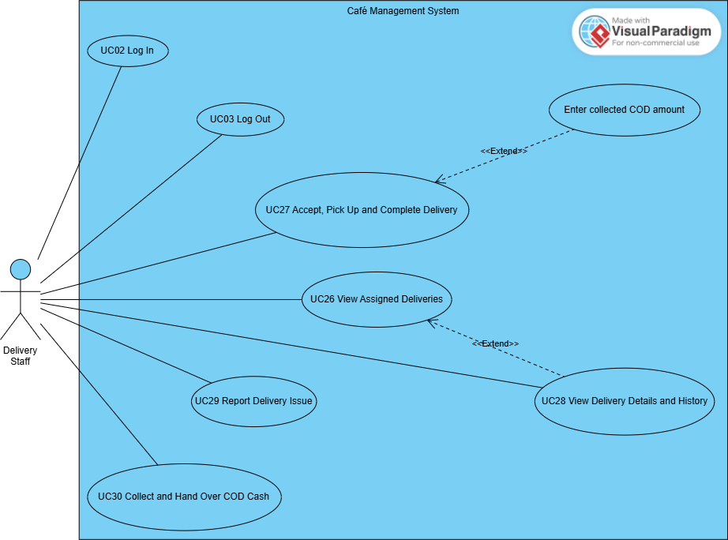

4.3.6 UCs for Admin – Menu, Recipe and Inventory
Responsible members: Nguyên (UC31–UC39); Duy (UC40–UC53).
This group covers category and product management, recipe configuration and costing, ingredient management, stock control, restock requests, suppliers and purchase orders.
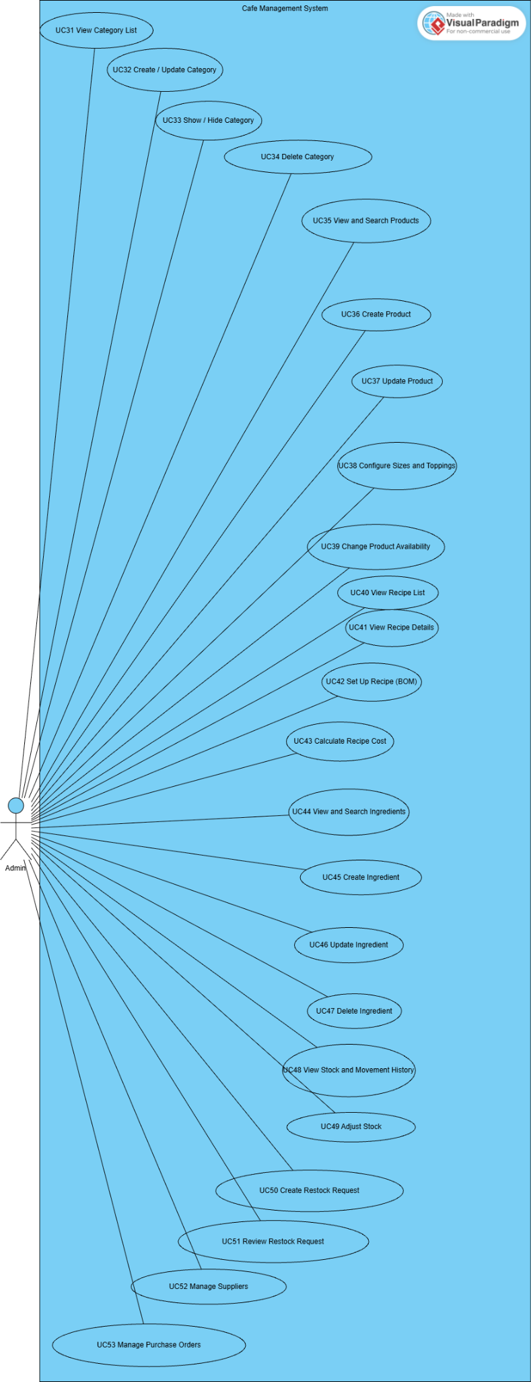
4.3.7 UCs for Admin – Employees, Shifts and Handover
Responsible member: Sơn (UC54–UC59, UC69).
This group covers employee management, weekly shift setup, work scheduling, attendance management and shift handover review.
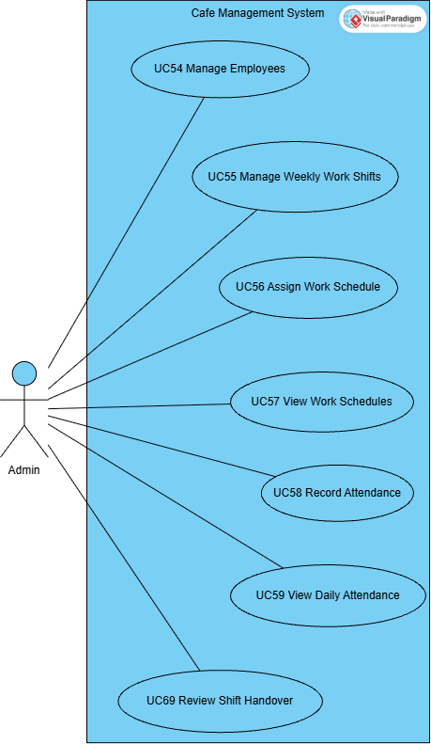

4.3.8 UCs for Admin – Orders, Customers and System
Responsible members: Mạnh (UC14, UC66, UC67, UC71, UC72); Ngọc (UC61, UC63); Sơn (UC70); Duy (UC68).
This group covers order management, electronic bills, business reports, customers, loyalty rules and points, feedback handling, shop settings and delivery configuration.
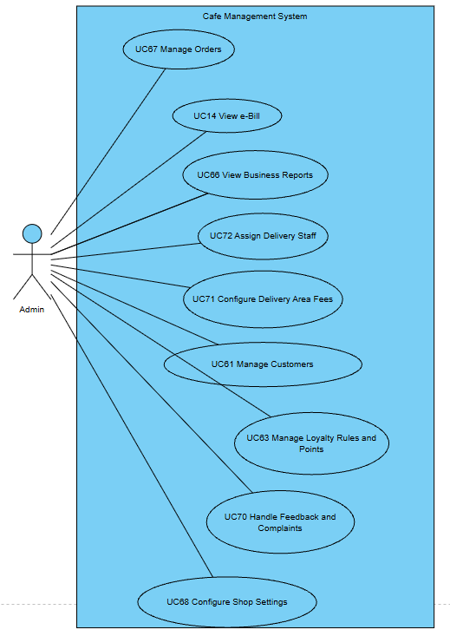

4.4 Permission Matrix
Full = unrestricted · Restricted = conditions apply (see footnotes) · No = denied
Entity | Action | Guest | Customer | Cashier | Barista | Delivery Staff | Admin
Account | Register (Customer) | Full | No | No | No | No | No
Account | Log in / reset password | Full | Full | Full | Full | Full | Full
Account | View / update own profile | No | Full | Restricted ¹ | Restricted ¹ | Restricted ¹ | Restricted ¹
Employee account | Create / edit / lock | No | No | No | No | No | Restricted ²
Customer account | View list / create / lock | No | No | No | No | No | Full
Category / Product | View (active / available) | Full | Full | Full | No | No | Full
Category / Product | Create / edit / hide / delete | No | No | No | No | No | Full
Recipe | View / set up / cost | No | No | No | No | No | Full
Cart | Manage browser/MongoDB cart | Full | Full | No | No | No | No
Online order | Place / pay / cancel (unpaid) | No | Restricted ³ | No | No | No | No
Online order | View own orders / reorder | No | Restricted ³ | No | No | No | No
Counter order | Create / take payment / cancel / hand over | No | No | Full | No | No | No
Counter order | View counter order list | No | No | Full | Full | No | No
Bill | View / print | No | Restricted ³ | Full | No | No | Full
Order | Prepare (PREPARING / READY) | No | No | No | Full | No | No
Order | View all / update status | No | No | No | No | No | Full
Delivery | Assign delivery staff | No | No | No | No | No | Full
Delivery | Accept / pick up / complete / report issue | No | No | No | No | Restricted ⁴ | View
COD cash | Hand over to Cashier | No | No | Receive | No | Restricted ⁴ | No
Ingredient / Inventory | View / create / edit / adjust | No | No | No | No | No | Full
Restock / Purchase order / Supplier | Create / review / receive | No | No | No | No | No | Full
Work shift / Schedule / Attendance | Create / edit / record | No | No | No | No | No | Full
Shift handover | Close shift / resubmit | No | No | Restricted ⁵ | No | No | No
Shift handover | Confirm / reject | No | No | No | No | No | Full
Loyalty points | Redeem | No | Restricted ³ | Restricted ⁶ | No | No | No
Loyalty points | Configure rules / adjust | No | No | No | No | No | Full
Feedback ticket | Submit / view own | No | Restricted ³ | No | No | No | No
Feedback ticket | Respond / close | No | No | No | No | No | Full
Reports / Settings / Delivery areas | View / configure | No | No | No | No | No | Full

¹ Staff and Admin can open the profile page of their own account; the page is designed for Customers (points history).
² Admin cannot downgrade, deactivate or lock the account he/she is currently signed in with.
³ Only for the Customer's own orders, points and tickets (ownership is checked on every request).
⁴ Only for deliveries assigned to the signed-in delivery staff member.
⁵ Only for the Cashier's own PRESENT shift (close) or own REJECTED handover (resubmit).
⁶ Only for an ACTIVE customer found by phone number, capped by balance and order subtotal.

5. System Functionalities
The system is organised in five portals that share one login: the public/Customer website, the Cashier POS, the Barista dashboard, the Delivery Staff dashboard and the Admin back-office. After login the user is redirected by role and position: ADMIN → Admin Dashboard, CASHIER → Cashier POS, BARISTA → Barista Dashboard, SHIPPER → Delivery Management, CUSTOMER → Homepage.

5.1 Screen Inventory

a. Screen Flow
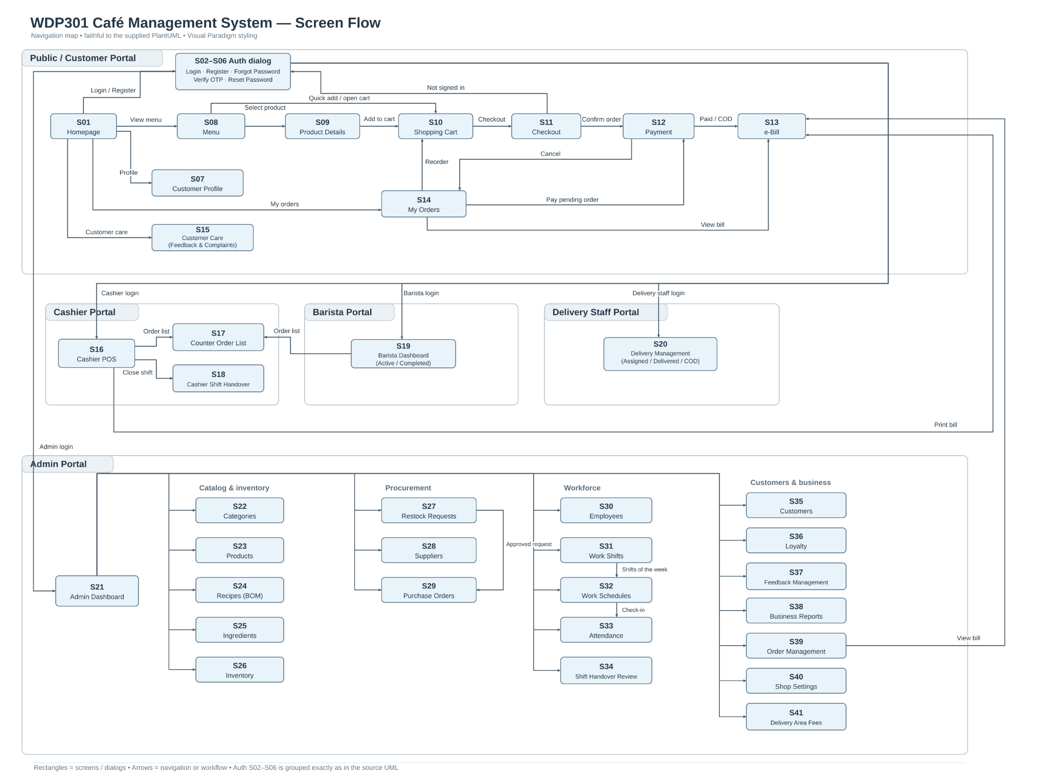

b. Screen List
# | Screen Name | Feature | Description
S01 | Homepage | Homepage | Landing page with banner product, favourite products and links to Menu, Cart, Orders and Profile. Hosts the authentication dialog.
S02 | Login (dialog) | Authentication | Sign in with phone / e-mail and password; redirects Admin, Cashier, Barista, Delivery Staff to their portal.
S03 | Register (dialog) | Authentication | Create a new Customer account.
S04 | Forgot Password (dialog) | Authentication | Request an OTP sent to the registered e-mail.
S05 | Verify OTP (dialog) | Authentication | Enter the 6-digit OTP; resend after 60 seconds.
S06 | Reset Password (dialog) | Authentication | Set a new password after OTP verification.
S07 | Customer Profile | Customer Profile | View/update personal information, change password and view phone-linked point balance and history. All Customers use the same earning and redemption rules.
S08 | Menu | Menu | Product list filtered by category and keyword with quick "add to cart".
S09 | Product Details | Product Detail | Product information, size and topping selection, quantity, add to cart, related products.
S10 | Shopping Cart | Shopping Cart | Cart lines with options, quantity, selection, point redemption and order summary.
S11 | Checkout | Online Ordering | Recipient and Hanoi delivery address, delivery fee by district, note, order confirmation.
S12 | Payment | Payment | VietQR information, backend-stored payment status polling, separate gated DEMO_ONLINE confirmation, COD selection and unpaid cancellation.
S13 | e-Bill | Bill | Electronic bill of an order with items, amounts, payment method and transaction code; printable.
S14 | My Orders | Customer Order Management | In-progress and past orders by status tab, code and date; pay, cancel, reorder, view bill.
S15 | Customer Care | Feedback & Complaints | Submit a rating/complaint about an own order and follow ticket status and responses.
S16 | Cashier POS | Counter Ordering | Product grid, order panel, member lookup, points, payment (cash / VietQR) and today's orders.
S17 | Counter Order List | Counter Order List | Counter orders of a date with status and type filters (Cashier, Barista).
S18 | Cashier Shift Handover | Shift Handover | Close the current shift (cash count) and view / resubmit the handover report.
S19 | Barista Dashboard | Drink Preparation | Active preparation queue (per item / per cup) and completed orders.
S20 | Delivery Management | Delivery Management | Assigned deliveries, delivery detail and issues, delivered list by date, COD holding and hand-over.
S21 | Admin Dashboard | Administration | Greeting and tiles linking to every admin function.
S22 | Category Management | Category Management | Category list and create/edit form with image upload.
S23 | Product Management | Product Management | Product list, filters and create/edit form with sizes, toppings and image.
S24 | Recipe Management | Recipe Management | Products with/without recipe, ingredient quantities, BOM saving and recipe cost; no instruction editor.
S25 | Ingredient Management | Ingredient Management | Ingredient list with stock, latest price and usage; create/edit/delete.
S26 | Inventory Management | Inventory Management | Current stock with status filter, movement history and stock adjustment.
S27 | Restock Requests | Restock Request | Low-stock list, create request (draft / send), request list with review actions.
S28 | Supplier Management | Supplier Management | Supplier list and create/edit form with status.
S29 | Purchase Orders | Purchase Order | Create draft purchase order, list with order / receive / cancel actions.
S30 | Employee Management | Employee Management | Employee list filtered by role; create/edit form; lock/unlock.
S31 | Work Shift Management | Work Shift Management | Week selector with the shifts of that week; add/edit/delete/copy shifts.
S32 | Work Schedules | Employee Schedule | Weekly calendar / table and daily board of schedules; assign, update, delete.
S33 | Attendance | Attendance | Attendance list of a date with late minutes; update check-in/out, status and note.
S34 | Shift Handover Review | Shift Handover | Handover reports by status; confirm or reject with reason.
S35 | Customer Management | Customer Management | Customer list with points, orders and spending; add customer; lock/unlock.
S36 | Loyalty Management | Phone Loyalty | Point rules, lookup by phone, add/subtract points, transaction log.
S37 | Feedback Management | Feedback & Complaints | Tickets filtered by type and status; respond and close.
S38 | Business Reports | Reports Dashboard | KPIs and charts for today / 7 days / 30 days / this month / custom range.
S39 | Order Management | Admin Order Management | All orders with filters; order detail with items, payment, delivery and issues; status and delivery staff update.
S40 | Shop Settings | Shop Settings | Online sales settings and the list of all setting keys; add a key.
S41 | Delivery Area Fees | Delivery Management | Districts with delivery fee and active flag; add a district.

5.2 External API Inventory
# | API Name | Calling Path | Description
1 | Payment callback (API-01) | Payment Gateway → CMS | POST /api/payments/callback receives provider-signed results and verifies HMAC-SHA256, transaction code, amount and order state. POST /api/payments/:id/demo-confirm is separate: owner JWT plus enabled demo mode, and DEMO_ONLINE only.
2 | VietQR image (API-02) | Browser → vietqr.app (URL generated by CMS) | Builds the VietQR "quick link" image URL (bank id, account number, amount, order code as transfer content, account name) shown on the Payment screen and the POS.
3 | E-mail OTP (API-03) | Email OTP: POST /api/auth/forgot-password, /api/auth/verify-otp and /api/auth/reset-password; protected SMTP configuration delivers recovery mail. | OTP codes expire, are rate/attempt limited and become unusable after verification or resend. Hash recovery secrets at rest and never disclose them through errors; failure to deliver mail does not authorize reset.

5.3 Background Job Inventory
# | Job Name | Group | Description
- | No scheduled background job | - | The current release has no timer-based job. All automatic processing (points, stock deduction, payment confirmation) is event-driven and runs inside the user request - see II.11.

3. Functional Requirements
This part describes the screens of the system grouped by feature. For each screen: the URL, actors and related use cases, a short description, the actions available and the description of its fields. Labels in Vietnamese are the texts shown on the user interface; message codes (MSGxx) refer to III.2 System Messages.

1. User Authentication

1.1 Account Authentication

1.1.1 Login
Screen / URL: / (dialog tab "login") → POST /login
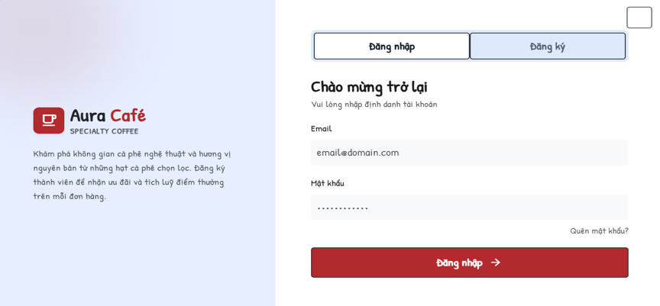
Actors: Guest, Customer, Cashier, Barista, Delivery Staff, Admin · Use cases: UC02, UC03
The React login form submits credentials to POST /api/auth/login. A successful response provides a JWT and the account role/position. The client preserves the guest cart and redirects only to a safe local route; protected API requests carry Authorization: Bearer <token>.
This screen allows the user to:
- Sign in with phone number, e-mail or the part of the e-mail before "@", and password.
- Log out from any portal by clearing the client token and account state; POST /api/auth/logout acknowledges the stateless logout request.
- Open the Register or Forgot password tabs.
Field Description
Field Name | Description
Email (identifier) | Textbox, required. Phone number, e-mail or e-mail name. Trimmed before checking.
Mật khẩu (Password) | Password box, required.
Đăng nhập (Sign in) | Button. Only ACTIVE accounts can sign in; on failure MSG10 is shown without telling which value was wrong.
Redirect after login | ADMIN → Admin Dashboard; STAFF + CASHIER → /cashier; STAFF + BARISTA → /barista; STAFF + SHIPPER → /delivery; CUSTOMER → previous page or Homepage.

1.1.2 Register
Screen / URL: / (dialog tab "register") → POST /register
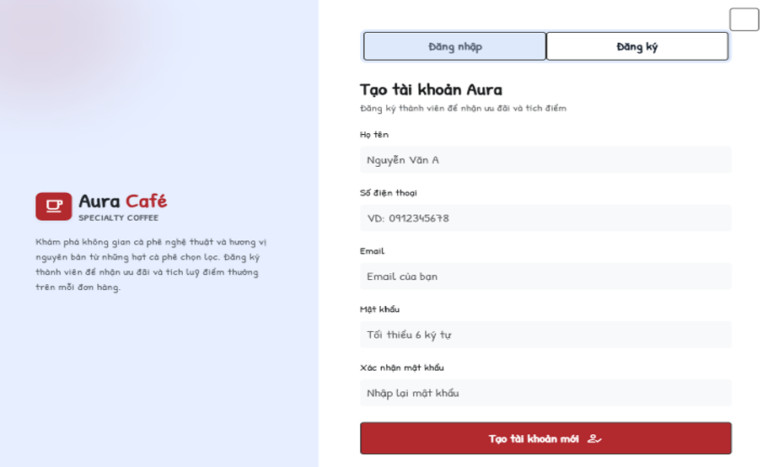
Actors: Guest · Use cases: UC01
Creates a new account with role CUSTOMER and status ACTIVE.
This screen allows the user to:
- Enter personal information and password, then create the account.
- Go to the Login tab after success.
Field Description
Field Name | Description
Họ tên (Full name) | Textbox, required.
Email | Textbox, required, e-mail format, must not exist (MSG13).
Số điện thoại (Phone) | Textbox, required; spaces and dots are removed; Vietnamese mobile format (84|0)[3|5|7|8|9]xxxxxxxx or 9-11 digits; must be unique (MSG12).
Mật khẩu (Password) | Password box, required, at least 6 characters.
Xác nhận mật khẩu (Confirm password) | Must equal Password.
Tạo tài khoản mới (Create account) | Button. On success shows MSG14 and opens the Login tab.

1.1.3 Forgot Password and Verify OTP
Screen / URL: /forgot-password; POST /api/auth/forgot-password and POST /api/auth/verify-otp.
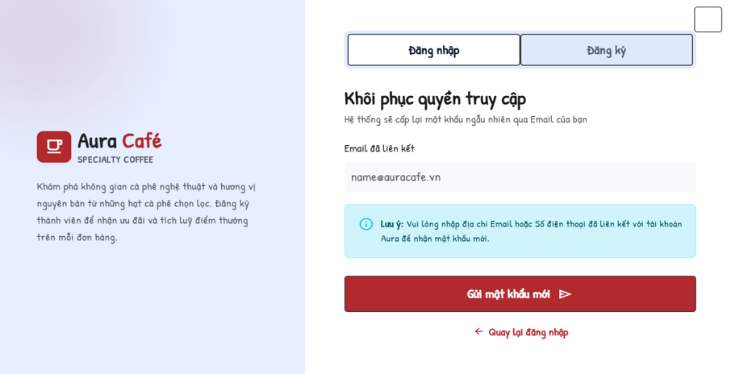
Actors: Guest · Use cases: UC04
Password recovery verifies control of the registered email using a short-lived OTP and then grants one-use password-reset authorization.
This screen allows the user to:
- Request an OTP using the registered email address.
- Verify a six-digit code within ten minutes; reject expired, reused or superseded codes and stop after five failed attempts.
- Resend after at least sixty seconds; invalidate the previous code and enforce the interval on the server.
Field Description
Field Name | Description
Email đã liên kết (Registered e-mail) | Textbox, required; must exist in the system (MSG15).
Gửi (Send) | Send mail through configured SMTP. Return a safe unavailable/delivery error without revealing the code; never bypass verification when mail fails.
Mã xác thực (OTP) | Six-digit input; the server rejects wrong, expired, reused or superseded codes and enforces the attempt limit.
Gửi lại (Resend) | Server-enforced minimum sixty-second resend interval; show remaining wait without exposing the code.

1.1.4 Reset Password
Screen / URL: reset step in /forgot-password; POST /api/auth/reset-password.
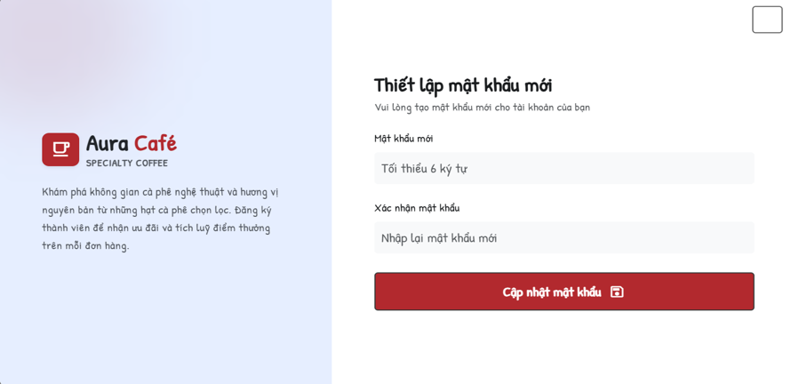
Actors: Guest · Use cases: UC04
Reset requires a valid one-use recovery token, matching new passwords and server validation. Store a bcrypt hash, consume the token and revoke earlier login tokens. Authenticated password change separately verifies the old password.
This screen allows the user to:
- Enter and confirm the new password.
Field Description
Field Name | Description
Mật khẩu mới (New password) | Password box, required.
Xác nhận mật khẩu mới (Confirm) | Must equal the new password (MSG19).
Cập nhật mật khẩu (Update) | Authenticated change uses PUT /api/auth/change-password, validates the current password and the new password confirmation, then stores a bcrypt hash.

2. Customer Portal

2.1 Homepage, Menu and Product

2.1.1 Homepage
Screen / URL: /
Actors: Guest, Customer · Use cases: UC06
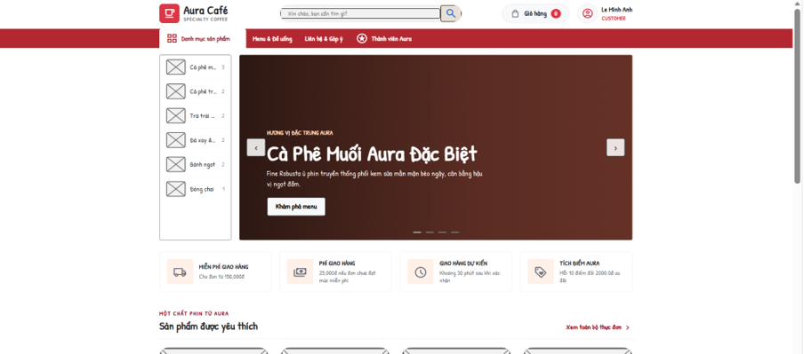
Landing page of the café website. Data (banner product, favourite products, categories, settings) is read from the database.
This screen allows the user to:
- View the banner product carousel and "Sản phẩm được yêu thích" (favourite products).
- Open a product, the Menu, Cart, My Orders, Profile or the login dialog from the header.
Field Description
Field Name | Description
Header | Logo, search box ("Xin chào, bạn cần tìm gì?"), Menu, Cart badge (item count), account menu.
Banner | Product name, image and "Xem món" button (carousel ‹ ›).
Favourite products | Product cards: image, name, price, "Xem món" / quick add.
Footer | Delivery policy, categories, account & support, Aura loyalty information.

2.1.2 Menu
Screen / URL: /menu?category={id}&keyword={text}
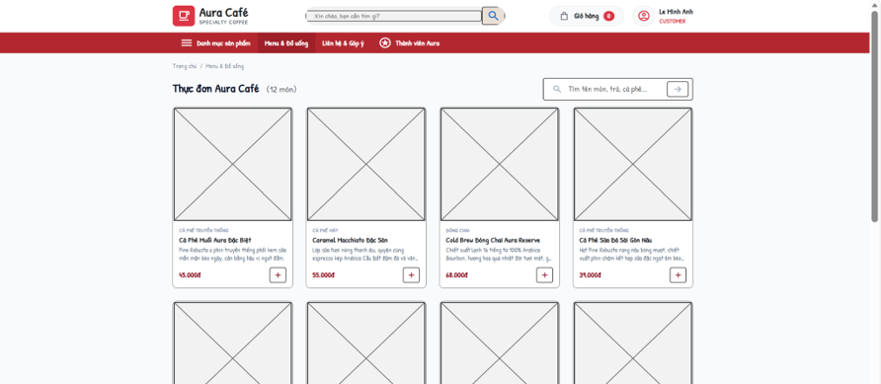
Actors: Guest, Customer · Use cases: UC07, UC08, UC10
Lists available products (is_available = true) of active categories.
This screen allows the user to:
- Filter by category (with product count per category).
- Search by keyword.
- Open a product detail dialog or page and add it to the cart.
Field Description
Field Name | Description
Category tabs | All + each ACTIVE category with its number of products.
Search box | Textbox "Tìm tên món, trà, cà phê..."; empty result shows "Không tìm thấy món phù hợp" (MSG01).
Product card | Image (from database), name, category, price (VND), "Xem món" and add button.

2.1.3 Product Details
Screen / URL: /products/:id?id={id} (also dialog via /menu?action=detail&id={id})
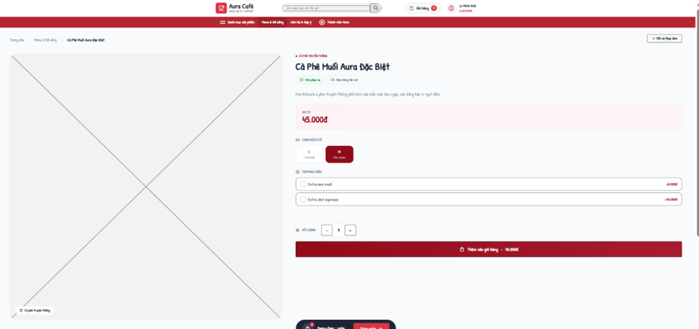
Actors: Guest, Customer · Use cases: UC09, UC10
Shows one product and lets the user choose options before adding it to the cart. The price shown is recalculated by the server when the item is added.
This screen allows the user to:
- Choose a size and toppings, set the quantity and add to cart.
- View related products of the same category.
Field Description
Field Name | Description
Product information | Image, name, category, description, base price.
Chọn size (Size) | Radio list from the product configuration; default = the size with 0 đ surcharge.
Topping thêm (Toppings) | Checkbox list with price per topping (default 8,000 đ when no price is configured).
Quantity | Stepper − / + (min 1).
Add to cart | Button. Unavailable product → MSG21 "Món này hiện đã ngừng phục vụ."
Có thể bạn cũng thích | Up to 4 related products.

2.2 Shopping and Ordering

2.2.1 Shopping Cart
Screen / URL: /cart (JSON: /api/cart, add: POST /api/cart)
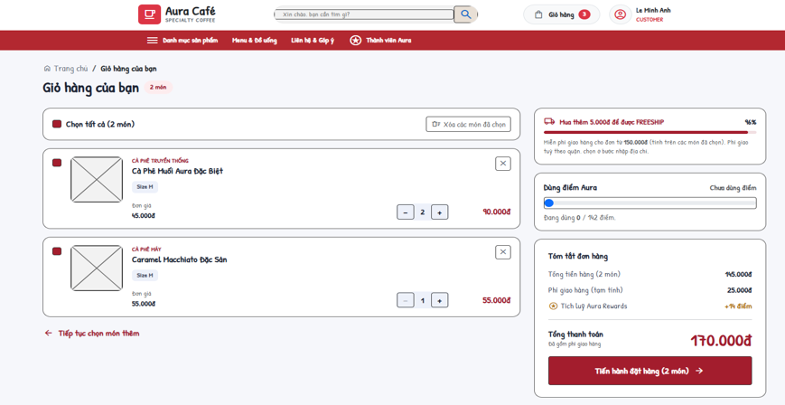
Actors: Guest, Customer · Use cases: UC10, UC64
The guest cart is kept in browser state. After Customer login it synchronizes through GET/PUT /api/cart. Order creation revalidates product availability, sizes, toppings, prices, points and totals using server data.
This screen allows the user to:
- Increase/decrease quantity, remove a line, clear the cart.
- Select lines to order (select all / remove selected).
- Redeem Aura points (Customer only).
- Go to Checkout.
Field Description
Field Name | Description
Cart lines
Chọn tất cả (Select all) | Checkbox; only selected lines are ordered.
Line | Image, name, size, toppings, unit price, quantity (1-99), subtotal; unavailable lines are flagged.
Remove / Clear | Remove one line, remove selected lines or clear the cart.
Tóm tắt đơn hàng (Order summary)
Tổng tiền hàng | Subtotal of selected lines.
Dùng điểm Aura (Points) | Number input. Capped by balance and subtotal and rounded down to a multiple of points_step; discount = (points / points_step) × points_step_value. Guest → MSG22; adjusted value → MSG23.
Phí giao hàng (tạm tính) | Estimated fee = delivery_fee setting, 0 when subtotal ≥ freeship_threshold.
Checkout button | Requires at least one selected line (MSG24).

2.2.2 Checkout
Screen / URL: /checkout
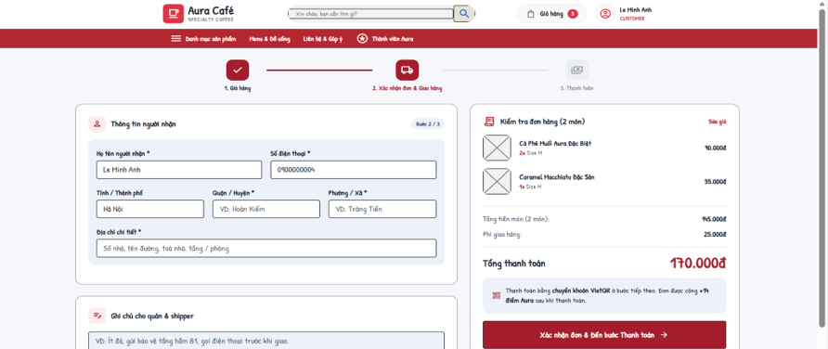
Actors: Customer · Use cases: UC11
Step 2 of 3 ("Xác nhận đơn & Giao hàng"). Online orders are delivered to an address in Hà Nội. Only a CUSTOMER account can place an order (Guest → MSG25, staff/admin → MSG26). Stock of all ingredients needed is checked before the form can be submitted.
This screen allows the user to:
- Enter recipient and delivery address.
- See the delivery fee of the chosen district and the total.
- Confirm the order and go to Payment.
Field Description
Field Name | Description
Thông tin người nhận (Recipient)
Họ tên người nhận * | Textbox, required, max 100 characters; default = Customer full name.
Số điện thoại * | Textbox, required, 10-11 digits starting with 0 (pattern 0\d{9,10}).
Địa chỉ giao hàng (Delivery address)
Tỉnh / Thành phố | Read-only: Hà Nội.
Quận / Huyện * | Dropdown of ACTIVE delivery areas with their fee; inactive/unknown district → MSG27.
Phường / Xã * | Textbox, 2-100 characters.
Địa chỉ chi tiết * | Textbox, 5-150 characters (house number, street, building, floor).
Ghi chú (Note) | Textarea, max 500 characters (for barista and delivery staff).
Order summary
Tổng tiền món | Subtotal of selected lines.
Điểm Aura | Discount from redeemed points.
Phí giao hàng | Fee of the selected district; 0 when subtotal ≥ freeship_threshold.
Xác nhận đơn & Đến bước Thanh toán | Confirm validates items, stock, address, points and expectedTotal before any old-order mutation. Atomically replace only an unpaid checkout of the same owner/session, refund held points and create the new order/payment/ledger. A failed request leaves the old order unchanged; an idempotent retry creates no duplicate.

2.2.3 Payment
Screen / URL: /payment?orderId={id}
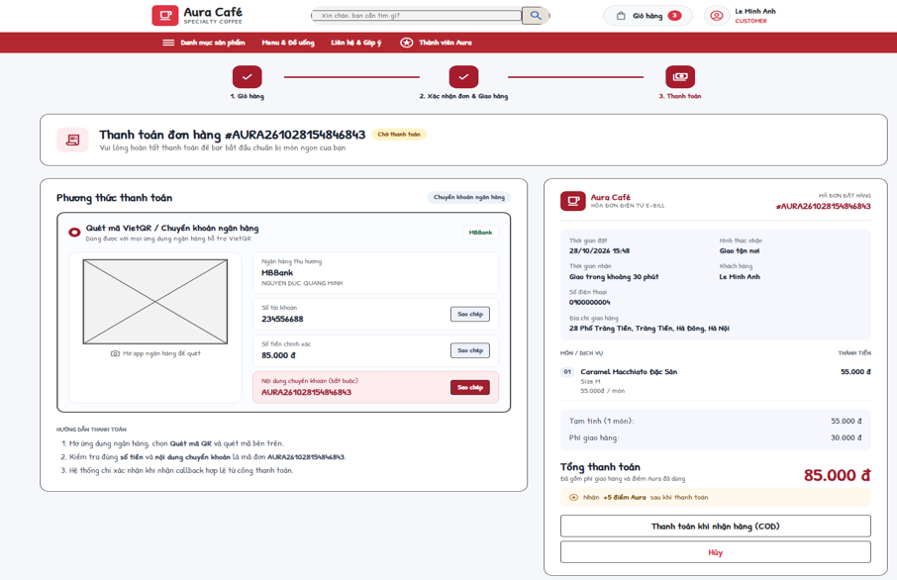
Actors: Customer, Payment Gateway · Use cases: UC12, UC13, UC17
Step 3 of 3. Only the owner of a PENDING order can open it; other statuses are redirected to the e-Bill. A PENDING BANK_TRANSFER payment is created or refreshed.
This screen allows the user to:
- Pay by bank transfer using the VietQR code and copied account/content.
- When demo mode is enabled, confirm a separate DEMO_ONLINE payment. BANK_TRANSFER always requires a provider-signed callback.
- Choose cash on delivery (COD).
- Cancel the order.
Field Description
Field Name | Description
Mã đơn (Order code) | Label, e.g. AURA261026103015123.
VietQR code | Image from vietqr.app with bank, account number, amount and order code as transfer content.
Ngân hàng / Số tài khoản / Chủ tài khoản | Read safe bank/account display data from the payment API. PAYMENT_* credentials stay server-side; Copy copies only the displayed public payment details.
Nội dung chuyển khoản | Order code (copy button).
Order summary | Items, subtotal, points discount, delivery fee, total, expected reward points.
Mô phỏng callback thanh toán thành công | DEMO_ONLINE only, gated by PAYMENT_DEMO_ENABLED and owner JWT: call /api/payments/:id/demo-confirm. Never sign or self-confirm a real BANK_TRANSFER in the browser.
Thanh toán khi nhận hàng (COD) | Button. Creates a CASH payment COD-<code> (PENDING) and confirms the order (MSG32).
Hủy | Cancels the unpaid order (see My Orders).

2.2.4 e-Bill
Screen / URL: /bill?orderId={id}
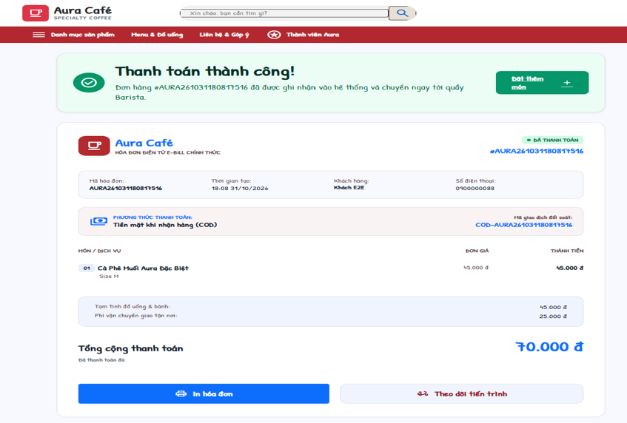
Actors: Customer, Cashier, Admin · Use cases: UC14
Electronic bill of an order. A Customer can only open bills of own orders (MSG33).
This screen allows the user to:
- View and print the bill.
Field Description
Field Name | Description
Header | Payment result, order code, time, order type, recipient / table.
Items | Quantity, product name, options, line amount.
Amounts | Subtotal, points discount, delivery fee, total.
Payment | Payment method, transaction code ("Mã giao dịch đối soát"), status.
Print | Button - browser print.

2.3 Orders, Profile and Customer Care

2.3.1 My Orders
Screen / URL: /orders?tab={all|pending|processing|delivering|completed|cancelled}&q={code}&date={yyyy-MM-dd}
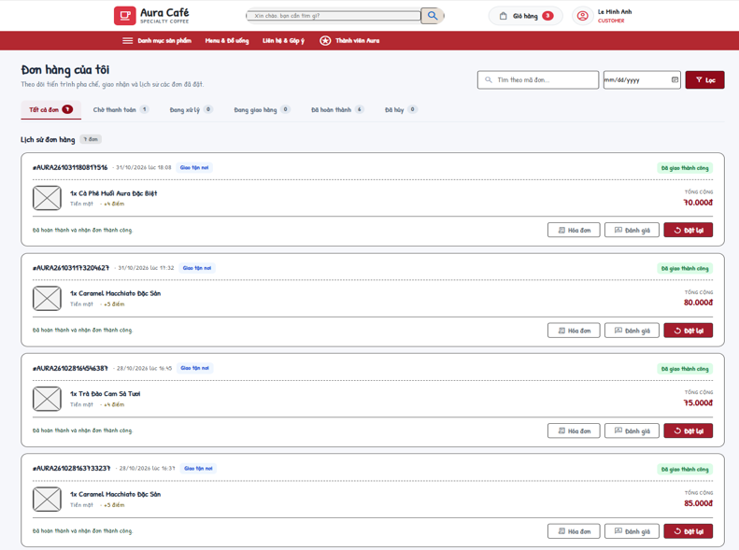
Actors: Customer · Use cases: UC15, UC16, UC17, UC25
Shows the Customer's orders, 10 per page ("load more" up to 100).
This screen allows the user to:
- Follow in-progress orders.
- Filter history by status tab, order code and date.
- Pay a pending order, view the bill, cancel an unpaid order or reorder.
Field Description
Field Name | Description
Status tabs | Tất cả, Chờ thanh toán (PENDING), Đang xử lý (CONFIRMED/PREPARING/READY), Đang giao (DELIVERING), Hoàn thành (COMPLETED), Đã hủy (CANCELLED) with counts.
Tìm theo mã đơn | Textbox, max 30 characters (upper-cased).
Ngày (Date) | Date picker (yyyy-MM-dd) for filtering orders.
Order card | Code, time, type, status, items, total, payment method.
Hủy đơn (Cancel) | Only PENDING orders without successful payment (MSG35); points refunded (MSG34).
Đặt lại (Reorder) | Adds still-available items to the cart at current prices (MSG36 / MSG37).

2.3.2 Customer Profile
Screen / URL: /profile
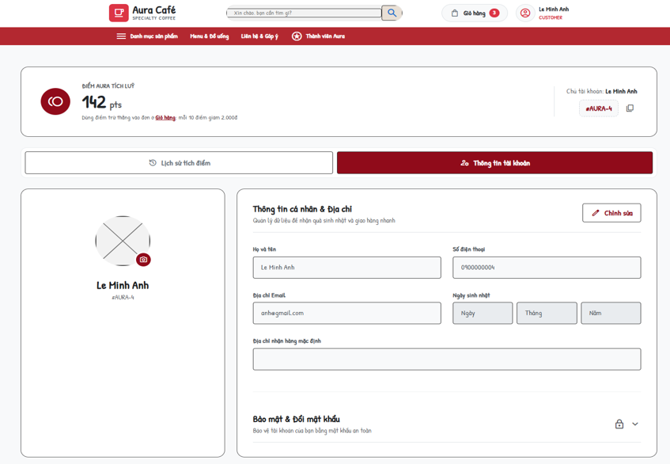
Actors: Customer · Use cases: UC05
Personal page of the signed-in user.
This screen allows the user to:
- Update personal information.
- Change password.
- View the point balance and transaction history for the Customer identified by the unique phone number.
Field Description
Field Name | Description
Thông tin cá nhân & Địa chỉ
Họ và tên | Textbox, required (MSG38).
Số điện thoại / Địa chỉ Email | Editable after clicking Edit. Phone: 9-15 digits when provided; email: format checked. Values are kept when omitted; duplicate phone/email errors are returned by User.
Ngày sinh nhật | Birthday day, month and year selectors populate the hidden birthday field.
Địa chỉ nhận hàng mặc định | Textbox.
Bảo mật & Đổi mật khẩu
Mật khẩu hiện tại | Required; must be correct (MSG39).
Mật khẩu mới / Xác nhận | At least 6 characters; must match.
Lịch sử biến động điểm thưởng
Point history | Phone-based point history: date, type, points change, resulting balance and linked order. Common earn/redeem rules apply to every Customer.

2.3.3 Customer Care (Feedback & Complaints)
Screen / URL: /feedback
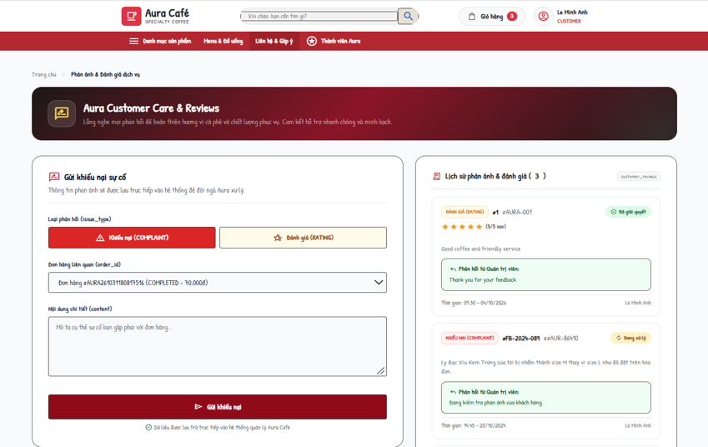
Actors: Customer · Use cases: UC65
The Customer sends a rating or a complaint about one of his/her orders and follows the tickets.
This screen allows the user to:
- Submit a rating (1-5 stars) or a complaint.
- View own tickets with status and admin response.
Field Description
Field Name | Description
Loại phản hồi (issue_type) | RATING (Đánh giá) or COMPLAINT (Khiếu nại).
Đơn hàng liên quan (order_id) | Dropdown of own orders that have no feedback yet ("Không còn đơn hàng chưa phản hồi" when empty). Invalid/already reviewed → MSG41.
Số sao đánh giá (rating) | 1-5, only for RATING (default 5).
Nội dung chi tiết (content) | Textarea, required (MSG40).
Gửi (Send) | Saves the ticket with status PENDING. Not signed in → MSG42.
My tickets | Code, order, type, rating, content, status, progress, admin response.

3. Counter Ordering (Cashier)

3.1 Point of Sale

3.1.1 Cashier POS
Screen / URL: /cashier (AJAX actions on /api/orders)
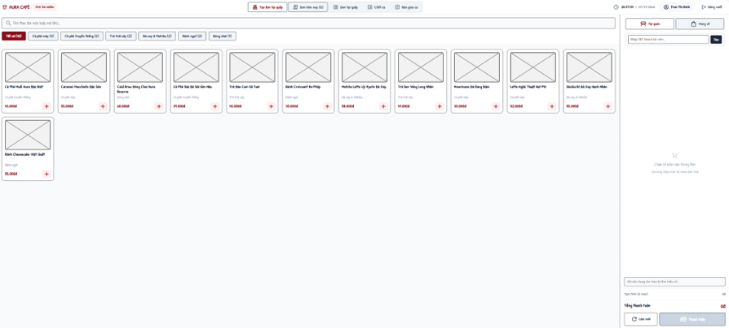
Actors: Cashier, Payment Gateway · Use cases: UC18, UC19, UC21, UC22, UC64, UC62
Point-of-sale screen. Access requires STAFF + CASHIER + ACTIVE (MSG43). Prices, points and totals sent by the browser are recalculated on the server.
This screen allows the user to:
- Pick products by category or search, choose options and add them to the order.
- Look up a member by phone and redeem points.
- Choose dine-in/takeaway, table and note; take cash or VietQR payment.
- See today's counter orders; cancel or hand over an order; print the bill.
Field Description
Field Name | Description
Product selection
Category filter / search | "Tất cả" + categories with counts; search "Tìm theo tên món hoặc mã SKU...".
Options dialog | Size, toppings, sugar (100% / 70% / 50% / 30% / Không đường), ice (100% / 70% / 50% / Ít đá / Không đá / Uống nóng), item note, quantity.
Order panel
Loại đơn | Tại quán (DINE_IN) with table number, or Mang đi (TAKEAWAY).
Nhập SĐT khách hội viên | Member lookup (GET action=search-customer). Not found → MSG44.
Dùng điểm | Points to redeem; capped to balance and subtotal; multiple of points_step.
Ghi chú chung | Order note.
Payment
Tiền mặt (Cash) | "Khách đưa (VNĐ)" with quick amounts (Đúng số tiền, 50k ... 1,000k) and "Tiền thừa trả khách". Order CONFIRMED, payment SUCCESS, points REDEEM/EARN.
VietQR | Shows bank, account number and holder for scanning. Payment PENDING until confirmed (auto-confirmed in test mode).
Create order | POST action=create-order. No item → MSG45; invalid member → MSG46; success → MSG47.
Đơn hôm nay (Today's orders)
Columns | Mã đơn, Thời gian, Loại đơn, Khách hàng, Món đã gọi, Tổng tiền, Hình thức, Trạng thái, Thao tác.
Hủy (Cancel) | action=cancel-order; only PENDING / CONFIRMED (MSG48).
Hoàn tất (Hand over) | action=complete-order; only READY dine-in / takeaway orders (MSG49).

3.1.2 Counter Order List
Screen / URL: /cashier/orders?date=&status=&type=
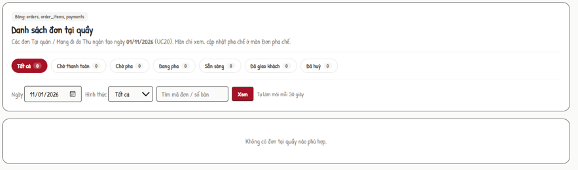
Actors: Cashier, Barista · Use cases: UC20
Read-only list of counter orders (DINE_IN / TAKEAWAY) of a day for Cashier and Barista (other roles → 403).
This screen allows the user to:
- Choose a date, filter by status and type, search by order code / table.
Field Description
Field Name | Description
Ngày (Date) | Date picker, default today.
Hình thức | Tất cả / Tại quán / Mang đi.
Status counters | ALL, PENDING, CONFIRMED, PREPARING, READY, COMPLETED, CANCELLED.
Order rows | Code, time, type, table / customer, items, amount, status.

3.2 Shift Handover

3.2.1 Cashier Shift Handover
Screen / URL: /cashier/handover?mode={close|handover}&scheduleId=

Actors: Cashier · Use cases: UC60, UC73
Closes the Cashier's current PRESENT shift and shows the resulting handover report. Only STAFF + CASHIER + ACTIVE (MSG50).
This screen allows the user to:
- Review the cash summary of the open shift and enter the counted cash.
- Submit the handover report.
- Read the review result; explain and resubmit a rejected report.
Field Description
Field Name | Description
Chốt két (Close mode)
Shift summary | Expected cash = opening cash + attributed counter CASH receipts + COD physically confirmed by the cashier - CASH refunds issued from this shift. Preserve the original receipt even if later refunded through BANK_TRANSFER. Save the reconciliation snapshot atomically; require a reason for a difference.
Tiền mặt thực tế cuối ca (actual_cash) | Number, 0 - 9,999,999,999, multiple of 1,000 đ (MSG51).
Ghi chú bàn giao (note) | Textarea, max 500 characters; required when actual ≠ expected (MSG52).
Chốt ca | Button. In one transaction: schedule → COMPLETED and handover → SUBMITTED (MSG53). Shift already closed → MSG54.
Biên bản bàn giao (Handover mode)
Report | Shift, opening cash, cash sales, expected, actual, difference (Khớp / Thừa / Thiếu), note, status, reviewer note.
Giải trình và gửi lại | Only for REJECTED reports; explanation required (MSG55); report → SUBMITTED (MSG56).
Recent shifts | Last 15 schedules of the Cashier.

4. Drink Preparation (Barista)

4.1 Order Preparation

4.1.1 Barista Dashboard
Screen / URL: /barista (JSON: /api/orders), completed view: /barista?action=completed
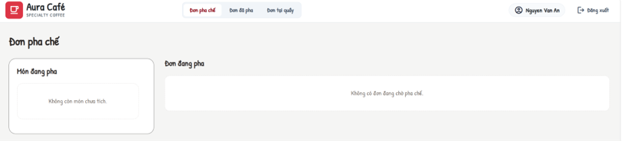
Actors: Barista · Use cases: UC23, UC24
Preparation queue shared by all channels (DINE_IN, TAKEAWAY, ONLINE). An order is shown when it is paid (payment SUCCESS) or is an ONLINE COD order. The page refreshes data from /api/orders. All POST actions require the Bearer JWT.
This screen allows the user to:
- See active orders (CONFIRMED / PREPARING) with items, customizations, table and note.
- Tick / untick prepared items (per cup); an order with ticked items is shown as "Đang pha".
- Finish an order (READY).
- See completed (READY) orders with completion time.
Field Description
Field Name | Description
Order card | Order code, type, created time, table / recipient, note, item count, status.
Item checkbox | action=update-items (itemIds, isPrepared). Prepared flags are kept by the server while the order is active; ticking an item shows the order as preparing.
Hoàn tất (Done) | action=update-order-status, status=READY; allowed from CONFIRMED / PREPARING. Deducts ingredients by recipe (OUT_ORDER) in the same transaction; not enough stock → MSG57; order changed meanwhile → MSG58. (status=PREPARING is also accepted by the API.)
Đơn đã pha (Completed) | READY orders, newest first.

5. Delivery Management (Delivery Staff)

5.1 Delivery Dashboard

5.1.1 Delivery Management
Screen / URL: /delivery?tab={active|done|cod}&id=&date=
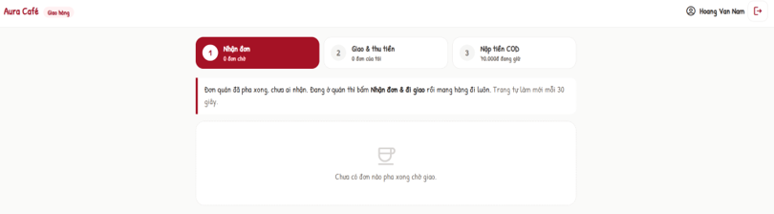
Actors: Delivery Staff · Use cases: UC26, UC27, UC28, UC29, UC30
Work screen of the delivery staff (STAFF + SHIPPER + ACTIVE; others → 403). Only deliveries assigned to the signed-in user are visible. All POST actions require the Bearer JWT.
This screen allows the user to:
- See assigned deliveries with counters (waiting, in progress, delivered today).
- Accept, pick up and confirm delivery; enter collected COD.
- Report a delivery issue.
- View delivered orders of a date.
- Hand over held COD cash to a Cashier and view the COD history.
Field Description
Field Name | Description
Đơn được phân công (Active tab)
Delivery card | Order code, recipient, phone, address, note, items, COD amount, status.
Nhận đơn (accept) | ASSIGNED → ACCEPTED (MSG59 when not waiting).
Lấy hàng (pickup) | ACCEPTED + order READY → delivery and order DELIVERING (MSG60).
Giao thành công (deliver) | "Tiền đã thu" (required for COD, must equal COD amount - MSG61) and delivery note (≤ 500). Payment SUCCESS + EARN points, delivery DELIVERED, order COMPLETED.
Báo sự cố (report) | Loại sự cố: Không liên lạc được khách, Sai / không tìm thấy địa chỉ, Khách từ chối nhận hàng, Hàng bị đổ vỡ / hư hỏng, Kẹt xe / thời tiết, giao trễ, Khác; Mô tả required ≤ 500 (MSG62). Allowed while the delivery is not DELIVERED.
Đơn đã giao (Done tab)
Date + table | Mã đơn, Người nhận, Địa chỉ, Giao lúc, COD đã thu.
Tiền COD (COD tab)
Tiền COD đang giữ | Delivered COD orders not yet handed over and their total.
Thu ngân nhận tiền | Dropdown of ACTIVE cashiers (MSG63). "Nộp tiền" records hand-over time and receiver for all held orders (MSG64).
Lịch sử nộp tiền COD | Mã đơn, Đã thu, Nộp lúc, Thu ngân nhận.

6. Administration - Menu and Recipe

6.1 Admin Home

6.1.1 Admin Dashboard
Screen / URL: /admin/reports, rendered by the React Admin workspace.
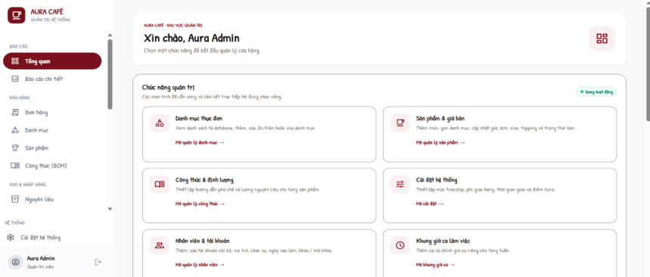
Actors: Admin
Home page of the back-office with a greeting and tiles for every admin function; the left sidebar is shared by all admin screens.
This screen allows the user to:
- Open any admin function.
Field Description
Field Name | Description
Tiles | Danh mục thực đơn, Sản phẩm & giá bán, Công thức & định lượng, Cài đặt bán hàng online, Nhân viên & tài khoản, Khung giờ ca làm việc, Lịch phân ca nhân viên, Chấm công nhân viên, Bàn giao ca, Nguyên vật liệu, Tồn kho & Xuất nhập, Đề xuất nhập hàng, Phiếu nhập hàng, Nhà cung cấp, Quản lý đơn hàng, Khách hàng, Tích điểm thành viên, Đánh giá & Khiếu nại, Báo cáo kinh doanh.

6.2 Category and Product

6.2.1 Category Management
Screen / URL: /admin/categories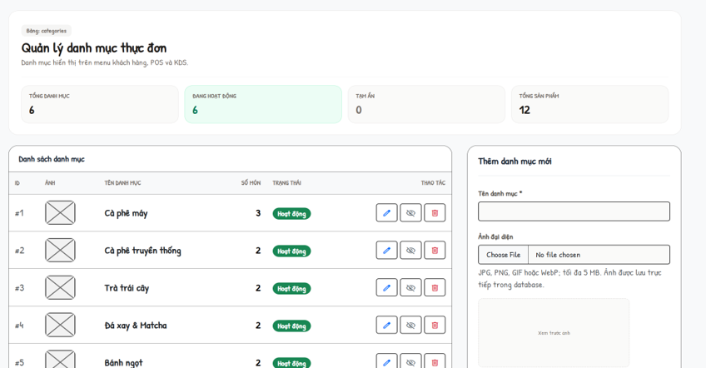

Actors: Admin · Use cases: UC31, UC32, UC33, UC34
Manages menu categories. All POST actions require the Bearer JWT (MSG65).
This screen allows the user to:
- List categories.
- Create or edit a category with image.
- Hide / show a category.
- Delete a category without products.
Field Description
Field Name | Description
List | ID, Ảnh, Tên danh mục, Số món, Trạng thái, Thao tác (edit, hide/show, delete).
Tên danh mục * | Required, max 100 characters, unique (MSG66).
Trạng thái | ACTIVE / INACTIVE.
Ảnh đại diện | Optional file: JPG, PNG, GIF, WebP, ≤ 2 MB, content must match the type (MSG67). "Xóa ảnh hiện tại" removes it.
Delete | Rejected when the category has products (MSG68).

6.2.2 Product Management
Screen / URL: /admin/products?categoryId=&q=
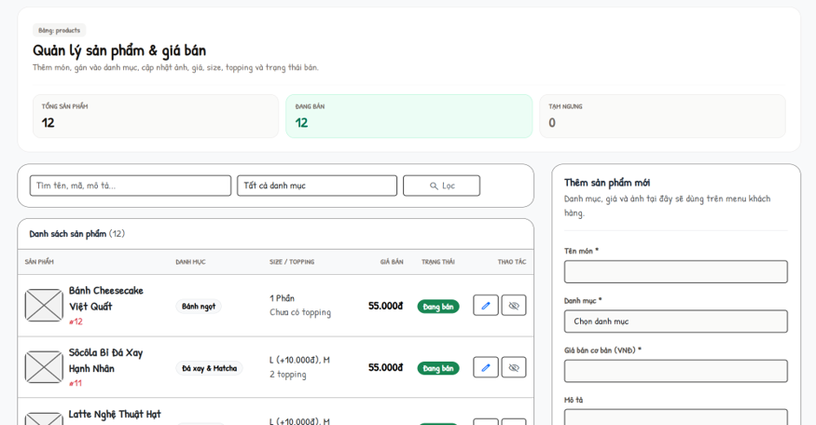
Actors: Admin · Use cases: UC35, UC36, UC37, UC38, UC39
Manages products, prices, options and images.
This screen allows the user to:
- Filter by category and keyword; see available / paused counters.
- Create or edit a product with sizes, toppings and image.
- Pause or resume selling.
Field Description
Field Name | Description
List | Sản phẩm, Danh mục, Size / Topping, Giá bán, Trạng thái, Thao tác.
Tên món * | Required, max 150 characters.
Danh mục * | Existing category.
Giá bán cơ bản (VNĐ) * | Number ≥ 0, max 2 decimals.
Mô tả | Textarea.
Sizes | Rows of name (≤ 30) + surcharge ≥ 0; at least one size and one size with 0 đ.
Toppings | Rows of name (≤ 50) + price ≥ 0.
Ảnh sản phẩm | Same rules as category image.
Bán / Tạm ngừng | Toggles is_available (MSG69).

6.3 Recipe

6.3.1 Recipe Management
Screen / URL: /admin/recipes?productId=
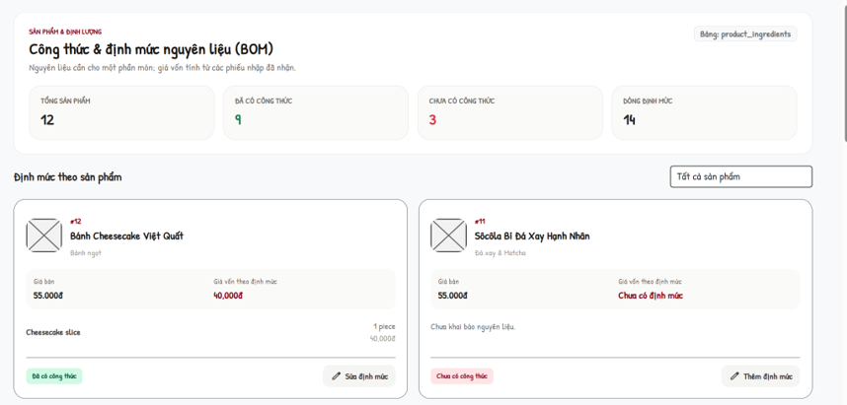
Actors: Admin · Use cases: UC40, UC41, UC42, UC43
Bill of materials per product. Cost of a portion = Σ(quantity required × latest unit price of a RECEIVED purchase order). Ingredients without a received price are listed as missing cost.
This screen allows the user to:
- See products with / without recipe and the number of recipe lines.
- Open a product recipe and its cost.
- Add, edit or remove ingredient lines and quantities; save the product BOM. There is no recipe deactivation or instruction editor in the active screen.
Field Description
Field Name | Description
Filter | Tất cả sản phẩm / Đã có công thức / Chưa có công thức.
Product summary | Product, ingredient lines for one portion, cost (complete or missing prices).
Legacy preparation instructions | Not editable or saved by the active Recipe Management form. Legacy instruction data may remain in products.variants_config.
Nguyên liệu + Định lượng | Rows: ingredient (dropdown with unit) and quantity > 0 with max 3 decimals; no duplicate ingredient (MSG70). "+ Thêm nguyên liệu" / "Xóa".
Lưu công thức | Replaces all lines of the product (MSG71).

7. Administration - Inventory and Purchasing

7.1 Ingredient and Inventory

7.1.1 Ingredient Management
Screen / URL: /admin/inventory?q=&supplierId=
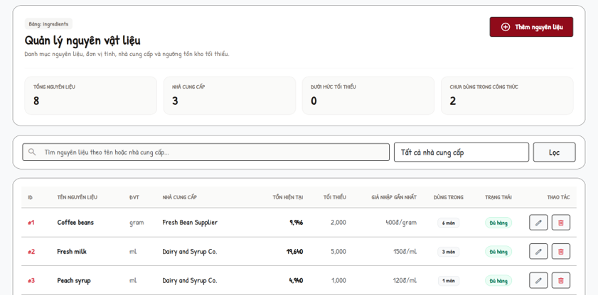
Actors: Admin · Use cases: UC44, UC45, UC46, UC47
Master data of ingredients with stock indicators.
This screen allows the user to:
- Search by name / supplier.
- Create, edit or delete an ingredient.
Field Description
Field Name | Description
List | ID, Tên nguyên liệu, ĐVT, Nhà cung cấp, Tồn hiện tại, Tối thiểu, Giá nhập gần nhất, Dùng trong (recipes), Trạng thái, Thao tác.
Tên nguyên liệu * | Required.
Đơn vị tính (ĐVT) * | Required (gram, ml, piece...).
Nhà cung cấp | Optional supplier.
Tồn kho ban đầu | Only on create, ≥ 0.
Ngưỡng tối thiểu | Minimum stock level ≥ 0.
Delete | Rejected when used in a recipe (MSG72).

7.1.2 Inventory Management
Screen / URL: /admin/inventory
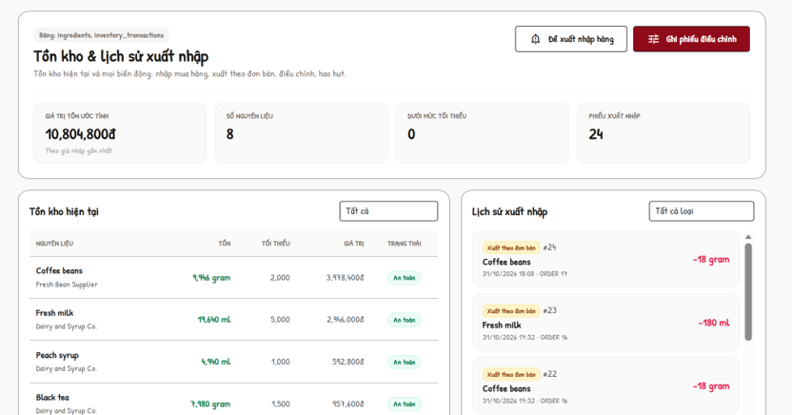
Actors: Admin · Use cases: UC48, UC49
Current stock and the movement history; manual adjustments are recorded as inventory transactions.
This screen allows the user to:
- Filter stock by status.
- Filter the movement history by type.
- Record a stock adjustment.
Field Description
Field Name | Description
Tồn kho hiện tại | Filter Tất cả / Sắp hết / An toàn / Hết hàng; columns Nguyên liệu, Tồn, Tối thiểu, Giá trị, Trạng thái.
Lịch sử xuất nhập | Filter Nhập mua hàng (IN_PURCHASE), Xuất đơn bán (OUT_ORDER), Điều chỉnh kho (ADJUSTMENT), Hao hụt / Hủy (SPOILAGE).
Nguyên liệu cần chỉnh * | Dropdown with current stock.
Loại điều chỉnh * | ADJUSTMENT (stock count) or SPOILAGE (always decreases).
Hướng điều chỉnh | Cộng thêm (+) / Trừ bớt (−).
Số lượng thay đổi * | Number > 0 (MSG73).
Lý do / Ghi chú | 3-500 characters (MSG74). Success → MSG75.

7.2 Purchasing

7.2.1 Restock Requests
Screen / URL: /admin/restock
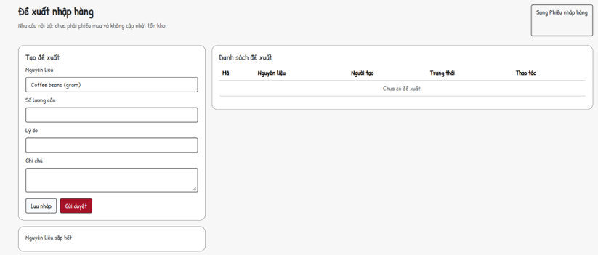
Actors: Admin · Use cases: UC50, UC51
Internal requests to buy ingredients, approved before a purchase order is made.
This screen allows the user to:
- See low-stock ingredients and counters (low stock, pending, approved, draft).
- Create a request as draft or send it for approval.
- Submit, approve, reject or cancel requests.
Field Description
Field Name | Description
Nguyên liệu | Dropdown (with unit).
Số lượng cần | Number > 0.
Lý do / Ghi chú | Text, max 500.
Lưu nháp / Gửi duyệt | Creates DRAFT or PENDING_APPROVAL.
List | Mã (RR-0001), Người tạo, items, Trạng thái, Thao tác (Gửi, Duyệt, Từ chối, Hủy with review note). Status changed meanwhile → MSG76.

7.2.2 Supplier Management
Screen / URL: /admin/suppliers
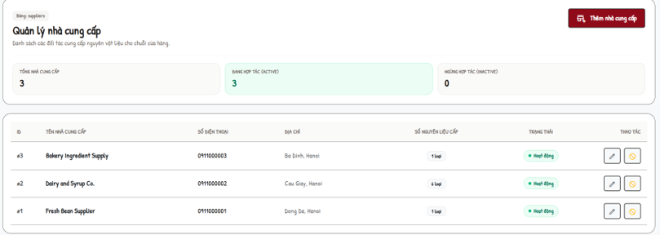
Actors: Admin · Use cases: UC52
Suppliers of ingredients.
This screen allows the user to:
- Create, edit and activate / deactivate suppliers.
Field Description
Field Name | Description
List | ID, Tên nhà cung cấp, Số điện thoại, Địa chỉ, Số nguyên liệu cấp, Trạng thái, Thao tác.
Tên nhà cung cấp * | Required (MSG77).
Số điện thoại / Địa chỉ | Optional.
Trạng thái | Hoạt động (ACTIVE) / Tạm ngừng (INACTIVE).

7.2.3 Purchase Orders
Screen / URL: /admin/purchases
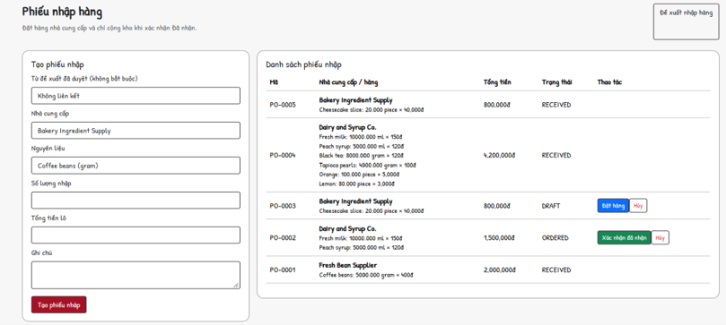
Actors: Admin · Use cases: UC53
Purchase orders to suppliers; stock is increased only when the order is confirmed as received.
This screen allows the user to:
- Create a draft purchase order (optionally from an approved restock request).
- Place, receive or cancel purchase orders.
Field Description
Field Name | Description
Từ đề xuất đã duyệt | Optional APPROVED request (each request used once; otherwise MSG78).
Nhà cung cấp | ACTIVE supplier, required.
Nguyên liệu | Required.
Số lượng nhập | Number > 0 (3 decimals).
Tổng tiền lô | Number ≥ 0; unit price = total / quantity (MSG79 when invalid).
Ghi chú | Max 500.
List | Mã (PO-0001), Nhà cung cấp / hàng, Tổng tiền, Trạng thái; Đặt hàng (DRAFT → ORDERED), Xác nhận đã nhận (ORDERED → RECEIVED, stock + IN_PURCHASE), Hủy (DRAFT / ORDERED).

8. Administration - Human Resources

8.1 Employees and Shifts

8.1.1 Employee Management
Screen / URL: /admin/employees?position=
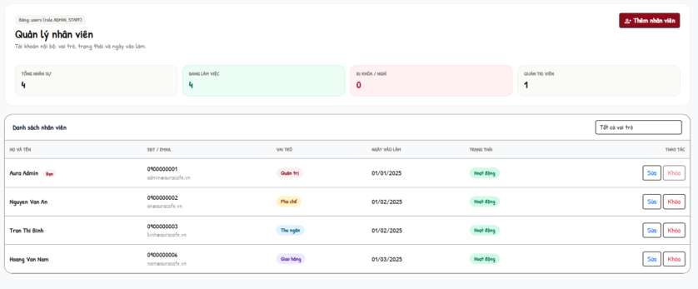
Actors: Admin · Use cases: UC54
Staff and administrator accounts. Only ADMIN can open it (MSG80).
This screen allows the user to:
- Filter employees by role.
- Add or edit an employee.
- Lock / unlock an account.
Field Description
Field Name | Description
Lọc theo vai trò | Tất cả vai trò, Quản trị, Pha chế, Thu ngân, Giao hàng.
List | Họ và tên, SĐT / Email, Vai trò, Ngày vào làm, Trạng thái, Thao tác (Sửa, Khóa / Mở khóa).
Họ và tên * | Required, max 120.
Số điện thoại (đăng nhập) * | 9-11 digits, unique.
Email | Optional, valid format, max 150, unique.
Mật khẩu * | Required on create, 6-255 characters; empty on edit keeps the old password.
Vai trò | Quản trị (ADMIN + MANAGER) / Thu ngân / Pha chế / Giao hàng (STAFF + position).
Trạng thái | Hoạt động / Ngừng hoạt động / Đã khóa. Admin cannot downgrade or lock himself (MSG81).
Ngày vào làm / Ngày sinh / Địa chỉ | Optional; birthday not in the future; address ≤ 500.

8.1.2 Work Shift Management
Screen / URL: /admin/shifts?week={yyyy-MM-dd}
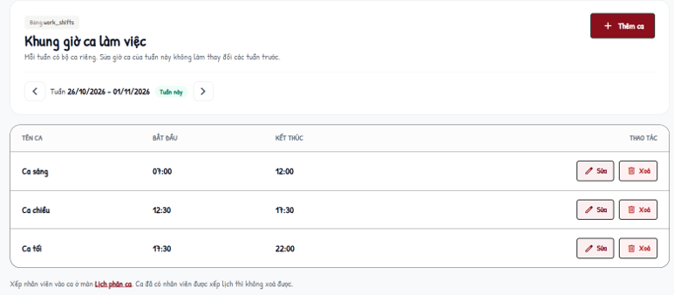
Actors: Admin · Use cases: UC55
Shift frames are stored per week so changing this week does not affect previous weeks. Past weeks are view-only.
This screen allows the user to:
- Move between weeks.
- Add, edit or delete a shift of the selected week.
- Copy the shifts of the latest earlier week into an empty week.
Field Description
Field Name | Description
Tuần (Week) | Week from Monday to Sunday.
Table | Tên ca, Bắt đầu, Kết thúc, Thao tác.
Tên ca * | Required, max 50, unique in the week (MSG82).
Bắt đầu / Kết thúc | HH:mm; end after start; must not overlap another shift of the week (MSG83).
Delete | Rejected when employees are scheduled in the shift (MSG84).
Sao chép ca | Only into an empty week; source = latest earlier week with shifts (MSG85).

8.2 Schedule and Attendance

8.2.1 Work Schedules
Screen / URL: /admin/schedules?view={calendar|table|board}&date=
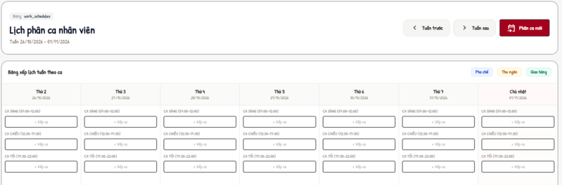
Actors: Admin · Use cases: UC56, UC57
Assigns employees to the shifts of the week that contains the work date.
This screen allows the user to:
- View the week as a calendar or table, or one day as a board.
- Assign, update or delete a schedule.
Field Description
Field Name | Description
Nhân viên * | ACTIVE employee with a position.
Ngày làm việc * | Date (yyyy-MM-dd).
Ca làm việc * | Shift of the week of the work date (MSG86 if the week has no shift / wrong week).
Tiền két đầu ca (VNĐ) | Cashier only; 0 - 9,999,999,999, multiple of 1,000 (MSG87).
Ghi chú | Max 500.
Trạng thái (update) | Đã xếp lịch, Có mặt, Vắng mặt, Hoàn thành; closing cash fields for cashier.
Duplicate | Same employee, date and shift → MSG88.

8.2.2 Attendance
Screen / URL: /admin/attendance?date=
Actors: Admin · Use cases: UC58, UC59
Daily attendance based on the schedules; late minutes are calculated from the start time of the shift of that week.
This screen allows the user to:
- Choose a date.
- Update check-in, check-out, status and note.
Field Description
Field Name | Description
List | Nhân viên, Ca làm việc, Giờ vào (late minutes), Giờ ra, Trạng thái, Ghi chú, Thao tác.
Trạng thái * | Đã xếp lịch / Có mặt / Hoàn thành / Vắng mặt.
Giờ vào / Giờ ra | HH:mm. PRESENT needs check-in; COMPLETED needs check-out after check-in (MSG89).
Ghi chú | Max 500.

8.2.3 Shift Handover Review
Screen / URL: /cashier/handover?status={SUBMITTED|CONFIRMED|REJECTED|ALL}
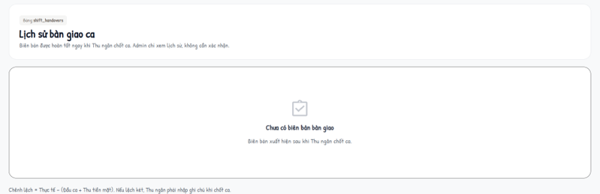
Actors: Admin · Use cases: UC69
Admin reviews the cash handover reports submitted by cashiers.
This screen allows the user to:
- Filter reports by status.
- Confirm or reject a SUBMITTED report.
Field Description
Field Name | Description
Table | Ca làm, Thu ngân, Đầu ca, Thu tiền mặt, Hệ thống, Thực tế, Chênh lệch (Khớp / Thừa / Thiếu), Ghi chú, Trạng thái, Thao tác.
Xác nhận | Optional opinion (≤ 500) → CONFIRMED.
Từ chối | Reason required (MSG90) → REJECTED; the cashier can resubmit.
Concurrency | Only SUBMITTED reports can be reviewed (MSG91).

9. Administration - Sales and Customers

9.1 Orders

9.1.1 Order Management
Screen / URL: /admin/orders?detailId=
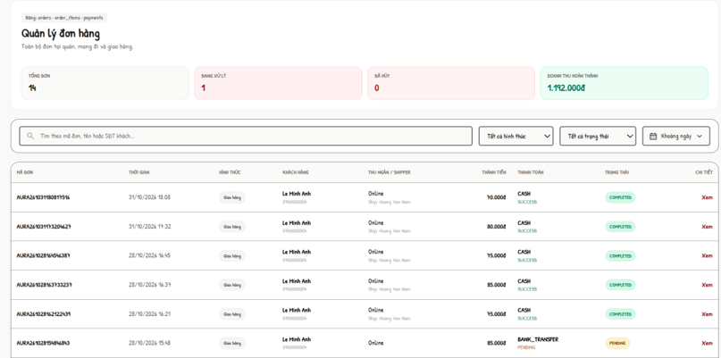
Actors: Admin · Use cases: UC67, UC72, UC14
All orders of all channels with KPIs (total, in progress, cancelled, completed revenue).
This screen allows the user to:
- Search and filter orders by type and status.
- Open the order detail (items, prepared flags, payment, delivery and issues).
- Update the order status.
- Assign, change or remove the delivery staff of an ONLINE order.
Field Description
Field Name | Description
Filters | Search (code, name, phone); Tại quán / Mang đi / Giao hàng; status list.
List | Mã đơn, Thời gian, Hình thức, Khách hàng, Thu ngân / Shipper, Thành tiền, Thanh toán, Trạng thái, Chi tiết.
Trạng thái đơn (status) | Any of PENDING, CONFIRMED, PREPARING, READY, DELIVERING, COMPLETED, CANCELLED (MSG92).
Shipper (shipper_id) | Select an active on-shift shipper for an unfinished ONLINE order before pickup. Persist ASSIGNED in Order.delivery and history. The assigned shipper explicitly accepts before pickup; reassignment after pickup requires a typed RETURN issue. Delivery is embedded in Order, not a separate authoritative collection.

9.2 Customers and Loyalty

9.2.1 Customer Management
Screen / URL: /admin/customers
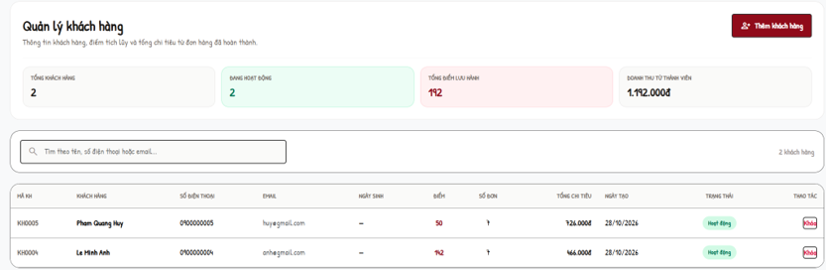
Actors: Admin · Use cases: UC61
Customers with loyalty and spending summary.
This screen allows the user to:
- Search customers.
- Add a customer.
- Lock / unlock a customer.
Field Description
Field Name | Description
List | Mã KH, Khách hàng, Số điện thoại, Email, Ngày sinh, Điểm, Số đơn, Tổng chi tiêu, Ngày tạo, Trạng thái, Thao tác.
Họ và tên / Số điện thoại | Required; phone format, unique (MSG94).
Email / Địa chỉ / Ngày sinh | Optional.
Điểm tặng khởi tạo | Initial points ≥ 0.
Khóa / Mở khóa | ACTIVE ↔ LOCKED.

9.2.2 Loyalty Management
Screen / URL: /admin/memberships?phone=
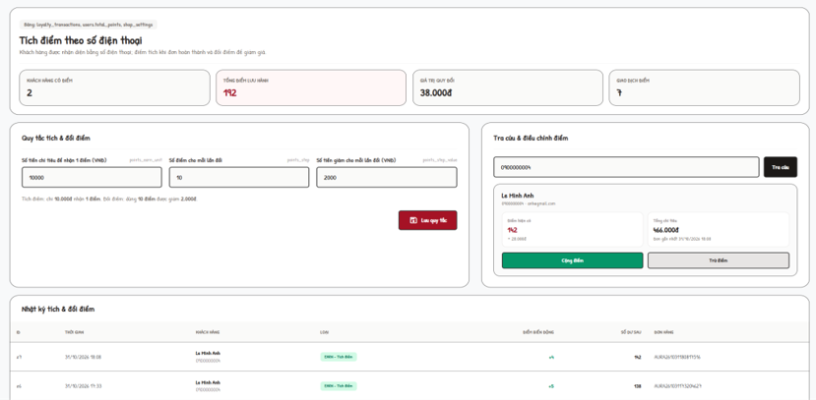
Actors: Admin · Use cases: UC63, UC62, UC64
Phone-number based loyalty: rules, lookup and manual adjustment.
This screen allows the user to:
- Edit earn and redeem rules.
- Look up a customer by phone.
- Add or subtract points (recorded as ADJUST).
- View the transaction log.
Field Description
Field Name | Description
points_earn_unit | Money spent for 1 point, 1 - 100,000,000 đ.
points_step | Points per redemption step, 1 - 1,000,000.
points_step_value | Discount per step, 0 - 100,000,000 đ.
Tra cứu | Phone lookup; not found → MSG95.
Cộng / Trừ điểm | 1 - 1,000,000 points.
Nhật ký | ID, Thời gian, Khách hàng, Loại, Điểm biến động, Số dư sau, Đơn hàng.

9.2.3 Feedback Management
Screen / URL: /admin/complaints?type=&status=
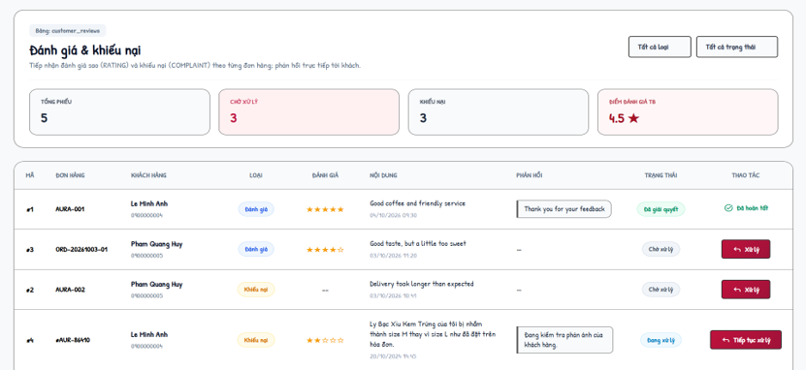
Actors: Admin · Use cases: UC70
Handles ratings and complaints. KPIs: total, complaints, average rating.
This screen allows the user to:
- Filter by type and status.
- Respond to a ticket and set its status.
Field Description
Field Name | Description
Filters | Tất cả loại / Đánh giá / Khiếu nại; Tất cả trạng thái / Chờ xử lý / Đang xử lý / Đã giải quyết / Từ chối.
List | Mã, Đơn hàng, Khách hàng, Loại, Nội dung, Phản hồi, Trạng thái, Thao tác.
Trạng thái xử lý | IN_PROGRESS (stays open), RESOLVED or REJECTED (closed, final).
Nội dung phản hồi * | Required, max 2,000 characters (MSG96). Closed tickets cannot be edited.

9.3 Reports

9.3.1 Business Reports
Screen / URL: /admin/reports?range={today|7d|30d|month|custom}&from=&to=
Actors: Admin · Use cases: UC66
Aggregated from orders, order items, payments, ingredients and inventory transactions; no report data is stored.
This screen allows the user to:
- Choose a period (default last 30 days; custom range ≤ 366 days).
- Read KPIs, charts and lists.
Field Description
Field Name | Description
Range | Hôm nay / 7 ngày / 30 ngày / Tháng này / Tùy chọn (from ≤ to, MSG97).
KPIs | Revenue (successful payments), paid orders, total / completed / cancelled / in-progress orders.
Charts and lists | Revenue by date, revenue by order type, successful payments by method, orders by status, top products, top ingredients used for orders.
Cần xử lý | Ingredients below minimum (current), pending restock requests, pending feedback.

10. Administration - System Configuration

10.1 Settings

10.1.1 Shop Settings
Screen / URL: /admin/settings
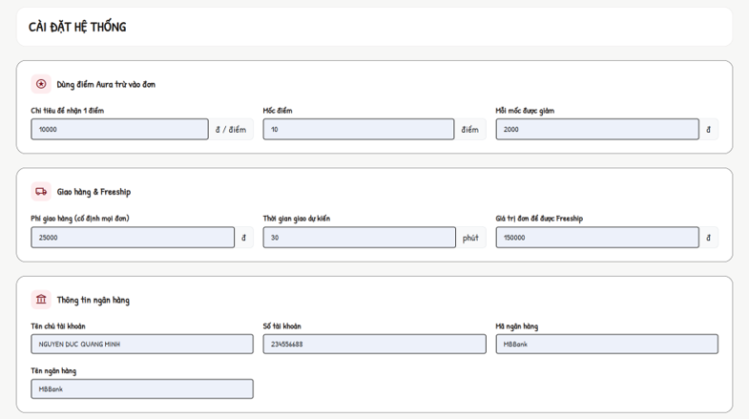
Actors: Admin · Use cases: UC68
Online-sales configuration plus a generic list of setting keys; changes apply on the next page load of the cart.
This screen allows the user to:
- Save online-sales settings.
- Edit all setting keys.
- Add a new setting key.
Field Description
Field Name | Description
Mua từ bao nhiêu thì được Freeship | freeship_threshold, 0 - 100,000,000 đ (0 = always free).
Phí giao tạm tính | delivery_fee, 0 - 1,000,000 đ (used before a district is chosen).
Thời gian giao dự kiến | delivery_minutes, 5 - 300.
Mốc điểm / Mỗi mốc được giảm / Chi tiêu để nhận 1 điểm | points_step 1 - 100,000; points_step_value 1,000 - 10,000,000 đ; points_earn_unit 1,000 - 100,000,000 đ.
Tất cả khóa cài đặt | Grouped: Giao hàng, Tích điểm, Ca làm việc, Khác; value required.
Thêm khóa cài đặt | Key: lowercase letters, digits, underscore, ≤ 50, unique; value ≤ 255 (MSG98).

10.1.2 Delivery Area Fees
Screen / URL: /admin/delivery-areas
Actors: Admin · Use cases: UC71
Fixed delivery fee per Hanoi district used at checkout.
This screen allows the user to:
- Edit fee and "Nhận giao" flag of each district.
- Add a district.
Field Description
Field Name | Description
Quận / Huyện | Name, required, max 50, unique.
Phí giao (đ) | 0 - 1,000,000 (MSG99).
Nhận giao | Active flag; inactive districts are not offered at checkout.

11. Background Job Inventory
The current release has no scheduled (timer-based) background job. The automatic processes below are event-driven: they run inside the request that triggers them and always in a single database transaction, so a failure leaves no partial data.
ID | Process | Trigger | Processing
EV-01 | Confirm payment from gateway callback | POST /api/payments/callback from the provider; authenticated DEMO_ONLINE uses its separate test-only confirmation. | Verify HMAC-SHA256 signature and amount; set payment SUCCESS/FAILED; order PENDING → CONFIRMED; EARN points once.
EV-02 | Earn loyalty points | Payment becomes SUCCESS (online, counter, COD on delivery) | points = floor((total − discount) / points_earn_unit); insert EARN; update user balance in the same transaction.
EV-03 | Deduct ingredients | An order moves from CONFIRMED to PREPARING or READY (Barista "Done") | For each recipe line: stock −= quantity × order quantity; insert OUT_ORDER once per ingredient; reject if stock is insufficient.
EV-04 | Receive purchase order | Admin confirms a purchase order as received | Increase stock, insert IN_PURCHASE movements, set RECEIVED in one transaction.
EV-05 | Refund / reverse points on cancellation | Customer or Cashier cancels an order | Insert REFUND for redeemed points and ADJUST for earned points; pending payment → FAILED.

12. External API Inventory

12.1 POST: /api/payments/callback (API-01)
Field | Value
URL | POST /api/payments/callback
Purpose | Verifies a provider-signed bank-transfer result and atomically updates payment/order and one-time point/cart effects. Demo confirmation uses its separate authenticated endpoint.
Caller | Payment provider server. The browser registers through the authenticated backend and reads stored status; it does not manufacture bank confirmation.
Auth | HMAC-SHA256 over orderCode|transactionCode|amount|STATUS using protected PAYMENT_CALLBACK_SECRET; constant-time comparison. This provider authentication is independent of a browser JWT.
Parameters | orderCode, transactionCode, amount, status (SUCCESS / FAILED), gatewayReference, signature.
Response | JSON accepted/successful result. HTTP 200 for accepted/repeated matching success; 401 for invalid signature; 400 for malformed data; 409 for mismatched amount/reference/state; 404 for unknown transaction. Do not apply payment effects on rejection.

12.2 GET VietQR image (API-02)
Field | Value
URL | GET https://vietqr.app/img?bank={bankId}&acc={accountNo}&template=compact&amount={amount}&des={orderCode}&showinfo=true&fullacc=true&holder={accountName}&store=AURA%20Cafe
Purpose | Renders the VietQR image that the customer scans to transfer the exact amount with the order code as content.
Caller | CMS pages (Payment screen, Cashier POS) - called by the browser.
Auth | No.

12.3 Password recovery API-03
Field | Value
URL | POST /api/auth/forgot-password; POST /api/auth/verify-otp; POST /api/auth/reset-password.
Purpose | Deliver an expiring email OTP, verify it and grant one-use reset authorization; no response or log may disclose recovery secrets.
Caller | Authentication recovery UI; backend/routes/passwordRecoveryRoutes.js calls backend/utils/recoveryEmail.js and persists PasswordRecovery documents.
Auth | No login JWT is required for recovery. Enforce email/code/token validation, TTL, attempt limits and resend limits; SMTP credentials remain server-only.

12.4 Internal JSON endpoints
Internal JSON APIs use Bearer JWT where protected. Public catalog reads do not require login; every write enforces its documented role, ownership and input contract.
Endpoint | Purpose
GET /api/cart; PUT /api/cart | Load/save the authenticated Customer cart; browser-only guest cart merges after login. Server recalculates supported options/prices.
GET /api/products; GET /api/products/:id | Public catalog/detail data for menu and product dialogs; the client applies category/keyword filters to available published products.
GET/POST /api/orders; PUT /api/orders/:id/status | Role-scoped order reads, counter creation and authorized status changes; separate payment endpoints confirm collection.
GET /api/orders; PUT /api/orders/:id/items/:itemIndex/prepared; PUT /api/orders/:id/status | Barista queue and preparation updates with Bearer JWT, position/eligibility/state checks and one-time stock effects.
GET /api/categories; GET /api/products | Read imageUrl/data URL metadata; image validation/upload belongs to authorized category/product mutations, not legacy image servlets.

4. Requirement Appendix

1. Business Rules
GBR-ID | Rule Statement | Applies To | Rationale | Enforced By
GB-01 | Prices, surcharges, points discount, delivery fee and totals are always recalculated on the server from the database; values sent by the browser are ignored. | Cart, Checkout, Cashier POS | Prevents price tampering and stale prices. | The system on every add-to-cart, cart view, checkout and counter order
GB-02 | Only a signed-in CUSTOMER account can place an online order; Admin and staff accounts cannot. | Checkout, Payment | Online orders and loyalty points belong to customers. | The system on every checkout / payment request
GB-03 | Online orders are delivery orders inside Hà Nội. The district must be an active delivery area; the fee is that district's fee, or 0 when the goods subtotal ≥ freeship_threshold. | Checkout | Fixed, explainable delivery cost per district. | The system at checkout
GB-04 | An order enters the preparation queue only when a payment is SUCCESS, or when it is an ONLINE order paid by COD. | Barista Dashboard | Avoids preparing unpaid orders. | The system when loading and updating the queue
GB-05 | Order status follows PENDING → CONFIRMED → PREPARING → READY → DELIVERING → COMPLETED (ONLINE) or READY → COMPLETED (DINE_IN / TAKEAWAY). A Customer can cancel only PENDING unpaid orders; a Cashier only PENDING / CONFIRMED counter orders. | Orders | Keeps the kitchen, delivery and payment consistent. | Role/position/ownership and current-state guards in the Express order, payment and work-schedule handlers.
GB-06 | Ingredients are deducted by recipe exactly once per order when it goes to PREPARING / READY; the change is rejected if any ingredient stock is insufficient. | Barista Dashboard, Inventory | Accurate stock without Number deduction. | The system in the same transaction as the status change
GB-07 | Points earned = floor((goods amount − points discount) / points_earn_unit); delivery fee is excluded; earned once per order when payment becomes SUCCESS (COD: on successful delivery). | Loyalty | Rewards actual spending only. | The system on payment success
GB-08 | Redeemed points must be a multiple of points_step, not exceed the balance, and the discount ((points / points_step) × points_step_value) must not exceed the goods amount. Redeemed points are refunded when the order is cancelled. | Cart, Cashier POS, Cancellation | Fair and reversible point usage. | The system at cart refresh, order creation and cancellation
GB-09 | Payment confirmation requires authenticated ownership/role, a matching server-calculated amount and the correct current payment state. A payment is confirmed and credited at most once. | Payment callback | Prevents forged or duplicated confirmations. | The system on every callback
GB-10 | A COD delivery can be completed only when the collected amount equals the COD amount; otherwise the delivery staff must report an issue. | Delivery Management | Cash accountability. | The system on "Giao thành công"
GB-11 | Delivery staff can see and act only on deliveries assigned to them; pick-up is allowed only when the order is READY; re-assignment is not allowed after pick-up. | Delivery Management, Order Management | Clear responsibility per order. | The system on every delivery request
GB-12 | A deactivated (INACTIVE) or LOCKED account cannot sign in; the login error does not reveal whether the identifier or the password is wrong. | Login | Security of accounts. | The system on every sign-in
GB-13 | Protected portals check current role, position and ACTIVE status through API middleware. Every request validates resource ownership; permissions do not rely on a stale browser session. | All staff and admin screens | Least privilege. | The system on every request
GB-14 | Protected JSON mutations use an explicit Bearer JWT rather than an ambient login-session cookie. Validate request bodies and configure deployment CORS and HTTPS. | Admin, Barista, Delivery screens | Prevents cross-site request forgery. | The relevant token-protected POST handlers
GB-15 | Work shifts are stored per week; editing a week never changes other weeks; past weeks are read-only; a shift with scheduled employees cannot be deleted. | Work Shift Management | Historical schedules and attendance stay correct. | The system on shift add / update / delete
GB-16 | Expected cash = opening cash + attributed counter CASH receipts + COD physically confirmed by the cashier - CASH refunds issued from this shift. Preserve the original receipt even if later refunded through BANK_TRANSFER. Save the reconciliation snapshot atomically; require a reason for a difference. | Cashier Shift Handover | Cash control between shifts. | The system on "Chốt ca"
GB-17 | A handover can be reviewed only while SUBMITTED; rejection requires a reason; a rejected handover can be resubmitted only by its cashier with an explanation. | Shift Handover Review | Auditable review cycle. | The system on confirm / reject / resubmit
GB-18 | Stock is increased only when a purchase order is confirmed as RECEIVED; recipe cost uses the latest received unit price of each ingredient. | Purchase Orders, Recipes | Inventory and cost reflect goods actually received. | The system on receive and on recipe view
GB-19 | Feedback tickets in RESOLVED or REJECTED status are final and cannot be edited or reopened. | Feedback Management | Stable history of customer care. | The system on every response
GB-20 | Admin cannot downgrade, deactivate or lock the account currently signed in. | Employee Management | Prevents locking out the last administrator. | The system on employee save and lock
GB-21 | Multi-table operations (place order, counter order, payment callback, COD completion, stock movements, shift close, purchase receive) run in one database transaction with conditional updates. | Whole system | No partial data after a failure. | The system (DAO layer)

2. System Messages
# | Message code | Message Type | Context | Content
1 | MSG01 | In line | Search / filter returns no data | Không tìm thấy món phù hợp / Không tìm thấy đơn hàng phù hợp
2 | MSG02 | Error page 403 | User opens a screen of another role | Chỉ tài khoản Admin được ... / Chỉ nhân viên ... được truy cập màn hình này.
3 | MSG03 | Alert (red) | Bearer JWT missing / expired on a staff or admin form | Phiên làm việc đã được làm mới. Vui lòng thao tác lại.
4 | MSG04 | Alert (red) | Database error while saving | Không thể lưu thay đổi vào database. Vui lòng thử lại.
5 | MSG05 | Alert (red) | Unknown action sent to a screen | Thao tác không hợp lệ.
6 | MSG06 | Error page | HTTP 404 / 500 | React error state with an actionable message and retry/navigation controls.
7 | MSG10 | Alert in login dialog | Wrong identifier / password or account not ACTIVE | Tên đăng nhập hoặc mật khẩu không chính xác, hoặc tài khoản đã bị khóa!
8 | MSG11 | Alert in register dialog | Invalid registration data | Họ và tên không được để trống. / Số điện thoại không hợp lệ (VD: 0912345678). / Địa chỉ email không hợp lệ. / Mật khẩu phải từ 6 ký tự trở lên. / Mật khẩu xác nhận không khớp.
9 | MSG12 | Alert in register dialog | Phone already used | Số điện thoại đã tồn tại trong hệ thống.
10 | MSG13 | Alert in register dialog | E-mail already used | Email đã tồn tại trong hệ thống.
11 | MSG14 | Alert (green) | Registration succeeded | Đăng ký thành công! Vui lòng đăng nhập.
12 | MSG15 | Alert (red) | Forgot password with unknown e-mail | Email không tồn tại trong hệ thống.
13 | MSG16 | Alert (red) | Wrong OTP | Mã OTP không chính xác. Vui lòng kiểm tra lại.
14 | MSG17 | Alert (red) | OTP session expired | Phiên xác thực đã hết hạn. Vui lòng yêu cầu lại.
15 | MSG18 | Alert (red) | Resend OTP within 60 seconds | Vui lòng đợi {n} giây trước khi gửi yêu cầu mới.
16 | MSG19 | Alert (red) | New password confirmation differs | Mật khẩu xác nhận không khớp.
17 | MSG20 | Alert (green) | Password reset succeeded | Đổi mật khẩu thành công! Vui lòng đăng nhập lại.
18 | MSG21 | Toast | Add an unavailable product to cart | Món này hiện đã ngừng phục vụ.
19 | MSG22 | Alert in cart | Guest tries to redeem points | Vui lòng đăng nhập bằng tài khoản khách hàng để dùng điểm Aura.
20 | MSG23 | Alert in cart | Redeemed points adjusted by the server | Số điểm Aura dùng cho đơn đã được điều chỉnh còn {n} điểm do tiền hàng, số điểm của bạn hoặc mốc điểm vừa thay đổi.
21 | MSG24 | Alert in cart | Checkout with no selected line | Vui lòng chọn ít nhất một món để đặt hàng.
22 | MSG25 | Alert in checkout | Guest submits checkout | Vui lòng đăng nhập bằng tài khoản khách hàng để tiếp tục đặt hàng.
23 | MSG26 | Alert in checkout | Staff / Admin submits checkout | Tài khoản quản trị/nhân viên không thể đặt hàng online. Vui lòng đăng nhập bằng tài khoản khách hàng.
24 | MSG27 | Alert in checkout | District not delivered | Quán chưa giao tới {district}. Vui lòng chọn quận khác hoặc Tự đến lấy.
25 | MSG28 | Alert in checkout | Not enough ingredient stock | Có món đã hết hoặc không đủ số lượng. Vui lòng sửa giỏ hàng.
26 | MSG29 | Alert in checkout | Point balance changed before placing | Số điểm Aura của bạn vừa thay đổi nên chưa thể trừ {n} điểm. Tổng tiền đã được cập nhật lại, vui lòng kiểm tra trước khi xác nhận.
27 | MSG30 | Alert in payment | Manual confirm when test mode is off | Giao dịch đang chờ cổng thanh toán xác nhận tự động.
28 | MSG31 | Alert (green) | Bank transfer confirmed | Thanh toán thành công đơn #{code}. Bạn được cộng {n} điểm Aura.
29 | MSG32 | Alert (green) | COD chosen | Đã xác nhận thanh toán COD cho đơn #{code}. Điểm sẽ được cộng sau khi giao hàng và thu tiền.
30 | MSG33 | Alert (red) | Customer opens another customer's bill | Bạn không có quyền truy cập hóa đơn của đơn hàng này!
31 | MSG34 | Alert (green) | Customer cancels an order | Đã hủy đơn #{code} và hoàn lại {n} điểm Aura.
32 | MSG35 | Alert (red) | Cancel a paid / processed order | Chỉ hủy được đơn chưa thanh toán.
33 | MSG36 | Alert (green) | Reorder succeeded | Đã thêm {n} món của đơn #{code} vào giỏ hàng (giá theo thực đơn hiện tại).
34 | MSG37 | Alert (red) | Reorder with no available item | Các món trong đơn #{code} hiện đã ngừng phục vụ.
35 | MSG38 | Alert (red) | Profile saved with empty name | Họ và tên không được để trống!
36 | MSG39 | Alert (red) | Wrong current password | Mật khẩu hiện tại không đúng!
37 | MSG40 | Alert (red) | Feedback without content | Vui lòng nhập nội dung góp ý hoặc phản ánh của bạn!
38 | MSG41 | Alert (red) | Feedback for invalid / already reviewed order | Đơn hàng không hợp lệ hoặc đã được bạn phản hồi trước đó.
39 | MSG42 | Alert (red) | Feedback when not signed in | Vui lòng đăng nhập trước khi gửi phản hồi!
40 | MSG43 | JSON error 403 | Non-cashier calls the POS | Chỉ nhân viên hoặc quản trị viên được phép truy cập POS.
41 | MSG44 | Toast (POS) | Member phone not found | Không tìm thấy thông tin hội viên.
42 | MSG45 | Toast (POS) | Create order without items | Vui lòng chọn ít nhất 1 món ăn/thức uống.
43 | MSG46 | Toast (POS) | Member id does not match phone / locked | Khách hàng không hợp lệ hoặc đã bị khóa.
44 | MSG47 | Toast (POS) | Counter order created | Tạo đơn tại quầy thành công!
45 | MSG48 | Toast (POS) | Cancel counter order | Đã hủy đơn hàng thành công. / Đơn hàng đang được Barista pha chế hoặc đang giao, không thể hủy. / Đơn hàng đã hoàn thành, không thể hủy.
46 | MSG49 | Toast (POS) | Hand over counter order | Đã đánh dấu hoàn tất đơn hàng và giao khách thành công. / Không thể hoàn tất đơn hàng này (đơn phải được Barista pha chế xong hoặc đang giao).
47 | MSG50 | Error page 403 | Non-cashier opens Shift Handover | Chỉ nhân viên Thu ngân được phép truy cập màn hình bàn giao ca.
48 | MSG51 | Alert (red) | Invalid actual cash | Tiền két thực tế phải từ 0 đến 9.999.999.999đ và là bội số của 1.000đ.
49 | MSG52 | Alert (red) | Cash difference without note | Tiền két thực tế lệch so với hệ thống, vui lòng nhập ghi chú giải trình.
50 | MSG53 | Alert (green) | Shift closed | Đã chốt két và gửi biên bản bàn giao ca. Biên bản đang chờ Admin xác nhận.
51 | MSG54 | Alert (red) | Shift already closed / changed | Ca đã được chốt hoặc trạng thái ca vừa thay đổi. Vui lòng tải lại trang.
52 | MSG55 | Alert (red) | Resubmit without explanation | Vui lòng nhập nội dung giải trình trước khi gửi lại.
53 | MSG56 | Alert (green) | Handover resubmitted | Đã gửi lại biên bản bàn giao, đang chờ Admin xác nhận.
54 | MSG57 | Toast (Barista) | Insufficient ingredient stock when finishing | Không đủ tồn kho {ingredient}: còn {stock}, can {required}
55 | MSG58 | Toast (Barista) | Order changed meanwhile | Đơn đã thay đổi hoặc không còn được pha chế. Vui lòng kiểm tra lại.
56 | MSG59 | Alert (red) | Accept a delivery not waiting | Đơn #{code} không còn ở trạng thái chờ nhận.
57 | MSG60 | Alert (red) | Pick up before READY | Chỉ lấy hàng khi đã nhận đơn và quán đã pha chế xong (Sẵn sàng).
58 | MSG61 | Alert (red) | Collected COD differs | Số tiền thu hộ phải đúng {amount}. Nếu khách không trả đủ, hãy báo sự cố thay vì xác nhận giao thành công.
59 | MSG62 | Alert (red) | Issue report incomplete | Vui lòng chọn loại sự cố. / Vui lòng nhập mô tả sự cố.
60 | MSG63 | Alert (red) | COD hand-over without cashier | Vui lòng chọn Thu ngân nhận tiền.
61 | MSG64 | Alert (green) | COD handed over | Đã ghi nhận nộp {amount} tiền COD cho Thu ngân {name}.
62 | MSG65 | Error 403 | Category / product form with expired token | Phiên làm việc đã hết hạn. Tải lại trang rồi thử lại.
63 | MSG66 | Alert (red) | Duplicate category name | Tên danh mục đã tồn tại.
64 | MSG67 | Alert (red) | Invalid image upload | Ảnh danh mục/sản phẩm không được lớn hơn 2 MB. / Chỉ chấp nhận ảnh JPG, PNG, GIF hoặc WebP. / Nội dung tệp không đúng định dạng ảnh đã chọn.
65 | MSG68 | Alert (red) | Delete category with products | Không thể xóa danh mục đang có sản phẩm. Hãy chuyển sang Tạm ẩn.
66 | MSG69 | Alert (green) | Product availability changed | Đã cập nhật trạng thái bán sản phẩm.
67 | MSG70 | Alert (red) | Invalid recipe line | Không chọn trùng một nguyên liệu trong cùng công thức. / Định lượng phải lớn hơn 0 và có tối đa 3 chữ số thập phân.
68 | MSG71 | Alert (green) | Recipe saved | Đã lưu công thức cho món “{product}”.
69 | MSG72 | Alert (red) | Delete ingredient used in a recipe | Nguyên liệu đang được sử dụng trong công thức món, không thể xóa!
70 | MSG73 | Alert (red) | Adjustment quantity ≤ 0 | Số lượng phải lớn hơn 0.
71 | MSG74 | Alert (red) | Adjustment reason length | Vui lòng nhập lý do điều chỉnh từ 3 đến 500 ký tự.
72 | MSG75 | Alert (green) | Stock adjusted | Ghi nhận phiếu điều chỉnh tồn kho thành công!
73 | MSG76 | Alert (red) | Restock request status changed meanwhile | Không thể cập nhật vì trạng thái đề xuất đã thay đổi.
74 | MSG77 | Alert (red) | Supplier without name | Tên nhà cung cấp không được để trống.
75 | MSG78 | Alert (red) | Purchase order from a non-approved request | Chỉ đề xuất đã duyệt mới được chuyển thành phiếu nhập.
76 | MSG79 | Alert (red) | Invalid quantity / lot total | Số lượng và tổng tiền không hợp lệ.
77 | MSG80 | Error page 403 | Non-admin opens Employee Management | Chỉ tài khoản Admin được quản lý nhân viên.
78 | MSG81 | Alert (red) | Admin edits own role / status | Bạn không thể tự hạ quyền tài khoản đang đăng nhập. / Bạn không thể tự khóa hoặc ngừng hoạt động tài khoản đang đăng nhập.
79 | MSG82 | Alert (red) | Duplicate shift name in week | Tuần này đã có ca tên "{name}".
80 | MSG83 | Alert (red) | Invalid shift time | Giờ kết thúc phải sau giờ bắt đầu. / Bị chồng giờ với {shift}.
81 | MSG84 | Alert (red) | Delete a shift in use | {shift} đã có nhân viên được xếp lịch. Hãy gỡ lịch ở màn Lịch phân ca trước khi xoá ca.
82 | MSG85 | Alert (red) | Copy shifts not allowed | Tuần này đã có khung ca, chỉ sao chép được vào tuần đang trống. / Chưa có tuần nào trước đó để sao chép.
83 | MSG86 | Alert (red) | Shift not in the week of the work date | Ca làm việc không thuộc tuần của ngày đã chọn. Hãy tạo khung ca cho tuần {week} ở màn Khung giờ ca.
84 | MSG87 | Alert (red) | Invalid opening / closing cash | {field} phải là bội số của 1.000đ. / {field} không được là số âm.
85 | MSG88 | Alert (red) | Duplicate schedule | Nhân viên đã được xếp vào ca này trong ngày đã chọn.
86 | MSG89 | Alert (red) | Invalid attendance time | Vui lòng nhập giờ vào. / Vui lòng nhập giờ ra khi ca đã hoàn thành. / Giờ ra phải sau giờ vào.
87 | MSG90 | Alert (red) | Reject handover without reason | Vui lòng nhập lý do từ chối để Thu ngân giải trình.
88 | MSG91 | Alert (red) | Handover already reviewed | Biên bản đã được xử lý trước đó, vui lòng tải lại trang.
89 | MSG92 | Alert (green) | Order status updated by Admin | Đã cập nhật trạng thái đơn hàng.
90 | MSG93 | Alert (red) | Assign delivery staff not allowed | Chỉ gán shipper cho đơn giao tận nơi chưa hoàn thành / huỷ và shipper chưa lấy hàng.
91 | MSG94 | Alert (red) | Add customer with existing phone | Số điện thoại đã tồn tại.
92 | MSG95 | In line | Loyalty lookup not found | Không tìm thấy khách hàng có số điện thoại {phone}.
93 | MSG96 | Alert (red) | Feedback response invalid | Nội dung phản hồi không được để trống. / Nội dung phản hồi không được vượt quá 2.000 ký tự.
94 | MSG97 | Alert (red) | Invalid report range | Ngày bắt đầu phải trước hoặc bằng ngày kết thúc. / Chỉ xem tối đa 366 ngày mỗi lần.
95 | MSG98 | Alert (red) | Invalid new setting key | Khóa chỉ gồm chữ thường, số, gạch dưới và tối đa 50 ký tự. / Khóa cài đặt đã tồn tại.
96 | MSG99 | Alert (red) | Invalid district fee | Phí giao của {district} phải từ 0 đến 1.000.000đ.

3. Other Requirements

3.1 Technology and Environment
- Server: Node.js 22.12 or later, Express REST API, Mongoose ODM, jsonwebtoken and bcryptjs. Dependency versions are managed by the project package manifests.
- Database: MongoDB, database aura_cafe_erp. Mongoose schemas define field validation, ObjectId references and indexes; no MySQL schema or JDBC driver is required.
- Recovery uses the configured SMTP adapter and PasswordRecovery storage; missing provider settings return an explicit unavailable error without disclosing OTP or granting reset.
- Client: React, Vite, TypeScript, React Router, Zustand and Tailwind CSS in modern Chrome, Edge, Firefox and Safari browsers.
- Automated checks use the Node.js test runner for backend integration and frontend regression/render tests, plus TypeScript and Vite build checks. Execute database tests only against isolated test databases.

3.2 Security
- JWT-based authentication. Passwords are stored as bcrypt hashes. Logout clears client authentication state. Protect middleware reloads the current account and rejects inactive or locked accounts.
- Protected Express routes use JWT middleware and current account checks. Each operation additionally enforces role, staff position and resource ownership as appropriate. React navigation and hidden controls are not authorization.
- Mongoose queries validate identifiers, enums, numeric bounds and request shapes. RedirectUtil restricts post-login redirects to safe local paths.
- Payment confirmation validates authenticated permissions, order ownership, expected amount and current payment status. Local simulation is explicitly separate from real bank confirmation.
- Uploaded images are limited to 2 MiB and validated by allowed MIME type and file signature; reject invalid content before persistence.

3.3 Data Integrity and Reliability
- Critical multi-document writes require replica-set transactions, conditional state changes, unique indexes and idempotency keys. In-process locks or compensating writes are not crash-safe atomicity. If transactions are required but unavailable, reject before writing and report configuration failure.
- Mongoose validation and indexes enforce unique identity and business keys. Application logic validates references, enum transitions, non-negative amounts, stock and points. MongoDB does not provide relational foreign-key enforcement.
- Product name and unit price are stored on each order item so past orders and bills never change when the menu changes.
- Category and product image locations are stored as imageUrl strings. Order items retain the product name, unit price, customization and subtotal at ordering time.

3.4 Usability and Localisation
- User interface language: Vietnamese; currency: VND (thousands separated by "."); time zone: Asia/Ho_Chi_Minh.
- Lists display explicit empty, loading and error states. API errors remain visible to the user; an empty fallback is not proof of success.

3.5 Current implementation and target scope
- Bank registration, signed callback, COD and gated simulation are separate contracts. Provider credentials and a verified test environment are deployment prerequisites; successful mock tests do not establish live-bank acceptance.
- Customer checkout is ONLINE delivery to an active served Hanoi district. DINE_IN and TAKEAWAY are counter workflows. The server owns price, points, fee and eligibility calculations.
- Staff read their own schedules and record attendance through protected work-schedule endpoints. Admin manages weekly shift definitions and assignments; historical shift definitions are read-only.
- There is no scheduled background job (see I.5.3).
- Recovery uses /api/auth/forgot-password, /verify-otp and /reset-password with expiry, resend/attempt limits and one-use authorization. Authenticated change-password requires the old password; both store bcrypt hashes and revoke obsolete tokens as specified.
- Password storage uses bcrypt hashes in User.passwordHash. Authentication accepts a unique phone, full email or unambiguous email local part and rejects inactive/locked accounts.
- Protected API requests pass protect middleware, which reloads the account and checks ACTIVE status. Route guards enforce role/position/ownership. Mutations use authenticated POST/PUT/PATCH/DELETE requests; GET settings is read-only.
- Recipe data uses ProductIngredient links and the Product recipe snapshot. Ingredient consumption and FIFO cost allocations are guarded and recorded once for each order. Do not infer support for a separate instruction/deactivation workflow from obsolete SWP fields.
- ONLINE delivery fees come from the active DeliveryArea district and the configured freeship_threshold. Reject unknown/inactive districts, snapshot the accepted fee/address, and use zero fee at the threshold. Public reads must never seed or change area records.
- Order administration uses orderRoutes with allowed transition checks, role restrictions and payment/stock eligibility. Terminal states and accounting safeguards remain enforced.
- Online simulation and counter confirmation use paymentRoutes. Clients reload the stored Payment and Order result. QR display and navigation to a bill do not prove a real bank payment.
- Customer feedback requires an active Customer and an owned eligible order, with one submission per order. Guests cannot read customer tickets; closed RESOLVED/REJECTED tickets cannot be reopened or removed through the normal API.
- This baseline specifies required behavior, not release acceptance. Code that differs is an implementation gap. Record tests, screenshots, defects and release results separately. Bug fixes/internal refactoring preserve this document; changed business rules, API contracts or module boundaries require approved revision.

III. Software Design Specification

1. High Level Design

1. Software Architecture
Aura Cafe uses React/Vite TypeScript, Node.js/Express and MongoDB/Mongoose. The following design fixes module responsibilities and business contracts across all 15 flows. Logical diagram methods are not literal private function signatures; acceptance evidence is maintained separately from this stable design.
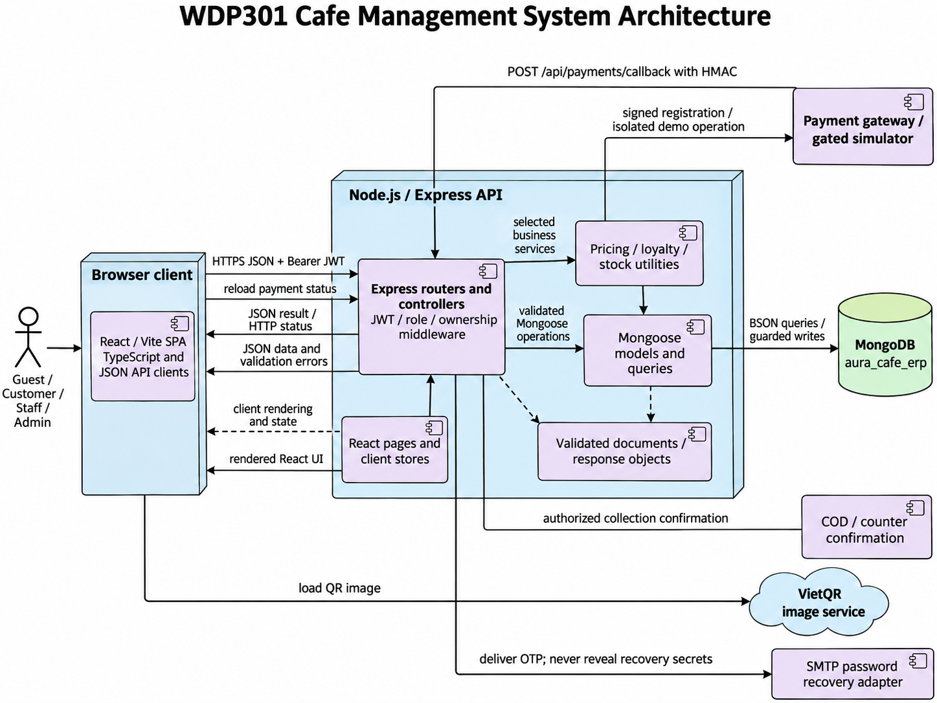

Component | Implementation | Responsibility
React client pages | frontend/src | React components, TypeScript, routing, browser cart state, API requests and payment-state display.
Express routing and controllers | backend/routes; backend/controllers; backend/middlewares | HTTP routing, JWT authentication, role/position/ownership checks, input validation and JSON responses.
Business utilities | cartItems; orderLoyalty; orderInventory; weeklyShifts | Server pricing, phone-based point changes, FIFO stock consumption, idempotency and weekly shift validation.
Data access | backend/models; Mongoose queries | BSON documents, ObjectId references and guarded writes inside required transaction boundaries. Unique indexes and state predicates support retries/concurrency; compensation is not a substitute for crash-safe atomicity.
Database | MongoDB aura_cafe_erp | Collections and embedded subdocuments model the business entities. Relational foreign keys and SQL CHECK constraints are replaced by Mongoose and application validation.
Payment integration | backend/routes/paymentRoutes.js; backend/utils/paymentGateway.js; backend/utils/paymentMode.js | Signed provider registration/callback and owner-authorized gated demo are separate. COD is confirmed on selection but collected only at successful delivery; the exact collected amount controls Payment SUCCESS.
Payment display and recovery boundary | PaymentPage; authController; EmailUtil; RedirectUtil | QR display is not proof of payment. EmailUtil normalizes login identities; RedirectUtil validates local paths; passwordRecoveryRoutes and recoveryEmail deliver server-validated, expiring OTP recovery.

2. Package Diagram
Backend modules use CommonJS routers, controllers, middleware, Mongoose models and shared utilities. The React/Vite client uses components, hooks, stores and TypeScript helpers. The browser accesses persistence only through the JSON API; there is no direct client-to-database exception.
PlantUML source - Package dependencies
@startuml CMS_Packages
title WDP301 Cafe Management System Package Diagram
skinparam packageStyle rectangle
package "routes / controllers" as controller
package "business utilities" as service
package "Mongoose persistence" as dao
package "schemas / documents" as model
package "MongoDB configuration" as context
package utils
package "React pages / hooks / stores" as webapp
controller ..> service
controller ..> dao
controller ..> model
controller ..> utils
service ..> dao
service ..> model
dao ..> model
dao ..> context
webapp ..> controller : JSON requests with Bearer JWT
controller ..> webapp : JSON response contracts
webapp ..> utils : formatting / safe redirects
note bottom of context
MongoDB is configured with MONGO_URI.
Mongoose models define validation and indexes.
end note
@enduml

Package | Examples | Purpose
routes / controllers | authController; orderRoutes; productIngredientRoutes | Express HTTP handlers, authentication and input/ownership validation.
utils | cartItems; orderLoyalty; orderInventory | Shared server pricing, point accounting and inventory operations.
models / queries | Order; ProductIngredient; Ingredient; LoyaltyTransaction | Mongoose queries, aggregation, guarded state changes and persistence.
models | User; Order; ProductIngredient; ShopSetting | Document schemas, ObjectId references, snapshots and validators.
config | Mongoose connection | MONGO_URI and protected environment settings configure the MongoDB connection.
utils | EmailUtil; RedirectUtil | Email normalization, login identifier matching and safe local redirects.
frontend | React pages, hooks, stores, assets and Vite configuration | Client presentation, navigation, local state and REST API integration.

3. Database Design

Cart → carts
Indexes: [[{"customer":1},{"unique":true}]]
Field | BSON / Mongoose type | Constraints / reference
customer | ObjectId | required; ref=User
items | Array | embedded=True
_id | ObjectId | optional / schema default
createdAt | Date | optional / schema default
updatedAt | Date | optional / schema default

Category → categories
Indexes: [[{"name":1},{"unique":true}]]
Field | BSON / Mongoose type | Constraints / reference
name | String | required
icon | String | optional / schema default
description | String | optional / schema default
imageUrl | String | optional / schema default
image_url | String | optional / schema default
status | String | enum=['ACTIVE', 'INACTIVE']
_id | ObjectId | optional / schema default
createdAt | Date | optional / schema default
updatedAt | Date | optional / schema default

CustomerReview → customerreviews
Indexes: [[{"submissionKey":1},{"unique":true,"partialFilterExpression":{"submissionKey":{"$type":"string"}}}]]
Field | BSON / Mongoose type | Constraints / reference
customer | ObjectId | required; ref=User
order | ObjectId | ref=Order
issueType | String | required; enum=['RATING', 'COMPLAINT']
rating | Number | min=1; max=5
topic | String | optional / schema default
content | String | required
attachments | Array | optional / schema default
status | String | enum=['PENDING', 'IN_PROGRESS', 'RESOLVED', 'REJECTED']
adminResponse | String | optional / schema default
respondedAt | Date | optional / schema default
respondedBy | ObjectId | ref=User
submissionKey | String | optional / schema default
_id | ObjectId | optional / schema default
createdAt | Date | optional / schema default
updatedAt | Date | optional / schema default

DeliveryArea → deliveryareas
Indexes: [[{"district":1},{"unique":true}],[{"isActive":1},{}]]
Field | BSON / Mongoose type | Constraints / reference
district | String | required
deliveryFee | Number | required; max=1000000
isActive | Boolean | optional / schema default
_id | ObjectId | optional / schema default
createdAt | Date | optional / schema default
updatedAt | Date | optional / schema default

DeliveryIssue → deliveryissues
Indexes: [[{"order":1},{}],[{"reporter":1},{}]]
Field | BSON / Mongoose type | Constraints / reference
order | ObjectId | required; ref=Order
reporter | ObjectId | required; ref=User
issueType | String | required; enum=['UNREACHABLE', 'BAD_ADDRESS', 'REFUSED', 'DAMAGED', 'DELAY', 'OTHER']
description | String | required
outcome | String | required; enum=['REPORT', 'RETURN', 'CANCEL']
_id | ObjectId | optional / schema default
createdAt | Date | optional / schema default
updatedAt | Date | optional / schema default

Ingredient → ingredients
Indexes: []
Field | BSON / Mongoose type | Constraints / reference
supplier | ObjectId | ref=Supplier
name | String | required
isActive | Boolean | optional / schema default
unit | String | required
currentStock | Number | optional / schema default
minStockLevel | Number | optional / schema default
stockLots | Array | embedded=True
lotsVersion | Number | optional / schema default
stockValuation.quantity | Number | optional / schema default
stockValuation.totalCost | Number | optional / schema default
stockValuation.updatedAt | Date | optional / schema default
stockValuation.updatedBy | ObjectId | ref=User
_id | ObjectId | optional / schema default

InventoryTransaction → inventorytransactions
Indexes: []
Field | BSON / Mongoose type | Constraints / reference
ingredient | ObjectId | required; ref=Ingredient
transactionType | String | required; enum=['IN_PURCHASE', 'OUT_ORDER', 'ADJUSTMENT', 'SPOILAGE']
quantity | Number | required
stockBefore | Number | optional / schema default
stockAfter | Number | optional / schema default
unitBefore | String | optional / schema default
unitAfter | String | optional / schema default
valueBefore | Number | optional / schema default
valueAfter | Number | optional / schema default
stockDelta | Number | required
referenceType | String | enum=['ORDER', 'PURCHASE_ORDER', 'ADJUSTMENT']
referenceId | Mixed | optional / schema default
note | String | optional / schema default
createdBy | ObjectId | ref=User
costTotal | Number | optional / schema default
lotAllocations | Array | embedded=True
_id | ObjectId | optional / schema default
createdAt | Date | optional / schema default
updatedAt | Date | optional / schema default

LoyaltyTransaction → loyaltytransactions
Indexes: [[{"order":1},{"unique":true,"partialFilterExpression":{"automatic":true}}],[{"order":1},{"name":"order_redemption_refund","unique":true,"partialFilterExpression":{"redemptionRefund":true}}],[{"order":1},{"name":"order_earning_reversal","unique":true,"partialFilterExpression":{"earningReversal":true}}]]
Field | BSON / Mongoose type | Constraints / reference
customer | ObjectId | required; ref=User
order | ObjectId | ref=Order
pointsChange | Number | required
balanceAfter | Number | optional / schema default
automatic | Boolean | optional / schema default
redemptionRefund | Boolean | optional / schema default
earningReversal | Boolean | optional / schema default
transactionType | String | required; enum=['EARN', 'REDEEM', 'REFUND', 'ADJUST']
reason | String | optional / schema default
performedBy | ObjectId | ref=User
_id | ObjectId | optional / schema default
createdAt | Date | optional / schema default
updatedAt | Date | optional / schema default

Order → orders
Indexes: [[{"orderCode":1},{"unique":true}],[{"customer":1,"idempotencyKey":1},{"unique":true,"partialFilterExpression":{"idempotencyKey":{"$type":"string"}}}]]
Field | BSON / Mongoose type | Constraints / reference
mutationLock | String | optional / schema default
orderCode | String | required
checkoutFlow | Boolean | optional / schema default
checkoutSessionId | String | optional / schema default
idempotencyKey | String | optional / schema default
requestHash | String | optional / schema default
cartClearedAt | Date | optional / schema default
customer | ObjectId | ref=User
cashier | ObjectId | ref=User
voucher | ObjectId | ref=Voucher
reward | ObjectId | ref=RewardItem
pointsRedeemed | Number | optional / schema default
orderType | String | required; enum=['DINE_IN', 'TAKEAWAY', 'ONLINE']
status | String | enum=['PENDING', 'CONFIRMED', 'PREPARING', 'READY', 'DELIVERING', 'COMPLETED', 'CANCELLED']
items | Array | embedded=True
totalAmount | Number | required
discountAmount | Number | optional / schema default
deliveryFee | Number | optional / schema default
finalAmount | Number | required
paymentMethod | String | enum=['COD', 'PAY_AT_COUNTER', 'CASH', 'VNPAY', 'MOMO', 'BANK_TRANSFER', 'DEMO_ONLINE']
demoProvider | String | enum=['MOMO', 'VNPAY', 'BANK_TRANSFER']
recipientName | String | optional / schema default
recipientPhone | String | optional / schema default
deliveryAddress | String | optional / schema default
district | String | optional / schema default
ward | String | optional / schema default
addressDetail | String | optional / schema default
shipper | ObjectId | ref=User
delivery.status | String | enum=['ASSIGNED', 'ACCEPTED', 'DELIVERING', 'DELIVERED', 'RETURNED', 'CANCELLED']
delivery.assignedAt | Date | optional / schema default
delivery.acceptedAt | Date | optional / schema default
delivery.pickedUpAt | Date | optional / schema default
delivery.deliveredAt | Date | optional / schema default
delivery.history | Array | embedded=True
tableNumber | String | optional / schema default
orderNote | String | optional / schema default
cancelReason | String | optional / schema default
inventoryDeductedAt | Date | optional / schema default
inventoryProcessing | Boolean | optional / schema default
costTotal | Number | optional / schema default
costCapturedAt | Date | optional / schema default
costStatus | String | enum=['PENDING', 'COMPLETE', 'MISSING_PRICE', 'LEGACY']
_id | ObjectId | optional / schema default
createdAt | Date | optional / schema default
updatedAt | Date | optional / schema default

OrderItem → orderitems
Indexes: []
Field | BSON / Mongoose type | Constraints / reference
order | ObjectId | ref=Order
product | ObjectId | required; ref=Product
productNameAtTime | String | required
unitPrice | Number | required
customization | Mixed | optional / schema default
quantity | Number | required; min=1
subtotal | Number | required
isPrepared | Boolean | optional / schema default
_id | ObjectId | optional / schema default
createdAt | Date | optional / schema default
updatedAt | Date | optional / schema default

PasswordRecovery → passwordrecoveries
Indexes: [[{"email":1},{"unique":true}],[{"expiresAt":1},{"expireAfterSeconds":0}]]
Field | BSON / Mongoose type | Constraints / reference
email | String | required
user | ObjectId | required; ref=User
challenge | String | required
otpHash | String | required
resetTokenHash | String | optional / schema default
attempts | Number | optional / schema default
sentAt | Date | required
expiresAt | Date | required
_id | ObjectId | optional / schema default

Payment → payments
Indexes: [[{"status":1,"paymentMethod":1,"paidAt":1},{}]]
Field | BSON / Mongoose type | Constraints / reference
order | ObjectId | required; ref=Order
paymentMethod | String | required; enum=['CASH', 'VNPAY', 'MOMO', 'BANK_TRANSFER', 'DEMO_ONLINE']
demoProvider | String | enum=['MOMO', 'VNPAY', 'BANK_TRANSFER']
transactionCode | String | optional / schema default
amount | Number | required
status | String | enum=['PENDING', 'SUCCESS', 'FAILED', 'REFUNDED']
paidAt | Date | optional / schema default
receivedAmount | Number | optional / schema default
changeAmount | Number | optional / schema default
refundedAt | Date | optional / schema default
refundAmount | Number | optional / schema default
refundMethod | String | enum=['CASH', 'BANK_TRANSFER', 'MOMO', 'VNPAY', 'DEMO_ONLINE']
refundReference | String | optional / schema default
refundNote | String | optional / schema default
refundedBy | ObjectId | ref=User
refundSchedule | ObjectId | ref=WorkSchedule
receivedBy | ObjectId | ref=User
remittanceId | String | optional / schema default
remittanceSchedule | ObjectId | ref=WorkSchedule
remittedAt | Date | optional / schema default
paymentNote | String | optional / schema default
_id | ObjectId | optional / schema default
createdAt | Date | optional / schema default
updatedAt | Date | optional / schema default

Product → products
Indexes: []
Field | BSON / Mongoose type | Constraints / reference
category | ObjectId | required; ref=Category
name | String | required
basePrice | Number | required
badge | String | optional / schema default
subtitle | String | optional / schema default
variantsConfig | Mixed | optional / schema default
description | String | optional / schema default
imageUrl | String | optional / schema default
isAvailable | Boolean | optional / schema default
recipe | Array | embedded=True
_id | ObjectId | optional / schema default
createdAt | Date | optional / schema default
updatedAt | Date | optional / schema default

ProductIngredient → productingredients
Indexes: [[{"product":1,"ingredient":1},{"unique":true}]]
Field | BSON / Mongoose type | Constraints / reference
product | ObjectId | required; ref=Product
ingredient | ObjectId | required; ref=Ingredient
quantityRequired | Number | required; min=0.001
_id | ObjectId | optional / schema default
createdAt | Date | optional / schema default
updatedAt | Date | optional / schema default

PurchaseOrder → purchaseorders
Indexes: []
Field | BSON / Mongoose type | Constraints / reference
supplier | ObjectId | required; ref=Supplier
creator | ObjectId | required; ref=User
totalCost | Number | optional / schema default
status | String | enum=['DRAFT', 'ORDERED', 'RECEIVED', 'CANCELLED']
note | String | optional / schema default
items | Array | embedded=True
_id | ObjectId | optional / schema default
createdAt | Date | optional / schema default
updatedAt | Date | optional / schema default

PurchaseOrderItem → purchaseorderitems
Indexes: []
Field | BSON / Mongoose type | Constraints / reference
purchaseOrder | ObjectId | ref=PurchaseOrder
ingredient | ObjectId | required; ref=Ingredient
quantity | Number | required; min=0.001
unitPrice | Number | required
totalCost | Number | optional / schema default
_id | ObjectId | optional / schema default
createdAt | Date | optional / schema default
updatedAt | Date | optional / schema default

RestockRequest → restockrequests
Indexes: []
Field | BSON / Mongoose type | Constraints / reference
requester | ObjectId | required; ref=User
reviewer | ObjectId | ref=User
status | String | required; enum=['DRAFT', 'PENDING_APPROVAL', 'APPROVED', 'REJECTED', 'CANCELLED']
reason | String | optional / schema default
note | String | optional / schema default
reviewNote | String | optional / schema default
reviewedAt | Date | optional / schema default
history | Array | embedded=True
items | Array | embedded=True
_id | ObjectId | optional / schema default
createdAt | Date | optional / schema default
updatedAt | Date | optional / schema default

RewardItem → rewarditems
Indexes: []
Field | BSON / Mongoose type | Constraints / reference
name | String | required
description | String | optional / schema default
pointsCost | Number | required
discountValue | Number | optional / schema default
minOrderValue | Number | optional / schema default
validDays | Number | optional / schema default
category | String | optional / schema default
imageIcon | String | optional / schema default
stock | Number | optional / schema default
status | String | enum=['ACTIVE', 'INACTIVE']
_id | ObjectId | optional / schema default

ShiftHandover → shifthandovers
Indexes: [[{"schedule":1},{"unique":true}],[{"cashier":1,"workDate":1},{}],[{"status":1},{}]]
Field | BSON / Mongoose type | Constraints / reference
schedule | ObjectId | required; ref=WorkSchedule
cashier | ObjectId | required; ref=User
workDate | Date | required
shiftName | String | required
checkInTime | Date | optional / schema default
checkOutTime | Date | optional / schema default
openingCash | Number | required
cashSales | Number | required
codReceipts | Number | optional / schema default
cashRefunds | Number | optional / schema default
expectedCash | Number | required
actualCash | Number | required
difference | Number | required
note | String | optional / schema default
status | String | required; enum=['SUBMITTED', 'CONFIRMED', 'REJECTED']
reviewedBy | ObjectId | ref=User
reviewedAt | Date | optional / schema default
reviewerNote | String | optional / schema default
resubmittedAt | Date | optional / schema default
revision | Number | optional / schema default
history | Array | embedded=True
_id | ObjectId | optional / schema default
createdAt | Date | optional / schema default
updatedAt | Date | optional / schema default

ShopSetting → shopsettings
Indexes: [[{"settingKey":1},{"unique":true}]]
Field | BSON / Mongoose type | Constraints / reference
settingKey | String | required
settingValue | String | required
_id | ObjectId | optional / schema default
createdAt | Date | optional / schema default
updatedAt | Date | optional / schema default

Supplier → suppliers
Indexes: []
Field | BSON / Mongoose type | Constraints / reference
name | String | required
phone | String | optional / schema default
address | String | optional / schema default
status | String | enum=['ACTIVE', 'INACTIVE']
_id | ObjectId | optional / schema default
createdAt | Date | optional / schema default
updatedAt | Date | optional / schema default

User → users
Indexes: [[{"phone":1},{"unique":true}],[{"emailKey":1},{"unique":true,"partialFilterExpression":{"emailKey":{"$type":"string"}}}]]
Field | BSON / Mongoose type | Constraints / reference
fullName | String | required
phone | String | required
email | String | optional / schema default
emailKey | String | optional / schema default
passwordHash | String | required
passwordChangedAt | Date | optional / schema default
checkoutRevision | Number | optional / schema default
birthday | Date | optional / schema default
address | String | optional / schema default
role | String | enum=['ADMIN', 'STAFF', 'CUSTOMER']
status | String | enum=['ACTIVE', 'INACTIVE', 'LOCKED']
position | String | enum=['MANAGER', 'BARISTA', 'CASHIER', 'SHIPPER']
baseSalary | Number | optional / schema default
hireDate | Date | optional / schema default
totalPoints | Number | optional / schema default
_id | ObjectId | optional / schema default
createdAt | Date | optional / schema default
updatedAt | Date | optional / schema default

UserReward → userrewards
Indexes: []
Field | BSON / Mongoose type | Constraints / reference
customer | ObjectId | required; ref=User
reward | ObjectId | required; ref=RewardItem
voucher | ObjectId | ref=Voucher
_id | ObjectId | optional / schema default
createdAt | Date | optional / schema default
updatedAt | Date | optional / schema default

Voucher → vouchers
Indexes: [[{"code":1},{"unique":true}]]
Field | BSON / Mongoose type | Constraints / reference
code | String | required
customer | ObjectId | ref=User
discountType | String | required; enum=['PERCENT', 'FIXED_AMOUNT']
discountValue | Number | required
minOrderValue | Number | optional / schema default
maxDiscount | Number | optional / schema default
startDate | Date | optional / schema default
validUntil | Date | optional / schema default
usageLimit | Number | optional / schema default
usedCount | Number | optional / schema default
status | String | enum=['ACTIVE', 'INACTIVE']
_id | ObjectId | optional / schema default
createdAt | Date | optional / schema default
updatedAt | Date | optional / schema default

WorkSchedule → workschedules
Indexes: [[{"user":1,"workDate":1,"shiftName":1},{"unique":true}]]
Field | BSON / Mongoose type | Constraints / reference
user | ObjectId | required; ref=User
workDate | Date | required
shiftName | String | required
shift | ObjectId | ref=WorkShift
checkInTime | Date | optional / schema default
checkOutTime | Date | optional / schema default
startingCash | Number | optional / schema default
endingCashSystem | Number | optional / schema default
endingCashActual | Number | optional / schema default
handoverCashSales | Number | optional / schema default
handoverPaymentCount | Number | optional / schema default
handoverUnattributedCash | Number | optional / schema default
handoverUnattributedCount | Number | optional / schema default
handoverAt | Date | optional / schema default
remittanceId | String | optional / schema default
codPaymentIds | Array | optional / schema default
codReceivedBy | ObjectId | ref=User
codReceivedAt | Date | optional / schema default
codReceivedAmount | Number | optional / schema default
codReceivedNote | String | optional / schema default
codReceivingSchedule | ObjectId | ref=WorkSchedule
codLedgerVersion | Number | optional / schema default
handoverCodReceipts | Number | optional / schema default
handoverCashRefunds | Number | optional / schema default
handoverNote | String | optional / schema default
status | String | enum=['SCHEDULED', 'PRESENT', 'ABSENT', 'COMPLETED']
note | String | optional / schema default
_id | ObjectId | optional / schema default
createdAt | Date | optional / schema default
updatedAt | Date | optional / schema default

WorkShift → workshifts
Indexes: [[{"weekStart":1,"shiftName":1},{"unique":true}]]
Field | BSON / Mongoose type | Constraints / reference
weekStart | Date | required
shiftName | String | required
startTime | String | required
endTime | String | required
_id | ObjectId | optional / schema default
createdAt | Date | optional / schema default
updatedAt | Date | optional / schema default

2. Detailed Code Design

Workflow Responsibility and Traceability
Ten design modules cover 15 flows and the existing screen allocations. Screen ownership is unchanged. Each module owns its UI/API/persistence/permission/acceptance responsibilities. Source paths define main entry points; private helper refactors do not change the business or public API contract.
SDS design module | SRS flows and use cases | Responsibility and SRS location
1 Online Order Placement and Payment | BF-01, BF-02; UC07-UC17, UC25, UC62, UC64 | Lead: Ngọc; screen owners: Ngọc, Nguyên; SRS I.2.1-I.2.2; II.2.1-II.2.2; II.2.3.1
2 Ingredient Restock and Purchasing | BF-08; UC44-UC53 | Lead: Duy; screen owners: Duy; SRS I.2.8; II.7
3 Customer Feedback and Complaint Handling | BF-09; UC65, UC70 | Lead: Sơn; screen owners: Sơn; SRS I.2.9; II.2.3.3; II.9.2.3
4 Delivery Management | BF-04; UC26-UC30, UC71-UC72 | Lead: Mạnh; screen owners: Mạnh; SRS I.2.4; II.5; II.9.1.1; II.10.1.2
5 Barista Order Preparation | BF-03; UC23-UC24 | Lead: Mạnh; screen owners: Mạnh; SRS I.2.3; II.4.1.1
6 Account Menu Recipe and Loyalty Design | BF-10, BF-11, BF-12; UC01-UC06, UC31-UC43, UC62-UC64 | Lead: Nguyên; screen owners: Nguyên, Duy, Ngọc; SRS I.2.10-I.2.12; II.1; II.2.1.1; II.2.3.2; II.6.2-II.6.3; II.9.2.2
7 Scheduling Attendance and Handover Design | BF-06, BF-07; UC55-UC60, UC69, UC73 | Lead: Sơn; screen owners: Sơn; SRS I.2.6-I.2.7; II.3.2.1; II.8.2
8 Order Oversight Reports and Settings Design | BF-13, BF-14; UC14, UC61, UC66-UC68 | Lead: Mạnh; screen owners: Mạnh, Ngọc, Duy; SRS I.2.13-I.2.14; II.9.1-II.9.3; II.10.1.1
9 Counter Ordering and Payment | BF-05; UC14, UC18-UC22, UC62, UC64 | Lead: Mạnh; screen owners: Mạnh, Ngọc; SRS I.2.5; II.3.1
10 Employee and Weekly Shift Setup | BF-15; UC54-UC55 | Lead: Sơn; screen owners: Sơn; SRS I.2.15; II.8.1

1. Online Order Placement and Payment (Ngọc)
SRS trace: BF-01, BF-02; UC07-UC17, UC25, UC62, UC64. Requirement sections: I.2.1-I.2.2; II.2.1-II.2.2; II.2.3.1.
The Customer ordering, payment, tracking, cancellation and reorder responsibilities follow BF-01/BF-02 and their source use cases. React pages communicate with orderRoutes, cartRoutes and paymentRoutes using JSON and Bearer JWT. Order item snapshots retain server-validated prices, options and quantities.
PaymentRoutes separates provider callback, DEMO_ONLINE simulation, counter confirmation and COD. Registration uses paymentGateway; callback verifies HMAC, transaction, amount and state. Provider integration requires environment credentials and independent acceptance evidence.

1.1 Class Diagrams
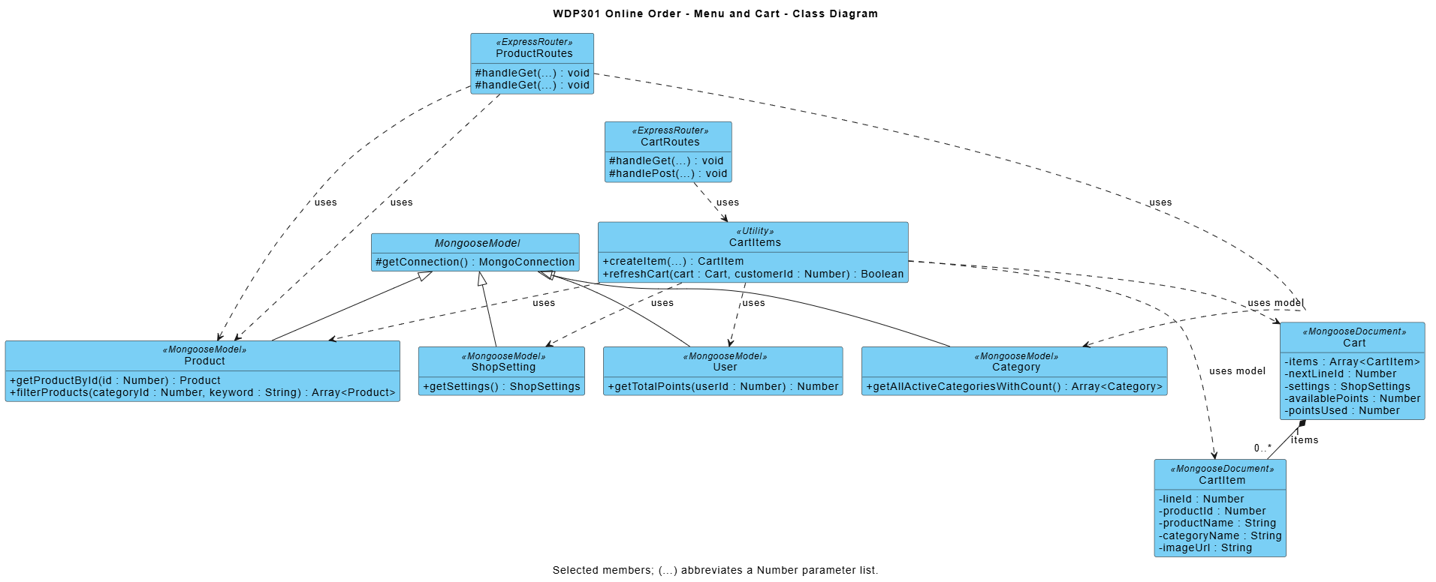
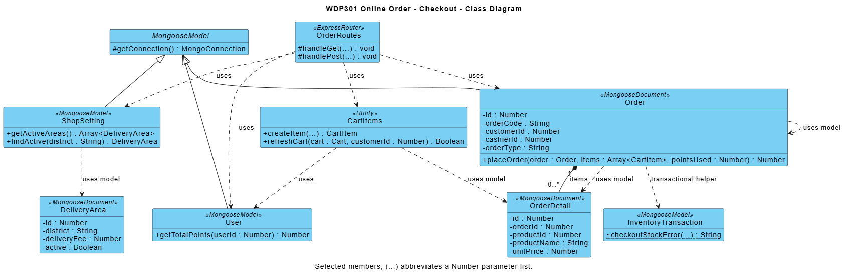

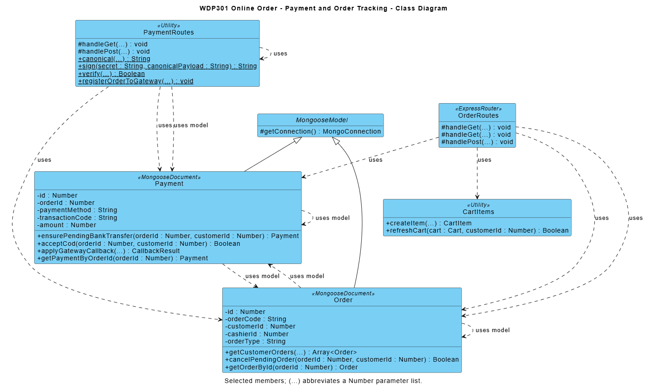

Module contract: React pages call Express JSON APIs; routers enforce access/validation and use shared business utilities and Mongoose models. Diagram methods are logical responsibilities, not private function names. Listed source paths identify primary modules; internal refactoring preserves public behavior and acceptance criteria.

1.2 Place Online Order
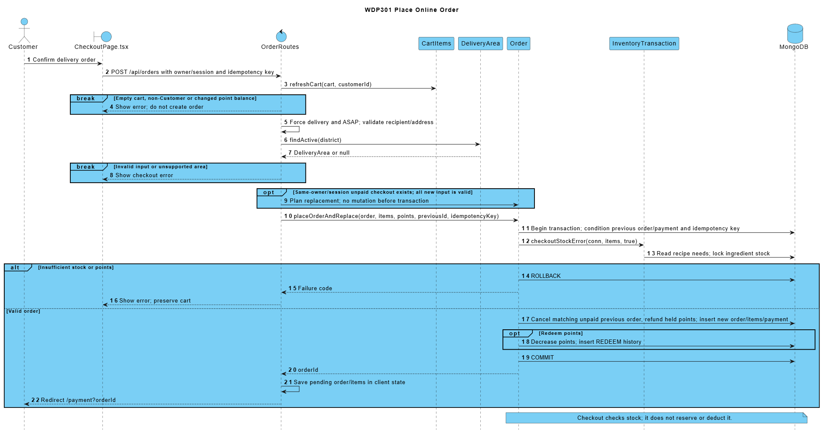

1.3 Confirm Online Bank Transfer
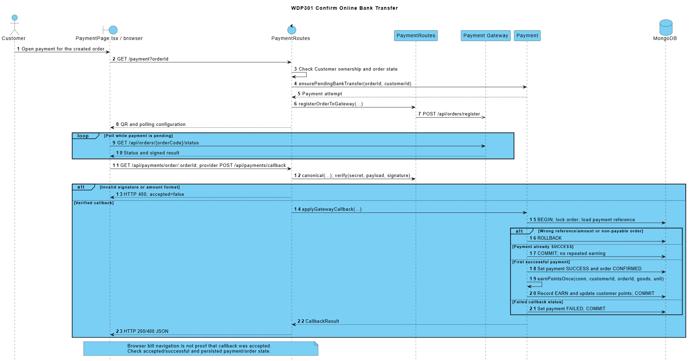

1.4 Choose COD and Track an Own Order
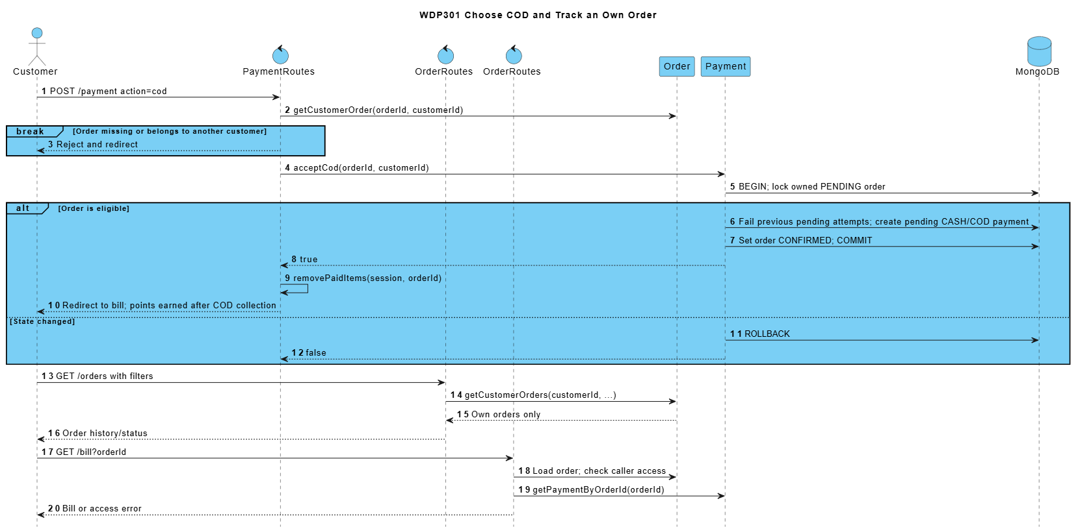

1.5 Cancel an Unpaid Order or Reorder
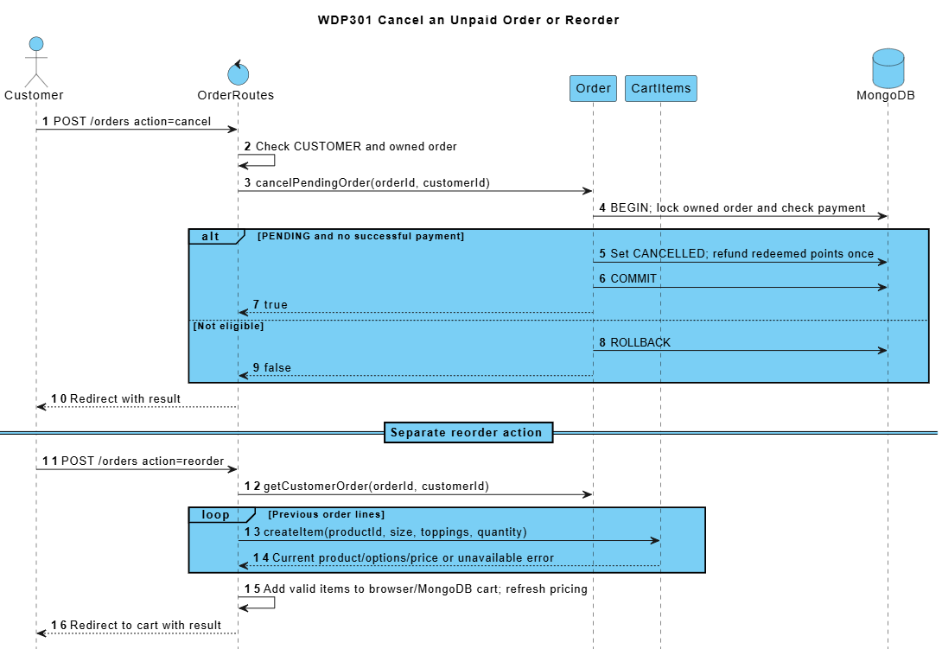

2. Ingredient Restock and Purchasing (Duy)
SRS trace: BF-08; UC44-UC53. Requirement sections: I.2.8; II.7.
Admin maintains suppliers and ingredients, checks stock and movement history, records adjustments or spoilage, reviews restock requests and receives purchase orders. The principal path converts an approved restock request into a purchase order; direct purchase-order creation is also supported.
RestockRequest follows DRAFT/PENDING_APPROVAL/APPROVED/REJECTED/CANCELLED with reviewer history. A linked purchase requires approval. DRAFT/ORDERED purchases do not change stock; atomic receipt records stock/lots and IN_PURCHASE exactly once.

2.1 Class Diagrams
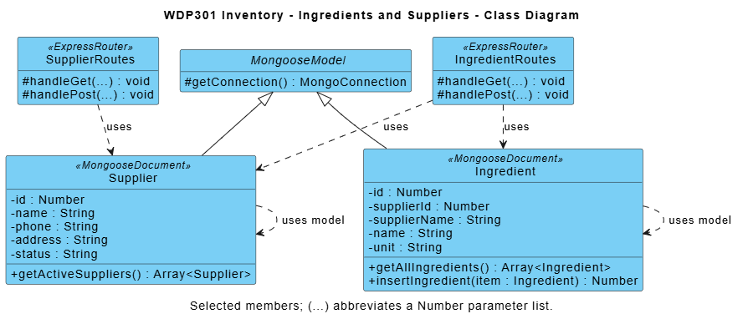

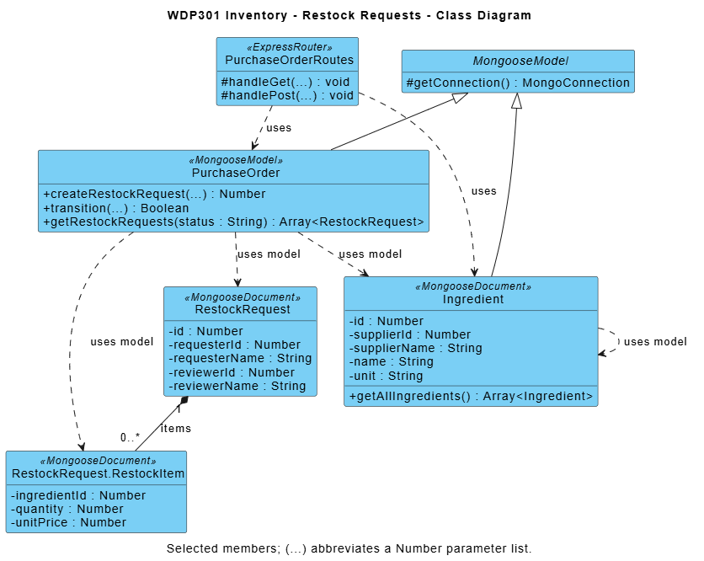

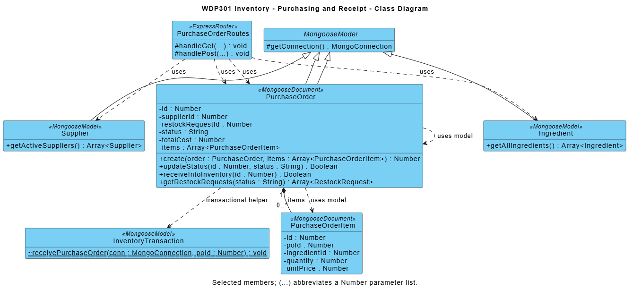
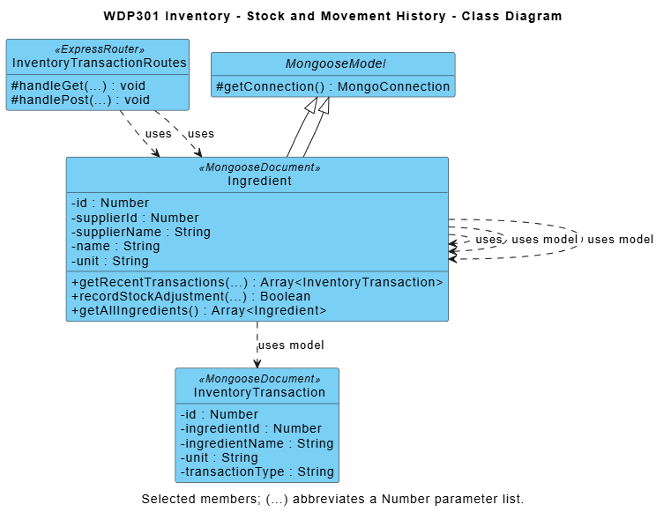

Module contract: React pages call Express JSON APIs; routers enforce access/validation and use shared business utilities and Mongoose models. Diagram methods are logical responsibilities, not private function names. Listed source paths identify primary modules; internal refactoring preserves public behavior and acceptance criteria.

2.2 Create Restock Request and Receive a Purchase Order
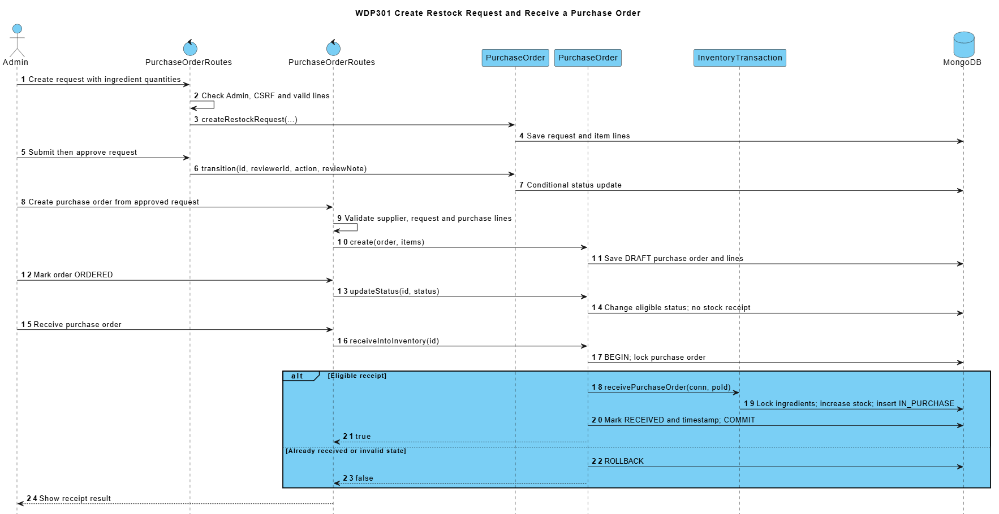

2.3 Adjust Stock or Record Spoilage
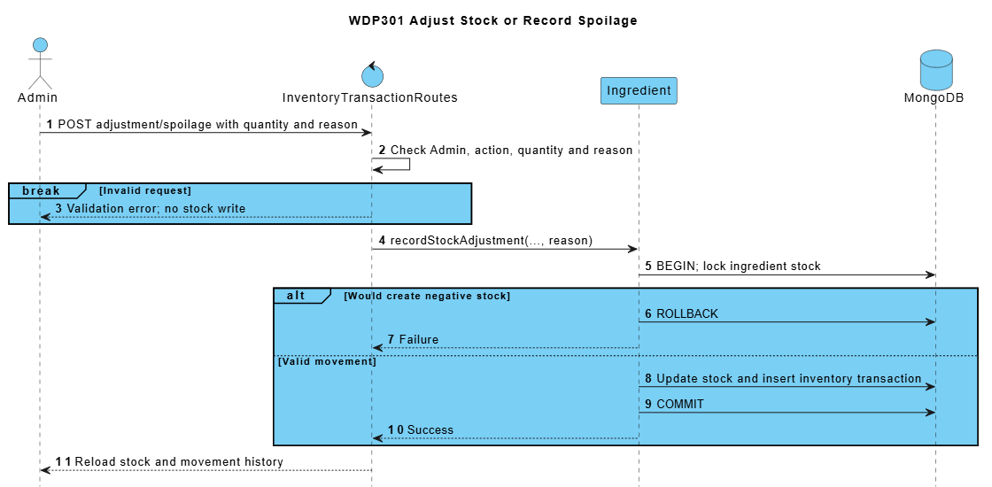

3. Customer Feedback and Complaint Handling (Sơn)
SRS trace: BF-09; UC65, UC70. Requirement sections: I.2.9; II.2.3.3; II.9.2.3.
A signed-in customer submits a rating or complaint linked to an own order, then reads its response. Admin filters tickets and moves an eligible ticket through Processing to Resolved or Rejected.
ReviewRoutes requires an active CUSTOMER and owned eligible order for submission. Customers read only their own tickets; guests/staff receive no unrestricted list. Enforce one submission per order and terminal ticket immutability on every request.

3.1 Class Diagram
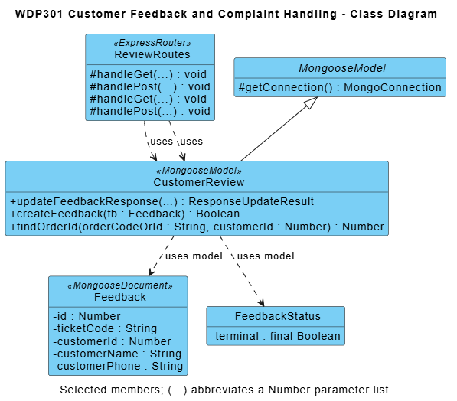

Module contract: React pages call Express JSON APIs; routers enforce access/validation and use shared business utilities and Mongoose models. Diagram methods are logical responsibilities, not private function names. Listed source paths identify primary modules; internal refactoring preserves public behavior and acceptance criteria.

3.2 Submit and Resolve Feedback
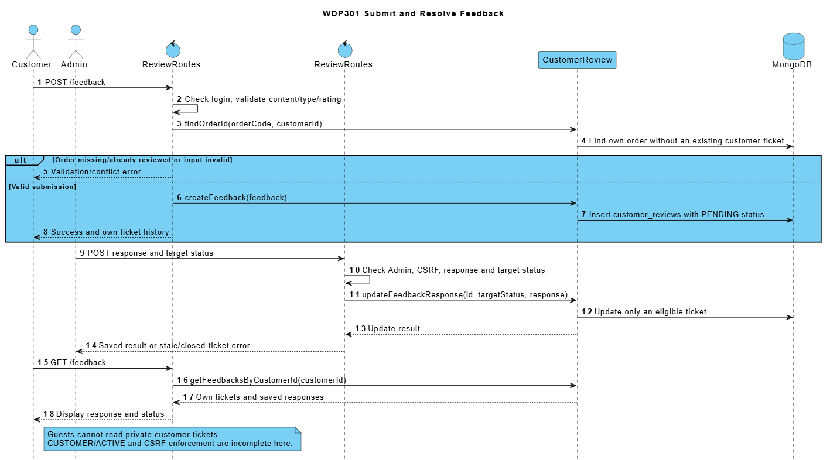

4. Delivery Management (Mạnh)
SRS trace: BF-04; UC26-UC30, UC71-UC72. Requirement sections: I.2.4; II.5; II.9.1.1; II.10.1.2.
Admin maintains delivery areas and assigns an active shipper to an eligible ONLINE delivery order. The assigned shipper accepts, picks up a READY order, completes delivery, reports issues and hands held COD cash to an active Cashier.
Delivery responsibilities include READY assignment/pickup, assigned-shipper transitions, issue history, exact COD collection and remittance to an active receiving cashier. Delivery state and history may be represented on Order and WorkSchedule without duplicate authoritative records.

4.1 Class Diagrams
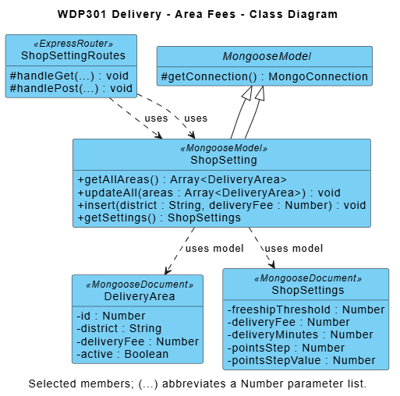

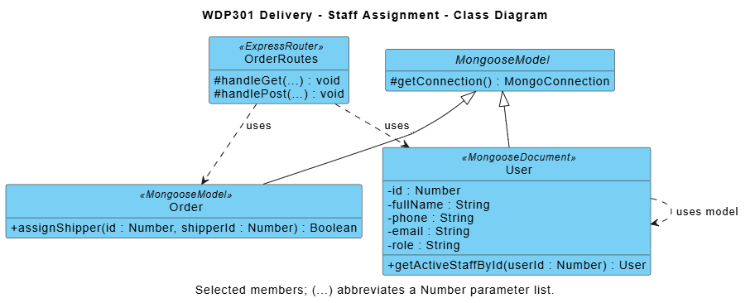

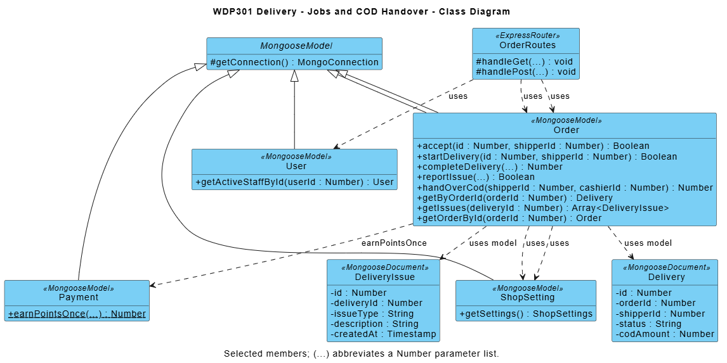

Module contract: React pages call Express JSON APIs; routers enforce access/validation and use shared business utilities and Mongoose models. Diagram methods are logical responsibilities, not private function names. Listed source paths identify primary modules; internal refactoring preserves public behavior and acceptance criteria.

4.2 Assign Delivery Staff
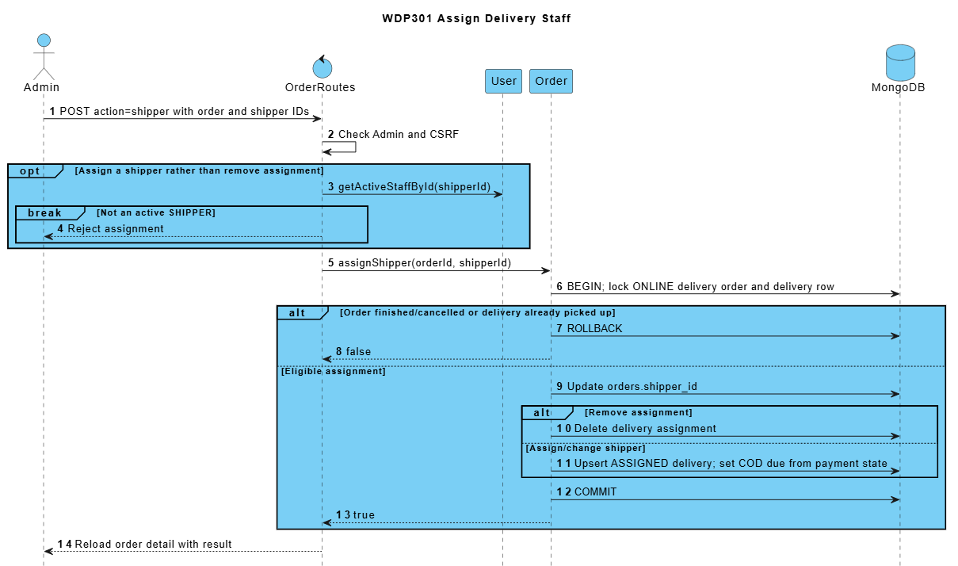

4.3 Accept Pick Up and Complete Delivery
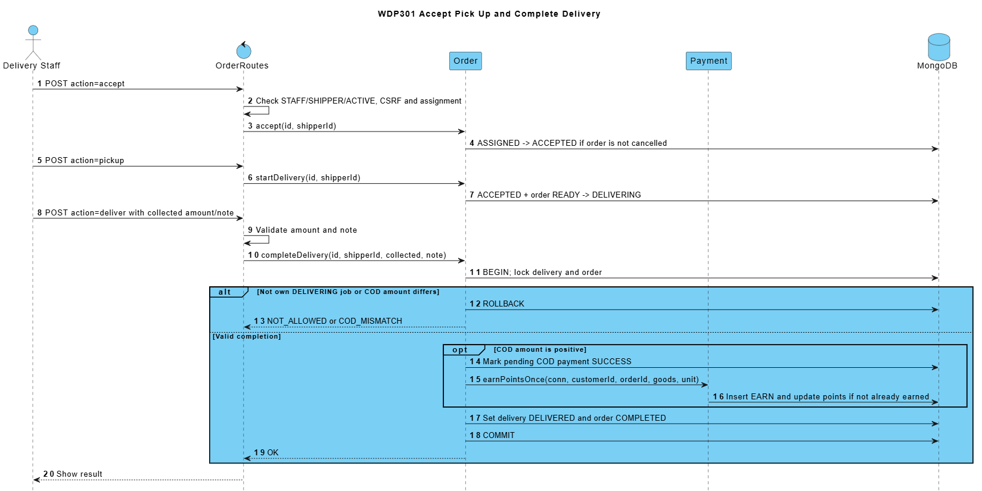

4.4 Report a Delivery Issue and Hand Over COD
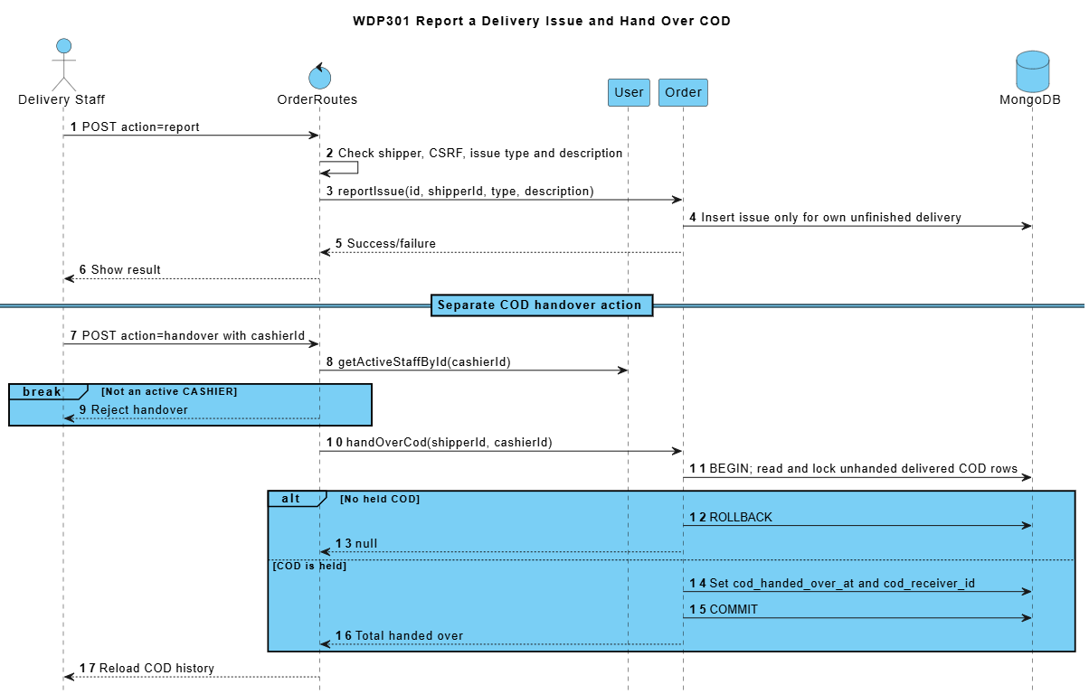

5. Barista Order Preparation (Mạnh)
SRS trace: BF-03; UC23-UC24. Requirement sections: I.2.3; II.4.1.1.
The Barista sees eligible paid orders and ONLINE COD orders. Entering PREPARING consumes recipe stock once; item-prepared flags are stored per item. Explicit completion persists READY only after preparation is complete, for cashier or shipper handover.
Persist preparation flags, status and timestamps in MongoDB so refresh/restart preserves progress. Order state guards, transaction sessions and OUT_ORDER idempotency protect stock across processes. Failed stock deduction leaves preparation unstarted; READY never deducts stock a second time.

5.1 Class Diagram
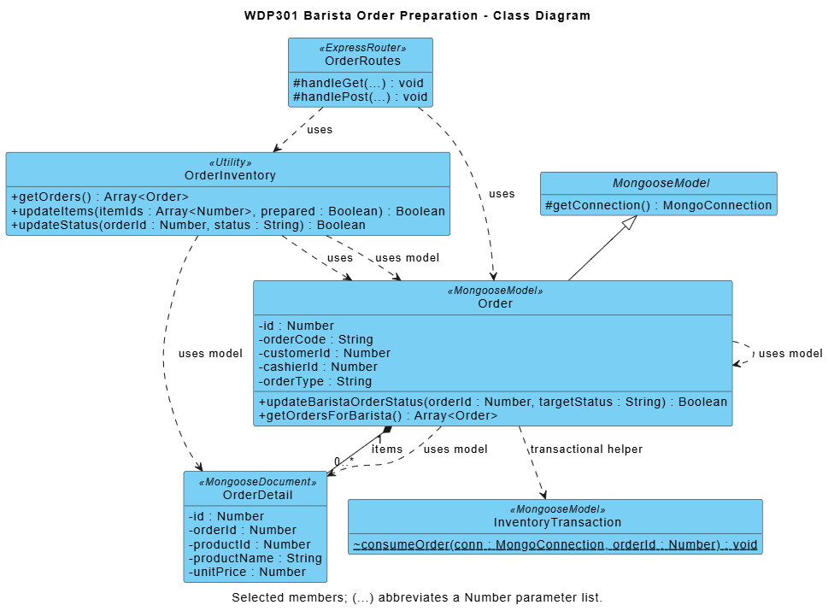

Module contract: React pages call Express JSON APIs; routers enforce access/validation and use shared business utilities and Mongoose models. Diagram methods are logical responsibilities, not private function names. Listed source paths identify primary modules; internal refactoring preserves public behavior and acceptance criteria.

5.2 Load Queue Update Items and Mark READY
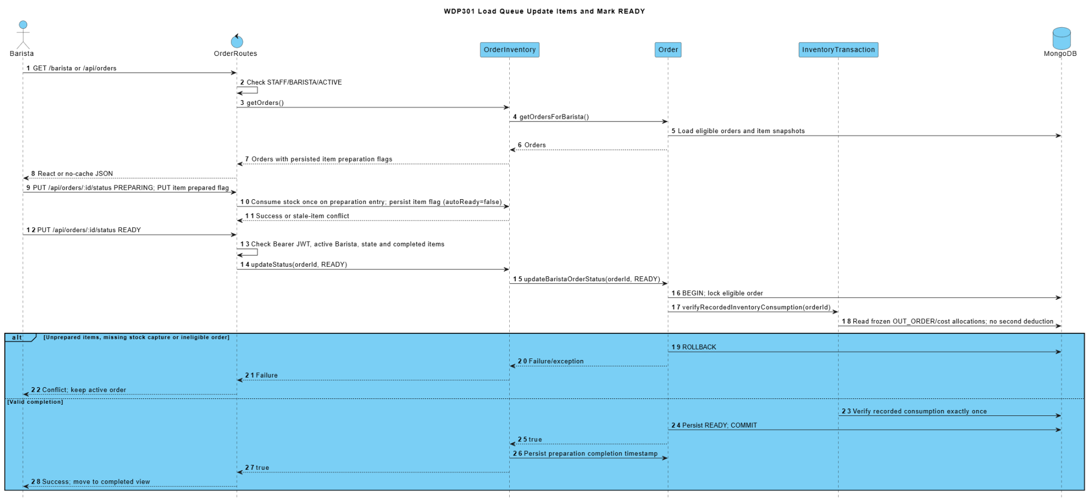

6. Account Menu Recipe and Loyalty Design (Nguyên)
SRS trace: BF-10, BF-11, BF-12; UC01-UC06, UC31-UC43, UC62-UC64. Requirement sections: I.2.10-I.2.12; II.1; II.2.1.1; II.2.3.2; II.6.2-II.6.3; II.9.2.2.
Homepage hosts the authentication dialog. Users register, recover access with an email OTP, sign in, log out and maintain their profile. Admin publishes category/product data and a BOM, calculates recipe cost from received purchase prices, and manages phone-based loyalty rules and adjustments. Role routing is handled by AuthController; endpoint authorization remains in the individual controllers.
AuthController, protect and User handle bcrypt/JWT identity, profile and phone points. PasswordRecoveryRoutes, PasswordRecovery and recoveryEmail own expiring OTP/reset. Product/category/recipe APIs own catalog data; React never queries MongoDB directly.

6.1 Class Diagrams
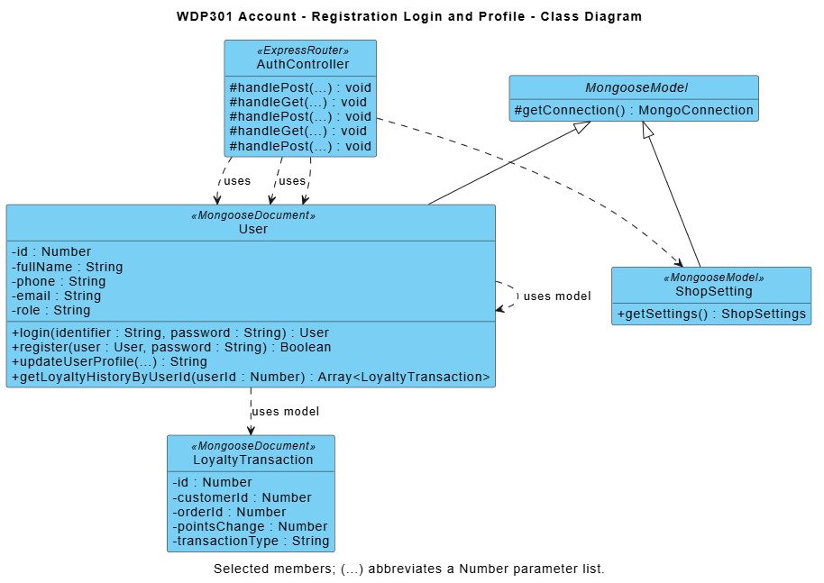

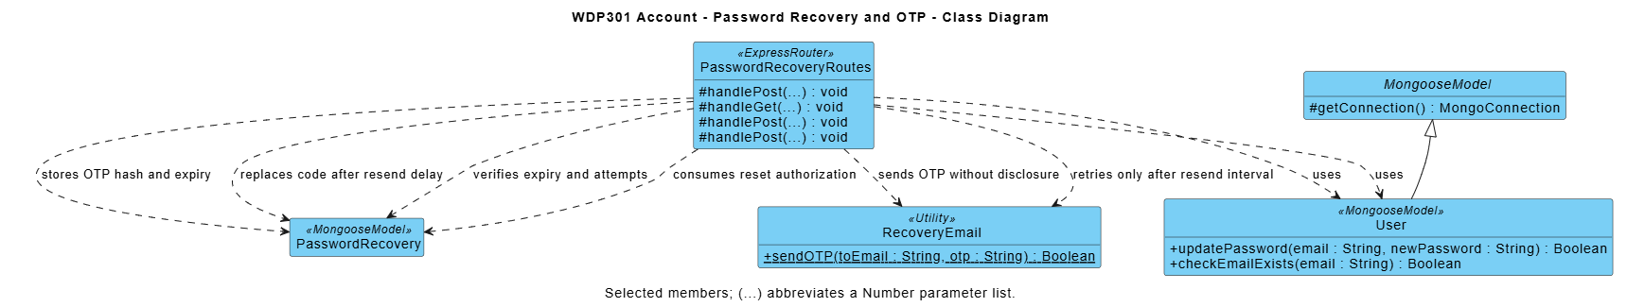

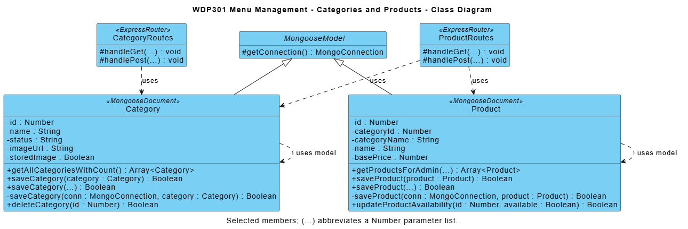

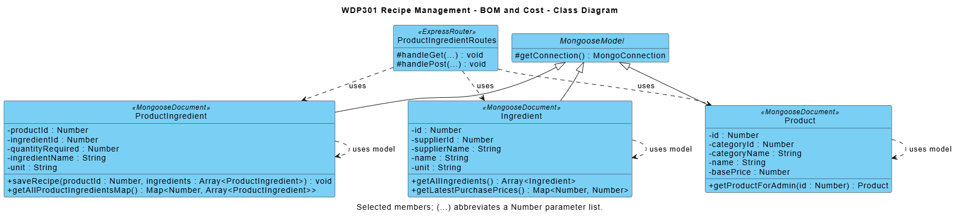

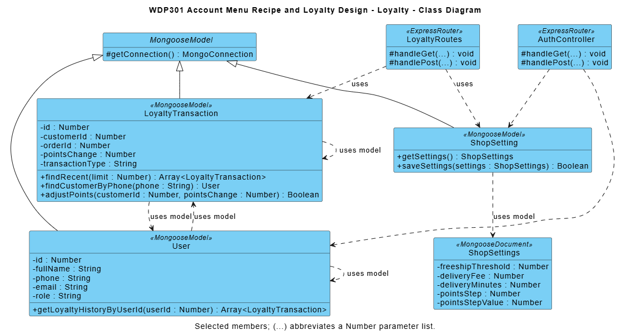

Module contract: React pages call Express JSON APIs; routers enforce access/validation and use shared business utilities and Mongoose models. Diagram methods are logical responsibilities, not private function names. Listed source paths identify primary modules; internal refactoring preserves public behavior and acceptance criteria.

6.2 Register Log In and Maintain Profile
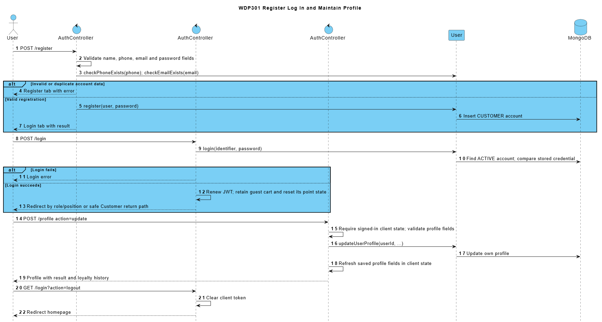

6.3 Recover Password with Email OTP
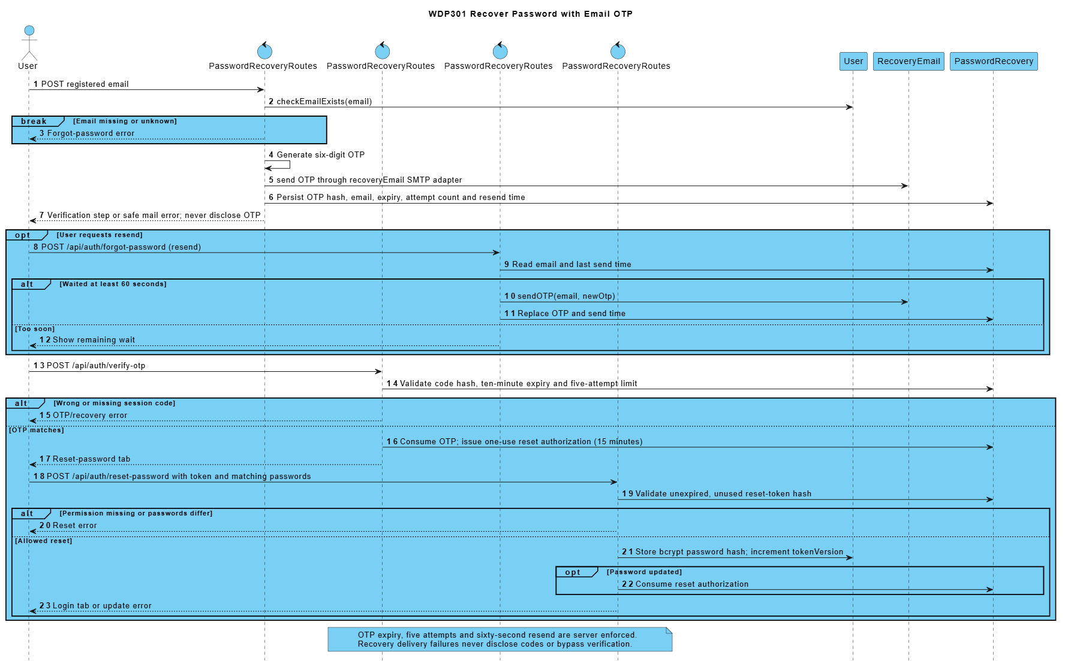

6.4 Publish Menu Data and Save a Recipe
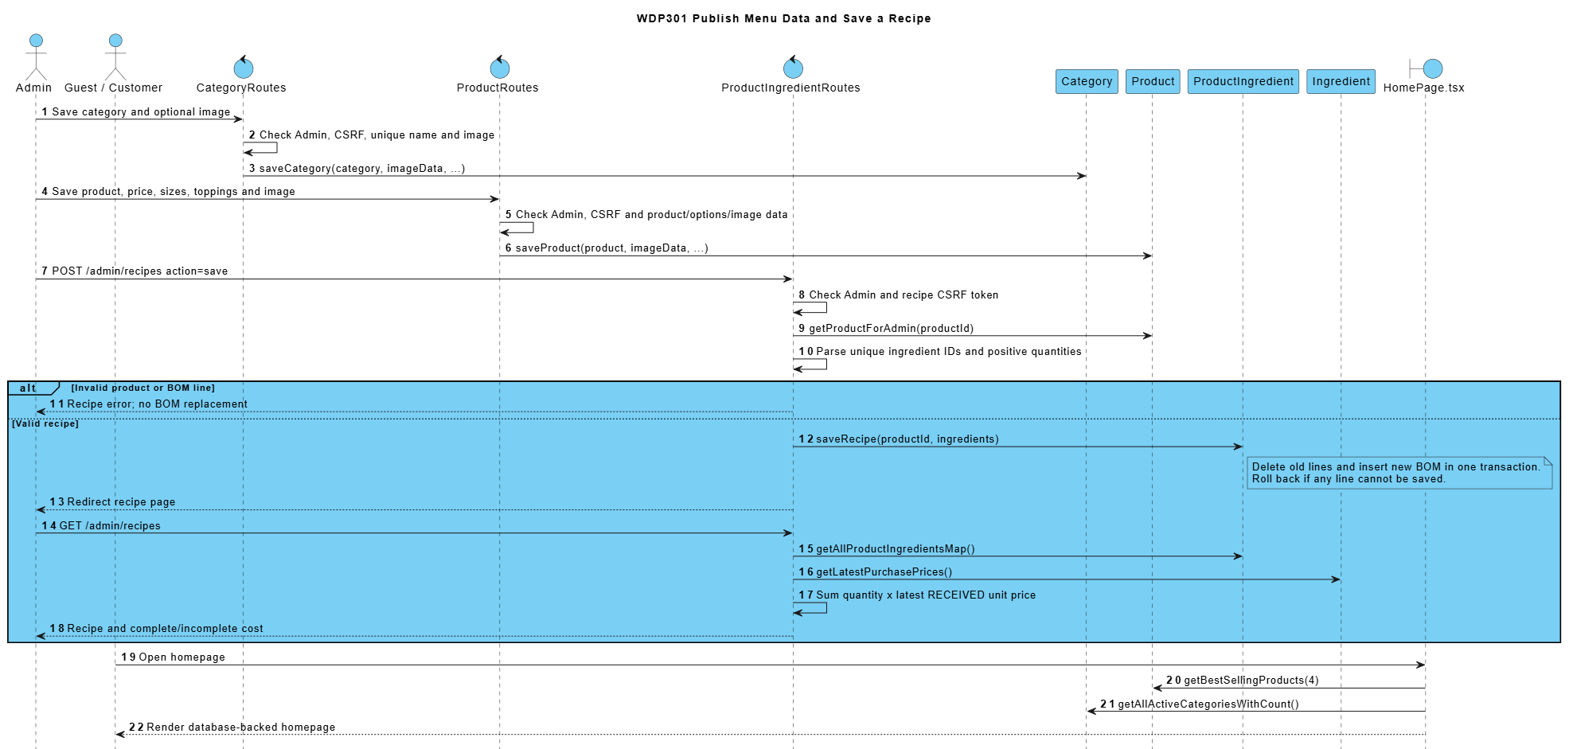

6.5 Look Up Customer Update Rules and Adjust Points
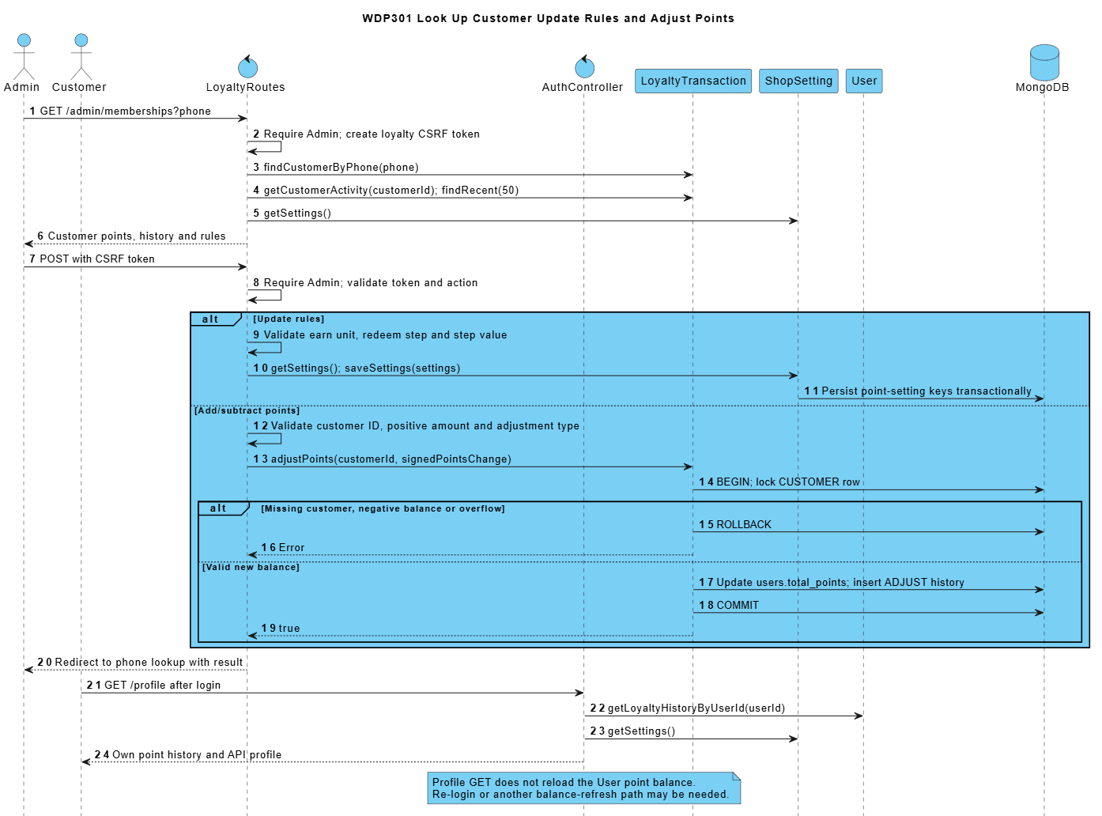

7. Scheduling Attendance and Handover Design (Sơn)
SRS trace: BF-06, BF-07; UC55-UC60, UC69, UC73. Requirement sections: I.2.6-I.2.7; II.3.2.1; II.8.2.
Admin assigns active employees to shifts of the matching week, records attendance and check-in cash, and reviews the Cashier shift report. Cashier submits counted cash, sees the result and may resubmit an own rejected report.
WorkShift/WorkSchedule define weekly frames and own attendance. ShiftHandover closes an owned PRESENT shift and stores SUBMITTED cash reconciliation atomically. Admin review and cashier resubmission are state-conditional and preserve every explanation/review in history.

7.1 Class Diagrams
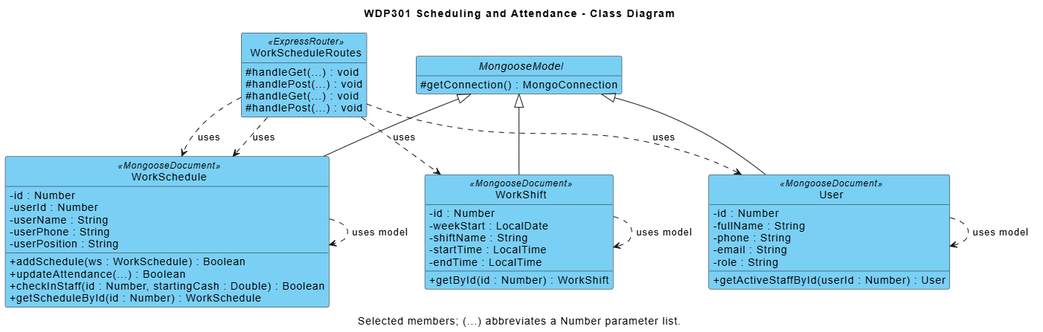

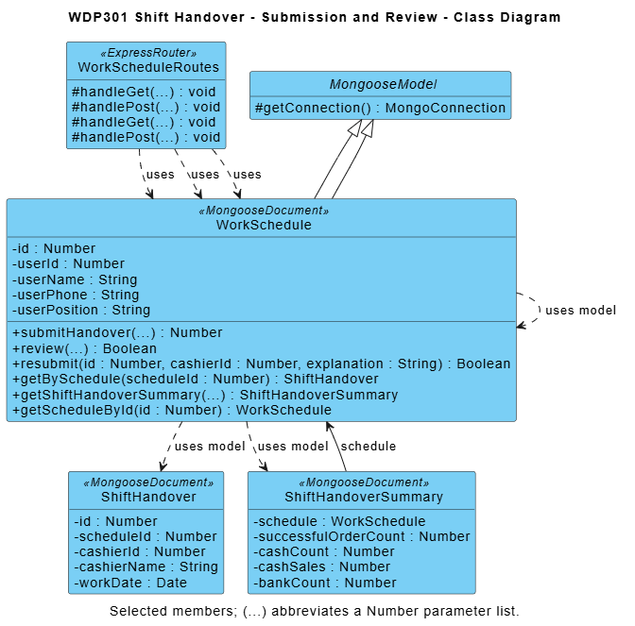

Module contract: React pages call Express JSON APIs; routers enforce access/validation and use shared business utilities and Mongoose models. Diagram methods are logical responsibilities, not private function names. Listed source paths identify primary modules; internal refactoring preserves public behavior and acceptance criteria.

7.2 Assign Work Schedule and Record Attendance
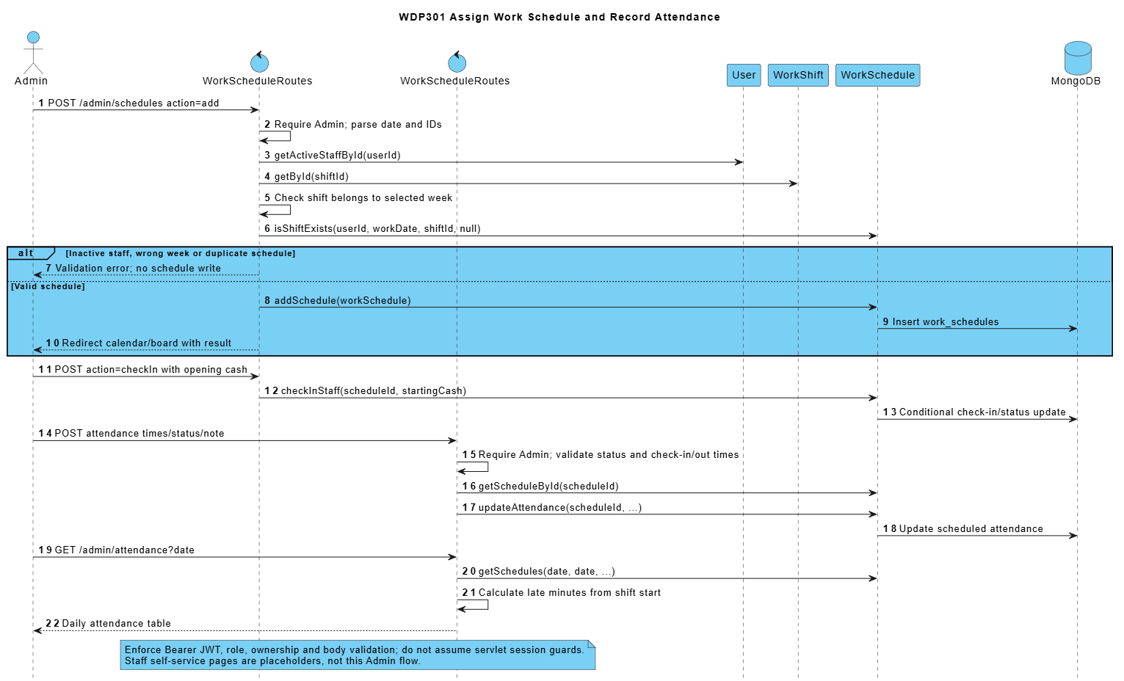

7.3 Close Review and Resubmit Shift Handover
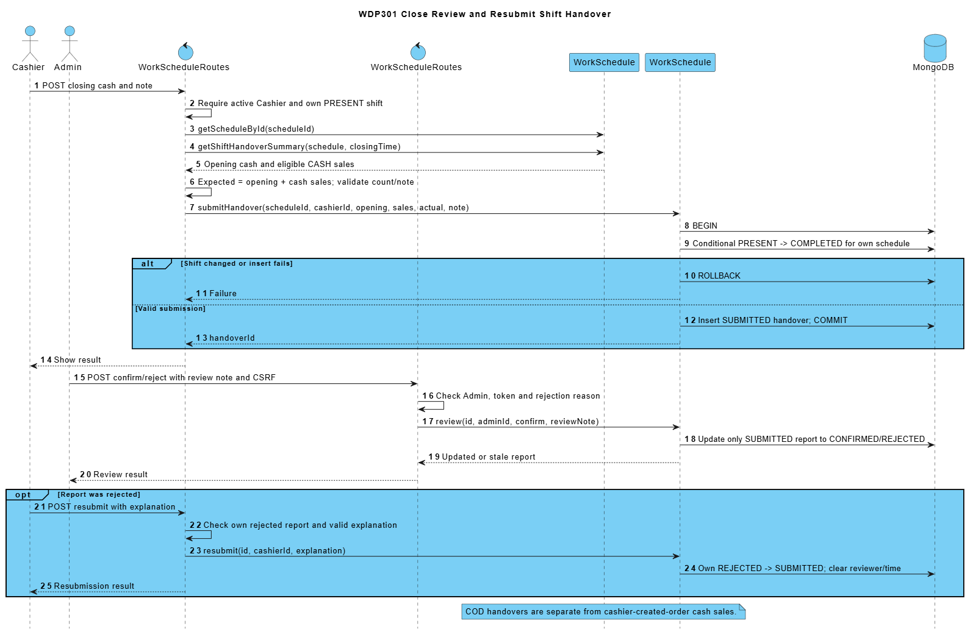

8. Order Oversight Reports and Settings Design (Mạnh)
SRS trace: BF-13, BF-14; UC14, UC61, UC66-UC68. Requirement sections: I.2.13-I.2.14; II.9.1-II.9.3; II.10.1.1.
Admin reviews orders with items, payments and delivery information, manages customers, loads period reports and persists shop settings. Report periods are validated before querying the report DAO.
Revenue, type sales and top products use matched SUCCESS payments by paidAt, excluding cancelled orders. Order counts use Order.createdAt; actual ingredient usage uses OUT_ORDER.createdAt. Vietnam calendar boundaries apply. Product totals are not net profit.

8.1 Class Diagrams
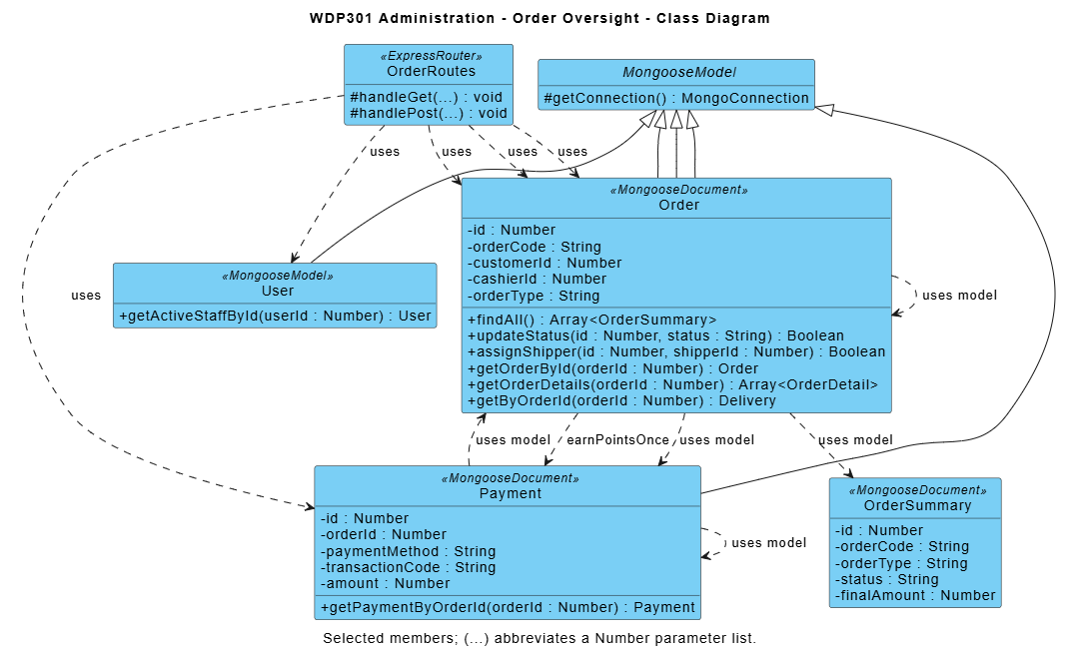

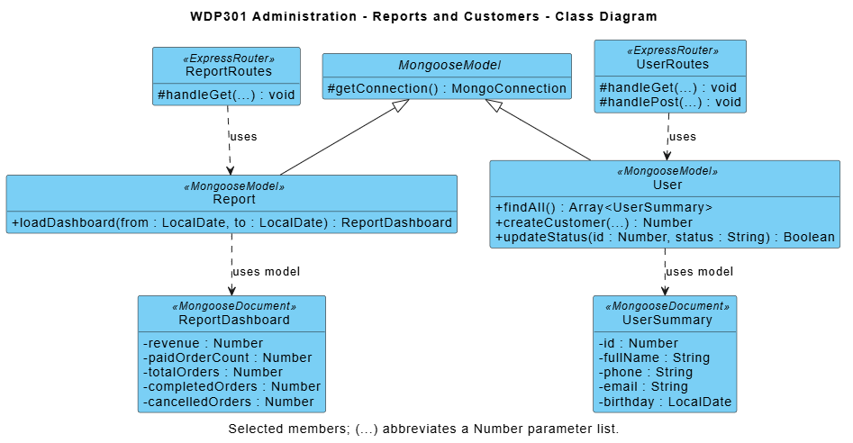

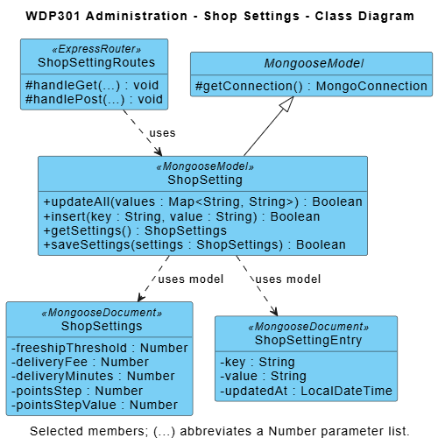

Module contract: React pages call Express JSON APIs; routers enforce access/validation and use shared business utilities and Mongoose models. Diagram methods are logical responsibilities, not private function names. Listed source paths identify primary modules; internal refactoring preserves public behavior and acceptance criteria.

8.2 Review Reports and Follow Up Orders or Customers
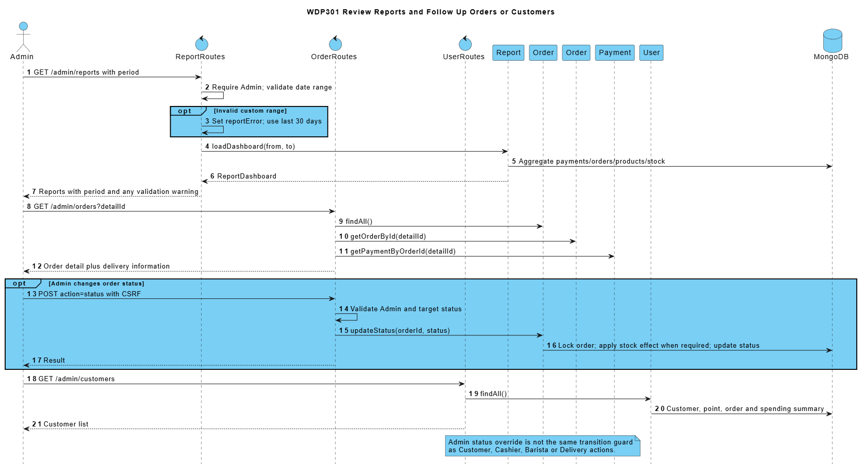

8.3 Load and Persist Shop Settings
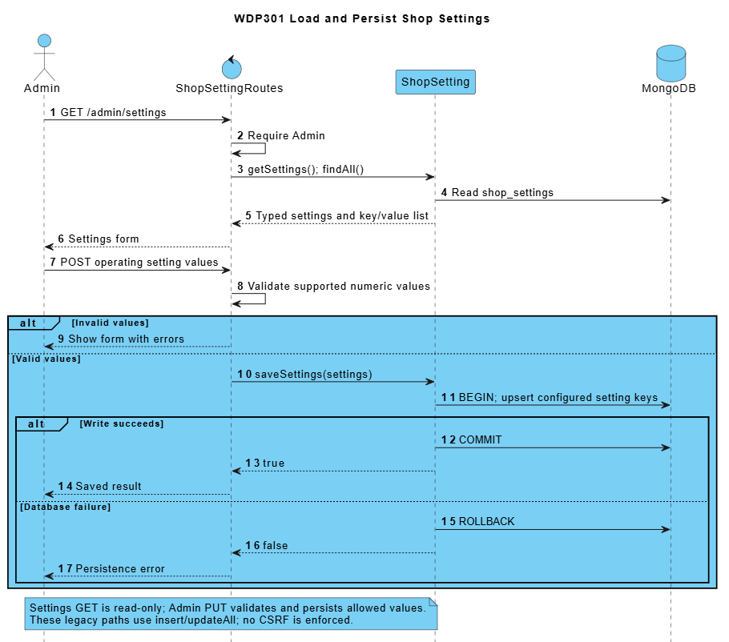

9. Counter Ordering and Payment (Mạnh)
SRS trace: BF-05; UC14, UC18-UC22, UC62, UC64. Requirement sections: I.2.5; II.3.1.
Cashier builds a DINE_IN or TAKEAWAY order, identifies an optional member, applies valid points and accepts cash or creates a bank-transfer payment. Counter list and Bill display the saved order. After Barista preparation, Cashier hands over a READY order.
Prices and totals are recalculated on the server rather than trusted from JSON. CASH confirmation and earning occur in createCounterOrder. BANK_TRANSFER remains pending outside test mode. The POS controller contains a local signed test callback but does not register the order with the external gateway; production POS bank integration is not demonstrated by that simulation.

9.1 Class Diagrams
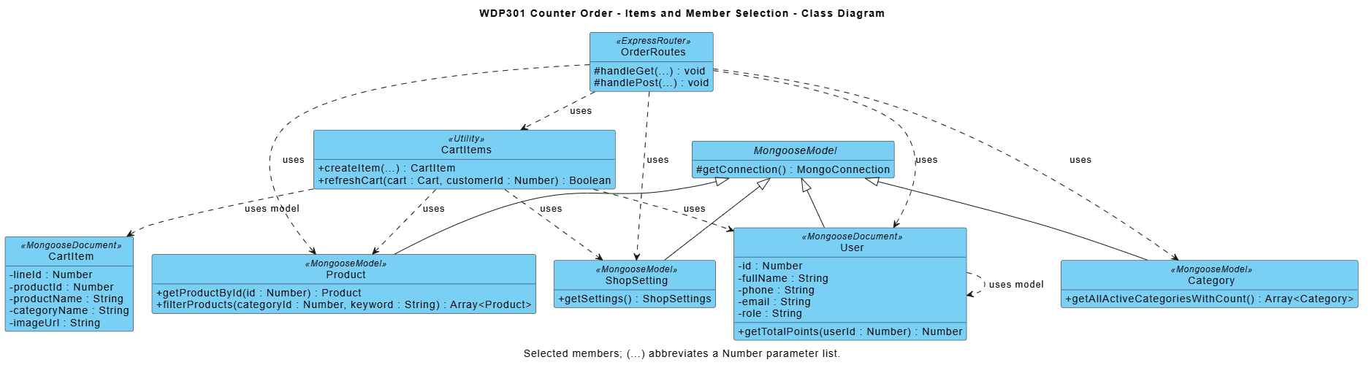

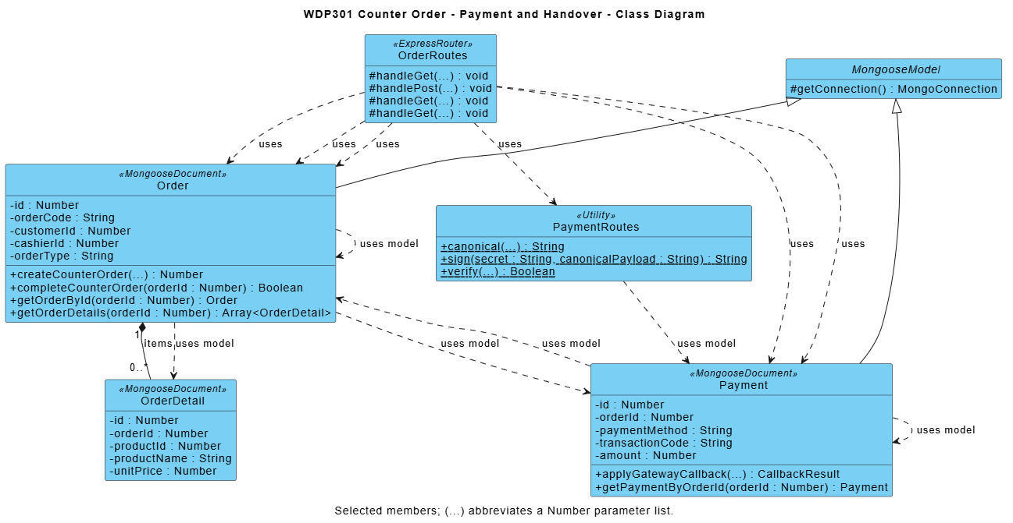

Module contract: React pages call Express JSON APIs; routers enforce access/validation and use shared business utilities and Mongoose models. Diagram methods are logical responsibilities, not private function names. Listed source paths identify primary modules; internal refactoring preserves public behavior and acceptance criteria.

9.2 Create Pay Prepare and Hand Over a Counter Order
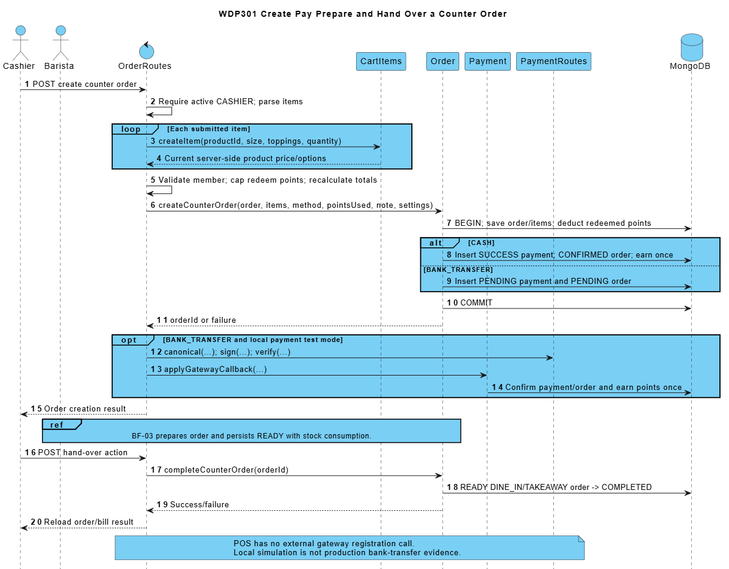

10. Employee and Weekly Shift Setup (Sơn)
SRS trace: BF-15; UC54-UC55. Requirement sections: I.2.15; II.8.1.
Admin creates and updates employees, locks or unlocks eligible accounts, and defines the shifts of a selected week. An empty week may copy the latest earlier week. These saved records are inputs to scheduling and attendance.
Employee forms validate phone/email uniqueness, role/position and password conditions. The current Admin cannot downgrade or lock their own account. Weekly shifts reject invalid hours, duplicate names and overlap; past weeks are not editable, and a shift referenced by a schedule cannot be deleted.

10.1 Class Diagram
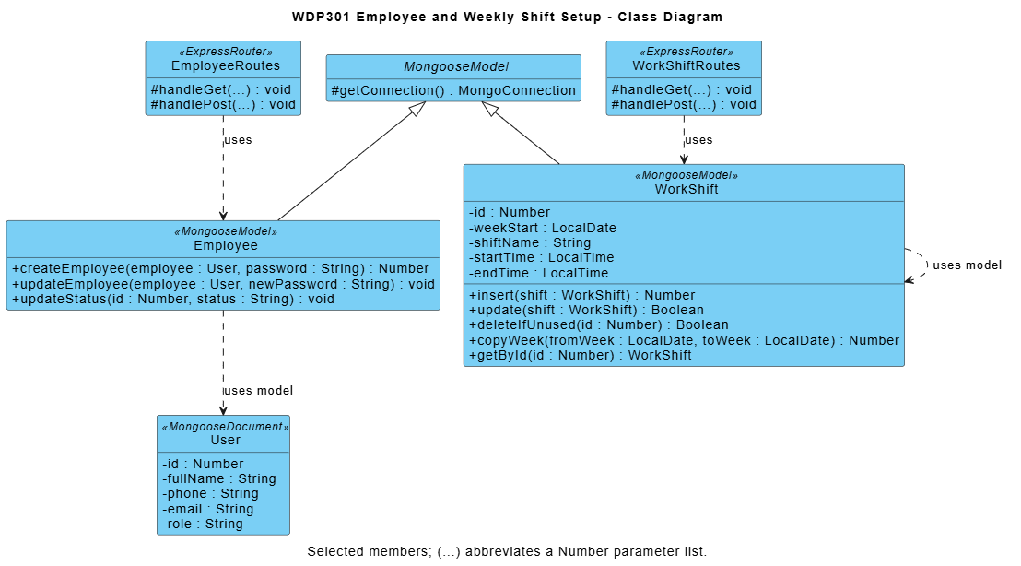

Module contract: React pages call Express JSON APIs; routers enforce access/validation and use shared business utilities and Mongoose models. Diagram methods are logical responsibilities, not private function names. Listed source paths identify primary modules; internal refactoring preserves public behavior and acceptance criteria.

10.2 Prepare Employee Accounts and Weekly Shifts
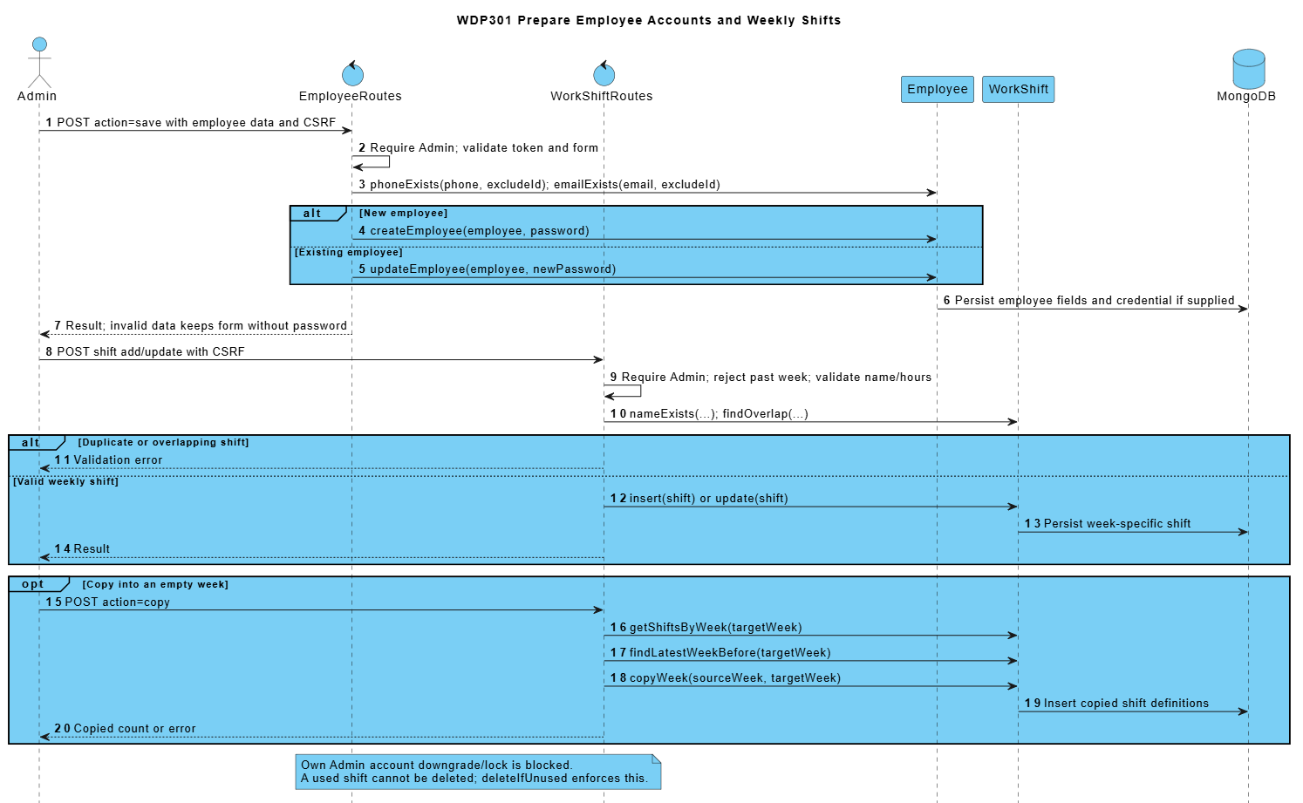

3. Other Design Specifications

1. State and Business Rules
Entity | Main transition path | Guard and implementation qualification
Online order | PENDING -> CONFIRMED -> READY -> DELIVERING -> COMPLETED | CONFIRMED follows verified bank payment or COD selection. PREPARING and item flags are persisted; entering preparation consumes stock once. Only an owned unpaid PENDING order may be cancelled by its customer; authorized overrides still enforce state/accounting guards.
Counter order | PENDING/CONFIRMED -> READY -> COMPLETED | Counter lifecycle: create, authorized payment confirmation, preparation, READY and customer handover. Successful payment is required before preparation/final handover; counter CASH/BANK_TRANSFER confirmation is not an online provider callback.
Payment | PENDING -> SUCCESS or FAILED | Signed callback checks payment reference and amount; repeat SUCCESS returns an idempotent result. COD earns only after successful collection.
Delivery | ASSIGNED -> ACCEPTED -> DELIVERING -> DELIVERED | Own assigned active shipper; READY order required for pickup; exact COD required for delivery completion. Reassignment is blocked after pickup.
Work schedule | SCHEDULED -> PRESENT -> COMPLETED, or ABSENT | WorkShift fixes weekly frames and WorkSchedule fixes assignments/check-in/check-out. Preserve historical shift definitions and own attendance permissions; close a PRESENT cashier shift together with its submitted reconciliation.
Shift handover | SUBMITTED -> CONFIRMED or REJECTED; REJECTED -> SUBMITTED | ShiftHandover: SUBMITTED -> CONFIRMED or REJECTED; only its cashier can explain and resubmit REJECTED -> SUBMITTED. One report per schedule; preserve review/resubmission history and state-guard concurrent requests.
Restock request | DRAFT -> PENDING_APPROVAL -> APPROVED/REJECTED | RestockRequest: DRAFT -> PENDING_APPROVAL -> APPROVED or REJECTED; permitted draft/pending cancellation follows SRS. Approval is required before a linked purchase; request transitions never directly increase stock.
Purchase order | DRAFT -> ORDERED -> RECEIVED | DRAFT/ORDERED may be cancelled. Only ORDERED can be received; receiving commits stock and movement records atomically.
Feedback | PENDING -> IN_PROGRESS -> RESOLVED/REJECTED | One review per owned eligible order; statuses PENDING/IN_PROGRESS/RESOLVED/REJECTED. Terminal tickets cannot be reopened, edited or deleted through the standard API.

2. Algorithms and Calculations
Calculation | Rule | Important boundary
Product line price | Base price + selected size surcharge + selected topping prices; multiply by quantity. | Prices/options are rebuilt from current product data before order persistence. Order lines store a historical snapshot.
Redeem discount | floor(pointsUsed / pointsStep) x pointsStepValue. | Redeem is capped by the customer balance and goods subtotal; guests/non-members cannot spend another customer balance.
Earn points | floor((goods total - discount) / pointsEarnUnit). | Shipping is excluded. Bank/CASH success earns once; COD earns on successful delivery collection.
Delivery fee | Delivery fee equals the selected active district fee when goods subtotal is below freeship_threshold, otherwise zero. Reject unknown/inactive areas and store the final address, district and fee snapshot on the order. | DeliveryAreaRoutes/AdminDeliveryAreasPage manage districts and rates. Public GET is read-only; explicit authorized setup is separate. Configuration changes do not reprice accepted orders.
Recipe cost | Recipe cost is the sum of consumed ingredient quantities multiplied by FIFO lot costs. Freeze per-order allocations at consumption; later purchases or recipe edits do not reprice historical orders. | Later receipts or recipe edits do not reprice consumed order snapshots. Missing costs remain unknown, not zero. The source latest-price estimate is distinguishable from this actual FIFO valuation.
Ingredient consumption | Aggregate BOM quantity x ordered quantity by ingredient. | Size/topping-specific BOM scaling is not implemented by this formula. No stock reservation occurs at checkout.
Shift expected cash | Expected cash = opening cash + attributed counter CASH receipts + COD physically confirmed by the cashier - CASH refunds issued from this shift. Preserve the original receipt even if later refunded through BANK_TRANSFER. Save the reconciliation snapshot atomically; require a reason for a difference. | BANK_TRANSFER is excluded from drawer receipts. Add COD only after the receiving cashier confirms physical receipt, once, through codReceivingSchedule; subtract CASH refunds attributed by refundSchedule. Difference = actual cash - expected cash.
Reports | Revenue, type sales and top products use matched SUCCESS payments by paidAt, excluding cancelled orders. Order counts use Order.createdAt; actual ingredient usage uses OUT_ORDER.createdAt. Vietnam calendar boundaries apply. Product totals are not net profit. | Range is [from 00:00, day after to 00:00). Low stock is current, not historical. Product totals use snapshots and are not net revenue/profit.

3. Transactions and Concurrency
Use transaction sessions for critical multi-document writes, with unique indexes, conditional states and idempotency keys. Every nested query/save participates in the same session. Unsupported transaction infrastructure fails before mutation; in-process locks and compensation alone do not satisfy atomicity. Keep network calls outside retryable database transactions.
Operation | Atomic writes and guards | Source
Online placement | Validate first; transactionally replace only same-owner/session unpaid checkout, refund held points and create Order/items/Payment/REDEEM. Bind an idempotency key; errors leave the previous checkout unchanged. | Order.placeOrder
Payment callback | Verify signature/reference/amount, condition Payment/order state, apply SUCCESS and EARN/cart effects once in the transaction. Coordinate with cancellation through shared order state guards across processes. | Payment.applyGatewayCallback/earnPointsOnce
Preparation entry | Guard eligible order; consume FIFO ingredient lots and record OUT_ORDER movements once, then update the order preparation state. | Order.updateBaristaOrderStatus; InventoryTransaction.consumeOrder
Purchase receipt | Within one session, require ORDERED, increase stock/lots, record IN_PURCHASE and set RECEIVED exactly once; any failure aborts all writes. | PurchaseOrder.receiveIntoInventory
Manual adjustment | Locked ingredient + non-negative stock result + movement record/reason. | Ingredient.recordStockAdjustment
Loyalty adjustment | Within one transaction, condition the phone-identified CUSTOMER balance to remain non-negative and append the matching ADJUST ledger entry; no balance-only partial result is allowed. | LoyaltyTransaction.adjustPoints
Recipe replacement | Validate the full replacement first; transactionally replace BOM links and embedded recipe so neither representation becomes partial or inconsistent. | ProductIngredient.saveRecipe
Shift submission | The owning active cashier closes PRESENT -> COMPLETED, stores checkOutTime and the cash snapshot, and creates SUBMITTED ShiftHandover in one transaction. Preserve compatible historical completed schedules without inventing Admin approval. | WorkSchedule.submitHandover
Admin review/resubmit | Admin review requires SUBMITTED; cashier resubmission requires ownership and REJECTED. Conditional writes and append-only history prevent concurrent decisions or lost explanations; related schedule/report writes share a transaction. | WorkSchedule.review/resubmit
Delivery completion | Require the assigned active shipper and DELIVERING state; transactionally record exact COD SUCCESS, EARN once and COMPLETED. A retry does not collect, credit or complete twice. | Order.completeDelivery
Category/product images | Persist imageUrl metadata on the Category/Product document; source relational image tables are not separate MERN collections. | Category.saveCategory; Product.saveProduct

4. Security and Requirement Alignment
Protected WDP301 JSON endpoints use JWT middleware and current account checks. The following controls define the MERN security boundary and replace observations about the SWP servlet implementation.
Area | Required control | Documentation boundary
Authentication and password storage | authController stores bcrypt password hashes, normalizes login identifiers and returns a JWT after credential and active-account checks. | Never include password hashes, database secrets or real credentials in API responses or design examples.
OTP recovery | RecoveryRoutes validate email/OTP/reset authorization and enforce expiry, attempts and resend interval; successful reset consumes authorization and revokes earlier login tokens. | Never disclose OTP/reset tokens in API errors or logs. Missing SMTP is an explicit delivery/configuration failure, never a verification bypass.
Endpoint authorization | protect middleware checks the current account; route guards check role, position and ownership for the requested operation. | Check authorization on the server for every protected request; hiding a React button is insufficient.
CSRF coverage | Client requests authenticate with an explicit Bearer JWT; the API does not use an ambient login-session cookie for protected writes. | Validate request bodies, origin/CORS configuration and safe redirects; do not describe a servlet CSRF filter.
Settings writes | GET reads settings; authenticated Admin PUT validates and persists configuration. | State changes must not be implemented as GET navigation or client-only updates.
Feedback privacy | Customers read their own reviews and submit once per owned order; Admin responds and views reports. Staff/guests do not receive unrestricted ticket access. | Closed tickets are immutable under the standard response/delete routes; record respondent and response time.
Online callback UI | PaymentPage registers through the backend and reads stored payment/order status. Only the signed provider callback confirms BANK_TRANSFER; owner-authorized demo applies only to DEMO_ONLINE when enabled. | Test the HTTP callback result plus stored order/payment state, not only the displayed screen.
Counter payment confirmation | An on-shift cashier/manager explicitly confirms CASH receipt. BANK_TRANSFER is confirmed only by a valid signed provider callback with matching amount and transaction. Manual references and QR display cannot settle a bank payment. | Local simulation and manual transaction references do not demonstrate a live bank webhook integration.
Category publication | Category ACTIVE tabs and product availability are read by separate public queries. | Every public catalog view must exclude unavailable products and products belonging to inactive categories; validate eligibility again on add/checkout.
Profile point refresh | Profile and loyalty views reload current User/ledger data from the API; balance changes are stored on the User identified by unique phone. | Points are linked to the unique Customer phone number. WDP301 has no card levels, automatic promotions, level multipliers or level discounts.
Cash reconciliation | BANK_TRANSFER is excluded from drawer receipts. Add COD only after the receiving cashier confirms physical receipt, once, through codReceivingSchedule; subtract CASH refunds attributed by refundSchedule. Difference = actual cash - expected cash. | BANK_TRANSFER is excluded from drawer receipts. Add COD only after the receiving cashier confirms physical receipt, once, through codReceivingSchedule; subtract CASH refunds attributed by refundSchedule. Difference = actual cash - expected cash.
Admin order override | Order routes apply explicit role, position, ownership and state validation, including stock and payment eligibility. | Admin permissions do not bypass invalid amounts, missing references or the terminal order state guards.
Unused and placeholder code | Staff schedule/attendance are served by workScheduleRoutes. React provides the active KdsTerminal and DeliveryScreen components. | Retained source sections describe business capabilities; they do not imply that servlet placeholder files are part of the MERN project.
Data/transport configuration | MONGO_URI and JWT_SECRET are environment settings. Configure HTTPS, CORS and protected secret storage for deployment. | Never copy production credentials into documents, client bundles or test fixtures.

5. Deployment and Integrations
Install backend/frontend dependencies from their manifests. Configure MONGO_URI and JWT_SECRET for the Express server; configure VITE_API_URL for the React client. Build the client with Vite and run the API on Node.js. Initialize sample data only in an explicitly selected development database.
Build the React/Vite client and run the Node.js/Express API with deployment-specific environment settings. React Router owns client navigation; protected JSON calls use JWT middleware.
PAYMENT_DEMO_ENABLED gates isolated DEMO_ONLINE. Configure PAYMENT_GATEWAY_URL, PAYMENT_CALLBACK_SECRET and bank/account variables for provider registration and HMAC callback. SMTP_* configures recovery delivery. Acceptance must test each configured provider without exposing secrets.
Business updates are request-driven. Preparation, payment and order states are persisted in MongoDB; no in-memory-only preparation state is described as durable. The release does not require a scheduled background job.

6. Route and Source Traceability
Controller | URL mappings | Module responsibility / acceptance boundary
WorkScheduleRoutes | /admin/attendance | Required contract; verify access, state and stored effects.
CategoryRoutes | /admin/categories | Required contract; verify access, state and stored effects.
ReportRoutes | /admin | frontend/src/pages/admin/AdminDashboardPage.tsx; authenticated Admin navigation and summaries; reports use the separately defined reporting contract.
UserRoutes | /admin/customers | Required contract; verify access, state and stored effects.
DeliveryAreaRoutes | /admin/delivery-areas | backend/routes/deliveryAreaRoutes.js; models/DeliveryArea.js; frontend/src/pages/admin/AdminDeliveryAreasPage.tsx; district/fee eligibility contract.
EmployeeRoutes | /admin/employees | Required contract; verify access, state and stored effects.
ReviewRoutes | /admin/complaints | Required contract; verify access, state and stored effects.
ShiftHandoverRoutes | /cashier/handover | backend/routes/shiftHandoverRoutes.js; models/ShiftHandover.js; close/review/resubmit contract with state/ownership/atomicity checks.
IngredientRoutes | /admin/inventory | Required contract; verify access, state and stored effects.
InventoryTransactionRoutes | /admin/inventory | Required contract; verify access, state and stored effects.
LoyaltyRoutes | /admin/memberships | Required contract; verify access, state and stored effects.
OrderRoutes | /admin/orders | Required contract; verify access, state and stored effects.
ProductRoutes | /admin/products | Required contract; verify access, state and stored effects.
PurchaseOrderRoutes | /admin/purchases | Required contract; verify access, state and stored effects.
ProductIngredientRoutes | /admin/recipes; /api/product-ingredients/product/:id | Required contract; verify access, state and stored effects.
ReportRoutes | /admin/reports | Required contract; verify access, state and stored effects.
PurchaseOrderRoutes | /admin/restock | Required contract; verify access, state and stored effects.
WorkScheduleRoutes | /admin/schedules | Required contract; verify access, state and stored effects.
ShopSettingRoutes | /admin/settings | Required contract; verify access, state and stored effects.
WorkShiftRoutes | /admin/shifts | Required contract; verify access, state and stored effects.
SupplierRoutes | /admin/suppliers | Required contract; verify access, state and stored effects.
AuthController | /login; /register; /api/auth/login; /api/auth/register | backend/controllers/authController.js; role/identity validation and safe post-login navigation.
OrderRoutes | /barista; /api/orders | Required contract; verify access, state and stored effects.
OrderRoutes | /bill | Required contract; verify access, state and stored effects.
CartRoutes | /cart; /api/cart | Required contract; verify access, state and stored effects.
ShiftHandoverRoutes | /cashier/handover | frontend/src/pages/pos/PosHandoverPage.tsx; frontend/src/pages/admin/AdminHandoversPage.tsx; submitted/reviewed report lifecycle.
CategoryRoutes | Category.imageUrl via /api/categories | Category image metadata/data URL; no separate legacy /category-image endpoint is required.
OrderRoutes | /checkout | Required contract; verify access, state and stored effects.
OrderRoutes | /cashier; /api/orders | Required contract; verify access, state and stored effects.
OrderRoutes | /cashier/orders | Required contract; verify access, state and stored effects.
UserRoutes | /profile; /api/users/customers | Own profile and Admin customer management remain separate permissions; no legacy /customer screen is required.
OrderRoutes | /delivery | Required contract; verify access, state and stored effects.
ReviewRoutes | /feedback | Required contract; verify access, state and stored effects.
PasswordRecoveryRoutes | /forgot-password; /api/auth/forgot-password | backend/routes/passwordRecoveryRoutes.js; frontend/src/components/PasswordRecoveryForm.tsx; OTP request and rate-limited resend.
AuthController | /login | Required contract; verify access, state and stored effects.
ProductRoutes | /menu | Required contract; verify access, state and stored effects.
OrderRoutes | /orders | Required contract; verify access, state and stored effects.
PaymentRoutes | /payment; /api/payments/callback; /api/payments/order/:orderId; /api/payments/:id/demo-confirm | backend/routes/paymentRoutes.js; utils/paymentGateway.js; frontend/src/pages/PaymentPage.tsx; signed provider callback separated from demo/COD.
ProductRoutes | /products/:id | Required contract; verify access, state and stored effects.
ProductRoutes | Product.imageUrl via /api/products | Product image metadata/data URL; no separate legacy /product-image endpoint is required.
AuthController | /profile | Required contract; verify access, state and stored effects.
AuthController | /register | Required contract; verify access, state and stored effects.
PasswordRecoveryRoutes | /api/auth/forgot-password (resend) | Same recovery request endpoint; minimum sixty-second resend interval and invalidation of the old code.
PasswordRecoveryRoutes | /api/auth/reset-password | One-use reset token, matching passwords, bcrypt storage and tokenVersion revocation.
WorkScheduleRoutes | /my-schedule; /api/work-schedules | Own-schedule reads; Admin weekly assignment writes; enforce ownership and historical frame rules.
WorkScheduleRoutes | /my-attendance; /api/work-schedules | Own check-in/check-out with schedule/time constraints; cashier close follows ShiftHandover transaction boundary.
WorkScheduleRoutes | /my-schedule; /my-attendance | frontend/src/pages employee schedule/attendance screens; WorkScheduleRoutes owns persisted assignments and attendance.
PasswordRecoveryRoutes | /api/auth/verify-otp | Verify hashed OTP, expiry and attempts; issue a one-use expiring reset token without exposing stored secrets.

IV. Testing and Quality Assurance

1. Test Plan
Scope: BF-01 to BF-15 across Customer, Cashier, Barista, Delivery Staff and Admin. Verify UI/API/database results, permissions, failed actions, retries and ledger integrity. Browser checks include navigation, reload and Vietnamese text. Live providers, performance/security testing and measured code coverage require separate evidence.
Environment: use isolated MongoDB fixtures and a replica set for transaction tests, with controlled SMTP/payment services and a controllable clock. Never run destructive fixtures, seed.js or real payment/email delivery against operational data. Reset fixtures between cases unless a stated precondition links them.
Shared test data. The following are controlled acceptance fixtures, not production catalog settings: C1 and C2 are distinct customers with valid unique emails and phones; P1 costs 45,000 VND, size M adds zero and has recipe 10 g of I1. D1 is active with fee 18,000 VND and a 150,000 VND goods-only free-shipping threshold. Unless overridden, I1 stock is 100 g. Loyalty fixture: 10 points redeem 2,000 VND; C1 starts with 120 points. Staff/Admin accounts have distinct tokens and eligible shifts. Other tests state their changed fixture values.
Execution process: record the source snapshot, runtime and fixture IDs; confirm database/service readiness. Compare UI feedback, API status and database/ledger changes. Save actual results, evidence, defect IDs, executor/date and reviewer. Retest fixes and affected connected flows.

2. Test Cases
TC-01 to TC-30 cover one success and one negative/concurrency case per business flow. Status for all 30 cases: NOT RUN; actual results, evidence, defects and executor/reviewer details will be recorded after execution. Automated results in Section IV.3 do not constitute acceptance of these cases.
TC-01 Create and track an online COD order
BF-01 | Owner: Ngọc. Preconditions: Customer C1; P1 available; I1 stock 100 g; district D1 active; cart contains one P1 size M.
Steps: 1. Open checkout as C1 and enter the fixture phone/address. 2. Select COD with zero redeemed points and submit once. 3. Open My Orders and the new detail page.
Expected result: One C1-owned ONLINE order is stored. Item subtotal is 45,000 VND, shipping 18,000 VND, total 63,000 VND. Item and address/fee snapshots match the quote. COD is unpaid until collection; history/detail display the same order.
TC-02 Invalid replacement preserves the previous checkout
BF-01 | Owner: Ngọc. Preconditions: C1 has a pending online bank-transfer checkout O1 and its pending payment; save their original states and cart.
Steps: 1. Submit a replacement checkout with phone abc. 2. Repeat with an unavailable product and an out-of-date quoted total. 3. Read O1, its payment and the cart after each rejected request.
Expected result: Each invalid request returns a validation/conflict response. No replacement is accepted; O1 and its payment retain their prior state and the cart is preserved. C2 cannot replace or cancel O1.
TC-03 Signed payment callback posts once
BF-02 | Owner: Ngọc. Preconditions: Pending bank-transfer order O1 and payment Pmt1; controlled callback secret/provider fixture; capture loyalty ledger and balance.
Steps: 1. Send a correctly signed success callback for the exact payment reference and amount. 2. Send the identical callback again. 3. Send a callback with an invalid signature or mismatched amount.
Expected result: The valid event confirms the eligible order and marks Pmt1 successful once. The duplicate returns the established outcome without a second financial/loyalty effect. Invalid signature/amount cannot confirm payment. Browser/demo confirmation cannot impersonate this provider callback.
TC-04 Retry and cancellation race preserve payment integrity
BF-02 | Owner: Ngọc. Preconditions: Pending C1 checkout O1 with redeemed points; a second customer C2; synchronized requests and a transaction-capable test database.
Steps: 1. Race a valid callback against eligible cancellation. 2. Retry both operations. 3. Retry checkout with the same idempotency key and then attempt it as C2. 4. Compare order, payment and point ledger.
Expected result: The final payment/order states are consistent with one accepted decision; no duplicate order, debit, award or refund occurs. Same-key retry returns the existing result. Foreign-owner actions are denied. Injected persistence failure does not leave partial related writes.
TC-05 Preparation persists item readiness and deducts once
BF-03 | Owner: Mạnh. Preconditions: Confirmed order containing two P1 items; each uses 10 g I1; I1 stock is 100 g; Barista account active.
Steps: 1. Start preparation. 2. Mark the items prepared and reload the dashboard. 3. Mark the eligible order READY. 4. Repeat the preparation/readiness requests.
Expected result: The stored item flags and timestamps survive reload. I1 becomes 80 g with one set of consumption/FIFO records; retries and READY do not deduct again. The order becomes READY only after all required items are prepared.
TC-06 Shortage and forbidden preparation cause no partial writes
BF-03 | Owner: Mạnh. Preconditions: Confirmed order requires 20 g I1 but stock is 15 g; save order, lot and inventory ledger snapshots; use a customer token too.
Steps: 1. Attempt preparation as Barista. 2. Attempt readiness with an unprepared item. 3. Attempt the protected preparation action as Customer. 4. Read all saved records.
Expected result: Shortage and incomplete readiness are rejected. Unauthorized action is denied. Stock remains 15 g and no partial consumption/ledger or false READY state appears. The UI reports the failed operation instead of showing success.
TC-07 Deliver and remit exact COD
BF-04 | Owner: Mạnh. Preconditions: READY ONLINE order with total 63,000 VND; active shipper S1 and receiving cashier with an active eligible shift.
Steps: 1. Assign S1 and accept/pick up the order. 2. Complete delivery while recording COD 63,000 VND. 3. Remit that collection to the receiving cashier. 4. Retry completion/remittance.
Expected result: Only assigned S1 performs shipper transitions. Delivery history is stored, the order reaches its permitted completed state, and exact COD collection and remittance are posted once. Retries do not double cash, revenue or loyalty effects.
TC-08 Reject invalid delivery and retain issue history
BF-04 | Owner: Mạnh. Preconditions: Assigned READY delivery for S1; S2 is unassigned; collectable COD is 63,000 VND; preserve history before testing.
Steps: 1. Attempt pickup as S2 and delivery before readiness. 2. Attempt COD collection of 62,000 VND. 3. Report a delivery issue through the permitted workflow. 4. Try remittance without an eligible receiving cashier.
Expected result: Wrong-owner, wrong-state, mismatched COD and invalid receiving-shift actions are rejected without false completion or partial cash entries. The authorized issue is recorded with actor/time and remains visible; it is not silently treated as successful delivery.
TC-09 Counter POS payment and bill
BF-05 | Owner: Mạnh. Preconditions: Cashier has an eligible active shift; P1 size M is available; no points or shipping apply to this counter fixture.
Steps: 1. Create a valid DINE_IN order with its required table information. 2. Take 50,000 VND cash for one 45,000 VND item and open the bill. 3. Repeat with a separate TAKEAWAY order. 4. Forward eligible items to preparation.
Expected result: Each order uses server price 45,000 VND, zero delivery fee and correct type/table rules. Cash change is 5,000 VND. One accepted payment/bill exists per order; preparation receives the correct items and neither counter order enters shipper delivery.
TC-10 Counter invalid inputs and payment retry
BF-05 | Owner: Mạnh. Preconditions: Cashier shift active; counter quote for one P1 is 45,000 VND; capture order/payment totals.
Steps: 1. Submit unsupported drink options or invalid quantity. 2. Attempt cash payment of 44,000 VND. 3. Retry an already accepted payment and attempt POS access as Customer.
Expected result: Invalid options/quantity, underpayment and unauthorized access are rejected. A retry does not create a second payment or duplicate revenue. No invalid order is forwarded to preparation and the cashier receives an actionable error.
TC-11 Weekly assignment and own attendance
BF-06 | Owner: Sơn. Preconditions: Active employee E1 and valid future weekly shift W1; test clock is within the permitted check-in interval.
Steps: 1. Assign E1 to W1 as Admin. 2. Open My Schedule and check in as E1. 3. Reload My Attendance and review the same assignment as Admin.
Expected result: The assignment persists with the correct employee/week/frame. A single check-in timestamp and PRESENT state are recorded and visible to authorized users. E1 can read only their own protected employee view. Cashier closing remains governed by the handover contract.
TC-12 Schedule conflicts and duplicate attendance
BF-06 | Owner: Sơn. Preconditions: E1 already assigned to W1; W2 overlaps W1; E2 belongs to a different schedule.
Steps: 1. Assign E1 to overlapping W2. 2. Attempt check-in outside the defined interval. 3. Check in twice to an eligible shift. 4. Attempt E2 attendance using E1 credentials.
Expected result: Conflict, invalid time and foreign ownership are rejected. Repeated valid check-in retains one attendance event rather than duplicate records. Existing valid assignments/timestamps remain unchanged by failed requests.
TC-13 Atomic close and handover review lifecycle
BF-07 | Owner: Sơn. Preconditions: PRESENT cashier shift; opening cash 100,000 VND, accepted counter cash 45,000 VND and separate COD 63,000 VND; no other cash movement.
Steps: 1. Submit counted cash 145,000 VND. 2. Review and reject with a reason as Admin. 3. Explain/resubmit as the owning cashier. 4. Confirm as Admin and inspect history.
Expected result: Expected cash is 145,000 VND. Close changes attendance and creates SUBMITTED handover atomically without requiring prior checkout. Review, rejection, resubmission and confirmation preserve actor/time/reason history; the final reviewed snapshot is immutable to ordinary edits.
TC-14 Close rollback and concurrent review
BF-07 | Owner: Sơn. Preconditions: Eligible PRESENT cashier shift and separate submitted handover; transaction-capable database; controlled fault injection.
Steps: 1. Inject failure between attendance completion and handover insertion, then submit close. 2. Read both records. 3. Send concurrent confirm/reject decisions for the submitted handover. 4. Attempt another cashier's resubmission.
Expected result: Failed close leaves attendance and handover unchanged together. At most one review decision is accepted; a stale reviewer receives a conflict and history is not lost. Foreign-cashier resubmission is denied. Compensation on standalone MongoDB alone is not proof of transaction rollback.
TC-15 Restock approval and one-time purchase receipt
BF-08 | Owner: Duy. Preconditions: Active supplier and ingredient I1 stock 20 g; approved purchasing fixture adds 100 g for total 50,000 VND.
Steps: 1. Submit/review the restock request using authorized roles. 2. Create/order the linked purchase order. 3. Receive it once and inspect stock, receipt and FIFO lot.
Expected result: Only permitted lifecycle transitions are accepted. Stock becomes 120 g and the new 100 g lot has unit cost 500 VND/g. Purchase, receipt and inventory records are linked and totals agree; drafts did not increase stock.
TC-16 Receipt retry and invalid purchasing preserve stock
BF-08 | Owner: Duy. Preconditions: Received purchase from TC-15 and a separate ordered purchase awaiting receipt; save stock/lot snapshots.
Steps: 1. Retry receipt of the received purchase. 2. Submit negative quantity or inactive supplier in a separate request. 3. Inject a persistence failure during receipt of the ordered purchase.
Expected result: Retry adds no second 100 g lot or stock increment. Invalid data is rejected. Failed receipt leaves purchase status, stock and ledger consistently unchanged. Existing historical FIFO costs are not replaced by later purchase prices.
TC-17 Customer feedback and Admin response
BF-09 | Owner: Sơn. Preconditions: C1 owns an order eligible for feedback/complaint; Admin account available.
Steps: 1. Submit valid feedback or complaint as C1. 2. Open the Admin complaint list, filter for the record and respond using a permitted status. 3. Reload the customer view.
Expected result: Validated content and the authorized response/status are saved with actor/time information. C1 can view the response. The UI displays success only after the API confirms storage and does not lose the record on reload.
TC-18 Feedback ownership and validation
BF-09 | Owner: Sơn. Preconditions: Order belongs to C1; use C2 credentials and a normal customer token for protected Admin actions.
Steps: 1. Submit feedback against C1's order as C2. 2. Submit blank/invalid content for an eligible owned order. 3. Attempt an Admin response as Customer. 4. Read the complaint list/history.
Expected result: Ownership, content and role violations are rejected without creating or modifying feedback. Private order/customer data is not returned to C2. A failed API call is not displayed as a saved response.
TC-19 Authentication profile and successful recovery
BF-10 | Owner: Nguyên. Preconditions: Unique fixture email/customer phone; controlled test email transport; no production recovery recipient.
Steps: 1. Register and log in with valid credentials. 2. Update the own profile. 3. Request and verify the delivered OTP, then reset with its one-use token. 4. Log in with the new password.
Expected result: Identity is validated/unique and passwords are hashed. Profile changes persist only for the owner. Valid recovery expires and consumes its token correctly; previous sessions are revoked according to tokenVersion policy. No stored OTP/password is returned through ordinary APIs.
TC-20 Recovery limits and forbidden profile access
BF-10 | Owner: Nguyên. Preconditions: Recovery requested for a fixture account; controllable clock and attempt counter; another customer C2.
Steps: 1. Resend before 60 seconds. 2. Verify a wrong code up to the five-attempt limit and a code after ten minutes. 3. Reuse an already consumed reset token or a token after fifteen minutes. 4. Access another profile/protected Admin endpoint as C2.
Expected result: Rate, attempt, expiry, reuse and authorization checks reject the action. Resending invalidates the previous code. No unauthorized password/profile change or secret disclosure occurs; UI errors state the failed operation without claiming success.
TC-21 Publish readable catalog and recipe data
BF-11 | Owner: Nguyên with Duy. Preconditions: Admin category/product and ingredient fixtures; P1 price 45,000 VND with size M and recipe 10 g I1; known best-seller fixture sales.
Steps: 1. Save category, P1 options/image and recipe. 2. Open home/menu/detail as Guest. 3. Search/filter and inspect bestseller/new-item presentation. 4. Open the item in cart/POS.
Expected result: Available published catalog data is consistent across screens and uses readable Vietnamese without mojibake. Price/options and recipe quantities match stored data. Bestseller presentation follows the defined sales rule rather than requiring a manual label only; private order lists are not exposed to Guest.
TC-22 Reject invalid catalog changes and preserve history
BF-11 | Owner: Nguyên with Duy. Preconditions: Accepted historical order for P1 and its consumed-cost snapshot; existing recipe/category references.
Steps: 1. Submit negative price and a recipe with invalid quantity or missing ingredient. 2. Hide or validly reprice P1. 3. Reload public catalog and the historical order/bill.
Expected result: Invalid updates preserve the previous valid catalog/recipe. Visibility changes affect new public selection. Accepted item price/options and historical consumed cost remain unchanged; no broken reference or silent repricing is introduced.
TC-23 Phone loyalty redemption and refund once
BF-12 | Owner: Ngọc. Preconditions: C1 phone-linked balance 120 points; fixture redemption is 10 points for 2,000 VND; checkout P1 subtotal 45,000 VND and fee 18,000 VND.
Steps: 1. Redeem 100 points and confirm the checkout quote. 2. Submit the eligible order. 3. Cancel through the permitted unpaid-order path, then repeat cancellation. 4. Read balance and ledger.
Expected result: Discount is 20,000 VND and payable total 43,000 VND. A successful redemption leaves 20 points; eligible cancellation restores the 100 points once to 120. A repeat cannot refund twice. Online and counter lookup refer to the same phone-based account without tiers.
TC-24 Reject excess points and unauthorized adjustments
BF-12 | Owner: Ngọc. Preconditions: Balance 20 points; 10-point redemption step; preserve the initial loyalty ledger.
Steps: 1. Attempt to redeem 30 points and an invalid step quantity. 2. Send concurrent redemptions exceeding the available balance. 3. Attempt Admin adjustment as Customer or without its required reason.
Expected result: Invalid/excess redemption and forbidden adjustments are rejected. Concurrent accepted operations cannot make balance negative or create duplicate ledger entries. Rejected attempts do not alter stock, discount or saved balance; errors remain visible to the caller.
TC-25 Reports reconcile controlled accepted records
BF-13 | Owner: Mạnh with Ngọc. Preconditions: Controlled report date range: one completed paid counter order at 45,000 VND item revenue, plus separate pending and cancelled orders; its frozen FIFO cost is 10,000 VND and no shipping applies.
Steps: 1. Open Admin reports for that range. 2. Drill into the accepted order and customer history. 3. Change a later catalog price/recipe cost and rerun the same report.
Expected result: The defined accepted-order revenue is 45,000 VND and retained ingredient cost 10,000 VND; excluded pending/cancelled records do not inflate paid revenue. Historical cost-based difference remains 35,000 VND where that report metric applies. Later edits do not recalculate the accepted snapshots.
TC-26 Report filters and authorization
BF-13 | Owner: Mạnh with Ngọc. Preconditions: Fixtures immediately inside/outside the chosen report interval; Customer and Admin accounts.
Steps: 1. Apply valid start/end filters as Admin. 2. Submit a reversed or invalid date range. 3. Request protected report data as Customer. 4. Compare included order IDs to the fixture interval.
Expected result: Only records matching the defined date/time convention are counted. Invalid range is rejected with no fabricated totals. Customer access is denied and private Admin/customer data is not leaked. Empty valid intervals display honest zero/empty states.
TC-27 Settings affect new quotes but not accepted snapshots
BF-14 | Owner: Duy. Preconditions: Admin and served district D1; accepted order already stores fee 18,000 VND; test setting values are known.
Steps: 1. Update a permitted valid setting and D1 fee to 20,000 VND through its Admin module. 2. Request a new eligible quote for one P1. 3. Reopen the accepted order and public settings response.
Expected result: The new below-threshold quote uses 20,000 VND shipping and total 65,000 VND. The accepted order retains its 18,000 VND fee snapshot. Public settings contain no SMTP, JWT, bank-provider callback secret or other protected configuration.
TC-28 Invalid settings and unserved district are rejected
BF-14 | Owner: Duy with Mạnh. Preconditions: Valid settings snapshot; inactive district D2 and unknown district DX; Customer token available.
Steps: 1. Submit invalid negative setting values and try a protected settings write as Customer. 2. Request checkout quotes for D2 and DX. 3. Read settings and existing orders after rejection.
Expected result: Validation and permission errors preserve valid settings. Both unserved addresses are rejected rather than receiving the configured fallback fee. Existing orders/snapshots are unchanged and the UI does not label an unsupported address as deliverable.
TC-29 Set up employee and future weekly shifts
BF-15 | Owner: Sơn. Preconditions: Admin account, unique employee identity and future week; no conflicting assignments.
Steps: 1. Create active employee E1 with a permitted staff role. 2. Define valid non-overlapping weekly shift frames. 3. Save and reload them, then create an assignment through BF-06.
Expected result: Staff identity/role and weekly frame times persist and can be used by scheduling. Admin employee management does not expose password hashes and does not change customer records. The resulting assignment points to the correct employee and frame.
TC-30 Protect shift references and staff permissions
BF-15 | Owner: Sơn. Preconditions: Existing assigned/historical shift and inactive employee; valid role reference snapshots saved.
Steps: 1. Create overlapping or invalid-time frames. 2. Try deleting/changing a referenced historical frame contrary to its constraints. 3. Attempt a forbidden assignment to inactive staff and perform employee administration as Customer.
Expected result: Invalid/conflicting/historical and unauthorized operations are rejected according to the baseline rules. Historical attendance and handover references remain intact. No privilege escalation, duplicate assignment or silent corruption of accepted staff records occurs.

3. Test Results
Report: AURA-TEST-2026-11-06, Aura Cafe, SE2064 Group 1. Run date: 06 November 2026; Node v24.14.1. Executor: Codex; group review pending. Source: HEAD 5dba696 plus uncommitted changes; the QA audit retains full source hashes.
Backend: npm.cmd test; exit 0; 62/62 reported tests passed, 0 failed or skipped; 23.05 seconds. Checks include rule and isolated database/API tests, not approved use-case counts.
Frontend: npm.cmd test; exit 0; 90/90 tests passed, 0 failed or skipped; 8.95 seconds. These are client logic/render/regression checks, not browser acceptance. Combined automated result: 152/152 passed.
Build: npm.cmd run build; exit 0. TypeScript and Vite v8.3.3 completed; a minified JavaScript chunk exceeds 500 kB. This warning is not a functional failure or a measured performance result.
Automation sources: backend/tests/*.test.js and frontend/tests/*.test.mjs. The QA audit records the source snapshot and run counts. Code coverage was not collected. Acceptance design covers all 15 flows with 30 cases; acceptance execution remains 0/30.

4. Defects and Release Decision
Record PASS only when all expected effects match actual results. For FAIL, log the requirement, severity, owner, reproduction steps and evidence. BLOCKED names its dependency; NOT RUN means unexecuted. Keep previous results and add dated retest evidence after each fix.
Release acceptance: NOT APPROVED. Automated regression/build checks passed, but the 30 acceptance cases, cross-role browser workflows, transaction races/rollback and configured providers still need recorded execution. Unresolved critical/high defects block acceptance; lower-severity risks require explicit review.
Change control: refactors and bug fixes update code/tests and execution records. Revise SRS/SDS only for approved business, public API or architecture changes. Keep planned effort separate from actual effort, and test definitions separate from test results.

V. Release Package and User Guides

1. Deliverable Package
This package defines the Aura Cafe design baseline. Business flows, permissions, public APIs and module responsibilities govern implementation. Bug fixes and internal refactoring do not change this baseline; approved business or public-contract changes require a versioned revision.
No. | Deliverable Name / File | Format / Version | Description & Scope
1 | WDP301_AuraCafe_SourceCode.zip | Source Code (v1.0.0) | Source package for the React/Vite TypeScript frontend and Node.js/Express backend; release contents and acceptance evidence must be verified before distribution.
2 | WDP301_AuraCafe_Database_Seeds.json / seed.js | MongoDB Seeds (v1.0.0) | Development-only initialization scripts and sample catalog/accounts. Seeds must never run against an operational database without an approved backup and migration plan.
3 | WDP301_CafeManagementSystem_SRS_MERN.docx | Word Doc (v1.0.0) | Software Requirements Specification documenting 15 business flows (BF-01 to BF-15), 73 use cases, screen inventory, and API definitions.
4 | WDP301_CafeManagementSystem_SDS_MERN.docx | Word Doc (v1.0.0) | Software Design Specification covering layered MERN architecture, business-entity mappings, module responsibilities and consistency requirements; business entities need not each become a separate collection.
5 | WDP301_CafeManagementSystem_ProjectTracking_MERN.xlsx | Excel Spreadsheet | Work allocation and iteration tracking: record UC/BF, owner, reviewer, complexity, estimated effort, planned dates, actual effort, dependencies and evidence links. Define the hours represented by one manday before estimating; retain approved estimates separately from actuals.
6 | WDP301_CafeManagementSystem_IssuesReport.xlsx | Excel Spreadsheet | Defect register: link each defect to its requirement and test case; record severity, reproduction steps, expected/actual results, owner, status, resolution commit and retest evidence. Closing a code change alone does not close its defect.
7 | WDP301_CafeManagementSystem_TestEvidence.docx | Word Doc (v1.0.0) | Versioned test report with release commit, environment, date, author/reviewer, case results, evidence and defect links. Include executed, passed, failed, blocked and not-run counts with denominators. Report measured code coverage separately from pass rate.

Other Related Deliverables:
Repository: https://github.com/nguyenha180033/wdp301-cafe-management-system. Record the verified release commit/tag in the delivery record; a tag is not assumed to exist.
Demonstration video: record a verified walkthrough link with the tested release. No example video URL constitutes acceptance evidence.

2. Installation Guide
Follow this guide to configure the database, backend and frontend, then start and verify the application.

2.1 System Requirements & Prerequisites
Before installing and launching the system, ensure that the target machine meets the following environment prerequisites:
Node.js: use a maintained runtime satisfying the locked dependencies; this baseline requires Node.js 22.12 or later. Install dependencies from backend/package-lock.json and frontend/package-lock.json.
MongoDB Server: use a deployment compatible with the installed Mongoose driver. Multi-document atomic operations require a replica set or supported sharded deployment; MongoDB Compass is an optional client, not the database server.
• Source Control: Git v2.30 or higher for cloning and version management.
• Web Browser: Modern Evergreen Browser: Google Chrome (v110+), Microsoft Edge (v110+), or Mozilla Firefox (v110+).

2.2 System Architecture & Directory Structure
The repository is organized into distinct decoupled subdirectories to enforce separation of concerns between client and server:
backend/: server.js mounts routes; controllers/ handle authentication; middlewares/ enforce access; models/ define documents; utils/ implement shared pricing, loyalty, inventory and transaction responsibilities.
frontend/: React/Vite TypeScript application. src/ConnectedApp.tsx owns navigation; pages/, interface/, components/, hooks/, store/ and lib/ separate screens, reusable UI, state and API contracts.
backend/tests and frontend/tests contain verification; backend/seed.js is development-only. Refactor internal helpers without changing documented module boundaries, public routes or business outcomes.

2.3 Backend Installation & Environment Configuration
Follow these steps to configure and initialize the backend server:
Step 1: Open a terminal console and change directory into the backend project:
cd backend
Step 2: Install required Node package dependencies:
npm install
Step 3: Configure backend/.env using backend/.env.example; keep existing settings and provide private credentials outside source control:
PORT=5000
; MONGO_URI=mongodb://127.0.0.1:27017/aura_ca
fe_erp; JWT_SECRET=<private-random-secret>; NOD
E_ENV=development
. Put each key on a separate .en
v line. Configure PAYMENT_DEMO_ENABLED expl
icitly; SMTP_* and PAYMENT_* provider settings are described in backend/.env.example. Never copy example secrets into production.

2.4 Database Setup & Data Seeding
Existing databases must be preserved. Initialization is optional and only for a newly selected disposable development database. backend/seed.js deletes existing records in its target database.
Step 1: Verify your local MongoDB service is actively listening on port 27017 (or that your MongoDB Atlas URI is reachable).
Step 2: Only after verifying a disposable database URI and explicit approval, run the development seed from backend. Skip this step for any existing application data.
node seed.js
Step 3: Verify the generated accounts/catalog in that development database. Do not assume a fixed collection count, and never use seeding as an application repair step.

2.5 Frontend Installation & Environment Configuration
Follow these steps to configure and build the frontend client application:
Step 1: In a new terminal window, navigate into the client directory:
cd frontend
Step 2: Install required client dependencies:
npm install
Step 3: Configure frontend/.env with the backend origin, without an /api suffix:
VITE_API_URL=http://localhost:5000

2.6 Application Startup & Verification
To run the application concurrently for daily operations and evaluation:
1. Backend: in backend/, run npm.cmd run dev on PowerShell (npm run dev elsewhere). The API listens on the configured PORT, default 5000.
2. Frontend: in frontend/, run npm.cmd run dev on PowerShell. Open the URL printed by Vite; the usual development port is 5173.
3. Verification: check the backend startup/connection logs, GET http://localhost:5000/ and GET /api/categories, then open the Vite URL. Test protected actions using the correct role; no /api/health contract is assumed.

2.7 Pre-Configured Test Accounts
Use accounts from an explicitly initialized disposable development database. The phone identifiers below refer to backend/seed.js fixtures, not operational credentials; verify roles before testing.
Role / Actor | Phone login identifier | Password | Access Level & Purpose
Administrator | 0900000001 | 123456 | Full system access: Menu, recipes, inventory, employees, settings, and business reports.
Cashier | 0900000003 | 123456 | Counter Point of Sale (POS), e-bill issuance, shift handover, counter orders list.
Barista | 0900000002 | 123456 | Barista dashboard, real-time drink queue, recipe modal, order status update (In Progress / Ready).
Delivery Staff | 0900000006 | 123456 | Delivery task board, accept assigned orders, update transit status, proof of delivery confirmation.
Customer | 0900000004 | 123456 | Customer portal, menu exploration, cart checkout, QR / COD payment, order tracking.

3. User Manual
This user manual provides step-by-step instructional guides for all primary end-user roles interacting with the Aura Café Management System. Each workflow corresponds directly to the functional requirements specified in the SRS.

3.1 Overview
Aura Café Management System connects five distinct user roles into a unified real-time workflow. The operational lifecycle spans customer online ordering, in-store POS transaction settlement, kitchen drink preparation by baristas, courier dispatch, cash handover reconciliation, and comprehensive back-office store administration.

3.2 Customer Online Ordering & Tracking (BF-01, BF-02)
Target Actor: Guest / Registered Customer. Purpose: Explore menu, customize beverage options, place an order online, complete payment, and monitor real-time fulfillment status.
• Step 1 - Menu Browsing: Navigate to the Home or Menu page. Filter drinks by category (Coffee, Specialty Tea, Pastries) or search by keyword.
Step 2 - Item Customization: open product details or the add-item popup. Select available size and toppings; each distinct customization is a separate cart line priced by the server.
Step 3 - Checkout: select cart lines and points, then enter recipient phone and the serving Hanoi district, ward and detailed address. Delivery is the customer checkout method; no scheduled-time option is assumed.
Step 4 - Payment: select QR bank transfer or COD on Payment. Only a valid server-verified callback confirms bank payment; an image, copied reference or client click is not proof. Demo confirmation is separate and configuration-gated.
Step 5 - Tracking: My Orders shows PENDING, CONFIRMED, PREPARING, READY, DELIVERING, COMPLETED or CANCELLED. Open the stored e-Bill; only an owned unpaid PENDING order can be cancelled by the customer.

3.3 Counter Ordering & Point of Sale (POS) (BF-05)
Target Actor: Cashier. Purpose: Rapid order taking for walk-in dine-in and takeaway patrons with instant receipt printing and payment settlement.
• Step 1 - POS Interface: Log in with cashier credentials. The POS screen displays the active product catalog grid on the left and the current order ticket on the right.
• Step 2 - Order Entry: Tap drink items to add them to the ticket. Use the modal pop-up to configure custom cup sizes, sugar, ice, and toppings. Enter Table Number for dine-in or select 'Takeaway'.
Step 3 - Loyalty: look up the Customer by unique phone, show the point balance and apply the shared redemption rule. There are no membership tiers, automatic level changes or tier discounts.
• Step 4 - Payment Settlement: Select Cash or VietQR. For cash, enter customer tender; the system calculates exact change. Click 'Complete Order'. The POS prints the e-bill ticket and dispatches the ticket directly to the Barista dashboard.

3.4 Drink Preparation & Barista Station (BF-03)
Target Actor: Barista. Purpose: Manage kitchen beverage preparation queue, review recipes, and transition drink statuses.
Step 1 - Barista: the active queue contains eligible CONFIRMED/PREPARING orders; grouped pending items share the same product and customization. READY orders appear in the completed-preparation tab.
Step 2 - Preparation: check item quantities, size/toppings and order notes. Recipes belong to the recipe module; a separate KDS recipe popup is not required by this screen.
Step 3 - Status: start PREPARING, mark individual items prepared, then explicitly complete the order as READY. ONLINE orders proceed to shipper pickup; DINE_IN/TAKEAWAY proceed to cashier handover.
Step 4 - Inventory: entering preparation consumes recipe ingredients and records stock/cost movements once. Repeated item checks or status requests must not deduct stock twice.

3.5 Order Delivery Management (BF-04)
Target Actor: Delivery Staff. Purpose: Pick up packed delivery orders, navigate to destination, and confirm successful customer handover.
• Step 1 - Delivery Task Board: Log in as Delivery Staff. Orders marked 'Ready' with delivery fulfillment appear on the task board.
Step 2 - Assignment: claim an eligible READY delivery or receive an authorized assignment. Assignment does not itself mean DELIVERING; pickup starts delivery only for the assigned active shipper.
Step 3 - Fulfillment and COD: explicitly accept the assigned order, pick up only when READY, then complete delivery with collectedAmount exactly equal to finalAmount. A matching pending CASH payment is required and attributed to the assigned shipper. Report issues through /delivery/problems; RETURN clears assignment and returns the order to READY atomically.
Step 4 - Completion: confirm successful delivery; COD requires the exact server-stored amount before Payment SUCCESS and Order COMPLETED. Record an issue rather than falsely completing an unsuccessful delivery.

3.6 Shift Scheduling, Attendance & Cashier Handover (BF-06, BF-07)
Target Actor: Cashier, Employee, Admin. Purpose: Record daily shift attendance, calculate cash drawer balances, and execute end-of-shift handover.
• Step 1 - Clock In: At shift commencement, employees tap 'Check In' to record timestamped attendance against their assigned weekly schedule.
Step 2 - Close Shift: the owning active cashier closes a PRESENT shift, enters the actual closing cash and supplies a reason for any difference. Closing and SUBMITTED handover persistence form one atomic operation.
Expected cash = opening cash + attributed counter CASH receipts + COD physically confirmed by the cashier - CASH refunds issued from this shift. Preserve the original receipt even if later refunded through BANK_TRANSFER. Save the reconciliation snapshot atomically; require a reason for a difference.
Step 4 - Review: Admin confirms or rejects the SUBMITTED report; rejection requires a reason. Only its cashier may explain and resubmit a REJECTED report. Preserve the review history; no incoming-cashier co-signature is required.

3.7 Admin Menu, Category & Recipe Management (BF-11)
Target Actor: Administrator. Purpose: Maintain product offerings, pricing tiers, and ingredient recipe definitions.
• Step 1 - Category Setup: In Admin > Menu Management > Categories, create and reorder menu categories with custom thumbnail icons.
• Step 2 - Product Creation: Under Products, click 'Add Product'. Enter product name, description, base selling price, size options, and upload product imagery. Set item status (Active / Out of Stock).
• Step 3 - Recipe Formulation: In Recipe Management, link each product size variant to specific inventory ingredients with defined standard consumption quantities.

3.8 Admin Inventory, Purchasing & Restock (BF-08)
Target Actor: Administrator. Purpose: Monitor raw materials, set low-stock reorder thresholds, and issue purchase orders to suppliers.
• Step 1 - Stock Monitoring: The Inventory Dashboard displays live stock levels for all raw ingredients (beans, milk, tea leaves, syrups, cups). Items below minimum threshold are highlighted in red.
Step 2 - Restock: review explicit requests and live low-stock alerts. A stock alert does not create or approve a request automatically; submit and review through the RestockRequest workflow.
• Step 3 - Purchase Order (PO): Create a PO selecting preferred registered supplier, quantities, and negotiated unit prices. Send PO to supplier.
• Step 4 - Goods Receipt: Upon delivery of physical goods, inspect items and click 'Receive Goods'. The system increments stock quantities and generates inventory transaction logs.

3.9 Admin Sales Reports, Customer Care & Settings (BF-09, BF-12, BF-13, BF-14)
Target Actor: Administrator. Purpose: Analyze store performance, manage customer loyalty programs, and configure storewide settings.
• Step 1 - Business Reports: Access the Business Reports dashboard to inspect interactive charts of daily/weekly/monthly revenue, order volume, average order value, and top-selling drinks.
Step 2 - Loyalty: find Customers by unique phone, inspect balances and ledger history, and configure the shared points_earn_unit, points_step and points_step_value rules. No card tiers or tier multipliers apply.
Step 3 - Customer care: an authorized Admin investigates and responds to submitted complaints, records status and response history, and preserves final-ticket immutability.
Step 4 - Settings: configure store information, delivery threshold/time, loyalty rules and served-district rates. Do not assume tax/radius-based pricing outside the documented business rules.

Implementation revision - 11 November 2026
Baseline: develop f560f68; branch fix/manh-report-workflow-audit. This revision describes the working-tree implementation and automated verification. Earlier dated release test records remain historical. The 30 formal acceptance cases and group approval remain separate.

MongoDB persistence
MongoDB with Mongoose is the only application database. A replica set or Atlas is required for multi-document transactions. Database.docx replaces the unrelated MySQL salon document and lists all 26 actual collections, ObjectId references and schema constraints. Earlier entity tables and diagrams are conceptual views, not literal SQL DDL. Delivery is embedded as Order.delivery; DeliveryIssue, DeliveryArea, RestockRequest and ShiftHandover are implemented models. RestockRequestItem is embedded in request.items.

Mạnh - seven assigned screens
Counter POS (/cashier); counter orders (/cashier/orders); barista (/barista); delivery (/delivery, /delivery/problems, /delivery/cod); reports (/admin/reports); admin orders (/admin/orders); delivery fees (/admin/delivery-areas). The Excel tracking sheet records implementation Done with evidence, without implying group acceptance.

Counter and delivery corrections
POS preserves the chosen CASH or BANK_TRANSFER method, member/points and item customizations. Server prices are authoritative. CASH requires explicit receipt; BANK_TRANSFER requires a verified signed callback. A QR or browser return does not settle a payment.
Order.delivery persists ASSIGNED, ACCEPTED, DELIVERING, DELIVERED, RETURNED and CANCELLED, actor/shipper history and stage timestamps. Accept: POST /api/orders/:id/delivery/accept. Issues: POST /api/orders/:id/delivery/issues; list: GET /api/delivery-issues. Admin/manager see all; shipper sees their reported issues. Terminal retries are idempotent and cannot rewrite cancellation evidence.
Issue types: UNREACHABLE, BAD_ADDRESS, REFUSED, DAMAGED, DELAY, OTHER. REPORT records only; RETURN is allowed for READY/DELIVERING and unassigns; CANCEL rejects already-paid orders requiring the manager refund flow. Unfinished assigned deliveries block shipper checkout/remittance. COD completion validates both the actual amount and pending payment amount; admin confirmation attributes receipt to the shipper.

Cash reconciliation and reports
An open shipper remittance includes all unremitted COD held by that shipper, including amounts collected before the current check-in. Closed-shift views use remittanceSchedule to prevent duplicate inclusion.
Expected drawer cash = opening cash + actual attributed counter CASH receipts + confirmed incoming COD - CASH refunds issued by this cashier shift. CASH refund requires an active issuing cashier/manager and stores refundSchedule; a later bank refund does not erase the original cash receipt. Persist cashRefunds in the handover snapshot. Legacy refunds lacking an issuing shift require manual reconciliation; no historical data is invented.
Revenue, order-type sales and top products use paidAt on matching successful payments; order counts use createdAt. Ingredient usage comes from actual OUT_ORDER movements, not current recipes or estimated sales. Vietnam calendar boundaries and a maximum inclusive range of 366 days apply. Attention counts include pending restock requests and in-progress feedback. The dashboard is not a net-profit statement.

Verification and remaining acceptance
Full backend: 102/102 tests passed on isolated MongoDB replica-set databases. Frontend: 103/103 direct test cases passed across six files; production build passed. Browser smoke opened all seven assigned screens (nine URLs) using isolated fixtures without JavaScript page errors. Regression tests cover ownership, accept-before-pickup, immutable terminal orders, issue persistence/rollback, exact COD, cash refunds and Vietnam-day usage.
SMTP delivery and real bank settlement require deployment credentials and provider acceptance tests. Automated provider fixtures do not prove a real email delivery or money transfer. See ../WORKFLOW_AUDIT_2026-11-11.md for workflow coverage, commands and limitations. Keep the original source report folder unchanged.

