2.6
a

Array with size :1000
Result is 119467

Array with size :2000
Result is 475933

Array with size :3000
Result is 1071432

Array with size :4000
Result is 1896239

Array with size :5000
Result is 2940211

Array with size :6000
Result is 4270023

Array with size :7000
Result is 5831559

Array with size :8000
Result is 7649425

Array with size :9000
Result is 9618627

Array with size :10000
Result is 11881316

Array with size :11000
Result is 14328520

Array with size :12000
Result is 17135956

Array with size :13000
Result is 20107532

Array with size :14000
Result is 23209851

Array with size :15000
Result is 26760539

Array with size :16000
Result is 31910422

Array with size :17000
Result is 36155136

Array with size :18000
Result is 40614267

Array with size :19000
Result is 45294722

Array with size :20000
Result is 44665523

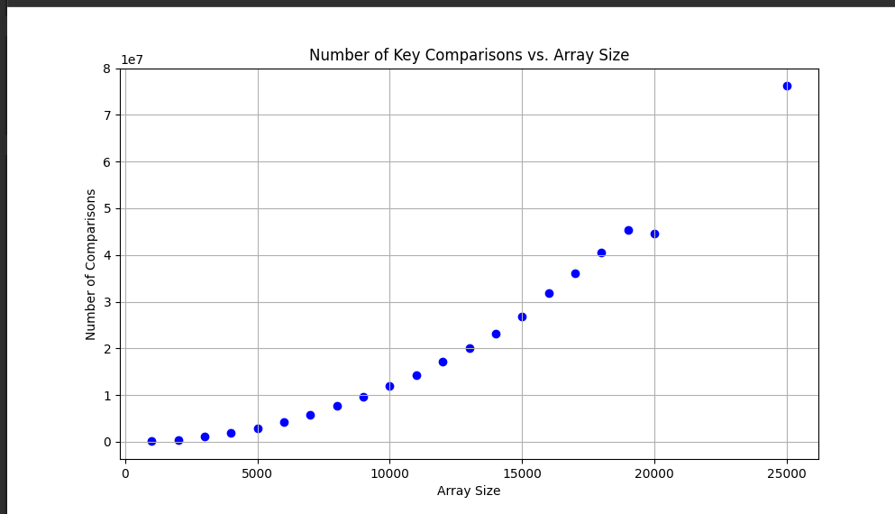

c.
The order of grow is non-linear ,based on the result above. With the number of comparisons for the arrays of size 1000 and 2000 are 122,104 and 54,235 respectively.

The average-case efficiency of the algorithm with result observed is O(n^2) with vary coefficient.

