# GPIO

### Features

* Setting multiplexed pin functions for LSI pins  
  Function of the R-Car S4 pin selectable by setting the registers in the PFC module  
  (The function of the LSI pin can be selected by the GPIO/peripheral function select registers 0 to 9 (GPSR0 to GPSR9) and peripheral function select registers 0 to 3 (IPSR0 to IPSR3) in each port group of each PFC module.  
  For details, see sections 7.2.4, GPIO/Peripheral Function Select Register 0-9 (GPSRn) through 7.2.5, Peripheral Function Select Register 0-3 (IPiSRn i = 0 - 3).)
* Bus Domain access: Please refer section 15 – AXI-bus
* DRV control for each LSI pin  
  DRV control resistors can control the driving abilities of pins.  
  DRV control resistors on each LSI pin can be controlled by setting the registers in the PFC module. (Selection is handled by the output drive select register (DRVCTRL0-3). For details, see sections 7.2.6, DRV Control Register 0-3 (DRViCTRLn i = 0 - 1 / DRVjCTRLSYS j = 0 - 1). POWER Condition control for each LSI pin.  
  POWER Condition control registers must be set according to IO voltage level that is supplied to the pin.  
  POWER Condition control resistors on each LSI pin can be controlled by setting the registers in the PFC module.  
  (Selection is handled by the IO voltage level select registers POWER Condition. For details, see sections 7.2.7,  
  POWER Condition Control Register (POCn).
* TDSEL control for each LSI pin  
  TDSEL control registers can control the driving abilities of pins in use for the SDHI.  
  TDSEL control resistors on each LSI pin can be controlled by setting the registers in the PFC module. (Selection is handled by the return path for SDHI clock drive select register TDSEL0-1. For details, see sections 7.2.11, TDSEL Control Register 0-1 (TDiSELn).
* Pull-up/down control for each LSI pin.  
  PUEN registers can on/off control of the pull resistors.  
  On/off of the pull resistors on each LSI pin can be controlled by setting the registers in the PFC module.  
  (Selection is handled by the Pull-on/off select registers PUEN. For details, see sections 7.2.8, LSI pin pull-enable register (PUENn).  
  PUD registers can pull-up/pull-down control of the pull resistors.  
  Pull-up/Pull-down control resistors on each LSI pin can be controlled by setting the registers in the PFC module.  
  (Selection is handled by the Pull-up/down select registers PUD. For details, see sections 7.2.9, LSI pin pullup/down control Register (PUDn / PUDSYS)).
* Module selection  
  Module Select Register can select the group for multiple LSI pins with multiplexed pin functions.  
  Enable and disable the functions of R-Car S4 LSI pins to which pin functions from multiple pin groups are  
  assigned by setting the registers in the PFC module.  
  (Selection is handled by the module select register (MODSELn). For details, see sections 7.2.10, Module Select  
  Register (MODSELn).
* Notes on configuring multiplexed pin functions  
  The multiplexed LSI pins (MODSELn, GPSRn, IPiSRn i = 0 - 3) must be set in the initial sequence (*).  
  Switching multiplexed LSI pins during operation is not guaranteed.  
  * : The initial sequence is Appendix B.(3)

### Operation

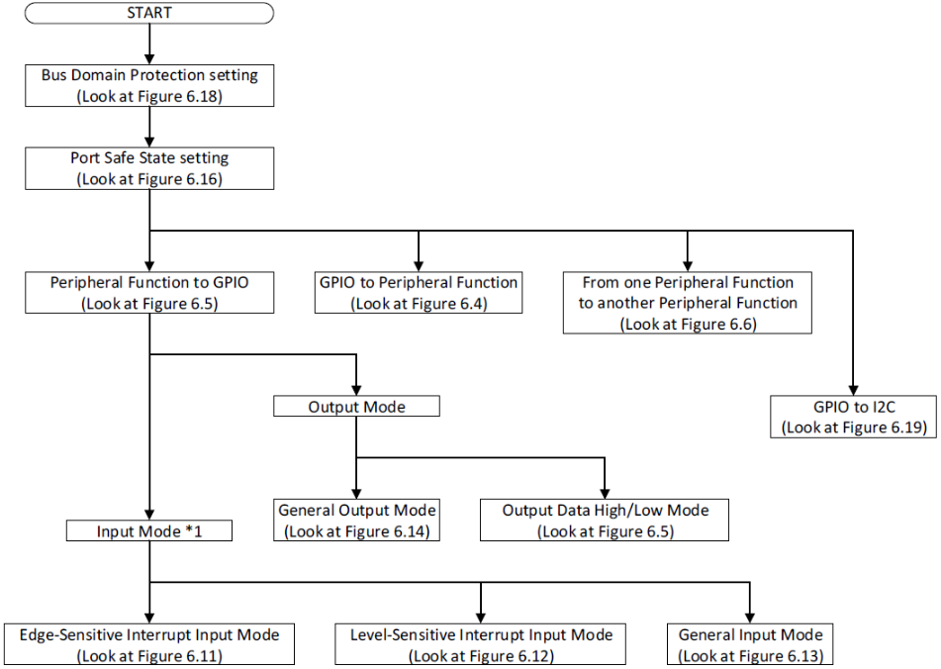

#### Setting Port Safe State

#### Function Setting for Multiplexed Pins

Setting the LSI multiplexed pin setting mask register (PMMRn) is necessary before setting each of the GPIO/peripheral  
function select register GPSRn, peripheral function select registers IP0SRn to IP3SRn, DRV control registers DRV0CTRLn to DRV3CTRLn, TDSEL control registers TD0SELn and TD1SELn, POWER Condition control registers POCn and Module select register MODSELn. Specifically, the inverse of the value to be set in the select register must be written to the LSI multiplexed pin setting mask register. Otherwise, the GPIO/peripheral function select register (GPSRn) and peripheral function select registers 0 to 3 (IP0SRn to IP3SRn) cannot be set.

##### Procedure for changing pin function from GPIO to peripheral function

##### Procedure for changing pin function from peripheral function to GPIO

##### Procedure 1 for changing pin function from one peripheral function to another peripheral function

##### Switching GPIO to I2C

#### Using GPIO

##### Setting General Input Mode

##### Setting Edge-Sensitive Interrupt Input Mode

##### Setting Level-Sensitive Interrupt Input Mode

##### Setting General Output Mode

##### Setting Output data high / Output data low Mode

