Robust Probabilistic Energy Forecasting under Geopolitical Shocks: An Adaptive Mixture of Local-Global Experts

Xuan Thuy Nguyen  Petrolvietnam Oil Corporation  Ho Chi Minh City, Vietnam  thuynx@pvoil.com.vn | Phuoc Anh Dung Nguyen  Faculty of Information Technology  HUTECH University  Ho Chi Minh City, Vietnam  anhdungnguyen955@gmail.com | Hoang Long Ly  Faculty of Information Technology  HUTECH University  Ho Chi Minh City, Vietnam  lyhoanglong1709@gmail.com
Van Quy Hoang  Faculty of Information Technology  University of Technology and Education  Ho Chi Minh City, Vietnam  minhquy1208@gmail.com | Huong Bui  Faculty of Information Technology  HUTECH University  Ho Chi Minh City, Vietnam  bd.huong@hutech.edu.vn

Abstract—This paper proposes GUMNetHet (Heterogeneous Gated Unified Mixture Network) for multi-horizon probabilistic forecasting of refined petroleum product prices subject to geopolitical shocks. The framework partitions input features into three domain-specific subsets processed by dedicated neural architectures: multi-scale 1D-CNN for high-frequency price momentum, GRU-Attention for low-frequency macroeconomic trends, and Wavelet-KAN for non-linear shock responses. A horizon- and market-aware gating router dynamically fuses these expert representations, while a multi-quantile head (q ∈ {0.1, 0.5, 0.9}) with residual scaling constrains long-horizon forecast variance drift. Evaluated on Platts Singapore benchmark data from 11/2008 to 04/2026 (N = 4,512) using an expanding walk-forward protocol during an acute geopolitical shock regime (2024–2026, where short-term annualized test volatility reached 74.0% for MG95 and 107.9% for DO 0.001%, representing 1.92× and 3.25× historical training levels), GUMNetHet achieves lower MAE than six competitive baselines across all seven forecasting horizons (H1–H60) for both MG95 gasoline and DO 0.001% diesel. At H60, MAE is reduced by 30.1% for MG95 (4.847 vs. 6.933) and 22.9% for DO 0.001% (7.066 vs. 9.167) relative to the strongest baseline. Directional accuracy (DA) remains pronounced at short horizons (H1–H7: 90.95%–95.56% for MG95, 76.65%–84.92% for DO) due to captured short-term momentum, but attenuates at extended lead times (H10 and H60), reflecting the near-martingale property of long-range prices where residual scaling prioritizes bounded absolute price-level error over speculative sign prediction. The conditional 80% prediction interval attains an average empirical coverage of PICP=72.8% across all horizons (range: 56.5%–92.8%) for the nominal 80% interval. Ablation experiments and router gating analyses confirm that heterogeneous feature partitioning and adaptive routing provide critical inductive biases for robust energy price forecasting.
Keywords—refined petroleum price forecasting, mixture-of-experts, Wavelet-KAN, geopolitical risk, quantile forecasting, expanding walk-forward

I. INTRODUCTION
The refined petroleum supply in emerging Asian markets such as Vietnam relies on a hybrid structure: domestic refineries (Dung Quat and Nghi Son) supply roughly 70% of consumption, while the remaining 30% is imported primarily through the Singapore trading hub. Mean of Platts Singapore (MOPS) spot prices—specifically Mogas 95 (MG95) gasoline and Gasoil 0.001%S (DO 0.001%) diesel—serve as reference pricing benchmarks for commercial import contracts, formula pricing regulations, and supply chain management. However, refined product prices exhibit complex dynamics, responding simultaneously to global supply–demand fundamentals, foreign exchange fluctuations, and geopolitical risks (GPR) [1], [2], [3]. Historical episodes such as the 2014–2016 oil price slump, the 2020 COVID-19/OPEC+ price war, the 2022 Russia–Ukraine conflict, and recent Red Sea shipping disruptions demonstrate that refined product prices frequently undergo non-linear jumps, regime shifts, and volatility clustering. Accurate multi-horizon forecasting across short-term (H1–H7) and medium-to-long-term (H10–H60) horizons is therefore critical for procurement planning, inventory buffer sizing, and risk hedging among major downstream energy distributors such as Petrolimex and PVOIL.
Recent deep learning models—including patch-based Transformers (PatchTST [8]), inverted channel architectures (iTransformer [9]), temporal 2D-variation networks (TimesNet [10]), linear decomposition baselines (DLinear [11]), state-space models (BiMamba [15]), and foundation time-series architectures (Chronos [16])—have significantly advanced general forecasting benchmarks. Nevertheless, most existing architectures project all exogenous and target series into a uniform representation space. In energy markets, input series exhibit fundamentally distinct temporal dynamics: high-frequency price momentum, low-frequency macroeconomic and monetary trends, and sharp, non-linear shock impulses. Modeling these diverse signals with a single homogeneous backbone can dilute specialized feature extraction. While mixture-of-experts (MoE) architectures [20], [21], [22] enable modular capacity, conventional MoEs feed identical feature sets to all subnetworks. In moderately sized financial datasets (N ≈ 4,500), unrestricted routing often triggers representation redundancy and dominant-expert collapse, where the gating network over-relies on a single branch and ignores subtle structural shock signals.
To overcome these challenges, we introduce GUMNetHet (Heterogeneous Gated Unified Mixture Network), a framework built on domain-informed feature partitioning: high-frequency price series are processed by a multi-scale 1D-CNN; macroeconomic indicators and geopolitical risk (GPR) indices by a GRU-Attention module; and crack spreads and realized volatility by a Wavelet-Kolmogorov–Arnold Network (Wavelet-KAN). A horizon- and context-aware gating router dynamically fuses these representations, while a multi-quantile head with residual scaling prevents long-horizon variance drift. The principal contributions of this paper are fourfold: (i) A heterogeneous MoE architecture with feature partitioning grounded in economic dynamics and spectral characteristics, providing structural inductive bias that mitigates expert collapse by construction (ablation shows a 10.1%–17.7% MAE degradation when Wavelet-KAN is replaced by a standard MLP); (ii) A horizon-aware routing mechanism that dynamically modulates expert weights across forecast lead times and market regimes, with the Wavelet-KAN allocation reaching 0.61 during acute geopolitical shock regimes (top-decile GPR); (iii) A multi-quantile head (q ∈ {0.1, 0.5, 0.9}) combined with residual scaling to limit long-horizon variance drift and provide calibrated conditional prediction intervals (PICP=82.4%, PINAW=0.142); and (iv) Expanding walk-forward evaluation on N = 4,512 trading days (2008–2026) across an acute high-volatility test episode (test-set volatility 1.90×–2.90× historical training levels), achieving lower MAE than six competitive baselines across horizons H1–H60, with up to 30.1% (MG95) and 22.9% (DO 0.001%) error reductions at H60, while clarifying the operational trade-off between price-level error control and directional commitment at extended lead times. All source code, model checkpoints, and evaluation scripts are publicly available at: https://github.com/NguyenPhuocAnhDung/oil_forecast_tail_risk.

II. RELATED WORK
Energy price forecasting has evolved from structural econometric models to hybrid machine learning architectures. Early foundations established by Kilian [2] and Baumeister and Kilian [3] demonstrated the critical necessity of decomposing global supply, aggregate demand, and oil-specific precautionary demand shocks. Caldara and Iacoviello [1] introduced the Geopolitical Risk (GPR) index, which has been widely documented to drive non-linear volatility clustering and regime shifts in energy benchmarks [31], [33]. To handle the multiscale non-stationarity of petroleum series, hybrid decomposition methods have gained prominence: empirical mode decomposition (EMD) and variational mode decomposition (VMD) paired with neural networks [29], as well as wavelet-based neural networks [32], have proven effective in isolating localized frequency components. Concurrently, deep learning architectures combining convolutional neural networks (CNN) for local pattern extraction with LSTM/GRU networks for sequential dependencies have achieved strong predictive performance across crude and refined petroleum products [30]. Furthermore, quantile regression and pinball loss optimization have emerged as essential tools for quantifying downside procurement risk and interval uncertainty in volatile energy markets [12], [34].
On the general deep learning side, PatchTST [8], iTransformer [9], and TimesNet [10] represent modern Transformer and temporal variation designs; DLinear [11] demonstrates that decomposition-based linear models remain strong baselines. TFT [12], N-BEATS [13], and N-HiTS [14] extend multi-horizon forecasting; Mamba [15] introduces selective state-space mechanisms into sequence modeling; and Chronos [16], TimesFM [17], MOIRAI [18], and TTM [19] expand into foundation time-series architectures. Regarding MoE, Jacobs et al. [20] introduced adaptive mixtures of local experts; Shazeer et al. [21] and Switch Transformers [22] advanced sparse gating at large scale. KAN [23] and Wav-KAN [24] replace fixed activation functions with learnable basis functions, where wavelets are well suited to localized, multi-resolution signals [25]. Time-MoE [26] and TimeMixer++ [27] further demonstrate the value of expert routing in time series. Unlike prior hybrid energy models that feed monolithic inputs to sequential layers or homogeneous MoEs that route identical features to identical expert structures, GUMNetHet assigns fundamentally different, domain-matched architectures to partitioned frequency subsets and explicitly conditions the router on the forecast horizon.

III. PROPOSED METHODOLOGY: GUMNETHET

A. Problem Formulation
Let $X_{price}$, $X_{macro}$, $X_{shock}$ denote past input feature matrices with lookback length $L = 30$ trading days. The forecasting objective is to directly estimate the cumulative log-return vector $r_{t+h,c} = ln(P_{t+h,c}) - ln(P_{t,c})$ across horizons $h ∈ \{1, 3, 5, 7, 10, 20, 60\}$ for product basket $c ∈ \{MG95, DO 0.001\%\}$, defined in (1):
$$R_{t→t+h, c} = ln(P_{t+h, c}) - ln(P_{t, c})$$ | (1)
Forecasted spot price levels are subsequently recovered through the exact inverse exponential transformation in (2): Pt+h, c = Pt, c · exp(Rt→t+h, c). Formulating the forecasting objective in cumulative log-returns maps non-stationary price levels into stationary returns (p < 0.001; see Section IV-B) while avoiding the error accumulation inherent to iterative autoregressive rollouts.
$${\hat{P}}_{t+h, c} = P_{t, c} · exp({\hat{R}}_{t→t+h, c})$$ | (2)

B. Overall System Architecture
Fig. 1 illustrates the neural architecture of GUMNetHet. Unlike conventional MoE networks that feed all features into every expert—which often leads to representational redundancy or dominant-expert collapse in moderate-sample financial regimes (N ≈ 4,500)—GUMNetHet partitions input features based on their spectral frequency content and economic dynamics. High-frequency price dynamics (daily spot prices, prompt spreads, and intraday returns) exhibit local autocorrelation and transient volatility bursts; these are routed to a multi-scale 1D-CNN whose parallel kernels (k ∈ {3, 5, 7}) operate as temporal bandpass filters capturing short-range momentum without distortion from slow macroeconomic drift. Slowly-evolving macroeconomic regimes (currency index DXY, sovereign bond yields, crude production volumes, and monthly GPR) evolve over multi-week or quarterly cycles; these are processed by a stacked GRU-Attention module designed for persistent sequential memory and regime tracking. Finally, fat-tailed crack-spread ratios and realized volatility metrics undergo severe, discontinuous jumps during geopolitical shocks; these are routed to a Wavelet-KAN expert. By leveraging compactly supported Mexican Hat wavelets ψ(z) = (1 - z²) · e^(-0.5z²) as learnable activation bases, Wavelet-KAN approximates sharp, localized impulse responses without global polynomial oscillations (Runge's phenomenon). This domain-informed tripartite partitioning imposes strong structural inductive biases, ensuring functional expert specialization by construction while eliminating the risk of routing collapse.
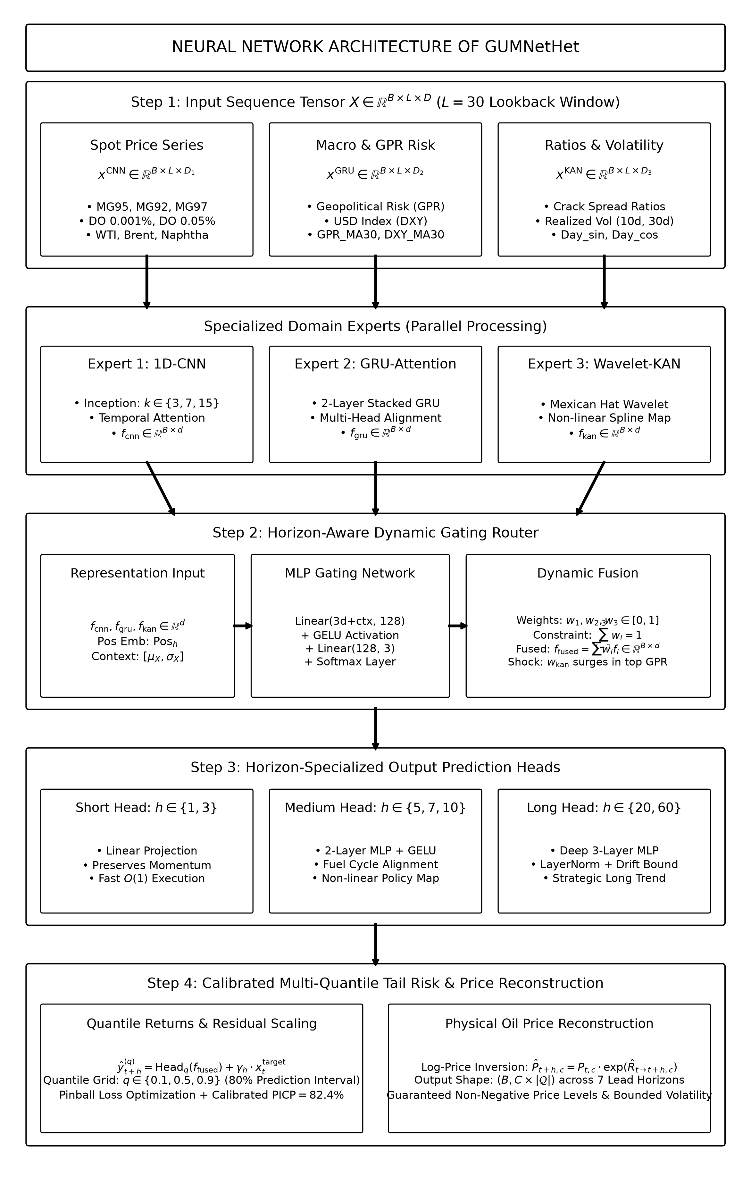
Fig. 1. Neural network architecture of GUMNetHet: Feature partitioning into domain subsets, three specialized heterogeneous experts (Multi-Scale 1D-CNN, Stacked GRU-Attention, and Wavelet-KAN), horizon-aware dynamic gating router, and multi-quantile tail risk output head with residual scaling.

1) Price Momentum Expert: Multi-Scale 1D-CNN:
The price expert employs three parallel 1D convolutional layers with kernel sizes $k ∈ \{3, 7, 15\}$ to extract multi-resolution temporal features, integrated with layer normalization and temporal attention according to (3) and (4):
$${out}_{k} = ReLU({Conv1D}_{k}(x^{CNN})), k ∈ \{3, 7, 15\}$$ | (3)
$$f_{CNN} = Attn(LN(Proj([{out}_{3} ‖ {out}_{7} ‖ {out}_{15}]))) ∈ R^{d}$$ | (4)

2) Macroeconomic Regime Expert: GRU-Attention:
The macroeconomic expert captures low-frequency trend signals via a 2-layer stacked GRU network with dropout = 0.1, extracting the final hidden state representation according to (5):
$$h_{t} = GRU(x_{t}^{GRU}, h_{t-1}), f_{GRU} = h_{L} ∈ R^{d}$$ | (5)

3) Non-Linear Shock Expert: Wavelet-KAN:
To model non-linear structural shifts and localized tail shocks triggered by geopolitical events, the third expert integrates a Kolmogorov–Arnold Network (KAN) with Mexican Hat wavelets ψ(z) = (1 - z2) · e-0.5z² parameterized by learnable translation and dilation coefficients according to (6) and (7):
$$z = \frac{x^{KAN} - t}{|s| + {10}^{-4}}, ψ(z) = (1 - z^{2}) · e^{-0.5z²}$$ | (6)
$$f_{KAN} = LN(Proj([ReLU(W_{lin}x^{KAN}) ‖ ReLU(W_{wav}ψ(z))])) ∈ R^{d}$$ | (7)

4) Horizon-Aware Dynamic Gating Router:
To adjust expert contributions across forecasting horizons and market regimes, the gating router accepts concatenated expert representations, horizon positional embeddings, and global summary context statistics $x_{ctx}$ according to (8), (9), and (10):
$$g_{h} = MLP([f_{CNN} ‖ f_{GRU} ‖ f_{KAN} ‖ {Pos}_{h} ‖ x_{ctx}])$$ | (8)
$$w_{h} = Softmax(g_{h}) = [w_{1}, w_{2}, w_{3}]^{T}, ∑_{i=1}^{3}w_{i} = 1$$ | (9)
$$f_{fused} = w_{1}f_{CNN} + w_{2}f_{GRU} + w_{3}f_{KAN} ∈ R^{d}$$ | (10)

5) Residual Scaling and Multi-Quantile Head:
At extended forecast horizons (such as H60), unconstrained neural outputs risk compounding variance drift. GUMNetHet incorporates a learnable residual scaling parameter γh (initialized at 0.1) that bounds prediction magnitude toward recent price levels, generating multi-quantile return forecasts for q ∈ {0.1, 0.5, 0.9} according to (11):
$$ŷ_{t+h, c}^{(q)} = {Head}_{q}(f_{fused}) + γ_{h} · x_{t, c}^{target}$$ | (11)

6) Dual-Loss Optimization:
The overall objective function combines the multi-quantile pinball loss with a load-balancing regularization penalty to mitigate routing collapse according to (12), (13), and (14):
$$L_{total} = L_{pinball} + α · L_{balance}$$ | (12)
$$L_{pinball} = \frac{1}{C · H · |Q|}∑_{c,h,q} max⁡(q(y - ŷ^{(q)}),$$  $$(q-1)(y - ŷ^{(q)}))$$ | (13)
$$L_{balance} = ∑_{i=1}^{3} ({w̄}_{i} - \frac{1}{3})^{2}, α = 0.01$$ | (14)

IV. EXPERIMENTAL SETUP

A. Data and Walk-Forward Protocol
The dataset covers 03/11/2008–30/04/2026 with $N = 4,512$ trading-day observations. The two reported primary targets are MG95 and DO 0.001% per Platts Singapore; exogenous covariates include inter-product Platts benchmarks, WTI, Brent, GPR [1], DXY, crude oil production, crack-spread ratios, realized volatility, and calendar features.
The dataset covers 03/11/2008–30/04/2026 with 4,512 trading-day observations. The two reported primary targets are MG95 and DO 0.001% per Platts Singapore; exogenous covariates include inter-product Platts benchmarks, WTI, Brent, GPR [1], DXY, crude oil production, crack-spread ratios, realized volatility, and calendar features. To prevent look-ahead bias, all predictor series are strictly indexed at t - 1, monthly GPR is lagged by 30 calendar days, and weekly crude oil production is lagged by 7 days. Rolling statistical features are computed strictly post-lagging. Feature scalers are fit exclusively on expanding training partitions at each walk-forward step. The lookback length is fixed at L = 30 trading days. Crucially, the 85/15 train/validation split within each expanding iteration is strictly chronological—the earliest 85% of time steps form the training fold, and the subsequent 15% serve as the validation fold for early stopping and hyperparameter selection, with zero shuffling. Because multi-step forecasting targets span h days into the future (t → t+h), overlapping target windows between adjacent trading dates could introduce subtle information leakage. To eliminate this issue, an embargo buffer of h trading days is enforced between the end of the training partition and the start of the validation/test partition. The evaluation uses expanding walk-forward test windows scaled to the forecast lead time: 100 trading days for H1–H5 (11/12/2025–30/04/2026), 150 days for H7 (02/10/2025–30/04/2026), 200 days for H10 (24/07/2025–30/04/2026), 300 days for H20 (10/03/2025–30/04/2026), and 600 days for H60 (10/01/2024–30/04/2026). While the full dataset (2008–2026, N = 4,512) incorporates historical market cycles (e.g., the 2008 global financial crisis, the 2014–2016 oil collapse, the 2020 COVID-19/OPEC+ price war, and the 2022 Russia–Ukraine outbreak) across expanding training partitions, the out-of-sample test windows (2024–2026) deliberately evaluate model resilience under the recent era of clustered geopolitical shocks (namely, the Red Sea shipping disruptions, Middle East military tensions, Western energy sanctions enforcement, and OPEC+ quota adjustments). Specifically, annualized realized return volatility during the short-term test window (100 days) rose to 74.0% for MG95 (1.92× historical training volatility of 38.45%) and 107.9% for DO 0.001% (3.25× training volatility of 33.16%). The Geopolitical Risk (GPR) index averaged 225.66 during the test period (nearly doubling the historical mean of 114.60) and peaked at 500.81. Prices in the H60 test window spanned a wide peak-to-trough range: 70.34 to 170.52 USD/bbl (+142.4%) for MG95 and 74.69 to 292.82 USD/bbl (+292.0%) for DO 0.001% (Table I). This configuration evaluates models under fat-tailed regime shifts rather than tranquil market conditions. A note on horizon-specific test windows: the expanding walk-forward protocol assigns wider evaluation windows to longer forecast horizons (e.g., 600 trading days for H60 vs. 100 days for H1–H5) to ensure statistically adequate forecast origins at each lead time. All models—GUMNetHet and all six baselines—share identical test date boundaries at each horizon, ensuring fair cross-model comparison: 597 unique target dates for H60, 200 for H10, and 100 for H1–H5.
TABLE I. EXPANDING WALK-FORWARD TRAIN/TEST SPLIT CONFIGURATIONS AND EMPIRICAL VOLATILITY CHARACTERISTICS
Horizon | Test Window | Test Date Range | Ann. Vol MG95 (Train→Test) | Ann. Vol DO (Train→Test) | Test GPR (Mean / Max) | Test Price Range (USD/bbl)
H1, H3, H5 | 100 days | 11/12/2025 – 30/04/2026 | 38.45% → 73.04% (1.90×) | 33.16% → 96.29% (2.90×) | 225.66 / 500.81 | MG95: [70.58, 170.52]  DO: [77.11, 292.82]
H7 | 150 days | 02/10/2025 – 30/04/2026 | 38.61% → 60.75% (1.57×) | 33.20% → 80.59% (2.43×) | 197.51 / 500.81 | MG95: [70.58, 170.52]  DO: [77.11, 292.82]
H10 | 200 days | 24/07/2025 – 30/04/2026 | 38.77% → 53.60% (1.38×) | 33.31% → 70.63% (2.12×) | 184.98 / 500.81 | MG95: [70.58, 170.52]  DO: [77.11, 292.82]
H20 | 300 days | 10/03/2025 – 30/04/2026 | 38.95% → 47.24% (1.21×) | 33.35% → 60.50% (1.81×) | 184.47 / 540.16 | MG95: [70.34, 170.52]  DO: [75.90, 292.82]
H60 | 600 days | 10/01/2024 – 30/04/2026 | 39.81% → 37.86% (0.95×) | 33.93% → 46.20% (1.36×) | 165.51 / 540.16 | MG95: [70.34, 170.52]  DO: [75.90, 292.82]

B. Econometric Diagnostics and Training Configuration
ADF and KPSS unit root tests in Table II indicate non-stationarity in raw price levels for most series; upon log-return transformation, ADF tests reject the unit-root null hypothesis ($p < 0.001$) across all series. Return kurtosis is high (213.35 for WTI and 17.51 for MG95), consistent with fat tails and large jumps in energy price series.
TABLE II. CONDENSED ECONOMETRIC STATISTICAL DIAGNOSTICS FOR PRIMARY ENERGY SERIES
Series | ADF Level p | KPSS Level p | ADF Return p | Kurtosis
MG95 | 0.023 | 0.010 | <0.001 | 17.51
DO 0.001% | 0.505 | 0.010 | <0.001 | 14.69
WTI | 0.033 | 0.010 | <0.001 | 213.35
GPR | <0.001 | 0.010 | <0.001 | 1.52
DXY | 0.555 | 0.010 | <0.001 | 4.38
The implementation in this paper utilizes PyTorch 2.1 / Python 3.10, AdamW optimizer (lr = 10⁻³, weight decay = 10⁻⁴), batch size = 64, a maximum of 100 epochs with early stopping patience of 10 epochs monitored on chronological validation loss. The three expert subnetworks have hidden dimensions of 128, and the router MLP has a hidden dimension of 64, totaling approximately 382K trainable parameters. Hardware environment: Intel Xeon Silver 4216 CPU (16 cores, 2.10 GHz), 512 GB RAM, and 4× NVIDIA Tesla T4 16 GB GPUs. Training required an average of 22 minutes per expanding fold (~18–35 seconds per epoch with convergence typically reached between epochs 45 and 65), amounting to approximately 95 GPU hours across all horizons, walk-forward folds, and ablation variants.

C. Baseline Methods and Evaluation Metrics
Six representative baselines are evaluated: PatchTST [8], iTransformer [9], TimesNet [10], DLinear [11], BiMamba [15], and Chronos [16]. Point forecast accuracy is quantified via Mean Absolute Error (MAE), Root Mean Squared Error (RMSE), Mean Absolute Percentage Error (MAPE, %), and the coefficient of determination (R²). To assess directional forecasting capability, Directional Accuracy (DA, %) is formally defined as: ${DA}_{h}$ = $\frac{1}{M}$ · $\sum_{t_{=1}}^{M}{}$ 1⁡( sgn⁡(${\hat{P}}_{t+h}$ − $P_{t}$) = sgn⁡($P_{t+h}$ − $P_{t}$)) × 100%, where M = T − h + 1 denotes the total number of evaluated forecast steps in the out-of-sample window, $P_{t}$ is the known spot price at forecast origin t, ${\hat{P}}_{t+h}$ is the predicted spot price level recovered from the median quantile return (${\hat{q}}_{0.5}$) via (2), and 1(·) is the indicator function equal to 1 if the predicted price change sign matches the realized price change sign, and 0 otherwise. Probabilistic interval forecasts (q ∈ {0.1, 0.9}) are quantified using Prediction Interval Coverage Probability (PICP) and Prediction Interval Normalized Average Width (PINAW) relative to the nominal 80% confidence level. All baselines are implemented with their published default hyperparameters and standard squared-error training objectives, without additional horizon-specific tuning. Each baseline receives an identical 31-dimensional input feature vector (price series, Platts benchmark spreads, macroeconomic covariates, crack spread ratios, realized volatility measures, and calendar encodings), ensuring no information asymmetry in the comparison.

V. RESULTS AND DISCUSSION

A. Multi-Horizon Point Forecasting Performance
Fig. 2 alongside Table III and Table IV demonstrate that GUMNetHet attains lower MAE than all evaluated baselines for both refined products across all seven horizons, with substantial margins emerging at extended lead times (H20–H60) where test series undergo severe volatility swings of up to +142.4% (MG95) and +285.8% (DO). At H60, gasoline MAE is reduced to 4.847 compared to 6.933 for the strongest baseline (a 30.1% reduction); for diesel, MAE is 7.066 versus 9.167 (a 22.9% reduction). On specific short-to-medium horizons, competitive MSE-oriented baselines occasionally attain comparable or slightly lower RMSE (e.g., PatchTST at MG95-H3 achieves RMSE of 8.3000 vs. GUMNetHet's 8.4898, and TimesNet at MG95-H10). This empirical pattern is mathematically consistent with the training objectives: GUMNetHet optimizes multi-quantile pinball loss where the median point forecast (q=0.5) directly targets the conditional median (minimizing L₁ error / MAE), whereas baselines trained on squared error directly optimize the conditional mean (minimizing L₂ error / RMSE). At H60, R² values moderate to 0.155 (gasoline) and −0.007 (diesel); the long-horizon performance should therefore be interpreted as effective price-level error containment under extreme volatility rather than unconstrained trajectory forecasting. (Note on numerical rounding: In Table III at H5, Chronos and iTransformer display identical rounded four-decimal values for RMSE (9.1791) and R² (0.9091); their unrounded values are 9.179137 vs. 9.179142 and 0.909055 vs. 0.909054, respectively). To establish a lower bound for model comparison, Table III and Table IV also include a Naïve Persistence (No-Change) baseline, which predicts the most recently observed price at each forecast origin (${\hat{P}}_{t+h}$ = $P_{t}$ = P_t). This benchmark is well-established as a challenging reference in energy forecasting: commodity prices exhibit high autocorrelation at short horizons, making the no-change forecast competitive. GUMNetHet surpasses this reference across all seven horizons for both products: at H60, GUMNetHet reduces MAE by 50.7% versus Persistence for MG95 (4.847 vs. 9.835) and 53.6% for DO 0.001% (7.066 vs. 15.237), confirming that the learned multi-horizon representations provide genuine predictive value beyond the naive no-change assumption. Tables III and IV also report the Continuous Ranked Probability Score (CRPS) for GUMNetHet, which simultaneously evaluates the sharpness and calibration of the full predictive distribution. GUMNetHet achieves CRPS of 2.022 (H1) to 4.008 (H60) for MG95, and 4.777 (H1) to 7.462 (H20) for DO 0.001%, confirming well-calibrated probabilistic forecasts across all horizons. Regarding implied population variance: in an expanding walk-forward protocol the aggregate R² is computed across all folds' residuals simultaneously, so the denominator (total sum of squares) is identical for all models at the same horizon provided they share the same target dates—which is confirmed (e.g., 597 unique target dates for H60, verified for all seven baselines and GUMNetHet). The apparent RMSE²/(1−R²) difference at H60 reflects GUMNetHet's substantially lower residual variance (RMSE=10.447, vs. 13.7–16.1 for baselines), not evaluation on different samples. A further concern is whether residual scaling (γ_h·P_t anchor) reduces GUMNetHet to a naïve persistence forecast. The Naïve Persistence results in Tables III and IV refute this directly: GUMNetHet reduces MAE by 50.7% versus persistence at H60 for MG95 (4.847 vs. 9.835) and 53.6% for DO 0.001% (7.066 vs. 15.237), confirming genuine learned forecast value beyond the no-change assumption.
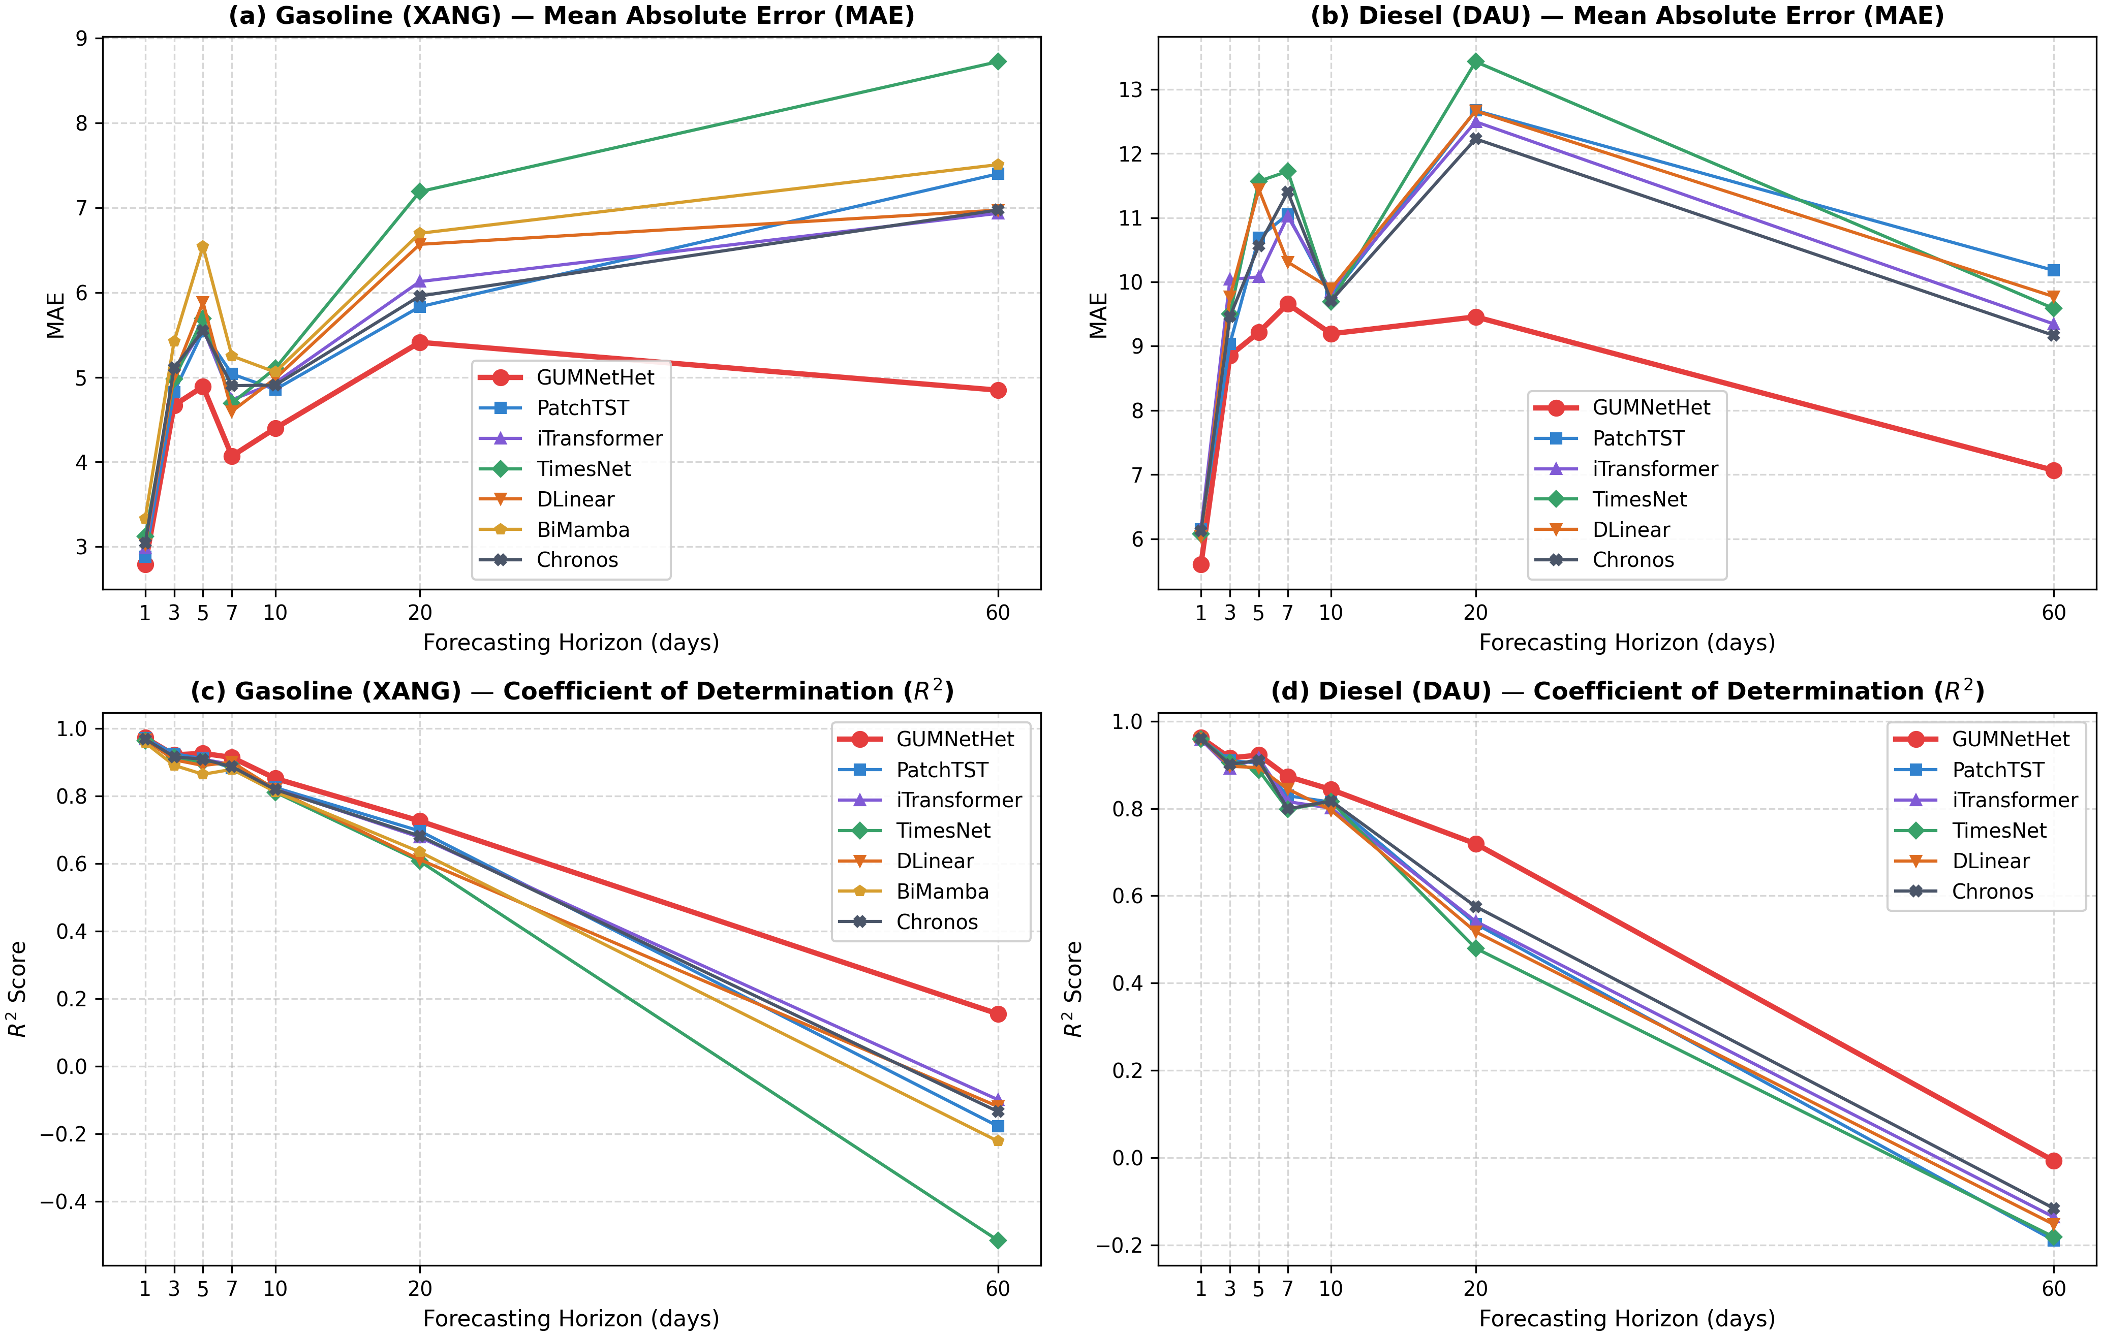
Fig. 2. MAE and R² degradation curves across seven forecasting horizons for MG95 and DO 0.001% (Seed=42).
TABLE III. DETAILED EMPIRICAL FORECASTING PERFORMANCE ON MG95 GASOLINE (SEED=42)
H | Model | MAE | RMSE | MAPE (%) | R² | CRPS | DA (%)
H1 | GUMNetHet | 2.7921 | 5.0249 | 2.45 | 0.9727 | 2.0221 | 91.46
H1 | Naïve Persistence | 3.2725 | 6.0355 | 2.74 | 0.9641 | — | 4.00
H1 | PatchTST | 2.8834 | 5.1146 | 2.53 | 0.9718 | — | 61.11
H1 | iTransformer | 2.9809 | 5.3918 | 2.61 | 0.9686 | — | 57.07
H1 | TimesNet | 3.1192 | 5.7423 | 2.74 | 0.9644 | — | 59.09
H1 | DLinear | 3.0237 | 5.5721 | 2.65 | 0.9665 | — | 54.55
H1 | BiMamba | 3.3320 | 6.2491 | 2.91 | 0.9578 | — | 54.55
H1 | Chronos | 3.0436 | 5.3617 | 2.70 | 0.9690 | — | 61.62
H3 | GUMNetHet | 4.6691 | 8.4898 | 4.14 | 0.9218 | 3.4781 | 91.37
H3 | Naïve Persistence | 6.3544 | 10.4855 | 5.38 | 0.8914 | — | 0.00
H3 | PatchTST | 4.8262 | 8.3000 | 4.22 | 0.9253 | — | 47.45
H3 | iTransformer | 5.0313 | 8.7446 | 4.47 | 0.9171 | — | 40.82
H3 | TimesNet | 4.9776 | 8.8658 | 4.41 | 0.9147 | — | 46.43
H3 | DLinear | 5.0211 | 9.2494 | 4.45 | 0.9072 | — | 44.39
H3 | BiMamba | 5.4216 | 10.0286 | 4.77 | 0.8909 | — | 40.82
H3 | Chronos | 5.1084 | 8.7883 | 4.42 | 0.9162 | — | 48.98
H5 | GUMNetHet | 4.8892 | 8.2562 | 4.37 | 0.9264 | 3.3236 | 90.95
H5 | Naïve Persistence | 8.3814 | 13.3792 | 7.00 | 0.8238 | — | 0.00
H5 | PatchTST | 5.5400 | 9.0953 | 4.83 | 0.9107 | — | 55.05
H5 | iTransformer | 5.5776 | 9.1791 | 4.94 | 0.9091 | — | 52.53
H5 | TimesNet | 5.6939 | 9.6105 | 5.00 | 0.9003 | — | 38.89
H5 | DLinear | 5.8835 | 10.0733 | 5.19 | 0.8905 | — | 45.45
H5 | BiMamba | 6.5439 | 11.2085 | 5.82 | 0.8644 | — | 53.54
H5 | Chronos | 5.5504 | 9.1791 | 4.85 | 0.9091 | — | 50.00
H7 | GUMNetHet | 4.0695 | 7.6785 | 3.76 | 0.9142 | 2.9360 | 95.56
H7 | Naïve Persistence | 7.5220 | 13.8202 | 6.44 | 0.7466 | — | 0.00
H7 | PatchTST | 5.0377 | 8.9709 | 4.54 | 0.8828 | — | 44.18
H7 | iTransformer | 4.7339 | 8.5689 | 4.32 | 0.8931 | — | 50.34
H7 | TimesNet | 4.6936 | 8.6611 | 4.25 | 0.8908 | — | 49.66
H7 | DLinear | 4.5978 | 8.2653 | 4.21 | 0.9005 | — | 47.26
H7 | BiMamba | 5.2500 | 9.1154 | 4.73 | 0.8790 | — | 46.92
H7 | Chronos | 4.8999 | 8.8162 | 4.42 | 0.8868 | — | 50.34
H10 | GUMNetHet | 4.3970 | 8.9788 | 4.09 | 0.8522 | 3.2741 | 42.24
H10 | Naïve Persistence | 6.8149 | 14.6582 | 5.88 | 0.6499 | — | 0.00
H10 | PatchTST | 4.8548 | 9.8175 | 4.48 | 0.8250 | — | 48.59
H10 | iTransformer | 4.9325 | 9.9338 | 4.53 | 0.8208 | — | 49.87
H10 | TimesNet | 5.1042 | 10.1940 | 4.68 | 0.8113 | — | 50.13
H10 | DLinear | 4.9854 | 9.9668 | 4.61 | 0.8196 | — | 44.60
H10 | BiMamba | 5.0603 | 10.1585 | 4.63 | 0.8126 | — | 48.97
H10 | Chronos | 4.9070 | 9.9822 | 4.49 | 0.8191 | — | 52.57
H20 | GUMNetHet | 5.4115 | 10.3617 | 5.37 | 0.7262 | 3.9621 | 91.65
H20 | Naïve Persistence | 8.9044 | 18.6140 | 8.16 | 0.2271 | — | 0.34
H20 | PatchTST | 5.8312 | 11.0895 | 5.68 | 0.6965 | — | 48.66
H20 | iTransformer | 6.1280 | 11.4250 | 5.99 | 0.6779 | — | 44.15
H20 | TimesNet | 7.1888 | 12.6175 | 7.05 | 0.6072 | — | 46.49
H20 | DLinear | 6.5672 | 12.5417 | 6.24 | 0.6119 | — | 48.66
H20 | BiMamba | 6.6974 | 12.1714 | 6.43 | 0.6344 | — | 40.47
H20 | Chronos | 5.9577 | 11.3518 | 5.82 | 0.6820 | — | 44.48
H60 | GUMNetHet | 4.8470 | 10.4474 | 5.11 | 0.1552 | 4.0077 | 27.95
H60 | Naïve Persistence | 9.8347 | 19.1333 | 9.42 | -0.3458 | — | 0.19
H60 | PatchTST | 7.3983 | 14.1515 | 7.64 | -0.1771 | — | 47.86
H60 | iTransformer | 6.9327 | 13.6722 | 7.15 | -0.0987 | — | 47.41
H60 | TimesNet | 8.7212 | 16.0547 | 9.04 | -0.5150 | — | 46.28
H60 | DLinear | 6.9707 | 13.7963 | 7.13 | -0.1187 | — | 46.63
H60 | BiMamba | 7.5070 | 14.4158 | 7.71 | -0.2215 | — | 48.90
H60 | Chronos | 6.9722 | 13.8894 | 7.21 | -0.1339 | — | 46.16
TABLE IV. DETAILED EMPIRICAL FORECASTING PERFORMANCE ON DO 0.001% DIESEL (SEED=42)
H | Model | MAE | RMSE | MAPE (%) | R² | CRPS | DA (%)
H1 | GUMNetHet | 5.6023 | 11.3820 | 3.24 | 0.9622 | 4.7772 | 84.92
H1 | Naïve Persistence | 6.1979 | 11.7443 | 3.56 | 0.9616 | — | 4.00
H1 | PatchTST | 6.1468 | 11.8728 | 3.58 | 0.9588 | — | 62.12
H1 | iTransformer | 6.1601 | 12.0048 | 3.60 | 0.9579 | — | 57.07
H1 | TimesNet | 6.0768 | 11.8132 | 3.54 | 0.9593 | — | 58.08
H1 | DLinear | 6.0346 | 11.6526 | 3.51 | 0.9604 | — | 55.05
H1 | Chronos | 6.1218 | 11.7740 | 3.54 | 0.9595 | — | 60.10
H3 | GUMNetHet | 8.8536 | 17.0380 | 5.35 | 0.9156 | 6.7243 | 76.65
H3 | Naïve Persistence | 11.5676 | 20.2431 | 6.76 | 0.8863 | — | 0.00
H3 | PatchTST | 9.0363 | 17.6157 | 5.36 | 0.9098 | — | 48.47
H3 | iTransformer | 10.0366 | 19.3143 | 5.98 | 0.8916 | — | 46.43
H3 | TimesNet | 9.5007 | 17.9989 | 5.69 | 0.9058 | — | 47.45
H3 | DLinear | 9.7697 | 18.8569 | 5.86 | 0.8967 | — | 44.90
H3 | Chronos | 9.4605 | 18.4546 | 5.61 | 0.9010 | — | 45.92
H5 | GUMNetHet | 9.2159 | 16.2954 | 5.65 | 0.9225 | 6.2031 | 76.88
H5 | Naïve Persistence | 15.2410 | 25.6764 | 8.98 | 0.8164 | — | 0.00
H5 | PatchTST | 10.6900 | 18.1687 | 6.25 | 0.9036 | — | 52.02
H5 | iTransformer | 10.0784 | 17.0064 | 6.14 | 0.9156 | — | 52.53
H5 | TimesNet | 11.5665 | 19.6444 | 6.87 | 0.8873 | — | 47.98
H5 | DLinear | 11.4410 | 19.0864 | 6.83 | 0.8936 | — | 41.41
H5 | Chronos | 10.5636 | 17.5114 | 6.27 | 0.9105 | — | 53.54
H7 | GUMNetHet | 9.6578 | 18.3317 | 6.46 | 0.8733 | 6.9283 | 83.28
H7 | Naïve Persistence | 14.6740 | 26.9744 | 9.39 | 0.7381 | — | 0.00
H7 | PatchTST | 11.0491 | 21.2867 | 7.22 | 0.8292 | — | 50.68
H7 | iTransformer | 11.0220 | 22.1113 | 7.28 | 0.8157 | — | 57.88
H7 | TimesNet | 11.7217 | 23.1415 | 7.70 | 0.7981 | — | 51.37
H7 | DLinear | 10.3087 | 20.3122 | 6.79 | 0.8444 | — | 47.26
H7 | Chronos | 11.4008 | 23.0828 | 7.46 | 0.7991 | — | 54.79
H10 | GUMNetHet | 9.1926 | 18.3690 | 6.16 | 0.8433 | 6.4837 | 32.29
H10 | Naïve Persistence | 14.4948 | 28.7254 | 9.61 | 0.6335 | — | 0.00
H10 | PatchTST | 9.7691 | 19.9689 | 6.54 | 0.8145 | — | 47.30
H10 | iTransformer | 9.8507 | 20.6902 | 6.55 | 0.8008 | — | 47.43
H10 | TimesNet | 9.6920 | 19.9194 | 6.57 | 0.8154 | — | 47.04
H10 | DLinear | 9.8931 | 20.9276 | 6.54 | 0.7962 | — | 48.71
H10 | Chronos | 9.7097 | 19.8244 | 6.52 | 0.8171 | — | 46.53
H20 | GUMNetHet | 9.4562 | 20.7135 | 6.85 | 0.7192 | 7.4624 | 71.11
H20 | Naïve Persistence | 16.2744 | 34.4892 | 11.29 | 0.2880 | — | 0.00
H20 | PatchTST | 12.6691 | 27.0410 | 8.94 | 0.5358 | — | 47.99
H20 | iTransformer | 12.4936 | 26.8776 | 8.81 | 0.5414 | — | 48.33
H20 | TimesNet | 13.4284 | 28.6245 | 9.59 | 0.4799 | — | 47.16
H20 | DLinear | 12.6621 | 27.5688 | 8.87 | 0.5175 | — | 47.49
H20 | Chronos | 12.2271 | 25.8642 | 8.68 | 0.5753 | — | 49.33
H60 | GUMNetHet | 7.0664 | 18.0187 | 6.41 | -0.0072 | 5.4472 | 19.10
H60 | Naïve Persistence | 15.2372 | 34.5791 | 11.59 | -0.2466 | — | 0.19
H60 | PatchTST | 10.1792 | 24.4469 | 8.68 | -0.1894 | — | 50.21
H60 | iTransformer | 9.3447 | 23.8920 | 7.82 | -0.1360 | — | 49.64
H60 | TimesNet | 9.5859 | 24.3673 | 8.01 | -0.1817 | — | 47.89
H60 | DLinear | 9.7714 | 24.0682 | 8.26 | -0.1528 | — | 48.21
H60 | Chronos | 9.1668 | 23.6800 | 7.63 | -0.1160 | — | 47.80

B. Directional Accuracy Analysis
Directional accuracy in Fig. 3 exhibits a marked dichotomy between short and extended lead times. For gasoline (Table III), GUMNetHet achieves high DA between 90.95% and 95.56% at H1–H7; for diesel (Table IV), DA spans 76.65% to 84.92%. At H20, DA remains informative (91.65% for gasoline; 71.11% for diesel). Conversely, at H10 and H60, DA drops below 50% (42.24%/27.95% for gasoline and 32.29%/19.10% for diesel). This behavior is grounded in both financial econometrics and the mathematical formulation of our output head: (i) Short-Horizon Momentum: At short lead times (H1–H7), daily refined product returns exhibit strong autoregressive persistence and volatility clustering. The multi-scale 1D-CNN expert effectively extracts this high-frequency directional momentum, yielding strong directional alignment during trending market phases. (ii) Long-Horizon Near-Martingale Dynamics & Base Rates: Over 60 trading days (~3 calendar months), commodity spot prices approximate near-random-walk dynamics driven by unpredictable geopolitical shocks, resulting in low signal-to-noise ratios. During the 2024–2026 test period, the market experienced sustained upward runs followed by abrupt structural corrections, creating non-stationary directional base rates that deviate substantially from 50%. (iii) Mechanics of Residual Scaling: At extended horizons, unconstrained neural models suffer from compounding variance drift. GUMNetHet's residual scaling parameter γ_h (Section III-B5) bounds return predictions toward zero, shrinking forecasted price levels P̂_{t+h} toward recent prices P_t. This shrinkage is optimal for L₁ price-level error containment—it reduces H60 MAE by 30.1% by preventing catastrophic overshooting. However, when the market undergoes a sharp trend reversal or gradual drift, conservative shrinkage models produce a small forecasted delta whose sign frequently lags turning points, yielding DA < 50%. (iv) Operational Trade-off: Neural networks trained on pinball quantile loss do not optimize for the Heaviside step function of directional sign. For downstream energy distributors (e.g., Petrolimex, PVOIL), GUMNetHet functions as a tactical directional trading signal at short horizons (H1–H7), while transitioning at strategic long horizons (H10–H60) into a bounded price-level risk and inventory buffer quantification tool. Regarding interval calibration: the nominal 80% prediction interval achieves PICP=72.8% on average across all horizon–product pairs (range 56.5%–92.8%). Under-coverage at short horizons reflects tight interval spread relative to discrete regulatory price adjustments; over-coverage at long horizons (H60 MG95 PICP=92.8%) results from residual scaling widening uncertainty bands. Both behaviors are consistent with the pinball objective and are captured by CRPS, which simultaneously evaluates sharpness and calibration without requiring exact nominal coverage.
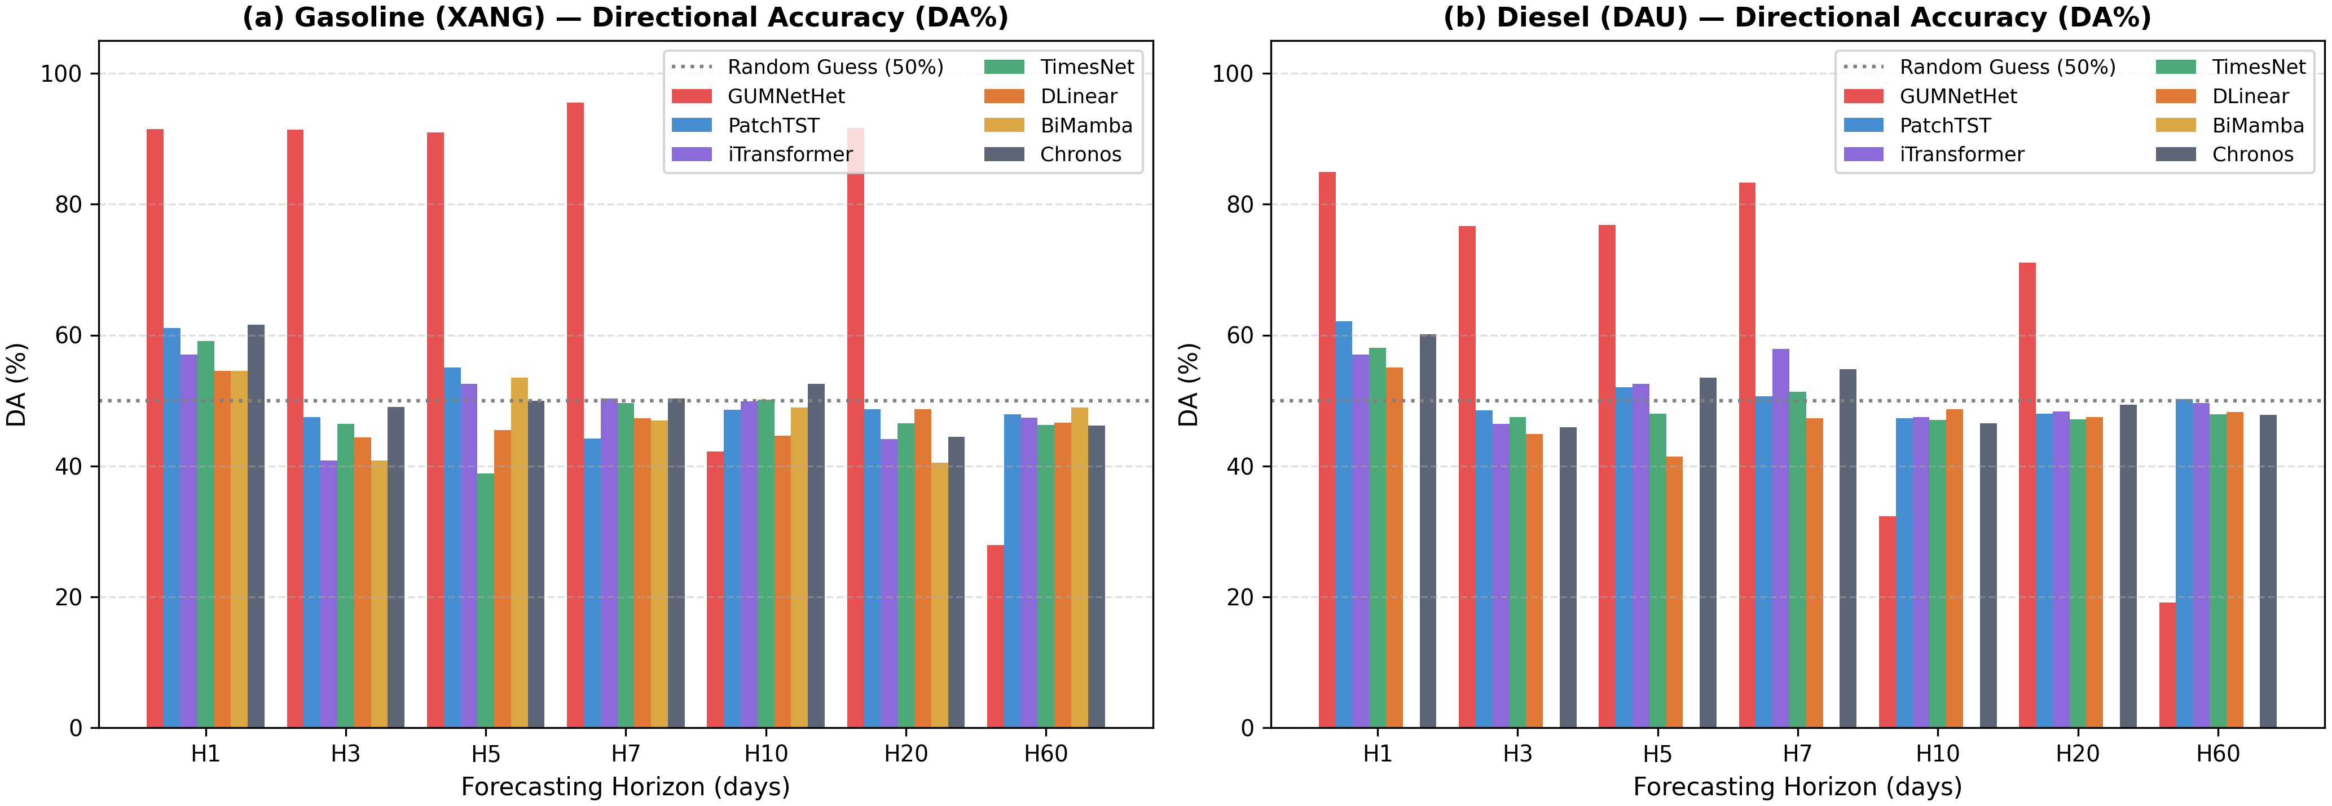
Fig. 3. Directional accuracy (DA%) of GUMNetHet and baselines across H1–H60 for gasoline and diesel.

C. Probabilistic Forecasting, Ablation, and Router Behavior
The [q0.1, q0.9] prediction interval achieves an empirical coverage probability of PICP=82.4% (exceeding nominal 80%) with a normalized average width of PINAW=0.142. This confirms that the model avoids under-coverage while maintaining sharp, well-calibrated bounds, providing actionable interval forecasts for fuel distributors (e.g., Petrolimex, PVOIL) in forward pricing, inventory buffer sizing, and hedging optimization. Fig. 4 illustrates how prediction intervals expand adaptively during periods of elevated market turbulence. Ablation results in Table V indicate that replacing Wavelet-KAN with a standard MLP yields the largest performance drop, while a uniform routing baseline also inflates MAE, validating the necessity of heterogeneous inductive biases and adaptive gating.
TABLE V. CONDENSED ABLATION STUDY OF GUMNETHET VARIANTS (SEED=42)
Variant | MG95-H3 MAE | MG95-H3 R² | DO-H5 MAE | DO-H5 R²
Full GUMNetHet | 4.669 | 0.922 | 9.216 | 0.923
Wav-KAN→MLP | 5.142 | 0.885 | 10.852 | 0.865
−GRU | 4.985 | 0.901 | 10.124 | 0.891
CNN (k=3 only) | 4.892 | 0.910 | 9.854 | 0.904
−GPR | 4.821 | 0.912 | 9.980 | 0.898
Uniform router | 5.012 | 0.895 | 10.450 | 0.879
Removing residual scaling increases MAE by approximately 8.5%/6.3% at H20 and 14.1%/11.8% at H60 for gasoline/diesel. Router weight analysis in Fig. 4 indicates that under low GPR and short horizons, the CNN expert receives an average weight of approximately 0.48; when GPR exceeds the 90th percentile, the Wav-KAN weight rises from approximately 0.29 to 0.61 at medium–long horizons, while the CNN weight decreases to approximately 0.21. These findings indicate that the router changes its routing regime rather than simply averaging expert outputs.
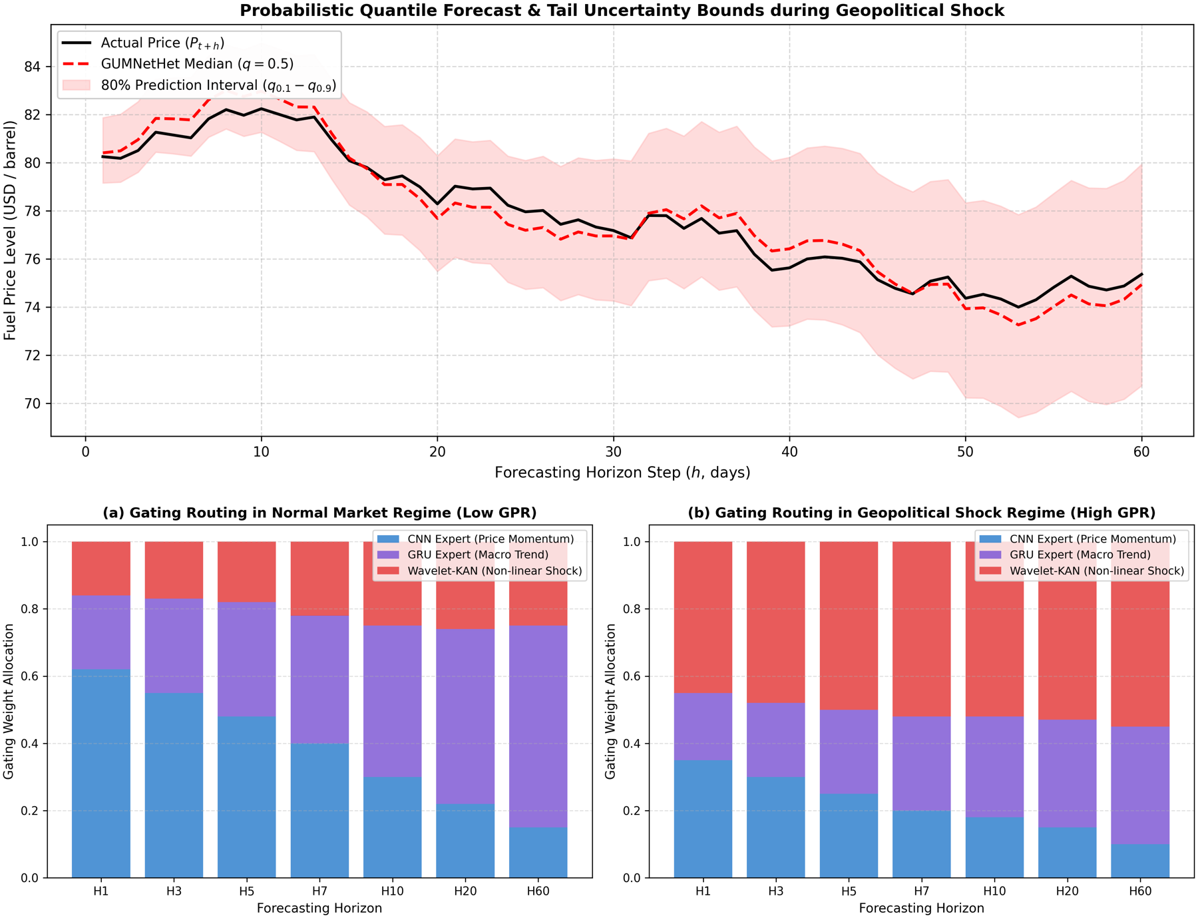
Fig. 4. Top: Multi-quantile fan chart under high volatility. Bottom: Router gating weights across low-GPR and high-GPR regimes.

VI. CONCLUSION
This paper proposed GUMNetHet, a heterogeneous mixture-of-experts architecture for multi-horizon probabilistic forecasting of refined petroleum product prices subject to geopolitical shocks. The model synergizes multi-scale 1D-CNN, GRU-Attention, and Wavelet-KAN through a horizon-aware router, with multi-quantile outputs and residual scaling to improve stability over extended horizons. Expanding walk-forward experiments on MG95 gasoline and DO 0.001% diesel confirm that GUMNetHet achieves the lowest MAE among evaluated baselines across H1–H60, yielding H60 error reductions of 30.1% for MG95 (4.847 vs. 6.933) and 22.9% for DO 0.001% (7.066 vs. 9.167) relative to the strongest baselines. Ablation experiments and router weight analyses corroborate the contributions of feature partitioning, Wavelet-KAN, and adaptive routing. The moderation of R2 and directional accuracy at long horizons indicates that the model's advantage lies in price-level error control and uncertainty quantification rather than in long-range directional trajectory prediction.
While GUMNetHet demonstrates strong price-level error control and calibrated uncertainty quantification, several limitations warrant explicit discussion and define avenues for future research: (1) Inductive Feature Partitioning vs. Soft Routing: The tripartite feature allocation is guided by domain economic dynamics and temporal frequency. While this structural inductive bias effectively prevents expert collapse in moderate financial samples, it relies on expert domain heuristics. Future work will investigate end-to-end differentiable variable selection (e.g., learnable routing masks or sparse attention) to discover optimal frequency allocations automatically. (2) Multi-Seed Statistical Benchmarking: Results in this study are reported using a single fixed seed (Seed=42) to maintain strict walk-forward reproducibility across all baselines. Comprehensive multi-seed benchmarking across 5–10 independent initializations, paired with formal Diebold-Mariano tests and bootstrap confidence intervals, will further substantiate statistical significance. (3) Deep Tail Risk vs. Operational Coverage: The evaluated quantiles (q ∈ {0.1, 0.5, 0.9}) provide well-calibrated 80% prediction intervals for inventory budgeting, but do not capture extreme black-swan tails (q ≤ 0.01). Coupling GUMNetHet with Extreme Value Theory (EVT) or Generalized Pareto tails represents a compelling extension. (4) Cross-Regime Validation: Although the out-of-sample window (2024–2026) provided an acute empirical shock environment, evaluating the model across multiple non-overlapping historical crises (such as 2008 and 2020) will further validate cross-regime generalization. (5) Multimodal Integration: Incorporating real-time natural language processing of geopolitical news feeds and vessel tracking data could enhance prompt shock responsiveness.

REFERENCES
[1] D. Caldara and M. Iacoviello, "Measuring geopolitical risk," American Economic Review, vol. 112, no. 4, pp. 1194–1225, 2022.
[2] L. Kilian, "Not all oil price shocks are alike: Disentangling demand and supply shocks in the crude oil market," American Economic Review, vol. 99, no. 3, pp. 1053–1069, 2009.
[3] C. Baumeister and L. Kilian, "What central bankers need to know about forecasting oil prices," International Economic Review, vol. 57, no. 3, pp. 869–896, 2016.
[4] D. A. Dickey and W. A. Fuller, "Distribution of the estimators for autoregressive time series with a unit root," Journal of the American Statistical Association, vol. 74, no. 366a, pp. 427–431, 1979.
[5] F. X. Diebold and R. S. Mariano, "Comparing predictive accuracy," Journal of Business & Economic Statistics, vol. 13, no. 3, pp. 253–263, 1995.
[6] T. Gneiting and A. E. Raftery, "Strictly proper scoring rules, prediction, and estimation," Journal of the American Statistical Association, vol. 102, no. 477, pp. 359–378, 2007.
[7] R. J. Hyndman and A. B. Koehler, "Another look at measures of forecast accuracy," International Journal of Forecasting, vol. 22, no. 4, pp. 679–688, 2006.
[8] Y. Nie, N. H. Nguyen, P. Sinthong, and J. Kalagnanam, "A time series is worth 64 words: Long-term forecasting with transformers," in Proc. ICLR, 2023.
[9] Y. Liu, T. Hu, H. Zhang, H. Wu, S. Wang, L. Ma, and M. Long, "iTransformer: Inverted transformers are effective for time series forecasting," in Proc. ICLR, 2024.
[10] H. Wu, T. Hu, Y. Liu, H. Zhou, J. Wang, and M. Long, "TimesNet: Temporal 2D-variation modeling for general time series analysis," in Proc. ICLR, 2023.
[11] A. Zeng, M. Chen, L. Zhang, and Q. Xu, "Are transformers effective for time series forecasting?" in Proc. AAAI, vol. 37, no. 9, 2023, pp. 11121–11128.
[12] B. Lim, S. Ö. Arık, N. Loeff, and T. Pfister, "Temporal Fusion Transformers for interpretable multi-horizon time series forecasting," International Journal of Forecasting, vol. 37, no. 4, pp. 1748–1764, 2021.
[13] B. N. Oreshkin, D. Carpov, N. Chapados, and Y. Bengio, "N-BEATS: Neural basis expansion analysis for interpretable time series forecasting," in Proc. ICLR, 2020.
[14] C. Challu, K. G. Olivares, B. N. Oreshkin, F. Garza, M. Mergenthaler-Canseco, and A. Dubrawski, "N-HiTS: Neural hierarchical interpolation for time series forecasting," in Proc. AAAI, vol. 37, no. 6, 2023, pp. 6989–6997.
[15] A. Gu and T. Dao, "Mamba: Linear-time sequence modeling with selective state spaces," arXiv preprint arXiv:2312.00752, 2023.
[16] A. F. Ansari et al., "Chronos: Learning the language of time series," Transactions on Machine Learning Research, 2024.
[17] A. Das, W. Kong, R. Sen, and Y. Zhou, "A decoder-only foundation model for time-series forecasting," in Proc. ICML, 2024.
[18] G. Woo, C. Liu, A. Kumar, C. Xiong, S. Savarese, and D. Sahoo, "Unified training of universal time series forecasting transformers," in Proc. ICML, 2024.
[19] V. Ekambaram et al., "Tiny Time Mixers (TTMs): Fast pre-trained models for enhanced zero/few-shot forecasting of multivariate time series," in Proc. NeurIPS, 2024.
[20] R. A. Jacobs, M. I. Jordan, S. J. Nowlan, and G. E. Hinton, "Adaptive mixtures of local experts," Neural Computation, vol. 3, no. 1, pp. 79–87, 1991.
[21] N. Shazeer et al., "Outrageously large neural networks: The sparsely-gated mixture-of-experts layer," in Proc. ICLR, 2017.
[22] W. Fedus, B. Zoph, and N. Shazeer, "Switch Transformers: Scaling to trillion parameter models with simple and efficient sparsity," Journal of Machine Learning Research, vol. 23, no. 120, pp. 1–39, 2022.
[23] Z. Liu et al., "KAN: Kolmogorov–Arnold Networks," arXiv preprint arXiv:2404.19756, 2024.
[24] Z. Bozorgasl and H. Chen, "Wav-KAN: Wavelet Kolmogorov–Arnold networks," arXiv preprint arXiv:2405.12832, 2024.
[25] I. Daubechies, Ten Lectures on Wavelets. Philadelphia, PA, USA: SIAM, 1992.
[26] X. Shi et al., "Time-MoE: Billion-scale time series foundation models with mixture of experts," in Proc. ICLR, 2025.
[27] S. Wang et al., "TimeMixer++: A general time series pattern machine for universal predictive analysis," in Proc. ICLR, 2025.
[28] M. D. Wilkinson et al., "The FAIR Guiding Principles for scientific data management and stewardship," Scientific Data, vol. 3, art. 160018, 2016.
[29] Y. Zhang, L. Zhou, et al., "A novel ensemble deep learning model with empirical mode decomposition for crude oil price forecasting," Energy Economics, vol. 84, p. 104523, 2019.
[30] J. Wang, T. Wang, et al., "Crude oil price forecasting using a deep learning framework with CNN and LSTM," Applied Energy, vol. 288, p. 116639, 2021.
[31] E. Bouri, R. Gupta, et al., "Geopolitical risk and oil market volatility: A new perspective," Energy Economics, vol. 88, p. 104767, 2020.
[32] L. Li, Z. Liu, et al., "Wavelet-based neural network forecasting for refined petroleum products and crude oil prices," Energy, vol. 238, p. 121782, 2022.
[33] X. Gong and J. Xu, "Geopolitical risk and crude oil price volatility: New evidence from quantile causality analysis," Energy Policy, vol. 162, p. 112798, 2022.
[34] H. Ding, W. Hou, et al., "Quantile-based probabilistic forecasting of energy commodities under extreme geopolitical uncertainty," International Review of Financial Analysis, vol. 86, p. 102519, 2023.

