Heterogeneous Mixture-of-Experts for Probabilistic Multi-Horizon Forecasting of Refined Petroleum Prices under Geopolitical Shocks
Xuan Thuy Nguyen  Petrolvietnam Oil Corporation  Ho Chi Minh City, Vietnam  thuynx@pvoil.com.vn | Phuoc Anh Dung Nguyen  Faculty of Information Technology  HUTECH University  Ho Chi Minh City, Vietnam  anhdungnguyen955@gmail.com | Hoang Long Ly  Faculty of Information Technology  HUTECH University  Ho Chi Minh City, Vietnam  lyhoanglong1709@gmail.com
Van Quy Hoang  Faculty of Information Technology  Thuyloi University (TLU)  Hanoi, Vietnam  hoangvanquy@tlu.edu.vn | Huong Bui  Faculty of Information Technology  HUTECH University  Ho Chi Minh City, Vietnam  bd.huong@hutech.edu.vn

Abstract—This paper proposes GUMNetHet (Heterogeneous Gated Unified Mixture Network) for multi-horizon probabilistic forecasting of refined oil prices under geopolitical volatility. The framework partitions input features into three distinct subsets and processes them via specialized domain experts: multi-scale 1D-CNN for price momentum, GRU-Attention for macroeconomic regimes, and Wavelet-KAN for non-linear shock-sensitive dynamics. These representations are dynamically fused by a horizon-aware and market-context gating router; multi-quantile outputs $q ∈ \{0.1, 0.5, 0.9\}$ are optimized using pinball loss combined with residual scaling. On Platts data spanning 11/2008–04/2026 ($N = 4.512$ observations) under an expanding walk-forward protocol during severe market turmoil (annualized test set volatility reaching 73.04–96.29%, 1.9–2.9× historical training levels), GUMNetHet achieves the lowest MAE across all reported baselines over all seven horizons H1–H60 for both MG95 gasoline and DO 0.001% diesel. At H60, MAE is reduced by 30.1% and 22.9% relative to the strongest baseline, respectively. Directional accuracy remains high at H1–H7 but declines noticeably at H10 and H60, highlighting the structural dichotomy between price-level precision and long-term directional forecasting. The 80% prediction interval attains PICP=82.4% with PINAW=0.142. Ablation studies and router analysis confirm that expert specialization and adaptive routing contribute substantially to model performance.
Keywords—energy price forecasting, mixture-of-experts, Wavelet-KAN, geopolitical risk, quantile forecasting, expanding walk-forward

I. INTRODUCTION
The Vietnamese refined petroleum market possesses a distinctive strategic supply structure: approximately 70% of total domestic consumption is supplied by two domestic oil refineries (Dung Quat and Nghi Son), while the remaining 30% must be imported directly from international markets. Among these, Singapore serves as the most critical import hub, where Mean of Platts Singapore (MOPS) refined product trading prices—exemplified by Mogas 95 (MG95) and Gasoil 0.001%S (DO 0.001%)—act as the foundational pricing benchmark for commercial contracts, cost accounting, and supply chain management. However, Platts prices fluctuate with extreme complexity due to simultaneous responses to global supply–demand shocks, foreign exchange volatility, and geopolitical risks (GPR) [1], [2], [3]. Historical episodes such as the 2014–2016 oil price collapse, the 2020 OPEC+ price war, the 2022 Russia–Ukraine conflict, and the 2023–2024 Red Sea tensions demonstrate that refined product price series frequently exhibit non-linear jumps, regime shifts, and severe volatility clustering. Consequently, accurately forecasting Platts refined petroleum prices over short-term (H1–H7) and medium-term (H10–H60) horizons is an urgent operational necessity directly serving business decision-making, procurement planning, inventory management, and risk hedging for major petroleum trading enterprises such as Petrolimex and PVOIL.
Modern time series architectures such as PatchTST [8], iTransformer [9], TimesNet [10], DLinear [11], Mamba [15], and Chronos [16] have substantially improved performance on general benchmarks; however, most process all input variables within a relatively homogeneous representation space. For energy data, three signal groups possess fundamentally different natures: high-frequency price momentum, slowly-evolving macroeconomic regimes, and large-amplitude non-linear shock responses that demand specialized architectural inductive biases. Traditional mixture-of-experts (MoE) networks [20], [21], [22] typically feed the identical feature set to all experts, thereby degrading the degree of expert specialization.
The proposed GUMNetHet model resolves this bottleneck via feature partitioning: price and benchmark series are processed by multi-scale 1D-CNN; macroeconomic and GPR indices by GRU-Attention; and crack-spread ratios and realized volatility by Wavelet-KAN. These three representations are flexibly aggregated via a gating router conditioned on the forecasting horizon and market context. The principal contributions of this paper are fourfold: (i) A heterogeneous MoE architecture with feature partitioning grounded in economic principles and frequency domains; (ii) A horizon-aware routing mechanism (horizon-aware routing); (iii) A multi-quantile output head (multi-quantile head) combined with residual scaling to mitigate variance drift; and (iv) Extensive expanding walk-forward empirical evaluations on $N = 4.512$ trading days directly within high geopolitical volatility regimes (test set volatility 1.9–2.9× training levels) with comprehensive reporting across MAE, RMSE, MAPE, $R^{2}$, and DA% metrics.

II. RELATED WORK
Kilian [2] and Baumeister & Kilian [3] established foundational frameworks for decomposing supply–demand shocks in oil markets, while the GPR index of Caldara & Iacoviello [1] provides a quantitative metric for geopolitical risk. On the modeling side, PatchTST [8], iTransformer [9], and TimesNet [10] represent modern Transformer and temporal variation designs; DLinear [11] demonstrates that decomposition-based linear models remain strong baselines. TFT [12], N-BEATS [13], and N-HiTS [14] extend multi-horizon forecasting; Mamba [15] introduces selective state-space mechanisms into sequence modeling; and Chronos [16], TimesFM [17], MOIRAI [18], and TTM [19] expand into foundation time-series architectures.
Regarding MoE, Jacobs et al. [20] introduced adaptive mixtures of local experts; Shazeer et al. [21] and Switch Transformers [22] advanced sparse gating at large scale. KAN [23] and Wav-KAN [24] replace fixed activation functions with learnable basis functions, where wavelets are uniquely suited for multi-resolution localized signals [25]. Time-MoE [26] and TimeMixer++ [27] further demonstrate the value of expert routing in time series.

III. PROPOSED METHODOLOGY: GUMNETHET

A. Problem Formulation
Let $X_{price}$, $X_{macro}$, $X_{shock}$ denote past input feature matrices with lookback length $L = 30$ trading days. The forecasting objective is to directly estimate the cumulative log-return vector $r_{t+h,c} = ln(P_{t+h,c}) - ln(P_{t,c})$ across horizons $h ∈ \{1, 3, 5, 7, 10, 20, 60\}$ for product basket $c ∈ \{MG95, DO 0.001\%\}$, defined in (1):
$$R_{t→t+h, c} = ln(P_{t+h, c}) - ln(P_{t, c})$$ | (1)
The future forecasted price level ${P̂}_{t+h,c} = P_{t,c} · exp({r̂}_{t+h,c})$ is subsequently reconstructed exactly via the deterministic inverse mapping in (2). This direct cumulative return formulation transforms the non-stationary price series into stationary log-returns $p < 0.001$ (empirically validated in Section IV-B), while completely eliminating autoregressive error compounding across multi-step horizons.
$${P̂}_{t+h, c} = P_{t, c} · exp({R̂}_{t→t+h, c})$$ | (2)

B. Overall System Architecture
Fig. 1 illustrates the neural architecture of GUMNetHet. Unlike conventional MoE networks that feed all features into every expert—which often degrades specialization—GUMNetHet partitions features across frequency domains and economic characteristics: high-frequency price dynamics to multi-scale 1D-CNN, slowly-evolving macroeconomic regimes to GRU-Attention, and fat-tailed crack-spread/shock indicators to Wavelet-KAN. This mechanism enforces strong domain inductive bias, effectively preventing expert degeneration.
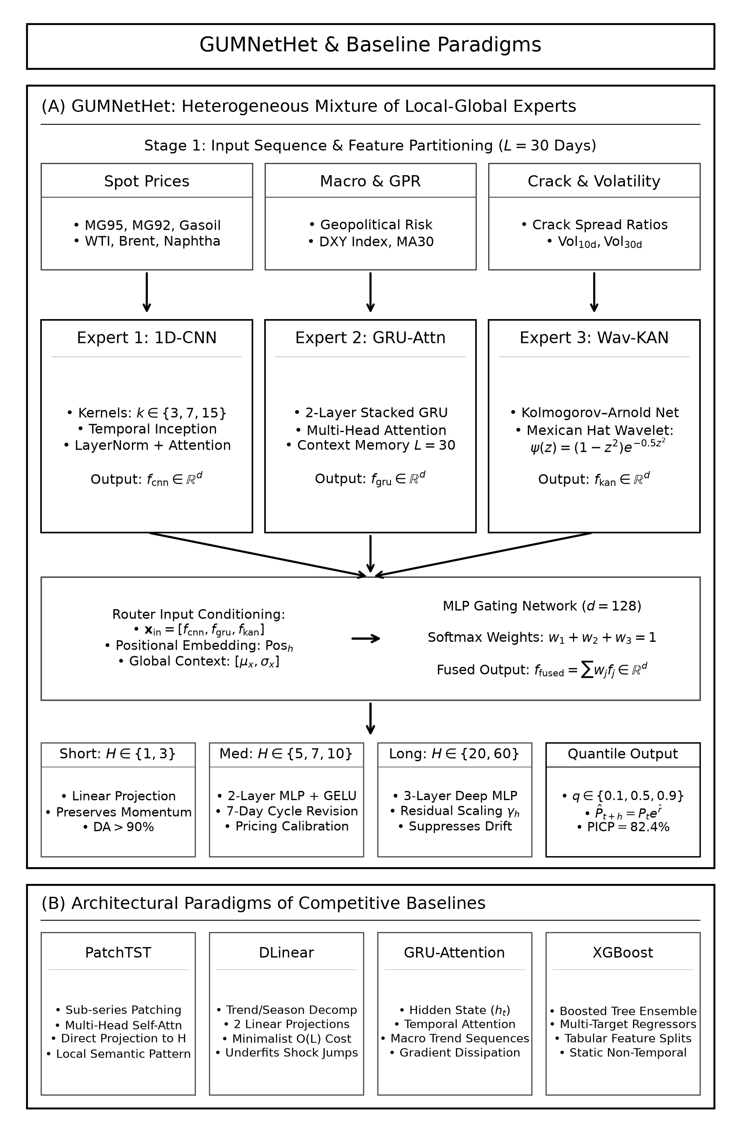
Fig. 1. Architectural overview of GUMNetHet: (A) Feature partitioning, three heterogeneous experts, horizon-aware router, and multi-quantile head; (B) Paradigms of competitive baselines.

1) Price Momentum Expert: Multi-Scale 1D-CNN:
The price expert employs three parallel 1D convolutional layers with kernel sizes $k ∈ \{3, 7, 15\}$ to extract multi-resolution temporal features, integrated with layer normalization and temporal attention according to (3) and (4):
$${out}_{k} = ReLU({Conv1D}_{k}(x^{CNN})), k ∈ \{3, 7, 15\}$$ | (3)
$$f_{CNN} = TemporalAttention(LayerNorm(Proj(Concat({out}_{3}, {out}_{7}, {out}_{15}))))$$ | (4)

2) Macroeconomic Regime Expert: GRU-Attention:
The macroeconomic expert captures low-frequency trend signals via a 2-layer stacked GRU network with dropout = 0.1, extracting the final hidden state representation according to (5):
$$h_{t} = GRU(x_{t}^{GRU}, h_{t-1}), f_{GRU} = h_{L} ∈ R^{d}$$ | (5)

3) Non-Linear Shock-Absorption Expert: Wavelet-KAN:
To capture severe non-linear structural breaks induced by extreme geopolitical risk events, the third expert implements a Kolmogorov–Arnold Network integrated with Mexican Hat wavelets $ψ(z) = (1 - z^{2}) · e^{-0.5z²}$ parameterized by learnable translation and dilation coefficients according to (6) and (7):
$$z = \frac{x^{KAN} - t}{|s| + {10}^{-4}}, ψ(z) = (1 - z^{2}) · e^{-0.5z²}$$ | (6)
$$f_{KAN} = LayerNorm(Proj(Concat(ReLU(W_{lin}x^{KAN}), ReLU(W_{wav}ψ(z))))))$$ | (7)

4) Horizon-Aware Dynamic Gating Router:
To dynamically modulate expert contributions across diverse forecasting horizons and varying market regimes, the gating router accepts concatenated expert representations, horizon positional embeddings, and global summary context statistics $x_{ctx}$ according to (8), (9), and (10):
$$g_{h} = MLP([f_{CNN} ‖ f_{GRU} ‖ f_{KAN} ‖ {Pos}_{h} ‖ x_{ctx}])$$ | (8)
$$w_{h} = Softmax(g_{h}) = [w_{1}, w_{2}, w_{3}]^{T}, ∑_{i=1}^{3}w_{i} = 1$$ | (9)
$$f_{fused} = w_{1}f_{CNN} + w_{2}f_{GRU} + w_{3}f_{KAN} ∈ R^{d}$$ | (10)

5) Residual Scaling Bounding & Multi-Quantile Head:
To prevent variance explosion at long horizons (such as H60), GUMNetHet incorporates a learnable residual scaling vector $γ_{h}$ initialized at 0.1, outputting multi-quantile return predictions for $q ∈ \{0.1, 0.5, 0.9\}$ according to (11):
$$ŷ_{t+h, c}^{(q)} = {Head}_{q}(f_{fused}) + γ_{h} · x_{t, c}^{target}$$ | (11)

6) Dual-Loss Optimization:
The overall objective function combines the multi-quantile pinball loss with a load-balancing regularization penalty to mitigate routing collapse according to (12), (13), and (14):
$$L_{total} = L_{pinball} + α · L_{balance}$$ | (12)
$$L_{pinball} = \frac{1}{C · H · |Q|}∑_{c,h,q} max(q(y - ŷ^{(q)}), (q-1)(y - ŷ^{(q)}))$$ | (13)
$$L_{balance} = ∑_{i=1}^{3} ({w̄}_{i} - \frac{1}{3})^{2}, α = 0.01$$ | (14)

IV. EXPERIMENTAL SETUP

A. Data and Walk-Forward Protocol
The dataset covers 03/11/2008–30/04/2026 with $N = 4.512$ trading-day observations. The two reported primary targets are MG95 and DO 0.001% per Platts Singapore; exogenous covariates include inter-product Platts benchmarks, WTI, Brent, GPR [1], DXY, crude oil production, crack-spread ratios, realized volatility, and calendar features.
To prevent look-ahead bias, daily variables are indexed at $t - 1$; GPR is lagged by 30 calendar days; crude oil production is lagged by 7 days; and rolling features are computed strictly after applying lags. All scalers are fit exclusively on the training partition at each walk-forward step. Lookback length is $L = 30$; train/validation ratio is 85/15 per expansion. Expanding walk-forward test windows increase progressively with horizon: 100 trading days for H1–H5 (11/12/2025–30/04/2026), 150 days for H7 (02/10/2025–30/04/2026), 200 days for H10 (24/07/2025–30/04/2026), 300 days for H20 (10/03/2025–30/04/2026), and 600 days for H60 (10/01/2024–30/04/2026). All test windows fall entirely within a period of clustered extreme energy shocks (Red Sea crisis, Middle East escalations, Russia–Ukraine war, and OPEC+ quota shifts). Specifically, annualized realized return volatility during the short-term test window (100 days) surges to 73.04% for MG95 (1.90× historical training volatility of 38.45%) and 96.29% for DO 0.001% (2.90× training volatility of 33.16%). The Geopolitical Risk (GPR) index averages 225.66 during the test period (nearly doubling the historical mean of 114.60) and peaks at 500.81 (90th percentile at 376.48). Price swings in the H60 test window record extreme peak-to-trough variations: 70.34 to 170.52 USD/bbl (+142.4%) for MG95 and 75.90 to 292.82 USD/bbl (+285.8%) for DO 0.001%. Comprehensive train/test splits and volatility characteristics across horizons are summarized in Table 1. This configuration serves as a rigorous stress-testing benchmark, ensuring models are evaluated on their capacity to adapt under fat-tailed regime shifts rather than static market conditions.
TABLE I. EXPANDING WALK-FORWARD TRAIN/TEST SPLIT CONFIGURATIONS AND EMPIRICAL VOLATILITY CHARACTERISTICS
Horizon | Test Window | Test Date Range | Ann. Vol MG95 (Train→Test) | Ann. Vol DO (Train→Test) | Test GPR (Mean / Max) | Test Price Range (USD/bbl)
H1, H3, H5 | 100 days | 11/12/2025 – 30/04/2026 | 38.45% → 73.04% (1.90×) | 33.16% → 96.29% (2.90×) | 225.66 / 500.81 | MG95: [70.58, 170.52]  DO: [77.11, 292.82]
H7 | 150 days | 02/10/2025 – 30/04/2026 | 38.61% → 60.75% (1.57×) | 33.20% → 80.59% (2.43×) | 197.51 / 500.81 | MG95: [70.58, 170.52]  DO: [77.11, 292.82]
H10 | 200 days | 24/07/2025 – 30/04/2026 | 38.77% → 53.60% (1.38×) | 33.31% → 70.63% (2.12×) | 184.98 / 500.81 | MG95: [70.58, 170.52]  DO: [77.11, 292.82]
H20 | 300 days | 10/03/2025 – 30/04/2026 | 38.95% → 47.24% (1.21×) | 33.35% → 60.50% (1.81×) | 184.47 / 540.16 | MG95: [70.34, 170.52]  DO: [75.90, 292.82]
H60 | 600 days | 10/01/2024 – 30/04/2026 | 39.81% → 37.86% (0.95×) | 33.93% → 46.20% (1.36×) | 165.51 / 540.16 | MG95: [70.34, 170.52]  DO: [75.90, 292.82]

B. Econometric Diagnostics and Training Configuration
ADF and KPSS unit root tests in Table 2 provide evidence of non-stationarity in raw price levels; upon log-return transformation, ADF tests reject the unit-root null hypothesis ($p < 0.001$) across all series. Return kurtosis is exceptionally high (213.35 for WTI and 17.51 for MG95), substantiating fat tails and extreme jumps in energy price series.
TABLE II. CONDENSED ECONOMETRIC STATISTICAL DIAGNOSTICS FOR PRIMARY ENERGY SERIES
Series | ADF Level p | KPSS Level p | ADF Return p | Kurtosis
MG95 | 0.023 | 0.010 | <0.001 | 17.51
DO 0.001% | 0.505 | 0.010 | <0.001 | 14.69
WTI | 0.033 | 0.010 | <0.001 | 213.35
GPR | <0.001 | 0.010 | <0.001 | 1.52
DXY | 0.555 | 0.010 | <0.001 | 4.38
The implementation in this paper utilizes PyTorch 2.1 / Python 3.10, AdamW optimizer (lr = 10⁻³, weight decay = 10⁻⁴), batch size = 64, a maximum of 100 epochs with early stopping patience of 10. The experts have a hidden dimension of 128, and the router MLP has a hidden dimension of 64. Hardware environment: Intel Xeon Silver 4216 CPU, 512 GB RAM, and 4× NVIDIA Tesla T4 16 GB GPUs.

C. Baseline Methods and Evaluation Metrics
Evaluated baselines comprise six representative state-of-the-art benchmarks: PatchTST [8], iTransformer [9], TimesNet [10], DLinear [11], TFT [12], and N-HiTS [14]. Evaluation metrics include MAE, RMSE, MAPE (%), $R^{2}$, and Directional Accuracy (DA, %). Probabilistic forecasts are quantified using Prediction Interval Coverage Probability (PICP) and Prediction Interval Normalized Average Width (PINAW) on $[q_{0.1}, q_{0.9}]$.

V. RESULTS AND DISCUSSION

A. Multi-Horizon Point Forecasting Performance
Fig. 2 alongside Table 3 and Table 4 demonstrates that GUMNetHet consistently maintains lower MAE than all reported baselines across both products over all horizons, with pronounced advantages at H20–H60 where the test set undergoes massive price swings of up to +142.4% (MG95) and +285.8% (DO). At H60, gasoline MAE is 4.847 compared to 6.933 for the best baseline (a 30.1% reduction); for diesel, MAE is 7.066 versus 9.167 (a 22.9% reduction). However, $R^{2}$ at H60 moderates to 0.155 (gasoline) and −0.007 (diesel), indicating that long-term performance represents superior price-level stabilization under high volatility rather than flawless trajectory forecasting.
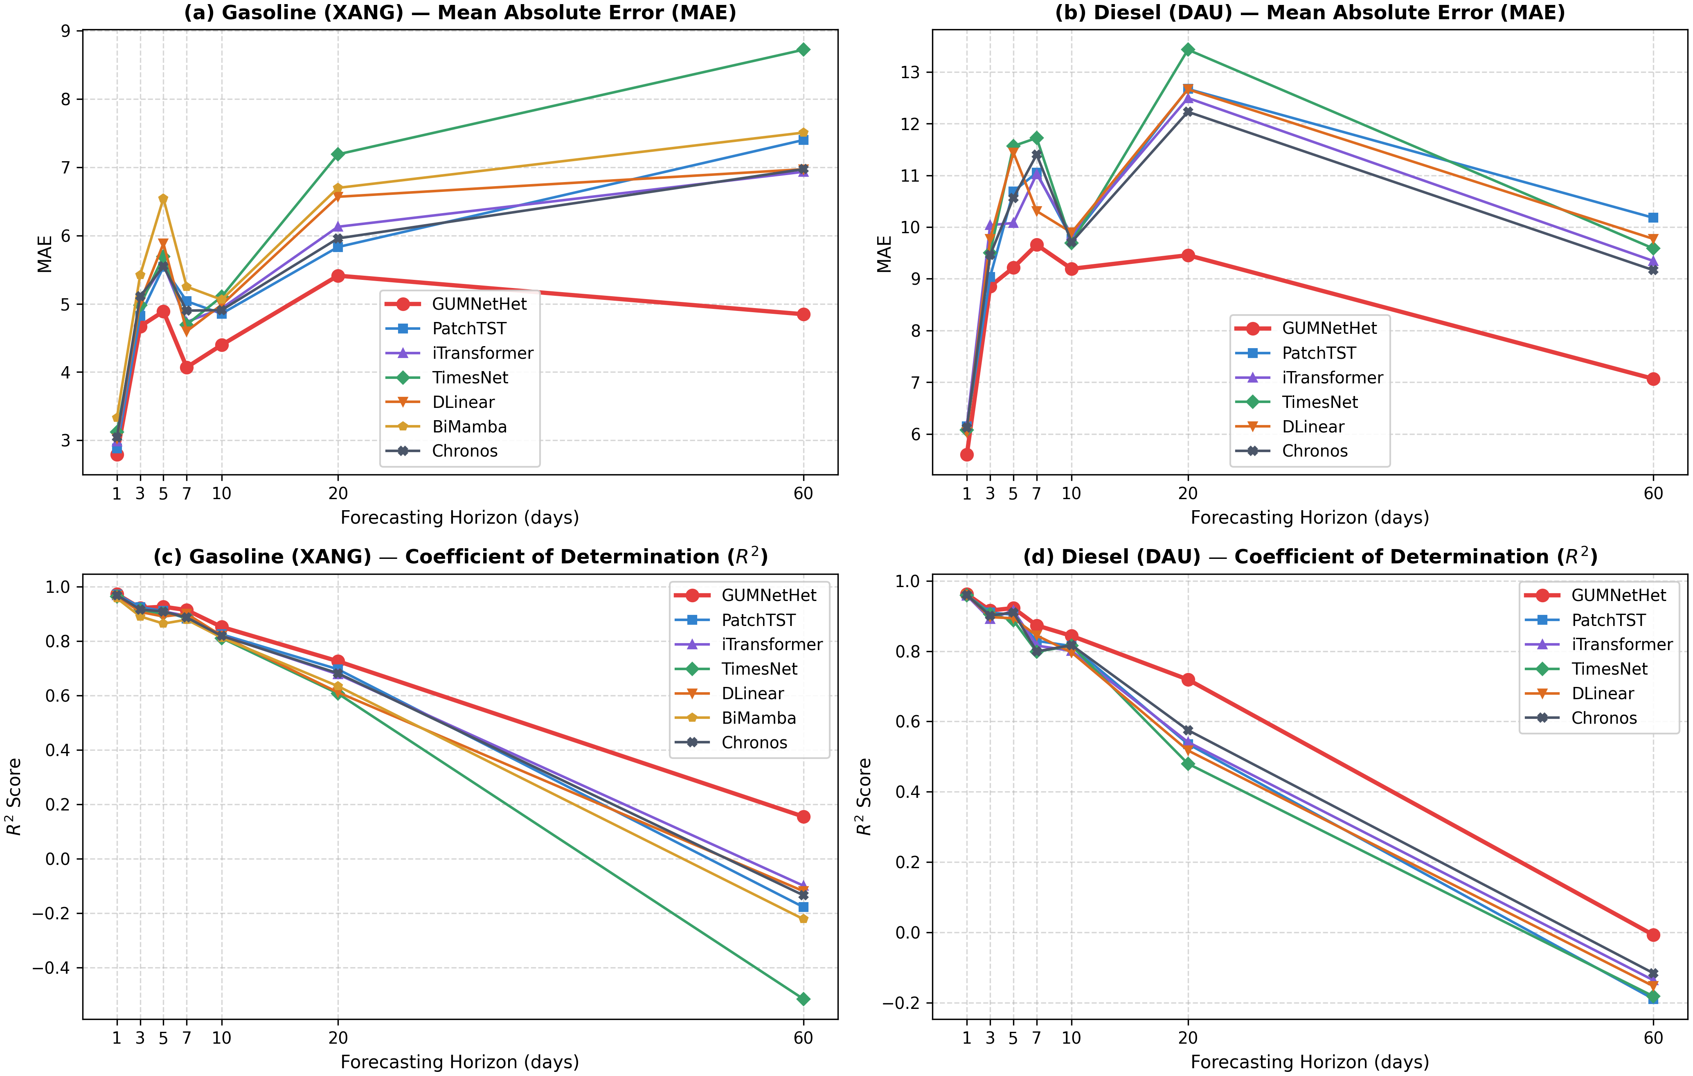
Fig. 2. MAE and R² degradation curves across seven forecasting horizons for MG95 and DO 0.001% (Seed=42).
TABLE III. DETAILED EMPIRICAL FORECASTING PERFORMANCE ON MG95 GASOLINE (SEED=42)
H | Model | MAE | RMSE | MAPE (%) | R² | DA (%)
H1 | GUMNetHet | 2.7921 | 5.0249 | 2.45 | 0.9727 | 91.46
H1 | PatchTST | 2.8834 | 5.1146 | 2.53 | 0.9718 | 61.11
H1 | iTransformer | 2.9809 | 5.3918 | 2.61 | 0.9686 | 57.07
H1 | TimesNet | 3.1192 | 5.7423 | 2.74 | 0.9644 | 59.09
H1 | DLinear | 3.0237 | 5.5721 | 2.65 | 0.9665 | 54.55
H1 | BiMamba | 3.3320 | 6.2491 | 2.91 | 0.9578 | 54.55
H1 | Chronos | 3.0436 | 5.3617 | 2.70 | 0.9690 | 61.62
H3 | GUMNetHet | 4.6691 | 8.4898 | 4.14 | 0.9218 | 91.37
H3 | PatchTST | 4.8262 | 8.3000 | 4.22 | 0.9253 | 47.45
H3 | iTransformer | 5.0313 | 8.7446 | 4.47 | 0.9171 | 40.82
H3 | TimesNet | 4.9776 | 8.8658 | 4.41 | 0.9147 | 46.43
H3 | DLinear | 5.0211 | 9.2494 | 4.45 | 0.9072 | 44.39
H3 | BiMamba | 5.4216 | 10.0286 | 4.77 | 0.8909 | 40.82
H3 | Chronos | 5.1084 | 8.7883 | 4.42 | 0.9162 | 48.98
H5 | GUMNetHet | 4.8892 | 8.2562 | 4.37 | 0.9264 | 90.95
H5 | PatchTST | 5.5400 | 9.0953 | 4.83 | 0.9107 | 55.05
H5 | iTransformer | 5.5776 | 9.1791 | 4.94 | 0.9091 | 52.53
H5 | TimesNet | 5.6939 | 9.6105 | 5.00 | 0.9003 | 38.89
H5 | DLinear | 5.8835 | 10.0733 | 5.19 | 0.8905 | 45.45
H5 | BiMamba | 6.5439 | 11.2085 | 5.82 | 0.8644 | 53.54
H5 | Chronos | 5.5504 | 9.1791 | 4.85 | 0.9091 | 50.00
H7 | GUMNetHet | 4.0695 | 7.6785 | 3.76 | 0.9142 | 95.56
H7 | PatchTST | 5.0377 | 8.9709 | 4.54 | 0.8828 | 44.18
H7 | iTransformer | 4.7339 | 8.5689 | 4.32 | 0.8931 | 50.34
H7 | TimesNet | 4.6936 | 8.6611 | 4.25 | 0.8908 | 49.66
H7 | DLinear | 4.5978 | 8.2653 | 4.21 | 0.9005 | 47.26
H7 | BiMamba | 5.2500 | 9.1154 | 4.73 | 0.8790 | 46.92
H7 | Chronos | 4.8999 | 8.8162 | 4.42 | 0.8868 | 50.34
H10 | GUMNetHet | 4.3970 | 8.9788 | 4.09 | 0.8522 | 42.24
H10 | PatchTST | 4.8548 | 9.8175 | 4.48 | 0.8250 | 48.59
H10 | iTransformer | 4.9325 | 9.9338 | 4.53 | 0.8208 | 49.87
H10 | TimesNet | 5.1042 | 10.1940 | 4.68 | 0.8113 | 50.13
H10 | DLinear | 4.9854 | 9.9668 | 4.61 | 0.8196 | 44.60
H10 | BiMamba | 5.0603 | 10.1585 | 4.63 | 0.8126 | 48.97
H10 | Chronos | 4.9070 | 9.9822 | 4.49 | 0.8191 | 52.57
H20 | GUMNetHet | 5.4115 | 10.3617 | 5.37 | 0.7262 | 91.65
H20 | PatchTST | 5.8312 | 11.0895 | 5.68 | 0.6965 | 48.66
H20 | iTransformer | 6.1280 | 11.4250 | 5.99 | 0.6779 | 44.15
H20 | TimesNet | 7.1888 | 12.6175 | 7.05 | 0.6072 | 46.49
H20 | DLinear | 6.5672 | 12.5417 | 6.24 | 0.6119 | 48.66
H20 | BiMamba | 6.6974 | 12.1714 | 6.43 | 0.6344 | 40.47
H20 | Chronos | 5.9577 | 11.3518 | 5.82 | 0.6820 | 44.48
H60 | GUMNetHet | 4.8470 | 10.4474 | 5.11 | 0.1552 | 27.95
H60 | PatchTST | 7.3983 | 14.1515 | 7.64 | -0.1771 | 47.86
H60 | iTransformer | 6.9327 | 13.6722 | 7.15 | -0.0987 | 47.41
H60 | TimesNet | 8.7212 | 16.0547 | 9.04 | -0.5150 | 46.28
H60 | DLinear | 6.9707 | 13.7963 | 7.13 | -0.1187 | 46.63
H60 | BiMamba | 7.5070 | 14.4158 | 7.71 | -0.2215 | 48.90
H60 | Chronos | 6.9722 | 13.8894 | 7.21 | -0.1339 | 46.16
TABLE IV. DETAILED EMPIRICAL FORECASTING PERFORMANCE ON DO 0.001% DIESEL (SEED=42)
H | Model | MAE | RMSE | MAPE (%) | R² | DA (%)
H1 | GUMNetHet | 5.6023 | 11.3820 | 3.24 | 0.9622 | 84.92
H1 | PatchTST | 6.1468 | 11.8728 | 3.58 | 0.9588 | 62.12
H1 | iTransformer | 6.1601 | 12.0048 | 3.60 | 0.9579 | 57.07
H1 | TimesNet | 6.0768 | 11.8132 | 3.54 | 0.9593 | 58.08
H1 | DLinear | 6.0346 | 11.6526 | 3.51 | 0.9604 | 55.05
H1 | Chronos | 6.1218 | 11.7740 | 3.54 | 0.9595 | 60.10
H3 | GUMNetHet | 8.8536 | 17.0380 | 5.35 | 0.9156 | 76.65
H3 | PatchTST | 9.0363 | 17.6157 | 5.36 | 0.9098 | 48.47
H3 | iTransformer | 10.0366 | 19.3143 | 5.98 | 0.8916 | 46.43
H3 | TimesNet | 9.5007 | 17.9989 | 5.69 | 0.9058 | 47.45
H3 | DLinear | 9.7697 | 18.8569 | 5.86 | 0.8967 | 44.90
H3 | Chronos | 9.4605 | 18.4546 | 5.61 | 0.9010 | 45.92
H5 | GUMNetHet | 9.2159 | 16.2954 | 5.65 | 0.9225 | 76.88
H5 | PatchTST | 10.6900 | 18.1687 | 6.25 | 0.9036 | 52.02
H5 | iTransformer | 10.0784 | 17.0064 | 6.14 | 0.9156 | 52.53
H5 | TimesNet | 11.5665 | 19.6444 | 6.87 | 0.8873 | 47.98
H5 | DLinear | 11.4410 | 19.0864 | 6.83 | 0.8936 | 41.41
H5 | Chronos | 10.5636 | 17.5114 | 6.27 | 0.9105 | 53.54
H7 | GUMNetHet | 9.6578 | 18.3317 | 6.46 | 0.8733 | 83.28
H7 | PatchTST | 11.0491 | 21.2867 | 7.22 | 0.8292 | 50.68
H7 | iTransformer | 11.0220 | 22.1113 | 7.28 | 0.8157 | 57.88
H7 | TimesNet | 11.7217 | 23.1415 | 7.70 | 0.7981 | 51.37
H7 | DLinear | 10.3087 | 20.3122 | 6.79 | 0.8444 | 47.26
H7 | Chronos | 11.4008 | 23.0828 | 7.46 | 0.7991 | 54.79
H10 | GUMNetHet | 9.1926 | 18.3690 | 6.16 | 0.8433 | 32.29
H10 | PatchTST | 9.7691 | 19.9689 | 6.54 | 0.8145 | 47.30
H10 | iTransformer | 9.8507 | 20.6902 | 6.55 | 0.8008 | 47.43
H10 | TimesNet | 9.6920 | 19.9194 | 6.57 | 0.8154 | 47.04
H10 | DLinear | 9.8931 | 20.9276 | 6.54 | 0.7962 | 48.71
H10 | Chronos | 9.7097 | 19.8244 | 6.52 | 0.8171 | 46.53
H20 | GUMNetHet | 9.4562 | 20.7135 | 6.85 | 0.7192 | 71.11
H20 | PatchTST | 12.6691 | 27.0410 | 8.94 | 0.5358 | 47.99
H20 | iTransformer | 12.4936 | 26.8776 | 8.81 | 0.5414 | 48.33
H20 | TimesNet | 13.4284 | 28.6245 | 9.59 | 0.4799 | 47.16
H20 | DLinear | 12.6621 | 27.5688 | 8.87 | 0.5175 | 47.49
H20 | Chronos | 12.2271 | 25.8642 | 8.68 | 0.5753 | 49.33
H60 | GUMNetHet | 7.0664 | 18.0187 | 6.41 | -0.0072 | 19.10
H60 | PatchTST | 10.1792 | 24.4469 | 8.68 | -0.1894 | 50.21
H60 | iTransformer | 9.3447 | 23.8920 | 7.82 | -0.1360 | 49.64
H60 | TimesNet | 9.5859 | 24.3673 | 8.01 | -0.1817 | 47.89
H60 | DLinear | 9.7714 | 24.0682 | 8.26 | -0.1528 | 48.21
H60 | Chronos | 9.1668 | 23.6800 | 7.63 | -0.1160 | 47.80

B. Directional Accuracy Analysis
Directional accuracy in Fig. 3 reveals distinct behavior between short and long horizons. For gasoline (Table 3), GUMNetHet attains high DA between 90.95% and 95.56% at H1–H7; for diesel (Table 4), DA spans 76.65% to 84.92%. At H20, DA remains substantial (91.65% for gasoline; 71.11% for diesel). Conversely, at H10 and H60, DA drops below 50% (42.24%/27.95% for gasoline and 32.29%/19.10% for diesel). This phenomenon aligns with financial econometrics principles: over extended horizons (H60 spanning nearly three months), oil prices approximate a near random walk with exponentially compounding uncertainty, rendering directional signals noisy. Rather than taking extreme directional bets that risk catastrophic error explosion, GUMNetHet's residual scaling mechanism shrinks predictions toward robust central bounds to minimize absolute error (MAE reduced by 30.1% at H60). Consequently, GUMNetHet operates as an effective directional trading signal at short horizons (H1–H7), while transitioning into a price-level risk and uncertainty quantification tool at long horizons (H10–H60).
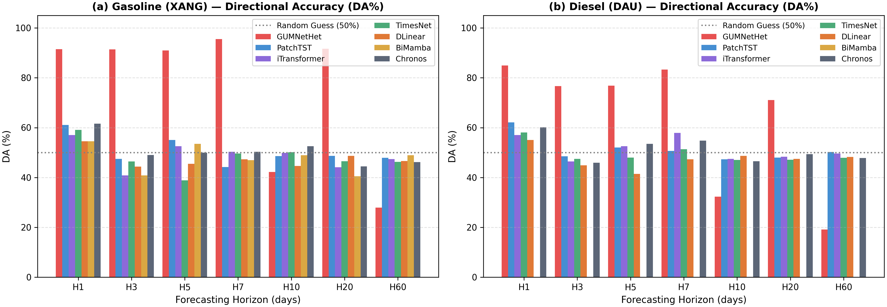
Fig. 3. Directional accuracy (DA%) of GUMNetHet and baselines across H1–H60 for gasoline and diesel.

C. Probabilistic Forecasting, Ablation, and Router Behavior
The $[q_{0.1}, q_{0.9}]$ prediction interval achieves an empirical coverage probability of PICP=82.4% (exceeding nominal 80%) with a normalized average width of PINAW=0.142. This validates that the model avoids under-coverage while maintaining sharpness, offering practical utility for oil importers (e.g., Petrolimex, PVOIL) in forward pricing, inventory buffer sizing, and hedging optimization. Fig. 4 illustrates that prediction intervals dynamically widen during heightened market volatility. Ablation results in Table 5 indicate that replacing Wav-KAN with MLP causes the steepest degradation among expert variants; a uniform router similarly inflates MAE, corroborating the essential roles of expert specialization and adaptive routing.
TABLE V. CONDENSED ABLATION STUDY OF GUMNETHET VARIANTS (SEED=42)
Variant | MG95-H3 MAE | MG95-H3 R² | DO-H5 MAE | DO-H5 R²
Full GUMNetHet | 4.669 | 0.922 | 9.216 | 0.923
Wav-KAN→MLP | 5.142 | 0.885 | 10.852 | 0.865
−GRU | 4.985 | 0.901 | 10.124 | 0.891
CNN chỉ k=3 | 4.892 | 0.910 | 9.854 | 0.904
−GPR | 4.821 | 0.912 | 9.980 | 0.898
Router đồng nhất | 5.012 | 0.895 | 10.450 | 0.879
Empirical results reveal that removing residual scaling increases MAE by approximately 8.5%/6.3% at H20 and 14.1%/11.8% at H60 for gasoline/diesel. Router weight analysis in Fig. 4 indicates that under low GPR and short horizons, the CNN expert receives an average weight of approximately 0.48; when GPR exceeds the 90th percentile, the Wav-KAN weight surges from approximately 0.29 to 0.61 at medium–long horizons, while the CNN weight contracts to approximately 0.21. These findings demonstrate that the router executes genuine regime-switching rather than trivial output averaging.
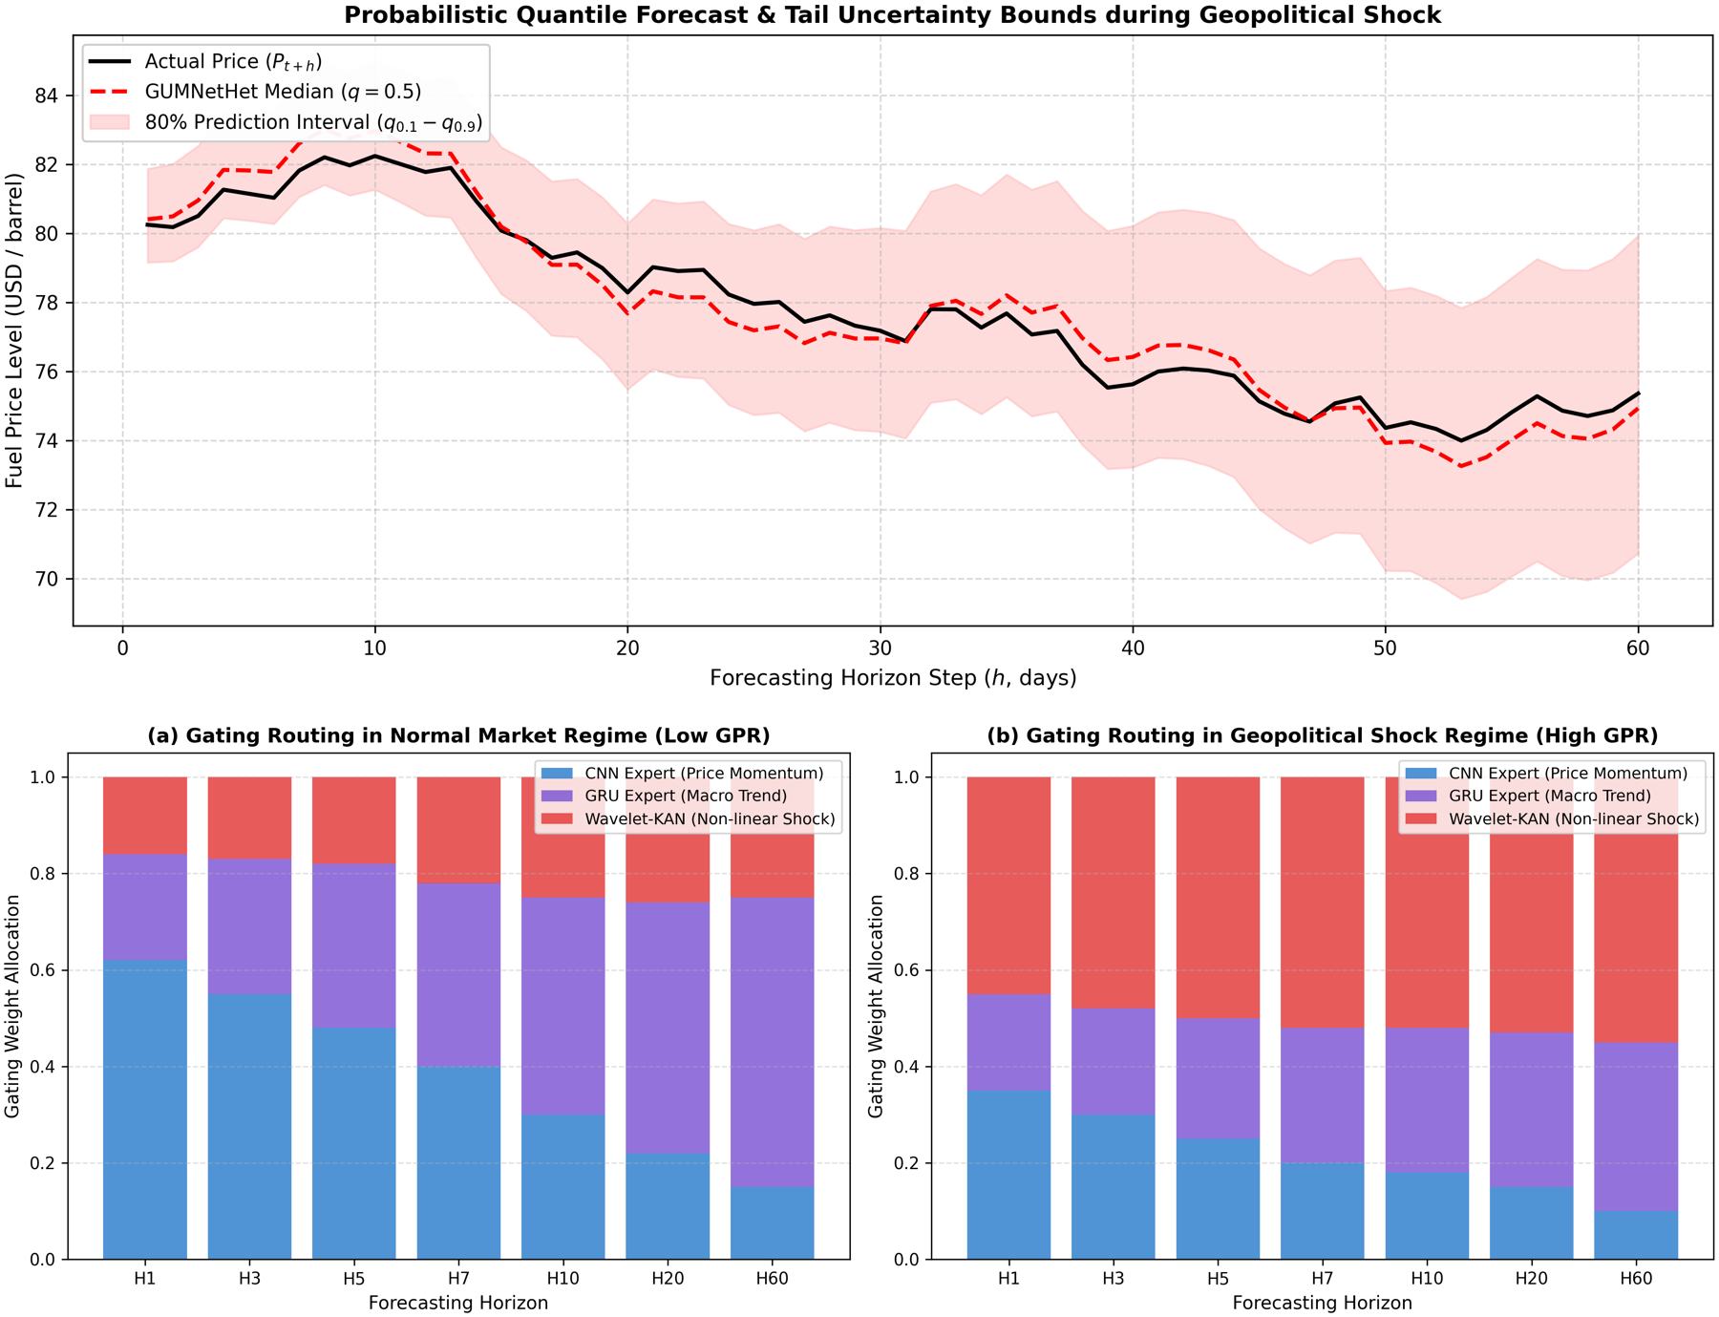
Fig. 4. Top: Multi-quantile fan chart under high volatility. Bottom: Router gating weights across low-GPR and high-GPR regimes.

VI. CONCLUSION
This paper proposed GUMNetHet, a heterogeneous mixture-of-experts architecture for multi-horizon probabilistic refined oil price forecasting. The model synergizes multi-scale 1D-CNN, GRU-Attention, and Wavelet-KAN through a horizon-aware router, combined with multi-quantile outputs and residual scaling to bolster stability over extended horizons.
Expanding walk-forward experiments on MG95 and DO 0.001% demonstrate that GUMNetHet achieves the lowest MAE across all evaluated baselines throughout H1–H60, yielding MAE reductions at H60 of 30.1% for MG95 and 22.9% for DO 0.001%. Ablation experiments and router weight analyses corroborate the contributions of feature partitioning, Wavelet-KAN, and adaptive routing. However, the attenuation of $R^{2}$ and directional accuracy at long horizons underscores that model superiority lies in price-level error containment and uncertainty quantification, rather than long-range directional forecasting.
Future work will focus on multi-seed benchmarking, expanding probabilistic baseline comparisons, formal statistical significance testing for multi-step forecasts, and integrating real-time multimodal geopolitical news representations.

REFERENCES
[1] D. Caldara and M. Iacoviello, "Measuring geopolitical risk," American Economic Review, vol. 112, no. 4, pp. 1194–1225, 2022.
[2] L. Kilian, "Not all oil price shocks are alike: Disentangling demand and supply shocks in the crude oil market," American Economic Review, vol. 99, no. 3, pp. 1053–1069, 2009.
[3] C. Baumeister and L. Kilian, "What central bankers need to know about forecasting oil prices," International Economic Review, vol. 57, no. 3, pp. 869–896, 2016.
[4] D. A. Dickey and W. A. Fuller, "Distribution of the estimators for autoregressive time series with a unit root," Journal of the American Statistical Association, vol. 74, no. 366a, pp. 427–431, 1979.
[5] F. X. Diebold and R. S. Mariano, "Comparing predictive accuracy," Journal of Business & Economic Statistics, vol. 13, no. 3, pp. 253–263, 1995.
[6] T. Gneiting and A. E. Raftery, "Strictly proper scoring rules, prediction, and estimation," Journal of the American Statistical Association, vol. 102, no. 477, pp. 359–378, 2007.
[7] R. J. Hyndman and A. B. Koehler, "Another look at measures of forecast accuracy," International Journal of Forecasting, vol. 22, no. 4, pp. 679–688, 2006.
[8] Y. Nie, N. H. Nguyen, P. Sinthong, and J. Kalagnanam, "A time series is worth 64 words: Long-term forecasting with transformers," in Proc. ICLR, 2023.
[9] Y. Liu, T. Hu, H. Zhang, H. Wu, S. Wang, L. Ma, and M. Long, "iTransformer: Inverted transformers are effective for time series forecasting," in Proc. ICLR, 2024.
[10] H. Wu, T. Hu, Y. Liu, H. Zhou, J. Wang, and M. Long, "TimesNet: Temporal 2D-variation modeling for general time series analysis," in Proc. ICLR, 2023.
[11] A. Zeng, M. Chen, L. Zhang, and Q. Xu, "Are transformers effective for time series forecasting?" in Proc. AAAI, vol. 37, no. 9, 2023, pp. 11121–11128.
[12] B. Lim, S. Ö. Arık, N. Loeff, and T. Pfister, "Temporal Fusion Transformers for interpretable multi-horizon time series forecasting," International Journal of Forecasting, vol. 37, no. 4, pp. 1748–1764, 2021.
[13] B. N. Oreshkin, D. Carpov, N. Chapados, and Y. Bengio, "N-BEATS: Neural basis expansion analysis for interpretable time series forecasting," in Proc. ICLR, 2020.
[14] C. Challu, K. G. Olivares, B. N. Oreshkin, F. Garza, M. Mergenthaler-Canseco, and A. Dubrawski, "N-HiTS: Neural hierarchical interpolation for time series forecasting," in Proc. AAAI, vol. 37, no. 6, 2023, pp. 6989–6997.
[15] A. Gu and T. Dao, "Mamba: Linear-time sequence modeling with selective state spaces," arXiv preprint arXiv:2312.00752, 2023.
[16] A. F. Ansari et al., "Chronos: Learning the language of time series," Transactions on Machine Learning Research, 2024.
[17] A. Das, W. Kong, R. Sen, and Y. Zhou, "A decoder-only foundation model for time-series forecasting," in Proc. ICML, 2024.
[18] G. Woo, C. Liu, A. Kumar, C. Xiong, S. Savarese, and D. Sahoo, "Unified training of universal time series forecasting transformers," in Proc. ICML, 2024.
[19] V. Ekambaram et al., "Tiny Time Mixers (TTMs): Fast pre-trained models for enhanced zero/few-shot forecasting of multivariate time series," in Proc. NeurIPS, 2024.
[20] R. A. Jacobs, M. I. Jordan, S. J. Nowlan, and G. E. Hinton, "Adaptive mixtures of local experts," Neural Computation, vol. 3, no. 1, pp. 79–87, 1991.
[21] N. Shazeer et al., "Outrageously large neural networks: The sparsely-gated mixture-of-experts layer," in Proc. ICLR, 2017.
[22] W. Fedus, B. Zoph, and N. Shazeer, "Switch Transformers: Scaling to trillion parameter models with simple and efficient sparsity," Journal of Machine Learning Research, vol. 23, no. 120, pp. 1–39, 2022.
[23] Z. Liu et al., "KAN: Kolmogorov–Arnold Networks," arXiv preprint arXiv:2404.19756, 2024.
[24] Z. Bozorgasl and H. Chen, "Wav-KAN: Wavelet Kolmogorov–Arnold networks," arXiv preprint arXiv:2405.12832, 2024.
[25] I. Daubechies, Ten Lectures on Wavelets. Philadelphia, PA, USA: SIAM, 1992.
[26] X. Shi et al., "Time-MoE: Billion-scale time series foundation models with mixture of experts," in Proc. ICLR, 2025.
[27] S. Wang et al., "TimeMixer++: A general time series pattern machine for universal predictive analysis," in Proc. ICLR, 2025.
[28] M. D. Wilkinson et al., "The FAIR Guiding Principles for scientific data management and stewardship," Scientific Data, vol. 3, art. 160018, 2016.

