1150080030 Nguyễn Văn Phú
CNPM1
Thực hành 1: Thiết kế và lập trình ứng dụng Winform theo mô tả sau:
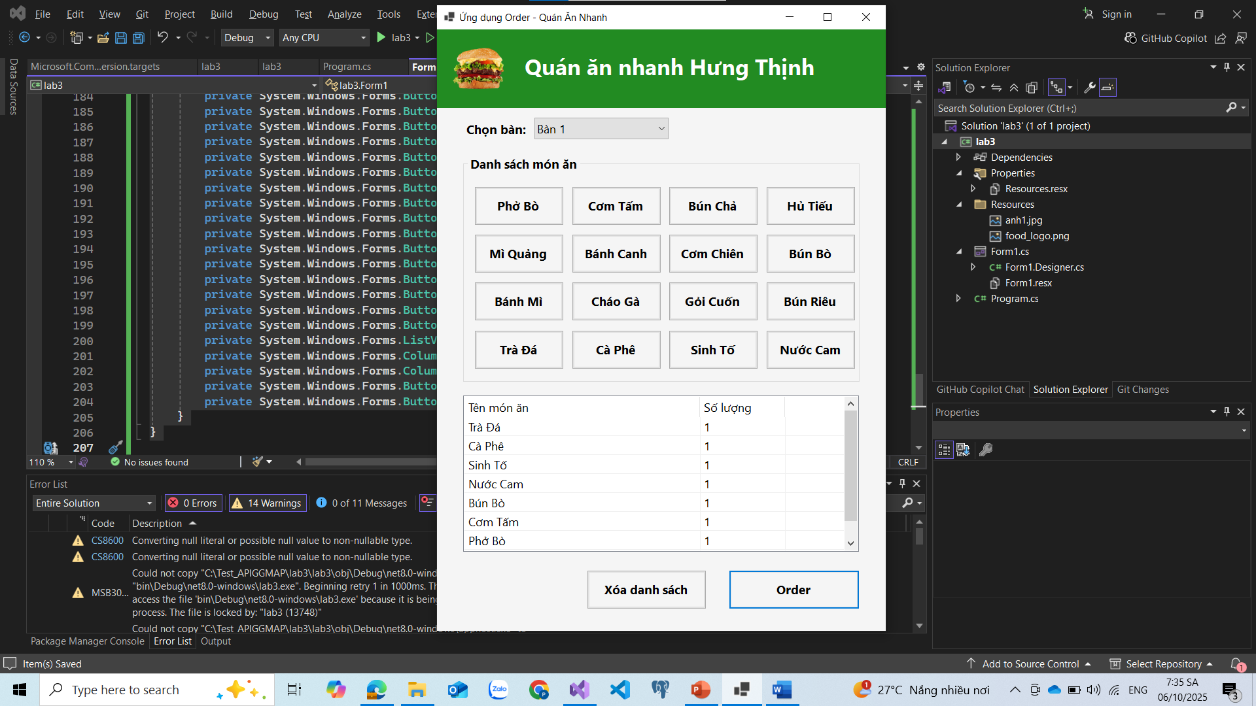
Form1.cs
using System;
using System.Collections.Generic;
using System.IO;
using System.Windows.Forms;

namespace lab3
{
public partial class Form1 : Form
{
private Dictionary<string, int> orderList = new Dictionary<string, int>();

public Form1()
{
InitializeComponent();
LoadTableList();
AddFoodButtonEvents();
AddButtonEvents(); // Gắn sự kiện cho nút Order và Xóa
}

private void LoadTableList()
{
comboBoxBan.Items.AddRange(new string[] { "Bàn 1", "Bàn 2", "Bàn 3", "Bàn 4", "Bàn 5" });
comboBoxBan.SelectedIndex = 0;
}

private void AddFoodButtonEvents()
{
foreach (Control c in groupBoxMonAn.Controls)
{
if (c is Button)
c.Click += BtnFood_Click;
}
}

private void AddButtonEvents()
{
btnOrder.Click += btnOrder_Click;
btnXoa.Click += btnXoa_Click;
}

private void BtnFood_Click(object sender, EventArgs e)
{
Button btn = sender as Button;
string tenMon = btn.Text;

if (orderList.ContainsKey(tenMon))
orderList[tenMon]++;
else
orderList[tenMon] = 1;

HienThiLenListView();
}

private void HienThiLenListView()
{
listViewOrder.Items.Clear();
foreach (var item in orderList)
{
ListViewItem lvi = new ListViewItem(item.Key);
lvi.SubItems.Add(item.Value.ToString());
listViewOrder.Items.Add(lvi);
}
}

private void btnXoa_Click(object sender, EventArgs e)
{
orderList.Clear();
listViewOrder.Items.Clear();
}

private void btnOrder_Click(object sender, EventArgs e)
{
if (orderList.Count == 0)
{
MessageBox.Show("Chưa có món nào được chọn!", "Thông báo", MessageBoxButtons.OK, MessageBoxIcon.Warning);
return;
}

string tenBan = comboBoxBan.SelectedItem.ToString();
string folderPath = Path.Combine(Application.StartupPath, "Orders");

if (!Directory.Exists(folderPath))
Directory.CreateDirectory(folderPath);

string fileName = $"Order_{tenBan.Replace(" ", "_")}_{DateTime.Now:yyyyMMdd_HHmmss}.txt";
string fullPath = Path.Combine(folderPath, fileName);

using (StreamWriter writer = new StreamWriter(fullPath))
{
writer.WriteLine($"BÀN: {tenBan}");
writer.WriteLine($"THỜI GIAN: {DateTime.Now}");
writer.WriteLine("======================");
foreach (var item in orderList)
{
writer.WriteLine($"{item.Key} - Số lượng: {item.Value}");
}
writer.WriteLine("======================");
writer.WriteLine("ĐÃ GỬI NHÀ BẾP");
}

MessageBox.Show($"Đã lưu order vào file:\n{fullPath}", "Thành công", MessageBoxButtons.OK, MessageBoxIcon.Information);

orderList.Clear();
listViewOrder.Items.Clear();
}
}
}

Form1.Designer.cs
namespace lab3
{
partial class Form1
{
private System.ComponentModel.IContainer components = null;

protected override void Dispose(bool disposing)
{
if (disposing && (components != null))
components.Dispose();
base.Dispose(disposing);
}

#region Windows Form Designer generated code

private void InitializeComponent()
{
this.pictureBoxLogo = new System.Windows.Forms.PictureBox();
this.panelHeader = new System.Windows.Forms.Panel();
this.labelTitle = new System.Windows.Forms.Label();
this.labelChonBan = new System.Windows.Forms.Label();
this.comboBoxBan = new System.Windows.Forms.ComboBox();
this.groupBoxMonAn = new System.Windows.Forms.GroupBox();
this.listViewOrder = new System.Windows.Forms.ListView();
this.colTenMon = ((System.Windows.Forms.ColumnHeader)(new System.Windows.Forms.ColumnHeader()));
this.colSoLuong = ((System.Windows.Forms.ColumnHeader)(new System.Windows.Forms.ColumnHeader()));
this.btnXoa = new System.Windows.Forms.Button();
this.btnOrder = new System.Windows.Forms.Button();

// Các nút món ăn
this.btnMon1 = new System.Windows.Forms.Button();
this.btnMon2 = new System.Windows.Forms.Button();
this.btnMon3 = new System.Windows.Forms.Button();
this.btnMon4 = new System.Windows.Forms.Button();
this.btnMon5 = new System.Windows.Forms.Button();
this.btnMon6 = new System.Windows.Forms.Button();
this.btnMon7 = new System.Windows.Forms.Button();
this.btnMon8 = new System.Windows.Forms.Button();
this.btnMon9 = new System.Windows.Forms.Button();
this.btnMon10 = new System.Windows.Forms.Button();
this.btnMon11 = new System.Windows.Forms.Button();
this.btnMon12 = new System.Windows.Forms.Button();
this.btnMon13 = new System.Windows.Forms.Button();
this.btnMon14 = new System.Windows.Forms.Button();
this.btnMon15 = new System.Windows.Forms.Button();
this.btnMon16 = new System.Windows.Forms.Button();

((System.ComponentModel.ISupportInitialize)(this.pictureBoxLogo)).BeginInit();
this.panelHeader.SuspendLayout();
this.groupBoxMonAn.SuspendLayout();
this.SuspendLayout();

// pictureBoxLogo
this.pictureBoxLogo.Image = global::lab3.Properties.Resources.food_logo;
this.pictureBoxLogo.Location = new System.Drawing.Point(20, 10);
this.pictureBoxLogo.Size = new System.Drawing.Size(70, 70);
this.pictureBoxLogo.SizeMode = System.Windows.Forms.PictureBoxSizeMode.StretchImage;
this.pictureBoxLogo.TabStop = false;

// labelTitle
this.labelTitle.Font = new System.Drawing.Font("Segoe UI", 20F, System.Drawing.FontStyle.Bold);
this.labelTitle.ForeColor = System.Drawing.Color.White;
this.labelTitle.Location = new System.Drawing.Point(110, 25);
this.labelTitle.Size = new System.Drawing.Size(420, 40);
this.labelTitle.Text = "Quán ăn nhanh Hưng Thịnh";

// panelHeader
this.panelHeader.BackColor = System.Drawing.Color.ForestGreen;
this.panelHeader.Controls.Add(this.pictureBoxLogo);
this.panelHeader.Controls.Add(this.labelTitle);
this.panelHeader.Dock = System.Windows.Forms.DockStyle.Top;
this.panelHeader.Size = new System.Drawing.Size(600, 90);

// labelChonBan
this.labelChonBan.AutoSize = true;
this.labelChonBan.Font = new System.Drawing.Font("Segoe UI", 11F, System.Drawing.FontStyle.Bold);
this.labelChonBan.Location = new System.Drawing.Point(35, 105);
this.labelChonBan.Text = "Chọn bàn:";

// comboBoxBan
this.comboBoxBan.DropDownStyle = System.Windows.Forms.ComboBoxStyle.DropDownList;
this.comboBoxBan.Font = new System.Drawing.Font("Segoe UI", 11F);
this.comboBoxBan.Location = new System.Drawing.Point(130, 101);
this.comboBoxBan.Size = new System.Drawing.Size(180, 28);

// groupBoxMonAn
this.groupBoxMonAn.Font = new System.Drawing.Font("Segoe UI", 11F, System.Drawing.FontStyle.Bold);
this.groupBoxMonAn.Location = new System.Drawing.Point(35, 145);
this.groupBoxMonAn.Size = new System.Drawing.Size(530, 260);
this.groupBoxMonAn.Text = "Danh sách món ăn";

// Thêm 16 nút món ăn vào groupBox
string[] tenMon = {
"Phở Bò", "Cơm Tấm", "Bún Chả", "Hủ Tiếu",
"Mì Quảng", "Bánh Canh", "Cơm Chiên", "Bún Bò",
"Bánh Mì", "Cháo Gà", "Gỏi Cuốn", "Bún Riêu",
"Trà Đá", "Cà Phê", "Sinh Tố", "Nước Cam"
};

System.Windows.Forms.Button[] btnMons = {
btnMon1, btnMon2, btnMon3, btnMon4,
btnMon5, btnMon6, btnMon7, btnMon8,
btnMon9, btnMon10, btnMon11, btnMon12,
btnMon13, btnMon14, btnMon15, btnMon16
};

int w = 120, h = 45;
int startX = 15, startY = 35, spacingX = 130, spacingY = 55;

for (int i = 0; i < btnMons.Length; i++)
{
btnMons[i].Text = tenMon[i];
btnMons[i].Size = new System.Drawing.Size(w, h);
btnMons[i].Location = new System.Drawing.Point(startX + (i % 4) * spacingX, startY + (i / 4) * spacingY);
this.groupBoxMonAn.Controls.Add(btnMons[i]);
}

// listViewOrder
this.listViewOrder.Columns.AddRange(new System.Windows.Forms.ColumnHeader[] {
this.colTenMon,
this.colSoLuong
});
this.listViewOrder.Font = new System.Drawing.Font("Segoe UI", 11F);
this.listViewOrder.FullRowSelect = true;
this.listViewOrder.GridLines = true;
this.listViewOrder.Location = new System.Drawing.Point(35, 420);
this.listViewOrder.Size = new System.Drawing.Size(530, 180);
this.listViewOrder.View = System.Windows.Forms.View.Details;

// colTenMon
this.colTenMon.Text = "Tên món ăn";
this.colTenMon.Width = 360;

// colSoLuong
this.colSoLuong.Text = "Số lượng";
this.colSoLuong.Width = 130;

// btnXoa
this.btnXoa.Font = new System.Drawing.Font("Segoe UI", 11F, System.Drawing.FontStyle.Bold);
this.btnXoa.Location = new System.Drawing.Point(200, 620);
this.btnXoa.Size = new System.Drawing.Size(160, 45);
this.btnXoa.Text = "Xóa danh sách";

// btnOrder
this.btnOrder.Font = new System.Drawing.Font("Segoe UI", 11F, System.Drawing.FontStyle.Bold);
this.btnOrder.Location = new System.Drawing.Point(390, 620);
this.btnOrder.Size = new System.Drawing.Size(175, 45);
this.btnOrder.Text = "Order";

// Form1
this.AutoScaleDimensions = new System.Drawing.SizeF(7F, 15F);
this.AutoScaleMode = System.Windows.Forms.AutoScaleMode.Font;
this.BackColor = System.Drawing.Color.WhiteSmoke;
this.ClientSize = new System.Drawing.Size(600, 690);
this.Controls.Add(this.btnOrder);
this.Controls.Add(this.btnXoa);
this.Controls.Add(this.listViewOrder);
this.Controls.Add(this.groupBoxMonAn);
this.Controls.Add(this.comboBoxBan);
this.Controls.Add(this.labelChonBan);
this.Controls.Add(this.panelHeader);
this.Font = new System.Drawing.Font("Segoe UI", 9F);
this.Name = "Form1";
this.StartPosition = System.Windows.Forms.FormStartPosition.CenterScreen;
this.Text = "Ứng dụng Order - Quán Ăn Nhanh";

((System.ComponentModel.ISupportInitialize)(this.pictureBoxLogo)).EndInit();
this.panelHeader.ResumeLayout(false);
this.groupBoxMonAn.ResumeLayout(false);
this.ResumeLayout(false);
this.PerformLayout();
}

#endregion

private System.Windows.Forms.PictureBox pictureBoxLogo;
private System.Windows.Forms.Panel panelHeader;
private System.Windows.Forms.Label labelTitle;
private System.Windows.Forms.Label labelChonBan;
private System.Windows.Forms.ComboBox comboBoxBan;
private System.Windows.Forms.GroupBox groupBoxMonAn;

private System.Windows.Forms.Button btnMon1;
private System.Windows.Forms.Button btnMon2;
private System.Windows.Forms.Button btnMon3;
private System.Windows.Forms.Button btnMon4;
private System.Windows.Forms.Button btnMon5;
private System.Windows.Forms.Button btnMon6;
private System.Windows.Forms.Button btnMon7;
private System.Windows.Forms.Button btnMon8;
private System.Windows.Forms.Button btnMon9;
private System.Windows.Forms.Button btnMon10;
private System.Windows.Forms.Button btnMon11;
private System.Windows.Forms.Button btnMon12;
private System.Windows.Forms.Button btnMon13;
private System.Windows.Forms.Button btnMon14;
private System.Windows.Forms.Button btnMon15;
private System.Windows.Forms.Button btnMon16;

private System.Windows.Forms.ListView listViewOrder;
private System.Windows.Forms.ColumnHeader colTenMon;
private System.Windows.Forms.ColumnHeader colSoLuong;
private System.Windows.Forms.Button btnXoa;
private System.Windows.Forms.Button btnOrder;
}
}

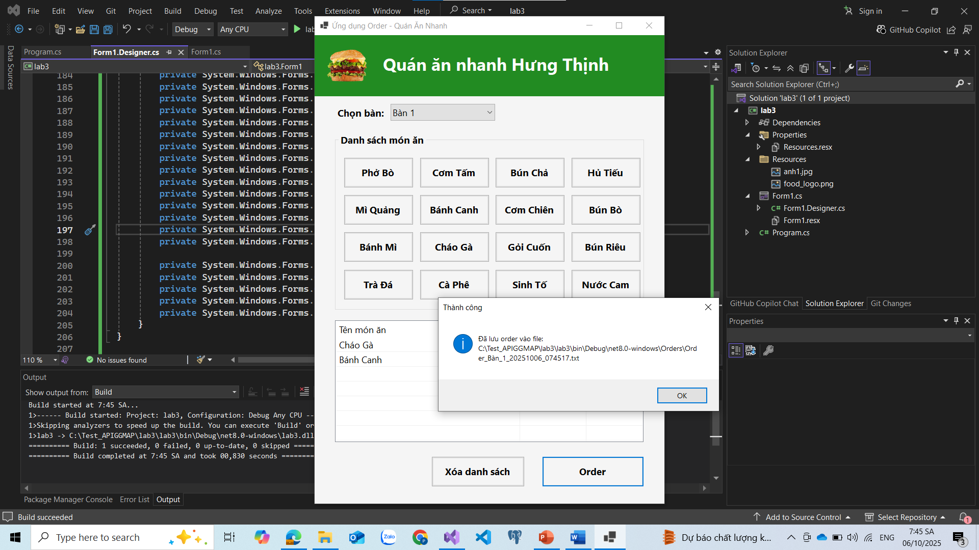
Thực hành 2: Tạo mới 1 project có tên là “ThucHanh2” với form chính được minh họa như sau:
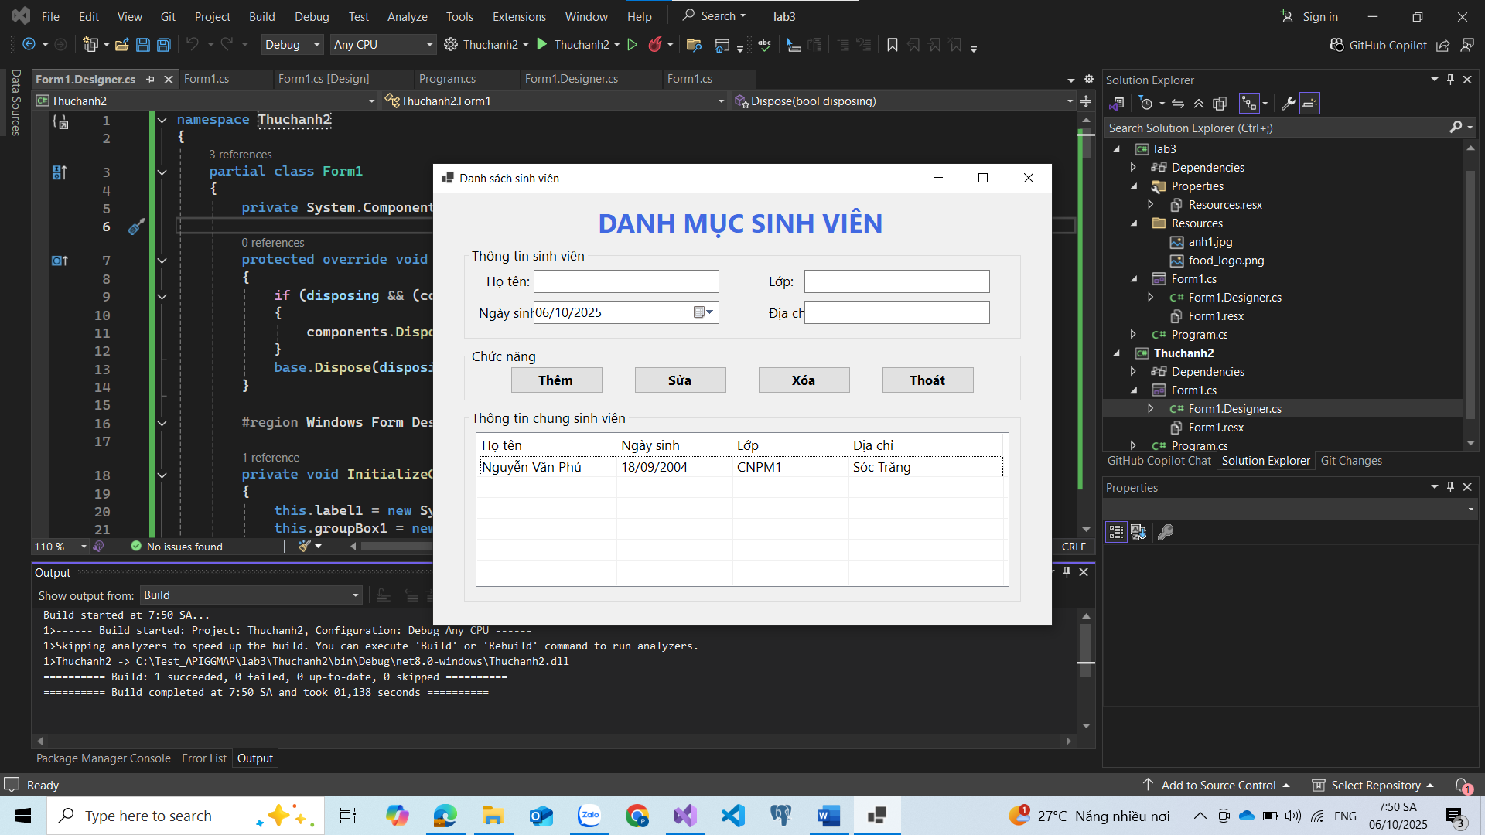
Form1.cs
using System;
using System.Windows.Forms;

namespace Thuchanh2
{
public partial class Form1 : Form
{
public Form1()
{
InitializeComponent();
}

private void btnThem_Click(object sender, EventArgs e)
{
if (txtHoTen.Text.Trim() == "")
{
MessageBox.Show("Họ tên không được để trống!", "Thông báo", MessageBoxButtons.OK, MessageBoxIcon.Warning);
return;
}

ListViewItem item = new ListViewItem(txtHoTen.Text);
item.SubItems.Add(dtpNgaySinh.Value.ToShortDateString());
item.SubItems.Add(txtLop.Text);
item.SubItems.Add(txtDiaChi.Text);
lvSinhVien.Items.Add(item);

ClearInputs();
}

private void btnXoa_Click(object sender, EventArgs e)
{
if (lvSinhVien.SelectedItems.Count == 0)
{
MessageBox.Show("Vui lòng chọn 1 dòng để xóa!", "Thông báo", MessageBoxButtons.OK, MessageBoxIcon.Warning);
return;
}

lvSinhVien.Items.Remove(lvSinhVien.SelectedItems[0]);
ClearInputs();
}

private void btnSua_Click(object sender, EventArgs e)
{
if (lvSinhVien.SelectedItems.Count == 0)
{
MessageBox.Show("Vui lòng chọn 1 dòng để sửa!", "Thông báo", MessageBoxButtons.OK, MessageBoxIcon.Warning);
return;
}

ListViewItem item = lvSinhVien.SelectedItems[0];
item.Text = txtHoTen.Text;
item.SubItems[1].Text = dtpNgaySinh.Value.ToShortDateString();
item.SubItems[2].Text = txtLop.Text;
item.SubItems[3].Text = txtDiaChi.Text;
}

private void btnThoat_Click(object sender, EventArgs e)
{
Application.Exit();
}

private void lvSinhVien_SelectedIndexChanged(object sender, EventArgs e)
{
if (lvSinhVien.SelectedItems.Count > 0)
{
ListViewItem item = lvSinhVien.SelectedItems[0];
txtHoTen.Text = item.Text;
dtpNgaySinh.Text = item.SubItems[1].Text;
txtLop.Text = item.SubItems[2].Text;
txtDiaChi.Text = item.SubItems[3].Text;
}
}

private void ClearInputs()
{
txtHoTen.Clear();
txtLop.Clear();
txtDiaChi.Clear();
dtpNgaySinh.Value = DateTime.Now;
}
}
}
Form1.designer.cs
namespace Thuchanh2
{
partial class Form1
{
private System.ComponentModel.IContainer components = null;

protected override void Dispose(bool disposing)
{
if (disposing && (components != null))
{
components.Dispose();
}
base.Dispose(disposing);
}

#region Windows Form Designer generated code

private void InitializeComponent()
{
this.label1 = new System.Windows.Forms.Label();
this.groupBox1 = new System.Windows.Forms.GroupBox();
this.txtDiaChi = new System.Windows.Forms.TextBox();
this.dtpNgaySinh = new System.Windows.Forms.DateTimePicker();
this.txtLop = new System.Windows.Forms.TextBox();
this.txtHoTen = new System.Windows.Forms.TextBox();
this.label5 = new System.Windows.Forms.Label();
this.label4 = new System.Windows.Forms.Label();
this.label3 = new System.Windows.Forms.Label();
this.label2 = new System.Windows.Forms.Label();
this.groupBox2 = new System.Windows.Forms.GroupBox();
this.btnThoat = new System.Windows.Forms.Button();
this.btnXoa = new System.Windows.Forms.Button();
this.btnSua = new System.Windows.Forms.Button();
this.btnThem = new System.Windows.Forms.Button();
this.groupBox3 = new System.Windows.Forms.GroupBox();
this.lvSinhVien = new System.Windows.Forms.ListView();
this.colHoTen = ((System.Windows.Forms.ColumnHeader)(new System.Windows.Forms.ColumnHeader()));
this.colNgaySinh = ((System.Windows.Forms.ColumnHeader)(new System.Windows.Forms.ColumnHeader()));
this.colLop = ((System.Windows.Forms.ColumnHeader)(new System.Windows.Forms.ColumnHeader()));
this.colDiaChi = ((System.Windows.Forms.ColumnHeader)(new System.Windows.Forms.ColumnHeader()));
this.groupBox1.SuspendLayout();
this.groupBox2.SuspendLayout();
this.groupBox3.SuspendLayout();
this.SuspendLayout();

//
// label1 - tiêu đề
//
this.label1.Font = new System.Drawing.Font("Segoe UI", 20F, System.Drawing.FontStyle.Bold);
this.label1.ForeColor = System.Drawing.Color.RoyalBlue;
this.label1.Location = new System.Drawing.Point(100, 15);
this.label1.Name = "label1";
this.label1.Size = new System.Drawing.Size(600, 45);
this.label1.Text = "DANH MỤC SINH VIÊN";
this.label1.TextAlign = System.Drawing.ContentAlignment.MiddleCenter;

//
// groupBox1 - Thông tin sinh viên
//
this.groupBox1.Controls.Add(this.txtDiaChi);
this.groupBox1.Controls.Add(this.dtpNgaySinh);
this.groupBox1.Controls.Add(this.txtLop);
this.groupBox1.Controls.Add(this.txtHoTen);
this.groupBox1.Controls.Add(this.label5);
this.groupBox1.Controls.Add(this.label4);
this.groupBox1.Controls.Add(this.label3);
this.groupBox1.Controls.Add(this.label2);
this.groupBox1.Font = new System.Drawing.Font("Segoe UI", 10F);
this.groupBox1.Location = new System.Drawing.Point(40, 70);
this.groupBox1.Size = new System.Drawing.Size(720, 120);
this.groupBox1.Text = "Thông tin sinh viên";

//
// txtHoTen
//
this.txtHoTen.Font = new System.Drawing.Font("Segoe UI", 10F);
this.txtHoTen.Location = new System.Drawing.Point(90, 30);
this.txtHoTen.Size = new System.Drawing.Size(240, 25);

//
// txtLop
//
this.txtLop.Font = new System.Drawing.Font("Segoe UI", 10F);
this.txtLop.Location = new System.Drawing.Point(440, 30);
this.txtLop.Size = new System.Drawing.Size(240, 25);

//
// dtpNgaySinh
//
this.dtpNgaySinh.Font = new System.Drawing.Font("Segoe UI", 10F);
this.dtpNgaySinh.Format = System.Windows.Forms.DateTimePickerFormat.Short;
this.dtpNgaySinh.Location = new System.Drawing.Point(90, 70);
this.dtpNgaySinh.Size = new System.Drawing.Size(240, 25);

//
// txtDiaChi
//
this.txtDiaChi.Font = new System.Drawing.Font("Segoe UI", 10F);
this.txtDiaChi.Location = new System.Drawing.Point(440, 70);
this.txtDiaChi.Size = new System.Drawing.Size(240, 25);

//
// label2 - label5
//
this.label2.Text = "Họ tên:";
this.label2.Location = new System.Drawing.Point(25, 33);
this.label2.AutoSize = true;

this.label3.Text = "Lớp:";
this.label3.Location = new System.Drawing.Point(390, 33);
this.label3.AutoSize = true;

this.label4.Text = "Ngày sinh:";
this.label4.Location = new System.Drawing.Point(15, 74);
this.label4.AutoSize = true;

this.label5.Text = "Địa chỉ:";
this.label5.Location = new System.Drawing.Point(390, 74);
this.label5.AutoSize = true;

//
// groupBox2 - Chức năng
//
this.groupBox2.Controls.Add(this.btnThoat);
this.groupBox2.Controls.Add(this.btnXoa);
this.groupBox2.Controls.Add(this.btnSua);
this.groupBox2.Controls.Add(this.btnThem);
this.groupBox2.Font = new System.Drawing.Font("Segoe UI", 10F);
this.groupBox2.Location = new System.Drawing.Point(40, 200);
this.groupBox2.Size = new System.Drawing.Size(720, 70);
this.groupBox2.Text = "Chức năng";

//
// Buttons
//
var btnFont = new System.Drawing.Font("Segoe UI", 10F, System.Drawing.FontStyle.Bold);

this.btnThem.Font = btnFont;
this.btnThem.Text = "Thêm";
this.btnThem.Size = new System.Drawing.Size(120, 35);
this.btnThem.Location = new System.Drawing.Point(60, 25);
this.btnThem.Click += new System.EventHandler(this.btnThem_Click);

this.btnSua.Font = btnFont;
this.btnSua.Text = "Sửa";
this.btnSua.Size = new System.Drawing.Size(120, 35);
this.btnSua.Location = new System.Drawing.Point(220, 25);
this.btnSua.Click += new System.EventHandler(this.btnSua_Click);

this.btnXoa.Font = btnFont;
this.btnXoa.Text = "Xóa";
this.btnXoa.Size = new System.Drawing.Size(120, 35);
this.btnXoa.Location = new System.Drawing.Point(380, 25);
this.btnXoa.Click += new System.EventHandler(this.btnXoa_Click);

this.btnThoat.Font = btnFont;
this.btnThoat.Text = "Thoát";
this.btnThoat.Size = new System.Drawing.Size(120, 35);
this.btnThoat.Location = new System.Drawing.Point(540, 25);
this.btnThoat.Click += new System.EventHandler(this.btnThoat_Click);

//
// groupBox3 - Thông tin chung
//
this.groupBox3.Controls.Add(this.lvSinhVien);
this.groupBox3.Font = new System.Drawing.Font("Segoe UI", 10F);
this.groupBox3.Location = new System.Drawing.Point(40, 280);
this.groupBox3.Size = new System.Drawing.Size(720, 250);
this.groupBox3.Text = "Thông tin chung sinh viên";

//
// lvSinhVien
//
this.lvSinhVien.Columns.AddRange(new System.Windows.Forms.ColumnHeader[] {
this.colHoTen,
this.colNgaySinh,
this.colLop,
this.colDiaChi});
this.lvSinhVien.Font = new System.Drawing.Font("Segoe UI", 10F);
this.lvSinhVien.FullRowSelect = true;
this.lvSinhVien.GridLines = true;
this.lvSinhVien.View = System.Windows.Forms.View.Details;
this.lvSinhVien.Location = new System.Drawing.Point(15, 30);
this.lvSinhVien.Size = new System.Drawing.Size(690, 200);
this.lvSinhVien.SelectedIndexChanged += new System.EventHandler(this.lvSinhVien_SelectedIndexChanged);

this.colHoTen.Text = "Họ tên";
this.colHoTen.Width = 180;

this.colNgaySinh.Text = "Ngày sinh";
this.colNgaySinh.Width = 150;

this.colLop.Text = "Lớp";
this.colLop.Width = 150;

this.colDiaChi.Text = "Địa chỉ";
this.colDiaChi.Width = 200;

//
// Form1
//
this.ClientSize = new System.Drawing.Size(800, 560);
this.Controls.Add(this.label1);
this.Controls.Add(this.groupBox1);
this.Controls.Add(this.groupBox2);
this.Controls.Add(this.groupBox3);
this.Font = new System.Drawing.Font("Segoe UI", 9F);
this.Text = "Danh sách sinh viên";
this.StartPosition = System.Windows.Forms.FormStartPosition.CenterScreen;
this.groupBox1.ResumeLayout(false);
this.groupBox1.PerformLayout();
this.groupBox2.ResumeLayout(false);
this.groupBox3.ResumeLayout(false);
this.ResumeLayout(false);
}

#endregion

private System.Windows.Forms.Label label1;
private System.Windows.Forms.GroupBox groupBox1;
private System.Windows.Forms.TextBox txtDiaChi;
private System.Windows.Forms.DateTimePicker dtpNgaySinh;
private System.Windows.Forms.TextBox txtLop;
private System.Windows.Forms.TextBox txtHoTen;
private System.Windows.Forms.Label label5;
private System.Windows.Forms.Label label4;
private System.Windows.Forms.Label label3;
private System.Windows.Forms.Label label2;
private System.Windows.Forms.GroupBox groupBox2;
private System.Windows.Forms.Button btnThoat;
private System.Windows.Forms.Button btnXoa;
private System.Windows.Forms.Button btnSua;
private System.Windows.Forms.Button btnThem;
private System.Windows.Forms.GroupBox groupBox3;
private System.Windows.Forms.ListView lvSinhVien;
private System.Windows.Forms.ColumnHeader colHoTen;
private System.Windows.Forms.ColumnHeader colNgaySinh;
private System.Windows.Forms.ColumnHeader colLop;
private System.Windows.Forms.ColumnHeader colDiaChi;
}
}
LAB 4:
WINFORM KẾT NỐI CƠ SỞ DỮ LIỆU CƠ BẢN
Thực hành 1: Tạo kết nối giữa Winform và CSDL.
Kết nối với PostgreSQL
Tạo Database
Vào Microsoft visual studio, Mở Solution Explorer, Click chuột phải vào project → Manage NuGet Packages, Chọn tab Browse, Gõ Npgsql → Cài gói: npqsql
Tạo một biến kết nối
string connStr = "Host=localhost;Port=5432;Username=postgres;Password=123456;Database=qlsinhvien";
Thay đổi username, password,database phù hợp với bài của mình
Test kết nối
From1.cs
using Npgsql;
using System.Data;
using System.Windows.Forms;

namespace lab4
{
public partial class Form1 : Form
{
// 🔷 CHUỖI KẾT NỐI ĐẶT Ở ĐÂY
string connStr = "Host=localhost;Port=5432;Username=postgres;Password=123456;Database=qlsinhvien";

NpgsqlConnection conn;

public Form1()
{
InitializeComponent();
}

private void btnMoKetNoi_Click(object sender, EventArgs e)
{
try
{
if (conn == null)
conn = new NpgsqlConnection(connStr);

if (conn.State == ConnectionState.Closed)
{
conn.Open();
MessageBox.Show("Kết nối thành công!");
}
}
catch (Exception ex)
{
MessageBox.Show("Lỗi: " + ex.Message);
}
}
}
}
Form1.designer.cs
namespace lab4
{
partial class Form1
{
private System.ComponentModel.IContainer components = null;

// Khai báo nút mở kết nối
private System.Windows.Forms.Button btnMoKetNoi;

protected override void Dispose(bool disposing)
{
if (disposing && (components != null))
{
components.Dispose();
}
base.Dispose(disposing);
}

private void InitializeComponent()
{
this.btnMoKetNoi = new System.Windows.Forms.Button();
this.SuspendLayout();
//
// btnMoKetNoi
//
this.btnMoKetNoi.Location = new System.Drawing.Point(100, 50);
this.btnMoKetNoi.Name = "btnMoKetNoi";
this.btnMoKetNoi.Size = new System.Drawing.Size(150, 40);
this.btnMoKetNoi.TabIndex = 0;
this.btnMoKetNoi.Text = "Mở kết nối";
this.btnMoKetNoi.UseVisualStyleBackColor = true;
this.btnMoKetNoi.Click += new System.EventHandler(this.btnMoKetNoi_Click);
//
// Form1
//
this.ClientSize = new System.Drawing.Size(350, 150);
this.Controls.Add(this.btnMoKetNoi);
this.Name = "Form1";
this.Text = "Kết nối PostgreSQL";
this.ResumeLayout(false);
}
}
}
2. Truy vấn lấy 1 dòng dữ liệu
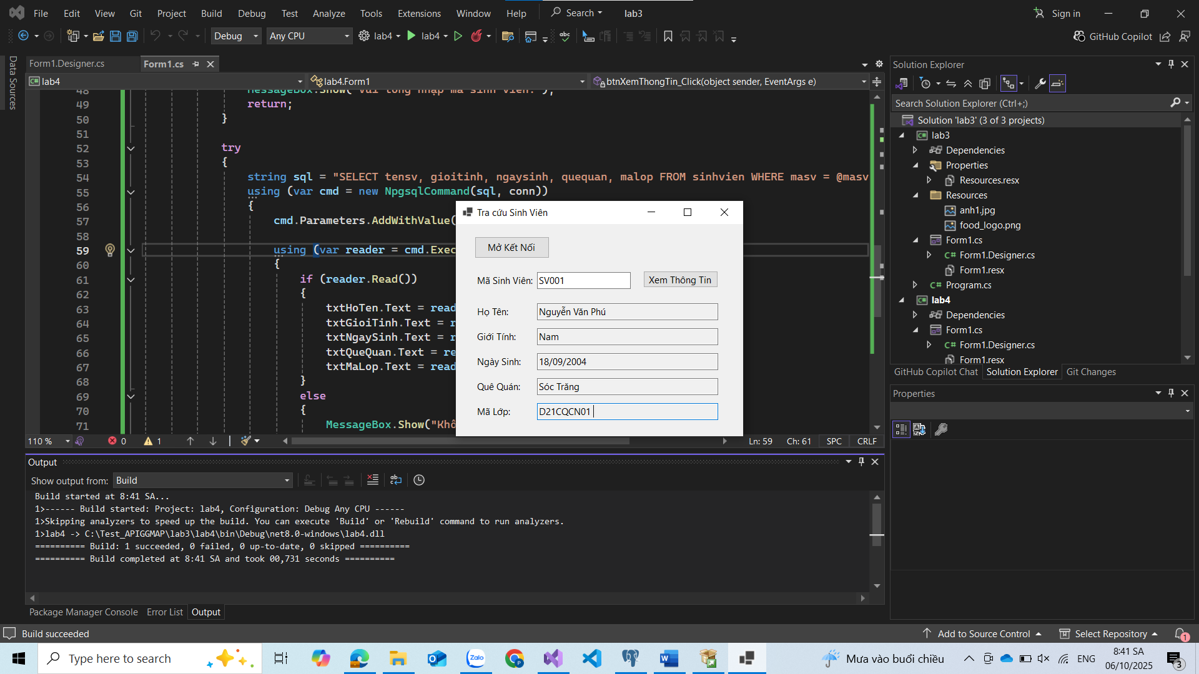
Form1.cs
using Npgsql;
using System;
using System.Data;
using System.Windows.Forms;

namespace lab4
{
public partial class Form1 : Form
{
string connStr = "Host=localhost;Port=5432;Username=postgres;Password=123456;Database=qlsinhvien";
NpgsqlConnection conn;

public Form1()
{
InitializeComponent();
}

private void btnMoKetNoi_Click(object sender, EventArgs e)
{
try
{
if (conn == null)
conn = new NpgsqlConnection(connStr);

if (conn.State == ConnectionState.Closed)
{
conn.Open();
MessageBox.Show("Kết nối thành công!");
}
}
catch (Exception ex)
{
MessageBox.Show("Lỗi: " + ex.Message);
}
}

private void btnXemThongTin_Click(object sender, EventArgs e)
{
if (conn == null || conn.State == ConnectionState.Closed)
{
MessageBox.Show("Bạn chưa mở kết nối!");
return;
}

string maSV = txtMaSV.Text.Trim();
if (string.IsNullOrEmpty(maSV))
{
MessageBox.Show("Vui lòng nhập mã sinh viên.");
return;
}

try
{
string sql = "SELECT tensv, gioitinh, ngaysinh, quequan, malop FROM sinhvien WHERE masv = @masv";
using (var cmd = new NpgsqlCommand(sql, conn))
{
cmd.Parameters.AddWithValue("masv", maSV);

using (var reader = cmd.ExecuteReader())
{
if (reader.Read())
{
txtHoTen.Text = reader.GetString(0);
txtGioiTinh.Text = reader.GetString(1);
txtNgaySinh.Text = reader.GetDateTime(2).ToString("dd/MM/yyyy");
txtQueQuan.Text = reader.GetString(3);
txtMaLop.Text = reader.GetString(4);
}
else
{
MessageBox.Show("Không tìm thấy sinh viên có mã này.");
}
}
}
}
catch (Exception ex)
{
MessageBox.Show("Lỗi truy vấn: " + ex.Message);
}
}
}
}
Form1.designer.cs
namespace lab4
{
partial class Form1
{
private System.ComponentModel.IContainer components = null;

private System.Windows.Forms.Button btnMoKetNoi;
private System.Windows.Forms.Button btnXemThongTin;

private System.Windows.Forms.TextBox txtMaSV;
private System.Windows.Forms.TextBox txtHoTen;
private System.Windows.Forms.TextBox txtGioiTinh;
private System.Windows.Forms.TextBox txtNgaySinh;
private System.Windows.Forms.TextBox txtQueQuan;
private System.Windows.Forms.TextBox txtMaLop;

private System.Windows.Forms.Label labelMaSV;
private System.Windows.Forms.Label labelHoTen;
private System.Windows.Forms.Label labelGioiTinh;
private System.Windows.Forms.Label labelNgaySinh;
private System.Windows.Forms.Label labelQueQuan;
private System.Windows.Forms.Label labelMaLop;

protected override void Dispose(bool disposing)
{
if (disposing && (components != null))
{
components.Dispose();
}
base.Dispose(disposing);
}

private void InitializeComponent()
{
this.btnMoKetNoi = new System.Windows.Forms.Button();
this.btnXemThongTin = new System.Windows.Forms.Button();

this.txtMaSV = new System.Windows.Forms.TextBox();
this.txtHoTen = new System.Windows.Forms.TextBox();
this.txtGioiTinh = new System.Windows.Forms.TextBox();
this.txtNgaySinh = new System.Windows.Forms.TextBox();
this.txtQueQuan = new System.Windows.Forms.TextBox();
this.txtMaLop = new System.Windows.Forms.TextBox();

this.labelMaSV = new System.Windows.Forms.Label();
this.labelHoTen = new System.Windows.Forms.Label();
this.labelGioiTinh = new System.Windows.Forms.Label();
this.labelNgaySinh = new System.Windows.Forms.Label();
this.labelQueQuan = new System.Windows.Forms.Label();
this.labelMaLop = new System.Windows.Forms.Label();

//
// btnMoKetNoi
//
this.btnMoKetNoi.Location = new System.Drawing.Point(30, 20);
this.btnMoKetNoi.Name = "btnMoKetNoi";
this.btnMoKetNoi.Size = new System.Drawing.Size(120, 35);
this.btnMoKetNoi.Text = "Mở Kết Nối";
this.btnMoKetNoi.UseVisualStyleBackColor = true;
this.btnMoKetNoi.Click += new System.EventHandler(this.btnMoKetNoi_Click);

//
// labelMaSV
//
this.labelMaSV.AutoSize = true;
this.labelMaSV.Location = new System.Drawing.Point(30, 80);
this.labelMaSV.Name = "labelMaSV";
this.labelMaSV.Size = new System.Drawing.Size(90, 15);
this.labelMaSV.Text = "Mã Sinh Viên:";

//
// txtMaSV
//
this.txtMaSV.Location = new System.Drawing.Point(130, 77);
this.txtMaSV.Name = "txtMaSV";
this.txtMaSV.Size = new System.Drawing.Size(150, 23);

//
// btnXemThongTin
//
this.btnXemThongTin.Location = new System.Drawing.Point(300, 75);
this.btnXemThongTin.Name = "btnXemThongTin";
this.btnXemThongTin.Size = new System.Drawing.Size(120, 27);
this.btnXemThongTin.Text = "Xem Thông Tin";
this.btnXemThongTin.UseVisualStyleBackColor = true;
this.btnXemThongTin.Click += new System.EventHandler(this.btnXemThongTin_Click);

//
// labelHoTen
//
this.labelHoTen.AutoSize = true;
this.labelHoTen.Location = new System.Drawing.Point(30, 130);
this.labelHoTen.Name = "labelHoTen";
this.labelHoTen.Size = new System.Drawing.Size(48, 15);
this.labelHoTen.Text = "Họ Tên:";

//
// txtHoTen
//
this.txtHoTen.Location = new System.Drawing.Point(130, 127);
this.txtHoTen.Name = "txtHoTen";
this.txtHoTen.ReadOnly = true;
this.txtHoTen.Size = new System.Drawing.Size(290, 23);

//
// labelGioiTinh
//
this.labelGioiTinh.AutoSize = true;
this.labelGioiTinh.Location = new System.Drawing.Point(30, 170);
this.labelGioiTinh.Name = "labelGioiTinh";
this.labelGioiTinh.Size = new System.Drawing.Size(58, 15);
this.labelGioiTinh.Text = "Giới Tính:";

//
// txtGioiTinh
//
this.txtGioiTinh.Location = new System.Drawing.Point(130, 167);
this.txtGioiTinh.Name = "txtGioiTinh";
this.txtGioiTinh.ReadOnly = true;
this.txtGioiTinh.Size = new System.Drawing.Size(290, 23);

//
// labelNgaySinh
//
this.labelNgaySinh.AutoSize = true;
this.labelNgaySinh.Location = new System.Drawing.Point(30, 210);
this.labelNgaySinh.Name = "labelNgaySinh";
this.labelNgaySinh.Size = new System.Drawing.Size(64, 15);
this.labelNgaySinh.Text = "Ngày Sinh:";

//
// txtNgaySinh
//
this.txtNgaySinh.Location = new System.Drawing.Point(130, 207);
this.txtNgaySinh.Name = "txtNgaySinh";
this.txtNgaySinh.ReadOnly = true;
this.txtNgaySinh.Size = new System.Drawing.Size(290, 23);

//
// labelQueQuan
//
this.labelQueQuan.AutoSize = true;
this.labelQueQuan.Location = new System.Drawing.Point(30, 250);
this.labelQueQuan.Name = "labelQueQuan";
this.labelQueQuan.Size = new System.Drawing.Size(64, 15);
this.labelQueQuan.Text = "Quê Quán:";

//
// txtQueQuan
//
this.txtQueQuan.Location = new System.Drawing.Point(130, 247);
this.txtQueQuan.Name = "txtQueQuan";
this.txtQueQuan.ReadOnly = true;
this.txtQueQuan.Size = new System.Drawing.Size(290, 23);

//
// labelMaLop
//
this.labelMaLop.AutoSize = true;
this.labelMaLop.Location = new System.Drawing.Point(30, 290);
this.labelMaLop.Name = "labelMaLop";
this.labelMaLop.Size = new System.Drawing.Size(47, 15);
this.labelMaLop.Text = "Mã Lớp:";

//
// txtMaLop
//
this.txtMaLop.Location = new System.Drawing.Point(130, 287);
this.txtMaLop.Name = "txtMaLop";
this.txtMaLop.ReadOnly = true;
this.txtMaLop.Size = new System.Drawing.Size(290, 23);

//
// Form1
//
this.ClientSize = new System.Drawing.Size(460, 340);
this.Controls.Add(this.btnMoKetNoi);
this.Controls.Add(this.labelMaSV);
this.Controls.Add(this.txtMaSV);
this.Controls.Add(this.btnXemThongTin);
this.Controls.Add(this.labelHoTen);
this.Controls.Add(this.txtHoTen);
this.Controls.Add(this.labelGioiTinh);
this.Controls.Add(this.txtGioiTinh);
this.Controls.Add(this.labelNgaySinh);
this.Controls.Add(this.txtNgaySinh);
this.Controls.Add(this.labelQueQuan);
this.Controls.Add(this.txtQueQuan);
this.Controls.Add(this.labelMaLop);
this.Controls.Add(this.txtMaLop);

this.Name = "Form1";
this.Text = "Tra cứu Sinh Viên";
this.StartPosition = System.Windows.Forms.FormStartPosition.CenterScreen;
}
}
}
3. Truy vấn lấy nhiều dòng dữ liệu
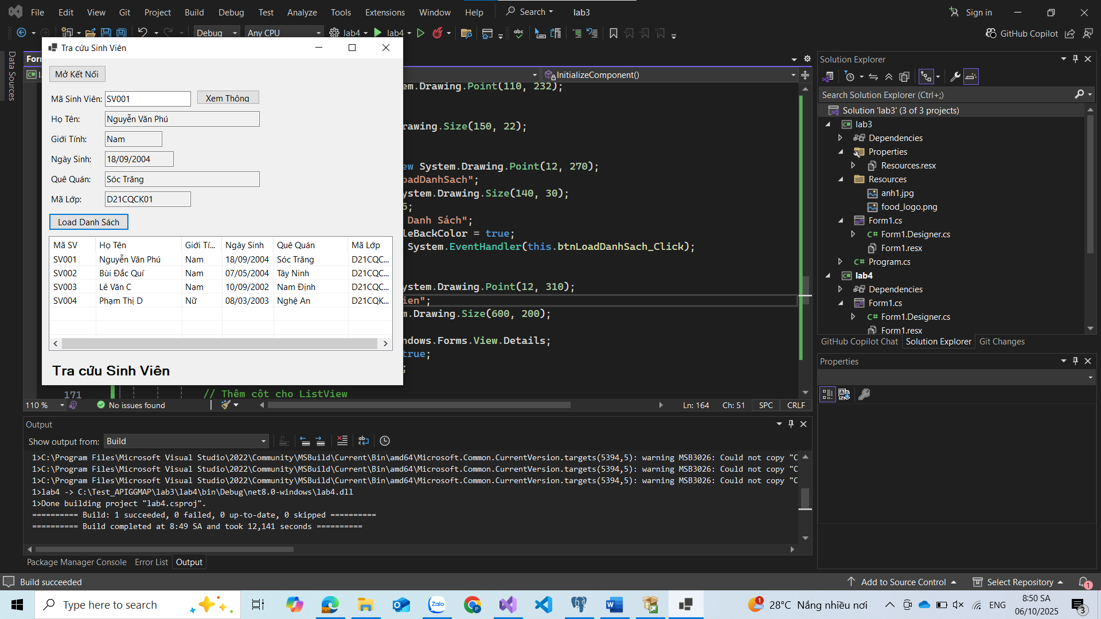
Form1.cs
using Npgsql;
using System;
using System.Data;
using System.Windows.Forms;

namespace lab4
{
public partial class Form1 : Form
{
string connStr = "Host=localhost;Port=5432;Username=postgres;Password=123456;Database=qlsinhvien";
NpgsqlConnection conn;

public Form1()
{
InitializeComponent();
}

// Mở kết nối
private void btnMoKetNoi_Click(object sender, EventArgs e)
{
try
{
if (conn == null)
conn = new NpgsqlConnection(connStr);

if (conn.State == ConnectionState.Closed)
{
conn.Open();
MessageBox.Show("Kết nối thành công!");
}
else
{
MessageBox.Show("Kết nối đã mở.");
}
}
catch (Exception ex)
{
MessageBox.Show("Lỗi: " + ex.Message);
}
}

// Tìm sinh viên theo mã và hiển thị chi tiết
private void btnXemThongTin_Click(object sender, EventArgs e)
{
if (conn == null || conn.State == ConnectionState.Closed)
{
MessageBox.Show("Bạn chưa mở kết nối!");
return;
}

string maSV = txtMaSV.Text.Trim();
if (string.IsNullOrEmpty(maSV))
{
MessageBox.Show("Vui lòng nhập mã sinh viên.");
return;
}

try
{
string sql = "SELECT tensv, gioitinh, ngaysinh, quequan, malop FROM sinhvien WHERE masv = @masv";
using (var cmd = new NpgsqlCommand(sql, conn))
{
cmd.Parameters.AddWithValue("masv", maSV);

using (var reader = cmd.ExecuteReader())
{
if (reader.Read())
{
txtHoTen.Text = reader.GetString(0);
txtGioiTinh.Text = reader.GetString(1);
txtNgaySinh.Text = reader.GetDateTime(2).ToString("dd/MM/yyyy");
txtQueQuan.Text = reader.GetString(3);
txtMaLop.Text = reader.GetString(4);
}
else
{
MessageBox.Show("Không tìm thấy sinh viên có mã này.");
ClearTextBoxes();
}
}
}
}
catch (Exception ex)
{
MessageBox.Show("Lỗi truy vấn: " + ex.Message);
}
}

// Load tất cả sinh viên và hiển thị lên ListView
private void btnLoadDanhSach_Click(object sender, EventArgs e)
{
if (conn == null || conn.State == ConnectionState.Closed)
{
MessageBox.Show("Bạn chưa mở kết nối!");
return;
}

try
{
string sql = "SELECT masv, tensv, gioitinh, ngaysinh, quequan, malop FROM sinhvien ORDER BY masv";
using (var cmd = new NpgsqlCommand(sql, conn))
using (var reader = cmd.ExecuteReader())
{
lsvSinhVien.Items.Clear();

while (reader.Read())
{
var item = new ListViewItem(reader.GetString(0)); // masv
item.SubItems.Add(reader.GetString(1)); // tensv
item.SubItems.Add(reader.GetString(2)); // gioitinh
item.SubItems.Add(reader.GetDateTime(3).ToString("dd/MM/yyyy")); // ngaysinh
item.SubItems.Add(reader.GetString(4)); // quequan
item.SubItems.Add(reader.GetString(5)); // malop

lsvSinhVien.Items.Add(item);
}
}
}
catch (Exception ex)
{
MessageBox.Show("Lỗi truy vấn: " + ex.Message);
}
}

// Xóa dữ liệu trong các TextBox hiển thị thông tin sinh viên
private void ClearTextBoxes()
{
txtHoTen.Text = "";
txtGioiTinh.Text = "";
txtNgaySinh.Text = "";
txtQueQuan.Text = "";
txtMaLop.Text = "";
}
}
}
Form1.designer.cs
namespace lab4
{
partial class Form1
{
private System.ComponentModel.IContainer components = null;

private System.Windows.Forms.Button btnMoKetNoi;
private System.Windows.Forms.Button btnXemThongTin;
private System.Windows.Forms.Button btnLoadDanhSach;
private System.Windows.Forms.TextBox txtMaSV;
private System.Windows.Forms.TextBox txtHoTen;
private System.Windows.Forms.TextBox txtGioiTinh;
private System.Windows.Forms.TextBox txtNgaySinh;
private System.Windows.Forms.TextBox txtQueQuan;
private System.Windows.Forms.TextBox txtMaLop;
private System.Windows.Forms.ListView lsvSinhVien;

private System.Windows.Forms.Label label1;
private System.Windows.Forms.Label label2;
private System.Windows.Forms.Label label3;
private System.Windows.Forms.Label label4;
private System.Windows.Forms.Label label5;
private System.Windows.Forms.Label label6;
private System.Windows.Forms.Label label7;

protected override void Dispose(bool disposing)
{
if (disposing && (components != null))
{
components.Dispose();
}
base.Dispose(disposing);
}

private void InitializeComponent()
{
this.btnMoKetNoi = new System.Windows.Forms.Button();
this.btnXemThongTin = new System.Windows.Forms.Button();
this.btnLoadDanhSach = new System.Windows.Forms.Button();
this.txtMaSV = new System.Windows.Forms.TextBox();
this.txtHoTen = new System.Windows.Forms.TextBox();
this.txtGioiTinh = new System.Windows.Forms.TextBox();
this.txtNgaySinh = new System.Windows.Forms.TextBox();
this.txtQueQuan = new System.Windows.Forms.TextBox();
this.txtMaLop = new System.Windows.Forms.TextBox();
this.lsvSinhVien = new System.Windows.Forms.ListView();

this.label1 = new System.Windows.Forms.Label();
this.label2 = new System.Windows.Forms.Label();
this.label3 = new System.Windows.Forms.Label();
this.label4 = new System.Windows.Forms.Label();
this.label5 = new System.Windows.Forms.Label();
this.label6 = new System.Windows.Forms.Label();
this.label7 = new System.Windows.Forms.Label();

this.SuspendLayout();

// btnMoKetNoi
this.btnMoKetNoi.Location = new System.Drawing.Point(12, 12);
this.btnMoKetNoi.Name = "btnMoKetNoi";
this.btnMoKetNoi.Size = new System.Drawing.Size(100, 30);
this.btnMoKetNoi.TabIndex = 0;
this.btnMoKetNoi.Text = "Mở Kết Nối";
this.btnMoKetNoi.UseVisualStyleBackColor = true;
this.btnMoKetNoi.Click += new System.EventHandler(this.btnMoKetNoi_Click);

// label1 - Mã Sinh Viên
this.label1.AutoSize = true;
this.label1.Location = new System.Drawing.Point(12, 60);
this.label1.Name = "label1";
this.label1.Size = new System.Drawing.Size(75, 17);
this.label1.Text = "Mã Sinh Viên:";

// txtMaSV
this.txtMaSV.Location = new System.Drawing.Point(110, 57);
this.txtMaSV.Name = "txtMaSV";
this.txtMaSV.Size = new System.Drawing.Size(150, 22);

// btnXemThongTin
this.btnXemThongTin.Location = new System.Drawing.Point(270, 55);
this.btnXemThongTin.Name = "btnXemThongTin";
this.btnXemThongTin.Size = new System.Drawing.Size(110, 25);
this.btnXemThongTin.TabIndex = 3;
this.btnXemThongTin.Text = "Xem Thông Tin";
this.btnXemThongTin.UseVisualStyleBackColor = true;
this.btnXemThongTin.Click += new System.EventHandler(this.btnXemThongTin_Click);

// label2 - Họ Tên
this.label2.AutoSize = true;
this.label2.Location = new System.Drawing.Point(12, 95);
this.label2.Name = "label2";
this.label2.Size = new System.Drawing.Size(52, 17);
this.label2.Text = "Họ Tên:";

// txtHoTen
this.txtHoTen.Location = new System.Drawing.Point(110, 92);
this.txtHoTen.Name = "txtHoTen";
this.txtHoTen.ReadOnly = true;
this.txtHoTen.Size = new System.Drawing.Size(270, 22);

// label3 - Giới Tính
this.label3.AutoSize = true;
this.label3.Location = new System.Drawing.Point(12, 130);
this.label3.Name = "label3";
this.label3.Size = new System.Drawing.Size(65, 17);
this.label3.Text = "Giới Tính:";

// txtGioiTinh
this.txtGioiTinh.Location = new System.Drawing.Point(110, 127);
this.txtGioiTinh.Name = "txtGioiTinh";
this.txtGioiTinh.ReadOnly = true;
this.txtGioiTinh.Size = new System.Drawing.Size(100, 22);

// label4 - Ngày Sinh
this.label4.AutoSize = true;
this.label4.Location = new System.Drawing.Point(12, 165);
this.label4.Name = "label4";
this.label4.Size = new System.Drawing.Size(71, 17);
this.label4.Text = "Ngày Sinh:";

// txtNgaySinh
this.txtNgaySinh.Location = new System.Drawing.Point(110, 162);
this.txtNgaySinh.Name = "txtNgaySinh";
this.txtNgaySinh.ReadOnly = true;
this.txtNgaySinh.Size = new System.Drawing.Size(120, 22);

// label5 - Quê Quán
this.label5.AutoSize = true;
this.label5.Location = new System.Drawing.Point(12, 200);
this.label5.Name = "label5";
this.label5.Size = new System.Drawing.Size(63, 17);
this.label5.Text = "Quê Quán:";

// txtQueQuan
this.txtQueQuan.Location = new System.Drawing.Point(110, 197);
this.txtQueQuan.Name = "txtQueQuan";
this.txtQueQuan.ReadOnly = true;
this.txtQueQuan.Size = new System.Drawing.Size(270, 22);

// label6 - Mã Lớp
this.label6.AutoSize = true;
this.label6.Location = new System.Drawing.Point(12, 235);
this.label6.Name = "label6";
this.label6.Size = new System.Drawing.Size(52, 17);
this.label6.Text = "Mã Lớp:";

// txtMaLop
this.txtMaLop.Location = new System.Drawing.Point(110, 232);
this.txtMaLop.Name = "txtMaLop";
this.txtMaLop.ReadOnly = true;
this.txtMaLop.Size = new System.Drawing.Size(150, 22);

// btnLoadDanhSach
this.btnLoadDanhSach.Location = new System.Drawing.Point(12, 270);
this.btnLoadDanhSach.Name = "btnLoadDanhSach";
this.btnLoadDanhSach.Size = new System.Drawing.Size(140, 30);
this.btnLoadDanhSach.TabIndex = 15;
this.btnLoadDanhSach.Text = "Load Danh Sách";
this.btnLoadDanhSach.UseVisualStyleBackColor = true;
this.btnLoadDanhSach.Click += new System.EventHandler(this.btnLoadDanhSach_Click);

// lsvSinhVien
this.lsvSinhVien.Location = new System.Drawing.Point(12, 310);
this.lsvSinhVien.Name = "lsvSinhVien";
this.lsvSinhVien.Size = new System.Drawing.Size(600, 200);
this.lsvSinhVien.TabIndex = 16;
this.lsvSinhVien.View = System.Windows.Forms.View.Details;
this.lsvSinhVien.FullRowSelect = true;
this.lsvSinhVien.GridLines = true;

// Thêm cột cho ListView
this.lsvSinhVien.Columns.Add("Mã SV", 80);
this.lsvSinhVien.Columns.Add("Họ Tên", 150);
this.lsvSinhVien.Columns.Add("Giới Tính", 70);
this.lsvSinhVien.Columns.Add("Ngày Sinh", 90);
this.lsvSinhVien.Columns.Add("Quê Quán", 130);
this.lsvSinhVien.Columns.Add("Mã Lớp", 80);

// label7 - Tiêu đề form
this.label7.AutoSize = true;
this.label7.Font = new System.Drawing.Font("Microsoft Sans Serif", 14F, System.Drawing.FontStyle.Bold);
this.label7.Location = new System.Drawing.Point(12, 530);
this.label7.Name = "label7";
this.label7.Size = new System.Drawing.Size(180, 29);
this.label7.Text = "Tra cứu Sinh Viên";

// Form1
this.ClientSize = new System.Drawing.Size(630, 570);
this.Controls.Add(this.label7);
this.Controls.Add(this.lsvSinhVien);
this.Controls.Add(this.btnLoadDanhSach);
this.Controls.Add(this.txtMaLop);
this.Controls.Add(this.label6);
this.Controls.Add(this.txtQueQuan);
this.Controls.Add(this.label5);
this.Controls.Add(this.txtNgaySinh);
this.Controls.Add(this.label4);
this.Controls.Add(this.txtGioiTinh);
this.Controls.Add(this.label3);
this.Controls.Add(this.txtHoTen);
this.Controls.Add(this.label2);
this.Controls.Add(this.btnXemThongTin);
this.Controls.Add(this.txtMaSV);
this.Controls.Add(this.label1);
this.Controls.Add(this.btnMoKetNoi);

this.Name = "Form1";
this.Text = "Tra cứu Sinh Viên";
this.ResumeLayout(false);
this.PerformLayout();
}
}
}

