//1.hien thi danh sach bac si va ten khoa
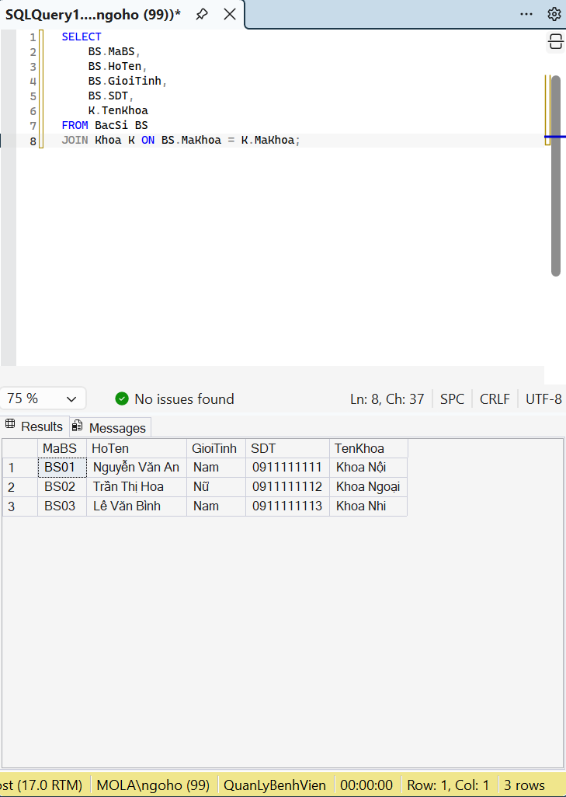

//2.hien thi lich kham cua benh nhan
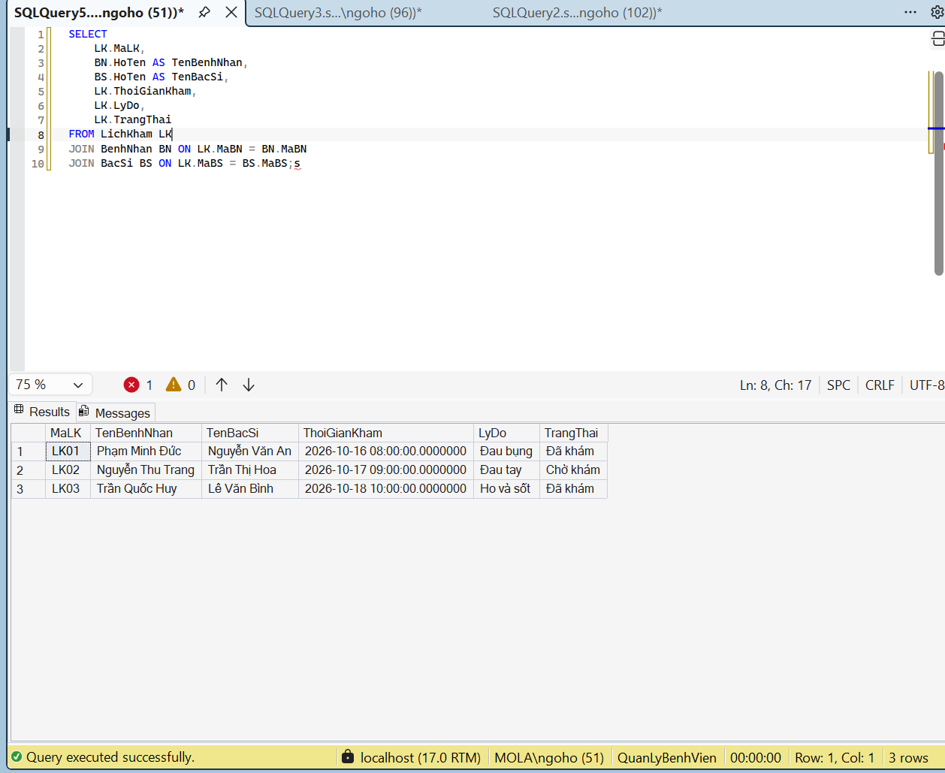

//3.tim cac lich kham dang cho kham
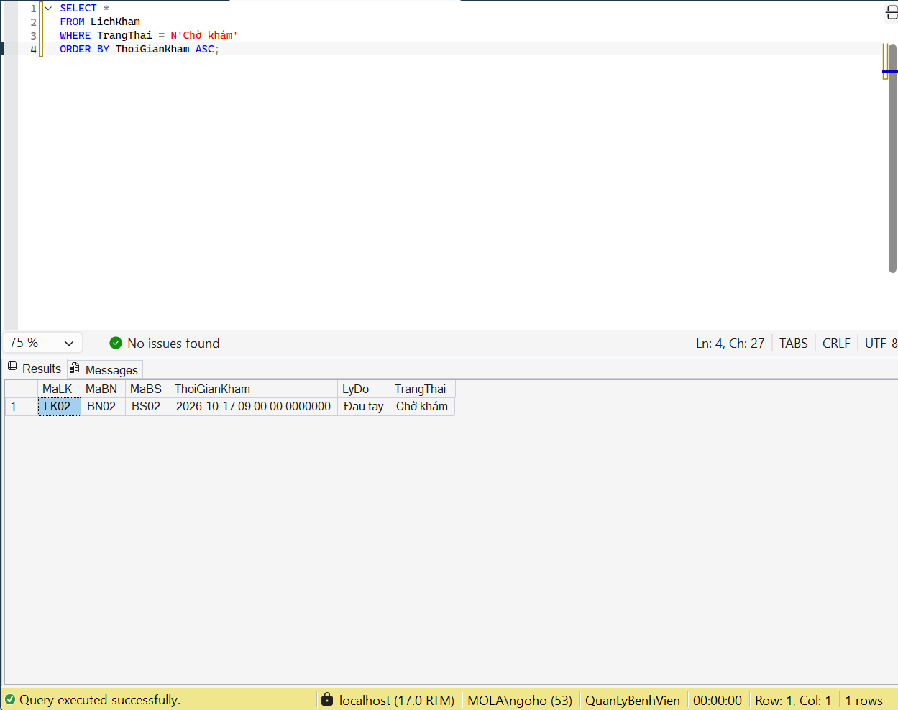

//4.tim benh nhan da kham trong mot khoang thoi gian
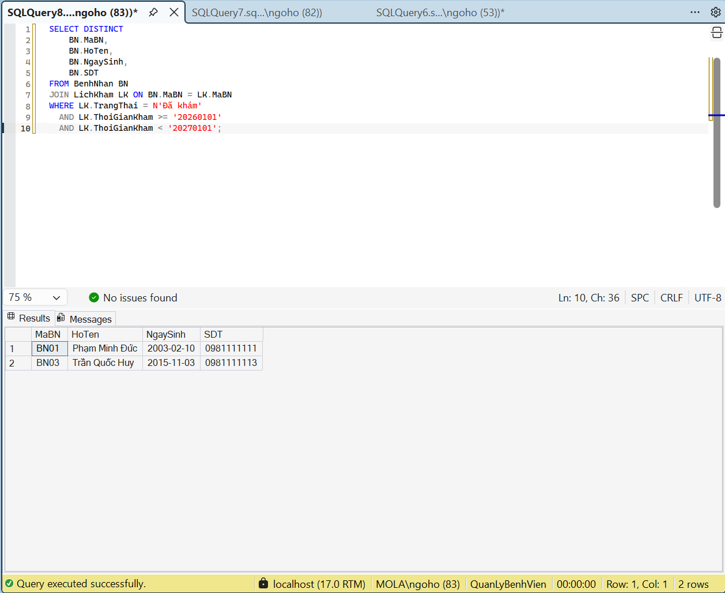

//5.dem so bac si cua tung khoa
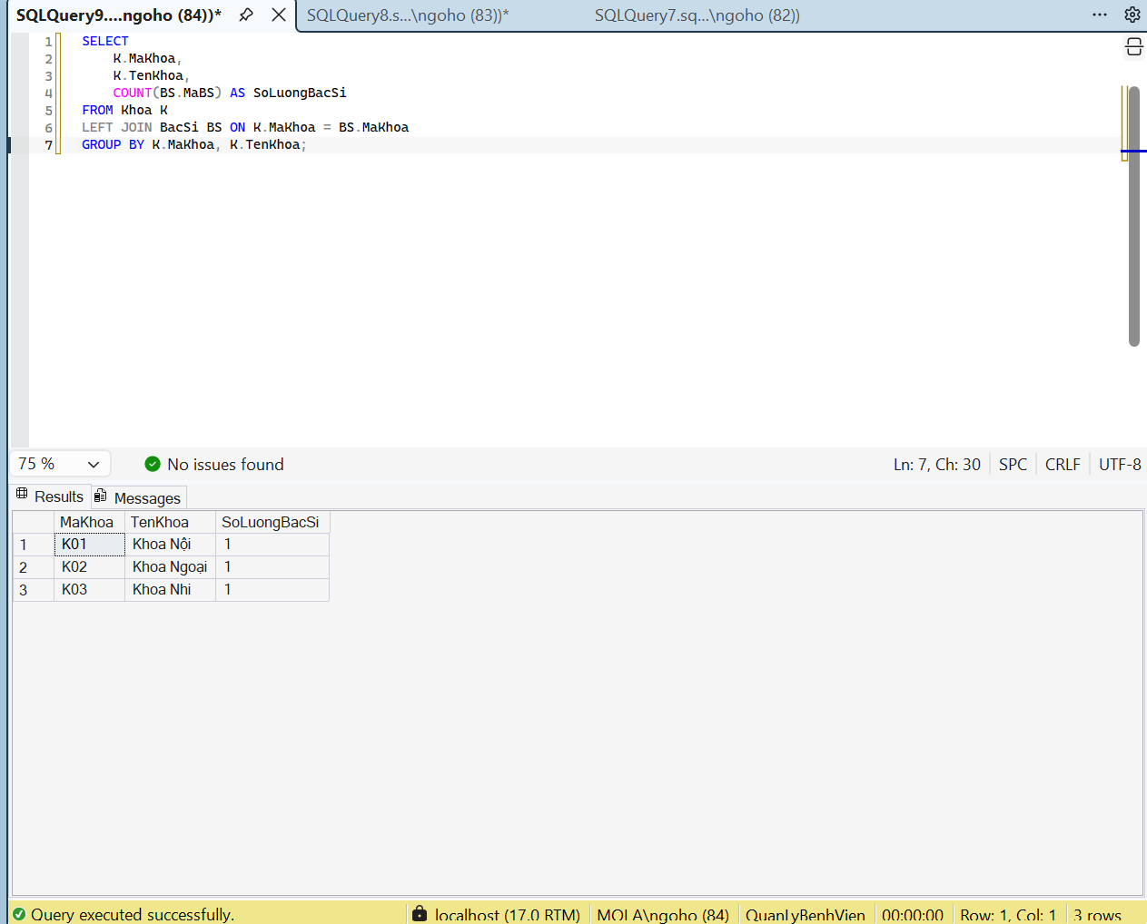

//6.tim cac khoa co 3 bac si tro len
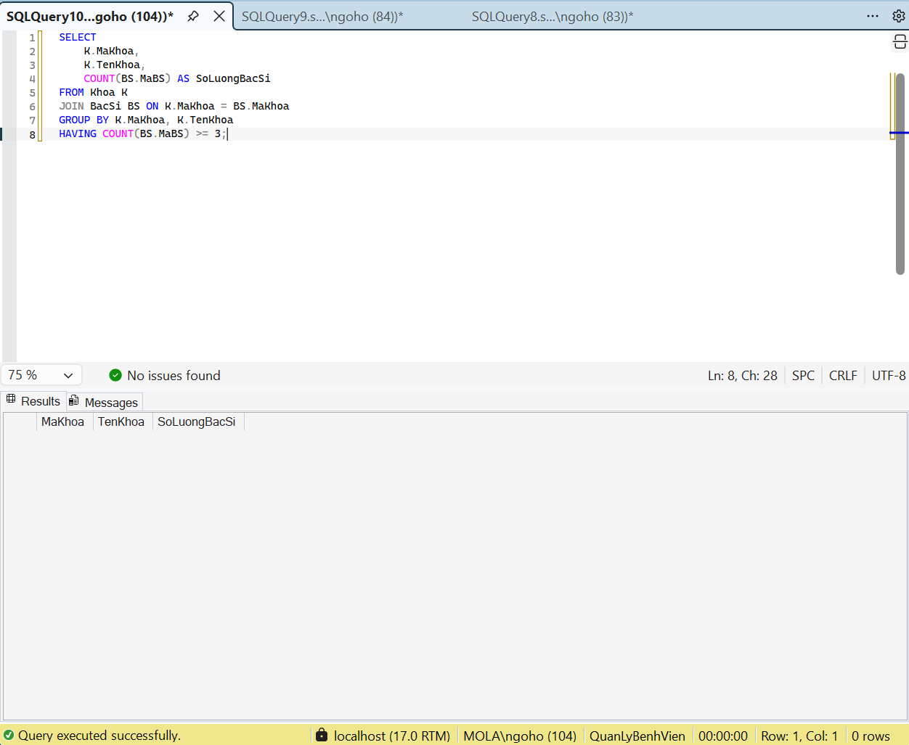

//7.thong ke so lich kham cua tung bac si
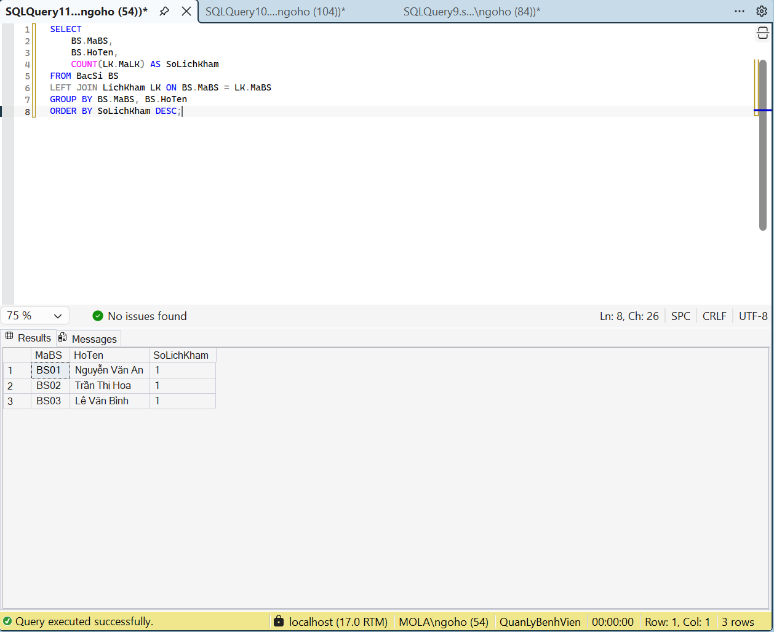

//8.tim cac thuoc co gia ban cao hon gia trung binh tat ca thuoc

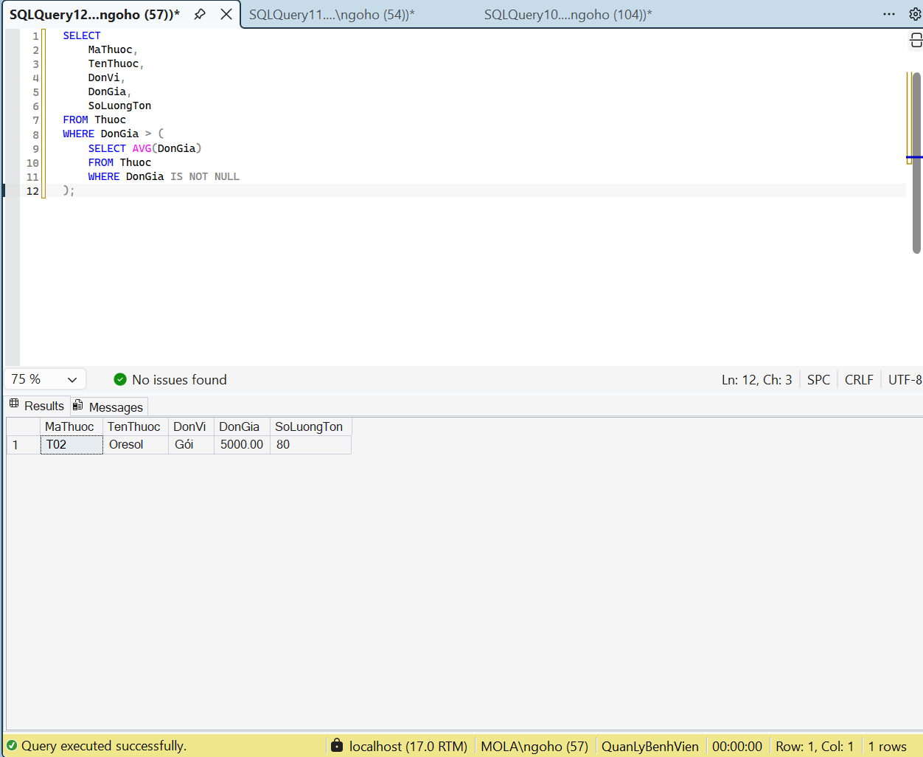

//9.thong ke tong tien thuoc theo tung don thuoc
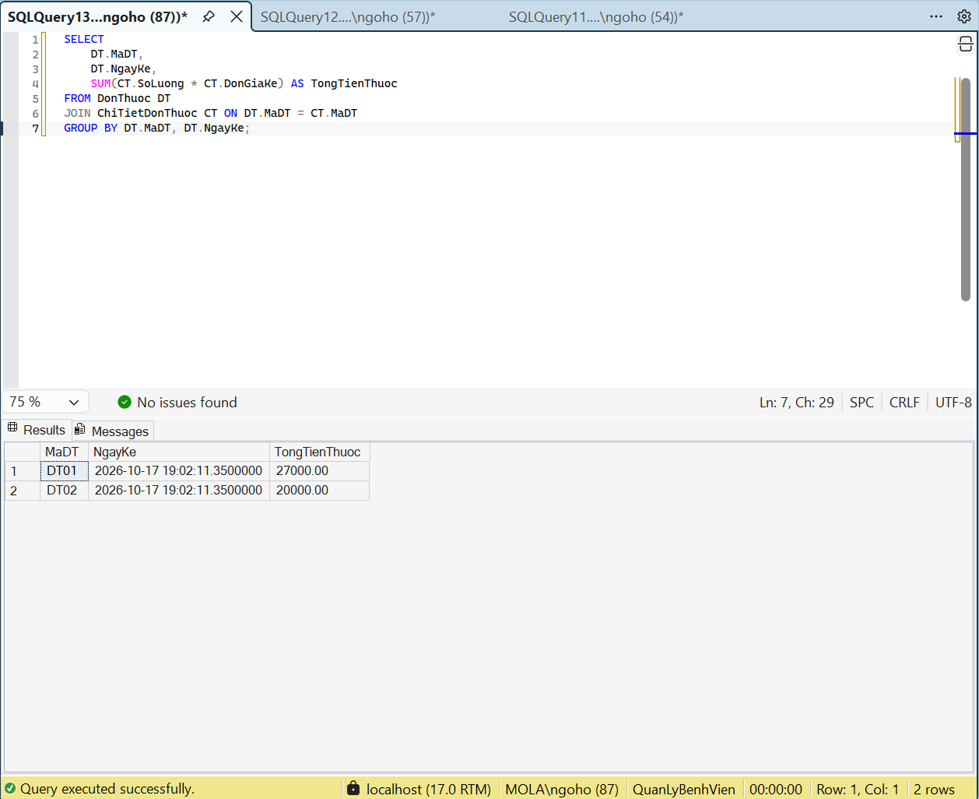

//10.thong ke doanh thu hoa don da thanh toan theo thang

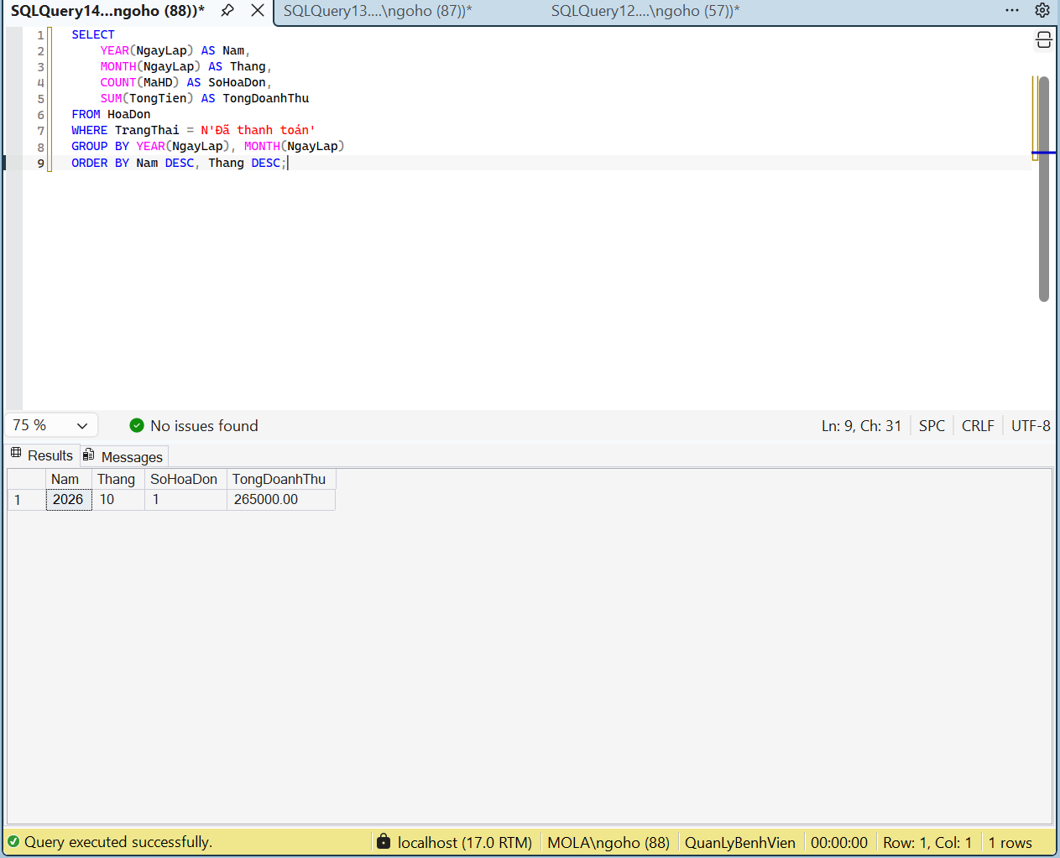

//view1 danh sach lich kham chi tiet
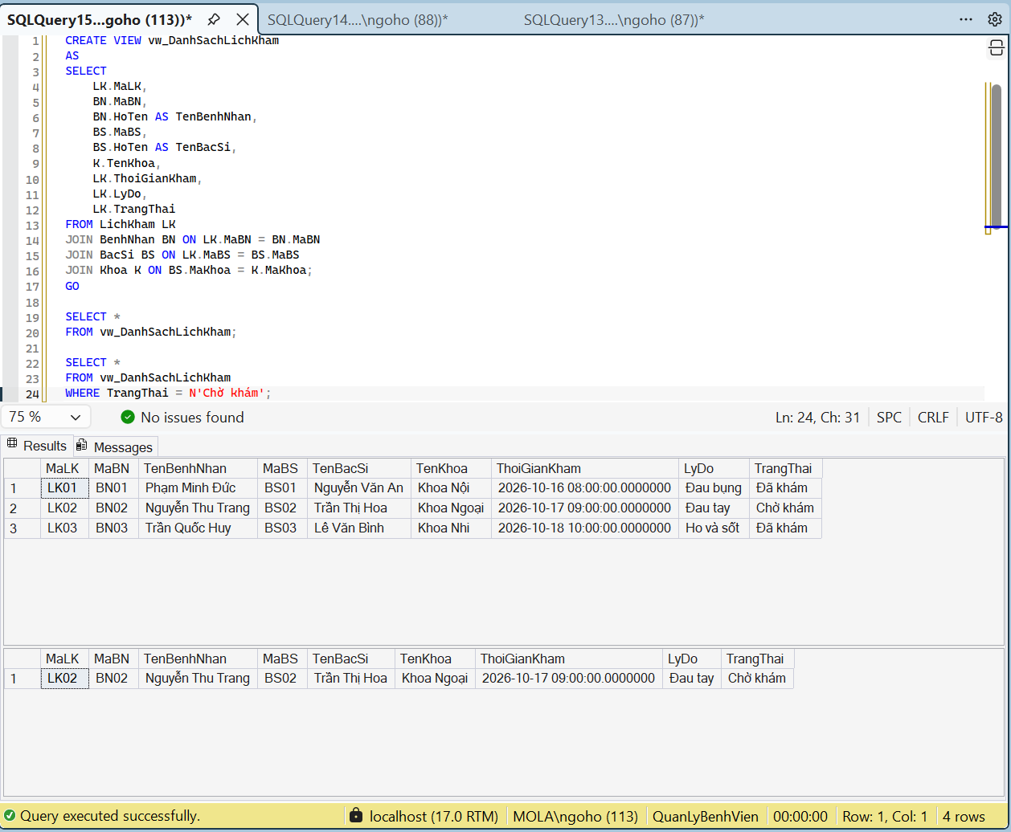

//view2 thong ke hoa don theo benh nhan
