**VISION SEMICON OVEN PROGRAM MANUAL**

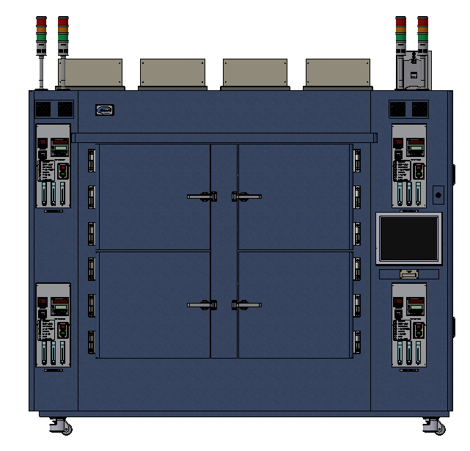

**Program Ver. : 1.4**

**2025. 07. 30**

TABLE OF CONTENTS

● Introductions 3

● Symbols 3

1. Specifications 4

2. Program Operations 4

2.1 Graph 4

2.2 Engineer Mode 5

3. Trouble Shooting 5

3.1 Alarm Window 5

3.2 Alarm List 7

* **Introductions**

This document is the user manual of oven program of Vision Semicon Co., Ltd..

This user manual explains how to use oven program and oven system.

* **Symbols**

** Caution**

This symbol shows that if improper handling can cause the system to be inoperable or result in dangerous consequences or injury to the user.

**Notice**

This symbol shows that user need to know how to use.

**Cautions**

* **Disconnect the system's power breaker before connecting main power.**
* **Do not touch the power source.**
* **Do not disassemble or assemble without consulting the manufacturer.**

1. Overview

VSPO is a specialized software designed for controlling and monitoring industrial thermal chamber systems. The software is built to support operation, real-time data monitoring, and safety control during the heat treatment process. With a modern, intuitive interface and multilingual support, VSPO enables users to easily operate and manage the entire system.

* 1. Specifications

|  |  |
| --- | --- |
| Controller | PC : Industrial PC  Temp. Controller : UP55A, UP550 (YOKOGAWA)  Temp. Logger: I-7018 (ICP CON) |
| Display | 15 Inch Touch Monitor(Resolution :1024 x 768) |
| Power | 220VAC / 3PHASE |

* 1. Features
     1. Thermal Chamber Status Monitoring
* Displays real-time data such as temperature, O₂ (oxygen) levels, logger readings, motor status, safety limits (T. Limit), and DIO signals.
* Provides visual charts illustrating changes in temperature and O₂ concentration over time.
* A grid-based interface displays multiple chambers simultaneously for comprehensive system monitoring.
  + 1. Thermal Chamber Configuration Management
* Configure the number of chambers, chamber names, installation floors, IP addresses, COM ports, and connection types (TCP or Serial).
* Check the connection status of each device inside the chambers (Temp, Motor, Logger, DIO, O₂...).
* Set warning thresholds, temperature limits, password protection, and safety startup options.
  + 1. Thermal Process (Pattern) Setup and Management
* Create and edit thermal processes (recipes) with multiple segments.
* Set target temperatures, durations, damper openings, and automatic events for each segment.
* User-friendly pattern management interface with support for importing/exporting operation recipes.
  + 1. I/O Inspection and Monitoring
* Display all input and output signals such as sensors, valves, relays, warning lights, etc.
* Allows selecting individual chambers for separate signal inspection.
  + 1. System and Language Customization
* Support flexible language switching for different market regions.
* Configure automatic functions such as temperature alarms, timers, door locks, N₂ checking, and cooling fan control.
* Select target customers to activate specific compatibility modes (e.g., Amkor, Hynix...).
* A simple, easy-to-read, and multilingual interface helps minimize operational errors.
  1. Intended Users
     1. Machine Operators / Equipment Technicians

This group consists of users who operate the software daily on the factory floor. They use VSPO to start, run, and monitor thermal processes, track chamber status, and respond quickly to any alarms.

* + 1. Maintenance Engineers

They utilize functions such as I/O testing, alarm monitoring, and operation history to diagnose hardware faults, check sensors, motors, and cooling systems. VSPO helps them quickly identify fault locations through visual error messages and logger data.

* + 1. Process Engineers

This group is responsible for setting up and optimizing thermal process patterns. VSPO provides tools to build detailed operation recipes with segment-based steps, making it ideal for designing standardized processes - especially in the semiconductor and electronics industries.

* + 1. Production Supervisors / Managers

They use the software to monitor the overall status of all chambers, review operation history, and ensure all equipment follows standard operating procedures. Features like exporting history data, configuring temperature and O₂ limits support compliance monitoring and reporting.

* + 1. System Integrators / Automation Developers

If the software is part of a larger system, integration teams can configure TCP/Serial communication, add new devices, or synchronize data with MES, SCADA, and other systems.

* + 1. QA / QC Teams (Quality Assurance / Quality Control)

They retrieve operational and logger data to verify that machine conditions align with product outcomes. They inspect temperature, runtime, and any abnormal or limit-exceeding parameters.

1. Program Operations
   1. Start Screen

This is the first screen that appears when opening the program.

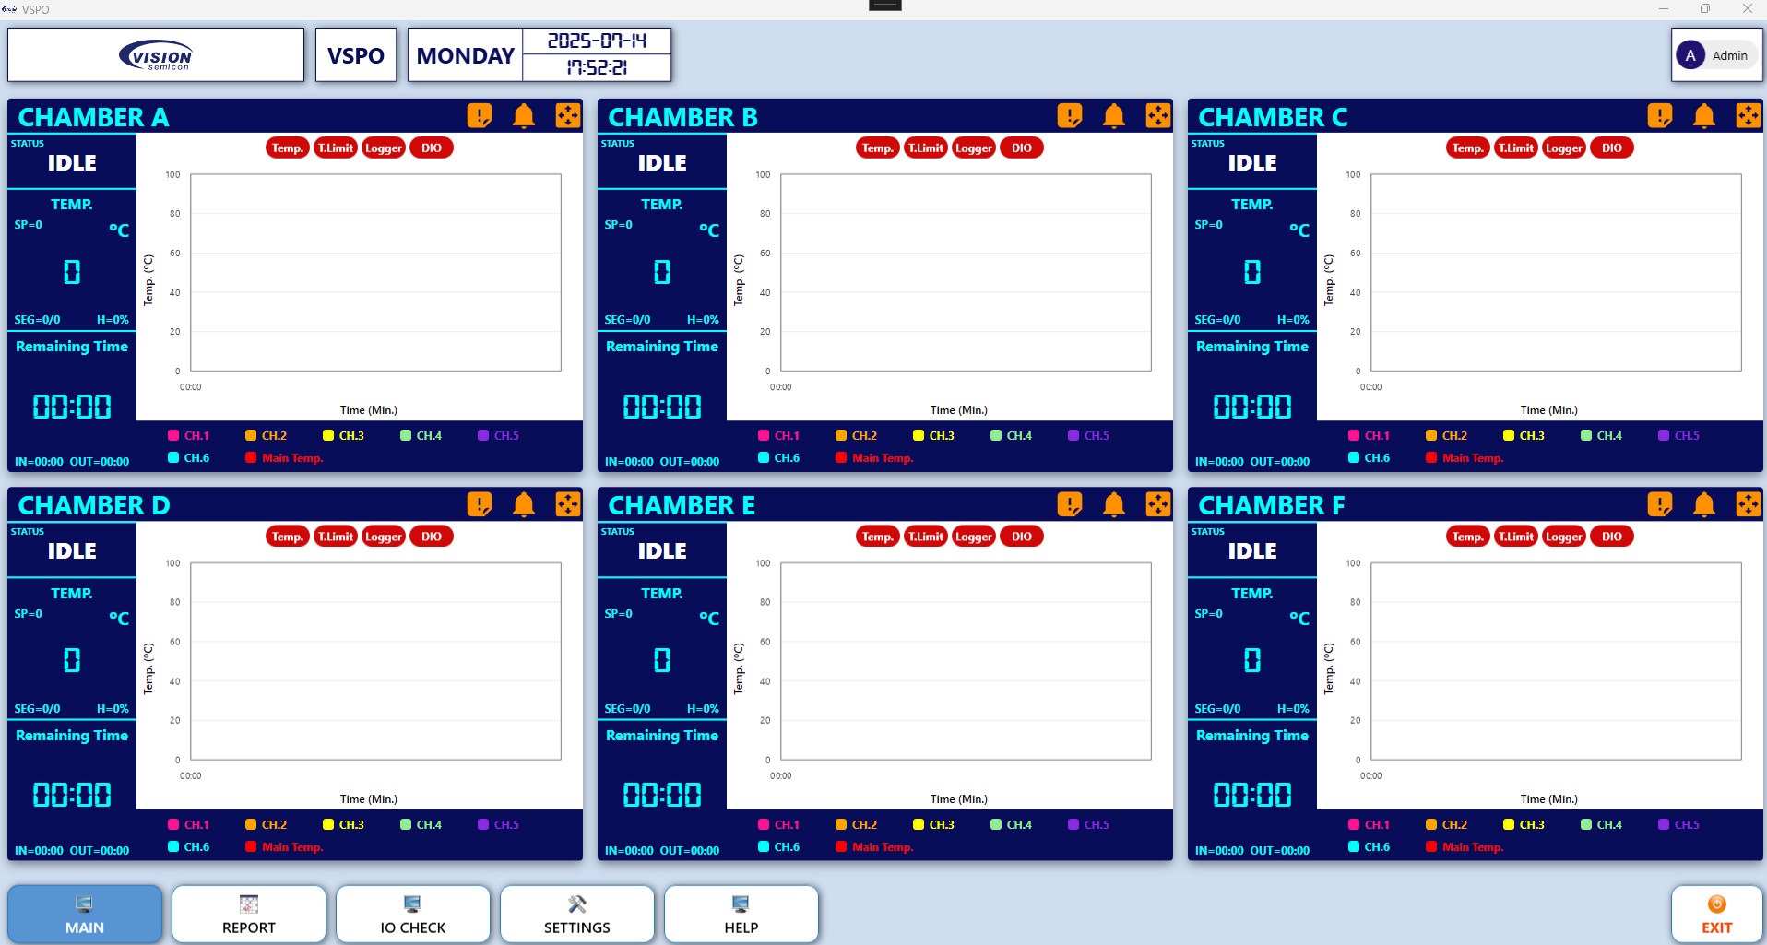

In the Non-Login Mode, the first screen is appeared like that:

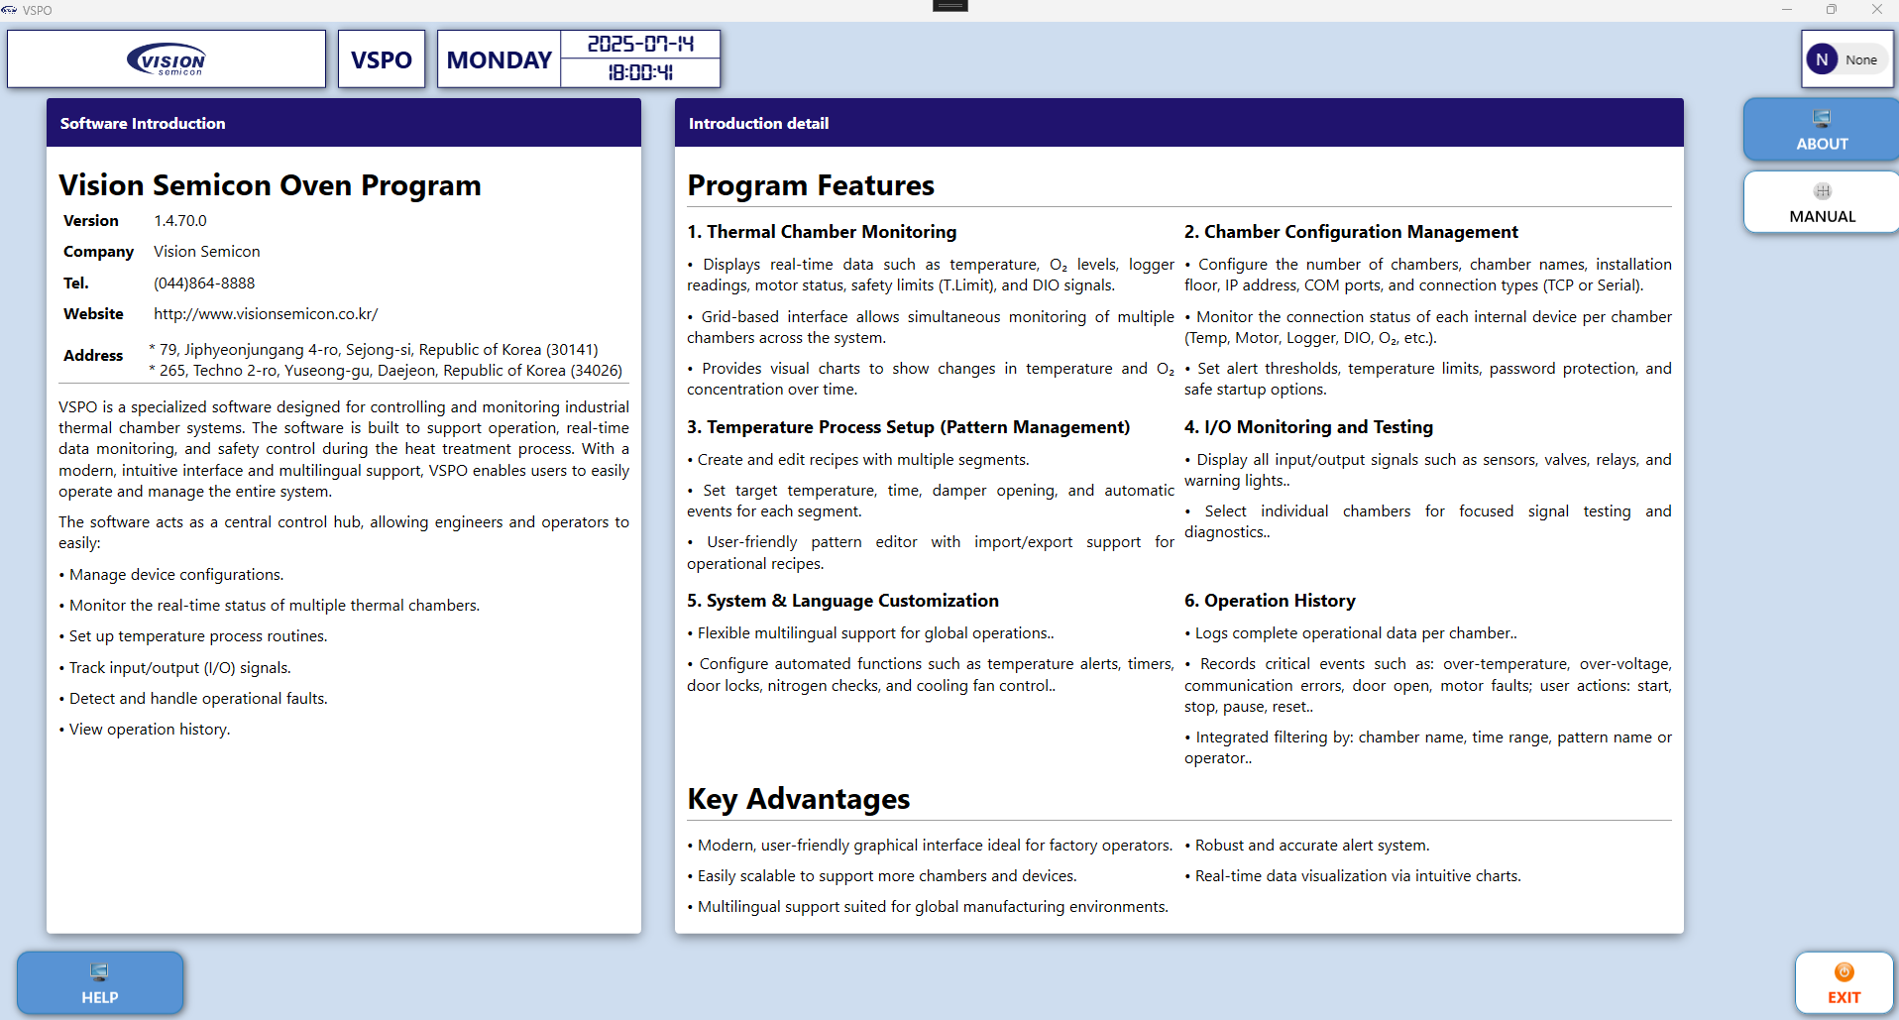

* 1. Report Screen
  2. IO Check Screen
  3. Setting Screen
     1. System Setting Screen
     2. Chamber Setting Screen
     3. Pattern Setting Screen
     4. Alarm Setup Screen
  4. Help Screen
     1. About Screen
     2. Manual View

1. Trouble Shooting
   1. Alarm Windows

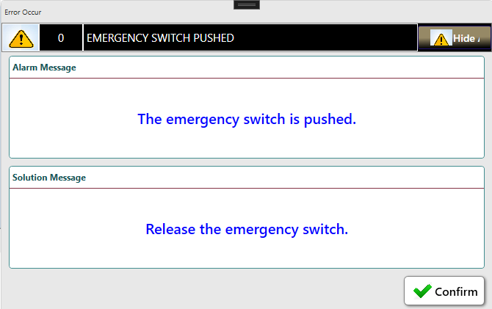

*Figure 2. Alarm window*

This is the alarm window. It displays the alarm message and solution message of the alarm.



Hide alarm window.



It stops the sound of the buzzer.

* 1. Alarm List

|  |  |  |  |
| --- | --- | --- | --- |
| Code | Alarm | Cause | Actions |
| 0 | EMERGENCY SWITCH PUSHED | The emergency switch is pushed. | Release the emergency switch. |
| 1 | DOOR OPENED | The door is opened. | It's dangerous to work during door opened => Check the door lock. |
| 2 | MAIN AIR PRESSURE NOT DETECTED | The pressure of main air is not detected. | Check the status of main air => Check the pressure detector of main air. |
| 3 | N2 PRESSURE NOT DETECTED | The pressure of N2 is not detected. | Check the status of N2 => Check the pressure detector of N2. |
| 4 | HEATER OVERLOAD | The heater overload signal is detected. | Check the status of heater => Check the status of SSR => Check the status of EOCR. |
| 5 | BLOWER OVERLOAD | The blower overload signal is detected. | Check the blower motor => Check the EMPR of the blower motor. |
| 6 | BLOWER OVERLOAD | The blower overload signal is detected. | Check the blower motor. |
| 7 | CHAMBER OVER TEMP. | The chamber over temp. signal is detected. | Check the heater => Check the limit controller's setting value. |
| 8 | DAMPER MOTOR ALARM | The damper motor alarm signal is detected. | Check the damper motor. |
| 9 | DIFFERENTIAL PRESSURE ALARM | The differential pressure detector alarm signal is detected. | Check the differential pressure detector => Check the status HEPA filter => Check the pollution degree of HEPA filter and replace it if needed. |
| 10 | SSR OVER TEMP. | The SSR over temp. signal is detected. | Check the status of heater => Check the status of SSR. |
| 11 | WATER FLOW NOT DETECTED | The water flow of chamber is not detected. | Check the water flow with equipment => Check the status of water flow detector => Check the status of solenoid valve in chamber. |
| 12 | ELECTRONIC PANEL OPENED | The open signal of electronic panel is detected. | Close the electronic door for safety => Check the status of door detect sensor of electronic panel. |
| 13 | O2 DENSITY ALARM | The O2 density alarm is detected. | The O2 density is higher than setting value => Check the equipment => Check the status of O2 analyzer => Check the status of damper. |
| 14 | GROUNDING ALARM | The grounding alarm is detected. | Check the status of equipment ground. |
| 15 | PV HIGH ALARM | The PV high alarm signal was detected. | Check the temp. controller => Check the PV high setting value of the pattern in the setting window. |
| 16 | PV LOW ALARM | The PV low alarm signal was detected. | Check the temp. controller => Check the PV low setting value of the pattern in the setting window. |
| 17 | TEMP CONTROLLER COMM. TIMEOVER | No response from temperature controller. | Check the comm. port setting => Check the communication line. |
| 18 | LIMIT CONTROLLER COMM. TIMEOVER | No response from the limit controller. | Check the comm. port setting => Check the communication line. |
| 19 | TEMP DATA LOGGER COMM. TIMEOVER | No response from the temperature logger. | Check the comm. port setting => Check the communication line. |
| 20 | DAMPER MOTOR COMM. TIMEOVER | No response from damper motor. | Check the comm. port setting => Check the communication line. |
| 21 | DIFFERENCE PRESSURE COMM. TIMEOVER | No response from Differential Pressure. | Check the comm. port setting => Check the communication line. |
| 22 | O2 ANALYZER COMM. TIMEOUT | No response from O2 Aanalyzer. | Check the comm. port setting => Check the communication line. |
| 23 | DI COMM. TIMEOUT | No response from DI Module. | Check the comm. port setting => Check the communication line. |
| 24 | DO COMM. TIMEOUT | No response from DO Module. | Check the comm. port setting => Check the communication line. |
| 25 | DIO COMM. TIMEOUT | No response from DIO Module. | Check the comm. port setting => Check the communication line. |
| 26 | DOOR UNLOCKED | The door is unlocked. | It's dangerous to work during door opened => Check the door lock. |
| 27 | O2 ANALYZER FLOW RATE ALARM | Abnormal flow rate of oxygen analyzer is detected. | Recommended flow rate of oxygen analyzer is 10.0 l/h ~ 15.0 l/h => Check the oxygen analyzer. |
| 28 | CHMABER TEMP. INTERLOCK | The door is locked because of high temperature of chamber. | Check the temperature of door-lock controller => Check the status of temperature controller of chamber. |
| 29 | N2 FLOW NOT DETECTED | The flow of N2 is not detected. | Check the status of N2 => Check the flow detector of N2. |
| 30 | INVERTER TRIP DETECTED | Inverter Trip is detected. | Check the inverter. |
| 31 | INVERTER COMM. TIMEOVER | No response from the Inverter. | Check the comm. port setting => Check the communication line. |
| 32 | TEMP. LOGGER CHANNEL 1 TEMP. DEVIATION ALARM | Temperature logger channel 1 temperature deviation alarm has occurred. | Check the Temp. logger => Check the status of temperature sensor of chamber. |
| 33 | TEMP. LOGGER CHANNEL 2 TEMP. DEVIATION ALARM | Temperature logger channel 2 temperature deviation alarm has occurred. | Check the Temp. logger => Check the status of temperature sensor of chamber. |
| 34 | TEMP. LOGGER CHANNEL 3 TEMP. DEVIATION ALARM | Temperature logger channel 3 temperature deviation alarm has occurred. | Check the Temp. logger => Check the status of temperature sensor of chamber. |
| 35 | TEMP. LOGGER CHANNEL 4 TEMP. DEVIATION ALARM | Temperature logger channel 4 temperature deviation alarm has occurred. | Check the Temp. logger => Check the status of temperature sensor of chamber. |
| 36 | TEMP. LOGGER CHANNEL 5 TEMP. DEVIATION ALARM | Temperature logger channel 5 temperature deviation alarm has occurred. | Check the Temp. logger => Check the status of temperature sensor of chamber. |
| 37 | TEMP. LOGGER CHANNEL 6 TEMP. DEVIATION ALARM | Temperature logger channel 6 temperature deviation alarm has occurred. | Check the Temp. logger => Check the status of temperature sensor of chamber. |
| 38 | TEMP. LOGGER CHANNEL 7 TEMP. DEVIATION ALARM | Temperature logger channel 7 temperature deviation alarm has occurred. | Check the Temp. logger => Check the status of temperature sensor of chamber. |
| 39 | TEMP. LOGGER CHANNEL 8 TEMP. DEVIATION ALARM | Temperature logger channel 8 temperature deviation alarm has occurred. | Check the Temp. logger => Check the status of temperature sensor of chamber. |
| 40 | TEMP. LOGGER CHANNEL 9 TEMP. DEVIATION ALARM | Temperature logger channel 9 temperature deviation alarm has occurred. | Check the Temp. logger => Check the status of temperature sensor of chamber. |
| 41 | TEMP. LOGGER CHANNEL 10 TEMP. DEVIATION ALARM | Temperature logger channel 10 temperature deviation alarm has occurred. | Check the Temp. logger => Check the status of temperature sensor of chamber. |
| 42 | CURE NOT STARTED AFTER DOOR CLOSE | The door is closed, but cure is not started. | The door is closed, but cure is not started => Be sure to cure is started. |
| 43 | TEMP CONTROLLER RUN STATE ALARM | The temperature controller is not in RUN state. | Check the temperature controller => Check if the temperature controller is in RUN state. |
| 44 | TEMP CONTROLLER HOLD STATE ALARM | The temperature controller is not in HOLD state. | Check the temperature controller => Check if the temperature controller is in HOLD state. |
| 45 | CHAMBER TEMP. DOOR OPEN ALARM | The door open alarm because of high temperature of chamber. | Check the chamber status => Check the chamber option setting value. |
| 46 | CDA FLOW SWITCH NOT DETECTED | The flow switch of CDA is not detected. | Check the status of CDA => Check the flow switch detector of CDA. |
| 47 | N2 PURGE FLOW SWITCH NOT DETECTED | The flow switch of N2 PURGE is not detected. | Check the status of N2 PURGE => Check the flow switch detector of N2 PURGE. |