**VISION SEMICON OVEN PROGRAM MANUAL**

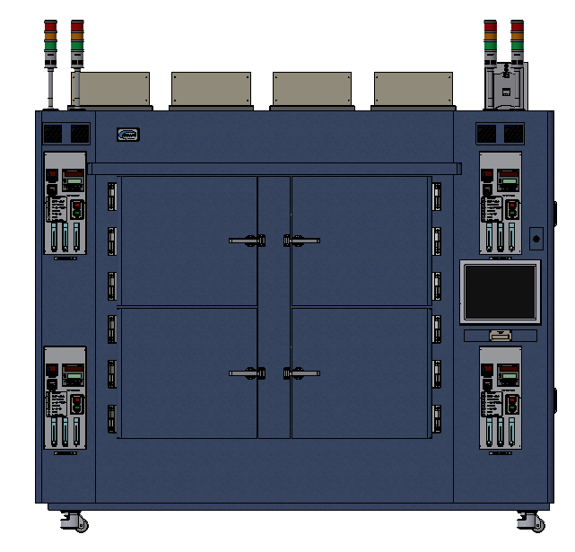

**Program Ver. : 1.4**

**2025. 07. 30**

TABLE OF CONTENTS

● Introductions 4

● Symbols 4

1. Overview 5

1.1 Specifications 5

1.2 Features 5

1.2.1 Thermal Chamber Status Monitoring 5

1.2.2 Thermal Chamber Configuration Management 5

1.2.3 Thermal Process (Pattern) Setup and Management 5

1.2.4 I/O Inspection and Monitoring 5

1.2.5 System and Language Customization 6

1.3 Intended Users 6

1.3.1 Machine Operators / Equipment Technicians 6

1.3.2 Maintenance Engineers 6

1.3.3 Process Engineers 6

1.3.4 Production Supervisors / Managers 6

1.3.5 System Integrators / Automation Developers 6

1.3.6 QA / QC Teams (Quality Assurance / Quality Control) 6

2. Program Operations 7

2.1 Main Screen 7

2.1.1 Header Bar 7

2.1.2 Login Panel 8

2.1.3 Chamber Monitoring Area 8

2.1.4 Main Menu Bar 10

2.2 Report Screen 11

2.2.1 Work Report Screen 12

2.2.2 Log Report Screen 15

2.3 IO Check Screen 17

2.3.1 Input Signal Table 18

2.3.2 Output Signal Table 19

2.4 Setting Screen 20

2.4.1 System Setting Screen 20

2.4.2 Chamber Setting Screen 21

2.4.3 Pattern Setting Screen 24

2.4.4 Alarm Setup Screen 27

2.5 Help Screen 30

2.5.1 About Screen 30

2.5.2 Manual View Window 31

3. Trouble Shooting 31

3.1 Alarm Window 31

3.2 Alarm List 32

* **Introductions**

This document is the user manual for the oven program developed by Vision Semicon Co., Ltd. It provides instructions and guidance on how to use the oven program effectively.

* **Symbols**

** Caution**

This symbol shows that if improper handling can cause the system to be inoperable or result in dangerous consequences or injury to the user.

**Notice**

This symbol shows that user need to know how to use.

**Cautions**

* **Disconnect the system's power breaker before connecting main power.**
* **Do not touch the power source.**
* **Do not disassemble or assemble without consulting the manufacturer.**

1. Overview

VSPO is a specialized software designed for controlling and monitoring industrial thermal chamber systems. The software is built to support operation, real-time data monitoring, and safety control during the heat treatment process. With a modern, intuitive interface and multilingual support, VSPO enables users to easily operate and manage the entire system.

* 1. Specifications

|  |  |
| --- | --- |
| Controller | PC : Industrial PC  Temp. Controller : UP55A, UP550 (YOKOGAWA)  Temp. Logger: I-7018 (ICP CON) |
| Display | 15 Inch Touch Monitor(Resolution :1024 x 768) |
| Power | 220VAC / 3PHASE |

* 1. Features
     1. Thermal Chamber Status Monitoring
* Displays real-time data such as temperature, O₂ (oxygen) levels, logger readings, motor status, safety limits (T. Limit), and DIO signals.
* Provides visual charts illustrating changes in temperature and O₂ concentration over time.
* A grid-based interface displays multiple chambers simultaneously for comprehensive system monitoring.
  + 1. Thermal Chamber Configuration Management
* Configure the number of chambers, chamber names, installation floors, IP addresses, COM ports, and connection types (TCP or Serial).
* Check the connection status of each device inside the chambers (Temp, Motor, Logger, DIO, O₂...).
* Set warning thresholds, temperature limits, password protection, and safety startup options.
  + 1. Thermal Process (Pattern) Setup and Management
* Create and edit thermal processes (recipes) with multiple segments.
* Set target temperatures, durations, damper openings, and automatic events for each segment.
* User-friendly pattern management interface with support for importing/exporting operation recipes.
  + 1. I/O Inspection and Monitoring
* Display all input and output signals such as sensors, valves, relays, warning lights, etc.
* Allows selecting individual chambers for separate signal inspection.
  + 1. System and Language Customization
* Support flexible language switching for different market regions.
* Configure automatic functions such as temperature alarms, timers, door locks, N₂ checking, and cooling fan control.
* Select target customers to activate specific compatibility modes (e.g., Amkor, Hynix...).
* A simple, easy-to-read, and multilingual interface helps minimize operational errors.
  1. Intended Users
     1. Machine Operators / Equipment Technicians

This group consists of users who operate the software daily on the factory floor. They use VSPO to start, run, and monitor thermal processes, track chamber status, and respond quickly to any alarms.

* + 1. Maintenance Engineers

They utilize functions such as I/O testing, alarm monitoring, and operation history to diagnose hardware faults, check sensors, motors, and cooling systems. VSPO helps them quickly identify fault locations through visual error messages and logger data.

* + 1. Process Engineers

This group is responsible for setting up and optimizing thermal process patterns. VSPO provides tools to build detailed operation recipes with segment-based steps, making it ideal for designing standardized processes - especially in the semiconductor and electronics industries.

* + 1. Production Supervisors / Managers

They use the software to monitor the overall status of all chambers, review operation history, and ensure all equipment follows standard operating procedures. Features like exporting history data, configuring temperature and O₂ limits support compliance monitoring and reporting.

* + 1. System Integrators / Automation Developers

If the software is part of a larger system, integration teams can configure TCP/Serial communication, add new devices, or synchronize data with MES, SCADA, and other systems.

* + 1. QA / QC Teams (Quality Assurance / Quality Control)

They retrieve operational and logger data to verify that machine conditions align with product outcomes. They inspect temperature, runtime, and any abnormal or limit-exceeding parameters.

1. Program Operations
   1. Main Screen

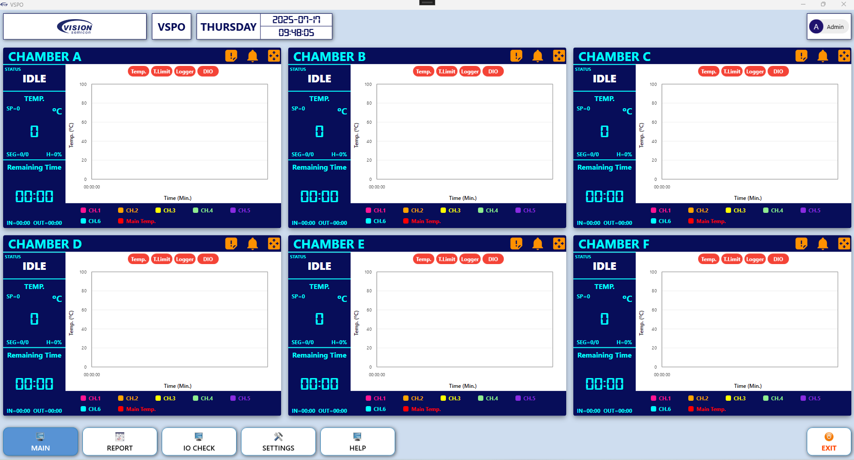

Figure 1. Main Screen

The Main Screen of the VSPO software serves as the central interface where users can directly monitor the overall status and operating parameters of all thermal chambers during pattern-based temperature testing.

The main interface of VSPO is organized into four primary sections:

* Header Bar.
* Login Panel.
* Chamber Monitoring Area.
* Main Menu Bar.
  + 1. Header Bar



Figure 2. Header Bar

Located at the top of the screen, the header provides system-related information, including:

* Company Logo and Software Name (VSPO): Helps reinforce branding and identify the application.
* Day, Date, and System Time: Displays the current day of the week, date, and time, making it easy for users to track the production schedule.
  + 1. Login Panel



Figure 3. Login Panel

Positioned at the top-right corner of the screen, this area displays the currently logged-in user (e.g., “Admin”).  
This section is separated to ensure secure access control, data protection, and role-based functionality customization.

* + 1. Chamber Monitoring Area

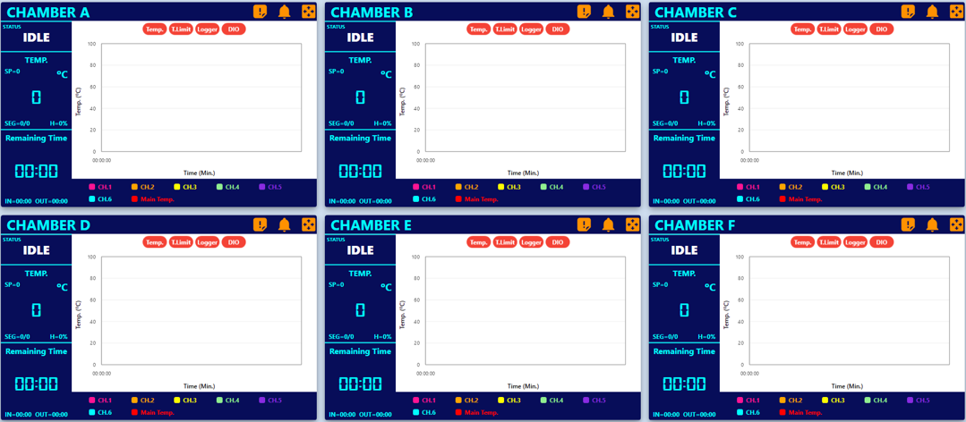

Figure 4. Chamber Monitoring Area

This is the core area of the interface, where all configured thermal chambers are displayed.

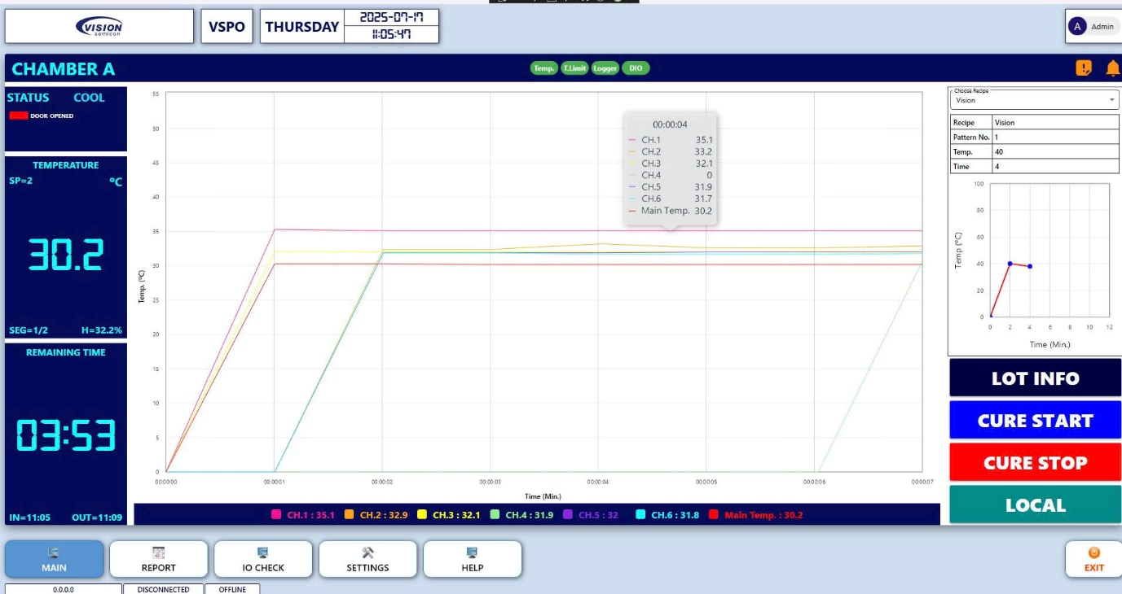

Figure 5. Chamber Block Area

Each chamber block provides the following information:

* Operating Status:
* IDLE: Idle / Not running.
* PURGE: Purging in progress.
* COOL: Cooling in progress.
* RUN: Pattern is currently running.
* DONE: Pattern completed.
* LOCAL: Operating in standalone mode with a single setpoint.

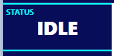

Figure 6. Operating Status

* Key Monitoring Information:
* TEMP. (°C): Current chamber temperature.
* SP (Set Point): Target temperature of the active segment.
* SEG = x/y: The current segment (x) out of total segments (y) in the pattern.
* H = %: Current heating output percentage.
* Remaining Time: Estimated time remaining to complete the current pattern.
* IN / OUT: Timestamp of the latest pattern run.
* IN = Start time (e.g., 08:15).
* OUT = End time (e.g., 17:28).

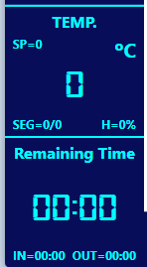

Figure 7. Key Monitoring Information

* Real-Time Temperature Chart: A dynamic graph shows the temperature curves of different measurement channels in real time.
* CH.1 → CH.n: Logger channels representing temperature probes/sensors.
* Channels are defined based on Chamber Settings**.**
* Different colors are used to distinguish each channel line clearly.

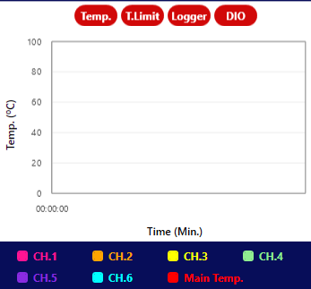

Figure 8. Real-Time Temperature Chart

* Controller Status Indicators: displays the connection status of associated controllers that contain:
* Temp. Controller.
* Temp. Limit Controller.
* Logger.
* DIO Controller.

Controller’s color indicators:

* Green: Connected.
* Red: Disconnected.



Figure 9. Controller Status Indicator

* Functional Icons:
* Exclamation mark (!): Opens the list of current alarms.
* Bell icon: Mutes the chamber's alarm buzzer.
* Window / full-screen icon: Switches to full-screen view for detailed monitoring of the selected chamber.

**Note:** The number of chambers shown is flexible and depends on the system configuration set by the user in the **Chamber Setting** section.

* + 1. Main Menu Bar



Figure 10. Main Menu Bar

Located at the bottom of the screen, the Main Menu Bar provides access to the primary navigation buttons:

* MAIN: Return to the main monitoring screen.
* REPORT: View and export operation reports.
* IO CHECK: Inspect input/output signals.
* SETTINGS: Adjust system configuration and preferences.
* HELP: Access the user manual and guidance materials.
* EXIT: Safely exit the software.
  1. Report Screen

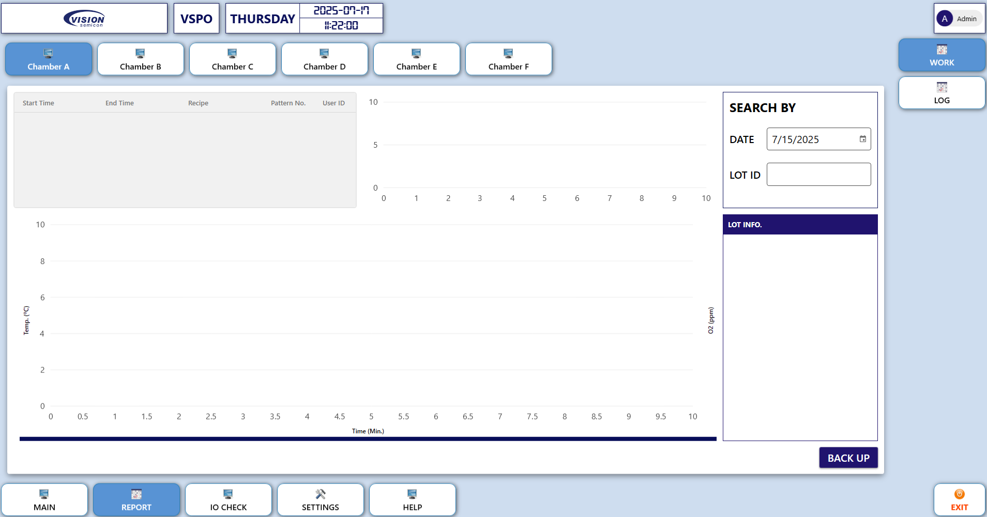

Figure 11. The Report Screen

The Report Screen allows users to review system activity logs and operation history by chamber. It includes two main display modes:

* Work Report Screen.
* Log Report Screen.
  + 1. Work Report Screen

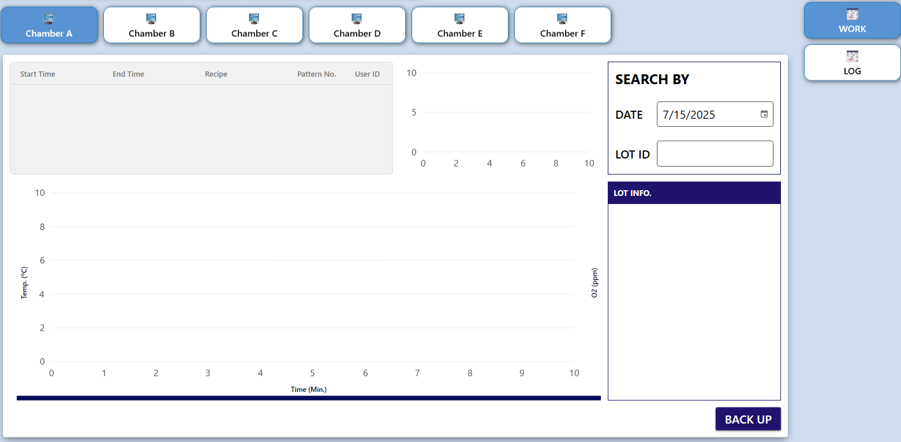

Figure 12. Work Report Screen

* Function: Allows users to review the operating history of each thermal chamber, including temperature charts and production lot information.
* Interface Details:
* Chamber Tabs (CHAMBER A → F, or more depending on configuration): Click each tab to switch between individual chamber reports.



Figure 13. Chamber Tabs

* Operation Information (Left Section):
* Start Time – End Time: Start and end time of the operation.
* Recipe: Name of the recipe used.
* Pattern No.: Pattern number executed.
* User ID: ID of the user who ran the operation.

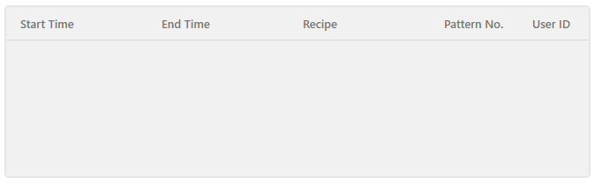

Figure 14. Operation Information

* Temperature / O₂ Chart:
* Left Y-Axis: Temperature (°C).
* Right Y-Axis: O₂ concentration (ppm).
* X-Axis: Time (minutes).
* The chart displays temperature and O₂ curves if corresponding data is available for the selected lot or date.

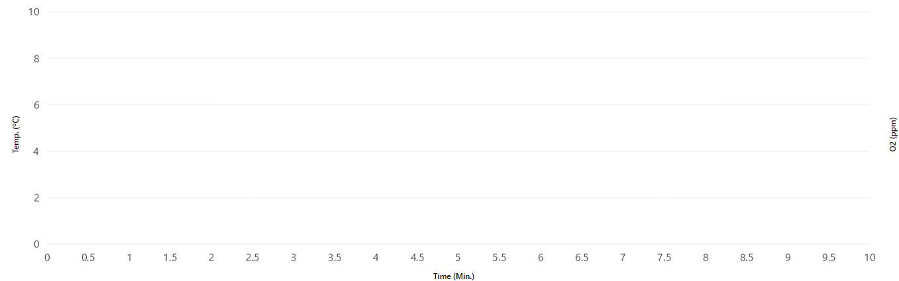

Figure 15. Temperature / O₂ Chart

* Search By Panel:
* DATE: Select the operation date to search.
* LOT ID: Enter the lot ID to retrieve related data.
* Press Enter to display search results.

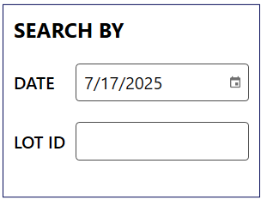

Figure 16. Search By Panel

* LOT INFO Panel:
* Shows detailed information for the selected lot.
* BACK UP Button: Allows backing up data related to the selected lot.

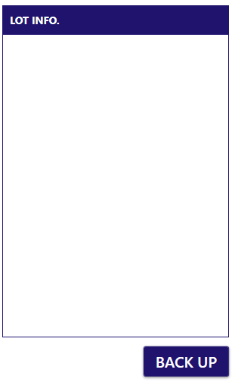

Figure 17. Lot Info. Panel

* + 1. Log Report Screen

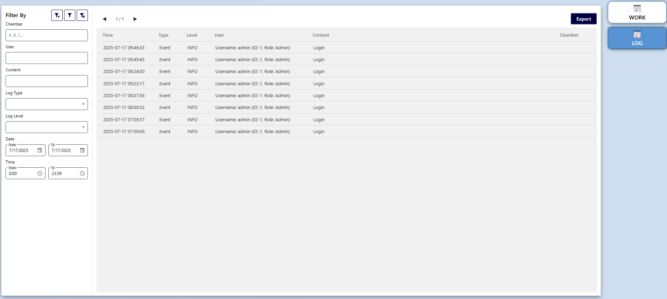

Figure 18. Log Report Screen

* Function: Displays system logs that record all actions and events, helping administrators track system and user activity. User clicks to export log data.
* Interface Details:
* Filters:
* Chamber: Filter logs by chamber name.
* User: Enter the username to filter logs.
* Content: Enter a keyword (e.g., “Login”, “Start Pattern”).
* Log Type: Select log type (Event, Error, etc.).
* Log Level: Select log severity (INFO, WARNING, ERROR).
* Date & Time: Select the date/time range for log retrieval.
* Clear filter:
* Apply filter:
* Filter config:

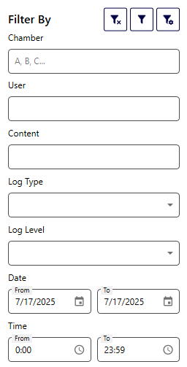

Figure 19. Data Filter Panel

* Log Table Fields:
* Time: Timestamp of the log entry.
* Type: Type of log (Event, Error, etc.).
* Level: Severity level.
* User: The user who performed the action.
* Content: Log content (e.g., “User logged in”).
* Chamber: Associated chamber (if applicable).

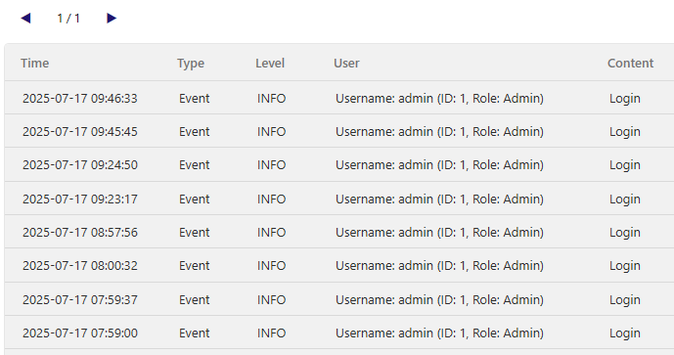

Figure 20. Log Table

* 1. IO Check Screen

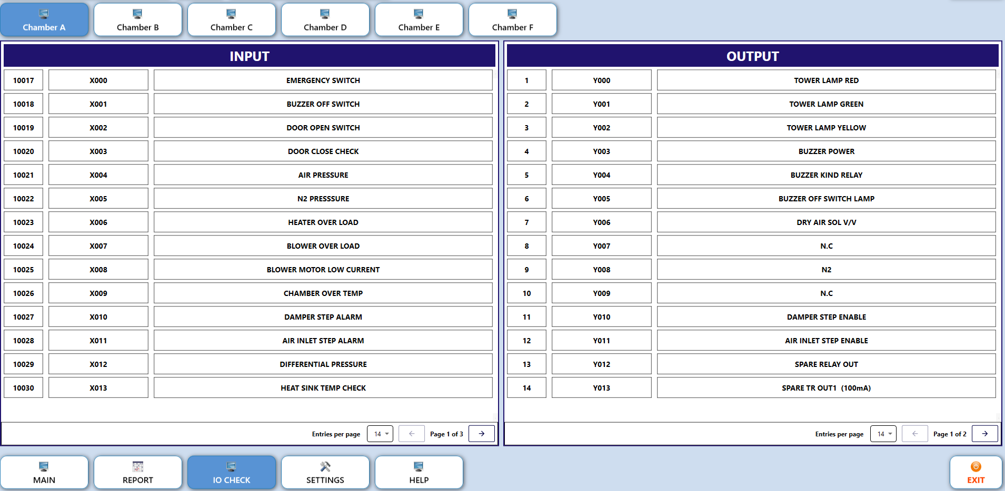

Figure 21. IO Check Screen

The IO Check Screen allows users to inspect, monitor, and directly control the system’s input/output (I/O) signals. This feature is especially useful for engineers to verify connections and operating status of:

* Input devices: such as sensors, switches, and alarm signals.
* Output devices: such as indicator lights, relays, valves, etc.

It provides a convenient interface to diagnose and troubleshoot hardware communication or logic control issues in the thermal chamber system.

The interface is divided into the following main sections:

* Chamber Selector: Lists available chambers (e.g., Chamber A → Chamber F, or more depending on configuration). Users can select a chamber to inspect by clicking on the corresponding tab.



Figure 22. Chamber Selector Tabs

* + 1. Input Signal Table

Input Signal Table (Left Side): Monitors input signals, including:   
– Register value (e.g., 10017, 10018...)   
– Function code (e.g., X000, X001...)   
– Description (e.g., EMERGENCY SWITCH, DOOR OPEN SWITCH...)

⛔ **Input signals are read-only** and cannot be operated.

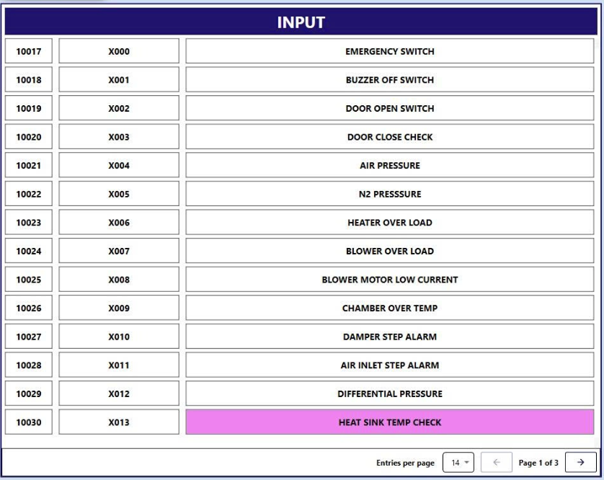

Figure 23. Input Signal Monitoring Table

* + 1. Output Signal Table

Output Signal Table (Right Side) displays output signals, including:

* Register value (e.g., 1, 2...)
* Function code (e.g., Y000, Y001...)
* Description (e.g., TOWER LAMP RED, BUZZER POWER...)  
  ✅ **Click on the description to toggle the output signal ON/OFF**.

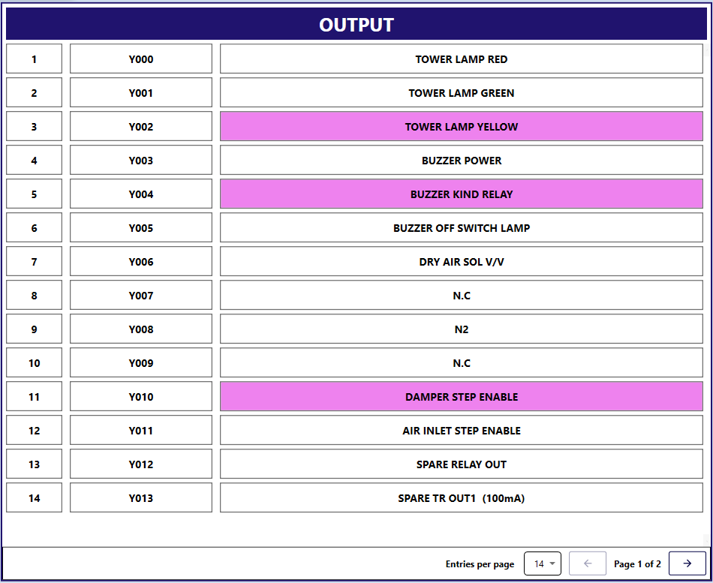

Figure 24. Output Signal Control Table

* Pagination Control: Allows selection of entries per page and navigation between pages.
  1. Setting Screen

The Setting Screen is a critical configuration interface in the VSPO software, allowing users to define system parameters, configure chambers, set temperature patterns, and manage alarms.

This interface is intuitively designed and divided into four main sections:

* System.
* Chambers.
* Patterns.
* Alarm Setup.

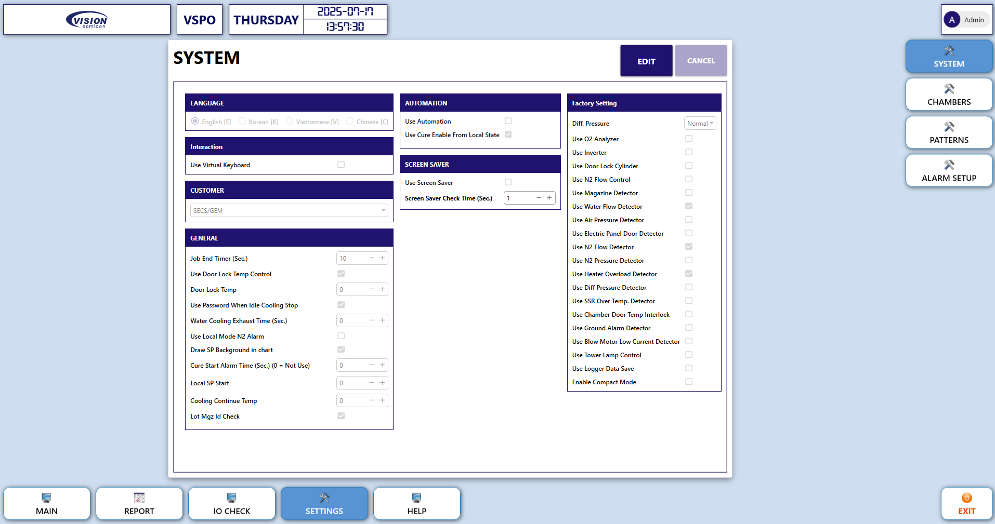

Figure 25. Setting Screen

* + 1. System Setting Screen

In this section, users can define general parameters for the entire system, including:

* Interface Language: English, Korean, Vietnamese, Chinese.
* Automation and screen-saver Options.
* Customer Configuration: e.g., SECS/GEM settings.
* General Parameters: includes timers, door lock conditions, passwords, N2 alarm mode, etc.
* Factory Setting: enables/disables sensors and detectors such as Water Flow, N2 Flow, Air Pressure, Door Lock, etc.

**Note**: Click **Edit** to enable editing. After making changes, click **Save** to apply or **Cancel** to discard.

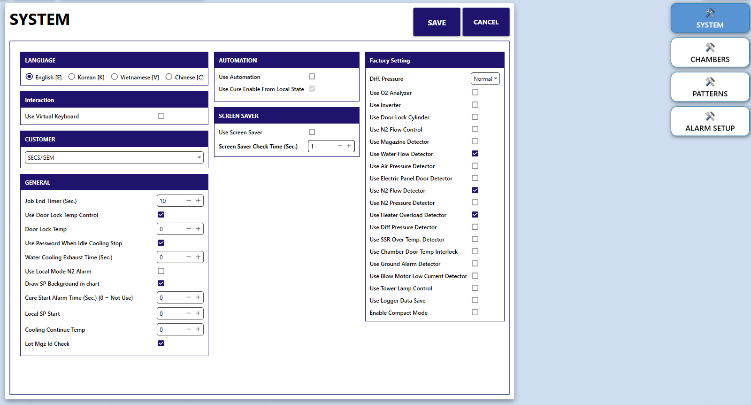

Figure 26. System Setting Screen

* + 1. Chamber Setting Screen

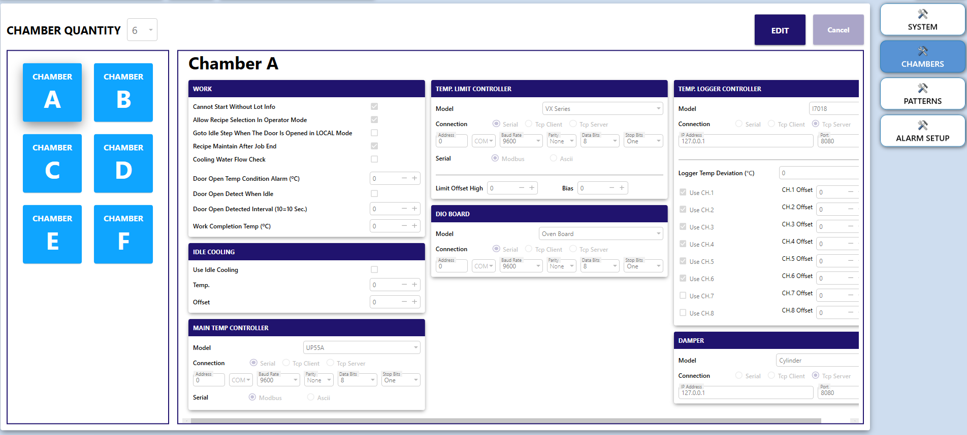

Figure 27. Chamber Setting Screen

In this section, users can edit the chamber quantity and configure each chamber separately, as follows:

* Edit the chamber quantity**:** Click **Edit** and select the number of chambers corresponding to the actual working oven.

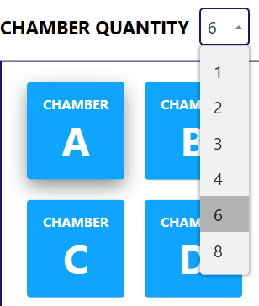

Figure 28. Edit the chamber quantity

* Work Setting Panel sets chamber’s operational logic such as:
* Lot information validation.
* Door open conditions.
* Recipe retention.
* Temperature alarms, etc.

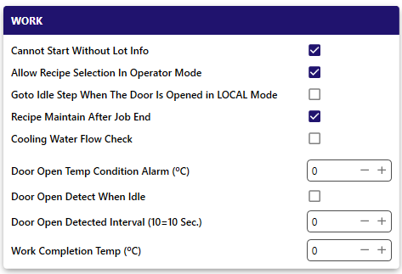

Figure 29. Work Panel

* Idle Cooling Setting Panel:
* Enables cooling during Idle state.
* Configures cooling temperature and offset values.

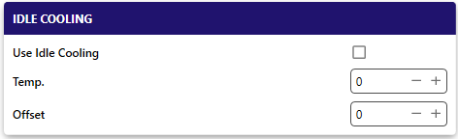

Figure 30. Ideal Cooling Setting Panel

* Popular Controller Panels (Main Temp. Controller, Temp. Limit Controller, Temp. Logger Controller, DIO Board, Damper) contain settings that is defined how each device communicates and operates within the system, including:
* Set device model.
* Select communication method: COM or TCP (with IP and Port).
* Define communication parameters: Baud Rate, Parity, Data Bits, Stop Bits.
* Enable specific channels for the Logger.
* O₂ Analyzer Panel is used to configure the Oxygen (O₂) sensor for measuring O₂ concentration inside the chamber. Monitoring O₂ levels helps ensure accurate temperature control. Special configuration parameters:
* O₂ Density Limit (ppm): The allowable oxygen concentration limit inside the chamber (ppm = parts per million). Exceeding this limit may trigger an alarm or stop the process.
* O₂ Density Alarm Enable Time (Sec.): Duration the threshold must be exceeded before a real alarm is confirmed, helping to avoid false alerts due to minor fluctuations.
* Cure Stop On O₂ Density Alarm: When enabled, the cure (heating) process will stop if the O₂ level exceeds the defined limit.
* Cure Start On O₂ Target Density: When enabled, the system will only start the cure process when the O₂ concentration reaches the required target level.
* O₂ Target Density Run Limit (ppm): The target O₂ concentration required to start or maintain the process.
* O₂ Target Density Alarm Run Limit Time (Min.): If the O₂ concentration does not reach the target within this time frame, an alarm will be triggered.
* Large N₂ Valve Open O₂ Density (Min.): When the O₂ level exceeds this threshold, the system will open the large nitrogen valve to flush out excess O₂.

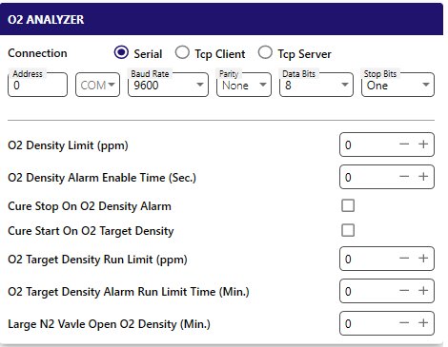

Figure 31. O₂ Analyzer Setting Panel

**Note**: Each chamber can be configured independently depending on the furnace model or production process.

* + 1. Pattern Setting Screen

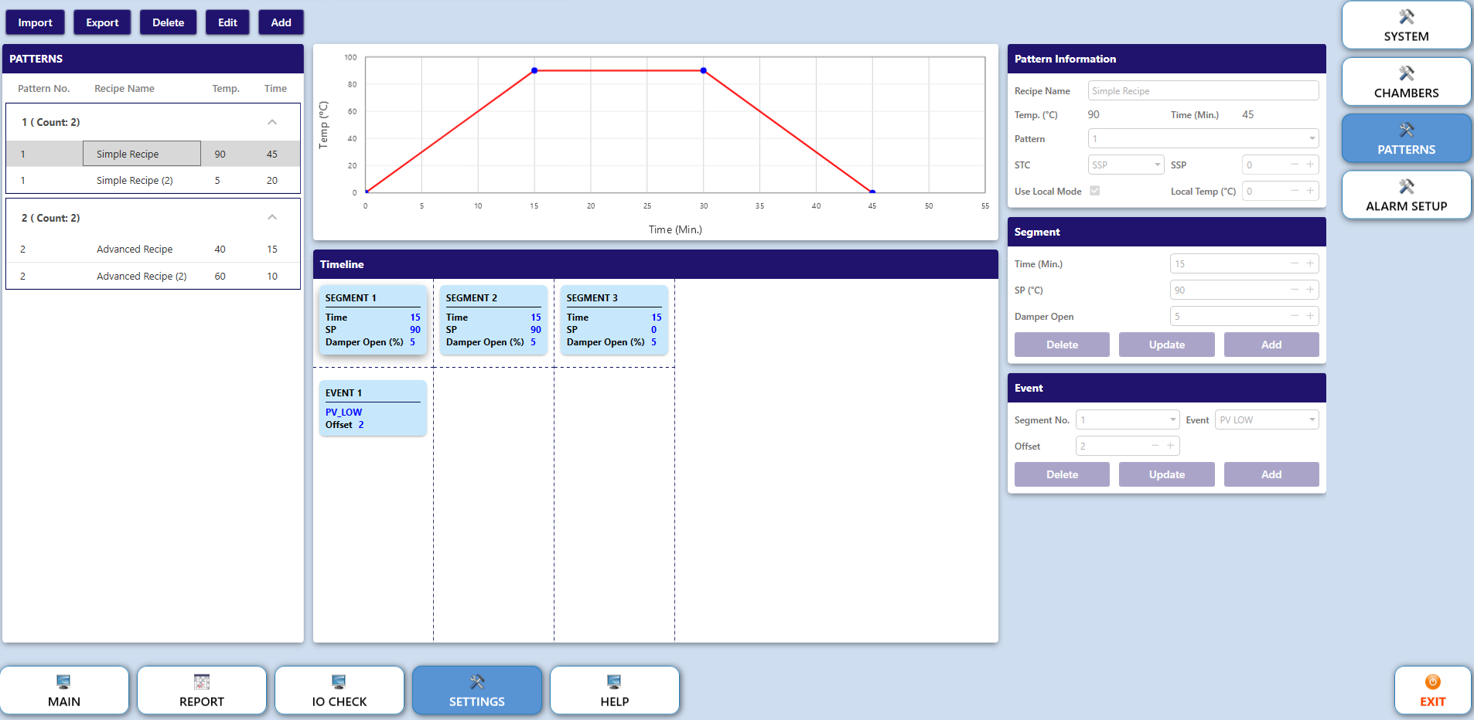

Figure 32. Pattern Setting Screen

This screen is used to create, edit, and manage heating programs (Patterns) — including time-based temperature control steps, damper (air valve) settings, and corresponding events. These patterns are applied during the operation of ovens or temperature test chambers.

#### 2.4.3.1 Overview Interface

* Top Toolbar:
* **Import:** Import a pattern from an external file.
* **Export:** Export the selected pattern to a file.
* **Delete:** Delete the selected pattern.
* **Edit:** Open the selected pattern in edit mode.
* **Add**: Add a new pattern.



Figure 33. Pattern Screen’s Top Toolbar

* Pattern List (Left Panel) that displays a list of existing patterns has field descriptions below:
* Pattern No.: Pattern number.
* Recipe Name: Name of the process recipe.
* Temp.: Highest temperature within the pattern.
* Time: Total run time of the pattern.

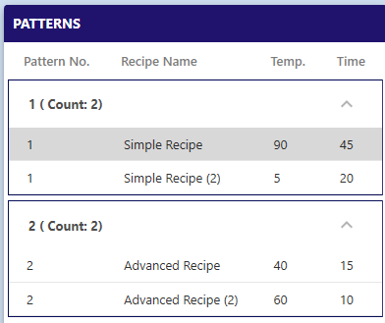

Figure 34. Pattern List their Recipes

* Chart and Timeline (Center Panel):
* **Chart**: Displays the temperature curve over time.
* **Timeline**: Lists the **segments** and **events** in chronological order.

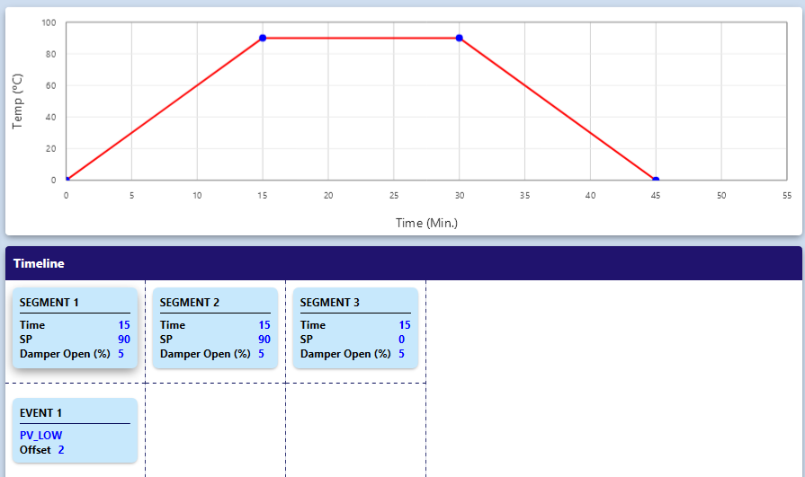

Figure 35. Segment’s Chart and Timeline

#### 2.4.3.2 Configuration Area

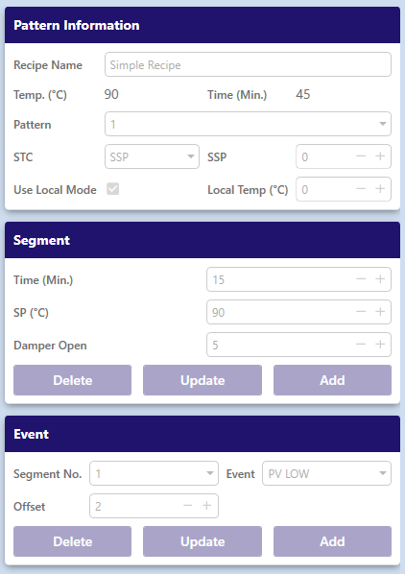

Figure 36. Pattern Configuration Area

* Pattern Information Fields:
* Recipe Name: Name of the process recipe.
* Temp. (°C): Highest temperature (for reference – not a setpoint).
* Time (Min.): Total duration of the pattern.
* Pattern: Pattern No.
* STC: Start Code
* SSP: Start Setpoint value.
* Use Local Mode: (Ticked) Use locally measured temperature.
* Local Temp (°C): Target temperature when using Local Mode.
* Segment Panel:
* Fields:
* Time (Min.): Duration for this segment.
* SP (°C): Setpoint – target temperature for step.
* Damper Open: Damper opening level (0–100%).
* Operations:
* Button **Add**: Add a new segment to the timeline.
* Button **Update**: Update the selected segment.
* Button **Delete:** Remove the selected segment.
* Event Panel:
* Fields:
* Segment No.: Assign the event to a specific segment number.
* Event: Type of event (e.g. PV LOW, PV HIGH, Alarm...).
* Offset: Delay time (minutes) from the start of the segment.
* Operations:
* Button **Add**: Add a new event.
* Button **Update**: Edit the selected event.
* Button **Delete**: Delete the selected event.
  + 1. Alarm Setup Screen

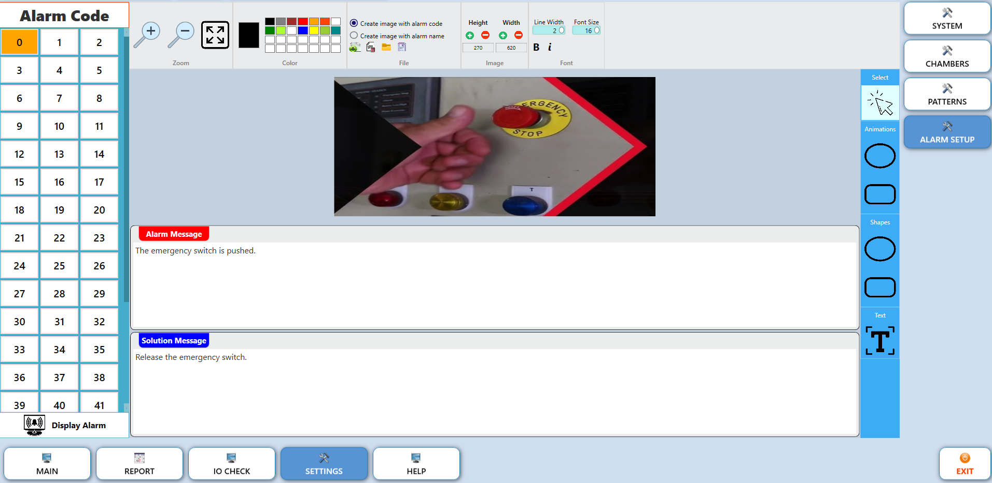

Figure 37. Alarm Setup Screen

This screen allows users to view alarm codes and change the illustrative image associated with each alarm code.  
However, the **Alarm Message** and **Solution Message** are pre-configured by technicians and **cannot be edited** by users.

#### 2.4.4.1. Screen structure

* Alarm Code Table (Left Panel):
* Displays a list of alarm codes, numbered from 0 to 41.
* Click on a specific code to view its corresponding information and illustration.
* The selected code is highlighted in orange.

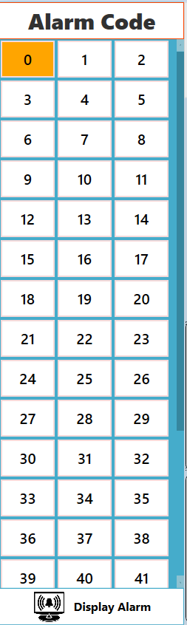

Figure 38. Alarm code list

* Image Display Area (Center Screen):
* Shows the illustration related to the selected alarm.
* Users can change the illustration by:
* Clicking to select a new image from the computer.
* Uploading a screenshot or real photo related to the actual issue.

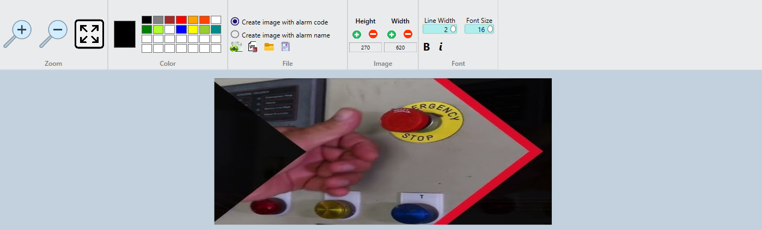

Figure 39. Image Display Area

* Image Editing Toolbar (Top) includes tools for:
* Zoom, Color Picker, Shapes Drawing, Text Insertion.
* Allows users to create annotated images with alarm codes or names.
* Used to highlight key areas related to the alarm.

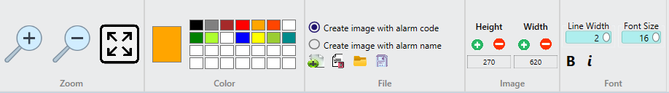

Figure 40. Image Editing Toolbar

* Alarm & Solution Message Panel contains:
* Alarm Message (Red Box): Describes the error condition.
* Solution Message (Green Box): Provides corresponding troubleshooting instructions.

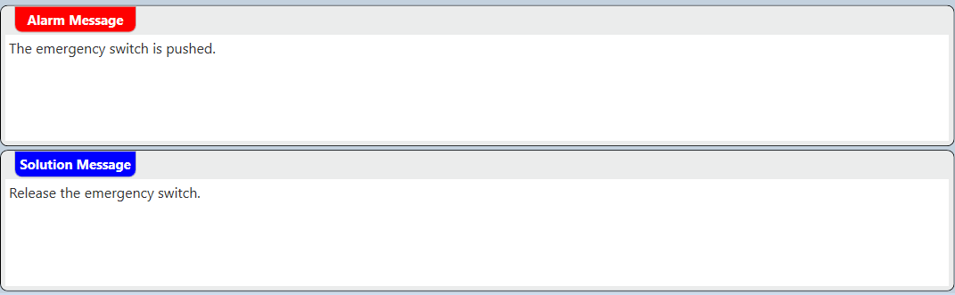

Figure 41. Alarm & Solution Message Panel

#### 2.4.4.2 Usage Procedure

1. **Select** an alarm code from the list on the left panel.
2. **Review** the alarm message and the corresponding solution provided.
3. ******Click (Create)**, (**Delete)**, (**Select)** or (**Save)** to update alarm code’s image. If you click the **Create** button, select one of the two available options by checking the corresponding box:

* “Create image with alarm code”.
* “Create image with alarm name”

1. **Use** the drawing tools to highlight, annotate, or mark important areas in the image.

#### 2.4.4.3 Purpose

* Updating real images helps operators quickly identify the error.
* Ensures that troubleshooting is performed in accordance with the standard procedure defined by the technicians.
  1. Help Screen

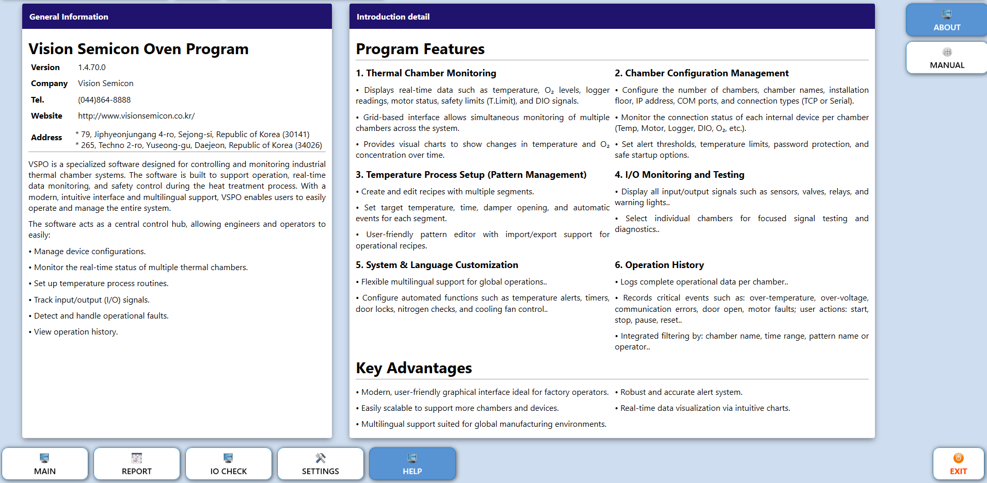

Figure 42. Help Screen

* + 1. About Screen

The screen’s main content contains:

* Software name and current version.
* Developer company name, contact information, and official website.
* Company address.
* Software introduction.
* Core functionalities supported.
  + 1. Manual View Window

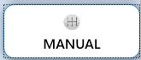Click on the button to open Manual View Window

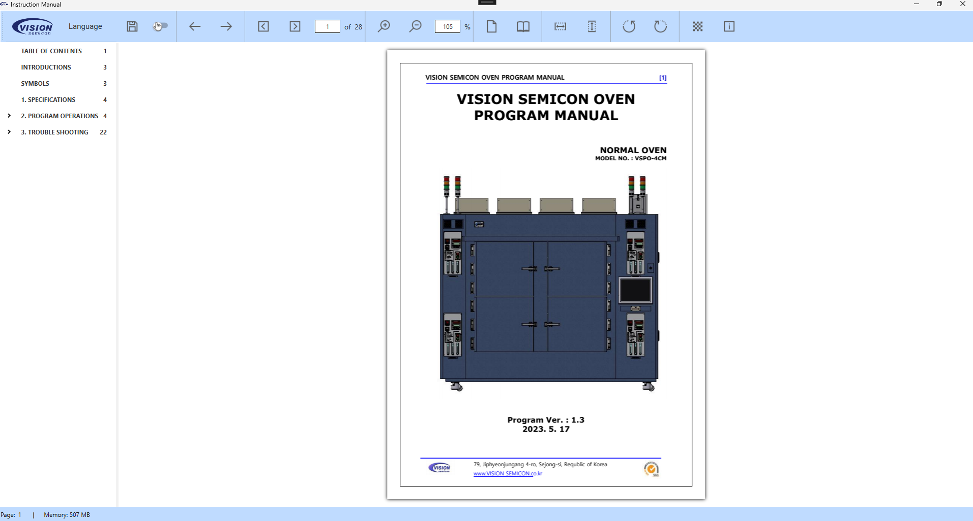

Figure 43. Manual View Window

1. Trouble Shooting
   1. Alarm Window

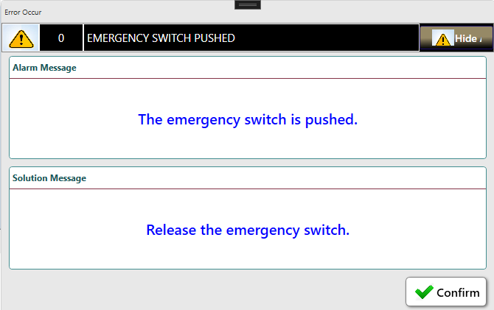

*Figure 44. Alarm window*

This is the alarm window. It displays the alarm message and solution message of the alarm.

* Click the button to hide alarm window.
* Click the button to stop the sound of the buzzer.
  1. Alarm List

|  |  |  |  |
| --- | --- | --- | --- |
| Code | Alarm | Cause | Actions |
| 0 | EMERGENCY SWITCH PUSHED | The emergency switch is pushed. | Release the emergency switch. |
| 1 | DOOR OPENED | The door is opened. | It's dangerous to work during door opened => Check the door lock. |
| 2 | MAIN AIR PRESSURE NOT DETECTED | The pressure of main air is not detected. | Check the status of main air => Check the pressure detector of main air. |
| 3 | N2 PRESSURE NOT DETECTED | The pressure of N2 is not detected. | Check the status of N2 => Check the pressure detector of N2. |
| 4 | HEATER OVERLOAD | The heater overload signal is detected. | Check the status of heater => Check the status of SSR => Check the status of EOCR. |
| 5 | BLOWER OVERLOAD | The blower overload signal is detected. | Check the blower motor => Check the EMPR of the blower motor. |
| 6 | BLOWER OVERLOAD | The blower overload signal is detected. | Check the blower motor. |
| 7 | CHAMBER OVER TEMP. | The chamber over temp. signal is detected. | Check the heater => Check the limit controller's setting value. |
| 8 | DAMPER MOTOR ALARM | The damper motor alarm signal is detected. | Check the damper motor. |
| 9 | DIFFERENTIAL PRESSURE ALARM | The differential pressure detector alarm signal is detected. | Check the differential pressure detector => Check the status HEPA filter => Check the pollution degree of HEPA filter and replace it if needed. |
| 10 | SSR OVER TEMP. | The SSR over temp. signal is detected. | Check the status of heater => Check the status of SSR. |
| 11 | WATER FLOW NOT DETECTED | The water flow of chamber is not detected. | Check the water flow with equipment => Check the status of water flow detector => Check the status of solenoid valve in chamber. |
| 12 | ELECTRONIC PANEL OPENED | The open signal of electronic panel is detected. | Close the electronic door for safety => Check the status of door detect sensor of electronic panel. |
| 13 | O2 DENSITY ALARM | The O2 density alarm is detected. | The O2 density is higher than setting value => Check the equipment => Check the status of O2 analyzer => Check the status of damper. |
| 14 | GROUNDING ALARM | The grounding alarm is detected. | Check the status of equipment ground. |
| 15 | PV HIGH ALARM | The PV high alarm signal was detected. | Check the temp. controller => Check the PV high setting value of the pattern in the setting window. |
| 16 | PV LOW ALARM | The PV low alarm signal was detected. | Check the temp. controller => Check the PV low setting value of the pattern in the setting window. |
| 17 | TEMP CONTROLLER COMM. TIMEOVER | No response from temperature controller. | Check the comm. port setting => Check the communication line. |
| 18 | LIMIT CONTROLLER COMM. TIMEOVER | No response from the limit controller. | Check the comm. port setting => Check the communication line. |
| 19 | TEMP DATA LOGGER COMM. TIMEOVER | No response from the temperature logger. | Check the comm. port setting => Check the communication line. |
| 20 | DAMPER MOTOR COMM. TIMEOVER | No response from damper motor. | Check the comm. port setting => Check the communication line. |
| 21 | DIFFERENCE PRESSURE COMM. TIMEOVER | No response from Differential Pressure. | Check the comm. port setting => Check the communication line. |
| 22 | O2 ANALYZER COMM. TIMEOUT | No response from O2 Aanalyzer. | Check the comm. port setting => Check the communication line. |
| 23 | DI COMM. TIMEOUT | No response from DI Module. | Check the comm. port setting => Check the communication line. |
| 24 | DO COMM. TIMEOUT | No response from DO Module. | Check the comm. port setting => Check the communication line. |
| 25 | DIO COMM. TIMEOUT | No response from DIO Module. | Check the comm. port setting => Check the communication line. |
| 26 | DOOR UNLOCKED | The door is unlocked. | It's dangerous to work during door opened => Check the door lock. |
| 27 | O2 ANALYZER FLOW RATE ALARM | Abnormal flow rate of oxygen analyzer is detected. | Recommended flow rate of oxygen analyzer is 10.0 l/h ~ 15.0 l/h => Check the oxygen analyzer. |
| 28 | CHMABER TEMP. INTERLOCK | The door is locked because of high temperature of chamber. | Check the temperature of door-lock controller => Check the status of temperature controller of chamber. |
| 29 | N2 FLOW NOT DETECTED | The flow of N2 is not detected. | Check the status of N2 => Check the flow detector of N2. |
| 30 | INVERTER TRIP DETECTED | Inverter Trip is detected. | Check the inverter. |
| 31 | INVERTER COMM. TIMEOVER | No response from the Inverter. | Check the comm. port setting => Check the communication line. |
| 32 | TEMP. LOGGER CHANNEL 1 TEMP. DEVIATION ALARM | Temperature logger channel 1 temperature deviation alarm has occurred. | Check the Temp. logger => Check the status of temperature sensor of chamber. |
| 33 | TEMP. LOGGER CHANNEL 2 TEMP. DEVIATION ALARM | Temperature logger channel 2 temperature deviation alarm has occurred. | Check the Temp. logger => Check the status of temperature sensor of chamber. |
| 34 | TEMP. LOGGER CHANNEL 3 TEMP. DEVIATION ALARM | Temperature logger channel 3 temperature deviation alarm has occurred. | Check the Temp. logger => Check the status of temperature sensor of chamber. |
| 35 | TEMP. LOGGER CHANNEL 4 TEMP. DEVIATION ALARM | Temperature logger channel 4 temperature deviation alarm has occurred. | Check the Temp. logger => Check the status of temperature sensor of chamber. |
| 36 | TEMP. LOGGER CHANNEL 5 TEMP. DEVIATION ALARM | Temperature logger channel 5 temperature deviation alarm has occurred. | Check the Temp. logger => Check the status of temperature sensor of chamber. |
| 37 | TEMP. LOGGER CHANNEL 6 TEMP. DEVIATION ALARM | Temperature logger channel 6 temperature deviation alarm has occurred. | Check the Temp. logger => Check the status of temperature sensor of chamber. |
| 38 | TEMP. LOGGER CHANNEL 7 TEMP. DEVIATION ALARM | Temperature logger channel 7 temperature deviation alarm has occurred. | Check the Temp. logger => Check the status of temperature sensor of chamber. |
| 39 | TEMP. LOGGER CHANNEL 8 TEMP. DEVIATION ALARM | Temperature logger channel 8 temperature deviation alarm has occurred. | Check the Temp. logger => Check the status of temperature sensor of chamber. |
| 40 | TEMP. LOGGER CHANNEL 9 TEMP. DEVIATION ALARM | Temperature logger channel 9 temperature deviation alarm has occurred. | Check the Temp. logger => Check the status of temperature sensor of chamber. |
| 41 | TEMP. LOGGER CHANNEL 10 TEMP. DEVIATION ALARM | Temperature logger channel 10 temperature deviation alarm has occurred. | Check the Temp. logger => Check the status of temperature sensor of chamber. |
| 42 | CURE NOT STARTED AFTER DOOR CLOSE | The door is closed, but cure is not started. | The door is closed, but cure is not started => Be sure to cure is started. |
| 43 | TEMP CONTROLLER RUN STATE ALARM | The temperature controller is not in RUN state. | Check the temperature controller => Check if the temperature controller is in RUN state. |
| 44 | TEMP CONTROLLER HOLD STATE ALARM | The temperature controller is not in HOLD state. | Check the temperature controller => Check if the temperature controller is in HOLD state. |
| 45 | CHAMBER TEMP. DOOR OPEN ALARM | The door open alarm because of high temperature of chamber. | Check the chamber status => Check the chamber option setting value. |
| 46 | CDA FLOW SWITCH NOT DETECTED | The flow switch of CDA is not detected. | Check the status of CDA => Check the flow switch detector of CDA. |
| 47 | N2 PURGE FLOW SWITCH NOT DETECTED | The flow switch of N2 PURGE is not detected. | Check the status of N2 PURGE => Check the flow switch detector of N2 PURGE. |