1. Feasibility Study
2. Client Request: Developing a system to create exam questions for teachers.

* The system can manage a question bank including multiple choice questions and constructed response questions.

* Each essay question has suggested answers.

* Each multiple-choice question has answer options and answers to that question. The number of options is unlimited.
* A multiple-choice question can also have multiple correct answers.
* Requires each question to belong to a certain subject.
* Each question can also be assigned a difficulty level, within one or more chapters of that subject.

The system must have functions:

* Manage questions by subject, chapter, difficulty
* When creating a test, teachers can create a test that mixes multiple-choice and essay questions or has essay sections and multiple-choice section separated.
* Questions are hand-picked or randomly generated according to pre-selected chapters and difficulty levels.
* Shuffle answer, question for the same exam
* Store exam information
* Export to file (txt, doc, pdf...)

1. Executive summary

The proposed system for teachers of Hanoi University of Science and Technology. The customer is represented by Mr. Trinh Thanh Trung.

Our goal is to develop a question management system that can automatically generate exams for teachers at Hanoi University of Science and Technology. There are two categories of questions : multiple choice that can have multiple answers and written questions with hints for answers. The system will be able to separate them by subjects, chapters, and difficulties, allowing teachers to randomly create an exam with predefined difficulties and chapters, or hand- picked. For the same exams, questions and multiple-choice answers can be shuffled. Finally, teachers can save the exam and export to a file ( txt, doc or pdf ... ). We aim to automate the exam creations process.

1. Preliminary requirement analysis
   1. Application overview

The goal : The application should be able to automate the exams

creation process, either hand-picked or randomly using chosen subject, difficulties and chapters from a predefined question bank.

 Business goal : Through this system, we hope to create a more efficient way to store questions and previously created exams, and furthermore reduce the workload on teachers during exam weeks by replacing manual work with an automated process and user- friendly UI.

Current business process : Currently, even with the same subject, teachers of different classes still have to manually create their own exams.

 User roles : The system will have only one type of user with access to every feature

Interaction with other systems: The system will be built from ground-up using existing libraries. The exams generated by this system can be combined with an automatic testing and grading application for students in the future.

* 1. Features requirements
* The user should be able to view the questions bank at any time, and their subject, chapters, or difficulty
* Questions are divided into 2 categories : Multiple choice questions and written questions. Each question should be provided an answer, with multiple choice questions can have several answers.
* The system allows adding, removing questions or edit existing ones
* Generate an exam with existing questions, randomly or hand- picked, save and export those exams to a file
* View previously generated exams and their subject

**Chapter 4: Software Design**

**4.1. User case diagram**

**4.2. Database Design**

**4.3. Entity Relationship Diagram**

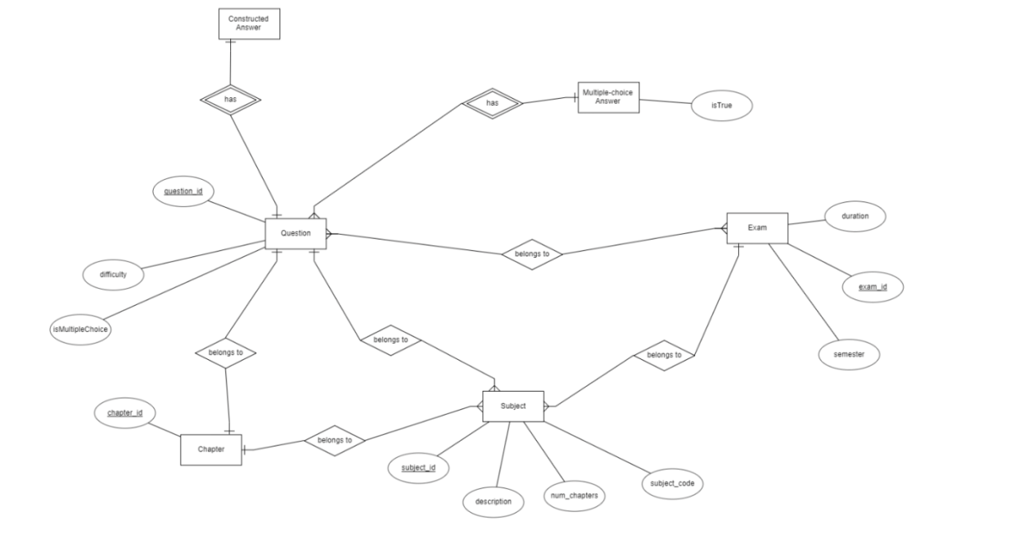

**Chapter 5: Building illustration program**

5.1. Library and tool

PROGRAMMING LANGUAGE: PYTHON

**List of using tool**

|  |  |  |
| --- | --- | --- |
| **Purpose** | **Tool** | **URL** |
| **CODING IDE** | **PYCHARM COMMUNITY EDITION** | **https://www.jetbrains.com/pycharm/** |
| **Design GUI** | **QT DESIGNER** | **https://build-system.fman.io/qt-designer-download** |

LIST OF USING LIBRARY

|  |  |
| --- | --- |
| Library | purpose |
| PyQt5 | Design GUI |
| Pandas | Read, write and retrieve data |

5.2 Program demo results

5.3 Demo GUI

Main Screen Interface: Main screen of the application

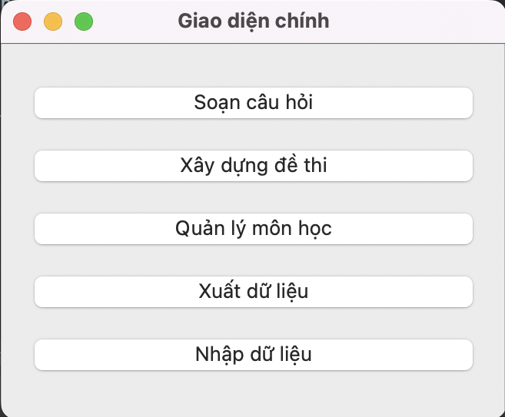

Question manage:

* Add, modify, and delete question of the question database.
* Add, modify, and delete answer or suggested answer from the answer database

Function:

* Switch between “Trắc nghiệm” and “Tự luận” radio button will change the question list regard to question type.
* When click “Thêm câu hỏi” label a pop up apprear to fill in the question.
* Edit “Chương” and “Độ khó” combo box change chapter and difficulty of question.
* When click “Thêm” label a pop up apprear to add answer option of multiple-choice question.
* When click “Chỉnh sửa” label a pop up apprear to modify the current clicked answer option of multiple-choice question.
* Click “Xoá” will delete current clicked answer option of multiple-choice question.
* Click “Xoá câu hỏi” button delete the current clicked question.
* Click “Lưu” button for saving changes.

Exam List Interface: Show exams of subject.

Function:

* Click “Tạo để thi mới” button to create new exam. This pop up appear for user to choose how to create new exam: Manually or automatically.

* Click the exam button (yellow background button) for open edit exam interface.

Create exam automatically interface: This interface shows when use choose to create exam automatically. Let user to automatically create exam based on type of question and based on difficulty (or chapters)

Function:

* Choose “Dạng đề thi” combobox to choose type of question. Available option: “Trắc nghiệm”, “Tự luận”, “Trắc nghiệm và tự luận”.
* Choose “Thiết lập độ khó combobox to for how the exam will generated. Available option: “Độ khó” and “Độ bao phủ”.
* Fill in the number of questions user want to generate and click “Tạo đề thi”. After click, this frame will be closed and the exam manage interface will appear.

Exam manage interface. This interface appear when user click generate exam manually, click the exam label from exam list interface, or after create exam automatically.

Purpose:

* Edit, add or delete question from exam.
* Edit exam information.
* Save, modify and delete exam.
* Export exam to text file.

Function:

* Edit question score in “Điểm cho câu hỏi” Spinbox.
* Click “Thêm vào đề thi” button to add the current clicked question of question list to the exam.
* Click “Xoá câu hỏi ra khỏi đề thi” label to delete the curent clicked question in exam question list
* Click Up and down arrow button to move the current clicked exam question up and down.
* Fill the exam infomation (Time, Year, Semester)
* Click “Xuất ra file” label to save exam to file (txt, rtf, …)
* Click “Xáo trộn các câu hỏi” to shuffle the question in exam.
* Click “Lưu đề thi” button to save exam, “Xoá đề thi” to delete exam.

Subjects manage Interface: Add, modify, or delete subject.

Function:

* Edit subject infomation
  + Modify “Tên môn học” text edit to modify subject name.
  + Modify “Mã học phần” text edit to modify subject code.
  + Modify “Số chương” spin box to modify number of chapters.
  + Modify “Giới thiệu” text edit to modify description.
* Click “Lưu” button to save subject information.
* Click “Thêm môn học” to open add subject pop up.

* Click “Xoá môn học” button to delete current subject.

**Chapter 6: SOFTWARE TESTING**

1. **Input testing**

**Màn hình thêm câu hỏi**

|  |  |  |  |
| --- | --- | --- | --- |
| STT | INPUT | OUTPUT | Tại |
| 1 | Ấn xoá đáp án trắc nghiệm khi chưa chọn câu trắc nghiệm | Chương trình báo lỗi chưa chọn câu hỏi để xoá | Giao diện quản lí câu hỏi |
| 2 | Ấn chỉnh sửa câu trả lời trắc nghiệm khi chưa chọn câu trả lời | Chương trình báo lỗi chưa chọn câu hỏi để chỉnh sửa | Giao diện quản lí câu hỏi |
| 3 | Ấn thêm câu hỏi khi chưa chọn câu hỏi | Chương trình báo lỗi chưa chọn câu hỏi để chỉnh thêm | Giao diện quản lí câu hỏi |
| 4. | Nhập vào thời gian thi không hợp lệ  “jdkfgdkgfd” | Thông báo thời gian thi không hợp lệ | Giao diện tạo đề thi |
|  |  |  |  |

**Pop up thêm câu hỏi**

|  |  |  |
| --- | --- | --- |
| STT | INPUT | OUTPUT |
| 1 | Không nhập thông tin gì | Chương trình báo lỗi chưa điền thông tin |
| 2 | Không chọn câu hỏi trắc nghiệm hay tự luận | Chương trình báo lỗi chưa điền thông tin |
|  |  |  |
|  |  |  |
|  |  |  |
|  |  |  |
|  |  |  |

Nhập và xuất dữ liệu

|  |  |  |
| --- | --- | --- |
| STT | INPUT | OUTPUT |
| 1 | Bấm Cancel trong giao diện chọn file sau khi bấm xuất dữ liệu | Thông báo xuất dữ liệu thất bại |
| 2 | Bấm Cancel trong giao diện chọn file sau khi bấm nhập dữ liệu | Thông báo nhập dữ liệu thất bại |
| 3 | Bấm Cancel trong giao diện chọn file sau khi bấm “xuất ra file” | Thông báo xuất đề thi ra file thất bại |

Chapter 7: Installation and usage instructions

7.1. Installation

7.2. Intended Users and Software Scope

* Intended users: Teacher.
* Software Scope: Question database management, Exam database management, generate exam based on question database.

7.3. Installation requirement

Hardware requirement: None

Software requirement:

* Version control (Git)
* Python3
* Python3 library
* Python package manager (PIP)

7.4 Detailed Installation instruction

The software is programmed using Python3 language, so it is necesssary to have python3 environment.

Python3

Check python version in your environment using the command:

python --version

If there is some error or python version is <= 3.x.x then a new version of python is required.

Python3 can be downloaded from the homepage

<https://www.python.org/downloads/>

PIP

PIP is already installed if you download python3 from homepage(above). Incase you dont have, you can type the following command to install

MacOS and Linux user:

python -m ensurepip --upgrade

Window user:

py -m ensurepip --upgrade

Installation guide can be found here:

<https://pip.pypa.io/en/stable/installation/>

Git Version Control

Installation guide:

<https://git-scm.com/downloads>

When all requirements are satisfied, user can go back to 7.1 to install.

7.5. Software Usage Guide.

The software has 3 main functions: question manage, exam manage, and question manage. They can be access when click from the main screen. The button functions are clearly defined in Section 5.3

CONCLUSION AND FUTURE WORK

Our software has satisfied most of client’s requirements, which include:

* Storing questions
* Manage questions based on subject, chapter, and question difficulty
* Generate exam automatically or manually based on chapter or based on difficulty
* Shuffle question in an exam
* Store exam information
* Export exam to a file

However, due to time constraint, some of the functions are simplified or cannot work as the way we intend. For example, the current import function will overwrite data of the user. Although this solves the data conflicts problem (happens when 2 users edit the same question), it will delete all the question of the 2nd user, which is not what they might want.

In the future, we will include online server so that different user can access the same exam and same question, which solve the data conflict problem. We will keep the offline database and solve the data conflict problem by notify the user which question is duplicated and modified and provide user option to handle the situation.