International School, Duy Tan University

CAPSTONE PROJECT 2

Grace Coffee Management

ARCHITECTURE DESIGN DOCUMENT

Version 1.0
05/11/2018

Mentor: MSc. Nguyen Minh Nhat
Group Name: Hasagi Team

Project Information
Project Title | Grace Coffee Management (GCM)
Start Date – End Date | 20/09/2018 to 1/12/2018
Lead Institution | International School, Duy Tan University
Project Mentor | Msc Nguyen Minh Nhat
Project Manager & Contact detail | Project Leader, Pham Tan Anh Khoa  K21CMUTPM2, International School, Duy Tan University  Mail: phamanhkhoa0@gmail.com  Tel: +84 1886240924
Team member | Nguyen Quoc Bao – Email: nguyenquocbao19182@gmail.com  Vo Ngoc Tin - Email: tin.vongoc.54@gmail.com  Tran Anh Tai - Email: iitaitran57696@gmail.com  Nguyen Van Thang - Email: thangnguyendien@gmail.com

Document Information

Project | Grace Coffee Management
Document Title | Architecture Design Document
Creator | Nguyen Quoc Bao

Revision History

Version | Person | Date | Description
1.0 | Nguyen Quoc Bao | 01-Nov - 2018 | Offical

Document Approval
The following signatures are required for approval of this document
Prepared by
Pham Tan Anh Khoa Date
Team Leader

CONTENTS
1. Introduction 6
1.1. Purpose 6
1.2. Documents Referenced 6
2. Project Statement 6
2.1. Project Overview 6
2.2. Business Driver 6
2.2.1. Business Problems 6
2.2.2. Business Need 6
2.3. Project Goals 7
3. Architecture Drivers 7
3.1. High-Level Requirements 7
3.2. System Context 7
3.3. Architecture Driver Specification 8
3.4. Quality Attributes 14
4. Constraints 15
4.1. Business Constraint 15
4.2. Technical Constraint 15
5. High level architecture 16
5.1. Component and Connector view (C&C view) 16
5.2. Module view 17
5.3. Allocation view 18

- Introduction
  - Purpose
This specification covers following:
- Brief specification of the project, high level requirement, system context for the system.
- Use case diagram, detail quality attribution.
- Architecture presented by various architecture view types: Component and Connect tor view, Module view, Allocation view.
  - Documents Referenced
Table 1: Document Reference
No | References
1 | Proposal
2 | ProjectPlan
3 | SrS

- Project Statement
  - Project Overview
- Project name: Grace Coffee Management
- Development team:
Table 2: Development team

Full name | Position
Phan Tan Anh Khoa | Leader
Nguyen Quoc Bao | Team Member
Vo Ngoc Tin | Team Member
Tran Anh Tai | Team Member

  - Business Driver
    - Business Problems
In today's rapidly evolving technology, the application of technology to business is extremely necessary, typically as in management, which will no longer have to be managed manually as before, the technology will do all of that with great accuracy.
Grace coffee grasped that, and with the desire to expand its business model, they would apply technology to their business systems.
On the market, there are many cafe management software examples: Vi-RES, posApp…, but they are not highly customizable or they are not fit with Grace Coffee services and idea.
    - Business Need
With the current situation, business needs:
- A website that can advertises about their product, their coffee shop and new events.
- A website that can allow user to order online.
- A website has Facebook Messenger Chat so that users can review or ask some question
- An application allows you to manage order, menu.
- An application allows you to manage inventory, it can notice material which are running out.
- An application can be integrated with website to synchronized data.
- Can be connected to bill printer.

  - Project Goals
  - With the hustle lifestyle, crowded as nowadays . If you want to take some cup of coffee or tea, but you dont have time or dont want to go out.
- Grace Coffee shop developed an Website have functions help people order drink online.
- Special, Grace Coffee will support door-to-door delivery service for you to order Drink. We believe that users will be satisfied.
- It helps in better planning and management of resources as per the requirements of the Shop.
- Better work flow and improved efficiency are some of the important benefits of using system.
- It increases the quality of services, shortens delivery times and enhances the performance rate offered by companies.
- It helps in better planning and coordination of business resources so as to achieve maximum profit.

- Architecture Drivers
  - High-Level Requirements
  - System Context

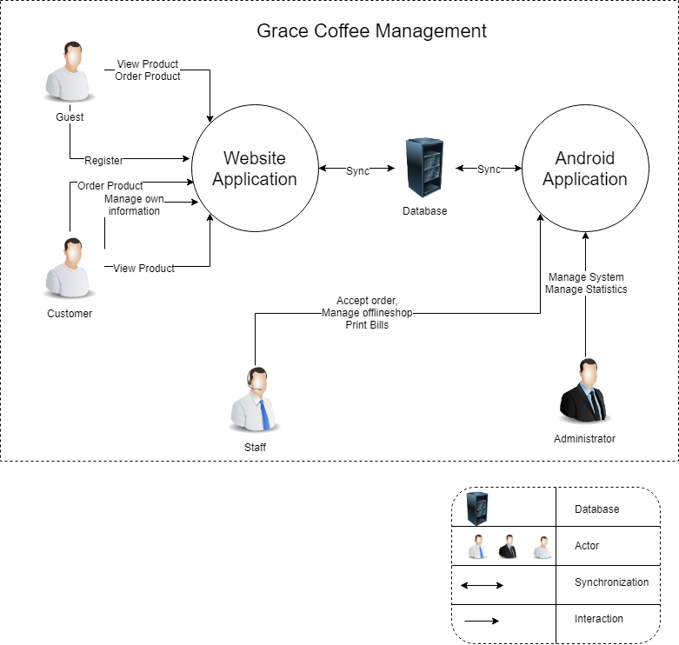
Figure 1: Context Diagram
- Admin is the highest authority. Admin can login, logout, change password, maintain the system and use the system to allow lower levels, very important for with Food Safety Review management such as: check report of post, delete accounts.
- Customer is the person who can manage information such as: add new a post, receive notifications the post, report, search, like comment or share post. After the dinners completes the function of the system will process.
- Staff is the person who can manage information such as: add new a post, receive notifications the post, report, search, like comment or share post. After the dinners completes the function of the system will process.

Architecture Driver Specification

Use case 1: Register

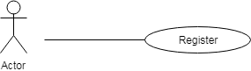

Figure 4.1: Register

Table 4.1: Register
Use Case ID: UC01
Use Case Name : Register
Member Create: Vo Ngoc Tin , Nguyen Quoc Bao |  | Member Last Update: Nguyen Quoc Bao , Trần Anh Tài
Date Create: 04/10/2018 |  | Date Last Update : 12/10/2018
Actor: Users (Customers)
Describes: This use case describes how users register gain access to the website system.
Pre-conditions: |  | The user is on the "Register" screen
Post-conditions: |  | The user is either registered in or failed to register in and is appropriately notified
Priority: H/M/L |  | M
Use frequency: |  | High
Standard processes:
Step | Actor Action |  | System Response
1 | At the external interface of the site, the user clicks on the member button |  | The system will show down the main function list is "register and login"
2 | The user continues to click on the registration button |  | The system will display the registration interface
3 | At the registration interface, the user enters his/her username, password and information in the returning of the "Register" screen.
4 | After entering the full user information continue to select "I agree to the terms and conditions."
5 | The user clicks the register button |  | If account name is in the account list displays message: "username already exists" else show messenger:" Register successfully "

Use case 2: Login member

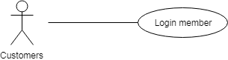
Figure 4.2: Login member

Table 4.2: Login member
Use Case ID: UC02
Use Case Name: Login member
Member Create : Vo Ngoc Tin, Nguyen Quoc Bao |  | Member Last Update Nguyen Quoc Bao, Trần Anh Tài
Date Create: 04/10/2018 |  | Date Last Update : 12/10/2018
Actor: Customers

Describes: This use case describes how users gain access to the website system through the login process.
Pre-conditions: |  | The user is on the "Login" screen
Post-conditions: |  | The user is either logged in or failed to log in and is appropriately notified
Priority: H/M/L |  | M
Use frequency: |  | High
Standard processes:
Step | Actor Action |  | System Response
1 | At the external interface of the site, the user clicks on the member button |  | The system will show down the main function list is "register and login"
2 | The user clicks on the login button |  | The system will display the login interface
3 | The user enters his/her username, password in the returning of the "Login" screen.
4 | User click on “Get started” button |  | If account name is in the account list, displays message: "successfully" else show messenger:" invalid user or password "

Use case 3: Order Online
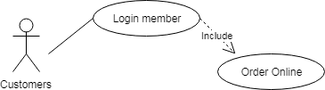
Figure 4.3: Order Online

Table 4.3: Order Online
Use Case ID: UC03
Use Case Name: Order Online
Member Create: Vo Ngoc Tin, Nguyen Quoc Bao |  | Member Last Update: Nguyen Quoc Bao , Trần Anh Tài
Date Create: 04/10/2018
Actor: Customers
Describes: This use case describes how customers can order online in web site
Pre-conditions: |  | The actor is on the Cart Screen and have already logged in.
Post-conditions:
Priority: H/M/L |  | Medium
Use frequency: |  | Low
Standard processes:
Step | Actor Action |  | System Response
1 | At shopping cart interface
2 | Customer click on Order button |  | If (row is empty) displays message: "empty" else show messenger "defined "

Use case 4: Insert drinks into the shopping cart
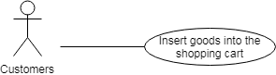
Figure 4.4: Insert goods into the shopping cart

Table 4.4: Insert drinks into the shopping cart
Use Case ID: UC04
Use Case Name: Insert drinks into the shopping cart
Member Create: Tin Vo Ngoc , Bao Nguyen Quoc |  | Member Create: Tin Vo Ngoc , Bao Nguyen Quoc
Date Create: 04/10/2018 |  | Date Create: 04/10/2018
Actor: Customers
Describes: This use case describes how customer can insert drink into shopping cart.
Pre-conditions: |  | Pre-conditions:
Post-conditions: |  | Post-conditions:
Priority: H/M/L |  | Priority: H/M/L
Use frequency: |  | Use frequency:
Standard processes |  | Standard processes
Use Case ID: UC04
Step | Actor Action |  | System Response
1 | At main interface , customer click on the button” ” of product customer want to buy |  | The system will go to the cart interface
2 | At the customer cart interface, customer click button + to add drink into shopping cart |  | Show product quantity of product

Use case 5: View, Edit Shopping cart
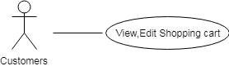

Figure 4.5: View Edit Shopping cart

Table 4.5: View, Edit Shopping cart
Use Case ID: UC05
Use Case Name: View, Edit Shopping cart
Member Create: Tin Vo Ngoc |  | Member Last Update: Khoa Pham Tan Anh, Bao Nguyen Quoc , Tran Anh Tai
Date Create: 04/10/2018
Actor: Customers
Describes: This use case describes how an actor can view, Edit Shopping cart.
Pre-Conditions:
Post-Conditions:
Priority: H/M/L |  | Medium
Use frequency: |  | High
Standard processes
Step | Actor Action |  | System Response
1 | At main interface , customer click on the button”View Shopping cart” |  | The system will go to the cart interface
2 | At the customer cart interface, customer can edit size of row in shopping cart |  | Show selected customer size

Use case 6: View drinks and information

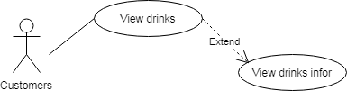

Figure 4.6: View drinks and information

Table 4.6: View drinks and information
Use Case ID: UC06
Use Case Name: View drinks and information
Member Create: Tin Vo Ngoc |  | Member Last Update: Khoa Pham Tan Anh, Bao Nguyen Quoc, Tran Anh Tai
Date Create: 04/10/2018 |  | Date Last Update: 07/11/2018
Actor: Customers
Describes: This use case describes how actors can view drinks and information
Pre-conditions:
Post-conditions:
Priority: H/M/L |  | High
Use frequency: |  | High
Standard processes
Step | Actor Action |  | System Response
1 | At main interface user click on "other" |  | Show down list of main functions of "other"
2 | The user clicks the "menu" button in the list |  | The system will display the information interface of all products
3 | Customer can see the drinks they need to buy
3.1 | The customer clicks on any product |  | System move to information drink interface

Use case 7: View news
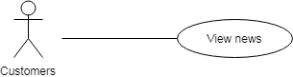

Figure 4.7: View news

Table 4.7: View news
Use Case ID: UC07
Use Case Name: View news
Member Create: Tin Vo Ngoc |  | Member Last Update: Khoa Pham Tan Anh, Bao Nguyen Quoc
Date Create: 04/10/2018 |  | Date Last Update: 07/11/2018
Actor: Customer
Describes: This use case describes how customer can view news drink.
Pre-Conditions:
Post-Conditions:
Priority: H/M/L |  | H
Use frequency:
Step | Actor Action |  | System Response
1 | At main interface
2 | Customer can see when drink is noted as new drink

Use case 8: Check promotion code
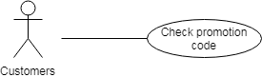
Figure 4.8: Check promotion code

Table 4.8: Check promotion code
Use Case ID: UC08
Use Case Name: Check promotion code
Member Create: Tin Vo Ngoc |  | Member Last Update: Khoa Pham Tan Anh, Bao Nguyen Quoc, Tran Anh Tai
Date Create: 04/10/2018 |  | Date Last Update: 07/11/2018
Actor: Customer
Describes: This use case describes how customers can check promotion code
Pre-conditions:
Post-conditions:
Priority: H/M/L |  | High
Use frequency: |  | High
Standard processes
Step | Actor Action |  | System Response
1 | At promotion interface, customer click on the button”View Shopping cart” |  | The system will go to the cart interface
2 | Customer can see promotion codes

Use case 9: Input promotion code

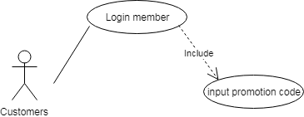
Figure 4.9: Input promotion code

Table 4.9: Input promotion code
Use Case ID: UC08
Use Case Name: Check promotion code
Member Create: Tin Vo Ngoc |  | Member Last Update: Khoa Pham Tan Anh, Bao Nguyen Quoc , Tran Anh Tai
Date Create: 04/10/2018 |  | Date Last Update: 07/11/2018
Actor: Customer
Describes: This use case describes how customers can input promotion code
Pre-conditions:
Post-conditions:
Priority: H/M/L |  | High
Use frequency: |  | High
Standard processes
Step | Actor Action |  | System Response
1 | At promotion interface, customer click on the button”View Shopping cart” |  | The system will go to the cart interface
2 | Customer down input promotion code |  | If promotion code is not in the promotion code valid list,displays message: "promotion code invalid " else show messenger:" promotion code valid " and decrease bill

Use case 10: Chat face-book
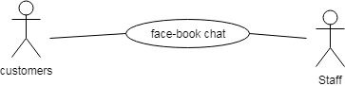
Figure 4.10: Chat face-book

Table 4.10: Chat face-book
Use Case ID: UC10
Use Case Name: Chat face-book
Member Create: Tin Vo Ngoc, Bao Nguyen Quoc |  | Member Last Update: Khoa Pham Tan Anh, Bao Nguyen Quoc
Date Create: 04/10/2018 |  | Date Last Update: 12/10/2018
Actor: Customer,Staff
Describes: This use case describes how an actor can modify chat with employee of Grace Coffee
Pre-Conditions: |  | Log-in facebook
Post-Conditions:
Priority: H/M/L |  | High
Use frequency: |  | High
Standard processes
Step | Actor Action |  | System Response
1 | At main interface
2 | Customer click button chat to move to face-book chat interface

Use case 11: Login admin
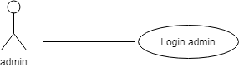
Figure 4.11: Login admin

Table 4.11: Login admin
Use Case ID: UC11
Use Case Name: Login admin
Member Create: Tin Vo Ngoc, Bao Nguyen Quoc |  | Member Last Update: Bao Nguyen Quoc
Date Create: 04/10/2018 |  | Date Last Update: 07/11/2018
Actor: Admin
Describes: This use case describes how an actor can login with rights access admin
Pre-Conditions: |  | The actor is admin and on the Login interface
Post-Conditions:
Priority: H/M/L |  | High
Use frequency: |  | High
Standard processes
Step | Actor Action |  | System Response
1 | At the interface outside the site, users click on the "Members" |  | The system will show down the main function list is "register and login"
2 | The user enters his/her username, password in the returning of the "Login" screen.
3 | The user click button define |  | If account name is in the account list, displays message: "successfully" else show messenger:" invalid user or password "

Use case 12: Insert/Update/Delete members
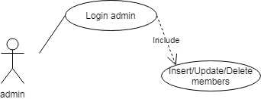
Figure 4.12: Insert/Update/Delete members

Table 4.12: Insert/Update/Delete members
Use Case ID: UC12
Use Case Name: Insert/Update/Delete members
Member Create: Tin Vo Ngoc, Bao Nguyen Quoc |  | Member Last Update: Bao Nguyen Quoc, Tran Anh Tai
Date Create: 04/10/2018 |  | Date Last Update: 08/11/2018
Actor: Admin
Describes: This use case describes how a admin can Insert/Update/Delete members.
Pre-conditions: |  | The actor is admin and on the member management interface
Post-conditions:
Priority: H/M/L |  | H
Use frequency: |  | High
Standard processes
Step | Actor Action |  | System Response
1 | At the admin page, the user clicks on the “member” button |  | The system will display the member list
2 | The admin enters click insert member |  | The system displays entries for administrators to enter member information
2.1 | After entering the member information, the administrator presses the button to add more members |  | The system displays the message "Successfully added"
3 | The admin enters click update member |  | System displays member information
3.1 | Admin change information and press confirm button |  | The system displays the message "Successfully updated"
4 | The admin enters click delete member |  | The system displays the message "you delete this member"
4.1 | The administrator presses the confirmation button |  | That member is removed from the list

Use case 13: Insert/Update/Delete drinks
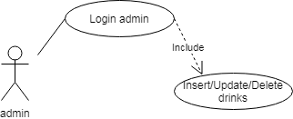

Figure 4.13 Insert/Update/Delete drinks

Table 4.13: Insert/Update/Delete drinks
Use Case ID: UC13
Use Case Name: Insert/Update/Delete drinks
Member Create: Tin Vo Ngoc, Bao Nguyen Quoc |  | Member Last Update: Bao Nguyen Quoc
Date Create: 04/10/2018 |  | Date Last Update: 08/11/2018
Actor: Users : Admin
Describes: This use case describes how user can Insert/Update/Delete drinks into menu
Pre-conditions: |  | The actor is admin and on the Update menu interface
Post-conditions:
Priority: H/M/L |  | H
Use frequency: |  | High
Standard processes
Use Case ID: UC13
Step | Actor Action |  | System Response
1 | At the admin page, the user clicks on the “Menu” button |  | The system will display the menu list
2 | The admin enters click insert drinks |  | The system displays entries for administrators to enter drinks information
2.1 | After entering the drinks information, the administrator presses the button to add more drinks |  | The system displays the message "Successfully added"
3 | The admin enters click update drinks |  | System displays drinks information
3.1 | Admin change information and press confirm button |  | The system displays the message "Successfully updated"
4 | The admin enters click delete drinks |  | The system displays the message "you delete this drinks"
4.1 | The administrator presses the confirmation button |  | That drinks is removed from the list

Use case 14: Insert/Update/Delete promotion code

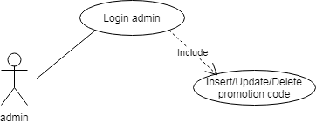
Figure 4.14 Insert/Update/Delete promotion code

Table 4.14: Insert/Update/Delete promotion code
Use Case ID: UC14
Use Case Name: Insert/Update/Delete promotion code
Member Create: Tin Vo Ngoc, Bao Nguyen Quoc |  | Member Last Update: Bao Nguyen Quoc
Date Create: 04/10/2018 |  | Date Last Update: 08/11/2018
Actor: Admin
Describes: This use case describes how user can Insert/Update/Delete promotion code
Pre-conditions: |  | The actor is admin and on the Update promotion code interface
Post-conditions:
Priority: H/M/L |  | L
Use frequency: |  | Medium
Standard processes
Step | Actor Action |  | System Response
1 | At the admin page, the user clicks on the “Promotion Code” button |  | The system will display the promotion code list
2 | The admin enters click insert promotion code |  | The system displays entries for administrators to enter promotion code information
2.1 | After entering the promotion code information, the administrator presses the button to add more promotion code |  | The system displays the message "Successfully added"
3 | The admin enters click update promotion code |  | System displays promotion code information
3.1 | Admin change information and press confirm button |  | The system displays the message "Successfully updated"
4 | The admin enters click delete promotion code |  | The system displays the message "you delete this promotion code"
4.1 | The administrator presses the confirmation button |  | That promotion code is removed from the list

Use case 15: Insert/Update/Delete events

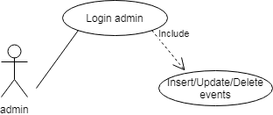
Figure 4.15 Insert/Update/Delete events

Table 4.15: Insert/Update/Delete events
Use Case ID: UC15
Use Case Name: Insert/Update/Delete events
Member Create: Tin Vo Ngoc |  | Member Last Update: Khoa Pham Tan Anh, Bao Nguyen Quoc
Date Create: 04/10/2018 |  | Date Last Update: 12/10/2018
Actor: Admin
Describes: This use case describes how user Insert/Update/Delete events.
Pre-conditions: |  | The actor is admin and on the Update promotion code interface
Post-conditions:
Priority: H/M/L |  | L
Use frequency: |  | Medium
Standard processes
Step | Actor Action |  | System Response
1 | At the admin page, the user clicks on the “events” button
2 | The admin enters click insert/update/delete events in the "events management" screen.

Use case 16: Login staff Android app

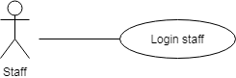
Figure 4.16 : Login(staff Android app)

Table 4.16: Login staff (Android app)
Use Case ID: UC16
Use Case Name: Login staff (Android app)
Member Create: Tin Vo Ngoc , Bao Nguyen Quoc |  | Member Last Update: Bao Nguyen Quoc
Date Create: 04/10/2018 |  | Date Last Update: 08/11/2018
Actor: Staff
Describes: This use case describes how user can Login staff Android app
Pre-conditions: |  | The actor is Staff of Grace Coffee
Post-conditions:
Priority: H/M/L |  | L
Use frequency: |  | Medium
Step | Actor Action |  | System Response
1 | At Login interface
2 | The user enters his/her username, password in the returning of the "Login" screen.
3 | The user click button define |  | If account name is in the account list, displays message: "successfully" else show messenger:" invalid user or password "

Use case 17: Order for customer Android app

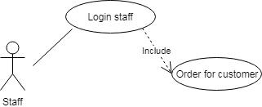
Figure 4.17 : Order for customer Android app

Table 4.17: Order for customer Android app
Use Case ID: UC17
Use Case Name: : Order for customer Android app
Member Create: Tin Vo Ngoc, Bao Nguyen Quoc |  | Member Last Update : Bao Nguyen Quoc
Date Create: 04/10/2018 |  | Date Last Update: 08/11/2018
Actor: Staff
Describes: This use case describes how user Order for customer Android app
Pre-conditions: |  | The actor is Staff
Post-conditions:
Priority: H/M/L |  | L
Use frequency: |  | Medium
Standard processes
Step | Actor Action |  | System Response
1 | At main interface
2 | The user click category |  | Drinking water display system by category
3 | The user click the drink the customer wants to order |  | The system automatically updates the drinks to the bill
4 | The user update bill and print bill for customer

Use case 18: View order online in (Android app)

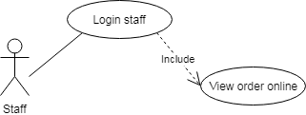

Figure 4.18: View order online Android app
Table 4.18: View order online (Android app)
Use Case ID: UC18
Use Case Name: View order online (Android app)
Member Create: Tin Vo Ngoc |  | Member Last Update: Khoa Pham Tan Anh, Bao Nguyen Quoc
Date Create: 04/10/2018 |  | Date Last Update: 08/11/2018
Actor: User
Describes: This use case describes how user can View order online in Android app
Pre-conditions: |  | The actor is Staff
Post-conditions:
Priority: H/M/L |  | L
Use frequency: |  | Medium
Standard processes
Use Case ID: UC18
Step | Actor Action |  | System Response
1 | At main interface |  | When there are new orders the system automatically reports on the "thông báo" icon
2 | The user click button “thông báo” |  | The system load to the online bill interface
3 | The user can see order online

Use case 19: Insert/Update/Delete Table (Android app)

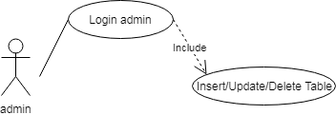
Figure 4.19 : Insert/Update/Delete Table Android app

Table 4.19: Insert/Update/Delete Table (Android app)
Use Case ID: UC19
Use Case Name: Insert/Update/Delete Table (Android app)
Member Create: Tin Vo Ngoc, Bao Nguyen Quoc |  | Member Last Update: Bao Nguyen Quoc
Date Create: 04/10/2018 |  | Date Last Update: 08/11/2018
Actor: Admin
Describes: This use case describes how user can Insert/Update/Delete Table (Android app)
Pre-conditions: |  | The actor is Admin
Post-conditions:
Priority: H/M/L |  | L
Use frequency: |  | Medium
Standard processes
Step | Actor Action |  | System Response
1 | At main interface
2 | The user click button “Cập nhập” |  | The system load to the update interface
3 | The user Click button “Bàn” |  | The system load to the update table interface
4 | If user want insert table .The user click button “Thêm bàn ” |  | The system load to the insert table interface
4.1 | The user input table number into editText “Số bàn”
4.2 | Click “Xác nhận” to complete |  | The system load to the update table interface and display dialog “Thêm thành công”
4.3 | Click “Hủy” to cancel operation
5 | If user want update number table .The user click button “ ” |  | The system load to the update table interface
5.1 | The user deletes the old table number and enters the new table number
5.2 | Click “Xác nhận” to complete |  | The system load to the insert table interface and display dialog “Sửa thành công”
5.3 | Click “Hủy” to cancel operation
6 | If user want delete table .The user click button “ ” |  | The system display dialog “Ban co muon xoa ban … khong”
6.1 | Click “Có” to complete |  | The system delete table as indicated
6.2 | Click “Khong” to cancel operation

Use case 20: Insert/Update/Delete Employee Android app

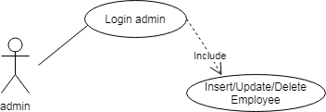

Figure 4.20 : Insert/Update/Delete Employee Android app

Table 4.20: Insert/Update/Delete Employee Android app
Use Case ID: UC20
Use Case Name: Insert/Update/Delete Employee Android app
Member Create: Tin Vo Ngoc |  | Member Last Update: Khoa Pham Tan Anh, Bao Nguyen Quoc
Date Create: 04/10/2018 |  | Date Last Update: 08/11/2018
Actor: Admin
Describes: This use case describes how user can Insert/Update/Delete Employee Android app
Pre-conditions: |  | The actor is Admin
Post-conditions:
Priority: H/M/L |  | L
Use frequency: |  | Medium
Standard processes
Step | Actor Action |  | System Response
1 | At main interface
2 | The user click button “Cập nhập” |  | The system load to the update interface
3 | The user Click Button “Nhân viên” |  | The system load to the update employee interface
4 | If user want insert employee .The user click button “Thêm nhân viên ” |  | The system load to the insert employee interface
4.1 | The user input employee name and positon into editText “tên nhân viên” and edittext “chức vụ”
4.2 | Click “Xác nhận” to complete |  | The system load to the update employee interface and display dialog “Thêm thành công”
4.3 | Click “Hủy” to cancel operation
5 | If user want update employee .The user click button “ ” |  | The system load to the update empoyee interface
5.1 | The user deletes the old employee name and employee positon then enters the new employee name and employee position
5.2 | Click “Xác nhận” to complete |  | The system load to the update employee interface and display dialog “Sửa thành công”
5.3 | Click “Hủy” to cancel operation
6 | If user want delete table .The user click button “ ” |  | The system display dialog “Ban co muon xoa nhân viên … khong”
6.1 | Click “Có” to complete |  | The system delete employee as indicated
6.2 | Click “Khong” to cancel operation

Use case 21: Insert/Update/Delete drink Android app
Figure 4.21 : Insert/Update/Delete drink Android app

Table 4.21: Insert/Update/Delete drink Android app
Use Case ID: UC21
Use Case Name: Insert/Update/Delete drink Android app
Member Create: Tin Vo Ngoc |  | Member Last Update: Khoa Pham Tan Anh, Bao Nguyen Quoc
Date Create: 04/10/2018 |  | Date Last Update: 08/11/2018
Actor: Admin
Describes: This use case describes how user can Insert/Update/Delete drink Android app
Pre-conditions: |  | The actor is Admin
Post-conditions:
Priority: H/M/L |  | L
Use frequency: |  | Medium
Standard processes
Step | Actor Action |  | System Response
1 | At main interface
2 | The user click button “Cập nhập” |  | The system load to the update interface
3 | The user Click Button “Menu” |  | The system load to the update menu interface
4 | If user want insert menu .The user click button “Thêm món ” |  | The system load to the insert drink interface
4.1 | The user input category and drinks name and price into spinner “Mục” and edittext “Tên món” and edittext “Giá”
4.2 | Click “Xác nhận” to complete |  | The system load to the update menu interface and display dialog “Thêm thành công”
4.3 | Click “Hủy” to cancel operation
5 | If user want update employee .The user click button “ ” |  | The system load to the update menu interface
5.1 | The user deletes the old drink name and price then enters the new drink name and price
5.2 | Click “Xác nhận” to complete |  | The system load to the update menu interface and display dialog “Sửa thành công”
5.3 | Click “Hủy” to cancel operation
6 | If user want delete table .The user click button “ ” |  | The system display dialog “Ban co muon xoa món … khong”
6.1 | Click “Có” to complete |  | The system delete drink as indicated
6.2 | Click “Khong” to cancel operation

Use case 22: View bill history (Android app)

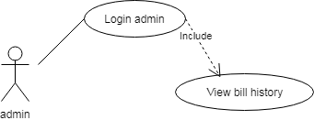
Figure 4.22 : View bill history Android app

Table 4.22: View bill history (Android app)
Use Case ID: UC22
Use Case Name: View bill history (Android app)
Member Create: Tin Vo Ngoc, Bao Nguyen Quoc |  | Member Last Update: Bao Nguyen Quoc
Date Create: 04/10/2018 |  | Date Last Update: 08/11/2018
Actor: Admin
Describes: This use case describes how user can View bill history (Android app)
Pre-conditions: |  | The actor is admin
Post-conditions:
Priority: H/M/L |  | L
Use frequency: |  | Medium
Standard processes
Step | Actor Action |  | System Response
1 | At main interface
2 | The user click button “Thống kê” |  | The system load to the statictis interface
3 | The user can see bill history interface

SEQUENSE DIAGRAM

Quality Attributes
Table 3: Quality Attribute: Usability
Quality attributes: Usability | ID: QA01
Stimulus | User view information product , bill , event
Source(s) of the stimulus | User
Relevant environment | Runtime
Architectural elements | Website
System response | The system will display information on the website after clicking on the button
Response measure(s) | The information is displayed for 4 seconds after the user clicks the button

Quality attributes: Usability | ID: QA02
Stimulus | User paid products
Source(s) of the stimulus | User
Relevant environment | Runtime
Architectural elements | Website and application
System response | The system will announce payment results after the user clicks on the payment button
Response measure(s) | The system will announce payment results in 3 seconds

Quality attributes: Usability | ID: QA03
Stimulus | User wants to change personal information
Source(s) of the stimulus | User
Relevant environment | Runtime
Architectural elements | Website
System response | The system will respond after the user changes the information
Response measure(s) | The system will respond within 3 seconds after processing the change request from the user.

Table 4: Quality Attribute: Performance
Quality attributes: Performance | ID: QA04
Stimulus | Users want to get the notifications of order
Source(s) of the stimulus | Users
Relevant environment | Runtime
Architectural elements | Website
System response | User can receive the notifications from Grace Coffe website
Response measure(s) | Users should take less than 3s to receive notifications from order product after order from website

Quality attributes: Performance | ID: QA05
Stimulus | Users want to receive information of system Grace Coffee
Source(s) of the stimulus | Users
Relevant environment | Runtime
Architectural elements | App
System response | Users to receive information of system Grace Coffee after click button
Response measure(s) | Users will wait for three seconds to receive information of system Grace Coffee

Table 5: Quality Attributes: Security
Quality Attributes: Security | ID: QA06
Stimulus | Users don't want to unauthorized disclosure of information.
Source(s) of The Stimulus | System.
Relevant Environment | The system is on-line, connected to a network.
Architectural Elements | System Database, Server.
System Response
Response Measure(s)

- Constraints
  - Business Constraint
- Project will be started on: 20 – Sep – 2018.
- Project will be finished on: 05 – Dec – 2018.
  - Technical Constraint
- Technical for Development
Technology: PHP, Javascript, Java.
- Environment:
  - Operating system: Windows, Android.
  - Develop tools: Android Studio, Visual studio code.
  - Source version control: Bitbutcket.
  - Database: Mysql MariaDB.
  - Internet Connection.

- High level architecture
  - Component and Connector view (C&C view)
The diagram below shows the overview architecture including component and other related component. We have representations and behaviors for important components in the following sections.
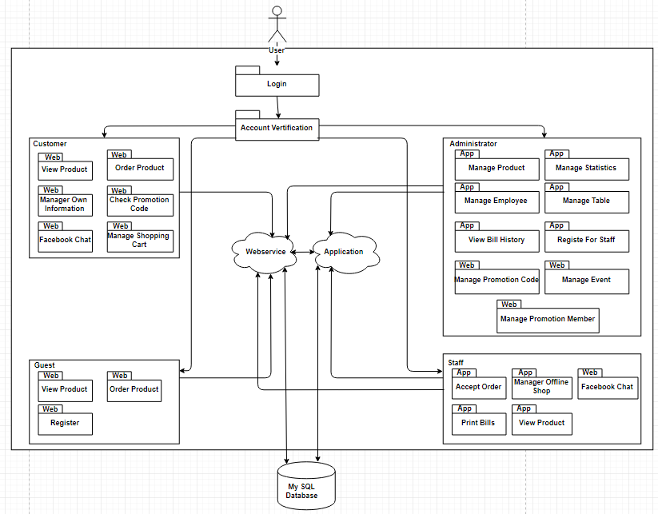
Figure 2: C&C view
- Prose:
  - User will use web browser and requires internet connection to access to system. One user accessed to system, the front-end interface will be displayed. With these front-end interfaces, user can go around the entire of the website. They can know which functions are on system easily. They will have a panoramic picture of some of the main functions of the system. From that, database from server can be transacted to users by back-end working.
  - The website is authorized to access the database through data access.

  - Module view

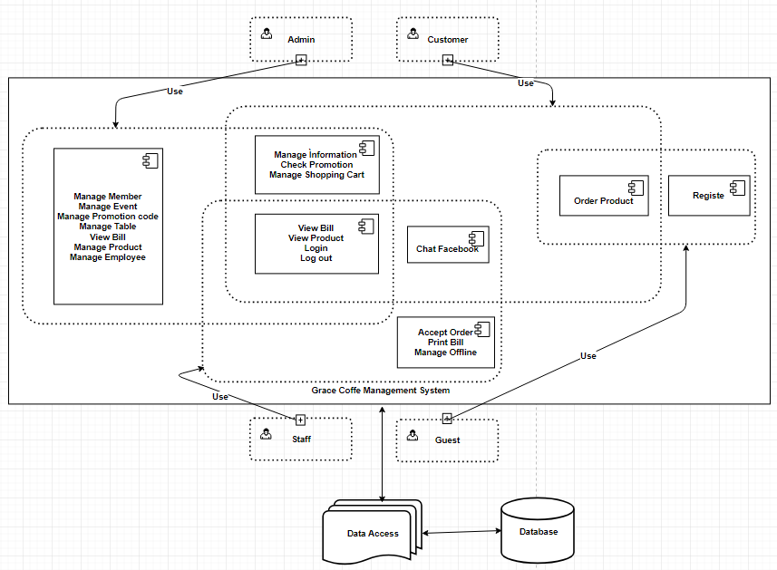
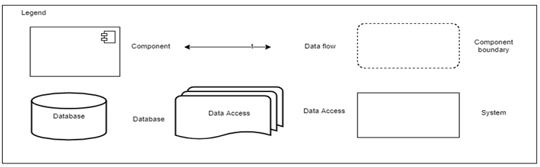

Figure 3: Module view

- Prose:
These modules have relationship and interact each other to create this system, module Login determines the functionality of users, after logging in successfully, it will be directed to the modules that users have permission to access. The functionality interacting each other, relationship will be defined by arrows.

  - Allocation view

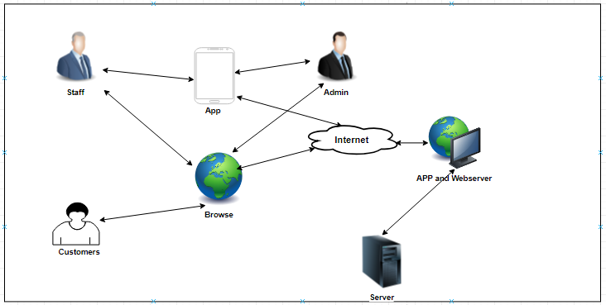
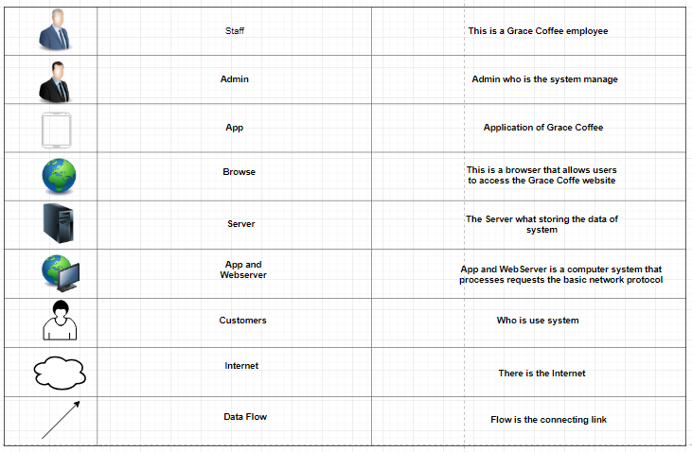
Figure 4: Allocation view
- Prose:
User will use web browser (Chrome, Firefox, Opera, Safari, etc) to can access to the system. It required have Internet network if you use external link. Once you did access to the website, the PHP environment will be processed handle to interact database between user and system. Any transaction between user and system will be implemented on Microsoft SQL Server.

