International School, Duy Tan University

CAPSTONE PROJECT 1

Grace Coffee Management
DETAIL DESIGN DOCUMENT
Version 1.0
26/12/2018

Mentor : MSc. Nguyen Minh Nhat
Group name : Hasagi Team

Document Information
Project | Grace Coffee Management
Document Title | Detail Design Document
Creator | Trần Anh Tài

Revision History

Version | Person | Date | Description
1.0 | Trần Anh Tài | 26 October - 2018 | Draft

Document Approval
The following signatures are required for approval of this document
Prepared by
Trần Anh Tài Date
Team Member 26/12/2018
Table of Contents
1. INTRODUCTION 4
1.1. Purpose 4
1.2. Scope 4
2. Project statement 4
2.1. Project overviews 4
2.2. Project background 4
2.3. Project goal 4
2.4. System Context Diagram 5
3. Laravel model 6
4. Architectural Detail 7
4.1. C&C View 7
4.2. Modele view 8
4.3. Allocation view 9
5.Design Detail 10
5.1. Design Web Interface 10
5.1.1. Homepage 10
5.1.2. Register 11
5.1.3. Member Interface 12
5.1.4. Admin Interface 13
5.1.5. Product 13
5.1.6. Contact 14
5.1.7. Customer infomation 14
5.2. Design App Interface 15
5.2.2. User Information 15
5.2.3. History 16
5.3. Design Database 17
5.3.1. ERD 17
5.3.2. RMD 18
6.References and definition 18
6.1. Definition, Acronyms and Abbreviations 18
6.2. References 18

- Introduction
  - Purpose
The purpose of this document is to present a detailed description of the Grace Coffee Management functions, the interfaces of the system.
Explain the operation of the function through UML diagrams.
  - Scope
This document is intended for both the Stakeholders and developers of the system.
- PROJECT STATEMENT
  - Project overviews
Project name Grace Coffee Management
Client Nhat Nguyen Minh
Mentor Nhat Nguyen Minh
Developer team Phạm Tấn Anh Khoa
Nguyễn Quốc Bảo
Võ Ngọc Tín
Trần Anh Tài
Nguyễn Văn Thắng

  - Project background
The Grace Coffee Management can help the user set the row and swap with the kernel's window. It is very convenient and details..
  - Project goal
Goal | Description
Software | Design an the Grace Coffee Management full function, nice and friendly interface.
Business | Meet the customer’s need.
Technology | Use the latest technology and suitable for many smartphone.
Quality | Bug is at least
Team member | Corporation to develop together.
Process | Support project is on time, on budget, assurance software quality and motivate team works.
  - System Context Diagram
This view defines the context of the system during normal operation
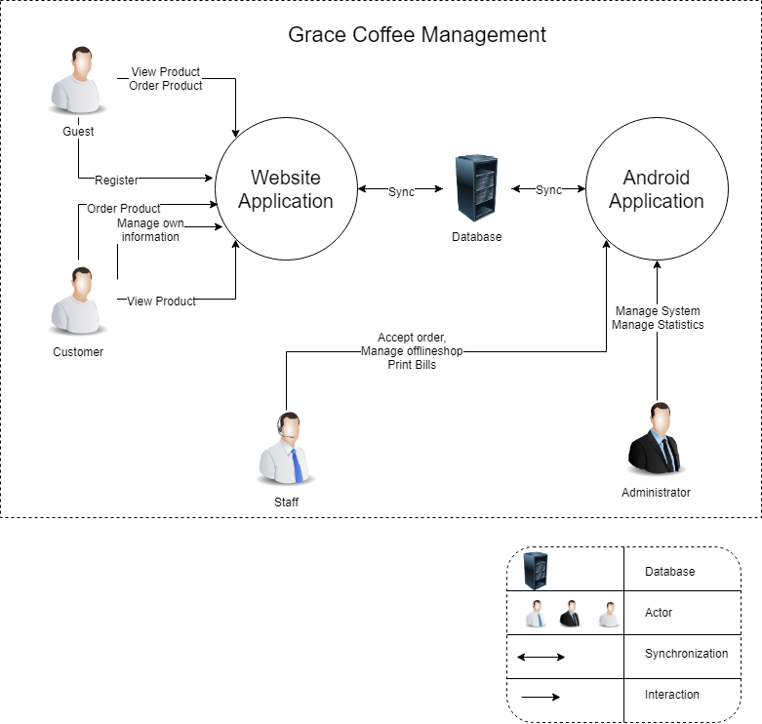
Figure 2.1: System Context Diagram

- Laravel Model

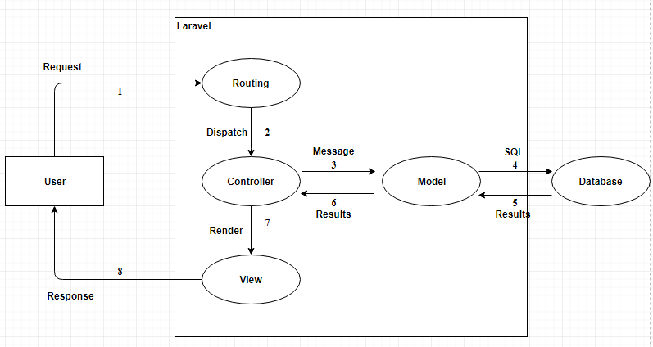

Figure 3.1: Laravel Model

- ARCHITECTURAL DETAIL
  - C&C View

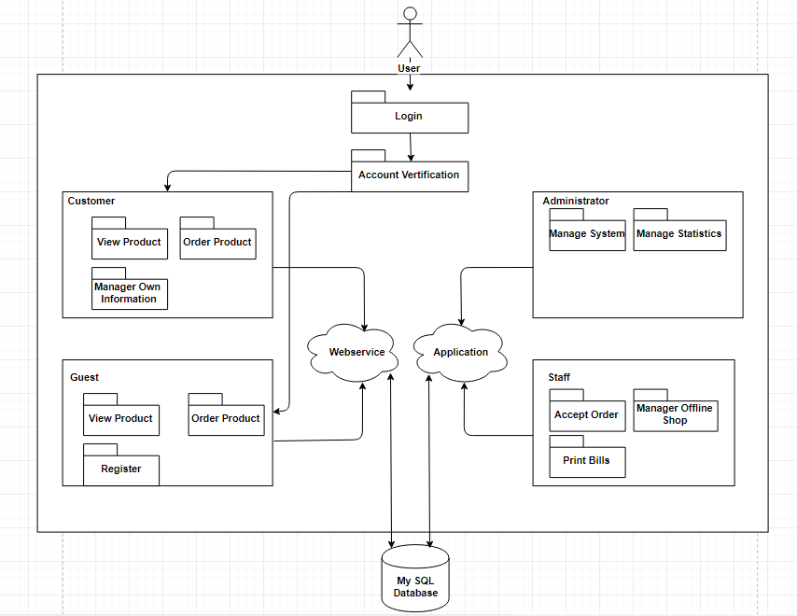

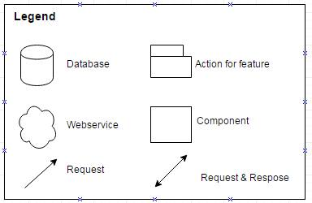
Figure 4.1: C&C View

  - Model View
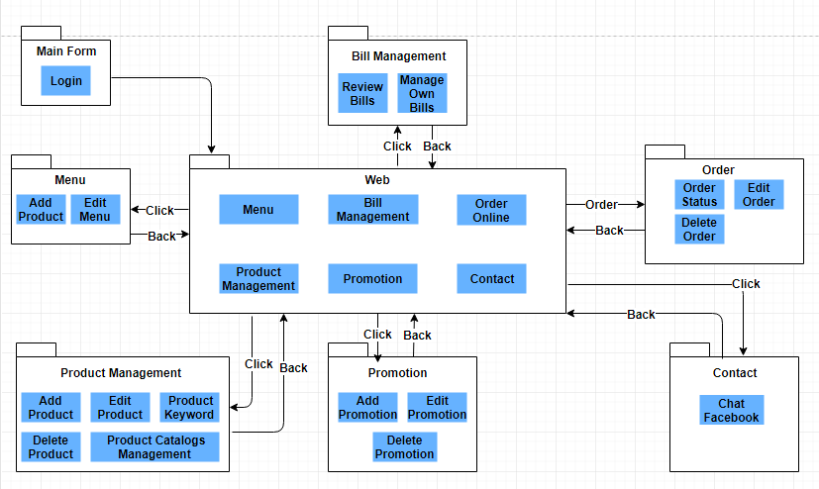

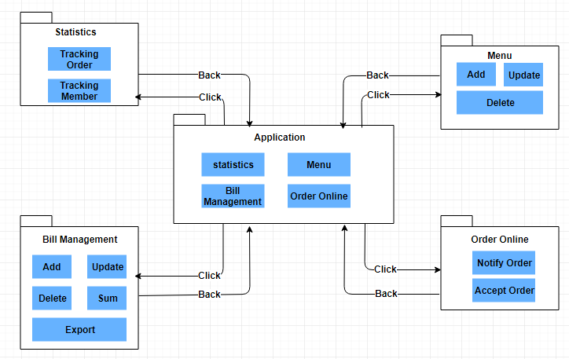
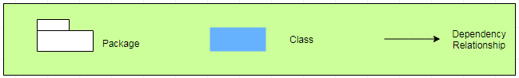
Figure 4.2: Module View
4.3 Allocation View
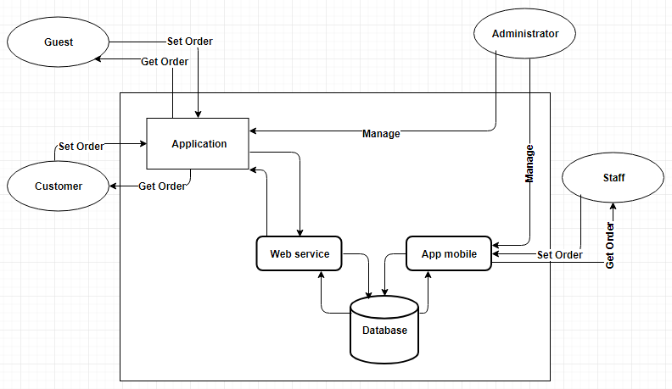
Figure 4.3:Allocation View

- Design Detail
  - Design Web Interface
    - Homepage 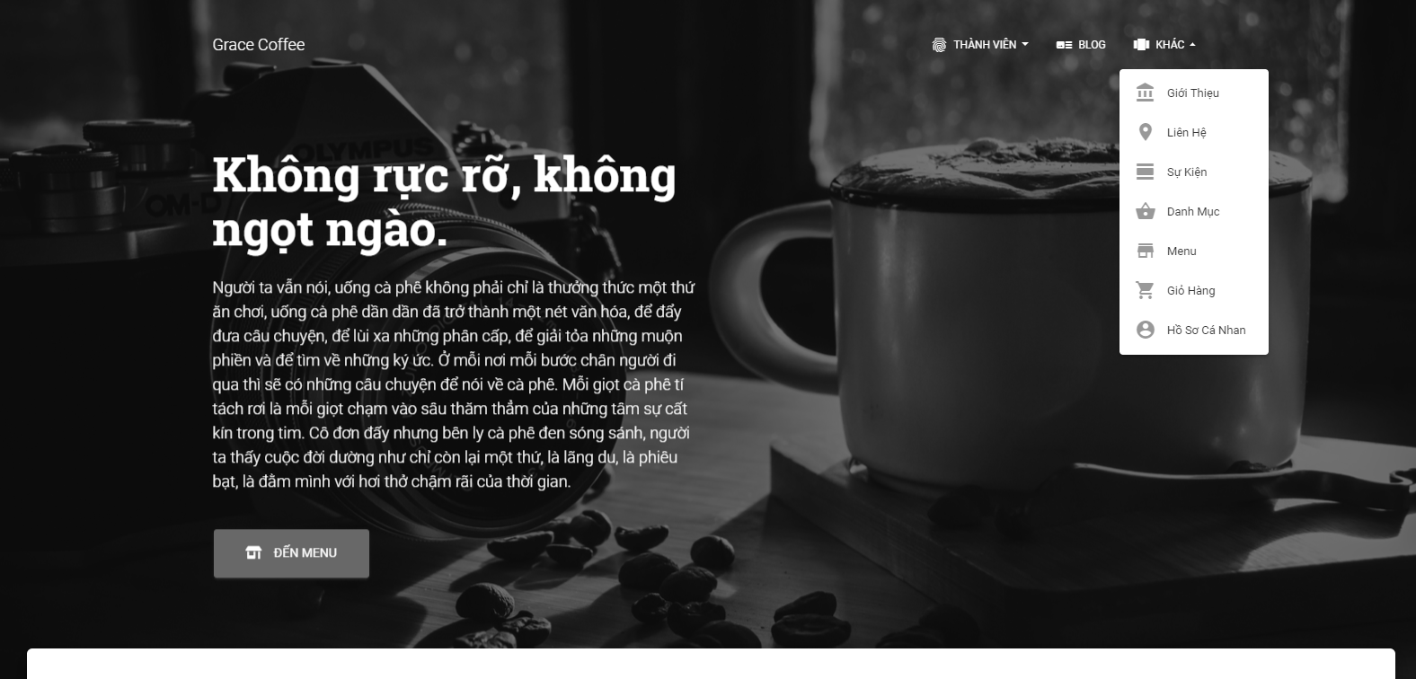

Figure 5.1: Homepage

5.1.2 Register

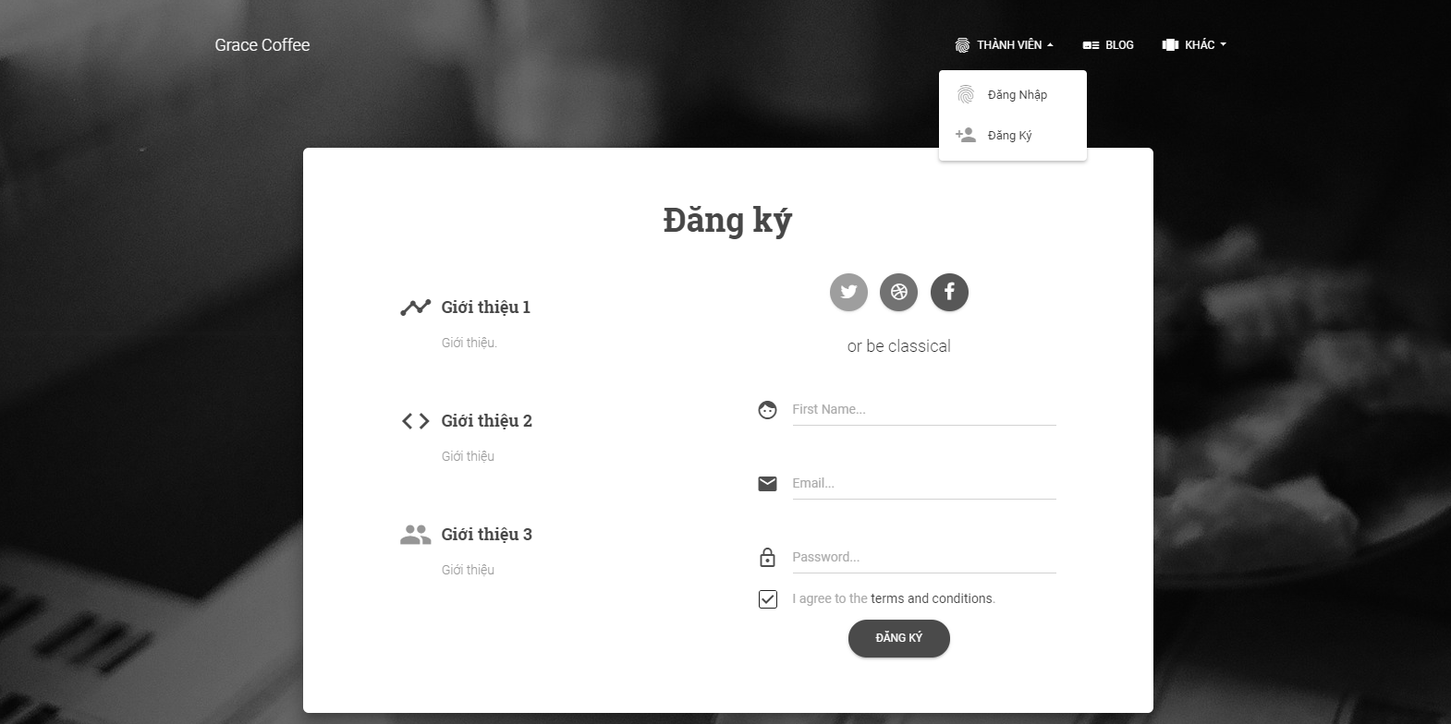

Figure 5.2: Register

5.1.3 Member Interface

Figure 5.3: Member Interface

5.1.4 Admin Interface
Figure 5.4: Admin Interface

5.1.5 Product

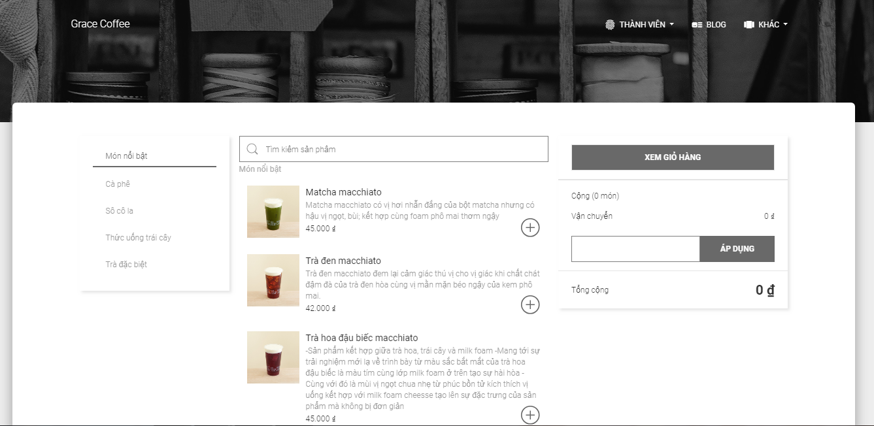

Figure 5.5: Product Interface

5.1.6 Contact
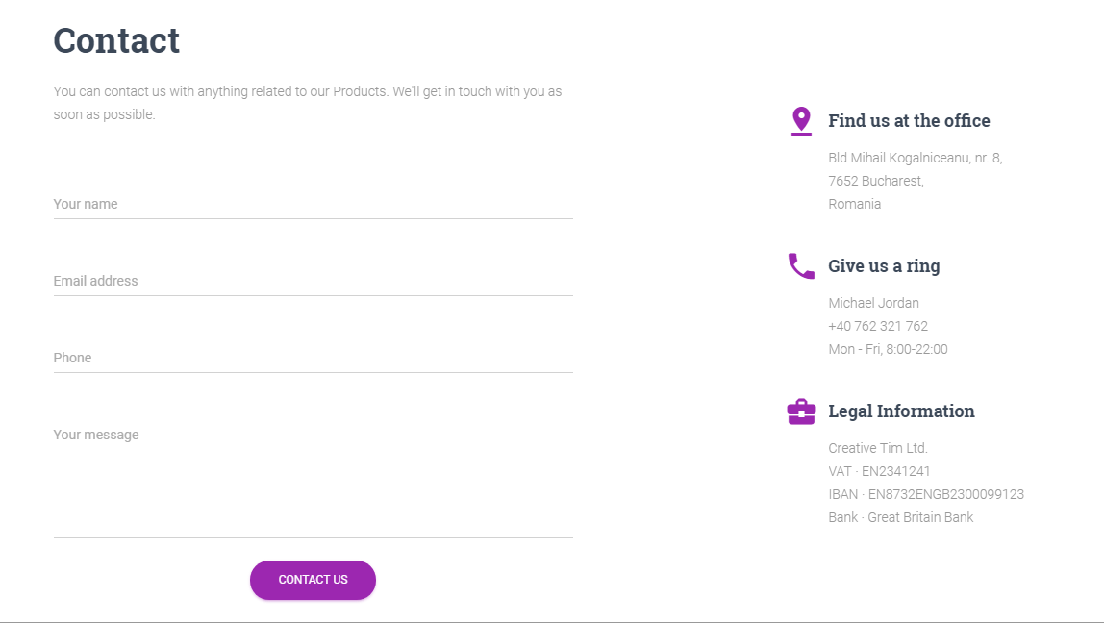
Figure 5.6: Contact Interface

5.1.7 Customer infomation


Figure 5.7: Customer information

  - Design App Interface

5.2.1 Goods list

Figure 5.8: Goods list

5.2.3 User Information

Figure 5.9: User information

5.2.4 History

Figure 5.10: History Information

5.3 Design Database

5.3.1 ERD
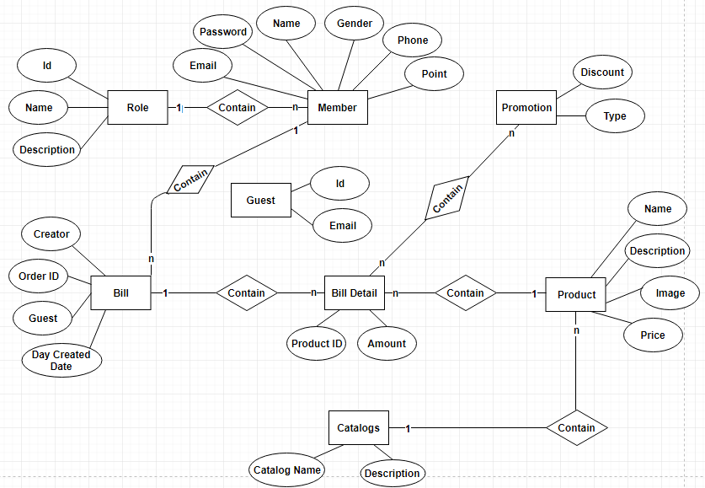

Figure 5.11: ERD

5.3.2 RMD
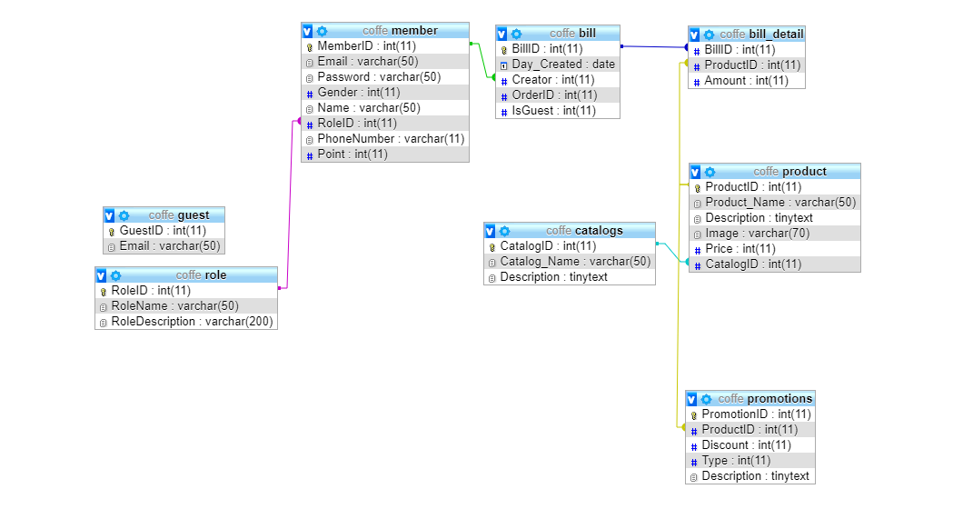
Figure 5.12: RMD

- REFERENCES AND DEFINITION

6.1 Definition, Acronyms and Abbreviations
Acronyms | Definitions
ERD | Entity Relationship Diagram
RMD | Relational Model Diagram

6.2 References
- VJS Architecture v1.2 – Man Nguyen Duc (2010)
- Information Systems Project: Detail Design Document

Prepared by | Signature | Date
Phạm Tấn Anh Khoa  Mr  K18CMUTPM1 |  | / /
Võ Ngọc Tín  Mr  K18CMUTPM1 |  | / /
Nguyễn Quốc Bảo  Mr  K18CMUTPM1 |  | / /
Trần Anh Tài  Mr  K18CMUTPM1 |  | / /
Nguyễn Văn Thắng  Mr  K18CMUTPM1 |  | / /
Approved by | Date | Signature
Nguyen Minh Nhat  Msc, Mentor  Duy Tan University |  | / /

