International School, Duy Tan University

CAPSTONE PROJECT 1

GRACE COFFE MANAGEMENT

PROJECT PLAN DOCUMENT

Version 2
25/09/2018

Mentor: MSc. Nguyen Minh Nhat
Group Name: Hasagi Team

Document Information

Project | Grace Coffe Management
Document Title | Project Plan
Creator | Pham Tan Anh Khoa, Nguyen Quoc Bao

Revision History

Version | Person | Date | Description
1.0 | Pham Tan Anh Khoa | 10 - SEP - 2018 | Draft
2.0 | Pham Tan Anh Khoa,Nguyen Quoc Bao | 23 - SEP - 2018 | Draft

Document Approval
The following signatures are required for approval of this document
Prepared by
Pham Tan Anh Khoa Date
Team Leader 20/09/2018
Contents
1. INTRODUCTION 5
2. EXECUTIVE SUMMARY OF PROJECT CHARTER 5
2.1. Executive Summary 5
2.2. Assumptions/ Constraints 5
2.2.1. Assumptions 5
2.2.2. Constraints 6
3. SCOPE MANAGEMENT 6
3.1. Scope 6
3.2. Work Breakdown Structure 7
4. SCHEDULE/ TIME MANAGEMENT 8
4.1. Milestones 8
4.2. Project Schedule 8
5. COST/ BUDGET MANAGEMENT 9
5.1. Unit Price 9
5.2. Cost Detail 9
5.3. Other Cost 9
5.4. Total Cost 9
6. HUMAN RESOURCE MANAGEMENT 9
7. COMMUNICATIONS MANAGEMENT 11
8. RISK MANAGEMENT 12
8.1. Probability Of Risk 12
8.2. Description And Solution Risks 13
- INTRODUCTION
The intended audience of Grace Coffee Management is all project stakeholders including the project sponsor, senior leadership and the project team.
- EXECUTIVE SUMMARY OF PROJECT CHARTER
  - Executive Summary
Hasagi team is pleased to provide our proposal to your store. In providing consulting, we commit to adding value through our role as a business partner. We share with you our implementation and business experience for our proposed solution as well as our promise to realize a system, which meets the goals and objectives of this organization.
  - Assumptions/ Constraints
    - Assumptions
- Management will ensure that project team members are available as needed to complete project tasks and objectives.
- The mentor will participate in the timely execution of the Project Plan (i.e., timely approval cycles and meeting when required).
- Failure to identify changes to draft deliverables within the time specified in the project timeline will result in project delays.
- Project team members will adhere to the Communications Plan.
- All project participants will abide by the guidelines identified within this plan.
- The Project Plan may change as new information and issues are revealed.

    - Constraints
- Time of project implementation constraints: Date of acceptance test the project (Review): 30/08/2018; Date of handover the project:1/12/2018
- Budget constraints: The budget for each stages of the project will be reported and presented clearly in the relevant documents.
- Development technology constraints: Technology is allowed to use to implement the project:
  - Website: PHP language, MYSQL.
  - Database System: MySQL.
  - Internet
  - Environment: Web service
  - Java Android
  - Signature of the parties related to the project: The representative of Hasagi Team and Grace Coffee Management
- SCOPE MANAGEMENT
  - Scope
Introduce the coffee product of the store to the customer, bring feelings of confidence and encourage customers to make order coffee. A successful online ordering website will greatly contribute to increasing sales

  - Work Breakdown Structure

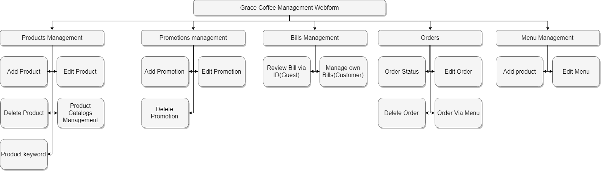

Figure 1.2 Work Break-Down Structure

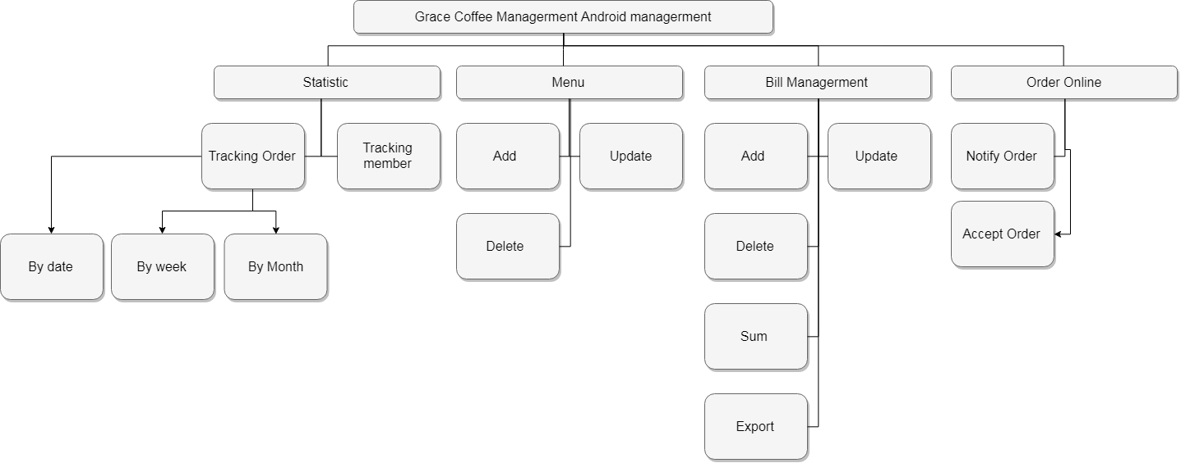
Figure 1.3 Work Break-Down Structure

- SCHEDULE/ TIME MANAGEMENT
  - Milestones
The table below lists the milestones for this project, along with their estimated completion timeframe.
Table 4.1 Milestones
No. | Task Name | Start  Day | Finish Day | Time  (hours) | Assign to
1 | Initial | 20-8-2018 | 29-8-2018 | 220 | All Team
2 | Development | 5-10-2018 |  | 498 | All Team
3 | Meeting |  |  | 8
4 | Final Meeting | 3-12-2018 | 3-12-2018 | 3 | All Team
5 | Final release | 4-12-2018 | 4-12-2018 | 3 | All Team
The total of working hour(s) |  |  |  | 732

  - Project Schedule
Table 4.2 Project Schedule
No. | Task Name | Start  Day | Finish Day | Time(hours) | Assign to
1 | Initial | 20-9-2018 | 23-8-2018 | 16
1.1 | Project Kick Off Meeting | 20-9-2018 | 21-9-2018 | 8 | All Team
1.2 | Discuss About project ideal | 22-9-2018 | 23-9-2018 | 8 | All Team
1.3 | Create Document for the project | 24-9-2018 |  |  | All Team
1.3.1 | Proposal Document | 24-9-2018 | 26-9-2018 | 20 | Thắng, Tín, Tài
1.3.2 | Project Plan and Schedule Plan | 24/09/2018 | 26-9-2018 | 20 | Khoa,Bảo
1.3.3 | Process Description | 27-9-2018 | 27-9-2018 | 6 | Khoa
1.3.4 | SRS | 30-9-2018 | 7-10-2018 | 50 | Thắng, Tài, Tín
1.3.5 | Vision and Scope | 01/10/2018 | 3-10-2018 | 4 | Tín
1.3.6 | Test plan | 16-10-2018 | 18-10-2018 | 12 | Thắng,Tài
1.3.7 | Test case | 19-11-2018 | 21-11-2018 | 16 | Thắng,Tài
1.3.8 | Test report | 28-11-2018 | 29-11-2018 | 4 | Thắng,Tài
1.3.9 | Interface Document | 1-10-2018 | 3-10-2018 | 24 | Khoa,Bảo
2 | Development | 5-10-2018 |  | 380
 | Cycle 0
2.1 | Write Document | 5-10-2018 | 15-10-2018 | 32 | Team
2.1.1 | Create Architecture Document | 5-11-2018 | 10-11-2018 | 16 | Team
2.1.2 | Create Database Design Document | 11-11-2018 | 15-11-2018 | 16 | Khoa
 | Cycle 1
2.2 | Design | 15-10-2018 |  | 118
2.2.1 | Review all document | 15-10-2018 | 17-10-2018 | 8 | Team
2.2.2 | Design interface | 18-10-2018 | 22-10-2018 | 16 | Khoa, Bảo
 | Cycle 2
2.2.3 | Create Prototype (WEB, Android) | 18-10-2018 | 20-10-2018 | 8 | Khoa, Bảo
2.2.4 | Create GUI (WEB,Android) | 21-10-2018 | 22-10-2018 | 8 | Khoa, Bảo
2.2.5 | Design Database |  |  |  | Khoa
 | Cycle 3
2.2.6 | Code Web Function | 25-10-2018 | 10-11-2018 | 24 | Khoa
2.2.6.1 | Code Menu Management function | 25-10-2018 | 26-10-2018 | 16 | Khoa
2.2.6.1.1 | Code function Add product | 25-10-2018 | 25-10-2018 | 8 | Khoa
2.2.6.1.2 | Code function Edit product | 26-10-2018 | 26-10-2018 | 5 | Khoa
2.2.6.1.3 | Code function Delete product | 26-10-2018 | 26-10-2018 | 3 | Khoa
2.2.6.1.4 | Code function Product Catalogs managements | 27-10-2018 | 30-10-2018 | 32 | Khoa
2.2.6.1.4.1 | Code function Add,Edit,Delete Catalog | 27-10-2018 | 28-10-2018 | 16 | Khoa
2.2.6.2 | Code function Promotions managerment | 31-10-2018 | 1-11-2018 | 16 | Khoa
2.2.6.2.1 | Code function Add, Edit, Delete Promotion | 31-10-2018 | 1-11-2018 | 16 | Khoa
2.2.6.3 | Code Order Management | 2-11-2018 |  | 56 | Khoa
2.2.6.3.1 | Code function Get, View, Edit, Delete Order | 2-11-2018 | 4-11-2018 | 24 | Khoa
2.2.6.4 | Code Menu Management | 9-11-2018 | 10-11-2018 | 16 | Khoa
2.2.6.4.1 | Code function Add product to menu | 9-11-2018 | 9-11-2018 | 8 | Khoa
2.2.6.4.2 | Code function Edit Menu | 10-11-2018 | 10-11-2018 | 8 | Khoa
2.2.6.5 | Code Function Blog Post | 12-11-2018 | 15-11-2018 | 24 | Khoa
 | Cycle 4 | 25-10-2018 | 4-11-2018 | 72 | Bảo
2.2.7 | Manage Android | 25-10-2018 | 4-11-2018 | 72 | Bảo
2.2.7.1 | Code Statistic Function | 25-10-2018 | 29-10-2018 | 40 | Bảo
2.2.7.1.1 | Code Function " Tracking Order : by date " | 25-10-2018 | 25-10-2018 | 8 | Bảo
2.2.7.1.2 | Code Function " Tracking Order : by week " | 26-10-2018 | 26-10-2018 | 8 | Bảo
2.2.7.1.3 | Code Function " Tracking Order : by month " | 27-10-2018 | 27-10-2018 | 8 | Bảo
2.2.7.1.4 | Code Function " Tracking customer" | 28-10-2018 | 28-10-2018 | 8 | Bảo
2.2.7.2 | Code Function "Menu" : Add, Update, Delete | 30-10-2018 | 1-11-2018 | 18 | Bảo
2.2.7.3 | Code Function "Bill Management" : Add, Edit,Delete, Sum, Expert | 2-11-2018 | 4-11-2018 | 18 | Bảo
2.2.7.4 | Code Function Manage Order : Notify Order, Accept Order | 5-11-2018 | 7-11-2018 | 20 | Bảo
 | Cycle 5 | 24-11-2018 | 2-12-2018 | 64 | Team
2.2.8.1 | Test according to Testcase And Test Plan  (Reference: Test_Plan) | 22-11-2018 | 27-11-2018 | 40 | Thắng,Tài
2.2.8.2 | Fix All bugs, error (Reference: Test_report) | 30-11-2018 | 2-12-2018 | 24 | Team
3 | Final Meeting | 3-12-2018 | 3-12-2018 | 4 | Team
4 | Final release | 4-12-2018 | 4-12-2018 | 4 | Team
The total of working hour(s) |  |  |  | 732

- COST/ BUDGET MANAGEMENT
  - UNIT PRICE
Full Name | Role | Salary Rate (USD/hour)
Phạm Tấn Anh Khoa | Leader | 1
Nguyễn Quốc Bảo | Team Member | 1
Võ Ngọc Tín | Team Member | 1
Trần Anh Tài | Team Member | 1
Nguyễn Văn Thắng | Team Member | 1
  - Cost Detail
  - Team members: 5 people
  - Hours of work: 4 h/day
  - Cost per hour: 1 USD/h
  - Cost = Cost = (Teamwork-hours*5*Cost per hours)+(Khoa,Bao*2 work-hours*cost per hours)+(Khoa work-hours*cost per hours)+(Bao work-hours*cost per hours)= (406*5+40*2+208+72)*1 = 2390 USD

Other Cost
  - Drink = 50 USD
  - Go out = 20 USD
  - Hosting = 20 USD
  - Domain = 10 USD

Total Cost
- 2490 USD
- HUMAN RESOURCE MANAGEMENT
Table 6.1 Human Resources
Stakeholders | Roles and Responsibilities
Team Leader | - Identify and analyze the system.  - Specify work for team members.  - Monitor and track team members.  - Orientation for team members.  - Ensure that the task is completed on time, scope and cost.  - Protect team work and avoid trouble.  - Provide solutions to problems.
Hasagi team | • Initial  Define requirement and complete some documents.  • Analysis and Design  Hasagi member will analysis risk, budget, resource and requirement. Then we will preliminary design about structure, database and UI of “Ur-Store System”.  • Coding and Debugging  The Leader will review again functional specifications and assign appropriate task for each member. Then, we start to code web and android system.  • Testing  After finish coding phase, the leader will generate test plan to test unit and integration.  • Acceptance  When testing phase finish and everything in our system is fine. We will pack and release the system.  • Maintenance  After release, our team will continue to support the warranty. Fix bugs and update the system usually.

- COMMUNICATIONS MANAGEMENT
Participants | Topic | Frequency | Method
Mentor and Team member | Evaluate project progress | Weekly | Offline, Mail, Google Drive ,Facebook
Team Leader and Team Member | Review about progress and update process. | Daily | Using Email, FaceBook, Google Drive and Trello in exchanging the information about the teamwork.

- RISK MANAGEMENT
  - Probability Of Risk
Table 8.1 Probability of Risks
 | Risks | Probability | Impact | References
1 | Specification document is not  consistent with the product | 15% | 4 | _
2 | Time problem | 20% | 3 | _
3 | Health | 8% | 3
4 | Technical | 25% | 3 | _
5 | Without consistency of ideas  between members of the group | 10% | 2 | _
6 | Mistake occurred in the process of  coding | 5% | 2 | _
7 | Members of the group cannot meet | 8% | 4 | _

  - Description And Solution Risks
Table 8.2 Risk Description
 | Risks | Description | Solution
1 | Time problem | The time of project may be duplicate with calendar or history of personal users in the group, the project may be late compared to schedule. | If the project team seen  that the work is done ahead of schedule delay, the group will deploy to work overtime to finish projects on schedule.
2 | Health | Due to weather conditions or due to overwork, can the sick members of the group can sick in the course of the project. | The member of team must split the project and prepare the working program in weekly and check each team members program every week and control how project is run.
3 | Technical | computer technology makes changes to the project delay | Defensive equipment necessary preparatory planning machinery in the process of project word.
4 | Disagree between team members | Disagreement between the members of the group result in the behavior do not respect each other | Team project must solve the problem between team members in early time and prevention disagreement things before the conflict.
5 | Mistake occurred  in the process of coding | Coding is the team members responsible for component in a project which each person has an own idea. Therefore, when combined together can lead to traits do not coincide with each other. | If team project does not want any mistake in coding, the team must do control the coding and test every week or control and test small part and back up codes every week.
6 | Meetings in the group are inconsistent | As each team member has their own schedule, it is difficult to work with each other | The leader will look at each person's personal calendar and choose the time that all team members have time to meet each other

