International School, Duy Tan University


CAPSTONE PROJECT 1

Grace Coffee Management

PROJECT PROPOSAL DOCUMENT

Version 2.0
23/09/2018

Mentor: MSc. Nguyen Minh Nhat
Group Name: Hasagi Team

PROJECT OVERVIEW

Project Title | Grace Coffee Management (GCM)
Start Date – End Date | 20/09/2018 to 1/12/2018
Lead Institution | International School, Duy Tan University
Project Mentor | Msc Nguyen Minh Nhat
Project Manager & Contact detail | Project Leader, Pham Tan Anh Khoa  K21CMUTPM2, International School, Duy Tan University  Mail: phamanhkhoa0@gmail.com  Tel: +84 1886240924
Team member | Nguyen Quoc Bao – Email: nguyenquocbao19182@gmail.com  Vo Ngoc Tin - Email: tin.vongoc.54@gmail.com  Tran Anh Tai - Email: iitaitran57696@gmail.com  Nguyen Van Thang - Email: thangnguyendien@gmail.com

DOCUMENT

Document Title | Proposal Document
Reporting period | Aug, 2018
Author | Team Hasagi
Role | Team member
Filename | Proposal Document_v1.0

document approval
The following signatures are required for approval of this document. Note, however, that since some role assignments will change during the course of the project, the perspective names should be update if needed.
No. | F. Name | L. Name | Role | Date | Signature
01 | Nguyen Minh | Nhat | Mentor
02 | Pham Tan | Anh Khoa | Leader
03 | Nguyen Quoc | Bao | Member
04 | Vo Ngoc | Tin | Member
05 | Tran Anh | Tai | Member
06 | Nguyen Van | Thang | Member

CONTENTS
1. Introduction 5
1.1 Purpose 5
1.2 Scope 5
1.3 References 5
2. Project Overview 6
2.1 Project definition 6
2.2 Business needs 6
2.3 Implementation Methodology 6
2.4 Critical Success Factors and Assumptions 7
3. System Architecture Overview 8
3.1 System Context 8
3.2 System Context Description 8
3.3 Technical Constraints 9
3.3.1 Technical to develop the system 9
3.3.2 Environment 9
3.3.3 Other constraints 9
4. Profile of Hasagi Group 9
5. Statement of work 10
5.1 Company Organization and Geographical Scope 10
5.2 Scope of Work 10
5.3 General Assumptions 10
5.4 Customer Responsibilities and Deliverables 11
6. Implementation Methodology 11
6.1 The Project Methodology 12
6.2 Project Plan 13
6.3 Organization Management 13
6.3.1 Human Resources 13
6.3.2 Costs Estimate 14

1. Introduction

1.1 Purpose
- The document provides an overview of the project includes the purpose and scope of project.
- In addition, identify business needs, problems or situation related to the initialization and construction projects.
- Provide solution for business needs and give the overview of system architecture.
- Provide overview about resources, schedule, risk, solution and budget for the project.

1.2 Scope
- This document provides an overview of project will be developed. It includes overview of the product, overview of the process and overview of the project team.
- This document provides a plan for each stage of software development process based on Advanced Waterfall Process include: start time, end time and number of working days. This is the general plan and will be updated with detail of the software development process in the next version of document. Proposal includes the introduction of solutions; determine the best way to develop software that we make the total estimated costs, payback period, and breakeven volume for the project.

1.3 References
No. | References | Document Information
1 | Waterfall process | https://en.wikipedia.org/wiki/Waterfall_model
1 | Waterfall process | https://www.ukessays.com/essays/information-technology/advantages-of-waterfall-model-information-technology-essay.php
2 | Technical | https://stackoverflow.com
2 | Technical | http://www.codeproject.com/

2. Project Overview

2.1 Project definition
In today's rapidly evolving technology, the application of technology to business is extremely necessary, typically as in management, which will no longer have to be managed manually as before, the technology will do all of that with great accuracy.
Grace coffee grasped that, and with the desire to expand its business model, they would apply technology to their business systems.
On the market, there are many cafe management software examples: Vi-RES, posApp…, but they are not highly customizable or they are not fit with Grace Coffee services and idea.

2.2 Business needs
With the current situation, business needs:
- A website that can advertises about their product, their coffee shop and new events.
- A website that can allow user to order online.
- A website has Facebook Messenger Chat so that users can review or ask some question
- An application allows you to manage order, menu.
- An application allows you to manage inventory, it can notice material which are running out.
- An application can be integrated with website to synchronized data.
- Can be connected to bill printer.

2.3 Implementation Methodology
We implement on Web and Application foundation, method of implementation will be focus to plan:
- Minimize the length of implementation time.
- Maximize the utilization and resources.
- Incorporate a process-oriented approach

2.4 Critical Success Factors and Assumptions
- Adherence to scope and objectives of the project.
- Adherence to the no-modifications objective.
- Efficient use of both internal and external resources.
- Timely decision making.
- Clarity of business objectives for the project.

3. System Architecture Overview

3.1 System Context
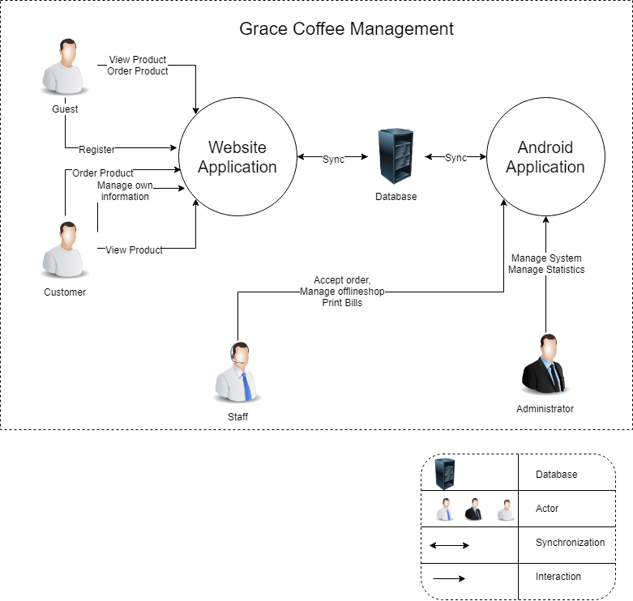
1.1 System Context Diagram

3.2 System Context Description
- Administrator will able to manage the system on Web Application and Android Application with some main function:
- Statistics.
- Manage GCM system.
- Customer will able to access the Web Application with three main functions:
- View, order products.
- Review their bills.
- Manage personal information and order.
- Guest will able to access the Web Application with three main functions:
- View, order products.
- Review Bill via Bill ID.
- Register account to be customer.
- Sales Staff will able to manage about orders, bills and promotions on Android Application and the Menu on Web Form.

3.3 Technical Constraints

3.3.1 Technical to develop the system
- Programing: PHP(Framework : Laravel), Java android
- Database: MySQL
- Web server: Apache, XAMPP

3.3.2 Environment
- Develop tools: Visual Studio Code, Google Drive, slack, Android Studio.
- PC, laptop with Internet connection.

3.3.3 Other constraints
- Resources: 5 people.
- Cost: …………….
- Time: The project must be completed within 3 months frame.

4. Profile of Hasagi Group
- Leader : Pham Tan Anh Khoa
Phone: +84 1886240924
- Team member: Tran Anh Tai
- Team member: Nguyen Quoc Bao
- Team member: Nguyen Van Thang
- Team member: Vo Ngoc Tin

5. Statement of work

5.1 Company Organization and Geographical Scope
- Desiring to expand his business and achieve better results, Graces coffee wishes to have a website and mobile app to grow their business.

Scope of Work

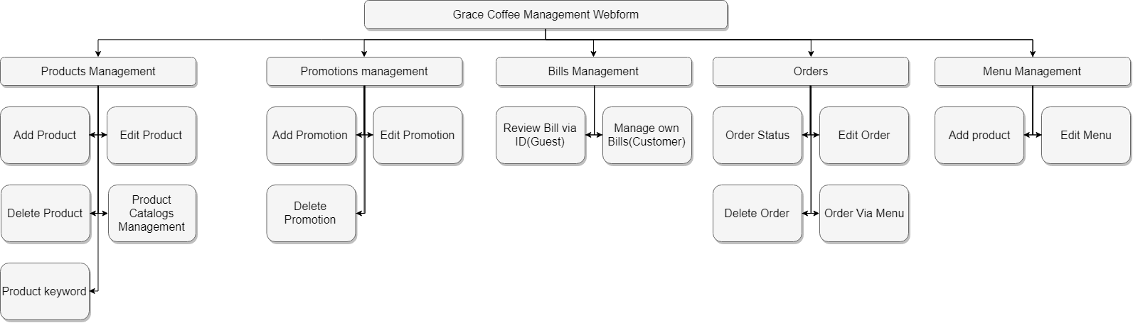

Figure 1.2 Work Break-Down Structure

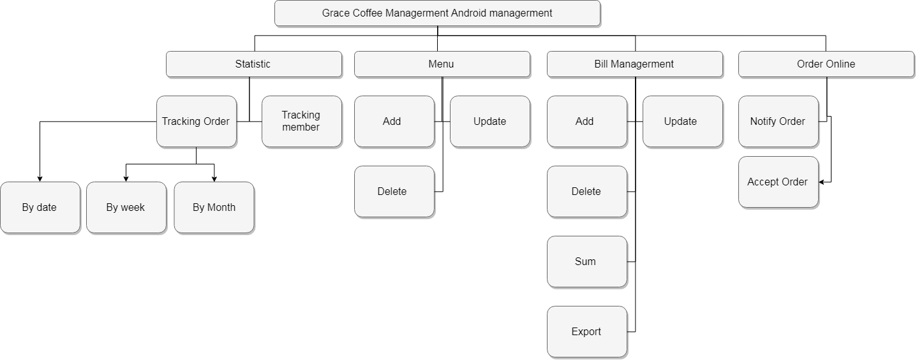
Figure 1.3 Work Break-Down Structure

5.3 General Assumptions
- The project will focus on implementing those business processes listed in section on scope. Processes not listed will be considered out of scope for the project defined in this proposal.
- Data is storage in host and web service.

5.4 Customer Responsibilities and Deliverables
- Ownership and overall project responsibility, providing a project manager, driving resources, providing direction to that team regarding decision making, planning and scope management.
- Effective and timely decision making processes are critical to the success of any software implementation. To ensure a successful implementation, all issues will need to be resolved within 24 hours.
- Data extraction, preparation & cleaning
- Change Management
- Ensure knowledge transfer from key users to end users, e.g.
- Test and validate the delivered business processes
- Provide a working environment and adequate facilities

6. Implementation Methodology
We will use technical solution to reach your target project and follow plan:
- Project will be implemented in the following platforms and database:
- Implement on Android and PHP foundation
- Web Service.
- Project will be managed on the following tools:
    - Google Drive, Trello
    - Teamwork
    - Software Development Process: Advanced Water Fall

6.1 The Project Methodology

Initial (Requirement)
Analysis and Design
Testing
Acceptance
Maintenance

Coding and Debugging

Figure 1.4 Advanced Waterfall Process
- Although there are a variety of project management methodologies on the market, waterfall stands out for a multitude of reasons.
Easy to Follow
Much like a map or a set system, the waterfall method is successful because it’s easy to follow. Knowing exactly where you are in the life cycle of the project at all times helps project managers stay organized and keep the process flowing.
Minimal Management
Since the rules in a waterfall model are so clearly defined, these types of projects are somewhat easy to manage. You simply follow the steps one-by-one until completion. Waterfall works best for projects where the requirements are easily understood and the order is clearly defined.
No Overlapping
Unlike other project management methods, the phases in this type of system never overlap. Design cannot happen until analysis is complete, coding cannot happen until design is complete…and so on and so forth. This makes it easy to follow along through the phases of the project without getting lost in two separate steps.
Final Product
Since the waterfall model is so thorough, chances are your final product will be much more fully formed and complete than other project management methods, like the business Agile Model. This is because there is an entire step in the process solely committed to finding bugs and errors within the newly designed system. Therefore, products that run through the waterfall method are typically fully debugged when finally released.
Choosing the right type of model to manage a task is really the universal first step to planning a successful project. The waterfall methodology was developed years ago with a clear set of steps and rules to run the tightest ship possible. Understanding the advantages of this type of system and applying the standards accordingly will ensure you develop a successful product every step of the way.

6.2 Project Plan
Reference to Project_Plan.docx

6.3 Organization Management

6.3.1 Human Resources
ROLES | RESPONSIBILITIES | PARTICIPANT
Mentor | - Guide on the process.  - Monitoring all activities of Team.  - Help with anything. | MSc, Nhat, Nguyen Minh
Team Members | - Estimate time to finish task.  - Analysis Requirements.  - Design and gradually improve the design.  - Coding and Testing.  - Install and implement functions tests.  - Deploy product. | - Khoa, Pham Tan Anh  - Bao, Nguyen Quoc  - Tin, Vo Ngoc  - Tai, Tran Anh  - Thang, Nguyen Van

6.3.2 Costs Estimate
Reference to Project_Plan.docx

