International School, Duy Tan University

CAPSTONE PROJECT 1

Grace Coffee Management

Software Requirements
Specification Document

Version 1.0
09/10/2018

Mentor: MSc. Nguyen Minh Nhat
Group Name: Hasagi Team

Document Information

Project | Grace Coffee
Document Title | Software Requirement Specification Document
Creator | Pham Tan Anh Khoa  Nguyen Quoc Bao  Vo Ngoc Tin  Tai

Revision History

Version | Person | Date | Description
1.0 | Pham Tan Anh Khoa | 09-10-2018 | Release
1.1 | Nguyen Quoc Bao | 11-06-2018 | Release

Document Approval
The following signatures are required for approval of this document
Prepared by
Pham Tan Anh Khoa Date
Team Leader 09/10/2018

Contents
1. INTRODUCTION 2
1.1. Purpose 2
1.2. The Rules Of The Document 2
1.3. DOCUMENT READER GUIDANCE 2
1.4. RANGE OF SOFTWARE PRODUCT 3
1.5. REFERENCE 3
2. BACKGROUND 4
2.1. THE CONTEXT OF SOFTWARE PRODUCTS 4
2.2. FUNCTION 4
2.3. THE CLASS AND CHARACTER OF USER 6
2.4. OPERATING ENVIRONMENT 6
2.5. CONSTRAIN DESGIGN AND EXECUTE 6
2.6. Assumptions and dependencies 6
3. Requirements interface out 7
Context Diagram 7
4. Software Fuatures 8
UseCase Diagram 8
4.1. User’s interface 26
4.2. Hardware’s interface 26
4.3. Software’s interface 24
4.4. Communication’s interface 27
5. Non-functional requirements other 27
5.1. Performance Requirements 27
5.2. Safety Requirements 27
5.3. Security Requirements 27
5.4. The properties of the product quality 27
5.5. User Documentation 27
6. Other Riquirements 24

- INTRODUCTION
  - PURPOSE
This document describes the functional and nonfunctional of Grace Coffee Management System version 1.1. This document is for the stakeholders and the development team of the system
  - THE RULES OF THE DOCUMENT
Here are the conventions and abbreviations used in this document and project.
Table 1.1 Conventions and abbreviations
No | The term, acronym | Explain
1 | Display | is used for communication, interaction between system and users through different means: Web, app on Android,
2 | User | The app users. example: everyone have a device with internet connection and browser
3 | Use-Case | Describe how the function work

  - DOCUMENT READER GUIDANCE
The object reference this description include:
- The development team
- Project Management
- Stakeholders:

Table 1.2 Role and skill of Team
Stakeholder | Role | Skill
Project Management | The entire project management, costing, time and resources | Management, Sales, Engineering
Testers | Testing, product testing in accordance with requirements and wishes of customers | Engineering
The developers | Using the programming language to build products | Engineering, Coder
The designer | Product design: the interface, the architecture, database, graphic... | Engineering

- The description will be reviewed regularly by the object on to examine project through requirements.
- Any change in requirements will also be updated in this description.
  - Range of Software Product
This system was designed with the aim of bring feelings of confidence and encourage customers to make order coffee. A successful online ordering website will greatly contribute to increasing sales.
  - Reference
- Specification
- Vision and Scope Document
- Documentation Use-case

- BACKGROUND
  - The Context Of Software Products
- Nowadays, when technology has developed rapidly, the application of technology to replace manual forms in the business with high accuracy has created many advantages in the business. Grace coffee knows that and with the desire to expand its business model, they want a business system that consists of a web page and a synced application.
- Once the technology has been successfully deployed, they can advertise their products on the Web, so that the site can allow users to order online, Facebook Messenger Chat sites for users to exchange with Grace Coffee. Besides the site, the application allows Grace Coffee to manage the order, making the business menu easy.
  - Function
- Feature 1: Login
- Priority: Normal.
- Risk: confirm code maybe wrong or password have special sympol.
- Function: Login.
- Environment: Web, App.
- Feature 2: Show product information
- Priority: High.
- Risk: spend time for load data.
- Function: Show good’s information.
- Environment: Web, App.
- Feature 3: Show good’s list
- Priority: High.
- Risk: spend time for load data.
- Function: Show good’s list.
- Environment: Web, App

- Feature 4: Shopping cart
- Priority: High.
- Risk: Spend time for load data from user’s booked.
- Function: Shopping cart.
- Environment: App
- Feature 5: Event, advertisement.
- Priority: Low.
- Risk: Spend time for load data.
- Function: News.
- Environment: Web, App.
- Feature 6: Chat
- Priority: Normal.
- Risk: Chat’s server offline.
- Function: Chat.
- Environment: Web, App.
- Feature 7: User’s information
- Priority: High.
- Risk: Spend time for load user’s data.
- Function: User’s information.
- Environment: Web, App.

  - THE CLASS AND CHARACTER OF USER

Table 2.1 Class and character of user
User | Description
Customer | This user can search fresh food, booking, and contact with shop manager and another features
Shop Manager | This user can general manage product or category’s information and user’s information.

  - Operating Environment
- Web Technology
- Android App
  - Constrain design and execute
- System will be construct in Android and web site
- User can use web site order drinks.
- Language: Vietnamese.
  - Assumptions and dependencies
- Dependence
  - Booking accidentally to internet
  - User must have android’s device or another device login to website
  - User must login to booking
- Supposelly

- Requirements interface out

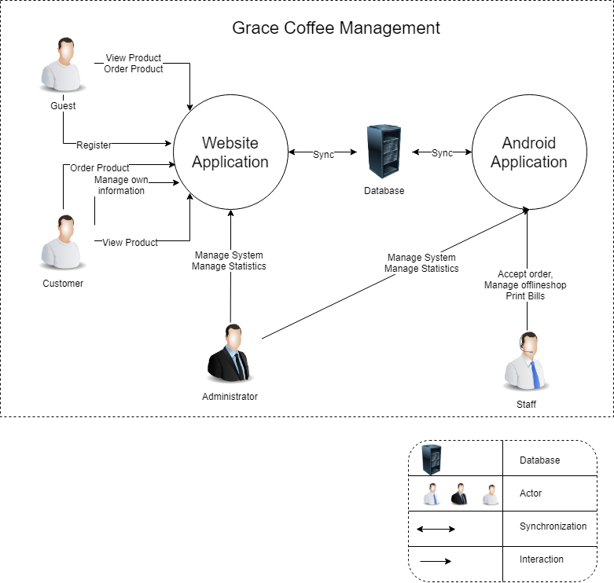
Figure 3.1 Context Diagram

- Software Fuatures

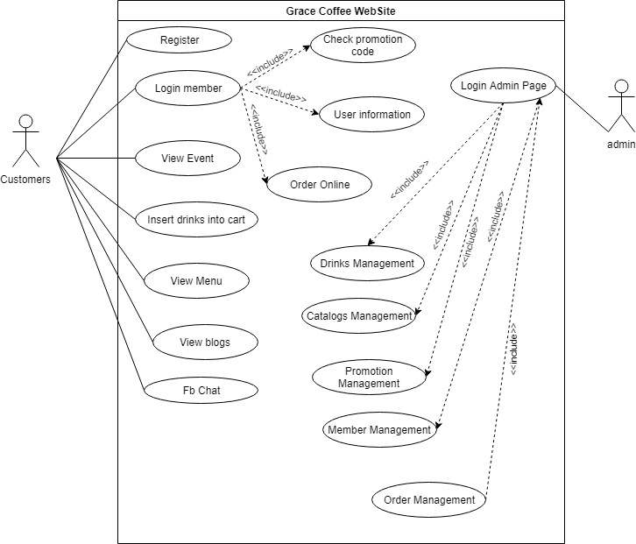
Figure 4.0: Use Case Diagram for Web site system
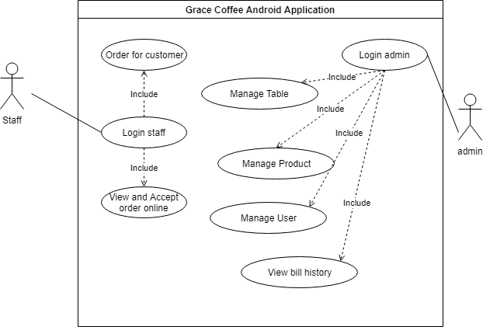
Figure 4.0.1: Use Case Diagram for Android system

Use case 1: Registers

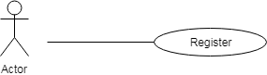

Figure 4.1: Register

Table 4.1: Register
Use Case ID: UC01
Use Case Name : Register
Member Create: Vo Ngoc Tin , Nguyen Quoc Bao |  | Member Last Update: Nguyen Quoc Bao , Trần Anh Tài
Date Create: 04/10/2018 |  | Date Last Update : 12/10/2018
Actor: Users (Customers)
Describes: This use case describes how users register gain access to the website system.
Pre-conditions: |  | The user is on the "Register" screen
Post-conditions: |  | The user is either registered in or failed to register in and is appropriately notified
Priority: H/M/L |  | M
Use frequency: |  | High
Standard processes:
Step | Actor Action |  | System Response
1 | At the external interface of the site, the user clicks on the member button |  | The system will show down the main function list is "register and login"
2 | The user continues to click on the registration button |  | The system will display the registration interface
3 | At the registration interface, the user enters his/her username, password and information in the returning of the "Register" screen.
4 | After entering the full user information continue to select "I agree to the terms and conditions."
5 | The user clicks the register button |  | If account name is in the account list displays message: "username already exists" else show messenger:" Register successfully "

Use case 2: Login member

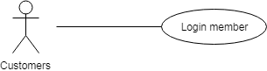
Figure 4.2: Login member

Table 4.2: Login member
Use Case ID: UC02
Use Case Name: Login member
Member Create : Vo Ngoc Tin, Nguyen Quoc Bao |  | Member Last Update Nguyen Quoc Bao, Trần Anh Tài
Date Create: 04/10/2018 |  | Date Last Update : 12/10/2018
Actor: Customers

Describes: This use case describes how users gain access to the website system through the login process.
Pre-conditions: |  | The user is on the "Login" screen
Post-conditions: |  | The user is either logged in or failed to log in and is appropriately notified
Priority: H/M/L |  | M
Use frequency: |  | High
Standard processes:
Step | Actor Action |  | System Response
1 | At the external interface of the site, the user clicks on the member button |  | The system will show down the main function list is "register and login"
2 | The user clicks on the login button |  | The system will display the login interface
3 | The user enters his/her username, password in the returning of the "Login" screen.
4 | User click on “Get started” button |  | If account name is in the account list, displays message: "successfully" else show messenger:" invalid user or password "

Use case 3: Order Online
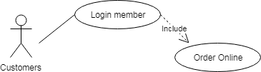
Figure 4.3: Order Online

Table 4.3: Order Online
Use Case ID: UC03
Use Case Name: Order Online
Member Create: Vo Ngoc Tin, Nguyen Quoc Bao |  | Member Last Update: Nguyen Quoc Bao , Trần Anh Tài
Date Create: 04/10/2018
Actor: Customers
Describes: This use case describes how customers can order online in web site
Pre-conditions: |  | The actor is on the Cart Screen and have already logged in.
Post-conditions:
Priority: H/M/L |  | Medium
Use frequency: |  | Low
Standard processes:
Step | Actor Action |  | System Response
1 | At shopping cart interface
2 | Customer click on Order button |  | If (row is empty) displays message: "empty" else show messenger "defined "

Use case 4: Insert drinks into the shopping cart
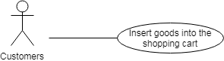
Figure 4.4: Insert goods into the shopping cart

Table 4.4: Insert drinks into the shopping cart
Use Case ID: UC04
Use Case Name: Insert drinks into the shopping cart
Member Create: Tin Vo Ngoc , Bao Nguyen Quoc |  | Member Create: Tin Vo Ngoc , Bao Nguyen Quoc
Date Create: 04/10/2018 |  | Date Create: 04/10/2018
Actor: Customers
Describes: This use case describes how customer can insert drink into shopping cart.
Pre-conditions: |  | Pre-conditions:
Post-conditions: |  | Post-conditions:
Priority: H/M/L |  | Priority: H/M/L
Use frequency: |  | Use frequency:
Standard processes |  | Standard processes
Use Case ID: UC04
Step | Actor Action |  | System Response
1 | At main interface , customer click on the button” ” of product customer want to buy |  | The system will go to the cart interface
2 | At the customer cart interface, customer click button + to add drink into shopping cart |  | Show product quantity of product

Use case 5: View, Edit Shopping cart
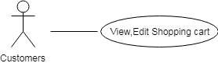

Figure 4.5: View Edit Shopping cart

Table 4.5: View, Edit Shopping cart
Use Case ID: UC05
Use Case Name: View, Edit Shopping cart
Member Create: Tin Vo Ngoc |  | Member Last Update: Khoa Pham Tan Anh, Bao Nguyen Quoc , Tran Anh Tai
Date Create: 04/10/2018
Actor: Customers
Describes: This use case describes how an actor can view, Edit Shopping cart.
Pre-Conditions:
Post-Conditions:
Priority: H/M/L |  | Medium
Use frequency: |  | High
Standard processes
Step | Actor Action |  | System Response
1 | At main interface , customer click on the button”View Shopping cart” |  | The system will go to the cart interface
2 | At the customer cart interface, customer can edit size of row in shopping cart |  | Show selected customer size

Use case 6: View drinks and information

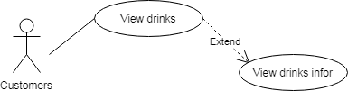

Figure 4.6: View drinks and information

Table 4.6: View drinks and information
Use Case ID: UC06
Use Case Name: View drinks and information
Member Create: Tin Vo Ngoc |  | Member Last Update: Khoa Pham Tan Anh, Bao Nguyen Quoc, Tran Anh Tai
Date Create: 04/10/2018 |  | Date Last Update: 07/11/2018
Actor: Customers
Describes: This use case describes how actors can view drinks and information
Pre-conditions:
Post-conditions:
Priority: H/M/L |  | High
Use frequency: |  | High
Standard processes
Step | Actor Action |  | System Response
1 | At main interface user click on "other" |  | Show down list of main functions of "other"
2 | The user clicks the "menu" button in the list |  | The system will display the information interface of all products
3 | Customer can see the drinks they need to buy
3.1 | The customer clicks on any product |  | System move to information drink interface

Use case 7: View news
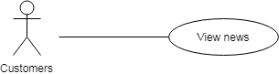

Figure 4.7: View news

Table 4.7: View news
Use Case ID: UC07
Use Case Name: View news
Member Create: Tin Vo Ngoc |  | Member Last Update: Khoa Pham Tan Anh, Bao Nguyen Quoc
Date Create: 04/10/2018 |  | Date Last Update: 07/11/2018
Actor: Customer
Describes: This use case describes how customer can view news drink.
Pre-Conditions:
Post-Conditions:
Priority: H/M/L |  | H
Use frequency:
Step | Actor Action |  | System Response
1 | At main interface
2 | Customer can see when drink is noted as new drink

Use case 8: Check promotion code
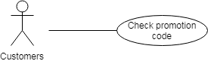
Figure 4.8: Check promotion code

Table 4.8: Check promotion code
Use Case ID: UC08
Use Case Name: Check promotion code
Member Create: Tin Vo Ngoc |  | Member Last Update: Khoa Pham Tan Anh, Bao Nguyen Quoc, Tran Anh Tai
Date Create: 04/10/2018 |  | Date Last Update: 07/11/2018
Actor: Customer
Describes: This use case describes how customers can check promotion code
Pre-conditions:
Post-conditions:
Priority: H/M/L |  | High
Use frequency: |  | High
Standard processes
Step | Actor Action |  | System Response
1 | At promotion interface, customer click on the button”View Shopping cart” |  | The system will go to the cart interface
2 | Customer can see promotion codes

Use case 9: Input promotion code

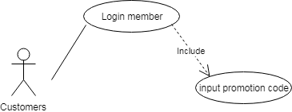
Figure 4.9: Input promotion code

Table 4.9: Input promotion code
Use Case ID: UC08
Use Case Name: Check promotion code
Member Create: Tin Vo Ngoc |  | Member Last Update: Khoa Pham Tan Anh, Bao Nguyen Quoc , Tran Anh Tai
Date Create: 04/10/2018 |  | Date Last Update: 07/11/2018
Actor: Customer
Describes: This use case describes how customers can input promotion code
Pre-conditions:
Post-conditions:
Priority: H/M/L |  | High
Use frequency: |  | High
Standard processes
Step | Actor Action |  | System Response
1 | At promotion interface, customer click on the button”View Shopping cart” |  | The system will go to the cart interface
2 | Customer down input promotion code |  | If promotion code is not in the promotion code valid list,displays message: "promotion code invalid " else show messenger:" promotion code valid " and decrease bill

Use case 10: Chat face-book
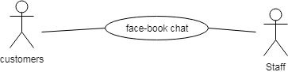
Figure 4.10: Chat face-book

Table 4.10: Chat face-book
Use Case ID: UC10
Use Case Name: Chat face-book
Member Create: Tin Vo Ngoc, Bao Nguyen Quoc |  | Member Last Update: Khoa Pham Tan Anh, Bao Nguyen Quoc
Date Create: 04/10/2018 |  | Date Last Update: 12/10/2018
Actor: Customer,Staff
Describes: This use case describes how an actor can modify chat with employee of Grace Coffee
Pre-Conditions: |  | Log-in facebook
Post-Conditions:
Priority: H/M/L |  | High
Use frequency: |  | High
Standard processes
Step | Actor Action |  | System Response
1 | At main interface
2 | Customer click button chat to move to face-book chat interface

Use case 11: Login admin
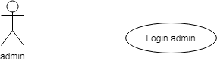
Figure 4.11: Login admin

Table 4.11: Login admin
Use Case ID: UC11
Use Case Name: Login admin
Member Create: Tin Vo Ngoc, Bao Nguyen Quoc |  | Member Last Update: Bao Nguyen Quoc
Date Create: 04/10/2018 |  | Date Last Update: 07/11/2018
Actor: Admin
Describes: This use case describes how an actor can login with rights access admin
Pre-Conditions: |  | The actor is admin and on the Login interface
Post-Conditions:
Priority: H/M/L |  | High
Use frequency: |  | High
Standard processes
Step | Actor Action |  | System Response
1 | At the interface outside the site, users click on the "Members" |  | The system will show down the main function list is "register and login"
2 | The user enters his/her username, password in the returning of the "Login" screen.
3 | The user click button define |  | If account name is in the account list, displays message: "successfully" else show messenger:" invalid user or password "

Use case 12: Insert/Update/Delete members
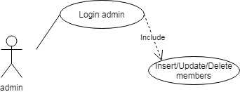
Figure 4.12: Insert/Update/Delete members

Table 4.12: Insert/Update/Delete members
Use Case ID: UC12
Use Case Name: Insert/Update/Delete members
Member Create: Tin Vo Ngoc, Bao Nguyen Quoc |  | Member Last Update: Bao Nguyen Quoc, Tran Anh Tai
Date Create: 04/10/2018 |  | Date Last Update: 08/11/2018
Actor: Admin
Describes: This use case describes how a admin can Insert/Update/Delete members.
Pre-conditions: |  | The actor is admin and on the member management interface
Post-conditions:
Priority: H/M/L |  | H
Use frequency: |  | High
Standard processes
Step | Actor Action |  | System Response
1 | At the admin page, the user clicks on the “member” button |  | The system will display the member list
2 | The admin enters click insert member |  | The system displays entries for administrators to enter member information
2.1 | After entering the member information, the administrator presses the button to add more members |  | The system displays the message "Successfully added"
3 | The admin enters click update member |  | System displays member information
3.1 | Admin change information and press confirm button |  | The system displays the message "Successfully updated"
4 | The admin enters click delete member |  | The system displays the message "you delete this member"
4.1 | The administrator presses the confirmation button |  | That member is removed from the list

Use case 13: Insert/Update/Delete drinks
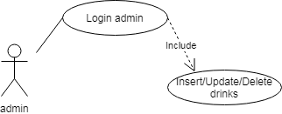

Figure 4.13 Insert/Update/Delete drinks

Table 4.13: Insert/Update/Delete drinks
Use Case ID: UC13
Use Case Name: Insert/Update/Delete drinks
Member Create: Tin Vo Ngoc, Bao Nguyen Quoc |  | Member Last Update: Bao Nguyen Quoc
Date Create: 04/10/2018 |  | Date Last Update: 08/11/2018
Actor: Users : Admin
Describes: This use case describes how user can Insert/Update/Delete drinks into menu
Pre-conditions: |  | The actor is admin and on the Update menu interface
Post-conditions:
Priority: H/M/L |  | H
Use frequency: |  | High
Standard processes
Use Case ID: UC13
Step | Actor Action |  | System Response
1 | At the admin page, the user clicks on the “Menu” button |  | The system will display the menu list
2 | The admin enters click insert drinks |  | The system displays entries for administrators to enter drinks information
2.1 | After entering the drinks information, the administrator presses the button to add more drinks |  | The system displays the message "Successfully added"
3 | The admin enters click update drinks |  | System displays drinks information
3.1 | Admin change information and press confirm button |  | The system displays the message "Successfully updated"
4 | The admin enters click delete drinks |  | The system displays the message "you delete this drinks"
4.1 | The administrator presses the confirmation button |  | That drinks is removed from the list

Use case 14: Insert/Update/Delete promotion code

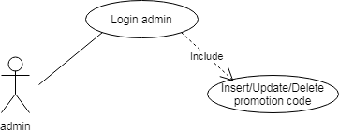
Figure 4.14 Insert/Update/Delete promotion code

Table 4.14: Insert/Update/Delete promotion code
Use Case ID: UC14
Use Case Name: Insert/Update/Delete promotion code
Member Create: Tin Vo Ngoc, Bao Nguyen Quoc |  | Member Last Update: Bao Nguyen Quoc
Date Create: 04/10/2018 |  | Date Last Update: 08/11/2018
Actor: Admin
Describes: This use case describes how user can Insert/Update/Delete promotion code
Pre-conditions: |  | The actor is admin and on the Update promotion code interface
Post-conditions:
Priority: H/M/L |  | L
Use frequency: |  | Medium
Standard processes
Step | Actor Action |  | System Response
1 | At the admin page, the user clicks on the “Promotion Code” button |  | The system will display the promotion code list
2 | The admin enters click insert promotion code |  | The system displays entries for administrators to enter promotion code information
2.1 | After entering the promotion code information, the administrator presses the button to add more promotion code |  | The system displays the message "Successfully added"
3 | The admin enters click update promotion code |  | System displays promotion code information
3.1 | Admin change information and press confirm button |  | The system displays the message "Successfully updated"
4 | The admin enters click delete promotion code |  | The system displays the message "you delete this promotion code"
4.1 | The administrator presses the confirmation button |  | That promotion code is removed from the list

Use case 15: Insert/Update/Delete events

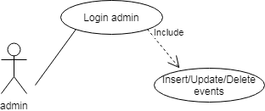
Figure 4.15 Insert/Update/Delete events

Table 4.15: Insert/Update/Delete events
Use Case ID: UC15
Use Case Name: Insert/Update/Delete events
Member Create: Tin Vo Ngoc |  | Member Last Update: Khoa Pham Tan Anh, Bao Nguyen Quoc
Date Create: 04/10/2018 |  | Date Last Update: 12/10/2018
Actor: Admin
Describes: This use case describes how user Insert/Update/Delete events.
Pre-conditions: |  | The actor is admin and on the Update promotion code interface
Post-conditions:
Priority: H/M/L |  | L
Use frequency: |  | Medium
Standard processes
Step | Actor Action |  | System Response
1 | At the admin page, the user clicks on the “events” button
2 | The admin enters click insert/update/delete events in the "events management" screen.

Use case 16: Login staff Android app

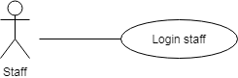
Figure 4.16 : Login(staff Android app)

Table 4.16: Login staff (Android app)
Use Case ID: UC16
Use Case Name: Login staff (Android app)
Member Create: Tin Vo Ngoc , Bao Nguyen Quoc |  | Member Last Update: Bao Nguyen Quoc
Date Create: 04/10/2018 |  | Date Last Update: 08/11/2018
Actor: Staff
Describes: This use case describes how user can Login staff Android app
Pre-conditions: |  | The actor is Staff of Grace Coffee
Post-conditions:
Priority: H/M/L |  | L
Use frequency: |  | Medium
Step | Actor Action |  | System Response
1 | At Login interface
2 | The user enters his/her username, password in the returning of the "Login" screen.
3 | The user click button define |  | If account name is in the account list, displays message: "successfully" else show messenger:" invalid user or password "

Use case 17: Order for customer Android app

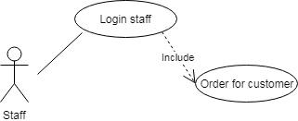
Figure 4.17 : Order for customer Android app

Table 4.17: Order for customer Android app
Use Case ID: UC17
Use Case Name: : Order for customer Android app
Member Create: Tin Vo Ngoc, Bao Nguyen Quoc |  | Member Last Update : Bao Nguyen Quoc
Date Create: 04/10/2018 |  | Date Last Update: 08/11/2018
Actor: Staff
Describes: This use case describes how user Order for customer Android app
Pre-conditions: |  | The actor is Staff
Post-conditions:
Priority: H/M/L |  | L
Use frequency: |  | Medium
Standard processes
Step | Actor Action |  | System Response
1 | At main interface
2 | The user click category |  | Drinking water display system by category
3 | The user click the drink the customer wants to order |  | The system automatically updates the drinks to the bill
4 | The user update bill and print bill for customer

Use case 18: View order online in (Android app)

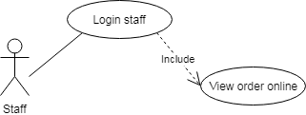

Figure 4.18: View order online Android app
Table 4.18: View order online (Android app)
Use Case ID: UC18
Use Case Name: View order online (Android app)
Member Create: Tin Vo Ngoc |  | Member Last Update: Khoa Pham Tan Anh, Bao Nguyen Quoc
Date Create: 04/10/2018 |  | Date Last Update: 08/11/2018
Actor: User
Describes: This use case describes how user can View order online in Android app
Pre-conditions: |  | The actor is Staff
Post-conditions:
Priority: H/M/L |  | L
Use frequency: |  | Medium
Standard processes
Use Case ID: UC18
Step | Actor Action |  | System Response
1 | At main interface |  | When there are new orders the system automatically reports on the "thông báo" icon
2 | The user click button “thông báo” |  | The system load to the online bill interface
3 | The user can see order online

Use case 19: Insert/Update/Delete Table (Android app)

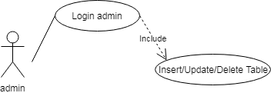
Figure 4.19 : Insert/Update/Delete Table Android app

Table 4.19: Insert/Update/Delete Table (Android app)
Use Case ID: UC19
Use Case Name: Insert/Update/Delete Table (Android app)
Member Create: Tin Vo Ngoc, Bao Nguyen Quoc |  | Member Last Update: Bao Nguyen Quoc
Date Create: 04/10/2018 |  | Date Last Update: 08/11/2018
Actor: Admin
Describes: This use case describes how user can Insert/Update/Delete Table (Android app)
Pre-conditions: |  | The actor is Admin
Post-conditions:
Priority: H/M/L |  | L
Use frequency: |  | Medium
Standard processes
Step | Actor Action |  | System Response
1 | At main interface
2 | The user click button “Cập nhập” |  | The system load to the update interface
3 | The user Click button “Bàn” |  | The system load to the update table interface
4 | If user want insert table .The user click button “Thêm bàn ” |  | The system load to the insert table interface
4.1 | The user input table number into editText “Số bàn”
4.2 | Click “Xác nhận” to complete |  | The system load to the update table interface and display dialog “Thêm thành công”
4.3 | Click “Hủy” to cancel operation
5 | If user want update number table .The user click button “ ” |  | The system load to the update table interface
5.1 | The user deletes the old table number and enters the new table number
5.2 | Click “Xác nhận” to complete |  | The system load to the insert table interface and display dialog “Sửa thành công”
5.3 | Click “Hủy” to cancel operation
6 | If user want delete table .The user click button “ ” |  | The system display dialog “Ban co muon xoa ban … khong”
6.1 | Click “Có” to complete |  | The system delete table as indicated
6.2 | Click “Khong” to cancel operation

Use case 20: Insert/Update/Delete Employee Android app

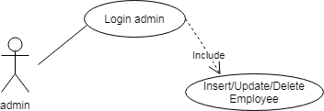

Figure 4.20 : Insert/Update/Delete Employee Android app

Table 4.20: Insert/Update/Delete Employee Android app
Use Case ID: UC20
Use Case Name: Insert/Update/Delete Employee Android app
Member Create: Tin Vo Ngoc |  | Member Last Update: Khoa Pham Tan Anh, Bao Nguyen Quoc
Date Create: 04/10/2018 |  | Date Last Update: 08/11/2018
Actor: Admin
Describes: This use case describes how user can Insert/Update/Delete Employee Android app
Pre-conditions: |  | The actor is Admin
Post-conditions:
Priority: H/M/L |  | L
Use frequency: |  | Medium
Standard processes
Step | Actor Action |  | System Response
1 | At main interface
2 | The user click button “Cập nhập” |  | The system load to the update interface
3 | The user Click Button “Nhân viên” |  | The system load to the update employee interface
4 | If user want insert employee .The user click button “Thêm nhân viên ” |  | The system load to the insert employee interface
4.1 | The user input employee name and positon into editText “tên nhân viên” and edittext “chức vụ”
4.2 | Click “Xác nhận” to complete |  | The system load to the update employee interface and display dialog “Thêm thành công”
4.3 | Click “Hủy” to cancel operation
5 | If user want update employee .The user click button “ ” |  | The system load to the update empoyee interface
5.1 | The user deletes the old employee name and employee positon then enters the new employee name and employee position
5.2 | Click “Xác nhận” to complete |  | The system load to the update employee interface and display dialog “Sửa thành công”
5.3 | Click “Hủy” to cancel operation
6 | If user want delete table .The user click button “ ” |  | The system display dialog “Ban co muon xoa nhân viên … khong”
6.1 | Click “Có” to complete |  | The system delete employee as indicated
6.2 | Click “Khong” to cancel operation

Use case 21: Insert/Update/Delete drink Android app
Figure 4.21 : Insert/Update/Delete drink Android app

Table 4.21: Insert/Update/Delete drink Android app
Use Case ID: UC21
Use Case Name: Insert/Update/Delete drink Android app
Member Create: Tin Vo Ngoc |  | Member Last Update: Khoa Pham Tan Anh, Bao Nguyen Quoc
Date Create: 04/10/2018 |  | Date Last Update: 08/11/2018
Actor: Admin
Describes: This use case describes how user can Insert/Update/Delete drink Android app
Pre-conditions: |  | The actor is Admin
Post-conditions:
Priority: H/M/L |  | L
Use frequency: |  | Medium
Standard processes
Step | Actor Action |  | System Response
1 | At main interface
2 | The user click button “Cập nhập” |  | The system load to the update interface
3 | The user Click Button “Menu” |  | The system load to the update menu interface
4 | If user want insert menu .The user click button “Thêm món ” |  | The system load to the insert drink interface
4.1 | The user input category and drinks name and price into spinner “Mục” and edittext “Tên món” and edittext “Giá”
4.2 | Click “Xác nhận” to complete |  | The system load to the update menu interface and display dialog “Thêm thành công”
4.3 | Click “Hủy” to cancel operation
5 | If user want update employee .The user click button “ ” |  | The system load to the update menu interface
5.1 | The user deletes the old drink name and price then enters the new drink name and price
5.2 | Click “Xác nhận” to complete |  | The system load to the update menu interface and display dialog “Sửa thành công”
5.3 | Click “Hủy” to cancel operation
6 | If user want delete table .The user click button “ ” |  | The system display dialog “Ban co muon xoa món … khong”
6.1 | Click “Có” to complete |  | The system delete drink as indicated
6.2 | Click “Khong” to cancel operation

Use case 22: View bill history (Android app)

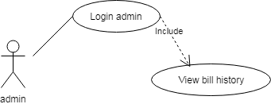
Figure 4.22 : View bill history Android app

Table 4.22: View bill history (Android app)
Use Case ID: UC22
Use Case Name: View bill history (Android app)
Member Create: Tin Vo Ngoc, Bao Nguyen Quoc |  | Member Last Update: Bao Nguyen Quoc
Date Create: 04/10/2018 |  | Date Last Update: 08/11/2018
Actor: Admin
Describes: This use case describes how user can View bill history (Android app)
Pre-conditions: |  | The actor is admin
Post-conditions:
Priority: H/M/L |  | L
Use frequency: |  | Medium
Standard processes
Step | Actor Action |  | System Response
1 | At main interface
2 | The user click button “Thống kê” |  | The system load to the statictis interface
3 | The user can see bill history interface

  - User’s interface
- User can change language
- User can view product’s information and image.
- Search products
- Booking in website
- Live chat to supporter
  - Hardware’s interface
- Android operating system
- Internet or 3G connection

  - Software’s interface
- System can connect with MySQL
- Run with android operating system or website
  - Communication’s interface
This application can link to the website. As described above, this will be communicating with a server and the HTTPS protocol. Integrated Facebook app will let users login. Accounts and user’s information will be kept confidential.

- Non-functional requirements other
  - Performance Requirements

Table 5.1 Performance
1 | Web : -The interface will appear within four seconds from the time access to the system if connect strong.  Mobile: -Placement notice will be displayed after 3 seconds if the connect strong
2 | -Users will wait for three seconds to receive information of system Grace Coffee
3 | -The system will provide accurate list of Coffee information within one second
  - Safety Requirements
No safety requirement for this system, the hazards occur depending usage by the user. Example : search for Coffee improperly.
  - Security Requirements
The user account information will be kept confidential.
  - The properties of the product quality
-Availability: the information in the system will be stored in the database so the system is always active, and this information will be updated regularly.
-Ease of use: the app has a guide for users with user-friendly interface.
  - User Documentation
After downloading and installing the product will have an electronic guide for users. When users encounter problems in using the product can send their inquiries via the product review section.

- Other Riquirements
No | The term | Explain
1 | URD | User requirement document

