Android
tx1.append(dataSnapshot.getValue().toString()+"\n"); append để nối chuỗi
Integer.parseInt( scn.nextLine() ) : là phân tích chuỗi đó thành số kiểu Integer
String text_b=b.getText().toString(); //lấy text trong edittext 2
//b là ánh xạ edittext
Intent
Có 2 loại
-Intent explicit ( tường minh ) là truyền dữ liệu trong app

-Intent Implicit (không tường minh): là truyền đi ra khỏi ứng dụng,có thể vào ứng dụng khác trong cùng 1 thiết bị :

vd intent.setAction(Intent.ACTION_VIEW)

+ ACTION VIEW : mở trình duyệt

+ ACTION SENDTO : gởi

Recycler view
Thêm rycler view
Tạo class hướng đối tượng
package com.example.dell.hero;
/**
* Created by Dell on 15-Jan-18.
*/
public class Hero {
private int image;
private String name;
Hero(int img, String name) {
image = img;
this.name = name;
}
public int getImage() {
return image;
}
public String getName() {
return name;
}
public void setImage(int image) {
this.image = image;
}
public void setName(String name) {
this.name = name;
}
}
Tạo lớp Adapter
package com.example.dell.hero;
import android.content.Context;
import android.support.v7.widget.RecyclerView;
import android.view.LayoutInflater;
import android.view.View;
import android.view.ViewGroup;
import android.widget.ImageView;
import android.widget.TextView;
import java.util.ArrayList;
/**
* Created by Dell on 15-Jan-18.
*/
public class HeroAdapter extends RecyclerView.Adapter <HeroAdapter.ViewHolder> {
ArrayList<Hero> heroList;
Context context;
public HeroAdapter(ArrayList<Hero> heroList, Context context) {
this.heroList = heroList;
this.context = context;
}
@Override
public ViewHolder onCreateViewHolder(ViewGroup viewGroup, int viewType) {
LayoutInflater layoutInflater = LayoutInflater.from(viewGroup.getContext());
View itemView = layoutInflater.inflate(R.layout.list_item, viewGroup, false);
ViewHolder viewHolder = new ViewHolder(itemView);
return viewHolder;
}
@Override
public void onBindViewHolder(ViewHolder holder, int position) {
// Take data each positon
holder.nameTextView.setText(heroList.get(position).getName());
holder.imageView.setImageResource(heroList.get(position).getImage());
}
@Override
public int getItemCount() {
return heroList.size();
}
public class ViewHolder extends RecyclerView.ViewHolder{
TextView nameTextView;
ImageView imageView;
public ViewHolder(View itemView) {
super(itemView);
nameTextView = itemView.findViewById(R.id.name_textview);
imageView = itemView.findViewById(R.id.image_view);
}
}
}

Tạo layout item
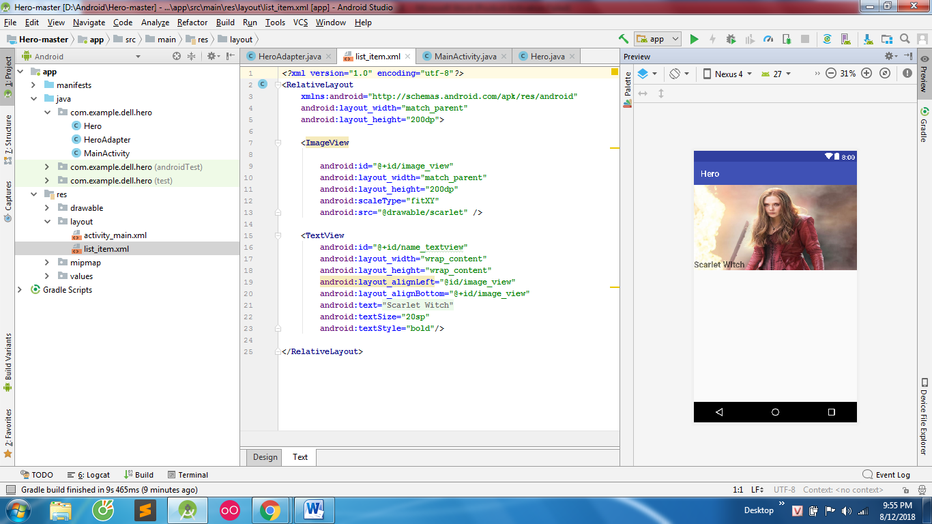
Main class
package com.example.dell.hero;
import android.support.v7.app.AppCompatActivity;
import android.os.Bundle;
import android.support.v7.widget.LinearLayoutManager;
import android.support.v7.widget.RecyclerView;
import android.widget.LinearLayout;
import java.util.ArrayList;
public class MainActivity extends AppCompatActivity {
@Override
protected void onCreate(Bundle savedInstanceState) {
super.onCreate(savedInstanceState);
setContentView(R.layout.activity_main);
initView();
}
public void initView(){
RecyclerView recyclerView = findViewById(R.id.recycler_view);
recyclerView.setHasFixedSize(true);
LinearLayoutManager layoutManager = new LinearLayoutManager(this, LinearLayoutManager.VERTICAL ,false);
recyclerView.setLayoutManager(layoutManager);
final ArrayList<Hero> heroArrayList = new ArrayList<>();
heroArrayList.add(new Hero(R.drawable.scarlet, "Scarlet Witch"));
heroArrayList.add(new Hero(R.drawable.hulk, "Hulk"));
heroArrayList.add(new Hero(R.drawable.iron_man, "Iron Man"));
heroArrayList.add(new Hero(R.drawable.captain_america, "Captain America"));
HeroAdapter heroAdapter = new HeroAdapter(heroArrayList, getApplicationContext());
recyclerView.setAdapter(heroAdapter);
}
}
Layout Main
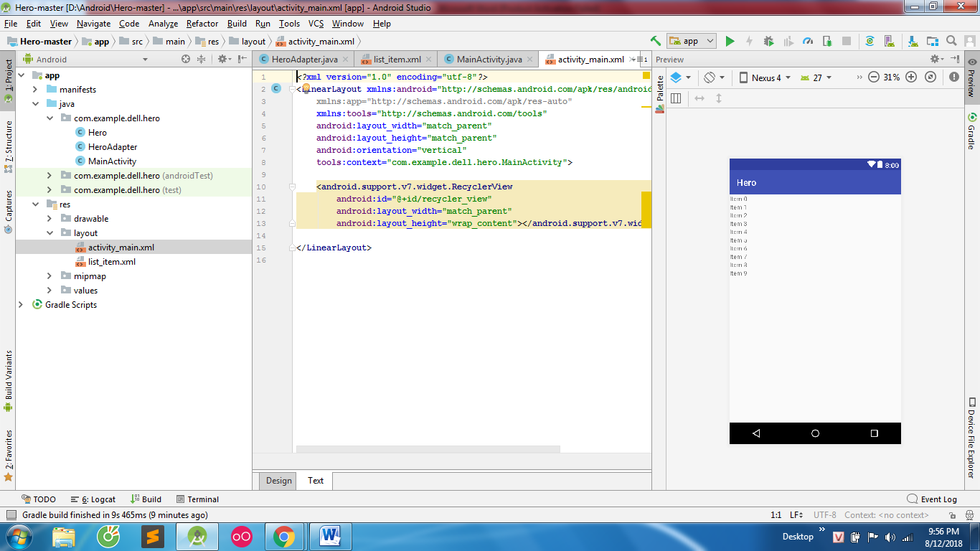
Menu
Tạo direction Menu
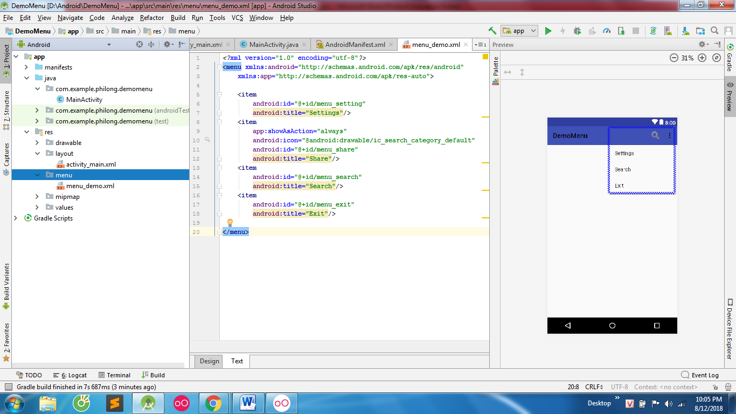
Tạo layout menu_demo trong direction
<?xml version="1.0" encoding="utf-8"?>
<menu xmlns:android="http://schemas.android.com/apk/res/android"
xmlns:app="http://schemas.android.com/apk/res-auto">
<item
android:id="@+id/menu_setting"
android:title="Settings"/>
<item
app:showAsAction="always"
android:icon="@android:drawable/ic_search_category_default"
android:id="@+id/menu_share"
android:title="Share"/>
<item
android:id="@+id/menu_search"
android:title="Search"/>
<item
android:id="@+id/menu_exit"
android:title="Exit"/>
</menu>
Class Main
package com.example.philong.demomenu;
import android.support.v7.app.AppCompatActivity;
import android.os.Bundle;
import android.view.Menu;
import android.view.MenuItem;
import android.widget.Toast;
public class MainActivity extends AppCompatActivity {
@Override
protected void onCreate(Bundle savedInstanceState) {
super.onCreate(savedInstanceState);
setContentView(R.layout.activity_main);
}
@Override
public boolean onCreateOptionsMenu(Menu menu) { //khởi tạo menu
getMenuInflater().inflate(R.menu.menu_demo , menu );
return super.onCreateOptionsMenu(menu);
}
@Override
public boolean onOptionsItemSelected(MenuItem item) { //bat su kien cho menu
switch (item.getItemId()){
case R.id.menu_search:
Toast.makeText(this, "Bạn muốn search", Toast.LENGTH_SHORT).show();
break;
case R.id.menu_setting:
Toast.makeText(this, "Bạn muốn settings", Toast.LENGTH_SHORT).show();
break;
case R.id.menu_share:
Toast.makeText(this, "Bạn muốn share", Toast.LENGTH_SHORT).show();
break;
case R.id.menu_exit:
Toast.makeText(this, "Bạn muốn exit", Toast.LENGTH_SHORT).show();
break;
}
return super.onOptionsItemSelected(item);
}
}
Sqlite
Tạo class DataBase
package com.example.philong.myapplication;
import android.content.Context;
import android.database.Cursor;
import android.database.sqlite.SQLiteDatabase;
import android.database.sqlite.SQLiteOpenHelper;
public class DataBase extends SQLiteOpenHelper{
public DataBase (Context context, String name, SQLiteDatabase.CursorFactory factory, int version) {
super(context, name, factory, version);
}
//ham de su dung truy van khong ket qua create,insert,update
public void QueryDaTa(String sql){
SQLiteDatabase database=getWritableDatabase();
database.execSQL(sql);
}
//ham de su dung truy van co ket qua select,tra ve kieu con tro cursor
public Cursor GetDaTa(String sql){
SQLiteDatabase database=getReadableDatabase();
return database.rawQuery(sql,null);
}
@Override
public void onCreate(SQLiteDatabase db) {
}
@Override
public void onUpgrade(SQLiteDatabase db, int oldVersion, int newVersion) {
}
}
Class main
package com.example.philong.myapplication;
import android.database.Cursor;
import android.support.v7.app.AppCompatActivity;
import android.os.Bundle;
import android.widget.Toast;
public class MainActivity extends AppCompatActivity {
DataBase dataBase;
@Override
protected void onCreate(Bundle savedInstanceState) {
super.onCreate(savedInstanceState);
setContentView(R.layout.activity_main);
//tao database
dataBase=new DataBase(this,"ghichu.sqlite",null,1);
//tao table
dataBase.QueryDaTa("create table if not exists congviec(id integer primary key ,ten cv varchar(40))");
//insert du lieu
dataBase.QueryDaTa("insert into congviec values(01,'lambaitapandroid') ");
dataBase.QueryDaTa("insert into congviec values(02,'ghichu') ");
//select data
Cursor dataCongViec=dataBase.GetDaTa("select * from congviec");
while (dataCongViec.moveToNext()){
String ten=dataCongViec.getString(1);
Toast.makeText(this, ten, Toast.LENGTH_SHORT).show();
}
}
}
WebService

Cấp quyền truy cập internet tại manifest
<uses-permission android:name="android.permission.INTERNET" />
Tạo hướng đối tượng sinhviên
package com.example.philong.wedservices;
import java.io.Serializable;
public class SinhVien implements Serializable {
private int ID;
private String hoTen;
private int namSinh;
private String diaChi;
public SinhVien(int ID, String hoTen, int namSinh, String diaChi) {
this.ID = ID;
this.hoTen = hoTen;
this.namSinh = namSinh;
this.diaChi = diaChi;
}
public int getID() {
return ID;
}
public void setID(int ID) {
this.ID = ID;
}
public String getHoTen() {
return hoTen;
}
public void setHoTen(String hoTen) {
this.hoTen = hoTen;
}
public int getNamSinh() {
return namSinh;
}
public void setNamSinh(int namSinh) {
this.namSinh = namSinh;
}
public String getDiaChi() {
return diaChi;
}
public void setDiaChi(String diaChi) {
this.diaChi = diaChi;
}
}
Class sinhvienAdapter
package com.example.philong.wedservices;
import android.app.AlertDialog;
import android.content.Context;
import android.content.DialogInterface;
import android.content.Intent;
import android.view.LayoutInflater;
import android.view.View;
import android.view.ViewGroup;
import android.widget.BaseAdapter;
import android.widget.ImageView;
import android.widget.TextView;
import android.widget.Toast;
import java.util.List;
public class SinhVienAdapterTest extends BaseAdapter {
private MainActivity context;
private int layout;
private List<SinhVien> SinhVienList;
public SinhVienAdapterTest(MainActivity context, int layout, List<SinhVien> sinhVienList) {
this.context = context;
this.layout = layout;
this.SinhVienList = sinhVienList;
}
@Override
public int getCount() {
return SinhVienList.size();
}
@Override
public Object getItem(int position) {
return null;
}
@Override
public long getItemId(int position) {
return 0;
}
private class ViewHolder{
TextView txtTen,txtNamSinh,txtDiaChi;
ImageView imgSua,imgXoa;
}
//Alert Xác nhận xóa
private void XacNhanXoa(String ten, final int id){
AlertDialog.Builder dialogxoa=new AlertDialog.Builder(context);
dialogxoa.setMessage("Ban co muon xoa sinh vien : "+ten+" khong");
dialogxoa.setPositiveButton("Co", new DialogInterface.OnClickListener() {
@Override
public void onClick(DialogInterface dialog, int which) {
context.DeleteStudent(id);
}
});
dialogxoa.setNegativeButton("khong", new DialogInterface.OnClickListener() {
@Override
public void onClick(DialogInterface dialog, int which) {
}
});
dialogxoa.show();
}
@Override
public View getView(int position, View convertView, ViewGroup parent) {
ViewHolder holder;
if(convertView==null){
holder=new ViewHolder();
LayoutInflater inflater= (LayoutInflater) context.getSystemService(Context.LAYOUT_INFLATER_SERVICE);
convertView =inflater.inflate(layout,null);
holder.txtTen=convertView.findViewById(R.id.text_view_ten);
holder.txtDiaChi=convertView.findViewById(R.id.text_view_diachi);
holder.txtNamSinh=convertView.findViewById(R.id.text_view_namsinh);
holder.imgSua= convertView.findViewById(R.id.image_view_edit);
holder.imgXoa=convertView.findViewById(R.id.image_view_delete);
convertView.setTag(holder); // nếu else thì giữ ánh xạ vào biến holder
}
else{
holder=(ViewHolder) convertView.getTag();
}
final SinhVien SinhVien=SinhVienList.get(position);
holder.txtTen.setText(SinhVien.getHoTen());
holder.txtNamSinh.setText("Nam sinh : "+SinhVien.getNamSinh());
holder.txtDiaChi.setText(SinhVien.getDiaChi());
holder.imgSua.setOnClickListener(new View.OnClickListener() {
@Override
//bắt sự kiện xóa sửa
public void onClick(View v) {
Intent intent=new Intent(context,Update.class);
intent.putExtra("dataSinhVien",SinhVien);
context.startActivity(intent);
}
});
//click xóa
holder.imgXoa.setOnClickListener(new View.OnClickListener() {
@Override
public void onClick(View v) {
XacNhanXoa(SinhVien.getHoTen(),SinhVien.getID());
}
});
return convertView;
}
}
Class main 2 để thêm sinh viên
package com.example.philong.wedservices;
import android.content.Intent;
import android.support.v7.app.AppCompatActivity;
import android.os.Bundle;
import android.util.Log;
import android.view.View;
import android.widget.Button;
import android.widget.EditText;
import android.widget.Toast;
import com.android.volley.AuthFailureError;
import com.android.volley.Request;
import com.android.volley.RequestQueue;
import com.android.volley.Response;
import com.android.volley.VolleyError;
import com.android.volley.toolbox.StringRequest;
import com.android.volley.toolbox.Volley;
import java.util.HashMap;
import java.util.Map;
public class Main2Activity extends AppCompatActivity {
EditText edtTen,edtNamSinh,edtDiaChi;
Button btThem;
String urlInsert="http://192.168.43.229:81/androidwebservice/insert.php";
@Override
protected void onCreate(Bundle savedInstanceState) {
super.onCreate(savedInstanceState);
setContentView(R.layout.activity_main2);
anhXa();
btThem.setOnClickListener(new View.OnClickListener() {
@Override
public void onClick(View v) {
String hoTen=edtTen.getText().toString().trim();
String namSinh=edtNamSinh.getText().toString().trim();
String diaChi=edtDiaChi.getText().toString().trim();
if(hoTen.isEmpty()||namSinh.isEmpty()||diaChi.isEmpty()){
Toast.makeText(Main2Activity.this, "Nhap du thong tin nha", Toast.LENGTH_SHORT).show();
}
else {
themSinhVien(urlInsert);
}
}
});
}
private void themSinhVien(String url){
RequestQueue requestQueue= Volley.newRequestQueue(this);
//POST để đấy lên
StringRequest stringRequest=new StringRequest(Request.Method.POST, url, new Response.Listener<String>() {
@Override
public void onResponse(String response) {//khi insert thành công
if(response.trim().equals("success")){//success là báo thành công trên php lấy xuống để dùng
Toast.makeText(Main2Activity.this, "Them thanh cong", Toast.LENGTH_SHORT).show();
startActivity(new Intent(Main2Activity.this,MainActivity.class));
}
else {
Toast.makeText(Main2Activity.this, "có lỗi gì rồi", Toast.LENGTH_SHORT).show();
}
}
}, new Response.ErrorListener() {//khi insert thất bại
@Override
public void onErrorResponse(VolleyError error) {
Toast.makeText(Main2Activity.this, "Loi ", Toast.LENGTH_SHORT).show();
Log.d("AAA","Loi!\n"+error.toString());//chi tiết lỗi
}
}
){
@Override
protected Map<String, String> getParams() throws AuthFailureError {
//tạo map để đẩy lên
Map<String,String> params=new HashMap<>();
params.put("hotenSV",edtTen.getText().toString().trim());//đẩy lên Json hotenSV với edtTen .trim để dùng khoảng trắng
params.put("namsinhSV",edtNamSinh.getText().toString().trim());//đẩy lên Json hotenSV với edtTen
params.put("diachiSV",edtDiaChi.getText().toString().trim());//đẩy lên Json hotenSV với edtTen
return params;
}
};
requestQueue.add(stringRequest);//add vao
}
private void anhXa(){
edtTen=findViewById(R.id.edt_ten);
edtNamSinh=findViewById(R.id.edt_namsinh);
edtDiaChi=findViewById(R.id.edt_diachi);
btThem=findViewById(R.id.btn_them);
}
}
Class Update sinh viên
package com.example.philong.wedservices;
import android.content.Intent;
import android.support.v7.app.AppCompatActivity;
import android.os.Bundle;
import android.util.Log;
import android.view.View;
import android.widget.Button;
import android.widget.EditText;
import android.widget.Toast;
import com.android.volley.AuthFailureError;
import com.android.volley.Request;
import com.android.volley.RequestQueue;
import com.android.volley.Response;
import com.android.volley.VolleyError;
import com.android.volley.toolbox.StringRequest;
import com.android.volley.toolbox.Volley;
import java.util.HashMap;
import java.util.Map;
public class Update extends AppCompatActivity {
private EditText edt_suaTen,edt_suaNamSinh,edt_suaDiaChi;
private Button btn_sua;
int id=0;
String urlThem="http://192.168.43.229:81/androidwebservice/update.php";
@Override
protected void onCreate(Bundle savedInstanceState) {
super.onCreate(savedInstanceState);
setContentView(R.layout.activity_update);
Intent intent=getIntent();
SinhVien sinhvien=(SinhVien) intent.getSerializableExtra("dataSinhVien");
anhXa();
id=sinhvien.getID();
edt_suaTen.setText(sinhvien.getHoTen());
edt_suaNamSinh.setText(sinhvien.getNamSinh()+"");
edt_suaDiaChi.setText(sinhvien.getDiaChi());
btn_sua.setOnClickListener(new View.OnClickListener() {
@Override
public void onClick(View v) {
String hoTen= edt_suaTen.getText().toString().trim();
String namSinh= edt_suaNamSinh.getText().toString().trim();
String diaChi= edt_suaDiaChi.getText().toString().trim();
if(hoTen.isEmpty()||namSinh.isEmpty()||diaChi.isEmpty()){
Toast.makeText(Update.this, "Nhap du thong tin nha", Toast.LENGTH_SHORT).show();
}
else {
CapNhap(urlThem);
}
}
});
}
public void CapNhap(String url){
RequestQueue requestQueue= Volley.newRequestQueue(this);
StringRequest stringRequest=new StringRequest(Request.Method.POST, url, new Response.Listener<String>() {
@Override
public void onResponse(String response) {
if(response.trim().equals("success")){//success là báo thành công trên php lấy xuống để dùng
Toast.makeText(Update.this, "Sua thanh cong", Toast.LENGTH_SHORT).show();
startActivity(new Intent(Update.this,MainActivity.class));
}
else {
Toast.makeText(Update.this, "có lỗi gì rồi", Toast.LENGTH_SHORT).show();
}
}
}
, new Response.ErrorListener() {
@Override
public void onErrorResponse(VolleyError error) {
Toast.makeText(Update.this, "Loi ", Toast.LENGTH_SHORT).show();
Log.d("AAA","Loi!\n"+error.toString());//chi tiết lỗi
}
}
){
@Override
protected Map<String, String> getParams() throws AuthFailureError {
//tạo map để đẩy lên
Map<String,String> params=new HashMap<>();
params.put("idSV", String.valueOf(id));
params.put("hotenSV",edt_suaTen.getText().toString().trim());//đẩy lên Json hotenSV với edtTen .trim để dùng khoảng trắng
params.put("namsinhSV",edt_suaNamSinh.getText().toString().trim());//đẩy lên Json hotenSV với edtTen
params.put("diachiSV",edt_suaDiaChi.getText().toString().trim());//đẩy lên Json hotenSV với edtTen
return params;
}
};
requestQueue.add(stringRequest);
}
private void anhXa(){
edt_suaTen=findViewById(R.id.edt_suaten);
edt_suaNamSinh=findViewById(R.id.edt_suanamsinh);
edt_suaDiaChi=findViewById(R.id.edt_suadiachi);
btn_sua=findViewById(R.id.btn_capnhap);
}
}
Class Main
package com.example.philong.wedservices;
import android.content.Intent;
import android.support.v7.app.AppCompatActivity;
import android.os.Bundle;
import android.view.Menu;
import android.view.MenuItem;
import android.widget.ListView;
import android.widget.Toast;
import com.android.volley.AuthFailureError;
import com.android.volley.Request;
import com.android.volley.RequestQueue;
import com.android.volley.Response;
import com.android.volley.VolleyError;
import com.android.volley.toolbox.JsonArrayRequest;
import com.android.volley.toolbox.StringRequest;
import com.android.volley.toolbox.Volley;
import org.json.JSONArray;
import org.json.JSONException;
import org.json.JSONObject;
import java.util.ArrayList;
import java.util.HashMap;
import java.util.Map;
public class MainActivity extends AppCompatActivity {
String urlGetData=" http://quocbao19182.byethost24.com/getdata.php";
String urlDeleteData="http://192.168.43.229:81/androidwebservice/delete.php";
//Xóa
public void DeleteStudent(final int idsv){
RequestQueue requestQueue= Volley.newRequestQueue(this);
StringRequest stringRequest=new StringRequest(Request.Method.POST, urlDeleteData, new Response.Listener<String>() {
@Override
public void onResponse(String response) {
if(response.trim().equals("success")){
Toast.makeText(MainActivity.this, "XoaThanhCong", Toast.LENGTH_SHORT).show();
GetData(urlGetData);
}
else Toast.makeText(MainActivity.this, "loi xoa", Toast.LENGTH_SHORT).show();
}
}
, new Response.ErrorListener() {
@Override
public void onErrorResponse(VolleyError error) {
Toast.makeText(MainActivity.this, "Loi xoa", Toast.LENGTH_SHORT).show();
}
}){
@Override
protected Map<String, String> getParams() throws AuthFailureError {
Map<String,String> params=new HashMap<>();
params.put("idSV", String.valueOf(idsv));
return params;
}
};
requestQueue.add(stringRequest);
}
private ListView lvSinhVien;
ArrayList<SinhVien> arraySinhVien;
SinhVienAdapterTest adapter;
@Override
protected void onCreate(Bundle savedInstanceState) {
super.onCreate(savedInstanceState);
setContentView(R.layout.activity_main);
lvSinhVien=findViewById(R.id.list_view_main);
arraySinhVien=new ArrayList<>();
adapter=new SinhVienAdapterTest(this,R.layout.dong_sinh_vien,arraySinhVien);
lvSinhVien.setAdapter(adapter);
GetData(urlGetData);
}
private void GetData (String url){
RequestQueue requestQueue= Volley.newRequestQueue(this);
//GET để lấy xuống
JsonArrayRequest jsonArrayRequest = new JsonArrayRequest(Request.Method.GET, url,null,
new Response.Listener<JSONArray>() {
@Override
//khi doc duoc json
public void onResponse(JSONArray response) {
arraySinhVien.clear();
for (int i=0;i<response.length();i++){
try {
JSONObject object = response.getJSONObject(i);
arraySinhVien.add(new SinhVien(
object.getInt("ID"),
object.getString("HoTen"),
object.getInt("NamSinh"),
object.getString("DiaChi")
));
} catch (JSONException e) {
e.printStackTrace();
}
}
adapter.notifyDataSetChanged();
}
},
//khi doc json bi loi
new Response.ErrorListener() {
@Override
public void onErrorResponse(VolleyError error) {
Toast.makeText(MainActivity.this, error.toString(), Toast.LENGTH_SHORT).show();
}
});
requestQueue.add(jsonArrayRequest);
}
@Override
public boolean onCreateOptionsMenu(Menu menu)
{
getMenuInflater().inflate(R.menu.add_sinh_vien,menu);
return super.onCreateOptionsMenu(menu);
}
@Override
public boolean onOptionsItemSelected(MenuItem item) {
if(item.getItemId()==R.id.it_menu)
{
startActivity(new Intent(MainActivity.this,Main2Activity.class));
}
return super.onOptionsItemSelected(item);
}
}
Layout dongsinhvien
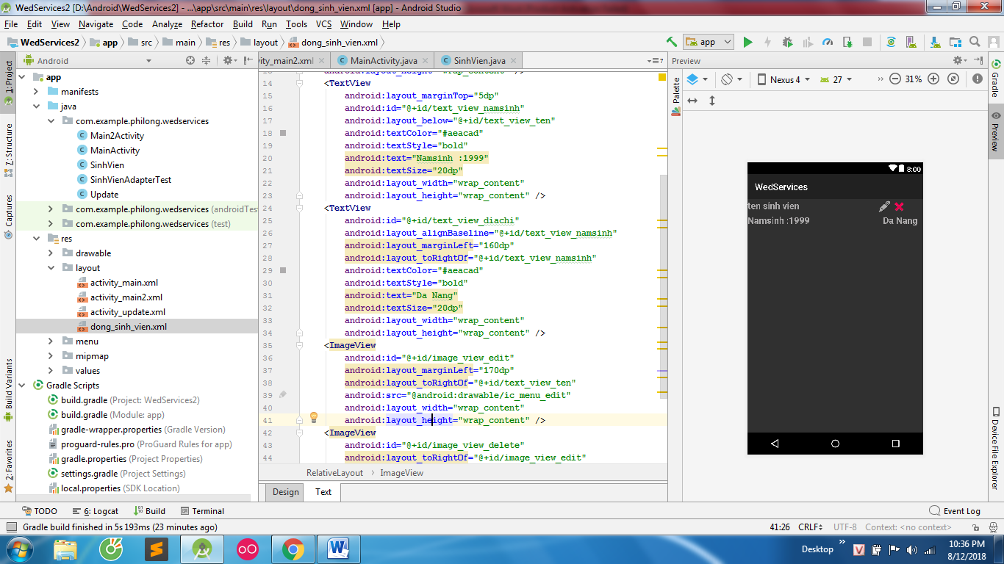
<?xml version="1.0" encoding="utf-8"?>
<RelativeLayout
xmlns:android="http://schemas.android.com/apk/res/android"
android:layout_width="match_parent"
android:layout_height="match_parent">
<TextView
android:id="@+id/text_view_ten"
android:textColor="#aeacad"
android:textStyle="bold"
android:text="ten sinh vien"
android:textSize="20dp"
android:layout_width="wrap_content"
android:layout_height="wrap_content" />
<TextView
android:layout_marginTop="5dp"
android:id="@+id/text_view_namsinh"
android:layout_below="@+id/text_view_ten"
android:textColor="#aeacad"
android:textStyle="bold"
android:text="Namsinh :1999"
android:textSize="20dp"
android:layout_width="wrap_content"
android:layout_height="wrap_content" />
<TextView
android:id="@+id/text_view_diachi"
android:layout_alignBaseline="@+id/text_view_namsinh"
android:layout_marginLeft="160dp"
android:layout_toRightOf="@+id/text_view_namsinh"
android:textColor="#aeacad"
android:textStyle="bold"
android:text="Da Nang"
android:textSize="20dp"
android:layout_width="wrap_content"
android:layout_height="wrap_content" />
<ImageView
android:id="@+id/image_view_edit"
android:layout_marginLeft="170dp"
android:layout_toRightOf="@+id/text_view_ten"
android:src="@android:drawable/ic_menu_edit"
android:layout_width="wrap_content"
android:layout_height="wrap_content" />
<ImageView
android:id="@+id/image_view_delete"
android:layout_toRightOf="@+id/image_view_edit"
android:src="@android:drawable/ic_delete"
android:layout_width="wrap_content"
android:layout_height="wrap_content" />
</RelativeLayout>
Layout Update
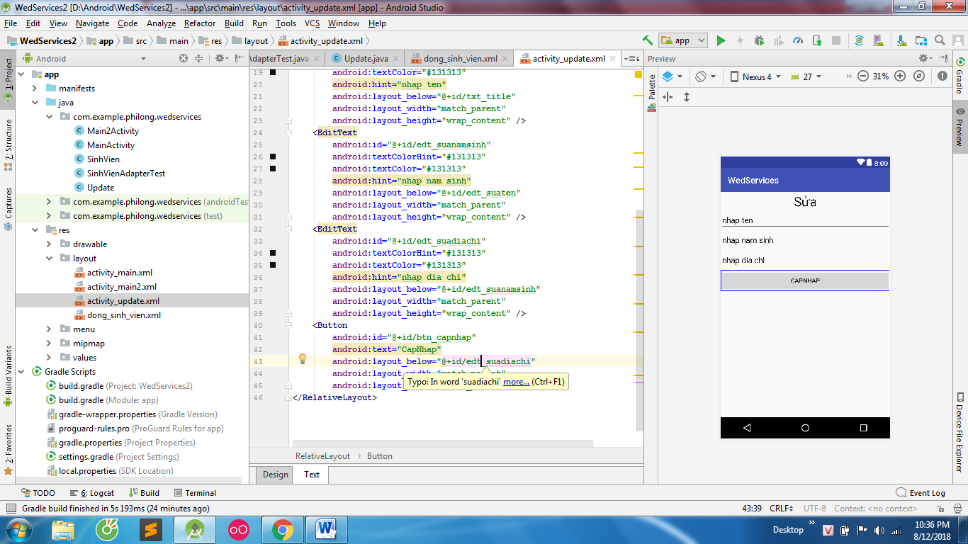
<?xml version="1.0" encoding="utf-8"?>
<RelativeLayout xmlns:android="http://schemas.android.com/apk/res/android"
xmlns:app="http://schemas.android.com/apk/res-auto"
xmlns:tools="http://schemas.android.com/tools"
android:layout_width="match_parent"
android:layout_height="match_parent"
tools:context=".Update">
<TextView
android:textColor="#121111"
android:id="@+id/txt_title"
android:textSize="30dp"
android:gravity="center"
android:text="Sửa"
android:layout_width="match_parent"
android:layout_height="wrap_content" />
<EditText
android:id="@+id/edt_suaten"
android:textColorHint="#131313"
android:textColor="#131313"
android:hint="nhap ten"
android:layout_below="@+id/txt_title"
android:layout_width="match_parent"
android:layout_height="wrap_content" />
<EditText
android:id="@+id/edt_suanamsinh"
android:textColorHint="#131313"
android:textColor="#131313"
android:hint="nhap nam sinh"
android:layout_below="@+id/edt_suaten"
android:layout_width="match_parent"
android:layout_height="wrap_content" />
<EditText
android:id="@+id/edt_suadiachi"
android:textColorHint="#131313"
android:textColor="#131313"
android:hint="nhap dia chi"
android:layout_below="@+id/edt_suanamsinh"
android:layout_width="match_parent"
android:layout_height="wrap_content" />
<Button
android:id="@+id/btn_capnhap"
android:text="CapNhap"
android:layout_below="@+id/edt_suadiachi"
android:layout_width="match_parent"
android:layout_height="wrap_content" />
</RelativeLayout>
Layout thêm
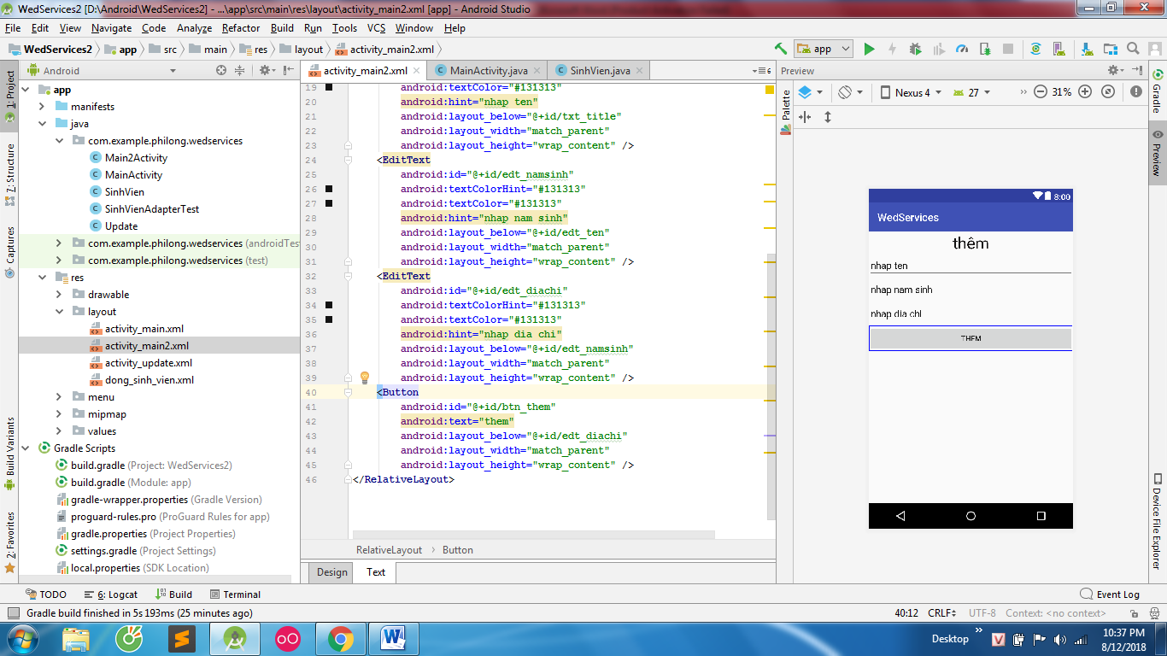
<?xml version="1.0" encoding="utf-8"?>
<RelativeLayout xmlns:android="http://schemas.android.com/apk/res/android"
xmlns:app="http://schemas.android.com/apk/res-auto"
xmlns:tools="http://schemas.android.com/tools"
android:layout_width="match_parent"
android:layout_height="match_parent"
tools:context=".Main2Activity">
<TextView
android:textColor="#121111"
android:id="@+id/txt_title"
android:textSize="30dp"
android:gravity="center"
android:text="thêm"
android:layout_width="match_parent"
android:layout_height="wrap_content" />
<EditText
android:id="@+id/edt_ten"
android:textColorHint="#131313"
android:textColor="#131313"
android:hint="nhap ten"
android:layout_below="@+id/txt_title"
android:layout_width="match_parent"
android:layout_height="wrap_content" />
<EditText
android:id="@+id/edt_namsinh"
android:textColorHint="#131313"
android:textColor="#131313"
android:hint="nhap nam sinh"
android:layout_below="@+id/edt_ten"
android:layout_width="match_parent"
android:layout_height="wrap_content" />
<EditText
android:id="@+id/edt_diachi"
android:textColorHint="#131313"
android:textColor="#131313"
android:hint="nhap dia chi"
android:layout_below="@+id/edt_namsinh"
android:layout_width="match_parent"
android:layout_height="wrap_content" />
<Button
android:id="@+id/btn_them"
android:text="them"
android:layout_below="@+id/edt_diachi"
android:layout_width="match_parent"
android:layout_height="wrap_content" />
</RelativeLayout>
Layout Main
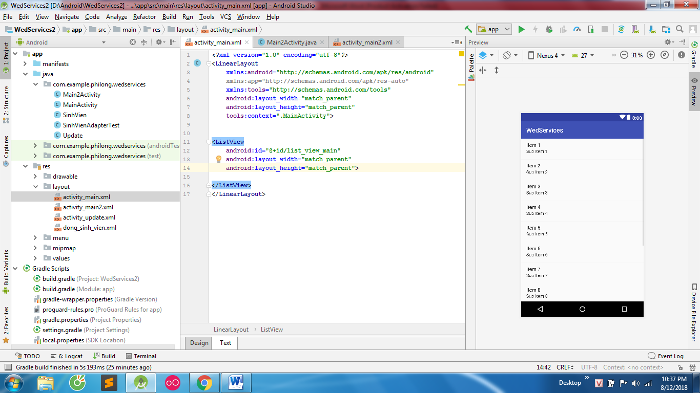
Google FireBase
Tạo project và connect trên firebase
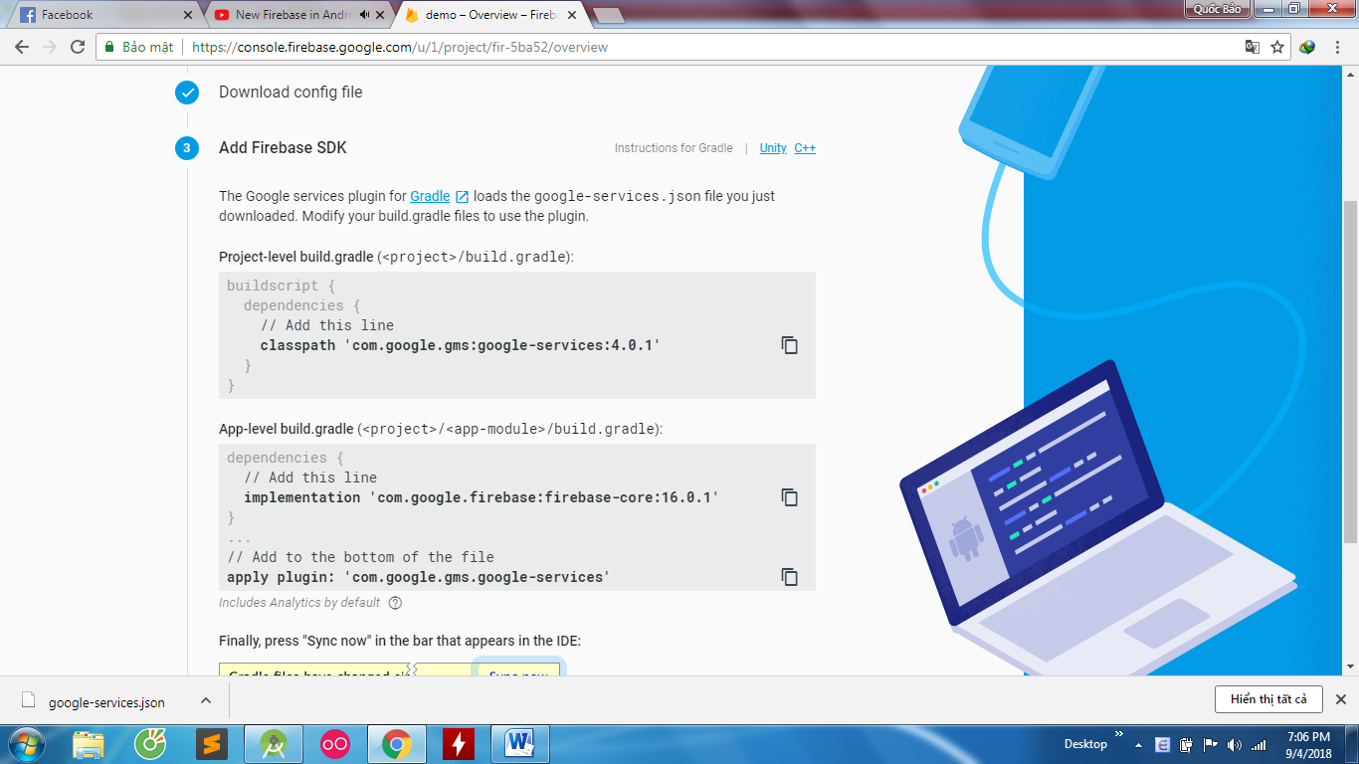
Add Library
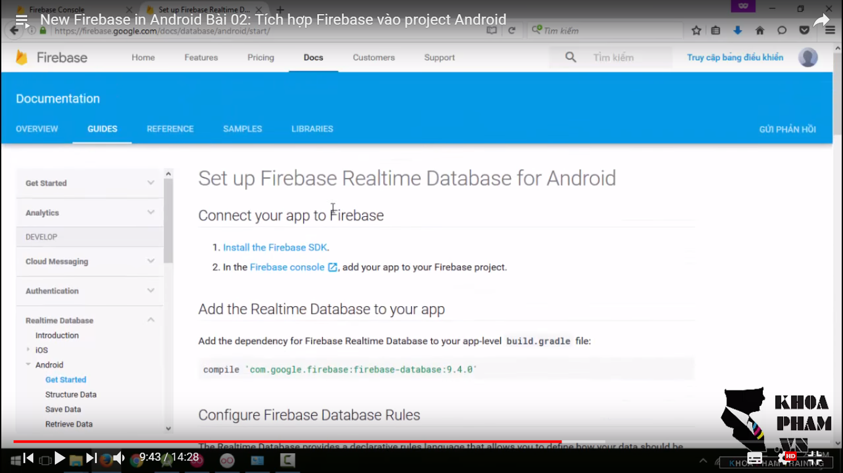

Các kiểu lưu dữ liệu vs fire base
package com.example.philong.myapplication;
import android.support.annotation.NonNull;
import android.support.annotation.Nullable;
import android.support.v7.app.AppCompatActivity;
import android.os.Bundle;
import android.util.Log;
import android.widget.Toast;
import com.google.firebase.database.DataSnapshot;
import com.google.firebase.database.DatabaseError;
import com.google.firebase.database.DatabaseReference;
import com.google.firebase.database.FirebaseDatabase;
import com.google.firebase.database.ValueEventListener;
import java.util.HashMap;
import java.util.Map;
public class MainActivity extends AppCompatActivity {
DatabaseReference mData;
@Override
protected void onCreate(Bundle savedInstanceState) {
super.onCreate(savedInstanceState);
setContentView(R.layout.activity_main);
mData = FirebaseDatabase.getInstance().getReference(); //khởi tạo node gốc
//Luu du lieu kieu 1 sử dụng setValue
mData.child("HoTen").setValue("Bao"); // từ node gốc tạo node con voi name and value (.child là tạo thêm 1 node)
//Luu du lieu kieu 2 sử dụng setValue voi Object
SinhVien sinhvien=new SinhVien("KhoaPham","HCM",1990 );
mData.child("SinhVien1").setValue(sinhvien);
//Lưu du lieu kieu 3 sử dụng setValue voi map
Map<String,Integer> myMap = new HashMap<String, Integer>(); //tạo map để đưa dữ liệu vào
myMap.put("XeMay",2 ); //put để đưa vào
mData.child("PhuongTien").setValue(myMap); //tạo 1 node rồi đầy map vào node đó
//Lưu du lieu kieu 4 sử dụng push kết hợp setValue voi map để tạo key
SinhVien sinhvien1=new SinhVien("KhoaPhamCao","HCM",1990 );
mData.child("SinhVien2").push().setValue(sinhvien1);
//bắt sự kiện hoàn thành khi setValue
mData.child("KhoaPhamTraining1").setValue("Lap trinh Android vs firebase", new DatabaseReference.CompletionListener() {
@Override
public void onComplete(@Nullable DatabaseError databaseError, @NonNull DatabaseReference databaseReference) {
if(databaseError==null){
Toast.makeText(MainActivity.this, "Luu thanh cong", Toast.LENGTH_SHORT).show();
}
else Toast.makeText(MainActivity.this, "loi roi", Toast.LENGTH_SHORT).show();
}
});
}
}
Các kiểu nhận dữ liệu trong FireBase
package com.example.philong.myapplication1;
import android.support.annotation.NonNull;
import android.support.v7.app.AppCompatActivity;
import android.os.Bundle;
import android.widget.TextView;
import com.google.firebase.database.DataSnapshot;
import com.google.firebase.database.DatabaseError;
import com.google.firebase.database.DatabaseReference;
import com.google.firebase.database.FirebaseDatabase;
import com.google.firebase.database.ValueEventListener;
public class MainActivity extends AppCompatActivity {
DatabaseReference mData;
TextView tx1;
@Override
protected void onCreate(Bundle savedInstanceState) {
super.onCreate(savedInstanceState);
setContentView(R.layout.activity_main);
tx1=findViewById(R.id.txt1);
mData = FirebaseDatabase.getInstance().getReference(); //khởi tạo node gốc
mData.child("HoTen").setValue("Bao"); // từ node gốc tạo node con voi name and value (.child là tạo thêm 1 node)
mData.child("HoTen").addValueEventListener(new ValueEventListener() { //hàm nhận dữ liệu sử dụng addValue
@Override
public void onDataChange(@NonNull DataSnapshot dataSnapshot) { //khi data thay đổi
tx1.setText(dataSnapshot.getValue().toString());
}
@Override
public void onCancelled(@NonNull DatabaseError databaseError) {
}
});
}
}

Multi Thread
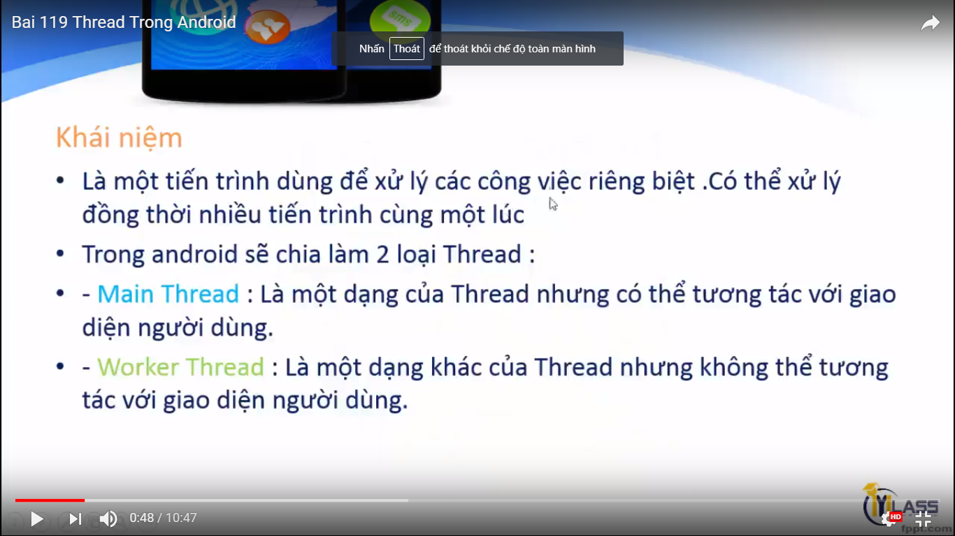
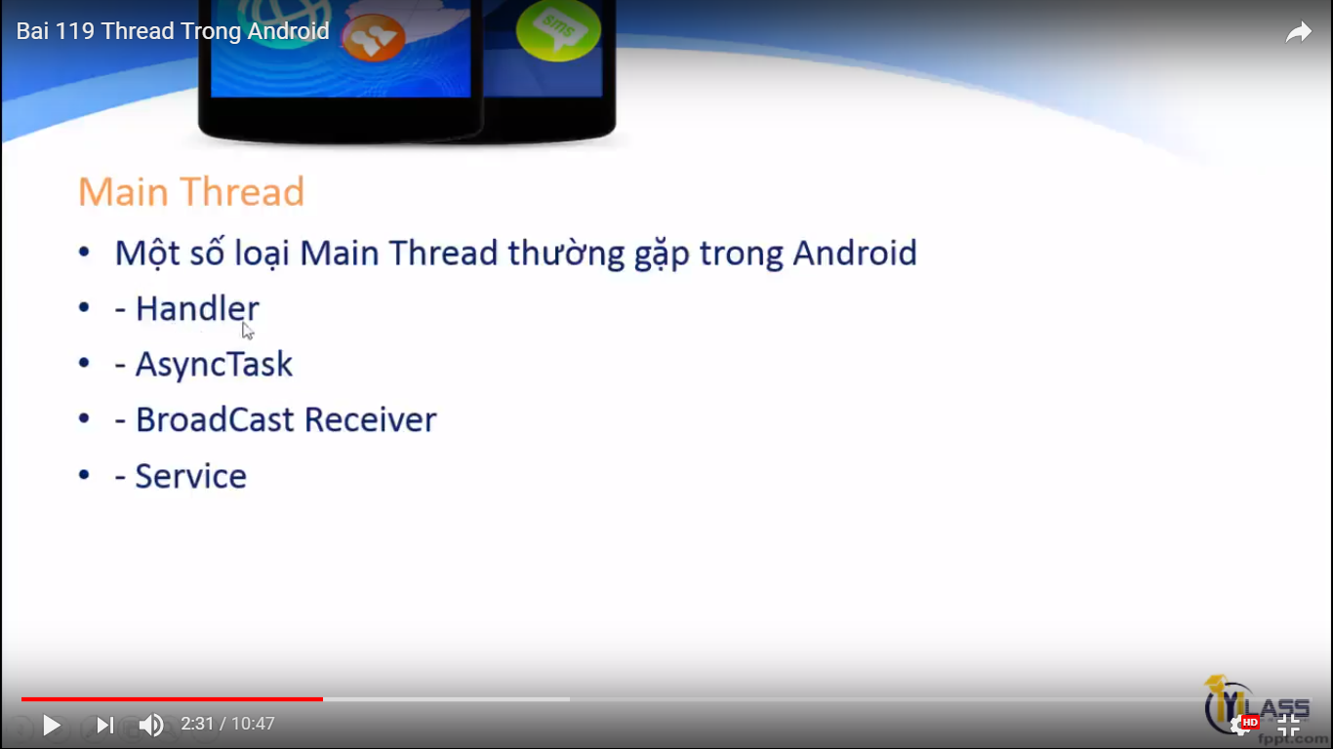

Handler : là thread cho phép cập nhập giao diện màn hình

Tìm hiểu AsynkTask(Xử lý đa nhiệm) : là 1 thread UI thread (Main thread )
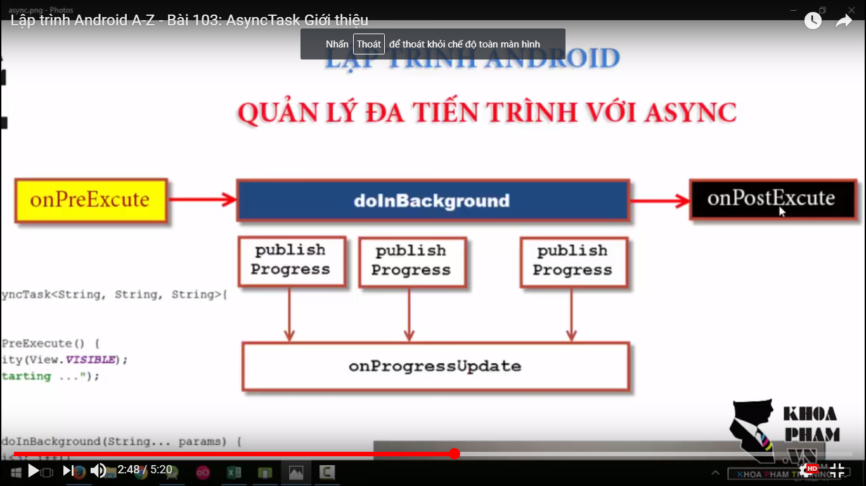
package com.example.philong.asynktaskdemo;
import android.os.AsyncTask;
import android.support.v7.app.AppCompatActivity;
import android.os.Bundle;
import android.view.View;
import android.widget.Button;
import android.widget.TextView;
public class MainActivity extends AppCompatActivity {
Button buttonXuLy;
TextView txtThongTin;
@Override
protected void onCreate(Bundle savedInstanceState) {
super.onCreate(savedInstanceState);
setContentView(R.layout.activity_main);
AnhXa();
}
void AnhXa(){
buttonXuLy=findViewById(R.id.button);
txtThongTin=findViewById(R.id.textView1);
buttonXuLy.setOnClickListener(new View.OnClickListener() {
@Override
public void onClick(View v) {
new QlCongViec().execute();
}
});
}
private class QlCongViec extends AsyncTask<Void,String,String> {
//3 tham số : 1 params kiểu dữ liệu , 2 progress trong quá trình sử lý , 3 khi hoàn thành tác vụ
@Override
protected void onPreExecute() { //công việc đầu tiên asynktask
super.onPreExecute();
txtThongTin.setText("Bắt đầu . \n");
}
@Override
protected String doInBackground(Void... voids) { //hàm này không thay đổi được giao diện
for(int i=0;i<5;i++){
try {
Thread.sleep(2000);
} catch (InterruptedException e) {
e.printStackTrace();
}
publishProgress("Xong viec"+i+"\n"); //hiển thị doInBackGround
}
return "Xong rồi. \n";
}
@Override
protected void onPostExecute(String s) {//nhận về giá trị khi xong tất cả các việc của AsynkTask
super.onPostExecute(s);
txtThongTin.append(s); //append để giữ biến ban đầu + hiển thị thêm
}
@Override
protected void onProgressUpdate(String... values) { //gọi quá trình doInBackground làm việc và xuất ra màn hình
super.onProgressUpdate(values);
txtThongTin.append(values[0]);
}
}
}

Tìm hiểu Thread sử dụng bằng Runable (Thread Worker) và kèm theo Handler để xử lý UI
Thread này không tương tác với UI được mà phải gởi message đến Handler
package com.example.philong.demothreadwithhandler;
import android.os.Handler;
import android.os.Message;
import android.support.v7.app.AppCompatActivity;
import android.os.Bundle;
import android.view.View;
import android.widget.Button;
import android.widget.TextView;
import android.widget.Toast;
public class MainActivity extends AppCompatActivity {
TextView textViewCount;
Button buttonCount;
private Handler handler; //handler.os library
public static final int MESSAGECOUNTDOWN = 1001;
public static final int MESSAGE_DONE=1002;
@Override
protected void onCreate(Bundle savedInstanceState) {
super.onCreate(savedInstanceState);
setContentView(R.layout.activity_main);
AnhXa();
XuLy();
initHandler();
}
private void initHandler() {
handler=new Handler(){
@Override
public void handleMessage(Message msg) {
if(msg.what==MESSAGECOUNTDOWN){
textViewCount.setText(String.valueOf(msg.arg1));
}
if(msg.what == MESSAGE_DONE){
Toast.makeText(MainActivity.this, "Done", Toast.LENGTH_SHORT).show();
}
}
};
}
private void XuLy() {
buttonCount.setOnClickListener(new View.OnClickListener() {
@Override
public void onClick(View v) {
DoDouwnCount();
}
});
}
void DoDouwnCount(){
final Thread thread=new Thread(new Runnable() {
@Override
public void run() {
int time=10;
do{
time--;
Message message=new Message();
message.what =MESSAGECOUNTDOWN; //nơi đến message phải có để gởi đi giống id để phân biệt
message.arg1=time; //đối số gởi đi
handler.sendMessageAtFrontOfQueue(message); //handler để gởi đi vào method handler và gán vào main vì Thread này k tương tác với UI được
try {
Thread.sleep(1000);
} catch (InterruptedException e) {
e.printStackTrace();
}
}
while (time>0);
handler.sendEmptyMessage(MESSAGE_DONE); //gởi bằng cách 2 khi chỉ cần gởi message
}
});
thread.start();
}
private void AnhXa() {
textViewCount=findViewById(R.id.textView_dem);
buttonCount=findViewById(R.id.button_dem);
}
}

