**International School, Duy Tan University**



CAPSTONE PROJECT 2

An Phu Farm System

**PROJECT PROPOSAL DOCUMENT**

Version 1.0

26/01/2016

**Mentor : MSc. Nguyen Minh Nhat**

**Group name : Lucid Team**

**PROJECT OVERVIEW**

|  |  |
| --- | --- |
| Project Title | An Phu Farm System |
| Start Date – End Date | 26/01/2015 to 20/05/2016 |
| Lead Institution | International School, Duy Tan University |
| Project Mentor | Msc Nguyen Minh Nhat |
| Project Manager & Contact detail | Project lead, Doan Hai Dang  K18CMUTPM1, International School, Duy Tan University  Mail: [doanhaidang32@gmail.com](mailto:doanhaidang32@gmail.com)  Tel: +84 1202348323 |
| Team member | Nguyen Ba Chinh, [nguyenbachinh94@gmail.com](mailto:nguyenbachinh94@gmail.com)  Le Dinh Doan, [ledinhdoan.0083@gmail.com](mailto:ledinhdoan.0083@gmail.com)  Le Hoang Phuc, lehoangphucdtu@gmail.com |

**DOCUMENT**

|  |  |
| --- | --- |
| Document Title | Proposal document |
| Reporting period | Jan, 2016 |
| Author | Team Lucid |
| Role | Team member |
| Filename | ProposalDocument_v1.1 |

document approval

The following signatures are required for approval of this document. Note, however, that since some role assignments will change during the course of the project, the perspective names should be update if needed.

|  |  |  |  |  |  |
| --- | --- | --- | --- | --- | --- |
| No. | F. Name | L. Name | Role | Date | Signature |
| 01 | Nguyen Minh | Nhat | Mentor |  |  |
| 02 | Doan Hai | Dang | Leader |  |  |
| 03 | Nguyen Ba | Chinh | Member |  |  |
| 04 | Le Dinh | Doan | Member |  |  |
| 05 | Le Hoang | Phuc | Member |  |  |

Contents

1. EXECUTIVE SUMMARY 5

1.1Requirements 5

1.1.1 Overview 5

1.1.2 Business needs 6

1.2 Implementation Scope and Approach 6

1.3 Implementation Methodology 6

1.4 Critical Success Factors and Assumptions 6

1.5 Investment Summary 7

2.SYSTEM ARCHITECTURE OVERVIEW 7

3.PROFILE OF LUCID GROUP 8

4. STATEMENT OF WORK 9

4.1 Company Organization and Geographical Scope 9

4.2 Scope of Work 9

4.3 General Assumptions 10

4.4 Customer Responsibilities and Deliverables 10

5. IMPLEMENTATION METHODOLOGY 10

5.1 The Project Methodology 11

5.2 Project Implementation Plan 12

5.3 Project Plan 13

6. ROLES AND RESPONSIBILITIES 13

# 1. EXECUTIVE SUMMARY

Divine team are happy to provide our proposal to stakeholders. In providing consulting services to user, we commit to adding and providing An Phu Farm for user

The key benefits are summarized below:

* Advertisement
* Benefit from reserve field.
* Sell Foods.

## 1.1 Requirement

### Overview

Nowadays, Fresh foods is most important with people in the world even so Viet Nam. Many people too busy for find and don’t know the quality of foods so it’s necessary when people can book fresh food with the best quality

Our products will provide for people foods’s information that they can book and receive foods quickly by more features:

* Show goods’s informations.
* Show goods’s images.
* Show goods’s price
* Online order.
* Search by bar code
* Online’s chat.
* Online’s payment.
* Show goods’s news.
* Show goods order‘s history.
* Shopping cart.

**Situation**

When people want find fresh food’s information. With “An Phu Farm” ,we will adapt their demand.

### 1.1.2 Business needs

With the hustle lifestyle, crowded as nowadays. If you want to have a meal with a full range of nutrients almost you must go to the market where crowded, noisy and stuffy air, so uncomfortable to buy food or seek to mini-mart with a lack variety of foods.

So difficult after a busy day you must go to the market to buy the food to prepare the family 's meal. Realize this problem. An Phu Farm ordered my team to developed an application have functions buy the food online with the full of variety food to solve all difficult about meal of users. Special, with An Phu farm you will be support door-to-door delivery service. We believe that users will be satisfied.

## 1.2 Implementation Scope and Approach

Product focus to people want to find fresh food’s information for buying with good quality.

## 1.3 Implementation Methodology

Divine team implement on Android foundation, method of implementation will be focus to plan:

• Minimize the length of implementation time.

• Maximize the utilization and customer resources.

• Incorporate a process-oriented approach.

## 1.4 Critical Success Factors and Assumptions

• Adherence to scope and objectives of the project.

• Adherence to the no-modifications objective.

• Skill level and commitment of Divine project team.

• Efficient use of both internal and external resources.

• Timely decision making.

• Clarity of business objectives for the project.

• Empowered project team.

## 1.5 Investment Summary

Table 1.1 Investment Summary

|  |  |  |  |  |
| --- | --- | --- | --- | --- |
| **Type** | **Description** | **Unit** | **Unit Price (USD)** | **Total (USD)** |
| **Host** |  |  |  |  |
| **Annual Maintenance fees** | | | |  |
| **Total Price** | | | | 40 |

1. **System Architecture Overview**

Table 2.1 The application includes these modules:

|  |  |  |  |
| --- | --- | --- | --- |
| **Modules No#** | **Modules** | **Function** | **Actor** |
| M01 | Parsing Database from Internet | * Web manager * Member manager | Admin |
| M02 | Developing Module 01 | * Post’s manager | Mod |
| M03 | Developing Module 02 | * Booking * Chat. * Call. * Update information | User |

# 

# Profile of Divine Group

1. Leader : Doan Hai Dang

Phone: +841202348323

Mail:doanhaidang32@gmail.com

1. Member: Nguyen Ba Chinh

Phone: +841225665828

Mail: [nguyenbachinh94@gmail.com](mailto:nguyenbachinh94@gmail.com)

1. Member: Le Dinh Doan

Phone: +841632492429

Mail: [ledinhdoan.0083@gmail.com](mailto:ledinhdoan.0083@gmail.com)

1. Member: Le Hoang Phuc

Phone: +84 1202436036

Mail: lehoangphucdtu@gmail.com

# 4. Statement of work

## Company Organization and Geographical Scope

People that they want find fresh food’s information for buying

* 1. **Scope of Work**

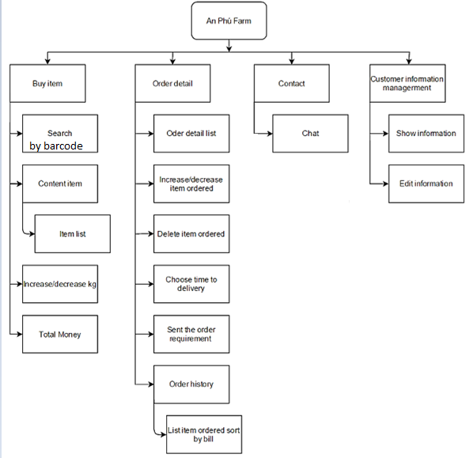

Figture 4.1 Work BreakDown Structure

## 4.3 General Assumptions

* The project will focus on implementing those business processes listed in section on scope. Processes not listed will be considered out of scope for the project defined in this proposal.
* Product can work if don’t have network.
* Vietnamese language be actived.
* Data be storage in host and web service.

## 4.4 Customer Responsibilities and Deliverables

* Ownership and overall project responsibility, providing a project manager, driving resources, providing direction to that team regarding decision making, planning and scope management.
* Effective and timely decision making processes are critical to the success of any resman software implementation. To ensure a successful implementation, all issues will need to be resolved within 24 hours.
* Data extraction, preparation & cleaning
* Change Management
* Ensure knowledge transfer from key users to end users, e.g.
* Test and validate the delivered business processes
* Provide a working environment and adequate facilities

# 5. Implementation Methodology

We will use technical solution to reach your target project and follow plan:

* Project will be implemented in the following platforms and database:
* Implement on Android foundation
* WebService.
* Socket.
* Project will be managed on the following tools:
  + - Google Drive
    - Teamwork
    - Software Development Process: Water Fall

## 5.1 The Project Methodology

Intinial (Requirement)

Analysis and Design

Testing

Controlling

CloseOut(Maintenance)

Coding and Debuggin

Figture 5.1 Waterfall Process

## 5.2 Project Implementation Plan

* SRS Document.
* Project Plan.
* Prototype Document.

Table 5.1 The deliverables for each phase is as under.

|  |  |
| --- | --- |
| SRS document | * Create document * Collect requirement form an phu farm. * Prepare for use case |
| Project plan | * Select starting time of process * Commit to deliver by end of phase. |
| Prototype document | * Interface’s design. |

## 

## 5.3 Project Plan

**Project Schedule:**

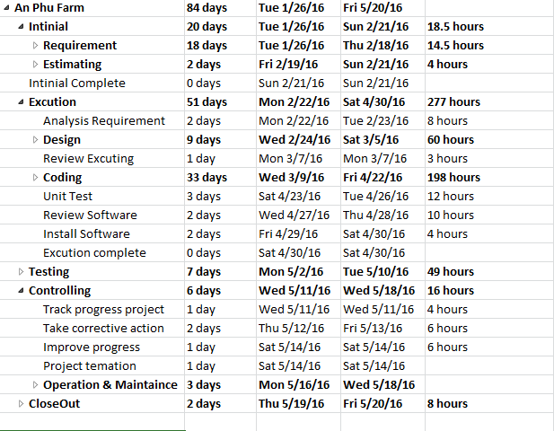

Figture 5.2 Project Shedule

# 6. Roles and Responsibilities

Specific roles and responsibilities includes the following:

Table 6.1 Roles and Responsibilities

|  |  |
| --- | --- |
| Stakeholders | Roles and Responsibilities |
| **Project Managers** | * The Project Managers will also be responsible for maintaining the project plan, streamlining resolution of issues and communicating the project status to the steering committee. * Provide overall project management for the implementation, and play an active role in the integration between the project team and real requirement. |
| **Team Divine** | * Implement and build project : code, unit test,... * Design Background * Build realse and features |
| **User** | * Provide requirement or feed back for product * Use and check features of product * Send feedback to improve product |

**Divine Team**

|  |  |  |
| --- | --- | --- |
| Ngyen Ba Chinh  Mr    K18CMUTM1 | |  |
| Le Hoang Phuc  Mr    K18CMUTM1 | |  |
| Le Dinh Doan  Mr    K18CMUTPM1 | |  |
| Doan Hai Dang  Mr    K18CMUTPM1 | |  |
| ***Approved by*** | ***Signature*** | ***Date*** |
| Nguyen Minh Nhat  Msc, Mentor  Duy Tan University | |  |