**International School, Duy Tan University**



CAPSTONE PROJECT 2

An Phu Farm System

**SOFTWARE REQUIREMENT**

**SPECIFICATION DOCUMENT**

Version 1.0

22/02/2016

**Mentor : MSc. Nguyen Minh Nhat**

**Group name : Divine Team**

**Document Information**

|  |  |
| --- | --- |
| Project | An Phu Farm System |
| Document Title | Software Requirement Specification Document |
| Creator | Le Dinh Doan |

**Revision History**

|  |  |  |  |
| --- | --- | --- | --- |
| Version | Person | Date | Description |
| 1.0 | Le Dinh Doan | 22-Feb - 2016 | Offical |

**Document Approval**

The following signatures are required for approval of this document

**Prepared by**

Doan Hai Dang Date

*Team Leader 22/02/2016*

Contents

1. INTRODUCTION 2

1.1. Purpose 2

1.2. The Rules Of The Document 2

1.3. DOCUMENT READER GUIDANCE 2

1.4. RANGE OF SOFTWARE PRODUCT 3

1.5. REFERENCE 3

2. BACKGROUND 4

2.1. THE CONTEXT OF SOFTWARE PRODUCTS 4

2.2. FUNCTION 4

2.3. THE CLASS AND CHARACTER OF USER 6

2.4. OPERATING ENVIRONMENT 6

2.5. CONSTRAIN DESGIGN AND EXECUTE 6

2.6. Assumptions and dependencies 6

3. Requirements interface out 7

Context Diagram 7

4. Software Fuatures 8

UseCase Diagram 8

4.1. User’s interface 26

4.2. Hardware’s interface 26

4.3. Software’s interface 27

4.4. Communication’s interface 27

5. Non-functional requirements other 27

5.1. Performance Requirements 27

5.2. Safety Requirements 27

5.3. Security Requirements 27

5.4. The properties of the product quality 27

5.5. User Documentation 27

6. Other Riquirements 28

1. **INTRODUCTION**
   1. **PURPOSE**

This document describes the functional and nonfunctional of An Phu Farm System version 1.0. This document is for the stakeholders and the development team of the system

* 1. **THE RULES OF THE DOCUMENT**

Here are the conventions and abbreviations used in this document and project.

Table 1.1 Conventions and abbreviations

|  |  |  |  |
| --- | --- | --- | --- |
| No | The term, acronym | Explain |  |
| 1 | Display | is used for communication, interaction between system and users through different means: Web, app on Android, app on Windows Phone... |  |
| 2 | User | The app users. example: everyone have smartphone and apps An Phu Farm |  |
| 3 | Use-Case | Trường hợp sử dụng |  |

* 1. **DOCUMENT READER GUIDANCE**

The object reference this description include:

* The development team
* Project Management
* Stakeholders:

Table 1.2 Role and skill of Team

|  |  |  |
| --- | --- | --- |
| Stakeholder | Role | Skill |
| Project Management | The entire project management, costing, time and resources | Management, Sales, Engineering |
| Testers | Testing, product testing in accordance with requirements and wishes of customers | Engineering |
| The developers | Using the programming language to build products | Engineering, Coder |
| The designer | Product design: the interface, the architecture, database,graphic... | Engineering |

* The description will be reviewed regularly by the object on to examine project through requirements.
* Any change in requirements will also be updated in this description.
  1. **Range Of Software Product**

This system was designed with the aim of searching, tracking fresh food items on An Phu Farm System to meet the needs of consumers. In addition the system also provides promotional news, online payment functions, online chat function.

* 1. **Reference**
* Specification
* Concept of operation document
* URD.doc
* Vision and Scope Document
* Documentation Use-case
* Documentation Software Requirement

1. **BACKGROUND**
   1. **The Context Of Software Products**

* Nowadays, more and more hurtful food in market. It affected to people about healthy and disease. With An Phu Farm System, customer can have a live connect with An Phu Farm System shop to search, booking fresh foods and another features. Everything become easily and convenient for improve healthy and quality of the life.
* When the system is implemented successfully, An Phu Farm System shop can increase competitive ability, grow the business performance and maximize the profits. Additionally, the system will be developed with a web application to help user accessing anywhere, anytime. And have ability to upgrade, update the new functions to meet the user requirements
  1. **Function**
* Feature 1: Login
* Priority: Normal.
* Risk: confirm code maybe wrong or password have special sympol.
* Function: Login.
* Environment: Web, App.
* Feature 2: Show goods’s information
* Priority: High.
* Risk: spend time for load data.
* Function: Show goods’s information.
* Environment: Web, App.
* Feature 3: Show goods’s list
* Priority: High.
* Risk: spend time for load data.
* Function: Show goods’s list.
* Environment: Web, App
* Feature 4: Shopping cart
* Priority: High.
* Risk: Spend time for load data from user’s booked.
* Function: Shopping cart.
* Environment: Web, App.
* Feature 5: News
* Priority: Low.
* Risk: Spend time for load data.
* Function: News.
* Environment: Web, App.
* Feature 6: Chat
* Priority: Normal.
* Risk: Chat’s server offline.
* Function: Chat.
* Environment: Web, App.
* Feature 7: Call
* Priority: Normal.
* Risk: Call center busy.
* Function: Call.
* Environment: App.
* Feature 8: User’s information
* Priority: High.
* Risk: Spend time for load user’s data.
* Function: User’s information.
* Environment: Web, App.
  1. **THE CLASS AND CHARACTER OF USER**

Table 2.1 Class and character of user

|  |  |
| --- | --- |
| **User** | **Description** |
| Customer | This user can search fresh food, booking, and contact with shop manager and another features |
| Shop Manager | This user can general manage product or category’s information and user’s information. |

* 1. **Operating Environment**
* Web
* Android App
  1. **Constrain desgign and execute**
* System will be construct in Android and website
* User have to download Android app or use website
* Exactly information and image
* Two languages : Vietnammese, English.
  1. **Assumptions and dependencies**
* **Dependence**
  + Booking accidentally to internet
  + User must have android’s device or another device login to website
  + User must login to booking
* **Supposelly**

1. **Requirements interface out**

**Context Diagram**

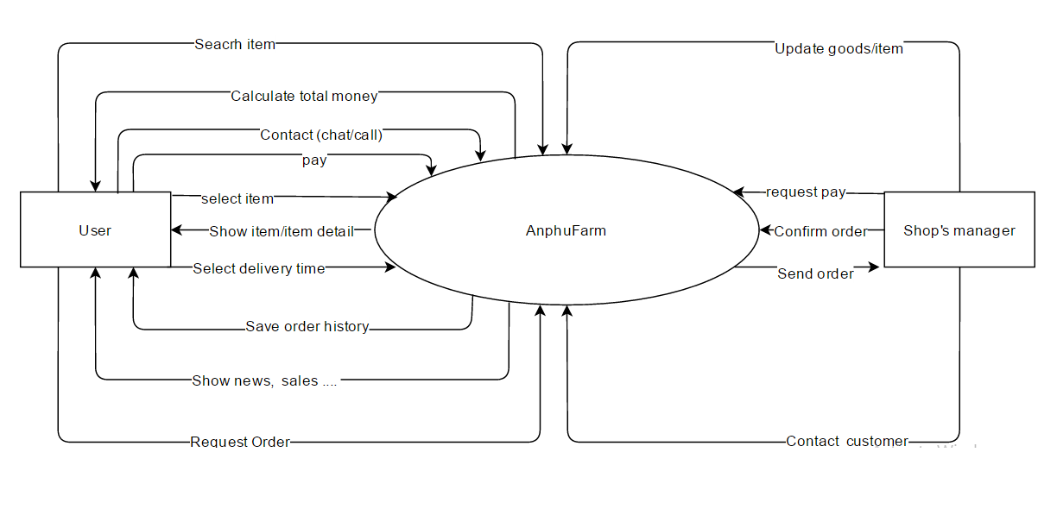

Figure 3.1 Context Diagram

1. **Software Fuatures**

**UseCase Diagram**

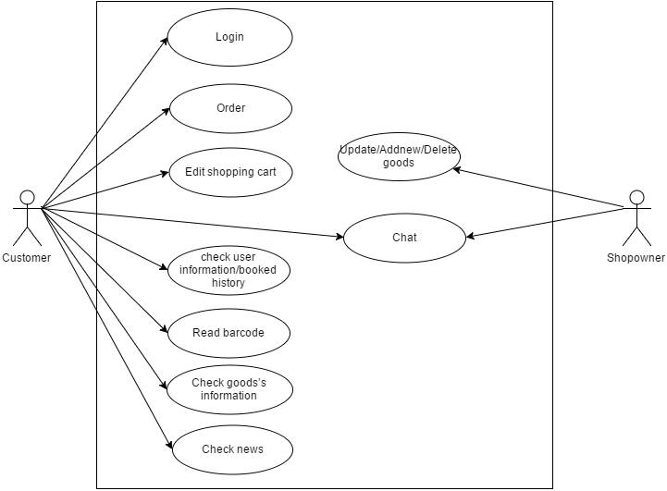

### Figure 4.0: Use Case Diagram

## Use case 1: Login

Table 4.1: Login

|  |  |
| --- | --- |
| Use Case ID: UC01 | |
| Use Case Name: Login | |
| Member Create: Hoang Phuc Le | Member Last Update: Hai Dang Doan, Dinh Doan Le, Ba Chinh Nguyen |
| Date Create: 08/03/2016 | Date Last Update : 12/03/2016 |
| Actor: Users (Customers, Administrators) | |
| Describes: This use case describes how users gain access to the website system through the login/registration (account creation) process. | |
| Pre-conditions: | The user is on the "Sign In" screen |
| Post-conditions: | The user is either logged in or failed to log in and is appropriately notified |
| Priority: H/M/L | M |
| Use frequency: | High |
| Standard processes: | |
| Action (Actor): | The response of the system |
| 1. The user browses to the "Sign In" page. 2. The user enters his/her username and password in the returning user section of the "Sign In" screen. | 1. The system validates the username and password (successfully) and displays the user's account information page. |

### 

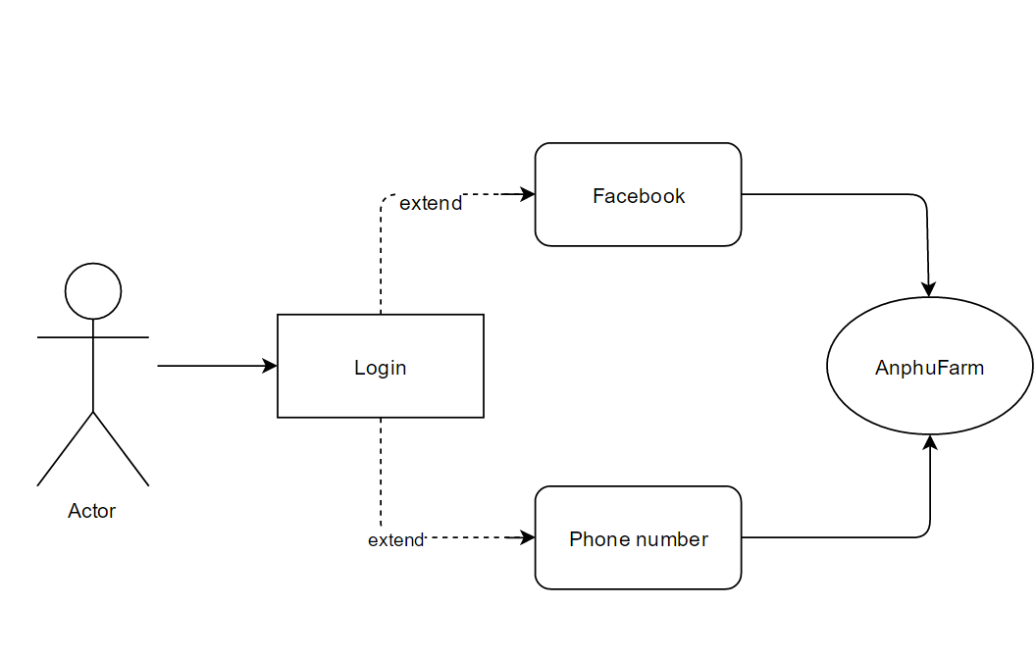

### Figure 4.1: Login

## Use case 2: Show goods’s information

### Table 4.2: Show goods’s information

|  |  |
| --- | --- |
| Use Case ID: UC02 | |
| Use Case Name: Show goods ’s information | |
| Member Create: Hoang Phuc Le | Member Last Update: Hai Dang Doan, Dinh Doan Le, Ba Chinh Nguyen |
| Date Create: 08/03/2016 | Date Last Update: 12/03/2016 |
| Actor: Admin | |
| Describes: This use case describes the good information not only about hygiene and food safety but also the product information will be update weekly. | |
| Pre-conditions: | At homepage login to system |
| Post-conditions: | Change to the Manager interface  to backup, upgrade the data. |
| Priority: H/M/L | High |
| Use frequency: | High |
| Standard processes | |
| Action (Actor) | The response of the system |
| 1. At homepage | 2. Admin login to the Manager interface to backup and upgrade the new information |

### 

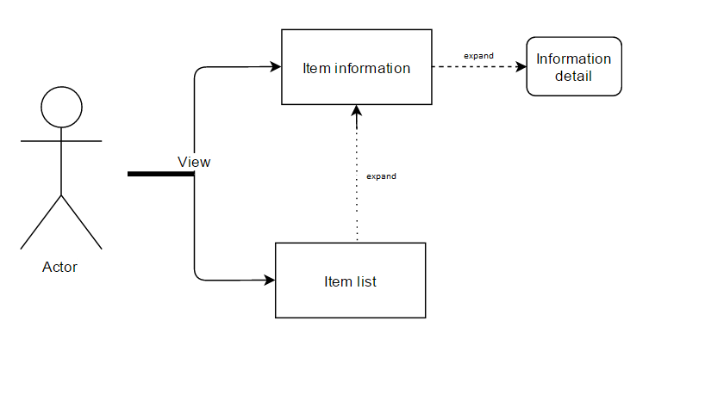

### Figure 4.2: Show goods’s information

## Use case 3: Show goods’s list

Table 4.3: Show goods’s list

|  |  |
| --- | --- |
| Use Case ID: UC03 | |
| Use Case Name: Show goods ’s list | |
| Member Create: Hoang Phuc Le | Member Last Update: Hai Dang Doan, Dinh Doan Le, Ba Chinh Nguyen |
| Date Create: 08/03/2016 | Date Last Update: 12/03/2016 |
| Actor: Admin | |
| Describes: This use case describes that manage the good list of product. | |
| Pre-conditions: | At homepage login to system |
| Post-conditions: | Change to the Good Product Page |
| Priority: H/M/L | High |
| Use frequency: | High |
| Standard processes | |
| Action (Actor) | The response of the system |
| 1. At homepage  2. If user choose tab Good Product | 3. System perform to change Good Product  4. The Good Product will be shown. |



### Figure 4.3: Show goods’s list

## Use case 4: Shopping cart

Table 4.4: Shopping cart

|  |  |
| --- | --- |
| Use Case ID: UC04 | |
| Use Case Name: Shopping cart. | |
| Member Create: Hoang Phuc Le | Member Last Update: Hai Dang Doan, Dinh Doan Le, Ba Chinh Nguyen |
| Date Create: 08/03/2016 | Date Last Update: 12/03/2016 |
| Actor: User | |
| Describes: This use case describes how an actor can modify items in the shopping cart | |
| Pre-Conditions: | The actor is on the Cart Screen and have already logged in. |
| Post-Conditions: | The user successfully modifies existing items in the cart or adds new items to the cart. |
| Priority: H/M/L | High |
| Use frequency: | High |
| Standard processes | |
| Action (Actor) | The response of the system |
| 1. The user clicks on one of the category in the left frame of the screen and navigates to the item he wishes to add to the cart and clicks on the “Add to Cart” link.  2. The system displays the Cart Screen with the all the old items and the newly added item. The subtotal field displays the total cost of the shopping cart.  3. The user repeats steps 3 and 4 for all the items he wants to add to the cart. | 4. The user modifies the item quantity for one or multiple items and clicks “Update Cart”.  5. The system updates the new quantity and displays the modified line item totals and sub-total to the user.  6. The user clicks the “Remove” link to remove any of the items in the cart.  7. The system deletes the item from the cart and adjusts the sub-total accordingly. |

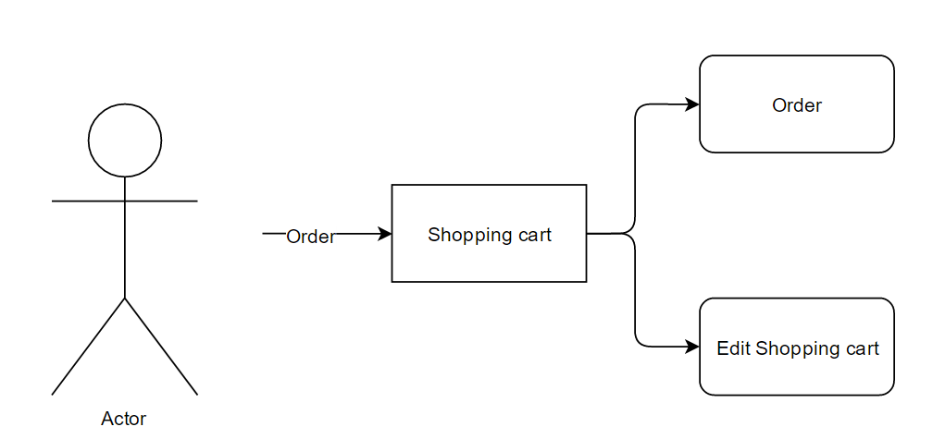

### Figure 4.4: Shopping cart

## Use case 5: News

### Table 4.5: News

|  |  |
| --- | --- |
| Use Case ID: UC05 | |
| Use Case Name: News | |
| Member Create: Hoang Phuc Le | Member Last Update: Hai Dang Doan, Dinh Doan Le, Ba Chinh Nguyen |
| Date Create: 08/03/2016 | Date Last Update: 12/03/2016 |
| Actor: User | |
| Describes: This use case describes how user can find the other news such as: Prices, introduce about cart, health, nutrition,… | |
| Pre-conditions: | The actor is on homepage |
| Post-conditions: | Change to news page |
| Priority: H/M/L | L |
| Use frequency: | M |
| Standard processes | |
| Action (Actor) | The response of the system |
| 1. At homepage  2. If user choose tab News | 3. System perform to change part News |

### 

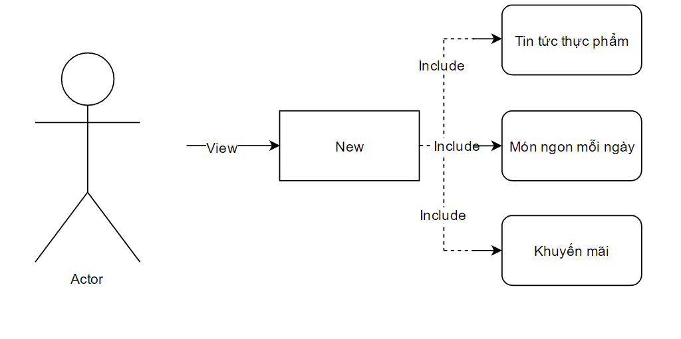

### Figure 4.5: News

## Use case 6: Chat

### Table 4.6: Chat

|  |  |
| --- | --- |
| Use Case ID: UC06 | |
| Use Case Name: Chat | |
| Member Create: Hoang Phuc Le | Member Last Update: Hai Dang Doan, Dinh Doan Le, Ba Chinh Nguyen |
| Date Create: 08/03/2016 | Date Last Update: 12/03/2016 |
| Actor: Users (Customers, Administrators) | |
| Describes: This use case describes how user need the live support by staffs of system through chat on the internet | |
| Pre-conditions: | The User send questions to chat interface. |
| Post-conditions: | Staffs will be support by resolve the question. |
| Priority: H/M/L | M |
| Use frequency: | Medium |
| Standard processes | |
| Action (Actor) | The response of the system |
| 1. At website when user choose chat online tab.  2. The conversation between support staffs and users will start. |  |

### 

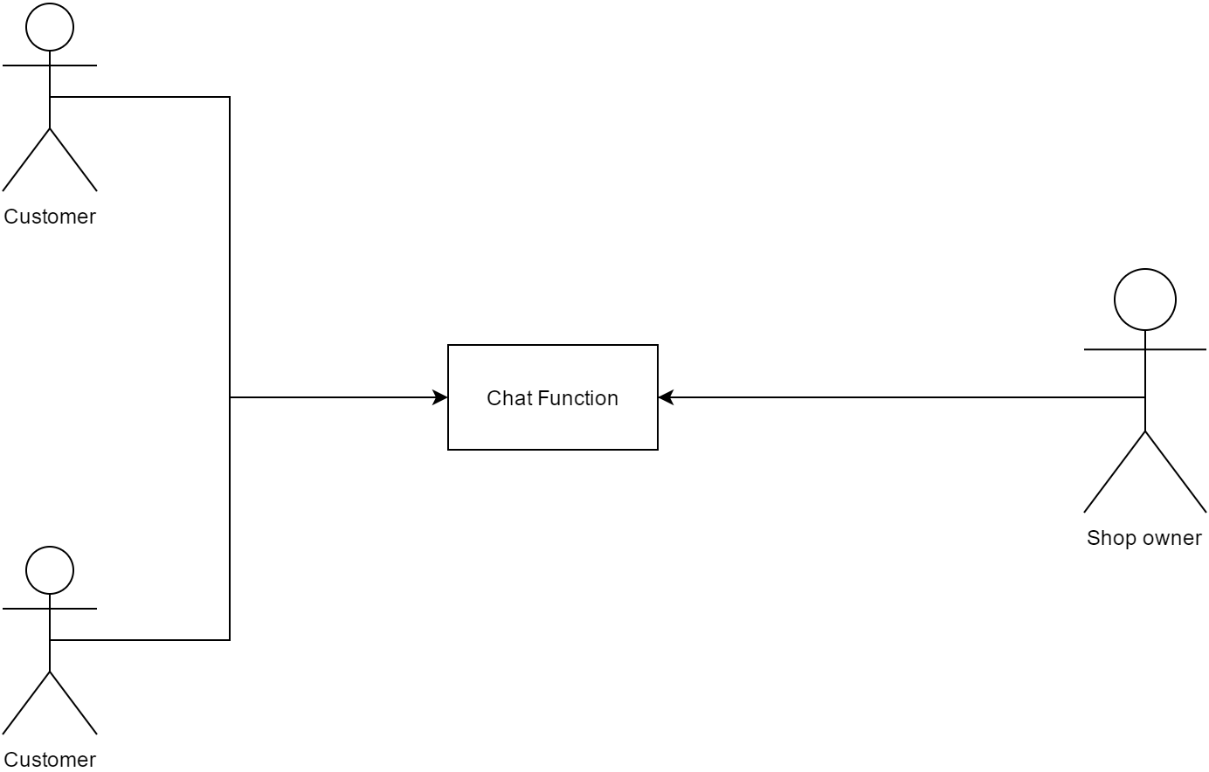

### Figure 4.6: Chat

## Use case 7: Barcode reader

Table 4.7: Barcode reader

|  |  |
| --- | --- |
| Use Case ID: UC07 | |
| Use Case Name: Barcode reader | |
| Member Create: Hoang Phuc Le | Member Last Update: Hai Dang Doan, Dinh Doan Le, Ba Chinh Nguyen |
| Date Create: 08/03/2016 | Date Last Update: 12/03/2016 |
| Actor: Users (Customers) | |
| Describes: This use case describes how user need the support consist of: User want to check the goods by Barcode. User can user barcode reader function on app to check it | |
| Pre-conditions: | The user have the app |
| Post-conditions: | Barcode confirm |
| Priority: H/M/L | M |
| Use frequency: | Medium |
| Standard processes | |
| Action (Actor) | The response of the system |
| 1. User camera occur on app.  2. Check and confirm barcode |  |

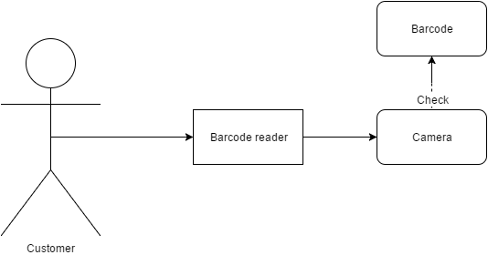

### Figure 4.7: Barcode reader

## Use case 8: User’s information

### Table 4.8: User’s information

|  |  |
| --- | --- |
| Use Case ID: UC08 | |
| Use Case Name: User’s information | |
| Member Create: Hoang Phuc Le | Member Last Update: Hai Dang Doan, Dinh Doan Le, Ba Chinh Nguyen |
| Date Create: 08/03/2016 | Date Last Update: 12/03/2016 |
| Actor: Users (Customers) | |
| Describes: This use case describes how a user can look their account information or update their account information with store. | |
| Pre-conditions: | Store website or app main page is loaded. |
| Post-conditions: | Account Information Screen lets the user review his/her account details and then successfully modifying its contents. |
| Priority: H/M/L | H |
| Use frequency: | High |
| Standard processes | |
| Action (Actor) | The response of the system |
| 1. User Clicks on the Signin Link 2. System displays the sign In screen 3. User enters the Username and Password 4. System displays the Account Information Page. 5. User can click on the ''update Account'' link | 1. User is at Modifiable Account Information Page. 2. User modifies the account information and exits the page by clicking on “Finish”. 3. System displays the confirmation message “Account Information is updated”. |

### 



### Figure 4.8: User’s information

## Use case 9: Show booked ’s history

Table 4.9: Show booked ’s history

|  |  |
| --- | --- |
| Use Case ID: UC09 | |
| Use Case Name: Show booked ’s history | |
| Member Create: Hoang Phuc Le | Member Last Update: Hai Dang Doan, Dinh Doan Le, Ba Chinh Nguyen |
| Date Create: 08/03/2016 | Date Last Update: 12/03/2016 |
| Actor: Users | |
| Describes: This use case describes how a user can check their booked ‘s history. | |
| Pre-conditions: | Customer choose booked history on the Account Information Interface. |
| Post-conditions: | Account Information Screen lets the user look their Book History of his/her account details and then successfully modifying its contents. |
| Priority: H/M/L | H |
| Use frequency: | High |
| Standard processes | |
| Action (Actor) | The response of the system |
| 1. User choose in the booked history. | 1. List of history will shown for user check. |

### 

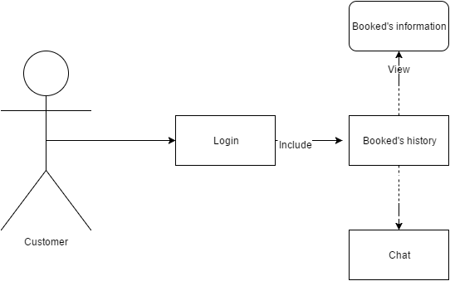

### Figure 4.9: Show booked ’s history

## Use case 10: Show goods follow to category

### Table 4.10: Show goods follow to category

|  |  |
| --- | --- |
| Use Case ID: UC110 | |
| Use Case Name: Show goods follow to category | |
| Member Create: Hoang Phuc Le | Member Last Update: Hai Dang Doan, Dinh Doan Le, Ba Chinh Nguyen |
| Date Create: 08/03/2016 | Date Last Update: 12/03/2016 |
| Actor: Administrators | |
| Describes: This use case describes that the good will divide expand category such as: vegetable, meat, fish, chicken,… | |
| Pre-conditions: | At homepage or app, user can choose product expand many other category. |
| Post-conditions: | One category Screen lets the user look and then successfully modifying its contents. |
| Priority: H/M/L | H |
| Use frequency: | High |
| Standard processes | |
| Action (Actor) | The response of the system |
| 1. Administrators usually check and update the category | 1. Information must update, maintain weekly |

### 



Figure 4.10: Show goods follow to category

## Use case 11: Payment Online

### Table 4.11: Payment Online

|  |  |
| --- | --- |
| Use Case ID: UC11 | |
| Use Case Name: Payment Online | |
| Member Create: Hoang Phuc Le | Member Last Update: Hai Dang Doan, Dinh Doan Le, Ba Chinh Nguyen |
| Date Create:08/03/2016 | Date Last Update:12/03/2016 |
| Actor: Administrators | |
| Describes: This use case describes how the User of the system can make payments for the loan. | |
| Pre-conditions: | Payment page should be loaded. |
| Post-conditions: | - User is able to pay online successfully.  - A Confirmation Id is generated by the system.  - Confirmation e-mail is sent by the system to the User. |
| Priority: H/M/L | H |
| Use frequency: | High |
| Standard processes | |
| Action (Actor) | The response of the system |
| 1. User clicks on “Financing link”.  2. System displays the “Financing” main page.  3. User clicks on ‘Make Payments’ link in the Screen.  4. System displays the ‘Payment Screen’.  5. User enters the following information. | 6. User clicks on ‘Submit’ button.  7. System displays ‘Confirm the payment information again’ to the User.  8. User click on 'Confirm'.  9. System sends a confirmation e-mail to the User or call live to User. |

### 



Figure 4.11: Payment Online

### 

* 1. **User’s interface**
* User can change language
* User can view goods’s information and image.
* Search fresh food follow good’s name and barcode
* Payment online in website
* Booking in android app
* Live chat to supporter
  1. **Hardware’s interface**
* Android operating system
* Internet or 3G connection

* 1. **Software’s interface**
* System can connect with MySQL
* Run with android operating system or website
  1. **Communication’s interface**

This application can link to the website. As described above, this will be communicating with a server and the HTTPS protocol. Integrated Facebook app will let users login. Accounts and user’s information will be kept confidential.

1. **Non-functional requirements other**
   1. **Performance Requirements**

Table 5.1 Performance

|  |  |
| --- | --- |
| 1 | Web : -The interface will appear within four seconds from the time access to the system if connect strong.  Mobile: -Placement notice will be displayed after 3 seconds if the connect strong |
| 2 | -Users will wait for three seconds to receive information of system Grace Coffee |
| 3 | -The system will provide accurate list of Coffee information within one second |

* 1. **Safety Requirements**

No safety requirement for this system, the hazards occur depending usage by the user. example: search for Coffee improperly.

* 1. **Security Requirements**

The user account information will be kept confidential.

* 1. **The properties of the product quality**

-Availability: the information in the system will be stored in the database so the system is always active, and this information will be updated regularly.

-Ease of use: the app has a guide for users with user-friendly interface.

* 1. **User Documentation**

After downloading and installing the product will have an electronic guide for users. When users encounter problems in using the product can send their inquiries via the product review section.

1. **Other Riquirements**

|  |  |  |
| --- | --- | --- |
| No | The term | Explain |
| 1 | URD | User requirement document |

|  |  |  |
| --- | --- | --- |
| ***Prepared by*** | ***Signature*** | ***Date*** |
| Doan Hai Dang  Mr    K18CMUTPM1 | | / / |
| Le Hoang Phuc  Mr    K18CMUTPM1 | | / / |
| Le Dinh Doan  Mr  K18CMUTPM1 | | / / |
| Nguyen Ba Chinh  Mr  K18CMUTPM1 | | / / |
| ***Approved by*** | ***Signature*** | ***Date*** |
| Nguyen Minh Nhat  Msc, Mentor  Duy Tan University | | / / |