**International School, Duy Tan University**



CAPSTONE PROJECT 2

AN PHU FARM SYSTEM

**DETAIL DESIGN DOCUMENT**

Version 1.0

01/3/2016

**Mentor : MSc. Nguyen Minh Nhat**

**Group name : Lucid Team**

**Document Information**

|  |  |
| --- | --- |
| Project | An Phu Farm System |
| Document Title | Detail Design Document |
| Creator | Chinh Nguyen Ba |

**Revision History**

|  |  |  |  |
| --- | --- | --- | --- |
| Version | Person | Date | Description |
| 1.0 | Chinh Nguyen Ba | 1- March - 2016 | Draft |
|  |  |  |  |
|  |  |  |  |

**Document Approval**

The following signatures are required for approval of this document

**Prepared by**

Chinh Nguyen Ba Date

*Team Member 01/03/2016*

Table of Contents

1. INTRODUCTION 4

1.1. Purpose 4

1.2. Scope 4

2. Project statement 4

2.1. Project overviews 4

2.2. Project background 4

2.3. Project goal 4

2.4. System Context Diagram 5

3. Spring MVC model 6

4. Architectural Detail 7

4.1. C&C View 7

4.2. Modele view 8

4.3. Allocation view 9

5.Design Detail 10

5.1. Design Web Interface 10

5.1.1. Homepage 10

5.1.2. Register 11

5.1.3. Member Interface 12

5.1.4. Admin Interface 13

5.1.5. Product 13

5.1.6. Contact 14

5.1.7. Customer infomation 14

5.2. Design App Interface 15

5.2.2. User Information 15

5.2.3. History 16

5.3. Design Database 17

5.3.1. ERD 17

5.3.2. RMD 18

6.References and definition 18

6.1. Definition, Acronyms and Abbreviations 18

6.2. References 18

1. **Introduction**
   1. **Purpose**

The purpose of this document is to present a detailed description of the An Phu Farm functions, the interfaces of the system.

Explain the operation of the function through UML diagrams.

* 1. **Scope**

This document is intended for both the Stakeholders and developers of the system.

1. **PROJECT STATEMENT**
   1. **Project overviews**

Project name An Phu Farm

Client Nhat Nguyen Minh

Mentor Nhat Nguyen Minh

Developer team Dang Doan Hai

Chinh Nguyen Ba

Phuc Le Hoang

Doan Le Dinh

* 1. **Project background**

An Phu Farm system can help user order and contact to shop’s owner. It’s very convenient and save the time.

* 1. **Project goal**

|  |  |
| --- | --- |
| **Goal** | **Description** |
| Software | Design an An Phu Farm full function, nice and friendly interface. |
| Business | Meet the customer’s need. |
| Technology | Use the latest technology and suitable for many smartphone. |
| Quality | Bug is at least |
| Team member | Corporation to develop together. |
| Process | Support project is on time, on budget, assurance software quality and motivate team works. |

* 1. **System Context Diagram**

This view defines the context of the system during normal operation

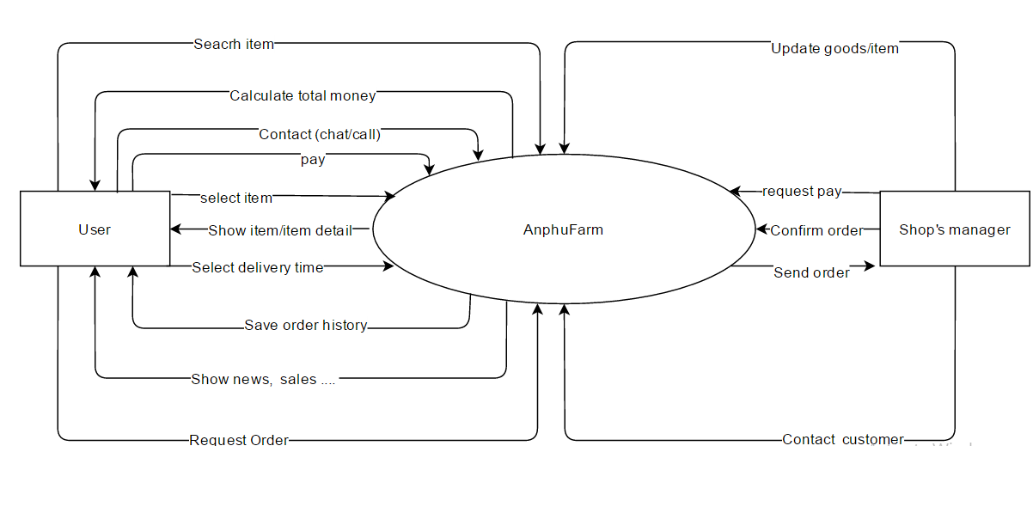

Figure 2.1: System Context Diagram

1. **Spring MVC model**



Figure 3.1: Spring MVC

1. **ARCHITECTURAL DETAIL**
   1. **C&C View**

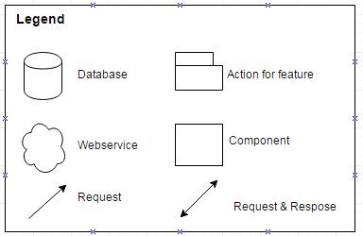

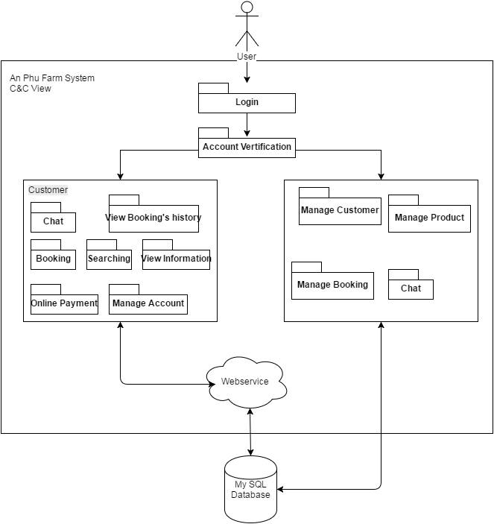

Figure 4.1: C&C View

* 1. **Model View**

C:\Users\Admin\AppData\Local\Microsoft\Windows\INetCache\Content.Word\module (1).png

*Figure 4.2: Module View*

**4.3 Allocation View**

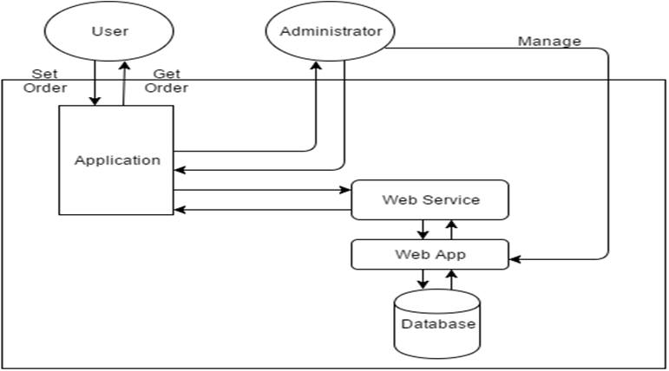

Figure 4.3:Allocation View

1. **Design Detail**
   1. **Design Web Interface**
      1. **Homepage** 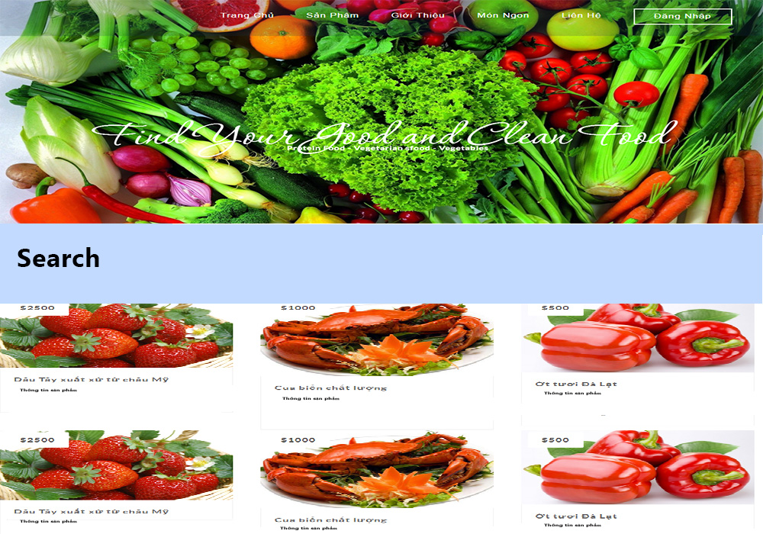

Figure 5.1: Homepage

* + 1. **Register**

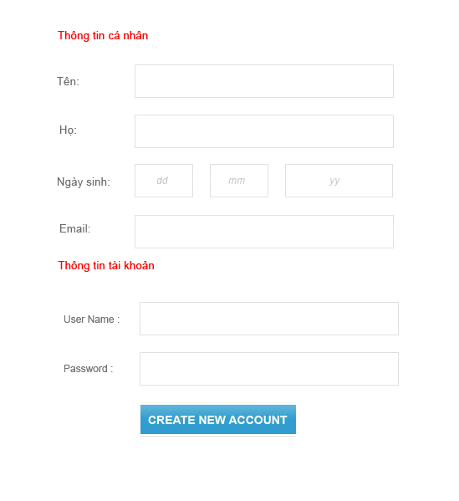

Figure 5.2: Register

* + 1. **Member Interface**



Figure 5.3: Member Interface

* + 1. **Admin Interface**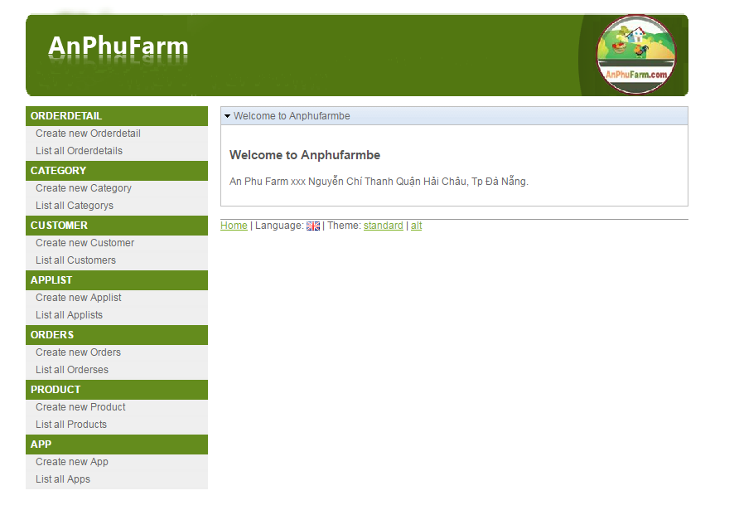

Figure 5.4: Admin Interface

* + 1. **Product**

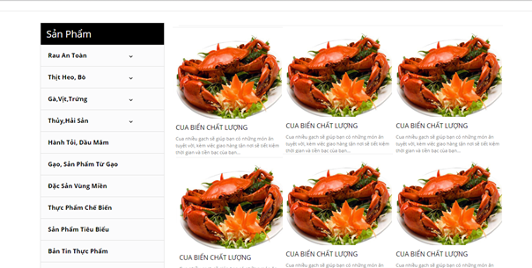

Figure 5.5: Product Interface

* + 1. **Contact**

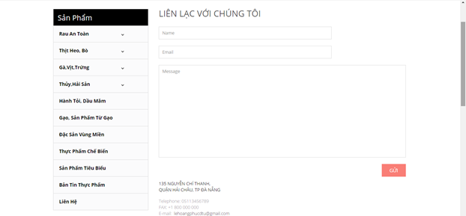

Figure 5.6: Contact Interface

* + 1. **Customer infomation** 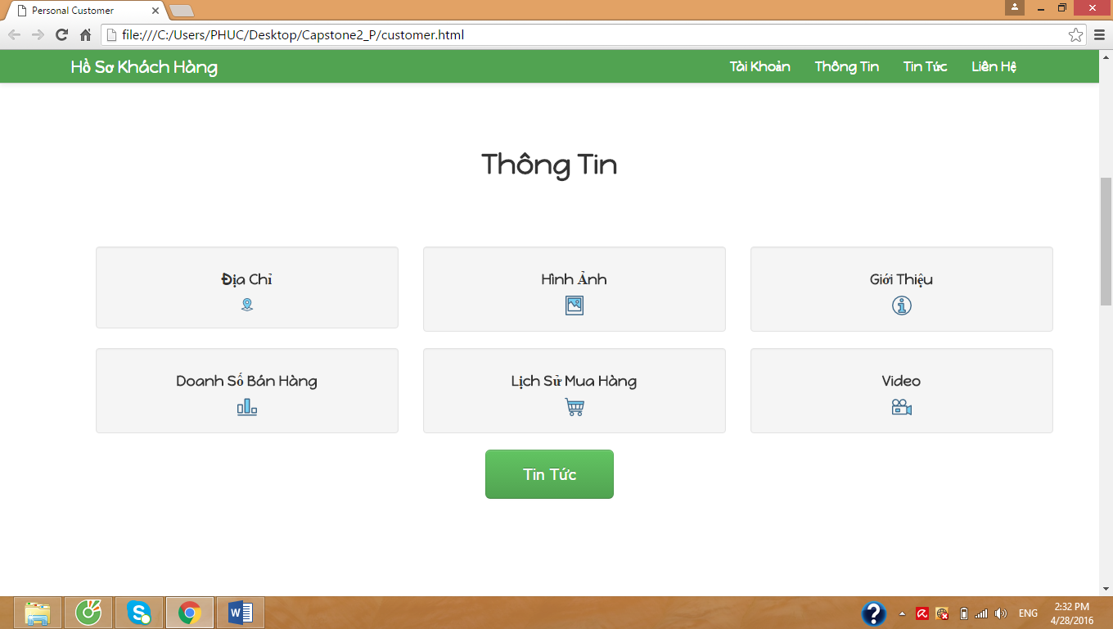

Figure 5.7: Customer information

* 1. **Design App Interface**
     1. **Goods list**

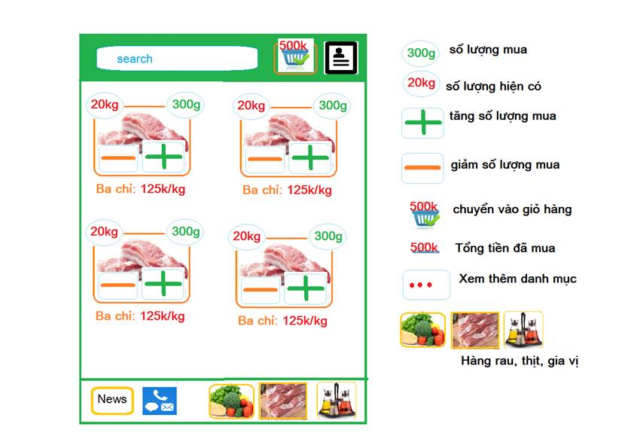

Figure 5.8: Goods list

* + 1. **User Information**

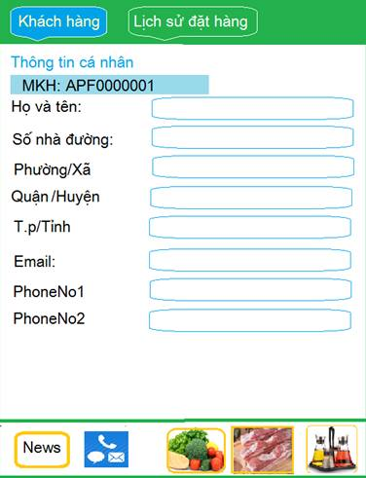

Figure 5.9: User information

* + 1. **History**

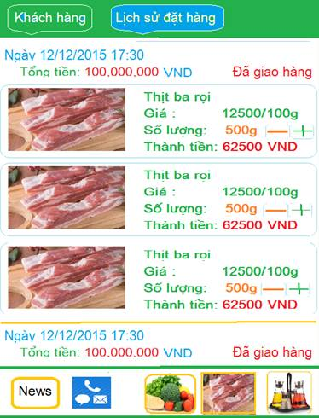

Figure 5.10: History Information

* 1. **Design Database**
     1. **ERD**

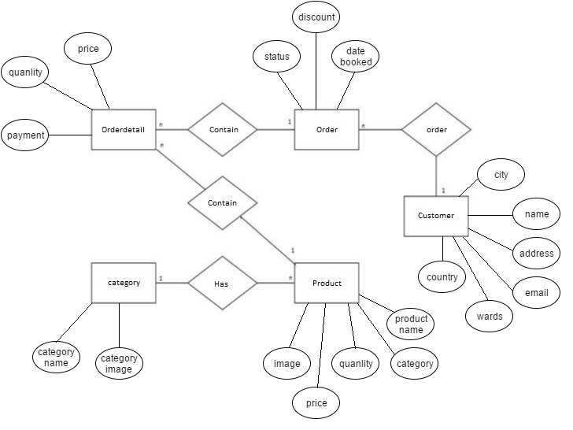

Figure 5.11: ERD

* + 1. **RMD**

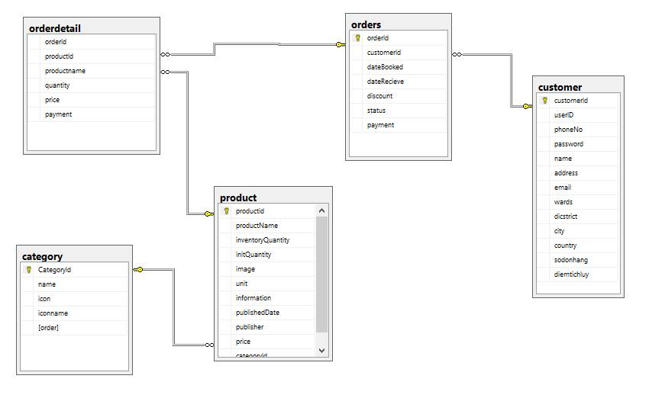

Figure 5.12: RMD

1. **REFERENCES AND DEFINITION**
   1. **Definition, Acronyms and Abbreviations**

|  |  |
| --- | --- |
| **Acronyms** | **Definitions** |
| ERD | Entity Relationship Diagram |
| RMD | Relational Model Diagram |

* 1. **References**
* VJS Architecture v1.2 – Man Nguyen Duc (2010)
* Information Systems Project: Detail Design Document

|  |  |  |
| --- | --- | --- |
| ***Prepared by*** | ***Signature*** | ***Date*** |
| Doan Hai Dang  Mr    K18CMUTPM1 | | / / |
| Le Hoang Phuc  Mr    K18CMUTPM1 | | / / |
| Le Dinh Doan  Mr  K18CMUTPM1 | | / / |
| Nguyen Ba Chinh  Mr  K18CMUTPM1 | | / / |
| ***Approved by*** | ***Date*** | ***Signature*** |
| Nguyen Minh Nhat  Msc, Mentor  Duy Tan University | | / / |