**International School, Duy Tan University**



CAPSTONE PROJECT 2

An Phu Farm System

**DATABASE DESIGN DOCUMENT**

Version 1.0

01/04/2016

**Mentor : MSc. Nguyen Minh Nhat**

**Group name : Divine Team**

**Document Information**

|  |  |
| --- | --- |
| Project | An Phu Farm System |
| Document Title | Database Design |
| Creator | Doan Hai Dang |

**Revision History**

|  |  |  |  |
| --- | --- | --- | --- |
| Version | Person | Date | Description |
| 1.0 | Doan Hai Dang | 01-April - 2016 | Offical |

**Document Approval**

The following signatures are required for approval of this document

**Prepared by**

Doan Hai Dang Date

*Team Leader 01/04/2016*

Contents

1. Describe of requirement on how to save data of the system 1

2. Database ERD Diagram 2

Figure 2.1 2

3. Databse RDM diagram 3

Figure 3.1 3

4. Physical Table Design 3

Table 4.1 3

Table 4.2 4

Table 4.3 4

Table 4.4 4

Table 4.5 5

Table 4.6 5

Table 4.7 5

# Describe of requirement on how to save data of the system

This system can view, search goods’s information then booking follow a reciept and review with history booked’s item.

* Once time, customer can view many item.
* Once time, customer can search 1 item, 1 item can search by many people
* One Customer can book many item, 1 item can book by many peopke
* Once time, Customer can book 1 receipt, 1 receipt book by one people
* One category have many item, 1 item have 1 category.
* One history’s booked have many receipt, 1 receipt have 1 history’s booked.
* One customer have one history’s booked, 1 history’s booked have 1 customer.
* One customer with application have an AppID, 1 AppID have one customer with application.
* One AppListID have many AppID, 1 AppID have 1 AppListID.

# Database ERD Diagram

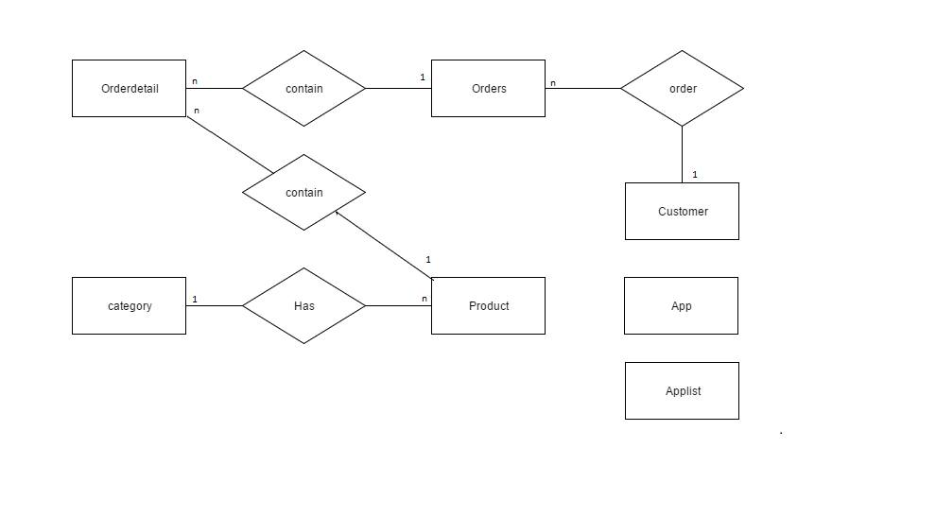

### Figure 2.1

# Databse RDM diagram

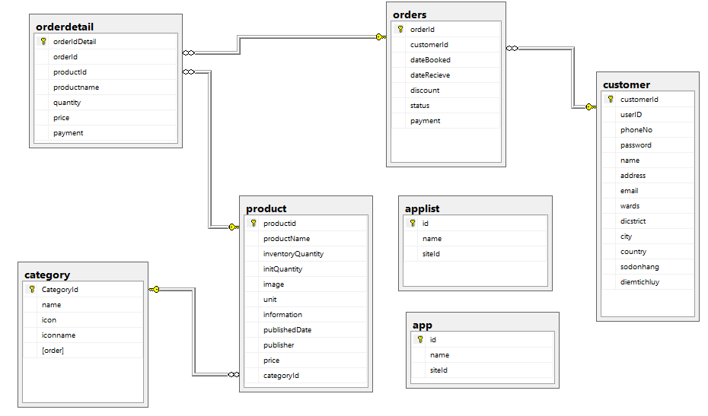

### Figure 3.1

# Physical Table Design

App

|  |  |  |
| --- | --- | --- |
| Properties | Datatype | Constraint |
| ID | varchar(32) | NOT NULL, PRIMARY KEY |
| NAME | varchar(32) | DEFAULT NULL |
| SITEID | varchar(100) | DEFAULT NULL |

### Table 4.1

AppList

|  |  |  |
| --- | --- | --- |
| Properties | Datatype | Constraint |
| ID | varchar(32) | NOT NULL, PRIMARY KEY |
| NAME | varchar(32) | DEFAULT NULL |
| SITEID | varchar(100) | DEFAULT NULL |

### Table 4.2

CATEGORY

|  |  |  |
| --- | --- | --- |
| Properties | Datatype | Constraint |
| CategoryID | int(11) | NOT NULL AUTO_INCREMENT, PRIMARY KEY |
| NAME | varchar(45) | NOT NULL |
| ICON | varchar(500) | NOT NULL |
| ICONNAME | varchar(500) | NOT NULL |
| ORDER | int(11) | DEFAULT NULL |

### Table 4.3

CUSTOMER

|  |  |  |
| --- | --- | --- |
| Properties | Datatype | Constraint |
| CUSTOMERID | varchar(45) | NOT NULL, PRIMARY KEY |
| USERID | varchar(50) | NOT NULL |
| PHONENO | varchar(15) | DEFAULT NULL |
| PASSWORD | varchar(45) | DEFAULT NULL |
| NAME | varchar(45) | DEFAULT NULL |
| ADDRESS | varchar(45) | DEFAULT NULL |
| EMAIL | varchar(45) | DEFAULT NULL |
| WARDS | varchar(45) | DEFAULT NULL |
| DISTRICT | varchar(45) | DEFAULT NULL |
| CITY | varchar(45) | DEFAULT NULL |
| COUNTRY | varchar(45) | DEFAULT NULL |
| SODONHANG | int(11) | DEFAULT ‘0’ |
| DIEMTICHLUY | int(11) | DEFAULT ‘0’ |

### Table 4.4

ORDERDETAIL

|  |  |  |
| --- | --- | --- |
| Properties | Datatype | Constraint |
| ORDERID | varchar(45) | NOT NULL, PRIMARY KEY |
| PRODUCTID | int(11) | NOT NULL, PRIMARY KEY |
| PRODUCTNAME | Number | DEFAULT NULL |
| QUALITY | varchar(100) | DEFAULT '0' |
| PRICE | int(11) | DEFAULT NULL |
| PAYMENT | int(11) | DEFAULT NULL |

### Table 4.5

ORDERS

|  |  |  |
| --- | --- | --- |
| Properties | Datatype | Constraint |
| ORDERID | varchar(45) | NOT NULL, PRIMARY KEY |
| CUSTOMERID | varchar(45) | DEFAULT NULL |
| DATEBOOKED | datetime | DEFAULT NULL |
| DATERECEIVE | varchar(45) | DEFAULT NULL |
| DISCOUNT | int(11) | DEFAULT NULL |
| STATUS | varchar(45) | DEFAULT NULL |
| PAYMENT | int(11) | DEFAULT NULL |

### Table 4.6

PRODUCT

|  |  |  |
| --- | --- | --- |
| Properties | Datatype | Constraint |
| PRODUCTID | int(11) | NOT NULL AUTO_INCREMENT, PRIMARY KEY |
| PRODUCTNAME | varchar(100) | DEFAULT NULL |
| INVENTORYQUANTITY | int(11) | NOT NULL DEFAULT '0' |
| INITQUANTITY | int(11) | NOT NULL DEFAULT '0' |
| IMAGE | varchar(1000) | DEFAULT NULL |
| UNIT | varchar(20) | DEFAULT NULL |
| INFORMATION | tinytext |  |
| PUBLISHEDDATE | datetime | DEFAULT NULL |
| PUBLISHER | varchar(500) | DEFAULT NULL |
| PRICE | int(11) | NOT NULLS |
| CategoryID | int(10) | DEFAULT NULL, PRIMARY KEY |

### Table 4.7

|  |  |  |
| --- | --- | --- |
| ***Prepared by*** | ***Signature*** | ***Date*** |
| Doan Hai Dang  Mr    K18CMUTPM1 | | / / |
| Le Hoang Phuc  Mr    K18CMUTPM1 | | / / |
| Le Dinh Doan  Mr  K18CMUTPM1 | | / / |
| Nguyen Ba Chinh  K18CMUTPM1 | | / / |
| ***Approved by*** | ***Signature*** | ***Date*** |
| Nguyen Minh Nhat  Msc, Mentor  Duy Tan University | | / / |