|  |  |  |
| --- | --- | --- |
|  | | |
| **CAPSTONE PROJECT 1** | | |
| **Project Title: “Food Safety Review”** | | |
| **ARCHITECTURE DESIGN DOCUMENT** | | |
|  | **Code**  **Version**  **Date** | **:** FSR  **:**  1.1  **:**  24 - Sep - 2017 |
| **Warning Team**  **International School – Duy Tan University** | | |

|  |  |  |  |  |  |
| --- | --- | --- | --- | --- | --- |
| **PROJECT INFORMATION** | | | | | |
| **Project acronym** | FSR | | | | |
| **Project title** | Food Safety Review | | | | |
| **Start date** | 09 – Aug – 2017 | **End Date** | | 05 – Dec – 2017 | |
| **Lead institution** | International School, Duy Tan University | | | | |
| **Project mentor** | MSc. Nguyen Thi Bao Trang  Email: [nguyenthibaotrang@gmail.com](C:\\Users\\lethienan\\Dropbox\\Capstone1_WarningTeam\\WarningTeam_Capstone1_Official\\5_ArchitectureDeign\\nguyenthibaotrang@gmail.com)  Phone: 0915 774 711 | | | | |
| **Product owner & Contact detail** | Le Thien An  Email: lethienan3196@gmail.com  Phone: 0934 889 355 | | | | |
| **Partner organization** | Duy Tan University | | | | |
| **Project manager & Scrum master** | Tran Quoc Thang | | thangquoctran.qb@gmail.com | | 0168 986 2979 |
| **Team members** | Le Thien An | | lethienan3196@gmail.com | | 0934 889 355 |
| Ho Anh Vu | | hoanhvuzz@gmail.com | | 0128 769 3699 |
| Tran Thi Thao Suong | | thaosuong1599@gmail.com | | 0126 288 3942 |

|  |  |  |  |
| --- | --- | --- | --- |
| **DOCUMENT NAME** | | | |
| **Document Title** | Architecture Design Document | | |
| **Author(s)** | Le Thien An, Ho Anh Vu, Tran Quoc Thang | | |
| **Role** | Team Member, Scrum Master | | |
| **Date** | 24 – Sep – 2017 | **File name:** | FSR_ArchitectureDesign_Ver.1.1 |
| **URL** |  | | |
| **Access** |  | | |

|  |  |  |  |
| --- | --- | --- | --- |
| **REVISION HISTORY** | | | |
| **Version** | **Person** | **Date** | **Description** |
| 1.0 | Le Thien An  Tran Quoc Thang | 22 – Sep – 2017 | Draft |
| 1.1 | Le Thien An  Tran Quoc Thang | 24 – Sep – 2017 | Edit and update |

|  |  |  |  |
| --- | --- | --- | --- |
| **Document Approval**  The following signatures are required for approval of this document | | | |
| **Mentor** | MSc. Nguyen Thi Bao Trang | **Signature:** |  |
| **Date:** |  |
| **Product owner** | Le Thien An | **Signature:** |  |
| **Date:** |  |
| **Scrum master** | Tran Quoc Thang | **Signature:** |  |
| **Date:** |  |
| **Team member(s)** | Le Thien An | **Signature:** |  |
| **Date:** |  |
| Ho Anh Vu | **Signature:** |  |
| **Date:** |  |
| Tran Thi Thao Suong | **Signature:** |  |
| **Date:** |  |

**CONTENTS**

**1. Introduction 6**

1.1. Purpose 6

1.2. Documents Referenced 6

**2. Project Statement 6**

2.1. Project Overview 6

2.2. Business Driver 6

2.2.1. Business Problems 6

2.2.2. Business Need 6

2.3. Project Goals 7

**3. Architecture Drivers 7**

3.1. High-Level Requirements 7

3.2. System Context 7

3.3. Architecture Driver Specification 8

3.4. Quality Attributes 14

**4. Constraints 15**

4.1. Business Constraint 15

4.2. Technical Constraint 15

**5. High level architecture 16**

5.1. Component and Connector view (C&C view) 16

5.2. Module view 17

5.3. Allocation view 18

1. **Introduction**
   1. **Purpose**

This specification covers following:

* Brief specification of the project, high level requirement, system context for the system.
* Use case diagram, detail quality attribution.
* Architecture presented by various architecture view types: Component and Connect tor view, Module view, Allocation view.
  1. **Documents Referenced**

***Table 1: Document Reference***

|  |  |
| --- | --- |
| **No** | **References** |
| **1** | FSR_ProductBacklog_Ver.1.1 |
| **2** | FSR_ProjectPlan_Ver.1.1 |

1. **Project Statement**
   1. **Project Overview**

* Project name: **Food Safety Review**
* Development team:

***Table 2: Development team***

|  |  |
| --- | --- |
| **Full name** | **Position** |
| Tran Quoc Thang | Scrum Master |
| Le Thien An | Product Owner |
| Ho Anh Vu | Team Member |
| Tran Thi Thao Suong | Team Member |

* 1. **Business Driver**
     1. **Business Problems**
* Nowadays, more and more have food restaurants open, beside causes difficulties in the management of food safety and hygiene in Da Nang, so can affect the diners and tourism images of Da Nang. That is the problem that market managers Da Nang is concerned.
* There is various society network but, no one focus on food safety issue to help diners know where good restaurants are, or discuss the terrible restaurant.
  + 1. **Business Need**

To build a website named “Food Safety Review” based on Product owner’s requirements that is a responsive website run on various browsers (Chrome, Safari, Cốc cốc, Firefox…) and mobile. Moreover, can help users easy to connect with the food community including restaurants owner, diners, tourists... Otherwise, the website supports the market manager reduces time to know the feedbacks about the issue of ripped off tourists or the restaurants lacking of assurance safety food.

* 1. **Project Goals**

The goal of project is to build the “Food Safety Review” website with many functions that quickly help diners find the information of the high rating restaurant, which was rated, by lots of diners. Moreover, Food Safety Review is where anyone can express their feeling about the experience of the restaurants they come by posting on the website. Then others also comment, like and share the posts to easily avoid the bad restaurants and properly choose the good restaurants. Additionally, with a friendly user interface, we will make user have better experience when using.

1. **Architecture Drivers**
   1. **High-Level Requirements**

Refer to FSR_ProductBacklog_Ver.1.1

* 1. **System Context**

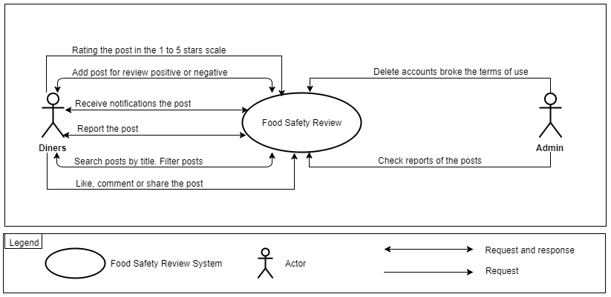

***Figure 1: Context diagram***

* **Admin** is the highest authority. Admin can login, logout, change password, maintain the system and use the system to allow lower levels, very important for with Food Safety Review management such as: check report of post, delete accounts.
* **Diners** is the person who can manage information such as: add new a post, receive notifications the post, report, search, like comment or share post. After the dinners completes the function of the system will process.

## Architecture Driver Specification

***Use Case Entities***

|  |  |
| --- | --- |
| ID | E01 |
| Title | Admin |
| Description | Admin who is the system administrator |
| Provides Assumptions | Admin is the management of all posts, accounts of system |
| Requires Assumptions | Already have an account |
| Identified Use Cases | UC02: Login, UC03: Logout, UC04: Change passwords, UC12: Delete post, UC16: Check the report of the post, UC17: Delete accounts |

|  |  |
| --- | --- |
| ID | E02 |
| Title | Diners |
| Description | Diners who are using system and interact with website |
| Provides Assumptions | Provide person information, manage their posts |
| Requires Assumptions | Already have an account |
| Identified Use Cases | UC01: Register, UC02: Login, UC03: Logout, UC04: Change passwords, UC05: Edit profile, UC06: Add post, UC07: Like, comment, share the post, UC08: Rating the post, UC09: Report the post, UC10: Receive notifications, UC11: Edit post, UC12: Delete post, UC13: View post's history, UC14: Search the post, UC15: Filter post |

***Operational Use Cases***

|  |  |
| --- | --- |
| ID | UC01 |
| Title | Register |
| Description | This is a register page for new user. |
| Entities Involved | E02: Diners |
| Preconditions | Internet connection |
| Primary Flow | 1. Diners access to address of “Food Safety Review” website  2. Diners sign in account and input, full name, password, gender, address, phone, email, and then click on [Register] button.  3. Account is successfully created when inputting correctly value on fields. |
| Postconditions |  |
| Alternate Flows | - In step 1 of the Primary Flow, if the user can’t connect internet: the system shows the error message and requires the internet connection.  - In step 2 of the Primary Flow, if one of fields is invalid then the system shows the error message.  - In step 3 of the Primary Flow, generate failure or success messages when processing. |
| ID | UC02 |
| Title | Login |
| Description | Click on Login to access into system by their account |
| Entities Involved | E01: Admin, E02: Diners |
| Preconditions | Internet connection |
| Primary Flow | 1. User clicks [Login] button on Bar menu to open login form.  2. User inputs data value on [Email or PhoneNumber] textbox and [Password] textbox.  3. User clicks on [Login] button.  4. System validates [Email or PhoneNumber] and password.  5. User visits on Home Page. |
| Postconditions |  |
| Alternate Flows | - In step 4 of the Primary Flow, if [Email or PhoneNumber] or password is incorrect.  1. The system will prompt user “input wrong email, phone number or password”.  2. User clicks ok to continue.  If [Email or PhoneNumber] and password are correct, continue to step 5. |

|  |  |
| --- | --- |
| ID | UC03 |
| Title | Logout |
| Description | Click on Logout to exit website |
| Entities Involved | E01: Admin, E02: Diners |
| Preconditions | Successfully logged in the website |
| Primary Flow | 1. User clicks [Logout] button on [Account Settings] menu bar.  2. System checks and closes account. Return Home Page. |
| Postconditions |  |
| Alternate Flows | In step 2 of the Primary Flow, if the system have a problem,it will show error messages. |

|  |  |
| --- | --- |
| ID | UC04 |
| Title | Change password |
| Description | Click on change password on menu of website |
| Entities Involved | E01: Admin, E02: Diners |
| Preconditions | Successfully logged in the website |
| Primary Flow | 1. User clicks [Change Password] button on [Account Settings] menu bar.  2. System checks and returns Change Password Page.  3. User inputs into [Old Password], [New password], and [Repeat New Password] field.  4. Click [Save Change] button. |
| Postconditions |  |
| Alternate Flows | - In step 3 of the Primary Flow, if one of fields is invalid then the system shows the error messages.  - In step 4 of the Primary Flow, if the system have a problem,it will show error messages. |

|  |  |
| --- | --- |
| ID | UC05 |
| Title | Edit profile |
| Description | Click on Edit Profile to modify information of account |
| Entities Involved | E02: Diners |
| Preconditions | Successfully logged in the website |
| Primary Flow | 1. Diners click on [My Profile] button on [Account Settings] menu bar. System goes to My Profile form.  2. Diners click [Edit Profile] button.  3. Diners enter the data value on relevant field to edit.  4. Diners click [Save Change] button. |
| Postconditions |  |
| Alternate Flows | - In step 3 of the Primary Flow, if one of fields is invalid then the system show the error messages.  - In step 4 of the Primary Flow, if the system have a problem,it will show error messages. |

|  |  |
| --- | --- |
| ID | UC06 |
| Title | Add post |
| Description |  |
| Entities Involved | E02: Diners |
| Preconditions | Successfully logged in the website |
| Primary Flow | 1. Diners enter correctly the data value on relevant field such as [Title], [Description], [Image], and [Location].  2. Diners click on [Post] button. |
| Postconditions |  |
| Alternate Flows | - In step 1 of the Primary Flow, if one of fields is invalid then the system show the error messages.  - In step 2 of the Primary Flow, if the system have a problem,it will show error messages. |

|  |  |
| --- | --- |
| ID | UC07 |
| Title | Like, comment, share the post |
| Description | Click on Like button, enter text, and click share button on post |
| Entities Involved | E02: Diners |
| Preconditions | Successfully logged in the website |
| Primary Flow | 1. Diners click on [Like] button. The [Like] button will turn blue  2. Diners enter a comment on comment area then press enter or click [Send] button. The system will show this comment under the post.  3. Diners clicki on [Share] button. The system shows share form, the enter data value on [Description] or not. Click on [Post Share]. |
| Postconditions |  |
| Alternate Flows | - In step 1 of the Primary Flow, if before Diners have click [Like] button then the post showing "Like".  - In step 2,3 of the Primary Flow, if the system have a problem,it will show error messages. |

|  |  |
| --- | --- |
| ID | UC08 |
| Title | Rating the post |
| Description | Select the rating star for the post |
| Entities Involved | E02: Diners |
| Preconditions | Successfully logged in the website |
| Primary Flow | 1. Diners click on [Rate] button. Select 1 to 5 stars number for rating. |
| Postconditions |  |
| Alternate Flows |  |

|  |  |
| --- | --- |
| ID | UC09 |
| Title | Report the post |
| Description | Diners report the post which are impolite and violent |
| Entities Involved | E02: Diners |
| Preconditions | Successfully logged in the website |
| Primary Flow | 1. Diners clicking on [Report] button.  2. System shows the message “Do you want to report this post? Yes or No”  2.1. If Diners want to report, user clicks “Yes” button in the message.  Diners enter data value on [Description].  2.2. If Diners don’t want to report, click “No” in the message of the FSR Website |
| Postconditions |  |
| Alternate Flows |  |
| ID | UC10 |
| Title | Receive notifications |
| Description | Diners receive notifications of the activity’s post chose |
| Entities Involved | E02: Diners |
| Preconditions | Successfully logged in the website |
| Primary Flow | 1. Diners click on [Receive notifications] button on dropdown menu in the post  2. The system shows message "Successfully receive notifications" |
| Postconditions |  |
| Alternate Flows |  |

|  |  |
| --- | --- |
| ID | UC11 |
| Title | Edit post |
| Description | Diners edit their post |
| Entities Involved | E02: Diners |
| Preconditions | Successfully added new post in the website |
| Primary Flow | 1. Diners click on [Edit] button.  2. Diners enter data value on relevant field.  3. Diners click on [Save Change] button. The system shows message "Save change successful". |
| Postconditions |  |
| Alternate Flows | In step 3 of the Primary Flow, if the system have a problem then show error messages “Save change failed and reload this page. |

|  |  |
| --- | --- |
| ID | UC12 |
| Title | Delete post |
| Description | Diners delete their post |
| Entities Involved | E02: Diners |
| Preconditions | Successfully added the post in the website |
| Primary Flow | 1. Diners click [Delete] button on scroll menu on the post  2. System shows messages “Do you want to delete this post? Yes or No”  2.1 If Diners want to delete, user clicks “Yes” button in the message  2.2 If Diners don’t want to delete, user clicks “No” in the message of the FSR Website |
| Postconditions |  |
| Alternate Flows |  |

|  |  |
| --- | --- |
| ID | UC13 |
| Title | View post's history |
| Description | Diners see their posts to manage posts |
| Entities Involved | E02: Diners |
| Preconditions | Successfully logged in the website |
| Primary Flow | 1. Diners click on [View Post's History] button on menu bar.  2. Website checks and returns the list of posts that Diners have posted. |
| Postconditions |  |
| Alternate Flows | In step 3 of the Primary Flow,website will return the list of empty if Diners haven’t added new post yet |

|  |  |
| --- | --- |
| ID | UC14 |
| Title | Search the post by title |
| Description | Diners enter title to search the post which user want to see |
| Entities Involved | E02: Diners |
| Preconditions | Successfully logged in the website |
| Primary Flow | 1. Diners enter post’s title on Search box.  2. Diners press enter or click on the suggestion list of the title under Search box.  3. System checks and returns the post with the same this title. |
| Postconditions |  |
| Alternate Flows | In step 3 of the Primary Flow, system showing a message failure if it did not find the post matching the input |

|  |  |
| --- | --- |
| ID | UC15 |
| Title | Filter post |
| Description | Diners filter post by title, location, and post type |
| Entities Involved | E02: Diners |
| Preconditions | Successfully logged in the website |
| Primary Flow | 1. Diners click on [Filter] button.  2. Diners select location, post type, and title to filter  3. Diners clicks on [Apply Filter] button.  4. System checks and returns the list of posts matching the properties in the filter. |
| Postconditions |  |
| Alternate Flows | In step 4 of the Primary Flow, system shows a message failure if it did not find the post matching the properties in the filter. |

|  |  |
| --- | --- |
| ID | UC16 |
| Title | Check the report of the post |
| Description | Admin checks post that users reported |
| Entities Involved | E01: Admin |
| Preconditions | Successfully logged in the website as an admin |
| Primary Flow | 1. Admin clicks on [List of Reports].  2. System checks and returns the list of reports with information such as: report content, post was reported,the name of account has added this post.  3. Admin clicks on [Post Detail] button. System shows the detail information of this post. |
| Postconditions |  |
| Alternate Flows |  |

|  |  |
| --- | --- |
| ID | UC17 |
| Title | Delete accounts |
| Description | Admin deletes the accounts breaking the Term of website |
| Entities Involved | E01: Admin |
| Preconditions | Successfully logged in the website as an admin |
| Primary Flow | 1. Admin clicks on [List of break the Term].  2. System checks and returns the list of account with information such as: name of account, the times break the Terms of use.  3. Admin clicks on [Delete] an account in this list.  4. System show messages “Do you want to delete this account? Yes or No”  4.1 If Diners want to delete, user clicks “Yes” button in the message.  4.2 If Diners don’t want to delete, click “No” in the message of the FSR Website |
| Postconditions |  |
| Alternate Flows |  |

## Quality Attributes

***Table 3: Quality Attribute: Usability***

|  |  |
| --- | --- |
| **Quality attributes: Usability** | **ID:** QA01 |
| **Stimulus** | User adding new post |
| **Source(s) of the stimulus** | User |
| **Relevant environment** | Runtime |
| **Architectural elements** | Website |
| **System response** | System adds new post in the website after user added |
| **Response measure(s)** | The post is added within 5 seconds after adding by user. |

***Table 4: Quality Attribute: Performance***

|  |  |
| --- | --- |
| **Quality attributes:** Performance | **ID:** QA02 |
| **Stimulus** | Users want to get the notifications of their posts. |
| **Source(s) of the stimulus** | Users |
| **Relevant environment** | Runtime |
| **Architectural elements** | Website |
| **System response** | User can receive the notifications from Food Safety Review website |
| **Response measure(s)** | Users should take less than 3s to receive notifications from Food Safety Review after appearing new effect of their posts. |

***Table 5: Quality Attributes: Security***

|  |  |
| --- | --- |
| **Quality Attributes:** Security | **ID:** QA03 |
| **Stimulus** | Users don't want to unauthorized disclosure of information. |
| **Source(s) of The Stimulus** | System. |
| **Relevant Environment** | The system is on-line, connected to a network. |
| **Architectural Elements** | System Database, Server. |
| **System Response** |  |
| **Response Measure(s)** |  |

1. **Constraints**
   1. **Business Constraint**

* Project will be started on: 09 – Aug – 2017.
* Project will be finished on: 05 – Dec – 2017.
* Project will be finished in 119 days (812 hours).
  1. **Technical Constraint**
* Technical for Development

Technology: C#, .NET, JavaScript Languages.

* Environment:
  + Operating system: Computer OS, any device used Web Browser.
  + Develop tools: Visual Studio.
  + Source version control: Git.
  + Database: Microsoft SQL Server 2016.
  + Internet Connection.

1. **High level architecture**
   1. **Component and Connector view (C&C view)**

The diagram below shows the overview architecture including component and other related component. We have representations and behaviors for important components in the following sections.

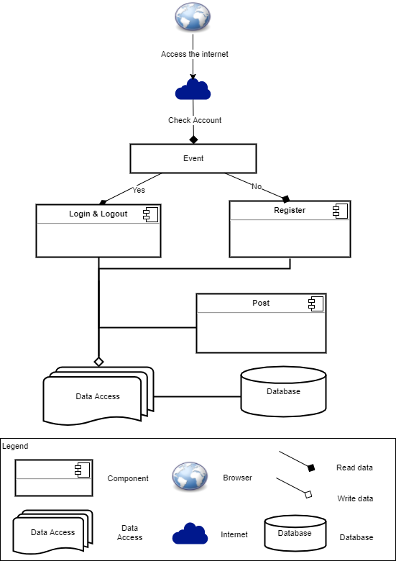

***Figure 2: C&C view***

* **Prose:**
  + User will use web browser and requires internet connection to access to system. One user accessed to system, the front-end interface will be displayed. With these front-end interfaces, user can go around the entire of the website. They can know which functions are on system easily. They will have a panoramic picture of some of the main functions of the system. From that, database from server can be transacted to users by back-end working.
  + The website is authorized to access the database through data access.
  1. **Module view**

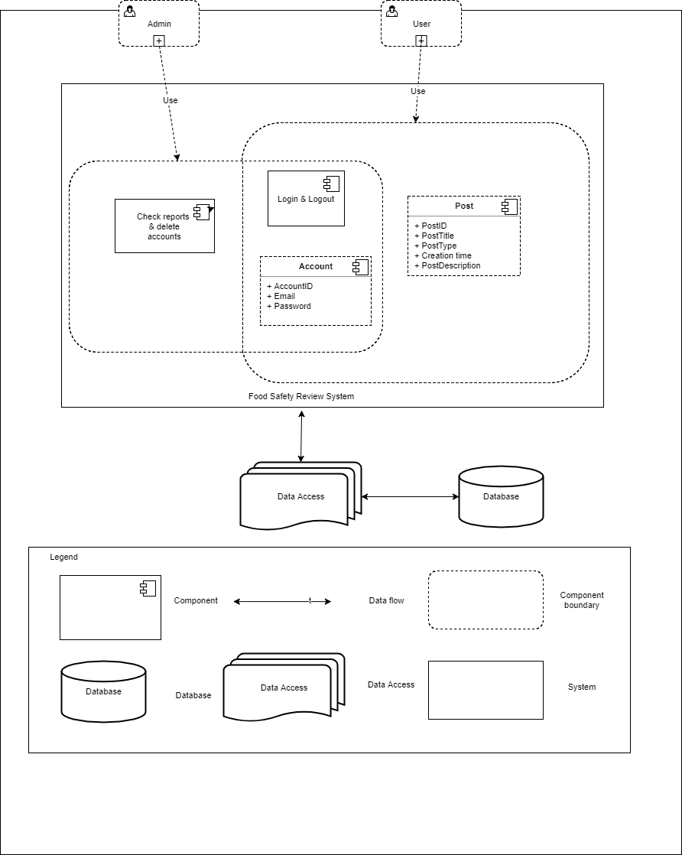

***Figure 3: Module view***

* **Prose:**

These modules have relationship and interact each other to create this KMS system, module Login determines the functionality of users, after logging in successfully, it will be directed to the modules that users have permission to access. The functionality interacting each other, relationship will be defined by arrows.

* 1. **Allocation view**

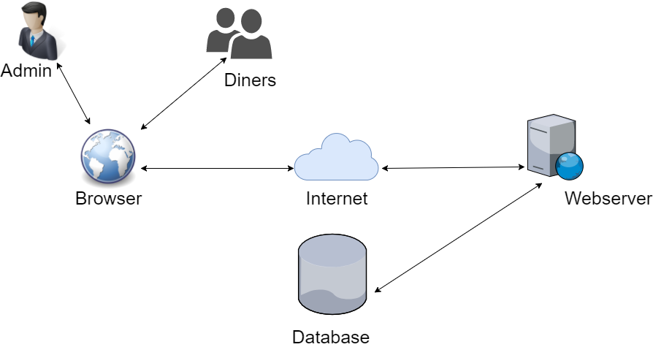

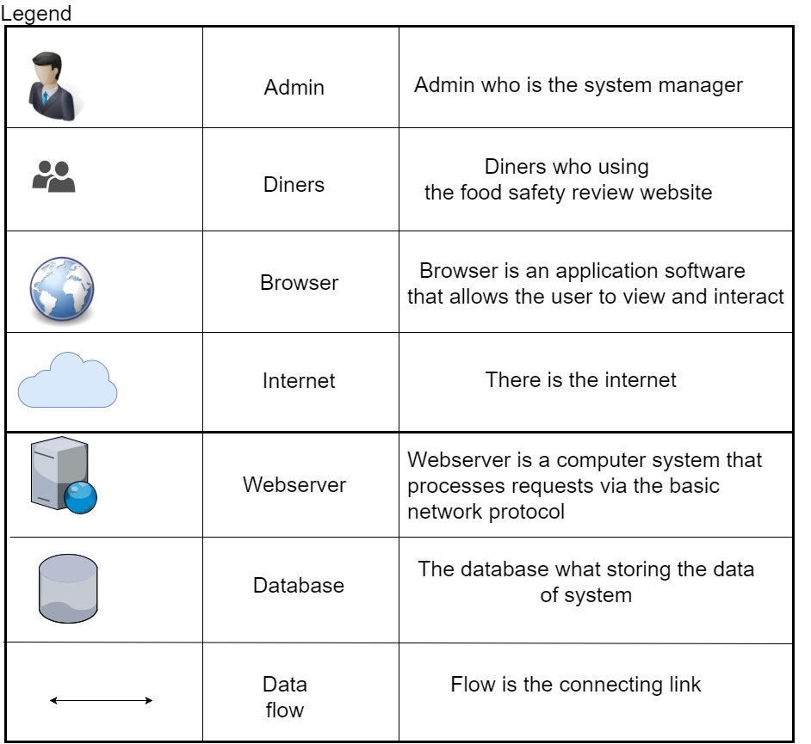

***Figure 4: Allocation view***

* **Prose:**

User will use web browser (Chrome, Firefox, Opera, Safari, ...) to can access to the system. It required have internet network if you use external link. Once you did access to the website, the Asp.net environment will be processed handle to interact database between user and system. Any transaction between user and system will be implemented on Microsoft SQL Server.