**International School, Duy Tan University**



CAPSTONE PROJECT 1

Grace Coffee Management

**ARCHITECTURE DESIGN DOCUMENT**

Version 1.0

05/11/2018

**Mentor: MSc. Nguyen Minh Nhat**

**Group Name: Hasagi Team**

**Project Information**

|  |  |
| --- | --- |
| Project Title | Grace Coffee Management (GCM) |
| Start Date – End Date | 20/09/2018 to 1/12/2018 |
| Lead Institution | International School, Duy Tan University |
| Project Mentor | Msc Nguyen Minh Nhat |
| Project Manager & Contact detail | Project Leader, Pham Tan Anh Khoa  K21CMUTPM2, International School, Duy Tan University  Mail: [phamanhkhoa0@gmail.com](mailto:phamanhkhoa0@gmail.com)  Tel: +84 1886240924 |
| Team member | Nguyen Quoc Bao – Email: [nguyenquocbao19182@gmail.com](mailto:nguyenquocbao19182@gmail.com)  Vo Ngoc Tin - Email: [tin.vongoc.54@gmail.com](mailto:tin.vongoc.54@gmail.com)  Tran Anh Tai - Email: [iitaitran57696@gmail.com](mailto:iitaitran57696@gmail.com) |

**Document Information**

|  |  |
| --- | --- |
| Project | Grace Coffee Management |
| Document Title | Architecture Design Document |
| Creator | Nguyen Quoc Bao |

**Revision History**

|  |  |  |  |
| --- | --- | --- | --- |
| Version | Person | Date | Description |
| 1.0 | Nguyen Quoc Bao | 01-Nov - 2018 | Offical |

**Document Approval**

The following signatures are required for approval of this document

**Prepared by**

Pham Tan Anh Khoa Date

*Team Leader*

**CONTENTS**

**1. Introduction 6**

1.1. Purpose 6

1.2. Documents Referenced 6

**2. Project Statement 6**

2.1. Project Overview 6

2.2. Business Driver 6

2.2.1. Business Problems 6

2.2.2. Business Need 6

2.3. Project Goals 7

**3. Architecture Drivers 7**

3.1. High-Level Requirements 7

3.2. System Context 7

3.3. Sequence diagram 8

3.4. Quality Attributes 14

**4. Constraints 15**

4.1. Business Constraint 15

4.2. Technical Constraint 15

**5. High level architecture 16**

5.1. Component and Connector view (C&C view) 16

5.2. Module view 17

5.3. Allocation view 18

1. **Introduction**
   1. **Purpose**

This specification covers following:

* Brief specification of the project, high level requirement, system context for the system.
* Use case diagram, detail quality attribution.
* Architecture presented by various architecture view types: Component and Connect tor view, Module view, Allocation view.
  1. **Documents Referenced**

***Table 1: Document Reference***

|  |  |
| --- | --- |
| **No** | **References** |
| **1** | Proposal |
| **2** | ProjectPlan |
| **3** | SrS |

1. **Project Statement**
   1. **Project Overview**

* Project name: **Grace Coffee Management**
* Development team:

***Table 2: Development team***

|  |  |
| --- | --- |
| **Full name** | **Position** |
| Phan Tan Anh Khoa | Leader |
| Nguyen Quoc Bao | Team Member |
| Vo Ngoc Tin | Team Member |
| Tran Anh Tai | Team Member |

* 1. **Business Driver**
     1. **Business Problems**

In today's rapidly evolving technology, the application of technology to business is extremely necessary, typically as in management, which will no longer have to be managed manually as before, the technology will do all of that with great accuracy.

Grace coffee grasped that, and with the desire to expand its business model, they would apply technology to their business systems.

On the market, there are many cafe management software examples: Vi-RES, posApp…, but they are not highly customizable or they are not fit with Grace Coffee services and idea.

* + 1. **Business Need**

With the current situation, business needs:

* A website that can advertises about their product, their coffee shop and new events.
* A website that can allow user to order online.
* A website has Facebook Messenger Chat so that users can review or ask some question
* An application allows you to manage order, menu.
* An application allows you to manage inventory, it can notice material which are running out.
* An application can be integrated with website to synchronized data.
* Can be connected to bill printer.
  1. **Project Goals**
  + With the hustle lifestyle, crowded as nowadays . If you want to take some cup of coffee or tea, but you dont have time or dont want to go out.
* Grace Coffee shop developed an Website have functions help people order drink online.
* Special, Grace Coffee will support door-to-door delivery service for you to order Drink. We believe that users will be satisfied.
* It helps in better planning and management of resources as per the requirements of the Shop.
* Better work flow and improved efficiency are some of the important benefits of using system.
* It increases the quality of services, shortens delivery times and enhances the performance rate offered by companies.
* It helps in better planning and coordination of business resources so as to achieve maximum profit.

1. **Architecture Drivers**
   1. **High-Level Requirements**
   2. **System Context**

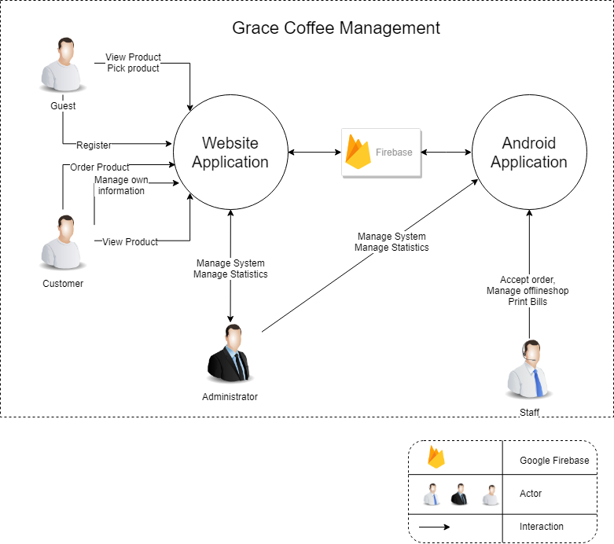

***Figure 1: Context Diagram***

* **Admin** is the highest authority. Admin can login, logout, change password, maintain the system and use the system to allow lower levels, very important for with Food Safety Review management such as: check report of post, delete accounts.
* **Customer** is the person who can manage information such as: add new a post, receive notifications the post, report, search, like comment or share post. After the dinners completes the function of the system will process.
* **Staff** is the person who can manage information such as: add new a post, receive notifications the post, report, search, like comment or share post. After the dinners completes the function of the system will process.

## Sequence Diagram

**Sequence diagram Register**

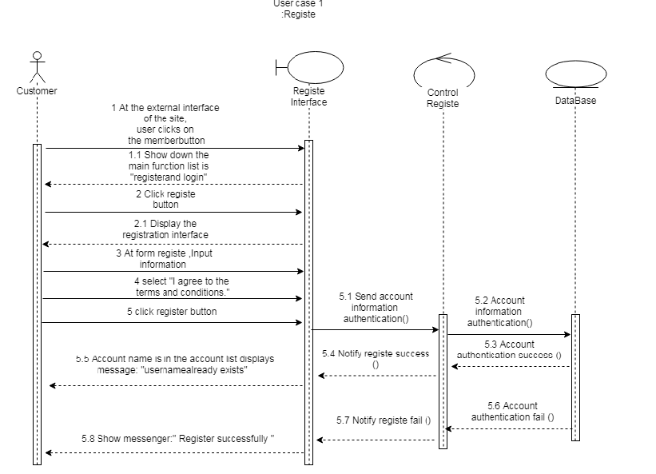

**Sequence diagram Login member**

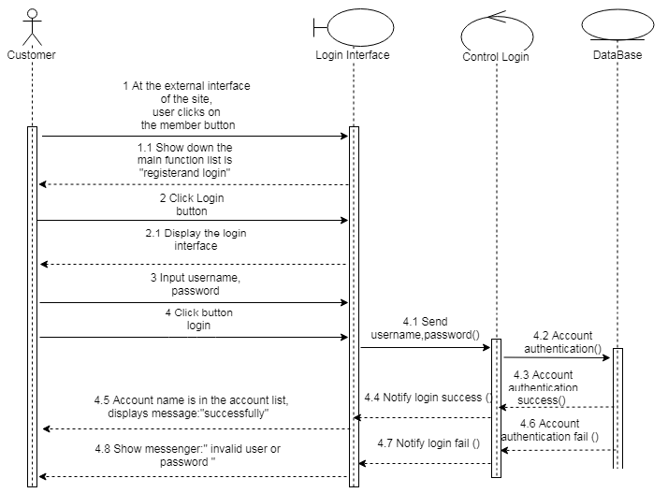

## Sequence diagram login staff (Android app)

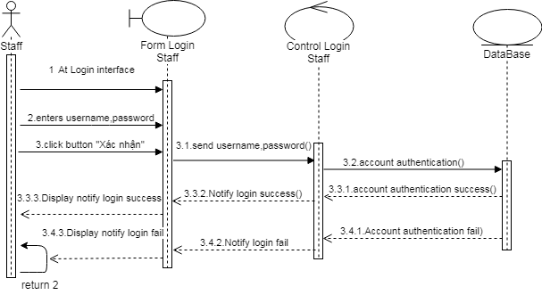

## Sequence diagram order for customer (Android app)

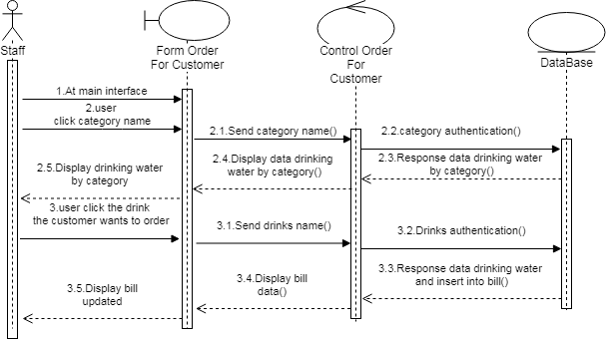

## Sequence diagram view order online (Android app)

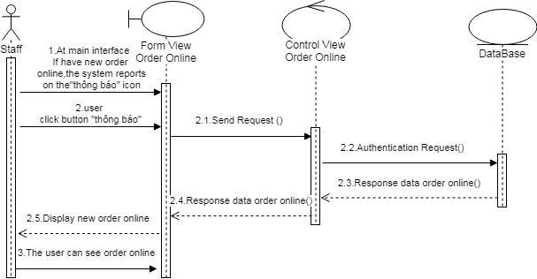

## Sequence diagram insert table (Android app)

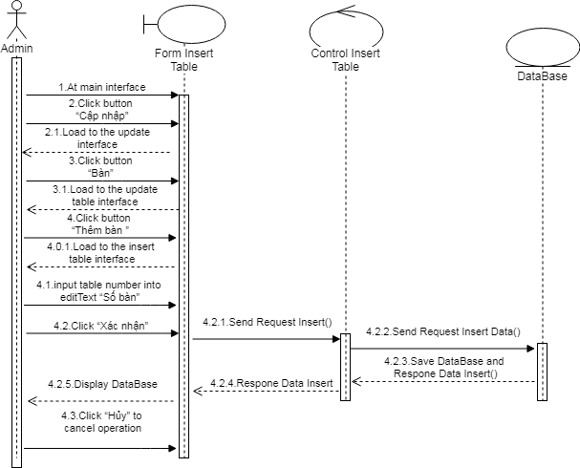

**Sequence diagram update table (Android app)**

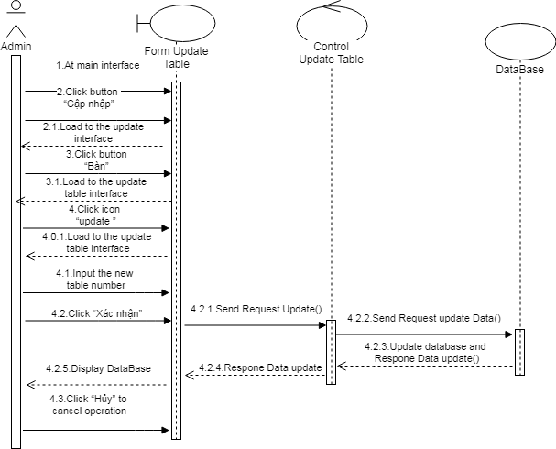

**Sequence diagram delete table (Android app)**

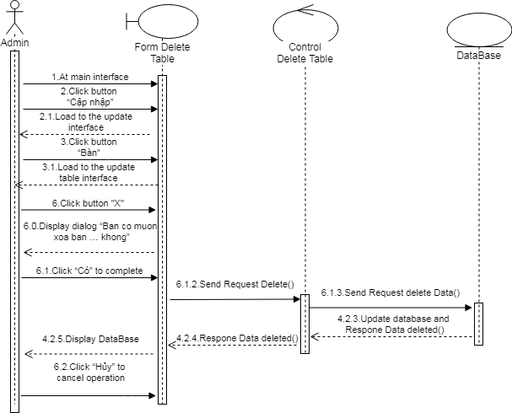

**Sequence diagram insert employee (Android app)**

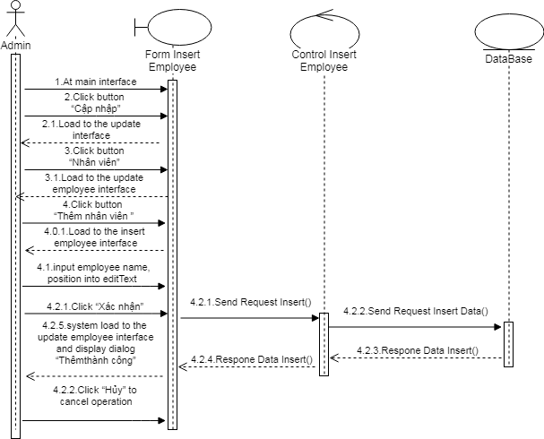

**Sequence diagram update employee (Android app)**

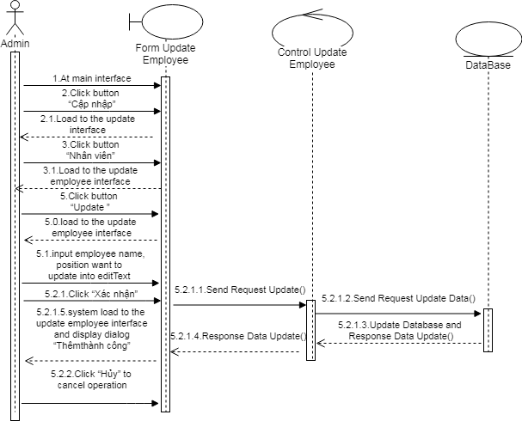

**Sequence diagram delete employee (Android app)**

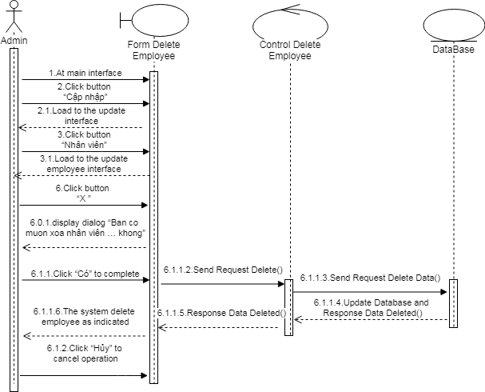

**Sequence diagram insert menu (Android app)**

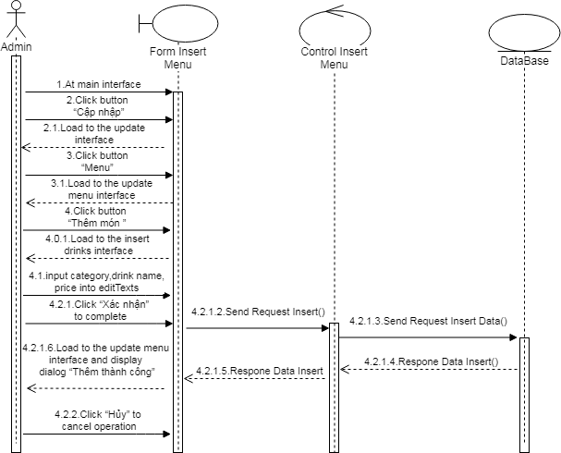

**Sequence diagram update menu(Android app)**

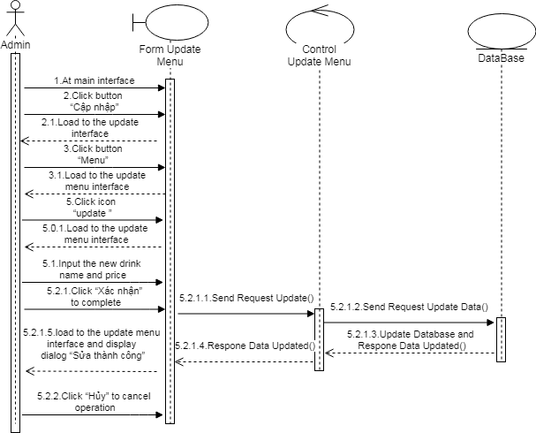

**Sequence diagram delete menu (Android app)**

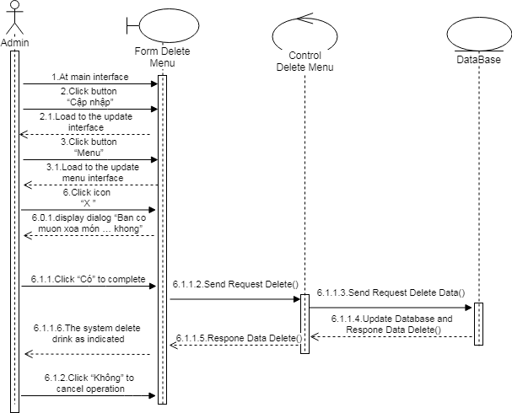

**Sequence diagram view bill history (Android app)**

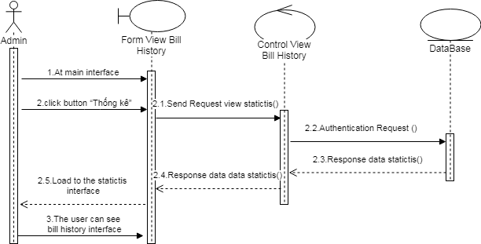

## Quality Attributes

***Table 3: Quality Attribute: Usability***

|  |  |
| --- | --- |
| **Quality attributes: Usability** | **ID:** QA01 |
| **Stimulus** | User view information product , bill , event |
| **Source(s) of the stimulus** | User |
| **Relevant environment** | Runtime |
| **Architectural elements** | Website |
| **System response** | The system will display information on the website after clicking on the button |
| **Response measure(s)** | The information is displayed for 4 seconds after the user clicks the button |

|  |  |
| --- | --- |
| **Quality attributes: Usability** | **ID:** QA02 |
| **Stimulus** | User paid products |
| **Source(s) of the stimulus** | User |
| **Relevant environment** | Runtime |
| **Architectural elements** | Website and application |
| **System response** | The system will announce payment results after the user clicks on the payment button |
| **Response measure(s)** | The system will announce payment results in 3 seconds |

|  |  |
| --- | --- |
| **Quality attributes: Usability** | **ID:** QA03 |
| **Stimulus** | User wants to change personal information |
| **Source(s) of the stimulus** | User |
| **Relevant environment** | Runtime |
| **Architectural elements** | Website |
| **System response** | The system will respond after the user changes the information |
| **Response measure(s)** | The system will respond within 3 seconds after processing the change request from the user. |

***Table 4: Quality Attribute: Performance***

|  |  |
| --- | --- |
| **Quality attributes:** Performance | **ID:** QA04 |
| **Stimulus** | Users want to get the notifications of order |
| **Source(s) of the stimulus** | Users |
| **Relevant environment** | Runtime |
| **Architectural elements** | Website |
| **System response** | User can receive the notifications from Grace Coffe website |
| **Response measure(s)** | Users should take less than 3s to receive notifications from order product after order from website |

|  |  |
| --- | --- |
| **Quality attributes:** Performance | **ID:** QA05 |
| **Stimulus** | Users want to receive information of system Grace Coffee |
| **Source(s) of the stimulus** | Users |
| **Relevant environment** | Runtime |
| **Architectural elements** | App |
| **System response** | Users to receive information of system Grace Coffee after click button |
| **Response measure(s)** | Users will wait for three seconds to receive information of system Grace Coffee |

***Table 5: Quality Attributes: Security***

|  |  |
| --- | --- |
| **Quality Attributes:** Security | **ID:** QA06 |
| **Stimulus** | Users don't want to unauthorized disclosure of information. |
| **Source(s) of The Stimulus** | System. |
| **Relevant Environment** | The system is on-line, connected to a network. |
| **Architectural Elements** | System Database, Server. |
| **System Response** |  |
| **Response Measure(s)** |  |

1. **Constraints**
   1. **Business Constraint**

* Project will be started on: 20 – Sep – 2018.
* Project will be finished on: 05 – Dec – 2018.
  1. **Technical Constraint**
* Technical for Development

Technology: PHP, Javascript, Java.

* Environment:
  + Operating system: Windows, Android.
  + Develop tools: Android Studio, Visual studio code.
  + Source version control: Bitbutcket.
  + Database: Mysql MariaDB.
  + Internet Connection.

1. **High level architecture**
   1. **Component and Connector view (C&C view)**

The diagram below shows the overview architecture including component and other related component. We have representations and behaviors for important components in the following sections.

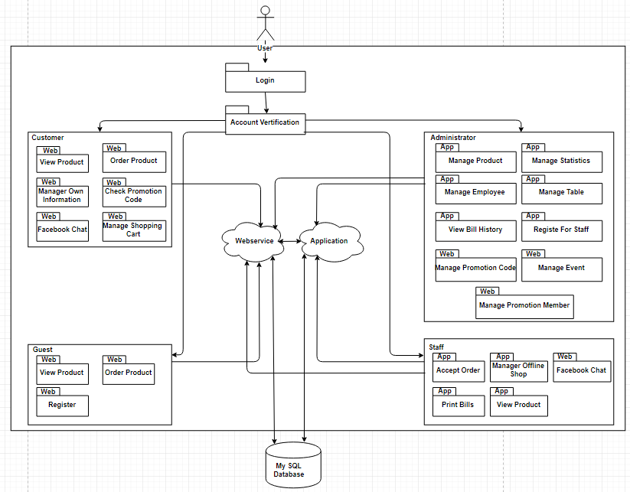

***Figure 2: C&C view***

* **Prose:**
  + User will use web browser and requires internet connection to access to system. One user accessed to system, the front-end interface will be displayed. With these front-end interfaces, user can go around the entire of the website. They can know which functions are on system easily. They will have a panoramic picture of some of the main functions of the system. From that, database from server can be transacted to users by back-end working.
  + The website is authorized to access the database through data access.
  1. **Module view**

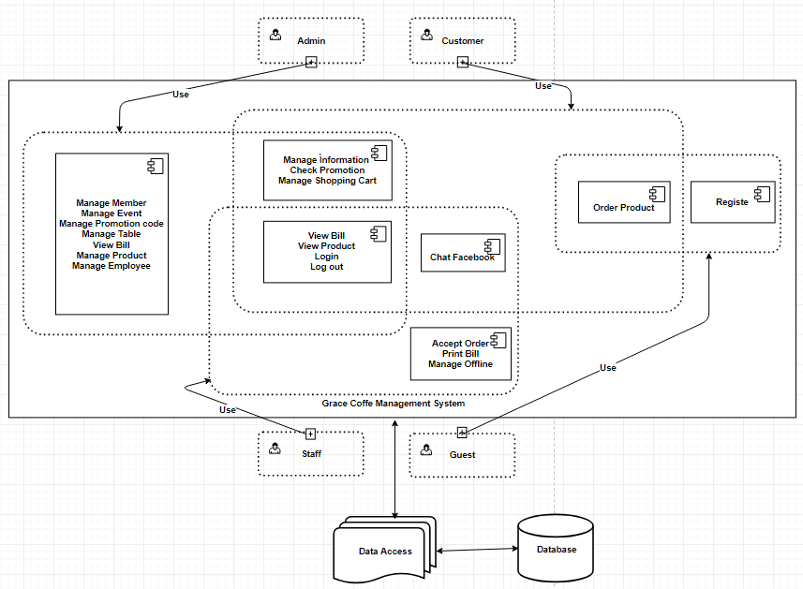

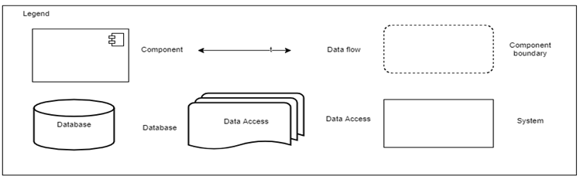

***Figure 3: Module view***

* **Prose:**

These modules have relationship and interact each other to create this system, module Login determines the functionality of users, after logging in successfully, it will be directed to the modules that users have permission to access. The functionality interacting each other, relationship will be defined by arrows.

* 1. **Allocation view**

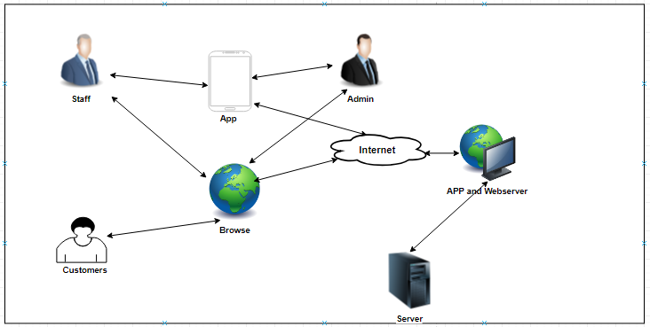

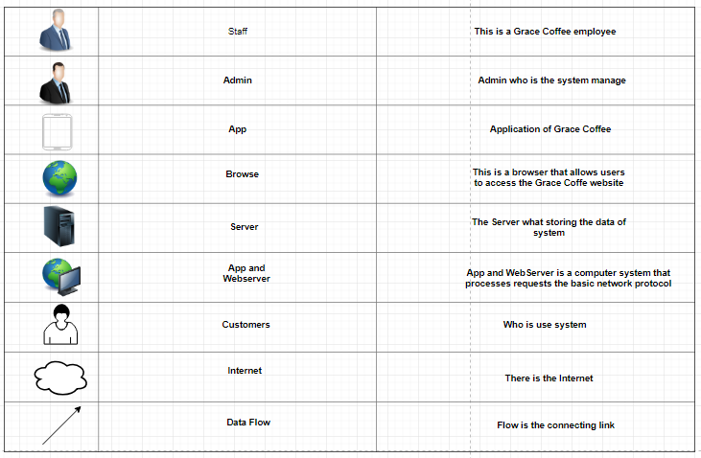

***Figure 4: Allocation view***

* **Prose:**

User will use web browser (Chrome, Firefox, Opera, Safari, etc) to can access to the system. It required have Internet network if you use external link. Once you did access to the website, the PHP environment will be processed handle to interact database between user and system. Any transaction between user and system will be implemented on Microsoft SQL Server.