**International School, Duy Tan University**

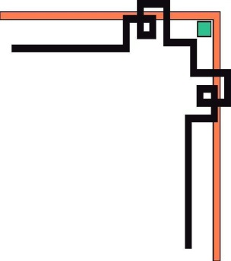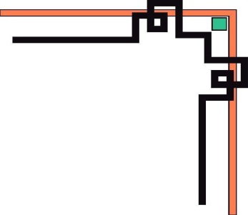

***Capstone Project 1***

**INTERFACE DESIGN DOCUMENT**

Applying AI in Controlling Mini Garden

Version 1.1

September 10, 2018

***Mentor: Ms. Thuy Trinh Tran Thi***

***Member: Minh Thai Le***

***Hung Cuong Phan***

***Xuan Tai Cao***

***Dieu Linh Vo Thi***

***Truong Thinh Ngo***

|  |  |  |  |  |  |
| --- | --- | --- | --- | --- | --- |
| **PROJECT INFORMATION** | | | | | |
| **Project Tittle** | Applying AI in Controlling Mini Garden | | | | |
| **Start Date** | August 15, 2018 | **End Date** | December 10, 2018 | | |
| **Lead Institution** | International School, Duy Tan University | | | | |
| **Project Mentor** | Ms. Thuy Trinh Tran Thi | | | thuytrinh85@gmail.com | |
| **Partner Organization** |  | | | | |
| **Team Member** | Minh Thai Le | leminhthai1@gmail.com | | | 01649237675 |
| Dieu Linh Vo Thi | linhlinhvo2310@gmail.com | | | 0967051711 |
| Xuan Tai Cao | anhtaipro2kt@gmail.com | | | 0989485150 |
| Hung Cuong Phan | phancuong437@gmail.com | | | 0966012440 |
| Truong Thinh Ngo | ngotruongthinh4@gmail.com | | | 0905799695 |

|  |  |  |  |
| --- | --- | --- | --- |
| **DOCUMENT NAME** | | | |
| **Document Title** | Interface Design Document v1.1 | | |
| **Author & Project** | Team | | |
| **Date** | September 10, 2018 | Filename | Proposal v1.1 |

|  |  |  |
| --- | --- | --- |
| **DOCUMENT HISTORY** | | |
| **Version** | Date | Comment |
| **v1.0** | October 10, 2018 |  |

**Document Approvals:** The following signatures are required for approval of this document. Note, however, that since some role assignments will change during the course of the project, the perspective names should be update if needed.

|  |  |  |  |  |
| --- | --- | --- | --- | --- |
| **No.** | **Full Name** | **Role** | **Date** | **Signature** |
| 1 | Ms. Thuy Trinh Tran Thi | Mentor |  |  |
| 2 | Minh Thai Le | Leader |  |  |
| 3 | Dieu Linh Vo Thi | Member |  |  |
| 4 | Xuan Tai Cao | Member |  |  |
| 5 | Hung Cuong Phan | Member |  |  |
| 6 | Truong Thinh Ngo | Member |  |  |

1. **Introduction**
   1. **Purpose**

* This document describes the design “Interface of Applying AI in Controlling Mini Garden”.
  1. **Scope**
* Overview of the stages and modules of the software.
* Create complete interfaces and describe them clearly.

1. **List of User Interface Designs**

|  |  |  |
| --- | --- | --- |
| User Interface ID | UI Name | Description |
| UI – 01 | Login | This will display form Login |
| UI – 02 | Home Page | This will display information of the plants as the humidity, the current temperature. Displays the date, time, mode, etc. |
| UI – 03 | Custom System Page | This will displaying custom items of system equipment such as turning on the pump, turning on lights, etc. |
| UI – 04 | Admin Page | This will display form about user management and plant management. Allows admin to edit it. |

1. **UI – 01: Login Page**

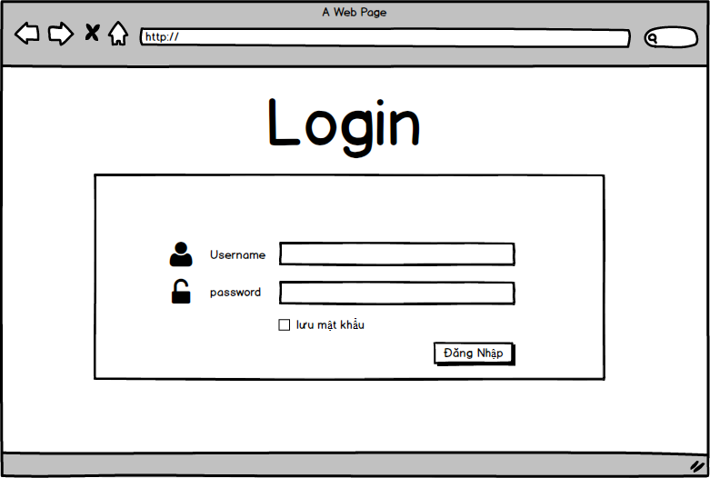

**Picture 1. Login (Demo Interface)**

1. **UI – 02: Home Page**

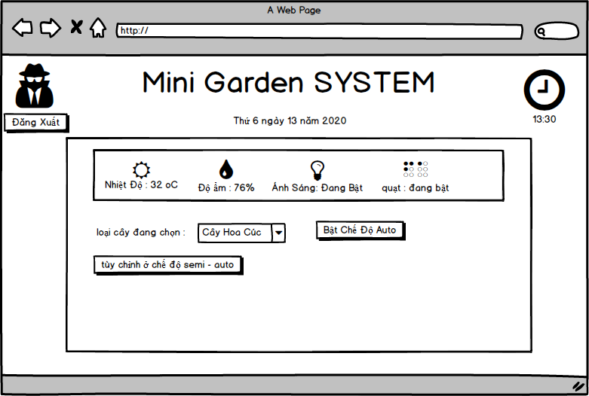

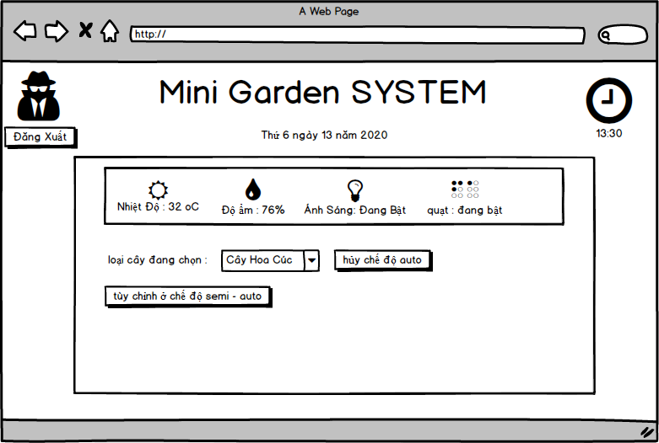

**Picture 2. Home Page (Demo Interface)**

1. **UI – 03: Custom System Page**

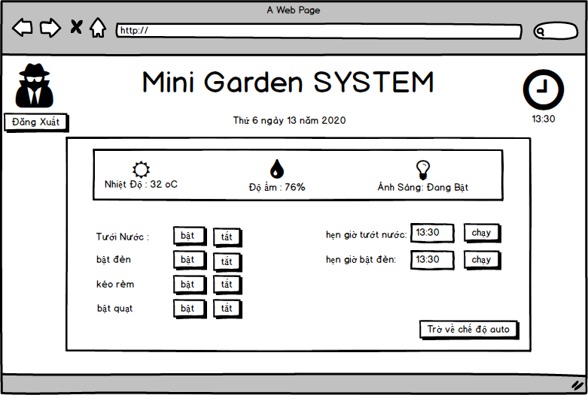

**Picture 3. Custom System Page (Demo Interface)**

1. **UI – 04: Admin Page**

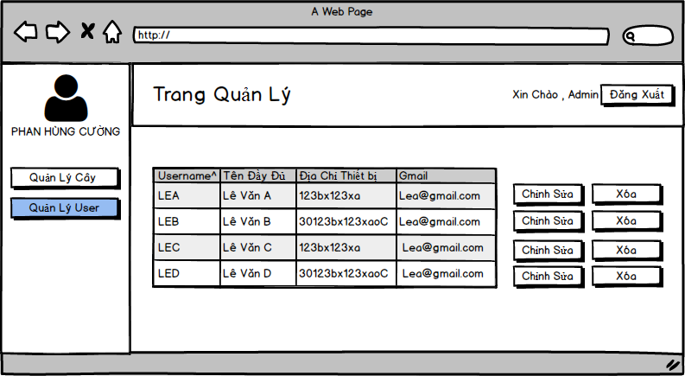

**Picture 4.1 Manage User Page (Demo Interface)**

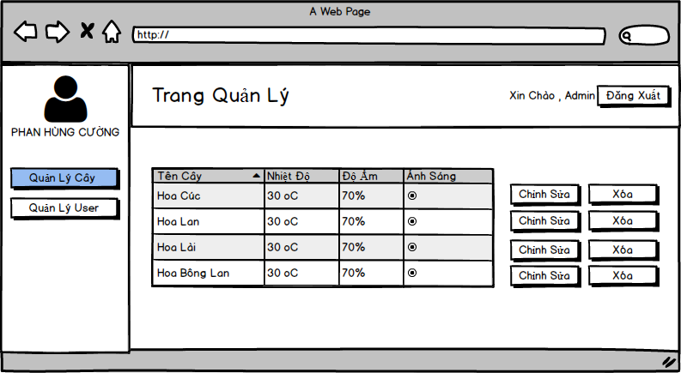

**Picture 4.2 Manage Plant Page (Demo Interface)**