**International School, Duy Tan University**



CAPSTONE PROJECT 1

Grace Coffee Management

**Software Requirements**

**Specification Document**

Version 1.0

09/10/2018

**Mentor: MSc. Nguyen Minh Nhat**

**Group Name: Hasagi Team**

**Document Information**

|  |  |
| --- | --- |
| Project | Grace Coffee |
| Document Title | Software Requirement Specification Document |
| Creator | Pham Tan Anh Khoa  Nguyen Quoc Bao  Vo Ngoc Tin  Tai |

**Revision History**

|  |  |  |  |
| --- | --- | --- | --- |
| Version | Person | Date | Description |
| 1.0 | Pham Tan Anh Khoa | 09-10-2018 | Release |
| 1.1 | Nguyen Quoc Bao | 11-06-2018 | Release |

**Document Approval**

The following signatures are required for approval of this document

**Prepared by**

Pham Tan Anh Khoa Date

*Team Leader 09/10/2018*

Contents

1. INTRODUCTION 2

1.1. Purpose 2

1.2. The Rules Of The Document 2

1.3. DOCUMENT READER GUIDANCE 2

1.4. RANGE OF SOFTWARE PRODUCT 3

1.5. REFERENCE 3

2. BACKGROUND 4

2.1. THE CONTEXT OF SOFTWARE PRODUCTS 4

2.2. FUNCTION 4

2.3. THE CLASS AND CHARACTER OF USER 6

2.4. OPERATING ENVIRONMENT 6

2.5. CONSTRAIN DESGIGN AND EXECUTE 6

2.6. Assumptions and dependencies 6

3. Requirements interface out 7

Context Diagram 7

4. Software Fuatures 8

UseCase Diagram 8

4.1. User’s interface 26

4.2. Hardware’s interface 26

4.3. Software’s interface 24

4.4. Communication’s interface 27

5. Non-functional requirements other 27

5.1. Performance Requirements 27

5.2. Safety Requirements 27

5.3. Security Requirements 27

5.4. The properties of the product quality 27

5.5. User Documentation 27

6. Other Riquirements 24

1. **INTRODUCTION**
   1. **PURPOSE**

This document describes the functional and nonfunctional of Grace Coffee Management System version 1.1. This document is for the stakeholders and the development team of the system

* 1. **THE RULES OF THE DOCUMENT**

Here are the conventions and abbreviations used in this document and project.

Table 1.1 Conventions and abbreviations

|  |  |  |  |
| --- | --- | --- | --- |
| No | The term, acronym | Explain |  |
| 1 | Display | is used for communication, interaction between system and users through different means: Web, app on Android, |  |
| 2 | User | The app users. example: everyone have a device with internet connection and browser |  |
| 3 | Use-Case | Describe how the function work |  |

* 1. **DOCUMENT READER GUIDANCE**

The object reference this description include:

* The development team
* Project Management
* Stakeholders:

Table 1.2 Role and skill of Team

|  |  |  |
| --- | --- | --- |
| Stakeholder | Role | Skill |
| Project Management | The entire project management, costing, time and resources | Management, Sales, Engineering |
| Testers | Testing, product testing in accordance with requirements and wishes of customers | Engineering |
| The developers | Using the programming language to build products | Engineering, Coder |
| The designer | Product design: the interface, the architecture, database, graphic... | Engineering |

* The description will be reviewed regularly by the object on to examine project through requirements.
* Any change in requirements will also be updated in this description.
  1. **Range of Software Product**

This system was designed with the aim of bring feelings of confidence and encourage customers to make order coffee. A successful online ordering website will greatly contribute to increasing sales.

* 1. **Reference**
* Specification
* Vision and Scope Document
* Documentation Use-case

1. **BACKGROUND**
   1. **The Context Of Software Products**

* Nowadays, when technology has developed rapidly, the application of technology to replace manual forms in the business with high accuracy has created many advantages in the business. Grace coffee knows that and with the desire to expand its business model, they want a business system that consists of a web page and a synced application.
* Once the technology has been successfully deployed, they can advertise their products on the Web, so that the site can allow users to order online, Facebook Messenger Chat sites for users to exchange with Grace Coffee. Besides the site, the application allows Grace Coffee to manage the order, making the business menu easy.
  1. **Function**
* ***Feature 1: Login***
* Priority: Normal.
* Risk: confirm code maybe wrong or password have special sympol.
* Function: Login.
* Environment: Web, App.
* ***Feature 2: Show product information***
* Priority: High.
* Risk: spend time for load data.
* Function: Show good’s information.
* Environment: Web, App.
* ***Feature 3: Show good’s list***
* Priority: High.
* Risk: spend time for load data.
* Function: Show good’s list.
* Environment: Web, App
* ***Feature 4: Shopping cart***
* Priority: High.
* Risk: Spend time for load data from user’s booked.
* Function: Shopping cart.
* Environment: App
* ***Feature 5: Event, advertisement.***
* Priority: Low.
* Risk: Spend time for load data.
* Function: News.
* Environment: Web, App.
* ***Feature 6: Chat***
* Priority: Normal.
* Risk: Chat’s server offline.
* Function: Chat.
* Environment: Web, App.
* ***Feature 7: User’s information***
* Priority: High.
* Risk: Spend time for load user’s data.
* Function: User’s information.
* Environment: Web, App.
  1. **THE CLASS AND CHARACTER OF USER**

Table 2.1 Class and character of user

|  |  |
| --- | --- |
| **User** | **Description** |
| Customer | This user can search fresh food, booking, and contact with shop manager and another features |
| Shop Manager | This user can general manage product or category’s information and user’s information. |

* 1. **Operating Environment**
* Web Technology
* Android App
  1. **Constrain design and execute**
* System will be construct in Android and web site
* User can use web site order drinks.
* Language: Vietnamese.
  1. **Assumptions and dependencies**
* **Dependence**
  + Booking accidentally to internet
  + User must have android’s device or another device login to website
  + User must login to booking
* **Supposelly**

1. **Requirements interface out**

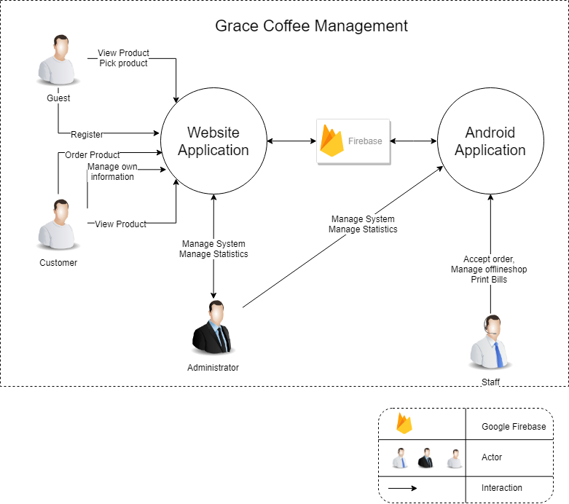

Figure 3.1 Context Diagram

1. **Software Fuatures**

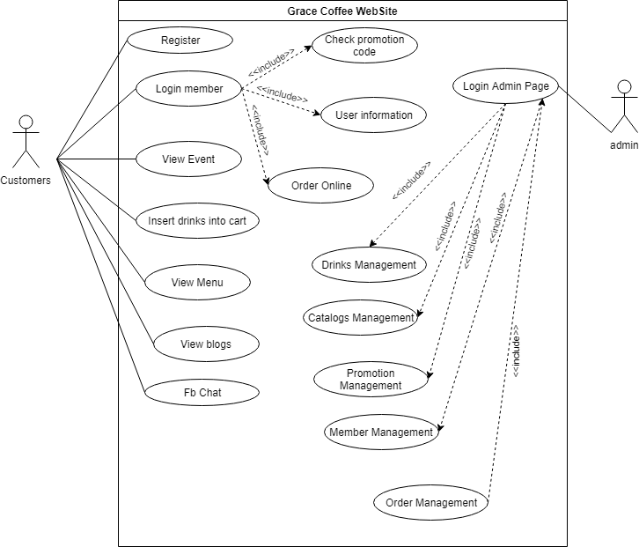

Figure 4.0: Use Case Diagram for Web site system

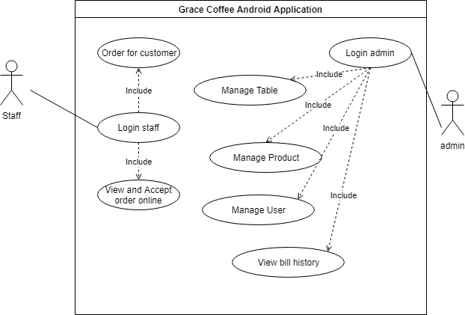

Figure 4.0.1: Use Case Diagram for Android system

## Use case 1: Register

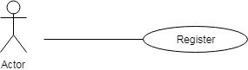

Figure 4.1: Register

Table 4.1: Register

|  |  |  |  |
| --- | --- | --- | --- |
| Use Case ID: UC01 | | | |
| Use Case Name : Register | | | |
| Member Create: Vo Ngoc Tin , Nguyen Quoc Bao | | Member Last Update: Nguyen Quoc Bao , Trần Anh Tài | |
| Date Create: 04/10/2018 | | Date Last Update : 12/10/2018 | |
| Actor: Users (Customers) | | | |
| Describes: This use case describes how users register gain access to the website system. | | | |
| Pre-conditions: | | The user is on the "Register" screen | |
| Post-conditions: | | The user is either registered in or failed to register in and is appropriately notified | |
| Priority: H/M/L | | M | |
| Use frequency: | | High | |
| Standard processes: | | | |
| Step | Actor Action | | System Response |
| 1 | At the external interface of the site, the user clicks on the member button | | The system will show down the main function list is "register and login" |
| 2 | The user continues to click on the registration button | | The system will display the registration interface |
| 3 | At the registration interface, the user enters his/her username, password and information in the returning of the "Register" screen. | |  |
| 4 | After entering the full user information continue to select "I agree to the terms and conditions." | |  |
| 5 | The user clicks the register button | | If account name is in the account list displays message: "username already exists" else show messenger:" Register successfully " |

## Use case 2: Login member

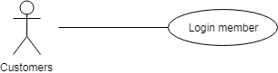

Figure 4.2: Login member

Table 4.2: Login member

|  |  |  |  |
| --- | --- | --- | --- |
| Use Case ID: UC02 | | | |
| Use Case Name: Login member | | | |
| Member Create : Vo Ngoc Tin, Nguyen Quoc Bao | | Member Last Update Nguyen Quoc Bao, Trần Anh Tài | |
| Date Create: 04/10/2018 | | Date Last Update : 12/10/2018 | |
| Actor: Customers | | | |
| Describes: This use case describes how users gain access to the website system through the login process. | | | |
| Pre-conditions: | | The user is on the "Login" screen | |
| Post-conditions: | | The user is either logged in or failed to log in and is appropriately notified | |
| Priority: H/M/L | | M | |
| Use frequency: | | High | |
| Standard processes: | | | |
| Step | Actor Action | | System Response |
| 1 | At the external interface of the site, the user clicks on the member button | | The system will show down the main function list is "register and login" |
| 2 | The user clicks on the login button | | The system will display the login interface |
| 3 | The user enters his/her username, password in the returning of the "Login" screen. | |  |
| 4 | User click on “Get started” button | | If account name is in the account list, displays message: "successfully" else show messenger:" invalid user or password " |

## Use case 3: Order Online

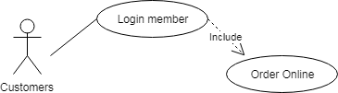

**Figure 4.3**: **Order Online**

Table 4.3: Order Online

|  |  |  |  |
| --- | --- | --- | --- |
| Use Case ID: UC03 | | | |
| Use Case Name: Order Online | | | |
| Member Create: Vo Ngoc Tin, Nguyen Quoc Bao | | Member Last Update: Nguyen Quoc Bao , Trần Anh Tài | |
|  | |  | |
| Date Create: 04/10/2018 | | | |
| Actor: Customers | | | |
| Describes: This use case describes how customers can order online in web site | | | |
| Pre-conditions: | | The actor is on the Cart Screen and have already logged in. | |
| Post-conditions: | |  | |
| Priority: H/M/L | | Medium | |
| Use frequency: | | Low | |
| Standard processes: | | | |
| Step | Actor Action | | System Response |
| 1 | At shopping cart interface | |  |
| 2 | Customer click on Order button | | If (row is empty) displays message: "empty" else show messenger "defined " |

**Use case 4: Insert drinks into the shopping cart**

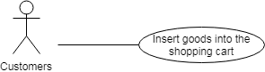

**Figure 4.4: Insert goods into the shopping cart**

Table 4.4: Insert drinks into the shopping cart

|  |  |  |  |
| --- | --- | --- | --- |
| Use Case ID: UC04 | | | |
| Use Case Name: Insert drinks into the shopping cart | | | |
| Member Create: Tin Vo Ngoc , Bao Nguyen Quoc | | Member Create: Tin Vo Ngoc , Bao Nguyen Quoc | |
| Date Create: 04/10/2018 | | Date Create: 04/10/2018 | |
| Actor: Customers | | | |
| Describes: This use case describes how customer can insert drink into shopping cart. | | | |
| Pre-conditions: | | Pre-conditions: | |
| Post-conditions: | | Post-conditions: | |
| Priority: H/M/L | | Priority: H/M/L | |
| Use frequency: | | Use frequency: | |
| Standard processes | | Standard processes | |
| Use Case ID: UC04 | | | |
| Step | Actor Action | | System Response |
| 1 | At main interface , customer click on the button” ” of product customer want to buy | | The system will go to the cart interface |
| 2 | At the customer cart interface, customer click button + to add drink into shopping cart | | Show product quantity of product |

**Use case 5: View, Edit Shopping cart**

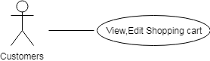

### Figure 4.5: View Edit Shopping cart

Table 4.5: View, Edit Shopping cart

|  |  |  |  |
| --- | --- | --- | --- |
| Use Case ID: UC05 | | | |
| Use Case Name: View, Edit Shopping cart | | | |
| Member Create: Tin Vo Ngoc | | Member Last Update: Khoa Pham Tan Anh, Bao Nguyen Quoc , Tran Anh Tai | |
|  | |  | |
| Date Create: 04/10/2018 | | | |
| Actor: Customers | | | |
| Describes: This use case describes how an actor can view, Edit Shopping cart. | | | |
| Pre-Conditions: | |  | |
| Post-Conditions: | |  | |
|  | |  | |
| Priority: H/M/L | | Medium | |
| Use frequency: | | High | |
| Standard processes | | | |
| Step | Actor Action | | System Response |
| 1 | At main interface , customer click on the button”View Shopping cart” | | The system will go to the cart interface |
| 2 | At the customer cart interface, customer can edit size of row in shopping cart | | Show selected customer size |

## Use case 6: View drinks and information

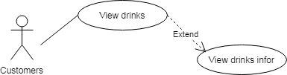

## Figure 4.6: View drinks and information

## Table 4.6: View drinks and information

|  |  |  |  |
| --- | --- | --- | --- |
| Use Case ID: UC06 | | | |
| Use Case Name: View drinks and information | | | |
| Member Create: Tin Vo Ngoc | | Member Last Update: Khoa Pham Tan Anh, Bao Nguyen Quoc, Tran Anh Tai | |
| Date Create: 04/10/2018 | | Date Last Update: 07/11/2018 | |
| Actor: Customers | | | |
| Describes: This use case describes how actors can view drinks and information | | | |
| Pre-conditions: | |  | |
| Post-conditions: | |  | |
| Priority: H/M/L | | High | |
| Use frequency: | | High | |
| Standard processes | | | |
| Step | Actor Action | | System Response |
| 1 | At main interface user click on "other" | | Show down list of main functions of "other" |
| 2 | The user clicks the "menu" button in the list | | The system will display the information interface of all products |
| 3 | Customer can see the drinks they need to buy | |  |
| 3.1 | The customer clicks on any product | | System move to information drink interface |

## Use case 7: View news

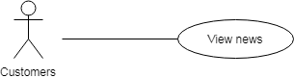

Figure 4.7: View news

### Table 4.7: View news

|  |  |  |  |
| --- | --- | --- | --- |
| Use Case ID: UC07 | | | |
| Use Case Name: View news | | | |
| Member Create: Tin Vo Ngoc | | Member Last Update: Khoa Pham Tan Anh, Bao Nguyen Quoc | |
| Date Create: 04/10/2018 | | Date Last Update: 07/11/2018 | |
| Actor: Customer | | | |
| Describes: This use case describes how customer can view news drink. | | | |
| Pre-Conditions: | |  | |
| Post-Conditions: | |  | |
| Priority: H/M/L | | H | |
| Use frequency: | | | |
| Step | Actor Action | | System Response |
| 1 | At main interface | |  |
| 2 | Customer can see when drink is noted as new drink | |  |

## Use case 8: Check promotion code

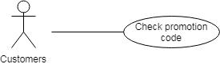

Figure 4.8: Check promotion code

Table 4.8: Check promotion code

|  |  |  |  |
| --- | --- | --- | --- |
| Use Case ID: UC08 | | | |
| Use Case Name: Check promotion code | | | |
| Member Create: Tin Vo Ngoc | | Member Last Update: Khoa Pham Tan Anh, Bao Nguyen Quoc, Tran Anh Tai | |
| Date Create: 04/10/2018 | | Date Last Update: 07/11/2018 | |
| Actor: Customer | | | |
| Describes: This use case describes how customers can check promotion code | | | |
| Pre-conditions: | |  | |
| Post-conditions: | |  | |
| Priority: H/M/L | | High | |
| Use frequency: | | High | |
| Standard processes | | | |
| Step | Actor Action | | System Response |
| 1 | At promotion interface, customer click on the button”View Shopping cart” | | The system will go to the cart interface |
| 2 | Customer can see promotion codes | |  |

## Use case 9: Input promotion code

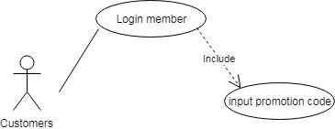

Figure 4.9: Input promotion code

Table 4.9: Input promotion code

|  |  |  |  |
| --- | --- | --- | --- |
| Use Case ID: UC08 | | | |
| Use Case Name: Check promotion code | | | |
| Member Create: Tin Vo Ngoc | | Member Last Update: Khoa Pham Tan Anh, Bao Nguyen Quoc , Tran Anh Tai | |
| Date Create: 04/10/2018 | | Date Last Update: 07/11/2018 | |
| Actor: Customer | | | |
| Describes: This use case describes how customers can input promotion code | | | |
| Pre-conditions: | |  | |
| Post-conditions: | |  | |
| Priority: H/M/L | | High | |
| Use frequency: | | High | |
| Standard processes | | | |
| Step | Actor Action | | System Response |
| 1 | At promotion interface, customer click on the button”View Shopping cart” | | The system will go to the cart interface |
| 2 | Customer down input promotion code | | If promotion code is not in the promotion code valid list,displays message: "promotion code invalid " else show messenger:" promotion code valid " and decrease bill |

## Use case 10: Chat face-book

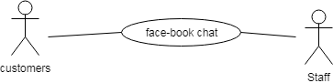

Figure 4.10: Chat face-book

Table 4.10: Chat face-book

|  |  |  |  |
| --- | --- | --- | --- |
| Use Case ID: UC10 | | | |
| Use Case Name: Chat face-book | | | |
| Member Create: Tin Vo Ngoc, Bao Nguyen Quoc | | Member Last Update: Khoa Pham Tan Anh, Bao Nguyen Quoc | |
| Date Create: 04/10/2018 | | Date Last Update: 12/10/2018 | |
| Actor: Customer,Staff | | | |
| Describes: This use case describes how an actor can modify chat with employee of Grace Coffee | | | |
| Pre-Conditions: | | Log-in facebook | |
| Post-Conditions: | |  | |
| Priority: H/M/L | | High | |
| Use frequency: | | High | |
| Standard processes | | | |
| Step | Actor Action | | System Response |
| 1 | At main interface | |  |
| 2 | Customer click button chat to move to face-book chat interface | |  |

## Use case 11: Login admin

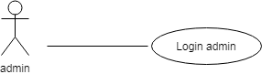

Figure 4.11: Login admin

Table 4.11: Login admin

|  |  |  |  |
| --- | --- | --- | --- |
| Use Case ID: UC11 | | | |
| Use Case Name: Login admin | | | |
| Member Create: Tin Vo Ngoc, Bao Nguyen Quoc | | Member Last Update: Bao Nguyen Quoc | |
| Date Create: 04/10/2018 | | Date Last Update: 07/11/2018 | |
| Actor: Admin | | | |
| Describes: This use case describes how an actor can login with rights access admin | | | |
| Pre-Conditions: | | The actor is admin and on the Login interface | |
| Post-Conditions: | |  | |
| Priority: H/M/L | | High | |
| Use frequency: | | High | |
| Standard processes | | | |
| Step | Actor Action | | System Response |
| 1 | At the interface outside the site, users click on the "Members" | | The system will show down the main function list is "register and login" |
| 2 | The user enters his/her username, password in the returning of the "Login" screen. | |  |
| 3 | The user click button define | | If account name is in the account list, displays message: "successfully" else show messenger:" invalid user or password " |

## Use case 12: Insert/Update/Delete members

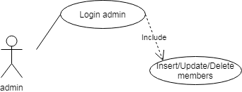

Figure 4.12: Insert/Update/Delete members

Table 4.12: Insert/Update/Delete members

|  |  |  |  |
| --- | --- | --- | --- |
| Use Case ID: UC12 | | | |
| Use Case Name: Insert/Update/Delete members | | | |
| Member Create: Tin Vo Ngoc, Bao Nguyen Quoc | | Member Last Update: Bao Nguyen Quoc, Tran Anh Tai | |
| Date Create: 04/10/2018 | | Date Last Update: 08/11/2018 | |
| Actor: Admin | | | |
| Describes: This use case describes how a admin can Insert/Update/Delete members. | | | |
| Pre-conditions: | | The actor is admin and on the member management interface | |
| Post-conditions: | |  | |
| Priority: H/M/L | | H | |
| Use frequency: | | High | |
| Standard processes | | | |
| Step | Actor Action | | System Response |
| 1 | At the admin page, the user clicks on the “member” button | | The system will display the member list |
| 2 | The admin enters click insert member | | The system displays entries for administrators to enter member information |
| 2.1 | After entering the member information, the administrator presses the button to add more members | | The system displays the message "Successfully added" |
| 3 | The admin enters click update member | | System displays member information |
| 3.1 | Admin change information and press confirm button | | The system displays the message "Successfully updated" |
| 4 | The admin enters click delete member | | The system displays the message "you delete this member" |
| 4.1 | The administrator presses the confirmation button | | That member is removed from the list |

## Use case 13: Insert/Update/Delete drinks

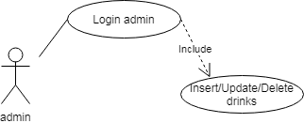

Figure 4.13 Insert/Update/Delete drinks

Table 4.13: Insert/Update/Delete drinks

|  |  |  |  |
| --- | --- | --- | --- |
| Use Case ID: UC13 | | | |
| Use Case Name: Insert/Update/Delete drinks | | | |
| Member Create: Tin Vo Ngoc, Bao Nguyen Quoc | | Member Last Update: Bao Nguyen Quoc | |
| Date Create: 04/10/2018 | | Date Last Update: 08/11/2018 | |
| Actor: Users : Admin | | | |
| Describes: This use case describes how user can Insert/Update/Delete drinks into menu | | | |
| Pre-conditions: | | The actor is admin and on the Update menu interface | |
| Post-conditions: | |  | |
| Priority: H/M/L | | H | |
| Use frequency: | | High | |
| Standard processes | |  | |
| Use Case ID: UC13 | | | |
| Step | Actor Action | | System Response |
| 1 | At the admin page, the user clicks on the “Menu” button | | The system will display the menu list |
| 2 | The admin enters click insert drinks | | The system displays entries for administrators to enter drinks information |
| 2.1 | After entering the drinks information, the administrator presses the button to add more drinks | | The system displays the message "Successfully added" |
| 3 | The admin enters click update drinks | | System displays drinks information |
| 3.1 | Admin change information and press confirm button | | The system displays the message "Successfully updated" |
| 4 | The admin enters click delete drinks | | The system displays the message "you delete this drinks" |
| 4.1 | The administrator presses the confirmation button | | That drinks is removed from the list |

## Use case 14: Insert/Update/Delete promotion code

### C:\Users\PHI LONG\Desktop\Untitled Diagram (4).png

Figure 4.14 Insert/Update/Delete promotion code

Table 4.14: Insert/Update/Delete promotion code

|  |  |  |  |
| --- | --- | --- | --- |
| Use Case ID: UC14 | | | |
| Use Case Name: Insert/Update/Delete promotion code | | | |
| Member Create: Tin Vo Ngoc, Bao Nguyen Quoc | | Member Last Update: Bao Nguyen Quoc | |
| Date Create: 04/10/2018 | | Date Last Update: 08/11/2018 | |
| Actor: Admin | | | |
| Describes: This use case describes how user can Insert/Update/Delete promotion code | | | |
| Pre-conditions: | | The actor is admin and on the Update promotion code interface | |
| Post-conditions: | |  | |
| Priority: H/M/L | | L | |
| Use frequency: | | Medium | |
| Standard processes | |  | |
| Step | Actor Action | | System Response |
| 1 | At the admin page, the user clicks on the “Promotion Code” button | | The system will display the promotion code list |
| 2 | The admin enters click insert promotion code | | The system displays entries for administrators to enter promotion code information |
| 2.1 | After entering the promotion code information, the administrator presses the button to add more promotion code | | The system displays the message "Successfully added" |
| 3 | The admin enters click update promotion code | | System displays promotion code information |
| 3.1 | Admin change information and press confirm button | | The system displays the message "Successfully updated" |
| 4 | The admin enters click delete promotion code | | The system displays the message "you delete this promotion code" |
| 4.1 | The administrator presses the confirmation button | | That promotion code is removed from the list |

## Use case 15: Insert/Update/Delete events

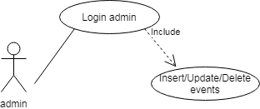

Figure 4.15 Insert/Update/Delete events

Table 4.15: Insert/Update/Delete events

|  |  |  |  |
| --- | --- | --- | --- |
| Use Case ID: UC15 | | | |
| Use Case Name: Insert/Update/Delete events | | | |
| Member Create: Tin Vo Ngoc | | Member Last Update: Khoa Pham Tan Anh, Bao Nguyen Quoc | |
| Date Create: 04/10/2018 | | Date Last Update: 12/10/2018 | |
| Actor: Admin | | | |
| Describes: This use case describes how user Insert/Update/Delete events. | | | |
| Pre-conditions: | | The actor is admin and on the Update promotion code interface | |
| Post-conditions: | |  | |
| Priority: H/M/L | | L | |
| Use frequency: | | Medium | |
| Standard processes | |  | |
| Step | Actor Action | | System Response |
| 1 | At the admin page, the user clicks on the “events” button | |  |
| 2 | The admin enters click insert/update/delete events in the "events management" screen. | |  |

## Use case 16: Login staff Android app

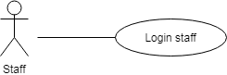

Figure 4.16 : Login(staff Android app)

Table 4.16: Login staff (Android app)

|  |  |  |  |
| --- | --- | --- | --- |
| Use Case ID: UC16 | | | |
| Use Case Name: Login staff (Android app) | | | |
| Member Create: Tin Vo Ngoc , Bao Nguyen Quoc | | Member Last Update: Bao Nguyen Quoc | |
| Date Create: 04/10/2018 | | Date Last Update: 08/11/2018 | |
| Actor: Staff | | | |
| Describes: This use case describes how user can Login staff Android app | | | |
| Pre-conditions: | | The actor is Staff of Grace Coffee | |
| Post-conditions: | |  | |
| Priority: H/M/L | | L | |
| Use frequency: | | Medium | |
| Step | Actor Action | | System Response |
| 1 | At Login interface | |  |
| 2 | The user enters his/her username, password in the returning of the "Login" screen. | |  |
| 3 | The user click button define | | If account name is in the account list, displays message: "successfully" else show messenger:" invalid user or password " |

## Use case 17: Order for customer Android app

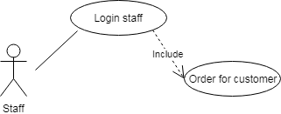

Figure 4.17 : Order for customer Android app

Table 4.17: Order for customer Android app

|  |  |  |  |
| --- | --- | --- | --- |
| Use Case ID: UC17 | | | |
| Use Case Name: : Order for customer Android app | | | |
| Member Create: Tin Vo Ngoc, Bao Nguyen Quoc | | Member Last Update : Bao Nguyen Quoc | |
| Date Create: 04/10/2018 | | Date Last Update: 08/11/2018 | |
| Actor: Staff | | | |
| Describes: This use case describes how user Order for customer Android app | | | |
| Pre-conditions: | | The actor is Staff | |
| Post-conditions: | |  | |
| Priority: H/M/L | | L | |
| Use frequency: | | Medium | |
| Standard processes | |  | |
| Step | Actor Action | | System Response |
| 1 | At main interface | |  |
| 2 | The user click category | | Drinking water display system by category |
| 3 | The user click the drink the customer wants to order | | The system automatically updates the drinks to the bill |
| 4 | The user update bill and print bill for customer | |  |

## Use case 18: View order online in (Android app)

### C:\Users\PHI LONG\Desktop\Untitled Diagram (2).png

## Figure 4.18: View order online Android app

Table 4.18: View order online (Android app)

|  |  |  |  |
| --- | --- | --- | --- |
| Use Case ID: UC18 | | | |
| Use Case Name: View order online (Android app) | | | |
| Member Create: Tin Vo Ngoc | | Member Last Update: Khoa Pham Tan Anh, Bao Nguyen Quoc | |
| Date Create: 04/10/2018 | | Date Last Update: 08/11/2018 | |
| Actor: User | | | |
| Describes: This use case describes how user can View order online in Android app | | | |
| Pre-conditions: | | The actor is Staff | |
| Post-conditions: | |  | |
| Priority: H/M/L | | L | |
| Use frequency: | | Medium | |
| Standard processes | |  | |
| Use Case ID: UC18 | | | |
| Step | Actor Action | | System Response |
| 1 | At main interface | | When there are new orders online the system automatically reports on the "thông báo" icon |
| 2 | The user click button “thông báo” | | The system load to the online bill interface |
| 3 | The user can see order online | |  |

## Use case 19: Insert/Update/Delete Table (Android app)

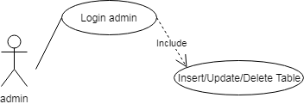

Figure 4.19 : Insert/Update/Delete Table Android app

Table 4.19: Insert/Update/Delete Table (Android app)

|  |  |  |  |
| --- | --- | --- | --- |
| Use Case ID: UC19 | | | |
| Use Case Name: Insert/Update/Delete Table (Android app) | | | |
| Member Create: Tin Vo Ngoc, Bao Nguyen Quoc | | Member Last Update: Bao Nguyen Quoc | |
| Date Create: 04/10/2018 | | Date Last Update: 08/11/2018 | |
| Actor: Admin | | | |
| Describes: This use case describes how user can Insert/Update/Delete Table (Android app) | | | |
| Pre-conditions: | | The actor is Admin | |
| Post-conditions: | |  | |
| Priority: H/M/L | | L | |
| Use frequency: | | Medium | |
| Standard processes | |  | |
| Step | Actor Action | | System Response |
| 1 | At main interface | |  |
| 2 | The user click button “Cập nhập” | | The system load to the update interface |
| 3 | The user Click button “Bàn” | | The system load to the update table interface |
| 4 | If user want insert table .The user click button “Thêm bàn ” | | The system load to the insert table interface |
| 4.1 | The user input table number into editText “Số bàn” | |  |
| 4.2 | Click “Xác nhận” to complete | | The system load to the update table interface and display dialog “Thêm thành công” |
| 4.3 | Click “Hủy” to cancel operation | |  |
| 5 | If user want update number table .The user click button “C:\Users\PHI LONG\Desktop\pen.png ” | | The system load to the update table interface |
| 5.1 | The user deletes the old table number and enters the new table number | |  |
| 5.2 | Click “Xác nhận” to complete | | The system load to the insert table interface and display dialog “Sửa thành công” |
| 5.3 | Click “Hủy” to cancel operation | |  |
| 6 | If user want delete table .The user click button “C:\Users\PHI LONG\Desktop\delete.png” | | The system display dialog “Ban co muon xoa ban … khong” |
| 6.1 | Click “Có” to complete | | The system delete table as indicated |
| 6.2 | Click “Khong” to cancel operation | |  |

## Use case 20: Insert/Update/Delete Employee Android app

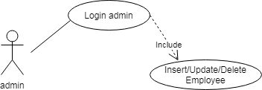

Figure 4.20 : Insert/Update/Delete Employee Android app

Table 4.20: Insert/Update/Delete Employee Android app

|  |  |  |  |
| --- | --- | --- | --- |
| Use Case ID: UC20 | | | |
| Use Case Name: Insert/Update/Delete Employee Android app | | | |
| Member Create: Tin Vo Ngoc | | Member Last Update: Khoa Pham Tan Anh, Bao Nguyen Quoc | |
| Date Create: 04/10/2018 | | Date Last Update: 08/11/2018 | |
| Actor: Admin | | | |
| Describes: This use case describes how user can Insert/Update/Delete Employee Android app | | | |
| Pre-conditions: | | The actor is Admin | |
| Post-conditions: | |  | |
| Priority: H/M/L | | L | |
| Use frequency: | | Medium | |
| Standard processes | |  | |
| Step | Actor Action | | System Response |
| 1 | At main interface | |  |
| 2 | The user click button “Cập nhập” | | The system load to the update interface |
| 3 | The user Click Button “Nhân viên” | | The system load to the update employee interface |
| 4 | If user want insert employee .The user click button “Thêm nhân viên ” | | The system load to the insert employee interface |
| 4.1 | The user input employee name and positon into editText “tên nhân viên” and edittext “chức vụ” | |  |
| 4.2.1 | Click “Xác nhận” to complete | | The system load to the update employee interface and display dialog “Thêm thành công” |
| 4.2.2 | If want cancel, click “Hủy” to cancel operation | |  |
| 5 | If user want update employee .The user click button “C:\Users\PHI LONG\Desktop\pen.png ” | | The system load to the update employee interface |
| 5.1 | The user deletes the old employee name and employee position then enters the new employee name and employee position | |  |
| 5.2.1 | Click “Xác nhận” to complete | | The system load to the update employee interface and display dialog “Sửa thành công” |
| 5.2.2 | Click “Hủy” to cancel operation | |  |
| 6 | If user want delete employee .The user click button “C:\Users\PHI LONG\Desktop\delete.png” | | The system display dialog “Ban co muon xoa nhân viên … khong” |
| 6.1.1 | Click “Có” to complete | | The system delete employee as indicated |
| 6.1.2 | Click “Khong” to cancel operation | |  |

## Use case 21: Insert/Update/Delete menu Android app



Figure 4.21 : Insert/Update/Delete menu Android app

Table 4.21: Insert/Update/Delete menu Android app

|  |  |  |  |
| --- | --- | --- | --- |
| Use Case ID: UC21 | | | |
| Use Case Name: Insert/Update/Delete drink Android app | | | |
| Member Create: Tin Vo Ngoc | | Member Last Update: Khoa Pham Tan Anh, Bao Nguyen Quoc | |
| Date Create: 04/10/2018 | | Date Last Update: 08/11/2018 | |
| Actor: Admin | | | |
| Describes: This use case describes how user can Insert/Update/Delete drink Android app | | | |
| Pre-conditions: | | The actor is Admin | |
| Post-conditions: | |  | |
| Priority: H/M/L | | L | |
| Use frequency: | | Medium | |
| Standard processes | |  | |
| Step | Actor Action | | System Response |
| 1 | At main interface | |  |
| 2 | The user click button “Cập nhập” | | The system load to the update interface |
| 3 | The user Click Button “Menu” | | The system load to the update menu interface |
| 4 | If user want insert menu .The user click button “Thêm món ” | | The system load to the insert drink interface |
| 4.1 | The user input category and drinks name and price into spinner “Mục” and edittext “Tên món” and edittext “Giá” | |  |
| 4.2.1 | Click “Xác nhận” to complete | | The system load to the update menu interface and display dialog “Thêm thành công” |
| 4.2.2 | Click “Hủy” to cancel operation | |  |
| 5 | If user want update employee .The user click button “C:\Users\PHI LONG\Desktop\pen.png ” | | The system load to the update menu interface |
| 5.1 | The user deletes the old drink name and price then enters the new drink name and price | |  |
| 5.2.1 | Click “Xác nhận” to complete | | The system load to the update menu interface and display dialog “Sửa thành công” |
| 5.2.2 | Click “Hủy” to cancel operation | |  |
| 6 | If user want delete drink .The user click icon “C:\Users\PHI LONG\Desktop\delete.png” | | The system display dialog “Ban co muon xoa món … khong” |
| 6.1.1 | Click “Có” to complete | | The system delete drink as indicated |
| 6.1.2 | Click “Khong” to cancel operation | |  |

### Use case 22: View bill history (Android app)

### C:\Users\PHI LONG\Desktop\Untitled Diagram (8).png

Figure 4.22 : View bill history Android app

Table 4.22: View bill history (Android app)

|  |  |  |  |
| --- | --- | --- | --- |
| Use Case ID: UC22 | | | |
| Use Case Name: View bill history (Android app) | | | |
| Member Create: Tin Vo Ngoc, Bao Nguyen Quoc | | Member Last Update: Bao Nguyen Quoc | |
| Date Create: 04/10/2018 | | Date Last Update: 08/11/2018 | |
| Actor: Admin | | | |
| Describes: This use case describes how user can View bill history (Android app) | | | |
| Pre-conditions: | | The actor is admin | |
| Post-conditions: | |  | |
| Priority: H/M/L | | L | |
| Use frequency: | | Medium | |
| Standard processes | |  | |
| Step | Actor Action | | System Response |
| 1 | At main interface | |  |
| 2 | The user click button “Thống kê” | | The system load to the statictis interface |
| 3 | The user can see bill history interface | |  |

* 1. **User’s interface**
* User can change language
* User can view product’s information and image.
* Search products
* Booking in website
* Live chat to supporter
  1. **Hardware’s interface**
* Android operating system
* Internet or 3G connection

* 1. **Software’s interface**
* System can connect with MySQL
* Run with android operating system or website
  1. **Communication’s interface**

This application can link to the website. As described above, this will be communicating with a server and the HTTPS protocol. Integrated Facebook app will let users login. Accounts and user’s information will be kept confidential.

1. **Non-functional requirements other**
   1. **Performance Requirements**

Table 5.1 Performance

|  |  |
| --- | --- |
| 1 | Web : -The interface will appear within four seconds from the time access to the system if connect strong.  Mobile: -Placement notice will be displayed after 3 seconds if the connect strong |
| 2 | -Users will wait for three seconds to receive information of system Grace Coffee |
| 3 | -The system will provide accurate list of Coffee information within one second |

* 1. **Safety Requirements**

No safety requirement for this system, the hazards occur depending usage by the user. Example : search for Coffee improperly.

* 1. **Security Requirements**

The user account information will be kept confidential.

* 1. **The properties of the product quality**

-Availability: the information in the system will be stored in the database so the system is always active, and this information will be updated regularly.

-Ease of use: the app has a guide for users with user-friendly interface.

* 1. **User Documentation**

After downloading and installing the product will have an electronic guide for users. When users encounter problems in using the product can send their inquiries via the product review section.

1. **Other Riquirements**

|  |  |  |
| --- | --- | --- |
| No | The term | Explain |
| 1 | URD | User requirement document |