**Exercise 1**

**1.**

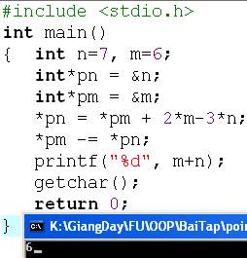

Output:

n= m+2*m-3*n= 6+2*6-3*7= -3;

m = m-n= 6-(-3) = 9;

print- m+n = 9 +( -3) = 6.

Output is 6.

**2.**

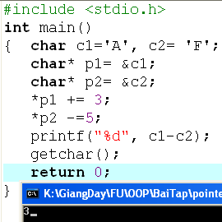

*p1+=3 ⬄ *p1 = *p1+3 = c1+3= A+3 = D = c1

*p2-=5 ⬄ *p2 = *p2 – 5 = c2 – 5 = F – 5 = A = c2

Output = c1-c2= D- A= 68-65= 3.

**3.**

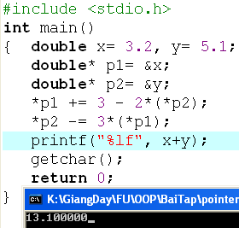

x= *p1 += 3 -2*(*p2) = *p1 + 3 – 2*5.1 = 3.2 + 3 -2*5.1 = -4

y= *p2 -= 3*(*p1) = p2 – 3*(p1) = 5.1 – 3*(-4) = 17.1

=> OUTPUT = x +y = -4 + 17.1 = 13.1

**Exercise 2:**

int n=7,m=8;

int* p1= &n, *p2=&m;

*p1 +=12-m+ (*p2);

*p2 = m + n- 2*(*p1);

printf(“%d”, m+n);

What is the output?

*p1 = *p1 + 12-m +(*p2) = n+12-m+m=n+12 = 7+12=19 ⬄ n = 19.

*p2 = m +n -2*(*p1) = 8+19-2*(n)=8+19-2*19 = -11 ⬄ m = -11.

=> OUTPUT = m+n = -11 +19 = 8.

int n=7,m=8;

int* p1= &n, *p2=&m;

*p1 +=12-m+ (*p2);

*p2 = m + n- 2*(*p1);

printf(“%d”, m+n);

What is the output?

*p1 = *p1 + 12-m +(*p2) = n+12-m+m=n+12 = 7+12=19 ⬄ n = 19.

*p2 = m +n -2*(*p1) = 8+19-2*(n)=8+19-2*19 = -11 ⬄ m = -11.

=> OUTPUT = m+n = -11 +19 = 8.

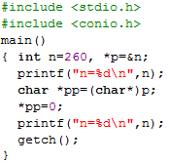

n= 260 = 0001 0000 0100

0001 (byte cao) 0000 0100( byte thấp)

Byte thấp ghi trước, byte cáo ghi sau.

=> 260 : **00000100** **00000001** 00000000 00000000

char * pp = (char *) p; => con trỏ **pp** trỏ tới ô nhớ đầu tiên của n

*pp = 0 => thay đổi giá trị ô nhớ 1 từ **00000100** thành **00000000**

**=> n : 00000000 00000001 00000000 00000000**

**=> n = 0000 0001 0000 0000 = 256.**

Output: n =256.

**Exercise 3:**

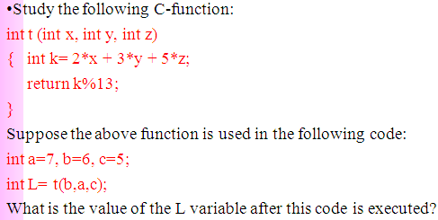

L = (2*6+3*7+5*5)%13 = 6

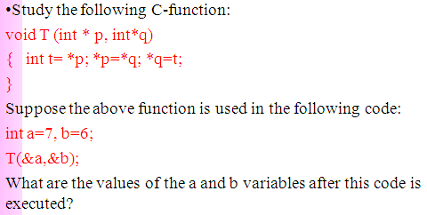

Swapping.

a= 6; b=7.

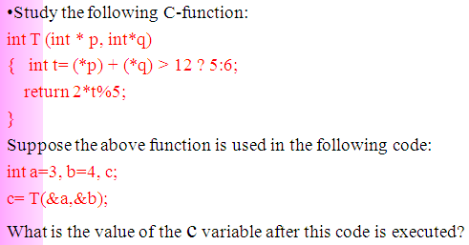

In Function T:

t= *p +*q = a+b= 3+4=7

Evaluate : 7>12 if true t =5/ if false t = 6 => t =6;

2*t%5 = (2*6)%5 = 2.

Value of c = 2.