**LAB 5**

Họ tên : Đinh Vũ Hà

MSSV : 2113269

**1. ICMP and Ping**

**Question 1**: What is the IP address of your host? What is the IP address of the destination host?

**ANSWER:**

My host IP address: 192.168.56.1

Destination host IP address: 143.89.12.134

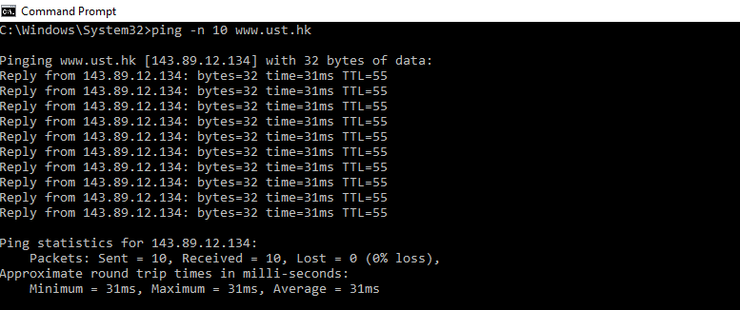

**Question 2** Why is it that an ICMP packet does not have source and destination port numbers?

**ANSWER:**

ICMP packet is designed to communicate network-layer information between hosts androuters, not between application layer processes.

Each ICMP packet has a "Type" and a "Code". The Type/Code combination identifies the specificmessage being received.

Because the network software itself interprets all ICMPmessages

=> NO source/ destination port numbers are needed to direct the ICMP message to anapplication layer process.

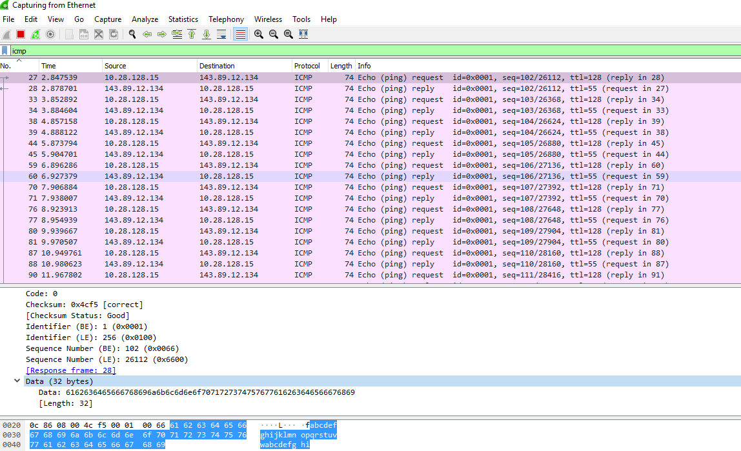

**Question 3:** Examine one of the ping request packets sent by your host. What are the ICMP type and code numbers? What other fields does this ICMP packet have? How many bytes are the checksum, sequence number and identifier fields?

**ANSWER:**

ICMP type: 8, code number: 0.

Other field:checksum (2 byte), identifier (2 byte), sequence number (2 byte), and data fields.

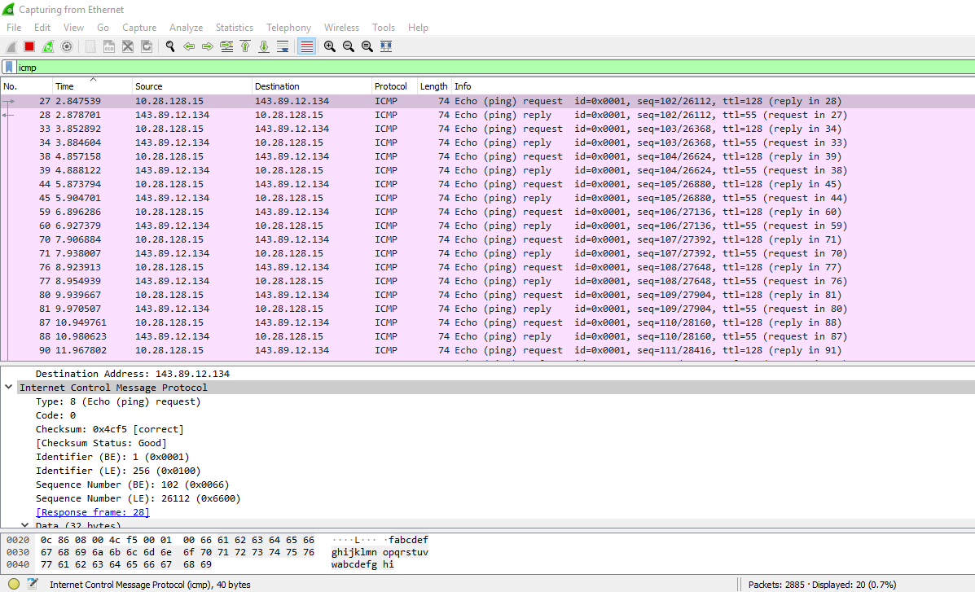

**Question 4** Examine the corresponding ping reply packet. What are the ICMP type and code numbers? What other fields does this ICMP packet have? How many bytes are the checksum, sequence number and identifier fields?

**ANSWER:**

ICMP type: 0, code number: 0.

Other field:checksum (2 byte), identifier (2 byte), sequence number (2 byte), and data fields.

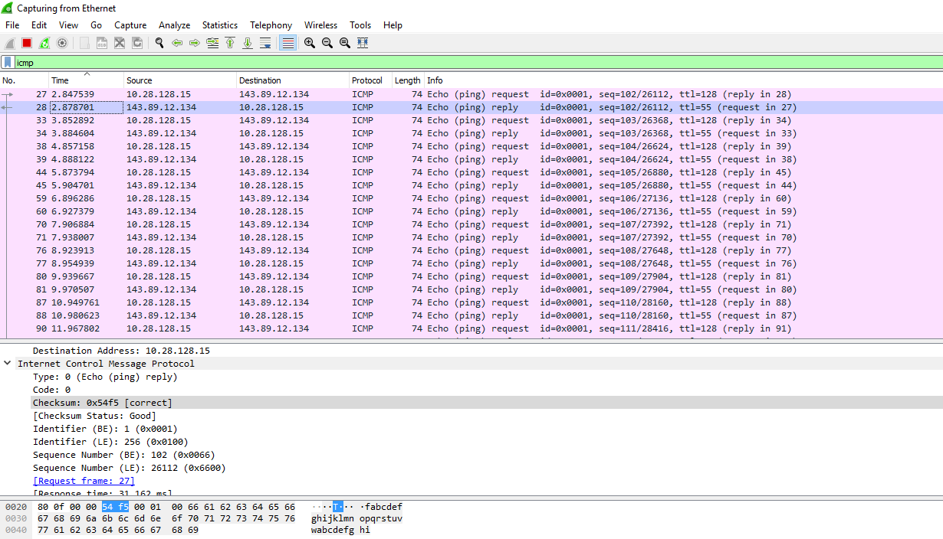

**2. ICMP and Traceroute**

**Question 5**: What is the IP address of your host? What is the IP address of the target  
destination host?

**ANSWER:**

My host IP address: 192.168.56.1

Destination host IP address: 128.93.162.83

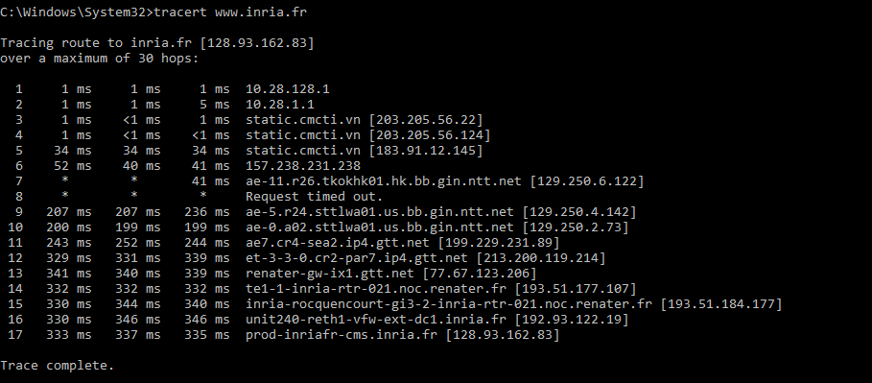

**Question 6:** If ICMP sent UDP packets instead (as in Unix/Linux), would the IP protocol number still be 01 for the probe packets? If not, what would it be?

**ANSWER:**

No.

If ICMP sent UDP packets instead => the IP protocol number would be0x11

**Question 7:** Examine the ICMP echo packet in your screenshot. Is this different from the ICMP ping query packets in the first half of this lab? If yes, how so?

**ANSWER:**

The ICMP echo packet has the same fields as the ping query packets.

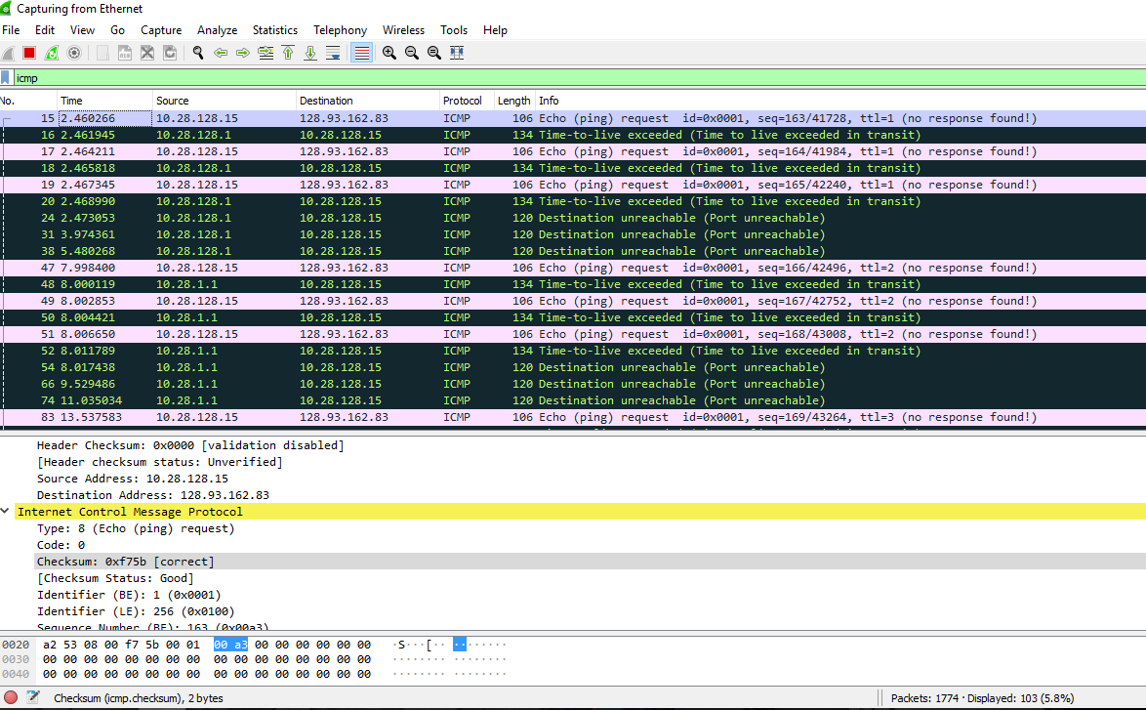

**Question 8:** Examine the ICMP error packet in your screenshot. It has more fields than the ICMP echo packet. What is included in those fields?

**ANSWER:**

The ICMP error packet has more fields than the ICMP echo packet.

It containsboth the IP header and the first 8 bytes of the original ICMP packet that theerror is for.

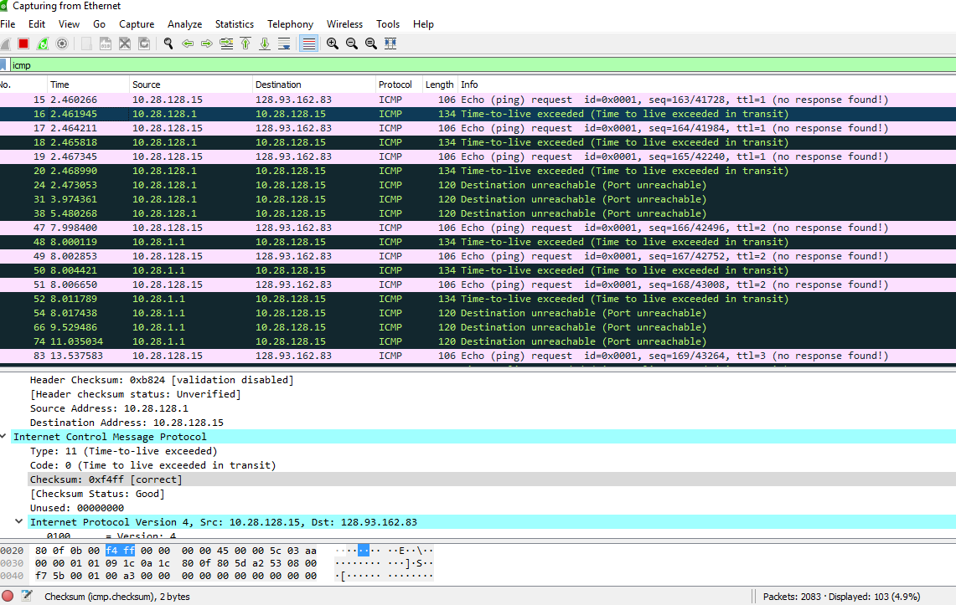

**Question 9**: Examine the last three ICMP packets received by the source host. How are these packets different from the ICMP error packets? Why are they different?

**ANSWER:**

The last three ICMP packets are message type 0 (echo reply) rather than type 11(TTL expired).

=> They are different because the datagrams have made it all theway to the destination host before the TTL expired.

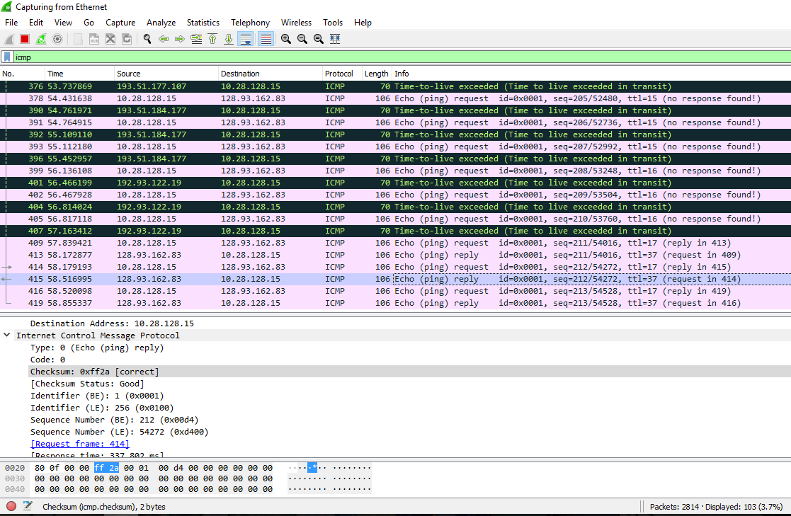

**Question 10:** Within the tracert measurements, is there a link whose delay is significantly longer than others? Refer to the screenshot in Figure 4, is there a link whose delay is significantly longer than others? On the basis of the router names, can you guess the location of the two routers on the end of this link?

**ANSWER:**

There is a link between router 4 and 5 that has a significantly longer delay.

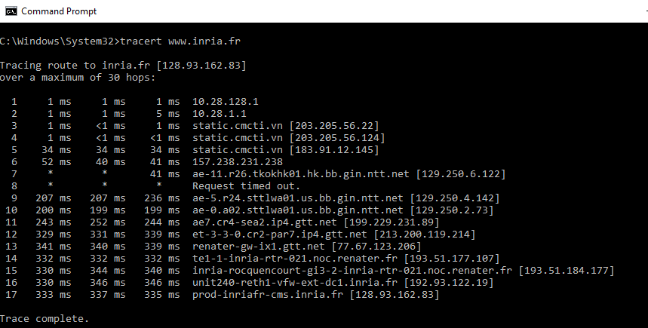

*In figure 4:There is a link between router 9 and 10 whose delay is significantly longer than others. This link is from New York to Pastourelle (France)

2 routers on the end of this link are from New York and Bagnolet (France)

