HANOI UNIVERSITY OF SCIENCE AND TECHNOLOGY

School of Information and communications technology

Software Requirement Specification

Version 1.0

Project: Internet Banking System

Subject: Software Development

Group Number 1

Nguyen Sy An

Nguyen Viet Anh

Theo Mercurio

*Hanoi, 27.12.2018*

Table of contents

Table of contents 1

1 Introduction 2

1.1 Objective 2

1.2 Scope 2

1.3 Glossary 2

1.4 References 2

2 Overall Description 3

3 Specific Requirements 4

4 Supplementary specification 6

4.1 Functionality 6

4.2 Usability 6

4.3 Reliability 6

4.4 Performance 6

4.5 Supportability 6

4.6 Other requirements 6

# Introduction

## Objective

This document presents the detailed description for Internet Banking System, user group and their usable function. This document also describes the objectives and features of the system, interfaces and constraints of the system in response to external action.

*This document is for stakeholders and related software developers.*

## Scope

*The software product: Internet banking system*

* The system will be responsible to:
* Provide user an interface to transfer money, pay online receipts, do online saving.
* Provide bank officer an interface to manage bank accounts.

## Glossary

*\** ***Bank Customer****: A person to be known as a customer of the bank there must be either a current account or any sort of deposit account or any sort of deposit account like saving, term deposit, recurring deposit, a loan account or some similar relation.*

*\** ***Bank Officer****: An employee of the bank endowed with the legal capacity to agree to and sign documents on behalf of the institution. The title is usually held by branch managers, assistance managers, loan officiers, and other experienced personnel. Executives and others holding titles such as "Vice President" are considered officers of the bank for legal purposes.*

*\** ***EVN Software****: EVN is a Vietnam Electricity Corporation. EVN Software will sent Digital Receipt to Bank Customer to inform and track EVN's customer easier in terms of purchase.*

*\** ***Bank Consortium****: A Subidiary bank, which numerous other banks create. These banks might create a consortium bank to fund a specific project (such as providing affordable homeownership for low- and moderate-income home buyers) or to execute a specific deal (such as selling loans in the loan syndication market).*

*\** ***Balances Inquires****: A function to check for available funds on pre-paid credit card in a seperate transaction (not as part of a purchase transaction).*

*\** ***Transaction History Inquires****: Look up payment or receipt transactions originating in account (within a range of dates, amounts, or source currencies).*

*\** ***Transfer Transaction (internal and interbank network)****: When performing an online bank transfer you must access your own account. Determine the amount you would like to send to the receipt. Input their information and authorize the transaction. The entire process is done online.*

*\** ***Electric Receipt Payment****: This is a kind of Digital Receipt, normally sent via e-mail or an app. Unlike paper receipts, e-receipts are used to reduce paper usage. The e-receipt are used to inform the customer of rebates and discounts.*

*\** ***Online Saving****: You put money in the bank. The bank lends you money out to other people and bussiness in form of personal and bussiness loans, charging the borrowers interest on what they owe untill they pay back the money.Meanwhile, the bank pays you interest for privilege of your money. However, we will seperate this action into sub-action more specifically:*

*+* ***Deposit to Saving Account****: Sent the money that you don't intend to use for daily or regular expenses to Saving Account.*

*+* ***Withdraw from Saving Account****: You receive the money with interest after a time interval, maybe a month or a year.*

## References

[*https://en.wikipedia.org/wiki/Bank*](https://en.wikipedia.org/wiki/Bank)

[*https://en.wikipedia.org/wiki/Consortium*](https://en.wikipedia.org/wiki/Consortium)

<https://en.wikipedia.org/wiki/Electronic_receipt>

<https://en.wikipedia.org/wiki/Savings_account>

# Overall Description

**2.1 Actors**

There are 4 main actors in the system: Bank Customer, Bank Officer, Bank Consortium and EVN Software.

**2.2 Overall use case diagram**

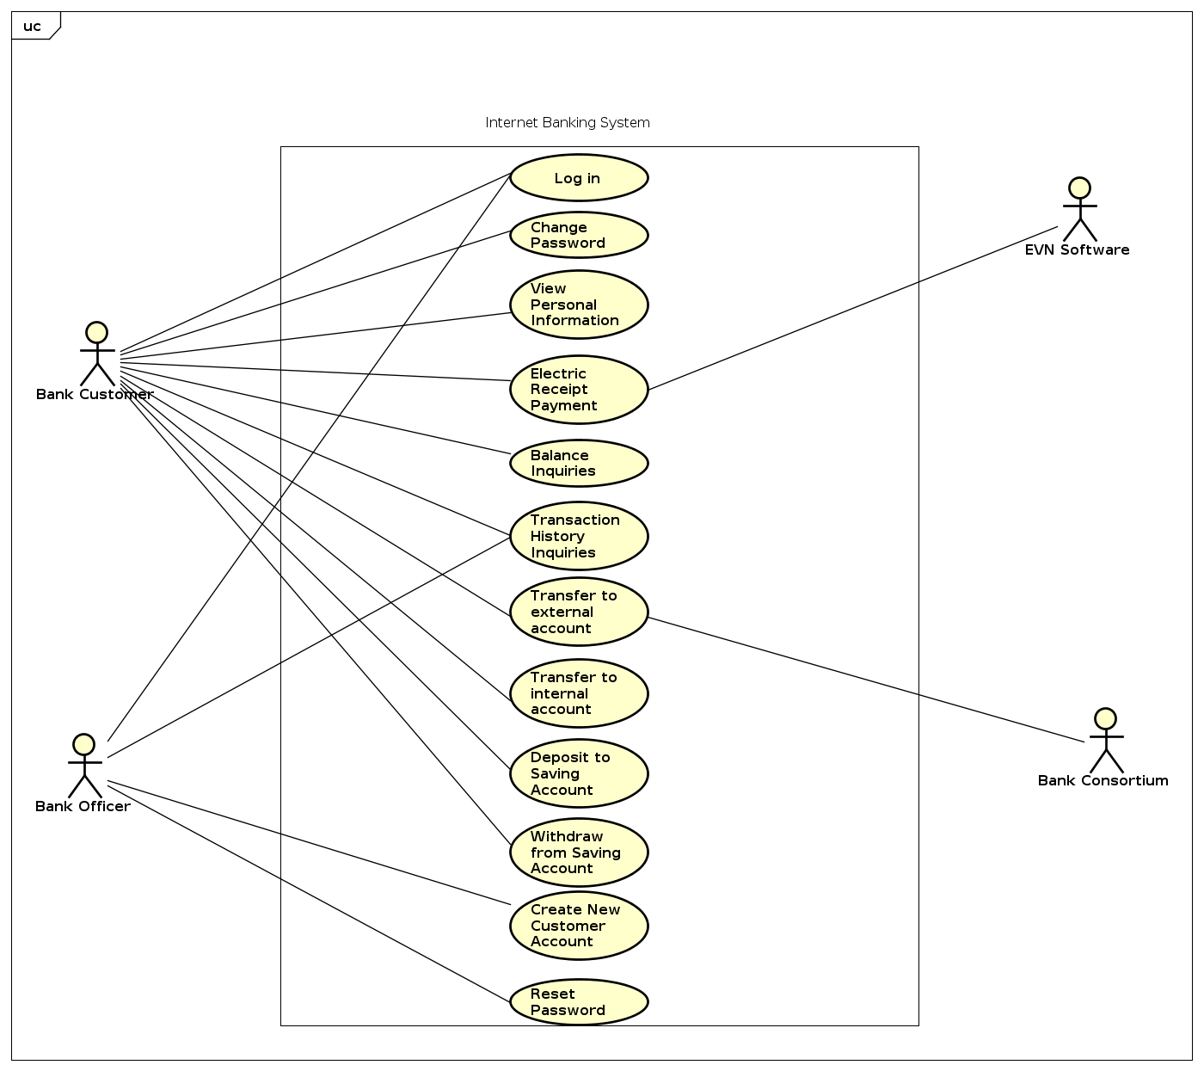

**2.3 Business processes**

2.4.1 Process of log in

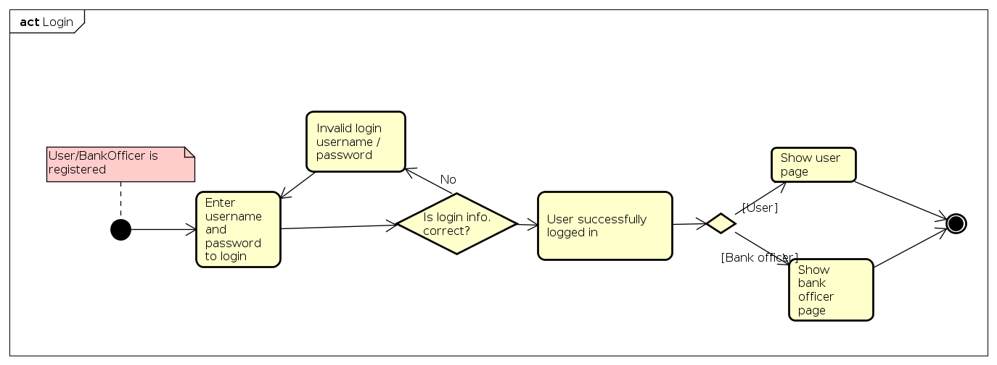

2.4.2 Process of reset user passwords

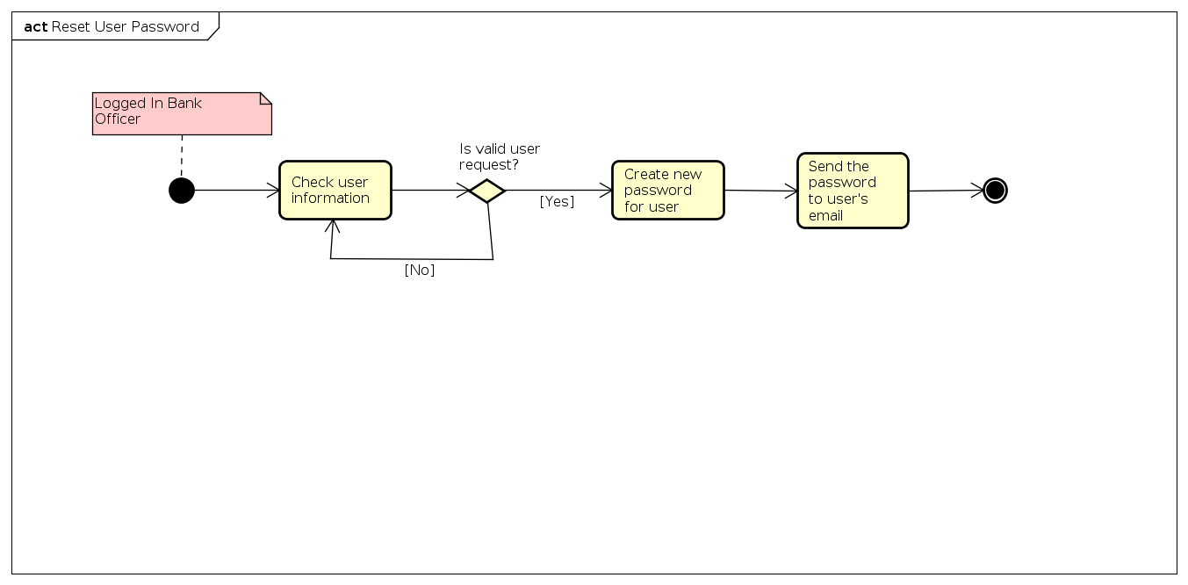

2.4.3 Process of change passwords

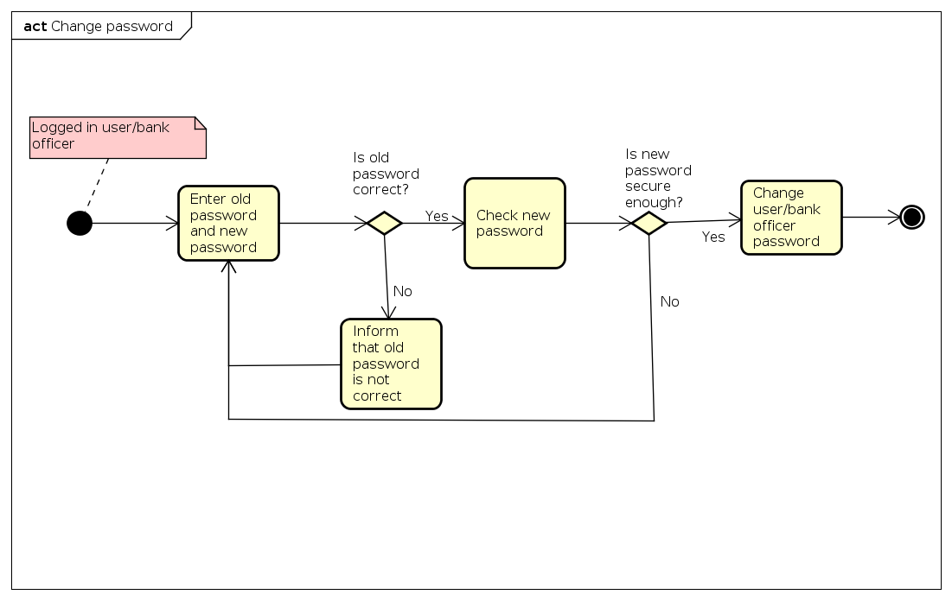2.4.4 Process of balance inquiries

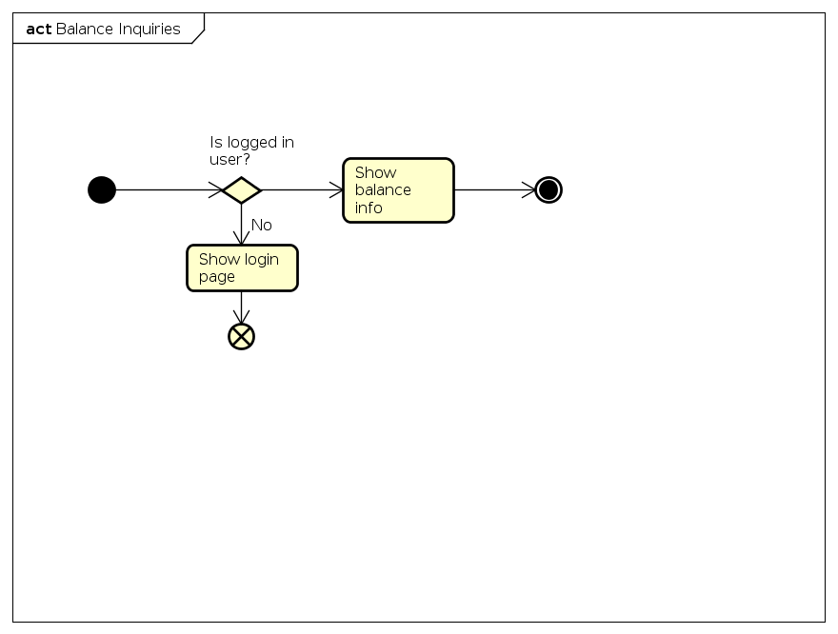

2.4.5 Process of view personal information

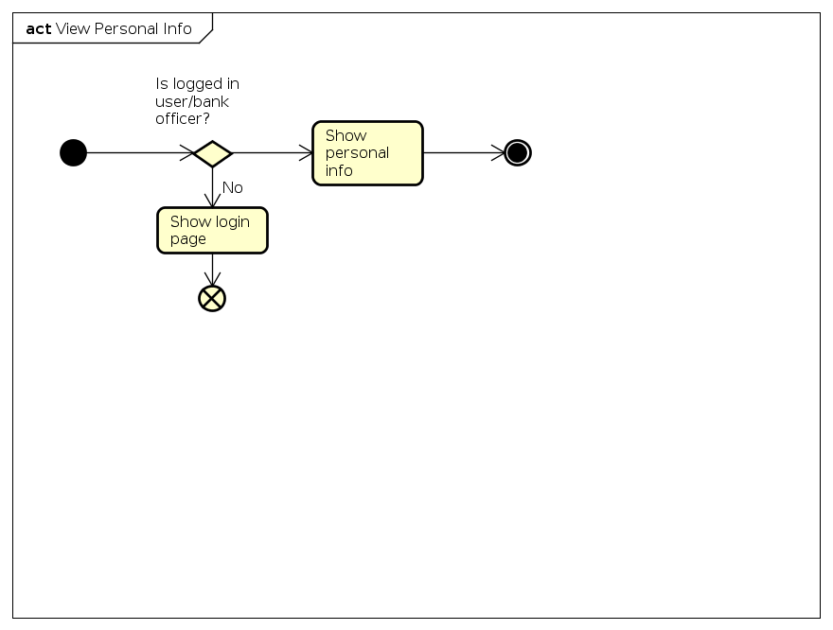

2.4.6 Process of deposit to saving accounts

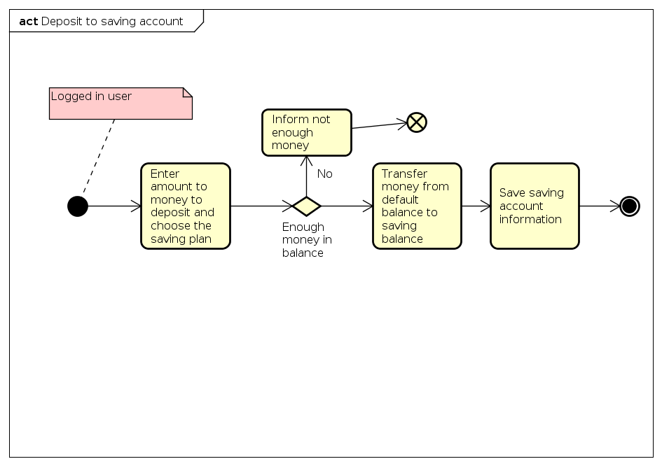

2.4.7 Process of withdraw from saving accounts

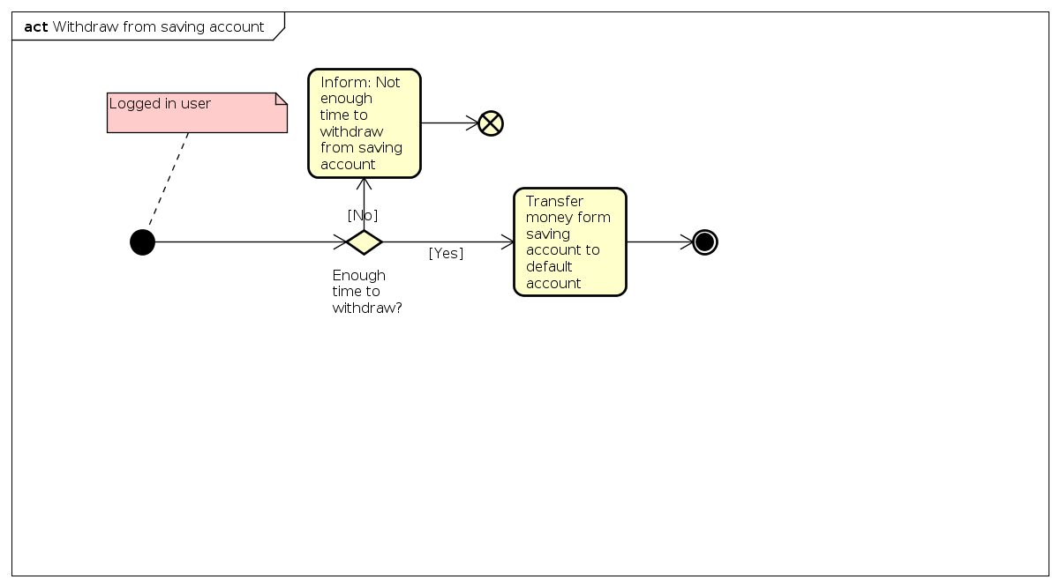

2.4.8 Process of electric receipt payment

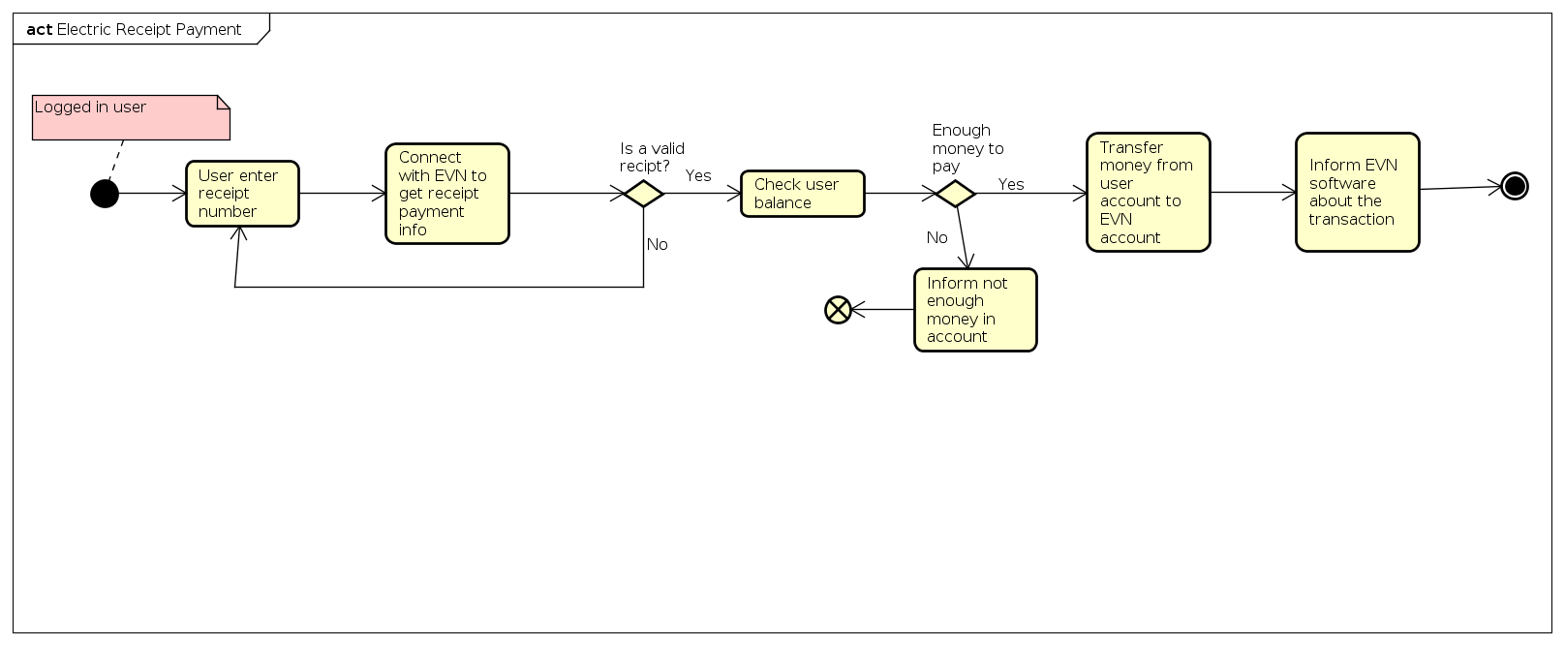

2.4.9 Process of Transaction history inquires

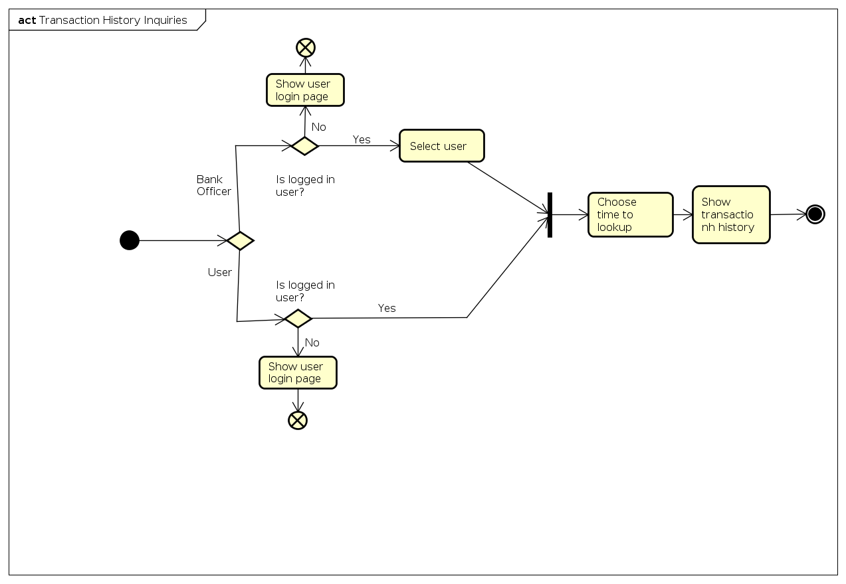

2.4.10 Process of Transfer money

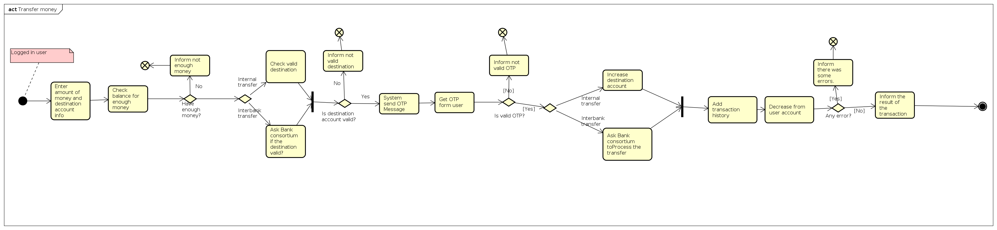

2.4.11 Process of create new customer account

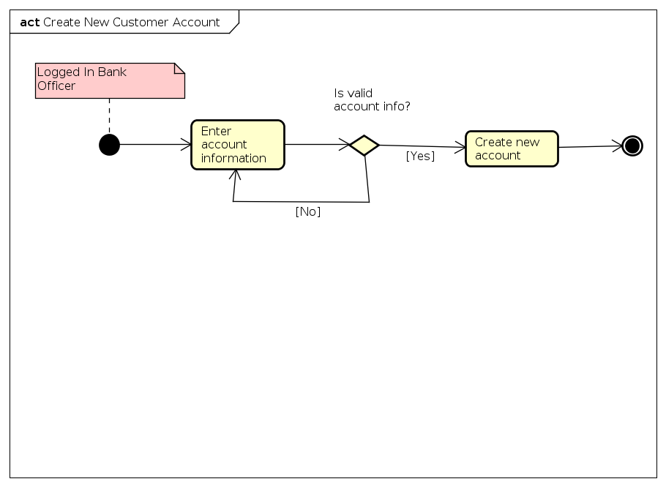

# Specific Requirements

Details of the use cases given in following sections are specified below.

**3.1 Specification of Use case UC001 - “Log in”**

|  |  |
| --- | --- |
| Use case code | UC001 |
| Use case name | Log in |
| Actor | User (Customer, Bank Officer) |
| Pre-condition | None |
| Main flow of events (Success) | |  |  |  | | --- | --- | --- | | No | Actor | Action | | 1. | User | Select Log in function | | 2. | System | Display log in interface | | 3. | User | Input user name and passwords | | 4. | User | Request log in | | 5. | System | Check whether user had input the required field | | 6. | System | Validate the user name and password | | 7. | System | Log user into the system | | 8. | System | Display the Main Form and the use case end | |
| Alternative flow of events | |  |  |  | | --- | --- | --- | | No | Actor | Action | | 6a. | System | Output Error: need to put into the missing required field if had not done so | | 7a. | System | Output error: If the user name and password is invalid, require user enter user name and password again | |
| Post-condition | None |

**3.2 Specification of Use case UC001 - “Change password”**

|  |  |
| --- | --- |
| Use case code | UC002 |
| Use case name | Change password |
| Actor | User (Customer, Bank Officer) |
| Pre-condition | User logged in system |
| Main flow of events (Success) | |  |  |  | | --- | --- | --- | | No | Actor | Action | | 1. | User | Select change password function | | 2. | System | Display change password interface, require confirm old password and new password | | 3. | User | Enter old password and new password | | 4. | System | Check whether user had input the required field | | 5. | System | Check the new password is secure enough or not | | 6. | System | Check the old password is right or not | | 7. | System | Display change password successfully, save new password | |
| Alternative flow of events | |  |  |  | | --- | --- | --- | | No | Actor | Action | | 5a. | System | Output error: need to put into the missing required field if had not done so | | 6a. | System | Output error: the new password is not secure enough, back to step confirm password | | 7a. | System | Output error: the old password is not right, back to step confirm password | |
| Post-condition | None |

**3.3 Specification of Use case UC003 - “View Personal Information”**

|  |  |
| --- | --- |
| Use case code | UC003 |
| Use case name | View Personal Information |
| Actor | User (Customer, Bank Officer) |
| Pre-condition | None |
| Main flow of events (Success) | |  |  |  | | --- | --- | --- | | No | Actor | Action | | 1. | User | Request personal information | | 2. | System | Check if the user/bank officer has logged in | | 3. | System | Display the personal information | |
| Alternative flow of events | |  |  |  | | --- | --- | --- | | No | Actor | Action | | 2a. | System | Output error and redirect to login page if user / bank officer hasn't logged in | |
| Post-condition | None |

**3.4 Specification of Use case UC004- “Pay electric receipt”**

|  |  |
| --- | --- |
| Use case code | UC004 |
| Use case name | Pay electric receipt |
| Actor | Customer, EVN software |
| Pre-condition | Customer logged in system |
| Main flow of events (Success) | |  |  |  | | --- | --- | --- | | No | Actor | Action | | 1. | Customer | Request electric receipt payment and enter the receipt id | | 2. | System | Connect with EVN to get receipt payment info | | 3. | EVN Software | Return payment info with the provided receipt id or an error message | | 4. | System | Check the customer balance if there is enough money to pay for the receipt | | 5. | System | Transfer money to EVN account then inform the EVN software | | 6. | EVN Software | Confirm the payment | | 7. | System | Inform customer that payment was successful | |
| Alternative flow of events | |  |  |  | | --- | --- | --- | | No | Actor | Action | | 2a. | System | Output error if customer do not enter the receipt id | | 4a. | System | Output error if receipt id is not valid | | 5a. | System | Output error if there is not enough money in the Customer account | | 7a. | System | Output error if there is an error on the transaction | |
| Post-condition | None |

**3.5 Specification of Use case UC005 - “Transfer to external account”**

|  |  |
| --- | --- |
| Use case code | UC005 |
| Use case name | Transter to external account |
| Actor | Customer, Bank consortium |
| Pre-condition | Customer logged in the system |
| Main flow of events (Success) | |  |  |  | | --- | --- | --- | | No | Actor | Action | | 1. | Customer | Select transfer to external account function | | 2. | System | Display form to enter destination bank and destination account | | 3. | Customer | Enter the destination bank and destination account | | 4. | System | Software ask the Bank consortium to display information of the destination account | | 5. | Bank consortium | Return information of the destination account to system | | 6. | System | Software display information of the destination account | | 7. | System | System ask to enter the amount of money to transfer | | 8. | Customer | Enter the amount of money | | 9. | System | Check the customer balance if the funds are insufficient | | 10. | System | Send OTP (One-Time Password) to customer | | 11. | Customer | Enter the OTP number | | 12. | System | System check if OTP number that Customer enter is valid or not | | 13. | System | System ask Bank consortium to process the transfer to the destination account | | 14. | System | System add a new transaction history | | 15. | System | System decrease the transfer amount of the customer account | | 16. | System | Notify successfully transfer | |
| Alternative flow of events | |  |  |  | | --- | --- | --- | | No | Actor | Action | | 6a. | System | Output error: destination account is not exist, back to step enter destination bank and destination account | | 10a. | System | Output error: Notify insufficient funds, back to step enter amount of money to transfer | | 13a. | System | Output error: Notify OTP is not correct, back to main menu | |
| Post-condition | The system should be ready to perform another transaction or should be in a disabled state awaiting service. |

**3.6 Specification of Use case UC006 - “Transfer to internal account”**

|  |  |
| --- | --- |
| Use case code | UC006 |
| Use case name | Transter to internal account |
| Actor | Customer |
| Pre-condition | Customer logged in the system |
| Main flow of events (Success) | |  |  |  | | --- | --- | --- | | No | Actor | Action | | 1. | Customer | Select transfer to internal account function | | 2. | System | Display form to enter destination account | | 3. | Customer | Enter the destination account | | 4. | System | System ask to enter the amount of money to transfer | | 5. | Customer | Enter the amount of money | | 6. | System | Check the customer balance if the funds are insufficient | | 7. | System | Send OTP (One-Time Password) to customer | | 8. | Customer | Enter the OTP number | | 9. | System | System check if OTP number that Customer enter is valid or not | | 10. | System | Transfer to the destination account | | 11. | System | System add a new transaction history | | 12. | System | System decrease the transfer amount of the customer account | | 13. | System | Notify successfully transfer | |
| Alternative flow of events | |  |  |  | | --- | --- | --- | | No | Actor | Action | | 6a. | System | Output error: destination account is not exist, back to step enter destination account | | 7a. | System | Output error: Notify insufficient funds, back to step enter amount of money to transfer | | 10a. | System | Output error: Notify OTP is not correct, back to main menu | |
| Post-condition | The system should be ready to perform another transaction or should be in a disabled state awaiting service. |

# Supplementary specification

*<Presenting other requirements if necessary, including non-functional requirements such as performance, reliability, usability, and supportability; or other technical requirements such as database system, used technology…>*

## Functionality

*<Functional requirements that are general to many use cases>*

## Usability

<*Requirements that relate to, or affect, the usability of the system. Examples include ease-of-use requirements or training requirements that specify how readily the system can be used by its actors*>

## Reliability

*<Any requirements concerning the reliability of the system. Quantitative measures such as mean time between failure or defects per thousand lines of code should be stated>*

## Performance

*<The performance characteristics of the system. Include specific response times. Reference related use cases by name>*

## Supportability

*<Any requirements that will enhance the supportability or maintainability of the system being built>*

## Other requirements

*<Descriptions of other requirements are located here>*