SCREEN SPECIFICATION

Report
Function: - Create Report
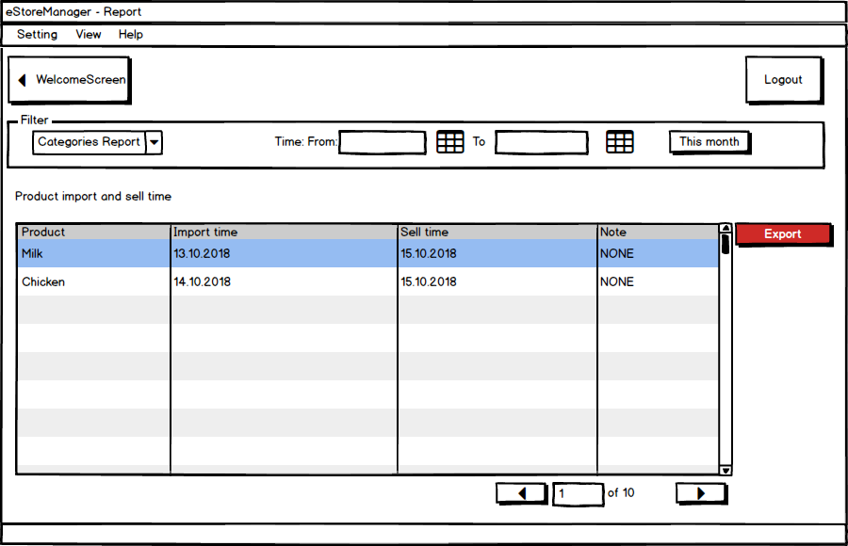
Control | Operation | Function
Menu | Click | Open menu items
Welcome Screen | Click | Go back to Welcome Screen
Categories Report | Choose | What kind of report you want to export
Export | Click | Export to file

